68C-22.008 St. Lucie County Zones.
(1) The Commission designates those portions of the Indian River and North Fork St. Lucie River, including all associated waters, within St. Lucie County as areas where manatees are frequently sighted. The Commission has further determined that manatees are assumed to inhabit these waters periodically or continuously. This rule is for the purpose of regulating the speed and operation of motorboats in portions of these designated areas in St. Lucie County.
(2) For the purpose of regulating the speed and operation of motorboats within St. Lucie County, the following year-round and seasonal zones are established, which shall include all associated and navigable tributaries, lakes, creeks, coves, bends, backwaters, canals, and boat basins unless otherwise designated or excluded: (Access to the No Entry and Motorboats Prohibited zones designated below in paragraphs (2)(a) and (2)(b), respectively, will be provided in accordance with procedures set forth in subsection (4), hereunder, and applicable provisions under Rule 68C-22.003, F.A.C.)
(a) No Entry Zone (Year-round) – Harbor Branch Area: Those waters of the Harbor Branch waterway including all associated canals and boat basins westerly of a due south line from the westernmost point of the rail system associated with the hoist on the northern side and near the western end of said Harbor Branch waterway (approximate latitude 27° 32' 03" North, approximate longitude 80° 21' 24" West).
(b) Motorboats Prohibited Zone (November 15 through March 31)/Idle Speed Zone (Remainder of Year) – Moore’s Creek Area: Those waters of Moore’s Creek lying westerly of the general contour of the westerly shoreline of Indian River, and easterly of the centerline of the Indian River Drive Bridge.
(c) Idle Speed Zone (Year-round) –
1. Harbor Branch Area: Those waters of the Harbor Branch waterway including all associated canals and boat basins, westerly of a line drawn across the eastern extremities of the north and south jetties at the entrance of said waterway and easterly of a due south line from the westernmost point of the rail system associated with the hoist on the northern side and near the western end of said Harbor Branch waterway (approximate latitude 27° 32' 03" North, approximate longitude 80° 21' 24" West),
2. Garfield Cut Area: Those waters of Garfield Cut, including the canal system of the Queens Cove residential development and all other associated waters easterly and northeasterly of a line which bears North 11° 00' 00" West from a point on the westerly side of Garfield Point (approximate latitude 27° 30' 54" North, approximate longitude 80° 19' 38" West), with said line running approximately through privately maintained channel marker “8”,
3. Jack Island Area: Those waters lying easterly and northeasterly of Jack Island, northerly of lines which bear North 65° 00' 00" West and North 65° 00' 00" East from the northeasternmost tip of an unnamed mangrove island lying on the south side of Snapper Cut (approximate latitude 27° 29' 17" North, approximate longitude 80° 18' 49" West), and southerly of a line which bears East from the southernmost tip of a peninsula near the north end of the easterly side of Jack Island (approximate latitude 27° 30' 13" North, approximate longitude 80° 18' 33" West), including the waters of the bay immediately west of said peninsula and the canals of Coastal Coves residential area,
4. Ft. Pierce Cut, Wildcat Cove Area: Those waters of Ft. Pierce Cut and Wildcat Cove, including the canal system of the Coral Cove development, northeasterly of a line which bears North 60° 00' 00" West from a point approximately 2640 feet northeasterly of Cook Point on the southeasterly side of the Ft. Pierce Cut (approximate latitude 27°29'08" North, approximate longitude 80° 18' 28" West),
5. North Beach Causeway to Delaware Avenue Area: Those waters of Indian River, westerly of a line 100 feet westerly of and parallel with the westerly boundary of the Atlantic Intercoastal Waterway, southerly of the centerline of the North Beach Causeway Bridge, and northerly of a line which bears South 69° 00' 00" West running through Green Atlantic Intracoastal Waterway Channel Marker “189” (latitude 27° 26' 39" North, longitude 80° 18' 44" West), including those waters of Taylor Creek easterly of the centerline of the North 25th Street Bridge and those waters of Belcher Canal easterly of the salinity control structure located near the North 14th Street Bridge, except as designated for alternative regulation under paragraph (2)(b),
6. Little Mud Creek Area: Those waters of Little Mud Creek, easterly of a line which bears approximately South 27° 00' 00" East from the tip of a peninsula on the northerly shoreline of Little Mud Creek (approximate latitude 27° 22' 38" North, approximate longitude 80° 15' 36" West) to the westernmost tip of a peninsula on the southerly shoreline of Little Mud Creek (approximate latitude 27° 22' 30" North, approximate longitude 80° 15' 33" West), and westerly of the centerline of the US Highway A-1-A Bridge,
7. Big Mud Creek Area: Those waters of Big Mud Creek, easterly of a line which bears North 25° 00' 00" East from the northernmost tip of Herman Bay Point (approximate latitude 27° 20' 58" North, approximate longitude 80° 15' 32" West), and westerly of the centerline of the US Highway A-1-A Bridge.
(d) Slow Speed Zone (Year-round) –
1. Blue Hole Point Area: Those waters of Indian River, channel included, southerly of the Indian River County/St. Lucie County line, and northerly of an East-West line running through Green Atlantic Intracoastal Waterway Channel Marker “173” (latitude 27° 31' 14" North, longitude 80° 20' 18" West), including the waters of Big Starvation Cove, the unnamed backwater northeasterly of Big Starvation Cove in the Northwest 1/4 of Section 3, Township 34 South, Range 40 East, and all the waters of Blue Hole Creek, except as otherwise designated for alternative regulation under subparagraphs (2)(c)1. and (2)(h)1.,
2. Indrio to North Beach Causeway Area: Those waters within 600 feet of the general contour of the westerly shoreline of Indian River, southerly of an East-West line running through Green Atlantic Intracoastal Waterway Channel Marker “173” (latitude 27° 31' 14" North, longitude 80° 20' 18" West), and northerly of the centerline of the North Beach Causeway Bridge,
3. Snapper Cut, Southern Jack Island Area: Those waters of the Indian River within 300 feet of the general contour of the westerly and southwesterly shoreline of Jack Island, southerly and southeasterly of a line which bears West from a point on the westerly shoreline of Jack Island (approximate latitude 27° 29' 38" North, approximate longitude 80° 19' 19" West) and northerly and northwesterly of a line which bears North 41° 00' 00" East from the northwesterly tip (approximate latitude 27° 29' 12" North, approximate longitude 80° 19' 02" West) of the unnamed mangrove island that forms the southern boundary of Snapper Cut; and all waters of Snapper Cut and the Indian River easterly and southeasterly of a line which bears North 41° 00' 00" East from said northwesterly tip of the unnamed mangrove island southerly of Jack Island, southwesterly of a line which bears North 65° 00' 00" West from the northeasternmost tip of said unnamed mangrove island (approximate latitude 27° 29' 17" North, approximate longitude 80°18' 49" West), and northerly of the northern shoreline of said unnamed mangrove island that forms the southern boundary of Snapper Cut,
4. Ft. Pierce Inlet Area: Those waters of Indian River and the Ft. Pierce Inlet, northeasterly of a line 100 feet northeasterly of and parallel with the northeasterly boundary of the main marked channel of the Atlantic Intracoastal Waterway, westerly and northwesterly of a line which bears South from a point on the northerly shoreline of Ft. Pierce Inlet approximately 800 feet southwesterly of the southerly end of Beach Boulevard (approximate latitude 27° 28' 20" North, approximate longitude 80° 17' 45" West), southerly of the centerlines of the North Beach Causeway bridges, and northerly of the general contour of the northerly shoreline of Causeway Island and the centerline of the South Beach Causeway Bridge, except as designated for alternative regulation under subparagraphs (2)(e)2. and (2)(g)1., and excepting the following described waters: Those waters of Indian River southeasterly of the general contour of the southerly shoreline of the North Beach Causeway, northeasterly of a line which bears South 30° 00' 00" East from the southernmost tip of a peninsula near the southwest end of said causeway (approximate latitude 27° 28' 20" North, approximate longitude 80° 19' 14" West), northeasterly of a line which bears North 65° 00' 00" West from a Red Isophase 6 Second Range Light (latitude 27° 28 '02" North, longitude 80° 18' 56" West), northwesterly of a line which bears approximately North 80° 00' 00" East from said Red Isophase 6 Second Range Light, westerly of the general contour of the westerly shoreline of the unnamed mangrove island westerly of the privately maintained channel leading to Jim Island, and southwesterly of a line which bears North 30° 00' 00" West from the northernmost tip of said unnamed mangrove island (approximate latitude 27° 28' 22" North, approximate longitude 80° 18' 40" West); also excepting those waters of Tucker Cove, northwesterly of a line which bears North 30° 00' 00" East from the easternmost tip of Coon Island (approximate latitude 27° 28' 25" North, approximate longitude 80° 17' 55" West), northeasterly of a line which bears approximately North 50° 00' 00" West from said easternmost tip of Coon Island to the easternmost tip of the small unnamed island immediately north of the eastern end of Coon Island, northeasterly of the general contour of the northeasterly shoreline of said unnamed island, and northeasterly of a line which bears approximately North 35° 00' 00" West from the northernmost tip of said unnamed island to the easternmost tip of a peninsula on the westerly shore of Tucker Cove (approximate latitude 27° 28' 34" North, approximate longitude 80° 18' 13" West),
5. Causeway Island Area: Those waters of Indian River northeasterly of a line 100 feet northeasterly of and parallel with the northeasterly boundary line of the main marked channel of the Atlantic Intracoastal Waterway, southerly of the centerline of the South Beach Causeway Bridge and the general contour of the southerly shoreline of Causeway Island, southwesterly of a line 2,500 feet northeasterly of and parallel with said northeasterly boundary line, and northerly of a line which bears North 69° 00' 00" East running through Green Atlantic Intracoastal Waterway Channel Marker “189” (latitude 27° 26' 39" North, longitude 80° 18' 44" West); those waters of Indian River and Faber Cove lying northerly and northeasterly of an East-West line which runs through private red channel marker “12A” (approximate latitude 27° 27' 41" North, approximate longitude 80° 18' 04" West); and those waters of Indian River lying northerly of the northern boundary of the privately maintained channel on the south side of Causeway Island, northeasterly of a line 2,500 feet northeasterly of and parallel with the northeasterly boundary of the main marked channel of said Intracoastal Waterway, southerly and southwesterly of said East-West line which runs through private red channel marker “12A,” and southerly of the general contour of the southerly shoreline of Causeway Island,
6. Delaware Avenue to St. Lucie County/Martin County Line Area: Those waters of Indian River westerly of a line 200 feet southwesterly of and parallel with the southwesterly boundary line of the main marked channel of the Atlantic Intracoastal Waterway, southeasterly of a line which bears South 69° 00' 00" West running through Green Atlantic Intracoastal Waterway Channel Marker “189” (latitude 27° 26' 39" North, longitude 80° 18' 44" West), and northerly of the St. Lucie County/Martin County line,
7. Hook Point to Bear Point Cove Area: Those waters of the Indian River within 1,000 feet of the general contour of the easterly shoreline of said Indian River, southerly of a due West line from a point on said easterly shoreline (approximate latitude 27° 26' 03" North, approximate longitude 80° 17' 51'' West), said point lying approximately 5,800 feet southerly of Hook Point, and northerly and westerly of a line which bears South from the southern tip of Bear Point (approximate latitude 27° 25' 41" North, approximate longitude 80° 17' 18" West); and those waters of Bear Point Cove northerly of a line which bears West from a point located on the easterly shoreline of Indian River (approximate latitude 27° 25' 30" North, approximate longitude 80° 16' 56" West), easterly of a line that bears South from the southern tip of Bear Point (approximate latitude 27° 25' 41" North, approximate longitude 80° 17' 18" West), and northeasterly of a line that bears South 85° 00' 00" East from a point on the aforementioned line bearing South located 1,000 feet southerly of the southerly shoreline of Bear Point to a point on aforementioned line bearing West located 1,000 feet westerly of the easterly shoreline of Indian River,
8. Bear Point Cove to Herman Bay Area: Those waters of the Indian River within 1,000 feet of the general contour of the easterly shoreline of the Indian River, southerly of a line which bears West from a point on the easterly shoreline of the Indian River (approximate latitude 27° 25' 30" North, approximate longitude 80° 16' 56" West), and northerly of a line which bears West from the southernmost tip of a peninsula on the northwesterly shoreline of Herman Bay (approximate latitude 27° 20' 18" North, approximate longitude 80° 14' 55" West); and those waters easterly of a line that bears North 04° 00' 00" East from a point 1,000 feet West of the westernmost tip of Herman Bay Point (approximate latitude 27° 20' 55" North, approximate longitude 80° 15' 36" West) and those waters of Pete Stones Creek and Middle Cove lying southwesterly of the centerlines of the US Highway A-1-A bridges, excepting the waters of Blind Creek and those waters designated for alternative regulation under subparagraphs (2)(c)6. and (2)(c)7.,
9. Nettles Island Area: Those waters of the Indian River, including associated canals and boat basins lying southeasterly of a line which bears South 35° 00' 00" West from the southernmost tip of a mangrove peninsula (approximate latitude 27° 17' 30" North, approximate longitude 80° 13' 40" West) to a point 600 feet northwesterly of the northwest tip of Nettles Island, northeasterly of a line 600 feet southwesterly of and parallel with the general contour of the southwesterly shoreline of Nettles Island, and northerly and northeasterly of a line which bears North 85° 00' 00" West from a point on the easterly shoreline of the Indian River (approximate latitude 27° 16' 03" North, approximate longitude 80° 12' 52" West) to a point 600 feet southwesterly of the southwest tip of Nettles Island; and those waters (including all associated canals and boat basins) lying within 600 feet of the general contour of the easterly shoreline of the Indian River southerly of a line which bears North 85° 00' 00" West from a point on the easterly shoreline of the Indian River (approximate latitude 27° 16' 03" North, approximate longitude 80° 12' 52" West) and northerly of the St. Lucie County/Martin County line,
10. North Fork St. Lucie River Area: Those portions of North Fork St. Lucie River described as follows:
a. Those waters within 600 feet of the general contour of the southwesterly shoreline of said river, northwesterly of the St. Lucie County/Martin County line, and westerly and southerly of a line which bears South from the easternmost tip of the peninsula between North Fork St. Lucie River and Blakeslee Creek (approximate latitude 27° 14' 32" North, approximate longitude 80° 19' 16" West), including all navigable waters of Blakeslee Creek, but excluding the waters of Brill and Winters creeks,
b. Those waters within 600 feet of the general contour of the northeasterly shoreline of said river, northwesterly of the St. Lucie County/Martin County line, and northerly and easterly of a line which bears East 600 feet from the southernmost tip of Greenridge Point (approximate latitude 27° 14' 28" North, approximate longitude 80° 18' 42" West), including all navigable waters of Howard Creek,
c. Those waters of Kitching Cove northwesterly of a line which bears North 60° 00' 00" East from the easternmost tip of a peninsula on the westerly shore of Kitching Cove (approximate latitude 27° 14' 44" North, approximate longitude 80° 19' 17" West),
d. Those waters of C-24 Diversion Canal westerly of the centerline of the Florida Turnpike (Sunshine State Parkway) and easterly of the canal control structure located approximately 2,100 feet westerly of said centerline,
e. Those waters within 1,300 feet downstream and 1,800 feet upstream of said river’s confluence with C-24 Diversion Canal; those waters of the C-24 Diversion Canal easterly of the centerline of the Southbend Boulevard Bridge; and all waters of Mud Cove and Long Creek, including the canal north of Port St. Lucie Boulevard that connects Long Creek to said river,
f. Those waters westerly of approximate longitude 80° 19' 05" West, northerly of approximate latitude 27° 18' 07" North, southerly of approximate latitude 27° 18' 15" North, and easterly of Coral Reef Street, including the waters of the creek and canal easterly of Coral Reef Street,
g. Those waters within 1,000 feet upstream and 2,300 feet downstream of said river’s confluence with the waterway lying south of Calmosa Drive, including said waterway and the waterway lying west of Degan Drive,
h. Those waters northeasterly of the south end of the cut through located approximately 1,000 feet northwesterly of the centerline of the Prima Vista Boulevard Bridge and those waters easterly and northeasterly of the north end of said cut through located approximately 2,300 feet northwesterly of said centerline,
i. All other navigable side creeks and canals not described above or otherwise designated (as depicted on Maps 5-8).
(e) Slow Speed Zone (November 15 through April 30)/Maximum 30 MPH Speed Zone (Remainder of Year) –
1. Intracoastal Waterway, Ft. Pierce Inlet Area: That portion of the main marked channel of the Atlantic Intracoastal Waterway, and those waters within 100 feet of the eastern and western boundaries of said channel, southeasterly of the centerline of the North Beach Causeway Bridge, and northerly of a line which bears North 69° 00' 00" East running through Green Atlantic Intracoastal Waterway Channel Marker “189” (latitude 27° 26' 39" North, longitude 80° 18' 44" West); and,
2. Shark Cut, Ft. Pierce Inlet Area: That portion of Shark Cut (Swash Channel) within the channel to be marked by local government (said marked channel to generally follow the contours of the natural channel and not to exceed 250 feet in width), northwesterly of the northern boundary line of the main marked east-west channel leading out of Ft. Pierce Inlet and southeasterly of the northeastern boundary of the main marked channel of the Atlantic Intracoastal Waterway.
(f) Slow Speed Zone (November 15 through April 15) – Fish House Cove Area: Those waters of Indian River and Fish House Cove easterly and northeasterly of a line 100 feet easterly of and parallel with the northeasterly boundary of the main marked channel of the Atlantic Intracoastal Waterway, southerly of an East-West line running through Green Atlantic Intracoastal Waterway Channel Marker “173” (latitude 27° 31' 14" North, longitude 80° 20' 18" West), westerly of the general contour of the easterly shoreline of the Indian River and Fish House Cove and a line which bears North 11° 00' 00" West from a point on the westerly side of Garfield Point (approximate latitude 27° 30' 54" North, approximate longitude 80° 19' 38" West), northerly of the general contour of the southerly shoreline of Fish House Cove and the northwesterly shoreline of an unnamed island on the north side of Old Inlet and a line which bears North 45° 00' 00" East from the northernmost tip of said unnamed island (approximate latitude 27° 30' 22" North, approximate longitude 80° 19' 39" West), and northerly and northwesterly of a line which bears South 71° 00' 00" West from a point on the southwestern shoreline of last said unnamed island (approximate latitude 27° 30' 10" North, approximate longitude 80° 19' 43" West), including the waters of the privately maintained channel leading into Garfield Cut from a line 100 feet northeasterly of and parallel with the northeasterly boundary of the main marked channel of the Atlantic Intracoastal Waterway, except as designated for alternative regulation under subparagraph (2)(c)2.
(g) Maximum 25 MPH Speed Zone (Year-round) –
1. Coon Island, Jim Island Area: That portion of the privately maintained channel westerly of Coon Island and southerly and easterly of Jim Island, northerly and northwesterly of a line bearing North 67° 00' 00" East from Green Beacon “5” (approximate latitude 27° 28' 08" North, approximate longitude 80° 18' 28" West) and southerly and southeasterly of a line bearing East from Green Beacon “11” (approximate latitude 27° 28' 41" North, approximate longitude 80° 18' 38'' West); and,
2. North Fork St. Lucie River, North of Port St. Lucie Boulevard Area: Those waters of North Fork St. Lucie River, Five Mile Creek and Ten Mile Creek lying between the general contour of the shorelines (excepting associated and navigable tributaries, oxbows, lakes, creeks, coves, backwaters, canals and boat basins, and those waters designated for alternative regulation under subparagraph (2)(d)10.), northerly of approximate latitude 27° 18' 15" North, including those waters of the cut-through beginning at a point located approximately 1,000 feet northeasterly of the centerline of Prima Vista Boulevard and terminating at a point approximately 2,300 feet northwesterly of said centerline (as depicted on Maps 6-8).
(h) Maximum 30 MPH Speed Zone (Year-round) –
1. Blue Hole Point Area: That portion of the main marked channel of the Atlantic Intracoastal Waterway and those waters within 100 feet of the eastern and western boundaries of said channel, southerly of the Indian River County/St. Lucie County line, and northerly of a line which bears North 77° 00' 00" East running through Green Atlantic Intracoastal Waterway Channel Marker “171” (latitude 27° 32' 10" North, longitude 80° 20' 33" West); and,
2. North Fork St. Lucie River, Greenridge Point to Port St. Lucie Boulevard Area: Those waters of the North Fork St. Lucie River lying between the general contour of the shorelines of the river (excepting associated and navigable tributaries, oxbows, lakes, creeks, coves, backwaters, canals and boat basins, and those waters designated for alternative regulation under subparagraph (2)(d)10.), northerly of a line which bears East from the easternmost tip of the peninsula between North Fork St. Lucie River and Blakeslee Creek (approximate latitude 27° 14' 32" North, approximate longitude 80° 19' 16" West), and southerly of approximate latitude 27° 18' 07" North (as depicted on Maps 5-6).
(3) For the purpose of exempting qualifying commercial fishermen and professional fishing guides from certain speed zone restrictions, as provided under subsection 68C-22.003(6), F.A.C., the following limitations and procedures for exemption application shall apply:
(a) Exemptions shall be considered seasonally or year-round in zones, or portions of zones, described under subparagraphs (2)(d)1. through (2)(d)9. and under paragraph (2)(f).
(b) A recipient of an exemption must maintain speeds of 20 MPH or less at all times within the restricted area and comply with all conditions specified within the notice of exemption, under the provisions of this rule or subsection 68C-22.003(6), F.A.C.
(c) Exemptions granted will not apply on weekends and state-recognized holidays.
(d) Any commercial fisherman or professional fishing guide fulfilling the requirements set forth under subsection 68C-22.003(6), F.A.C. shall be considered for an exemption, one of which shall be required for each vessel so operated, by completing the application form specified. Applications for exemption in accordance with the provisions of this rule may be obtained from the Fish and Wildlife Conservation Commission, Division of Law Enforcement Office, 1300 Marcinski Road, Jupiter, FL 33477 (telephone (407)624-6935).
(4) Access to the No Entry and Motorboats Prohibited zones designated in paragraphs (2)(a) and (2)(b), above, will be allowed as follows:
(a) Research vessels affiliated with the Harbor Branch Oceanographic Institute will be authorized access to the No Entry zone designated in paragraph (2)(a), for ingress and egress purposes only, in accordance with applicable provisions of Rule 68C-22.003, F.A.C.
(b) Operators of sailboats who are leasing dock space from the public marina within the seasonal Motorboats Prohibited zone designated in paragraph (2)(b), will be authorized access to said dock space for ingress and egress purposes only, in accordance with subsection 68C-22.003(5), F.A.C.
(c) Exemptions for access to the zones designated in paragraphs (2)(a) and (2)(b), if applied for and granted, will be issued to the owners of the respective upland facilities, with guest passes being issued for individual vessels. The owner/operator of the upland facility shall be responsible for issuing guest passes to operators of vessels prior to said vessels entering the respective zones and shall be responsible for informing recipients of guest passes of all applicable restrictions and requirements. For identification purposes, guest passes must be prominently displayed on the vessel while the vessel is within the subject restricted area.
(d) Operators of vessels within the zones designated in paragraph (2)(a) or (2)(b), are to take extreme care while operating within the zones so as not to, either intentionally or negligently, molest, harass, injure, or otherwise harm manatees. Operators will not be held harmless from any actions on their part that result in the harassment, injury or death of a manatee while operating their vessels within these zones.
(5) The zones described in subsection 68C-22.008(2), F.A.C., are depicted on the following maps, labelled “St. Lucie County Manatee Protection Zones” and dated July 1994, which shall replace all previously published maps. Maps provided are intended as depictions of the above-described zones. In the event of conflict between the two, the above descriptions shall prevail.
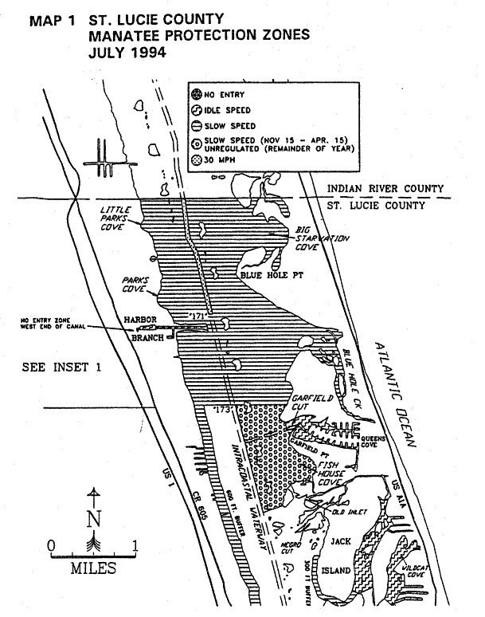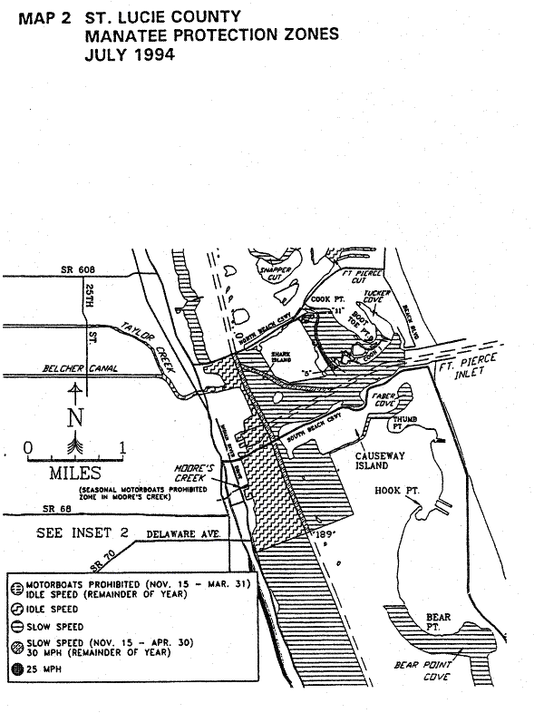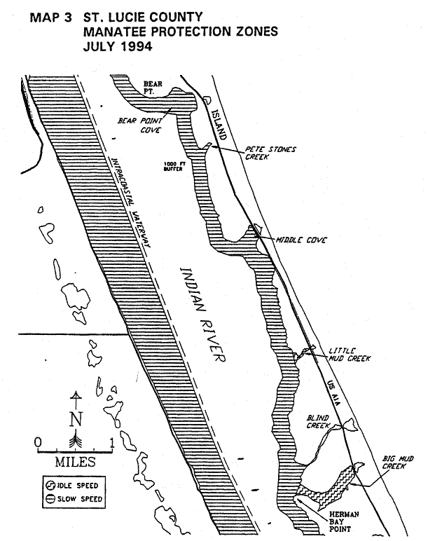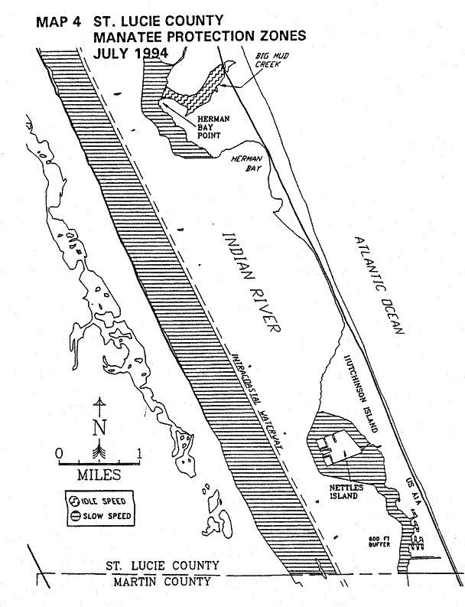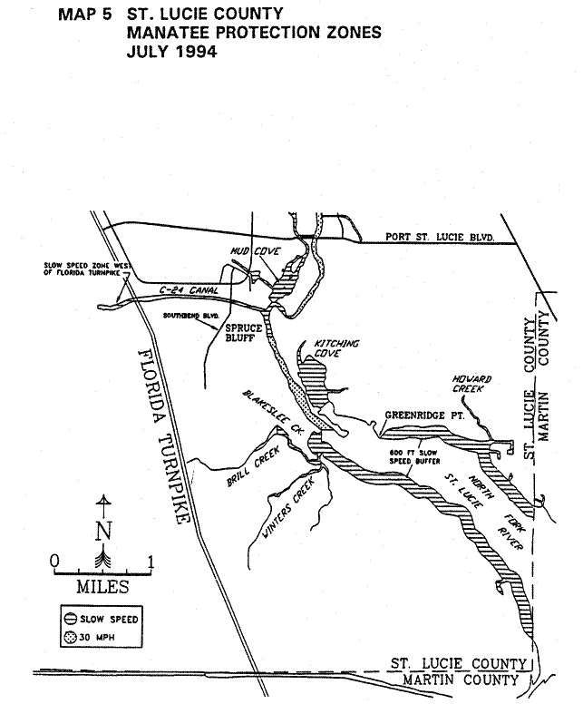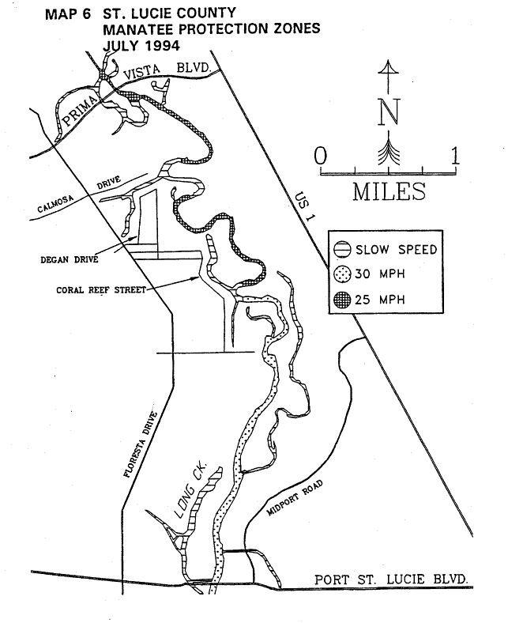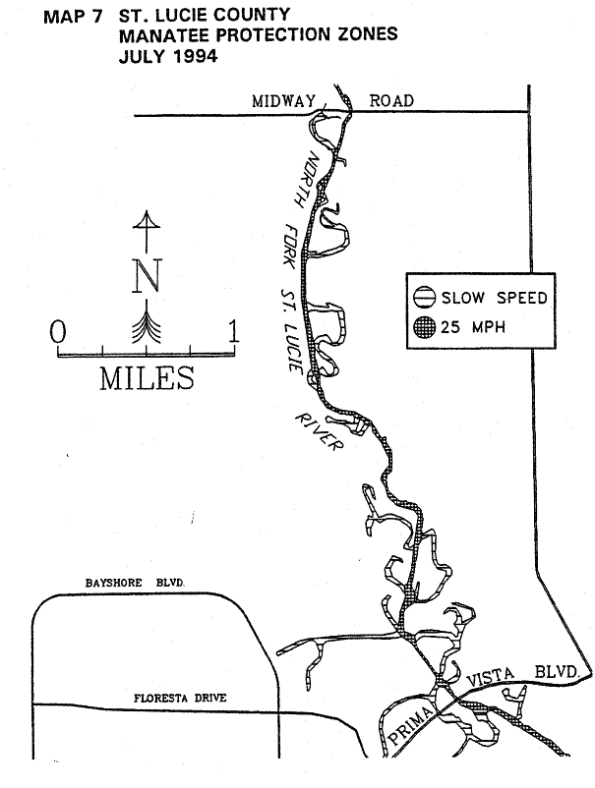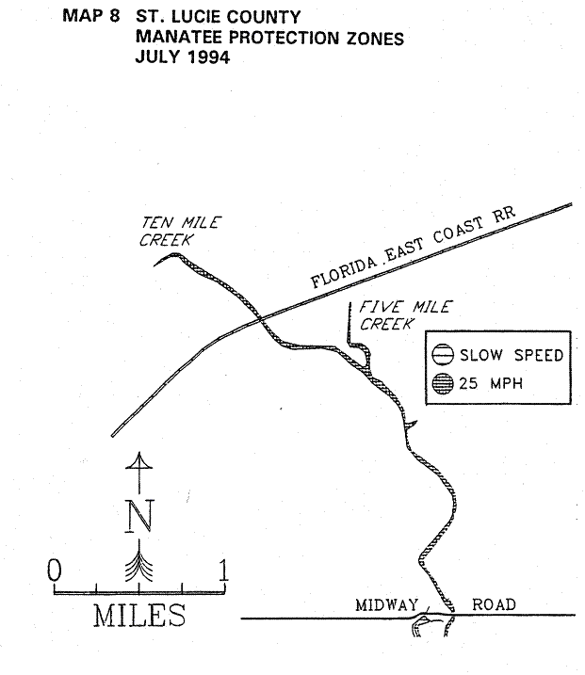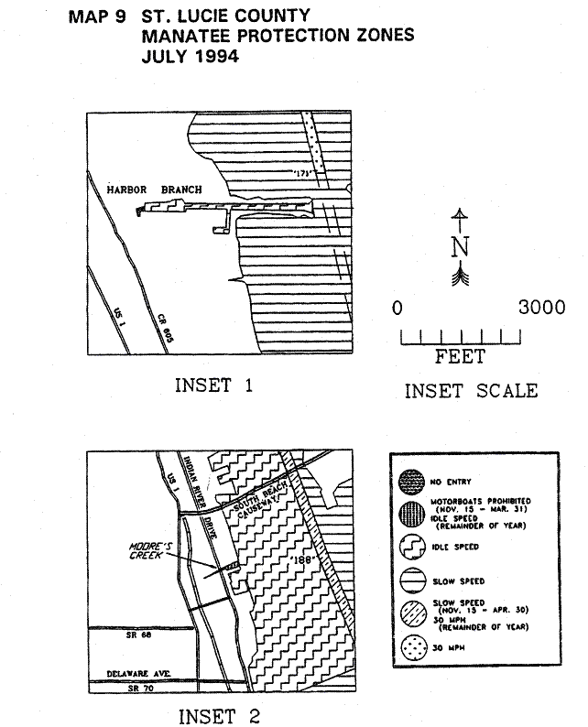
Rulemaking Authority 370.12(2)(f), (n), (o) FS. Law Implemented 370.12(2)(f), (4)(n), (o) FS. History–New 3-19-79, Formerly 16N-22.08, Amended 8-16-94, Formerly 16N-22.008, 62N-22.008.

