Notice of Proposed Rule

WATER MANAGEMENT DISTRICTS
South Florida Water Management District
RULE NOS.: RULE TITLES:
40E-10.021 Definitions
40E-10.031 Water Reservations Implementation
40E-10.071 Water Reservation Areas: Upper and Lower Kissimmee Basin Planning Areas
PURPOSE AND EFFECT: The Kissimmee River Restoration Project (KRRP) restores over 40 square miles of river/floodplain ecosystem including 43 miles of meandering river channel and 27,000 acres of wetlands. The project is a joint partnership between the District and U.S. Army Corps of Engineers. The KRRP involves an estimated $800 million public investment that was developed to address public concerns about the effects of the Central and Southern Florida Flood Control Project on the Kissimmee River — specifically the altered hydrology, loss of floodplain wetlands, and resulting loss of habitat and reduced populations of many species of fish and wildlife. The proposed rules identify and reserve water needed for the protection of fish and wildlife.
SUMMARY: The proposed rules will reserve from additional allocation: 1) all surface water in the Kissimmee River, its floodplain, and the Headwaters Revitalization Lakes; 2) quantities of surface water up to specific water reservation stages in the Upper Chain of Lakes; and 3) surface water and groundwater in the surficial aquifer system and contributing waterbodies that contribute water to the reservation lakes and the Kissimmee River and floodplain.
The proposed reservation rules will be implemented in coordination with the District’s water use permitting program to ensure future water users do not withdraw reserved water. Direct and indirect withdrawals of water from the Kissimmee River and Headwaters Lakes will be limited to existing permitted water use allocations. Additional direct and indirect withdrawals of water from the Upper Chain of Lakes and contributing waterbodies will be limited to quantities of surface water above the proposed water reservation stages. Any new withdrawals authorized under the water use permitting program shall not reduce average annual flows at S-65 by 4.18 percent. This requirement is imposed to ensure that water use withdrawals do not interfere with KRRP restoration targets. The proposed rules also include regulatory criteria to protect downstream users in the Lake Okeechobee Service Area.
SUMMARY OF STATEMENT OF ESTIMATED REGULATORY COSTS AND LEGISLATIVE RATIFICATION:
The agency has determined that this rule will have an adverse impact on small business or likely increase directly or indirectly regulatory costs in excess of $200,000 in the aggregate within one year after the implementation of the rule. A SERC has been prepared by the agency. The SERC is available on the District’s website at: https://www.sfwmd.gov/our-work/water-reservations.
The Agency has determined that the proposed rule is not expected to require legislative ratification based on the statement of estimated regulatory costs or if no SERC is required, the information expressly relied upon and described herein: The District completed the Governor’s Office of Fiscal Accountability and Regulatory Reform’s (OFARR) form “Is a SERC Required?” and prepared a SERC, both of which are available upon request. Based on the completed “Is a SERC Required?” form and the District’s SERC and analysis performed to prepare and complete said documents, the proposed rule amendment does not require legislative ratification pursuant to subsection 120.541(3), F.S.
Any person who wishes to provide information regarding the statement of estimated regulatory costs, or to provide a proposal for a lower cost regulatory alternative must do so in writing within 21 days of this notice.
RULEMAKING AUTHORITY (formerly “Specific Authority”): 373.044, 373.113, 373.171 FS.
LAW IMPLEMENTED: 373.016, 373.026, 373.036, 373.1501, 373.1502, 373.219, 373.223, 373.4592, 373.4595, 373.470 FS.
IF REQUESTED WITHIN 21 DAYS OF THE DATE OF THIS NOTICE, A HEARING WILL BE SCHEDULED AND ANNOUNCED IN THE FAR.
THE PERSON TO BE CONTACTED REGARDING THE PROPOSED RULE IS: Don Medellin, Principal Scientist, P. O. Box 24680, West Palm Beach, FL 33416-4680, 1(800)432-2045, ext. 6340 or (561)682-6340, dmedelli@sfwmd.gov.

THE FULL TEXT OF THE PROPOSED RULE IS:

40E-10.021 Definitions
(1) through (6) No change.
(7) For the Upper Chains of Lakes, Headwaters Revitalization Lakes, and Kissimmee River water reservation, the following definitions apply:
(a) Lakes Hart-Mary Jane Reservation Waterbodies – Lake Hart, Lake Mary Jane, Lake Whippoorwill, Whippoorwill Canal, and the Central and Southern Florida Flood Control Project canals that occur between the S-57 and S-62 structures in Orange and Osceola counties, as depicted in Appendix 4, Figures 4-1 and 4-2A.
(b) Lakes Myrtle-Preston-Joel Reservation Waterbodies – Lake Myrtle, Lake Preston, Lake Joel, Myrtle/Preston Canal, and the Central and Southern Florida Flood Control Project canals that occur between the S-57 and S-58 structures in Osceola County, as depicted in Appendix 4, Figures 4-1 and 4-3A.
(c) East Lake Tohopekaliga Reservation Waterbodies – East Lake Tohopekaliga, Fells Cove, Ajay Lake, Lake Runnymede, Runnymede Canal, and the Central and Southern Florida Flood Control Project canals that occur between the S-59 and S-62 structures in Orange and Osceola counties, as depicted in Appendix 4, Figures 4-1 and 4-4A.
(d) Lake Tohopekaliga Reservation Waterbodies – Lake Tohopekaliga and the Central and Southern Florida Flood Control Project canals that occur between the S-59 and S-61 structures in Osceola County, as depicted in Appendix 4, Figures 4-1 and 4-5A.
(e) Alligator Chain of Lakes Reservation Waterbodies – Alligator Chain of Lakes, including Lake Center, Coon Lake, Trout Lake, Lake Lizzie, Brick Lake, Alligator Lake, Live Oak Lake, and Sardine Lake; Center/Coon, Live Oak, Sardine, and Brick canals; and the Central and Southern Florida Flood Control Project canals that occur between the S-58 and S-60 structures in Osceola County, as depicted in Appendix 4, Figures 4-1 and 4-6A.
(f) Lake Gentry Reservation Waterbodies – Lake Gentry and the Central and Southern Florida Flood Control Project canals that occur between the S-60 and S-63A structures in Osceola County, as depicted in Appendix 4, Figures 4-1 and 4-7A.
(g) Headwaters Revitalization Lakes Reservation Waterbodies – Lake Kissimmee, Lake Hatchineha, Tiger Lake, Tiger Creek, Cypress Lake, Zipprer Canal east of the G-103 structure, Jackson Canal downstream of the G-111 structure, and the Central and Southern Florida Flood Control Project canals that occur between the S-61, S-63A, and S-65 structures in Osceola and Polk counties, as depicted in Appendix 4, Figures 4-1 and 4-8A.
(h) Kissimmee River Reservation Waterbodies – The Kissimmee River and its 100-year floodplain between the S-65 and S-65D structures, Istokpoga Canal and the floodplain located east of the S-67 structure; and the C-38 Canal and remnant river channels between the S-65D and S-65E structures in Polk, Osceola, Okeechobee and Highlands counties, as depicted in Appendix 4, Figures 4-1 and 4-9.
(i) Upper Chain of Lakes Reservation Waterbodies – Refers to the collective waterbodies defined in paragraphs (7)(a)–(7)(f) above, as depicted in Figure 4-1.
(j) Contributing Waterbodies – All wetlands and other surface waters, including canals and ditches, that contribute surface water to a reservation waterbody, as depicted in Figures 4-1, 4-4A, 4-5A, 4-6A, 4-7A, 4-8A, and 4-9.
Rulemaking Authority: 373.044, 373.113, 373.171, F.S. Laws Implemented 373.016, 373.026, 373.036, 373.1501, 373.1502, 373.219, 373.223, 373.4592, 373.4595, 373.470, F.S. History- New 7-2-2009, Amended 3-18-10, 7-21-13, 7-14-14, 7-16-14, .

40E-10.031 Water Reservations Implementation
(1) through (5) No change.
(6) Water reserved for the protection of fish and wildlife contained within the Upper Chain of Lakes, Headwaters Revitalization Lakes, Kissimmee River, and Contributing Waterbodies is defined in Subsections 40E-10.071(1)-(3), F.A.C. These water reservation rules do not adjudicate property rights or dictate the operation of the Central & Southern Florida Flood Control Project (C&SF Project).
Rulemaking Authority: 373.044, 373.113, 373.171, F.S. Laws Implemented 373.016, 373.026, 373.036, 373.1501, 373.1502, 373.219, 373.223, 373.4592, 373.4595, 373.470, F.S. History- New 7-2-2009, Amended 3-18-10, 7-21-13, 7-14-14, 7-16-14, .

40E-10.071 Water Reservation Areas: Upper and Lower Kissimmee Basin Planning Areas
(1) Upper Chain of Lakes
(a) Lakes Hart-Mary Jane Reservation Waterbodies, as defined in paragraph 40E-10.021(7)(a), F.A.C.:
1. Surface Water: All surface water in Lakes Hart-Mary Jane (Figure 4-2A) up to the water reservation stages depicted in Figure 4-2B and listed in Table 4-2 is reserved from additional allocations.
2. Groundwater: Surficial aquifer system groundwater contributing to Lakes Hart-Mary Jane that is required for the protection of fish and wildlife is reserved from allocation in accordance with Subsection 3.11.5 of the Applicant’s Handbook.
(b) Lakes Myrtle-Preston-Joel Reservation Waterbodies, as defined in paragraph 40E-10.021(7)(b), F.A.C.:
1.Surface Water: All surface water in Lakes Myrtle-Preston-Joel (Figure 4-3A) up to the water reservation stages depicted in Figure 4-3B and listed in Table 4-3 is reserved from additional allocations.
2. Groundwater: Surficial aquifer system groundwater contributing to Lakes Myrtle-Preston-Joel that is required for the protection of fish and wildlife is reserved from allocation in accordance with Subsection 3.11.5 of the Applicant’s Handbook.
(c) East Lake Tohopekaliga Reservation Waterbodies, as defined in paragraph 40E-10.021(7)(c), F.A.C., and Contributing Waterbodies, as defined in paragraph 40E-10.021(7)(j), F.A.C.:
1. Surface Water: All surface water in East Lake Tohopekaliga (Figure 4-4A) up to the water reservation stages depicted in Figure 4-4B and listed in Table 4-4 is reserved from additional allocations.
2. Groundwater: Surficial aquifer system groundwater contributing to East Lake Tohopekaliga or its contributing waterbodies that is required for the protection of fish and wildlife is reserved from allocation in accordance with Subsection 3.11.5 of the Applicant’s Handbook.
3. Contributing Waterbodies: Surface water that is required for the protection of fish and wildlife is reserved from allocation in accordance with Subsection 3.11.5 of the Applicant’s Handbook.
(d) Lake Tohopekaliga Reservation Waterbodies, as defined in paragraph 40E-10.021(7)(d), F.A.C., and Contributing Waterbodies, as defined in paragraph 40E-10.021(7)(j), F.A.C.:
1. Surface Water: All surface water in Lake Tohopekaliga (Figure 4-5A) up to the water reservation stages depicted in Figure 4-5B and listed in Table 4-5 is reserved from additional allocations.
2. Groundwater: Surficial aquifer system groundwater contributing to Lake Tohopekaliga or its contributing waterbodies that is required for the protection of fish and wildlife is reserved from allocation in accordance with Subsection 3.11.5 of the Applicant’s Handbook.
3. Contributing Waterbodies: Surface water that is required for the protection of fish and wildlife is reserved from allocation in accordance with Subsection 3.11.5 of the Applicant’s Handbook.
(e) Alligator Chain of Lakes Reservation Waterbodies, as defined in paragraph 40E-10.021(7)(e), F.A.C., and Contributing Waterbodies, as defined in paragraph 40E-10.021(7)(j), F.A.C.:
1. Surface Water: All surface water in the Alligator Chain of Lakes (Figure 4-6A) up to the water reservation stages depicted in Figure 4-6B and listed in Table 4-6 is reserved from additional allocations.
2. Groundwater: Surficial aquifer system groundwater contributing to the Alligator Chain of Lakes or its contributing waterbodies that is required for the protection of fish and wildlife is reserved from allocation in accordance with Subsection 3.11.5 of the Applicant’s Handbook.
3. Contributing Waterbodies: Surface water that is required for the protection of fish and wildlife is reserved from allocation in accordance with Subsection 3.11.5 of the Applicant’s Handbook.
(f) Lake Gentry Reservation Waterbodies, as defined in paragraph 40E-10.021(7)(f), F.A.C., and Contributing Waterbodies, as defined in paragraph 40E-10.021(7)(j), F.A.C.:
1. Surface Water: All surface water in Lake Gentry (Figure 4-7A) up to the water reservation stages depicted in Figure 4-7B and listed in Table 4-7 is reserved from additional allocations.
2. Groundwater: Surficial aquifer system groundwater contributing to Lake Gentry or its contributing waterbodies that is required for the protection of fish and wildlife is reserved from allocation in accordance with Subsection 3.11.5 of the Applicant’s Handbook.
3. Contributing Waterbodies: Surface water that is required for the protection of fish and wildlife is reserved from allocation in accordance with Subsection 3.11.5 of the Applicant’s Handbook.
(2) Headwaters Revitalization Lakes Reservation Waterbodies, as defined in paragraph 40E-10.021(7)(g), F.A.C., and Contributing Waterbodies, as defined in paragraph 40E-10.021(7)(j), F.A.C.:
(a) Surface Water: All surface water in the Headwaters Revitalization Lakes (Figure 4-8A; Figure 4-8B; Table 4-8) is reserved from additional allocations.
(b) Groundwater: Surficial aquifer system groundwater contributing to the Headwaters Revitalization Lakes or their contributing waterbodies that is required for the protection of fish and wildlife is reserved from allocation in accordance with Subsection 3.11.5 of the Applicant’s Handbook.
(c) Contributing Waterbodies: Surface water that is required for the protection of fish and wildlife is reserved from allocation in accordance with Subsection 3.11.5 of the Applicant’s Handbook.
(3) Kissimmee River Reservation Waterbodies, as defined in paragraph 40E-10.021(7)(h), F.A.C., and Contributing Waterbodies, as defined in paragraph 40E-10.021(7)(j), F.A.C.:
(a) Surface Water: All surface water in the Kissimmee River (Figure 4-9) is reserved from additional allocations in accordance with Subsection 3.11.5 of the Applicant’s Handbook.
(b) Groundwater: Surficial aquifer system groundwater contributing to the Kissimmee River or its contributing waterbodies that is required for the protection of fish and wildlife is reserved from allocation in accordance with Subsection 3.11.5 of the Applicant’s Handbook.
(c) Contributing Waterbodies: Surface water that is required for the protection of fish and wildlife is reserved from allocation in accordance with Subsection 3.11.5 of the Applicant’s Handbook.
(4) The reservation contained in this rule and the criteria contained in Subsection 3.11.5 of the “Applicant’s Handbook for Water Use Permit Applications within the South Florida Water Management District,” incorporated by reference in Rule 40E-2.091, F.A.C., shall be reviewed and revised pursuant to Section 373.223(4), F.S., in light of changed conditions or new information, including any revised regulation schedules.
Rulemaking Authority: 373.044, 373.113, 373.171, F.S. Laws Implemented 373.016, 373.026, 373.036, 373.1501, 373.1502, 373.219, 373.223, 373.4592, 373.4595, 373.470, F.S. History- New .

Appendix 4: Upper and Lower Kissimmee Basin
Planning Areas
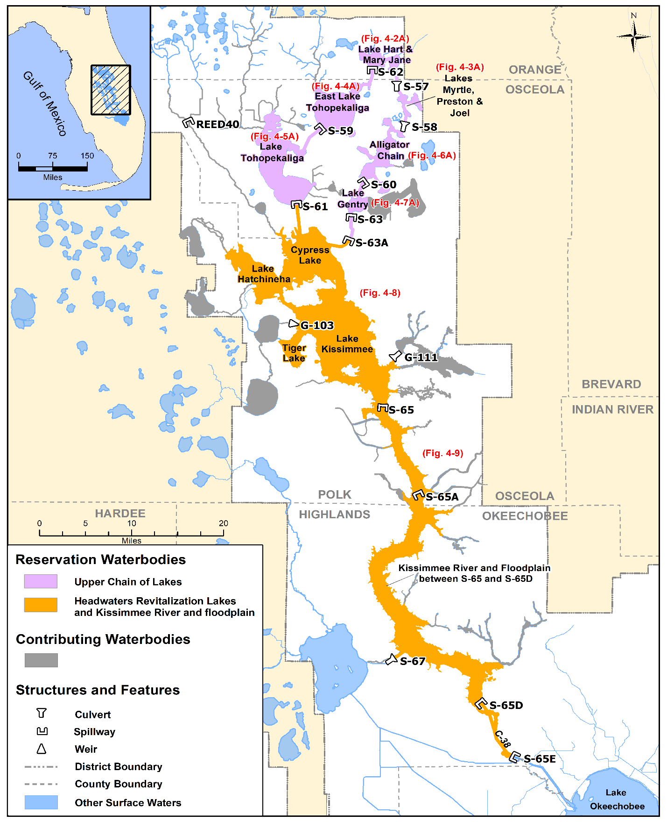
Figure 4-1. Kissimmee River and Chain of Lakes reservation and contributing waterbodies.

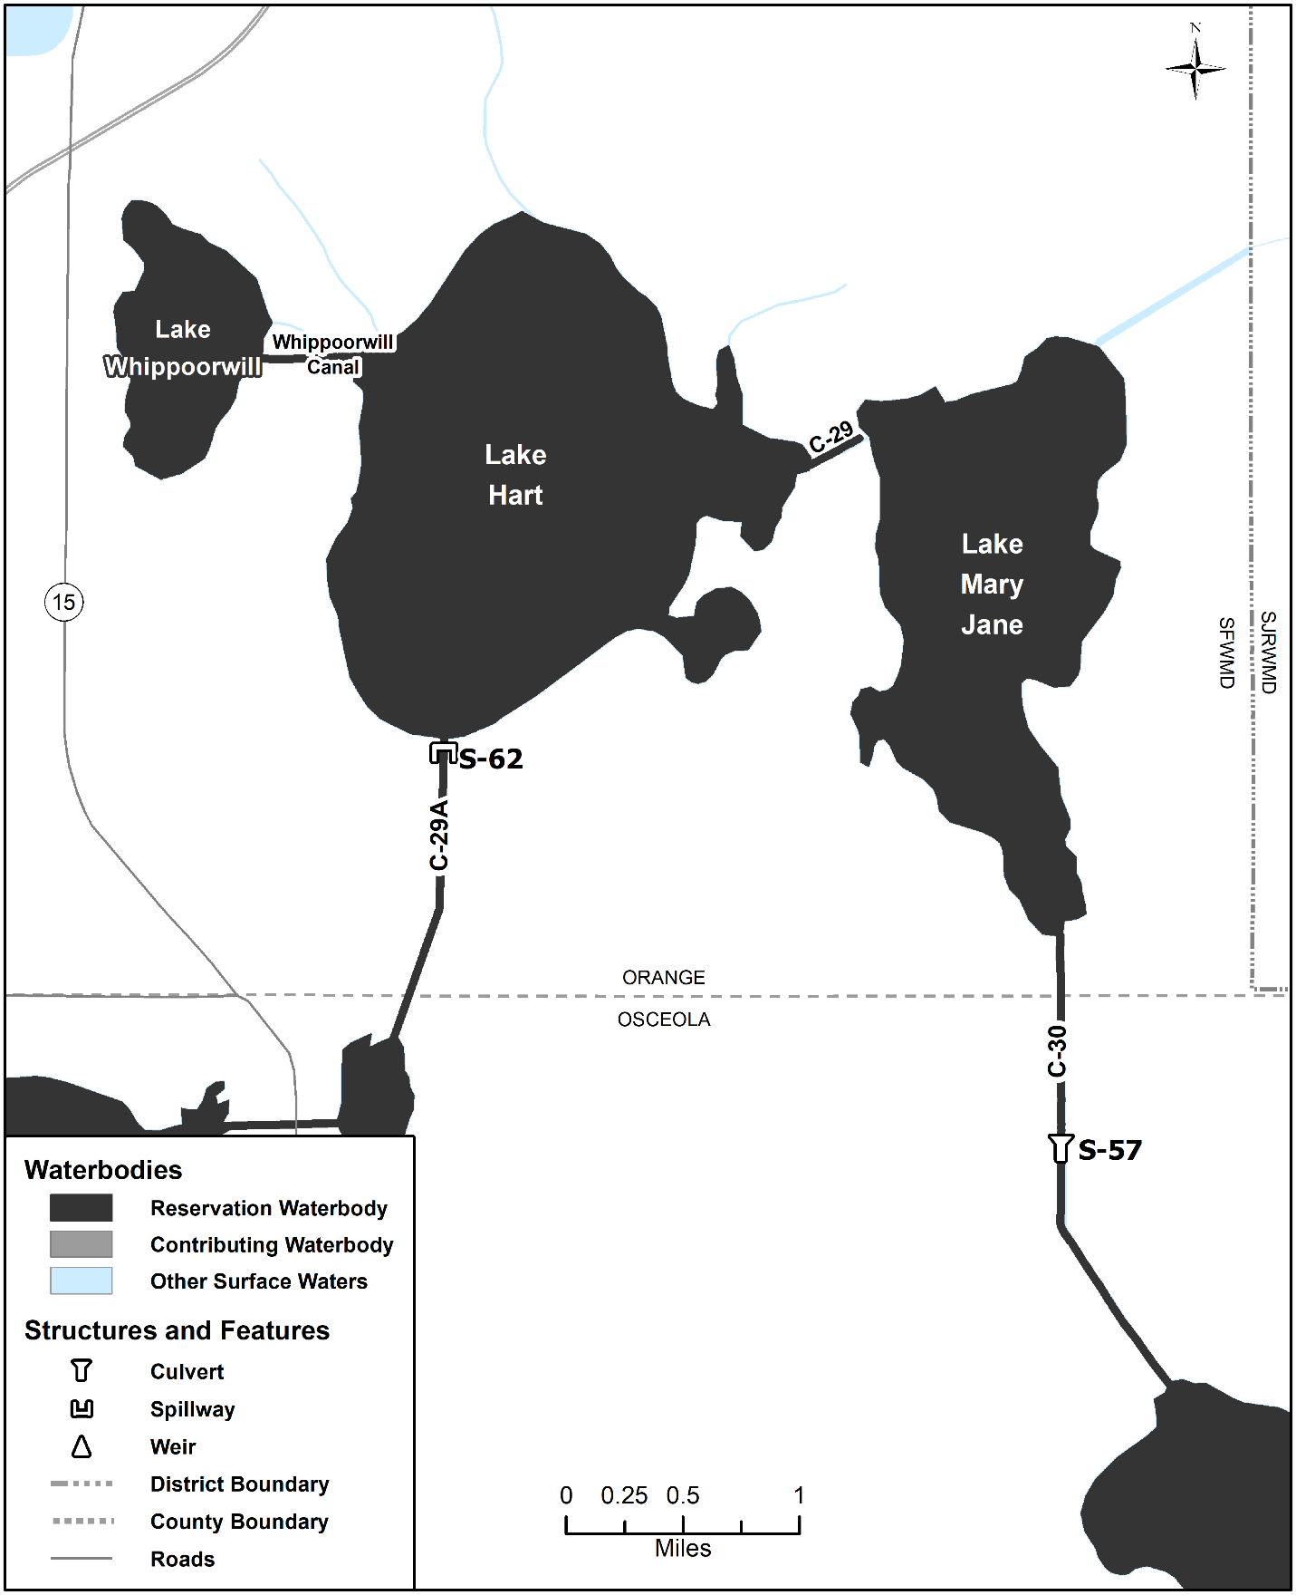Figure 4-2A. Lakes Hart-Mary Jane reservation waterbodies (no contributing waterbodies present). Unlabeled waterbodies in this figure are not included in this reservation waterbody group.

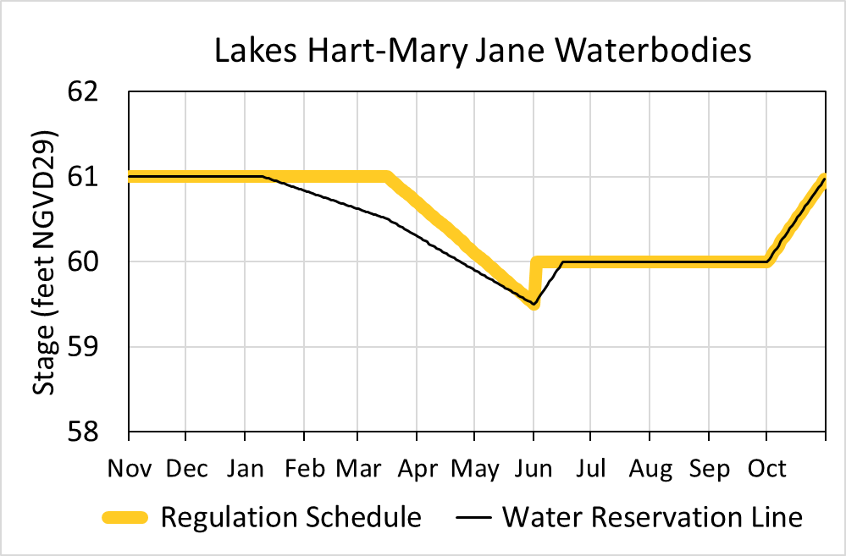
Figure 4-2B. Hydrograph of the current regulation schedule and the water reservation stage at S-62 (water reservation line) for Lakes Hart-Mary Jane reservation waterbodies. The water reservation line is derived from data in Table 4-2.
Table 4-2. Maximum daily water reservation stages at S-62 for Lakes Hart-Mary Jane reservation waterbodies (black line in Figure 4-2B).
Day | January | February | March | April | May | June | July | August | September | October | November | December
1 | 61.00 | 60.83 | 60.62 | 60.29 | 59.90 | 59.50 | 60.00 | 60.00 | 60.00 | 60.00 | 61.00 | 61.00
2 | 61.00 | 60.82 | 60.61 | 60.28 | 59.89 | 59.53 | 60.00 | 60.00 | 60.00 | 60.03 | 61.00 | 61.00
3 | 61.00 | 60.82 | 60.60 | 60.27 | 59.88 | 59.57 | 60.00 | 60.00 | 60.00 | 60.06 | 61.00 | 61.00
4 | 61.00 | 60.81 | 60.59 | 60.25 | 59.86 | 59.60 | 60.00 | 60.00 | 60.00 | 60.10 | 61.00 | 61.00
5 | 61.00 | 60.80 | 60.58 | 60.24 | 59.85 | 59.63 | 60.00 | 60.00 | 60.00 | 60.13 | 61.00 | 61.00
6 | 61.00 | 60.79 | 60.58 | 60.23 | 59.84 | 59.67 | 60.00 | 60.00 | 60.00 | 60.16 | 61.00 | 61.00
7 | 61.00 | 60.78 | 60.57 | 60.21 | 59.82 | 59.70 | 60.00 | 60.00 | 60.00 | 60.19 | 61.00 | 61.00
8 | 61.00 | 60.78 | 60.56 | 60.20 | 59.81 | 59.73 | 60.00 | 60.00 | 60.00 | 60.23 | 61.00 | 61.00
9 | 61.00 | 60.77 | 60.55 | 60.19 | 59.80 | 59.77 | 60.00 | 60.00 | 60.00 | 60.26 | 61.00 | 61.00
10 | 61.00 | 60.76 | 60.55 | 60.18 | 59.79 | 59.80 | 60.00 | 60.00 | 60.00 | 60.29 | 61.00 | 61.00
11 | 60.99 | 60.75 | 60.54 | 60.16 | 59.77 | 59.83 | 60.00 | 60.00 | 60.00 | 60.32 | 61.00 | 61.00
12 | 60.98 | 60.75 | 60.53 | 60.15 | 59.76 | 59.87 | 60.00 | 60.00 | 60.00 | 60.35 | 61.00 | 61.00
13 | 60.98 | 60.74 | 60.52 | 60.14 | 59.75 | 59.90 | 60.00 | 60.00 | 60.00 | 60.39 | 61.00 | 61.00
14 | 60.97 | 60.73 | 60.52 | 60.12 | 59.73 | 59.93 | 60.00 | 60.00 | 60.00 | 60.42 | 61.00 | 61.00
15 | 60.96 | 60.72 | 60.51 | 60.11 | 59.72 | 59.97 | 60.00 | 60.00 | 60.00 | 60.45 | 61.00 | 61.00
16 | 60.95 | 60.72 | 60.50 | 60.10 | 59.71 | 60.00 | 60.00 | 60.00 | 60.00 | 60.48 | 61.00 | 61.00
17 | 60.95 | 60.71 | 60.49 | 60.08 | 59.69 | 60.00 | 60.00 | 60.00 | 60.00 | 60.52 | 61.00 | 61.00
18 | 60.94 | 60.70 | 60.47 | 60.07 | 59.68 | 60.00 | 60.00 | 60.00 | 60.00 | 60.55 | 61.00 | 61.00
19 | 60.93 | 60.69 | 60.46 | 60.06 | 59.67 | 60.00 | 60.00 | 60.00 | 60.00 | 60.58 | 61.00 | 61.00
20 | 60.92 | 60.68 | 60.45 | 60.05 | 59.66 | 60.00 | 60.00 | 60.00 | 60.00 | 60.61 | 61.00 | 61.00
21 | 60.92 | 60.68 | 60.44 | 60.03 | 59.64 | 60.00 | 60.00 | 60.00 | 60.00 | 60.65 | 61.00 | 61.00
22 | 60.91 | 60.67 | 60.42 | 60.02 | 59.63 | 60.00 | 60.00 | 60.00 | 60.00 | 60.68 | 61.00 | 61.00
23 | 60.90 | 60.66 | 60.41 | 60.01 | 59.62 | 60.00 | 60.00 | 60.00 | 60.00 | 60.71 | 61.00 | 61.00
24 | 60.89 | 60.65 | 60.40 | 59.99 | 59.60 | 60.00 | 60.00 | 60.00 | 60.00 | 60.74 | 61.00 | 61.00
25 | 60.88 | 60.65 | 60.38 | 59.98 | 59.59 | 60.00 | 60.00 | 60.00 | 60.00 | 60.77 | 61.00 | 61.00
26 | 60.88 | 60.64 | 60.37 | 59.97 | 59.58 | 60.00 | 60.00 | 60.00 | 60.00 | 60.81 | 61.00 | 61.00
27 | 60.87 | 60.63 | 60.36 | 59.95 | 59.56 | 60.00 | 60.00 | 60.00 | 60.00 | 60.84 | 61.00 | 61.00
28 | 60.86 | 60.62 | 60.34 | 59.94 | 59.55 | 60.00 | 60.00 | 60.00 | 60.00 | 60.87 | 61.00 | 61.00
29 | 60.85 |  | 60.33 | 59.93 | 59.54 | 60.00 | 60.00 | 60.00 | 60.00 | 60.90 | 61.00 | 61.00
30 | 60.85 |  | 60.32 | 59.92 | 59.53 | 60.00 | 60.00 | 60.00 | 60.00 | 60.94 | 61.00 | 61.00
31 | 60.84 |  | 60.31 |  | 59.51 |  | 60.00 | 60.00 |  | 60.97 |  | 61.00

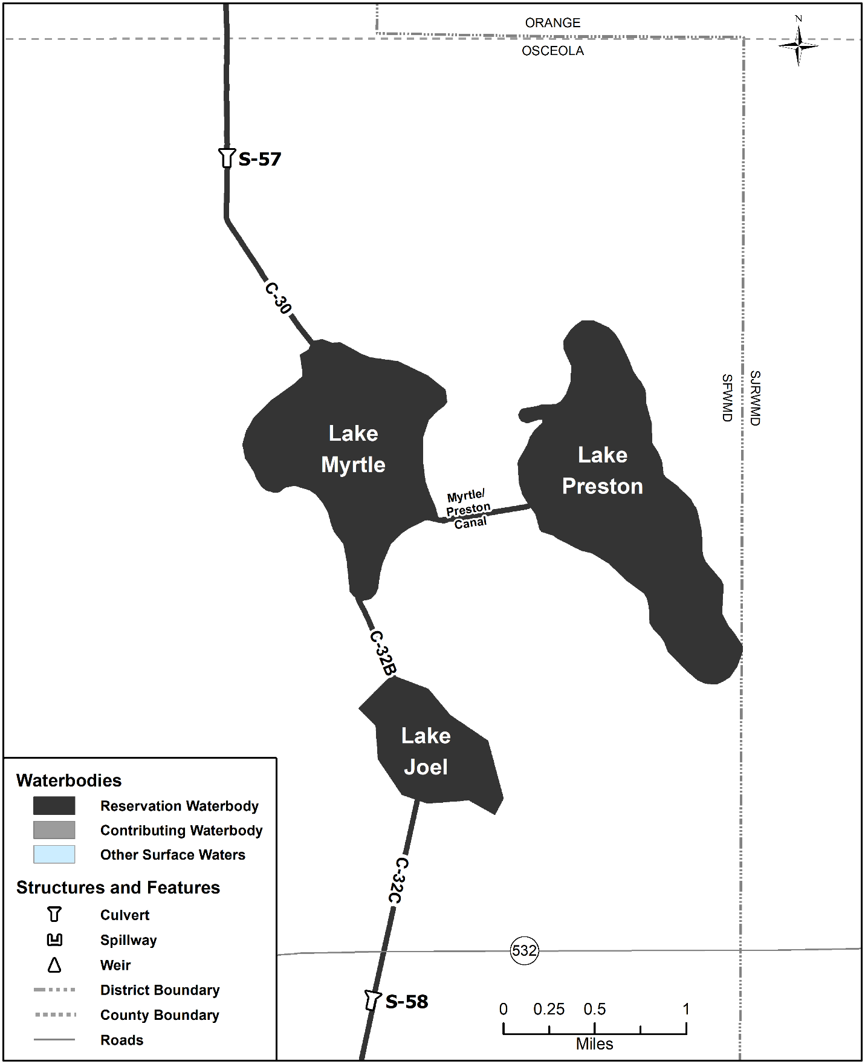Figure 4-3A. Lakes Myrtle-Preston-Joel reservation waterbodies (no contributing waterbodies present). Unlabeled waterbodies in this figure are not included in this reservation waterbody group.

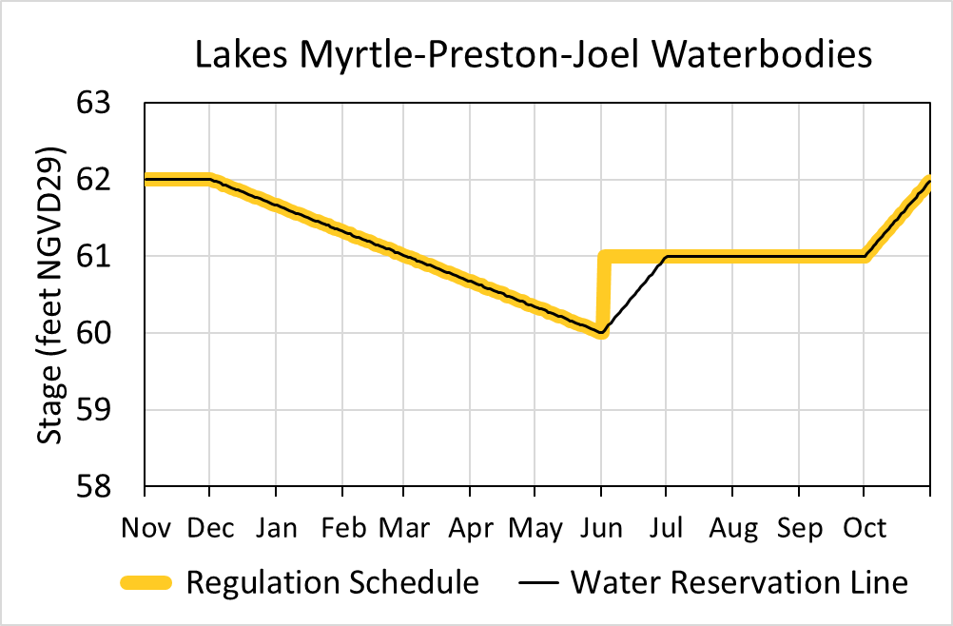
Figure 4-3B. Hydrograph of the current regulation schedule and the water reservation stage at S-57 (water reservation line) for Lakes Myrtle-Preston-Joel reservation waterbodies. The water reservation line is derived from data in Table 4-3.
Table 4-3. Maximum daily water reservation stages at S-57 for Lakes Myrtle-Preston-Joel reservation waterbodies (black line in Figure 4-3B).
Day | January | February | March | April | May | June | July | August | September | October | November | December
1 | 61.66 | 61.32 | 61.01 | 60.67 | 60.34 | 60.00 | 61.00 | 61.00 | 61.00 | 61.00 | 62.00 | 62.00
2 | 61.65 | 61.31 | 61.00 | 60.66 | 60.33 | 60.03 | 61.00 | 61.00 | 61.00 | 61.03 | 62.00 | 61.99
3 | 61.64 | 61.30 | 60.99 | 60.65 | 60.32 | 60.07 | 61.00 | 61.00 | 61.00 | 61.06 | 62.00 | 61.98
4 | 61.63 | 61.29 | 60.98 | 60.64 | 60.31 | 60.10 | 61.00 | 61.00 | 61.00 | 61.10 | 62.00 | 61.97
5 | 61.62 | 61.27 | 60.97 | 60.63 | 60.30 | 60.13 | 61.00 | 61.00 | 61.00 | 61.13 | 62.00 | 61.96
6 | 61.60 | 61.26 | 60.96 | 60.62 | 60.29 | 60.17 | 61.00 | 61.00 | 61.00 | 61.16 | 62.00 | 61.95
7 | 61.59 | 61.25 | 60.94 | 60.60 | 60.27 | 60.20 | 61.00 | 61.00 | 61.00 | 61.19 | 62.00 | 61.93
8 | 61.58 | 61.24 | 60.93 | 60.59 | 60.26 | 60.23 | 61.00 | 61.00 | 61.00 | 61.23 | 62.00 | 61.92
9 | 61.57 | 61.23 | 60.92 | 60.58 | 60.25 | 60.27 | 61.00 | 61.00 | 61.00 | 61.26 | 62.00 | 61.91
10 | 61.56 | 61.22 | 60.91 | 60.57 | 60.24 | 60.30 | 61.00 | 61.00 | 61.00 | 61.29 | 62.00 | 61.90
11 | 61.55 | 61.21 | 60.90 | 60.56 | 60.23 | 60.33 | 61.00 | 61.00 | 61.00 | 61.32 | 62.00 | 61.89
12 | 61.54 | 61.20 | 60.89 | 60.55 | 60.22 | 60.37 | 61.00 | 61.00 | 61.00 | 61.35 | 62.00 | 61.88
13 | 61.53 | 61.19 | 60.88 | 60.54 | 60.21 | 60.40 | 61.00 | 61.00 | 61.00 | 61.39 | 62.00 | 61.87
14 | 61.52 | 61.18 | 60.87 | 60.53 | 60.20 | 60.43 | 61.00 | 61.00 | 61.00 | 61.42 | 62.00 | 61.86
15 | 61.51 | 61.16 | 60.86 | 60.52 | 60.19 | 60.47 | 61.00 | 61.00 | 61.00 | 61.45 | 62.00 | 61.85
16 | 61.49 | 61.15 | 60.85 | 60.51 | 60.18 | 60.50 | 61.00 | 61.00 | 61.00 | 61.48 | 62.00 | 61.84
17 | 61.48 | 61.14 | 60.84 | 60.49 | 60.16 | 60.53 | 61.00 | 61.00 | 61.00 | 61.52 | 62.00 | 61.83
18 | 61.47 | 61.13 | 60.82 | 60.48 | 60.15 | 60.57 | 61.00 | 61.00 | 61.00 | 61.55 | 62.00 | 61.81
19 | 61.46 | 61.12 | 60.81 | 60.47 | 60.14 | 60.60 | 61.00 | 61.00 | 61.00 | 61.58 | 62.00 | 61.80
20 | 61.45 | 61.11 | 60.80 | 60.46 | 60.13 | 60.63 | 61.00 | 61.00 | 61.00 | 61.61 | 62.00 | 61.79
21 | 61.44 | 61.10 | 60.79 | 60.45 | 60.12 | 60.67 | 61.00 | 61.00 | 61.00 | 61.65 | 62.00 | 61.78
22 | 61.43 | 61.09 | 60.78 | 60.44 | 60.11 | 60.70 | 61.00 | 61.00 | 61.00 | 61.68 | 62.00 | 61.77
23 | 61.42 | 61.08 | 60.77 | 60.43 | 60.10 | 60.73 | 61.00 | 61.00 | 61.00 | 61.71 | 62.00 | 61.76
24 | 61.41 | 61.07 | 60.76 | 60.42 | 60.09 | 60.77 | 61.00 | 61.00 | 61.00 | 61.74 | 62.00 | 61.75
25 | 61.40 | 61.05 | 60.75 | 60.41 | 60.08 | 60.80 | 61.00 | 61.00 | 61.00 | 61.77 | 62.00 | 61.74
26 | 61.38 | 61.04 | 60.74 | 60.40 | 60.07 | 60.83 | 61.00 | 61.00 | 61.00 | 61.81 | 62.00 | 61.73
27 | 61.37 | 61.03 | 60.73 | 60.38 | 60.05 | 60.87 | 61.00 | 61.00 | 61.00 | 61.84 | 62.00 | 61.72
28 | 61.36 | 61.02 | 60.71 | 60.37 | 60.04 | 60.90 | 61.00 | 61.00 | 61.00 | 61.87 | 62.00 | 61.70
29 | 61.35 |  | 60.70 | 60.36 | 60.03 | 60.93 | 61.00 | 61.00 | 61.00 | 61.90 | 62.00 | 61.69
30 | 61.34 |  | 60.69 | 60.35 | 60.02 | 60.97 | 61.00 | 61.00 | 61.00 | 61.94 | 62.00 | 61.68
31 | 61.33 |  | 60.68 |  | 60.01 |  | 61.00 | 61.00 |  | 61.97 |  | 61.67

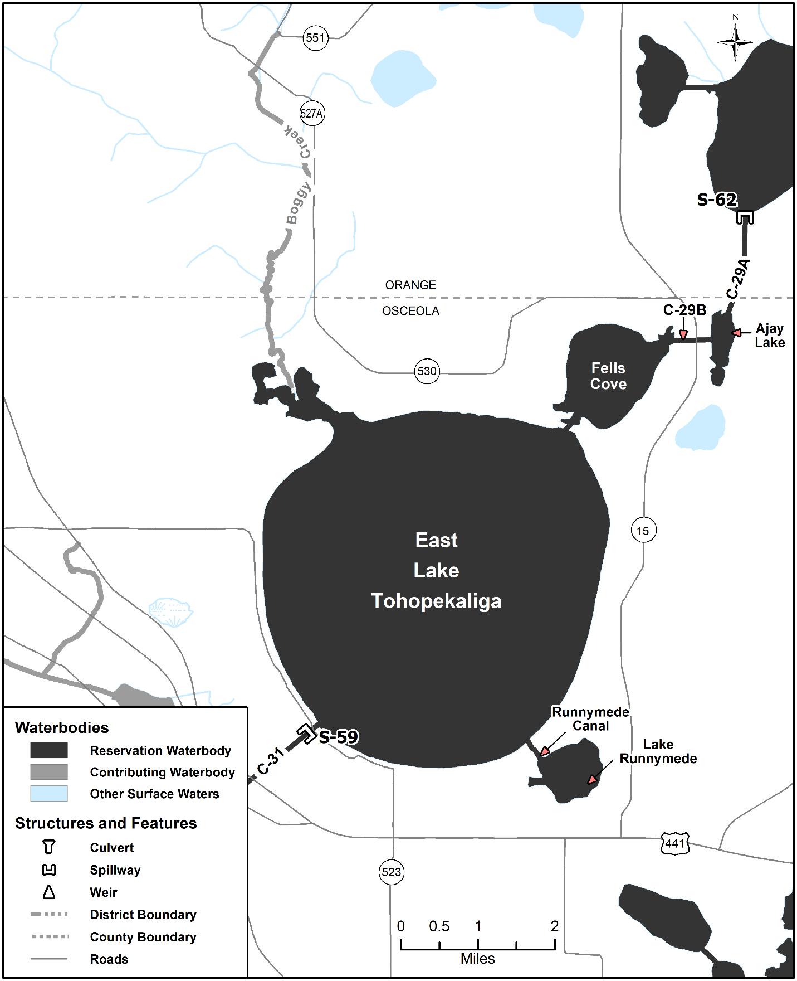Figure 4-4A. East Lake Tohopekaliga reservation and contributing waterbodies. Unlabeled waterbodies in this figure are not included in this reservation/contributing waterbody group.

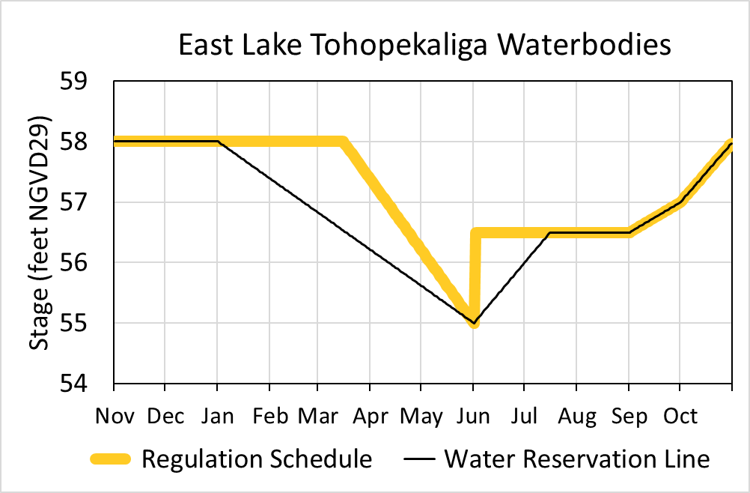
Figure 4-4B. Hydrograph of the current regulation schedule and the water reservation stage at S-59 (water reservation line) for East Lake Tohopekaliga reservation waterbodies. The water reservation line is derived from data in Table 4-4.
Table 4-4. Maximum daily water reservation stages at S-59 for East Lake Tohopekaliga reservation waterbodies (black line in Figure 4-4B).
Day | January | February | March | April | May | June | July | August | September | October | November | December
1 | 58.00 | 57.38 | 56.83 | 56.21 | 55.62 | 55.00 | 56.00 | 56.50 | 56.50 | 57.00 | 58.00 | 58.00
2 | 57.98 | 57.36 | 56.81 | 56.19 | 55.60 | 55.03 | 56.03 | 56.50 | 56.52 | 57.03 | 58.00 | 58.00
3 | 57.96 | 57.34 | 56.79 | 56.17 | 55.58 | 55.07 | 56.07 | 56.50 | 56.53 | 57.06 | 58.00 | 58.00
4 | 57.94 | 57.32 | 56.77 | 56.15 | 55.56 | 55.10 | 56.10 | 56.50 | 56.55 | 57.10 | 58.00 | 58.00
5 | 57.92 | 57.30 | 56.75 | 56.13 | 55.54 | 55.13 | 56.13 | 56.50 | 56.57 | 57.13 | 58.00 | 58.00
6 | 57.90 | 57.28 | 56.73 | 56.11 | 55.52 | 55.17 | 56.17 | 56.50 | 56.58 | 57.16 | 58.00 | 58.00
7 | 57.88 | 57.26 | 56.71 | 56.09 | 55.50 | 55.20 | 56.20 | 56.50 | 56.60 | 57.19 | 58.00 | 58.00
8 | 57.86 | 57.25 | 56.69 | 56.07 | 55.48 | 55.23 | 56.23 | 56.50 | 56.62 | 57.23 | 58.00 | 58.00
9 | 57.84 | 57.23 | 56.67 | 56.05 | 55.46 | 55.27 | 56.27 | 56.50 | 56.63 | 57.26 | 58.00 | 58.00
10 | 57.82 | 57.21 | 56.65 | 56.03 | 55.44 | 55.30 | 56.30 | 56.50 | 56.65 | 57.29 | 58.00 | 58.00
11 | 57.80 | 57.19 | 56.63 | 56.01 | 55.42 | 55.33 | 56.33 | 56.50 | 56.67 | 57.32 | 58.00 | 58.00
12 | 57.78 | 57.17 | 56.61 | 55.99 | 55.40 | 55.37 | 56.37 | 56.50 | 56.68 | 57.35 | 58.00 | 58.00
13 | 57.76 | 57.15 | 56.59 | 55.97 | 55.38 | 55.40 | 56.40 | 56.50 | 56.70 | 57.39 | 58.00 | 58.00
14 | 57.74 | 57.13 | 56.57 | 55.95 | 55.36 | 55.43 | 56.43 | 56.50 | 56.72 | 57.42 | 58.00 | 58.00
15 | 57.72 | 57.11 | 56.55 | 55.93 | 55.34 | 55.47 | 56.47 | 56.50 | 56.73 | 57.45 | 58.00 | 58.00
16 | 57.70 | 57.09 | 56.53 | 55.91 | 55.32 | 55.50 | 56.50 | 56.50 | 56.75 | 57.48 | 58.00 | 58.00
17 | 57.68 | 57.07 | 56.51 | 55.89 | 55.30 | 55.53 | 56.50 | 56.50 | 56.77 | 57.52 | 58.00 | 58.00
18 | 57.66 | 57.05 | 56.49 | 55.87 | 55.28 | 55.57 | 56.50 | 56.50 | 56.78 | 57.55 | 58.00 | 58.00
19 | 57.64 | 57.03 | 56.47 | 55.85 | 55.26 | 55.60 | 56.50 | 56.50 | 56.80 | 57.58 | 58.00 | 58.00
20 | 57.62 | 57.01 | 56.45 | 55.83 | 55.24 | 55.63 | 56.50 | 56.50 | 56.82 | 57.61 | 58.00 | 58.00
21 | 57.60 | 56.99 | 56.43 | 55.81 | 55.22 | 55.67 | 56.50 | 56.50 | 56.83 | 57.65 | 58.00 | 58.00
22 | 57.58 | 56.97 | 56.41 | 55.79 | 55.20 | 55.70 | 56.50 | 56.50 | 56.85 | 57.68 | 58.00 | 58.00
23 | 57.56 | 56.95 | 56.39 | 55.77 | 55.18 | 55.73 | 56.50 | 56.50 | 56.87 | 57.71 | 58.00 | 58.00
24 | 57.54 | 56.93 | 56.37 | 55.75 | 55.16 | 55.77 | 56.50 | 56.50 | 56.88 | 57.74 | 58.00 | 58.00
25 | 57.52 | 56.91 | 56.35 | 55.74 | 55.14 | 55.80 | 56.50 | 56.50 | 56.90 | 57.77 | 58.00 | 58.00
26 | 57.50 | 56.89 | 56.33 | 55.72 | 55.12 | 55.83 | 56.50 | 56.50 | 56.92 | 57.81 | 58.00 | 58.00
27 | 57.48 | 56.87 | 56.31 | 55.70 | 55.10 | 55.87 | 56.50 | 56.50 | 56.93 | 57.84 | 58.00 | 58.00
28 | 57.46 | 56.85 | 56.29 | 55.68 | 55.08 | 55.90 | 56.50 | 56.50 | 56.95 | 57.87 | 58.00 | 58.00
29 | 57.44 |  | 56.27 | 55.66 | 55.06 | 55.93 | 56.50 | 56.50 | 56.97 | 57.90 | 58.00 | 58.00
30 | 57.42 |  | 56.25 | 55.64 | 55.04 | 55.97 | 56.50 | 56.50 | 56.98 | 57.94 | 58.00 | 58.00
31 | 57.40 |  | 56.23 |  | 55.02 |  | 56.50 | 56.50 |  | 57.97 |  | 58.00

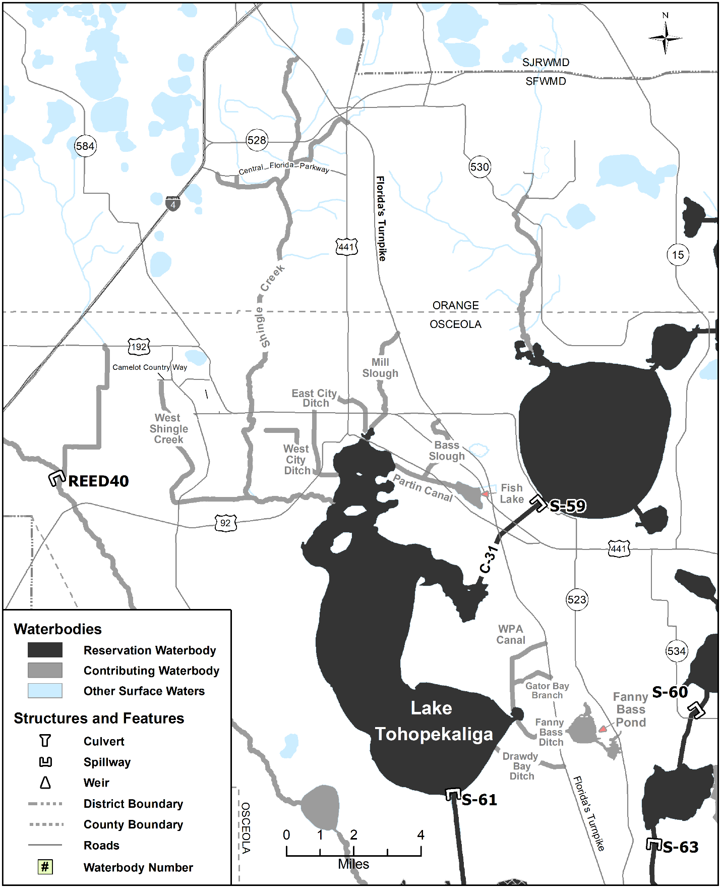Figure 4-5A. Lake Tohopekaliga reservation and contributing waterbodies. Unlabeled waterbodies in this figure are not included in this reservation/contributing waterbody group.

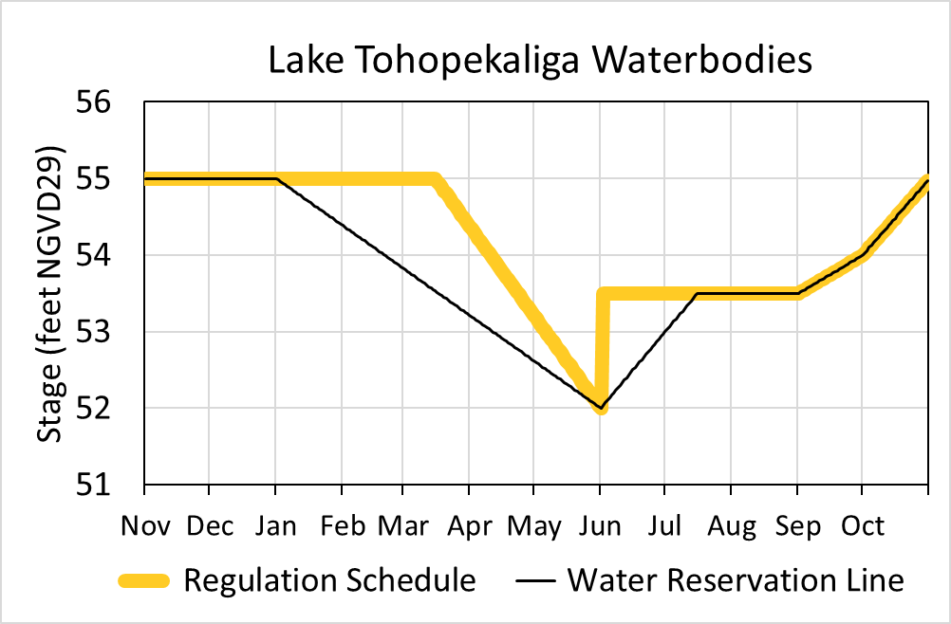
Figure 4-5B. Hydrograph of the current regulation schedule and the water reservation stage at S-61 (water reservation line) for Lake Tohopekaliga reservation waterbodies. The water reservation line is derived from data in Table 4-5.
Table 4-5. Maximum daily water reservation stages at S-61 for Lake Tohopekaliga reservation waterbodies (black line in Figure 4-5B).
Day | January | February | March | April | May | June | July | August | September | October | November | December
1 | 55.00 | 54.38 | 53.83 | 53.21 | 52.62 | 52.00 | 53.00 | 53.50 | 53.50 | 54.00 | 55.00 | 55.00
2 | 54.98 | 54.36 | 53.81 | 53.19 | 52.60 | 52.03 | 53.03 | 53.50 | 53.52 | 54.03 | 55.00 | 55.00
3 | 54.96 | 54.34 | 53.79 | 53.17 | 52.58 | 52.07 | 53.07 | 53.50 | 53.53 | 54.06 | 55.00 | 55.00
4 | 54.94 | 54.32 | 53.77 | 53.15 | 52.56 | 52.10 | 53.10 | 53.50 | 53.55 | 54.10 | 55.00 | 55.00
5 | 54.92 | 54.30 | 53.75 | 53.13 | 52.54 | 52.13 | 53.13 | 53.50 | 53.57 | 54.13 | 55.00 | 55.00
6 | 54.90 | 54.28 | 53.73 | 53.11 | 52.52 | 52.17 | 53.17 | 53.50 | 53.58 | 54.16 | 55.00 | 55.00
7 | 54.88 | 54.26 | 53.71 | 53.09 | 52.50 | 52.20 | 53.20 | 53.50 | 53.60 | 54.19 | 55.00 | 55.00
8 | 54.86 | 54.25 | 53.69 | 53.07 | 52.48 | 52.23 | 53.23 | 53.50 | 53.62 | 54.23 | 55.00 | 55.00
9 | 54.84 | 54.23 | 53.67 | 53.05 | 52.46 | 52.27 | 53.27 | 53.50 | 53.63 | 54.26 | 55.00 | 55.00
10 | 54.82 | 54.21 | 53.65 | 53.03 | 52.44 | 52.30 | 53.30 | 53.50 | 53.65 | 54.29 | 55.00 | 55.00
11 | 54.80 | 54.19 | 53.63 | 53.01 | 52.42 | 52.33 | 53.33 | 53.50 | 53.67 | 54.32 | 55.00 | 55.00
12 | 54.78 | 54.17 | 53.61 | 52.99 | 52.40 | 52.37 | 53.37 | 53.50 | 53.68 | 54.35 | 55.00 | 55.00
13 | 54.76 | 54.15 | 53.59 | 52.97 | 52.38 | 52.40 | 53.40 | 53.50 | 53.70 | 54.39 | 55.00 | 55.00
14 | 54.74 | 54.13 | 53.57 | 52.95 | 52.36 | 52.43 | 53.43 | 53.50 | 53.72 | 54.42 | 55.00 | 55.00
15 | 54.72 | 54.11 | 53.55 | 52.93 | 52.34 | 52.47 | 53.47 | 53.50 | 53.73 | 54.45 | 55.00 | 55.00
16 | 54.70 | 54.09 | 53.53 | 52.91 | 52.32 | 52.50 | 53.50 | 53.50 | 53.75 | 54.48 | 55.00 | 55.00
17 | 54.68 | 54.07 | 53.51 | 52.89 | 52.30 | 52.53 | 53.50 | 53.50 | 53.77 | 54.52 | 55.00 | 55.00
18 | 54.66 | 54.05 | 53.49 | 52.87 | 52.28 | 52.57 | 53.50 | 53.50 | 53.78 | 54.55 | 55.00 | 55.00
19 | 54.64 | 54.03 | 53.47 | 52.85 | 52.26 | 52.60 | 53.50 | 53.50 | 53.80 | 54.58 | 55.00 | 55.00
20 | 54.62 | 54.01 | 53.45 | 52.83 | 52.24 | 52.63 | 53.50 | 53.50 | 53.82 | 54.61 | 55.00 | 55.00
21 | 54.60 | 53.99 | 53.43 | 52.81 | 52.22 | 52.67 | 53.50 | 53.50 | 53.83 | 54.65 | 55.00 | 55.00
22 | 54.58 | 53.97 | 53.41 | 52.79 | 52.20 | 52.70 | 53.50 | 53.50 | 53.85 | 54.68 | 55.00 | 55.00
23 | 54.56 | 53.95 | 53.39 | 52.77 | 52.18 | 52.73 | 53.50 | 53.50 | 53.87 | 54.71 | 55.00 | 55.00
24 | 54.54 | 53.93 | 53.37 | 52.75 | 52.16 | 52.77 | 53.50 | 53.50 | 53.88 | 54.74 | 55.00 | 55.00
25 | 54.52 | 53.91 | 53.35 | 52.74 | 52.14 | 52.80 | 53.50 | 53.50 | 53.90 | 54.77 | 55.00 | 55.00
26 | 54.50 | 53.89 | 53.33 | 52.72 | 52.12 | 52.83 | 53.50 | 53.50 | 53.92 | 54.81 | 55.00 | 55.00
27 | 54.48 | 53.87 | 53.31 | 52.70 | 52.10 | 52.87 | 53.50 | 53.50 | 53.93 | 54.84 | 55.00 | 55.00
28 | 54.46 | 53.85 | 53.29 | 52.68 | 52.08 | 52.90 | 53.50 | 53.50 | 53.95 | 54.87 | 55.00 | 55.00
29 | 54.44 |  | 53.27 | 52.66 | 52.06 | 52.93 | 53.50 | 53.50 | 53.97 | 54.90 | 55.00 | 55.00
30 | 54.42 |  | 53.25 | 52.64 | 52.04 | 52.97 | 53.50 | 53.50 | 53.98 | 54.94 | 55.00 | 55.00
31 | 54.40 |  | 53.23 |  | 52.02 |  | 53.50 | 53.50 |  | 54.97 |  | 55.00

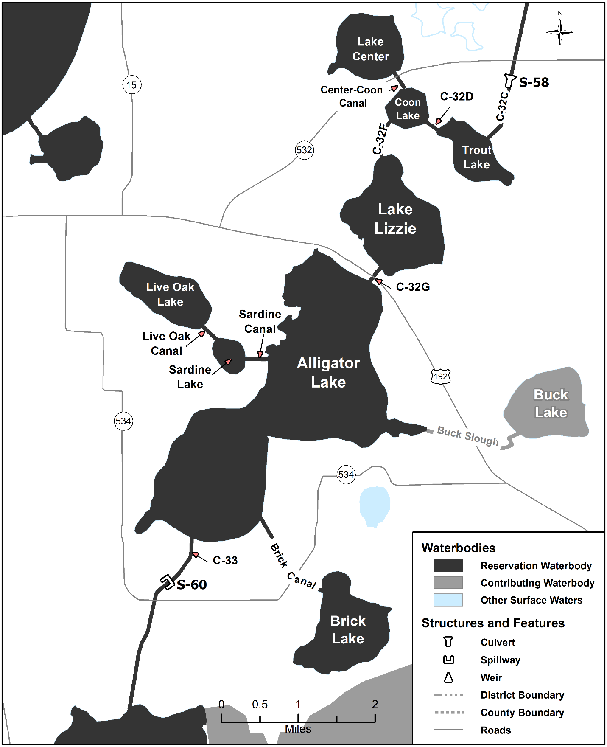Figure 4-6A. Alligator Chain of Lakes reservation and contributing waterbodies. Unlabeled waterbodies in this figure are not included in this reservation/contributing waterbody group.

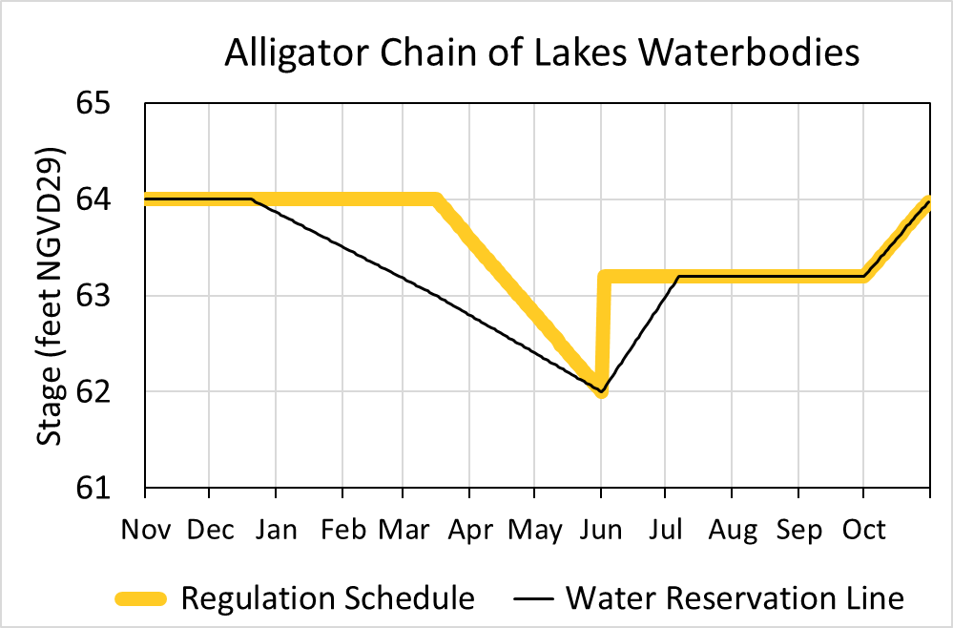
Figure 4-6B. Hydrograph of the current regulation schedule and the water reservation stage at S-60 (water reservation line) for Alligator Chain of Lakes reservation waterbodies. The water reservation line is derived from data in Table 4-6.
Table 4-6. Maximum daily water reservation stages at S-60 for Alligator Chain of Lakes reservation waterbodies (black line in Figure 4-6B).
Day | January | February | March | April | May | June | July | August | September | October | November | December
1 | 63.86 | 63.50 | 63.17 | 62.79 | 62.40 | 62.00 | 63.00 | 63.20 | 63.20 | 63.20 | 64.00 | 64.00
2 | 63.85 | 63.49 | 63.16 | 62.78 | 62.39 | 62.03 | 63.03 | 63.20 | 63.20 | 63.23 | 64.00 | 64.00
3 | 63.84 | 63.48 | 63.15 | 62.77 | 62.38 | 62.07 | 63.07 | 63.20 | 63.20 | 63.25 | 64.00 | 64.00
4 | 63.83 | 63.47 | 63.14 | 62.75 | 62.36 | 62.10 | 63.10 | 63.20 | 63.20 | 63.28 | 64.00 | 64.00
5 | 63.81 | 63.45 | 63.13 | 62.74 | 62.35 | 62.13 | 63.13 | 63.20 | 63.20 | 63.30 | 64.00 | 64.00
6 | 63.80 | 63.44 | 63.12 | 62.73 | 62.34 | 62.17 | 63.17 | 63.20 | 63.20 | 63.33 | 64.00 | 64.00
7 | 63.79 | 63.43 | 63.10 | 62.71 | 62.32 | 62.20 | 63.20 | 63.20 | 63.20 | 63.35 | 64.00 | 64.00
8 | 63.78 | 63.42 | 63.09 | 62.70 | 62.31 | 62.23 | 63.20 | 63.20 | 63.20 | 63.38 | 64.00 | 64.00
9 | 63.77 | 63.41 | 63.08 | 62.69 | 62.30 | 62.27 | 63.20 | 63.20 | 63.20 | 63.41 | 64.00 | 64.00
10 | 63.76 | 63.40 | 63.07 | 62.68 | 62.29 | 62.30 | 63.20 | 63.20 | 63.20 | 63.43 | 64.00 | 64.00
11 | 63.74 | 63.38 | 63.06 | 62.66 | 62.27 | 62.33 | 63.20 | 63.20 | 63.20 | 63.46 | 64.00 | 64.00
12 | 63.73 | 63.37 | 63.05 | 62.65 | 62.26 | 62.37 | 63.20 | 63.20 | 63.20 | 63.48 | 64.00 | 64.00
13 | 63.72 | 63.36 | 63.03 | 62.64 | 62.25 | 62.40 | 63.20 | 63.20 | 63.20 | 63.51 | 64.00 | 64.00
14 | 63.71 | 63.35 | 63.02 | 62.62 | 62.23 | 62.43 | 63.20 | 63.20 | 63.20 | 63.54 | 64.00 | 64.00
15 | 63.70 | 63.34 | 63.01 | 62.61 | 62.22 | 62.47 | 63.20 | 63.20 | 63.20 | 63.56 | 64.00 | 64.00
16 | 63.69 | 63.33 | 63.00 | 62.60 | 62.21 | 62.50 | 63.20 | 63.20 | 63.20 | 63.59 | 64.00 | 64.00
17 | 63.67 | 63.31 | 62.99 | 62.58 | 62.19 | 62.53 | 63.20 | 63.20 | 63.20 | 63.61 | 64.00 | 64.00
18 | 63.66 | 63.30 | 62.97 | 62.57 | 62.18 | 62.57 | 63.20 | 63.20 | 63.20 | 63.64 | 64.00 | 64.00
19 | 63.65 | 63.29 | 62.96 | 62.56 | 62.17 | 62.60 | 63.20 | 63.20 | 63.20 | 63.66 | 64.00 | 64.00
20 | 63.64 | 63.28 | 62.95 | 62.55 | 62.16 | 62.63 | 63.20 | 63.20 | 63.20 | 63.69 | 64.00 | 64.00
21 | 63.63 | 63.27 | 62.94 | 62.53 | 62.14 | 62.67 | 63.20 | 63.20 | 63.20 | 63.72 | 64.00 | 63.99
22 | 63.62 | 63.26 | 62.92 | 62.52 | 62.13 | 62.70 | 63.20 | 63.20 | 63.20 | 63.74 | 64.00 | 63.98
23 | 63.60 | 63.24 | 62.91 | 62.51 | 62.12 | 62.73 | 63.20 | 63.20 | 63.20 | 63.77 | 64.00 | 63.97
24 | 63.59 | 63.23 | 62.90 | 62.49 | 62.10 | 62.77 | 63.20 | 63.20 | 63.20 | 63.79 | 64.00 | 63.95
25 | 63.58 | 63.22 | 62.88 | 62.48 | 62.09 | 62.80 | 63.20 | 63.20 | 63.20 | 63.82 | 64.00 | 63.94
26 | 63.57 | 63.21 | 62.87 | 62.47 | 62.08 | 62.83 | 63.20 | 63.20 | 63.20 | 63.85 | 64.00 | 63.93
27 | 63.56 | 63.20 | 62.86 | 62.45 | 62.06 | 62.87 | 63.20 | 63.20 | 63.20 | 63.87 | 64.00 | 63.92
28 | 63.55 | 63.19 | 62.84 | 62.44 | 62.05 | 62.90 | 63.20 | 63.20 | 63.20 | 63.90 | 64.00 | 63.91
29 | 63.53 |  | 62.83 | 62.43 | 62.04 | 62.93 | 63.20 | 63.20 | 63.20 | 63.92 | 64.00 | 63.90
30 | 63.52 |  | 62.82 | 62.42 | 62.03 | 62.97 | 63.20 | 63.20 | 63.20 | 63.95 | 64.00 | 63.88
31 | 63.51 |  | 62.81 |  | 62.01 |  | 63.20 | 63.20 |  | 63.97 |  | 63.87

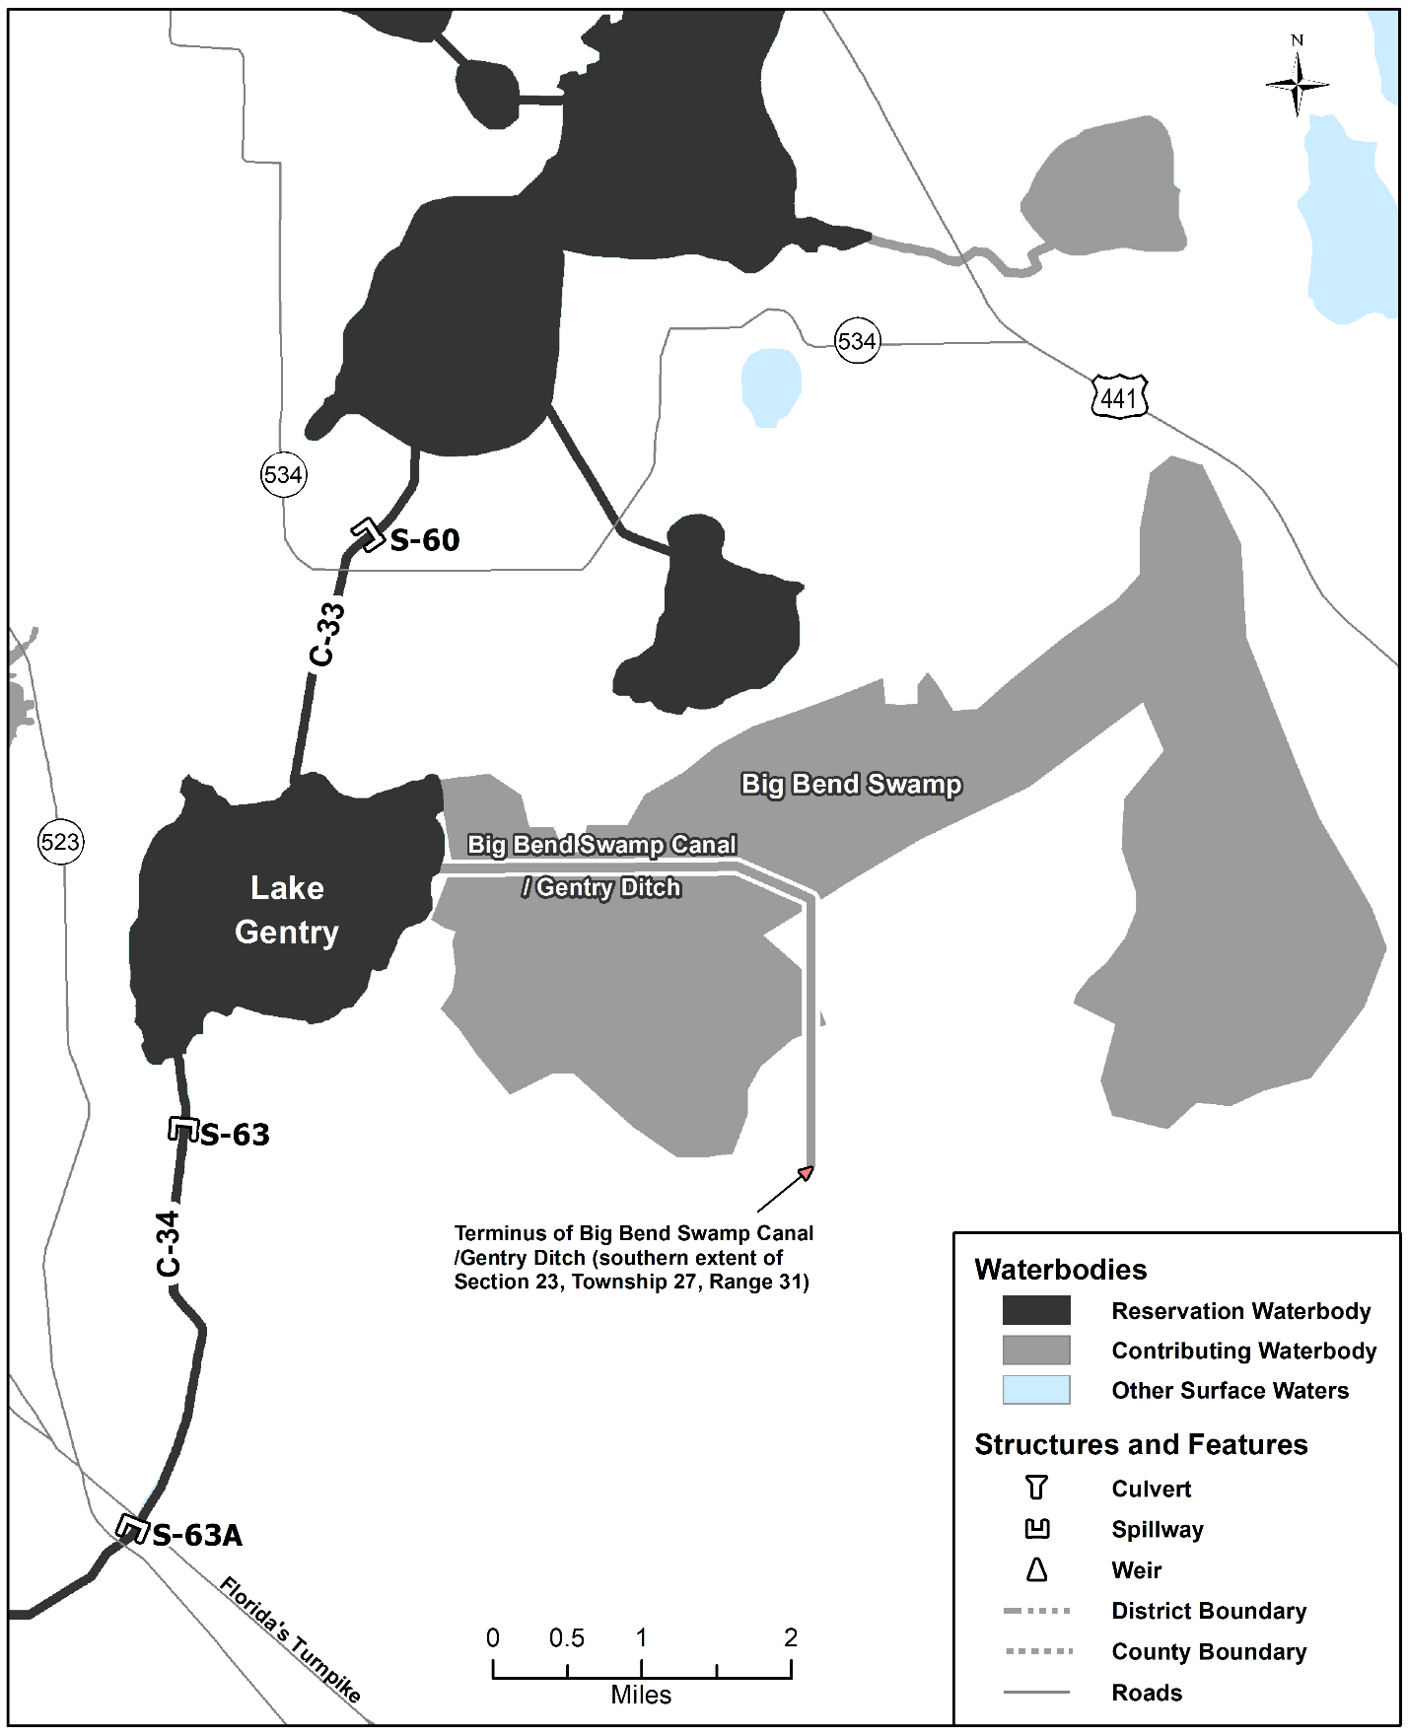Figure 4-7A. Lake Gentry reservation and contributing waterbodies. Unlabeled waterbodies in this figure are not included in this reservation/contributing waterbody group.

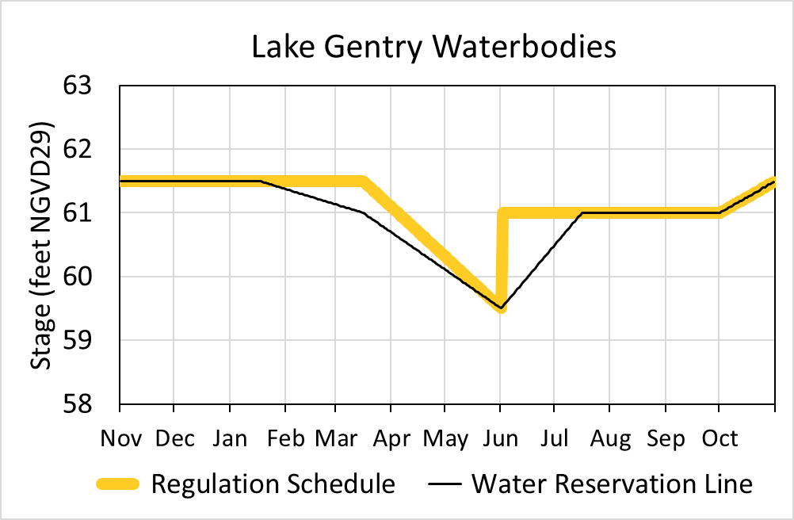
Figure 4-7B. Hydrograph of the current regulation schedule and the water reservation stage at S-63 (water reservation line) for Lake Gentry reservation waterbodies. The water reservation line is derived from data in Table 4-7.
Table 4-7. Maximum daily water reservation stages at S-63 for Lake Gentry reservation waterbodies (black line in Figure 4-7B).
Day | January | February | March | April | May | June | July | August | September | October | November | December
1 | 61.50 | 61.37 | 61.13 | 60.69 | 60.10 | 59.50 | 60.50 | 61.00 | 61.00 | 61.00 | 61.50 | 61.50
2 | 61.50 | 61.36 | 61.12 | 60.67 | 60.08 | 59.53 | 60.53 | 61.00 | 61.00 | 61.02 | 61.50 | 61.50
3 | 61.50 | 61.35 | 61.11 | 60.65 | 60.06 | 59.57 | 60.57 | 61.00 | 61.00 | 61.03 | 61.50 | 61.50
4 | 61.50 | 61.34 | 61.10 | 60.63 | 60.05 | 59.60 | 60.60 | 61.00 | 61.00 | 61.05 | 61.50 | 61.50
5 | 61.50 | 61.34 | 61.09 | 60.61 | 60.03 | 59.63 | 60.63 | 61.00 | 61.00 | 61.06 | 61.50 | 61.50
6 | 61.50 | 61.33 | 61.09 | 60.59 | 60.01 | 59.67 | 60.67 | 61.00 | 61.00 | 61.08 | 61.50 | 61.50
7 | 61.50 | 61.32 | 61.08 | 60.57 | 59.99 | 59.70 | 60.70 | 61.00 | 61.00 | 61.10 | 61.50 | 61.50
8 | 61.50 | 61.31 | 61.07 | 60.55 | 59.97 | 59.73 | 60.73 | 61.00 | 61.00 | 61.11 | 61.50 | 61.50
9 | 61.50 | 61.30 | 61.06 | 60.53 | 59.95 | 59.77 | 60.77 | 61.00 | 61.00 | 61.13 | 61.50 | 61.50
10 | 61.50 | 61.29 | 61.05 | 60.51 | 59.93 | 59.80 | 60.80 | 61.00 | 61.00 | 61.15 | 61.50 | 61.50
11 | 61.50 | 61.28 | 61.04 | 60.49 | 59.91 | 59.83 | 60.83 | 61.00 | 61.00 | 61.16 | 61.50 | 61.50
12 | 61.50 | 61.28 | 61.03 | 60.47 | 59.89 | 59.87 | 60.87 | 61.00 | 61.00 | 61.18 | 61.50 | 61.50
13 | 61.50 | 61.27 | 61.03 | 60.45 | 59.87 | 59.90 | 60.90 | 61.00 | 61.00 | 61.19 | 61.50 | 61.50
14 | 61.50 | 61.26 | 61.02 | 60.44 | 59.85 | 59.93 | 60.93 | 61.00 | 61.00 | 61.21 | 61.50 | 61.50
15 | 61.50 | 61.25 | 61.01 | 60.42 | 59.83 | 59.97 | 60.97 | 61.00 | 61.00 | 61.23 | 61.50 | 61.50
16 | 61.50 | 61.24 | 61.00 | 60.40 | 59.81 | 60.00 | 61.00 | 61.00 | 61.00 | 61.24 | 61.50 | 61.50
17 | 61.50 | 61.23 | 60.98 | 60.38 | 59.79 | 60.03 | 61.00 | 61.00 | 61.00 | 61.26 | 61.50 | 61.50
18 | 61.49 | 61.22 | 60.96 | 60.36 | 59.77 | 60.07 | 61.00 | 61.00 | 61.00 | 61.27 | 61.50 | 61.50
19 | 61.48 | 61.22 | 60.94 | 60.34 | 59.75 | 60.10 | 61.00 | 61.00 | 61.00 | 61.29 | 61.50 | 61.50
20 | 61.47 | 61.21 | 60.92 | 60.32 | 59.73 | 60.13 | 61.00 | 61.00 | 61.00 | 61.31 | 61.50 | 61.50
21 | 61.47 | 61.20 | 60.90 | 60.30 | 59.71 | 60.17 | 61.00 | 61.00 | 61.00 | 61.32 | 61.50 | 61.50
22 | 61.46 | 61.19 | 60.88 | 60.28 | 59.69 | 60.20 | 61.00 | 61.00 | 61.00 | 61.34 | 61.50 | 61.50
23 | 61.45 | 61.18 | 60.86 | 60.26 | 59.68 | 60.23 | 61.00 | 61.00 | 61.00 | 61.35 | 61.50 | 61.50
24 | 61.44 | 61.17 | 60.84 | 60.24 | 59.66 | 60.27 | 61.00 | 61.00 | 61.00 | 61.37 | 61.50 | 61.50
25 | 61.43 | 61.16 | 60.82 | 60.22 | 59.64 | 60.30 | 61.00 | 61.00 | 61.00 | 61.39 | 61.50 | 61.50
26 | 61.42 | 61.16 | 60.81 | 60.20 | 59.62 | 60.33 | 61.00 | 61.00 | 61.00 | 61.40 | 61.50 | 61.50
27 | 61.41 | 61.15 | 60.79 | 60.18 | 59.60 | 60.37 | 61.00 | 61.00 | 61.00 | 61.42 | 61.50 | 61.50
28 | 61.41 | 61.14 | 60.77 | 60.16 | 59.58 | 60.40 | 61.00 | 61.00 | 61.00 | 61.44 | 61.50 | 61.50
29 | 61.40 |  | 60.75 | 60.14 | 59.56 | 60.43 | 61.00 | 61.00 | 61.00 | 61.45 | 61.50 | 61.50
30 | 61.39 |  | 60.73 | 60.12 | 59.54 | 60.47 | 61.00 | 61.00 | 61.00 | 61.47 | 61.50 | 61.50
31 | 61.38 |  | 60.71 |  | 59.52 |  | 61.00 | 61.00 |  | 61.48 |  | 61.50

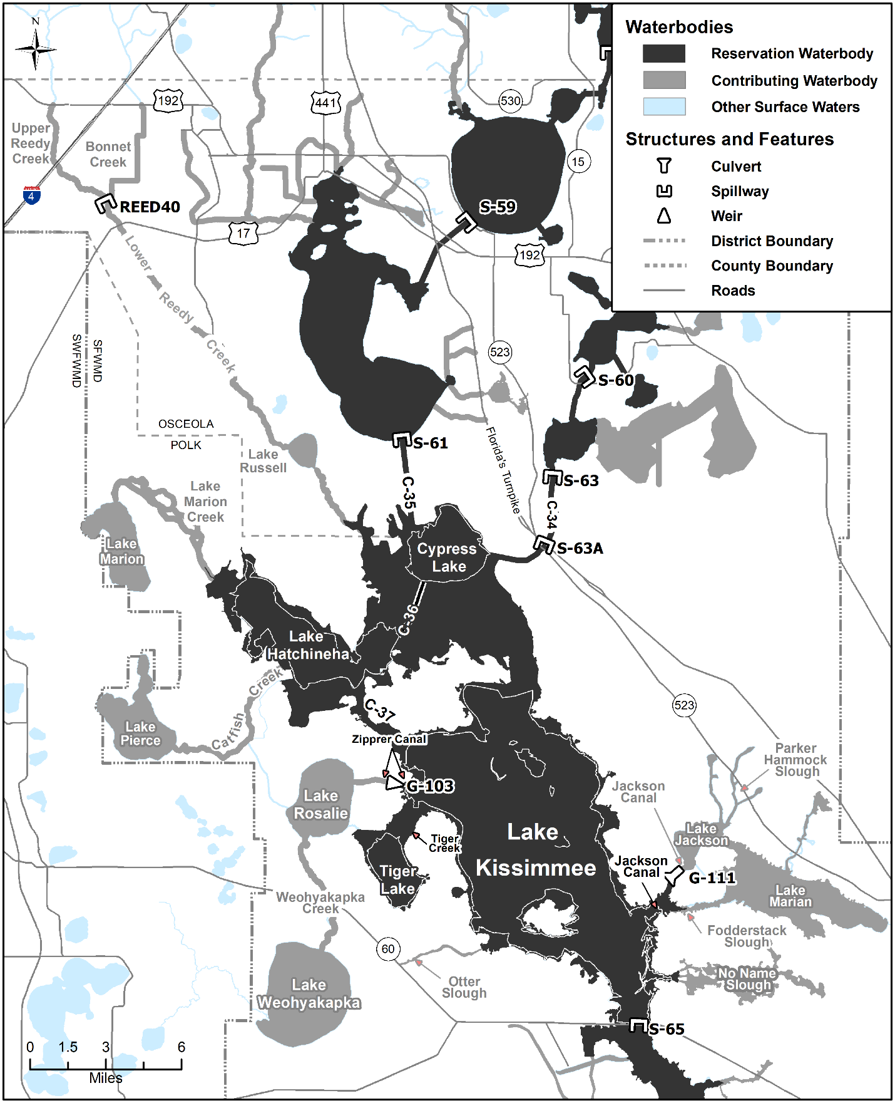
Figure 4-8A. Headwaters Revitalization Lakes reservation and contributing waterbodies. Unlabeled waterbodies in this figure are not included in this reservation/contributing waterbody group.
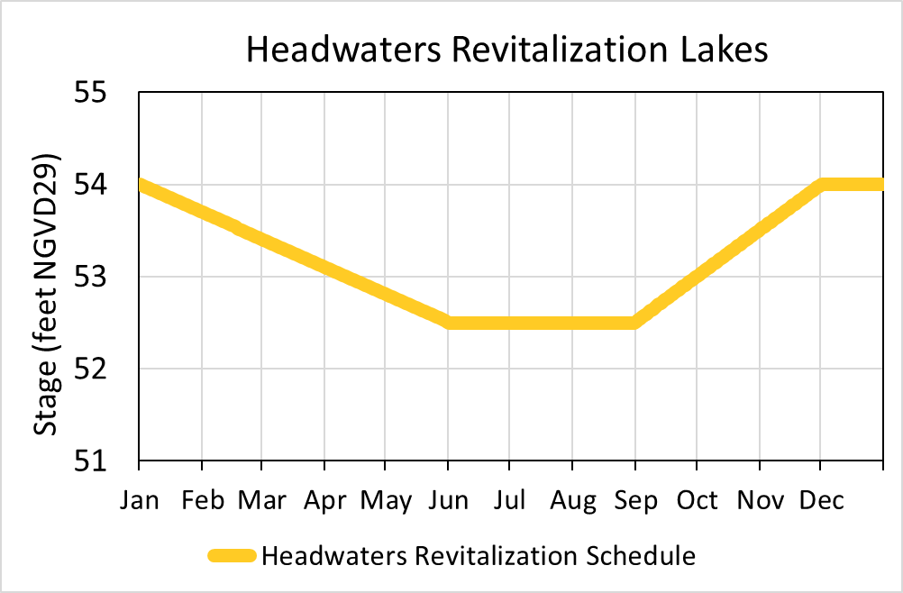
Figure 4-8B. Hydrograph of the authorized Headwaters Revitalization Schedule (HRS) at S-65 (derived from data in Table 4-8) for the Headwaters Revitalization Lakes reservation waterbodies.
Table 4-8. Stages for the Headwaters Revitalization Lakes reservation waterbodies (yellow line in Figure 4-8B).
Day | January | February | March | April | May | June | July | August | September | October | November | December
1 | 54.00 | 53.69 | 53.41 | 53.10 | 52.81 | 52.50 | 52.50 | 52.50 | 52.52 | 53.01 | 53.51 | 54.00
2 | 53.99 | 53.68 | 53.40 | 53.09 | 52.80 | 52.50 | 52.50 | 52.50 | 52.53 | 53.02 | 53.53 | 54.00
3 | 53.98 | 53.67 | 53.39 | 53.08 | 52.79 | 52.50 | 52.50 | 52.50 | 52.55 | 53.04 | 53.54 | 54.00
4 | 53.97 | 53.66 | 53.38 | 53.07 | 52.78 | 52.50 | 52.50 | 52.50 | 52.57 | 53.05 | 53.56 | 54.00
5 | 53.96 | 53.65 | 53.37 | 53.06 | 52.77 | 52.50 | 52.50 | 52.50 | 52.58 | 53.07 | 53.58 | 54.00
6 | 53.95 | 53.64 | 53.36 | 53.05 | 52.76 | 52.50 | 52.50 | 52.50 | 52.60 | 53.09 | 53.59 | 54.00
7 | 53.94 | 53.63 | 53.35 | 53.04 | 52.75 | 52.50 | 52.50 | 52.50 | 52.61 | 53.10 | 53.61 | 54.00
8 | 53.93 | 53.63 | 53.34 | 53.03 | 52.74 | 52.50 | 52.50 | 52.50 | 52.63 | 53.12 | 53.62 | 54.00
9 | 53.92 | 53.62 | 53.33 | 53.02 | 52.73 | 52.50 | 52.50 | 52.50 | 52.65 | 53.14 | 53.64 | 54.00
10 | 53.91 | 53.61 | 53.32 | 53.01 | 52.72 | 52.50 | 52.50 | 52.50 | 52.66 | 53.15 | 53.66 | 54.00
11 | 53.90 | 53.60 | 53.31 | 53.00 | 52.71 | 52.50 | 52.50 | 52.50 | 52.68 | 53.17 | 53.67 | 54.00
12 | 53.89 | 53.59 | 53.30 | 52.99 | 52.70 | 52.50 | 52.50 | 52.50 | 52.70 | 53.18 | 53.69 | 54.00
13 | 53.88 | 53.58 | 53.29 | 52.98 | 52.69 | 52.50 | 52.50 | 52.50 | 52.71 | 53.20 | 53.71 | 54.00
14 | 53.87 | 53.57 | 53.28 | 52.97 | 52.68 | 52.50 | 52.50 | 52.50 | 52.73 | 53.22 | 53.72 | 54.00
15 | 53.86 | 53.56 | 53.27 | 52.96 | 52.67 | 52.50 | 52.50 | 52.50 | 52.74 | 53.23 | 53.74 | 54.00
16 | 53.85 | 53.55 | 53.26 | 52.95 | 52.66 | 52.50 | 52.50 | 52.50 | 52.76 | 53.25 | 53.76 | 54.00
17 | 53.84 | 53.54 | 53.25 | 52.94 | 52.65 | 52.50 | 52.50 | 52.50 | 52.78 | 53.27 | 53.77 | 54.00
18 | 53.83 | 53.53 | 53.24 | 52.93 | 52.64 | 52.50 | 52.50 | 52.50 | 52.79 | 53.28 | 53.79 | 54.00
19 | 53.82 | 53.52 | 53.23 | 52.92 | 52.63 | 52.50 | 52.50 | 52.50 | 52.81 | 53.30 | 53.80 | 54.00
20 | 53.81 | 53.51 | 53.22 | 52.91 | 52.62 | 52.50 | 52.50 | 52.50 | 52.83 | 53.32 | 53.82 | 54.00
21 | 53.80 | 53.50 | 53.21 | 52.90 | 52.61 | 52.50 | 52.50 | 52.50 | 52.84 | 53.33 | 53.84 | 54.00
22 | 53.79 | 53.49 | 53.20 | 52.89 | 52.60 | 52.50 | 52.50 | 52.50 | 52.86 | 53.35 | 53.85 | 54.00
23 | 53.78 | 53.48 | 53.19 | 52.88 | 52.59 | 52.50 | 52.50 | 52.50 | 52.88 | 53.36 | 53.87 | 54.00
24 | 53.77 | 53.47 | 53.18 | 52.88 | 52.58 | 52.50 | 52.50 | 52.50 | 52.89 | 53.38 | 53.89 | 54.00
25 | 53.76 | 53.46 | 53.17 | 52.87 | 52.57 | 52.50 | 52.50 | 52.50 | 52.91 | 53.40 | 53.90 | 54.00
26 | 53.75 | 53.45 | 53.16 | 52.86 | 52.56 | 52.50 | 52.50 | 52.50 | 52.92 | 53.41 | 53.92 | 54.00
27 | 53.74 | 53.44 | 53.15 | 52.85 | 52.55 | 52.50 | 52.50 | 52.50 | 52.94 | 53.43 | 53.93 | 54.00
28 | 53.73 | 53.43 | 53.14 | 52.84 | 52.54 | 52.50 | 52.50 | 52.50 | 52.96 | 53.45 | 53.95 | 54.00
29 | 53.72 | 53.42 | 53.13 | 52.83 | 52.53 | 52.50 | 52.50 | 52.50 | 52.97 | 53.46 | 53.97 | 54.00
30 | 53.71 |  | 53.12 | 52.82 | 52.52 | 52.50 | 52.50 | 52.50 | 52.99 | 53.48 | 53.98 | 54.00
31 | 53.70 |  | 53.11 |  | 52.51 |  | 52.50 | 52.50 |  | 53.49 |  | 54.00

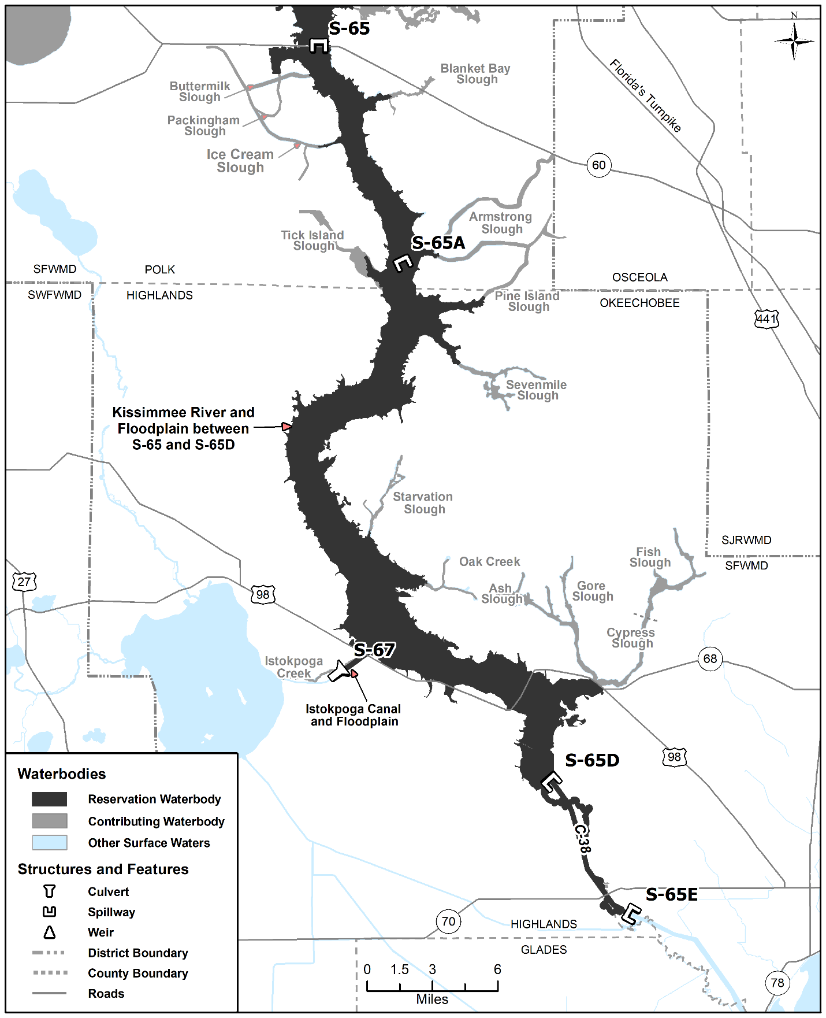
Figure 4-9. Kissimmee River reservation and contributing waterbodies. Unlabeled waterbodies in this figure are not included in this reservation/contributing waterbody group.

NAME OF PERSON ORIGINATING PROPOSED RULE: Lawrence Glenn, Division Director, Water Resources
NAME OF AGENCY HEAD WHO APPROVED THE PROPOSED RULE: South Florida Water Management District Governing Board
DATE PROPOSED RULE APPROVED BY AGENCY HEAD: November 12, 2020
DATE NOTICE OF PROPOSED RULE DEVELOPMENT PUBLISHED IN FAR: July 16, 2014

