ENVIRONMENTAL RESOURCE PERMIT

APPLICANT’S HANDBOOK, VOLUME II:

FOR USE WITHIN THE GEOGRAPHIC LIMITS

OF THE ST. JOHNS RIVER WATER MANAGEMENT DISTRICT

[EFFECTIVE DATE]

ST. JOHNS RIVER WATER MANAGEMENT DISTRICT
4049 Reid Street
Palatka, FL 32177-2529
(386) 329-4500

TABLE OF CONTENTS

Preface

- ENVIRONMENTAL RESOURCE PERMIT APPLICANT’S HANDBOOK, VOLUME II

PART I – INTRODUCTION, ORGANIZATION, DEFINITIONS AND APPLICABILITY

- Introduction
  - Organization
1.2 District-specific Thresholds
1.2.1 Background
1.2.2 Activities in the Wekiva Riparian Habitat Protection Zone
1.2.3 Agricultural Surface Water Management Systems
1.3 District-specific Exemptions
1.3.1 Background
1.3.2 Existing Systems
1.3.3 Agricultural Surface Water Management Systems

PART II – GENERAL CRITERIA

- Criteria for Evaluation – Reasonable Assurance
2.1 Definitions
2.2 Existing Ambient Water Quality
2.3 Professional Certification
2.4 Maintenance Access
2.5 Legal Authorization
2.6 Public Safety
2.6.1 Basin Side Slopes
2.6.2 Basin Side Slope Stabilization
2.6.3 Control Structures
2.7 Tailwater Considerations
2.7.1 Tailwater for Water Quality Design
2.7.2 Tailwater for Water Quantity Design
2.8 Applicant Responsibility
2.9 Operation and Maintenance
2.10 Retrofits of Existing Surface Water Management Systems
2.11 Flexibility for State Transportation Projects and Facilities

PART III – STORMWATER QUANTITY/FLOOD CONTROL

3.0 General Flood Control Performance Criteria
3.1 Projects that Must Meet Water Quantity Criteria
3.2 Design Standards for Flood Protection
3.2.1 Water Quantity
3.2.2 Alternative Peak Discharge Criteria
3.2.3 Methodologies
3.2.4 Computer Programs Accepted by the District
3.2.5 Aggregate Discharge
3.2.6 Rainfall Intensity
3.2.7 System Recovery
3.2.8 Upper Soil Zone Storage and Surface Storage
3.3 Storage and Conveyance
3.3.1 Conveyance
3.3.2 Floodways and Floodplain Storage
3.3.3 Level of Service
3.3.4 Floodway and Floodplain Elevation Determination
3.3.5 Flow Velocity
3.4 Dams and Impoundments
3.4.1
3.4.2
3.5 Low Flow and Base Flow Maintenance
3.5.1 Low Flow
3.5.2 Base Flow

PART IV – STORMWATER QUALITY

4.0 Criterion
4.1 State Water Quality Standards
4.1.1 Surface Water Quality Standards
4.1.2 Ground Water Quality Standards
4.1.3 How Standards May be Met
4.2 Erosion and Sediment Control Criteria for Stormwater Management Systems, Works and other Projects
4.3 Oil and Grease Control
4.4 On-Line and Off-line Stormwater Systems
4.5 Hazardous or Toxic Substances

PART V – BEST MANAGEMENT PRACTICES

5.0 Retention System Design Criteria and Performance Criteria
5.1 Description
5.2 Treatment Volume
5.3 Recovery Time
5.4 Basin Stabilization
5.5 Retention Basin Construction
5.5.1 Overview
5.5.2 Construction Requirements
5.6 References
6.0 Underdrain Design and Performance Criteria
6.1 Description
6.2 Treatment Volume
6.3 Recovery Time
6.4 Safety Factor
6.5 Underdrain Media
6.6 Filter Fabric
6.7 Inspection and Cleanout Ports
6.8 Basin Stabilization
6.9 References
7.0 Exfiltration Trench Design and Performance Criteria
7.1 Description
7.2 Treatment Volume
7.3 Recovery Time
7.4 Safety Factor
7.5 Minimum Dimensions
7.6 Filter Fabric
7.7 Inspection and Cleanout Structures
7.8 Ground Water Table
7.9 Construction
7.10 Alternative Designs
7.11 References
8.0 Wet Detention Design and Performance Criteria
8.1 Description
8.2 Treatment Volume
8.3 Recovery Time
8.4 Outlet Structure
8.5 Permanent Pool
8.6 Littoral Zone
8.7 Littoral Zone Alternatives
8.8 Pond Depth
8.9 Pond Configuration
8.10 Ground Water Table
8.11 Pre-treatment
8.12 Pond Side Slopes
8.13 Direct Discharges to Class I, Class II, OFWs, or
Shellfishing Waters
8.14 References
9.0 Swale Systems Design and Performance Criteria
9.1 Description
9.2 Treatment Volume
9.3 Recovery Time
9.4 Dimensional Requirements
9.5 Stabilization
10.0 Wetlands Stormwater Management Systems Design and Performance Criteria
10.1 Description
10.2 Types of Wetlands that may be Utilized for Stormwater Treatment
10.3 Treatment Volume
10.4 Recovery Time
10.5 Inlet Structures
10.6 Wetland Function
10.7 Residence Time
10.8 Monitoring
10.9 Dredge and Fill
10.10 Alternative Criteria
10.11 References
11.0 [Reserved ]
12.0 Dry Detention Design and Performance Criteria
12.1 Description
12.2 Treatment Volume
12.3 Recovery Time
12.4 Outlet Structure
12.5 Ground Water Table, Basin Floor, and Control Elevation
12.6 Basin Stabilization
12.7 Basin Configuration
12.8 Inlet Structures
12.9 Maintenance

PART VI – BASIN CRITERIA

13.0 Basin Criteria
13.1 Upper St. Johns River Hydrologic Basin
13.1.1 Storm Frequency
13.1.2 Runoff Volume
13.1.3 Interbasin Diversion
13.2 Ocklawaha River Hydrologic Basin
13.2.1 Storm Frequency
13.2.2 Runoff Volume
13.3 Wekiva River Hydrologic Basin and Wekiva Recharge Protection Basin
13.3.1 Recharge Standard
13.3.2 Storage Standard
13.3.3 Standards for Erosion and Sediment Control and Water Quality
13.3.4 Standard for Limiting Drawdown
13.3.5 Standard for Riparian Wildlife Habitat
13.3.6 Local Government Notification for Wekiva River Protection Area
13.4 Econlockhatchee River Hydrologic Basin
13.4.1 Design Storm Criteria
13.4.2 Floodplain Storage Criteria
13.4.3 Riparian Wildlife Habitat Standard
13.4.4. Off-site Land Preservation as Mitigation in the Econlockhatchee River
Hydrologic Basin
13.5 Tomoka River and Spruce Creek Hydrologic Basins
13.5.1 Recharge Standard
13.5.2 Floodplain Storage Criteria
13.5.3 Stormwater Management Standard
13.5.4 Riparian Wildlife Habitat Standard
13.6 Sensitive Karst Areas Basin Design Criteria
13.6.1 Background of the Sensitive Karst Areas Design Criteria
13.6.2 Hydrogeology of the Sensitive Karst Areas Basin
13.6.3 Design Criteria for Sensitive Karst Areas
13.7 Lake Apopka Hydrologic Basin
13.8 Additional Basin Criteria
13.8.1 Soil Types
13.8.2 Erosion and Sediment Control Principles
13.8.3 Erosion and Sediment Control Plan

PART VII– AGRICULTURAL SURFACE WATER MANAGEMENT SYSTEMS
14.0 Introduction
14.1 Policy
14.2 Purpose
14.3 Organization of Part VII
14.4 Applicable Statutes and Rules
14.5 General Description of Rule
14.6 Explanation of Thresholds, Exemptions and Individual Permits
14.7 Definitions
14.8 Activities Requiring a Permit
14.8.1 Date of Implementation
14.8.2 Permits Required
14.8.3
14.9 Activities Authorized by Permit
14.10 Exemptions
14.10.1
14.10.2
14.11 Minor Alterations
14.11.1
14.11.2
14.11.3
15.0 Application Preparation
15.1 Pre-application Conference
15.1.1
15.1.2
15.2 Forms and Instructions
15.2.1
15.3 Permit Processing Fee
15.3.1
15.4 Checklist for Application Completeness
15.4.1 Procedure for Processing Applications
16.0 Permits
16.1 Operation and Maintenance Unique to Agricultural Systems
16.1.1 Responsibility for Operation and Maintenance
16.1.2 Operation and Maintenance Requirements
16.2 Transfers
16.2.1
16.3 Related Permits
16.3.1
16.3.2
16.3.3
16.4 Duration
16.4.1
16.4.2
16.4.3
16.4.4
16.4.5
16.5 Enforcement and Inspection
16.5.1
16.5.2
16.6 Compliance
16.6.1
16.6.2 Forms
16.6.3 Water Quality Monitoring
16.6.4 Pump Hour Monitoring
16.6.5 Pond Stage Monitoring
17.0 Criteria for Evaluation
17.1 Purpose
17.2 Source of Criteria
17.3 Statutory Criteria
17.3.1
17.4 State Water Quality Standards
17.4.1 Surface Water Quality Standards
17.4.2 Groundwater Quality Standards
18.0 Overall Objectives of the District
18.1 Objectives
18.1.1
18.1.2
19.0 Harm to the Water Resources of the District
19.1 Harm to the Water Resources Standards
19.1.1
19.1.2
19.2 Harm to the Water Resources Criteria
19.2.1
19.2.2 Individual Permits
19.2.3 Discharge to Class I, Class II, or Outstanding Florida Waters
19.2.4 Water Quality Practices
19.2.5
19.2.6

PART VIII – APPENDICES

Appendix

A Drainage Basins and Regional Watersheds
B Basin Boundaries
C Methodology and Design Example for the Modified Rational Hydrograph Method
D Subparagraph 40C-4.041(2)(b)8 as it existed on September 25, 1991

PART I
INTRODUCTION, ORGANIZATION, DEFINITIONS AND APPLICABILITY

- Introduction

This is Volume II of a two-volume Applicant’s Handbook that is designed to assist persons in understanding the rules, procedures, standards and criteria of the environmental resource permit (ERP) program under Part IV of Chapter 373 of the Florida Statutes (F.S.). Within the St. Johns River Water Management District, the ERP program is governed by chapters 373, 403 and 120, F.S. and chapters 62-330, 40C-1, 40C-4, 40C-41, 40C-42, and 40C-44, F.A.C. This handbook volume accompanies Applicant’s Handbook – Volume I (General and Environmental). Volume II and portions of Volume I are incorporated by reference in chapter 62-330, F.A.C., and are, therefore rules of the Department of Environmental Protection (DEP). In accordance with paragraph 373.4131(2)(a), F.S. (2012), they are also rules of the District.

This Volume includes:

- Design and performance standards and criteria for water quality and quantity for stormwater management systems, including alternative criteria for those systems
- Explanations of standards and criteria pertaining to water flows and levels, flood protection and the design of dams
- Design and performance standards for agricultural surface water management (Chapter 40C-44, F.A.C.)
- Description of drainage basins and regional watersheds
- Explanations of basin criteria (Chapter 40C-41, F.A.C.)
- Descriptions of District-specific thresholds and exemptions referenced in chapter 62-330

This Volume should be used in conjunction with Volume I, which provides general background information on the ERP program including points of contact, a summary of the statutes and rules used to authorize and implement the ERP program, and forms used to notice or apply to the District for an ERP authorization, except those forms related to agricultural systems which are incorporated by reference in 40C-44.061 and 40C-44.101, F.A.C. Volume I also provides discussion of:

  - Activities that are regulated by the ERP program
  - Types of permits, permit thresholds, and exemptions
  - Procedures used in the review of ERPs
  - Conditions for issuance of an ERP, including a detailed discussion of the environmental criteria that are used for activities located in wetlands and other surface waters
  - Erosion and sediment control practices to prevent water quality violations
  - Operation and maintenance requirements and copies of maps used in implementing the provisions of the ERP program
The term “District” or “SJRWMD” where used in this Volume shall apply to the Department of Environmental Protection, the St. Johns River Water Management District or a delegated local government as applicable in accordance with the division of responsibility specified by the operating agreement incorporated by reference in subsection 62-330.010(3), F.A.C., except where a specific agency is otherwise identified. In cases where conflicting or ambiguous interpretations of the information in this Volume result in uncertainty, the final determination of appropriate procedures to be followed will be made by reference to chapters 120 and 373, and chapters 40C-1, 40C-4, 40C-41, 40C- 42, 40C-44 and 62-330, F.A.C.

References to a section or subsection shall include all parts of the section or subsection unless otherwise specified.

1.1 Organization

This Volume is divided into eight parts:

Part I – Introduction, Organization, Definitions and Applicability
Part II – General Criteria
Part III – Stormwater Quantity/Flood Control
Part IV – Stormwater Quality
Part V – Best Management Practices and Special Basin Criteria
Part VI – Basin Criteria
Part VII - Agricultural Surface Water Management Systems
Part VIII – Appendices

1.2 District-Specific Thresholds

1.2.1 Background
Rule 62-330.020 sets forth the thresholds for when an environmental resource permit must be obtained under Part IV of chapter 373. Subsection (2) of this rule requires a person to obtain an environmental resource permit before constructing, altering, operating, maintaining, removing, or abandoning any new project that, by itself or in combination with an activity conducted after [effective date], cumulatively results in “[a]ny project exceeding the thresholds in Section 1.2 (District-specific thresholds) of the applicable Volume II” unless the proposed project is governed by subsection 62-330.020(1), F.A.C. [62-330.020(2)(i), F.A.C.]

Subsections 1.2.2 and 1.2.3 of this Volume set forth the District-specific thresholds for activities within the St. Johns River Water Management District.

The District encourages applicants to consult section 2.0 of Volume I which contains definitions of important terms such as “project” and “activity”.

1.2.2 Activities in the Wekiva Riparian Habitat Protection Zone

A permit under chapter 62-330 is required for any activity that is located wholly or partially within the Wekiva River Hydrologic Basin’s Riparian Habitat Protection Zone (RHPZ) described in paragraph 40C-41.063(3)(e), F.A.C. When an activity requires a permit pursuant to this subsection, the review for determining compliance with all relevant permitting requirements will be conducted in accordance with rule 62-330.054.

1.2.3 Agricultural Surface Water Management Systems

A permit under chapter 62-330, F.A.C., is required for the alteration, maintenance and operation of certain existing agricultural surface water management systems and for the construction, maintenance and operation of certain new agricultural surface water management systems, in accordance with chapter 40C-44, F.A.C. (Environmental Resource Permits: Regulation of Agricultural Surface Water Management Systems). These systems are described in rule 40C-44.041, but are also described in this subsection and in Part VII of this Volume.

Agricultural operations that are required to obtain a permit shall satisfy the requirements of the District in terms of the quality of water discharged from the system, by implementing the performance standards and water quality practices described in Part VII of this Volume.

A permit for an agricultural system is required under this subsection and chapter
40C-44, F.A.C., if the activity exceeds any of the following thresholds:

(a) The activity incorporates pumped discharges from an existing agricultural surface water management system, when:

(1) the pumps are stationary or portable facilities, and

(2) the pump(s) have a capacity, either individually or cumulatively, of 10,000 GPM or greater. [40C-44.041(1)(a), F.A.C.]

(b) The activity causes or contributes to a violation of state water quality standards in waters of the state, when:

(1) the discharge is pumped or gravity drained, and

(2) the District has considered the following information on a case-by-case basis:

a. water quality monitoring data collected by the District or other agency,

b. the size of the agricultural operation and the amount of stormwater and associated wastewater reaching waters of the state, relative to the size and nature of the immediate drainage basin,

c. the means of conveyance of stormwater and associated wastewater to waters of the state,

d. characteristics of the site including the slope, vegetation, rainfall and other factors related to the likelihood or frequency of discharge of stormwater and associated wastewater to waters of the state,

e. the status, results and recommendations of available basin-specific studies, including those conducted as part of a Surface Water Improvement and Management Plan or pursuant to chapter 62-40, F.A.C., and

f. the existence of mixing zones, variances or site specific alternative criteria granted by DEP pursuant to chapters 62-4 and 62-302, F.A.C. [40C-44.041(1)(b), F.A.C.]

(c) An applicant proposes construction, maintenance and operation of new agricultural surface water management systems, or alteration of existing systems, which:

(1) drain an agricultural area greater than 2 acres;

(2) are not located in, on, or over existing wetlands or other surface waters;

(3) serve a project with a total land area less than 40 acres; and

(4) do not provide for the placement of 12 or more acres of impervious surface which constitutes 40 or more percent of the total land area. [40C-44.041(2), F.A.C.]

When an activity that requires a permit pursuant to this subsection also requires a permit because it exceeds one or more thresholds listed in paragraphs 62-330.020(2)(a),(b), (c),(d),(e),(f),(g),(h), or (j), F.A.C., or in subsection 1.2.2 of this Volume, the review for determining compliance with all relevant permitting requirements will be conducted in accordance with rule 62-330.054.

When an activity requires a permit solely pursuant to this subsection, the permit application for such activity shall be filed, and shall be reviewed and acted upon, in accordance with chapter 40C-44, F.A.C., and Part VII of this Volume. The District encourages applicants to contact the District’s Agricultural Assistance Team to assist them in completing such permit applications.

1.3 District-Specific Exemptions

1.3.1 Background

Rule 62-330.051(1) exempts from permitting under chapter 62-330, F.A.C.,
activities that are conducted in conformance with the District-specific exemptions
in Section 1.3 of Volume II applicable to the location of the activity. However, if
an activity is not exempt and requires an individual ERP under chapter 62-330,
F.A.C., rule 62-330.054 requires the application for the individual ERP to be
prepared, submitted, reviewed and acted upon in accordance with subparagraphs 62-
330.054(2)(a), (b) and (c), F.A.C., except as otherwise provided by the ERP rules.

Consistent with these rules, the District has established one District-specific exemption from permitting and one District-specific exemption from certain provisions of chapter 62-330, F.A.C. More specifically, subsection 1.3.2 of this Volume sets forth a District-specific exemption from permitting within the St. Johns River Water Management District while subsection 1.3.3 exempts certain agricultural systems from certain requirements in chapter 62-330, F.A.C.

1.3.2 Existing Systems

The District’s rules in chapters 40C-4, 40C-40, and 40C-41, F.A.C. became effective on December 7, 1983. Before December 7, 1983, rules authorized under part IV, chapter 373, F.S. were implemented in the Upper St. Johns River and the Ocklawaha River basins as shown in Figure 1.3-1. The rules adopted on December 7, 1983 superseded all previous rules. The date of implementation is important in determining whether a permit is required and the effective date for the District’s permitting programs are described in rule 40C-4.031. Certain systems are not required to be permitted until they are to be altered, removed, or abandoned. These systems are identified in the paragraph below.

Specifically exempted from permitting under chapter 62-330 for the purpose of construction, operation, and maintenance are:

(a) Each system or phase of a phased system which is located in the areas described in the Upper St. Johns River Basin or the Ocklawaha River Basin as depicted in Figure 1.3-1, except agricultural operations, which:

(1) Was constructed and operating under the provisions of a valid District permit on December 7, 1983; or

(2) Was not required to obtain a permit prior to December 7, 1983, and was:

a. Constructed and operating prior to December 7, 1983; or

b. Being constructed on December 7, 1983, and was completed and operating by June 7, 1984; or

c. Under construction on December 7, 1983, and which had complied with the regulations of the Florida Department of Environmental Regulation and the appropriate local governmental agency.

(3) Was constructed and operating as of March 2, 1974 for the Upper St. Johns River Basin as described in Figure 1.3-1; or

(4) Was constructed and operating as of January 1, 1975 for the portion of the Oklawaha River Basin as described in Figure 1.3-1.

(b) Each system or phase of a phased system which is located in the Lower St. Johns River Basin as described in Figure 1.3-1 and section 373.069(2)(c), F.S. (Supp. 1976)., except agricultural operations, and which was:

(1) Constructed and operating prior to December 7, 1983; or

(2) Being constructed on December 7, 1983, and was completed and operating on June 7, 1984; or

(3) Under construction on December 7, 1983, and which had complied with the regulations of the Florida Department of Environmental Regulation and the appropriate local governmental agency and was completed December 7, 1984.

(c) The exemptions listed in paragraphs (a) and (b) above apply only to those systems or phases of a phased system as such systems are set forth in its plans, specifications and performance criteria prepared and existing as of December 7, 1983 and to the extent:

(1) Construction of such system is completed, within the applicable time frames, in accordance with such plans, specifications and performance criteria; and

(2) Such system is maintained and operated in a manner consistent with such plans, specifications and performance criteria.

(d) The exemptions listed in paragraphs (a),(b) and (c) above shall not apply to those systems or phases of a phased system which on December 7, 1983 have been abandoned or removed or have ceased to operate as set forth in such system’s plans, specifications and performance criteria.

(e) Those systems or phases of a phased system exempted by paragraphs (a)(b) and (c) above shall not be required to obtain a permit for construction, operation or maintenance.

(1) Any alteration of such system, or a portion thereof (including the rebuilding of such system if it has ceased to operate as set forth in such system’s plans, specifications and performance criteria), shall require that a permit be obtained for such alteration, which permit shall include an authorization to alter as well as an authorization to operate and maintain such alteration. For purposes of this subsection, the following are not considered to be alterations, and consequently are not required to be permitted:

a. The relocation of pumps, provided that the pump is not moved out of the immediate vicinity of its existing location, not to another drainage basin or subbasin, and operation of the pump at the new location will not result in increased adverse impacts to the water resource.

b. The installation of driveway and road inlets and pipes with a diameter of less than 60 inches or equivalent size within an existing surface water management system, provided that the pipe or inlet will not increase the volume of water discharged, and causes no upstream or downstream flooding.

c. The change of the location of a drainage system’s secondary or tertiary drainage ditches provided that the total linear length and cross-sectional dimensions of the ditches are not changed.

d. Roadways not located in wetlands may be widened provided that fill material is not obtained by excavating ditches next to the roadway, and provided that the roadway is otherwise constructed in accordance with accepted engineering practices. Roadways not located in wetlands may be increased in height provided that the elevation of the existing centerline road grade is above the 10-year flood elevation, and provided that no increase in upstream flooding is caused.

(2) Any abandonment or removal of such system or portion thereof, shall require that a permit be obtained for such abandonment or removal.

(3) The activities in subparagraphs (e)1.i. through iv. are also exempt from permitting when conducted by agricultural operations.

(f) The amendments to subsections 10.7.2, 10.7.4, 10.7.5., 16.1.3 and 16.1.5, Applicant’s Handbook: Management and Storage of Surface Waters, effective September 25, 1991, shall not apply to each system for which the District has issued an individual or general permit pursuant to Chapter 40C-4 or 40C-40, F.A.C., prior to September 25, 1991. This subsection applies only to the project area and plan approved in the referenced permit; however, where the referenced permit authorizes construction of a master system for drainage and flood control, this subsection shall apply to the project area served by the master system and to the plan approved in the referenced permit.

(g) The amendments to subsections 10.7.2, 10.7.4, 10.7.5, 16.1.3 and 16.1.5, Applicant’s Handbook: Management and Storage of Surface Waters, effective September 25, 1991 shall not apply to each system for which the District has issued, pursuant to Chapter 40C-4, F.A.C., and prior to September 25, 1991, both a conceptual approval permit and at least one permit authorizing construction consistent with the conceptual approval permit. This subsection applies only to the project area and plan approved in the referenced conceptual approval permit.

(h) The permitting threshold set forth in subparagraph 40C- 4.041(2)(b)8., F.A.C., as it existed on September 25, 1991,
incorporated by reference in 40C-4.091(1)(a), F.A.C., and
contained in Appendix D of this Volume, regarding isolated
wetlands and the amendments to subsections 10.7.2, 10.7.4, 10.7.5,
16.1.3 and 16.1.5, Applicant’s Handbook: Management and
Storage of Surface Waters, effective September 25, 1991 shall not
apply to each system for which the District has issued a permit
pursuant to Chapter 40C-42, F.A.C., prior to September 25, 1991.
This subsection applies only to a system which did not require a
permit pursuant to Chapter 40C-4 or 40C-40, F.A.C., prior to
September 25, 1991 and only to the project area and the plan
approved in the referenced permit.

(i) The amendments to section 10.3.2 of the Applicant’s Handbook: Management and Storage of Surface Waters effective February 27, 1994, shall not apply to any general or individual permit application pursuant to Chapter 40C-4 or 40C-40, F.A.C., which is complete prior to February 27, 1994.

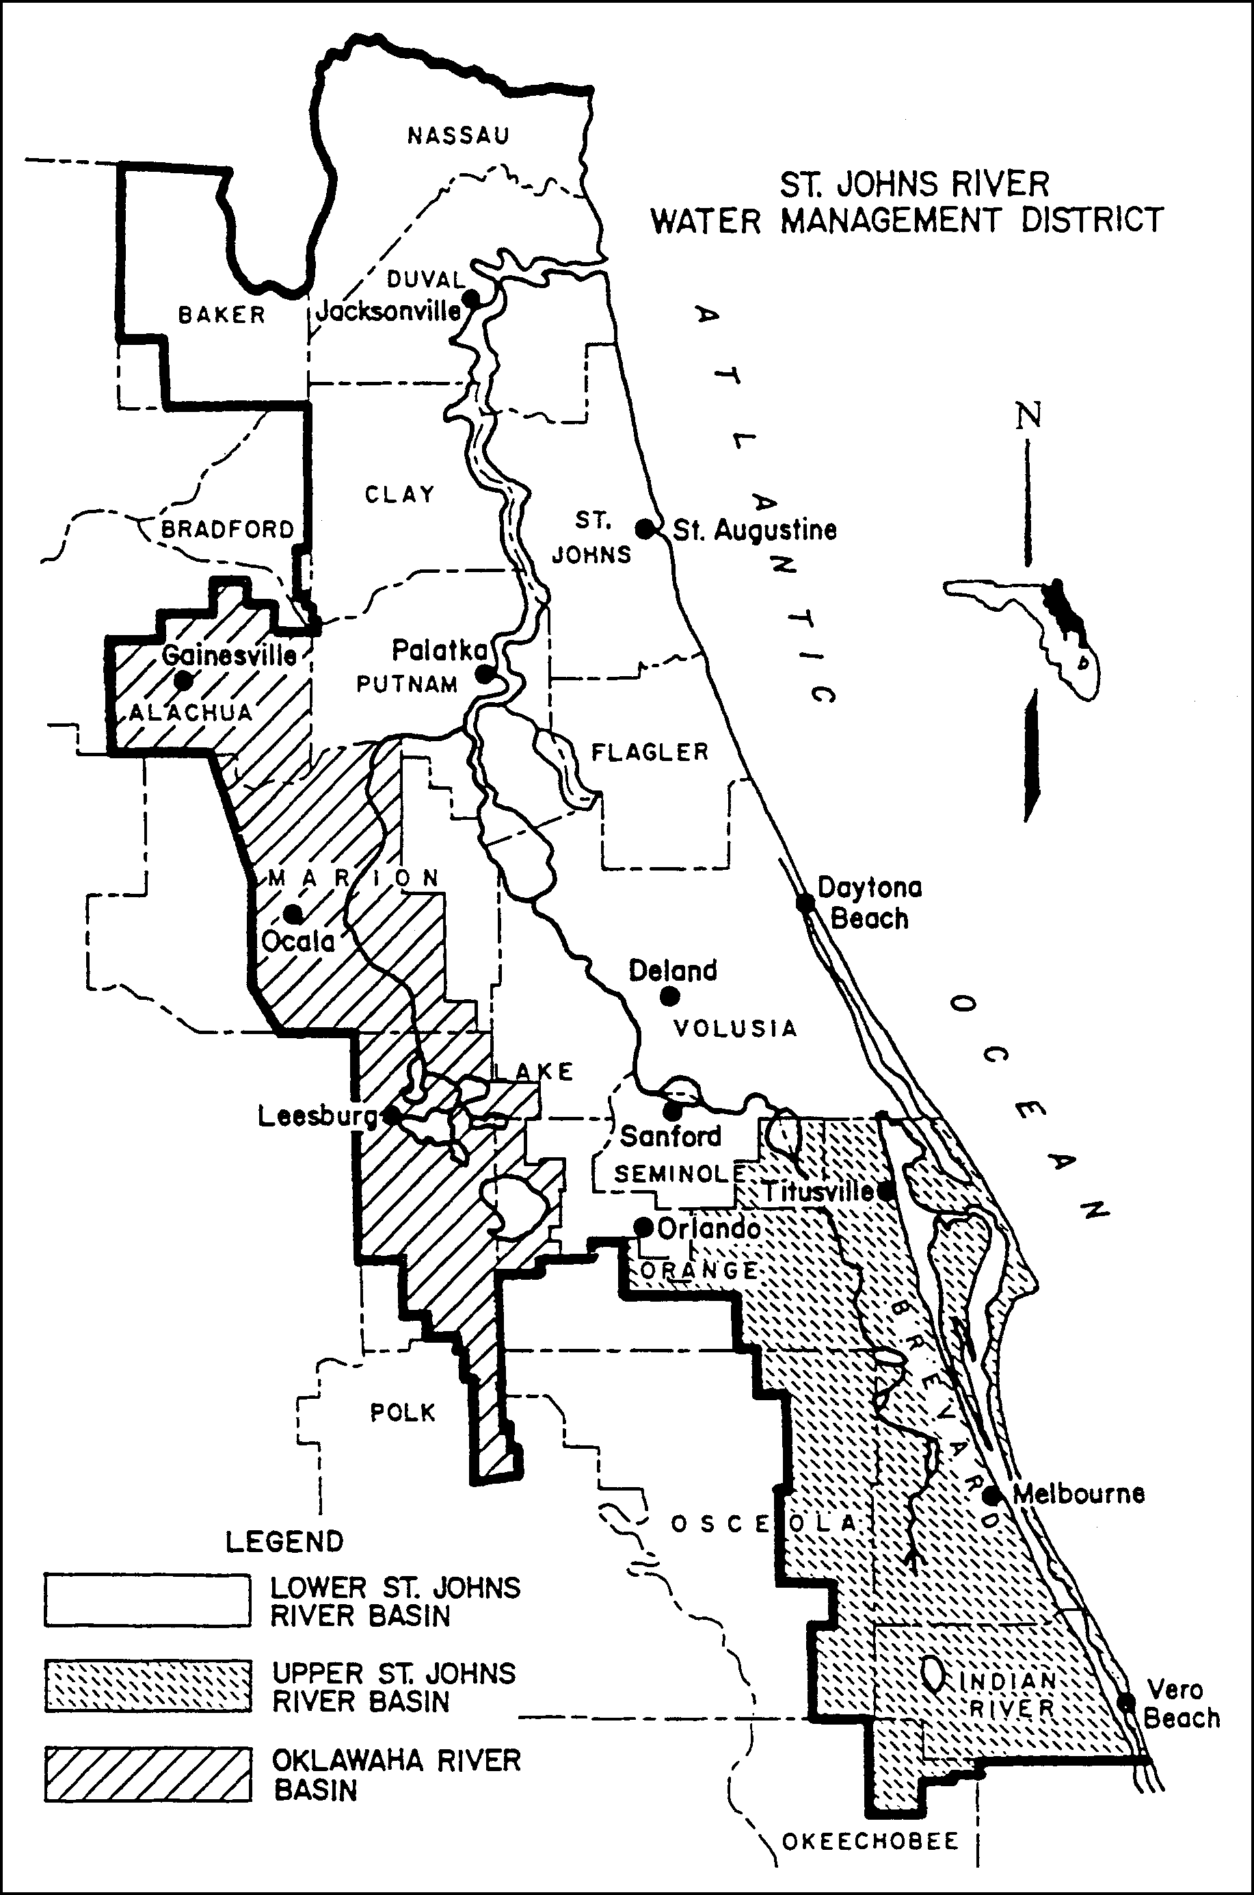

Figure 1.3-1 Areas within the District Having Differing Effective Dates for Implementation of Management and Storage of Surface Water Rules

1.3.3 Agricultural Surface Water Management Systems

Each system that requires an individual permit solely pursuant to section 1.2.3 of this Volume shall be exempt from the requirements in rules 62- 330.060, 62-330.062, 62-330.090(1),(4) and (6), 62-330.301, 62-330.302, 62-330.310, 62-330.311, 62-330.315, 62-330.320, 62-330.340, and 62-330.350. Permit applications for such systems shall be filed, reviewed and acted upon in accordance with chapter 40C-44, F.A.C., and Part VII of this Volume. Once authorized, such systems shall be constructed, operated and maintained in accordance with 40C-44, F.A.C., and Part VII of this Volume.

PART II – GENERAL CRITERIA

2.0 Criteria for Evaluation – Reasonable Assurance

Except as provided in section 1.2.3 of this Volume, an applicant for an individual permit must provide reasonable assurance that the proposed activities will meet the criteria in rules 62-330.301 and 62-330.302, F.A.C. More specifically, under 62-330.301, F.A.C., an applicant must provide reasonable assurance that the construction, alteration, operation, maintenance, removal or abandonment of a project within SJRWMD:

(a) Will not cause adverse water quantity impacts to receiving waters and adjacent lands (62-330.301(1)(a), F.A.C.);

(b) Will not cause adverse flooding to on-site or off-site property (62- 330.301(1)(b), F.A.C.);

(c) Will not cause adverse impacts to existing surface water storage and conveyance capabilities (62-330.301(1)(c), F.A.C.);

(d) Will not adversely impact the value of functions provided to fish and wildlife and listed species by wetlands and other surface waters (62- 330.301(1)(d), F.A.C.);

(e) Will not adversely affect the quality of receiving waters such that the water quality standards set forth in Chapters 62-4, 62-302, 62-520, and 62-550, F.A.C.,
(incorporated by reference in 40C-4.091(1)(c)) including the antidegradation provisions of paragraphs 62- 4.242(1)(a) and (b), F.A.C., subsections 62-4.242(2)
and (3), F.A.C., and Rule 62-302.300, F.A.C., and any special standards for Outstanding Florida Waters and Outstanding National Resource Waters set forth in subsections 62-4.242(2) and (3), F.A.C., will be violated (62-330.301(1)(e), F.A.C.);

(f) Will not cause adverse secondary impacts to the water resources (62- 330.301(1)(f), F.A.C.;

(g) Will not adversely impact the maintenance of surface or ground water levels or surface water flows established in Chapter 40C-8, F.A.C., (effective date) (62-330.301(1)(g), F.A.C.);

(h) Will not cause adverse impacts to a Work of the District established pursuant to Section 373.086, F.S. (62-330.301(1)(h), F.A.C.);

(i) Will be capable, based on generally accepted engineering and scientific principles, of being performed and of functioning as proposed (62- 330.301(1)(i), F.A.C.);

(j) Will be conducted by a person with the financial, legal and administrative capability of ensuring that the activity will be undertaken in accordance with the terms and conditions of the permit, if issued (62-330.301(1)(j), F.A.C.); and

(k) Will comply with the applicable special basin or geographic area criteria in Chapter 40C-41, F.A.C. (62-330.301(1)(k), F.A.C.);

The provisions in this Volume and in Volume I explain how applicants may provide the requisite reasonable assurance to demonstrate compliance with these criteria within SJRWMD. In certain instances, an applicant for an individual permit that involves an agricultural surface water management system will be governed solely by Chapter 40C- 44, F.A.C. and Part VII of this Volume. (See subsection 62-330.054(2), F.A.C. and subsections 1.2.3 and 1.3.3 of this Volume) Therefore, the District recommends that applicants whose projects involve an agricultural surface water management system that only exceeds the thresholds set forth in section 1.2.3 of this Volume initially consult Part VII of this handbook.

2.1 Definitions

The following definitions are used by the District to clarify its intent in implementing its permitting programs pursuant to part IV, chapter 373, F.S.

(a) “Compensating treatment” means treatment for water quality in an offsite location when physical conditions do not allow for treatment on-site equivalent to that otherwise required by Chapter 62-330, F.A.C., and Environmental Resource Permit Applicant’s Handbook Volume II: For Use Within the Geographic Limits of the St. Johns River Water Management District.”

(b) "Control Device" or "Bleed-down Device" means that element of a discharge structure which allows the gradual release of water under controlled conditions.

(c) "Control Elevation" means the lowest elevation at which water can be released through the control device or withdrawn by a stormwater harvesting system.

(d) "Detention with filtration" or "Filtration" means the selective removal of pollutants from stormwater by the collection and temporary storage of stormwater and the subsequent gradual release of the stormwater into surface waters in the state through at least 2 feet of suitable fine textured granular media such as porous soil, uniformly graded sand, or other natural or artificial fine aggregate, which may be used in conjunction with filter fabric and/or perforated pipe.

(e) "Detention" or "To Detain" means the collection and temporary storage of stormwater with subsequent gradual release of the stormwater.

(f) "Direct Discharge" means, for purposes of this Volume, either a point or nonpoint discharge which enters Class I, Class II, Outstanding Florida Waters, or Class III waters which are approved, conditionally approved, restricted, or conditionally restricted for shellfish harvesting without an adequate opportunity for mixing and dilution to prevent significant degradation. Examples of direct discharge include the following:

(1) Discharge without entering any other water body or conveyance prior to release to the Class I, Class II, Outstanding Florida Water, or Class III waters which are approved, conditionally approved, restricted, or conditionally restricted for shellfish harvesting.

(2) Discharge into an intermittent watercourse which is a tributary of a Class I, Class II, Outstanding Florida Water, or Class III waters which are approved, conditionally approved, restricted, or conditionally restricted for shellfish harvesting.

(3) Discharge into a perennial watercourse which is a tributary of a Class I, Class II, Outstanding Florida Water, or Class III waters which are approved, conditionally approved, restricted, or conditionally restricted for shellfish harvesting when there is not an adequate opportunity for mixing and dilution to prevent significant degradation.

(g) "Dry Detention" means a system designed to collect and temporarily store stormwater in a normally dry basin with subsequent gradual release of the stormwater.

(h) "Effective Grain Size" means the diameter of filter sand or other aggregate that corresponds to the 10 percentile finer by dry weight on the grain size distribution curve.

(i) Floodway - The permanent channel of a stream or other watercourse, plus any adjacent floodplain areas that must be kept free of any encroachment in order to discharge the 100 year flood without cumulatively increasing the water surface elevation more than a designated amount (not to exceed one foot except as otherwise established by the District or established by a Flood Insurance Rate Study conducted by the Federal Emergency Management Agency (FEMA) ).

(j) Hydrologically Sensitive Area - Wetlands and those geographical areas which are specifically designated as hydrologically sensitive areas by the Board because of the importance of the hydrology and hydraulics of the area in meeting the Legislative policy contained in section 373.016, F.S.

(k) "Intermittent Watercourse" means a stream or waterway that flows only at certain times of the year, flows in a direct response to rainfall, and is normally an influent stream except when the ground water table rises above the normal wet season level.

(l) Littoral Zone - In reference to stormwater management systems, this phrase shall mean that portion of a wet detention pond which is designed to contain rooted aquatic plants.

(m) "Off-line" means the storage of a specified portion of the stormwater in such a manner so that subsequent runoff in excess of the specified volume of stormwater does not flow into the area storing the initial stormwater.

(n) "Perennial Watercourse" means a stream or waterway which is not an intermittent watercourse.

(o) Permanent Pool - That portion of a wet detention pond which normally holds water (e.g., between the normal water level and the pond bottom).

(p) "Reconstruction" means rebuilding or construction in an area upon which construction has previously occurred.

(q) "Retention" means a system designed to prevent the discharge of a given volume of stormwater runoff into surface waters in the state by complete on-site storage. Examples may include excavated or natural depression storage areas, pervious pavement with subgrade, or above ground storage areas.

(r) "Seasonal high ground water table elevation" means the highest level of the saturated zone in the soil in a year with normal rainfall.

(s) "Stormwater Discharge Facility" means a stormwater management system which discharges stormwater into surface waters of the state.

(t) "Stormwater Harvesting" means to prevent the discharge of a given volume of stormwater into surface waters of the state by deliberate application of stormwater for irrigation (such as irrigation of golf courses, cemeteries, highway medians, parks, playgrounds, school yards, retail nurseries, agricultural lands, and residential and commercial properties) or industrial uses (such as cooling water, process water, and wash water).

(u) "Swale" means a manmade trench which:

(1) Has a top width to depth ratio of the cross-section equal to or greater than 6:1, or side slopes equal to or greater than 3 feet horizontal to 1 foot vertical.

(2) Contains contiguous areas of standing or flowing water only following a rainfall event.

(3) Is planted with or has stabilized vegetation suitable for soil stabilization, stormwater treatment, and nutrient uptake.

(4) Is designed to take into account the soil erodibility, soil percolation, slope, slope length, and drainage area so as to prevent erosion and reduce pollutant concentration of any discharge.

(v) Traversing Work - Any artificial structure or construction that is placed in or across a stream, or other watercourse, or an impoundment

(w) "Underdrain" means a drainage system installed beneath a stormwater holding area to improve the infiltration and percolation characteristics of the natural soil when permeability is restricted due to periodic high water table conditions or the presence of layers of fine textured soil below the bottom of the holding area. These systems usually consist of a system of interconnected below-ground conduits such as perforated pipe, which simultaneously limit the water table elevation and intercept, collect, and convey stormwater which has percolated through the soil.

(x) "Underground Exfiltration Trench" or "Exfiltration Trench" means a below-ground system consisting of a conduit such as perforated pipe surrounded by natural or artificial aggregate which is utilized to percolate stormwater into the ground.

(y) "Uniformity Coefficient" means the number representing the degree of homogeneity in the distribution of particle sizes of filter sand or other granular material. The coefficient is calculated by determining the D60/D10 ratio where D10 and D60 refer to the particle diameter corresponding to the 10 and 60 percentile of the material which is finer by dry weight.

(z) Wet Detention - means the collection and temporary storage of stormwater in a permanently wet impoundment in such a manner as to provide for treatment through physical, chemical, and biological processes with subsequent gradual release of the stormwater.

(aa) "Wetlands Stormwater Management System" means a stormwater management system which incorporates those wetlands described in section 10.2 of this Volume II, into the stormwater management system to provide stormwater treatment.

2.2 Existing Ambient Water Quality

In instances where an applicant is unable to meet water quality standards because existing ambient water quality does not meet standards and the system will contribute to this existing condition, mitigation for water quality impacts can consist of water quality enhancement. In these cases, the applicant must implement mitigation measures that will cause net improvement of the water quality in the receiving waters for those parameters which do not meet standards. (see paragraph 373.414(1)(b), F.S. and section 8.2.3 of Volume I)

2.3 Professional Certification

All construction plans and supporting calculations submitted to the District must be signed, sealed, and dated by the appropriate registered professional (e.g., engineer, geologist, or landscape architect) as required by the relevant statutory provisions (i.e., chapters 471, 472, 481, or 492, F.S.) when the design of the project requires the services of a registered professional.

2.4 Maintenance Access

Regular maintenance is crucial to the long term effectiveness of stormwater management systems. The systems must be designed to permit personnel and equipment access and to accommodate regular maintenance activities. For example, high maintenance features such as inlets, outlets, and pumps should be easily accessible to maintenance equipment and personnel.

Legal authorization, such as an easement, deed restrictions, or other instrument must be provided establishing a right-of-way or access for maintenance of the stormwater management system unless the operation and maintenance entity wholly owns or retains ownership of the property. The following are requirements for specific types of maintenance access easements:

(a) Easements must cover at least the primary and high maintenance components of the system (i.e., inlets, outlets, littoral zones, filters, pumps, etc.).

(b) Easements for waterbodies, open conveyance systems, stormwater basins and storage areas must meet the following requirements:

1. Include the area of the water surface measured at the control elevation

2. Be a minimum of 20 feet from the edge of water at the control elevation or top of bank and include side slopes no steeper than 4H:1V

(c) Easements adjacent to water control structures must be 20 feet wide.

(d) Easements for piped stormwater conveyance must be a minimum of the width of the pipe plus 4 times the depth of the pipe invert.

(e) Access easements must be 20 feet wide from a public road or public right-of-way to the stormwater management system.

(f) As an alternative, the applicant may propose other authorization for maintenance access provided the applicant affirmatively demonstrates that equipment can enter and perform the necessary maintenance on the system.

A copy of the legal authorization must be submitted with the permit application.

2.5 Legal Authorization

Applicants which propose to utilize offsite areas not under their control to satisfy the
criteria for evaluation listed in section 2.0 must obtain sufficient legal authorization prior to permit issuance to use the area. For example, an applicant who proposes to locate the outfall pipe from the stormwater basin to the receiving water on an adjacent property owner's land must obtain a drainage easement or other appropriate legal authorization from the adjacent owner. A copy of the legal authorization must be submitted with the permit application.

2.6 Public Safety

2.6.1 Basin Side Slopes

Normally dry basins designed to impound more than two feet of water or permanently wet basins must contain side slopes that are no steeper than 4H:1V out to a depth of two feet below the control elevation. As an alternative, the basins can be fenced or otherwise restricted from public access if the slopes must be steeper due to space or other constraints.

2.6.2 Basin Side Slope Stabilization

All stormwater basin side slopes shall be stabilized by either vegetation or other material to minimize erosion of the basin.

Stabilization of side slopes is necessary in order to prevent erosion due to flow velocity and runoff from the banks. Good engineering practices, taking into consideration soil characteristics, flow and drainage characteristics, shall be employed. Again, the retardation of overland runoff and soil stabilization using naturally occurring vegetation coverage shall be considered before paving, riprap, lining, energy dissipation and other structural measures are employed.

2.6.3 Control Structures

Control structures that are designed to contain more than two feet of water within the
structure under the design storm and have openings of greater than one foot minimum dimension must be restricted from public access.

2.7 Tailwater Considerations

"Tailwater" refers to the water elevation (or pressure) at the final discharge part of the stormwater management system. Tailwater is an important component of the design and operation of nearly all stormwater management systems and can affect any of the following management objectives of the system:

(a) Peak discharge from the stormwater management system

(b) Peak stage in the stormwater management system

(c) Level of flood protection in the project

(d) Recovery of peak attenuation and stormwater treatment volumes

(e) Control elevations, normal water elevation regulation schedules, and ground water management

2.7.1 Tailwater for Water Quality Design

For recovery of the stormwater treatment volume, stormwater management systems
(except retention and exfiltration systems) must provide a gravity or pumped discharge that effectively operates (i.e., meets applicable criteria) under one of the following tailwater conditions:

(a) Maximum stage in the receiving water resulting from the mean annual 24-hour storm. This storm depth is shown on the isopluvial map in Figure 2.7.1-1 Generally, applicants utilizing this option would model the receiving waters utilizing standard hydrologic and hydraulic methods for the mean annual 24-hour storm to determine peak stages at various points of interest. Lower stages may be utilized if the applicant demonstrates that flow from the project will reach the receiving water prior to the time of maximum stage in the receiving water.

(b) Mean annual high tide for tidal areas. This elevation is the average of all the high tides for each year. This elevation may be determined from tide charts or other similar information.

(c) Mean annual seasonal high water elevation. This elevation may be determined by water lines on vegetation or structures, historical data, adventitious roots or other hydrological or biological indicators, design of man-made systems, or estimated by a registered professional using standard hydrological methods based on the site and receiving water characteristics.

(d) The applicant may propose applicable criteria established by a local government, state agency, or stormwater utility with jurisdiction over the project. However, the District must approve the use of alternative criteria. In this case, the applicant is encouraged to consult with District staff prior to submitting an application.

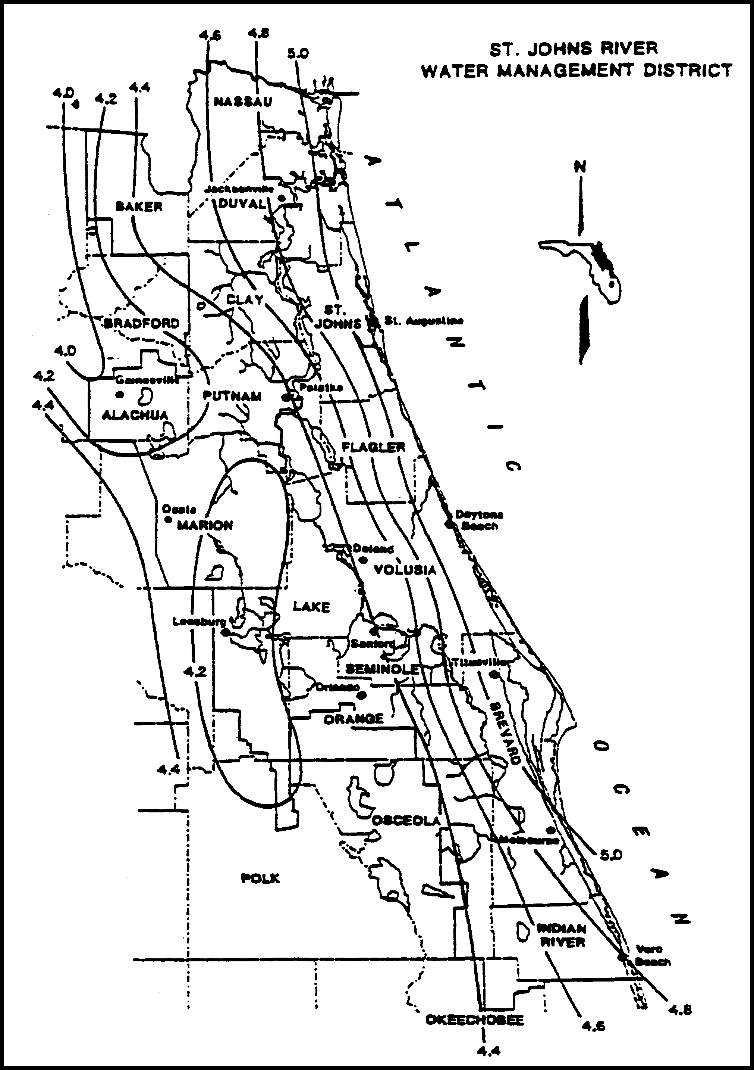

Figure 2.7.1-1 Mean Annual 24-Hour Maximum Rainfall, inches (Source: Rao, 1991)

2.7.2 Tailwater for Water Quantity Design

Receiving water stage can affect the amount of flow which will discharge from the project to the receiving water. This stage may be such that tailwater exists in portions of the project system, reducing the effective flow or storage area. Typical examples of this are illustrated in Figures 2.7.2-1 (gravity) and 2.7.2-2 (pumped).

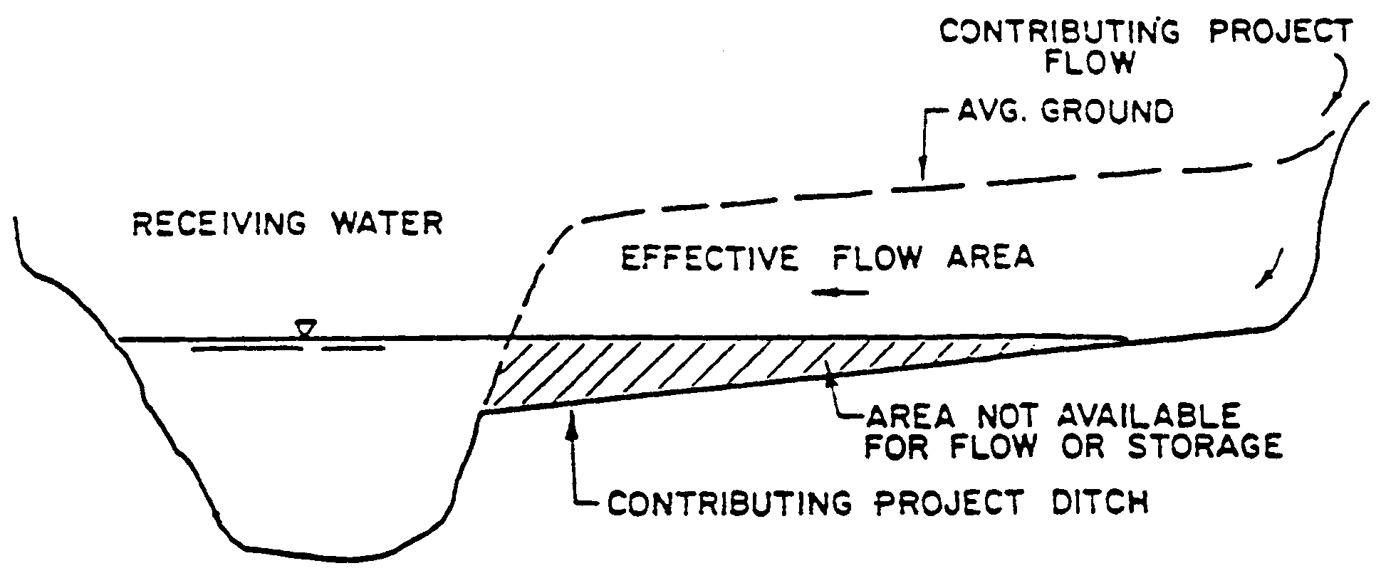
Figure 2.7.2-1

The stage in the receiving water should be considered to be the maximum stage which would exist in the receiving water from a storm equal to the project design storm. Lower stages may be used if the applicant can show that the flow from his project will reach the receiving water prior to the time of maximum stage in the receiving water.

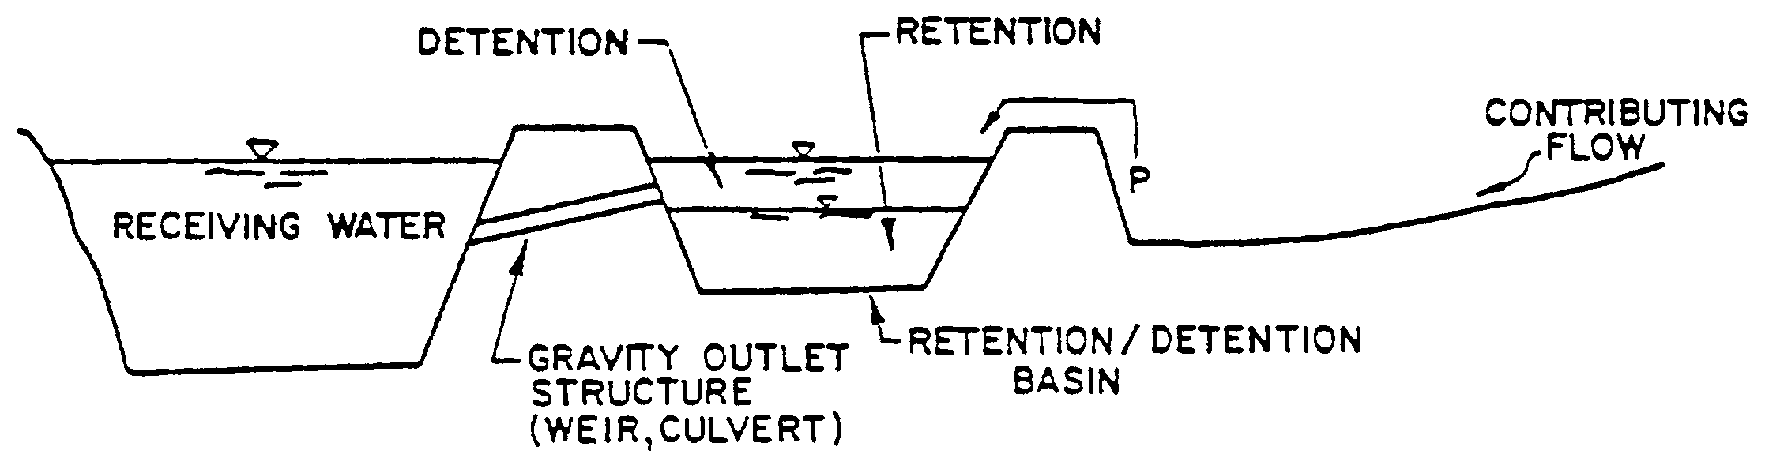

Figure 2.7.2-2

2.8 Applicant Responsibility

Except as provided in Part VII of this Volume, the applicant:

(a) must provide for an operation and maintenance entity as required in Part V of Applicant’s Handbook Volume I.

(b) is responsible for converting the permit from the construction phase to the operation and maintenance phase, as required in Rule 62-330.310 and section 6.1.4 of Applicant’s Handbook Volume I.

(c) is responsible for notifying the Agency of any transfer of permit,
ownership, or sale, including applying to the Agency for transfer of ownership using Form 62-330.340(1) within 30 days of such transfer (Rule 62-330.340, F.A.C.)

2.9 Operation and Maintenance

Except as provided in Part VII of this Volume, all systems under this Volume must be transferred to an operation and maintenance entity as provided in Rule 62-330.340, F.A.C. and Part V of Applicant’s Volume I.

2.10 Retrofits of Existing Surface Water Management Systems

(a) A stormwater retrofit project is typically proposed by a county, municipality, state agency, or water management district to provide new or additional treatment or attenuation capacity, or improved flood control to an existing stormwater management system or systems. Stormwater retrofit projects shall not be proposed or implemented for the purpose of providing the water quality treatment or flood control needed to serve new development or redevelopment.

Example components of stormwater retrofit projects are:

1. Construction or alteration that will add additional treatment or attenuation capacity and capability to an existing stormwater management system;

2. Modification, reconstruction, or relocation of an existing stormwater management system or stormwater discharge facility;

3. Stabilization of eroding banks through measures such as adding attenuation capacity to reduce flow velocities, planting of sod or other vegetation, and installation of rip rap boulders;

4. Excavation or dredging of sediments or other pollutants that have accumulated as a result of stormwater runoff and stormwater discharges.

(b) Stormwater Quality Retrofits

1. The applicant for a stormwater quality retrofit project must provide reasonable assurance that the retrofit project itself will, at a minimum provide additional water quality treatment such that there is a net reduction of the stormwater pollutant loading into receiving waters. Examples are:

(a) Addition of treatment capacity to an existing stormwater management system such that it reduces stormwater pollutant loadings to receiving waters;

(b) Adding treatment or attenuation capability to an existing developed area when either the existing stormwater management system or the developed area has substandard stormwater treatment and attenuation capabilities, compared to what would be required for a new system requiring a permit under Part IV of Chapter 373, F.S.; or

(c) Removing pollutants generated by, or resulting from, previous stormwater discharges.

2. If the applicant has conducted, and the Agency has approved, an analysis that provides reasonable assurance that the proposed stormwater quality retrofit will provide the intended pollutant load reduction from the existing system or systems, the project will be presumed to comply with the requirements in sections 4.0 through 4.5 of this Volume.

3. The pollutants of concern will be determined on a case-by-case basis during the permit application review based upon factors such as the type and intensity of land use, existing water quality data within the area subject to the retrofit, and the degree of impairment or water quality violations in the receiving waters.

(c) Stormwater Quantity (Flood Control) Retrofits

The applicant for a stormwater quantity retrofit project must provide reasonable assurance that the retrofit project will reduce existing flooding problems in such a way that it does not cause any of the following:

1. A net reduction in water quality treatment provided by the existing stormwater management system or systems;

2. Increased discharges of untreated stormwater entering adjacent or receiving waters;

If the applicant has conducted, and the Agency has approved, an analysis that provides reasonable assurance that the stormwater quantity retrofit project will comply with the above, the project will be presumed to comply with the requirements in sections 3.1 through 3.3 of this Volume.

(d) The applicant for any stormwater retrofit project must design, implement, and operate the project so that it:

1. Will not cause or contribute to a water quality violation;

2. Does not reduce stormwater treatment capacity or increase discharges of untreated stormwater. Where existing ambient water quality does not meet water quality standards the applicant must demonstrate that the proposed activities will not cause or contribute to a water quality violation. If the proposed activities will contribute to the existing violation, measures shall be proposed that will provide a net improvement of the water quality in the receiving waters for those parameters that do not meet standards.

3. Does not cause any adverse water quality impacts in receiving waters; or

4. Will not cause or contribute to increased flooding of adjacent lands or cause new adverse water quantity impacts to receiving waters.

2.11 Flexibility for State Transportation Projects and Facilities

With regard to state linear transportation projects and facilities, the District shall be governed by subsection 373.413(6), F.S. (2012).

PART III – STORMWATER QUANTITY/FLOOD CONTROL

3.0 General Flood Control Performance Criteria

Urbanization increases total runoff volume, peak discharge rates, and the
magnitude and frequency of flood events. With an increase in the number of flood events a stream is subjected to, the potential for accelerated erosion of both the stream banks and channel bottom is enhanced. Proper design of detention systems to limit post-development peak discharge rates to predevelopment rates can minimize some of the stormwater effects of urbanization.

3.1 Projects That Must Meet Water Quantity Criteria

Projects that do not exceed the thresholds listed in paragraphs 3.1 (a)–(h) below shall have a rebuttable presumption that they meet the criteria for issuance in paragraphs 2.0 (a)–(c) if they are designed to meet the standards listed in subsections 3.2.1 (a) and 3.3.1. Projects that exceed any of the thresholds listed in paragraphs 3.1 (a)–(h) shall have a rebuttable presumption that they meet the criteria for issuance in paragraphs 2.0 (a)–(c) if they are designed to meet the standards in subsections 3.2.1, 3.3.1, 3.3.2, 3.4.1, 3.5.1 and 3.5.2.

(a) Is capable of impounding a volume of water of 40 or more acre- feet;

(b) Serves a project with a total land area equal to, or exceeding 40 acres;

(c) Provides for the placement of 12 or more acres of impervious surface which constitutes 40 or more percent of the total land area;

(d) Is wholly or partially located in, on, or over any wetland or other surface water.

(e) Serves a project with a total land area equal to or exceeding ten acres, when any part of the project is located within the Wekiva River Hydrologic Basin north of State Road 436, within the Econlockhatchee River Hydrologic Basin, within the Tomoka River Hydrologic Basin, or within the Spruce Creek Hydrologic Basin;

(f) Provides for the placement of one-half acre or more of impervious surface, when any of the impervious surface is located within the Wekiva River Hydrologic Basin north of State Road 436;

(g) Provides for the placement of two acres or more of impervious surface, when any of the impervious surface is located within the Econlockhatchee River Hydrologic Basin, within the Tomoka River Hydrologic Basin, or within the Spruce Creek Hydrologic Basin; or

(h) Is wholly or partially located within the Wekiva River Hydrologic Basin's Riparian Habitat Protection Zone as described in Paragraph 40C-41.063(3)(e).

3.2 Design Standards for Flood Protection

3.2.1 Water Quantity

(a) The post-development peak discharge rate must not exceed the pre-development peak rate of discharge for the mean annual 24- hour storm for systems serving both of the following:
1. New construction area greater than 50% impervious (excluding waterbodies)

2. Projects for the construction of new developments that exceed the thresholds in paragraphs 62-330.020(2)(b) or (c), F.A.C.
Note: Both of these conditions must be met before a project is required to comply
with the peak discharge criterion. Also, projects which modify existing systems are exempt from this criterion pursuant to condition 2., above. Pervious concrete and turf blocks are not considered impervious surface for this purpose, however,
compacted soils and limerock are considered impervious for purposes of this subsection.

(b) The post-development peak rate of discharge must not exceed the pre-development peak rate of discharge for the 25-year frequency, 24-hour duration storm for all areas of the District except:
1. For those systems which discharge directly into the St. Johns River north of Lake George, the man-made portions of the Intracoastal Waterway, the Intracoastal Waterway north of the Matanzas Inlet, or the Atlantic Ocean.

2. Where separate basin criteria have been adopted (see section 13.0). Projects located in areas for which separate basin criteria have been developed must meet the flood protection design standards specified by the basin criteria.
(c) The post-development volume of direct runoff must not exceed the pre-development volume of direct runoff for the 25-year frequency, 96-hour duration storm for systems discharging to land- locked lakes which are adjacent to properties of more than one ownership. These systems shall not cause an increase in the total pre-development flood stage. This can be accomplished through retention with percolation or, if the soil conditions are not sufficient for percolation, then through detention for a duration sufficient to mitigate adverse impacts on flood stages.
(d) Systems which are within areas for which separate basin criteria have been adopted pursuant to Chapter 40C-41, F.A.C., must meet the applicable volume and rate requirements found in section 13.0.

3.2.2 Alternative Peak Discharge Criteria

The applicant has two options for providing reasonable assurances that the standards referenced in subsection 3.2.1 (a) and (b) are met. The applicant may make such demonstration through compliance with the criteria specified in subsection 3.2.1 (a) and (b) or applicants may propose to utilize the applicable storm even, duration, or criteria specified by a local government, state agency (including FDOT), or stormwater utility with jurisdiction over the project or by use of alternative methods as may be appropriate for the specific system. However, the District must review and approve the use of the alternative criteria. Applicants proposing to use alternative criteria are encouraged to have a preapplication conference with District Staff.

3.2.3 Methodologies

(a) A peak discharge analysis typically consists of generating pre- development and post-development runoff hydrographs, routing the post-development hydrograph through a detention basin, and sizing an overflow structure to control post-development discharges at or below predevelopment rates.

Peak discharge computations should consider the duration, frequency, and intensity of rainfall, the antecedent moisture conditions, upper soil zone and surface storage, time of concentration, tailwater conditions, changes in land use or land cover, and any other changes in topographic and hydrologic characteristics. Large systems should be divided into subbasins according to artificial or natural drainage divides to allow for more accurate hydrologic simulations.

The Natural Resources Conservation Service (NRCS) Curve Number Method is an example of an accepted methodology (see SJ No. 85-5: A Guide to SCS Runoff Procedures (1985) and
incorporated by reference in 40C-4.091(1)(e)).

(b) The modified rational method (see Appendix C of this Volume, incorporated
by reference in 40C-4.091(1)(a)) is a popular method for estimating peak
runoff rates for small urban areas. The rational method gives peak discharge
rates rather than a runoff hydrograph. The modified rational formula can be
modified to generate a runoff hydrograph by utilizing the rainfall intensity
for various increments of a design storm. Similar to the rational method, use
of the modified rational hydrograph method should be limited to small
drainage basins with short times of concentration. Therefore, the modified
rational method shall only be used for systems meeting the following
criteria:

(1) The drainage area is less than 40 acres.

(2) The predevelopment time of concentration for the system is less than 60 minutes.

(3) The post-development time of concentration for the system is less than 30 minutes.

The modified rational hydrograph method shall only be utilized for the mean annual return frequency, 24 hour duration storm.

3.2.4 Computer Programs Accepted by the District

Numerous computer programs have been written to solve the runoff hydrograph and
detention basin routing calculations required in a peak discharge analysis. If the
model is sound from a theoretical standpoint and the results compare favorably with
those of a benchmark standard model (such as HEC-1), the program is accepted for
use.

3.2.5 Aggregate Discharge

Depending on the location and design of large systems where multiple off-site
discharges are designed to occur, the District may allow the total post-development
peak discharge not to exceed the pre-development peak discharge for the combined
discharges rather than for each individual discharge. Such a consideration shall be
made only if the combined discharges meet all other requirements of chapter 62-
330, F.A.C., and discharge to the same receiving water body.

3.2.6 Rainfall Intensity

In determining peak discharge rates, intensity of rainfall values shall be obtained
through a statistical analysis of historical long term rainfall data or from sources or
methods generally accepted as good engineering practice.

(a) Examples of acceptable sources include:

1. USDA Soil Conservation Service, "Rainfall Frequency Atlas of Alabama, Florida, Georgia, and South Carolina for Durations from 30 Minutes to 24 Hours and Return Periods from 1 to 100 Years" January 1978; Gainesville, Florida.

2. U.S. Weather Bureau Technical Paper No. 49.

3. U.S. Weather Bureau Technical Paper No. 40.

4. U.S. Department of Interior, Bureau of Reclamation, "Design of Small Dams", 2nd Edition.

(b) For a drainage basin greater than 10 square miles, the areal rainfall can be calculated from point rainfall using a method that has been well documented. The converting factor as described in U.S. Weather Bureau Technical Paper No. 49 may be used.

3.2.7 System Recovery

Where basins are designed for reducing post-development peak rate discharge and volume, the outlet and regulation schedule should be designed to provide necessary design detention and retention storage within 14 days following any storm event.

3.2.8 Upper Soil Zone Storage and Surface Storage

In most instances, the upper soil zone storage and surface storage capacities will have an effect on the pre-development and post-development peak discharges and should be considered in these computations. Any generally accepted and well documented method may be used to develop the upper soil zone storage and surface storage values.

(a) The soil zone storage at the beginning of a storm should be estimated by
using reasonable and appropriate parameters to reflect drainage practices,
average wet season water table elevation, the antecedent moisture condition
(AMC II) and any underlying soil characteristics which would limit or
prevent percolation of storm water into the entire soil column. In no case
should the soil storage used in the computation exceed the difference
between the maximum soil water capacity and the field capacity (i.e.,
gravitational water) for the soil columns above any impervious layer or
seasonal ground water table.

(b) Surface storage, including that available in wetlands and low lying areas,
shall be considered as depression storage. Depression storage shall be
analyzed for its effect on peak discharge and the time of concentration.
Depression storage can also be considered in post- development storage
routing which would require development of stage-storage relationships; if
depression storage is considered, then both pre-development and post-
development storage routing must be considered.

3.3 Storage and Conveyance

3.3.1 Conveyance

Projects which alter existing conveyance systems (e.g., rerouting an existing ditch) must not adversely affect existing conveyance capabilities. It is presumed a system will meet this criterion if one of the following are met:

(a) The existing hydraulic capacity is maintained in the new system. This can be accomplished by maintaining existing headwater and tailwater conditions.

(b) The applicant demonstrates that changes in flood elevation and velocities will not adversely impact upstream or downstream off- site property. For example, this criterion may be satisfied by demonstrating that there is no increase in damages to existing off- site property (e.g., roads, buildings) resulting from changes in the existing flood elevations. Also, the applicant should demonstrate that proposed velocities are non-erosive or that erosion control measures (e.g., rip-rap, concrete lined channels, etc.) are sufficient to safely convey the flow.

(c) The criterion in paragraph 3.3.2(b) is met.

(d) As an alternative, the applicant may propose to utilize an applicable criterion established by a local government, state agency, or stormwater utility with jurisdiction over the project. However, District staff must approve the use of this criterion.

3.3.2 Floodways and Floodplain Storage

Floodways and floodplains, and levels of flood flows or velocities of adjacent streams, impoundments or other water courses must not be altered so as to adversely impact the off-site storage and conveyance capabilities of the water resource. It is presumed a system will meet this criterion if the following are met:

(a) A system may not cause a net reduction in flood storage within a 10- year floodplain except for structures elevated on pilings or traversing works. Traversing works, works or other structures shall cause no more than a one-foot increase in the 100-year flood elevation immediately upstream and no more than one tenth of a foot increase in the 100-year flood elevation 500 feet upstream. A system will not cause a net reduction in flood storage within a 10-year floodplain if compensating storage is provided outside the 10-year floodplain.

(b) A system may not cause a reduction in the flood conveyance capabilities provided by a floodway except for structure elevated on pilings or traversing works. Such works, or other structures shall cause no more than a one-foot increase in the 100-year flood elevation immediately upstream and no more than one tenth of a foot increase in the 100-year flood elevation 500 feet upstream.

(c) An applicant may only be permitted to contravene the requirements of (a) or (b) if the applicant gives reasonable assurance that were all other persons who could impact the surface water of any impoundment, stream, or other watercourse by floodplain encroachment to exceed (a) and (b) above to the same degree as the applicant proposes, the cumulative impacts would not contravene subparagraphs 62-330.301(1)(a)-(c), F.A.C.

3.3.3 Level of Service

In evaluating the potential for flood damages to residences, public buildings, or public streets and roadways, the following criteria will be utilized:

(a) Any proposed streets and roadways must be flood-free as required by local government criteria; and

(b) The first floor of any proposed building used for residence or as a public facility, must be set at or above an elevation adopted by local ordinance or, where a local ordinance has not been adopted, at the 100-year flood elevation calculated by the District, or approved by the District based upon the determination of the applicant.

3.3.4 Floodway and Floodplain Elevation Determination

(a) The floodway and floodplain criteria contained in subsection 3.3.2 are applicable only to locations downstream of the point on a stream or watercourse where the drainage area is five square miles.

(b) The District has detailed information regarding floodplain and floodway
elevations for many of the streams and water courses in its jurisdiction. The
applicant is encouraged to consult with the District prior to making
calculations. Other sources of information include the most recently
published data from flood insurance rate studies or relevant engineering
reports. If data are not available from the District, the flood insurance rate
studies, or published reports, the applicant will be responsible for making
determination of floodplain elevations or floodway limits using the
procedure of "Normal Depth Analysis", extrapolation of existing data, or any
other acceptable technique.

3.3.5 Flow Velocity

Good engineering practices shall be employed to minimize the flow velocity to avoid transport of soil particles and other suspended solids from one location and deposition in another location. Many different measures, structural or non- structural, may be used to reduce erosion from the bottom and side slopes of a conveyance system or around the control structures. However, velocity reduction measures and re-vegetation with naturally occurring species of the area should be considered before using other methods of bottom and side slope consolidation.

3.4 Dams and Impoundments

3.4.1 Dams greater than six feet in height or which have a storage capacity of greater than 15 acre-feet of water which could be released in the event of dam failure shall have a spillway system with a capacity to pass the flow resulting from the design storm indicated in Table 3.4.1-1, without overtopping the dam unless the applicant provides analyses to show that the design flood can be stored, passed through, or passed over the dam without failure occurring.

TABLE 3.4.1-1

Hazard  Classification | Storage Capacity  (acre-feet) | Height  (feet) | Design  Storm
A | > 15 | > 6 | 25-yr.
B | < 1000 | < 40 | 25-yr
 |  | 40-100 | 1/2 PMP
 |  | > 100 | PMP
 | 1000-50,000 | < 100 | 1/2 PMP
 |  | > 100 | PMP
 | 50,000 | > 6 | PMP
C | < 1000 | < 40 | 1/2 PMP
 |  | > 40 | PMP
 | > 1000 | > 6 | PMP

3.4.2 Dams greater than six feet in height or which have a storage capacity of greater than 15 acre-feet of water which could be released in the event of dam failure shall have a spillway system capable of removing from the reservoir at least 80% of the water detained in the reservoir above the principal spillway within ten days after passage of the design storm.

3.5 Low Flow and Base Flow Maintenance

Flows of adjacent streams, impoundments or other water courses must not be decreased so as to cause adverse impacts.

3.5.1 Low Flow

(a) Only systems with both of the following conditions meet the low flow
performance criteria in (b) and (c).

1. Systems which impound water for purposes in addition to temporary
detention storage. Water impounded longer than a 14 day bleed
down period is considered conservation storage for benefits other
than detention storage (i.e., recreation, irrigation, etc.).

2. Systems that impound a stream or other water course which, under
pre-development conditions, discharged surface water off-site to
receiving water during 5 year, 30-day drought frequency conditions.

(b) Any system meeting the conditions of (a) above shall be designed with an outlet structure to maintain a low flow discharge of available conservation storage. When the conservation storage is at the average dry season design stage, the low flow discharge should equal the average pre-development surface water discharge which occurred from the project site to receiving waters during the 5-year, 30-day drought.

(c) The system shall be operated to provide a low flow discharge whenever
water is impounded. However, discharge may be discontinued, if desired,
during the wet season (considered as June through October) unless a water
shortage condition is declared by the District. The actual discharge will vary
according to the water stage in the impoundment. When conservation storage
is at the average dry season design stage, the discharge will be the average 5
year, 30-day low flow. When storage is below the average dry season design
stage, the discharge may be less than the average 5 year, 30- day low flow.

3.5.2 Base Flow

It is presumed that an adverse impact will result if the system causes the ground water table to be lowered:

(a) more than an average three feet lower over the project area than the average dry season low water table; or

(b) at any location, more than five feet lower than the average dry season low water table; or

(c) to a level that would decrease the flows or levels of surface water bodies below any minimum level or flow established by the Governing Board pursuant to section 373.042, F.S.

PART IV – STORMWATER QUALITY

4.0 Criterion

Under 62-330.301, F.A.C., an applicant must provide reasonable assurance that the construction, alteration, operation, maintenance, removal or abandonment of a project will not adversely affect the quality of receiving waters such that the water quality standards set forth in Chapters 62-4, 62-302, 62-520, and 62-550, F.A.C., will be violated.

4.1 State Water Quality Standards

State water quality standards are established by DEP and are set forth in chapters 62-4, 62-302, 62-520 and 62-550, F.A.C. Surface and ground water discharges from stormwater management systems, works, and other projects may not cause or contribute to a violation of state water quality standards.

4.1.1 Surface Water Quality Standards

State water quality standards for surface waters are contained in chapters 62-4 and 62-302, F.A.C. The standards apply at the point of mixing of discharge from the system with waters of the state.

4.1.2 Ground Water Quality Standards

State water quality standards for ground water are set forth in chapter 62-520, F.A.C. In addition to the minimum criteria, Class G-I and G-II ground water must meet primary and secondary drinking water quality standards for public water systems established pursuant to the Florida Safe Drinking Water Act, which are listed in sections 62-550.310 and 62-550.320, F.A.C., (incorporated by reference in 40C-
4.091(1)(c)).

Only the minimum criteria apply within a zone of discharge, as determined in section 62-520.400, F.A.C., (incorporated by reference in 40C-4.091(1)(c)). A zone of discharge is defined as a volume underlying or surrounding the site and extending to the base of a specifically designated aquifer or aquifers, within which an opportunity for the treatment, mixture or dispersion of wastes into receiving ground water is afforded. Generally, stormwater systems have a zone of discharge 100 feet from the system boundary or to the project's property boundary, whichever is less.
4.1.3 How Standards May be Met
A showing by the applicant that a project complies with the applicable criteria in Parts II, IV, V and subsection 13.3.1 and sections 13.6 through 13.7 of this Volume and in Part IV of Volume I shall create a rebuttable presumption that the applicant has provided reasonable assurance that the proposed project meets the requirements in subsection 2.0(e) and 62-330.301(1)(e), F.A.C.

4.2 Erosion and Sediment Control Criteria for Stormwater Management Systems,
Works and other Projects

Land clearing actions, including the construction of stormwater management systems or works, shall be designed, constructed, and maintained at all times so that erosion and sedimentation from the system, including the areas served by the system, do not cause or contribute to violations of applicable water quality standards in receiving waters. Further, because sedimentation of off-site lands can lead to public safety concerns, erosion and sediment controls shall be designed and implemented to retain sediment on-site. In particular, the erosion and sediment control requirements described in Part IV of Applicant’s Handbook Volume I shall be followed during construction of the system.

4.3 Oil and Grease Control

Systems which receive stormwater from areas with a greater than 50 percent impervious area (excluding water bodies) or which are a potential source of oil and grease (e.g., gasoline station) must include a baffle, skimmer, grease trap or other mechanism suitable for preventing oil and grease from leaving the stormwater system in concentrations that would cause a violation of water quality standards. A typical illustration of a skimmer on an outlet structure is shown in Figure 4-1.

Figure 4-1. Oil skimmer detail for a typical outfall structure (N.T.S.)
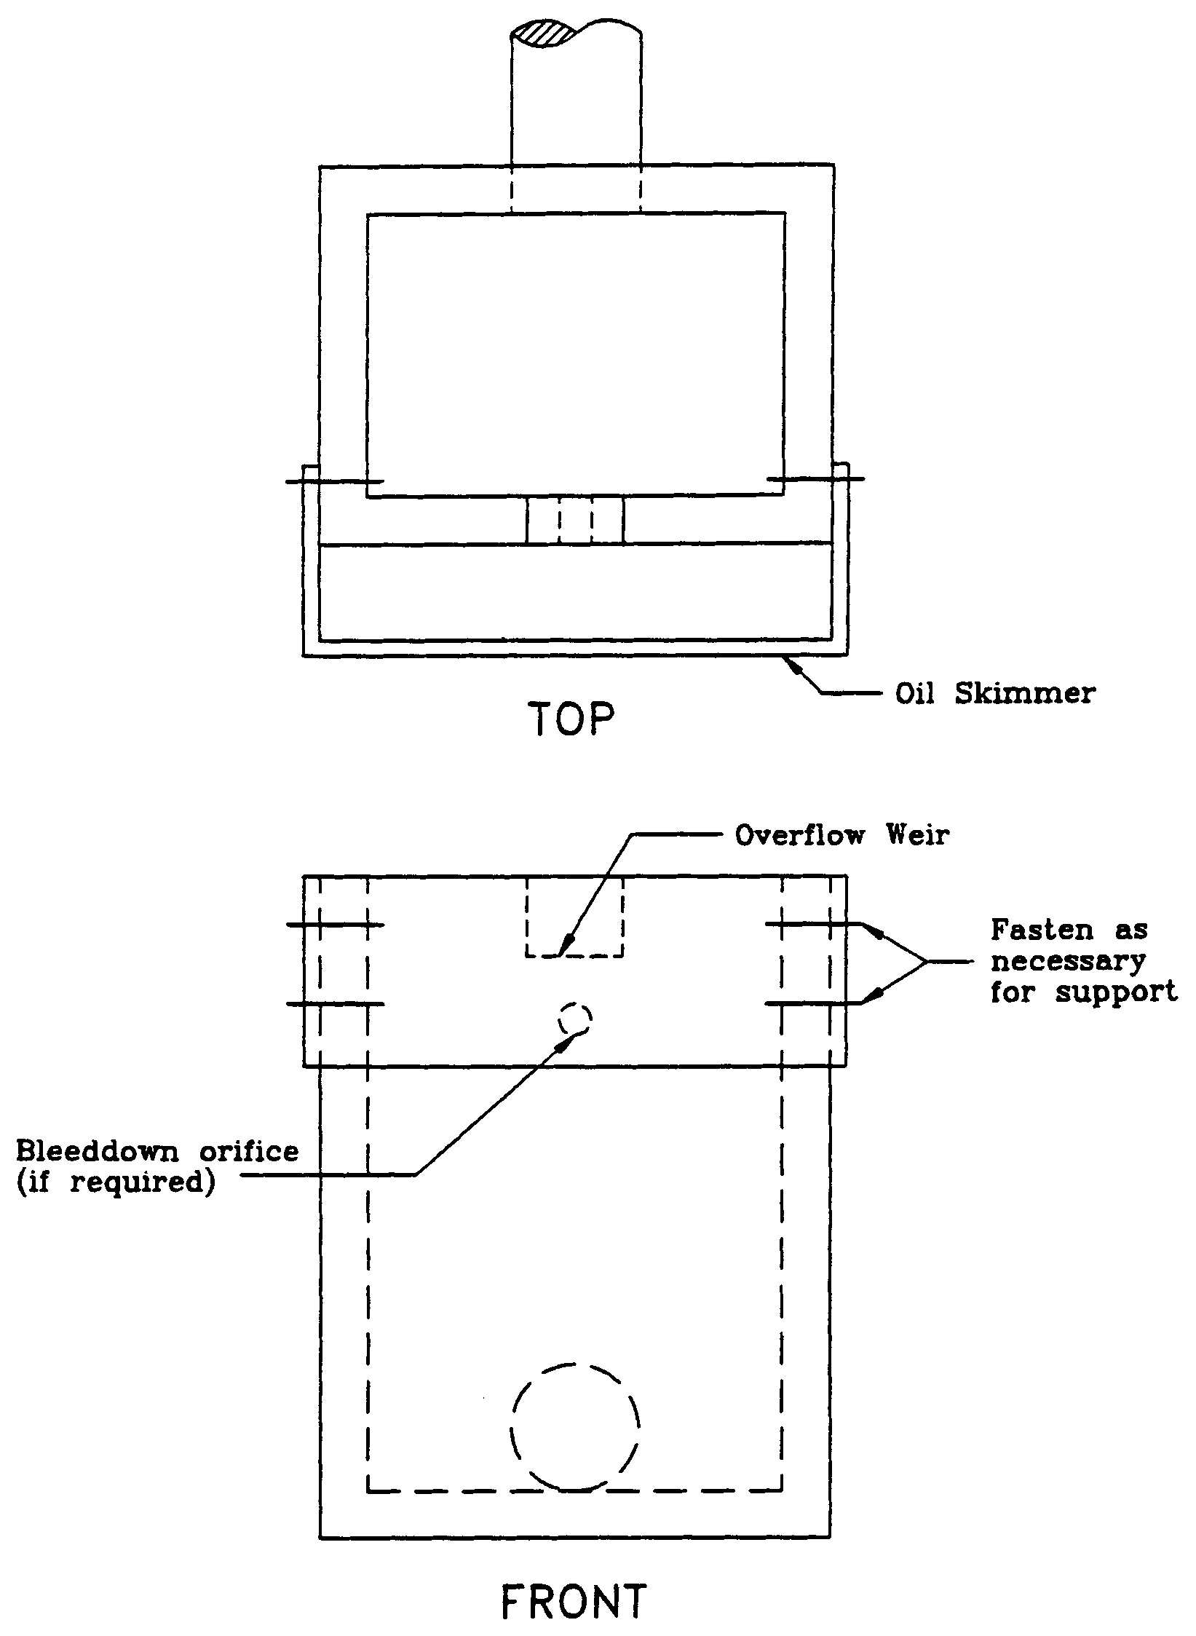

4.4 On-Line and Off-line Stormwater Systems

Pollutants in stormwater runoff from urbanized areas generally exhibit the "first flush" effect. This is the phenomenon where the concentration of pollutants in stormwater runoff are highest during the early part of the storm with concentrations declining as the runoff continues. Substantial reductions in pollutants loads will occur when this first flush is captured and treated. Therefore, each Best Management Practice (BMP) specifies a required volume of stormwater runoff to be captured and treated (i.e., treatment volume) prior to release to surface or ground water.

There are two basic types of configurations for capturing the treatment volume: on-line and off-line systems. On-line systems (Figure 4-2) consist of a storage area which provides storage of the required treatment volume for smaller storm events and, if required, temporary detention storage for peak discharge control during larger storm events. Runoff volumes in excess of the treatment volume mix with the treatment volume in the basin and transport a portion of the pollutant mass load over the basin control structure.

Off-line treatment systems (Figure 4-3) divert the treatment volume into a basin which is designed for storage and treatment of the applicable treatment volume. Runoff volumes in excess of the treatment volume by-pass the off-line basin and are discharged to the receiving water or routed to a detention basin if peak discharge attenuation is required. A diversion box (Figure 4-4) may be utilized to divert the treatment volume to the off-line basin and route subsequent flows away from the off-line basin.

Off-line systems are generally more effective at removing pollutants than on-line systems because accumulated pollutants cannot be "flushed out" during storm events that produce runoff volumes exceeding the treatment storage volume. Consequently, on-line systems must treat a greater volume of runoff than off-line systems to reduce the likelihood of flushing accumulated pollutants out of the system and achieve the pollutant removal goals required by the Water Resource Implementation Rule (chapter 62-40, F.A.C.). Treatment volumes for each of the stormwater treatment practices described in this Volume are discussed in sections 5.0 through 12.9 of Part V of this Volume.

The treatment storage provided in an off-line system can be considered in the stage/storage calculations for peak discharge attenuation. Off-line systems should be designed to bypass essentially all additional stormwater runoff volumes greater than the treatment volume to a discharge point or other detention storage area. Of course, there will be some incremental additional storage in the off-line system associated with the hydraulic grade line at the weir structure in the typical diversion structure. This will depend on the size of the weir, but the weir should be sized to pass the design flow with minimal headwater.

Proposed off-line systems which will also serve to provide significant detention storage above the off-line treatment volume storage will be considered to function as on-line systems. These systems should either be designed to meet on-line treatment volume requirements or the designer should discuss the merits of the particular system (in terms of potential of flushing accumulated pollutants) with District staff in a pre-application conference.

4.5 Hazardous or Toxic Substances

Systems serving a use that produces or stores hazardous or toxic substances shall be designed to have no stormwater discharge that contains such substances.

Figure 4-2. On-line treatment system

Figure 4-3. Off-line treatment system

Figure 4-4. Diversion box (N.T.S.)

PART V – BEST MANAGEMENT PRACTICES

5.0 Retention System Design and Performance Criteria

5.1 Description

Retention system is defined as a storage area designed to store a defined quantity of runoff, allowing it to percolate through permeable soils into the shallow ground water aquifer. Stormwater retention works best using a variety of retention systems throughout the project site. Examples of retention systems include:

- Man-made or natural depressional areas where the floor is graded as flat as possible and turf is established to promote infiltration and stabilize the basin slopes (see Figure 5-1)

- Shallow landscaped areas designed to store stormwater

- Vegetated swales with swale blocks or raised inlets

- Pervious concrete with continuous curb

Soil permeability and water table conditions must be such that the retention system can percolate the desired runoff volume within a specified time following a storm event. After drawdown has been completed, the basin does not hold any water, thus the system is normally "dry." Unlike detention basins, the treatment volume for retention systems is not discharged to surface waters.

Retention systems should not be located in close proximity to drinking water supply wells. Chapter 62-555, F.A.C., requires stormwater treatment facilities to be at least 100 feet from any public supply well. Chapter 40C-41, F.A.C., provides additional design features for systems constructed in Sensitive Karst Areas of the District where the drinking water aquifer is close to the land surface (see section 13.6).

Besides pollution control, retention systems can be utilized to promote the recharge of ground water to prevent saltwater intrusion in coastal areas or to maintain groundwater levels in aquifer recharge areas. Chapter 40C-41, F.A.C., contains recharge criteria for the Wekiva Recharge Protection Basin and the Tomoka River and Spruce Creek Hydrologic Basins (see sections 13.3.1 and 13.5.1). Retention systems can also be used to meet the runoff volume criteria for projects which discharge to land-locked lakes (see section 3.2 of this Volume).

There are several design and performance criteria specific to retention systems which are described below.

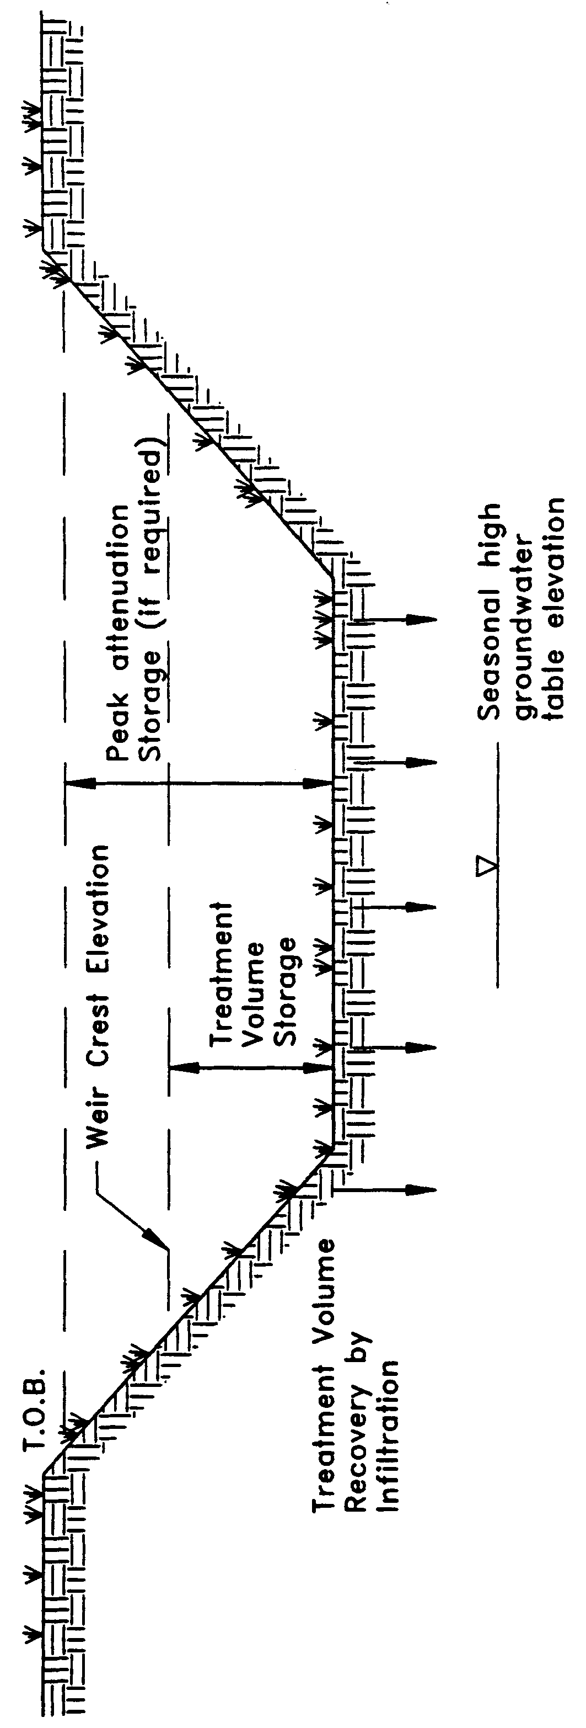

Figure 5-1. Retention (N.T.S.)

5.2 Treatment Volume

The first flush of runoff should be routed to the retention basin and percolated into the ground. Retention systems that discharge to Class III receiving water bodies shall provide for one of the following:

(a) Off-line retention of the first one-half inch of runoff or 1.25 inches of runoff from the impervious area, whichever is greater.

(b) On-line retention of an additional one half inch of runoff from the drainage area over that volume specified for off-line treatment.

(c) On-line retention that provides for percolation of the runoff from the three year, one-hour storm.

(d) On-line retention of the runoff from one inch of rainfall or 1.25 inches of runoff from the impervious area, whichever is greater, for systems which serve an area with less than 40 percent impervious surface and that contain only U.S. Department of Agriculture Natural Resources Conservation Service (SCS) hydrologic group "A" soils.

For direct discharges to Class I, Class II, OFWs, or Class III waters which are approved, conditionally approved, restricted, or conditionally restricted for shellfish harvesting the applicant shall provide retention for one of the following:

(a) At least an additional fifty percent of the applicable treatment volume specified for off-line retention in (a), above. Off-line retention must be provided for at least the first one-half inch of runoff or 1.25 inches of runoff from the impervious area, whichever is greater, of the total amount of runoff required to be treated.

(b) On-line retention of an additional fifty percent of the treatment volume specified in (b), above.

(c) On-line retention of the runoff from the three-year, one-hour storm.

(d) On-line retention that provides at least an additional 50 percent of the runoff volume specified in (d), above, for systems which serve an area with less that 40 percent impervious surface and that contain only U.S. Department of Agriculture Natural Resources Conservation Service (SCS) hydrologic group "A" soils.

5.3 Recovery Time

The retention system must provide the capacity for the appropriate treatment volume of stormwater specified in section 5.2 within 72 hours following a storm event assuming average antecedent moisture conditions. In retention systems, the stormwater is drawn down by natural soil infiltration and dissipation into the ground water table, evaporation, or evapotranspiration, as opposed to underdrain systems which rely on artificial methods like drainage pipes.

Antecedent moisture condition (AMC) refers to the amount of moisture and storage in the soil profile prior to a storm event. Antecedent soil moisture is an indicator of wetness and availability of soil to infiltrate water. The AMC can vary from dry to saturated depending on the amount of rainfall received prior to a given point in time. Therefore, "average AMC" means the soil is neither dry or saturated, but at an average moisture condition at the beginning of a storm event when calculating recovery time for retention systems.

The antecedent condition has a significant effect on runoff rate, runoff volume, infiltration rate, and infiltration volume. The infiltration volume is also known as the upper soil zone storage. Both the infiltration rate and upper soil zone storage are used to calculate the recovery time of retention systems and should be estimated using any generally accepted and well documented method with appropriate parameters to reflect drainage practices, seasonal high water table elevation, the AMC, and any underlying soil characteristics which would limit or prevent percolation of storm water into the soil column.

5.4 Basin Stabilization

The retention basin should be stabilized with pervious material or permanent vegetative cover. To provide proper treatment of the runoff in very permeable soils, permanent vegetative cover must be utilized when U.S. Department of Agriculture Natural Resources Conservation Service (SCS) hydrologic group "A" soils underlie the retention basin, except for pervious pavement systems.

5.5 Retention Basin Construction

5.5.1 Overview

Retention basin construction procedures and the overall sequence of site construction are two key factors that can control the effectiveness of retention basins. Sub-standard construction methods or construction sequence can render the basin inoperable prior to completion of site development.

5.5.2 Construction Requirements

The following construction procedures are recommended to avoid degradation of retention basin infiltration capacity due to construction practices (Andreyev and Wiseman 1989):

(a) Initially construct the retention basin to rough grade by under-excavating the basin bottom and sides by approximately 12 inches.

(b) After the drainage area contributing to the basin has been fully stabilized, the interior side slopes and basin bottom should be excavated to final design specifications. The excess soil and undesirable material should be carefully excavated and removed from the pond so that all accumulated silts, clays, organics, and other fine sediment material has been removed from the pond area. The excavated material should be disposed of beyond the limits of the drainage area of the basin.

(c) Once the basin has been excavated to final grade, the entire basin bottom should be deep raked and loosened for optimal infiltration.

(d) Finally, the basin should be stabilized according the section 5.4, above.

5.6 References

Andreyev, N.E., and L.P. Wiseman. 1989. Stormwater Retention Pond Infiltration Analysis in Unconfined Aquifers. Prepared for Southwest Florida Water Management District, Brooksville, Florida.
6.0 Underdrain Design and Performance Criteria

6.1 Description

Stormwater underdrain systems consist of a dry basin underlain with perforated drainage pipe which collects and conveys stormwater following percolation from the basin through suitable soil. Underdrain systems are generally used where high water table conditions dictate that recovery of the stormwater treatment volume cannot be achieved by natural percolation (i.e, retention systems) and suitable outfall conditions exist to convey flows from the underdrain system to receiving waters. Schematics of a typical underdrain system are shown in Figures 6-1 and 6-2.

Underdrain systems are intended to control both the water table elevation over the entire area of the treatment basin and provide for the drawdown of the treatment volume. Underdrains are utilized where the soil permeability is adequate to recover the treatment volume since the on-site soils overlay the perforated drainage pipes.

There are several design and performance criteria which must be met in order for a underdrain system to meet the rule requirements. The underdrain rule criteria are described below.

6.2 Treatment Volume

The first flush of runoff should be detained in a dry detention basin and percolated through the soil. Dry detention systems that discharge to Class III receiving water bodies, shall provide for either of the following treatment volumes:

(a) Off-line retention of the first one-half inch of runoff or 1.25 inches of runoff from the impervious area, whichever is greater, or

(b) On-line retention of an additional one half inch of runoff from the drainage area over that volume specified for off-line treatment.

For direct discharges to Class I, Class II, OFWs, or Class III waters which are approved, conditionally approved, restricted, or conditionally restricted for shellfish harvesting the applicant shall provide retention for either of the following:

(a) At least an additional fifty percent of the applicable treatment volume specified for off-line retention in (a), above. Off-line retention must be provided for at least the first one-half inch of runoff or 1.25 inches of runoff from the impervious area, whichever is greater, of the total amount of runoff required to be treated.

(b) On-line retention of the runoff from the three-year, one-hour storm or an additional fifty percent of the treatment volume specified in (b), above, whichever is greater.

6.3 Recovery Time

The system should be designed to provide for the drawdown of the appropriate treatment volume specified in section 6.2 within 72 hours following a storm event. The treatment volume is recovered by percolation through the soil with subsequent transport through the underdrain pipes. The system should only contain standing water within 72 hours of a storm event.

The pipe system configuration (e.g., pipe size, depth, pipe spacing, and pipe inflow capacity) of the underdrain system must be designed to achieve the recovery time requirement.

6.4 Safety Factor

The underdrain system must be designed with a safety factor of at least two unless the applicant affirmatively demonstrates based on plans, test results, calculations or other information that a lower safety factor is appropriate for the specific site conditions. Examples of how to apply this factor include but are not limited to the following:

(a) Reducing the design percolation rate by half

(b) Designing for the required drawdown within 36 hours instead of 72 hours.

6.5 Underdrain Media

To provide proper treatment of the runoff, at least two feet of indigenous soil must be between the bottom of the basin storing the treatment volume and the outside of the underdrain pipes (or gravel envelope as applicable).

6.6 Filter Fabric

Underdrain systems shall utilize filter fabric or other means to prevent the soil from moving into and clogging perforated pipe.

6.7 Inspection and Cleanout Ports

To facilitate maintenance of the underdrain system, capped and sealed inspection and cleanout ports which extend to the surface of the ground should be provided, at a minimum, at the following locations for each drainage pipe:

(a) The terminus

(b) At every 400 feet or every bend of 45 or more degrees, whichever is shorter.

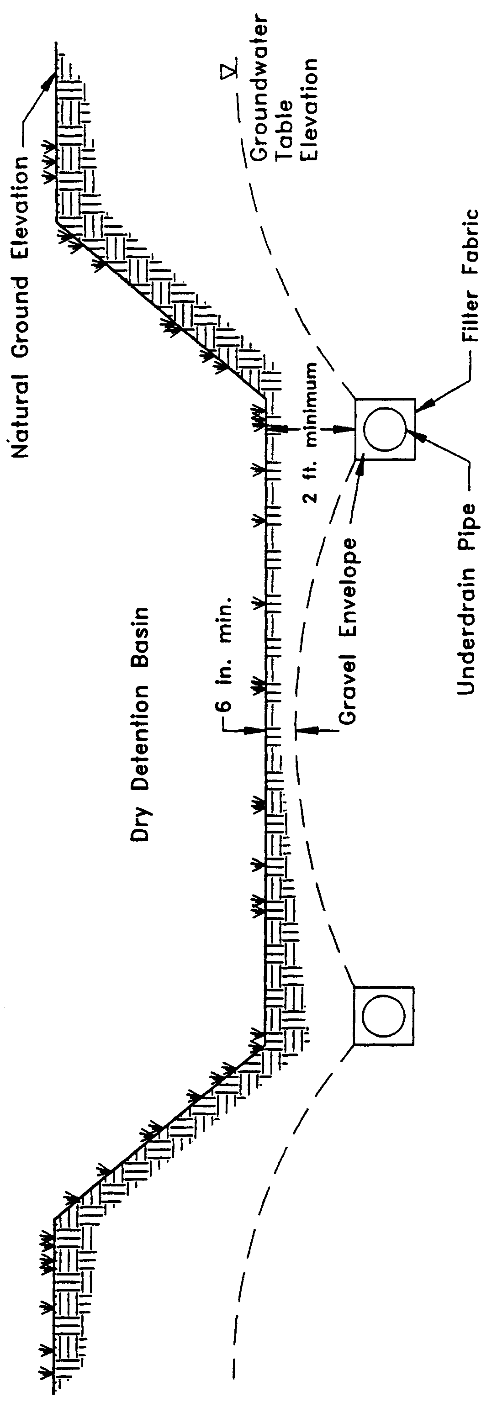

Figure 6-1. Cross-section of underdrain system (N.T.S.)

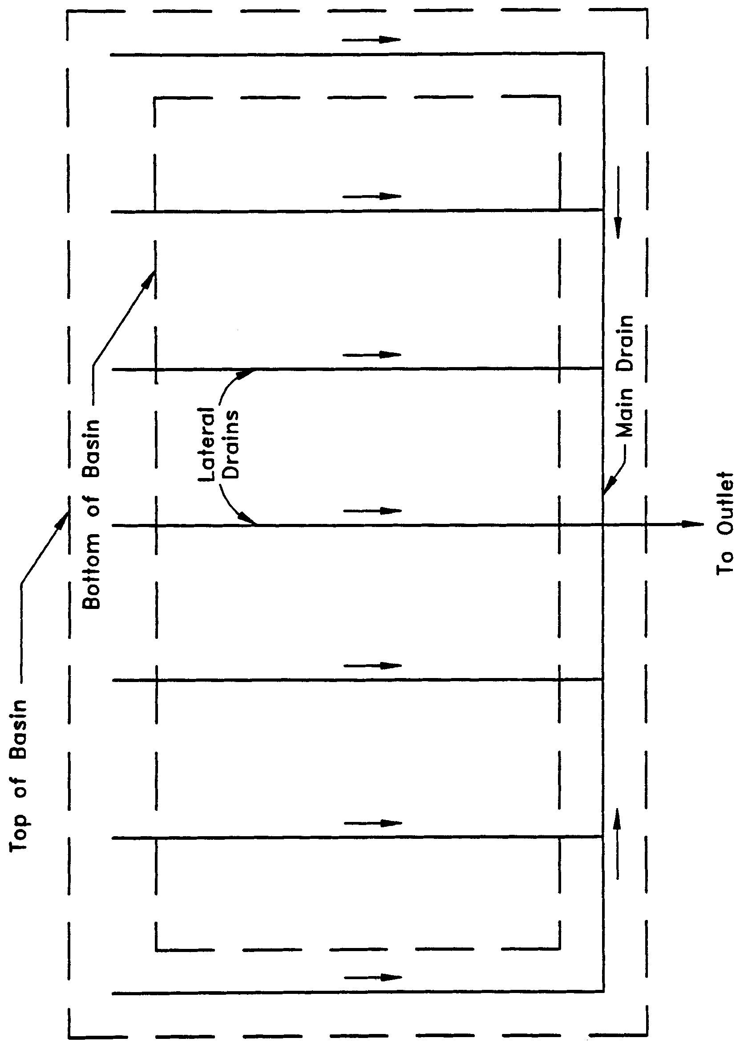

Figure 6-2. Top view of underdrain system (N.T.S.)

6.8 Basin Stabilization

The underdrain basin shall be stabilized with permanent vegetative cover and should contain standing water only immediately following a rainfall event.

6.9 References

Livingston, E.H., E. McCarron, J. Cox, P. Sanzone. 1988. The Florida Land Development Manual: A Guide to Sound Land and Water Management. Florida Department of Environmental Regulation, Nonpoint Source Management Section, Tallahassee, Florida.

7.0 Exfiltration Trench Design and Performance Criteria

7.1 Description

Exfiltration trench is a subsurface system consisting of a conduit such as perforated pipe surrounded by natural or artificial aggregate which temporarily stores and infiltrates stormwater runoff (Figure 7-1). Stormwater passes through the perforated pipe and infiltrates through the trench walls and bottom into the shallow groundwater aquifer. The perforated pipe increases the storage available in the trench and helps promote infiltration by making delivery of the runoff more effective and evenly distributed over the length of the system (Livingston et al. 1988). Generally, exfiltration trench systems are utilized where space is limited and/or land costs are high (i.e., downtown urban areas).

Soil permeability and water table conditions must be such that the trench system can percolate the required stormwater runoff treatment volume within a specified time following a storm event. The trench system is returned to a normally "dry" condition when drawdown of the treatment volume is completed. Like retention basins, the treatment volume in exfiltration trench systems is not discharged to surface waters. Thus, exfiltration is considered a type of retention system.

Exfiltration trench systems should not be located in close proximity to drinking water supply wells. Chapter 62-555, F.A.C., requires stormwater treatment systems to be at least 100 feet from any public supply well. Chapter 40C-41, F.A.C., provides additional design features for systems constructed in Sensitive Karst Areas of the District where the drinking water aquifer is close to the land surface (see section 13.6).

Besides pollution control, exfiltration trench systems can be utilized to promote the recharge of ground water and to prevent saltwater intrusion in coastal areas, or to maintain groundwater levels in aquifer recharge areas. Chapter 40C-41, F.A.C., contains recharge criteria for the Wekiva Recharge Protection Basin and the Tomoka River and Spruce Creek Hydrologic Basins (see sections 13.3.1 and 13.5.1). Exfiltration trench systems can also be used to meet the runoff volume criteria for projects which discharge to land-locked lakes (see section 3.2.1 of this Volume).

The operational life of an exfiltration trench is believed to be short (possibly 5 to 10 years) for most exfiltration systems. Sediment accumulation and clogging by fines can reduce the life of an exfiltration trench (Wanielista et al. 1991). Total replacement of the trench may be the only possible means of restoring the treatment capacity and recovery of the system. Periodic replacement of the trench should be considered routine operational maintenance when selecting this management practice.

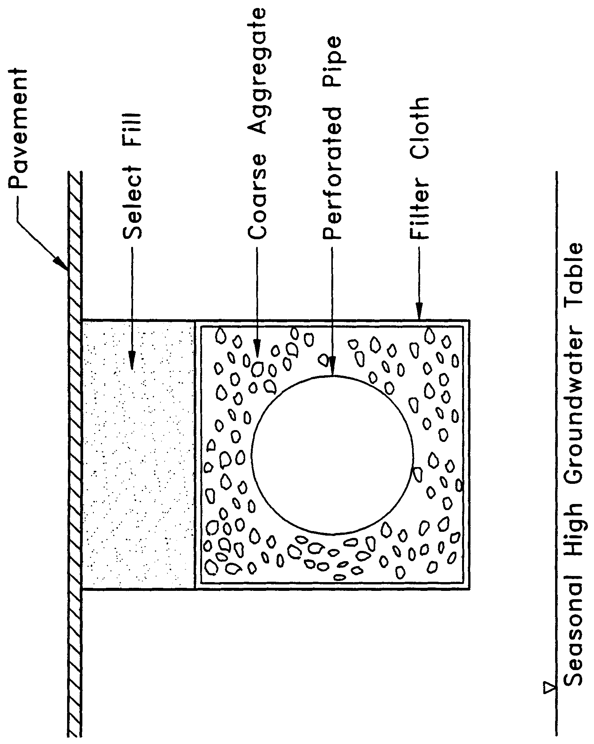

Figure 7-1. Cross-section of typical underground exfiltration trench (N.T.S.)

There are several design and performance criteria which must be met in order for an exfiltration trench system to meet the District’s requirements. A description of each criterion is presented below.

7.2 Treatment Volume

The first flush of runoff should be collected in the exfiltration trench and infiltrated into the surrounding soil. For systems which discharge to Class III receiving water bodies, the exfiltration trench shall provide either of the following:

(a) Off-line storage of the first one-half inch of runoff or 1.25 inches of runoff from the impervious area, whichever is greater.

(b) On-line storage of an additional one-half inch of runoff from the drainage area over that volume specified for off-line treatment.

For direct discharges to Class I, Class II, OFWs, or Class III waters which are approved, conditionally approved, restricted, or conditionally restricted for shellfish harvesting the applicant shall provide storage for either of the following:

(a) At least an additional fifty percent of the applicable treatment volume specified for off-line storage in (a), above. Off-line storage must be provided for at least the first one-half inch of runoff or 1.25 inches of runoff from the impervious area, whichever is greater, of the total amount of runoff required to be treated.

(b) On-line storage of the runoff from the three-year, one-hour storm or an additional fifty percent of the treatment volume specified in (b), above, whichever is greater.

Exfiltration trench systems must be designed to have the capacity to retain the required treatment volume without considering discharges to ground or surface waters.

7.3 Recovery Time

The system must be designed to provide for the appropriate treatment volume of stormwater runoff specified in section 7.2 within 72 hours following a storm event assuming average antecedent moisture conditions. The stormwater is drawn down by infiltration into the soil.

Antecedent moisture condition (AMC) refers to the amount of moisture and storage in the soil profile prior to a storm event. Antecedent soil moisture is an indicator of wetness and availability of soil to infiltrate water. The AMC can vary from dry to saturated depending on the amount of rainfall received prior to a given point in time. Therefore, "average AMC" means the soil is neither dry or saturated, but at an average moisture condition at the beginning of a storm event when calculating recovery time for exfiltration systems.

The antecedent condition has a significant effect on runoff rate, runoff volume, infiltration rate, and infiltration volume. The infiltration volume is also known as the upper soil zone storage. Both the infiltration rate and upper soil zone storage are used to calculate the recovery time of retention systems and should be estimated using any generally accepted and well documented method with appropriate parameters to reflect drainage practices, seasonal high water table elevation, the AMC, and any underlying soil characteristics which would limit or prevent percolation of storm water into the soil column.

7.4 Safety Factor

The exfiltration trench system must be designed with a safety factor of at least two unless the applicant affirmatively demonstrates based on plans, test results, calculations or other information that a lower safety factor is appropriate for the specific site conditions. For example, two possible ways to apply this factor are:

(a) Reducing the design percolation rate by half

(b) Designing for the required drawdown within 36 hours instead of 72 hours

7.5 Minimum Dimensions

The perforated pipe shall be designed with a 12-inch minimum pipe diameter and a three (3)-foot minimum trench width. The perforated pipe should be located within the trench section to minimize the accumulation of sediment in the aggregate void storage and maximize the preservation of this storage for stormwater treatment. To meet this goal, it is recommended that the perforated pipe be located at or within 6 inches of the trench bottom. The maximum trench width will be limited by the rate at which stormwater can effectively fill the void storage within the trench.

7.6 Filter Fabric

Exfiltration trench systems shall be designed so that aggregate in the trench is enclosed in filter fabric. This serves to prevent migration of fine materials from the surrounding soil that could result in clogging of the trench. Wanielista et al. (1991) reports that woven fabric (Mirafi 700XG) performed better in mixed sand and silty soil than non-woven fabric (Mirafi 140N). On the other hand, the 140N had higher exfiltration rates in sandy soils than the woven fabric.

Filter fabric may also be utilized directly surrounding the perforated pipe. In this instance, sedimentation of particulates will occur in the perforated pipe. Consequently, the pipe is more prone to clogging and reductions in capacity will occur more often than usual. Livingston et al. (1988) points out that while this may seem unacceptable, the pipe may be cleaned relatively easy using high pressure hoses, vacuum systems, etc. On the other hand, designs without the fabric directly surrounding the perforated pipe require complete replacement when clogging occurs.

7.7 Inspection and Cleanout Structures

Inspection and cleanout structures which extend to the surface of the ground must be provided, at a minimum, at the inlet and terminus of each exfiltration pipe. Inlet structures should include sediment sumps. These inspection and cleanout structures provide three primary functions:

(a) Observation of how quickly the trench recovers following a storm

(b) Observation of how quickly the trench fills with sediment

(c) Maintenance access to the perforated pipe

(d) Sediment control (sumps)

Standard precast concrete inlets and manholes are widely used to furnish the inspection and cleanout access.

7.8 Ground Water Table

The exfiltration trench system must be designed so that the invert elevation of the trench is at least two feet above the seasonal high ground water table elevation unless the applicant affirmatively demonstrates based on plans, test results, calculations or other information that an alternative design is appropriate for the specific site conditions.

7.9 Construction

During construction, measures should be implemented to limit the parent soil and debris from entering the trench. Wanielista (1991) reports complete failure (no exfiltration) when a 1" to 2" thickness of parent soil and stormwater solids were added to an exfiltration trench. Applicants and system designers should consult Part IV of Volume I for information on erosion and sediment control. Any method used to reduce the amount of fines entering the exfiltration trench during construction will extend the life of the system (Wanielista et al. 1991). The use of an aggregate with minimal fines is also recommended (Wanielista et al. 1991).

7.10 Alternative Designs

Wanielista et al. (1991) describes an alternative procedure for designing exfiltration trenches based on long term mass balance of an exfiltration system utilizing local rainfall conditions. Fifteen years of hourly precipitation data from six regions in Florida were used as input for the mass balance. From these simulations, design curves for exfiltration systems were developed. These curves relate the rate at which stored runoff is removed from the trench to the volume of storage within the trench. These curves can be used to design an exfiltration trench based on diversion efficiencies of 50%, 60%, 70%, 80%, 85%, 90%, and 95%. In lieu of the requirements of section 7.2, the District accepts this methodology for those areas of the District (i.e., Jacksonville and Orlando) for which the curves have been developed. Applicants designing systems which discharge to Class III receiving waters shall use the 80% curve and those that direct discharge to Class I, Class II, and Outstanding Florida Waters shall utilize the 95% curve.

7.11 References

Livingston, E.H., E. McCarron, J. Cox, and P. Sanzone. 1988. The Florida Land Development Manual: A Guide to Sound Land and Water Management. Florida Department of Environmental Regulation, Nonpoint Source Management Section, Tallahassee, Florida.

Wanielista, M.P., M.J. Gauthier, and D.L. Evans. 1991. Design and Performance of Exfiltration Systems. Department of Civil and Environmental Engineering, University of Central Florida, Orlando, Florida.

8.0 Wet Detention Design and Performance Criteria

8.1 Description

These systems are permanently wet ponds which are designed to slowly release collected stormwater runoff through an outlet structure. A schematic of a typical wet detention system is shown in Figure 8-1.

There are several components in a wet detention system which must be properly designed to achieve the required level of stormwater treatment. A description of each design feature and its importance to the treatment process is presented below. The design and performance criteria for wet detention systems are discussed below.

8.2 Treatment Volume

For wet detention systems, the design treatment volume is the greater of the following:

(a) one inch of runoff over the drainage area

(b) 2.5 inches times the impervious area (excluding water bodies)

Additional treatment volume is required for systems which discharge directly to Class I, Class II, Outstanding Florida Waters, or Class III waters which are approved, conditionally approved, restricted, or conditionally restricted for shellfish harvesting (see section 8.13 of this Volume).

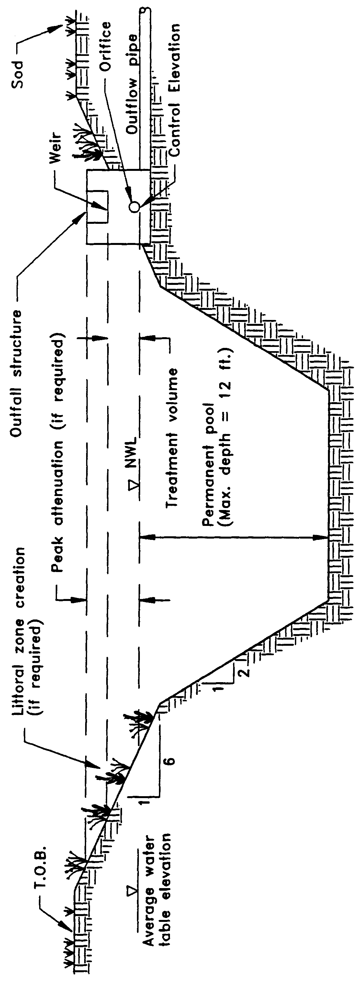

Figure 8-1. Wet detention (N.T.S.)

8.3 Recovery Time

The outfall structure shall be designed to drawdown one-half the required treatment volume within 24 and 30 hours following a storm event, but no more than one-half of this volume will be discharged within the first 24 hours.

8.4 Outlet Structure

The outlet structure generally includes a drawdown device (such as an orifice, "V" or square notch weir) set to establish a normal water control elevation and slowly release the treatment volume (see Figures 8-2 and 8-3 for schematics). The design of the outfall structure must also accommodate the passage of ground water baseflows and flows from upstream stormwater management systems (see Figure 8-4).

The control elevation shall be set at or above the design tailwater elevation so the pond can effectively recover the treatment storage. Also, drawdown devices smaller than 6 square inches of cross-section area that is 2 inches wide or less than 20 degrees for "V" notches shall include a device to eliminate clogging. Examples of such devices include baffles, grates, screens, and pipe elbows.

8.5 Permanent Pool

The permanent pool shall be sized to provide at least a 14-day average residence time during the wet season (June - October).

Additional permanent pool volume may be required for wet detention systems which directly discharge to Class I, Class II, or Outstanding Florida Waters (see section 8.13 of this Volume).

Figure 8-1. Wet detention (N.T.S.)

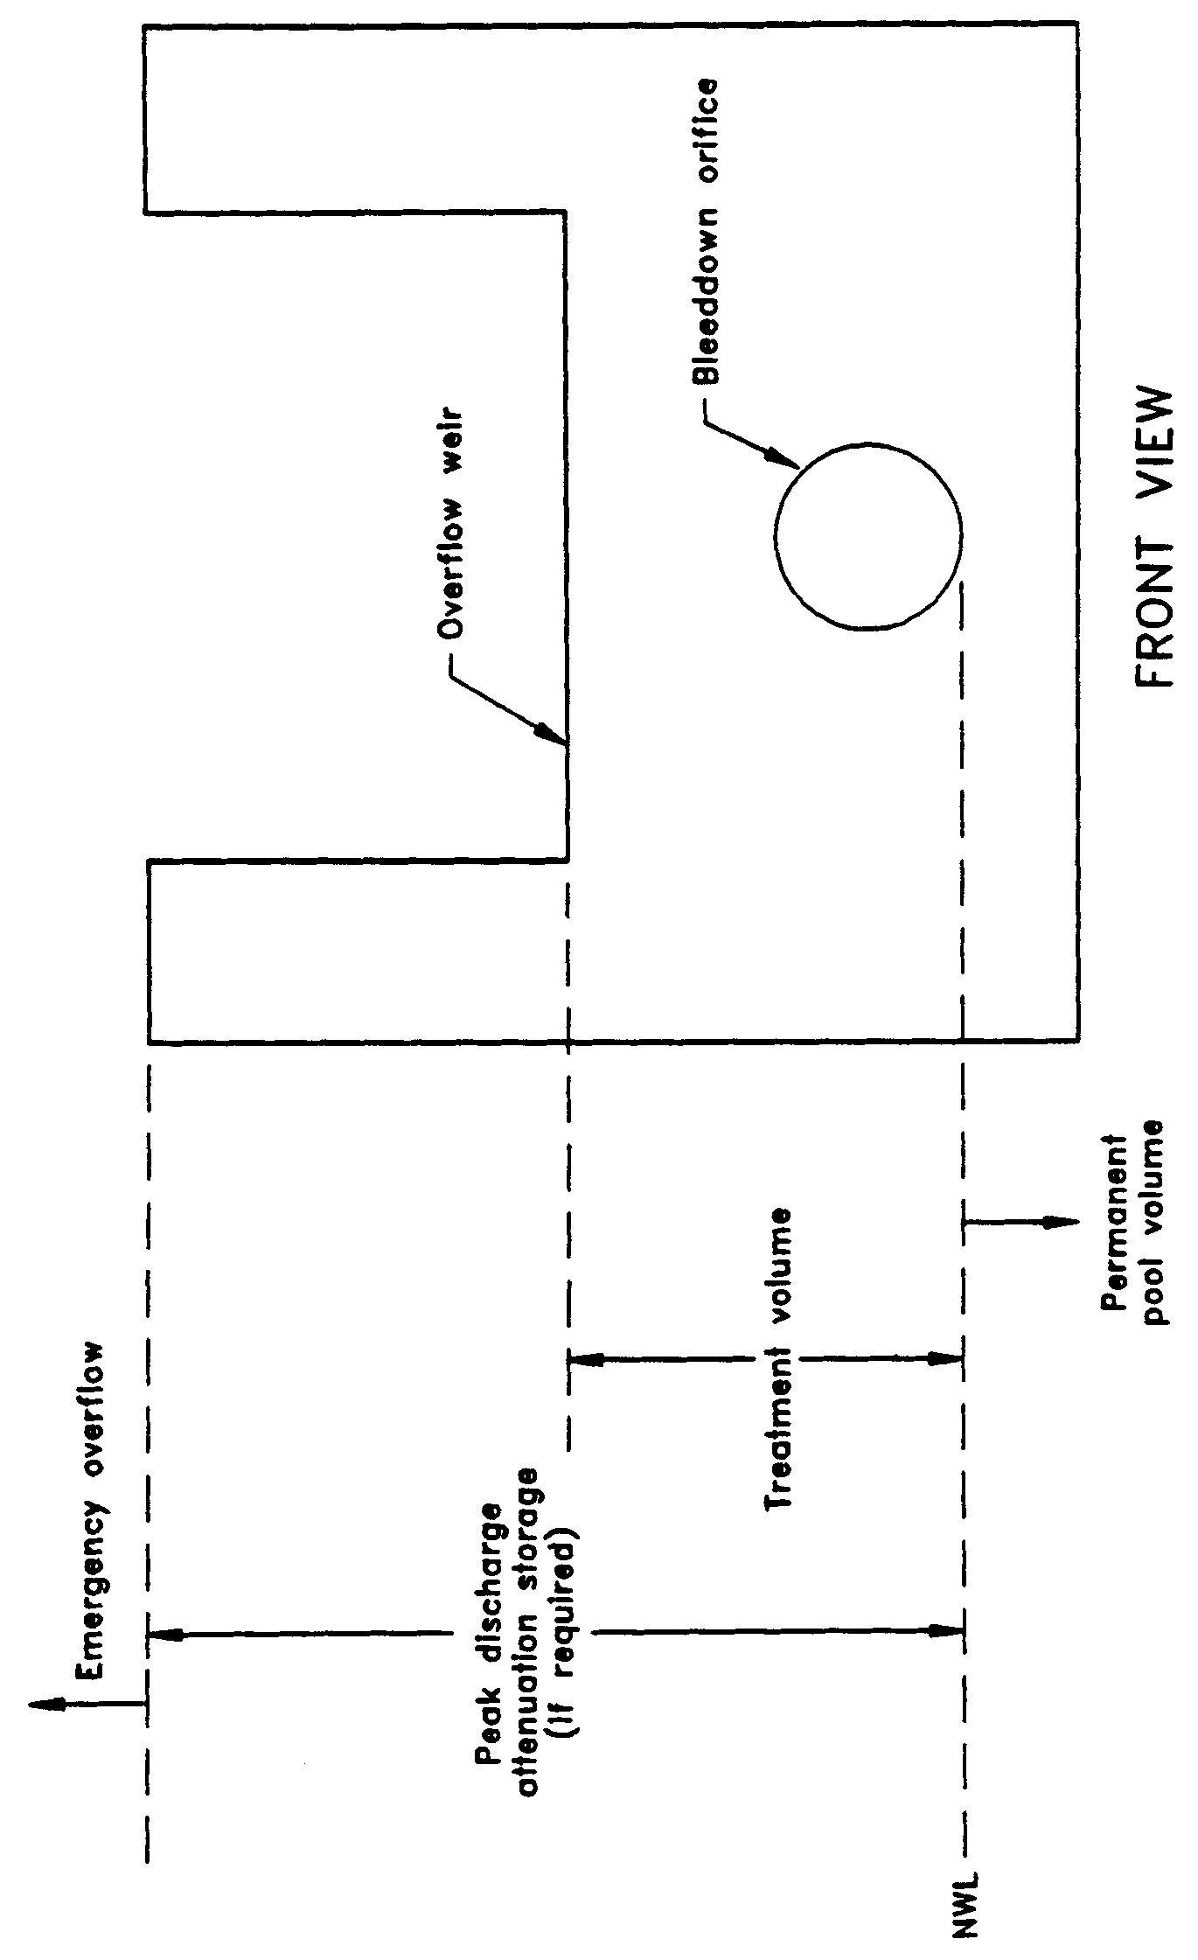

Figure 8-2. Typical wet detention outfall structure (N.T.S.)

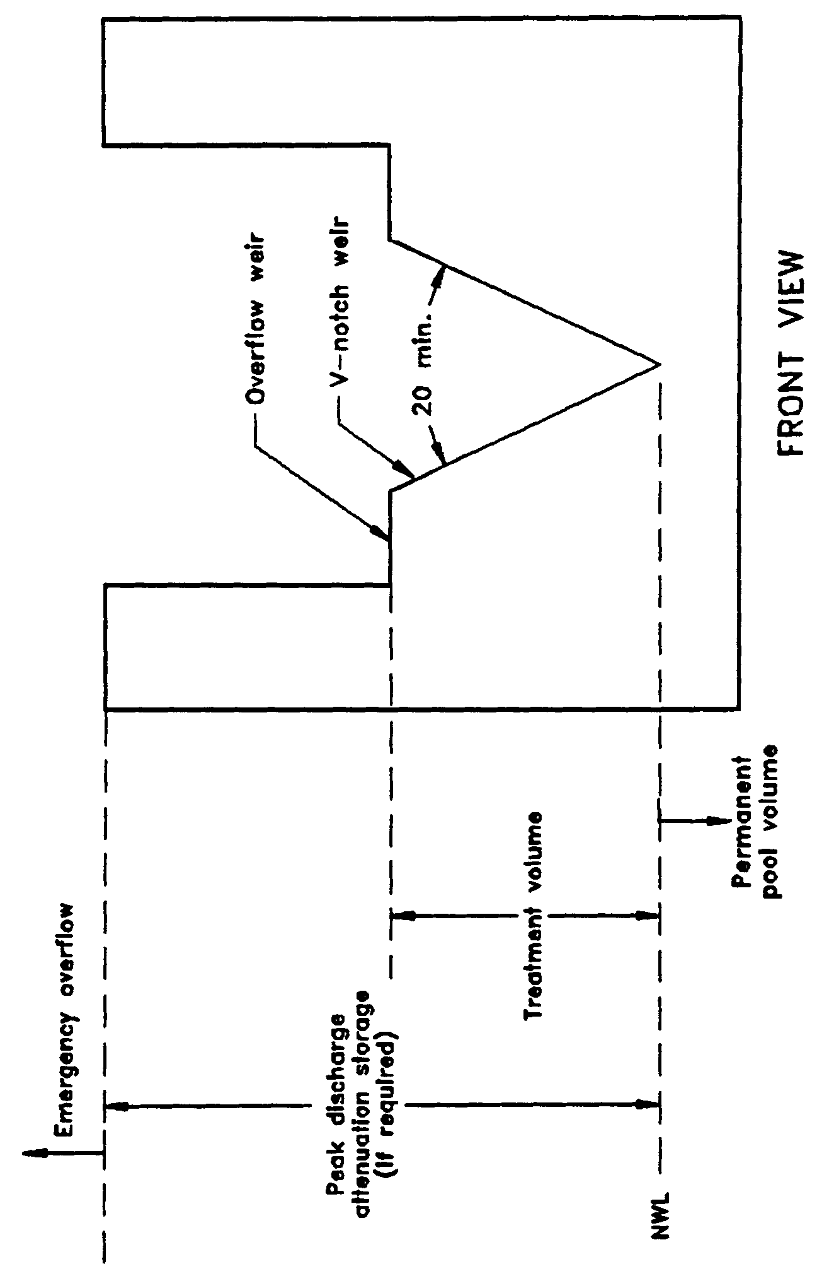

Figure 8-3. Typical wet detention outfall structure with "V"-notch weir (N.T.S.)

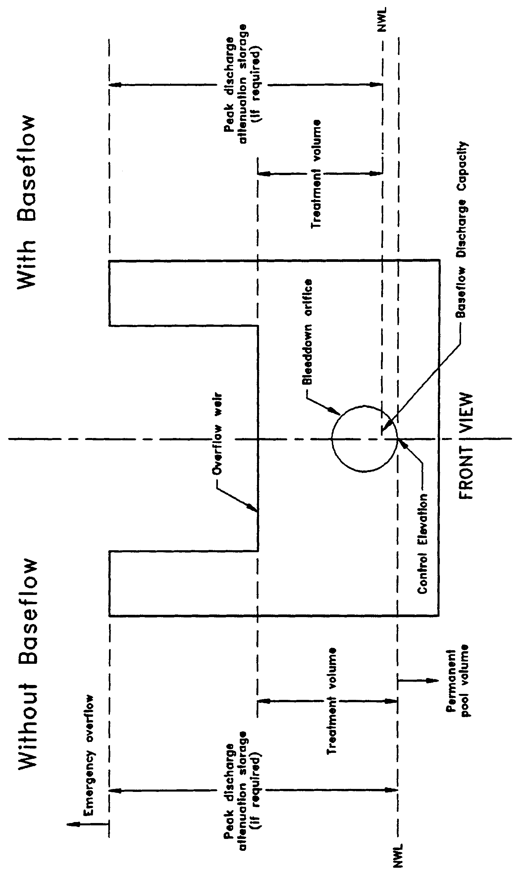
Figure 8-4. Typical wet detention outfall structure with and without baseflow conditions (N.T.S.)

8.6 Littoral Zone

The littoral zone is that portion of a wet detention pond which is designed to contain rooted aquatic plants. The littoral area is usually provided by extending and gently sloping the sides of the pond down to a depth of 2-3 feet below the normal water level or control elevation. Also, the littoral zone can be provided in other areas of the pond that have suitable depths (i.e., a shallow shelf in the middle of the lake).

The littoral zone is established with native aquatic plants by planting and/or the placement of wetland soils containing seeds of native aquatic plants. A specific vegetation establishment plan must be prepared for the littoral zone. The plan must consider the hydroperiod of the pond and the type of plants to be established. Livingston et al. (1988) has published a list of recommended native plant species suitable for littoral zone planting. In addition, a layer of muck can be incorporated into the littoral area to promote the establishment of the wetland vegetation. When placing muck, special precautions must be taken to prevent erosion and turbidity problems in the pond and at its discharge point while vegetation is becoming established in the littoral zone.

The following is a list of the design criteria for wet detention littoral zones:

(a) The littoral zone shall be gently sloped (6H:1V or flatter). At least 30 percent of the wet detention pond surface area shall consist of a littoral zone. The percentage of littoral zone is based on the ratio of vegetated littoral zone to surface area of the pond at the control elevation.

(b) The treatment volume should not cause the pond level to rise more than 18 inches above the control elevation unless the applicant affirmatively demonstrates that the littoral zone vegetation can survive at greater depths.

(c) Within 24 months of completion of the system or as specified by permit condition, 80 percent coverage of the littoral zone by suitable aquatic plants is required.

(d) Planting of the littoral zone is recommended to meet the 80% coverage requirement. As an alternative to planting, portions of the littoral zone may be established by placement of wetland top soils (at least a four inch depth) containing a seed source of desirable native plants. When utilizing this alternative, the littoral zone must be stabilized by mulching or other means and at least the portion of the littoral zone within 25 feet of the inlet and outlet structures must be planted.

8.7 Littoral Zone Alternatives

As an option to establishing and maintaining vegetative littoral zones as described in section 8.6, the applicant can provide either:

(a) An additional 50% of the appropriate permanent pool volume as required in section 8.5 or 8.13, or

(b) Pre-treatment of the stormwater prior to the stormwater entering the wet detention pond. The level of pre-treatment must be at least that required for retention, underdrain, exfiltration, or swale systems. See section 8.11 of this Volume for additional information on pre-treatment.

8.8 Pond Depth

Wet detention systems shall provide for a maximum pond depth of 12 feet and a mean depth (pond volume divided by the pond area at the control elevation) between 2 and 8 feet.

8.9 Pond Configuration

The average length to width ratio of the pond must be at least 2:1.

If short flow paths are unavoidable, the effective flow path can be increased by adding diversion barriers such as islands, peninsulas, or baffles to the pond. Inlet structures should be designed to dissipate the energy of water entering the pond. Examples of good and poor pond configurations are given in Figure 8-5.

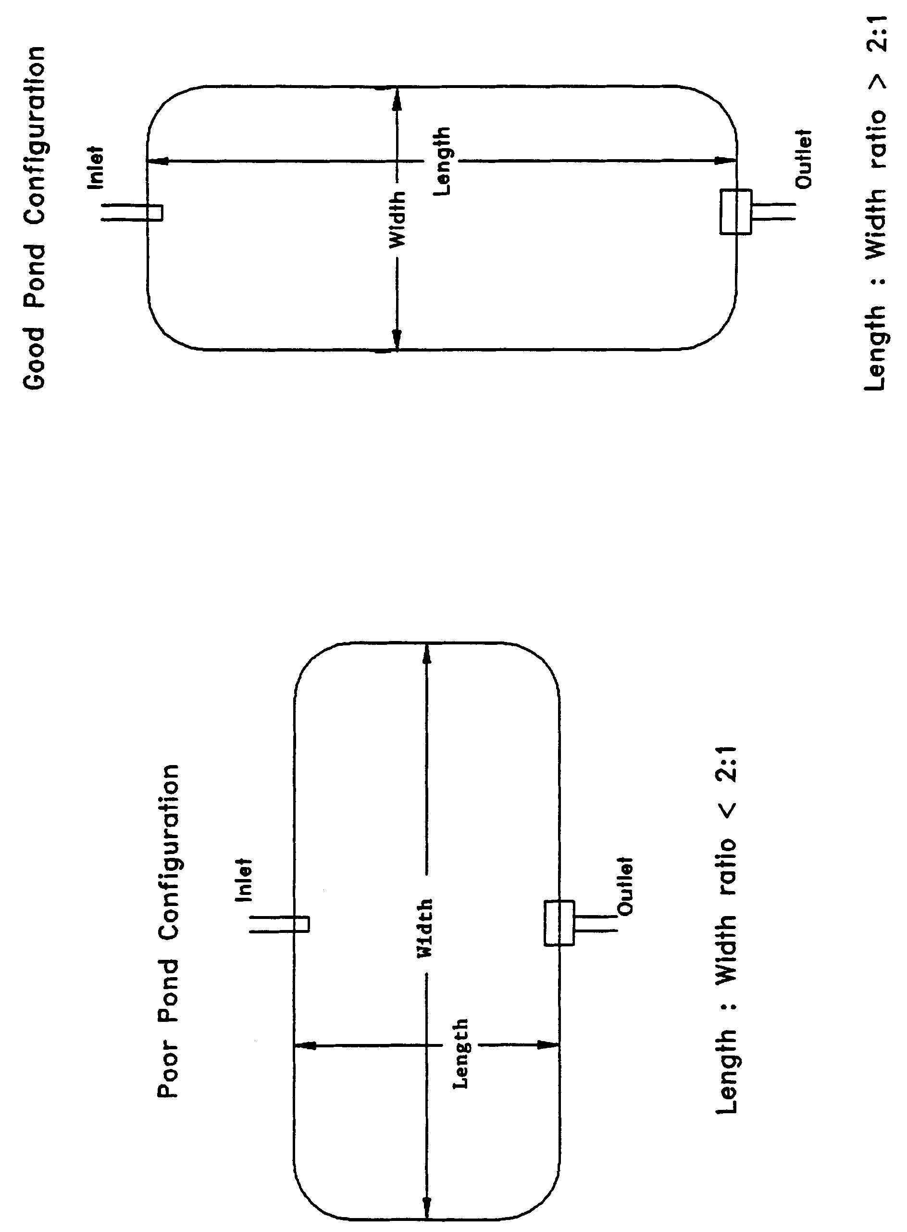

Figure 8-5. Examples of good and poor wet detention pond configurations (N.T.S.)

8.10 Ground Water Table

To minimize ground water contributions which may lower treatment efficiencies, the control elevation shall be set at or above the normal on-site ground water table elevation (Yousef et al. 1990). This elevation may be determined by calculating the average of the seasonal high and seasonal low ground water table elevations.

Ground water inflow (baseflow) must be considered when the control elevation is set below the normal ground water table elevation or the project utilizes underdrains (i.e., road underdrains) to control ground water conditions on-site. The design of the outfall structure must provide for the discharge of baseflow at the design normal water level in the pond. Baseflow rates must be included in the drawdown calculations for the outfall structure. Baseflow shall also be considered in the permanent pool residence time design. Establishment of the normal water level in the pond will also be influenced by baseflow conditions (see Figure 8-4).

8.11 Pre-treatment

"Pre-treatment" is defined as the treatment of a portion of the runoff prior to its entering the wet detention pond. Pre-treatment increases the pollutant removal efficiency of the overall stormwater system by reducing the pollutant loading to the wet detention pond. Pre-treatment may be used to enhance the appearance of the wet detention pond or meet the additional treatment criteria for discharges to receiving water which are classified as Class I, Class II, Outstanding Florida Waters (OFWs), or Class III waters which are approved, conditionally approved, restricted, or conditionally restricted for shellfish harvesting.

For developments where the appearance of the lake is important, pre-treatment can reduce the chances of algal blooms and slow the eutrophication process. Some types of pre-treatment practices include utilizing vegetative swales for conveyance instead of curb and gutter, perimeter swales or berms around the lake, oil and grease skimmers on inlet structures, retention storage in swales with raised inlets, or shallow landscaped retention areas (when soils and water table conditions will allow for adequate percolation).

For systems in which pre-treatment is utilized to meet the additional design criteria requirements for systems which direct discharge to Class I, Class II, OFWs, or Class III waters which are approved, conditionally approved, restricted, or conditionally restricted for shellfish harvesting, pre-treatment practices must meet the appropriate design and performance criteria for that BMP. Acceptable types of pre-treatment include the following:

(a) Retention systems which meet the design and performance criteria in section 5,

(b) Underdrain systems which meet the design and performance criteria in section 6,

(c) Exfiltration trench section 7, or

(d) Swales systems which meet the design and performance criteria in section 9.

Alternative pre-treatment methods will be evaluated on a case-by-case basis by the District. Applicants or system designers are encouraged to meet with District staff in a pre-application conference if alternative methods are proposed.

8.12 Pond Side Slopes

The pond must be designed so that the average pond side slope measured between the control elevation and two feet below the control elevation is no steeper than 3:1 (horizontal:vertical).

8.13 Direct Discharges to Class I, Class II, OFWs, or Shellfishing Waters

Wet detention systems which discharge to Class I, Class II, OFWs, or Class III waters which are approved, conditionally approved, restricted, or conditionally restricted for shellfish harvesting, must provide either:

(a) An additional fifty percent of both the required treatment and permanent
pool volumes

(b) Pre-treatment of the stormwater prior to the stormwater entering the wet
detention pond. The level of pre-treatment must be at least that required for
retention, underdrain, exfiltration, or swale systems (see section 8.11 of this
Volume).

8.14 References

Camp Dresser & McKee Inc (CDM). 1985. An Assessment of Stormwater Management Programs. Prepared for Florida Department of Environmental Regulation, Tallahassee, Florida.

Livingston, E.H., E. McCarron, J. Cox, P. Sanzone. 1988. The Florida Land Development Manual: A Guide to Sound Land and Water Management. Florida Department of Environmental Regulation, Nonpoint Source Management Section, Tallahassee, Florida.

Yousef, Y.A., M.P. Wanielista, L.Y. Lin, and M. Brabham. 1990. Efficiency Optimization of Wet Detention Ponds for Urban Stormwater Management (Phase I and II). University of Central Florida, Orlando, Florida

9.0 Swale Systems Design and Performance Criteria

9.1 Description

Swales are a man-made or natural system shaped or graded to required dimensions and designed for the conveyance and rapid infiltration of stormwater runoff. Swales are designed to infiltrate a defined quantity of runoff through the permeable soils of the swale floor and side slopes into the shallow ground water aquifer (Figure 9-1). Turf is established to promote infiltration and stabilize the side slopes. Soil permeability and water table conditions must be such that the swale can percolate the desired runoff volume from the 3-year, 1-hour storm event. The swale holds water only during and immediately after a storm event, thus the system is normally "dry." Unlike retention basins, swales are "open" conveyance systems. This means there are no physical barriers such as berms or check-dams to impound the runoff in the swale prior to discharge to the receiving water.

Swale systems should not be located in close proximity to drinking water supply wells. As required by chapter 62-555, F.A.C., stormwater treatment facilities must be at least 100 feet from any public supply well. Additional design criteria are established for swale systems constructed in Karst Sensitive Areas of the District where the drinking water aquifer is close to the land surface (see section 13.6).

Besides pollution control, swale systems can be utilized to promote the recharge of groundwater to prevent saltwater intrusion in coastal areas, and to maintain ground water levels in aquifer recharge areas. Swales can be incorporated into the design of a stormwater management system to meet the recharge criteria for the Wekiva Recharge Protection Basin and the Tomoka River and Spruce Creek Hydrologic Basins.

Swales can also be utilized to provide pre-treatment of runoff prior to its release to another treatment BMP such as wet detention (see section 8.11) or wetlands stormwater management systems (see section 10.4). Pre-treatment reduces the pollutant loading to the downstream treatment system, increases the pollutant efficiency of the overall stormwater management system, and reduces maintenance. In some cases, pre-treatment may be used to meet the additional treatment criteria for discharges to sensitive receiving waters (Class I, Class II, and OFWs). For developments where the appearance of the downstream system (i.e, wet detention lake) is important, pre-treatment can reduce the probability of algal blooms occurring and slows the eutrophication process.

The design and performance criteria specific to swale systems are described in the following sections.

Figure 9-1. Cross-section of swale system (N.T.S.)
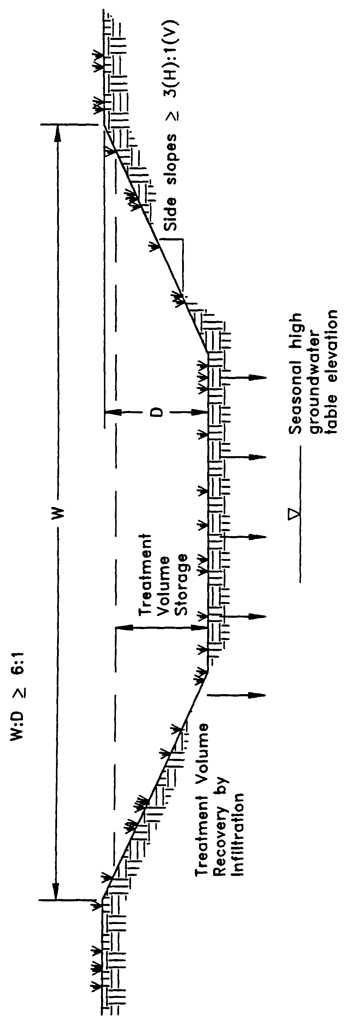

9.2 Treatment Volume

The runoff from the site should be routed to the swale system for conveyance and percolation into the ground. For systems which discharge to Class III receiving water bodies, the swales shall be designed to percolate 80% of the runoff from the 3-year, 1- hour storm. The remaining 20% of the runoff from the 3-year, 1-hour storm event may be discharged offsite by the swale system.

Swale systems which directly discharge to Class I, Class II, OFWs, or Class III waters which are approved, conditionally approved, restricted, or conditionally restricted for shellfish harvesting, shall be designed to percolate all of the runoff from the 3-year, 1-hour storm.

9.3 Recovery Time

Swale systems must provide the capacity for the specified treatment volume of stormwater and contain no contiguous areas of standing or flowing water within 72 hours following the storm event referenced in section 9.2 assuming average antecedent moisture conditions. The treatment volume must be provided by percolation through the soil, evaporation, or evapotranspiration.

Antecedent moisture condition (AMC) refers to the amount of moisture and storage in the soil profile prior to a storm event. Antecedent soil moisture is an indicator of wetness and availability of soil to infiltrate water. The AMC can vary from dry to saturated depending on the amount of rainfall received prior to a given point in time. Therefore, "average AMC" means the soil is neither dry or saturated, but at an average moisture condition at the beginning of a storm event when calculating recovery time for swale systems.

The antecedent condition has a significant effect on runoff rate, runoff volume, infiltration rate, and infiltration volume. The infiltration volume is also known as the upper soil zone storage. Both the infiltration rate and upper soil zone storage are used to calculate the recovery time of retention systems and should be estimated using any generally accepted and well documented method with appropriate parameters to reflect drainage practices, seasonal high water table elevation, the AMC, and any underlying soil characteristics which would limit or prevent percolation of storm water into the soil column.

9.4 Dimensional Requirements

Swales must have a top width to depth ratio of the cross-section equal to or greater than 6:1 or side slopes equal to or greater than 3:1 (horizontal to vertical).

9.5 Stabilization

Swales should be stabilized with vegetative cover suitable for soil stabilization, stormwater treatment, and nutrient uptake. Also, the swale should be designed to take into account the soil errodibility, soil percolation, slope, slope length, and drainage area so as to prevent erosion and reduce pollutant concentrations.

10.0 Wetlands Stormwater Management Systems Design and Performance Criteria

10.1 Description

For wetlands stormwater management systems the District must ensure that a proposed wetlands stormwater management system is compatible with the existing ecological characteristics of the wetlands proposed to be utilized for stormwater treatment. The District must also ensure that water quality standards will not be violated by discharges from wetlands stormwater management system. To achieve these goals, specific performance criteria are set forth and described below for systems which incorporate wetlands for stormwater treatment.

10.2 Types of Wetlands that may be Utilized for Stormwater Treatment

The only wetlands which may be considered for use to provide stormwater treatment are those which are:

(a) Isolated wetlands; and

(b) Those which would be isolated wetlands, but for a hydrologic connection to other wetlands or surface waters via another watercourse that was excavated through uplands.

10.3 Treatment Volume

The system shall be part of a comprehensive stormwater management system that utilizes wetlands in combination with other best management practices to provide treatment of the runoff from the project. For systems discharging to Class III waters, treatment of the runoff from the greater of the following shall be provided:

(a) First one inch of runoff, or

(b) 2.5 inches times the impervious area.

Those systems which directly discharge to Class I, Class II, OFWs, or Class III waters which are approved, conditionally approved, restricted, or conditionally restricted for shellfish harvesting, shall provide an additional fifty percent of the applicable treatment volume specified above.

If the wetland alone cannot provide the treatment volume, then other best management practices shall be incorporated upstream and outside of the wetland to store the proper level of runoff. Utilization of other BMPs must not adversely affect the ability of the wetlands stormwater management system from meeting the requirements of this section.

10.4 Recovery Time

The system shall be designed to bleed down one-half the applicable treatment volume specified above between 60 and 72 hours following a storm event.

10.5 Inlet Structures

Inlet structures shall be designed to dissipate the energy of runoff entering the wetland and minimize the channelized flow of stormwater. Methods include, but are not limited to, sprinklers, pipe energy dissipators, overland flow or spreader swales.

10.6 Wetland Function

The use of wetlands for stormwater treatment must meet the criteria in section 10.0, Environmental Considerations, of the Environmental Resource Permit Applicant’s Handbook, Volume I. Pre-treatment can reduce the impact of untreated stormwater upon the wetland. In addition, pre-treatment can be utilized to attenuate stormwater volumes and peak discharge rates so that the wetland's hydroperiod is not adversely altered (Livingston 1989). Swale conveyances and lakes adjacent to the wetland are typical pre-treatment practices.

10.8 Residence Time

The design features of the system should maximize residence time of the stormwater within the wetland to enhance the opportunity for the stormwater to come into contact with the wetland sediment, vegetation, and micro-organisms (Livingston 1989). This can be accomplished by several means. The inlets and outlets should be located to maximize the flow path through the wetland. Energy dissipators and spreader swales can promote overland flow and reduce the possibility of channelized flow occurring. In some instances, berms in wetlands can act as baffles to increase the flow path of surface flow through the wetland.

10.8 Monitoring

In order to establish a reliable, scientifically valid data base upon which to evaluate the performance criteria and the performance of the wetlands stormwater management system, a monitoring program may be required. Monitoring programs shall provide the District with comparable data for different types of wetlands and drainage designs. Data to be collected may include but not be limited to:

(a) Sedimentation rate

(b) Sediment trace metal concentrations

(c) Sediment nitrogen and phosphorus concentrations

(d) Changes in the frequency, abundance and distribution of vegetation

(e) Inflow and outflow water quality for nutrients, metals, turbidity, oils and greases, bacteria and other parameters related to the specific site conditions

Inflow and outflow water quality parameters will be monitored on such storm event occurrences as established by the District based on a site specific basis. The District shall eliminate the requirement to continue the monitoring program upon its determination that no further data is necessary to evaluate the performance criteria or ensure compliance with the performance criteria and applicable water quality standards.

10.9 Dredge and Fill

If the applicant proposes to dredge or fill in the wetlands used for stormwater treatment, the District in its review of the permit application shall evaluate the adverse effects of the dredging or filling on the treatment capability of the wetland.

10.10 Alternative Criteria

If the applicant is unable to show compliance with the performance criteria sections 10.3 – 10.9, above, the applicant may qualify for an environmental resource stormwater permit to use a wetlands stormwater management system permit using alternative design and performance criteria if the applicant affirmatively demonstrates that the use of the wetlands meets the criteria in section 10.0, Environmental Resource Permit Applicant’s Handbook, Volume I (General and Environmental) and the applicant complies with the requirements for issuance in section 2.0.

10.11 References

Livingston, E.H. 1989. The Use of Wetlands for Urban Stormwater Management. In Design of Urban Runoff Quality Controls, ed. L.A. Roesner, B. Urbonas, and M.B. Sonnen, pages 467-490. American Society of Civil Engineers. New York.

11.0 [Reserved]
12.0 Dry Detention Design and Performance Criteria

12.1 Description

Dry detention systems are normally dry storage areas which are designed to store a defined quantity of runoff and slowly release the collected runoff through an outlet structure to adjacent surface waters. After drawdown of the stored runoff is completed, the storage basin does not hold any water, thus the system is normally "dry." A schematic of a typical dry detention system is presented in Figure 12-1.

Dry detention basins are similar to retention systems in that the basins are normally dry. However, the main difference between the two systems is that retention systems are designed to percolate the stored runoff into the ground while dry detention systems are designed to discharge the runoff through an outlet structure to adjacent surface waters.

Sedimentation is the primary pollutant removal process which occurs in dry detention systems. Unfortunately, only pollutants which are primarily in particulate form are removed by sedimentation. Therefore, the pollutant removal efficiency of dry detention systems is not as great as systems such as retention and wet detention which remove both dissolved and particulate pollutants. Because of the limited pollutant removal efficiency of dry detention, this BMP must only be utilized where no other general permit BMP is feasible. For example, use of dry detention must be restricted to the following situations:

(a) Where high ground water table or soil conditions limit the feasibility of other BMPs such as retention, and

(b) Small drainage basins (less than 5 acres). For larger projects (greater than 5
acres) other BMPs like wet detention shall be utilized instead of dry
detention.

There are several design and performance criteria which must be met in order for a dry detention system to meet the District’s requirements. A description of each design criterion is presented below.

12.2 Treatment Volume

For discharges to Class III receiving water bodies, the dry detention system shall provide off-line detention of the first one inch of runoff or 2.5 inches of runoff from the impervious area, whichever is greater.

For direct discharges to Class I, Class II, OFWs, or Class III waters which are approved, conditionally approved, restricted, or conditionally restricted for shellfish harvesting, the applicant shall provide dry detention for at least an additional fifty percent of the applicable treatment volume specified for off-line dry detention in (a), above. Off-line detention must be provided for at least the first one inch of runoff or 2.5 inches of runoff from the impervious area, whichever is greater, of the total amount of runoff required to be treated.

Dry detention removes less pollutants on a per unit basis than other traditional best management practices. Therefore, dry detention systems must treat a greater volume of stormwater than the other treatment practices specified in the rule to achieve an equivalent level of pollutant removal.

12.3 Recovery Time

The outfall structure shall be designed to drawdown one-half the required treatment volume specified above between 24 and 30 hours following a storm event.

12.4 Outlet Structure

The outlet structure shall include a drawdown device (such as an orifice, "V" or square notch weir) set to slowly release the treatment volume (see Figures 12-2 and 12-3 for conceptual schematics). In addition, the structure must include a device to prevent the discharge of accumulated sediment, minimize exit velocities, and prevent clogging. Examples of such devices include perforated riser enclosed in a gravel jacket and perforated pipes enclosed in sand or gravel (see Figure 12-5).

In addition, the control elevation shall be set at or above the design tailwater elevation so the basin can effectively recover the treatment storage.

12.5 Ground Water Table, Basin Floor, and Control Elevation

To minimize ground water contributions and ensure the basin floor is normally dry, the control elevation and basin floor shall be set at least one foot above the seasonal high ground water table elevation. Sumps may be placed up to one foot below the control elevation. The basin floor shall be level or uniformly sloped toward the control structure. The system may only contain standing water within 3 days of a storm event. Continuous standing water in the basin may also reduce the aesthetic value of the system and may promote mosquito production.

12.6 Basin Stabilization

The dry detention basin shall be stabilized with permanent vegetative cover.

12.7 Basin Configuration

The average length to width ratio of the dry detention basin must be at least 2:1. Under these design conditions, short circuiting is minimized and pollutant removal efficiency is maximized.

If short flow paths are unavoidable, the effective flow path can be increased by adding diversion barriers such as peninsulas or baffles to the basin. Examples of good and poor basin configurations are given in Figure 12-4.

12.8 Inlet Structures

Inlet structures shall be designed to dissipate the energy of water entering the basin.

12.9 Maintenance

Dry detention systems must include provisions for removal of sediment and debris from the basin and mowing and removal of grass clippings.

Figure 12-1 Dry detention (N.T.S.)

Figure 12-2. Typical dry detention outfall structure with orifice (N.T.S.)

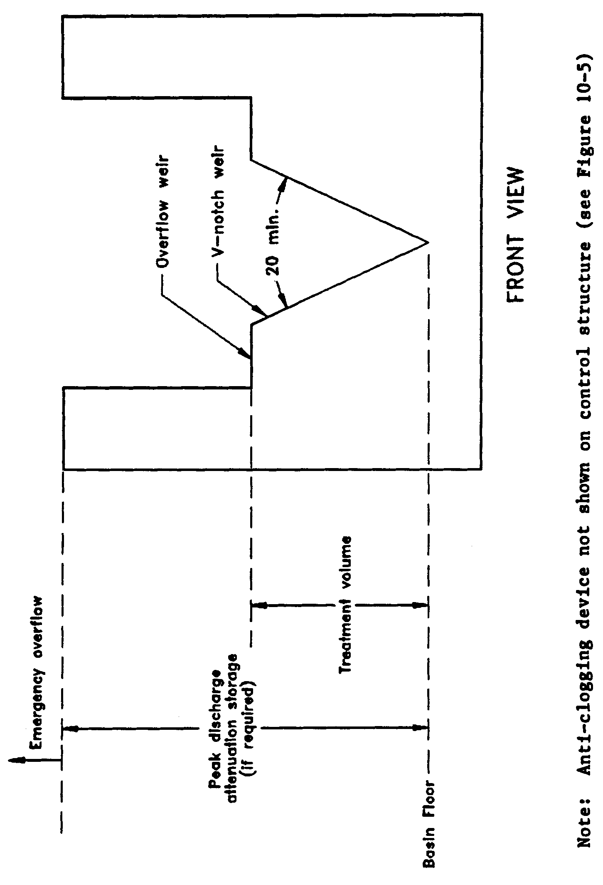

Figure 12-3. Typical dry detention outfall structure with “V”-notch weir (N.T.S.)

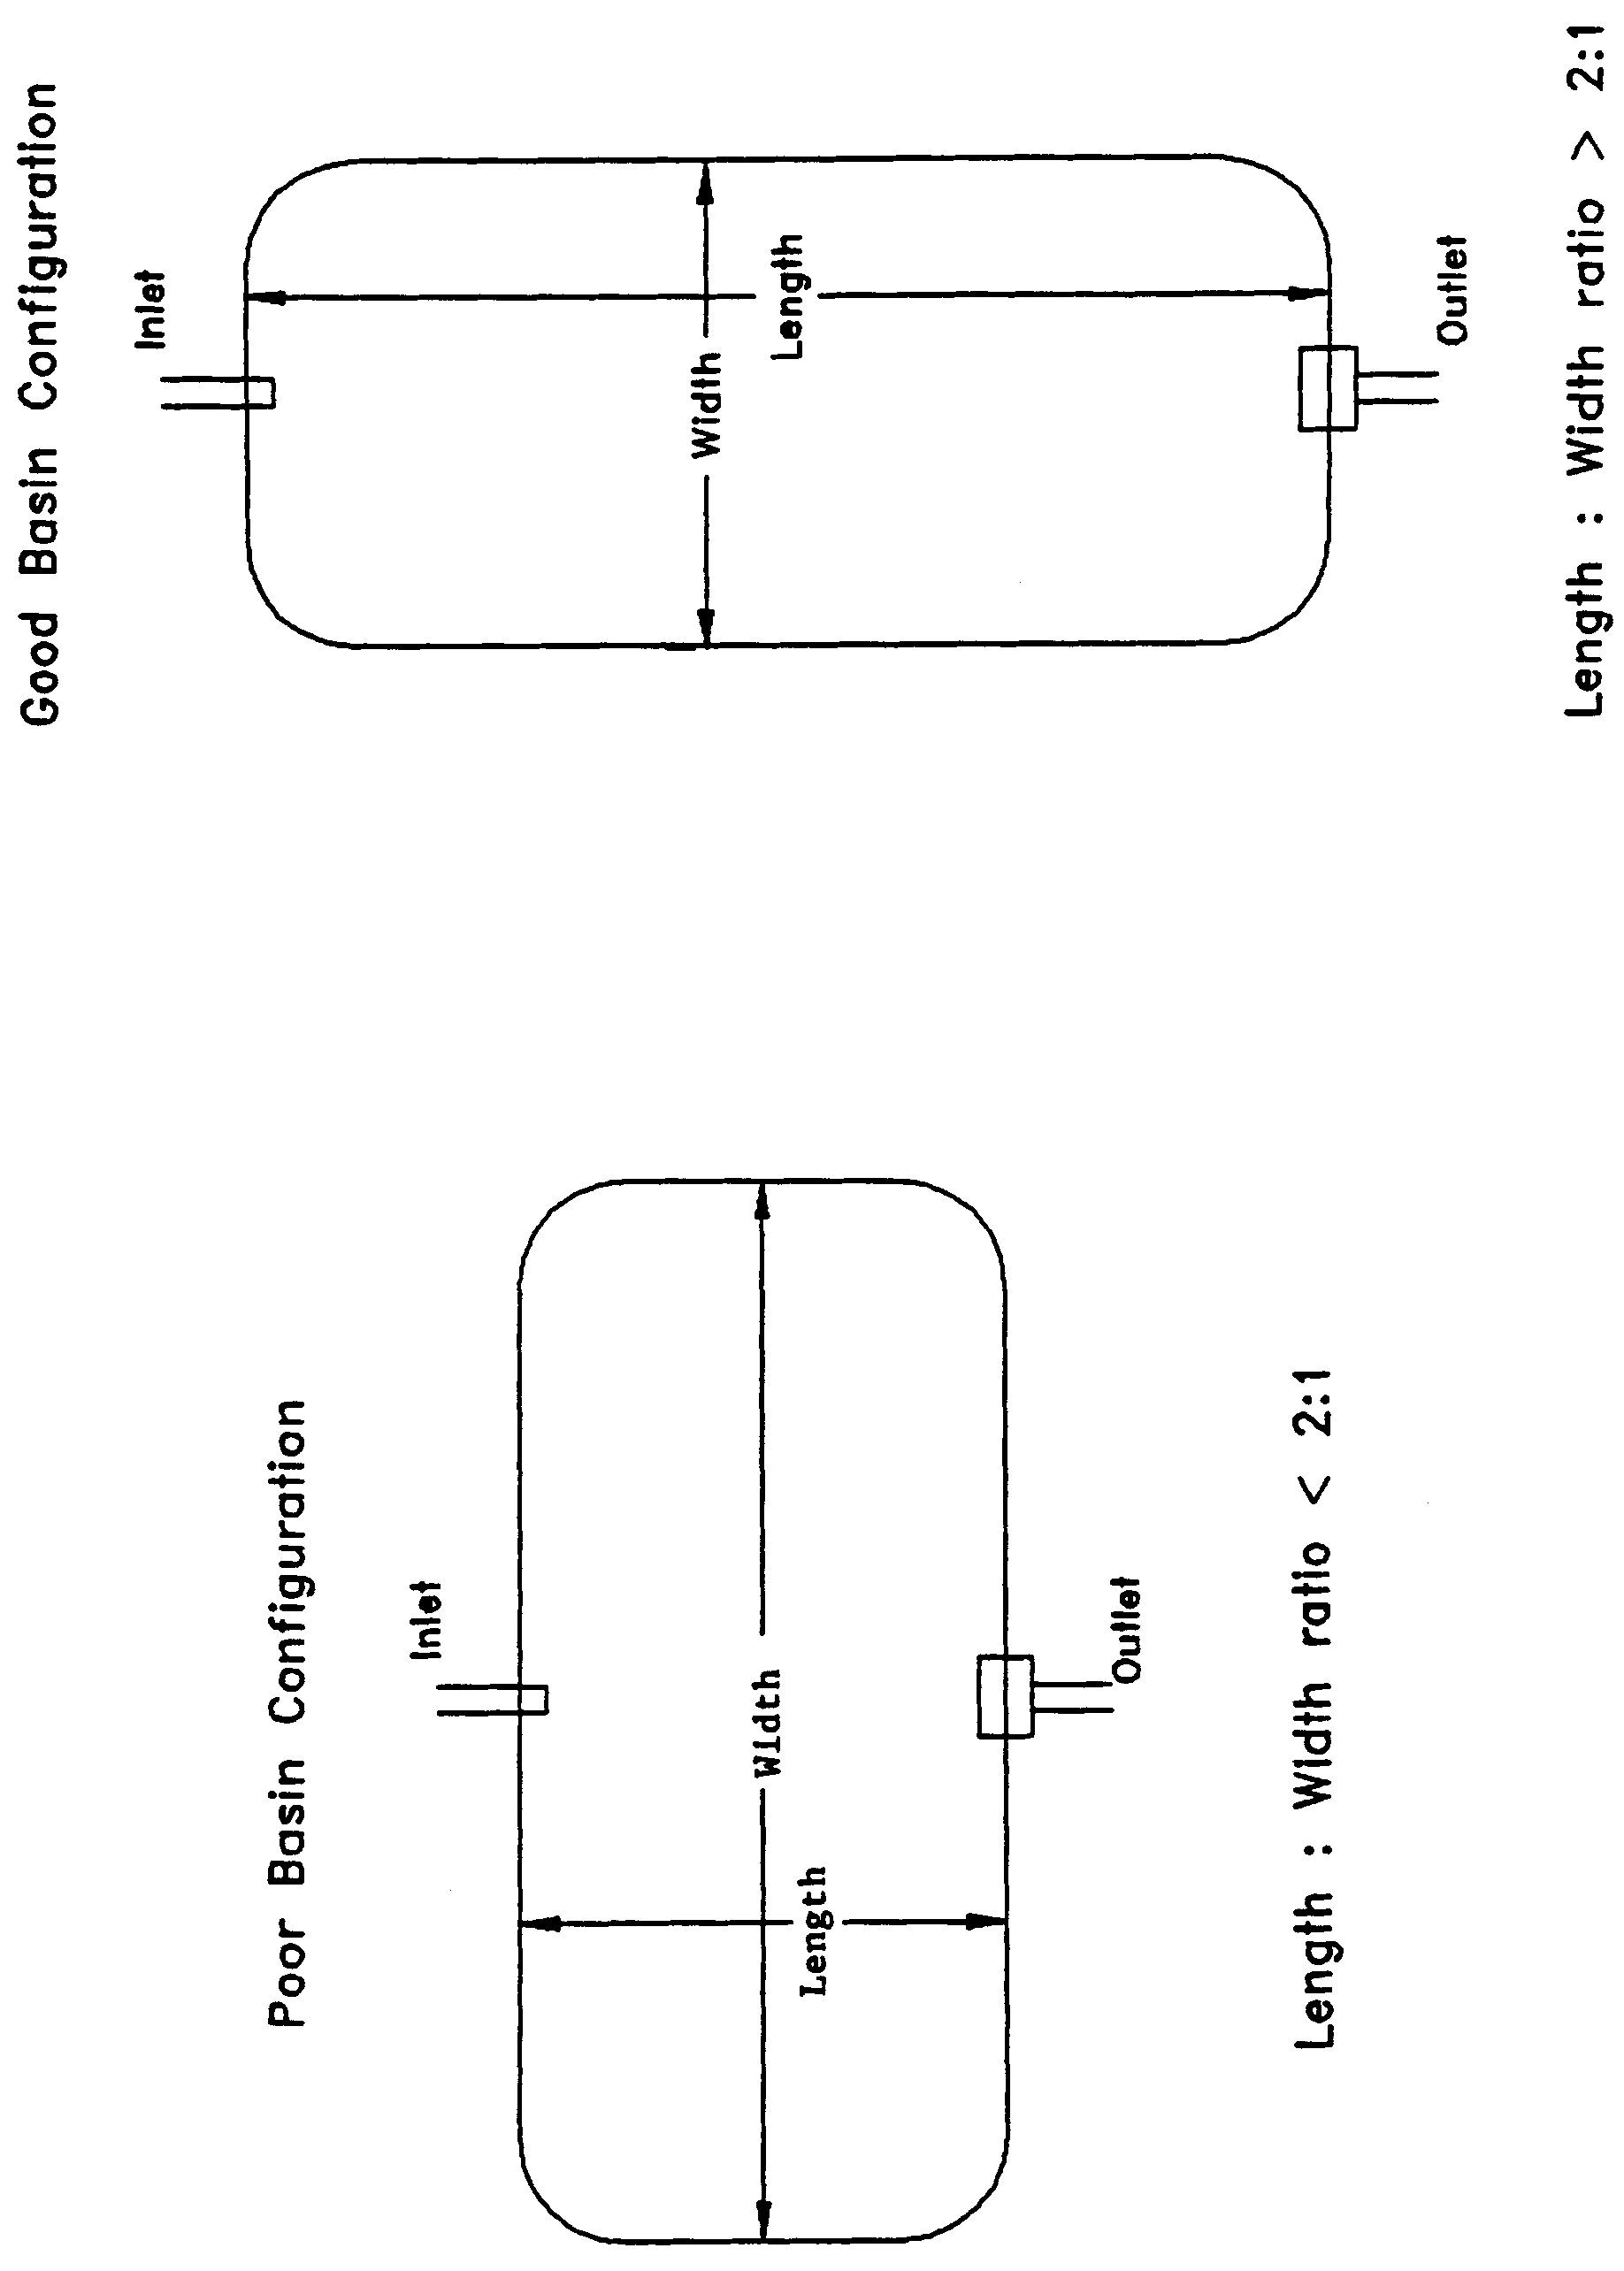

Figure 12-4. Examples of good and poor dry detention pond configurations (N.T.S.)

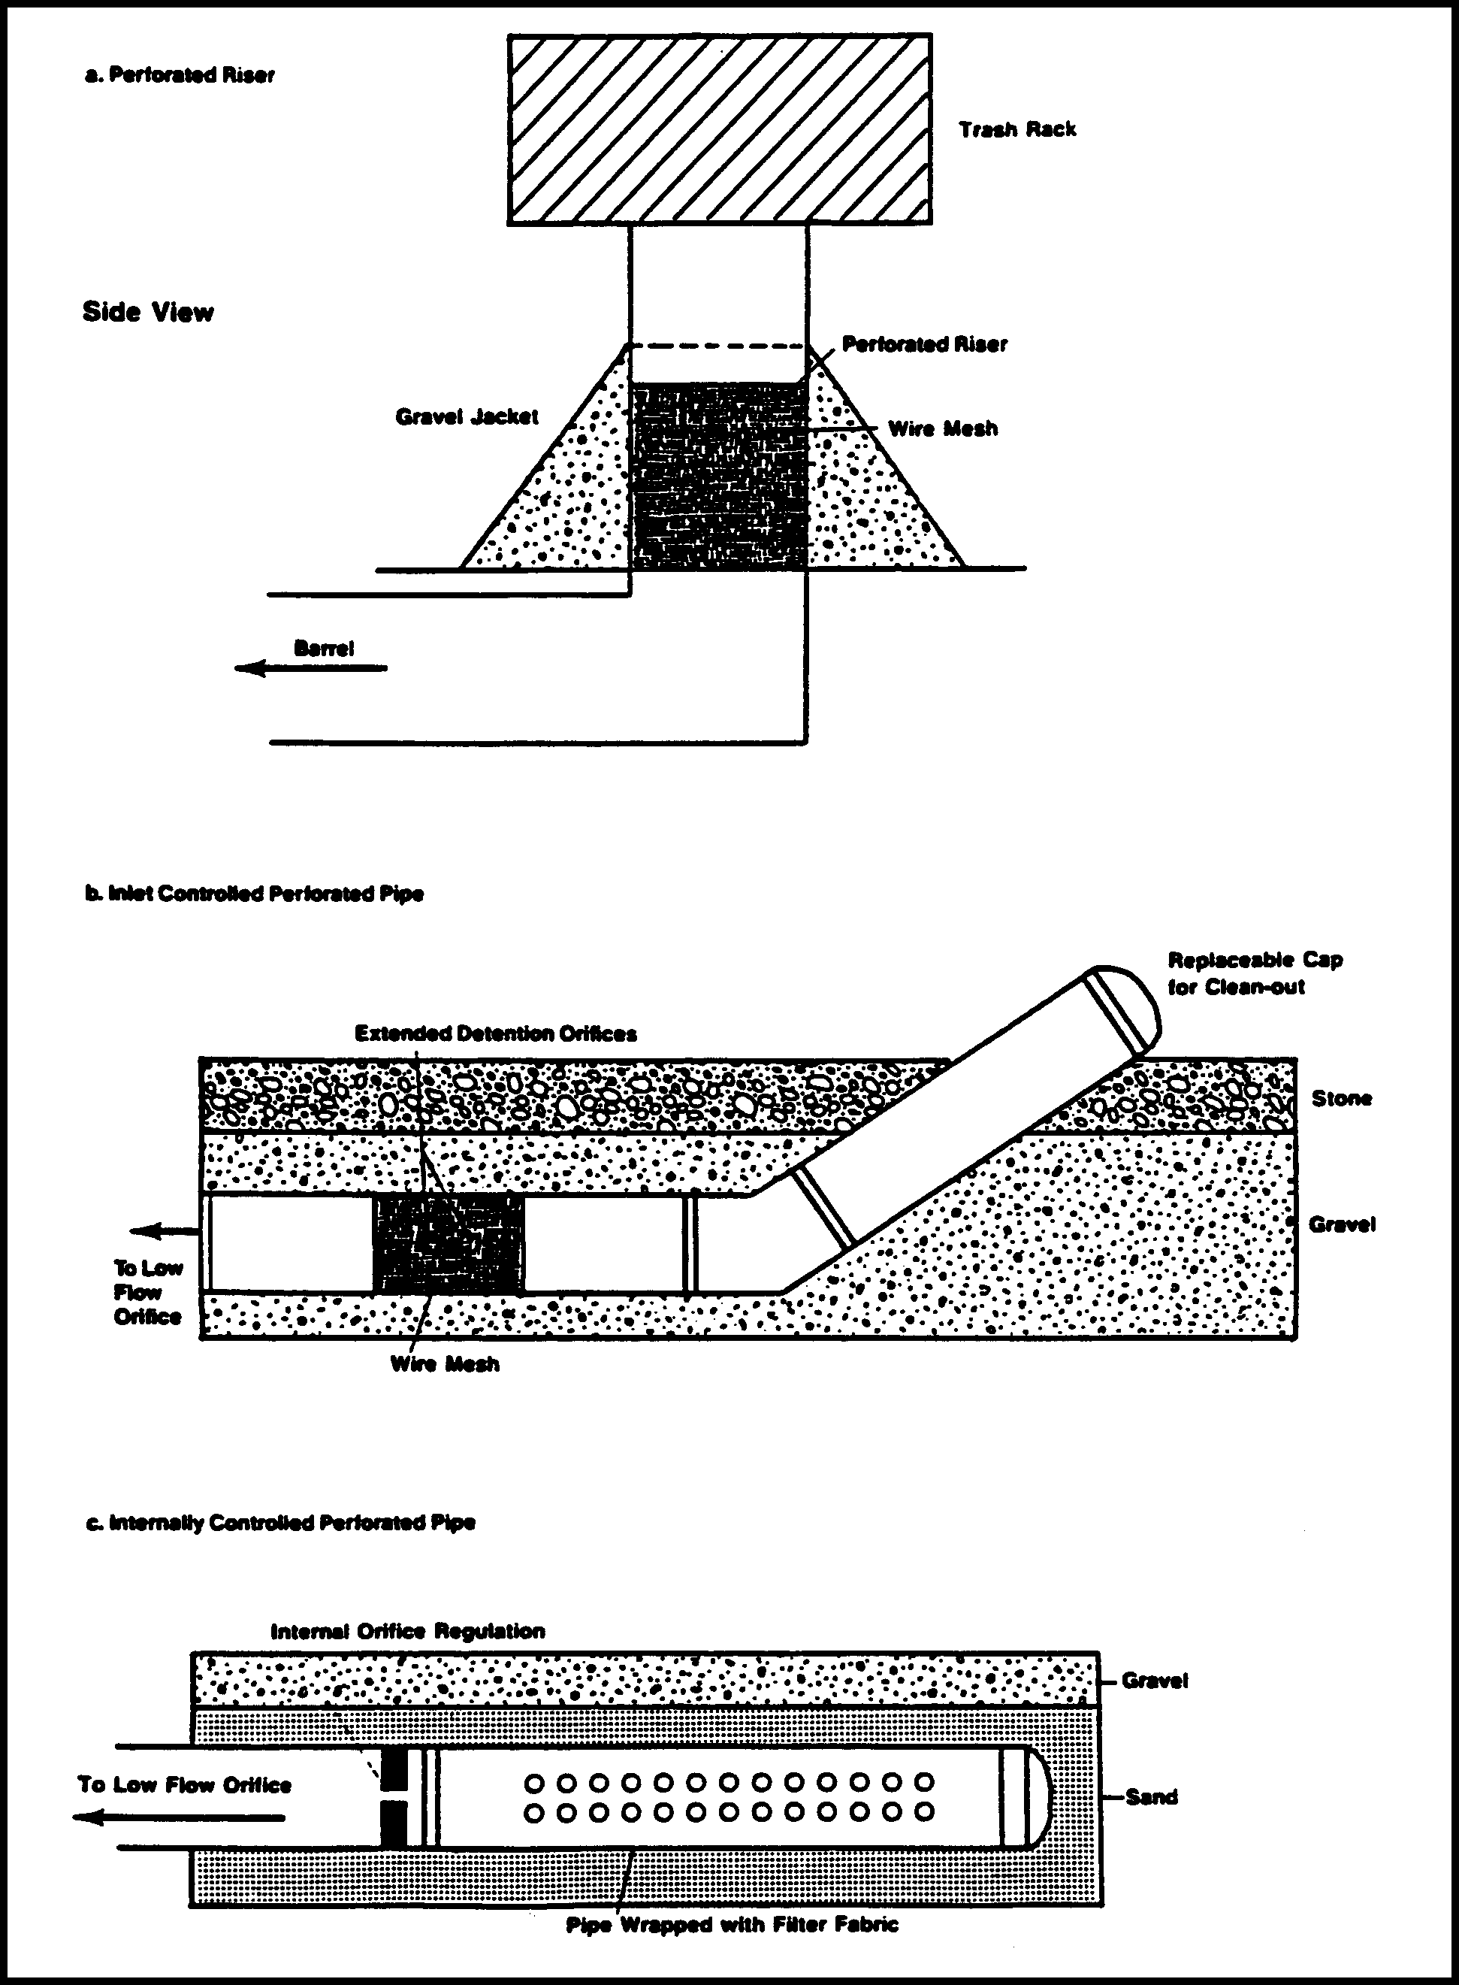
Figure 12-5. Devices to prevent clogging in dry detention control structures (Source: Schueler, T.R. 1987. Controlling Urban Runoff: A Practical Manual for Planning and Designing Urban BMP’s. Metropolitan Washington Council of Governments, Washington, D.C.)
PART VI – BASIN CRITERIA

13.0 Basin Criteria

Chapter 40C-41, F.A.C., and this section establish additional criteria which are to be used in reviewing applications for permits in certain hydrologic basins. These basins are:

(a) Upper St. Johns River Hydrologic Basin

(b) Ocklawaha River Hydrologic Basin

(c) Wekiva River Hydrologic Basin
(d) Wekiva Recharge Protection Basin
(e) Econlockhatchee River Hydrologic Basin

(f) Tomoka River Hydrologic Basin

(g) Spruce Creek Hydrologic Basin

(h) Sensitive Karst Areas Basin

(i) Lake Apopka Hydrologic Basin

See Figure 13.0-1 for a description of the areas contained within the Upper St. Johns River Hydrologic Basin, the Ocklawaha River Hydrologic Basin, the Wekiva River Hydrologic Basin, the Econlockhatchee River Hydrologic Basin, the Tomoka River Hydrologic Basin and the Spruce Creek Hydrologic Basin. See Figures 13.0-2, 13.0-3, and 13.0-4 for a description of the areas contained within the Sensitive Karst Areas Basin. See Figure 13.0-5 for a description of the areas contained within the Lake Apopka Hydrologic Basin. A legal description of the Hydrologic Basin boundaries is available in Appendix B.

Figure 13.0-1 Basin Criteria Map

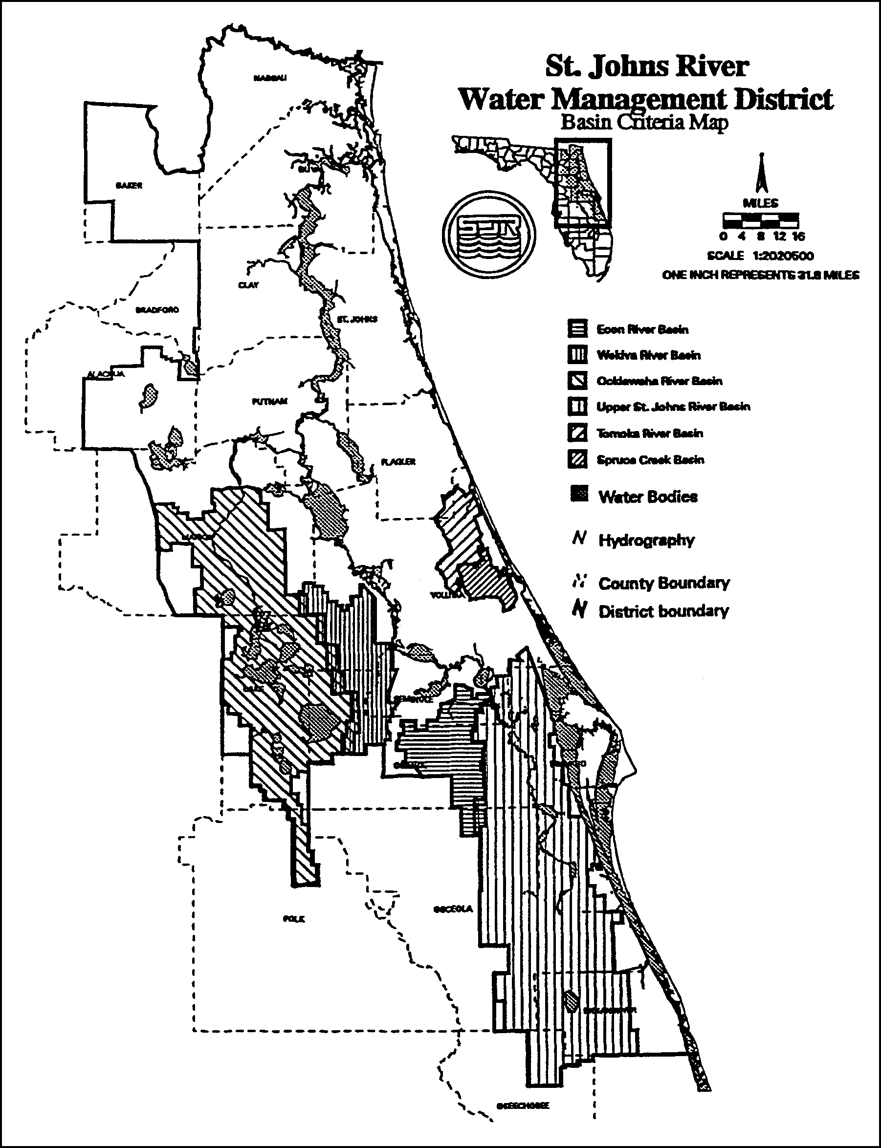

Figure 13.0-2 Sensitive Karst Areas in the St. Johns River Water Management District
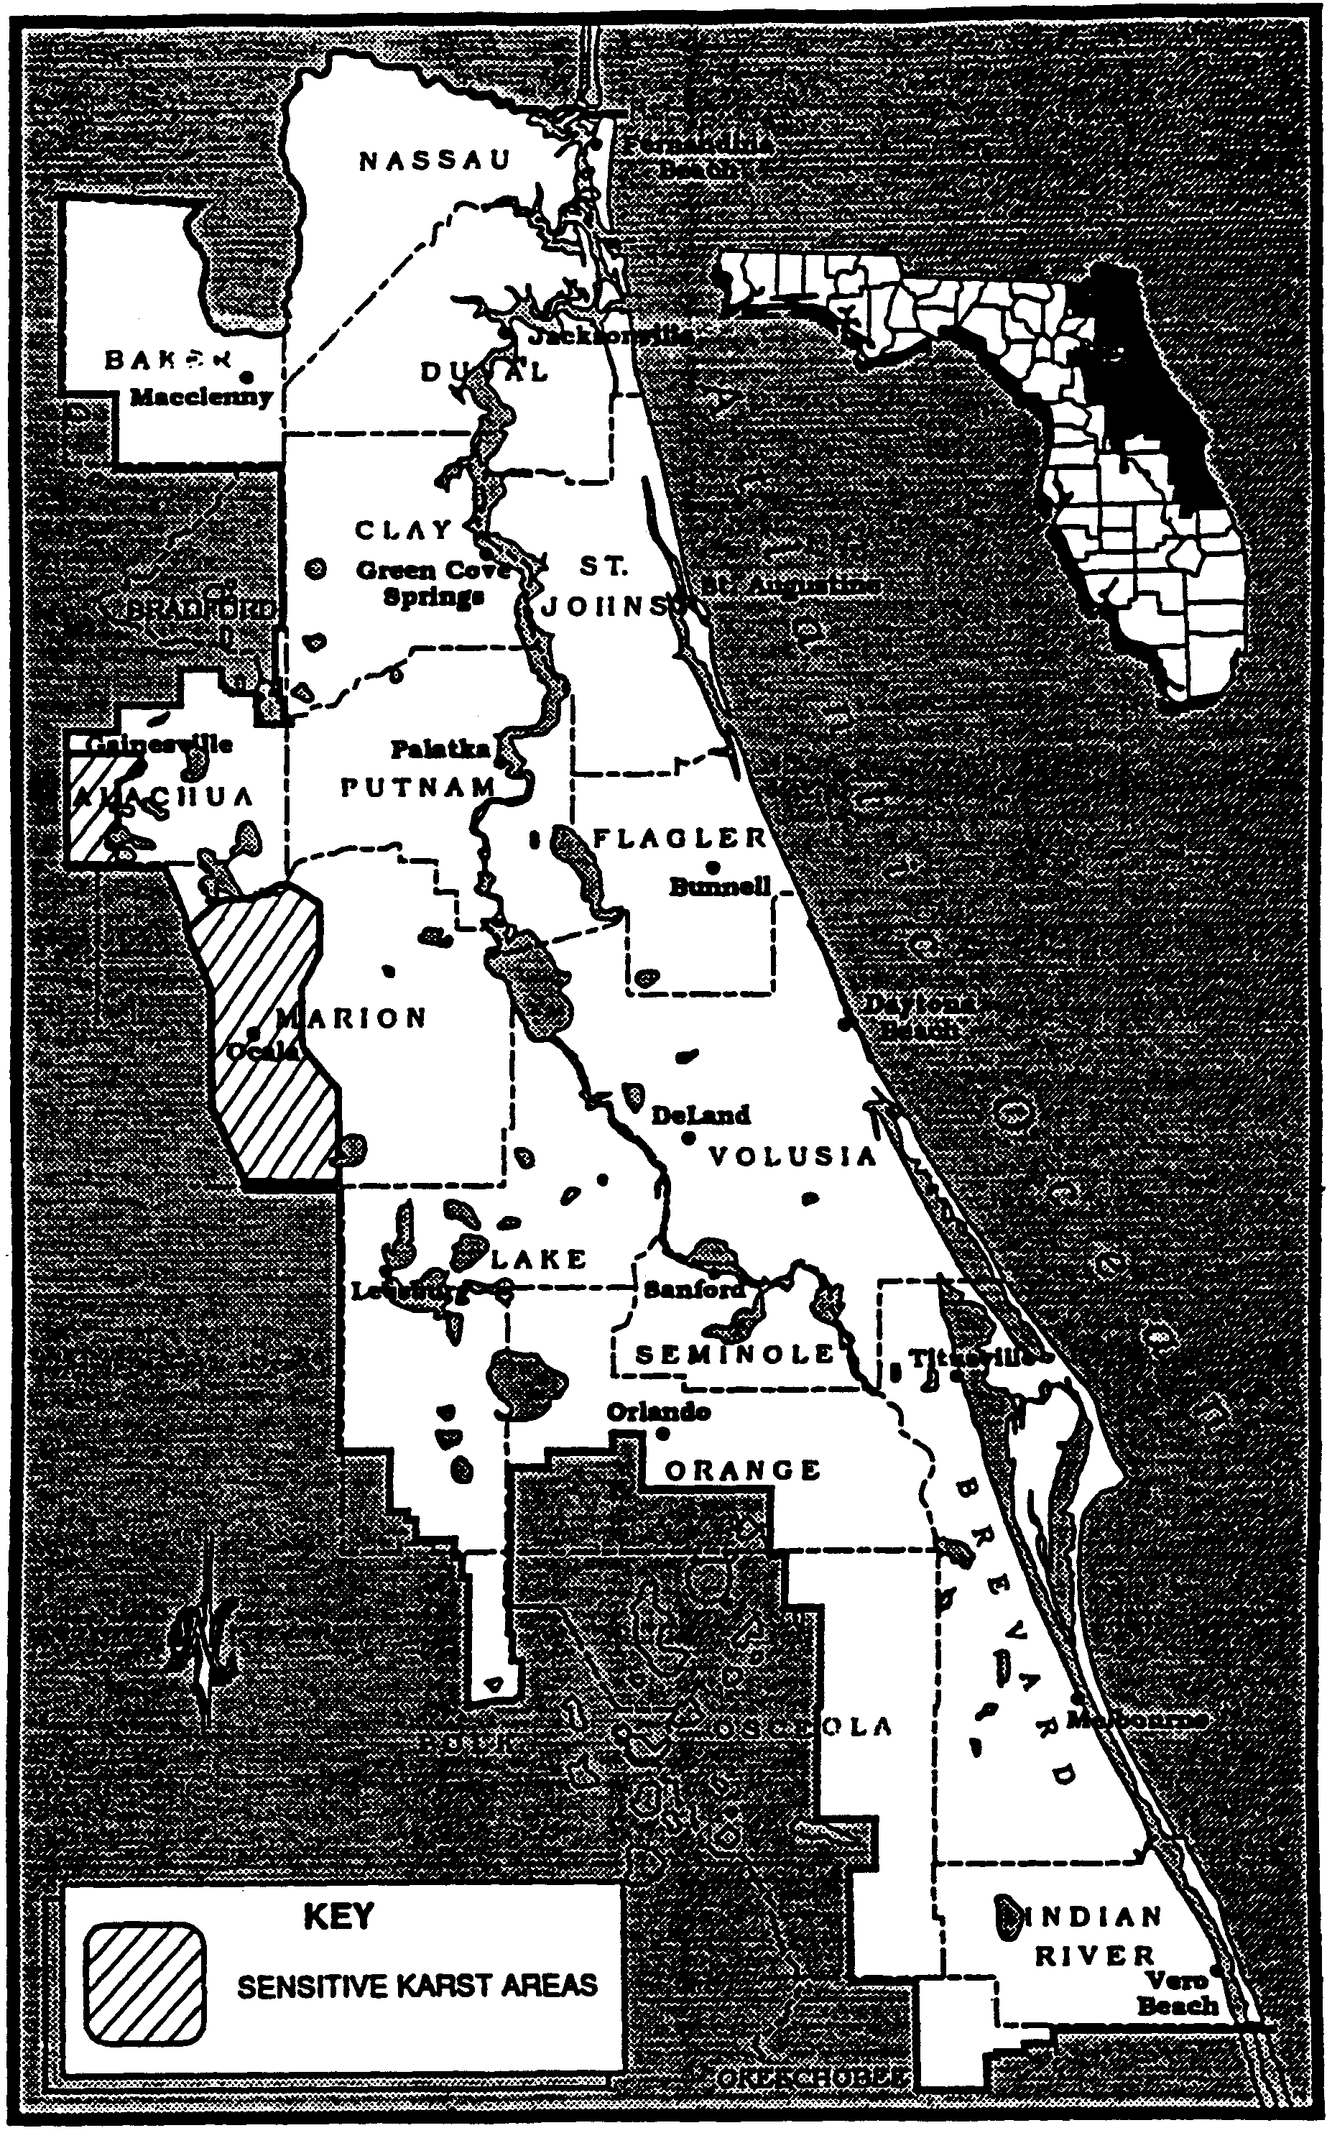
Figure 11.0-2 Sensitive Karst Areas in the St. Johns River Water Management District
Figure 13.0-3 Alachua County Karst Area
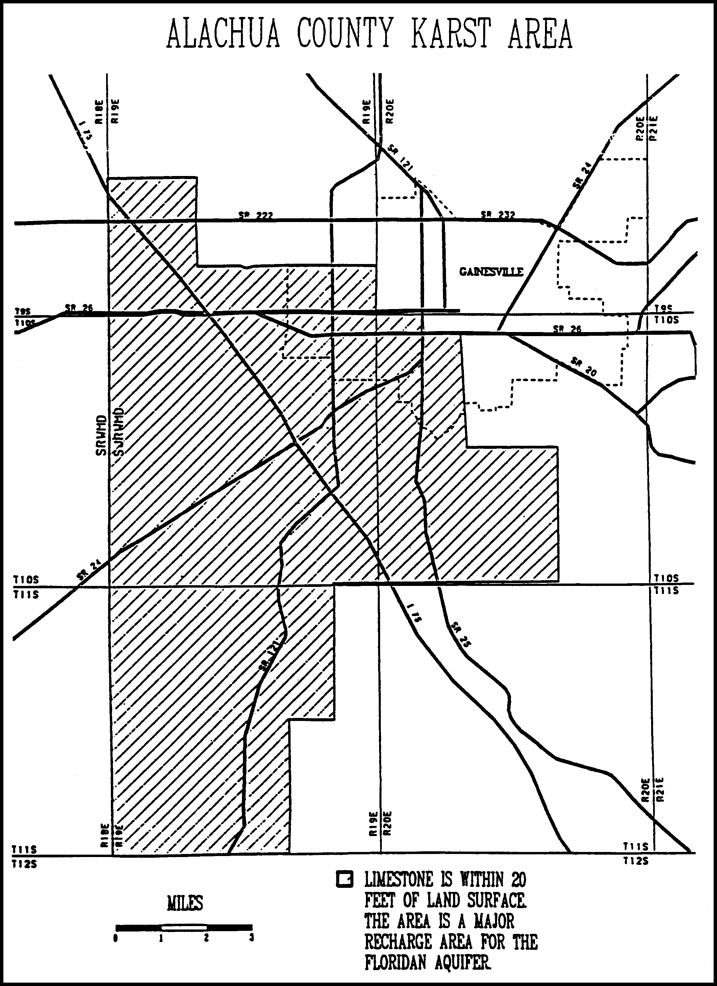
Figure 11.0-3 Alachua County Karst Area
Figure 13.0-4 Marion County Karst Area
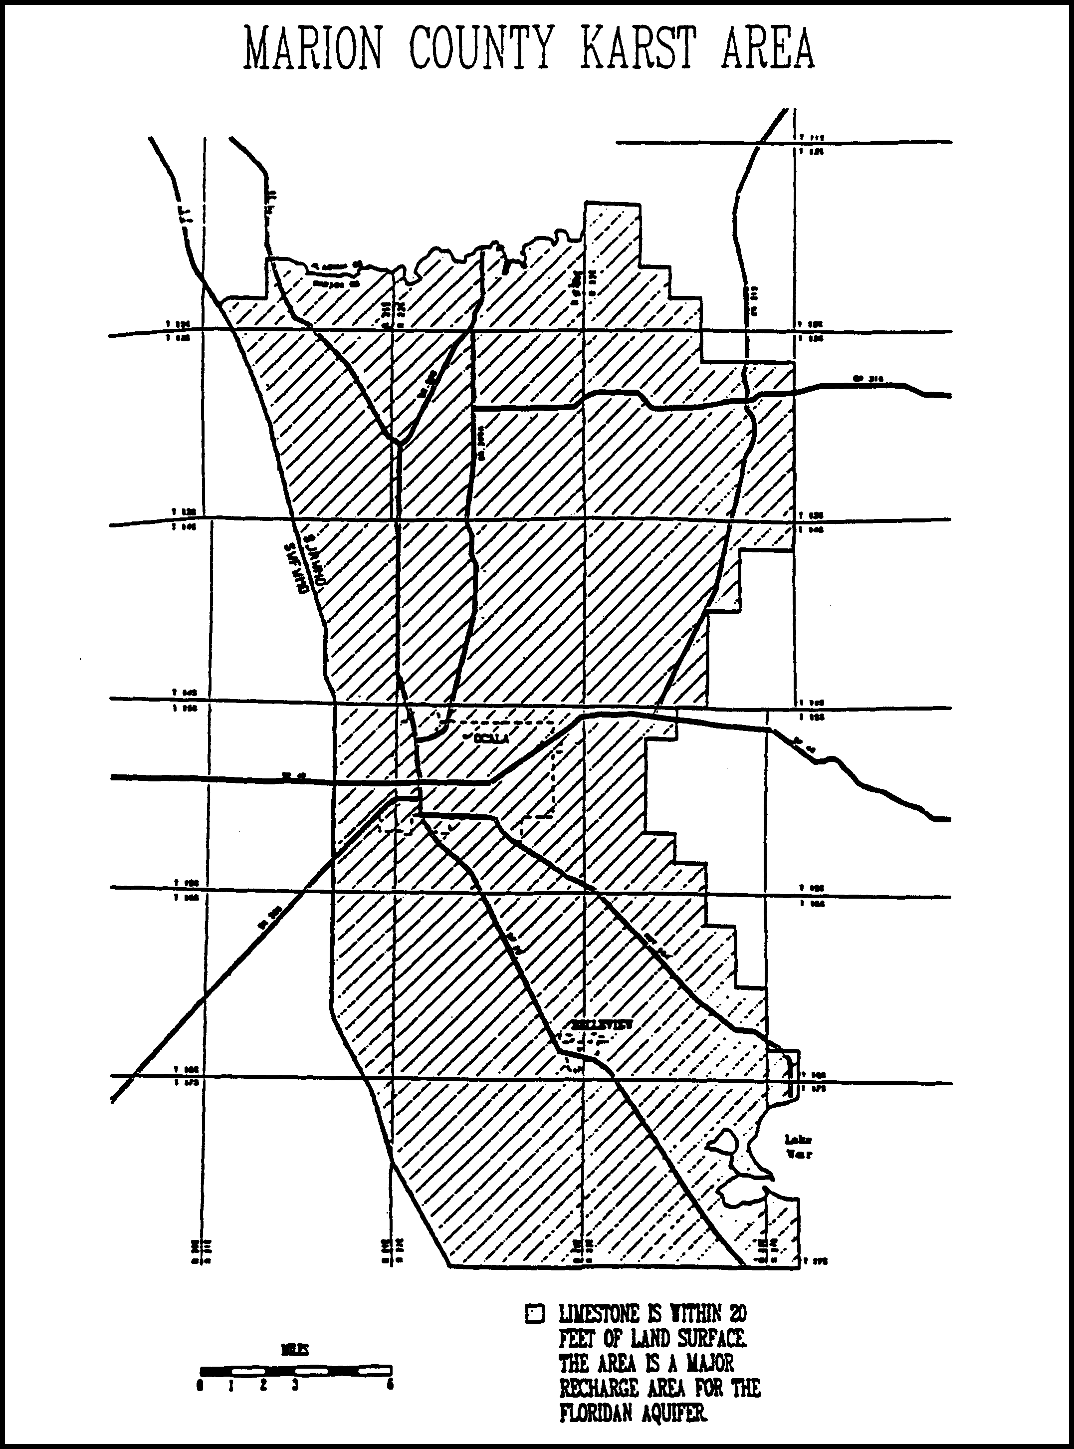
Figure 11.0-4 Marion County Karst Area
Figure 13.0-5 Lake Apopka Drainage Basin

13.1 Upper St. Johns River Hydrologic Basin

As part of the design criteria described in sections 62-330.301 and 62-330.302, F.A.C., above, systems in the Upper St. Johns River Basin must meet the following criteria:

13.1.1 Storm Frequency

The system shall meet applicable discharge criteria for 10 year and 25 year frequency storms. On-site storage and outlet capacity should be designed for the 25 year storm. Outlet capacity design should be checked and further refined, if necessary, for the 10 year storm.

13.1.2 Runoff Volume

For systems utilizing pumped discharges, the post-development discharge volume during the four day period beginning the third day of the four day duration storm may not exceed the pre-development discharge during the same period.

13.1.3 Interbasin Diversion

(a) A system may not result in an increase in the amount of water being diverted from the Upper St. Johns River Hydrologic Basin into coastal receiving waters.

(b) It is an objective of the District to, where practical, curtail diversions of water from the Upper St. Johns River Hydrologic Basin into coastal receiving waters.

13.2 Ocklawaha River Hydrologic Basin

As part of the design criteria described in sections 62-330.301 and 62-330.302, F.A.C., above, systems in the Ocklawaha River Hydrologic Basin must meet the following criteria:

13.2.1 Storm Frequency

The system shall meet applicable discharge criteria for 10 year and 25 year frequency storms. On-site storage and outlet capacity should be designed for the 25 year storm. Outlet capacity design should be checked and further refined, if necessary, for the 10 year storm.

13.2.2 Runoff Volume

For systems utilizing pumped discharges, the post-development discharge volume during the four day period beginning the third day of the four day duration storm may not exceed the pre-development discharge during the same period.

13.3 Wekiva River Hydrologic Basin and Wekiva Recharge Protection Basin

As part of the standards and design criteria described in sections 62-330.301 and 62-330.302, F.A.C., above, systems in the Wekiva River Hydrologic Basin or the Wekiva Recharge Protection Basin (which are both shown in Figure 13.3-2) must meet the following standards and criteria as described below:

13.3.1 Recharge Standard

Applicants required to obtain a permit pursuant to Chapters 62-330 or 40C-44, F.A.C., for a surface water management system located within the Wekiva Recharge Protection Basin shall demonstrate that the system provides for retention storage of three inches of runoff from all impervious areas proposed to be constructed on soils defined as a Type “A” Soils as defined by the Natural Resources Conservation Service (NRCS) Soil Survey in the following NRCS publications: Soil Survey of Lake County Area, Florida (1975); Soil Survey of Orange County Area, Florida (1989); and Soil Survey of Seminole County Area, Florida (1990), which are incorporated by reference in rule 40C-4.091(1)(d), F.A.C. For purposes of this rule, areas with Type “A” Soils shall be considered “Most Effective Recharge Areas.” The system shall be capable of infiltrating this storage volume through natural percolation into the surrounding soils within 72 hours. Off-site areas or regional systems may be utilized to satisfy this requirement. As an alternative, applicants may demonstrate that the post-development recharge capacity is equal to or greater than the pre-development recharge capacity. Pre-development recharge shall be based upon the land uses in place as of 12-3-06. Applicants may utilize existing permitted municipal master stormwater systems, in lieu of onsite retention, to demonstrate that post-development recharge is equal to or greater than pre-development recharge. Also, applicants may submit additional geotechnical information to establish whether or not a site contains Type “A” soils.

13.3.2 Storage Standard

Within the Wekiva River Hydrologic Basin, a system may not cause a net reduction in flood storage within the 100 year floodplain of a stream or other watercourse which has a drainage area upstream of more than one square mile and which has a direct hydrologic connection to the Wekiva or Little Wekiva Rivers or Black Water Creek.

Figure 13.3-2 Wekiva River Hydrologic Basin and Wekiva Recharge Protection Basin
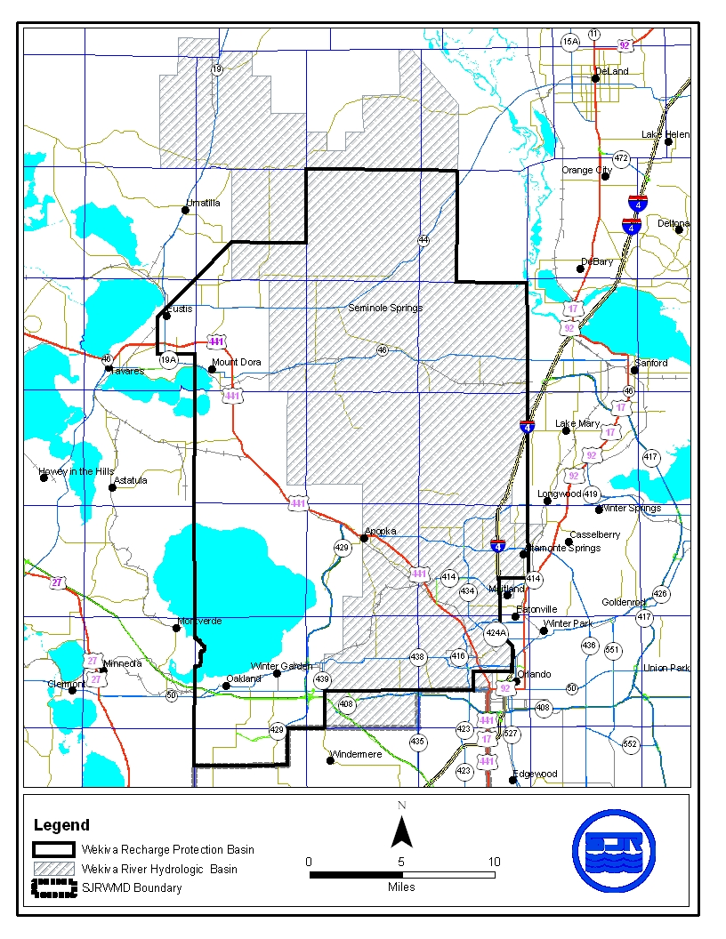

13.3.3 Standards for Erosion and Sediment Control and Water Quality

Construction and alteration of systems can result in erosion and downstream turbidity and sedimentation of waters. Erosion is the process by which the land surface is worn away by action of wind, water, and gravity. During construction and alteration, the potential for erosion increases dramatically. The result of erosion is discharges of turbid water and subsequent sedimentation (settling out) of soil particles in downstream receiving waters. Turbidity, suspended solids, and sedimentation result in adverse biological effects in aquatic and wetland environments, water quality degradation, and loss of flood storage and conveyance. The potential for erosion can be severe in the Wekiva River Hydrologic Basin as a result of steep slopes and erosive soils.

(a) Although erosion and sediment control measures are required throughout the St. Johns River Water Management District, the District has determined that the problems associated with erosion in the Wekiva River Hydrologic Basin are sufficiently serious to warrant requiring those applicants proposing certain systems to provide detailed plans when permit applications are submitted.

A Water Quality Protection Zone shall extend one half mile from the Wekiva River, Little Wekiva River north of State Road 436, Black Water Creek, Rock Springs Run, Seminole Creek, and Sulphur Run, and shall also extend one quarter mile from any wetland abutting an Outstanding Florida Water.

An erosion and sediment control plan must be submitted as part of the surface water management permit application for a surface water management system which:

1. Serves a project which is located wholly or partially within this zone; or

2. Serves a project with a total land area equal to or exceeding 120 acres.

The applicant proposing such a system must give reasonable assurance in the erosion and sediment control plan that during construction or alteration of the system (including revegetation and stabilization), erosion will be minimized and sediment will be retained on-site. The plan must be in conformance with the erosion and sediment control principles set forth in section 13.8.2, and must contain the information set forth in section 13.8.3.

(b) For a project which will be located wholly or partially within 100 feet of an Outstanding Florida Water or within 100 feet of any wetland abutting such a water, an applicant must provide reasonable assurance that the construction or alteration of the system will not cause sedimentation within these wetlands or waters and that filtration of runoff will occur prior to discharge into these wetlands and waters.

It is presumed that this standard will be met if, in addition to implementation of the plan required in paragraph (a), any one of the following criteria is met:

1. A minimum 100 foot width of undisturbed vegetation must be retained landward of the Outstanding Florida Water or the abutting wetland, whichever is more landward. During construction or alteration, runoff (including turbid discharges from dewatering activities) must be allowed to sheetflow across this undisturbed vegetation as the natural topography allows. Concentrated or channelized runoff from construction or alteration areas must be dispersed before flowing across this undisturbed vegetation. Construction or alteration of limited scope necessary for outfall structures may occur within this area of undisturbed vegetation.

2. Construction of the following perimeter controls at all outfall points to the Outstanding Florida Water or its abutting wetlands must be completed prior to the start of any construction or alteration of the remainder of the system:

a. Stormwater discharge facility meeting the requirements of Part V of this Volume;

b. Sedimentation trap or basin located immediately upstream of the stormwater discharge facility referred to above; and

c. Spreader swale to reduce the velocity of discharge from the stormwater facility to non-erosive rates before discharge to wetlands abutting the Outstanding Florida Water.

These perimeter controls must be maintained routinely and operated throughout construction or alteration of the entire system. A minimum 25 foot width of undisturbed vegetation must be retained landward of the Outstanding Florida Water or the abutting wetland, whichever is more landward. Construction or alteration of limited scope necessary for outfall structures may occur within this area of undisturbed vegetation.

3. During construction or alteration, no direct discharge to the Outstanding Florida Water or its abutting wetland may occur during the 10 year 24 hour storm event or due to discharge from dewatering activities. Any on-site storage required to satisfy this criteria must be available (recovered) within 14 days following the rainfall event. A minimum 25 foot width of undisturbed vegetation must be retained landward of the Outstanding Florida Water or the abutting wetland, whichever is more landward. Construction or alteration of limited scope necessary for outfall structures may occur within this area of undisturbed vegetation.

In determining whether construction or alteration is of "limited scope necessary", pursuant to any of the three presumptive criteria above, the District shall require that the area of disturbance be minimized and that the length of time between initial disturbance and stabilization of the area also be minimized.

13.3.4 Standard for Limiting Drawdown

Lowering the ground water table adjacent to wetlands can change the wetland hydroperiod such that the functions provided by the wetland are adversely affected.

Within the Wekiva River Hydrologic Basin a Water Quantity Protection Zone shall extend 300 feet landward of the landward extent of Black Water Swamp and the wetlands abutting the Wekiva River, Little Wekiva River, Rock Springs Run, Black Water Creek, Sulphur Run, Seminole Creek, Lake Norris, and Lake Dorr. As part of providing reasonable assurance that the standard set forth in paragraph 62-330.301(1)(d) is met, where any part of a system located within this zone will cause a drawdown, the applicant must provide reasonable assurance that construction, alteration, operation, or maintenance of the system will not cause ground water table drawdowns which would adversely affect the functions provided by the referenced wetlands.

The applicant shall provide an analysis which includes a determination of the magnitude and areal extent of any drawdowns, based on site specific hydrogeologic data collected by the applicant, as well as a description of the referenced wetlands, the functions provided by these wetlands, and the predicted impacts to these functions.

It is presumed that the part of this standard regarding drawdown effects will be met if the following criteria is met:

A ground water table drawdown must not occur within the Water Quantity Protection Zone.

13.3.5 Standard for Riparian Wildlife Habitat

Within the Wekiva River Hydrologic Basin, the wetlands abutting the Wekiva River, Little Wekiva River downstream of Maitland Boulevard, Rock Springs Run, Black Water Creek, Sulphur Run and Seminole Creek support an abundance and diversity of aquatic and wetland dependent wildlife. Uplands abutting these wetlands protect the wetlands from climatic extremes and also provide important habitat for some aquatic and wetland dependent species. Construction and alteration of surface water management systems within these wetlands and uplands can result in adverse changes in the habitat, abundance, and food sources of aquatic and wetland dependent species.

(a) The applicant must provide reasonable assurance that the construction or alteration of a system will not adversely affect the abundance, food sources, or habitat (including its use to satisfy nesting, breeding and resting needs) of aquatic or wetland dependent species provided by the following designated Riparian Habitat Protection Zone:

1. The wetlands abutting the Wekiva River, Little Wekiva River downstream of Maitland Boulevard, Rock Springs Run, Black Water Creek, Sulphur Run, or Seminole Creek;

2. The uplands which are within 50 feet landward of the landward extent of the wetlands above.

3. The uplands which are within 550 feet landward of the stream's edge as defined, for the purpose of this subsection, as the waterward extent of the forested wetlands abutting the Wekiva River, Little Wekiva River downstream of the northernmost crossing of the Little Wekiva River with S.R. 434, Rock Springs Run, Black Water Creek, Sulphur Run or Seminole Creek. In the absence of forested wetlands abutting these streams, the stream's edge shall be defined, for the purpose of this subsection, as the mean annual surface water elevation of the stream; however, if hydrologic records are unavailable, the landward extent of the herbaceous emergent wetland vegetation growing in these streams shall be considered to be the stream's edge.

(b) Any of the following activities within the Riparian Habitat Protection Zone is presumed to adversely affect the abundance, food sources, or habitat of aquatic or wetland dependent species provided by the zone: construction of buildings, golf courses, impoundments, roads, canals, ditches, swales, and any land clearing which results in the creation of any system. (Activities not listed above do not receive a presumption of no adverse effect.)

(c) The presumption in paragraph (b) shall not apply to any activity which promotes a more endemic state, where the land in the zone has been changed by man. An example of such an activity would be construction undertaken to return lands managed for agriculture or silviculture to a vegetative community that is more compatible with the endemic land cover.

13.3.6 Local Government Notification for Wekiva River Protection Area

The District shall not issue a conceptual approval, individual, or standard permit for a proposed surface water management system located wholly or partially within the Wekiva River Protection Area, as defined in Section 369.303(9), F.S., until the appropriate local government has provided written notification that the proposed activity is consistent with the local comprehensive plan and is in compliance with land development regulation in effect in the area where development will take place. The applicant proposing such a system must submit to the District form no. 40C-41.063(4), entitled "Local Government Notification", (incorporated by reference in 40C-41.063(4)), after it has been completed and executed by the local government. This form is available upon request from the St. Johns River Water Management District, 4049 Reid Street, Palatka, Florida 32177-2529. Permit applications for systems within the Wekiva River Protection Area shall be processed by the District staff pursuant to the time frames established in Section 120.60, F.S., and any District rule regarding permit processing, except that any agency action to approve or approve with conditions shall not occur until the Local Government Notification has been received by the District.

13.4 Econlockhatchee River Hydrologic Basin

As part of the standards and design criteria described in 62-330.301 and 62-330.302, F.A.C., above, systems in the Econlockhatchee River Hydrologic Basin must meet the following standards and criteria:

13.4.1 Design Storm Criteria

Systems must meet the peak discharge requirement for the following 24 hour duration design storm events:

(a) Mean annual storm (2.3 year return period) with a total 24 hour rainfall depth of 4.5 inches.

(b) 25-year return period.

System outlet control structures can be designed to meet the control peak discharge rates for both design storms by use of a two-stage weir, v-notch weir, multiple orifices, or other similar structures.

13.4.2 Floodplain Storage Criteria

A system must not cause a net reduction in flood storage within the 100 year floodplain of the Econlockhatchee River or any of its tributaries, at a location with an upstream drainage area of 1 square mile or greater, except for structures elevated on pilings or in subsection 3.3.

13.4.3 Riparian Wildlife Habitat Standard

The wetlands abutting the Econlockhatchee River and its tributaries support an abundance and diversity of aquatic and wetland dependent wildlife. Uplands abutting these wetlands protect the wetlands and provide important habitat for aquatic and wetland dependent species. Construction, alteration, operation, maintenance, removal or abandonment of surface water management systems within these wetlands and uplands can result in adverse changes in the habitat, diversity, abundance and food sources of aquatic and wetland dependent species. Implementation of these regulations should be done in a manner which encourages development of functional resource protection plans.

(a) The applicant must provide reasonable assurance that the construction, alteration, operation, maintenance, removal or abandonment of a system within the following designated Riparian Habitat Protection Zone will not adversely affect the abundance, diversity, food sources or habitat (including its use to satisfy nesting, breeding and resting needs) of aquatic or wetland dependent species:

1. The wetlands contiguous with the Econlockhatchee River and the following tributaries: Little Econlockhatchee River north of University Boulevard, Mills Creek, Silcox Branch (branch of Mills Creek), Mills Branch (branch of Mills Creek), Long Branch, Hart Branch, Cowpen Branch, Green Branch, Turkey Creek, Little Creek, and Fourmile Creek;

2. The uplands which are within 50 feet landward of the landward extent of the wetlands above; and

3. The uplands which are within 550 feet landward of the stream's edge as defined, for the purpose of this subsection, as the waterward extent of the forested wetlands abutting the Econlockhatchee River and the above named tributaries. In the absence of forested wetlands abutting these streams, the stream's edge shall be defined, for the purpose of this subsection, as the mean annual surface water elevation of the stream; however, if hydrologic records are unavailable, the landward extent of the herbaceous emergent wetland vegetation growing in these streams shall be considered to be the stream's edge.

4. The following portions of streams typically lack a defined water's edge, and subparagraph 3. shall not apply:

a. Mills Creek upstream of the intersection of the creek with the Fort Christmas Road in Section 2, Township 22 South, Range 32 East;

b. Long Branch upstream of the intersections of the creek with SR 520;

c. Hart Branch upstream of the intersection of the creek and the Old Railroad Grade in Section 18, Township 23 South, Range 32 East;

d. Cowpen Branch upstream of the southernmost bifurcation of the creek in Section 20, Township 23 South, Range 32 East;

e. Green Branch upstream of the intersection of the creek with the north-south section line between Section 29 and 30, Township 23 South, Range 32 East;

f. Turkey Creek including Turkey Creek Bay upstream of the intersection of the creek with the Weewahootee Road in Section 5, Township 24 South, Range 32 East;

g. Little Creek upstream of the intersection of the creek with the north-south section line between Sections 22 and 23, Township 24 South, Range 32 East;

h. Fourmile Creek including Bee Tree Swamp upstream of a point along the creek exactly halfway between section lines at the south end of Section 21 and the north end of Section 33 within Section 28, Township 24 South, Range 32 East; and

i. All of the Econlockhatchee River Swamp (a portion of the Econlockhatchee River).

(b) Any of the following activities within the Riparian Habitat Protection Zone are presumed to adversely affect the abundance, food sources, or habitat of aquatic or wetland dependent species provided by the zone: construction of buildings, golf courses, impoundments, roads, canals, ditches, swales, and any land clearing which results in the creation of any system. (activities not listed above do not receive a presumption of no adverse effect.)

(c) The presumption in paragraph (b) shall not apply to any activity which promotes a more endemic state, where the land in the zone has been changed by man. An example of such an activity would be construction undertaken to return lands managed for agriculture or silviculture to a vegetative community that is more compatible with endemic land cover.

(d) Applicants seeking to develop within the Riparian Habitat Protection Zone shall be given the opportunity to demonstrate that the particular development for which permitting is being sought will not have an adverse effect on the functions provided by the zone to aquatic or wetland dependent species. The functions provided by the zone are dependent on many factors. When assessing the value of the zone to aquatic and wetland dependent species, factors which the District will consider include: vegetative land cover, hydrologic regime, topography, soils, and land uses, existing within and adjacent to the zone; and range, habitat, and food source needs of aquatic and wetland dependent species, as well as sightings, tracks, or other such empirical evidence of use.

(e) The standard of paragraph 13.4.3(a) may be met by demonstrating that the overall merits of the proposed plan of development, including the preservation, creation or enhancement of viable wildlife habitat, provide a degree of resource protection to these types of fish and wildlife which offsets adverse effects that the system may have on the abundance, diversity, food sources, or habitat of aquatic or wetland dependent species provided by the zone. Mitigation plans will be considered on a case-by-case basis upon detailed site specific analyses. The goal of this analysis shall be the determination of the value of the proposed mitigation plan to aquatic and wetland dependent species with particular attention to threatened or endangered species. Mitigation plans should include: the information set forth in section 10.3.3 Applicant’s Handbook Volume I for the uplands and wetlands within the zone and within other areas to be preserved, created or enhanced as mitigation for impacts within the zone; as well as other pertinent information, including land use, and the proximity of the site to publicly owned land dedicated to conservation. Implementation of this section contemplates that the proximity of development to the river and tributaries named herein and activities permitted in the zone may vary from place to place in support of a functional resource protection plan. Furthermore, some reasonable use of the land within the protection zone can be allowed under subsection 13.4.4.

(f) Roads or other traversing works which cross the zone have the potential to fragment the zone and adversely affect the habitat value of the zone to aquatic and wetland dependent species. To minimize adverse effects to the zone, applicants for permits to construct traversing works in the zone must first demonstrate the need for the traversing works to provide for regional transportation, regional utility services, or reasonable property access, in addition to meeting the requirement of paragraph 13.4.4(a), above. Traversing works must also be designed to meet all requirements of the district rules related to water quality and quantity. Permittees responsible for traversing works shall be required to be responsible for maintaining the traversing works clean and free from trash and debris to the greatest extent practical.

13.4.4 Off-site Land Preservation as Mitigation in the Econlockhatchee River Hydrologic Basin.

Mitigation in the Econlockhatchee River Hydrologic Basin must offset any adverse impacts of the system to the functions provided by the Econlockhatchee River Riparian Habitat Protection Zone and wetlands outside this zone, to aquatic and wetland dependent species. The lands proposed for preservation must be regionally significant or provide unique fish and wildlife habitat. For the purposes of this section the land to be preserved must be located entirely within the Econlockhatchee River Basin as designated in section 40C-41.023, F.A.C., and the applicant must propose to convey the land in fee simple to the St. Johns River Water Management District or a mutually acceptable designee. At the option of the District, a perpetual conservation easement or other acceptable legal instrument may be conveyed to the District or a mutually acceptable designee in accordance with section 704.06, F.S. All of the following requirements will apply to off-site land preservation proposals within the Econlockhatchee River Basin:

(a) Prior to proposing off-site land preservation, the applicant must demonstrate that alternatives for avoiding adverse impacts to the functions provided by the Riparian Habitat Protection Zone and wetlands outside the zone have been evaluated, and that to the maximum extent practicable, adverse impacts to these functions have been avoided.

(b) As a part of an off-site land preservation proposal, the applicant must demonstrate that the proposal meets the standard described in paragraph 13.4.3(a) by providing a functional analysis, as described in paragraph 13.4.3(c), of the proposed impacts within the Riparian Habitat Protection Zone and the benefits of the proposed preservation area. If adverse impacts occur to wetlands, then as part of an off-site land preservation proposal, the applicant must demonstrate that the proposal meets the criteria described in section 10.3.3, Applicant’s Handbook Volume I.

(c) The functional gain afforded by the preservation will depend upon the functional analysis of impacts and benefits. The suitability of this mitigation option, to be assigned, and the use of these credits will be determined on a case-by-case basis based on site-specific information.

13.5 Tomoka River and Spruce Creek Hydrologic Basins

As part of the standards and design criteria described in 62-330.301 and 62-330.302, F.A.C., systems within the Tomoka River Hydrologic Basin or the Spruce Creek Hydrologic Basin must meet the following standards and criteria:

13.5.1 Recharge Standard

Projects, or portions of projects, in the Most Effective Recharge Areas must retain three (3) inches of runoff from the directly connected impervious area within the Most Effective Recharge Area of the project area. As an alternative, applicants may demonstrate that the post-development recharge capacity will be equal to or greater than the pre-development recharge capacity.

Most Effective Recharge Areas, as used in this section, are areas which have 10-20 inches of recharge per year. Most Effective Recharge Areas can be more accurately defined by soils types. Those areas with Type “A” Hydrologic Soil Group shall be considered to be Most Effective Recharge Areas. Figures 13.5-1 and Figure 13.5-2 show the approximate location of the Most Effective Recharge Area in the Tomoka River and Spruce Creek Hydrologic Basins.

Section 13.8.1 contains a list of Type “A” soils for Flagler and Volusia counties. This list will be used to determine whether a proposed project, or portion of a project, is in the Most Effective Recharge Area. Also, applicants may submit additional geotechnical information to establish whether or not a site contains Type “A” soils and is within the Most Effective Recharge Area.

Figure 13.5-1 Tomoka River Soils Map
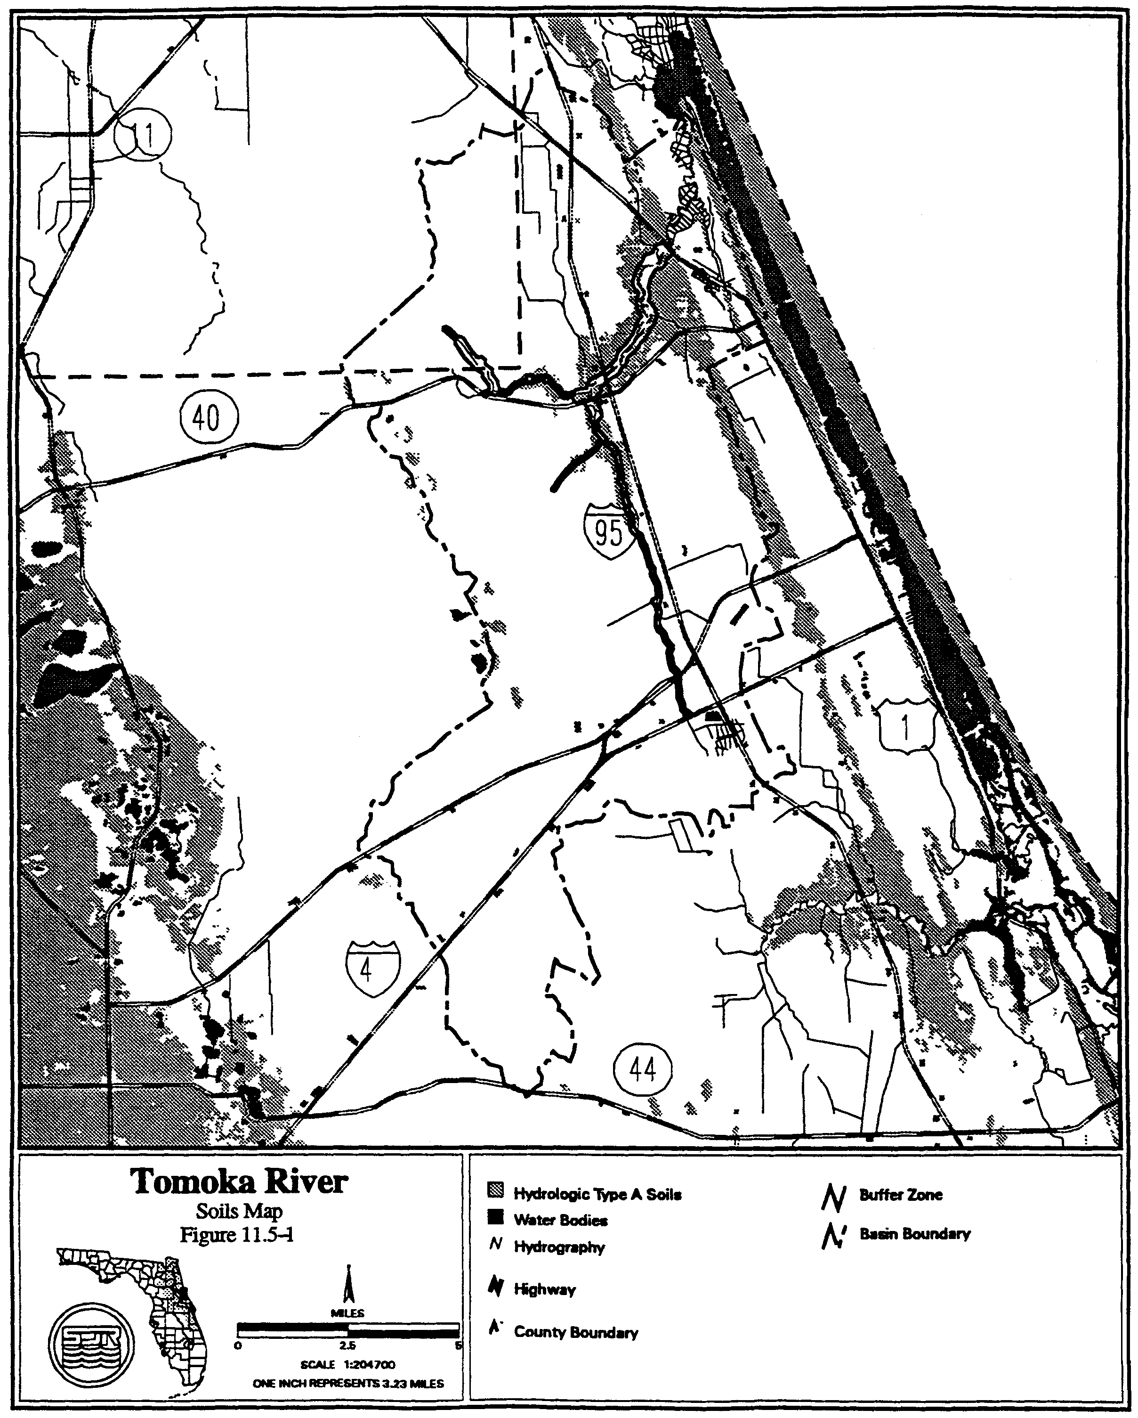
Figure 13.2-5 Spruce Creek Soils Map
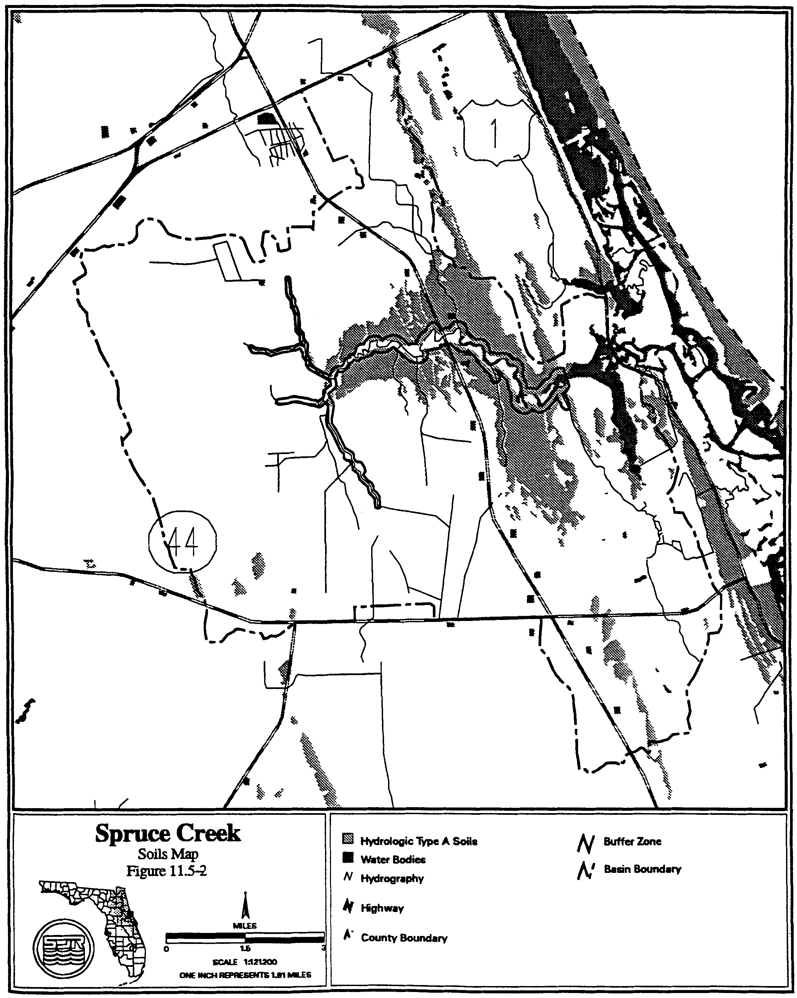

Directly connected impervious areas are those impervious areas, which are connected to the surface water management system by a drainage improvement, such as a ditch, storm sewer, paved channel, or other man-made conveyance. Stormwater that is retained must be infiltrated into the soil or evaporated such that the storage volume is recovered within 14 days following the storm event.

13.5.2 Floodplain Storage Criteria

Systems constructed in the 100 year floodplain have the potential to increase flood stages on adjacent property. A system must not cause a net reduction in flood storage within the 100 year floodplain of the Tomoka River or Spruce Creek or any of their tributaries except for structures elevated on pilings or traversing works that comply with conveyance requirements in subsection 3.3.2.

13.5.3 Stormwater Management Standard

Construction of new stormwater management systems must be in accordance with the design and performance standards of Part V of this Volume, However, systems which serve drainage areas in excess of 10 acres cannot use detention with filtration treatment as the sole stormwater treatment methodology. Additionally, when retention systems are not feasible due to limited percolation capacity, wet detention treatment or other treatment demonstrated to be equivalent to retention or wet detention, in accordance with Part V of this Volume, must be used.

13.5.4 Riparian Wildlife Habitat Standard

The wetlands abutting the Tomoka River and Spruce Creek and their tributaries support an abundance and diversity of aquatic and wetland dependent wildlife. Uplands abutting these wetlands protect the wetlands and provide important habitat for aquatic and wetland dependent species. Construction, alteration, operation, maintenance, removal or abandonment of surface water management systems within these wetlands and uplands can result in adverse changes in the habitat, diversity, abundance and food sources of aquatic and wetland dependent species. Implementation of these regulations should be done in a manner which encourages development of functional resource protection plans.

(a) The applicant must provide reasonable assurance that the construction, alteration, operation, maintenance, removal or abandonment of a system within the following designated Riparian Habitat Protection Zone will not adversely affect the abundance, diversity, food sources or habitat (including its use to satisfy nesting, breeding and resting needs) of aquatic or wetland dependent species:

1. The wetlands and uplands which are within 50 feet landward of the landward extent of the wetlands which abut Spruce Creek north of Pioneer Trail to the FEC railroad, and the Tomoka River north of I-4 to US 1 and the following tributaries:

a. Spruce Creek east of the western section line of Section 35, Township 16 South, Range 32 East, Volusia County, Florida.

b. Spruce Creek east of the power line easement in Section 27, Township 16 South, Range 32 East, Volusia County, Florida.

c. Spruce Creek west of SR 415 and south of the northern section line of Section 23, Township 16 South, Range 32 East, Volusia County, Florida.

d. The Little Tomoka River north of SR 40 in Volusia County and south of the western section line of Section 22, Range 31 East, Township 14 South, Flagler County.

e. Priest Branch east of the power line easement in Section 6, Township 15 South, Range 32 East, Volusia County, Florida.

2. The uplands which are within 550 feet landward of the stream's edge of the following portions of the streams. The stream’s edge is defined, for the purpose of this subsection, as the waterward extent of the wetlands abutting the stream:

a. Spruce Creek north of the southern section line of Section 25, Range 32 East, Township 16 South, Volusia County, Florida;

b. Tomoka River north of the confluence of the Tomoka River and Priest Branch; and

3. The uplands which are within 320 feet landward of the stream’s edge of the following stream. The stream’s edge is defined, for the purpose of this subsection, as the waterward extent of the wetlands abutting the stream:

a. Spruce Creek east of I-95 and west of the FEC railroad; and

4. The uplands that are within 275 feet landward of the edge of the following streams:

a. Spruce Creek south of the southern section line if Section 25, Range 32 East, Township 16 South, Volusia County, Florida;

b. Spruce Creek east of the western section line of Section 35, Township 16 South, Range 32 East, Volusia County, Florida.

c. Spruce Creek east of the power line easement in Section 27, Township 16 South, Range 32 East, Volusia County, Florida.

d. Spruce Creek west of SR 415 and south of the northern section line of Section 23, Township 16 South, Range 32 East, Volusia County, Florida.

e. The Tomoka River south of the confluence of the Tomoka River and Priest Branch in section 36, Range 31 East, Township 14 South, Volusia County, Florida;

f. The Little Tomoka River north of SR 40, Volusia County, and south of the western section line of Section 22, Range 31 East, Township 14 South, Flagler County, Florida.

g. Priest Branch east of the power line easement in Section 6, Township 15 South, Range 32 East, Volusia County, Florida.

(b) Any of the following activities within the Riparian Habitat Protection Zone are presumed to adversely affect the abundance, food sources, or habitat of aquatic or wetland dependent species provided by the Zone: construction of buildings, golf courses, impoundments, roads, canals, ditches, swales, and any land clearing which results in the creation of any system (activities not listed above do not receive a presumption of no adverse effect.)

(c) The presumption in paragraph (b) shall not apply to any activity which promotes a more endemic state, where the land in the Zone has been changed by man. An example of such an activity would be construction undertaken to return lands managed for agriculture or silviculture to a vegetative community that is more compatible with endemic land cover.

(d) The standard of subsection 13.5.4(a) may be met by demonstrating that the overall merits of the proposed plan of development, including mitigation as described in section 10.3, Applicant's Handbook Volume I provide a degree of resource protection to these types of fish and wildlife which offsets adverse effects of the proposed system on the uplands and wetlands within the Zone. Some reasonable use of the land within the Protection zone can be allowed under subsection 13.5.4.

(e) Roads or other traversing works which cross the Zone have the potential to fragment the Zone and adversely affect the habitat value of the Zone to aquatic and wetland dependent species. To minimize adverse effects to the Zone, applicants for permits to construct traversing works in the Zone must first demonstrate the need for the traversing works to provide for regional transportation, regional utility services, or reasonable property access, in addition to meeting the requirement of subsection 13.5.4(a), above. Traversing works must also be designed to meet all requirements of the district rules related to water quality and quantity.

13.6 Sensitive Karst Areas Basin Design Criteria

Chapter 40C-41, F.A.C., establishes additional surface water management criteria which are used in reviewing applications for permits in designated hydrologic basins. The Sensitive Karst Areas Basin covers those portions of western Alachua and western Marion counties within the District’s boundaries (Figures 13.0-5 and 13.0-4). The design criteria for the Sensitive Karst Areas Basin are found in subsection 40C-41.063(6), F.A.C., and are discussed below.

13.6.1 Background of the Sensitive Karst Areas Design Criteria

The Floridan aquifer is the drinking water source for most of the population in the SJRWMD. In parts of Alachua and Marion counties, the limestones that make up or comprise this aquifer are at or very near the land surface and potential sources of pollution. Potential contamination of the Floridan aquifer from surface pollutant sources in these areas is greater than within the rest of the District due to the hydrogeology and geology of these "sensitive karst areas." "Karst" is a geologic term used to describe areas where sinkhole formation is common and landscapes are formed by the solution of limestone.

13.6.2 Hydrogeology of the Sensitive Karst Areas Basin

Throughout the majority of the District the highly porous limestone which contains the Floridan aquifer is overlain by tens to hundreds of feet of sands, clays, and other material. This material acts as a buffer, isolating the Floridan aquifer from surface pollutants. Surface water seeps through this material slowly which allows for filtration, adsorption, and biological removal of contaminants.

However, in the Sensitive Karst Areas (SKA) the limestone which contains the Floridan aquifer exists at, or virtually at, land surface (Figure 13.6-1). The absence of cover material allows rapid movement of surface water into the aquifer with little treatment. The SKA are areas of high recharge for the Floridan aquifer. Floridan aquifer ground water levels vary from land surface to approximately 60 feet below land surface in the SKA.

A factor which makes the SKA particularly prone to stormwater contamination is the formation of solution pipe sinkholes. Solution pipe sinkholes are common in these areas and form due to the collapse of surficial material into vertical cavities that have been dissolved in the upper portion of the limestone (Figure 13.6-1). They are also formed by the movement of surface material into the porous limestone of the SKA. In most cases, the solution pipes are capped by a natural plug of sands and clays (Figures 13.6-1 and 13.6-2). If the cap is washed out, the resulting solution pipe sinkhole (Figure 13.6-3) can act as a direct avenue for the movement of inadequately treated stormwater into the Floridan aquifer.

Solution pipe sinkholes often form in the bottom of stormwater retention basins. The capping plug may be reduced by excavation of the pond. Stormwater in the basin may increase the hydraulic head on the remaining plug. Both of these factors can wash the plug down the solution pipe. Solution pipes act as natural drainage wells and can drain stormwater basins.

The irregular weathering of the limestone surface in the SKA causes uncertainty and errors in determining the depth from land surface to limestone. For example, in Figure 13.6-1, boring A would show limestone much deeper than it would actually be encountered during excavation, shown at boring B. This potential for error must be considered for site investigations when evaluating site borings.

The SKA has been delineated within the District using two criteria:

(a) The area is a major recharge area, defined by the United States Geological Survey (USGS) as 10 to 20 inches annual recharge, for the Floridan aquifer.

(b) The porous limestone of the Floridan aquifer occurs within 20 feet of the land surface.

Delineations were made using the best available data, including boring and geologic data from the District, the Florida Geologic Survey, and the USGS. As additional data becomes available, the delineation of these areas can be further refined if needed. A generalized map of the SKA is shown in Figure 13.0-2; detailed maps are provided in Figures 13.0-3 and 13.0-4. If needed, maps of the SKA on USGS Quad Sheets are available for viewing in the Palatka and Maitland offices.

13.6.3 Design Criteria for Sensitive Karst Areas

The stormwater system should be designed to assure adequate treatment of the water before it enters the Floridan aquifer. The system design should prevent the formation of solution pipe sinkholes in the basins. To protect the Floridan aquifer, the District requires the following minimum design features for all projects in the SKA:

(a) A minimum of three feet of unconsolidated soil material between the surface of the limestone bedrock and the bottom and sides of the stormwater basin. Excavation and backfill of suitable material may be made to meet this criteria. This provides reasonable assurance of adequate treatment of stormwater before it enters the Floridan aquifer.

(b) Stormwater storage areas should be as shallow as possible with a horizontal bottom (no deep spots). In general, the size of a stormwater storage basin can be minimized by providing retention throughout the project site by using shallow landscaped areas and swales.

(c) Maximum basin depth of 10 feet. (Items (b) and (c) reduce the potential for solution pipe sinkhole formation cause by a large hydraulic head.)

Figure 13.6-1 Generalized geologic section in karst sensitive area

Figure 13.6-2 Generalized geologic section in karst sensitive area with excavated retention basin

Figure 13.6-3. Generalized geologic section in karst sensitive area with excavated retention basin

(d) Fully vegetated basin side slopes and bottom. Vegetation plays a critical role in the removal of contaminants from stormwater and stabilization of side slopes. In the SKA, droughty, highly alkaline soils are common and prevent successful establishment of commonly used grasses such as bahia. Typically poor survival of vegetation in stormwater basins in the SKA has demonstrated the need for mat-forming vegetation which can tolerate these conditions.

Two species of grasses are best suited for use in retention basins in the SKA. These grasses are discussed below:

St. Augustine: This grass can tolerate high alkalinity and brief inundation.
However, irrigation is required to foster a healthy cover during dry periods.

Bermuda: This grass can grow in alkaline conditions, is drought resistant, and can
Figure 9-8. Generalized Geologic Section in Karst Sensitive Area with Excavated Retention Basin
Figure 9-9. Generalized Geologic Section in Karst Sensitive Area with Excavated Retention Basin
stand brief inundation. It is also a low maintenance species which provides excellent
cover and soil stabilization. Bermuda grass grows in a thick mat, eventually
covering all exposed soil. It recovers quickly after even extended drought.
Mowing is rarely required because bermuda creeps laterally rather than growing
vertically. Seed is available commercially and is inexpensive.

The above conditions represent the minimum design requirements for systems in the
SKA. Depending on the potential for contamination to the Floridan aquifer, more
stringent criteria may apply. Industrial and some commercial sites will normally
require more stringent design features. Some of the more stringent site specific
design requirements which may be necessary include:

(a) More than 3 feet of material between the limestone bedrock surface and the
bottoms and sides of retention basins

(b) Basin liners (Clay or geotextile)

(c) Sediment trapping structures at stormwater inlets

(d) Off-line treatment

(e) Special stormwater system design

(f) Ground water monitoring

(g) Paint/solvent and water separators

If the design of the proposed stormwater management systems does not include the minimum design criteria discussed in this section, an analysis must be submitted to the District that provides reasonable assurance that the ground water quality standards as set forth in chapter 62-520, F.A.C., are met.

13.7 Lake Apopka Hydrologic Basin

(a) Pursuant to section 373.461(3)(a), F.S., the total phosphorus criterion for Lake Apopka is 55 parts per billion. To meet this total phosphorus criterion, the applicant must provide reasonable assurance of compliance with the following total phosphorus discharge limitations and comply with the relevant monitoring requirements in section 13.7(b) and relevant inspection requirements of section 13.7(c):

(1) Sites Within Lake Apopka Hydrologic Basin

Applicants required to obtain a permit pursuant to chapters 62-330 or 40C-44, F.A.C., for a surface water management system located within the Lake Apopka Hydrologic Basin shall demonstrate: (i) that the system provides stormwater treatment equivalent to or greater than any of the applicable stormwater treatment options contained in Table 13.7-1 for the removal of total phosphorus; (ii) that the post-development total phosphorus load discharged from the project area will not exceed the pre-development total phosphorus load discharged from the project area; or (iii) that the system, under the soil moisture conditions described in section 3.2.7(a), will not discharge water to Lake Apopka or its tributaries for the 100-year, 24-hour storm event. Systems described under section 13.7(a)(1)iii shall be considered to discharge to a land-locked lake that must meet the criteria in section 3.2. Any alteration of a system originally permitted pursuant to section 13.7(a)(1)iii which results in an increase in discharge of water to Lake Apopka or its tributaries shall be considered an interbasin diversion that must meet the criteria in sections 13.7(a)(2) and 13.7(b)(4).

(2) Interbasin Diversion of Water to Lake Apopka Hydrologic Basin

Applicants required to obtain a permit pursuant to chapters 62-330 or 40C-44, F.A.C., for a surface water management system that will cause the importation of water from another hydrologic basin into the Lake Apopka Hydrologic Basin shall not discharge any phosphorus from the project area to Lake Apopka or its tributaries, unless the applicant implements measures to reduce the existing total phosphorus load to Lake Apopka or its tributaries from another existing source by at least an equivalent amount of total phosphorus. The imported water shall consist only of stormwater runoff. The imported water shall not be discharged to Lake Apopka or its tributaries when the water level of Lake Apopka is in Zone A of the Lake Apopka Regulation Schedule set forth in Figure 13.7-2. All measures to reduce existing phosphorous loads to Lake Apopka or its tributaries must be constructed and operating in compliance with the environmental resource permit prior to any importation of water into the Lake Apopka Hydrologic Basin. Measures that reduce existing phosphorous loads to Lake Apopka or its tributaries shall not include those measures taken on the District’s land.

(3) Methodology for Determining Total Phosphorus Loads.

Determination of Pre-Development Total Phosphorus Loads.

Pre-development total phosphorus loads shall be based upon the land uses in place as of March 7, 2003. For systems which have been constructed in accordance with a permit issued pursuant to chapters 62-330 or 40C-44, F.A.C., at the permit applicant’s option, the pre-development total phosphorus loads shall be based upon the land uses in place at the time the prior permit was issued. Pre-development total phosphorus loads shall be determined by: monitoring the total phosphorus loads from the project area for a period of one year prior to construction, alteration, abandonment, or removal of the proposed or existing system; calculating total phosphorus loads using the appropriate mean annual total phosphorus loadings in Table 13.7-3, or calculating total phosphorus loads for pre-development land uses not listed in Table 13.7-3 using mean annual total phosphorus loadings from the scientific literature. When the pre-development total phosphorus loads are determined by monitoring, the calculation of pre-development total phosphorus loads shall be adjusted by interpolation or extrapolation to reflect mean annual rainfall conditions.

Determination of Post-Development Total Phosphorus Loads.

Post-development total phosphorus loads shall be based upon the land uses proposed in the permit application and shall be determined by: calculating total phosphorus loads using the appropriate mean annual total phosphorus loadings in Table 13.7-3 and then reducing the total phosphorus load according to the appropriate total phosphorus removal efficiency values for systems listed in Tables 13.7-4 through 13.7-33. For purposes of Tables 13.7-4 and 13.7-6 through 13.7-33, the term “retention” includes stormwater reuse and underdrain and underground exfiltration trench systems as those terms are defined in section 2.1 of this Volume. The calculation of total phosphorus loads for post-development land uses not listed in Table 13.7-3 or total phosphorus removal efficiency values for systems not listed in Tables 13.7-4 through 13.7-33 may be calculated using mean annual total phosphorus loadings and total phosphorus removal efficiency values from the scientific literature.

(b) Monitoring

(1) Monitoring for Retention Systems.

A surface water management system to be permitted under section 13.7(a)(1)i which utilizes only retention, shall be monitored as set forth in this paragraph. Water elevations in such a system shall be monitored from the date that construction of the system is completed or any part of the system is used for its intended purpose, whichever is sooner. The monitoring shall continue for three years following completion of construction of the entire system, including all associated residential, commercial, transportation, or agricultural improvements. If the results of the monitoring indicate that the system is not recovering the treatment volume in accordance with the permitted design, then the permittee shall either perform maintenance on the system, or obtain a modification to the permit and implement measures, to bring the system into compliance, and in either event the monitoring shall continue for three years after the date the system is brought into compliance.

(2) Monitoring for Systems Permitted Under Section 13.7(a)(1)iii.

A surface water management system to be permitted under section 13.7(a)(1)iii, shall be monitored as set forth in this paragraph. Water elevations in such a system shall be monitored from the date that construction of the system is completed or any part of the system is used for its intended purpose, whichever is sooner. The monitoring in such a system shall continue for ten years following completion of construction of the entire system, including all associated residential, commercial, transportation, or agricultural improvements. If the results of the monitoring indicate that either the system is not recovering storage in accordance with the permitted design or causes water to be discharged to Lake Apopka or its tributaries for events less than the 100-year, 24-hour storm event, then the permittee shall either perform maintenance that brings the system into compliance or obtain a modification to the permit and implement measures to bring the system into compliance, and in either event the monitoring shall continue for three years after the date the system is brought into compliance.

(3) Monitoring for Other Systems

A surface water management system to be permitted, other than a system described in sections 13.7(b)(1), 13.7(b)(2) or 13.7(b)(4), shall be monitored as set forth in this paragraph. Except as provided below, the total phosphorus load from the project area shall be monitored from the date that construction of such a system is completed or any part of the system is used for its intended purpose, whichever is sooner. The monitoring shall continue for three years following completion of construction of the entire system, including all associated residential, commercial, transportation, or agricultural improvements. If the results of the monitoring indicate that post-development total phosphorus loads exceed pre-development total phosphorus loads, then the permittee shall either perform maintenance on the system, or obtain a modification to the permit and implement measures, to reduce the total phosphorus loads to no more than pre-development levels, and in either event the monitoring shall continue for three years after the date the system is maintained or modified as described herein.

No monitoring shall be required under section 13.7(b)(3) when an applicant demonstrates that the system provides stormwater treatment equivalent to or greater than any of the applicable stormwater treatment options contained in Table 13.7-1 for the removal of total phosphorus. Alternatively, no monitoring shall be required under section 13.7(b)(3) when an applicant demonstrates that the post-development total phosphorus load discharged from the project area will not exceed the pre-development total phosphorus load discharged from the project area when determined using the appropriate mean annual total phosphorus loadings and total phosphorus removal efficiency values from Tables 13.7-3 through 13.7-33.

(4) Monitoring for Interbasin Diversion of Water to Lake Apopka Hydrologic Basin

A surface water management system to be permitted under in section 13.7(a)(2) shall be monitored as set forth in this paragraph. The total phosphorus load shall be monitored from: (i) any system designed to reduce the existing total phosphorus load to Lake Apopka or its tributaries, and (ii) the system that is importing water to the Lake Apopka Hydrologic Basin. Monitoring of the system that is importing water to the Lake Apopka Hydrologic Basin shall commence from the date that construction of such system is completed or any part of the system is used for its intended purpose, whichever is sooner. Monitoring of systems designed to reduce the existing total phosphorus load to Lake Apopka or its tributaries shall commence from the date that construction of such system is completed. Monitoring shall continue for as long as water is imported from the system to the Lake Apopka Hydrologic Basin. If monitoring results indicate that the reductions in total phosphorus load are less than that in the imported water, then the permittee shall either perform maintenance or obtain a permit modification to bring the system(s) into compliance.

(c) Inspecting Systems

Systems subject to the inspection requirements in section 62-330.311, F.A.C., and which are also subject to the phosphorus discharge limitations in section 13.7(a), shall be inspected by the operation and maintenance entity within one year after completion of construction and every year thereafter.

TABLE 13.7-1
STORMWATER TREATMENT CRITERIA TO ACHIEVE NO NET INCREASE IN POST- DEVELOPMENT LOADINGS WITHIN THE LAKE APOPKA HYDROLOGIC BASIN
LAND USE  CATEGORY | HYDROLOGIC  SOIL GROUP | RETENTION¹  ONLY² | RETENTION¹/  WET  DETENTION  OPTION³
Low-Density  Residential  (max. 15% impervious) | A  B  C  D | 2.75"  1.75"  1.25"  1.00" | 1.00"/14 days  0.50"/14 days  0.50"/14 days  0.25"/14 days
Single-Family  Residential (max. 25% impervious) | A  B  C  D | 2.75"  2.00"  1.75"  1.50" | 1.00"/14 days  0.75"/14 days  0.75"/14 days  0.50"/14 days
Single-Family Residential (max. 40% impervious) | A  B  C  D | 3.75”  3.00"  2.00"  1.50" | 1.25"/14 days  1.00"/14 days  0.75"/14 days  0.50"/14 days
Multi-  Family  Residential (max. 65% impervious) | A  B  C  D | 4.00”  3.75"  3.25"  2.75" | 2.50"/14 days  2.00"/14 days  1.75"/14 days  1.50"/14 days
Commercial  (max. 80%impervious) | A  B  C  D | 4.00”  3.75"  2.75"  2.25" | 2.75"/14 days  2.25"/14 days  1.50"/14 days  1.25"/14 days
Highway  (max. 50%  impervious) | A  B  C  D | 4.00"  3.00"  2.50"  2.25" | 2.00"/14 days  1.50"/14 days  1.25"/14 days  1.00"/14 days
Highway  (max. 75%  impervious) | A  B  C  D | 4.00”  3.75"  2.75"  2.25" | 2.75"/14 days  2.25"/14 days  1.75"/14 days  1.25"/14 days
1. For purposes of this Table, the term “retention” includes stormwater reuse and underdrain and underground exfiltration trench systems as those terms are defined in section 1.1 of this Volume .

2. Required dry retention volume (inches of runoff over project area)

3. Required dry retention volume (inches of runoff over project area) followed by wet detention with listed minimum residence time.

Zone B

Zone A
Figure 13.7-2

TABLE 13.7-3

MEAN ANNUAL LOADINGS OF TOTAL PHOSPHORUS FOR LAND USE TYPES IN THE LAKE APOPKA Hydrologic BASIN

LAND USE  CATEGORY | MEAN ANNUAL  TOTAL PHOSPHORUS LOAD  (kg/ac-yr)
LAND USE  CATEGORY | HSG A | HSG B | HSG C | HSG D
Low-Density Residential (max. 15% impervious) | 0.069 | 0.135 | 0.215 | 0.284
Single-Family Residential (max. 25% impervious) | 0.227 | 0.286 | 0.383 | 0.465
Single-Family Residential (max. 40% impervious) | 0.250 | 0.333 | 0.446 | 0.536
Multi-Family Residential (max. 65% impervious) | 1.082 | 1.156 | 1.257 | 1.336
Commercial (max. 80% impervious) | 0.899 | 0.916 | 0.943 | 0.964
Highway – max. 50% impervious  Highway – max. 75% impervious | 0.710  1.053 | 0.756  1.076 | 0.817  1.106 | 0.871  1.133
Agriculture – Pasture | 0.026 | 0.118 | 0.239 | 0.347
Agriculture – Crops, Ornamentals, Nurseries  Agriculture – Groves | 0.040  0.007 | 0.180  0.036 | 0.366  0.079 | 0.531  0.123
Open Land/Recreational/Fallow Groves and Cropland | 0.004 | 0.017 | 0.035 | 0.051
Forests/Abandoned Tree Crops | 0.004 | 0.021 | 0.045 | 0.070

HSG = Hydrologic Soil Group

TABLE 13.7-4

REMOVAL EFFICIENCIES FOR TOTAL PHOSPHORUS IN DRY RETENTION SYSTEMS that Meet the Design and Performance Criteria in Part V, “ENVIRONMENTAL RESOURCE PERMIT APPLICANT’S HANDBOOK VOLUME II: FOR USE WITHIN THE GEOGRAPHIC LIMITS OF THE ST. JOHNS RIVER WATER MANAGEMENT DISTRICT”

LAND  USE | HSG A |  | HSG B |  | HSG C |  | HSG D
LAND  USE | STANDARD | OFW | STANDARD | OFW | STANDARD | OFW | STANDARD | OFW
Low-Density Residential (max. 15% impervious) | 78% | 82% | 67% | 74% | 63% | 72% | 60% | 71%
Single-Family Residential (max. 25% impervious) | 90% | 92% | 78% | 83% | 69% | 77% | 65% | 74%
Single-Family Residential (max. 40% impervious) | 84% | 88% | 72% | 80% | 65% | 75% | 63% | 73%
Multi-Family Residential (max. 65% impervious) | 74% | 83% | 69% | 79% | 64% | 75% | 62% | 74%
Commercial (max. 80% impervious) | 65% | 76% | 63% | 74% | 62% | 72% | 61% | 71%
Highway (max. 50% impervious) | 75% | 85% | 70% | 80% | 65% | 76% | 63% | 74%
Highway (max. 75% impervious) | 65% | 76% | 63% | 74% | 62% | 72% | 61% | 71%

Standard - Meets design and performance criteria in Part V, Environmental Resource Permit Applicant’s Handbook, Volume II: For Use Within the Geographic Limits of the St. Johns River Water Management District, for discharges to Class III waters
OFW - Meets design and performance criteria in Part V, Environmental Resource Permit Applicant’s Handbook, Volume II: For Use Within the Geographic Limits of the St. Johns River Water Management District, for discharges to Class I, Class II, or Outstanding Florida Waters

TABLE 13.7-5

Removal Efficiencies for Total Phosphorus in Wet Detention Systems that Meet the Design and Performance Criteria in
part v, eNVIRONMENTAL RESOURCE PERMIT APPLICANT’S HANDBOOK, VOLUME II: FOR USE WITHIN THE GEOGRAPHIC LIMITS OF THE ST. JOHNS RIVER WATER MANAGEMENT DISTRICT

Residence Time (days) | Phosphorus Removal Efficiency (%)
14 | 61.5
21 | 64.5

Table 13.7-6
Removal Efficiencies for Total Phosphorus Using Various
Treatment Options in Low-Density Residential (max. 15% impervious)
For Hydrologic Soil Group A
Retention Depth (inches) | Annual Total P Removal (%)
Retention Depth (inches) | Dry Retention¹ | Retention / Wet Detention²
Retention Depth (inches) | Dry Retention¹ | t_{d}=7 days | t_{d}=14 days | t_{d}=21 days
0.25 | 70 | 86 | 88 | 89
0.50 | 78 | 90 | 92 | 92
0.75 | 82 | 92 | 93 | 94
1.00 | 85 | 93 | 94 | 95
1.25 | 88 | 94 | 95 | 96
1.50 | 90 | 95 | 96 | 96
1.75 | 91 | 96 | 96 | 97
2.00 | 92 | 96 | 97 | 97
2.25 | 93 | 97 | 97 | 97
2.50 | 93 | 97 | 97 | 98
2.75 | 94 | 97 | 98 | 98
3.00 | 95 | 98 | 98 | 98
3.25 | 96 | 98 | 98 | 99
3.50 | 97 | 98 | 99 | 99
3.75 | 97 | 99 | 99 | 99
4.00 | 98 | 99 | 99 | 99

1. Dry retention alone.
2. Dry retention followed by wet detention with various residence times.
Table 13.7-7
Removal Efficiencies for Total Phosphorus Using Various
Treatment Options in Low-Density Residential (max. 15% impervious)
For Hydrologic Soil Group B
Retention Depth (inches) | Annual Total P Removal (%)
Retention Depth (inches) | Dry Retention¹ | Retention / Wet Detention²
Retention Depth (inches) | Dry Retention¹ | t_{d}=7 days | t_{d}=14 days | t_{d}=21 days
0.25 | 53 | 78 | 82 | 83
0.50 | 67 | 85 | 87 | 88
0.75 | 74 | 88 | 90 | 91
1.00 | 79 | 91 | 92 | 93
1.25 | 83 | 92 | 93 | 94
1.50 | 85 | 93 | 94 | 95
1.75 | 88 | 94 | 95 | 96
2.00 | 89 | 95 | 96 | 96
2.25 | 90 | 96 | 96 | 97
2.50 | 92 | 96 | 97 | 97
2.75 | 93 | 97 | 97 | 97
3.00 | 93 | 97 | 97 | 98
3.25 | 94 | 97 | 98 | 98
3.50 | 94 | 97 | 98 | 98
3.75 | 95 | 98 | 98 | 98
4.00 | 95 | 98 | 98 | 98

1. Dry retention alone.
2. Dry retention followed by wet detention with various residence times.

Table 13.7-8
Removal Efficiencies for Total Phosphorus Using Various
Treatment Options in Low-Density Residential (max. 15% impervious)
For Hydrologic Soil Group C
Retention Depth (inches) | Annual Total P Removal (%)
Retention Depth (inches) | Dry Retention¹ | Retention / Wet Detention²
Retention Depth (inches) | Dry Retention¹ | t_{d}=7 days | t_{d}=14 days | t_{d}=21 days
0.25 | 46 | 75 | 79 | 81
0.50 | 63 | 83 | 86 | 87
0.75 | 72 | 87 | 89 | 90
1.00 | 78 | 90 | 91 | 92
1.25 | 82 | 92 | 93 | 94
1.50 | 85 | 93 | 94 | 95
1.75 | 87 | 94 | 95 | 96
2.00 | 89 | 95 | 96 | 96
2.25 | 91 | 96 | 96 | 97
2.50 | 92 | 96 | 97 | 97
2.75 | 93 | 97 | 97 | 97
3.00 | 94 | 97 | 97 | 98
3.25 | 94 | 97 | 98 | 98
3.50 | 95 | 98 | 98 | 98
3.75 | 95 | 98 | 98 | 98
4.00 | 96 | 98 | 98 | 98

1. Dry retention alone.
2. Dry retention followed by wet detention with various residence times.

Table 13.7-9
Removal Efficiencies for Total Phosphorus Using Various
Treatment Options in Low-Density Residential (max. 15% impervious)
For Hydrologic Soil Group D
Retention Depth (inches) | Annual Total P Removal (%)
Retention Depth (inches) | Dry Retention¹ | Retention / Wet Detention²
Retention Depth (inches) | Dry Retention¹ | t_{d}=7 days | t_{d}=14 days | t_{d}=21 days
0.25 | 42 | 74 | 78 | 79
0.50 | 60 | 82 | 85 | 86
0.75 | 71 | 87 | 89 | 90
1.00 | 78 | 90 | 91 | 92
1.25 | 82 | 92 | 93 | 94
1.50 | 85 | 93 | 94 | 95
1.75 | 88 | 94 | 95 | 96
2.00 | 90 | 95 | 96 | 96
2.25 | 91 | 96 | 97 | 97
2.50 | 92 | 96 | 97 | 97
2.75 | 93 | 97 | 97 | 98
3.00 | 94 | 97 | 98 | 98
3.25 | 95 | 98 | 98 | 98
3.50 | 95 | 98 | 98 | 98
3.75 | 96 | 98 | 98 | 98
4.00 | 96 | 98 | 99 | 99

1. Dry retention alone.
2. Dry retention followed by wet detention with various residence times.

Table 13.7-10
Removal Efficiencies for Total Phosphorus Using Various
Treatment Options in Single-Family Residential (max. 25% impervious)
For Hydrologic Soil Group A
Retention Depth (inches) | Annual Total P Removal (%)
Retention Depth (inches) | Dry Retention¹ |  | Retention / Wet Detention²
Retention Depth (inches) |  |  | t_{d}=7 days |  | t_{d}=14 days |  | t_{d}=21 days
0.25 | 82 |  | 92 |  | 93 |  | 94
0.50 | 90 |  | 95 |  | 96 |  | 96
0.75 | 92 |  | 96 |  | 97 |  | 97
1.00 | 94 |  | 97 |  | 98 |  | 98
1.25 | 95 |  | 98 |  | 98 |  | 98
1.50 | 96 |  | 98 |  | 98 |  | 98
1.75 | 96 |  | 98 |  | 99 |  | 99
2.00 | 97 |  | 98 |  | 99 |  | 99
2.25 | 97 |  | 99 |  | 99 |  | 99
2.50 | 98 |  | 99 |  | 99 |  | 99
2.75 | 98 |  | 99 |  | 99 |  | 99
3.00 | 98 |  | 99 |  | 99 |  | 99
3.25 | 99 |  | 99 |  | 99 |  | 99
3.50 | 99 |  | 99 |  | 100 |  | 100
3.75 | 99 |  | 100 |  | 100 |  | 100
4.00 | 99 |  | 100 |  | 100 |  | 100

1. Dry retention alone.
2. Dry retention followed by wet detention with various residence times.

Table 13.7-11
Removal Efficiencies for Total Phosphorus Using Various
Treatment Options in Single-Family Residential (max. 25% impervious)
For Hydrologic Soil Group B
Retention Depth (inches) | Annual Total P Removal (%)
Retention Depth (inches) | Dry Retention¹ |  | Retention / Wet Detention²
Retention Depth (inches) |  |  | t_{d}=7 days |  | t_{d}=14 days |  | t_{d}=21 days
0.25 | 65 |  | 84 |  | 87 |  | 88
0.50 | 78 |  | 90 |  | 91 |  | 92
0.75 | 83 |  | 92 |  | 94 |  | 94
1.00 | 87 |  | 94 |  | 95 |  | 95
1.25 | 89 |  | 95 |  | 96 |  | 96
1.50 | 91 |  | 96 |  | 96 |  | 97
1.75 | 92 |  | 96 |  | 97 |  | 97
2.00 | 93 |  | 97 |  | 97 |  | 98
2.25 | 94 |  | 97 |  | 98 |  | 98
2.50 | 95 |  | 98 |  | 98 |  | 98
2.75 | 95 |  | 98 |  | 98 |  | 98
3.00 | 96 |  | 98 |  | 98 |  | 98
3.25 | 96 |  | 98 |  | 99 |  | 99
3.50 | 96 |  | 98 |  | 99 |  | 99
3.75 | 97 |  | 99 |  | 99 |  | 99
4.00 | 97 |  | 99 |  | 99 |  | 99

1. Dry retention alone.
2. Dry retention followed by wet detention with various residence times.

Table 13.7-12
Removal Efficiencies for Total Phosphorus Using Various
Treatment Options in Single-Family Residential (max. 25% impervious)
For Hydrologic Soil Group C
Retention Depth (inches) | Annual Total P Removal (%)
Retention Depth (inches) | Dry Retention¹ |  | Retention / Wet Detention²
Retention Depth (inches) |  |  | t_{d}=7 days |  | t_{d}=14 days |  | t_{d}=21 days
0.25 | 54 |  | 79 |  | 82 |  | 84
0.50 | 69 |  | 86 |  | 88 |  | 89
0.75 | 77 |  | 90 |  | 91 |  | 92
1.00 | 82 |  | 92 |  | 93 |  | 94
1.25 | 85 |  | 93 |  | 94 |  | 95
1.50 | 88 |  | 95 |  | 95 |  | 96
1.75 | 90 |  | 95 |  | 96 |  | 96
2.00 | 91 |  | 96 |  | 97 |  | 97
2.25 | 92 |  | 97 |  | 97 |  | 97
2.50 | 93 |  | 97 |  | 97 |  | 98
2.75 | 94 |  | 97 |  | 98 |  | 98
3.00 | 95 |  | 98 |  | 98 |  | 98
3.25 | 96 |  | 98 |  | 98 |  | 98
3.50 | 96 |  | 98 |  | 98 |  | 99
3.75 | 96 |  | 98 |  | 99 |  | 99
4.00 | 97 |  | 98 |  | 99 |  | 99

1. Dry retention alone.
2. Dry retention followed by wet detention with various residence times.

Table 13.7-13
 | Estimated Total P Removal Efficiencies for Various
Treatment Options in Single-Family Residential (max. 25% impervious)
For Hydrologic Soil Group D
Retention Depth (inches) |  | Annual Total P Removal (%)
 |  | Dry Retention¹ |  | Retention / Wet Detention²
 |  |  |  | t_{d}=7 days |  | t_{d}=14 days |  | t_{d}=21 days
0.25 |  | 48 |  | 76 |  | 80 |  | 81
0.50 |  | 65 |  | 84 |  | 86 |  | 87
0.75 |  | 74 |  | 88 |  | 90 |  | 91
1.00 |  | 81 |  | 91 |  | 93 |  | 93
1.25 |  | 84 |  | 93 |  | 94 |  | 94
1.50 |  | 87 |  | 94 |  | 95 |  | 95
1.75 |  | 89 |  | 95 |  | 96 |  | 96
2.00 |  | 91 |  | 96 |  | 96 |  | 97
2.25 |  | 92 |  | 96 |  | 97 |  | 97
2.50 |  | 93 |  | 97 |  | 97 |  | 98
2.75 |  | 94 |  | 97 |  | 98 |  | 98
3.00 |  | 95 |  | 98 |  | 98 |  | 98
3.25 |  | 95 |  | 98 |  | 98 |  | 98
3.50 |  | 96 |  | 98 |  | 98 |  | 98
3.75 |  | 96 |  | 98 |  | 99 |  | 99
4.00 |  | 97 |  | 98 |  | 99 |  | 99

1. Dry retention alone.
2. Dry retention followed by wet detention with various residence times.

Table 13.7-14
Removal Efficiencies for Total Phosphorus Using Various
Treatment Options in Single-Family Residential (max. 40% impervious)
for Hydrologic Soil Group A

Retention Depth (inches) | Annual Total P Removal (%)
Retention Depth (inches) | Dry Retention¹ | Retention / Wet Detention²
Retention Depth (inches) | Dry Retention¹ | t_{d}=7 days | t_{d}=14 days | t_{d}=21 days
0.25 | 71 | 90 | 93 | 94
0.50 | 86 | 95 | 96 | 97
0.75 | 90 | 97 | 98 | 98
1.00 | 93 | 97 | 98 | 99
1.25 | 94 | 98 | 99 | 99
1.50 | 95 | 98 | 99 | 99
1.75 | 96 | 99 | 99 | 99
2.00 | 97 | 99 | 99 | 99
2.25 | 97 | 99 | 99 | 99
2.50 | 97 | 99 | 99 | 99
2.75 | 98 | 99 | 99 | 100
3.00 | 98 | 99 | 99 | 100
3.25 | 98 | 99 | 100 | 100
3.50 | 98 | 99 | 100 | 100
3.75 | 99 | 100 | 100 | 100
4.00 | 99 | 100 | 100 | 100

1. Dry retention alone.
2. Dry retention followed by wet detention with various residence times.

Table 13.7-15
Removal Efficiencies for Total Phosphorus Using Various
Treatment Options in Single-Family Residential (max. 40% impervious)
for Hydrologic Soil Group B

Retention Depth (inches) | Annual Total P Removal (%)
Retention Depth (inches) | Dry Retention¹ | Retention / Wet Detention²
Retention Depth (inches) | Dry Retention¹ | t_{d}=7 days | t_{d}=14 days | t_{d}=21 days
0.25 | 61 | 86 | 90 | 92
0.50 | 77 | 92 | 94 | 95
0.75 | 83 | 94 | 95 | 97
1.00 | 87 | 95 | 97 | 97
1.25 | 89 | 96 | 97 | 98
1.50 | 91 | 97 | 98 | 98
1.75 | 93 | 97 | 98 | 99
2.00 | 94 | 98 | 98 | 99
2.25 | 94 | 98 | 99 | 99
2.50 | 95 | 98 | 99 | 99
2.75 | 95 | 99 | 99 | 99
3.00 | 96 | 99 | 99 | 99
3.25 | 97 | 99 | 99 | 99
3.50 | 97 | 99 | 99 | 99
3.75 | 97 | 99 | 99 | 99
4.00 | 97 | 99 | 99 | 99

1. Dry retention alone.
2. Dry retention followed by wet detention with various residence times.

Table 13.7-16
Removal Efficiencies for Total Phosphorus Using Various
Treatment Options in Single-Family Residential (max. 40% impervious)
for Hydrologic Soil Group C

Retention Depth (inches) | Annual Total P Removal (%)
Retention Depth (inches) | Dry Retention¹ | Retention / Wet Detention²
Retention Depth (inches) | Dry Retention¹ | t_{d}=7 days | t_{d}=14 days | t_{d}=21 days
0.25 | 51 | 82 | 87 | 90
0.50 | 68 | 88 | 91 | 93
0.75 | 77 | 92 | 94 | 95
1.00 | 83 | 94 | 95 | 96
1.25 | 86 | 95 | 96 | 97
1.50 | 89 | 96 | 97 | 97
1.75 | 91 | 96 | 97 | 98
2.00 | 92 | 97 | 98 | 98
2.25 | 93 | 97 | 98 | 98
2.50 | 94 | 97 | 98 | 98
2.75 | 95 | 98 | 98 | 98
3.00 | 95 | 98 | 98 | 99
3.25 | 96 | 98 | 98 | 99
3.50 | 96 | 98 | 99 | 99
3.75 | 97 | 98 | 99 | 99
4.00 | 97 | 98 | 99 | 99

1. Dry retention alone.
2. Dry retention followed by wet detention with various residence times.

Table 13.7-17
Removal Efficiencies for Total Phosphorus Using Various
Treatment Options in Single-Family Residential (max. 40% impervious)
for Hydrologic Soil Group D

Retention Depth (inches) | Annual Total P Removal (%)
Retention Depth (inches) | Dry Retention¹ | Retention / Wet Detention²
Retention Depth (inches) | Dry Retention¹ | t_{d}=7 days | t_{d}=14 days | t_{d}=21 days
0.25 | 48 | 82 | 87 | 90
0.50 | 65 | 88 | 91 | 93
0.75 | 75 | 91 | 94 | 95
1.00 | 81 | 93 | 95 | 96
1.25 | 85 | 95 | 96 | 97
1.50 | 88 | 96 | 97 | 98
1.75 | 90 | 96 | 97 | 98
2.00 | 92 | 97 | 98 | 98
2.25 | 93 | 97 | 98 | 99
2.50 | 94 | 98 | 98 | 99
2.75 | 94 | 98 | 99 | 99
3.00 | 95 | 98 | 99 | 99
3.25 | 96 | 98 | 99 | 99
3.50 | 96 | 99 | 99 | 99
3.75 | 97 | 99 | 99 | 99
4.00 | 97 | 99 | 99 | 99

1. Dry retention alone.
2. Dry retention followed by wet detention with various residence times.

Table 13.7-18
Removal Efficiencies for Total Phosphorus Using Various
Treatment Options in Multi-Family Residential (max. 65% impervious)
for Hydrologic Soil Group B

Retention Depth (inches) | Annual Total P Removal (%)
Retention Depth (inches) | Dry Retention¹ | Retention / Wet Detention²
Retention Depth (inches) | Dry Retention¹ | t_{d}=7 days | t_{d}=14 days | t_{d}=21 days
0.25 | 53 | 78 | 82 | 83
0.50 | 74 | 88 | 90 | 91
0.75 | 83 | 92 | 94 | 94
1.00 | 88 | 95 | 96 | 96
1.25 | 91 | 96 | 97 | 97
1.50 | 93 | 97 | 97 | 98
1.75 | 95 | 98 | 98 | 98
2.00 | 95 | 98 | 98 | 98
2.25 | 96 | 98 | 98 | 99
2.50 | 97 | 98 | 99 | 99
2.75 | 97 | 99 | 99 | 99
3.00 | 97 | 99 | 99 | 99
3.25 | 98 | 99 | 99 | 99
3.50 | 98 | 99 | 99 | 99
3.75 | 98 | 99 | 99 | 99
4.00 | 98 | 99 | 99 | 99

1. Dry retention alone.
2. Dry retention followed by wet detention with various residence times.

Table 13.7-19
Removal Efficiencies for Total Phosphorus Using Various
Treatment Options in Multi-Family Residential (max. 65% impervious)
for Hydrologic Soil Group B

Retention Depth (inches) | Annual Total P Removal (%)
Retention Depth (inches) | Dry Retention¹ | Retention / Wet Detention²
Retention Depth (inches) | Dry Retention¹ | t_{d}=7 days | t_{d}=14 days | t_{d}=21 days
0.25 | 49 | 77 | 81 | 82
0.50 | 69 | 86 | 88 | 89
0.75 | 79 | 90 | 92 | 92
1.00 | 85 | 93 | 94 | 95
1.25 | 89 | 95 | 96 | 96
1.50 | 91 | 96 | 96 | 97
1.75 | 92 | 97 | 97 | 97
2.00 | 94 | 97 | 98 | 98
2.25 | 95 | 98 | 98 | 98
2.50 | 95 | 98 | 98 | 98
2.75 | 96 | 98 | 98 | 99
3.00 | 96 | 98 | 99 | 99
3.25 | 97 | 99 | 99 | 99
3.50 | 97 | 99 | 99 | 99
3.75 | 98 | 99 | 99 | 99
4.00 | 98 | 99 | 99 | 99

1. Dry retention alone.
2. Dry retention followed by wet detention with various residence times.

Table 13.7-20
Removal Efficiencies for Total Phosphorus Using Various
Treatment Options in Multi-Family Residential (max. 65% impervious)
for Hydrologic Soil Group C

Retention Depth (inches) | Annual Total P Removal (%)
Retention Depth (inches) | Dry Retention¹ | Retention / Wet Detention²
Retention Depth (inches) | Dry Retention¹ | t_{d}=7 days | t_{d}=14 days | t_{d}=21 days
0.25 | 45 | 75 | 79 | 81
0.50 | 64 | 84 | 86 | 87
0.75 | 75 | 89 | 90 | 91
1.00 | 82 | 92 | 93 | 94
1.25 | 86 | 94 | 95 | 95
1.50 | 89 | 95 | 96 | 96
1.75 | 91 | 96 | 97 | 97
2.00 | 93 | 97 | 97 | 97
2.25 | 94 | 97 | 98 | 98
2.50 | 95 | 98 | 98 | 98
2.75 | 95 | 98 | 98 | 98
3.00 | 96 | 98 | 98 | 99
3.25 | 96 | 98 | 99 | 99
3.50 | 97 | 98 | 99 | 99
3.75 | 97 | 98 | 99 | 99
4.00 | 97 | 99 | 99 | 99

1. Dry retention alone.
2. Dry retention followed by wet detention with various residence times.

Table 13.7-21
Removal Efficiencies for Total Phosphorus Using Various
Treatment Options in Multi-Family Residential (max. 65% impervious)
for Hydrologic Soil Group D

Retention Depth (inches) | Annual Total P Removal (%)
Retention Depth (inches) | Dry Retention¹ | Retention / Wet Detention²
Retention Depth (inches) | Dry Retention¹ | t_{d}=7 days | t_{d}=14 days | t_{d}=21 days
0.25 | 43 | 74 | 78 | 80
0.50 | 62 | 83 | 85 | 86
0.75 | 74 | 88 | 90 | 91
1.00 | 80 | 91 | 92 | 93
1.25 | 85 | 93 | 94 | 95
1.50 | 88 | 95 | 95 | 96
1.75 | 90 | 96 | 96 | 97
2.00 | 92 | 96 | 97 | 97
2.25 | 93 | 97 | 97 | 98
2.50 | 94 | 97 | 98 | 98
2.75 | 95 | 98 | 98 | 98
3.00 | 96 | 98 | 98 | 98
3.25 | 96 | 98 | 99 | 99
3.50 | 97 | 99 | 99 | 99
3.75 | 97 | 99 | 99 | 99
4.00 | 97 | 99 | 99 | 99

1. Dry retention alone.
2. Dry retention followed by wet detention with various residence times.

Table 13.7-22

Removal Efficiencies for Total Phosphorus Using Various
Treatment Options in Commercial (max. 80% impervious)
for Hydrologic Soil Group A
Retention Depth (inches) | Annual Total P Removal (%)
Retention Depth (inches) | Dry Retention¹ |  | Retention / Wet Detention²
Retention Depth (inches) |  |  | t_{d}=7 days |  | t_{d}=14 days |  | t_{d}=21 days
0.25 | 41 |  | 73 |  | 77 |  | 79
0.50 | 65 |  | 84 |  | 86 |  | 87
0.75 | 76 |  | 89 |  | 91 |  | 91
1.00 | 83 |  | 92 |  | 93 |  | 94
1.25 | 88 |  | 95 |  | 95 |  | 96
1.50 | 91 |  | 96 |  | 96 |  | 97
1.75 | 93 |  | 97 |  | 97 |  | 97
2.00 | 94 |  | 97 |  | 98 |  | 98
2.25 | 95 |  | 98 |  | 98 |  | 98
2.50 | 96 |  | 98 |  | 98 |  | 99
2.75 | 97 |  | 98 |  | 99 |  | 99
3.00 | 97 |  | 99 |  | 99 |  | 99
3.25 | 97 |  | 99 |  | 99 |  | 99
3.50 | 98 |  | 99 |  | 99 |  | 99
3.75 | 98 |  | 99 |  | 99 |  | 99
4.00 | 98 |  | 99 |  | 99 |  | 99

1. Dry retention alone.
2. Dry retention followed by wet detention with various residence times.

Table 13.7-23

Removal Efficiencies for Total Phosphorus Using Various
Treatment Options in Commercial (max. 80% impervious)
for Hydrologic Soil Group B
Retention Depth (inches) | Annual Total P Removal (%)
Retention Depth (inches) | Dry Retention¹ |  | Retention / Wet Detention²
Retention Depth (inches) |  |  | t_{d}=7 days |  | t_{d}=14 days |  | t_{d}=21 days
0.25 | 41 |  | 73 |  | 77 |  | 79
0.50 | 63 |  | 83 |  | 86 |  | 87
0.75 | 74 |  | 88 |  | 90 |  | 91
1.00 | 81 |  | 92 |  | 93 |  | 93
1.25 | 87 |  | 94 |  | 95 |  | 95
1.50 | 89 |  | 95 |  | 96 |  | 96
1.75 | 92 |  | 96 |  | 97 |  | 97
2.00 | 93 |  | 97 |  | 97 |  | 98
2.25 | 94 |  | 97 |  | 98 |  | 98
2.50 | 95 |  | 98 |  | 98 |  | 98
2.75 | 96 |  | 98 |  | 98 |  | 99
3.00 | 97 |  | 98 |  | 99 |  | 99
3.25 | 97 |  | 99 |  | 99 |  | 99
3.50 | 97 |  | 99 |  | 99 |  | 99
3.75 | 98 |  | 99 |  | 99 |  | 99
4.00 | 98 |  | 99 |  | 99 |  | 99

1. Dry retention alone.
2. Dry retention followed by wet detention with various residence times.

Table 13.7-24

Removal Efficiencies for Total Phosphorus Using Various
Treatment Options in Commercial (max. 80% impervious)
for Hydrologic Soil Group C
Retention Depth (inches) | Annual Total P Removal (%)
Retention Depth (inches) | Dry Retention¹ |  | Retention / Wet Detention²
Retention Depth (inches) |  |  | t_{d}=7 days |  | t_{d}=14 days |  | t_{d}=21 days
0.25 | 39 |  | 72 |  | 77 |  | 78
0.50 | 62 |  | 83 |  | 85 |  | 86
0.75 | 72 |  | 87 |  | 89 |  | 90
1.00 | 80 |  | 91 |  | 92 |  | 93
1.25 | 85 |  | 93 |  | 94 |  | 95
1.50 | 88 |  | 95 |  | 96 |  | 96
1.75 | 91 |  | 96 |  | 97 |  | 97
2.00 | 92 |  | 97 |  | 97 |  | 97
2.25 | 94 |  | 97 |  | 98 |  | 98
2.50 | 95 |  | 98 |  | 98 |  | 98
2.75 | 96 |  | 98 |  | 98 |  | 98
3.00 | 96 |  | 98 |  | 99 |  | 99
3.25 | 97 |  | 98 |  | 99 |  | 99
3.50 | 97 |  | 99 |  | 99 |  | 99
3.75 | 97 |  | 99 |  | 99 |  | 99
4.00 | 98 |  | 99 |  | 99 |  | 99

1. Dry retention alone.
2. Dry retention followed by wet detention with various residence times.

Table 13.7-25

Removal Efficiencies for Total Phosphorus Using Various
Treatment Options in Commercial (max. 80% impervious)
for Hydrologic Soil Group D
Retention Depth (inches) | Annual Total P Removal (%)
Retention Depth (inches) | Dry Retention¹ |  | Retention / Wet Detention²
Retention Depth (inches) |  |  | t_{d}=7 days |  | t_{d}=14 days |  | t_{d}=21 days
0.25 | 39 |  | 72 |  | 76 |  | 78
0.50 | 61 |  | 82 |  | 85 |  | 86
0.75 | 71 |  | 87 |  | 89 |  | 90
1.00 | 79 |  | 90 |  | 92 |  | 93
1.25 | 84 |  | 93 |  | 94 |  | 94
1.50 | 88 |  | 94 |  | 95 |  | 96
1.75 | 90 |  | 96 |  | 96 |  | 97
2.00 | 92 |  | 96 |  | 97 |  | 97
2.25 | 94 |  | 97 |  | 98 |  | 98
2.50 | 94 |  | 97 |  | 98 |  | 98
2.75 | 95 |  | 98 |  | 98 |  | 98
3.00 | 96 |  | 98 |  | 98 |  | 99
3.25 | 97 |  | 98 |  | 99 |  | 99
3.50 | 97 |  | 99 |  | 99 |  | 99
3.75 | 97 |  | 99 |  | 99 |  | 99
4.00 | 98 |  | 99 |  | 99 |  | 99

1. Dry retention alone.
2. Dry retention followed by wet detention with various residence times.

Table 13.7-26
Removal Efficiencies for Total Phosphorus Using Various
Treatment Options in Highway (max. 50% impervious)
for Hydrologic Soil Group A
Retention Depth (inches) | Annual Total P Removal (%)
Retention Depth (inches) | Dry Retention¹ |  | Retention / Wet Detention²
Retention Depth (inches) |  |  | t_{d}=7 days |  | t_{d}=14 days |  | t_{d}=21 days
0.25 | 54 |  | 79 |  | 82 |  | 83
0.50 | 75 |  | 88 |  | 90 |  | 91
0.75 | 85 |  | 93 |  | 94 |  | 95
1.00 | 90 |  | 95 |  | 96 |  | 96
1.25 | 92 |  | 97 |  | 97 |  | 97
1.50 | 94 |  | 97 |  | 98 |  | 98
1.75 | 95 |  | 98 |  | 98 |  | 98
2.00 | 96 |  | 98 |  | 99 |  | 99
2.25 | 97 |  | 99 |  | 99 |  | 99
2.50 | 97 |  | 99 |  | 99 |  | 99
2.75 | 98 |  | 99 |  | 99 |  | 99
3.00 | 98 |  | 99 |  | 99 |  | 99
3.25 | 98 |  | 99 |  | 99 |  | 99
3.50 | 98 |  | 99 |  | 99 |  | 99
3.75 | 98 |  | 99 |  | 99 |  | 99
4.00 | 99 |  | 99 |  | 99 |  | 100

1. Dry retention alone.
2. Dry retention followed by wet detention with various residence times.

Table 13.7-27
Removal Efficiencies for Total Phosphorus Using Various
Treatment Options in Highway (max. 50% impervious)
for Hydrologic Soil Group B
Retention Depth (inches) | Annual Total P Removal (%)
Retention Depth (inches) | Dry Retention¹ |  | Retention / Wet Detention²
Retention Depth (inches) |  |  | t_{d}=7 days |  | t_{d}=14 days |  | t_{d}=21 days
0.25 | 50 |  | 77 |  | 81 |  | 82
0.50 | 70 |  | 86 |  | 89 |  | 89
0.75 | 80 |  | 91 |  | 92 |  | 93
1.00 | 86 |  | 93 |  | 94 |  | 95
1.25 | 89 |  | 95 |  | 96 |  | 96
1.50 | 91 |  | 96 |  | 97 |  | 97
1.75 | 93 |  | 97 |  | 97 |  | 97
2.00 | 94 |  | 97 |  | 98 |  | 98
2.25 | 95 |  | 98 |  | 98 |  | 98
2.50 | 96 |  | 98 |  | 98 |  | 98
2.75 | 96 |  | 98 |  | 99 |  | 99
3.00 | 97 |  | 98 |  | 99 |  | 99
3.25 | 97 |  | 99 |  | 99 |  | 99
3.50 | 97 |  | 99 |  | 99 |  | 99
3.75 | 98 |  | 99 |  | 99 |  | 99
4.00 | 98 |  | 99 |  | 99 |  | 99

1. Dry retention alone.
2. Dry retention followed by wet detention with various residence times.

Table 13.7-28
Removal Efficiencies for Total Phosphorus Using Various
Treatment Options in Highway (max. 50% impervious)
for Hydrologic Soil Group C
Retention Depth (inches) | Annual Total P Removal (%)
Retention Depth (inches) | Dry Retention¹ |  | Retention / Wet Detention²
Retention Depth (inches) |  |  | t_{d}=7 days |  | t_{d}=14 days |  | t_{d}=21 days
0.25 | 47 |  | 76 |  | 79 |  | 81
0.50 | 65 |  | 84 |  | 87 |  | 88
0.75 | 76 |  | 89 |  | 91 |  | 91
1.00 | 83 |  | 92 |  | 93 |  | 94
1.25 | 87 |  | 94 |  | 95 |  | 95
1.50 | 89 |  | 95 |  | 96 |  | 96
1.75 | 91 |  | 96 |  | 97 |  | 97
2.00 | 93 |  | 97 |  | 97 |  | 97
2.25 | 94 |  | 97 |  | 98 |  | 98
2.50 | 95 |  | 98 |  | 98 |  | 98
2.75 | 96 |  | 98 |  | 98 |  | 98
3.00 | 96 |  | 98 |  | 98 |  | 99
3.25 | 97 |  | 98 |  | 99 |  | 99
3.50 | 97 |  | 99 |  | 99 |  | 99
3.75 | 97 |  | 99 |  | 99 |  | 99
4.00 | 98 |  | 99 |  | 99 |  | 99

1. Dry retention alone.
2. Dry retention followed by wet detention with various residence times.

Table 13.7-29
Removal Efficiencies for Total Phosphorus Using Various
Treatment Options in Highway (max. 50% impervious)
for Hydrologic Soil Group D
Retention Depth (inches) | Annual Total P Removal (%)
Retention Depth (inches) | Dry Retention¹ |  | Retention / Wet Detention²
Retention Depth (inches) |  |  | t_{d}=7 days |  | t_{d}=14 days |  | t_{d}=21 days
0.25 | 44 |  | 74 |  | 78 |  | 80
0.50 | 63 |  | 83 |  | 86 |  | 87
0.75 | 74 |  | 88 |  | 90 |  | 91
1.00 | 81 |  | 91 |  | 93 |  | 93
1.25 | 85 |  | 93 |  | 94 |  | 95
1.50 | 89 |  | 95 |  | 96 |  | 96
1.75 | 91 |  | 96 |  | 96 |  | 97
2.00 | 92 |  | 96 |  | 97 |  | 97
2.25 | 93 |  | 97 |  | 97 |  | 98
2.50 | 94 |  | 97 |  | 98 |  | 98
2.75 | 95 |  | 98 |  | 98 |  | 98
3.00 | 96 |  | 98 |  | 98 |  | 99
3.25 | 96 |  | 98 |  | 99 |  | 99
3.50 | 97 |  | 98 |  | 99 |  | 99
3.75 | 97 |  | 99 |  | 99 |  | 99
4.00 | 97 |  | 99 |  | 99 |  | 99

1. Dry retention alone.
2. Dry retention followed by wet detention with various residence times.

Table 13.7-30
Removal Efficiencies for Total Phosphorus Using Various
Treatment Options in Highway (max. 75% impervious)
for Hydrologic Soil Group A
Retention Depth (inches) | Annual Total P Removal (%)
Retention Depth (inches) | Dry Retention¹ |  | Retention / Wet Detention²
Retention Depth (inches) |  |  | t_{d}=7 days |  | t_{d}=14 days |  | t_{d}=21 days
0.25 | 41 |  | 73 |  | 77 |  | 79
0.50 | 65 |  | 84 |  | 86 |  | 87
0.75 | 76 |  | 89 |  | 91 |  | 91
1.00 | 83 |  | 92 |  | 93 |  | 94
1.25 | 88 |  | 95 |  | 95 |  | 96
1.50 | 91 |  | 96 |  | 96 |  | 97
1.75 | 93 |  | 97 |  | 97 |  | 97
2.00 | 94 |  | 97 |  | 98 |  | 98
2.25 | 95 |  | 98 |  | 98 |  | 98
2.50 | 96 |  | 98 |  | 98 |  | 99
2.75 | 97 |  | 98 |  | 99 |  | 99
3.00 | 97 |  | 99 |  | 99 |  | 99
3.25 | 97 |  | 99 |  | 99 |  | 99
3.50 | 98 |  | 99 |  | 99 |  | 99
3.75 | 98 |  | 99 |  | 99 |  | 99
4.00 | 98 |  | 99 |  | 99 |  | 99

1. Dry retention alone.
2. Dry retention followed by wet detention with various residence times.

Table 13.7-31
Removal Efficiencies for Total Phosphorus Using Various
Treatment Options in Highway (max. 75% impervious)
for Hydrologic Soil Group B
Retention Depth (inches) | Annual Total P Removal (%)
Retention Depth (inches) | Dry Retention¹ | Retention / Wet Detention²
Retention Depth (inches) | Dry Retention¹ | t_{d}=7 days | t_{d}=14 days | t_{d}=21 days
0.25 | 41 | 73 | 77 | 79
0.50 | 63 | 83 | 86 | 87
0.75 | 74 | 88 | 90 | 91
1.00 | 81 | 91 | 93 | 93
1.25 | 87 | 94 | 95 | 95
1.50 | 89 | 95 | 96 | 96
1.75 | 92 | 96 | 97 | 97
2.00 | 93 | 97 | 97 | 98
2.25 | 94 | 97 | 98 | 98
2.50 | 95 | 98 | 98 | 98
2.75 | 96 | 98 | 98 | 99
3.00 | 97 | 98 | 99 | 99
3.25 | 97 | 99 | 99 | 99
3.50 | 97 | 99 | 99 | 99
3.75 | 98 | 99 | 99 | 99
4.00 | 98 | 99 | 99 | 99

1. Dry retention alone.
2. Dry retention followed by wet detention with various residence times.

Table 13.7-32
Removal Efficiencies for Total Phosphorus Using Various
Treatment Options in Highway (max. 75% impervious)
for Hydrologic Soil Group C
Retention Depth (inches) | Annual Total P Removal (%)
Retention Depth (inches) | Dry Retention¹ |  | Retention / Wet Detention²
Retention Depth (inches) |  |  | t_{d}=7 days |  | t_{d}=14 days |  | t_{d}=21 days
0.25 | 39 |  | 72 |  | 77 |  | 78
0.50 | 62 |  | 82 |  | 85 |  | 86
0.75 | 72 |  | 87 |  | 89 |  | 90
1.00 | 80 |  | 91 |  | 92 |  | 93
1.25 | 85 |  | 93 |  | 94 |  | 95
1.50 | 88 |  | 95 |  | 95 |  | 96
1.75 | 91 |  | 96 |  | 97 |  | 97
2.00 | 92 |  | 97 |  | 97 |  | 97
2.25 | 94 |  | 97 |  | 98 |  | 98
2.50 | 95 |  | 98 |  | 98 |  | 98
2.75 | 96 |  | 98 |  | 98 |  | 98
3.00 | 96 |  | 98 |  | 99 |  | 99
3.25 | 97 |  | 98 |  | 99 |  | 99
3.50 | 97 |  | 99 |  | 99 |  | 99
3.75 | 97 |  | 99 |  | 99 |  | 99
4.00 | 98 |  | 99 |  | 99 |  | 99

1. Dry retention alone.
2. Dry retention followed by wet detention with various residence times.

Table 13.7-33
Removal Efficiencies for Total Phosphorus Using Various
Treatment Options in Highway (max. 75% impervious)
for Hydrologic Soil Group D

Retention Depth (inches) | Annual Total P Removal (%)
Retention Depth (inches) | Dry Retention¹ | Retention / Wet Detention²
Retention Depth (inches) | Dry Retention¹ | t_{d}=7 days | t_{d}=14 days | t_{d}=21 days
0.25 | 38 | 72 | 76 | 78
0.50 | 61 | 82 | 85 | 86
0.75 | 71 | 87 | 89 | 90
1.00 | 79 | 90 | 92 | 93
1.25 | 84 | 93 | 94 | 94
1.50 | 88 | 94 | 95 | 96
1.75 | 90 | 96 | 96 | 97
2.00 | 92 | 96 | 97 | 97
2.25 | 94 | 97 | 98 | 98
2.50 | 94 | 97 | 98 | 98
2.75 | 95 | 98 | 98 | 98
3.00 | 96 | 98 | 98 | 99
3.25 | 97 | 98 | 99 | 99
3.50 | 97 | 99 | 99 | 99
3.75 | 97 | 99 | 99 | 99
4.00 | 98 | 99 | 99 | 99

1. Dry retention alone.
2. Dry retention followed by wet detention with various residence times.

13.8 Additional Basin Criteria

13.8.1 Type “A” Soils as defined by the Natural Resources Conservation Service (NRCS) Soil Survey in the following NRCS publications: Soil Survey of Flagler County Area, Florida (1997); Soil Survey of Lake County Area, Florida (1975); Soil Survey of Orange County Area, Florida (1989); Soil Survey of Seminole County Area, Florida (1990); and Soil Survey of Volusia County Area, Florida (1980), which are hereby incorporated by reference.

Flagler County
Orsino
Astatula
Tavares
Palm Beach Sand
Welaka
Cocoa
Bulow
Paola

Lake County
Apopka
Apopka Urban Land
Astaula
Chandler
Chandler Urban Land
Kendrick
Lake
Lake Urban Land
Orlando
Orsino
Paola
Paola Urban Land
St. Lucie
St. Lucie Urban Land
Tavares
Tavares Urban Land

Orange County
Archbold
Apopka
Candler
Candler Urban Land
Florahome
Florahome Urban Land
Lake
Millhopper
Millhopper Urban Land
St. Lucie
St. Lucie Urban Land
Tavares
Tavares Urban Land

Seminole County
Apopka
Astatula
Millhopper
Paola
St. Lucie
Tavares

Volusia County
Apopka
Arents
Astatula
Astatula Urban Land
Bulow
Cocoa
Cocoa Urban
Deland
Orsino
Palm Beach
Palm Beach Urban Land
Paola
Paola Urban Land
St. Lucie
Tavares

13.8.2 Erosion and Sediment Control Principles

Factors which influence erosion potential include soil characteristics, vegetative cover, topography, and climatic conditions. The following principles must be considered in planning and undertaking construction and alteration of surface water management systems:

(a) Plan the development to fit topography, soils, and drainage patterns;

(b) Minimize the extent of area exposed at one time and the duration of exposure;

(c) Schedule areas with greatest erosion potential for dry, rather than wet, season exposure;

(d) Apply erosion control practices to minimize erosion from disturbed areas;

(e) Apply perimeter controls to protect disturbed area from off-site runoff and to trap eroded material on-site to prevent sedimentation in downstream areas;

(f) Keep runoff velocities low and retain runoff on-site;

(g) Stabilize disturbed areas immediately after final grade has been attained or during interim periods of inactivity resulting from construction delays; and

(h) Implement a thorough maintenance and follow-up program.

13.8.3 Erosion and Sediment Control Plan

A plan must be prepared prior to construction and alteration for certain systems and submitted with the permit application to minimize erosion and retain sediment on-site. The details and scope of the plan will depend on the potential for erosion. Projects with larger exposed areas, long duration of construction, steep slopes, erosive soils, or close proximity to streams and other watercourses will require more detailed and comprehensive plans. The plan must include consideration of the site specific erosion potential, including slopes, soil erodability, vegetative cover, and runoff characteristics. The following is a listing of the minimum information, which must be included in the plan, to be shown on construction or alteration plans, detail sheets, or other appropriate documents:

(a) The existing and proposed topography;

(b) A general description of the predominant soil types on the site, and the corresponding erodability potential as described by the appropriate soil survey information or on-site investigation;

(c) Schedule and general description of each construction phase of the project. At a minimum, the following applicable phases must be addressed: clearing, excavation earthwork, embankment earthwork, site utilities, roads, site grading and stabilization. The schedule must include estimated starting date and duration. Description must include limits of area impacted by each phase; and

(d) For each construction phase, a description of the following:

1. Storm drainage characteristics, including flow patterns and the peak velocity and discharge from the 1-in-2 year 24 hour storm, at all locations where control measures are proposed and at points of off-site discharge; and

2. Individual control measures (to be shown on construction plans or detail sheets):

a. Estimated date of installation and removal,

b. Location,

c. Purpose of measure and area served,

d. Detailed construction drawings and specifications,

e. Operation and maintenance schedule, and

f. All supporting calculations and documentation including referenced design standards and specifications.

PART VII – AGRICULTURAL SURFACE WATER MANAGEMENT SYTEMS

(CHAPTER 40C-44)

A. POLICY AND PROCEDURES

14.0 Introduction

14.1 Policy

The District's policy is to assist those affected by the Agricultural Surface Water Management System rule (chapter 40C-44, F.A.C.) to understand the program and complete the application. Chapter 40C-44, F.A.C., is incorporated by reference in rule 62-330.010, F.A.C.

14.2 Purpose

The purpose of this part is to provide applicants, potential applicants, and others who are interested, with information and guidance regarding the Agricultural Surface Water Management System permitting program. The final determination of appropriate procedures to be followed will be made by reference to chapters 120 and 373, F.S., and chapters 62-330, 40C-1, and 40C-44, F.A.C. Specific rule citations are given, when appropriate, for further reference.

14.3 Organization of Part VII

This part contains information regarding the programs, policy and procedures and criteria used in permit evaluation of agricultural systems. Supplemental materials to assist the applicant are included in Appendices D through G.

If an applicant or potential applicant has any questions about these procedures or wishes to have District staff assistance in interpreting them or in completing an application, he is encouraged to contact the District’s Agricultural Assistance Team:

Division of Regulatory Services
St. Johns River Water Management District
4049 Reid Street
Palatka, FL 32177-2529
(386) 329-4500

14.4 Applicable Statutes and Rules

The Agricultural Surface Water Management System permit application process is governed by chapters 373 and 120, F.S., and chapters 62-330 40C-1, and 40C-44, F.A.C., and is affected by chapters 62-302, 62-4, and 62-40, F.A.C.
14.5 General Description of Rule

The rule requires an individual environmental resource agricultural system permit for existing systems with pumped discharges, if the capacity, either individually or cumulatively, is 10,000 GPM or greater. These pumps typically drain large citrus groves, improved pasture, or muck farms, which produce sod or vegetables on organic soils. The pumps may be significant sources of pollution, due to their erosive velocities and ability to drain water faster and to a greater depth than gravity drained agricultural operations.

The rule also authorizes the District to require an individual permit for (1) existing pumped or gravity drained agricultural operations, on a case by case basis, if the discharge causes or contributes to a violation of state water quality standards and (2) certain new agricultural stormwater management systems that fall below some of the thresholds in subsection 62-330.020(2), F.A.C.

The rule establishes performance standards for agricultural discharges which are required to obtain a permit. To prevent adverse impacts to the quality of the receiving water body, the discharge cannot cause or contribute to a violation of state water quality standards, must not exceed 20 mg/l BOD or TSS (domestic waste limits formerly applied to industrial waste under the delegated DEP program), and must comply with pollutant limitations established pursuant to a SWIM plan or chapter 62-40, F.A.C.

The rule contains water quality practices, which are presumed to provide reasonable assurance that the performance standards will be met when implemented as described in the rule. The water quality practices are more appropriate for agriculture than those which are currently used for urban projects and frequently applied to agriculture. The water quality practices include reduction of discharge volume by improved water table control and on-site recycling, implementation of a comprehensive Conservation Plan including nutrient and pesticide management plans, and installation of a treatment system using wet detention reservoirs or other equivalent alternatives.

Under this rule, permits for operation and maintenance are permanent. However, the rule allows modification or revocation of the permit if the permittee does not comply with the permit requirements or if monitoring indicates that the system does not comply with the performance standards.

Agricultural operations which are required to obtain a permit under subsection 62-330.020(2), F.A.C., must comply with the performance standards and water quality practices contained in this rule, in order to meet the District's water quality criteria.

14.6 Explanation of Thresholds, Exemptions, and Individual Permits

Permits are required for activities which exceed certain "thresholds" (see section 14.8). Activities below these thresholds are considered to have a minor impact on water resources and are not regulated.

Although certain activities may exceed a threshold, the District may elect to "exempt" them in the rule from a requirement to obtain a permit, usually because the activity is regulated by another agency or permit process (see section 14.10). Other exemptions are established by the Florida Legislature (see section 14.10.1).

14.7 Definitions

The following definitions are used by the District to clarify its intent in implementing chapter 40C-44, F.A.C., the Agricultural Surface Water Management System rule. Many of the definitions are derived directly from chapter 40C-44, F.A.C., and are reproduced here for the convenience of applicants.

(a) "Agriculture," for the purposes of this chapter, means the commercial production of crops, animals or animal products, or farm commodities including but not limited to vegetables, citrus and other fruits, grain, forage, sod, livestock, poultry, and foliage plants. For the purposes of this chapter, agriculture also includes horticulture and floriculture.

(b) "Agricultural Operation" means a contiguous farm, grove, ranch, nursery or similar entity owned or controlled by one or more persons, engaged in, or proposing to engage in, the practice of agriculture.

(c) "Associated Wastewater" means the flow of water which directly results from agricultural activities such as irrigation, soil flooding for pest control or soil preservation, freeze protection or pre-storm event drainage and is mixed or conveyed with stormwater in the surface water management system.

(d) "Closed System" means any reservoir or works located entirely within agricultural lands owned or controlled by the user and which requires water only for the filling, replenishing, and maintaining the water level thereof.

(e) "Conservation Plan" means a document, which describes a system of management practices to control and reduce soil erosion and sediment loss, and improve the quality of discharged water for a specific parcel of property, and which has been either:

(1) prepared by the U.S. Department of Agriculture Soil Conservation Service (SCS) in conjunction with a local Soil and Water Conservation District Board, organized pursuant to chapter 582, F.S., and which includes and applies the appropriate management practices consistent with the SCS Field Office Technical Guide - Section IV, and the Best Management Practices Selector, incorporated by reference in section 40C-44.091, F.A.C., and which includes the following elements when appropriate for the proposed land use, as reference in the SCS Field Office Technical Guide - Section IV:

a. Reduction of the volume of water discharged off-site;

b. Water Table Control in Open Channels;

c. Irrigation Land Leveling;

d. Irrigation Water Management;

e. Nutrient Management Plan;

f. Pesticide Management Plan;

g. Reuse of the runoff from the agricultural site, using reservoir or canal storage already existing, proposed as part of the plan or otherwise required by permit, for uses such as freeze protection, soil flooding for pest control or soil preservation, or irrigation needs; and

h. Control of soil erosion.

(2) prepared by a private consultant, who has professional expertise in the fields of hydrology, water pollution control, irrigation design and soil conservation, according to SCS standards, specifications and guidelines. The plan must include and apply the appropriate management practices consistent with the SCS Field Office Technical Guide - Section IV and the Best Management Practices Selector, incorporated by reference in section 40C-44.091, F.A.C., and include the following elements when appropriate for the proposed land use, as referenced in the SCS Field Office Technical Guide - Section IV:

a. Reduction of the volume of water discharged off-site;

b. Water Table Control in Open Channels;

c. Irrigation Land Leveling;

d. Irrigation Water Management;

e. Nutrient Management Plan;

f. Pesticide Management Plan;

g. Appropriate reuse of the annual stormwater runoff from the agricultural site for uses such as freeze protection, soil flooding for pest control or soil preservation, or irrigation needs;

h. Control of soil erosion; and

i. Reduction of suspended solids loading at points of discharge off-site.

(f) "Engineer" means a Professional Engineer registered in Florida, or other person exempted pursuant to the provisions of chapter 471, F.S., who is competent in the fields of hydrology and water pollution control.

(g) "Existing agricultural surface water management system" means a system which was constructed or implemented on or before the effective date of this chapter.

(h) "Hayland" means a tract of land used for forage production, which has been planted with desirable forage plant species.

(i) "Improved Pasture" means a tract of land used for livestock grazing, which has been planted with desirable forage plant species.

(j) "Littoral zone" means, in reference to stormwater management systems, that portion of a wet detention pond which is designed to contain rooted aquatic plants.

(k) “NAVD” means North Atlantic Vertical Datum.

(l) "NGVD" means national geodetic vertical datum.

(m) "Permanent Pool" means that portion of a wet detention pond, which normally holds water, between the pond bottom and control elevation, excluding any water volume claimed as treatment volume.

(n) "Treatment" means any method, technique, process or management practice which changes the physical, chemical, or biological character of water and thereby reduces its potential for polluting waters of the state.

14.8 Activities Requiring a Permit

14.8.1 Date of Implementation

Chapter 40C-44, F.A.C., became effective on August 11, 1991. The rule was amended on October 20, 1992, October 3, 1995, and (effective date).

Pumped agricultural operations, which have a valid Industrial Waste permit or consent order issued by DEP or the District, can continue to operate according to the terms of the permit or consent order until it expires. Ninety days prior to the expiration date of the permit or consent order, the agricultural operation must apply for a chapter 40C-44 permit or, if they also have a MSSW permit issued prior to June 1, 1988, must apply to modify the MSSW permit. [40C-44.031(1)(a)(b)(c), F.A.C.]

14.8.2 Permits Required

An individual environmental resource permit for an agricultural system is required prior to the undertaking of any activity described in section 14.9, if the activity exceeds the following thresholds:

(a) incorporates pumped discharges from an existing agricultural surface water management system, when:

(1) the pumps are stationary or portable facilities, and

(2) the pump(s) have a capacity, either individually or cumulatively, of 10,000 GPM or greater. [40C-4.041(1)(a), F.A.C.]

(b) causes or contributes to a violation of state water quality standards in waters of the state, when:

(1) the discharge is pumped or gravity drained, and

(2) the District has considered the following information on a case-by-case basis:

a. water quality monitoring data collected by the District or other agency,

b. the size of the agricultural operation and the amount of stormwater and associated wastewater reaching waters of the state, relative to the size and nature of the immediate drainage basin,

c. the means of conveyance of stormwater and associated wastewater to waters of the state,

d. characteristics of the site including the slope, vegetation, rainfall and other factors related to the likelihood or frequency of discharge of stormwater and associated wastewater to waters of the state,

e. the status, results and recommendations of available basin-specific studies, including those conducted as part of a Surface Water Improvement and Management Plan or pursuant to chapter 62-40, F.A.C., and

f. the existence of mixing zones, variances or site specific alternative criteria granted by DEP pursuant to chapters 62-4 and 62-302, F.A.C. [40C-44.041(1)(b), F.A.C.]

(c) proposes construction, maintenance and operation of new agricultural surface water management systems, or alteration of existing systems, which:

(1) drain an agricultural area greater than 2 acres;

(2) are below thresholds described in paragraphs 62-330.020(2)(a) and (e), F.A.C.;

(3) serve a project with a total land area less than 40 acres; and

(4) do not provide for the placement of 12 or more acres of impervious surface which constitutes 40 or more percent of the total land area. [40C-44.041(2), F.A.C.]

When an activity that requires a permit pursuant to paragraph 62-330.020(2)(i), F.A.C., and section 1.2.3 of this Volume (i.e., chapter 40C-44, F.A.C.), also requires a permit pursuant to paragraph 62-330.020(2)(a), (b), (c), (d), (e), (f), (g), (h) or (j), F.A.C., or section 1.2.2 of this Volume, the review for determining compliance with all relevant permitting requirements will be included as part of one environmental resource permit.

14.8.3 The District will not issue separate permits for parts of a system, except for a system which is to be constructed in phases.

14.9 Activities Authorized by Permit

An individual environmental resource agricultural system permit must be obtained pursuant to paragraph 62-330.020(2)(i), F.A.C., for any surface water management system which exceeds the thresholds listed in subsection 14.8.2 of this Volume. Such permit is to be obtained as:

(a) Authorization to maintain and operate an existing system.

(b) Authorization to construct prior to the construction of a proposed system.

(c) Authorization to alter prior to the alteration of an existing system.

(d) Authorization to operate the entire system prior to the construction or operation of a proposed system or alteration of an existing system.

(e) Authorization to maintain prior to the maintenance or repair of a proposed system, or alteration of an existing system, except for routine custodial maintenance.

(f) Authorization to abandon prior to the abandonment of an existing system.

(g) Authorization to remove prior to the removal of an existing system.

14.10 Exemptions

14.10.1 Section 373.406 of the Florida Statutes specifically exempts certain activities from the requirements of chapter 62-330, F.A.C. Please refer to this statute and section 3.2 of Volume I for details regarding these exemptions.

14.10.2 In addition to the statutory exemptions, chapter 40C-44, F.A.C., provides for the exemptions listed below:

(a) Concentrated Animal Feeding Operations with a valid permit issued by the DEP pursuant to chapter 62-670, F.A.C., provided that:

(1) For dairy farms, the permitted design incorporates a high intensity use area, from which the stormwater runoff is centrally collected for storage and disposal by land application, or is treated prior to discharge.

(2) For egg production facilities, the permitted design prevents the discharge of process wastewater and stormwater runoff to surface waters, except in the event of a storm greater than a 25 year, 24 hour event.

(3) For any concentrated animal feeding operation which does not incorporate a high intensity use area, the permitted design includes provisions to treat stormwater and associated wastewater from adjacent animal loafing and feeding areas; manure pits; animal watering systems; washing, cleaning or flushing pens; or other pollutant sources, so that discharges through the surface water management system from the operation will not cause or contribute to a violation of water quality standards in waters of the state. [40C-44.051(1), F.A.C.]

(b) Animal Feeding Operations, which do not discharge except in the event of a storm greater than a 25 year, 24 hour event and therefore are not Concentrated Animal Feeding Operations, pursuant to chapter 62-670, F.A.C. [40C-44.051(2), F.A.C.]

The exemptions for certain animal feeding operations, whose activities have been reviewed by DEP, and which provide treatment of their pollutant sources, are placed in the rule to minimize overlap between the District and the DEP. Only those areas of a Concentrated Animal Feeding Operation for which treatment has been provided, according to a DEP permit, are exempt. Likewise, only those areas of an Animal Feeding Operation which have facilities to retain the 25 year,24 hour storm event are exempt. For areas which may be a pollutant source and for which treatment or retention is not provided, such as adjacent pastures or haylands, the District may require an individual permit on a case-by-case basis, as stated in section 14.8 of this Volume.

(c) Privately owned or operated agricultural surface water management systems lying within the boundaries of an active water control district that has obtained a chapter 40C-44 permit. [40C-44.051(3), F.A.C.]

The following is a list of active water control districts within the St. Johns River Water Management District:

1. Delta Farms Water Control District
2. Elkton Water Control District
3. Fellsmere Water Control District
4. Florahome Water Control District
5. Hastings Water Control District
6. Indian River Farms Water Control District
7. Ranger Water Control District
8. Sebastian River Water Control District
9. Sixteen Mile Creek Water Control District
10. South Brevard Water Control District
11. St. Johns Water Control District
12. Zellwood Drainage and Water Control District

(d) Agricultural surface water management systems which are implementing one or more of the following practices under the District's Best Management Practices Cost-Sharing Program: SJ1 (Backflow Prevention), SJ5 (Pump Platform Fuel and Oil Containment) or SJ6 (Pesticide Mixing and Storage Area Containment). [40C-44.051(4), F.A.C.]

(e) Minor alterations, as described in section 14.11, of new or existing agricultural surface water management systems which have a permit under chapters 62-330, 40C-4, 40C-40, or 40C-44, F.A.C. [40C-44.051(5), F.A.C.]

This exemption applies to agricultural operations which propose minor alterations and which have obtained permits under the referenced rule chapters for their activities, and is intended to prevent repetitive permit modifications. For example, if the permit requires implementation of a Conservation Plan, but the Conservation Plan recommends installation of small water control structures which were not included in the original permit, no modification of the permit is necessary if the proposed activity is a minor alteration.

(f) Agricultural surface water management systems, which are required to obtain a permit as described in section 14.8.2, provided they have a Consumptive Use Permit which requires that they obtain, implement and maintain a Conservation Plan. [40C-44.051(6), F.A.C.]

This exemption is intended to minimize duplicative permitting for small agricultural operations such as ferneries or nurseries. It applies to agricultural operations with a project area less than <40 acres which propose no work in, on, or over wetlands or other surface waters that would require a permit pursuant to 62-330.020(2)(a), F.A.C., and which propose to construct or modify a surface water management system. If they have a valid Consumptive Use Permit, which requires that they obtain, implement and maintain a Conservation Plan, as defined in Section 14.7(e), then they do not have to obtain a permit under Chapter 40C-44, F.A.C. Under this exemption, the permit requirements described in Section 14.2.2.(a) have been transferred to a Consumptive Use permit condition.

14.11 Minor Alterations

14.11.1 Minor alterations are those alterations of existing agricultural surface water management systems which do not increase the peak discharge rate and total discharge volume (when applicable), alter off-site storage and conveyance capabilities of the water resource, adversely affect hydrologically related environmental functions, or increase the off-site pollutant loading. [40C-44.071(2), F.A.C.]

14.11.2 The following activities are presumed to be minor alterations:

(a) regrading or contouring of ditches and other conveyance systems necessary to implement a management practice recommended by a Conservation Plan.

(b) installation of new internal ditches or other conveyance systems necessary to implement a management practice recommended by a Conservation Plan.

(c) installation of internal water control structures necessary to implement a management practice recommended by a Conservation Plan.

(d) modification or expansion of existing detention ponds within previously diked areas, provided that public safety concerns related to levee failure are addressed, no floodplain encroachment occurs, and impacts to wetlands or other surface waters do not require a permit pursuant to paragraph 62-330.020(2)(a), F.A.C.

(e) construction of new detention ponds within previously diked areas, provided that public safety concerns related to levee failure are addressed, no floodplain encroachment occurs, and impacts to wetlands or other surface waters do not require a permit pursuant to paragraph 62-330.020(2)(a), F.A.C. [40C-44.071(3), F.A.C.]

14.11.3 The District’s determination that the conceptual plans are consistent with chapter 373, F.S., and chapters 62-330, and 40C-41, F.A.C., will provide the applicant with an assurance that the concepts upon which his designs are based can provide for systems which will not be harmful to the water resources of the District and will not be inconsistent with the overall objectives of the District.
15.0 Application Preparation

15.1 Pre-application Conference

15.1.1 The District encourages applicants to participate in a pre-application conference with District staff. At the applicant's request, District staff will arrange for and participate in a pre-application conference. At a pre-application conference, the staff will be prepared to discuss with the applicant such information as:

(a) application completion, processing and evaluation procedures;

(b) information which will be required for evaluation of the application;

(c) the criteria which will be used in evaluation of the application;

(d) other hydrological, environmental or water quality data.

15.1.2 To schedule a pre-application conference, potential applicants should contact:

Division of Regulatory Services
St. Johns River Water Management District
4049 Reid Street
Palatka, FL 32177-2529714
(386) 329-4500

15.2 Forms and Instructions

15.2.1 Applicants should complete Section A of form 62-330.060(1) (Joint Application for Individual and Conceptual Environmental Resource Permit/Authorization to Use State-Owned Submerged Lands/Federal Dredge and Fill Permit) (effective date) and incorporated by reference in rule 62-330.060(1), F.A.C., and form 40C-44.101(2) (Supplemental Information for Agricultural Systems), which has been incorporated by reference in 40C-44.101(2). These forms must be used in the application for an individual permit for construction, operation, maintenance, alteration, removal, or abandonment of new or existing systems.

15.3 Permit Processing Fee

15.3.1 A non-refundable permit processing fee as specified by chapter 40C-1, F.A.C., is required for the processing of each application for individual permits or for a permit modification, and must be submitted concurrently with the filing of an application. An application submitted without the fee will not be considered complete. The required processing fees are listed in section 40C-1.603.

15.4 Checklist for Application Completeness

The following items must be submitted at the time of an application:

(a) the appropriate application form with all spaces filled in along with all information required by the application;

(b) detailed engineering plans and recent aerial photographs as requested on the application form;

(c) a current location map with the property boundaries clearly indicated;

(d) additional information requested at the pre-application conference as described in section 15.1 above; and

(e) the application fee.

15.4.1 Procedure for Processing Applications

Applications will be processed in accordance with the procedures described in subsections 5.5.3.3 and 5.5.3.5 through 5.5.3.8 of Volume I and subsection 373.4141(1), F.S. Thus:

(a) Within 30 days after receipt of an application for a permit under this part, the District shall review the application and shall request submittal of all additional information the department or the water management district is permitted by law to require. If the applicant believes any request for additional information is not authorized by law or rule, the applicant may request a hearing pursuant to s. 120.57. Within 30 days after receipt of such additional information, the department or water management district shall review it and may request only that information needed to clarify such additional information or to answer new questions raised by or directly related to such additional information. If the applicant believes the request of the department or water management district for such additional information is not authorized by law or rule, the department or water management district, at the applicant’s request, shall proceed to process the permit application. [373.4141(1), F.S.]

(b) The District will inform the applicant within 30 days of receipt of the application, or within 30 days of receipt of additionally received information, whether the proposed activities are exempt from permitting or qualify for a general permit. Any processing fees received in excess of those required under Rule 62-330.071, F.A.C., will be refunded. [5.5.3.3, A.H., Volume I]
(c) The applicant shall have 90 days from the date the District makes a timely request for additional information to submit that information to the District. If an applicant requires more than 90 days to respond, it must notify the District in writing of the circumstances, at which time the application shall remain in active status for one additional period of up to 90 days. Additional extensions shall be granted for good cause shown by the applicant. A showing that the applicant is making a diligent effort to obtain the requested additional information, and that the additional time period is both reasonable and necessary to supply the information, shall constitute good cause. In such case, a specified amount of additional time shall be granted at the mutual consent of the District and the applicant. If the applicant chooses not to, or is unable to, respond to the request for additional information within the above time frames, the application shall be administratively denied without prejudice. An administrative denial is not a determination of the merits of an application and does not preclude the applicant from reapplying at a later time. However, the applicant will not receive a refund of processing fees submitted, and the District will not apply those processing fees to a subsequently submitted permit application or notice. [5.5.3.5, A.H., Volume I]

(d) The applicant may submit a written request for an application to be deemed complete at any time. Upon receipt of such request, the District will begin processing the application and will take agency action to issue or deny the application within 60 days of that date, or within such additional time as may be provided if the applicant voluntarily waives that time clock. [5.5.3.6 A.H., Volume I]

(e) The applicant may voluntarily request the application be withdrawn prior to agency action if it does not or cannot provide the requested information or required processing fees within the above time frames. If the request for withdrawal of the application is filed prior to the District’s administrative denial, the applicant will not receive a refund of processing fees. However, if a new application or notice is received from the same applicant for substantially the same activity on all or a part of the same parcel within 365 days of the date the District received the request to withdraw the previous application, the District will apply processing fees submitted for such withdrawn application to the processing fees required for the new application or notice. [5.5.3.7 A.H., Volume I]

(f) The applicant may request a Section 120.569, F.S., hearing pursuant to subsection 62-330.010(7), F.A.C., including Rule 28-106.201, F.A.C. when there are disputed issues of material fact, or Rule 28-106.301, F.A.C., when there are no disputed issues of material fact. [5.5.3.8, A.H., Volume I]

16.0 Permits

16.1 Operation and Maintenance Unique to Agricultural Systems

16.1.1 Responsibility for Operation and Maintenance

The entity responsible for operation of the system (owner, lessee, public body, etc.) must be identified. If the responsible entity is not the owner, the following will be required:

(a) If the operation entity is to be a public body, such as a water control district, a preliminary letter of acceptance from the public body shall be submitted. A final letter of acceptance by the governing body is required before an operation or maintenance permit can become effective.

(b) If the entity is a lessee, the lessee must provide a copy of the lease agreement, and a separate document stating that the lessee will be responsible for maintenance and operation.

16.1.2 Operation and Maintenance Requirements

(a) The permittee is required to provide for periodic inspections of the surface water management system to insure that the system is functioning as designed and permitted.

(b) The following operational maintenance activities shall be performed on all permitted systems on a regular basis or as needed:

(1) Removal of trash and debris from the surface water management system,

(2) Inspection of culverts, culvert risers, pipes and screwgates for damage, blockage, excessive leakage or deterioration,

(3) Inspection of pipes for evidence of lateral seepage,

(4) Inspection of flapgates for excessive backflow or deterioration,

(5) Removal of sediments when the storage volume or conveyance capacity of the surface water management system is below design levels,

(6) Stabilization and restoration of eroded areas,

(7) Inspection of pump stations for structural integrity and leakage of fuel or oil to the ground or surface water, and

(8) Inspection of monitoring equipment, including pump hour meters and staff gauges, for damage and operational status.

(c) The permittee shall maintain and operate the Conservation Practices contained in the Conservation Plan, consistent with current SCS standards, specifications and guidelines.

(d) In addition to the practices listed in subsection (b) above, specific operational maintenance activities are required, depending on the type of permitted system, as follows:

(1) Overland flow systems shall include provisions for:

a. Mowing and removal of clippings, and

b. Maintenance of spreader swales and overland flow areas to prevent channelization.

(2) Spray irrigation systems for reuse/disposal shall include provisions for:

a. Inspection of the dispersal system, including the sprayheads or perforated pipe for damage or clogging, and

b. Maintenance of the sprayfield to prevent channelization.

(3) Treatment systems which incorporate isolated wetlands shall include provisions for:

a. Stabilization and restoration of channelized areas, and

b. Removal of sediments which interfere with the function of the wetland or treatment system.

(4) Systems in Class I waters shall include provisions for inspection and maintenance of valves for wells which discharge from an aquifer which contains greater than 250 mg/l of chloride.

(e) If the system is not functioning as designed and permitted, operational maintenance must be performed immediately to restore the system. If the operational maintenance measures are insufficient to enable the system to meet the performance standards of this chapter, the permittee must either replace the system or construct an alternative design. A permittee must apply for and obtain a modification prior to constructing such alternative design. [40C-44.069, F.A.C.]

16.2 Transfers

16.2.1 The District must be notified in writing, within 30 days of any sale, conveyance, or other transfer of a permitted system or facility or within 30 days of any transfer of ownership or control of the real property at which the permitted system is located. Transfers of ownership or transfers of a permit obtained solely pursuant to 62-330.020(2)(i), F.A.C., and section 1.2.3 of this Volume are subject to the requirements of chapter 40C-1, F.A.C. All other transfers are subject to the requirements of chapter 62-330, F.A.C.

16.3 Related Permits

16.3.1 Application to construct, alter, or maintain a system must include application for any related permit required to operate a system.

16.3.2 Agricultural operations which are also required to obtain a permit pursuant to 62-330.020(2)(a),(b), (c), (d), (e), (f), (g), (h) or (j), F.A.C., or section 1.2.2 of this Volume, must comply with the performance standards and water quality practices contained in chapter 40C-44, F.A.C., in order to meet the District's water quality criteria. Additional special conditions, which will be applied in this case, are listed in Appendix E.

16.3.3 For permits which include construction, the permit for operation and maintenance will be granted with a condition that the operation and maintenance permit becomes valid upon satisfactory completion of the permitted construction or alteration (as demonstrated by the submission of certified as-built plans) and compliance with all conditions of the permit.

16.4 Duration

16.4.1 The permit which is granted will include a specified period for which the permit is valid. Unless revoked or modified, such period is:

(a) generally five years for permits to construct, alter, or remove a system; and

(b) permanent for permits to operate, maintain, or abandon a system.

16.4.2 The designed duration for permits to construct, alter, abandon, or remove, will be dependent upon the facts and circumstances of each situation. These include:

(a) size of a proposed system; and

(b) anticipated amount of time required to complete the proposed activity.

16.4.3 Permits expire at 11:59 pm on the date indicated on the permit conditions unless an application is made pursuant to chapter 40C-1, F.A.C., for an extension on or before the date of expiration. Application for an extension should be made by writing to:

Division of Regulatory Services
St. Johns River Water Management District
4049 Reid Street
Palatka, FL 32177-2529

16.4.4 If an application for re-issuance is made prior to expiration, the permit remains in effect until the District takes action on the application.

16.4.5 The District may revoke or modify a permit in accordance with the provisions of section 373.429, F.S., and chapter 40C-1, F.A.C. The following constitutes grounds for modification or revocation:

(a) Consistent noncompliance with permit conditions.

(b) Consistent noncompliance with state water quality standards.

(c) Noncompliance with approved wasteload allocations, developed pursuant to a Surface Water Improvement and Management Plan or other state or District program, when adopted by District rule, such that the operation has become inconsistent with the objectives of the District, as set forth in section 18.0 of Part VII of this Volume, or

(d) Noncompliance with a pollutant load reduction goal when adopted by District rule, such that the operation has become inconsistent with the objectives of the District, as set forth in section 18.0 of Part VII of this Volume.

For the purposes of this section of the rule only, the District will consider "consistent noncompliance with state water quality standards” to be violations of state water quality standards for 2 consecutive quarters of 3 or more parameters or violations of state water quality standards for 4 consecutive quarters of 1 or more parameters.

16.5 Enforcement and Inspection

16.5.1 Chapter 373, F.S. provides for the enforcement of District rules by administrative
and civil complaint. In addition to the authority of the District to enforce, the District has the authority to obtain the assistance of county and city officials in the enforcement of the rules (see sections 373.603 and 373.609, F.S.) A person who violates District rules or refuses to comply with a District order may be subject to criminal prosecution as set forth in section 373.403, F.S.

16.5.2 One condition of each permit will be that District authorized staff, upon proper
identification, will have permission to enter, inspect and observe the system to insure compliance with the approved plans and specifications included in the permit.

16.6 Compliance

16.6.1 Permit conditions routinely require installation of monitoring equipment and reporting of monitoring data. Other conditions, as directed by the District, may be placed on permits. Noncompliance by performing activities which have not been authorized by permit and are not exempt, or by failure to adhere to permit conditions is subject to the appropriate legal action (see section 16.5.1).

16.6.2 Forms

Compliance forms, used to report monitoring data, are contained in Appendices F and G.

16.6.3 Water Quality Monitoring

Water quality monitoring is typically required by individual permits. Permittees are required to analyze samples for the parameters listed in Table 1 (Appendix E) and may be required to perform additional analyses based on site specific conditions.

Samples must be analyzed by a laboratory certified by the Florida Department of Health (DOH).

16.6.4 Pump Hour Monitoring

Pump hour monitoring is typically required by individual permits. Pump hours are monitored by the installation of pump hour meters on each drainage pump, and submission of quarterly reports unless otherwise specified by permit condition.

16.6.5 Pond Stage Monitoring

Monitoring of pond stages is typically required by individual permits. A surveyed staff gauge (referenced to National Geodetic Vertical Datum (NGVD) or North American Vertical Datum (NAVD)) must be installed and maintained in each pond. Staff gauges are made of metal or plastic with graduated lines. They can be purchased from survey equipment suppliers or field equipment supply catalogs, such as Forestry Suppliers or Ben Meadows. The USDA Natural Resources Conservation Service may be able to provide assistance in the installation and surveying of staff gauges.

Water levels must be recorded a minimum of 3 non-consecutive days per week, or as an alternative, once a week and daily during pump operation. More frequent monitoring may be required, depending on pump capacity, amount of freeboard, etc. Reports of water levels must be submitted to the District quarterly unless otherwise specified by permit condition.

B. CRITERIA FOR EVALUATION

17.0 Criteria for Evaluation

17.1 Purpose

The criteria which are explained in this part are those which have been approved by the Governing Board for use by District staff in evaluating permit applications for agricultural systems. The criteria are used in evaluating applications for individual permits. The staff recommendation on permit approval for any permit will be based upon a determination of whether the system meets the criteria for evaluation.

17.2 Source of Criteria

The criteria for evaluation have been developed from guidelines established in chapter 373, F.S. (Water Resources Act of 1972); chapter 403, F.S.,
(Environmental Control); chapter 62-40, F.A.C. (State Water Policy); chapter 40C-4, F.A.C., (Environmental Resource Permits: Surface Water Management Systems), chapters 62-4 and 62-302, F.A.C. (Water Quality Standards), this handbook, and through permitting decisions of the District. These criteria have been incorporated by reference in chapter 62-330, F.A.C.

17.3 Statutory Criteria

17.3.1 In order to obtain a permit, an applicant must give reasonable assurance that:

(a) The construction or alteration of any dam, impoundment, reservoir, appurtenant work or works will not be harmful to the water resources of the District.

(b) The operation or maintenance of any dam, impoundment, reservoir, appurtenant work or works will not be inconsistent with the overall objectives of the District and will not be harmful to the water resources of the District.

(c) The abandonment or removal of any dam, impoundment, reservoir, appurtenant work or works will not be inconsistent with the overall objectives of the District.

17.4 State Water Quality Standards

State water quality standards are contained in chapters 62-4, 62-302, 62-520, and 62-550, F.A.C. The standards are set by DEP, not by the District. Discharges from the agricultural surface water management systems can not cause or contribute to a violation of state water quality standards in waters of the state, as set forth in chapters 62-4, 62-302, 62-520, and 62-550 F.A.C., including any antidegradation provisions of sections 62-4.242(1)(a) and (b), 62-4.242(2) and (3), and 62-302.300, F.A.C., and any special standards for Outstanding Florida Waters and Outstanding National Resource Waters set forth in sections 62-4.242(2) and (3), F.A.C.

17.4.1 Surface Water Quality Standards

State water quality standards for surface waters are contained in chapters 62-4 and 62-302, F.A.C. The standards apply at the point of mixing with waters of the state. For the purposes of this rule, violations must be projected, based on monitoring results at the pump inlet or pond outfall and sound scientific rationale, or observed at the edge of the "boil" caused by the pump or weir discharge.

17.4.2 Groundwater Quality Standards

State water quality standards for groundwater are contained in chapter 62-520, F.A.C. Section 62-520.400, F.A.C., specifies minimum criteria for groundwater. In addition to the minimum criteria, Class G-I and G-II groundwater must meet primary and secondary drinking water quality standards for public water systems established pursuant to the Florida Safe Drinking Water Act, which are listed in sections 62-550.310 and .320, F.A.C.

Only the minimum criteria apply within a zone of discharge, as determined in section 62-520.400, F.A.C. A zone of discharge is defined as a volume underlying or surrounding the site and extending to the base of a specifically designated aquifer or aquifers, within which an opportunity for the treatment, mixture or dispersion of wastes into receiving ground water is afforded. Stormwater facilities generally have a zone of discharge 100 feet from the site boundary or to the installation's property boundary, whichever is less.
18.0 Overall Objectives of the District

18.1 Objectives

18.1.1 To obtain a permit for operation, maintenance, removal or abandonment of a
system, each applicant must give reasonable assurance that such activity will not:

(a) Endanger life, health, or property;

(b) Be inconsistent with the maintenance of minimum flows and levels established pursuant to chapter 40C-8, F.A.C.;

(c) Adversely affect the availability of water for reasonable beneficial purposes;

(d) Be incapable of being effectively operated;

(e) Adversely affect the operation of a Work of the District established pursuant to section 373.086, F.S.

(f) Adversely affect existing agricultural, commercial, industrial, or residential developments;

(g) Cause adverse impacts to the quality of receiving waters;

(h) Adversely affect natural resources, fish and wildlife;

(i) Increase the potential for damages to off-site property or the public caused by:

(1) Floodplain development, encroachment or other alteration;

(2) Retardance, acceleration, displacement or diversion of surface water;

(3) Reduction of natural water storage areas;

(4) Facility failure;

(j) Increase the potential for flood damages to residences, public buildings, or proposed and existing streets and roadways; and

(k) Otherwise be inconsistent with the overall objectives of the District.

18.1.2 Because a system may result in both beneficial and harmful effects in terms of
various individual objectives, in determining whether the applicant has provided evidence of reasonable assurance of compliance with subparagraph 40C-44.301(l)(a), the District shall consider a balancing of specific effects to show the system is not inconsistent with the overall objectives of the District.
19.0 Harm to the Water Resources of the District

19.1 Harm to the Water Resources Standards

19.1.1 The Governing Board has delineated the following performance standards which must be met to demonstrate that the proposed activity will not be harmful to the water resources of the District and will not cause adverse impacts to the quality of the receiving waters:

(a) Discharges from the agricultural surface water management system shall not
cause or contribute to a violation of water quality standards in waters of the
state, as set forth in chapters 62-4, 62-302, 62-520, and 62-550, F.A.C.
(incorporated by reference in 40C-4.091(1)(c)), including any
antidegradation provisions of sections 62-4.242(1)(a) and (b), 62-4.242(2)
and (3), and 62-302.300, F.A.C., and any special standards for Outstanding
Florida Waters and Outstanding National Resource Waters set forth in
sections 62-4.242(2) and (3), F.A.C.

(b) The surface water management system shall be designed, operated, and maintained to provide a level of treatment so that discharges will not contain more than 20 mg/l BOD or 20 mg/l of total suspended solids.

(c) In addition to paragraphs (a) and (b) above, the applicant is advised that discharges from the agricultural surface water management system will be required to comply with a waste load allocations developed pursuant to a Surface Water Improvement and Management Plan or other state or District program, or a pollutant load reduction goal, pursuant to chapter 62-40, F.A.C., when said allocation or goal is adopted by District rule [40C-44.065, F.A.C.]

19.1.2 To obtain an individual permit for construction, alteration, operation, or maintenance of a system, each applicant must give reasonable assurance that such activity is not harmful to the water resources by meeting the following standards:

(a) Adverse water quantity impacts will not be caused to receiving waters and adjacent lands;

(b) Surface and ground water levels and surface water flow will not be adversely affected;

(c) Existing surface water storage and conveyance capabilities will not be adversely affected;

(d) The system must be capable of being effectively operated;

(e) The activity must not result in adverse impacts to the operation of Works of the District established pursuant to section 373.086, F.S.; and

(f) Hydrologically-related environmental functions will not be adversely affected;

19.2 Harm to the Water Resources Criteria

19.2.1 It is presumed that a system meets the standards listed in subsection 19.1.2 if the system meets the criteria in sections 62-330.301 and 62-330.302, F.A.C.

19.2.2 Individual Permits

(a) For the following types of systems qualifying for an individual permit pursuant to paragraph 40C-44.061(2), F.A.C., it is presumed that compliance with the criteria specified in section 19.1.2 will provide reasonable assurance that the system will comply with the performance standards described in section 19.1.1:

(1) Small agricultural operations (greater than 2 acres, but less than 40 acres) that do not propose any work in wetlands or other surface waters that would require a permit pursuant to paragraph 62-330.020(2)(a), F.A.C., if they have obtained a Conservation Plan, implemented the Conservation Plan within 180 days of permit issuance, and maintained the Conservation Plan. [40C-44.055(1), F.A.C.]

(2) Existing agricultural operations which are applying for a chapter 40C-44, F.A.C., permit prior to the expiration of a valid Industrial Waste permit or consent order (section
14.8.1), provided they:

(i.) Continue to maintain and operate the surface water management system, and associated treatment system, as previously permitted or authorized by consent order, and

(ii.) Demonstrate compliance with the performance standards described in subsections 40C-44.065(1) and (2), F.A.C., based upon data collected in compliance with monitoring conditions. If the District staff determines that the compliance monitoring data does not demonstrate compliance with the performance standards, staff will notify the applicant, in writing, of the specific pollutant or pollutants for which treatment will be required in order to obtain an individual permit. [40C-44.055(2), F.A.C.]

(3) Minor alterations, described in section 14.1, provided the applicant provides reasonable assurance, through plans, test results or other information, that the activity is a minor alteration [40C-44.055(3), F.A.C.]

(4) Surface water management systems which drain an agricultural operation of less than 120 acres, which do not contain a concentrated animal feeding operation, which implement a Conservation Plan within 180 days of permit issuance, and which maintain the Conservation Plan, provided the permittee satisfies the following monitoring conditions:

(i.) The permittee must maintain hour meters, in operating order, on each drainage pump. If the hour meters are not installed at the time of permit issuance, they must be installed within 60 days of the issuance of the permit. Reports of pump operating hours for each pump must be submitted to the District quarterly, using forms provided in the handbook.

(ii.) The permittee must maintain a surveyed staff gauge, (referenced to NGVD or NAVD), in each detention pond. If the staff gauges are not installed at the time of permit issuance, they must be installed within 60 days of the issuance of the permit. Water levels must be recorded a minimum of 3 nonconsecutive days per week, or as an alternative, once a week and daily during pump operation. Reports of water levels for each pond must be submitted quarterly to the District using forms provided in this Volume and incorporated by reference in chapter 40C-44.

(iii.) The permittee must monitor the water quality on a quarterly basis at each discharge point from pumps or pond outfalls to waters of the state. If no discharge has occurred during a particular quarter, no sampling is required. Water samples must be analyzed for the parameters listed in Table 1 (Appendix J). Samples must be analyzed by a laboratory certified by the Florida Department of Health.

(iv.) If, after five years of water quality monitoring, the permittee demonstrates that the data collected represents steady state conditions and is adequate to project future compliance with state water quality standards, the District shall amend the monitoring conditions by reducing the frequency of monitoring or the number of parameters monitored, or eliminating such requirements.

(v.) If, after five years of water quality monitoring, the District notifies the permittee in writing that discharges from the surface water management system have not complied with the performance standards described in subsections 40C-44.065 (1) and (2), F.A.C., then the permittee must apply for an individual permit in accordance with subsection 40C- 44.061(3), F.A.C.

(5) Surface water management systems which drain an agricultural operation which do not contain a concentrated animal feeding operation, which have obtained a Conservation Plan, implemented the Conservation Plan within 180 days of permit issuance, maintain the Conservation Plan, and which have not been issued an Industrial Waste permit or consent Order, provided the permittee satisfies the monitoring conditions described below:

(i.) The permittee must maintain hour meters, in operating Order, on each drainage pump. If the hour meters are not installed at the time of permit issuance, they must be installed within 60 days of the issuance of the permit. Reports of pump operating hours for each pump must be submitted to the District quarterly, using forms provided in the handbook.

(ii.) The permittee must maintain a surveyed staff gauge, (referenced to NGVD or NAVD), in each detention pond. If the staff gauges are not installed at the time of permit issuance, they must be installed within 60 days of the issuance of the permit. Water levels must be recorded a minimum of 3 nonconsecutive days per week, or as an alternative, once a week and daily during pump operation. Reports of water levels for each pond must be submitted quarterly to the District using forms provided in the handbook.

(iii.) The permittee must monitor the water quality on a quarterly basis at each discharge point from pumps or pond outfalls to waters of the state following implementation of the Conservation Plan or within 180 days of permit issuance, whichever occurs sooner. If no discharge has occurred during a particular quarter, no sampling is required. Water samples must be analyzed for the parameters listed in Table 1 (Appendix J). Samples must be analyzed by a laboratory certified by the Florida Department of Health.

(iv.) If, after five years of water quality monitoring, the permittee demonstrates that the data collected represents steady state conditions and is adequate to project future compliance with state water quality standards, the District shall amend the monitoring conditions by reducing the frequency of monitoring or the number of parameters monitored, or eliminating such requirements.

(v.) If, after one year of water quality monitoring, the District notifies the permittee in writing that discharges from the surface water management system have not complied with the performance standards described in sections 40C- 44.065 (1) and (2), F.A.C., then the permittee must apply for an individual permit in accordance with subsection 40C- 44.061(3), F.A.C.

(b) For all other systems which are required to obtain an individual permit under section 40C-44.061, F.A.C., it is presumed that implementation of the water quality practices listed in section 19.2.4 will provide reasonable assurance that the system will comply with the performance standards described in section 19.1.1.
The water quality practices or other alternatives shall be
implemented to the extent necessary to comply with the performance
standards described in section 19.1.1. In some cases, the
implementation of these practices may not result in compliance with
the performance standards for issuance of an individual permit. In
those cases, the applicant shall provide for implementation of such
additional water quality practices and/or treatment methodologies as
necessary to provide reasonable assurance that the discharge will
comply with the performance standards described in section 19.1.1.

19.2.3 Discharge to Class I, Class II, or Outstanding Florida Waters

New and existing systems which discharge to Class I, Class II or Outstanding Florida Waters shall be required to provide an additional level of treatment to provide reasonable assurance of compliance with section 19.1.1. Direct discharges to Outstanding Florida Waters shall provide an additional 50% of the applicable treatment volume.

19.2.4 Water Quality Practices

(a) Reduce the volume of stormwater and associated wastewater discharged to waters of the state by:

(1) Implementing management practices designed to reduce the volume of water discharged off-site, including Water Table Control in Open Channels, Irrigation Land Leveling and Irrigation Water Management, and

(2) Maximizing on-site recycling to satisfy irrigation, freeze protection and pest control needs. The applicant may demonstrate maximum reuse by using all the practically available water from reservoir storage prior to using groundwater.

(b) Implement and maintain a Conservation Plan, which includes a Nutrient Management Plan and Pesticide Management Plan.

(c) Provide treatment of the pollutants generated by the agricultural operation. The treatment method required depends on the intensity of land use and associated pollutants.

(1) Wet detention ponds, designed and operated in accordance with section 8.0 of this Volume, are presumed to satisfy the requirements of paragraphs (a)(2) and (c) for those portions of an agricultural operation described below:

a. Citrus, row crop, sod, hayland or improved pasture which discharge to Class I, Class II, or Outstanding Florida Waters, or

b. Citrus, row crop, sod, hayland or improved pasture on predominantly organic soils. For the purposes of this handbook, organic soils are listed as mucks, peats or mucky fine sands in the NRCS county Soil Surveys.

(2) Other water quality practices in lieu of wet detention, such as overland flow, vegetative filters and detention in isolated wetlands, are presumed to satisfy the requirements in section (c) for low intensity agricultural operations such as rough or semi-improved pasture, when the practice(s) is designed, operated and maintained using accepted engineering principles.

In evaluating the design of overland flow systems or vegetative filters, District staff will use as guidelines the engineering standards and specifications adopted under the District's Best Management Practices Cost-Share Program. The criteria contained in section 10.0 of this Volume, will be used as guidelines for evaluating the design of isolated wetland treatment systems.

(3) Agricultural surface water management systems may incorporate overland flow, vegetative filters and detention in isolated wetlands as water quality practices. Existing canals and conveyance systems may be incorporated into a wet detention treatment system, when appropriate. The applicant must provide reasonable assurance, through plans, test results or other information, that the practice will provide an adequate level of treatment to meet the performance standards in section 19.1.1.

(d) Applicants who propose to satisfy the performance standards in section 19.1.1 by employing a treatment methodology or device other than those described in sections 19.2.4(a)-(c), may seek approval for an equivalent alternative through the District's permit process.

19.2.5 Agricultural surface water management systems requiring a permit which will be
located in the Lake Apopka Hydrologic Basin or which will discharge water to
Lake Apopka or its tributaries, must comply with the requirements of subsection
40C-41.063(8), F.A.C., and Section 13.7 of this Volume.

19.2.6 Agricultural surface water management systems requiring a permit that will be
located within the Wekiva Recharge Protection Basin must comply with the
requirements of paragraph 40C-41.063(3)(a), F.A.C., and Section 13.3 of this
Volume.

APPENDIX A
SJRWMD Drainage Basins for Cumulative Impacts Evaluation and
Regional Watersheds for Mitigation Banking

SJRWMD Drainage Basins and Regional Watersheds
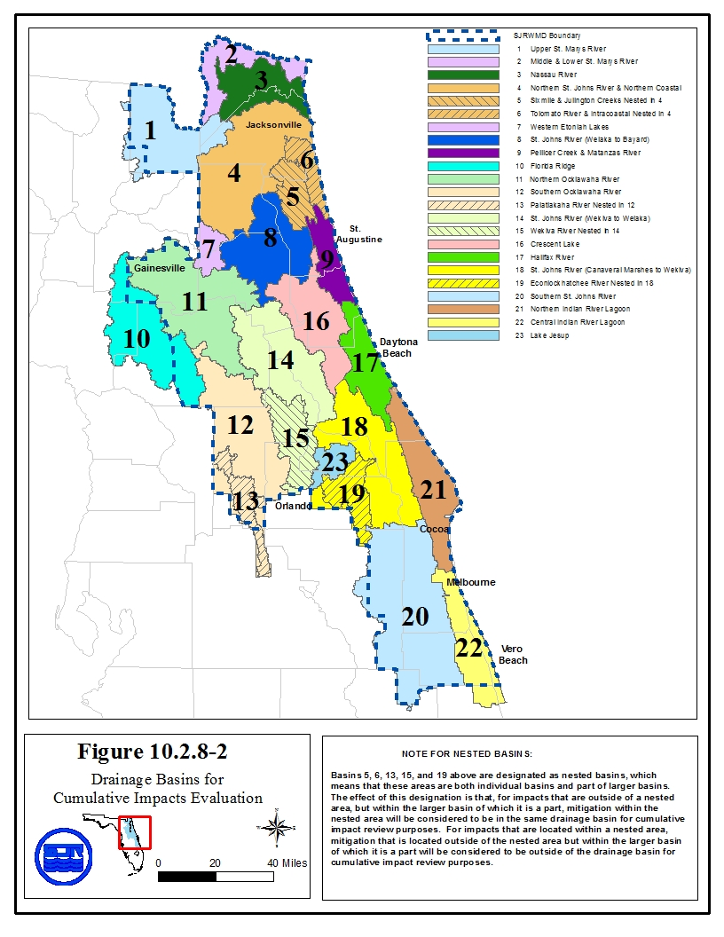
This figure constitutes Figure 10.2.8-2 in Applicant’s Handbook, Volume I (General and Environmental) effective (effective date)
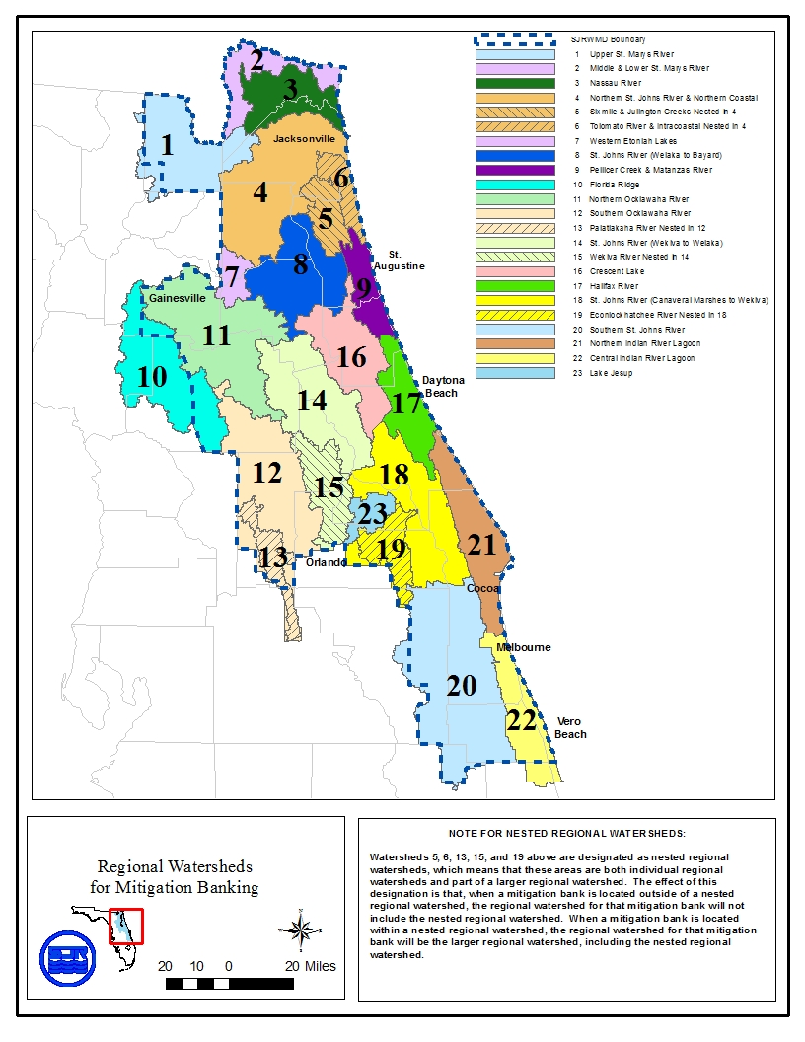
Revised 11/5/08

APPENDIX B

Basin Boundaries

LEGAL DESCRIPTION
UPPER ST. JOHNS RIVER HYDROLOGIC BASIN

Begin at the southeast corner of Section 33, Township 33 South, Range 38 East; thence west along the township section line between Township 33 and 34 South to the northwest corner of Section 6, Township 34 South, Range 37 East; thence south along the range line between Ranges 36 and 37 East to the southeast corner of Section 1, Township 34 South, Range 36 East; thence west along the section line to the northwest corner of Section 10, Township 34 South, Range 36 East; thence south along the section line to the southeast corner of Section 9, Township 34 South, Range 36 East; thence west along the section lines to the northwest corner of Section 18, Township 34 South, Range 36 East; thence south along the range line between Ranges 35 and 36 East to the southeast corner of Section 12, Township 34 South, Range 35 East; thence west along the section line to the northwest corner of Section 13, Township 34 South, Range 35 East; thence south along the section lines to the southwest corner of Section 35, Township 34 South, Range 35 East; thence west along the township line between Townships 34 and 35 South to the southwest corner of Section 35, Township 34 South, Range 34 East; thence north along the section lines to the Okeechobee and Osceola County line; thence west along the Okeechobee and Osceola County line to the southwest corner of Section 31, Township 32 South, Range 34 East; thence north along the section lines to the northeast corner of Section 1, Township 32 South, Range 33 East; thence west along the section lines to the southwest corner of Section 34, Township 31 South, Range 33 East; thence north along the section lines to the northwest corner of Section 3, Township 31 South, Range 33 East; thence east along the township line between Township 30 and Township 31 South to the southeast corner of Section 36, Township 30 South, Range 33 East; thence north along the range line between Ranges 33 and 34 East to the northeast corner of Section 1, Township 30 South, Range 33 East; thence west along the township line between Townships 29 and 30 South to the southwest corner of Section 31, Township 29 South, Range 33 East; thence north along the range line between Ranges 32 and 33 East to the northwest corner of Section 6, Township 28 South, Range 33 East; thence east along the township line between Townships 27 and 28 South to the southeast corner of Section 36, Township 27 South, Range 32 East; thence north along the range line between Ranges 32 and 33 East to the northeast corner of Section 1, Township 26 South, Range 32 East; thence west along the township line between Townships 25 and 26 South to the southwest corner of Section 35, Township 25 South, Range 32 East; thence north along the section lines to the northwest corner of Section 11, Township 25 South, Range 32 East; thence east along the section line to the southeast corner of Section 2, Township 25 South, Range 32 East; thence north along the section lines to the northwest corner of Section 24, Township 24 South, Range 32 East; thence east along the section line to the southeast corner of Section 13, Township 24 South, Range 32 East; thence north along the range line between Ranges 32 and 33 East to the northeast corner of Section 25, Township 22 South, Range 32 East; thence west along the section lines to the southwest corner of Section 23, Township 22 South, Range 32 East; thence north along the section lines to the northwest corner of Section 2, Township 22 South, Range 32 East; thence east along the township line between Townships 21 and 22 South to the southeast corner of Section 35, Township 21 South, Range 32 East; thence north along the section lines to the northwest corner of Section 13, Township 21 South, Range 32 East; thence east along the section lines to the southeast corner of Section 7, Township 21 South, Range 33 East; thence north along the section line to the northwest corner of Section 8, Township 21 South, Range 33 East, thence east along the section line to the southeast corner of Section 5, Township 21 South, Range 33 East; thence north along the section line to the northwest corner, Section 4, Township 21 South, Range 33 East; thence east along the township line between Township 20 and 21 South to the southeast corner of Section 33, Township 20 South, Range 33 East; thence north along the section lines to the northwest corner of Section 22, Township 20 South, Range 33 East; thence east along the section line to the southeast corner of Section 15, Township 20 South, Range 33 East; thence east along the section lines to the south east corner of Section 1, Township 20 South, Range 33 East; thence north along the range line between Ranges 33 and 34 East to the northwest corner of Section 30, Township 19 South, Range 34 East; thence east along the section lines to the northeast corner of Section 28, Township 19 South, Range 34 East; thence northerly along the boundary line between Section 21, Township 19 South, Range 34 East, and John H. McIntosh Grant to the northeast corner of Section 21, Township 19 South, Range 34; thence easterly along the boundary line between John Low Grant and John H. McIntosh Grant to the westerly right-of-way line of Interstate Highway 95; thence southerly along the westerly right-of-way line of Interstate Highway 95 to the Brevard-Volusia County line; thence east along the Brevard-Volusia County line to the westerly right-of-way line of U.S. Route No. 1; thence southerly along the westerly right-of-way line of U.S. Route No. 1 to the northerly right-of-way line of State Route No. 50; thence west along the northerly right-of-way line of State Route No. 50 to the northwest corner of Section 27, Township 22 South, Range 35 East; thence south along the section lines to the southwest corner of Section 34, Township 22 South, Range 35 East; thence east along the township line between Townships 22 and 23 South to the northeast corner of Section 3, Township 23 South, Range 35 East; thence south along the section lines to the southwest corner of Section 14, Township 23 South, Range 35 East; thence east along the section lines to the northeast corner of Section 24, Township 23 South, Range 35 East; thence south along the range line between Ranges 35 and 36 East to the southwest corner of Section 7, Township 24 South, Range 36 East; thence east along the section line to the northeast corner of Section 18, Township 24 South, Range 36 East; thence south along the section lines to the southwest corner of Section 17, Township 25 South, Range 36 East; thence east along the section lines to the westerly right-of-way line of U.S. Route No. 1, thence southerly along the westerly right-of-way line of U.S. Route No. 1 to the range line between Ranges 36 and 37 East; thence south along the range line between Ranges 36 and 37 East to the northeast corner of Section 13, Township 27 South, Range 36 and 37 East to the northeast corner of Section 13, Township 27 South, Range 36 East; thence west along the section line to the northwest corner of Section 13, Township 27 South, Range 36 East; thence south along the section line to the southeast corner of Section 14, Township 27 South, Range 36 East; thence west to the easterly right-of-way line of Interstate Highway 95; thence south along the easterly right-of-way line of Interstate Highway 95 to the township line between Townships 27 and 28 South; thence east along the township line between Townships 27 and 28 South to the north quarter corner of Section 6, Township 28 South, Range 37 East; thence south to the center of Section 7, Township 28 South, Range 37 East; thence east to the east quarter corner of said section; thence south along the section line to the southwest corner of Section 8, Township 28 South, Range 37 East; thence east along the section line to the north quarter corner of Section 17, Township 28 South, Range 37 East; thence south to the south quarter corner of said section; thence east along the section line to the northeast corner of Section 20, Township 28 South, Range 37 East; thence south along the section lines to the southwest corner of Section 28, Township 28 South, Range 37 East; thence east along the section lines to north quarter corner of Section 34, Township 28 South, Range 37 East; thence south to the south quarter corner of Section 3, Township 29 South, Range 37 East; thence west along the section line to the easterly right-of-way line of Interstate Highway 95; thence southerly along the easterly right-of-way line of Interstate Highway 95 to the section line between Sections 22 and 23, Township 29 South, Range 37 East; thence south along the section lines to the township line between Townships 29 and 30 South; thence west along the township line between Townships 29 and 30 South to the northwest corner of Section 3, Township 30 South, Range 37 East; thence south along the section lines to the southwest corner of Section 34, Township 30 South, Range 37 East; thence east along the township line between Townships 30 and 31 South to the southwest boundary of the Fleming Grant; thence southeast along the southwest boundary of the Fleming Grant to the range line between Ranges 37 and 38 East; thence south along the range line between Ranges 37 and 38 East to the southwest corner of Section 19, Township 32 South, Range 38 East; thence east along the section line to the northeast corner of Section 30, Township 32 South, Range 38 East; thence south along the section lines to the southwest corner of Section 5, Township 33 South, Range 38 East; thence east along the section line to the northeast corner of Section 8, Township 33 South, Range 38 East; thence south along the section line to the southwest corner of Section 9, Township 33 South, Range 38 East; thence east along the section line to the northeast corner of Section 16, Township 33 South, Range 38 East; thence south along the section line to the southeast corner of Section 33, Township 33 South, Range 38 East.
NOTE: This description based on Florida Department of Transportation County Maps.
LEGAL DESCRIPTION
OKLAWAHA RIVER HYDROLOGIC BASIN
Begin at the northeast corner of Section 13, Township 25 South, Range 26 East; thence south along the range line between Ranges 26 and 27 East to the southwest corner of Section 18, Township 26 South, Range 27 East; thence east along the section line to the northeast corner of Section 19, Township 26 South, Range 27 East; thence south along the section lines to the southwest corner of Section 32, Township 26 South, Range 27 East; thence east along the township line between Townships 26 and 27 South to the northeast corner of Section 5, Township 27 South, Range 27 East; thence south along the section lines to the southerly right-of-way line of State Road 600; thence westerly along the southerly right-of-way line of said State Road 600 to the west boundary of Section 27, Township 27 South, Range 26 East; thence north along the section lines to the northeast corner of Section 16, Township 25 South, Range 26 East; thence west along the section line to the southwest corner of Section 9, Township 25 South, Range 26 East; thence north along the section lines to the Lake and Polk County line; thence west along the county line to the southwest corner of Section 32, Township 24 South, Range 26 East; thence into Lake County, north along the section lines to the northeast corner of Section 30, Township 24 South, Range 26 East; thence west along the section lines to the northeast corner of Section 28, Township 24 South, Range 25 East; thence north along the section lines to the northeast corner of Section 16, Township 24 South, Range 25 East; thence west along the section line to the northwest corner of Section 16, Township 24 South, Range 25 East; thence north along the section line to the northeast corner of Section 8, Township 24 South, Range East; thence west along the section lines to the range line between Ranges 24 and 25; thence north along the range line to the northeast corner of Section 12, Township 22 South, Range 24 East; thence west along the section lines to the southwest corner of Section 2, Township 22 South, Range 24 East; thence north along the section lines to the northeast corner of Section 27, Township 21 South, Range 24 East; thence west along the section lines to the southwest corner of Section 20, Township 21 South, Range 24 East; thence north along the section lines to the northeast corner of Section 18, Township 21 South, Range 24 East; thence west along the section line to the northwest corner of Section 18, Township 21 South, Range 24 East; also being the Sumter and Lake County line; thence north along the Sumter and Lake County line, also being the range line between Ranges 23 and 24 East to the northwest corner of Section 30, Township 19 South, Range 24 East; thence east along the section line to the northeast corner of Section 30, Township 19 South, Range 24 East; thence north along the section line to the northwest corner of Section 20, Township 19 South, Range 24 East; thence east along the section line to the northeast corner of Section 20, Township 19 South, Range 24 East; thence north along the section lines to the northwest corner of Section 33, Township 18 South, Range 24 East; thence east along the section line to the northeast corner of Section 33, Township 18 South, Range 24 East; thence north along the section line to the northwest corner of Section 27, Township 18 South, Range 24 East; thence east along the section line to the southeast corner of Section 22, Township 18 South, Range 24 East; thence north along the section lines to the northeast corner of Section 15, Township 18 South, Range 24 East; thence west along the section lines to the northwest corner of Section 18, Township 18 South, Range 24 East also being the Sumter and Lake County line; thence north along the Sumter and Lake County line to the northeast corner of Section 1, Township 18 South, Range 23 East and the Marion County line; thence west along the Sumter and Marion County line, also being the township line between Township 17 and 18 South, to the southwest corner of Section 32, Township 17 South, Range 23 East; thence north along the section lines to the northwest corner of Section 8, Township 17 South, Range 23 East; thence east along the section line to the southeast corner of Section 5, Township 17 South, Range 23 East; thence north along the section lines to the northeast corner of Section 8, Township 16 South, Range 23 East; thence west along the section lines to the southwest corner of Section 6, Township 16 South, Range 23 East; thence north along the range lines between Range 22 and 23 East to the northeast corner of Section 24, Township 15 South, Range 22 East; thence west along the section lines to the northwest corner of Section 19, Township 15 South, Range 22 East; thence south along the range lines between Ranges 21 and 22 East to the Southeast corner of Section 24, Township 16 South, Range 21 East; thence west along the section lines to the westerly right-of-way line of Interstate Highway 75; thence northerly along the westerly right-of-way line of Interstate Highway 75 to the north boundary of Section 9, Township 14 South, Range 21 East; thence east along the section lines to the northeast corner of Section 12, Township 14 South, Range 21 East; thence south along the range line between Ranges 21 and 22 to the southwest corner of Section 7, Township 14 South, Range 22 East; thence east along the section line to the northeast corner of Section 18, Township 14 South, Range 22 East; thence south along the section line to the southwest corner of Section 17, Township 14 South, Range 22 East; thence east along the section line the northeast corner of Section 20, Township 14 South, Range 22 East; thence south along the section line to the southwest corner of Section 21, Township 14 South, Range 22 East; thence east along the section lines to the southeast corner of Section 24, Township 14 South, Range 22 East; thence north along the range line between Ranges 22 and 23 East to the northwest corner of Section 18, Township 14 South, Range 23 East to the northwest corner of Section 18, Township 14 South, Range 23 East; thence east along the section lines to the southeast corner of Section 9, Township 14 South, Range 23 East' thence north along the section lines to the northeast corner of Section 4, Township 14 South, Range 23 East; thence west along the township line between Townships 13 and 14 South of the southwest corner of Section 33, Township 13 South, Range 23 East; thence north along the section lines to the southerly right-of-way line or Florida Highway 316; thence easterly along the southerly right-of-way line of Florida Highway 316 to the east line of Section 14, Township 13 South, Range 24 East; thence south along the section lines to the southwest corner of Section 36, Township 13 South, Range 24 East; thence east along the township line between Township 13 and 14 South to the northeast corner of Section 1, Township 14 South, Range 24 East; thence south along the range line between Ranges 24 and 25 East to the southwest corner of Section 31, Township 14 South, Range 25 East; thence along the township line between Townships 14 and 15 South to the northeast corner of Section 2, Township 15 South, Range 25 East; thence south along the section lines to the southwest corner of Section 24, Township 15 South, Range 25 East; thence east along the section line to the northeast corner of section 25, Township 15 South, Range 25 East; thence south along the range line between Ranges 25 and 25 1/2 South to the township line between Townships 15 and 16 South; thence south along the range line between Ranges 25 and 26 East to the southwest corner of Section 7, Township 17 South, Range 26 East; thence east along the section lines to the northeast corner of Section 15, Township 17 South, Range 26 East; thence south along the section lines to the southwest corner of Section 35, Township 17 South, Range 26 East; thence east along the section lines to the northeast corner of Section 5, Township 18 South, Range 27 East; thence south along the section lines to the southwest corner of Section 33, Township 18 South, Range 27 East; thence east along the township line between Townships 18 and 19 South to the northeast corner of Section 3, Township 19 South, Range 27 East; thence south along the section lines to the southwest corner of section 35, Township 19 South, Range 27 East; thence east along the township line between Townships 19 and 20 South to the northeast corner of Section 2, Township 20 South, Range 26 East; thence south along the section lines to the southwest corner of Section 25, Township 20 South, Range 27 East; thence east along the section lines to the northeast corner of Section 33, Township 20 South, Range 28 East; thence south along the section lines to the southeast corner of Section 28, Township 21 South, Range 28 East; thence west along the section line to the northwest corner of Section 33, Township 21 South, Range 28 East; thence south along the section lines to the southeast corner of Section 8, Township 22 South, Range 28 East; thence west along the section line to the northeast corner of Section 18, Township 22 South, Range 28 East; thence south along the section lines to the southeast corner of Section 31, Township 22 South, Range 28 East; thence west along the township line between Townships 22 and 23 South to the northwest corner of Section 1, Township 23 South, Range 27 East; thence south along the section lines to the southeast corner of Section 11, Township 23 South, Range 27 East; thence west along the section lines to the northwest corner of Section 18, Township 23 South, Range 27 East; thence south along the range line between Ranges 26 and 27 East to the northeast corner of Section 24, Township 23 South, Range 26 East; thence west along the section line to the northwest corner of Section 24, Township 23 South, Range 26 East; thence south along the section line to the southeast corner of Section 23, Township 23 South, Range 26 East; thence west along the section lines to the northwest corner of Section 28, Township 23 South, Range 26 East; thence south along the section lines to the southwest corner of Section 16, Township 24 South, Range 26 East; thence east along the section lines to the northeast corner of Section 22, Township 24 South, Range 26 East; thence south along the section lines to the southwest corner of Section 16, Township 24 South, Range 26 East; thence east along the section lines to the northeast corner of Section 22, Township 24 South, Range 26 East; thence south along the section lines to southeast corner of Section 26, Township 24 South, Range 26 East; thence east along the section line to the northeast corner of Section 35, Township 24 South, Range 26 East; thence south along the section lines to the southwest corner of Section 12, Township 25 South, Range 26 East; thence east along the section line to the northeast corner of Section 13, Township 25 South, Range 26 East.
NOTE: This description based on Florida Department of County Maps.
LEGAL DESCRIPTION
WEKIVA RIVER HYDROLOGIC BASIN

Begin at the southeast corner of Section 31, Township 22 South, Range 28 East; thence east along the Township line between Townships 22 and 23 South to the center line of the State Highway 435, Township 22 South, Range 28 East; thence northerly along the center line of State Highway 435 to the center line of State Highway 50; thence east along the center line of State Highway 50 to the southeast corner of Section 22, Township 22 South, Range 29 East; thence north along the section line to the northeast corner of Section 22, Township 22 South, Range 29 East; thence east along the section line to center line of Interstate 4; thence northerly along the center line of Interstate 4 to the Seminole and Orange County line; thence east along the Seminole and Orange County line to the center line of State Highway 427, thence north along the center line of State Highway 427 to the center line of State Highway 436, thence east along the center line of State Highway 436 to the center line of State Highway 427; thence northeasterly along the center line of State Highway 427 to the southeast corner of Section 6, Township 21 South, Range 30 East; thence west along the section lines to the southeast corner of Section 2, Township 21 South, Range 29 East; thence north along the section lines to the center line of Interstate 4; thence north along the center line of Interstate 4 to the center line of State Highway 46A; thence west along the center line of State Highway 46A to the southwest corner of Section 31, Township 19 South, Range 30 East; thence north along the section lines also being the range line between Ranges 29 and 30 East to the Township line between Townships 18 and 19 South; thence west along the Township line between Townships 18 and 19 South to the Lake and Seminole County line, thence west along the Township line between Townships 18 and 19 South to the southwest corner of Section 33, Township 18 South, Range 29 East; thence north along the section lines to the north corner of Section 16, Townships 17 South, Range 29 East; thence northwesterly along section line to the northwest corner of Section 39 Township 17 South, Range 28 East (also being the Domingo Fernandez Grant line): thence west along Township line between Townships 16 and 17 South to the northeast corner of Section 2, Township 17 South, Range 28 East; thence south along the section lines to the southeast corner of Section 11, Township 17 South, Range 28 East; thence west along the section lines to the southwest corner of Section 10, Township 17 South, Range 28 East; thence south along the section lines to the southeast corner of Section 21, Township 17 South, Range 28 East; thence west along the section line to the southwest corner of Section 21, Township 17 South, Range 28 East; thence south along the section line to the southeast corner of Section 29, Township 17 South, Range 28 East; thence west along the section line to the southwest corner of Section 29, Township 17 South, Range 28 East; thence north along the section line to the northeast corner of Section 30, Township 17 South, Range 28 East; thence west along the section line to the northwest corner of Section 30, Township 17 South, Range 28 East; thence north along the section line to the northeast corner of Section 24, Township 17 South, Range 27 East; thence west along the section lines to the northwest corner of Section 23, Township 17 South, Range 27 East; thence north along the section lines to the northeast corner of Section 10, Township 17 South, Range 27 East; thence west along the section line to the northwest corner of Section 10, Township 17 South, Range 27 East; thence north along the section line to the northwest corner of Section 4, Township 17 South, Range 27 East; also being the Township line between Townships 16 and 17 South; thence west along the section line to the southwest corner of Section 31, Township 16 South, Range 27 East; thence north along the section line to the northwest corner of Section 31, Township 16 South, Range 27 East; also being the Lake and Marion County line; thence west along the section line to the northwest corner of Section 36, Township 16 South, Range 26 East; thence south along the section lines to the southwest corner of Section 1, Township 17 South, Range 26 East; thence west along the section line to the northwest corner of Section 11, Township 17 South, Range 26 East; thence south along the section lines to the southwest corner of Section 35, Township 17 South, Range 26 East; also being the Marion and Lake County line; thence east along the section lines to the northwest corner of Section 5, Township 18 South, Range 27 East; thence south along the section lines to the southwest corner of Section 33, Township 18 South, Range 27 East; thence east along the Township line between Townships 18 and 19 South to the northeast corner of Section 3, Township 19 South, Range 27 East; thence south along the section lines to the southwest corner of Section 35, Township 19 South, Range 27 East; thence east along the Township line between Townships 19 and 20 South to the northeast corner of Section 2, Township 20 South, Range 27 East; thence south along the section lines to the southwest corner of Section 25, Township 20 South, Range 27 East; thence east along the section lines to the northeast corner of Section 33, Township 20 South, Range 28 East; thence south along the section lines to the southeast corner of Section 28, Township 21 South, Range 28 East; thence west along the section line to the northwest corner of Section 33, Township 21 South, Range 28 East; thence south along the section lines to the southeast corner of Section 8, Township 22 South, Range 28 East; thence west along the section line to the northeast corner of Section 18, Township 22 South, Range 28 East; thence south along the section lines to the southeast corner of Section 31, Township 22 South, Range 28 East, which is also the point of beginning.

LEGAL DESCRIPTION
WEKIVA RECHARGE PROTECTION BASIN

Begin at the northwest corner of Section 6, Township 18 South, Range 28 East, Lake County, Florida, said corner lying on the north line of Township 18 South; thence Easterly along said north line of Township 18 South to the northeast corner of Section 5, Township 18 South, Range 29 East; thence Southerly along the east line of said Section 5 to the northeast corner of Section 8, Township 18 South, Range 29 East; thence Southerly along the east line of said Section 8 to the northeast corner of Section 17, Township 18 South, Range 29 East; thence Southerly along the east line of said Section 17 to the northeast corner of Section 20, Township 18 South, Range 29 East; thence Southerly along the east line of said Section 20 to the northeast corner of Section 29, Township 18 South, Range 29 East; thence Southerly along the east line of said Section 29 to the northeast corner of Section 32, Township 18 South, Range 29 East; thence Southerly along the east line of said Section 32 to the southeast corner thereof, said corner lying on the south line of Township 18 South; thence Easterly along the south line of said Township 18 South to an intersection with the east line of Range 29 East; thence Southerly along the east line of said Range 29 East to the southeast corner of Section 24, Township 21 South, Range 29 East; thence Westerly along the south line of said Section 24 to the southeast corner of Section 23, Township 21 South, Range 29 East; thence Westerly along the south line of said Section 23, to an intersection with the centerline of Interstate Highway No. 4; thence generally Southerly along the centerline of Interstate Highway No. 4 to an intersection with the south line of Section 13, Township 22 South, Range 29 East; thence Westerly along the south line of said Section 13 to the southeast corner of Section 14, Township 22 South, Range 29 East; thence Westerly along the south line of said Section 14 to the southeast corner of Section 15, Township 22 South, Range 29 East; thence Westerly along the south line of said Section 15 to the northeast corner of Section 21, Township 22 South, Range 29 East; thence Southerly along the east line of said Section 21 to an intersection with the centerline of State Road No. 50; thence Westerly along the centerline of said State Road No. 50 to the northeast corner of Section 30, Township 22 South, Range 28 East; thence Southerly along the east line of said Section 30 to the northeast corner of Section 31, Township 22 South, Range 28 East; thence Southerly along the east line of said Section 31 to the southeast corner thereof, said corner lying on the south line of Township 22 South; thence Westerly along said south line of Township 22 South to the northeast corner of Section 2, Township 23 South, Range 27 East; thence Southerly along the east line of said Section 2 to the northeast corner of Section 11, Township 23 South, Range 27 East; thence Southerly along the east line of said Section 11 to the southeast corner thereof; thence Westerly along the south line of said Section 11 to the southeast corner of Section 10, Township 23 South, Range 27 East; thence Westerly along the south line of said Section 10 to the southeast corner of Section 9, Township 23 South, Range 27 East; thence Westerly along the south line of said Section 9 to the Southeast corner of Section 8, Township 23 South, Range 27 East; thence Westerly along the south line of said Section 8 to the southeast corner of Section 7, Township 23 South, Range 27 East; thence Westerly along the south line of said Section 7 to the southwest corner thereof, said corner lying on the line of demarcation between Orange County and Lake County; thence generally Northerly and along said county line to the northeast corner of Section 12, Township 20 South, Range 26 East, said corner lying on the east line of Range 26 East; thence generally Northerly and along said east line of Range 26 East to the southeast corner of Section 24, Township 19 South, Range 26 East; thence Westerly along the south line of said Section 24 to the southeast corner of Section 23, Township 19 South, Range 26 East; thence Westerly along the south line of said Section 23 to the southwest corner thereof; thence Northerly along the west line of said Section 23 to the southwest corner of Section 14, Township 19 South, Range 26 East; thence Northerly along the west line of said Section 14 to the southwest corner of Section 11, Township 19 South, Range 26 East; thence generally Northeasterly to the southwest corner of Section 1, Township 19 South, Range 26 East; thence generally Northeasterly to the southwest corner of Section 31, Township 18 South, Range 27 East; thence generally Northeasterly to the southwest corner of Section 29, Township 18 South, Range 27 East; thence generally Northeasterly to the northwest corner of Section 28, Township 18 South, Range 27 East; thence Easterly along the north line of said Section 28 to the northwest corner of Section 27, Township 18 South, Range 27 East; thence Easterly along the north line of said Section 27 to the northwest corner of Section 26, Township 18 South, Range 27 East; thence Easterly along the north line of said Section 26 to the northwest corner of Section 25, Township 18 South, Range 27 East; thence Easterly along the north line of said Section 25 to an intersection with the west line of Range 28 East; thence Northerly along the west line of said Range 28 East, to the northwest corner of Section 6, Township 18 South, Range 28 East, and the Point of Beginning.
LEGAL DESCRIPTION
ECONLOCKHATCHEE RIVER HYDROLOGIC BASIN
Begin at the Northeast corner of Section 1, Township 26 South, Range 32 East; thence West along the Township line between Township 25 South and Township 26 South to the Southwest corner of Section 33, Township 25 South, Range 32 East; thence North along the Section lines to the Osceola and Orange County line; thence West along the Osceola and Orange County line to the South quarter corner of Section 31, Township 4 South, Range 32 East; thence North along the quarter section lines to the center of Section 18, Township 24 South, Range 32 East; thence West along the quarter section line to the Northwest corner of the Northeast quarter of the Southwest quarter of Section 18, Township 24 South, Range 32 East; thence North along the quarter quarter section lines to the Northeast corner of the Southwest quarter of the Southwest quarter of Section 7, Township 24 South, Range 32 East; thence West along the North line of the Southwest quarter of the Southwest quarter of Section 7, Township 24 South, Range 32 East to the range line between Range 31 East and Range 32 East; thence North along the range line between Range 31 East and Range 32 East to the Northerly Right-of-Way line of State Road 528, also known as the Bee Line Expressway; thence Westerly along the Northerly Right-of-Way line of State Road 528 to the Southwest Right-of-Way line of State Road 15; thence Northwesterly, Westerly and Northerly along the Southwest Right-of-Way line of State Road 15 to the South line of Section 8, Township 23 South, Range 30 East; thence East along the Section lines to the South quarter corner of Section 9, Township 23 South, Range 30 East; thence North along the quarter section lines to the center of Section 33, Township 22 South, Range 30 East; thence West along the quarter section lines to the center of Section 31, Township 22 South, Range 30 East; thence North along the quarter Section lines to the center of Section 19, Township 22 South, Range 30 East; thence East to the East quarter corner of Section 19, Township 22 South, Range 30 East; thence North along the Section lines to the Southwest corner of Section 8, Township 22 South, Range 30 East; thence East along the Section line to the Southeast corner of Section 8, Township 22 South, Range 30 East; thence North along the Section lines to the Northeast corner of Section 5, Township 22 South, Range 30 East; thence West along the Section line to the South quarter corner of Section 32, Township 21 South, Range 30 East; thence North to the North quarter corner of Section 32, Township 21 South, Range 30 East; thence East along the Section lines to the North quarter corner of Section 35, Township 21 South, Range 30 East; thence South along the quarter section lines to the South quarter corner of Section 2, Township 22 South, Range 30 East; thence East along the Section line to the Southwest corner of Section 1, Township 22 South, Range 30 East; thence North along the Section line to the Northwest corner of the South 1/2 of the South 1/2 of Section 1, Township 22 South, Range 30 East; thence East to the Northwest corner of the South 1/2 of the South 1/2 of Section 6, Township 22 South, Range 31 East; thence East to the Northeast corner of the South 1/2 of the South 1/2 of Section 6, Township 22 South, Range 31 East; thence North along the Section lines to the Northwest corner of Section 32, Township 21 South, Range 31 East; thence East along the Section lines to the West Right-of-Way line of State Road 520; thence North along the West Right-of-Way line of State Road 520 to the East West quarter section line of Section 27, Township 21 South Range 31 East; thence East to the center of Section 27, Township 21 South, Range 31 East; thence North along the quarter section lines to the North quarter corner of Section 22, Township 21 South, Range 31 East; thence East to the Southeast corner of Section 15, Township 21 South, Range 31 East; thence North along the Section lines to the North Right-of-Way line of State Road 426; thence East and Northeasterly along the North Right-of-Way line of State Road 426 to the West Section line of Section 5, Township 21 South, Range 32 East; thence North along the Section lines to the West quarter corner of Section 20, Township 20 South, Range 32 East; thence East to the East quarter corner of Section 20, Township 20 South, Range 32 East; thence East to the center of Section 21, Township 20 South, Range 32 East; thence North along the North-South quarter line of Section 21, Township 20 South, Range 32 East to the North Right-of-Way line of State Road 46; thence Southeasterly along the North Right-of-Way line of State Road 46 to the North-South quarter line of Section 26, Township 20 South, Range 32 East; thence South along the quarter section lines to the center of Section 2, Township 21 South, Range 32 East; thence East along the quarter Section lines to the center of Section 1, Township 21 South, Range 32 East; thence North along the quarter Section lines to the center of Section 36, Township 20 South, Range 32 East; thence East along the quarter section lines to the center of Section 33, Township 20 South, Range 33 East; thence South along the quarter section lines to the South quarter corner of Section 4, Township 21 South, Range 33 East; thence West along the Section lines to the Northeast corner of Section 7, Township 21 South, Range 33 East; thence South along the Section line to the Southeast corner of Section 7, Township 21 South, Range 33 East; thence West along the section line to the Southwest corner of Section 7, Township 21 South, Range 33 East; thence South along the Range line between Range 32 East and Range 33 East to the Southeast corner of Section 13, Township 21 South, Range 32 East; thence West along the Section line to the Northeast Corner of Section 23, Township 21 South, Range 32 East; thence South along the section lines to the Southeast corner of Section 2, Township 22 South, Range 32 East; thence West along the section line to the South quarter corner of Section 2, Townships 22 South, Range 32 East; thence South along the quarter section lines to the South quarter corner of Section 23, Township 22 South, Range 32 East; thence East along the Section lines to the Northeast corner of Section 30, Township 22 South, Range 33 East; thence South along the Section lines to the South Right-of-Way line of State Road 50; thence West along the South Right-of-Way line of State Road 50 to the North-South quarter Section line of Section 31, Township 22 South, Range 33 East; thence South along the quarter Section lines to the South quarter corner of Section 7, Township 23 South, Range 33 East; thence West to the Southwest corner of Section 7, Township 23 South, Range 33 East; thence South along the Range line between Range 32 East and Range 33 East to the Southwest corner of Section 19, Township 23 South, Range 33 East; thence East along the section line to the North quarter corner of Section 30, Township 23 South, Range 33 East; thence South along the quarter section lines to the South quarter corner of Section 6, Township 24 South, Range 33 East; thence East along the section line to the Southeast corner of Section 6, Township 24 South, Range 33 East; thence South along the section lines to the East quarter corner of Section 31, Township 24 South, Range 33 East; thence West along the quarter section lines to the West quarter corner of Section 36, Township 24 South, Range 32 East; thence South along the Section lines to the West quarter corner of Section 1, Township 25 South, Range 32 East; thence East along the quarter section lines to the East quarter corner of Section 6, Township 25 South, Range 33 East; thence South along the Section lines to the Southeast corner of Section 19, Township 25 South, Range 33 East; thence West along the section line to the Southwest corner of Section 19, Township 25 South, Range 33 East; thence South along the range line between Range 32 East and Range 33 East to the Northeast corner of Section 1, Township 26 South, Range 32 East which is also the Point of Beginning.
NOTE: This description is based on U.S. Geological Survey 7.5 minute series quadrant maps and Florida Department of Transportation County Maps.
LEGAL DESCRIPTION
MARION COUNTY KARST AREA
BEGIN at the intersection of the westerly right-of-way line of Interstate Highway 75 with the Sumter-Marion County line; thence northerly along the westerly right-of-way line of Interstate Highway 75 to the intersection of said westerly right-of-way line with the northerly right-of-way line of State Road 318; thence northeasterly and easterly along the northerly right-of-way line of State Road 318 to the intersection of said right-of-way line with the westerly line of Section 28, Township 12 South, Range 21 East;l thence north along the section line to the northwest corner of Section 28, Township 12 South, Range 21 East; thence east along he section lines to the Alachua-Marion County line; thence easterly along the Alachua-Marion County line (following the meanderings thereof) to the range line between Range 22 and Range 23 East, the same being the Alachua-Marion County line; thence north along the Alachua-Marion County line and the range line between Range 22 and Range 23 East to the northwest corner of Section 18, Township 12 South, Range 23 East; thence east along the section line to the northeast corner of Section 18, Township 12 South, Range 23 East; thence south along the section lines to the southwest corner of Section 20, Township 12 South, Range 23 East; thence east along the section line to the southeast corner of Section 20, Township 12 South, Range 23 East; thence south along the section line to the northwest corner of Section 33, Township 12 South, Range 23 East; thence east along the section line to the northeast corner of Section 33, Township 12 South, Range 23 East, thence south along the section lines to the southwest corner of Section 3, Township 13 South, Range 23 East; thence east along the section lines to the southeast corner of Section 1, Township 13 South, Range 23 East; thence south along the range line between Range 23 and Range 24 East to the southeast corner of Section 1, Township 14 South, Range 23 East; thence west along the section line to the southeast corner of Section 2, Township 14 South, Range 23 East; thence south along the section lines to the southeast corner of Section 14, Township 14 South, Range 23 East; thence west along the section line to the southwest corner of Section 14, Township 14 South, Range 23 East; thence south along the section lines to the southeast corner of Section 34, Township line between Townships 14 and 15 South to the northeast corner of Section 4, Township 15 South, Range 23 East; thence south along the section line to the southeast corner of Section 4, Township 15 South, Range 23 East; thence west along the section line to the southwest corner of Section 4, Township 15 South, Range 23 East; thence south along the section lines to the southwest corner of Section 21, Township 15 South, Range 23 East; thence east along the section line to the southeast corner of Section 21, Township 15 South, Range 23 East; thence south along the section line to the northwest corner of Section 34, Township 15 South, Range 23 East; thence east along the section line to the northeast corner of Section 34, Township 15 South, Range 23 East; thence south along the section lines to the northwest corner of Section 11, Township 16 South; Range 23 East; thence east along the section line to the northeast corner of Section 11, Township 16 South, Range 23 East; thence south along the section lines to the northwest corner of Section 24, Township 16 South, Range 23 East; thence east along the section line to the northeast corner of Section 24, Township 16 South, Range 23 East; thence south along the range line between Range 23 and Range 24 East to the northwest corner of Section 31, Township 16 South, Range 24 East; thence east along the section line to the northeast corner of Section 31, Township 16 South, Range 24 East; thence south along the section lines to the intersection of the division line between Sections 5 and 6, Township 17 South, Range 24 East with the waters of Lake Weir; thence south crossing the water of Lake Weir to the intersection of the division line between Sections 19 and 20, Township 17 South, Range 24 East with the waters of Lake Weir; thence south along the section lines to the southeast corner of Section 31, Township 17 South, Range 24 East, and the Marion-Lake County line, also being the township line between Townships 17 and 18 South; thence west along the Marion-Lake County line and west along the Sumter-Marion County line, also being the township line between Townships 17 and 18 South, to the POINT OF BEGINNING.
NOTE: This description is based on U.S. Geological Survey 7.5 minute series quadrangle maps and Florida Department of Transportation County Maps.
LEGAL DESCRIPTION
ALACHUA COUNTY KARST AREA
BEGIN at the southeast corner of Section 36, Township 11 South, Range 18 East on the Alachua-Levy County line; thence north along the range line between Range 18 and Range 19 East to the northwest corner of Section 19, Township 9 South, Range 19 East; thence east along the section lines to the northeast corner of Section 20, Township 9 South, Range 19 East; thence south along the section lines to the southeast corner of Section 29, Township 9 South, Range 19 East; thence east along the section lines to the northeast corner of Section 36, Township 9 South, Range 19 east; thence south along the range line between Range 19 and Range 20 East to the southeast corner of Section 36, Township 9 South, Range 19 East; thence east along the township line between Township 9 and Township 10 South to the intersection of said township line with the easterly right-of-way line of State Road No. 25 (U.S. Route No. 441); thence south along the easterly right-of-way line of State Road No. 25 (U.S. Route No. 441) to the intersection of said easterly right-of-way line with the northerly right-of-way line of State Road No. 26; thence east along said northerly right-of-way line to the intersection of said northerly right-of-way line with the division line between Section 4 and Section 5, Township 10 South, Range 20 East; thence south along the section lines to the southwest corner of Section 9, Township 10 South, Range 20 East; thence south to the northwest corner of Section 21 Township 10 South, Range 20 East; thence east along the section lines to the northeast corner of Section 22, Township 10 South, Range 20 East; thence south along the section lines and along a southerly prolongation of the east line of Section 27, Township 10 South, Range 20 East, to the intersection of said southerly prolongation with an easterly prolongation of the north line of Section 6, Township 11 South, Range 20 East; thence west along said easterly prolongation to the northeast corner of Section 6, Township 11 South, Range 20 East; thence west along the township line between Township 10 and Township 11 South, to the northwest corner of Section 1, Township 11 South, Range 19 East; thence south along the section lines to the southeast corner of Section 14, Township 11 South, Range 19 East; thence west along the section line to the southwest corner of Section 14, Township 11 South, Range 19 East; thence south along the section lines to the southeast corner of Section 34, Township 11 South, Range 19 East, and the Alachua Marion County line, also being the township line between Township 11 and Township 12 South; thence west along the Alachua-Marion County line and west along the Alachua-Levy County line to the POINT OF BEGINNING.
NOTE: This description is based on U.S. Geological Survey 7.5 minute series Quadrangle maps and Florida Department of Transportation County Maps.
LEGAL DESCRIPTION
LAKE APOPKA Hydrologic BASIN
Begin at the Northeast corner of Section 29, Township 22 South, Range 28 East; thence South along the Section lines to the Southeast corner of the Northeast quarter of Section 32, Township 22 South, Range 28 East; thence west along the quarter section line to the Southeast corner of the Northwest quarter of Section 31, Township 22 South, Range 28 East; thence South along the quarter section line to the Southeast corner of the Southwest quarter of Section 31, Township 22 South, Range 28 East; thence West along the Section lines to the Southwest corner of the Southeast quarter of Section 36, Township 22 South, Range 27 East; thence South along the quarter section line to the Southeast corner of the Southwest quarter of Section 1, Township 23 South, Range 27 East; thence West along the Section line to the Southeast corner of Section 2, Township 23 South, Range 27 East; thence South along the Section line to the Southeast corner of Section 11, Township 23 South, Range 27 East; thence West along the Section lines to the Southeast corner of the Southwest quarter of Section 7, Township 23 South, Range 27 East; thence South along the quarter section line to the Southeast corner of the Northeast quarter of the Northwest quarter of Section 18, Township 23 South, Range 27 East; thence West along the south line of the Northeast quarter of the Northwest quarter and along the south line of the Northwest quarter of the Northwest quarter, to the Southwest corner of the Northwest quarter of the Northwest quarter of Section 18, Township 23 South, Range 27 East; thence North along the Section line to the Southwest corner of Section 7, Township 23 South, Range 27 East: thence West along the Section line to the Southwest corner of the Southeast quarter of Section 12, Township 23 South, Range 26 East; thence North along the quarter section line to the Southeast corner of the Southwest quarter of Section 1, Township 23 South, Range 26 East; thence West along the Section lines to the Southwest corner of the Southeast quarter of Section 6, Township 23 South, Range 26 East; thence North along the quarter section line to the Northwest corner of the Northeast quarter of Section 6, Township 23 South, Range 26 East; thence East along the Section line to the Southwest corner of Section 32, Township 22 South, Range 26 East; thence North along the Section line to the Northwest corner of Section 32, Township 22 South, Range 26 East; thence East along the Section line to the Southwest corner of Section 28, Township 22 South, Range 26 East; thence North along the Section line to the Southeast corner of the Northeast Quarter of Section 5, Township 22 South, Range 26 East; thence West along the quarter section line to the Southwest corner of the Northwest Quarter of Section 5, Township 22 South, Range 26 East; thence North along the Section lines to the Northwest corner of Section 32, Township 21 South, Range 26 East; thence East along the Section line to the Northeast corner of the Northwest quarter of Section 32, Township 21 South, Range 26 East; thence North along the quarter section lines to the Northwest corner of the Northeast quarter of Section 20, Township 21 South, Range 26 East; thence East along the Section line to the Southwest corner of Section 16, Township 21 South, Range 26 East; thence North along the Section line to the Northwest corner of Section 16, Township 21 South, Range 26 East; thence East along the Section line to the Southwest corner of the Southeast quarter of Section 9, Township 21 South, Range 26 East; thence North along the quarter section line to the Northwest corner of the Southeast quarter of Section 4, Township 21 South, Range 26 East; thence West along the quarter section line to the Southwest corner of the Northwest quarter of Section 4, Township 21 South, Range 26 East; thence North along the Section line to the Northwest corner of Section 4, Township 21 South, Range 26 East and the South line of Section 33, Township 20 South, Range 26 East; thence West along said South line to the Southwest corner of said Section 33, Township 20 South, Range 26 East; thence North along the section lines to the Northwest corner of Section 28, Township 20 South, Range 26 East; thence East along the section lines to the Southwest corner of the Southeast quarter of Section 24, Township 20 South, Range 26 East; thence North along the quarter section line to the Northwest corner of the Southeast quarter of Section 24, Township 20 South, Range 26 East; thence East along the quarter section line to the Northeast corner of the Southeast quarter of Section 24, Township 20 South, Range 26 East; thence North along the Section line to the Northwest corner of Section 19, Township 20 South, Range 27 East; thence East along the Section lines to the Northwest corner of Section 21, Township 20 South, Range 27 East; thence North along the Section line to the Northwest corner of the Southwest quarter of Section 16, Township 20 South, Range 27 East; thence East along the quarter section line to the Northeast corner of the Southeast quarter of Section 16, Township 20 South, Range 27 East; thence North along the Section line to the Northwest corner of Section 15, Township 20 South, Range 27 East; thence East along the Section line to the Northeast corner of Section 14, Township 20 South, Range 27 East; thence South along the Section lines to the Southeast corner of Section 23, Township 20 South, Range 27 East; thence West along the Section line to the Southwest corner of the Southeast quarter of Section 23, Township 20 South, Range 27 East; thence South along the quarter section line to the Northwest corner of the Northeast quarter of Section 35, Township 20 South, Range 27 East; thence East along the Section line to the Northeast corner of Section 35, Township 20 South, Range 27 East; thence South along the Section line to the Southeast corner of Section 35, Township 20 South, Range 27 East; thence East along the Section line to the Southwest corner of the Southeast quarter of Section 36, Township 20 South, Range 27 East; thence North along the quarter section line to the Northwest corner of the Southeast quarter of Section 36, Township 20 South, Range 27 East; thence East along the quarter section line to the Northeast corner of the Southeast quarter of Section 36, Township 20 South, Range 27 East; thence North along the Section line to the Northwest corner of Section 31, Township 20 South, Range 28 East; thence East along the Section lines to the Northeast corner of the Northwest quarter of Section 33, Township 20 South, Range 28 East; thence South along the quarter section lines to the Southeast corner of the Southwest quarter of Section 9, Township 21 South, Range 28 East; thence East along the Section line to the Northwest corner of the Northeast quarter of the Northeast quarter of Section 16, Township 21 South, Range 28 East; thence South along the quarter-quarter Section lines to the Southwest corner of the Southeast quarter of the Southeast quarter of Section 16, Township 21 South, Range 28 East; thence West along the Section line to the Southwest corner of the Southeast quarter of Section 16, Township 21 South, Range 28 East; thence South along the quarter section line to the Southeast corner of the Southwest quarter of Section 21, Township 21 South, Range 28 East; thence West along the Section line to the Southeast corner of Section 20, Township 21 South, Range 28 East; thence South along the Section line to the Southeast corner of Section 32, Township 21 South, Range 28 East; thence West along the Section line to the Southwest corner of the Southeast quarter of Section 32, Township 21 South, Range 28 East; thence South along the quarter section line to the Southwest corner of the Northeast quarter of Section 8, Township 22 South, Range 28 East; thence East along the quarter section line to the Southeast corner of the Northeast quarter of Section 8, Township 22 South, Range 28 East; thence South along the Section line to the Southeast corner of Section 8, Township 22 South, Range 28 East; thence West along the Section line to the Southeast corner of Section 7, Township 22 South, Range 28 East; thence South along the Section line to the Southeast corner of the Northeast quarter of Section 18, Township 22 South, Range 28 East; thence West along the quarter section line to the Northeast corner of the Southeast quarter of Section 13, Township 22 South, Range 27 East; thence South along the Section line to the Southeast corner of Section 13, Township 22 South, Range 27 East; thence West along the Section line to the Southwest corner of the Southeast quarter of Section 13, Township 22 South, Range 27 East; thence South along the quarter section line to the Northwest corner of the Northeast quarter of Section 25, Township 22 South, Range 27 East; thence East along the Section lines to the Northeast corner of Section 29, Township 22 South, Range 28 East, and the Point of Beginning.

NOTE: This description is based on U.S. Geological Survey 7.5 minute series quadrangle maps and St. Johns River Water Management District Hydrologic Basin maps.

LEGAL DESCRIPTION
TOMOKA RIVER HYDROLOGIC BASIN

Begin at the intersection of the West line of the Northeast 1/4 of Section 35, Township 15 South, Range 32 East, and the southerly right-of-way line of State Road 400. Thence Northerly along said West line of said Northeast 1/4, to the Northwest corner of said Northeast corner of said Section 35; Thence Northerly to the Southmost corner of Section 39, Township15 South, Range 32 East; Thence Northeasterly along the Southeast line of said Section 39, a distance of 5400 feet to a point; Thence Northwesterly to a point on the Northwest line of said Section 39, said point lying 4600 feet northeast of the Westmost corner of said Section as measured along the Northwesterly line thereof; Thence Northeasterly to the Northmost corner of Section 13, Township 15 South, Range 32 East; Thence Northeasterly and perpendicular to the Southwest line of Section 38, Township 15 South, Range 32 East, a distance of 2000 feet; Thence Northwesterly and parallel to the Southwest line of said Section 38, a distance of 2000 feet; Thence Northeasterly and perpendicular to the Southwest line of said Section 38, a distance of 2000 feet; Thence Northwesterly to the Southwest corner of Section 1, Township 15 South, Range 32 East; Thence Northerly along the West line of said Section 1, to an intersection with the Southwest line of Section 37, Township 15 South, Range 32 East; Thence Northwesterly along the Southwest line of said Section 37 and the Southwest line of Section 42, Township 14 South , Range 32 East, to the Northwest corner of said Section 42; Thence Northeasterly along the Northwest line of said Section 42, to an intersection with the east right-of-way of U.S. Highway No. 1; Thence Northwesterly along said east right-of-way line, to an intersection with the south right-of-way of State Road No. 40; Thence Northeasterly along said south right-of-way, a distance of 1200 feet, more or less, to a point 1300 feet southwest of the southwesterly edge of water of the Halifax River, as depicted on USGS Quadrangle Map “Ormond Beach, FLA”, photorevised 1980; Thence Northwesterly and parallel to said southwesterly edge of water, a distance of 26,000 feet; Thence Southwesterly a distance of 9200 feet to an intersection with a point on the Southwest line of Section 40, Township 13 South, Range 32 East, said point lying 4000 feet southeast of the Northwest corner of said Section 40 as measured along said Southwest line; Thence Northwesterly along the Southwest line of said Section 40 and Section 39, Township 13 South, Range 32 East, a distance of 6100 feet; Thence Northwesterly a distance of 6800 feet more or less to the intersection of the west right-of-way line of Interstate Highway No. 95, and the west line of Section 24, Township 13 South, Range 31 East; Thence Northwesterly along said west right-of-way line of Interstate Highway No. 95, a distance of 2600 feet; Thence Southwesterly to the Southeast corner of the Southwest 1/4 of the Southwest 1/4 of Section 23, Township 13 South, Range 31 East; Thence Southerly to the intersection of the southwest right-of-way line of U.S. Highway No. 1 and the south line of the North 1/2 of Section 26, Township 13 South, Range 31 East; Thence Easterly along said south line of the North 1/2 of Section 26, to the Northwest corner of the Southwest 1/4 of said Section 26; Thence Easterly to the Northwest corner of the Northeast 1/4 of the Southwest 1/4 of Section 27, Township 13 South, Range 31 East; Thence Southwesterly to the Southwest corner of the Northeast 1/4 of Section 33, Township 13 South, Range 31 East; Thence Easterly to the Southwest corner of the Northeast 1/4 of the Northeast 1/4 of Section 32, Township 13 South, Range 31 East; Thence Southeasterly to the Southeast corner of said Section 32; Thence Southerly to the Southeast corner of Section 8, Township 14 South, Range 31 East; Thence Southwesterly to the Northwest corner of the Southwest 1/4 of the Southwest 1/4 of Section 19, Township 14 South, Range 31 East; Thence Southerly to the Southwest corner of said Section 19; Thence Southeasterly to the intersection of the North line of the South 1/4 of Section 30, Township 14 South, Range 31 East, and the south right-of-way line of State Road No. 40; Thence Easterly along said south right-of-way line of State Road No. 40 to a point 500 feet west of the East line of said Section 30, as measured along said south right-of-way line; Thence Southerly to a point on the south line of said Section 30, said point lying 700 feet west of the Southeast corner of said Section 30; Thence Southwesterly to the Southwest corner of the Northeast 1/4 of Section 31, Township 14 South, Range 31 East; Thence Southeasterly to a point on the East line of said Section 31, said point lying 600 feet north of the Southeast corner of said Section 31; Thence Southeasterly to the Northwest corner of Section 3, Township 15 South, Range 31 East; Thence Southeasterly to the Southwest corner of the Southeast 1/4 of said Section 3; Thence Southeasterly to the Southeast corner of Section 10, Township 15 South, Range 31 East; Thence Southeasterly to the Northwest corner of the Northeast 1/4 of the Southwest 1/4 of Section 14, Township 15 South, Range 31 East; Thence Easterly to the Northeast corner of the Southwest 1/4 of said Section 14; Thence Southerly to the Southeast corner of the Southwest 1/4 of said Section 14; Thence Southeasterly to a point on the South line of Section 23, Township 15 South, Range 31 East, said point lying 750 feet west of the Southeast corner of said Section 23; Thence Southeasterly to the Southeast corner of the Northeast 1/4 of Section 26, Township 15 South, Range 31 East; Thence Southwesterly to the Southwest corner of the Southeast 1/4 of the Southeast 1/4 of said Section 26; Thence Southeasterly to the Southeast corner of the Northeast 1/4 of Section 35, Township 15 South, Range 31 East; Thence Southwesterly to the Southwest corner of the Northeast 1/4 of the Northeast 1/4 of Section 9, Township 16 South, Range 31 East; Thence Southwesterly to the Southeast corner of the Northeast 1/4 of the Southwest 1/4 of said Section 9; Thence Westerly to the Southwest corner of the Northeast 1/4 of the Southwest 1/4 of said Section 9; Thence Southerly to the Southwest corner of the Southeast 1/4 of the Southwest 1/4 of said Section 9; Thence Southwesterly to the Northwest corner of the Southwest 1/4 of Section 16, Township 16 South, Range 31 East; Thence Southerly to the Southwest corner of the Northwest 1/4 of the Southwest 1/4 of said Section 16; Thence Southeasterly to the Northwest corner of the Northeast 1/4 of Section 21, Township 16 South, Range 31 East; Thence Southeasterly to the Southeast corner of said Section 21; Thence Southeasterly to a point on the South line of the North 1/2 of Section 34, Township 16 South, Range 31 East, said point lying 600 feet west of the East line of said Section 34, as measured along said South line of said North 1/2 of Section 34; Thence Southerly and parallel to the East line of Section 34, Township 16 South, Range 31 East, and Section 3, Township 17 South, Range 31 East, a distance of 7100 feet; Thence Southeasterly to the Southeast corner of the Northeast 1/4 of the Southeast 1/4 of Section 11, Township 17 South, Range 31 East; Thence Southeasterly to the Southeast corner of the Northwest 1/4 of Section 13, Township 17 South, Range 31 East; Thence Northeasterly to the Northeast corner of said Section 13; Thence Northerly to the Northwest corner of the Southwest 1/4 of the Southwest 1/4 of Section 7, Township 17 South, Range 32 East; Thence Easterly to the Southeast corner of the Northeast 1/4 of the Southwest 1/4 of said Section 7; Thence Northerly to the Northwest corner of the Northeast 1/4 of said Section 7; Thence Northwesterly to the Northwest corner of Section 6, Township 17 South, Range 32 East; Thence Northeasterly to the Northwest corner of the Northeast 1/4 of the Southwest 1/4 of Section 31, Township 16 South, Range 32 East; Thence Southeasterly to the Southeast corner of the Southwest 1/4 of the Southwest 1/4 of Section 32, Township 16 South, Range 32 East; Thence northerly to the Northeast corner of said Southwest 1/4 of said Southwest 1/4 of Section 32; Thence northwesterly to a point on the South line of Section 29, Township 16 South, Range 32 East, said point lying 600 feet easterly of the Southwest corner of said Section 29 as measured along the South line thereof; Thence northwesterly to the Northwest corner of the Southwest 1/4 of the Southwest 1/4 of said Section 29; Thence northwesterly to the Northwest corner of the Northeast 1/4 of the Northeast 1/4 of Section 30, Township 16 South, Range 32 East; Thence northwesterly to the Northeast corner of the Northwest 1/4 of the Northwest 1/4 of Section 19, Township 16 South, Range 32 East; Thence northeasterly to the Northeast corner of the Southeast 1/4 of the Southwest 1/4 of Section 18, Township 16 South, Range 32 East; Thence northerly to the Northeast corner of the Southwest 1/4 of said Section 18; Thence northeasterly to the Southeast corner of the Northeast 1/4 of the Northeast 1/4 of said Section 18; Thence easterly to the Southeast corner of the Northeast 1/4 of the Northwest 1/4 of Section 17, Township 16 South, Range 32 East; Thence northerly to the Northeast corner of the Northwest 1/4 of Section 17; Thence northeasterly to the Northeast corner of the Southwest 1/4 of the Southeast 1/4 of Section 8, Township 16 South, Range 32 East; Thence southeasterly to the Southeast corner of said Section 8; Thence southeasterly to the Southeast corner of the Northeast 1/4 of the Northwest 1/4 of Section 16, Township 16 South, Range 32 East; Thence easterly to the Southeast corner of the Northeast 1/4 of the Northwest 1/4 of Section 15, Township 16 South, Range 32 East; Thence southeasterly to the Northwest corner of the Southeast 1/4 of the Southeast 1/4 of said Section 15; Thence northeasterly to a point on the East line of said Section 15, lying 600 feet south of the Northeast corner of said Section as measured along the East line thereof; Thence southeasterly to the Southeast corner of the Southwest 1/4 of the Northwest 1/4 of Section 14, Township 16 South, Range 32 East; Thence northeasterly to a point on the North line of said Section 14, lying 1800 feet east of the Northwest corner of said Section as measured along the North line thereof; Thence easterly to the Southwest corner of the Southeast 1/4 of the Southeast 1/4 of Section 11, Township 16 South, Range 32 East; Thence northerly to the Northwest corner of said Southeast 1/4 of said Southeast 1/4 of said Section 11; Thence northeasterly to a point on the East line of said Section 11, lying 2000 feet north of the Southeast corner of said Section as measured along the East line thereof; Thence northeasterly to the Southeast corner of the Northeast 1/4 of the Northwest 1/4 of Section 12, Township 16 South, Range 32 East; Thence easterly to the Southeast corner of the Northwest 1/4 of the Northeast 1/4 of said Section 12; Thence northwesterly to the Northeast corner of the Southeast 1/4 of the Southwest 1/4 of Section 1, Township 16 South, Range 32 East; Thence westerly to the Northwest corner of said Southeast 1/4 of said Southwest 1/4 of Section 1; Thence northwesterly to the point of intersection of the West line of the Northeast 1/4 of Section 35, Township 15 South, Range 32 East and the south right-of-way line of State Road 400, and the Point of Beginning.
NOTE: This description is based on U.S. Geological Survey 7.5 minute series quadrant maps and St. Johns River Water Management District Hydrologic Basin maps.

LEGAL DESCRIPTION
SPRUCE CREEK HYDROLOGIC BASIN
Begin at the intersection of the West line of the Northeast 1/4 of Section 35, Township 15 South, Range 32 East, and the southerly right-of-way line of State Road 400. Thence northeasterly along said southerly right of way line of State Road 400, to an intersection with the North line of the South 1/2 of Section 30, Township 15 South, Range 33 East; Thence southerly along the East line of the Southwest 1/4 of said Section 30, to the Northeast corner of the Northwest 1/4 of Section 31, Township 15 South, Range 33 East; Thence southerly along the East line of the West 1/2 of said Section 31, to the Northeast corner of the Northwest 1/4 of Section 6, Township 16 South, Range 33 East; Thence southeasterly to a point on the East line of said Section 6, lying 500 feet north of the Southeast corner of said Section as measured along the East line thereof; Thence southeasterly to a point on the North line of Section 8, Township 16 South, Range 33 East, said point lying 500 feet east of the Northwest corner of said Section as measured along the North line thereof; Thence southerly to a point on the South line of said Section 8, said point lying 500 feet east of the Southwest corner of said Section as measured along the South line thereof; Thence southeasterly to the Southwest corner of the Southeast 1/4 of the Southeast 1/4 of Section 17, Township 16 South, Range 33 East; Thence easterly to the Northeast corner of the Northwest 1/4 of the Northwest 1/4 of Section 21, Township 16 South, Range 33 East; Thence southeasterly to the Southwest corner of the Southeast 1/4 of the Southeast 1/4 of said Section 21; Thence southeasterly to the west-most corner of Section 38, Township 16 South, Range 33 East; Thence easterly to an intersection with a southerly projection of the East line of the West 1/2 of Section 22, Township 16 South, Range 33 East; Thence northerly to the Northeast corner of the Southwest 1/4 of said Section 22; Thence easterly along the South line of the North 1/2 of said Section 22 and the easterly prolongation thereof, to an intersection with the West right-of-way line of U.S. Highway No. 1; Thence southerly and southeasterly along said West right-of-way line, to an intersection with a northerly projection of the West line of Section 36, Township 16 South, Range 33 East; Thence southerly to the Southwest corner of the Northwest 1/4 of said Section 36; Thence easterly to the Southeast corner of the Northwest 1/4 of said Section 36; Thence southeasterly to an intersection with a point on the Southeast line of Section 40, Township 17 South, Range 33 East, said point lying 9400 feet northeasterly of the southmost corner of said Section 40 as measured along the Southeast line thereof; Thence southerly to the Northeast corner of the Southwest 1/4 of Section 12, Township 17 South, Range 33 East; Thence southeasterly to an intersection with a point on the southeasterly right-of-way line of State Road 44, said point also lying on the East line of the West 1/2 of Section 19, Township 17 South, Range 34 East; Thence southerly to the westmost corner of Section 48, Township 17 South, Range 34 East; Thence southwesterly along the southwesterly prolongation of the Northwest line of said Section 48, a distance of 1000 feet to a point; Thence southwesterly to an intersection with a point on the South line of Section 44, Township 17 South, Range 33 East, said point lying 2300 feet easterly of the Southwest corner of said Section 44 as measured along the South line thereof; Thence southerly for 3800 feet to a point in the Ambrose Hull Grant Section 52, Township 17 South, Range 34 East, said point lying 1800 feet northwest of the Southeasterly line of said Section 52, and 1400 feet northeast of the Southwesterly line of said Section 52; Thence southwesterly to a point on the West line of the East 1/2 of Section 1, Township 18 South, Range 33 East, said point lying 2200 feet south of the North line of said Section 1 as measured along the West line of the East 1/2 thereof; Thence northerly to the Southwest corner of the Southeast 1/4 of Section 27, Township 17 South, Range 33 East; Thence northwesterly to the Northwest corner of said Section 27; Thence northerly along the line dividing Sections 21 and 22, Township 17 South, Range 33 East, to the north right-of-way line of State Road No. 44; Thence westerly along said north right-of-way line to the West line of Section 20, Township 17 South, Range 33 East; Thence northerly along the West line of said Section 20 to a point 1000 feet south of the Northwest corner thereof; Thence westerly and parallel to the North lines of Section 19, Township 17 South, Range 33 East, and Section 24, Township 17 South, Range 32 East, to an intersection with the West line of the East 1/2 of said Section 24; Thence southerly along said West line of said East 1/2, to an intersection with the north right-of-way line of State Road No. 44; Thence westerly along said north right-of-way line to an intersection with the west right-of-way line of State Road No. 415; Thence southwesterly to the Northwest corner of the Southwest 1/4 of the Southwest 1/4 of Section 23, Township 17 South, Range 32 East; Thence westerly to the Northeast corner of the Northwest 1/4 of the Southwest 1/4 of Section 22, Township 17 South, Range 32 East; Thence southwesterly to the Northwest corner of the Southwest 1/4 of the Southwest 1/4 of said Section 22; Thence westerly to the Northwest corner of the Southeast 1/4 of the Southeast 1/4 of Section 21, Township 17 South, Range 32 East; Thence northerly to the Northwest corner of the Northeast 1/4 of the Northeast 1/4 of said Section 21; Thence northwesterly to the Northwest corner of the Southeast 1/4 of Section 16, Township 17 South, Range 32 East; Thence westerly to the Northwest corner of the Northeast 1/4 of the Southwest 1/4 of said Section 16; Thence northwesterly to the Northwest corner of said Section 16; Thence northwesterly to the Northwest corner of the Northeast 1/4 of the Northeast 1/4 of Section 8, Township 17 South, Range 32 East; Thence northwesterly to the Southeast corner of the Southwest 1/4 of the Southwest 1/4 of Section 32, Township 16 South, Range 32 East; Thence northerly to the Northeast corner of said Southwest 1/4 of said Southwest 1/4 of Section 32; Thence northwesterly to a point on the South line of Section 29, Township 16 South, Range 32 East, said point lying 600 feet easterly of the Southwest corner of said Section 29 as measured along the South line thereof; Thence northwesterly to the Northwest corner of the Southwest 1/4 of the Southwest 1/4 of said Section 29; Thence northwesterly to the Northwest corner of the Northeast 1/4 of the Northeast 1/4 of Section 30, Township 16 South, Range 32 East; Thence northwesterly to the Northeast corner of the Northwest 1/4 of the Northwest 1/4 of Section 19, Township 16 South, Range 32 East; Thence northeasterly to the Northeast corner of the Southeast 1/4 of the Southwest 1/4 of Section 18, Township 16 South, Range 32 East; Thence northerly to the Northeast corner of the Southwest 1/4 of said Section 18; Thence northeasterly to the Southeast corner of the Northeast 1/4 of the Northeast 1/4 of said Section 18; Thence easterly to the Southeast corner of the Northeast 1/4 of the Northwest 1/4 of Section 17, Township 16 South, Range 32 East; Thence northerly to the Northeast corner of the Northwest 1/4 of Section 17; Thence northeasterly to the Northeast corner of the Southwest 1/4 of the Southeast 1/4 of Section 8, Township 16 South, Range 32 East; Thence southeasterly to the Southeast corner of said Section 8; Thence southeasterly to the Southeast corner of the Northeast 1/4 of the Northwest 1/4 of Section 16, Township 16 South, Range 32 East; Thence easterly to the Southeast corner of the Northeast 1/4 of the Northwest 1/4 of Section 15, Township 16 South, Range 32 East; Thence southeasterly to the Northwest corner of the Southeast 1/4 of the Southeast 1/4 of said Section 15; Thence northeasterly to a point on the East line of said Section 15, lying 600 feet south of the Northeast corner of said Section as measured along the East line thereof; Thence southeasterly to the Southeast corner of the Southwest 1/4 of the Northwest 1/4 of Section 14, Township 16 South, Range 32 East; Thence northeasterly to a point on the North line of said Section 14, lying 1800 feet east of the Northwest corner of said Section as measured along the North line thereof; Thence easterly to the Southwest corner of the Southeast 1/4 of the Southeast 1/4 of Section 11, Township 16 South, Range 32 East; Thence northerly to the Northwest corner of said Southeast 1/4 of said Southeast 1/4 of said Section 11; Thence northeasterly to a point on the East line of said Section 11, lying 2000 feet north of the Southeast corner of said Section as measured along the East line thereof; Thence northeasterly to the Southeast corner of the Northeast 1/4 of the Northwest 1/4 of Section 12, Township 16 South, Range 32 East; Thence easterly to the Southeast corner of the Northwest 1/4 of the Northeast 1/4 of said Section 12; Thence northwesterly to the Northeast corner of the Southeast 1/4 of the Southwest 1/4 of Section 1, Township 16 South, Range 32 East; Thence westerly to the Northwest corner of said Southeast 1/4 of said Southwest 1/4 of Section 1; Thence northwesterly to the point of intersection of the West line of the Northeast 1/4 of Section 35, Township 15 South, Range 32 East and the south right-of-way line of State Road 400, and the Point of Beginning.
NOTE: This description is based on U.S. Geological Survey 7.5 minute series quadrant maps and St. Johns River Water Management District Hydrologic Basin maps.

APPENDIX C
Methodology and Design Example for the Modified Rational Hydrograph Method
Methodology and Design Example for the Modified Rational Hydrograph Method

C.1 Description

The rational method is a popular method for estimating peak runoff rates for small urban areas. The rational formula is expressed as:

Q_{P} = C I A (C.1-1)

where: Q_{P} = Peak runoff rate (cfs)
C = Runoff coefficient
I = Rainfall intensity (in/hr)
A = Drainage area (acres)

Values for the runoff coefficient (C) are contained in Table G1-1. The intensity (I) is determined from intensity-duration-frequency (IDF) curves such as those published by the FDOT (1987a). The rational method gives peak discharge rates rather than a runoff hydrograph.

Table C 1.1 Runoff Coefficients (C) for a Design Storm Return Period of Ten Years or Less¹

 |  | Sandy Soils |  | Clay Soils
Slope | Land Use | Min. | Max. | Min. | Max.
Flat (0-2%) | Lawns | 0.05 | 0.10 | 0.13 | 0.17
 | Rooftops and pavement | 0.95 | 0.95 | 0.95 | 0.95
 | Pervious pavements² | 0.75 | 0.95 | 0.90 | 0.95
 | Woodlands | 0.10 | 0.15 | 0.15 | 0.20
 | Pasture, grass, and farmland³ | 0.15 | 0.20 | 0.20 | 0.25
 | Residential
 | SFR: 1/2 acre lots and larger | 0.30 | 0.35 | 0.35 | 0.45
 | SFR: smaller lots and duplexes | 0.35 | 0.45 | 0.40 | 0.50
 | MFR: apartments, condominiums | 0.45 | 0.60 | 0.50 | 0.70
 | Commercial and Industrial | 0.50 | 0.95 | 0.50 | 0.95
Rolling (2-7%) | Lawns | 0.10 | 0.15 | 0.18 | 0.22
 | Rooftops and pavements | 0.95 | 0.95 | 0.95 | 0.95
 | Pervious pavements² | 0.80 | 0.95 | 0.90 | 0.95
 | Woodlands | 0.15 | 0.20 | 0.20 | 0.25
 | Pasture, grass, and farmland³ | 0.20 | 0.25 | 0.25 | 0.30
 | Residential
 | SFR: 1/2 acre lots and larger | 0.35 | 0.50 | 0.40 | 0.55
 | SFR: smaller lots and duplexes | 0.40 | 0.55 | 0.45 | 0.60
 | MFR: apartments, condominiums | 0.50 | 0.70 | 0.60 | 0.80
 | Commercial and Industrial | 0.50 | 0.95 | 0.60 | 0.95
Steep (>7%) | Lawns | 0.15 | 0.20 | 0.25 | 0.35
 | Rooftops and pavements | 0.95 | 0.95 | 0.95 | 0.95
 | Pervious pavements² | 0.85 | 0.95 | 0.90 | 0.95
 | Woodlands | 0.20 | 0.25 | 0.25 | 0.30
 | Pasture, grass, and farmland³ | 0.25 | 0.35 | 0.30 | 0.40
 | Residential
 | SFR: 1/2 acre lots and larger | 0.40 | 0.55 | 0.50 | 0.65
 | SFR: smaller lots and duplexes | 0.45 | 0.60 | 0.55 | 0.70
 | MFR: apartments, condominiums | 0.60 | 0.75 | 0.65 | 0.85
 | Commercial and Industrial | 0.60 | 0.95 | 0.65 | 0.95

Sources: Florida Department of Transportation, 1987; Wanielista, 1990

¹For 25- to 100-yr recurrence intervals, multiply coefficient by 1.1 and 1.25, respectively, and the product cannot exceed 1.0.
²Coefficients assume good ground cover and conservation treatment.
³Depends on depth and degree of permeability of underlying strata.
Note: SFR = Single Family Residential;
MFR = Multi-Family Residential

However, the Suwannee River Water Management District (1990) reports that the traditional rational formula can be modified to generate a runoff hydrograph by utilizing the rainfall intensity for various increments of the storm. The rate of discharge at any point in time during a storm can be calculated by combining the rainfall intensity for that time increment with the traditional rational formula. The modified rational hydrograph equation is as follows:

Q = C (I/P_{Total}) (P_{Total}) A (C.1-2)

where: Q = Discharge for a given time increment (cfs)
C = Runoff coefficient
I/P_{Total} = Intensity for a given time increment (in/hr-in)
P_{Total} = Total rainfall depth (in)
A = Drainage area (acres)

The Suwannee River Water Management District (SRWMD) modified rational method, which was also adopted by the Florida Department of Transportation (FDOT) for their Drainage Connection permits (FDOT 1987b), utilizes rainfall data from the SRWMD and FDOT to determine values of I/P_{Total} and P_{Total} respectively. The SRWMD requires applicants to analyze the system for several storm frequencies over various durations to determine the "critical" storm (i.e., the storm event which requires the most storage for peak discharge attenuation).

To transfer this methodology to the St. Johns River Water Management District (SJRWMD), staff derived values of I/P_{Total} at 15 minute increments (see Table G24-2) from long term historic rainfall records within the SJRWMD for the mean annual, 24-hour storm as reported by Rao (1991). The applicant is only required to analyze the system for this rainfall distribution because it includes rainfall depths corresponding to the mean annual storm for durations up to and including 24 hours. Values of P_{Total} within the SJRWMD for the mean annual, 24-hour storm are found in Figure 2.7.1-1 of this Volume.

Similar to the rational method, use of the modified rational hydrograph method should be limited to small drainage basins with short times of concentration (SRWMD 1990). Therefore, the District’s rules restrict use of the modified rational method for systems meeting the following criteria:

(a) The drainage area is less than 40 acres.

(b) The predevelopment time of concentration for the system is less than 60 minutes.

(c) The postdevelopment time of concentration for the system is less than 30 minutes.

Note: The District does not accept the modified rational hydrograph method for use in 25-year peak discharge design storms (see section 3.2.3 of this Volume ). If a project requires a peak discharge analysis for multiple design storms to comply with chapter 62-330, F.A.C., and section 3.2.3, the District recommends that the system be analyzed for both design storm events using a methodology as described in section 3.2.3 of this Volume. As an alternative, the applicant may utilize the modified rational method only for the mean annual storm provided the above criteria are met.

Table C.1.2. SJRWMD Mean Annual, 24-Hour Storm Distribution for the Modified Rational Hydrograph Method

Time  (hrs) | I/P_{Total}  (in/hr-in) | Time  (hrs) | TimeI/P_{Total}  (hrs)(in/hr-in)
0.00 | 0.000 | 12.25 | 0.256
0.25 | 0.008 | 12.50 | 0.204
0.50 | 0.008 | 12.75 | 0.116
0.75 | 0.004 | 13.00 | 0.092
1.00 | 0.008 | 13.25 | 0.080
1.25 | 0.008 | 13.50 | 0.068
1.50 | 0.008 | 13.75 | 0.044
1.75 | 0.008 | 14.00 | 0.040
2.00 | 0.008 | 14.25 | 0.036
2.25 | 0.008 | 14.50 | 0.036
2.50 | 0.008 | 14.75 | 0.032
2.75 | 0.012 | 15.00 | 0.028
3.00 | 0.008 | 15.25 | 0.020
3.25 | 0.008 | 15.50 | 0.020
3.50 | 0.008 | 15.75 | 0.020
3.75 | 0.012 | 16.00 | 0.016
4.00 | 0.008 | 16.25 | 0.016
4.25 | 0.012 | 16.50 | 0.016
4.50 | 0.008 | 16.75 | 0.016
4.75 | 0.012 | 17.00 | 0.016
5.00 | 0.012 | 17.25 | 0.012
5.25 | 0.008 | 17.50 | 0.016
5.50 | 0.012 | 17.75 | 0.012
5.75 | 0.012 | 18.00 | 0.012
6.00 | 0.012 | 18.25 | 0.012
6.25 | 0.016 | 18.50 | 0.012
6.50 | 0.012 | 18.75 | 0.012
6.75 | 0.012 | 19.00 | 0.012
7.00 | 0.016 | 19.25 | 0.012
7.25 | 0.016 | 19.50 | 0.008
7.50 | 0.016 | 19.75 | 0.012
7.75 | 0.016 | 20.00 | 0.008
8.00 | 0.016 | 20.25 | 0.012
8.25 | 0.020 | 20.50 | 0.008
8.50 | 0.020 | 20.75 | 0.008
8.75 | 0.020 | 21.00 | 0.008
9.00 | 0.020 | 21.25 | 0.012
9.25 | 0.032 | 21.50 | 0.008
9.50 | 0.032 | 21.75 | 0.008
9.75 | 0.032 | 22.00 | 0.008
10.00 | 0.040 | 22.25 | 0.008
10.25 | 0.044 | 22.50 | 0.008
10.50 | 0.048 | 22.75 | 0.008
10.75 | 0.072 | 23.00 | 0.008
11.00 | 0.084 | 23.25 | 0.008
11.25 | 0.104 | 23.50 | 0.008
11.50 | 0.132 | 23.75 | 0.008
11.75 | 0.436 | 24.00 | 0.004
12.00 | 1.080 | 24.00 | 0.004

C.1.2 Example Problem for the Modified Rational Hydrograph Method

Given: A = 3 acres Project Location = Titusville

C_{pre} = 0.35 C_{post} = 0.85

Determine: Utilizing the modified rational method determine the predevelopment and
postdevelopment runoff hydrographs for the mean annual, 24-hour storm.

Step 1. Determine P_{Total} for the project location.

From Figure 2.7.1-1, the rainfall depth (P_{Total}) for the mean annual, 24-hour storm for Titusville
is 5.0 inches.

Step 2. Set up the modified rational equations for both pre-development and post-development
conditions utilizing equation 1-2.

Q_{pre} = (3 ac) (0.35) (5.0 in) (I/P_{Total}) = (5.25)(I/P_{Total})

Q_{post} = (3 ac) (0.85) (5.0 in) (I/P_{Total}) = (12.75)(I/P_{Total})

Step 3. Utilizing the values of I/P_{Total} in Table C.1-2, calculate the predevelopment and post-
development runoff hydrographs at 15-minute increments for the mean annual, 24-hour storm. See
Table C.1-3 for the Q_{pre} and Q_{post} hydrographs.

Step 4. From Table C.1-3, the post-development peak discharge rate is greater than the pre-
development rate. Therefore, the postdevelopment runoff hydrograph should be routed through a
detention basin and discharge structure with a suitable stage-storage-discharge relationship such that
the peak discharge rate from the basin is less than or equal to the predevelopment peak rate of 5.67
cfs.

C.1.3 References

Florida Department of Transportation. 1987a. Drainage Manual, Volume 2A - Procedures. Tallahassee, Florida.

Florida Department of Transportation. 1987b. Handbook for Drainage Connection Permit. Tallahassee, Florida.

Rao, D.V. 1991. 24-Hour Rainfall Distributions for Surface Water Basins Within the St. Johns River Water Management District, Northeast Florida. St. Johns River Water Management District Technical Publication No. 91-3, Palatka, Florida.

Suwannee River Water Managment District. 1990. MSSW Handbook. Live Oak, Florida.

Table C.1-3 Pre- and Post-Development Hydrographs for the Modified Rational Example Problem

Time  (hrs) | I/P_{Total} | Q_{pre}  (cfs) | Q_{post}  (cfs)
0.00 | 0.000 | 0.000 | 0.000
0.50 | 0.008 | 0.044 | 0.104
0.75 | 0.004 | 0.020 | 0.052
1.00 | 0.008 | 0.044 | 0.104
1.25 | 0.008 | 0.044 | 0.104
1.50 | 0.008 | 0.044 | 0.104
1.75 | 0.008 | 0.044 | 0.104
2.00 | 0.008 | 0.044 | 0.104
2.25 | 0.008 | 0.044 | 0.104
2.50 | 0.008 | 0.044 | 0.104
2.75 | 0.012 | 0.064 | 0.152
3.00 | 0.008 | 0.044 | 0.104
3.25 | 0.008 | 0.044 | 0.104
3.50 | 0.008 | 0.044 | 0.104
3.75 | 0.012 | 0.064 | 0.152
4.00 | 0.008 | 0.044 | 0.104
4.25 | 0.012 | 0.064 | 0.152
4.50 | 0.008 | 0.044 | 0.104
4.75 | 0.012 | 0.064 | 0.152
5.00 | 0.012 | 0.064 | 0.152
5.25 | 0.008 | 0.044 | 0.104
5.50 | 0.012 | 0.064 | 0.152
5.75 | 0.012 | 0.064 | 0.152
6.00 | 0.012 | 0.064 | 0.152
6.25 | 0.016 | 0.084 | 0.204
6.50 | 0.012 | 0.064 | 0.152
6.75 | 0.012 | 0.064 | 0.152
7.00 | 0.016 | 0.084 | 0.204
7.25 | 0.016 | 0.084 | 0.204
7.50 | 0.016 | 0.084 | 0.204
7.75 | 0.016 | 0.084 | 0.204
8.00 | 0.016 | 0.084 | 0.204
8.25 | 0.020 | 0.104 | 0.256
8.50 | 0.020 | 0.104 | 0.256
8.75 | 0.020 | 0.104 | 0.256
9.00 | 0.020 | 0.104 | 0.256
9.25 | 0.032 | 0.168 | 0.408
9.50 | 0.032 | 0.168 | 0.408
9.75 | 0.032 | 0.168 | 0.408
10.00 | 0.040 | 0.212 | 0.508
10.25 | 0.044 | 0.232 | 0.560
10.50 | 0.048 | 0.252 | 0.612
10.75 | 0.072 | 0.380 | 0.920
11.00 | 0.084 | 0.440 | 1.072
11.25 | 0.104 | 0.548 | 1.328
11.50 | 0.132 | 0.692 | 1.684
11.75 | 0.436 | 2.288 | 5.560
12.00 | 1.080 | 5.672 | 13.772
12.25 | 0.256 | 1.344 | 3.264
12.50 | 0.204 | 1.072 | 2.600
12.75 | 0.116 | 0.608 | 1.480
13.00 | 0.092 | 0.484 | 1.172
13.25 | 0.080 | 0.420 | 1.020
13.50 | 0.068 | 0.356 | 0.868
13.75 | 0.044 | 0.232 | 0.560
14.00 | 0.040 | 0.212 | 0.508
14.25 | 0.036 | 0.188 | 0.460
14.50 | 0.036 | 0.188 | 0.460
14.75 | 0.032 | 0.168 | 0.408
15.00 | 0.028 | 0.148 | 0.356
15.25 | 0.020 | 0.104 | 0.256
15.50 | 0.020 | 0.104 | 0.256
15.75 | 0.020 | 0.104 | 0.256
16.00 | 0.016 | 0.084 | 0.204
16.25 | 0.016 | 0.084 | 0.204
16.50 | 0.016 | 0.084 | 0.204
16.75 | 0.016 | 0.084 | 0.204
17.00 | 0.016 | 0.084 | 0.204
17.25 | 0.012 | 0.064 | 0.152
17.50 | 0.016 | 0.084 | 0.204
17.75 | 0.012 | 0.064 | 0.152
18.00 | 0.012 | 0.064 | 0.152
18.25 | 0.012 | 0.064 | 0.152
18.50 | 0.012 | 0.064 | 0.152
18.75 | 0.012 | 0.064 | 0.152
19.00 | 0.012 | 0.064 | 0.152
19.25 | 0.012 | 0.064 | 0.152
19.50 | 0.008 | 0.044 | 0.104
19.75 | 0.012 | 0.064 | 0.152
20.00 | 0.008 | 0.044 | 0.104
20.25 | 0.012 | 0.064 | 0.152
20.50 | 0.008 | 0.044 | 0.104
20.75 | 0.008 | 0.044 | 0.104
21.00 | 0.008 | 0.044 | 0.104
21.25 | 0.012 | 0.064 | 0.152
21.50 | 0.008 | 0.044 | 0.104
21.75 | 0.008 | 0.044 | 0.104
22.00 | 0.008 | 0.044 | 0.104
22.25 | 0.008 | 0.044 | 0.104
22.50 | 0.008 | 0.044 | 0.104
22.75 | 0.008 | 0.044 | 0.104
23.00 | 0.008 | 0.044 | 0.104
23.25 | 0.008 | 0.044 | 0.104
23.50 | 0.008 | 0.044 | 0.104
23.75 | 0.008 | 0.044 | 0.104
24.00 | 0.004 | 0.020 | 0.052
24.25 | 0.000 | 0.000 | 0.000

This legal description is for the same area defined as the “Wekiva Study Area” in Section 369.316, Florida Statutes.

