Florida Department of Law Enforcement
DNA Investigative Support Database

Oral Swab Collection Kit Instructions
Whenever possible, use a Rapid ID device for DNA collection. If Rapid ID is not available Prior to collection, make sure a sample is not already on file with the Database by calling, faxing, or checking the DNA Database Offender Search site located on the CJNET.
Please use Universal Precautions when handling biological samples.
Step 1 Fill out all information requested on the DNA Database Collection Information section, and on the “FTA” Card/Swab Envelope affixed to this form.
STEP 2 Ensure the offender’s subject’s hands are clean and dry.
Use pre-inked ink strips, pre-inked Porelon pads or printer’s ink for fingerprinting.
Gently roll or press the offender’s subject’s thumbs within the designated area of the form. The completed prints must show clear ridge detail. Unacceptable prints may will result in the rejection of the entire submission. If the offender subject is missing their thumbs, use an index finger and indicate the change on the form.
The individual taking the thumbprints must print their name, sign and date in the Official Taking Thumbprint section.
STEP 3 Remove the foam swab from the sterile package located inside of the affixed envelope. Be careful not to handle the foam tip.
Have the offender rub subject scrape the foam swab firmly against the inside of each cheek at least six (6) times.
Transfer the sample on the foam swab to the FTA Indicator Card by pressing within the pink area of the card. Press firmly (do not rub). Turn and roll the foam swab on its side, creating a fold to transfer as much swabbed material as possible. The pink area should turn white indicating the transfer of sample.
Return the form swab back into its original packaging and place the foam swab and FTA Indicator Card inside the affixed envelope.
STEP 4 Remove the cotton swab from the sterile package located inside the affixed envelope. Be careful not to handle the cotton tip.
Have the offender run subject scrape the cotton swab firmly against the inside of each cheek at least six (6) times.
Return the cotton tip swab back into its original packaging and place inside the affixed envelope and seal.
STEP 5 Make a copy of the completed form for your records then Insert the kit, swabs, and FTA Indicator Card into the return pre-printed address envelope and seal.
Mail or hand deliver the Swab Collection Kit sealed kit to the Florida Department of Law Enforcement – DNA Investigative Support Database in Tallahassee, FL.

Florida department of Law Enforcement Consent to Provide DNA Sample for Laboratory Analysis and entry into
the DNA Investigative Support database

I, ________________________________, hereby freely and voluntarily consent to provide FDLE with a mouth swab specimen for criminal investigative purposes. I understand that this specimen will be entered into a DNA Database maintained by the FDLE after analysis, and that it may be utilized in current or future criminal investigations to include or exclude me as a suspect, and that it could be used as evidence in any prosecution of me.

I fully understand that I have a right to refuse to give this specimen. I have read and understand the above statement and I consent to provide this specimen of my own free will without any threats or promises having been made to me.

Signature of Consenting Individual Date/Time

Witness (Print Name) Date/Time

Witness Signature Badge Number

qualifying convicted offenders required by law to provide a sample do not need to sign this consent waiver.

*Notice re Collection of Social Security Numbers: FDLE asks that you provide your social security number (SSN). The decision to provide your SSN is at your option, and if you provide your SSN, FDLE will use it for identification, and may share the information with other agencies for the same purpose. FDLE’s request for your SSN is authorized by state law § 119.071(5)(a)2.a.(ii), F.S. because use of it is imperative for FDLE to fulfill its lawful duties and responsibilities.

A copy of this notice should be given to the person whose SSN is requested. However, for purpose of the notice required by state law, the act of “collect(ing) an individual’s social security number” is not understood to apply for collection in which the SSN is gathered from an existing database.

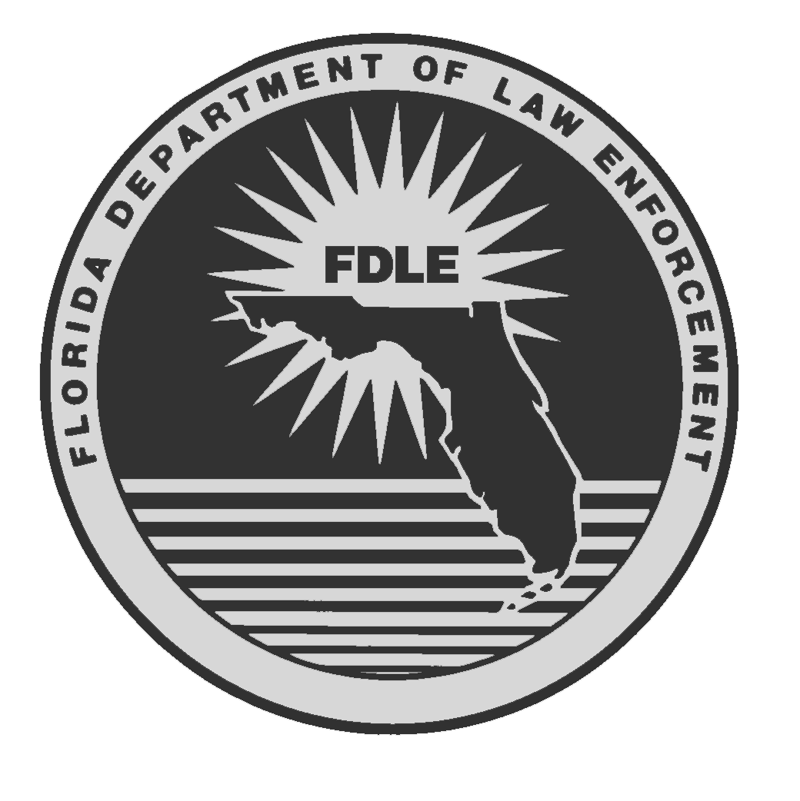

Florida Department of Law Enforcement
DNA Investigative Support Database

Oral Swab Collection Kit

Each kit should contain:
1 FTA Collection Card
1 Sterile Cotton Tip Swab
1 Sterile Foam Tip Swab
1 Return Envelope

FOR QUALIFYING CONVICTED OFFENDER DNA COLLECTION ONLY

Dn not use for the collection of evidence such as suspect, victim, or elimination standards in on-going investigations.

If you have any questions concerning the use of this kit or to order additional kits, please contact the FDLE DNA Investigative Support database at 850/617-1300 or FAX 850/921-6086.

Database Use Only

Gerald M. Bailey, Commissioner FDLE/FORM# FOR-005 (9/2011 10/2007)
Reference Rule 11D-6.003, F.A.C.


Florida Department of Law Enforcement
DNA INVESTIGATIVE SUPPORT DATABASE

Collection Information
Prior to collecting this offender specimen, make sure a sample is not already on file with the DNA Investigative Support Database.
(Print Legibly in Black or Blue Ink)
Last Name
First Name
Known Aliases: __________________________________________
Date of Birth / / Race:

Social
Security #: - - Sex:
(See *SNN notice on back panel)
DC#: SID#:
(FL Dept. of Corrections No) (State of Florida ID NO.)
Probation: Juvenile: County Jail:
CHECK OR WRITE THE APPROPRIATE COLLECTION REASON & STATUTE: CONVICTION INFORMATION:
(Provide All Available Information)

Conviction ARREST
Any Felony or Specified Meisdemeanors (see FL Statute 943.325 for
(see list below) qualifying felony offenses

County:
Court
Case #:
CHECK OR WRITE THE APPROPRIATE STATUTE NUMBER OF OFFENSE TYPE:
Any Felony Offense (partial list): Specific Misdemeanors (only):
○ 316 – Motor Vehicle ○ 784.048 – Stalking
○ 782 – Homicide ○ 810.14 – Voyeurism
○ 784 – Assault, Battery, Culp Neglig. ○ 847.011 – Obscenity
○ 787 – Kidnaping ○ 847.013 – Obscenity
○ 790 – Weapons & Firearms ○ 847.0135 – Obscenity
○ 794 – Sexual Battery ○ 877.25 – Observ./record
○ 800 – Lewdness; Indecent Act customers in dressing room
○ 806 – Arson ○ 847.04 – Gang-related offenses
○ 810 – Burglary _____________________________
○ 812 – Theft
○ 812.13, 812.131, 812.133, 812.135 ○ NON-FLORIDA CONVICTION
- Robberies Nature of Offenses: _____________
○ 817 – Fraud _____________________________
○ 825 – Abuse of Elderly or Disabled
○ 827 – Abuse of Child State: ________________________
○ 831 – Forgery/Counterfeiting
○ 847 – Obscenity ○ COURT ORDER
○ 893 – Drug Abuse (enclose a copy only if court
○ OTHER (List Felony Statute) ordered for non-felony offenses)
______________________________

SUBMITTING AGENCY
*Required Information

(Please Print)
*AGENCY NAME: ________________________________________
ADDDRES: _____________________________________________

*CONTACT NAME: _______________ *PHONE: _______________
(Name of Contact for DNA collection issues)

SAMPLE COLLECTION CERTIFICATION
(Please Check Appropriate Box – Print Legibly)
I hereby certify that I have on this date witnessed the collection of an oral specimen from the named individual who was positively identified to me using one or more of the following means (initial appropriate statements):
Visual inspection of the individual’s photo ID or some other official form
of identification.

Personal identification of the individual by the attending official.

In Court identification.

Other (specify)

WITNESS TO SAMPLE COLLECTION
(Print Name of Official Witnessing Swab Collections, Date and Sign)

NAME: DATE:

SIGNATURE:

OFFICIAL TAKING THUMBPRINTS
(Print name of Official Taking Prints, Date and Sign)

NAME: DATE:

SIGNATURE:

THUMBPRINTS ARE TO BE TAKEN AT THE TIME OF SAMPLE COLLECTION.
Note: Offender samples will NOT be accepted without legible thumbpritns.

LEEFT THUMB RIGHT THUMB

Swab Envelope Attached Here

