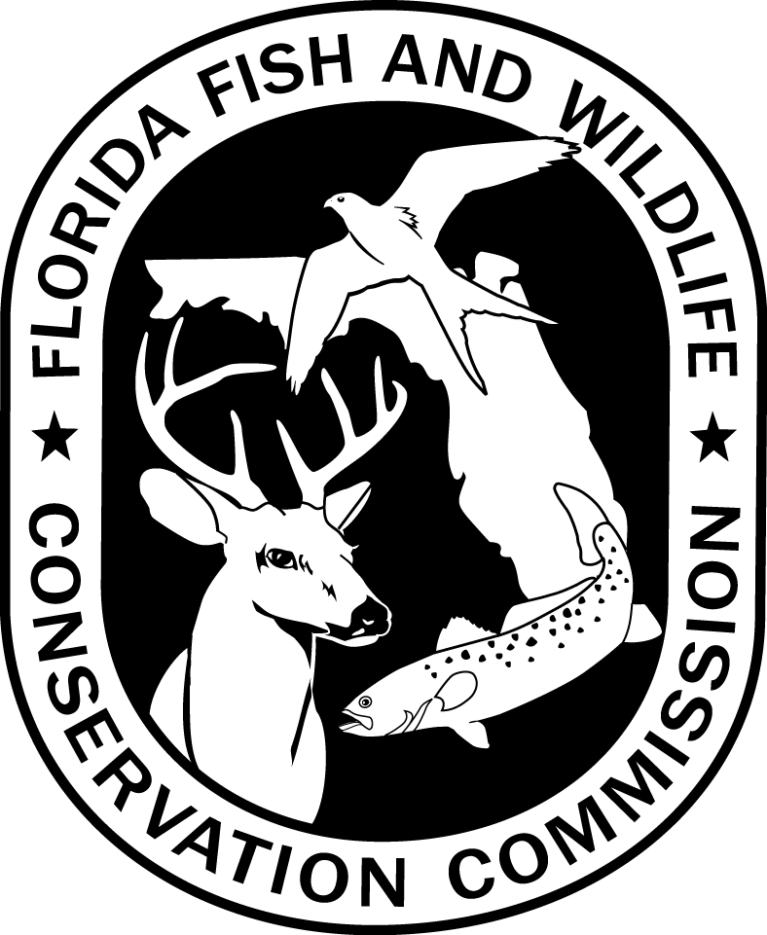
HAUL SEINE PERMIT APPLICATION FORM – SOUTH REGION

LAKE OKEECHOBEE FISHERIES BIOLOGIST
SOUTH REGIONAL OFFICE
Florida Fish and Wildlife Conservation Commission
3991 Southeast 27TH Court, Okeechobee, Florida 34974

Applicant Information
Applicant Name:
Mailing Address:
City, State, Zip:
Telephone: | Home: |  | Work:

Birth Date: |  | Sex: |  | Race: |  | Eyes:

Hair Color: |  | Height: |  | Weight:

Freshwater Commercial Fishing License Number

Have you been convicted of any violation of Chapter 379, Rule 68A-23.012, Florida Administrative Code, or other rules of the Commission relating to illegal taking or sale of freshwater fish within the last two years?
No Yes
If “Yes”, Provide Details:

The above information is true and correct. I agree to follow Florida Statutes and Fish and Wildlife Conservation Commission rules governing use of haul seines.

Signature Date

ALL INCOMPLETE APPLICATIONS WILL BE RETURNED
DFFM HSSR-01
7-14
68A-23.012 F.A.C.

