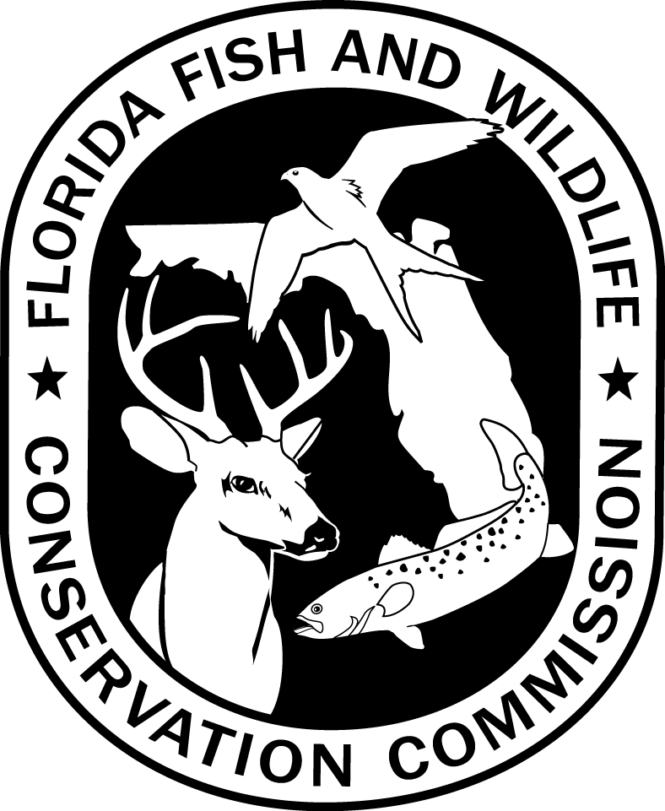
HAUL SEINE PERMIT APPLICATION FORM – SOUTHWEST REGION

REGIONAL FISHERIES ADMINISTRATOR
SOUTHWEST REGIONAL OFFICE
Florida Fish and Wildlife Conservation Commission
3900 Drane Field Road, Lakeland, FL 33811-1207

Applicant Information
Applicant Name:
Mailing Address:
City, State, Zip:
Telephone: | Home: |  | Work:

Birth Date: |  | Sex: |  | Race: |  | Eyes:

Hair Color: |  | Height: |  | Weight:

Freshwater Commercial Fishing License Number

Have you been convicted of any violation of Chapter 379, Rule 68A-23.003, Florida Administrative Code, or other rules of the Commission relating to illegal taking or sale of freshwater fish within the last two years?
No Yes
If “Yes”, Provide Details:

The above information is true and correct. I agree to follow Florida Statutes and Fish and Wildlife Conservation Commission rules governing use of haul seines.

Signature Date

ALL INCOMPLETE APPLICATIONS WILL BE RETURNED
DFFM HSSWR-01
7-14
68A-23.003 F.A.C.

