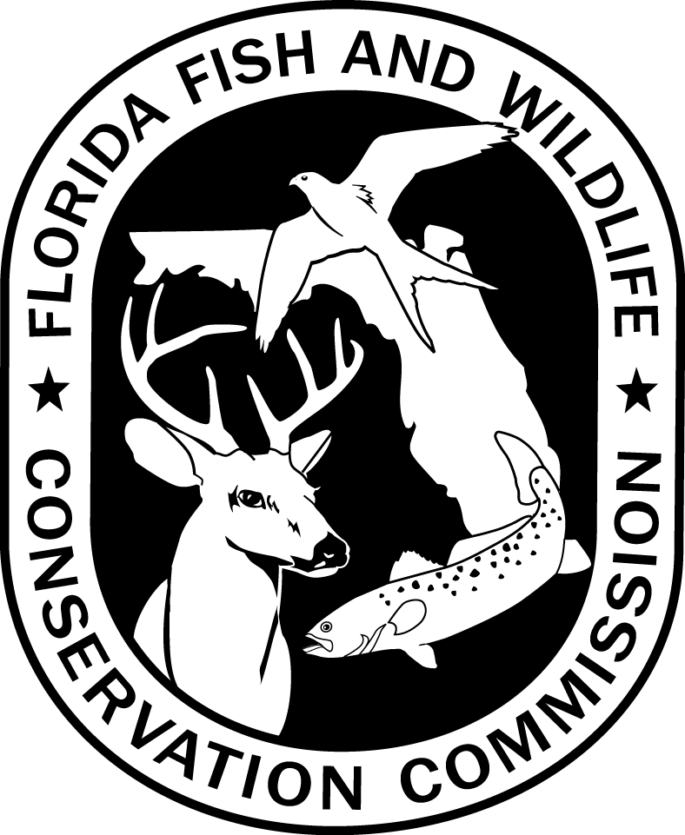
SOUTHWEST REGIONAL HAUL SEINE HARVEST REPORT
REGIONAL FISHERIES ADMINISTRATOR
SOUTHWEST REGIONAL OFFICE
Florida Fish and Wildlife Conservation Commission
3900 Drane Field Road, Lakeland, FL 33811-1207

Applicant Information
Permit Holder Name:
Mailing Address:
City, State, Zip:
Telephone: | Home: |  |  |  |  |  | Work:
Reporting Year: |  |  |  | to
Species: | Estimated Harvest: |  | Market Value:
Tilapia:
Catfish:
Shad:
Gar:
Other:
Totals:

Estimate percent harvest from each lake:
Lake: | Percent Harvest: |  | Lake: | Percent Harvest:
Banana: |  |  | Howard:
Bonny: |  |  | Hunter:
Bonnet: |  |  | Lulu:
Garfield: |  |  | Parker:
Hancock: |  |  | Shipp:
Hollingsworth

I certify that the information provided above is true and correct. I agree to follow Florida Statutes and Fish and Wildlife Conservation Commission rules governing use of haul seines.

Signature Date

DFFM HSSWR-02
7-14
68A-23.003 F.A.C.

