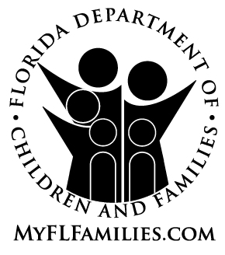

Florida Department of Children and Families
COMMUNITY RESIDENTIAL HOMES
DETERMINATION OF NEED AND LICENSING STATUS

The following community residential home has applied for licensure by:
Florida Department of Children and Families
Agency for Health Care Administration

to operate as a community residential home licensed to serve clients of the department.

Name or Business:

Address: Telephone:

City: State: Zip:

Licensed bed capacity:

Sponsor:

Address: Telephone:

City: State: Zip:

When licensed, this home will meet the licensing standards of the department for the safe care and supervision of clients under the following rules and regulations:
Adult Living Facility – 58A-5, F.A.C.
Adult Foster Home – 58A-14, F.A.C.
Residential Child Care Agency – 65C-14, F.A.C.
Residential Treatment Facility/ADM – 65E-4, F.A.C.
ICF/DD – 65B-38, F.A.C.
Foster Care Facility/DD or Group Home – 65B-6, F.A.C.

Signed: Date:

