Department of State

Division of Elections

Political Committee

EFS User’s Guide


Florida Department of State

Division of Elections

R.A. Gray Building, Room 316

500 S Bronough Street

Tallahassee, FL 32399-0250

EFS HELP LINE: 850-245-6280

January 2011

Rule 1S-2.017, F.A.C. DS-DE 110B (eff. 01/11)

Index

Introduction 1

Access the EFS 2

Passwords and PINs 3
Set a Password Recovery Question 3
Recover Password 4
Change a Password 5
Set a PIN Recovery Question 6
Recover a PIN 8
Change a PIN 10

Create a New Report by Data Entry 12
Enter Contributions 14
Enter Expenditures 16
Enter Other Distributions 20
Enter Fund Transfers 23

Report Credit Card Activity 25

Report Prepaid Distributions 29

Report Reimbursements 32

Create a New Report by File Upload 36

Review Data for Errors 39

Create an Error Filter 43

File the Report 45

Print a File Receipt 47

Make Changes to the Report after Chairperson Enters PIN 49

Access a Pending Report 50

Amend a Report 51

Print a Report 56

Introduction

The Electronic Filing System (EFS) is located on the internet at https://efs.dos.state.fl.us. Each political committee required to file reports with the Division of Elections (DOE) is provided an identification number. Access to the system is gained by inputting the DOE assigned Identification (ID) Number and Password. The committee chairperson is provided an initial password to gain entry to the EFS. Upon logging into the system for the first time, the user will be prompted to change it.
Campaign reports are created by directly entering data into the DOE EFS or by uploading data from external systems that meet DOE electronic file specifications.
A report goes through a three step process before it is filed with the DOE:

FIRST, data is created or uploaded to the system. At this point it is a pending report.
SECOND, the user submits the pending report for review by the system for correctness and completeness. Errors can be corrected in pending reports via the EFS or by uploading additional data.
THIRD, the report is filed. Reports are filed using personal identification numbers (PINs), which are considered the same as a person's signature on the report.

Any changes to be made to a filed report must be done by filing an amendment. Amendments can be done directly through the EFS or by file upload.
The Division of Elections anticipates that this guide will assist you with timely filing all reports required by Chapter 106, Florida Statutes. However, if you have any questions or comments please contact the Division of Elections at:
Department of State
Division of Elections
R.A. Gray Building, Room 316
500 South Bronough Street
Tallahassee, FL 32399-0250

EFS HELP LINE: 850-245-6280

Access the EFS

From Internet Explorer access the EFS at https://efs.dos.state.fl.us/Default.aspx.
Enter the Committee ID Number .
Enter your confidential Password. (IMPORTANT: Your password is case
sensitive.)
Click .

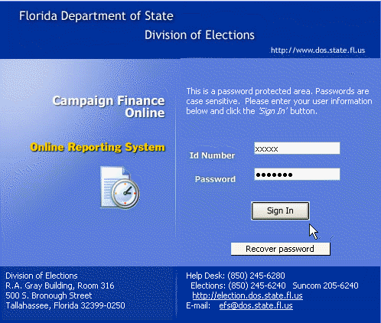
Passwords and PINs

Access to the system is gained by using the DOE assigned Identification (ID) Number and Password. The chairperson is provided an initial password to gain entry to the EFS. Upon logging into the system for the first time, the user will be prompted to change the password. Passwords must contain at least one uppercase letter; contain at least one lowercase letter; contain at least one numeric digit; and be 6-12 characters long.
Reports are filed using personal identification numbers (PINs), which are considered the same as a person's signature on the report.

Set a Password Recovery Question
Each chairperson should create a recovery question in case the password is lost or forgotten.
From the Welcome screen, click 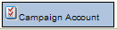

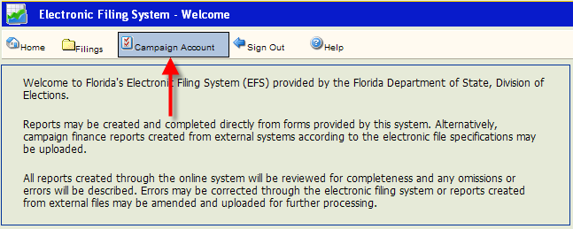
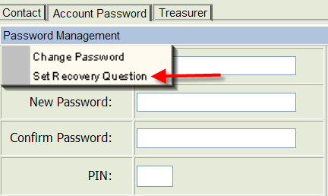

Click .
Click .
Click

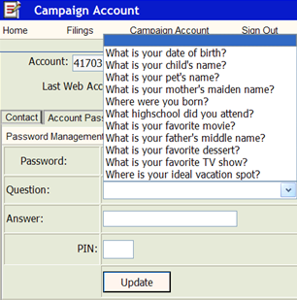
Type in the password.

Click on the arrow.

Select a recovery question.

Type in the answer.

Type in the chairperson PIN.

Click 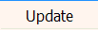.

If the procedure was successful, Answer Saved will appear on the screen.
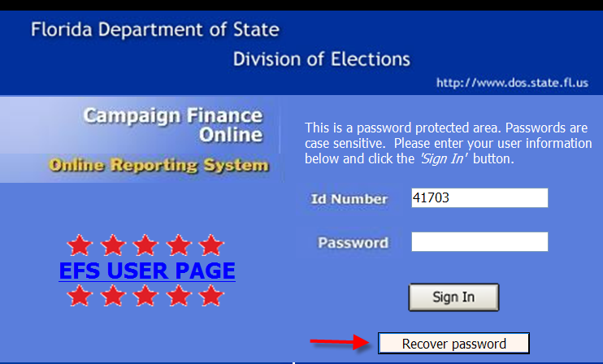
Recover Password

From the Log-in screen,
Enter your ID Number and
Click .

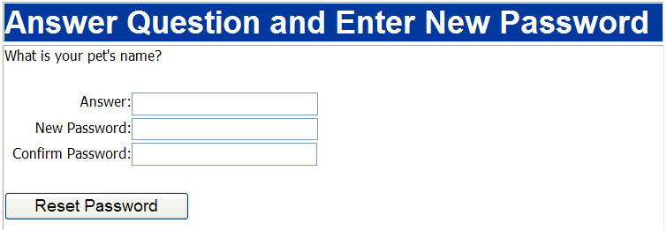

Enter the answer to the recovery question. Enter a new password. Confirm the new password.
Click . Click on
Return to the Log-in page and use the new password.

Change a Password

The password can be changed only by using the chairperson’s PIN.

From the Welcome screen, click .

Click , then . Select .
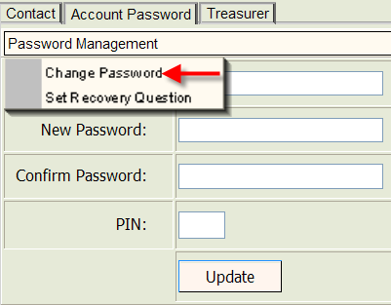

Type in current password.

Type in new password.

Confirm the new password.

Type in chairperson’s PIN and

click .

If the password change was successful, Password Updated will appear on the screen.

Set a PIN Recovery Question

Each chairperson, treasurer and deputy treasurer should create a “recovery question” in case a PIN is lost or forgotten. From the Welcome screen, click .

To set a recovery question for the chairperson, click .

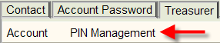

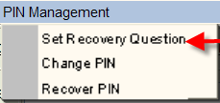
Select “Set Recovery Question.”
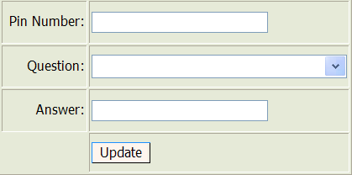

Type in the chairperson’s pin number, select question and then provide answer.

If the procedure was successful, Answer Saved will appear on the screen.

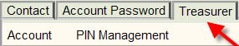
To set a recovery question for a treasurer or deputy treasurer, click .

Select the appropriate treasurer from the drop-down.

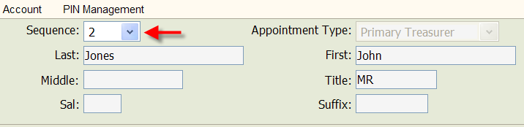

Click .
Select “Set Recovery Question.”

Type in treasurer pin number, select question and then provide answer.

If the procedure was successful, Answer Saved will appear on the screen.

Recover a PIN
From the Welcome screen, click .

To recover the chairperson’s PIN, click and then “Recover Pin.”

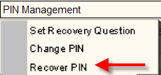
Type in the recovery question answer, a new PIN, confirm the PIN. Click on .

If the process was successful, PIN Reset! will appear on the screen.

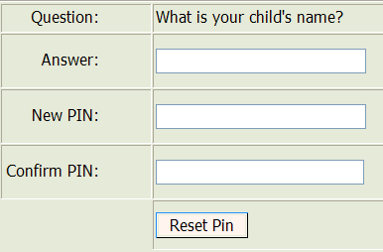

To recover a PIN for a treasurer or deputy treasurer, click .

Select the appropriate treasurer from the drop-down.

Click and the “Recover Pin.”
Type in the recovery question answer, a new PIN, confirm the PIN. Click on .

If the process was successful, PIN Reset! will appear on the screen.
Change a PIN
From the Welcome screen, click .

To change the chairperson’s PIN, click and then “Change Pin.”

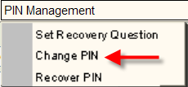

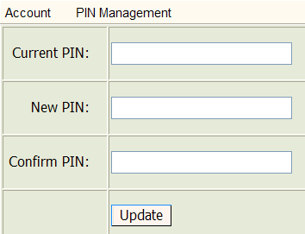

Type in current PIN. Type in the new PIN. Confirm the new PIN. Click .

If the PIN change was successful, PIN Updated! will appear on the screen

To change a PIN for a treasurer or deputy treasurer, click .

Select the appropriate treasurer from the drop-down.

Click and the “Change Pin.”

Type in current PIN. Type in new PIN. Confirm the new PIN. Click .

If the PIN change was successful, PIN Updated! will appear on the screen
Create a New Report by Data Entry

From the Welcome screen, click 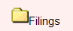 and then .

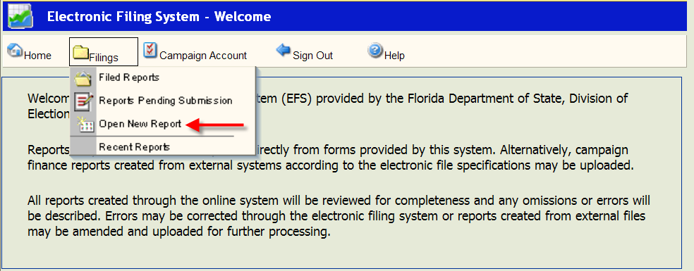

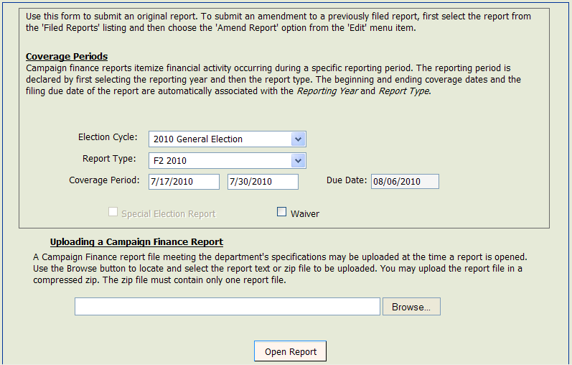

Click arrow next to Election Cycle. Scroll to the cycle associated with the report you are entering.

Click arrow next to Report Type select report type corresponding to the correct cover period and due date.

The Cover Period dates will automatically fill in based on the Calendar of Election and Reporting Dates.
The Due Date will automatically fill in based on the Calendar of Election and Reporting Dates.
If this report is for a special election, click the box next to Special Election Report. (If no special elections are scheduled this option will not be available.)
*****NOTE*****
If this report is a waiver of report (no activity), click the box next to Waiver.
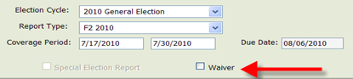

Click at the bottom of the screen. A Report Detail screen (view only) will appear. This screen will not indicate any activity until individual detail data is entered, saved and a review is performed.

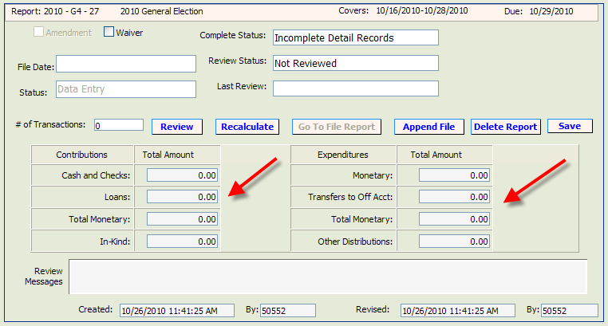
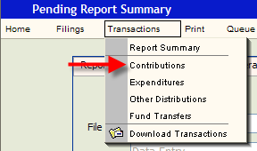
Enter Contributions

Click and then .

Click 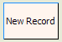.
.
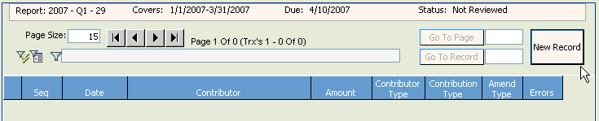

The Contribution Detail screen will be blank. Populate the fields as explained in the instructions below.

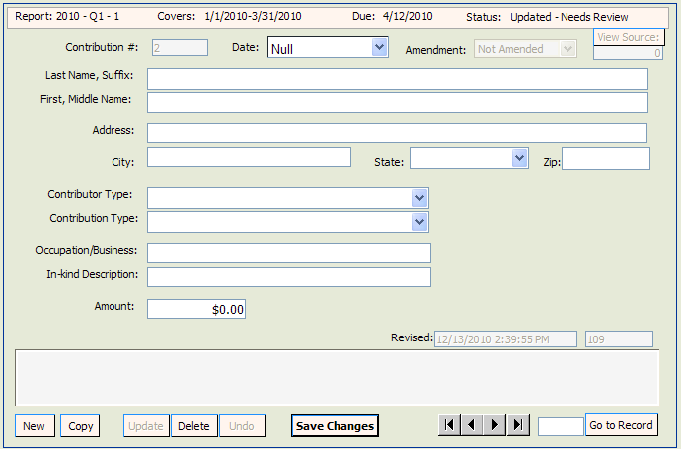

Contribution #: this field will be automatically populated by the system in sequential numbers.
Date: enter date the contribution was received.
Last Name, Suffix: enter contributor's last name and suffix (if given). Do not use titles such as Dr., Colonel, Reverend, etc. NOTE: if this is a business, the name must be placed in the “Last Name” field. If you put it in the “First, Middle Name” field, you will get an error message.

First, Middle Name: enter contributor's first name and middle name or initial (if given).
Address: enter contributor's complete street address or post office box number.
City: enter contributor's city.
State: click arrow and choose contributor's state. If the contributor resides outside the United states, choose at the bottom of the drop down list.
Zip: enter contributor's zip code.
Contributor Type: click arrow and choose one of the listed contributor types.
Contribution Type: click arrow and choose one of the listed contribution types.
Cash – used to report the receipt of cash and cashiers’ check.
Check – includes traditional paper checks, wire transfers, Paypal, contributions by credit card, and other types of electronic funds transfers.
In-kind – item of value other than money or volunteer services.
Interest – money earned on campaign or interest bearing accounts.
Loan – money that is loaned to the campaign rather than given outright.
Money Order - used to report the receipt of contribution by money order.
Refund – used to report bad checks or contributions returned (in whole or in part) to the contributor. Refunds must always be entered as a negative amount.
Occupation: enter contributor's specific occupation. (This field is required if the contribution is over $100.) Do not use generic occupations such as “businessman” or “sales.” Use specifics such as pharmaceutical sales or insurance.
In-kind Description: if Contribution Type is In-kind, enter a specific description of the in-kind contribution. Example: Food and beverage
Amendment: defaults to Not Amended.
Amount: enter exact amount of contribution (dollars and cents).

Click .

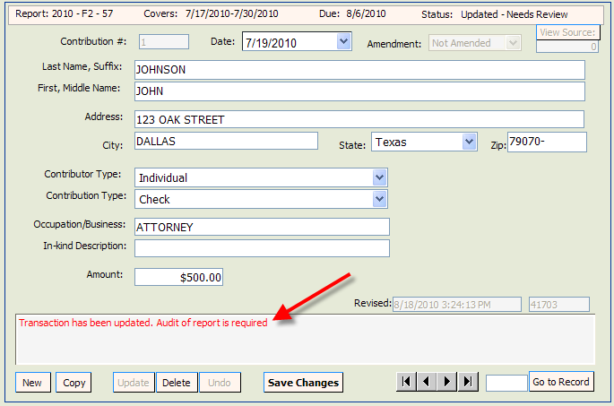

NOTE: Notice the statement in the Review Messages box in red. This statement will appear until the report has been reviewed by the system. (See page 39.) After the report has been reviewed, this box will be blank or have a specific error message if information is incomplete or not in compliance with Chapter 106, Florida Statutes.

To enter the next contribution, click .

Continue adding contributions as necessary. Upon completion of each entry, you must save the data by clicking .

Enter Expenditures
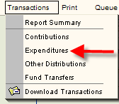
Click and then .

Click .

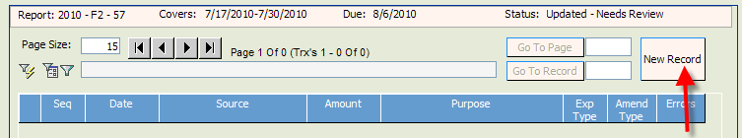
The Expenditure Detail screen will be blank. Populate the fields as explained in the instructions below.

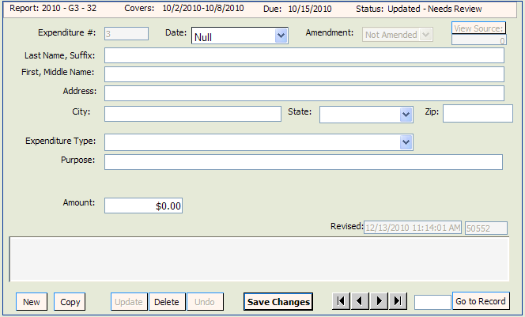

Expenditure #: this field will be automatically populated by the system in sequential numbers.
Date: enter date the expenditure was made.
Last Name, Suffix: enter the last name and suffix (if given). NOTE: if this is a business, the name must be placed in the “Last Name” field. If you put it in the “First, Middle Name” field, you will get an error message.
First, Middle Name: enter person’s first name and middle name or initial (if given).
Address: enter complete address.
City: enter city.
State: click arrow and choose a state. NOTE: If the address is outside the United States, choose at the bottom of the drop down list.
Zip: enter zip code.
Expenditure Type: click arrow and choose one of the listed expenditure types.
Candidate Expense – Used when making a contribution (monetary or in-kind) to a candidate. Example: XYZ political committee buys $500 of food for a campaign event for candidate John Smith. This would be an in-kind contribution.
Credit Card Payment – NOTE: This option may only be used by political committees that support or oppose statewide (Governor and Cabinet) candidates, constitutional amendments or both. Each purchase made with the credit card will be itemized under “Other Distribution Records” and linked to the Expenditure that represents payment of the credit card bill on which the purchase appears. See page 25 for further explanation on reporting credit card activity.
Electioneering Communication – use when making a communication relating to a candidate that does not expressly advocate the election or defeat of the candidate. See Section 106.011(18), FS for complete definition.
Independent Expenditure re Candidate – used when making an expenditure that is not coordinated with a candidate for the purpose of expressly advocating the election or defeat of a candidate. See Section 106.011(5), FS, for complete definition.
Independent Expenditure re Issue – used when making an expenditure for the purpose of expressly advocating the approval or rejection of an issue. See Section 106.011(5), FS, for definition.
Monetary – general expenditure type used when other specific expenditure types do not apply.
Petty Cash Spent – used to report the total amount of petty cash spent during a reporting time period. Expenditures made from petty cash are not required to be reported individually.
Petty Cash Withdrawn – used to report the amount of petty cash that has been withdrawn during a reporting time period.
Pre-paid Distribution – lump sum payment made up front to one person/entity that will be disbursed to different person/entities. Examples:

- Payment to a media consultant who will then make disbursements to various media such as a newspaper, radio or television station.

- Payment to an employment agency that will then distribute to campaign staff.

Related entries in “Other Distributions” will be reported and linked to the expenditure as they occur. See page 29 for further explanation on prepaid distributions.

Refund – used to report a refund of money from a vendor, etc. These must always be entered as a negative amount.

Reimbursement – reimbursement for authorized expenses made in connection with the campaign. (Example: John Smith paid for the cost of printing campaign signs with his own money for the committee. A check to reimbursement him for the cost would be coded as a “Reimbursement.” See page 32 for further explanation on reimbursement activity.

Purpose: enter a description of the expenditure. Examples:
- Campaign contribution
- For credit card payment, the purpose would be the month of the credit card statement – ie November Statement.
Office: if an in-kind contribution to a candidate is made, the office of the candidate must be reported.
Amount: enter exact amount of expenditure (dollars and cents).
Credit Card – Monthly Activity Amount – when the expenditure type used is “Credit Card Payment, “ enter the total amount of the activity in this field. The dollar amount in this field should match the dollar amount in the “Amount” field.

Complete all fields and then click .

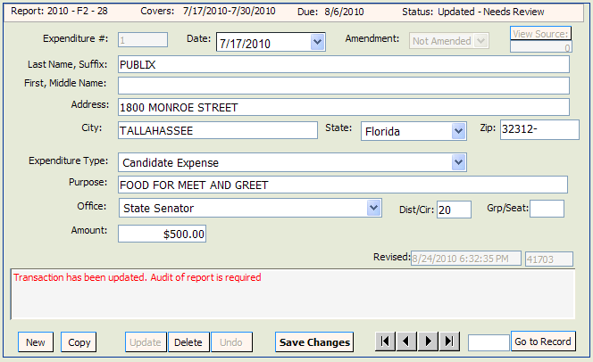
Note: Notice the statement in the Review Messages box in red. This statement will appear until the report has been reviewed by the system. (See page 39.) After the report has been reviewed, this box will be blank or will have a specific error message if information is incomplete or not in compliance with Chapter 106, Florida Statutes.

To enter the next expenditure, click . Continue adding expenditures as necessary. Upon completion of each entry, you must save the data by clicking .

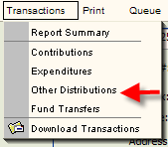
Enter Other Distributions

Click and then .

Click .

The Other Distribution Detail screen will be blank. Populate the fields as explained in the instructions below.

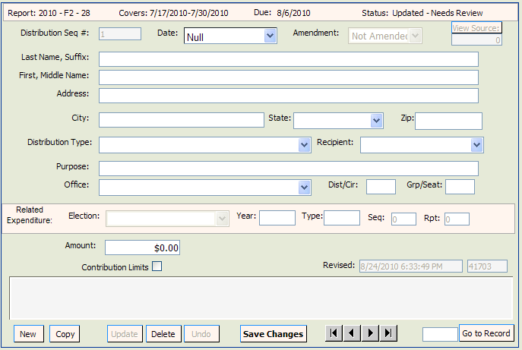

Distribution #: the distribution detail data is sequentially numbered and is automatically populated by the system.
Date: enter date the distribution was made.
Last Name, suffix: enter last name and suffix (if given). If a business or committee, enter the entire name in the Last Name field.
First, Middle Name: enter first and middle name or initial (if given). Leave blank if a business or committee.
Address: enter complete address.
City: enter city.
State: click arrow and choose a state. NOTE: If the address is outside the United states, choose Not in Country at the bottom of the drop down list.
Zip: enter zip code.
Distribution Type:

Credit Card Payment – NOTE: This option may only be used by political committees that support or oppose statewide (Governor and Cabinet) candidates, constitutional amendments or both. Each purchase made with the credit card will be itemized under “Other Distribution Records” and linked to the Expenditure that represents payment of the credit card bill on which the purchase appears. See page 25 for further explanation on reporting credit card activity.
Prepaid Distribution – use to itemize previously made lump sum payments. Example – payment to a media consultant who will then make disbursements to various media such as a newspaper, radio or television station. The “Other Distribution” entries will document how the media consultant is spending the lump sum payment. Items will be reported and linked to the pre-paid expenditure as they occur. See page 29 for additional information.
In-Kind Distribution – use to report an in-kind contribution when there is no corresponding expense. Example: ABC political committee owns a building and allows a candidate to use part of the building for a campaign fund raiser at no charge. As the committee owns the building, the committee does not spend money to make the contribution, and thus, would not show any money going out as an Expenditure. Therefore, the contribution is reported under “Other Distributions” rather than as an Expenditure.
Reimbursement – itemizes reimbursement for authorized expenses. Example: John Smith paid for the cost of printing signs with his own money. The signs were purchased at ABC Printing. This entry would provide the name and address of ABC Printing and how much was spent. It will be related to an expenditure showing reimbursement to Mr. Smith. See page 32 for additional information.
Related Expenditure: once the fields are populated and saved, the screen will refresh and this field will appear. It will be populated by the system once the Other Distribution is linked to an Expenditure. (See instructions for linking Expenditures beginning on page 25.)

Recipient: If the distribution is an in-kind contribution, designate the type of recipient.
Purpose: enter the purpose of the distribution – Example: newspaper ad. If the distribution is an in-kind contribution, the name of the recipient must be provided.
Office: if the distribution is an in-kind contribution, the office of the candidate must be reported.
Amount: enter exact amount of distribution (dollars and cents).

Enter all information and then click .

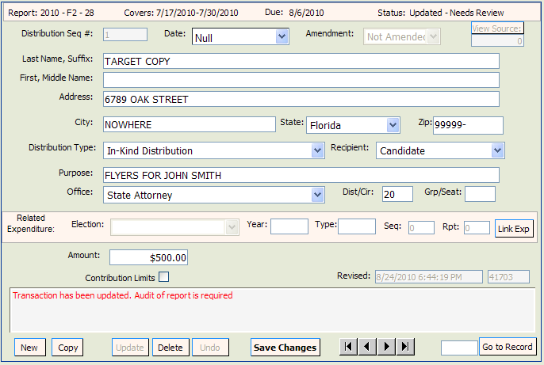

NOTE: Notice the statement in the Review Messages box in red. This statement will appear until the report has been reviewed by the system. (See page 39.) After the report has been reviewed, this message will be blank or have a specific error message if information is incomplete or not in compliance with Chapter 106, Florida Statutes.

To enter the next other distribution, click .

Continue adding Other Distributions as necessary. Upon completion of each entry, you must save the data by clicking .
Enter Fund Transfers

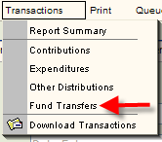
This section is used to report the transfer of funds between the primary depository and separate interest-bearing accounts.

Click and then .

Click .

The Fund Transfer Detail screen will be blank. Populate the fields as explained in the instructions below.

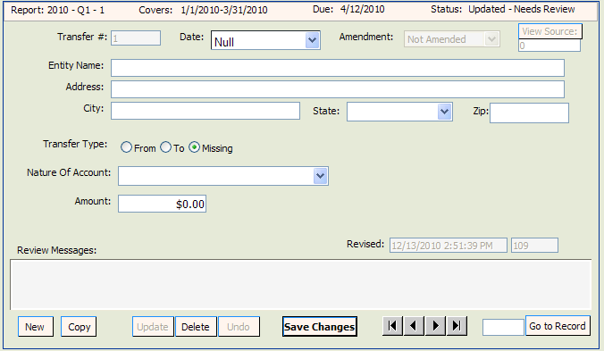

Transfer #: this field will be automatically populated by the system in sequential numbers.
Date: enter date the fund transfer was made.
Entity Name: enter entity's full name.
Address: enter entity's complete address.
City: enter entity's city.
State: click arrow and choose entity's state.
Zip: enter entity's zip code.
Transfer Type: click arrow and choose From or To.
Nature of Account: click arrow and choose nature of account.
Amendment: defaults to Not Amended.
Amount: enter exact amount of fund transfer (dollars and cents).

Enter all information and then click .
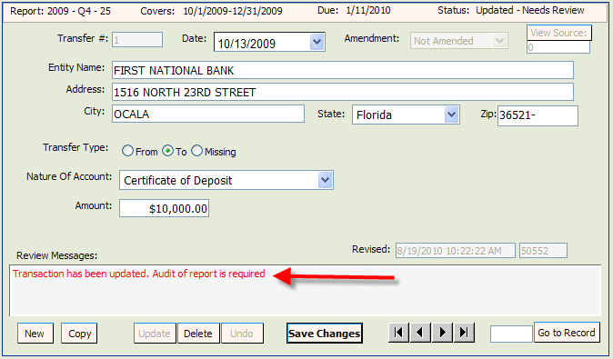
Note: Notice the statement in the Review Messages box in red. This statement will appear until the report has been reviewed by the system. After the report has been reviewed, this box will be blank or will have a specific error message if information is incomplete or not in compliance with Chapter 106, Florida Statutes.
To enter the next Funds Transfer, click

Continue adding Funds Transfers as necessary. Upon completion of each entry, you must save the data by clicking .
Report Credit Card Activity

Pursuant to section 106.125, Florida Statutes, only political committees formed to support or oppose statewide candidates (Governor and Cabinet), statewide issues, or both, may obtain campaign credit cards. The credit cards may be used only for travel related expenses.

Each time a credit card is used, there will be an entry in Other Distributions documenting the activity. Credit card activity is reported during the reporting period that it occurs. This may be, but is not always, the same reporting period that the expenditure for the credit card payment occurs and is reported. Once the expenditure (credit card payment) is made, the Other Distributions (credit card activity) must be “linked” to the Expenditure as explained in the instructions below.

Enter Credit Card Activity in Other Distributions:

Each time the credit card is used, create an “Other Distributions” record. (See instructions beginning on page 20.) The date for the record will be the date of the credit card purchase. For “Distribution Type,” choose Credit Card Purchase.
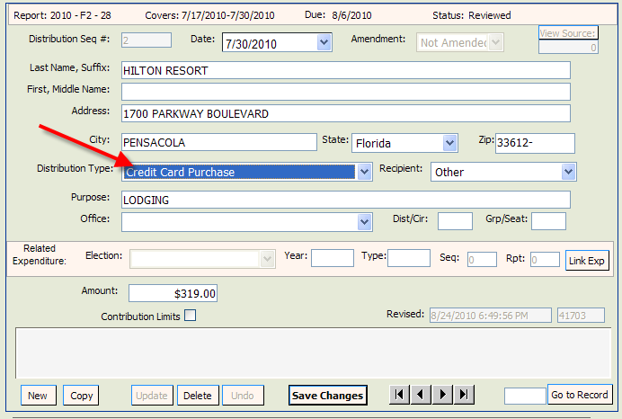

Enter all information and then click .

Repeat the process for each credit card purchase.
Enter Credit Card Payment in Expenditures:

To document payment of the credit card bill, create an “Expenditures” record for the payment. (See page 16 for detailed instruction on creating an expenditure record.) For Expenditure Type, select Credit Card Payment.

The purpose would be the month of the credit card statement – i.e. November Statement.

Enter the amount of the Expenditure in the Amount field.
Enter all information and then click .

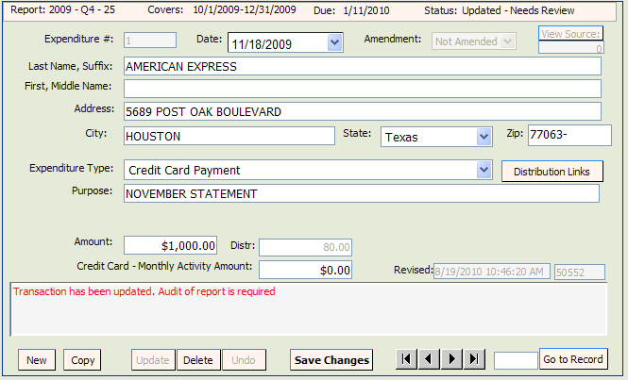

The screen will refresh. For “Credit Card - Monthly Activity Amount,” enter the total amount of credit card purchases for that particular statement period.
Click .

Link the Credit Card Payment to the Credit Card Transactions:

On the Expenditure sequence that documents the credit card payment, click on .

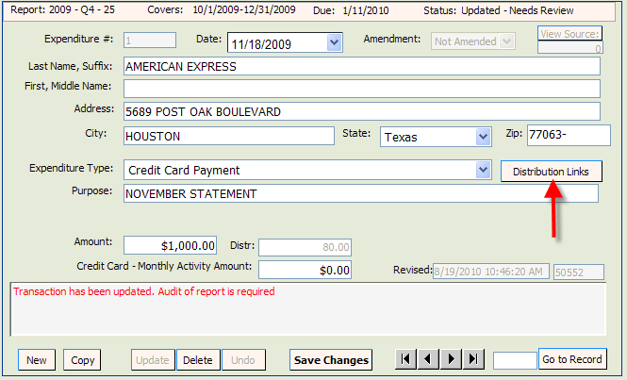

Click on the radio button “Not Linked” This will take you to a listing of all credit card purchases that have not been yet been linked to a credit card payment.

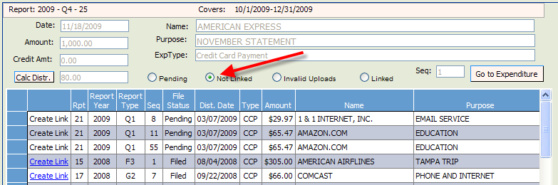
Click by each of the credit card purchases that you wish to link to the credit card payment. Click to determine the total amount of credit card activity that is currently linked to a payment. After all credit card activity has been linked, the totals in the “Amount,” “Credit Amt,” and “Cal Distr.” fields should be equal.

To verify the activity that has been linked to an Expenditure, go to the Expenditure and click on .
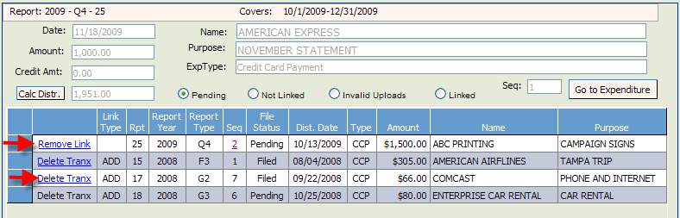
Everything that is currently linked to this Expenditure will be listed. If you have linked a purchase in error, click on (for pending links) or (for filed links) to remove the link.
Report Prepaid Distributions

Prepaid Distributions are lump sum payments to one entity or person who then distributes the funds to other entities or individuals.
Example: Payment to a media consultant who will then make disbursements to various media such as a newspaper, radio or television station. The Expenditure entry documents the lump sum payment. The “Other Distribution” entries will indicate how the media consultant is spending the lump sum payment. Items will be reported and linked to the pre-paid expenditure as they occur.

Enter Prepaid Amount in Expenditures:
Create an Expenditure record for the lump sum payment. (See page 16 for instruction on creating an expenditure record.) For Expenditure Type, choose 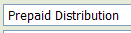.

Enter all information and then click .

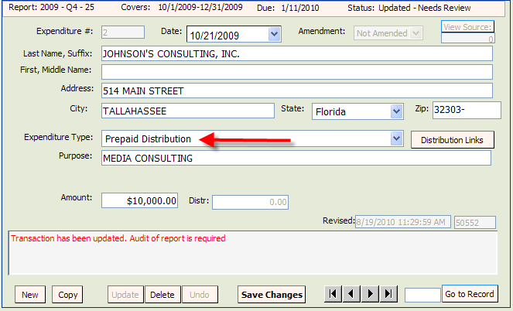

Enter Disbursements of the Payment in Other Distributions and Link to Expenditure:

As the funds are disbursed, Other Distribution records are created and linked to the original expenditure. (See page 20 for instruction on creating an Other Distributions record.) For Distribution type, select .
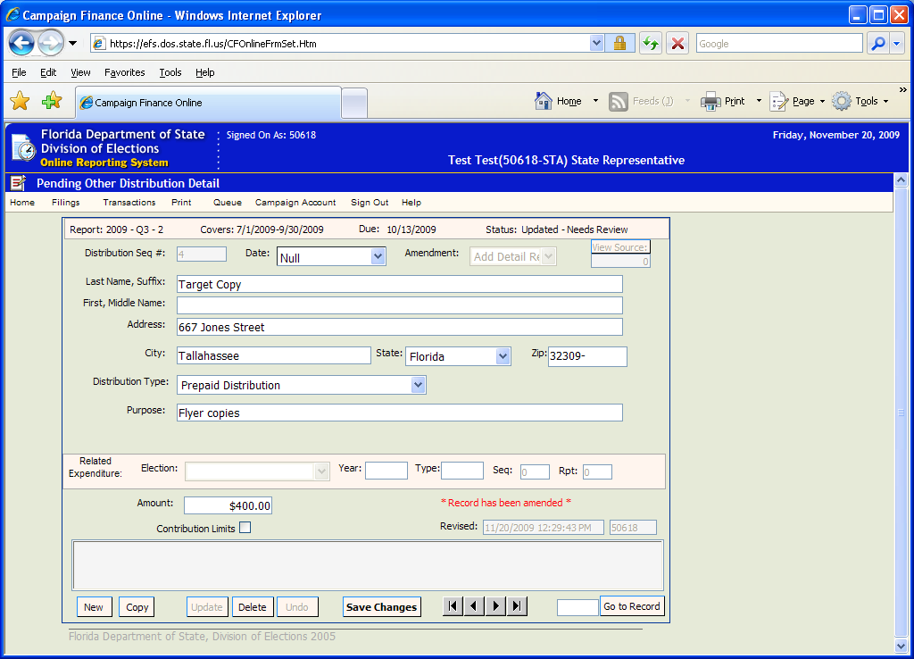

Enter all information and then click . The screen will refresh and will appear.

Click on .
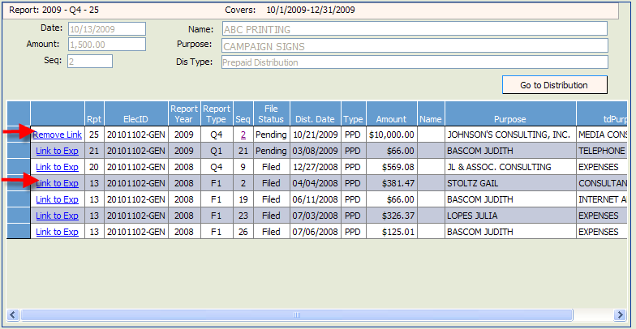

Determine which entry to link the distribution to the expenditure and click on .
To remove the link, click on .

For each disbursement of the prepaid expenditure, create an Other Distributions record. Link each distribution record to the original prepaid expenditure.
Report Reimbursements

Reimbursements are used to report authorized expenses incurred that are not otherwise reported as direct expenditures. Each time a person authorized to make an expenditure on behalf of the committee makes an expenditure that will be reimbursed, there must be an entry reported for the purchase in “Other Distributions.” The “Other Distribution” (the purchase) may be, but is not always, reported during the same reporting period as the “Expenditure” (the check written for reimbursement). Once the “Expenditure” is reported, it must be linked to the “Other Distribution.”

Enter Reimbursement Activity in Other Distributions:

For each purchase that will be reimbursed, create an “Other Distributions” record. (See page 20 for instructions on creating an Other Distributions record.) For Distribution Type, choose Reimbursement.
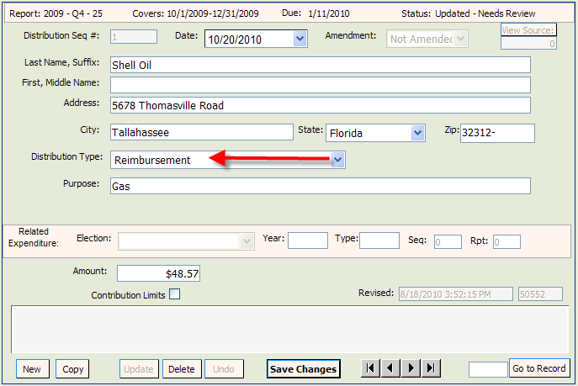
Enter all information and click .

Enter Reimbursement Payment in Expenditures:

To document the payment to reimburse authorized expenditures, create an Expenditure record. (See Page 16 for instructions on creating an Expenditure record.) For Expenditure Type, select Reimbursement.

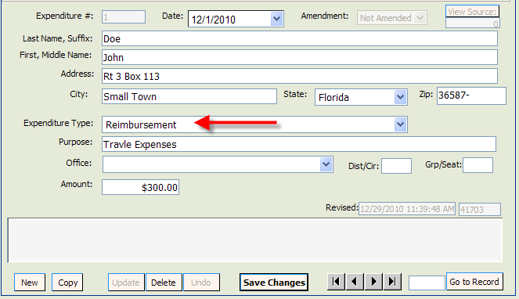

Enter all information and click . The screen will refresh and the will appear on the Expenditure screen.

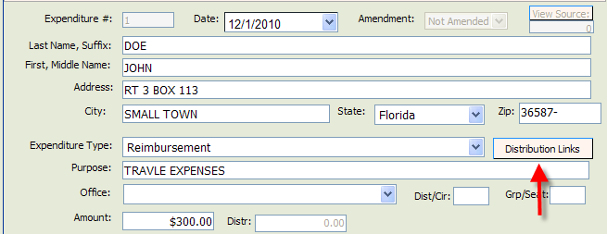
Link the Purchases to the Expenditure for Reimbursement

On the Expenditure sequence that documents the reimbursement payment, click on .
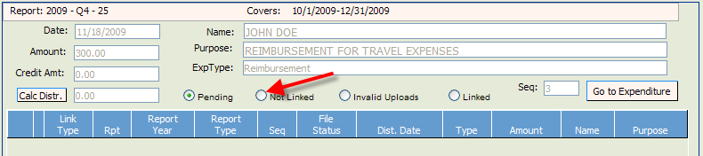
Click on the radio button “Not Linked.”
This will take you to a listing of all reimbursement expenses that have not yet been linked to a reimbursement payment.

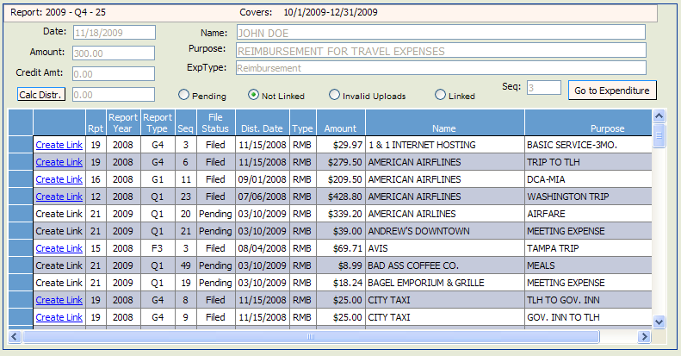

Click on by each purchase that will be linked to the reimbursement payment.

To verify the activity that is linked to a reimbursement payment, click on .
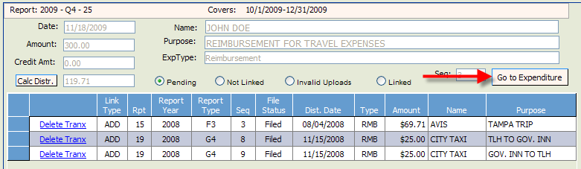

Click on .

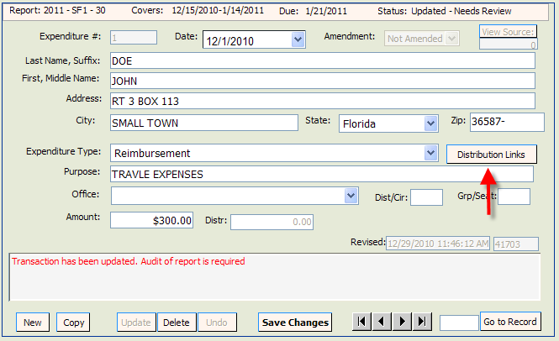

Everything that is currently linked to this Reimbursement Expenditure will be listed.

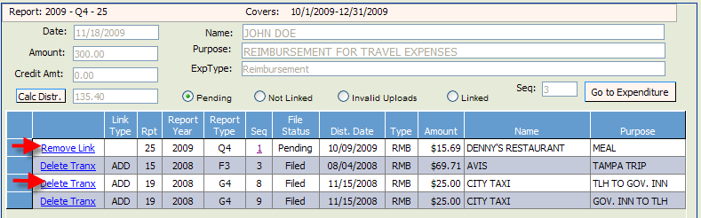

If you have linked a purchase in error, click on (for pending links) or (for filed links) to remove the link.
Create a New Report by File Upload

From the Welcome Screen, click and then .

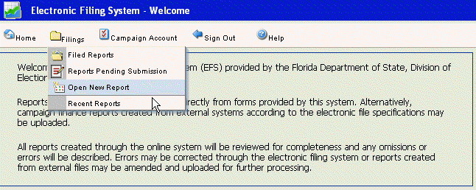
Click arrow next to Election Cycle. Scroll to cycle associated with the report you are entering.
Click arrow next to Report Type. Scroll to report type code associated with the report you are entering. Click .
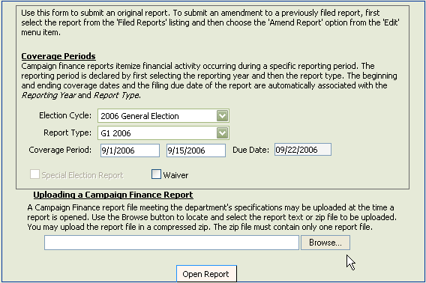
Navigate to the file you wish to upload to the EFS and double click on the name.
Note: The file name must be in the following format: IDNumber.ReportType

Example: 19932.G4

The file name will appear in the box next to . Click on . Click on View Report.

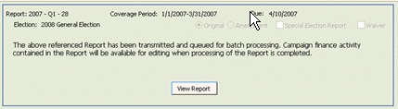

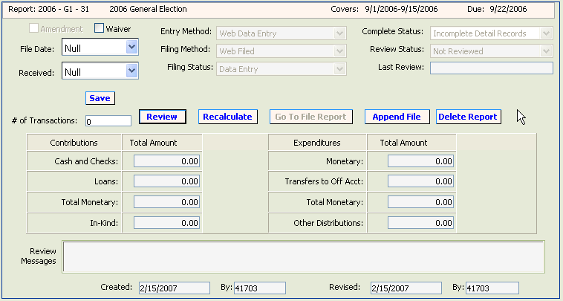

A screen will appear showing the report summary. The Complete Status box will indicate when the processing of the upload is complete (if a delay occurs keep refreshing the screen until complete).

If the file type is not valid:

Open Windows Explorer. Click Tools. Click Folder Options. Click View.
Uncheck Hide Extensions for Known File Types.
Click Apply. Click OK.
Save file under new name.

Review Data for Errors

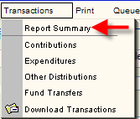
When all contributions, expenditures, fund transfers, and other distributions have been entered and saved or uploaded, the data should be reviewed by the EFS to determine completeness and correctness.

Go to the Pending Report Summary
page by clicking on
and then .

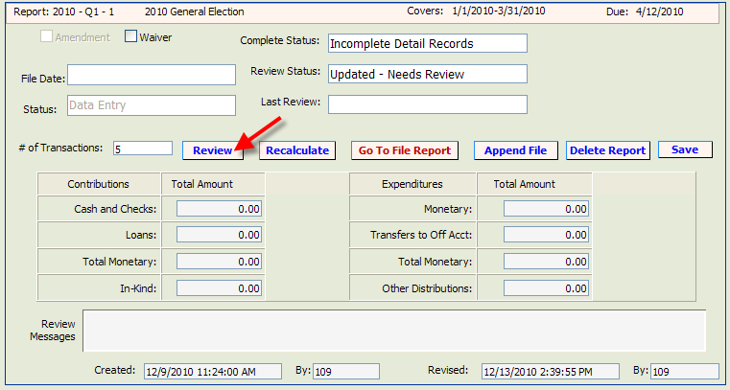
From the Pending Report Summary page, click on . To return to the Report Summary page, click on .
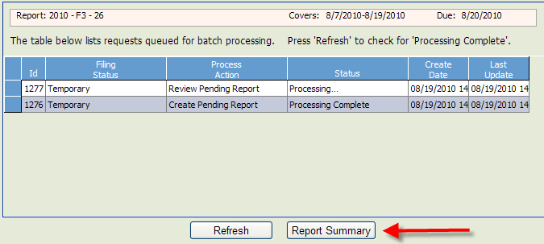

If the Complete Status box indicates “Incomplete Detail Records,” correct the errors prior to filing the report with the Division of Elections.

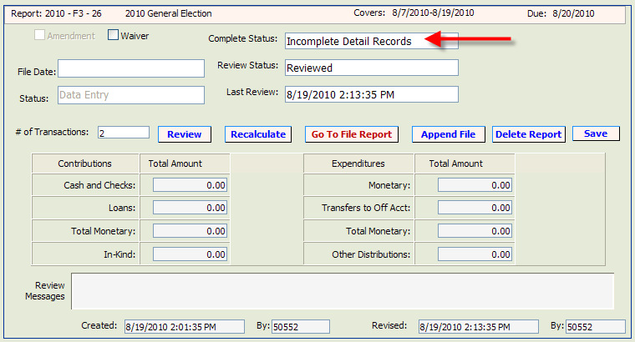

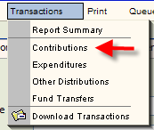
To find errors in Contributions, click
and then .

At the right under the “Errors” column, any number above 0 indicates that the entry has an error.

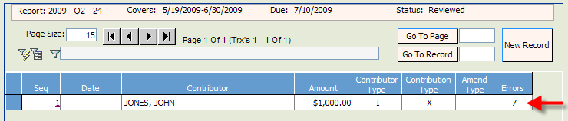

Open the entry by clicking on the sequence number to view the error messages.

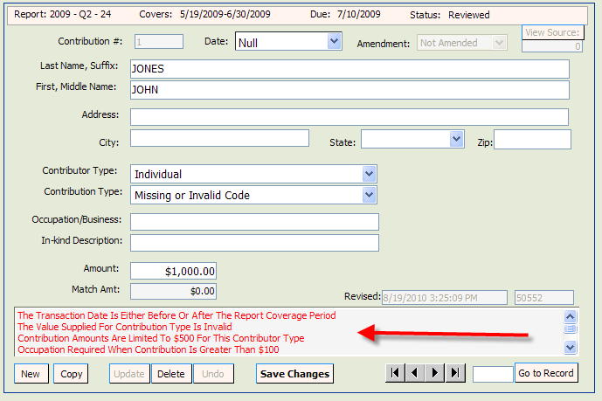

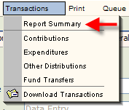
Correct the errors and then click on .

After correcting all errors, the report must be
reviewed by the system again. Click
and then .
Return to the Report Summary page and click on

If all errors are corrected, the Complete Status box will change to Complete Detail Records.

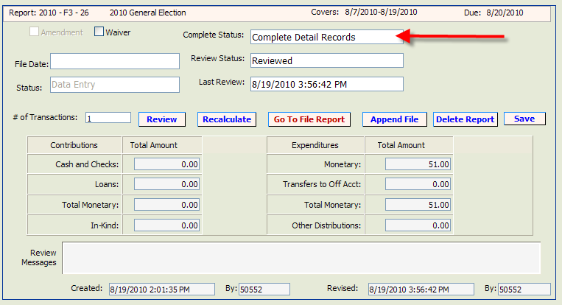

After the report is reviewed, you may choose to file the report or leave the report in pending status until a later date (see page 50 for instructions on accessing pending reports).

Errors in Expenditures, Other Distributions and Fund Transfer entries are corrected in the same manner.

Note: If report is voluminous, see page 43 for instructions on creating an error filter.
.
Create an Error Filter

If a report is voluminous, locating errors must be done by creating an error filter.
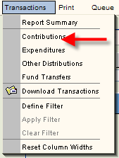
To create an error report for contributions,
click and then .
.

Click on the icon.

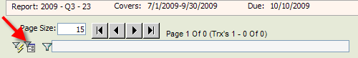

Click on the under Select Column to Search and choose .

Click on the under Select Type of Comparison and choose .

Under Enter value to compare, type 0 (zero).
Click and then .

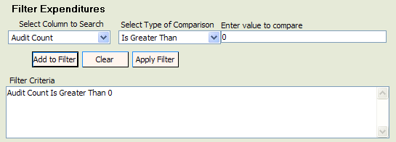

.

When the filter is applied, only those entries with errors will show. Click on the Sequence number for each entry and correct the errors.

The errors will be referenced in the Review Messages box and will be printed in red.

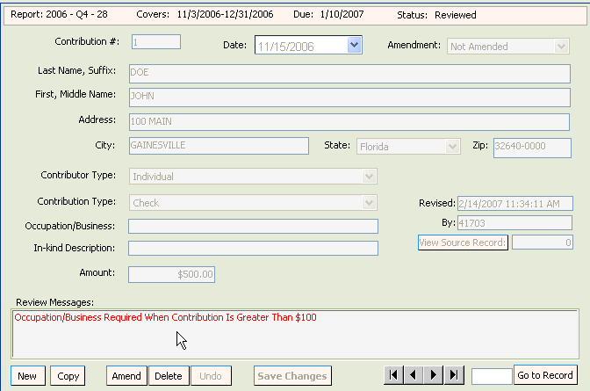

In order to see all entries, clear the error filter. Click on .

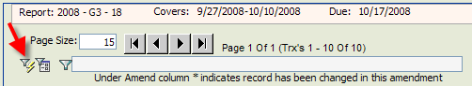

NOTE: Repeat the filter process for Expenditures, Funds Transfers and Other Distributions, if necessary.
File the Report

If the Review Status is Updated Detail – Needs Review the report has not been reviewed since the last update. (See page 39 for instructions on how to submit the report to the system for review.)

If the status of the report is Complete Detail Records, you are ready to file the report.

Click on .

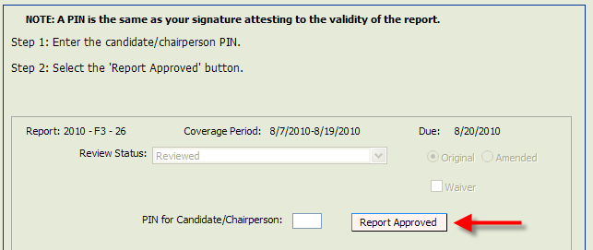
The chairperson enters his or her PIN, and then selects
.

If there is more than one treasurer, click on the drop down and select the treasurer that is filing the report.

The treasurer enters his PIN and then clicks .

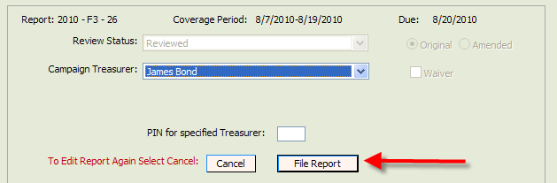

IMPORTANT NOTE: If changes need to be made after a chairperson PIN is entered, the treasurer must undo the chairperson PIN validation before the system will allow changes. See page 49 for instructions.

Print a File Receipt

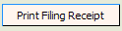
After a report is filed, click .
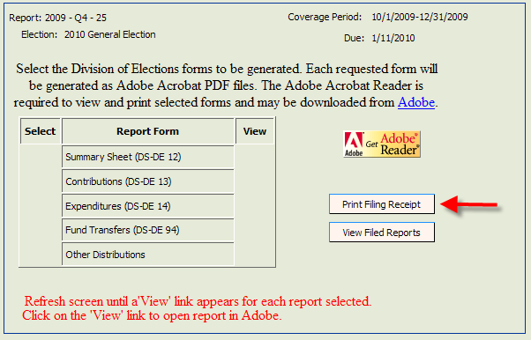

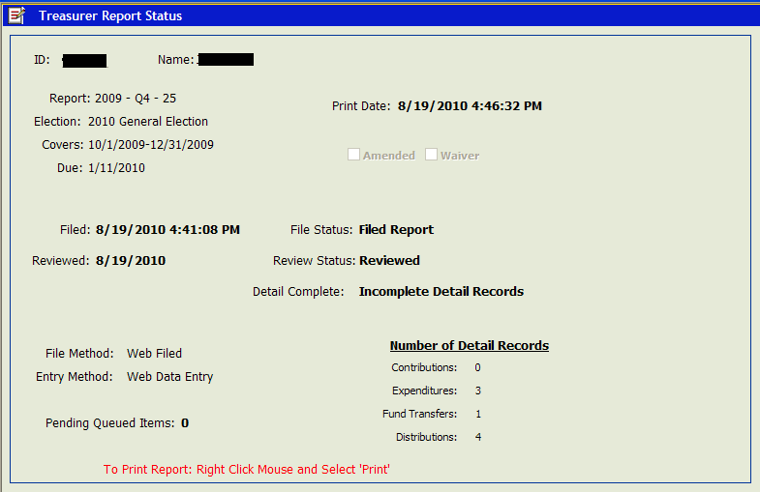

To print this screen, right click your mouse and select “Print.” Save this screen as your filing receipt.

IMPORTANT NOTE: the “Filed” field will be populated if the report has been correctly filed. If this fields is blank, you have not filed the report with the Division of Elections.

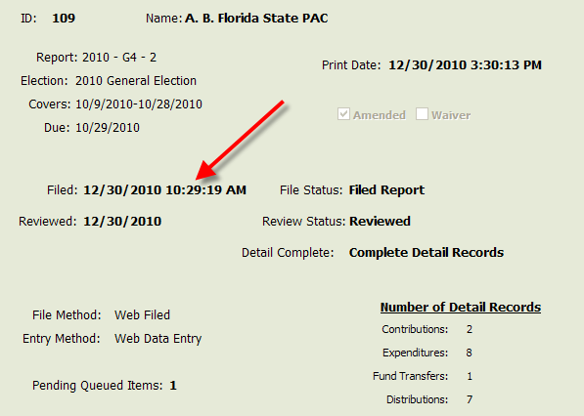

NOTE: If you are unable to print the receipt, make sure that your pop-up blocker is turned off.

Make Changes to the Report after
A Chairperson Enters PIN

If changes need to be made after a chairperson’s PIN has been entered, the treasurer must “cancel the filing” before the system will allow changes.

If there is more than one treasurer, click on the drop down and select the appropriate treasurer.

After selecting the treasurer’s name, enter the PIN and click

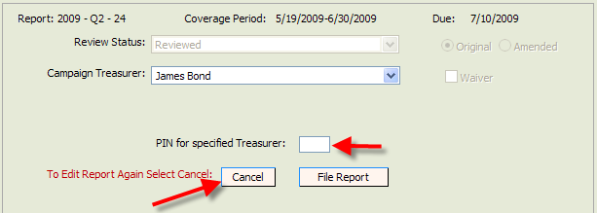

This will re-open the report for changes.
Access a Pending Report

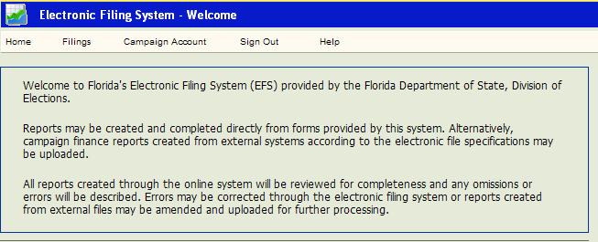

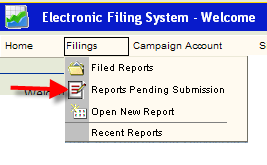
From the Welcome Page, click .

Select .

Click on the Sequence number of the report you wish to access.

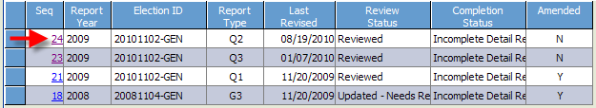

Amend a Report

Once a report is filed with the Division of Elections it cannot be edited. Any changes to a filed report must be done by filing an amendment. Amendments can be done directly through the EFS or by file upload.

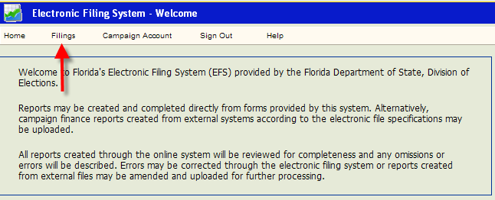

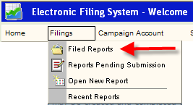

From the Welcome page, click
and then .

Click on the Sequence number of the report to be amended.
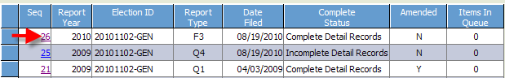

Click and then .

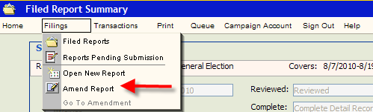

.

Click on .
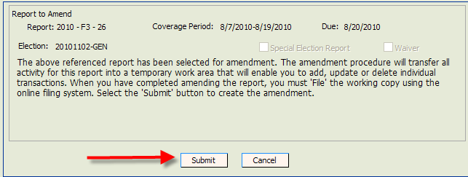
Click on the Sequence number of the report to be amended.
The status of the report will be “Amending.”

Amend a Report by Direct Entry

To update an entry, click on the Sequence number of the detail data (Contribution, Expenditure, Other Distribution or Funds Transfer) to be updated.
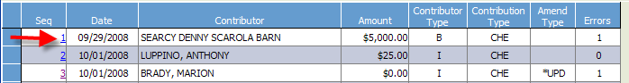

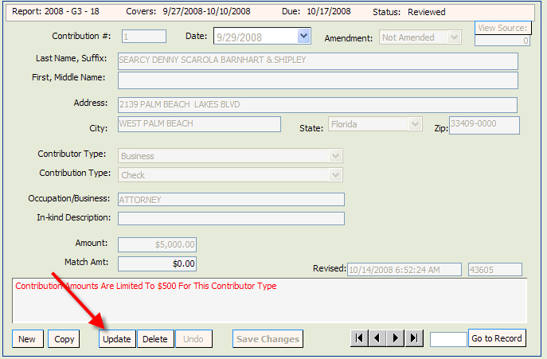

Click . Make necessary changes and click .

To add a new record, Click 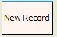.

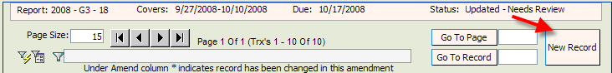

Populate the fields and
then click .

To delete an entry, click on the Sequence number of the detail data to be deleted.

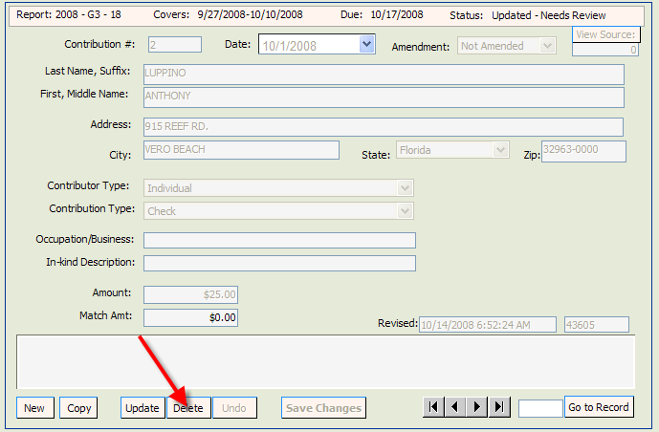

Click .

If the Complete Status box indicates Incomplete Detail Records, correct errors prior to filing the amended report. See page 39 for instructions on locating and correcting errors.
NOTE: The error message will not go away until you review the report.

Amend a Report by File Upload:

On the Pending Report Summary Page, click on .

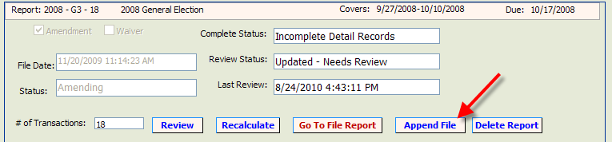

Click on .

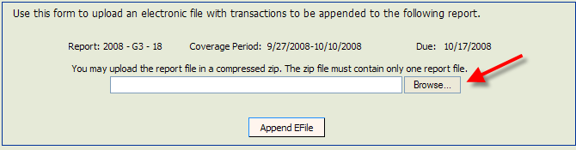

Select file to be uploaded and click on .
Print a Report

From the Welcome page, click .

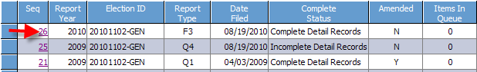
Select the report you wish to print by clicking on the report sequence number.

Click and then .

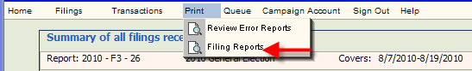

Select the items you wish to print by clicking in the appropriate box.

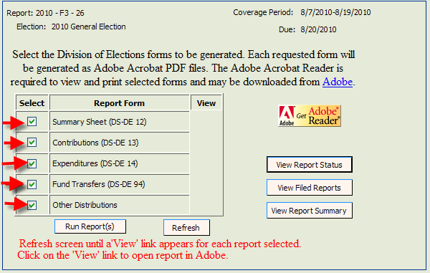

Click .

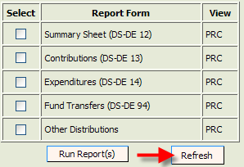
In the View column, you will see PRC.

Click on .

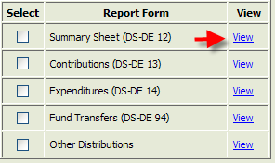

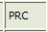 will change to .

Click on .

Print each segment of the report by clicking on next to the segment you wish to print.

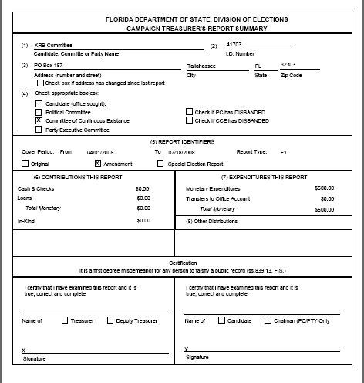
The segment will open in a PDF format. Click on the PRINT icon on the Internet Explorer toolbar to print.

Repeat the process for each segment.

