Methods of Making Sanitation Ratings of Milk Shippers and the
Certifications/Listings of Single-Service Containers and/or Closures for Milk and/or Milk Products Manufacturers
2017 REVISION


U.S. Department of Health and Human Services Public Health Service
Food and Drug Administration

PREFACE

The objective of a rating is to provide an assessment of the Regulatory Agency’s sanitation activities regarding public health protection and milk quality control. This is accomplished by evaluating sanitation compliance and enforcement standards of the current edition of the Grade "A" Pasteurized Milk Ordinance (Grade “A” PMO) and Related Documents as listed in the Procedures Governing the Cooperative State-Public Health Service/Food and Drug Administration Program of the National Conference on Interstate Milk Shipments (Procedures). Rating results are used for the purpose of evaluating the sanitation compliance and enforcement requirements of shippers to determine the degree of compliance with public health standards as expressed in the Grade "A" PMO. Rating results are further utilized as a means of uniform education and interpretation, in addition to providing a basis for the acceptance/rejection of shippers by Regulatory Agencies beyond the limits of routine inspection. Rating results are intended to establish uniform reciprocity between Regulatory Agencies to prevent unnecessary restrictions of the interstate flow of milk and/or milk products, yet assure public health protection.

The rating method for evaluating the sanitary quality of milk and/or milk products measures the extent to which a shipper complies with the standards contained in the Grade “A” PMO. These nationally recognized standards, rather than local requirements, are used as a yardstick in order that ratings of individual Bulk Tank Units (BTUs) or attached shippers and milk plants, receiving stations and/or transfer stations may be comparable to each other, both interstate and intrastate. Ratings are expressed in terms of percentage compliance. For example, if the milk plant, receiving station, transfer station and/or dairy farms comply with all of the requirements of the Grade “A” PMO, the Sanitation Compliance Rating of the pasteurized milk supply and/or raw milk supply, respectively, would be one hundred percent (100%); whereas, if the milk plant, receiving station, transfer station or some of the dairy farms fail to satisfy one (1) or more of these requirements, the Sanitation Compliance Rating would be reduced in proportion to the amount of milk and/or milk products involved in the violation and to the relative public health significance of the violated Item(s). Procedures for the collection of data, the computation of Sanitation Compliance Ratings for raw milk for pasteurization, ultra-pasteurization, aseptic processing and packaging or retort processed after packaging and pasteurized milk, and the computation of the Enforcement Rating of the Regulatory Agency, responsible for administering milk sanitation regulations, are described in the following Sections.

i

TABLE OF CONTENTS

Page

PREFACE i

TABLE OF CONTENTS ii

ABBREVIATIONS AND ACRONYMS vii

METHODS OF MAKING SANITATION RATINGS OF MILK SHIPPERS AND THE CERTIFICATIONS/ LISTINGS OF SINGLE-SERVICE CONTAINERS AND/OR CLOSURES FOR MILK AND/OR MILK PRODUCTS MANUFACTURERS 1

DEFINITIONS 1

RATING METHODS FOR RAW MILK FOR PASTEURIZATION, ULTRA- PASTEURIZATION, ASEPTIC PROCESSING AND PACKAGING OR RETORT PROCESSED AFTER PACKAGING 7
  - DRUG RESIDUE COMPLIANCE - PROCEDURE FOR DETERMINING BTU OR ATTACHED SUPPLY COMPLIANCE WITH APPENDIX N. OF THE GRADE “A” PMO 7
    - Record Review 7
    - Regulatory Notification and Disposition 7
    - Reinstatement 7
  - COLLECTION OF DATA 8
    - Number of Dairy Farms to be Rated 8
    - Random Selection of Dairy Farms to be Rated 9
    - Number of Bulk Milk Hauler/Samplers to be Evaluated 9
    - Recording of Inspection Data 10
    - Recording of Laboratory and Other Test Data 10
  - COMPUTATION OF SANITATION COMPLIANCE RATINGS 11

RATING METHODS FOR MILK PLANTS, RECEIVING STATIONS AND TRANSFER STATIONS 12
  - DRUG RESIDUE COMPLIANCE - PROCEDURE FOR DETERMINING MILK PLANT, RECEIVING STATION AND TRANSFER STATION COMPLIANCE WITH
APPENDIX N. OF THE GRADE “A” PMO 12
    - Record Review 12
    - Regulatory Notification 13
    - Industry Notification 13
  - FOOD SAFETY PLAN COMPLIANCE - PROCEDURES FOR DETERMINING MILK PLANT COMPLIANCE 13
    - Record Review 13
  - COLLECTION OF DATA 15
    - Recording of Inspection Data 15
    - Recording of Laboratory and Other Test Data 15

    - Recording of Data for Milk Plants, Receiving Stations and Transfer Stations Being
Listed Under the NCIMS Voluntary HACCP Listing Procedure 16
    - Recording of Data for Milk Plants and Receiving Stations Being Listed Under the NCIMS Aseptic Processing and Packaging Program and/or the NCIMS Retort
Processed after Packaging Program 19
  - COMPUTATION OF SANITATION COMPLIANCE RATINGS 20
- CERTIFICATION/LISTING METHODS FOR SINGLE-SERVICE CONTAINERS AND/OR CLOSURES FOR MILK AND/OR MILK PRODUCTS MANUFACTURERS . 22 1. COLLECTION OF DATA 22
- Recording of Inspection Data 22
- Recording of Laboratory and Other Test Data 23
2. COMPUTATION OF SANITATION COMPLIANCE RATINGS 23
- COMPUTATION OF ENFORCEMENT RATINGS 24
  - PURPOSE 24
  - RAW MILK FOR PASTEURIZATION, ULTRA-PASTEURIZATION, ASEPTIC PROCESSING AND PACKAGING OR RETORT PROCESSED AFTER PACKAGING ONLY. 25
  - RECEIVING STATION OR TRANSFER STATION 26
  - MILK PLANTS 27
    - Aseptic and/or Retort Milk Plant 27
    - Milk Plant with an Unattached Supply of Raw Milk 27
    - Milk Plant with an Attached Supply of Raw Milk 28
- PREPARATION OF THE SRO’s REPORT FOR MILK SHIPPERS 29
  - PURPOSE 29
  - SUMMARY OF RATING RESULTS 29
  - SUPPLEMENTARY NARRATIVE REPORT 29
  - RECOMMENDATIONS OF THE SRO 30
- PREPARATION OF THE SRO’s OR SSC’s REPORT FOR SINGLE-SERVICE CONTAINERS AND/OR CLOSURES MANUFACTURERS 30
  - PURPOSE 30
  - SUMMARY OF CERTIFICATION RESULTS 31
- PUBLICATION OF THE “INTERSTATE MILK SHIPPER’s REPORT” 31
  - PURPOSE 31
  - PREPARATION OF THE “INTERSTATE MILK SHIPPER’S REPORT” 32
    - Individual Shipper of Raw Milk for Pasteurization, Ultra-Pasteurization, Aseptic Processing and Packaging or Retort Processed after Packaging 32
    - Receiving Station or Transfer Station 32
    - Milk Plant 33
  - PREPARATION OF THE “INTERSTATE MILK SHIPPER’S REPORT” FOR
HACCP LISTINGS 35
  - PREPARATION OF THE “INTERSTATE MILK SHIPPER’S REPORT” FOR ASEPTIC PROCESSING AND PACKAGING PROGRAM AND/OR RETORT PROCESSED
AFTER PACKAGING PROGRAM LISTINGS 35
- PUBLICATION OF THE “REPORT OF CERTIFICATION (Fabrication of
Single-Service Containers and/or Closures for Milk and/or Milk Products)” 36
  - PURPOSE 36
  - PREPARATION OF THE “REPORT OF CERTIFICATION” 38

EXAMPLES OF RATING, NCIMS HACCP LISTING, ASEPTIC PROCESSING AND PACKAGING PROGRAM, AND RETORT PROCESSED AFTER PACKAGING PROGRAM LISTING FORMS AND SINGLE-SERVICE CONTAINERS AND/OR CLOSURES FOR MILK AND/OR MILK PRODUCTS MANUFACTURERS CERTIFICATION/LISTING FORMS 39
- FORM FDA 2359j-MILK SANITATION RATING REPORT-SECTION A. REPORT
OF THE MILKSANITATION RATING (PAGE1) 40
- FORM FDA 2359j-MILK SANITATION RATING REPORT-SECTION B. REPORT
OF ENFORCEMENT METHODS (PAGE 2) 41
- FORM FDA 2359j-MILK SANITATION RATING REPORT-SECTION C.
EVALUATION OF SAMPLING PROCEDURES (PAGE 3) 42
- FORM FDA 2359j-MILK SANITATION RATING REPORT-SECTION D. DAIRY
FARM ENFORCEMENT ACTION AND RECORDS EVALUATIONS (PAGE 4) 43
- FORM FDA 2359j-MILK SANITATION RATING REPORT-SECTION E. MILK
PLANT ENFORCEMENT ACTION AND RECORDS EVALUATIONS (PAGE 5) 44
- FORM FDA 2359k-STATUS OF RAW MILK FOR PASTEURIZATION, ULTRA- PASTEURIZATION, ASEPTIC PROCESSING AND PACKAGING OR RETORT PROCESSED AFTER PACKAGING 45
- FORM FDA 2359L- STATUS OF MILK PLANTS (INCLUDING DRYING AND
CONDENSING MILK PRODUCTS PLANTS, RECEIVING STATIONS AND TRANSFER STATIONS) 47
- FORM FDA 2359i-INTERSTATE MILK SHIPPER’s REPORT 48
- FORM FDA 2359i-INTERSTATE MILK SHIPPER’s REPORT (ELECTRONIC SUBMISSION) 50
- FORM FDA 2359m-MILK PLANT, RECEIVING STATION OR TRANSFER
STATION NCIMS HACCP SYSTEM AUDIT REPORT 51
- FORM FDA 2359n-NCIMS HACCP SYSTEM REGULATORY AGENCY REVIEW REPORT 54
- FORM FDA 2359o-PERMISSION FOR PUBLICATION- INTERSTATE MILK SHIPPER’s LISTING 55
- FORM FDA 2359p-NCIMS ASEPTIC PROCESSING AND PACKAGING PROGRAM AND/OR RETORT PROCESSED AFTER PACKAGING PROGRAM CRITICAL LISTING ELEMENTS (Low-Acid (pH greater than 4.6) Aseptic and Retort
Milk and/or Milk Products) 56
- FORM FDA 2359e-STATUS OF MANUFACTURING PLANTS (Single-Service Containers and/or Closures for Milk and/or Milk Products) 57
- FORM FDA 2359d-REPORT OF CERTIFICATION (Fabrication of Single-Service Containers and/or Closures for Milk and/or Milk Products) 58

EXAMPLES OF HOW TO PROPERLY COMPLETE RATING, NCIMS HACCP LISTING, ASEPTIC PROCESSING AND PACKAGING PROGRAM, AND RETORT PROCESSED AFTER PACKAGING PROGRAM LISTING FORMS AND SINGLE- SERVICE CONTAINERS AND/OR CLOSURES FOR MILK AND/OR MILK PRODUCTS MANUFACTURERS CERTIFICATION/LISTING FORMS 59
  - FORM FDA 2359j-MILK SANITATION RATING REPORT-SECTION A. REPORT
OF THE MILK SANITATION RATING (PAGE 1) 61
  - FORM FDA 2359j-MILK SANITATION RATING REPORT-SECTION B. REPORT
OF ENFORCEMENT MEHTODS (PAGE 2) (EXAMPLE: MILK PLANT ONLY) 62
  - FORM FDA 2359j-MILK SANITATION RATING REPORT-SECTION C. EVALUATION OF SAMPLING PROCEDURES (PAGE 3) (EXAMPLE: MILK PLANT
ONLY-PART II, ITEM 8) 63
  - FORM FDA 2359j-MILK SANITATION RATING REPORT-SECTION E. MILK PLANT ENFORCEMENT ACTION AND RECORDS EVALUATIONS (PAGE 5)
(EXAMPLE: MILK PLANT ONLY-PART II, ITEMS 9 AND 10) 64
  - FORM FDA 2359j-MILK SANITATION RATING REPORT-SECTION B. REPORT OF ENFORCEMENT METHODS (PAGE 2) (EXAMPLE: MULTIPLE FARM BTU AND
RECEIVING STATION) 65
  - FORM FDA 2359j-MILK SANITATION RATING REPORT-SECTION C. EVALUATION OF SAMPLING PROCEDURES (PAGE 3) (EXAMPLE: MULTIPLE FARM
BTU AND RECEIVING STATION- Part I, Item 9 and Part II, Item 8) 66
  - FORM FDA 2359j-MILK SANITATION RATING REPORT-SECTION D. DAIRY FARM ENFORCEMENT ACTION AND RECORDS EVALUATIONS (PAGE 4)
(EXAMPLE: MULITPLE FARM BTU- Part I, Items 10 and 11) 67
  - FORM FDA 2359j-MILK SANITATION RATING REPORT-SECTION E. MILK PLANT ENFORCEMENT ACTION AND RECORDS EVALUATIONS (PAGE 5)
(EXAMPLE: RECEIVING STATION- Part II, Items 9 and 10) 68
  - FORM FDA 2359j-MILK SANITATION RATING REPORT-SECTION B. REPORT
OF ENFORCEMENT METHODS (PAGE 2) (EXAMPLE: SINGLE FARMS BTU) 69
  - FORM FDA 2359j-MILK SANITATION RATING REPORT-SECTION D. DAIRY FARM ENFORCEMENT ACTION AND RECORDS EVALUATIONS (PAGE 4)
(EXAMPLE: SINGLE FARM BTU- Part I, Items 10 and 11) 70
  - FORM FDA 2359j- MILK SANITATION RATING REPORT-SECTION B. REPORT
OF ENFORCEMENT METHODS (PAGE 2) (EXAMPLE: MULTIPLE FARM BTU) 71
  - FORM FDA 2359j- MILK SANITATION RATING REPORT- SECTION D. DAIRY FARM ENFORCEMENT ACTION AND RECORDS EVALUATIONS (PAGE 4)
(EXAMPLE: MULTIPLE FARM BTU- Part I, Items 10 and 11) 72
  - FORM FDA 2359k-STATUS OF RAW MILK FOR PASTEURIZATION, ULTRA- PASTEURIZATION, ASEPTIC PROCESSING AND PACKAGING OR RETORT PROCESSED AFTER PACKAGING 73
  - FORM FDA 2359L-STATUS OF MILK PLANTS (INCLUDING DRYING AND
CONDENSING MILK PRODUCTS PLANTS, RECEIVING STATIONS AND TRANSFER STATIONS) 75
  - FORM FDA 2359L-STATUS OF MILK PLANTS (INCLUDING DRYING AND CONDENSING MILK PRODUCTS PLANTS, RECEIVING STATIONS AND
TRANSFER STATIONS) 76
  - FORM FDA 2359i-INTERSTATE MILK SHIPPER’s REPORT 77
  - FORM FDA 2359i-INTERSTATE MILK SHIPPER’s REPORT (ELECTRONIC SUBMISSION) 79
  - FORM FDA 2359m-MILK PLANT, RECEIVING STATION OR TRANSFER
STATION NCIMS HACCP SYSTEM AUDIT REPORT 80
  - FORM FDA 2359n-NCIMS HACCP SYSTEM REGULATORY AGENCY REVIEW REPORT 83
  - FORM FDA 2359i-INTERSTATE MILK SHIPPER’s REPORT (EXAMPLE: NCIMS HACCP LISTING) 84
  - FORM FDA 2359o-PERMISSION FOR PUBLICATION-INTERSTATE MILK SHIPPER’S LISTING (EXAMPLE: MILK PLANT HACCP LISTING) 86
  - FORM FDA 2359o-PERMISSION FOR PUBLICATION-INTERSTATE MILK
SHIPPER’s LISTING (EXAMPLE: BTU AND MILK PLANT RATING LISTING) 87
  - FORM FDA 2359p-NCIMS ASEPTIC PROCESSING AND PACKAGING PROGRAM AND/OR RETORT PROCESSED AFTER PACKAGING PROGRAM CRITICAL LISTING ELEMENTS (Low-Acid (pH greater than 4.6) Aseptic and Retort
Milk and/or Milk Products) 88
  - FORM FDA 2359j-MILK SANITATION RATING REPORT- SECTION B. REPORT
OF ENFORCEMENT METHODS (PAGE 2) (EXAMPLE: ASEPTIC AND/OR RETORT MILK PLANT) 89
  - FORM FDA 2359e-STATUS OF MANUFACTURING PLANTS (Single-Service Containers and/or Closures for Milk and/or Milk Products) 90
  - FORM FDA 2359d-REPORT OF CERTIFICATION (Fabrication of Single-Service Containers and/or Closures for Milk and/or Milk Products) 91

TABLE FOR COMPUTING PERCENT VIOLATION 92

APPENDIX A. GUIDELINES FOR COMPUTING ENFORCEMENT RATINGS
(FORM FDA 2359j-MILK SANITATION RATING REPORT-SECTION B. REPORT OF ENFORCEMENT METHODS (PAGE 2)) 93
PART I. DAIRY FARMS 93
PART II. MILK PLANTS 100
PART III. INDIVIDUAL SHIPPER RATING 107
GUIDANCE FOR COMPUTING ENFORCEMENT CREDIT FOR PART I, ITEM 9 AND/OR PART II, ITEM 8 OF FORM FDA 2359j-MILK SANITATION RATING REPORT-SECTION B. REPORT OF ENFORCEMENT METHODS (PAGE 2) 109

APPENDIX B. TABLE OF DAIRY FARM WATER SUPPLY VIOLATIONS 112

ABBREVIATIONS AND ACRONYMS

ACLE (Aseptic Critical Listing Element)
APPS (Aseptic Processing and Packaging System) AR (Audit Report)

BTU (Bulk Tank Unit)

CCP (Critical Control Point)
CFR (Code of Federal Regulations) CIP (Clean-in-Place)
CL (Critical Limit)
CLE (Critical Listing Element) cwt. (100 Pounds Weight Unit)
dSSO (delegated Sampling Surveillance Regulatory Agency Official) EML (Evaluation of Milk Laboratories)
EPA (Environmental Protection Agency)

FDA (Food and Drug Administration)
FFD&CA (Federal Food, Drug, and Cosmetic Act)
HACCP (Hazard Analysis Critical Control Point) ICP (International Certification Program)
IMS (Interstate Milk Shipper)

LACF (Low Acid Canned Food) LEO (Laboratory Evaluation Officer) LOI (Letter of Intent)
LOU (Letter of Understanding)
LPET (Laboratory Proficiency and Evaluation Team)

M-a (Memorandum of Interpretation) MC (Milk Company)
  - (Memorandum of Information)
MMSR (Methods of Making Sanitation Ratings of Milk Shippers and the Certifications/Listings of Single-Service Containers and/or Closures for Milk and/or Milk Products Manufacturers)
MOA (Memorandum of Agreement) MST (Milk Safety Team)
NCIMS (National Conference on Interstate Milk Shipments) PCQI (Preventive Controls Qualified Individual)
pH (Potential Hydrogen-acid/alkaline balance of a solution) PHS (Public Health Service)
PHS/FDA (Public Health Service/Food and Drug Administration)

vii
PMO (Pasteurized Milk Ordinance) PP (Prerequisite Program)
Procedures (Procedures Governing the Cooperative State-Public Health Service/Food and Drug Administration Program of the National Conference on Interstate Milk Shipments)

RPPS (Retort Processed after Packaging System)

SMEDP (Standard Methods for the Examination of Dairy Products) SRO (Sanitation Rating Officer)
SSC (Single-Service Consultant) SSO (Sampling Surveillance Officer)

TPC (Third Party Certifier)

USDA (United States Department of Agriculture)

viii
METHODS OF MAKING SANITATION RATINGS OF MILK SHIPPERS AND THE CERTIFICATIONS/ LISTINGS OF SINGLE-SERVICE CONTAINERS AND/OR CLOSURES FOR MILK AND/OR MILK PRODUCTS MANUFACTURERS

DEFINITIONS

Terms used in this document not specifically defined herein are those within Title 21, Code of Federal Regulations (CFR) and/or the Federal Food, Drug and Cosmetic Act (FFD&CA) as amended.

- AREA RATING: An area rating, if used, shall apply to raw milk for pasteurization, ultra- pasteurization, aseptic processing and packaging and retort processed after packaging. An area rating consists of more than one (1) producer group operating under the supervision of a single Regulatory Agency and which is rated as a single entity. An individual dairy farm shall only be included in one (1) IMS Listing.

- ASEPTIC CRITICAL LISTING ELEMENT (ACLE): An Item on FORM FDA 2359p- NCIMS ASEPTIC PROCESSING AND PACKAGING PROGRAM AND/OR RETORT PROCESSED AFTER PACKAGING PROGRAM CRITICAL LISTING ELEMENTS (Low- Acid (pH greater than 4.6) Aseptic and Retort Milk and/or Milk Products). The identification of any Aseptic Critical Listing Element (ACLE) element by a Milk Sanitation Rating Officer (SRO) or PHS/FDA Milk Specialist as not being in compliance, whereby a listing shall be immediately denied or withdrawn.

- ASEPTIC OR RETORT MILK PLANT RATING: A rating of a milk plant or portion of a milk plant that produces aseptically processed and packaged Grade “A” low-acid milk and/or milk products and/or retort processed after packaged Grade “A” low-acid milk and/or milk products that is rated separately from the rating of pasteurized and/or ultra-pasteurized Grade “A” milk and/or milk products produced in the milk plant. This rating shall be made for all milk plants producing aseptically processed and packaged Grade “A” low-acid milk and/or milk products and/or retort processed after packaged Grade “A” low-acid milk and/or milk products as defined in the Grade “A” PMO. An NCIMS HACCP milk plant listing that produces aseptically processed and packaged Grade “A” low-acid milk and/or milk products and/or retort processed after packaged Grade “A” low-acid milk and/or milk products shall have only an NCIMS HACCP listing.

NOTE: The raw milk receiving area may be rated with the aseptic or retort milk plant, or with a separately listed pasteurization and/or ultra-pasteurized milk plant, or separately as a receiving station.
- ASEPTIC PROCESSING AND PACKAGING SYSTEM (APPS): For the purposes of this document, the Aseptic Processing and Packaging System (APPS) in a milk plant is comprised of the processes and equipment used to process and package aseptic Grade "A" low- acid milk and/or milk products. The Aseptic Processing and Packaging System (APPS) shall be regulated in accordance with the applicable requirements of 21 CFR Parts 108, 113 and 117. The Aseptic Processing and Packaging System (APPS) shall begin at the constant level tank and end at the discharge of the packaging machine, provided that the Process Authority may provide written documentation which will clearly define additional processes and/or equipment that are considered critical to the commercial sterility of the product.

- AUDIT: An evaluation of the entire milk plant, receiving station, or transfer station facility, and NCIMS HACCP System to ensure compliance with the NCIMS HACCP System and other NCIMS regulatory requirements, with the exception of the Aseptic Processing and Packaging System (APPS) for aseptic processing and packaging milk plants and the Retort Processed after Packaging System (RPPS) for retort processed after packaging milk plants, respectively.

- BULK TANK UNIT (BTU): A dairy farm or group of dairy farms from which raw milk for pasteurization, ultra-pasteurization, aseptic processing and packaging or retort processed after packaging is collected under the routine supervision of one (1) Regulatory Agency and rated as a single entity and given a Sanitation Compliance and Enforcement Rating. An individual dairy farm shall only be included in one (1) IMS Listing.

- CERTIFIED MILK LABORATORY EVALUATION OFFICER (LEO): A Regulatory Agency or Milk Laboratory Control Agency employee who has been certified by the Public Health Service/Food and Drug Administration (PHS/FDA) Laboratory Proficiency and Evaluation Team (LPET) using the Evaluation of Milk Laboratories (EML) to evaluate milk laboratories for the purpose of accrediting or approving laboratories that conduct official NCIMS milk testing and has a valid certificate of qualification.

- CERTIFIED MILK SANITATION RATING OFFICER (SRO): A Regulatory Agency employee who has been certified by the Public Health Service/Food and Drug Administration (PHS/FDA); has a valid certificate of qualification; and does not have direct responsibility for the routine regulatory inspection and enforcement or regulatory auditing of the shipper to be rated or listed. Directors, administrators, supervisors, etc. may be certified as Milk Sanitation Rating Officers (SROs). A Milk Sanitation Rating Officer (SRO) may be certified to make HACCP milk plant, receiving station or transfer station listings.

- CERTIFIED SAMPLING SURVEILLANCE OFFICER (SSO): A Regulatory Agency employee who has been certified by the Public Health Service/Food and Drug Administration (PHS/FDA) and has a valid certificate of qualification. Directors, administrators, supervisors, etc., Milk Sanitation Rating Officers (SROs), Laboratory Evaluation Officers (LEOs), etc. may be certified as Sampling Surveillance Officers (SSOs).

- CERTIFIED SINGLE-SERVICE CONSULTANT (SSC): An individual who has been certified by the Public Health Service/Food and Drug Administration (PHS/FDA), has a valid certificate of qualification to conduct the certification and listing of foreign single-service containers and/or closures for milk and/or milk products manufacturers on the IMS List- Sanitation Compliance and Enforcement Ratings of Interstate Milk Shippers (IMS List) and does
not have direct responsibility for the routine regulatory inspection and enforcement or regulatory auditing of the foreign single-service containers and/or closures manufacturer to be certified.

- CRITICAL LISTING ELEMENT (CLE): An item on FORM FDA 2359m-MILK PLANT, RECEIVING STATION OR TRANSFER STATION NCIMS HACCP SYSTEM AUDIT REPORT identified with a double star (**). The marking of a Critical Listing Element (CLE) element by a Milk Sanitation Rating Officer (SRO) or FDA auditor, indicates a condition that constitutes a major dysfunction likely to result in a potential compromise to milk and/or milk product safety, or that violates NCIMS requirements regarding drug residue testing and trace back and/or raw milk sources, whereby a listing may be denied or withdrawn.

- DAIRY FARM: A dairy farm is any place or premises where one (1) or more lactating animals (cows, goats, sheep, water buffalo, or other hooved mammal) are kept for milking purposes, and from which a part or all of the milk or milk product(s) is provided, sold or offered for sale to a milk plant, receiving station or transfer station.

- ENFORCEMENT RATING: This is a measure of the degree to which enforcement provisions of the Grade “A” PMO are being applied by the Regulatory Agency.

- FDA AUDIT: An evaluation conducted by FDA of the entire milk plant, receiving station, or transfer station facility to ensure compliance with the NCIMS HACCP System and other NCIMS regulatory requirements, with the exception of the Aseptic Processing and Packaging System (APPS) for aseptic processing and packaging milk plants and Retort Processed after Packaging System (RPPS) for retort processed after packaging milk plants, respectively.

- HACCP LISTING: An inclusion on the IMS List–Sanitation Compliance and Enforcement Ratings of Interstate Milk Shippers (IMS List) based on a Milk Sanitation Rating Officer’s (SRO’s) evaluation of a milk plant’s, receiving station’s or transfer station’s NCIMS voluntary HACCP Program and other applicable NCIMS requirements.

- INDIVIDUAL RATING: An individual rating is the rating of a single producer group, milk plant, receiving station, and/or transfer station under the supervision of a single Regulatory Agency. Milk plants producing Grade “A” condensed and/or dried milk and milk products and/or Grade “A” condensed or dry whey and whey products may be rated separately from the same milk plant producing other Grade “A” milk and/or milk products, provided each listing holds a separate permit. Milk plants that produce aseptically processed and packaged Grade “A” low-acid milk and/or milk products, and/or retort processed after packaged Grade “A” low-acid milk and/or milk products, and pasteurized and/or ultra-pasteurized Grade “A” milk and/or milk products shall be rated separately. Provided, that an NCIMS HACCP milk plant listing that produces aseptically processed and packaged Grade “A” low-acid milk and/or milk products and/or retort processed after packaged Grade “A” low-acid milk and/or milk products shall have only an NCIMS HACCP listing. An individual dairy farm shall only be included in one (1) IMS Listing.

- INTERNATIONAL CERTIFICATION PROGRAM (ICP): The International Certification Program (ICP) means the NCIMS voluntary program designed to utilize Third Party Certifiers (TPCs) authorized by the NCIMS Executive Board in applying the requirements of the NCIMS Grade “A” Milk Safety Program for Milk Companies (MCs) located outside the
geographic boundaries of NCIMS Member States that desire to produce and process Grade “A” milk and/or milk products for importation into the United States.

- LETTER OF INTENT (LOI): A formal written signed agreement between a Third Party Certifier (TPC), authorized under the NCIMS voluntary International Certification Program (ICP), and a Milk Company (MC) that intends to be certified and IMS Listed under the NCIMS voluntary International Certification Program (ICP). A copy of each written signed agreement shall be immediately submitted to the International Certification Program (ICP) Committee following the signing by the Third Party Certifier (TPC) and Milk Company (MC).

- LETTER OF UNDERSTANDING (LOU): A formal written signed agreement between a Third Party Certifier (TPC) and the NCIMS Executive Board that acknowledges the NCIMS’ authorization of the Third Party Certifier (TPC) to operate under the NCIMS voluntary International Certification Program (ICP). It also states the Third Party Certifier’s (TPC’s) responsibilities under the NCIMS voluntary International Certification Program (ICP); their agreement to execute them accordingly; and their understanding of the consequences for failing to do so. The Letter of Understanding (LOU) shall include, but is not limited to, the issues and concerns addressed in all documents involved in the NCIMS voluntary International Certification Program (ICP).

- LISTING AUDIT: An evaluation conducted by a Milk Sanitation Rating Officer (SRO) of the entire milk plant, receiving station or transfer station facility to ensure compliance with the NCIMS voluntary HACCP Program and other NCIMS regulatory requirements, with the exception of the Aseptic Processing and Packaging System (APPS) for aseptic processing and packaging milk plants and the Retort Processed after Packaging System (RPPS) for retort processed after packaging milk plants, respectively.

- MEMORANDUM OF AGREEMENT (MOA): A formal written signed memorandum that states the requirements and responsibilities of each party (Third Party Certifier (TPC) and Milk Company (MC)) to participate and execute the NCIMS voluntary International Certification Program (ICP). The Memorandum of Agreement (MOA) shall include, but is not limited to, the issues and concerns addressed in all documents involved in the NCIMS voluntary International Certification Program (ICP). This agreement shall be considered the Milk Company’s (MC’s) permit to operate in the context of the NCIMS Grade “A” Milk Safety Program and shall be renewed (signed and dated) on an annual basis.

- MILK COMPANY (MC): A Milk Company (MC) is a private entity that is listed on the IMS List by a Third Party Certifier (TPC) including all associated dairy farms, bulk milk haulers/samplers, milk tank trucks, milk transportation companies, milk plants, receiving stations, transfer stations, dairy plant samplers, industry plant samplers, milk distributors, etc. and their servicing milk and/or water laboratories, as defined in the Grade “A” PMO, located outside the geographic boundaries of NCIMS Member States.

- MILK PLANT: A milk plant is any place, premises, or establishment where milk and/or milk products are collected, handled, processed, stored, pasteurized, ultra-pasteurized, aseptically processed and packaged, retort processed after packaged, condensed, dried, packaged, or prepared for distribution.
- PREVENTIVE CONTROLS QUALIFIED INDIVIDUAL: A qualified individual who has successfully completed training in the development and application of risk-based preventive controls at least equivalent to that received under a standardized curriculum recognized as adequate by FDA or is otherwise qualified through job experience to develop and apply a food safety system.

- RATING AGENCY: A Rating Agency shall mean a State Agency, which certifies interstate milk shippers (BTUs, receiving stations, transfer stations, and milk plants) as having attained the Sanitation Compliance and Enforcement Ratings necessary for inclusion on the IMS List. The ratings are based on compliance with the requirements of the Grade “A” PMO and were conducted in accordance with the procedures set forth in the Methods of Making Sanitation Ratings of Milk Shippers and the Certifications/Listings of Single-Service Containers and/or Closures for Milk and/or Milk Products Manufacturers (MMSR). Ratings are conducted by FDA certified Milk Sanitation Rating Officers (SROs). They also certify single-service containers and closures for milk and/or milk products manufacturers for inclusion on the IMS List. The certifications are based on compliance with the requirements of the Grade “A” PMO and were conducted in accordance with the procedures set forth in the Methods of Making Sanitation Ratings of Milk Shippers and the Certifications/Listings of Single-Service Containers and/or Closures for Milk and/or Milk Products Manufacturers (MMSR). The definition of a Rating Agency also includes a Third Party Certifier (TPC) that conducts ratings and certifications of Milk Companies (MCs) located outside the geographic boundaries of NCIMS Member States that desire to produce and process Grade “A” milk and/or milk products for importation into the United States.

- RECEIVING STATION: A receiving station is any place, premises, or establishment where raw milk is received, collected, handled, stored, or cooled and prepared for further transporting.

- RECIPROCITY: For the purposes of the National Conference on Interstate Milk Shipments (NCIMS) agreements, reciprocity shall mean any action or requirements on the part of any Regulatory Agency will not cause or require any action in excess of the requirements of the current edition of the Grade “A” PMO and Related Documents of the NCIMS agreements.

- REGULATORY AGENCY: A Regulatory Agency shall mean an agency which has adopted an ordinance, rule or regulation in substantial compliance with the current edition of the Grade “A” PMO and is responsible for the enforcement of such ordinance, rule or regulation, which is in substantial compliance with the Grade “A” PMO for a listed interstate milk shipper. The term "Regulatory Agency" whenever it appears in the MMSR shall also mean the appropriate Third Party Certifier (TPC) having jurisdiction and control over the matters cited within this MMSR.

- RETORT PROCESSED AFTER PACKAGING SYSTEM (RPPS): For the purposes of this document, the Retort Processed after Packaging System (RPPS) in a milk plant is comprised of the processes and equipment used to retort process after packaging low-acid Grade "A" milk and/or milk products. The Retort Processed after Packaging System (RPPS) shall be regulated in accordance with the applicable requirements of 21 CFR Parts 108, 113 and 117. The Retort Processed after Packaging System (RPPS) shall begin at the container filler and end at the palletizer, provided that the Process Authority may provide written documentation which will clearly define additional processes and/or equipment that are considered critical to the commercial sterility of the milk and/or milk product.
- SINGLE-SERVICE CONTAINERS AND/OR CLOSURES MANUFACTURER: A single-service containers and/or closures manufacturer shall mean any person or company in the business of manufacturing a single-service container and/or closure for the packaging or sampling of Grade “A” milk and/or milk products in accordance with Appendix J. Standards for the Fabrication of Single-Service Containers and/or Closures for Milk and/or Milk Products of the Grade “A” PMO.

- SINGLE-SERVICE CONTAINERS AND/OR CLOSURES MANUFACTURER AUDIT: The designated PHS/FDA and NCIMS Procedures method to ensure that the published certification/listing of a single-service containers and/or closures for milk and/or milk products manufacturer on the IMS List-Sanitation Compliance and Enforcement Ratings of Interstate Milk Shippers (IMS List) is valid and maintained during the interval between certifications.

- SINGLE-SERVICE CONTAINERS AND/OR CLOSURES MANUFACTURER CERTIFICATION: This is the certification conducted by a Milk Sanitation Rating Officer (SRO) for U.S. manufacturers of single-service containers and/or closures for milk and/or milk products; or a Third Party Certifier’s (TPC’s) Milk Sanitation Rating Officer (SRO) or a Certified Single-Service Consultant (SSC) for foreign manufacturers of single-service containers and/or closures for milk and/or milk products, which measures the degree to which the provisions of Appendix J. Standards for the Fabrication of Single-Service Containers and/or Closures for Milk and/or Milk Products of the Grade “A” PMO are being complied with by the single-service containers and/or closures manufacturer for inclusion on the IMS List-Sanitation Compliance and Enforcement Ratings of Interstate Milk Shippers (IMS List). The certification is based on compliance with the requirements of Appendix J. of the Grade “A” PMO and is conducted in accordance with the procedures set forth in the Methods of Making Sanitation Ratings of Milk Shippers and the Certifications/Listings of Single-Service Containers and/or Closures for Milk and/or Milk Products Manufacturers (MMSR).

- THIRD PARTY CERTIFIER (TPC): A Third Party Certifier (TPC) is a non-governmental individual(s) or organization authorized under the NCIMS voluntary International Certification Program (ICP) that is qualified to conduct the routine regulatory functions and enforcement requirements of the Grade “A” PMO in relationship to milk plants, receiving stations, transfer stations, associated dairy farms, bulk milk hauler/samplers, milk tank trucks, milk transportation companies, dairy plant samplers, industry plant samplers, milk distributors, etc. participating in the NCIMS voluntary International Certification Program (ICP). The Third Party Certifier (TPC) provides the means for the rating and listing of milk plants, receiving stations, transfer stations and their related raw milk sources. They also conduct the certification and IMS listing of related milk and/or water laboratories and related single-service container and closure manufacturers on the Sanitation Compliance and Enforcement Ratings of Interstate Milk Shippers (IMS) List. To be authorized under the NCIMS voluntary International Certification Program (ICP), a valid Letter of Understanding (LOU) shall be signed between the NCIMS Executive Board and the Third Party Certifier (TPC).

- TRANSFER STATION: A transfer station is any place, premises, or establishment where milk or milk products are transferred directly from one (1) milk tank truck to another.

RATING METHODS FOR RAW MILK FOR PASTEURIZATION, ULTRA-PASTEURIZATION, ASEPTIC PROCESSING AND
PACKAGING OR RETORT PROCESSED AFTER PACKAGING

- DRUG RESIDUE COMPLIANCE - PROCEDURE FOR DETERMINING BTU OR ATTACHED SUPPLY COMPLIANCE WITH APPENDIX N. OF THE GRADE “A” PMO

During an Interstate Milk Shippers’ (IMS) rating or check rating, it is necessary to determine compliance of the BTU or attached supply with the requirements of Appendix N. of the Grade “A” PMO. The following criteria are to be used in making that determination. If the BTU or attached supply is not in substantial compliance, a rating or check rating is not to be completed and the Rating Agency shall immediately withdraw the IMS certification.

  - Record Review

Determine from records that are stored in a manner acceptable to the Rating Agency that all milk pick-up tankers are screened daily, prior to processing, for Beta lactams with an approved test method. As necessary, determine that all dairy farms are randomly tested four
(4) times in any consecutive six (6) months for other drug residues, if directed by Section 6. of the Grade “A” PMO.

Compliance with the above Item would be satisfied in the following manner:

1.) Records indicating that milk was always shipped to an IMS listed shipper shall suffice for actual test results.
2.) If milk is shipped to a non-listed milk plant, receiving station and/or transfer station, records indicating actual testing shall be provided or available for review. When the Regulatory Agency has determined adequate documentation for compliance with this Section exists, the Rating Agency may accept this documentation. SROs may at their discretion request records on the testing of loads of milk that are sent to non-listed milk plants, receiving stations and/or transfer stations. If records are requested, the SRO should choose and request to review records for no more than fifteen (15) days, unless these selected records show a problem.

  - Regulatory Notification and Disposition

If a load sample or individual dairy farm sample is positive for a drug residue, determine if the Regulatory Agency was immediately notified, including the method of proper disposition to keep the contaminated milk out of the food chain.

  - Reinstatement

Determine if the violative dairy farm was not allowed to ship milk until the milk no longer tested positive for drug residues.
- COLLECTION OF DATA

Data from which the ratings are determined are obtained by the SRO from the records on file with the Regulatory Agency and from the evaluation of sanitary practices and facilities at the dairy farms. It is not necessary, except on very small BTUs or attached supplies, to inspect every dairy farm, since a sufficiently accurate determination of the percentage compliance with the sanitation requirements can be determined by rating statistically selected dairy farms.

  - Number of Dairy Farms to be Rated

1.) The minimum number of dairy farms to be included in the rating depends upon the number in the area to be rated and the accuracy desired. To attain accuracy such that the probable error in the individual percentages of compliance with the various Items of sanitation will be less than five percent (5%), the minimum number of dairy farms selected at random for inspection during the rating shall be determined from TABLE 1.

TABLE 1

MINIMUM NUMBER OF DAIRY FARMS TO BE SELECTED AT RANDOM FOR INCLUSION IN A RATING

Number in the BTU or Attached Supply Number to be Rated

1 to 25 | All
25 to 54 | 25
55 to 59 | 26
60 to 64 | 27
65 to 71 | 28
72 to 78 | 29
79 to 86 | 30
87 to 94 | 31
95 to 105 | 32
106 to 116 | 33
117 to 130 | 34
131 to 147 | 35
148 to 167 | 36
168 to 191 | 37
192 to 222 | 38
223 to 262 | 39
263 to 316 | 40
317 to 394 | 41
395 to 514 | 42
515 to 725 | 43
726 to 1,192 | 44
1,193 to 5,000 | 50
5,001 to 10,000 | 100

2.) TABLE 1 is used to determine separately the number of dairy farms to be included in the rating. The probable error is not applicable to small samples. If the total number is twenty-five (25) or less, the entire number shall be rated.

  - Random Selection of Dairy Farms to be Rated

The individual dairy farms included in the rating shall be representative to reflect conditions throughout the BTU or attached supply. It is important that the selection method excludes elements of pre-selection and provides a truly random sample. The selection of dairy farms for a rating should be made from a current listing of dairy farms making up the BTU or attached supply and may be compared to a list for the previous sixty (60) days to determine if an appreciable shifting of dairy farms has taken place. Random selections, once made, should be deviated from only in cases of emergencies. Replacements, where necessary, should also be selected at random. Whenever possible, random selection or announcements of such selections for only one (1) day's work at a time should be made.

Examples of methods, which are satisfactory for the random selection for dairy farms, include the following:

1.) The name of each dairy farm in the BTU or attached supply is written on a small card, one (1) name per card. These cards are then thoroughly shuffled and the number of dairy farms to be included in the rating, as determined from TABLE 1, are selected.
2.) The selection of dairy farms is made at intervals from a complete card index, ledger record, or other list. When this method is used, the sequence interval chosen shall be such that the entire card index, ledger record, or other list is subject to the sampling method. The sequence interval may be determined by dividing the total number of dairy farms by the number needed for the rating.

For Example: If there were 280 dairy farms in the BTU or attached supply, TABLE 1 indicates that forty (40) shall be included in the rating and the sequence interval in this case would be every seventh (7th) dairy. The first dairy farm in sequence is picked at random from the complete index, record or list in order that chance alone determines the selection of individual dairy farms.

3.) Immediately prior to the initial random drawing of dairy farms to be selected for inclusion in a rating, every dairy farm, which produces forty percent (40%) or more of the volume of milk in a BTU, which consists of five (5) dairy farms or more, shall become a separate BTU.

  - Number of Bulk Milk Hauler/Samplers to be Evaluated

At each dairy farm, during the rating or check rating of a BTU, determine the identification of the bulk milk hauler/sampler(s), from at least the previous thirty (30) days, to be used when computing FORM FDA 2359j-MILK SANITATION RATING REPORT, SECTION
- EVALUATION OF SAMPLING PROCEDURES (PAGE 3). Obtaining records on bulk milk hauler/samplers from other Regulatory Agencies may be necessary, depending on the Regulatory Agency, which issued the permit(s).
  - Recording of Inspection Data

1.) During a rating, inspection data are recorded on FORM FDA 2359a-DAIRY FARM INSPECTION REPORT, the Items of which correspond to the Items of sanitation in Section 7. of the Grade "A" PMO.
2.) Sanitary conditions are evaluated in terms of the requirements of Section 7. of the Grade "A" PMO. Professional judgment alone shall dictate whether an observed deficiency is representative of significant day-to-day sanitary conditions or is an anomaly. When significant violations of any given requirement are noted, the corresponding Item(s) or sub-item(s) on the individual FORM FDA 2359a-DAIRY FARM INSPECTION REPORT are marked with an "X". Each sub-item found in violation should be carefully marked, as this affects the computation of the Sanitation Compliance Rating.
3.) The number of pounds of milk sold daily is needed for computing the rating and is entered in the appropriate place at the top of FORM FDA 2359a-DAIRY FARM INSPECTION REPORT.

NOTE: A deficiency should not be based entirely on a discussion held with a dairy farm employee. Confirmation of a deficiency should be made with the responsible owner or manager in charge.

  - Recording of Laboratory and Other Test Data

1.) Regulatory Agency records are used in determining compliance with bacterial, drug residue, somatic cell, and cooling temperature requirements. The acceptance of data from Official and/or Officially Designated Laboratories is contingent upon the utilization of standard procedures by the laboratories concerned. Accordingly, it is necessary for the SRO to determine from the official Milk Laboratory Control Agency that both sampling and laboratory procedures have been approved in accordance with the methods of the current edition of the Evaluation of Milk Laboratories (EML). Ratings shall not be conducted when an approved laboratory is not utilized by the Regulatory Agency for the necessary tests.
2.) Compliance with bacterial, drug residue, somatic cell, and cooling temperature requirements is based on whether, at the time of the rating, a dairy farm meets the standards of Section 7. of the Grade "A" PMO. Credit for bacterial, somatic cell and cooling temperature requirements shall be given if no more than two (2) of the last four
(4) sample results exceed the limits. Provided, that the last sample result is within the limit. No credit for compliance with bacterial, drug residue, somatic cell and cooling temperature requirements shall be given when less than the required number of samples have been examined during the preceding six (6) months. For rating purposes, the preceding six (6) months is considered to be the elapsed period of the month in which the rating is made and the preceding six (6) months. Dairy farms, which have had a permit for less than six (6) months at the time of the rating and for which the Regulatory Agency has not yet examined the required number of samples, shall be given credit. Provided, that the last sample result is within the limits.
3.) The SRO shall utilize the Regulatory Agency’s records in determining compliance with those Items of sanitation which require laboratory tests to complete the evaluation.
- COMPUTATION OF SANITATION COMPLIANCE RATINGS

  - Rating results are transferred to FORM FDA 2359k-STATUS OF RAW MILK FOR PASTEURIZATION, ULTRA-PASTEURIZATION, ASEPTIC PROCESSING AND PACKAGING OR RETORT PROCESSED AFTER PACKAGING. This Form may be obtained from a PHS/FDA Milk Specialist or at the following FDA website. The Form is sufficiently flexible to permit various combinations of pages to be used for reporting ratings of area or individual shippers.

  - The identity of each dairy farm, included in the rating, and the total pounds of milk sold daily, expressed to the nearest 100 pound unit (cwt.), are entered in the first, “Name of Dairy Farm”, and second, "Pounds Sold Daily (100# Units)", columns, respectively, of FORM FDA 2359k-STATUS OF RAW MILK FOR PASTEURIZATION, ULTRA- PASTEURIZATION, ASEPTIC PROCESSING AND PACKAGING OR RETORT PROCESSED AFTER PACKAGING.

For Example: 3,760 pounds of milk sold per day shall result in an entry of thirty-eight (38) in the "Pounds Sold Daily (100# Units)" column.

Violations of Items or sub-items are indicated by an "X" or by inserting the point value of the violation in the appropriate column(s). The sum of the weights of all Items and sub-items found violated at each dairy farm is entered in the "Total Debits" column. This figure is then multiplied by the number in the "Pounds Sold Daily (100# Units)" column, and the results are entered in the "Pounds Sold Daily (100# Units) X Total Debits" column. When all entries have been made, the figures entered in the "Pounds Sold Daily (100# Units) X Total Debits" column are totaled as are the figures in the “Pounds Sold Daily (100# Units)” column from all the dairy farms rated. (Refer to Section K. #13, for an example.)

NOTE: Item 8-Water Supply on FORM FDA 2359a-DAIRY FARM INSPECTION
REPORT has been divided into two (2) point and five (5) point violations/debits. The maximum point value for the entire Item 8r cannot exceed five (5) points on FORM FDA 2359k-STATUS OF RAW MILK FOR PASTEURIZATION, ULTRA-PASTEURIZATION, ASEPTIC PROCESSING AND PACKAGING OR RETORT PROCESSED AFTER PACKAGING. (Refer to APPENDIX B. TABLE OF DAIRY FARM WATER SUPPLY
VIOLATIONS, which provides guidance, which may be used to differentiate between two
(2) point (minor) and five (5) point (major) violations of Section 7., Item 8r of the Grade “A” PMO during Ratings and FDA Check Ratings.)

Non-compliance with Item 15r-DRUG AND CHEMICAL CONTROL, Administrative Procedures #s 5, 6 and 7 of the Grade “A” PMO (debited under Item 15r(d) and (e) on FORM FDA 2359a-DAIRY FARM INSPECTION REPORT), would constitute a five (5) point debit, not to exceed a total of seven (7) points for the entire Item 15-Drugs on FORM FDA 2359k-STATUS OF RAW MILK FOR PASTEURIZATION, ULTRA- PASTEURIZATION, ASEPTIC PROCESSING AND PACKAGING OR RETORT PROCESSED AFTER PACKAGING.
Non-compliance with Item 18r-RAW MILK COOLING, Administrative Procedure #3 of the Grade “A” PMO, would constitute a one (1) point debit, not to exceed a total of five (5) points for the entire Item 18-Cooling on FORM FDA 2359k-STATUS OF RAW MILK FOR PASTEURIZATION, ULTRA-PASTEURIZATION, ASEPTIC PROCESSING AND PACKAGING OR RETORT PROCESSED AFTER PACKAGING.

  - The Sanitation Compliance Rating is Derived from the Following Formula:

Rating = 100 – (The Sum of the "Pounds Sold Daily (100# Units) X Total Debits" column) divided by (The Sum of the "Pounds Sold Daily (100# Units)" column)

This rating figure is entered in the appropriate space in the upper right hand corner of FORM FDA 2359k-STATUS OF RAW MILK FOR PASTEURIZATION, ULTRA- PASTEURIZATION, ASEPTIC PROCESSING AND PACKAGING OR RETORT PROCESSED AFTER PACKAGING. It is also entered on FORM FDA 2359j-MILK SANITATION RATING REPORT-SECTION A. REPORT OF THE MILK SANITATION
RATING (PAGE 1), in the appropriate location.

  - Provision is also made on the Form for computing the percentage of dairy farms violating individual Items of sanitation. The number of dairy farms violating each Item shall be totaled and the percentage computed by dividing this number by the total number of dairy farms rated and then multiplying by 100. The percentage of dairy farms violating an Item may also be determined by using the "TABLE FOR COMPUTING PERCENT VIOLATION".

C. RATING METHODS FOR MILK PLANTS, RECEIVING STATIONS
AND TRANSFER STATIONS

  - DRUG RESIDUE COMPLIANCE - PROCEDURE FOR DETERMINING MILK PLANT, RECEIVING STATION AND TRANSFER STATION COMPLIANCE WITH APPENDIX N. OF THE GRADE “A” PMO

During an IMS rating/listing audit or check rating/FDA audit, it is necessary to determine compliance of the milk plant, receiving station and transfer station with the requirements of Appendix N. of the Grade “A” PMO. The following criteria are to be used in making that determination. If the milk plant, receiving station or transfer station is not in substantial compliance, a rating/listing audit or check rating/FDA audit is not to be completed and the Rating Agency shall immediately withdraw the IMS certification.

    - Record Review

Determine from records that are stored in a manner acceptable to the Rating/Listing Agency that all milk pick-up tankers are screened daily, prior to processing, for Beta lactams with an approved test method. As necessary, determine that all dairy farms are randomly tested four
(4) times in any consecutive six (6) months for other drug residues, if directed by Section 6. of the Grade “A” PMO.
Milk plants, receiving stations and transfer stations having an attached supply with loads that occasionally are diverted by direct farm shipment shall be deemed in compliance if the following criteria are met:

1.) Records indicating that milk was always shipped to an IMS listed shipper shall suffice for actual test results.
2.) If milk is shipped to a non-listed milk plant, receiving station and/or transfer station, records indicating actual testing shall be provided or available for review. When the Regulatory Agency has determined adequate documentation for compliance with this Section exists, the Rating Agency may accept this documentation. SROs may at their discretion request records on the testing of loads of milk that are sent to non-listed milk plants, receiving stations and/or transfer stations. If records are requested, the SRO should choose and request to review records for no more than fifteen (15) days, unless these selected records show a problem.

    - Regulatory Notification

If a load of milk was found to have a positive drug residue, determine if the Regulatory Agency was properly notified.

    - Industry Notification

If a load of milk was found to have a positive drug residue, determine if the permit holder of the BTU or attached supply that the dairy farms are attached to, was properly notified.

  - FOOD SAFETY PLAN COMPLIANCE – PROCEDURES FOR DETERMINING MILK PLANT COMPLIANCE

During a PHS/FDA check rating/audit, it is necessary to determine compliance of the milk plant with the requirements of Appendix T. Preventive Controls for Human Food Requirements for Grade “A” Milk and Milk Products of the Grade “A” PMO related to the requirement that the milk plant shall have a written food safety plan. The following criteria are to be used in making that determination:

    - Record Review

Determine from records stored in a manner as required in the Grade “A” PMO that the milk plant’s food safety plan is in compliance. Significant deficiencies involving one (1) or more of the following constitutes grounds for the re-inspection of a milk plant’s IMS listing. Milk plants shall be deemed in compliance if the following criteria are met:

1.) The milk plant’s food safety plan is in writing and was prepared, or its preparation overseen by one (1) or more preventive controls qualified individuals (PCQIs).
2.) The milk plant’s written food safety plan and its contents included the following: A.) The written Recall Plan;
B.) The written Hazard Analysis;
C.) The written Preventive Controls, as appropriate, for hazards not addressed by the
Grade “A” PMO;
D.) The written Supply-Chain Program, as appropriate, for hazards not addressed by the Grade “A” PMO;
E.) The written Procedures for Monitoring the Implementation of the Preventive Controls, as appropriate, for hazards not addressed by the Grade “A” PMO;
F.) The written Corrective Action Procedures, as appropriate, for hazards not addressed by the Grade “A” PMO; and
G.) The written Verification Procedures, as appropriate, for hazards not addressed by the Grade “A” PMO.
3.) A reanalysis of the milk plant’s food safety plan, as a whole, or portion of the food safety plan, was conducted as required and was performed, or overseen, by a PCQI.
4.) The milk plant has a written Hazard Analysis for each kind or group of milk and/or milk products processed. A milk plant may group similar types of milk and milk products, or similar types of production methods together, if the hazards and procedures are essentially identical.
5.) The milk plant has controls at identified critical points (CCPs) and other preventive controls, as appropriate to the milk plant and the milk and/or milk products, for hazards not addressed by the Grade “A” PMO.
6.) The milk plant has established and implemented written procedures, including the frequency with which they are to be performed, for monitoring the preventive control and monitoring the preventive controls with adequate frequency to provide assurance that they are consistently performed, for hazards not addressed by the Grade “A” PMO.
7.) The milk plant has established and implemented written corrective action procedures that shall be taken if preventive controls are not properly implemented, for hazards not addressed by the Grade “A” PMO.
8.) The milk plant is verifying that the preventive controls are consistently implemented and are effectively and significantly minimizing or preventing the hazards, for hazards not addressed by the Grade “A” PMO.
9.) The milk plant has validated that the preventive controls identified and implemented are adequate to control the hazard as appropriate to the nature of the preventive control and its role in the milk plant’s food safety system, for hazards not addressed by the Grade “A” PMO.
10.) The milk plant has established and is maintaining the required records documenting the implementation of the food safety plan. These records have not been falsified, for hazards not addressed by the Grade “A” PMO.

If the milk plant is determined not to be in substantial compliance with Appendix T. of the Grade “A” PMO, PHS/FDA shall formally notify the Rating Agency that a re-inspection/re-audit of the milk plant shall be required within sixty (60) days.

NOTE: If a re-inspection/re-audit is required following a PHS/FDA check rating/audit because of the milk plant not being in substantial compliance with Appendix T. of the Grade “A” PMO, then the milk plant shall initially be determined to be in substantial compliance with Appendix T. of the Grade “A” PMO and then shall achieve a Sanitation Compliance Rating of ninety percent (90%) or higher on the re-inspection or shall receive an acceptable listing audit for NCIMS HACCP milk plants on a re-audit in order to be eligible for a listing on the IMS List.
  - COLLECTION OF DATA

Data from which ratings are determined are obtained by SROs from the records on file with the Regulatory Agency and from the evaluation of sanitary practices and facilities at the milk plants, receiving stations and transfer stations. Receiving stations and transfer stations may be considered as an integral part of the milk plant to which milk is shipped. Therefore, all such stations not having individual ratings and supplying milk to the milk plant selected for the rating shall be included. Receiving stations and/or transfer stations, which are not an integral part of a milk plant, shall have individual ratings and may be rated separate from their BTUs.

    - Recording of Inspection Data

1.) During a rating, inspection data are recorded on FORM FDA 2359-MILK PLANT INSPECTION REPORT, the Items of which correspond to the Items of sanitation in Section 7. of the Grade “A” PMO.
2.) Sanitary conditions are evaluated in terms of the requirements of Section 7. of the Grade “A” PMO. Professional judgment alone shall dictate whether an observed deficiency is representative of significant day-to-day sanitary conditions or is an anomaly. When significant violations of any given requirement are noted, the corresponding Item(s) or sub-item(s) on the individual FORM FDA 2359-MILK PLANT INSPECTION REPORT are marked with an "X". Each sub-item found in violation should be carefully marked, as this affects the computation of the Sanitation Compliance Rating.
3.) The average number of pounds of milk and milk products processed daily is needed for computing the rating and is entered in the appropriate place at the top of FORM FDA 2359-MILK PLANT INSPECTION REPORT. When a deficiency in a milk plant affects only one (1) type of packaging, i.e., paper, glass, single-service plastics, multi-use plastics, dispenser, cottage cheese, sour cream or yogurt containers; or the capping of these containers; or an individual pasteurization unit used, i.e., vat, HTST or HHST; or product(s) that has not been pasteurized at minimum pasteurization times and temperatures; only the quantity of all products affected by the deficiency, rather than the entire milk plant’s production, is recorded for use in the computation of the milk plant’s Sanitation Compliance Rating. Only violations of Items 16p, 18p and 19p of the Grade “A” PMO are to receive partial debits. Provided, that bacterial count, coliform count and cooling temperature may be partially debited for the particular product involved. All other violations should be considered as affecting the entire production of the milk plant.

    - Recording of Laboratory and Other Test Data

1.) Regulatory Agency records are used in determining compliance with bacterial, coliform, phosphatase, drug residue, and cooling temperature requirements. The acceptance of data from Official and/or Officially Designated Laboratories is contingent upon the utilization of standard procedures by the laboratories concerned. Accordingly, it is necessary for the SRO to determine from the official Milk Laboratory Control Agency that both sampling and laboratory procedures have been approved in accordance with the methods of the current edition of the EML. Ratings and HACCP listing audits shall not be conducted when an approved laboratory has not been utilized by the Regulatory Agency for the necessary tests.
2.) Compliance with bacterial, coliform and cooling temperature requirements is based on whether, at the time of the rating, a milk plant's Grade “A” milk and/or milk products meet the standards of Section 7. of the Grade "A" PMO. Each milk and/or milk product, including commingled raw milk prior to pasteurization, ultra-pasteurization, aseptic processing and packaging and retort processed after packaging for each of the above applicable requirements, shall be debited if two (2) of the last four (4) sample results exceed the limit(s), and the last sample result is in violation. A debit shall be given when less than the required number of samples has been examined during the preceding six (6) months. For rating purposes, the preceding six (6) months is considered to be the elapsed period for the month in which the rating is made and the preceding six (6) months. Milk plants which have had a permit for less than six (6) months at the time of the rating or which do not operate on a year round basis and for which the Regulatory Agency has not yet examined the required number of samples shall not be debited. Provided, that the last sample result is within the limit(s).
3.) The SRO shall utilize Regulatory Agency’s records in determining compliance with those Items of sanitation, which require laboratory tests to complete the evaluation. Official records of Equipment Tests may also be used in lieu of performing such Equipment Tests during the rating. Provided, that the SRO is satisfied as to the competency of the Regulatory Agency’s personnel to perform these Equipment Tests as described in Appendix I. of the Grade "A" PMO.

NOTE: All pasteurized and ultra-pasteurized milk and/or milk products required sampling and testing is to be conducted only when there are test methods available that are validated by FDA and accepted by the NCIMS. Milk and/or milk products that do not have validated and accepted methods are not required to be tested. (Refer to M-a-98, latest revision, for the specific milk and/or milk products that have FDA validated and NCIMS accepted test methods.)

The sampling and testing of aseptically processed and packaged Grade “A” low-acid milk and/or milk products and retort processed after packaged Grade “A” low-acid milk and/or milk products is not required, with the exception of the annual vitamin assay analysis to which vitamin(s) A and/or D have been added for fortification purposes. The sampling and testing requirements of Section 6. of the Grade “A” PMO for raw milk for aseptic processing and packaging and retort processed after packaging is required.

    - Recording of Data for Milk Plants, Receiving Stations and Transfer Stations Being Listed Under the NCIMS Voluntary HACCP Listing Procedure

1.) Prior to conducting the initial HACCP listing audit, there shall be a Regulatory audit conducted of the milk plant, receiving station, or transfer station and the milk plant, receiving station, or transfer station shall have a minimum of sixty (60) days of HACCP System records prior to a HACCP listing audit.
2.) The listing audit may be announced at the discretion of the auditor under limited circumstances, such as, the initial audit or a re-audit in response to an FDA audit. When unannounced audits are conducted, the audits shall not be completed until appropriate milk plant personnel have had an opportunity to make all pertinent records available for review by the auditor.
3.) Listing Audit Procedures
A.) Pre-Audit Management Interview: Review and discuss the milk plant’s, receiving station’s or transfer station’s HACCP System including:
      - The management structure;
      - The Hazard Analysis: Ensure that all milk or milk product hazards are addressed;
      - The HACCP Plan;
      - The Prerequisite Program (PP);
      - The flow diagrams; and (vi)The products/processes.
B.) Review past Audit Reports (AR) and corrections of deficiencies and non- conformities if any.
C.) In milk plant review of implementation and verification of the HACCP System. D.) Review records of the HACCP System.
E.) Review compliance with other applicable NCIMS regulatory requirements*. F.) Discuss findings and observations.
G.) Prepare and issue an AR based on findings of deficiencies and non-conformities. H.) Conduct the exit interview.

*Examples of Other Applicable NCIMS Requirements:
- Raw Milk Supply Source;
- Labeling Compliance;
- Adulteration;
- Licensing Requirements;
- Drug Residue Testing and Trace Back Requirements;
- Regulatory Samples in Compliance;
- Approved Laboratory Utilized for the Required Regulatory Tests; and
- Pasteurization Equipment Design, Construction, and Installation.

4.) Criteria and Procedures for Denial or Withdrawal of a Listing
A.) A Listing under the NCIMS HACCP Program may be denied or withdrawn when CLEs have been noted indicating that the milk plant, receiving station or transfer station has failed to recognize or correct a deficiency(ies) or nonconformity(ies) indicating:
- A major HACCP System dysfunction that is reasonably likely to result in a milk or milk product safety hazard or an adverse health consequence(s).*

*A milk and/or milk product safety hazard that is reasonably likely to occur is one for which a prudent milk plant, receiving station or transfer station operator would establish controls because experience, illness data, scientific reports, or other information provides a basis to conclude that there is a reasonable likelihood that, in the absence of those controls, the milk and/or milk product hazard will occur in the particular type of milk and/or milk product being processed.

- A series of observations that leads to a finding of a potential HACCP System failure that is likely to result in a compromise to milk or milk product safety. (iii)Drug residue testing and trace back requirements are not met.
(iv)Milk is received from a supply other than a NCIMS listed source or from a listed source with a Sanitation Compliance Rating below 90 percent (90%).

B.) Significant deficiencies involving one (1) or more CLEs constitute grounds for denial or withdrawal of a milk plant’s, receiving station’s or transfer station’s NCIMS HACCP listing.
Observations of CLE related concerns and anomalies that do not meet these criteria should be discussed with the milk plant, receiving station or transfer station being audited and/or the Regulatory Agency but not marked on the AR as a CLE or used to justify the denial or removal of a listing. In this case, professional judgment should be exercised to allow the milk plant, receiving station or transfer station to retain its listing and benefit from the observation by making the necessary corrections to their HACCP System.
CLEs are noted on FORM FDA 2359m-MILK PLANT, RECEIVING STATION OR TRANSFER STATION NCIMS HACCP SYSTEM AUDIT REPORT with a double
star (**) and cover the following areas of the NCIMS voluntary HACCP Program:

- HAZARD ANALYSIS: Flow Diagram and Hazard Analysis conducted and written for each kind or group of milk and/or milk products processed.
- HACCP PLAN: HACCP Plan prepared for each kind or group of milk or milk products processed.
- HACCP PLAN CRITICAL LIMITS (CLs): CLs are adequate to control the hazard identified.
- HACCP PLAN CORRECTIVE ACTION: Corrective action taken for milk or milk products produced during a deviation from CLs defined in the HACCP Plan.
- HACCP PLAN VERIFICATION AND VALIDATION: Calibration of Critical Control Point (CCP) process monitoring instruments performed as required and at the frequency defined in the HACCP Plan.
- HACCP SYSTEM RECORDS: Information on HACCP records not falsified.
- OTHER NCIMS REQUIREMENTS: Incoming milk supply from a NCIMS listed source(s) with a Sanitation Compliance Rating(s) of 90 percent (90%) or above and a drug residue control program implemented.
- HACCP SYSTEM AUDIT FOLLOW-UP ACTION: A series of
observations that lead to a finding of a potential HACCP System failure that is likely to result in a compromise to milk or milk product safety.

NOTE: In the case of a HACCP aseptic listed milk plant and/or HACCP retort listed milk plant, the identification of any ACLE element on FORM FDA 2359p-NCIMS ASEPTIC PROCESSING AND/OR PACKAGING PROGRAM AND RETORT PROCESSED AFTER PACKAGING PROGRAM CRITICAL LISTING ELEMENTS
(Low-Acid (pH greater than 4.6) Aseptic and Retort Milk and/or Milk Products) by a SRO or PHS/FDA Milk Specialist as not being in compliance shall also constitute an ACLE deficiency under the NCIMS HACCP System, whereby a listing shall be immediately denied or withdrawn.
    - Recording of Data for Milk Plants and Receiving Stations Being Listed Under the NCIMS Aseptic Processing and Packaging Program and/or the NCIMS Retort Processed after Packaging Program

1.) Inspection Criteria
A.) The NCIMS Aseptic Processing and Packaging Program includes all low-acid aseptically processed and packaged Grade “A” milk and/or milk products as defined in the Grade “A” PMO.
B.) The NCIMS Retort Processed after Packaging Program includes all low-acid retort processed after packaging Grade “A” milk and/or milk products as defined in the Grade “A” PMO.

NOTE: Retort processed after packaging low-acid milk and/or milk products as addressed in the definition of Milk Products as cited in the Grade “A” PMO shall be considered to be Grade "A" milk and/or milk products if they are used as an ingredient to produce any milk and/or milk product defined in the definition of Milk Products as cited in the Grade “A” PMO; or if they are labeled as Grade “A” as described in Section 4. of the Grade “A” PMO.

C.) Regulatory Agency inspections of a milk plant or portion of a milk plant that is listed to produce aseptically processed and packaged Grade “A” low-acid milk and/or milk products and/or retort processed after packaged Grade “A” low-acid milk and/or milk products shall be conducted in accordance with the Grade “A” PMO at least once every six (6) months. The milk plant's APPS and/or RPPS, respectively, as defined by the Grade “A” PMO, shall be inspected by FDA, or a Regulatory Agency designated by FDA under the FDA LACF, in accordance with the applicable requirements of 21 CFR Parts 108, 113 and 117 at a frequency determined by FDA. D.) For milk plants or portions of milk plants that are listed to produce aseptically processed and packaged Grade “A” low-acid milk and/or milk products and/or retort processed after packaged Grade “A” low-acid milk and/or milk products, the APPS and/or RPPS, respectively, as defined by the Grade “A” PMO, shall be exempt from Items 7p, 10p, 11p, 12p, 13p, 15p, 16p, 17p, 18p, and 19p of the Grade “A” PMO. These Items, which are dedicated only to the APPS or RPPS, respectively, shall comply with the applicable portions of 21 CFR Parts 108, 113 and 117. The rest of the milk plant, including the receiving area, shall be inspected in accordance with the Grade “A” PMO and rated and listed in accordance with the current NCIMS requirements. (Refer to Appendix S. Aseptic Processing and Packaging Program and Retort Processed after Packaging Program of the Grade “A” PMO.)
E.) When the APPS is utilized to produce aseptically processed and packaged Grade “A” milk and/or milk products and pasteurized and/or ultra-pasteurized Grade “A” milk and/or milk products, the APPS shall be inspected and tested by the Regulatory Agency in accordance with the requirements cited in Section 7. of the Grade “A” PMO.
F.) NCIMS HACCP listed aseptic and/or retort milk plants shall be inspected/audited and regulated under the NCIMS voluntary HACCP Program with the exception of the APPS or RPPS, respectively, which shall be inspected and regulated under the NCIMS Aseptic Processing and Packaging Program and/or Retort Processed after Packaging Program, respectively. Provided that FORM FDA 2359p-NCIMS
ASEPTIC PROCESSING AND/OR PACKAGING PROGRAM AND RETORT PROCESSED AFTER PACKAGING PROGRAM CRITICAL LISTING
ELEMENTS (Low-Acid (pH greater than 4.6) Aseptic and Retort Milk and/or Milk Products) shall also be completed and submitted.
2.) Criteria and Procedures for Denial or Withdrawal of a Listing
In addition to the current NCIMS requirements for a listing, the identification of any ACLE element on FORM FDA 2359p-NCIMS ASEPTIC PROCESSING AND PACKAGING PROGRAM AND/OR RETORT PROCESSED AFTER PACKAGING PROGRAM CRITICAL LISTING ELEMENTS (Low-Acid (pH greater than 4.6)
Aseptic and Retort Milk and/or Milk Products) by a SRO or PHS/FDA Milk Specialist as not being in compliance, requires that a listing shall be immediately denied or withdrawn.

- COMPUTATION OF SANITATION COMPLIANCE RATINGS

The criteria and procedures for actions following a HACCP listing audit are found in Section C., 2., c. of this document. Sanitation Compliance Ratings shall be made of dairy farms that are attached supplies of milk plants, receiving stations, or transfer stations listed under the HACCP listing procedure.

  - Rating results are transferred to FORM FDA 2359L-STATUS OF MILK PLANTS. This Form may be obtained from a PHS/FDA Milk Specialist or at the following FDA website.

  - The name of the milk plant and the total pounds of milk and/or milk products processed daily, expressed to the nearest 100 pound unit (cwt.), are entered in the first, "Name of Plant", and second, "Pounds Processed Daily (100# Units)", columns, respectively, of FORM FDA 2359L-STATUS OF MILK PLANTS.

For Example: 86,340 pounds processed per day shall result in an entry of 863 in the "Pounds Processed Daily (100# Units)" column.

If the milk plant's daily output varies, the recorded quantity is the daily average, based on actual operating days, for the week preceding the rating. Violations of Items or sub-items are indicated by an "X" or by inserting the point value of the violation in the appropriate column(s). When a deficiency in a milk plant affects one (1) type of packaging, capping, or individual pasteurization unit used, the number of pounds of all milk and/or milk products so packaged, capped or pasteurized are debited. In such cases, entries are made on separate lines below the name of the milk plant. The name or names of the milk and/or milk product(s) affected by the violation(s) of Items 16p, 18p, 19p, or bacterial, coliform or cooling temperature standards of the Grade "A" PMO is entered in the "Name of Plant" column, together with a parenthetic entry of the total volume in 100 pound units (cwt.) of the milk and/or milk product(s) involved. Care shall be taken not to enter this quantity in the "Pounds Processed Daily (100# Units)" column where it would again be included in the total pounds processed daily. (Refer to Section K. #s 14 and 15 for examples.)

  - For receiving and/or transfer stations operated by the milk plant and under the same routine supervision as the milk plant and shipping to the milk plant, the name of the station is entered in the "Name of Plant" column, together with a parenthetic entry of the
hundredweight (cwt.) shipped daily. An entry is not made in the "Pounds Processed Daily (100# Units)” column.

If the pounds shipped daily by a receiving and/or transfer station(s) to the milk plant varies, the recorded quantity is the daily average, based on actual operating days, of the shipments for the week preceding the rating. Violations of Items or sub-items are indicated by an "X" or by inserting the point value of the violation in the appropriate column(s).

To facilitate the rating computations, receiving station's and/or transfer station's entries follow the entries for the milk plant. If the rating of the receiving station and/or transfer station is equal to, or greater than, that of the milk plant, or equal to ninety percent (90%) or greater, the milk plant rating is considered as being inclusive of the receiving station's and/or transfer station's violation(s); therefore, an entry is not made in the "Total Debits" column, for the receiving and/or transfer station(s). However, if the receiving station’s and/or transfer station’s rating is less than ninety percent (90%) and lower than the milk plant’s rating, it is subtracted from the rating of the milk plant, which it supplies, and the difference is entered in the "Total Debits" column. This difference is then multiplied by the number of pounds of milk shipped daily by the receiving and/or transfer station to the milk plant and entered in the "Pounds Processed Daily X Total Debits" column. (Refer to Section K. #15 for an example.)

  - The computation procedure for a milk plant is similar to that for dairy farms, except that a modified procedure is necessary in computing debits for violations involving only one (1) type of packaging, capping or individual pasteurization unit used; or individual product(s) violating the bacterial, coliform or cooling temperature standards; and for violations involving receiving or transfer stations. The latter is explained in the preceding paragraph. For such violations, the entry in the "Total Debits" column is multiplied by the actual number of pounds of product involved, as entered parenthetically in the "Name of Plant" column, rather than by the plant’s entire production from the "Pounds Processed Daily (100# Units)" column. This figure is entered in the "Pounds Processed Daily (100# Units) X Total Debits" column.

The formula for determining the Sanitation Compliance Rating for the milk plant is as follows:

Rating = 100 - (The Sum of the “Pounds Processed Daily (100# Units) X Total Debits” column) divided by (The Sum of the “Pounds Processed Daily (100# Units)” column)

This rating figure is entered in the appropriate space in the upper right hand corner of FORM FDA 2359L-STATUS OF MILK PLANTS. It is also entered on FORM FDA 2359j-MILK SANITATION RATING REPORT-SECTION A. REPORT OF MILK SANITATION
RATING (PAGE 1), in the appropriate location.

  - The name(s) of the BTU(s), receiving station(s) and/or transfer station(s) shipping milk to the milk plant, which are separately rated and listed, are also entered in the "Name of Plant" column, below the name of the plant but the quantity of milk supplied daily is entered parenthetically in the same manner as for locally supervised receiving and/or transfer stations. The poundage is not recorded in the "Pounds Processed Daily (100# Units)" column, since this quantity is already accounted for in the milk plant figures. If the rating for
the receiving station(s) and/or transfer station(s) is equal to, or greater than, that of the milk plant, the plant rating is considered as being inclusive of the receiving station’s and/or transfer station’s violations; therefore, no entry is made in the "Total Debits" column. However, if the receiving station's and/or transfer station's rating(s) is less than ninety percent (90%) and lower than that of the milk plant, the difference is entered in the "Total Debits" column. For the station(s), this difference is then multiplied by the number of pounds of milk shipped daily by the receiving station(s) and/or transfer station(s) to the milk plant and entered in the "Pounds Processed Daily (100# Units) X Total Debits" column.

  - If, upon receipt, one (1) or more shipper(s) of unattached raw milk for pasteurization, ultra-pasteurization, aseptic processing and packaging or retort processed after packaging violates the bacterial and/or cooling temperature standards, the violations are debited against the rating of the receiving station(s) and/or transfer station(s) shipping the milk, prior to combining the ratings in accordance with the methods described above.

CERTIFICATION/LISTING METHODS FOR SINGLE-SERVICE CONTAINERS AND/OR CLOSURES FOR MILK AND/OR MILK
PRODUCTS MANUFACTURERS

The State Rating Agency shall certify U.S. manufacturers of single-service containers and/or closures for milk and/or milk products based on compliance with Appendix J. of the Grade “A” PMO and in accordance with the MMSR for inclusion on the IMS List.

A TPC’s SRO or a SSC shall certify foreign manufacturers of single-service containers and/or closures for milk and/or milk products based on compliance with Appendix J. of the Grade “A” PMO and in accordance with the MMSR for inclusion on the IMS List.

- COLLECTION OF DATA

Data from which certifications for U.S. manufacturers of single-service containers and/or closures for milk and/or milk products are determined shall be obtained by State Rating Agency SROs from the records on file with the Regulatory Agency and from the evaluation of sanitary practices and facilities at the single-service containers and/or closures manufacturer.

Data from which certifications for foreign manufacturers of single-service containers and/or closures for milk and/or milk products are determined shall be obtained by a TPC’s SRO or a SSC from the records on file with the Regulatory Agency, SSC or single-service containers and/or closures manufacturer, respectively, and from the evaluation of sanitary practices and facilities at the single-service containers and/or closures manufacturer.

  - Recording of Inspection Data

1.) During a certification, inspection data are recorded on FORM FDA 2359c- MANUFACTURING PLANT INSPECTION REPORT (Single-Service Containers and/or Closures for Milk and/or Milk Products), the Items of which correspond to the Items of sanitation in Appendix J. of the Grade “A” PMO.
2.) Sanitary conditions are evaluated in terms of the requirements of Appendix J. of the Grade “A” PMO. Professional judgment alone shall dictate whether an observed deficiency is representative of significant day-to-day sanitary conditions or is an anomaly. When significant violations of any given requirement are noted, the corresponding Item(s) or sub-item(s) on the individual FORM FDA 2359c- MANUFACTURING PLANT INSPECTION REPORT (Single-Service Containers and/or Closures for Milk and/or Milk Products) are marked with an "X". Each sub-item found in violation should be carefully considered before marking with an “X”, as this affects the computation of the Sanitation Compliance Rating.

  - Recording of Laboratory and Other Test Data

1.) As applicable, records from the Regulatory Agency, SSC and/or single-service containers and/or closures manufacturers are used in determining compliance with bacterial, coliform and chemical, as applicable, requirements. The acceptance of data from Official and/or Officially Designated Laboratories is contingent upon the utilization of standard procedures by the laboratories concerned. Accordingly, it is necessary for the SRO to determine from the official Milk Laboratory Control Agency or for the SSC that certified the single-service containers and/or closures manufacturer that both sampling and laboratory procedures have been approved in accordance with the methods of the current edition of the EML. Certifications shall not be conducted when an approved laboratory has not been utilized by the Regulatory Agency, SSC or single-service containers and/or closures manufacturers, as applicable, for the necessary tests.
2.) Compliance with bacterial and coliform requirements is based on whether, at the time of the certification, a single-service manufacturer’s containers and/or closures meet the standards of Appendix J. of the Grade "A" PMO. Each manufacturing line of containers and/or closures for each of the above applicable requirements, shall be debited if two (2) of the last four (4) sample set results exceed the limit(s), and the last sample set result is in violation. A debit shall be given when less than the required number of sample sets has been examined during the preceding six (6) months. For certification purposes, the preceding six (6) months is considered to be the elapsed period for the month in which the certification is made and the preceding six (6) months. Single-service containers and/or closures manufacturers which have had a permit, if applicable, for less than six (6) months at the time of the certification or which do not operate on a year round basis and for which the Regulatory Agency, SSC and/or single-service containers and/or closures manufacturer, as applicable, has not yet examined the required number of sample sets shall not be debited. Provided, that the last sample set result is within the limit(s).

- COMPUTATION OF SANITATION COMPLIANCE RATINGS

Sanitation Compliance Ratings shall be made of single-service containers and/or closures for milk and/or milk products manufacturers.

  - Certification results are transferred to FORM FDA 2359e-STATUS OF MANUFACTURING PLANTS (Single-Service Containers and/or Closures for Milk and/or Milk Products). This Form may be obtained from a PHS/FDA Milk Specialist or at the following FDA website.
  - The identity of each single-service containers and/or closures manufacturer is entered in the first column, “Name of Plant” on FORM FDA 2359e-STATUS OF MANUFACTURING PLANTS (Single-Service Containers and/or Closures for Milk and/or Milk Products).

Violations of Items are indicated by an "X" or by inserting the point value of the violation in the appropriate column(s). The sum of the weights of all Items found violated at the single- service containers and/or closures manufacturer is entered in the "Total Debits" column. (Refer to Section K. #25, for an example.)

  - The Sanitation Compliance Rating is Derived from the Following Formula: Sanitation Compliance Rating = 100 – (The Sum of the “Total Debits")
This Sanitation Compliance Rating is entered in the appropriate space in the upper right hand corner of FORM FDA 2359e-STATUS OF MANUFACTURING PLANTS (Single-Service Containers and/or Closures for Milk and/or Milk Products). (Refer to Section K. #25, for an example.)

COMPUTATION OF ENFORCEMENT RATINGS

For all NCIMS HACCP listings, including aseptic and/or retort milk plants, complete FORM FDA 2359n-NCIMS HACCP SYSTEM REGULATORY AGENCY REVIEW REPORT. (Refer
to Section K. #19 for an example.) Enforcement Ratings shall be made for dairy farms that are listed with milk plants, receiving stations, or transfer stations that are listed under the NCIMS voluntary HACCP listing procedure. These Enforcement Ratings shall be made using the procedures for raw milk for pasteurization, ultra-pasteurization, aseptic processed and packaging and retort processed after packaging addressed in 2. of this Section.

- PURPOSE

  - FORM FDA 2359j consists of five (5) parts: SECTION A. REPORT OF THE MILK SANITATION RATING is on Page 1, SECTION B. REPORT OF ENFORCEMENT METHODS is on Page 2, SECTION C. EVALUATION OF SAMPLING PROCEDURES is on Page 3, SECTION D. DAIRY FARM ENFORCEMENT ACTION AND RECORDS EVALUATIONS is on Page 4 and SECTION E. MILK PLANT ENFORCEMENT ACTION AND RECORDS EVALUATIONS is on Page 5. (Refer to Section J. #s 1, 2, 3, 4 and 5 for an example of this Form.) This Form provides a means of measuring the degree to which the enforcement provisions of the Grade "A" PMO are being applied by the Regulatory Agency. It serves to delineate specific areas where a milk sanitation program needs strengthening. The rating method provides for separate appraisals of these provisions as they are applied to dairy farms, milk plants, receiving stations and transfer stations. In some cases, the Enforcement Rating is derived by combining these appraisals with an appraisal of other regulatory actions for which the Regulatory Agency is responsible.

  - Appraisal of Items is based on the SROs observations made during the rating and their review of the Regulatory Agency's records for the lesser of the following periods:
1.) The period since the last rating, but not less than six (6) months; or 2.) The two (2) years preceding the date of the current rating.

  - Enforcement Rating scores shall be computed utilizing the GUIDELINES FOR COMPUTING ENFORCEMENT RATINGS, contained in Appendix A. of this document.

  - The Enforcement Rating applies directly to the individual Regulatory Agency; therefore, there are no provisions for combining the Enforcement Ratings of two (2) or more Regulatory Agencies. Enforcement Ratings shall be made in accordance with the procedures in the following Sections.

  - For rating purposes, to determine if inspections have been made at the required frequency, the interval shall include the designated period, plus the remaining days of the month in which the inspection is due.

- RAW MILK FOR PASTEURIZATION, ULTRA-PASTEURIZATION, ASEPTIC PROCESSING AND PACKAGING OR RETORT PROCESSED AFTER PACKAGING ONLY

  - When an individual shipper offers for sale only raw milk for pasteurization, ultra- pasteurization, aseptic processing and packaging or retort processed after packaging directly from dairy farms, known as a BTU, and there are not any milk plant(s), receiving and/or transfer station(s) involved, all Items in Part I-DAIRY FARMS, FORM FDA 2359j-MILK SANITATION RATING REPORT-SECTION B. REPORT OF ENFORCEMENT METHODS (PAGE 2) shall be evaluated. The total of the credit column of Part I shall be the Enforcement Rating and shall be recorded on Page 1 of this Form, in the appropriate location. (Refer to Section K. #s 1, 9 and 11 for examples.)

  - When an Item requires separate action on the part of the Regulatory Agency with respect to each dairy farm, compliance is prorated on the proportion of dairy farms included in the rating for which official records show the Item to have been satisfied.

  - When an Item requires an action by the Regulatory Agency that affects the entire program, quantitative estimates of compliance by the above-described procedure are not applicable. These Items have the “Percent Complying” column blocked out and the full weight of the Item is debited or credited, depending upon whether the milk sanitation program is satisfying the pertinent provisions of the Grade "A" PMO. In appraising these Items, the SRO’s judgment should be based on the attainment of objectives toward which the provisions of the appropriate Sections are directed and not on occasional circumstances or insignificant deviations in procedure. (Refer to Section K. #s 5, 9 and 11 for examples.)

  - For rating purposes, to determine if tests have been made at the required frequency, the interval shall include the designated period, plus the remaining days of the month in which the test(s) is due.

  - For dairy farms inspected under the provisions of Appendix P. of the Grade “A” PMO, the following rating criteria applies:
1.) At each three (3) month categorization during the rating period, the previous twelve
(12) month dairy farm records were used to determine the proper categorization of individual dairy farms into twelve (12), six (6), four (4) and three (3) month inspection intervals.
2.) Dairy farms were re-categorized properly every three (3) months.
3.) The due date for the next inspection is calculated from the date of the last routine inspection, unless, the due date was scheduled to occur before the re-categorization. However, the due date may be extended up to thirty (30) days after the re-categorization date for dairy farms assigned to a six (6), four (4) or three (3) month inspection frequency, if the due date was scheduled to occur before the re-categorization date.

- RECEIVING STATION OR TRANSFER STATION

  - When an individual shipper offers for sale raw milk for pasteurization, ultra- pasteurization, aseptic processing and packaging or retort processed after packaging, which is shipped from a receiving station or transfer station, with one (1) or more dairy farms rated with it, all Items in Part II-MILK PLANTS, except Numbers 5 and 7, and all Items on Part III-INDIVIDUAL SHIPPER RATING on FORM FDA 2359j-MILK SANITATION RATING REPORT-SECTION B. REPORT OF ENFORCEMENT METHODS (PAGE 2), shall be evaluated. When a receiving station and/or transfer station receives and trans-ships raw milk for pasteurization, ultra-pasteurization, aseptic processing and packaging or retort processed after packaging from one (1) or more rated and listed BTUs and wishes a separate listing for its facilities, all Items in Part II, except Numbers 5 and 7, and all Items in Part III, except Number 1 shall be evaluated. The procedures outlined in E., 3., b and E., 4., b.3.), 4.) and 5.) shall be followed in computing the Enforcement Rating of the receiving station and/or transfer station.

  - The total weight, which can be earned in Part II, is seventy-five (75). Therefore, the sum of the total credits earned in Part II should be divided by seventy-five (75) and multiplied by 100.

For Example: Assume that the addition of all credits, omitting Numbers 5 and 7 under Part II, equals 67.7. Then 67.7 divided by seventy-five (75), multiplied by 100 equals 90.3 percent. Fractions of 0.5 or higher are increased to the next whole number and fractions of less than 0.5 are dropped. Under these rules, the 90.3 percent would equal ninety percent (90%). The sums of the credits in Parts I and II are transferred to Part III. The sum of the credits in Part III shall be the Enforcement Rating of the Regulatory Agency. (Refer to Section K. #5 for an example.)

  - When an Item requires separate action on the part of the Regulatory Agency with respect to each receiving station or transfer station, compliance is based on the proportion of receiving stations or transfer stations that are included in the rating for which local records show the Item to have been satisfied. If an Item requires more than one (1) test or determination, i.e., Part II, Numbers 2, 4, 6, 8, 9, and 10, then compliance is also based on the proportion of tests or determinations, which according to the Regulatory Agency’s records, were made at the required frequency.
For Example: If only six (6) of the required eight (8) inspections were made in the past two
(2) years, the compliance would be 6/8 or seventy-five percent (75%).

  - When an Item requires an action by the Regulatory Agency, which affects the entire control program, quantitative estimates of compliance by the procedure described in the preceding paragraph are not applicable. These Items have the "Percent Complying" column blocked out and the full weight of the Item is debited or credited, depending upon whether the program being rated is satisfying the pertinent provisions of the Grade "A" PMO. In appraising these Items, the SROs judgment should be based on the attainment of objectives toward which the milk sanitation regulations are directed and not on occasional circumstances or insignificant deviations in procedure.

- MILK PLANTS

  - For NCIMS aseptic milk plants and retort milk plants, all Items in Part II-MILK PLANTS, except Number 5, and all Items on Part III-INDIVIDUAL SHIPPER RATING on FORM FDA 2359j-MILK SANITATION RATING REPORT-SECTION B. REPORT OF ENFORCEMENT METHODS (PAGE 2), shall be evaluated. The total weight, which can be earned in Part II, is eighty-five (85). Therefore, the sum of the total credits earned in Part II shall be divided by eighty-five (85) and multiplied by 100.

  - Milk Plant with an Unattached Supply of Raw Milk

1.) When an individual shipper of pasteurized milk and/or milk products imports all raw milk for pasteurization, ultra-pasteurization, aseptic processing and packaging or retort processed after packaging from outside the jurisdiction of the Regulatory Agency in which the milk plant is located, only Parts II and III of FORM FDA 2359j-MILK SANITATION RATING REPORT-SECTION B. REPORT OF ENFORCEMENT
METHODS (PAGE 2), shall be evaluated. If an Item requires more than one (1) test or determination, i.e., Part II, Numbers 2, 4, 5, 6, 7, 8, 9, and 10, then compliance is also based on the proportion of tests or determinations, which according to the Regulatory Agency’s records, were made at the required frequency.

For Example: For an Enforcement Rating, all required tests shall be performed on each individual pasteurizer used to receive credit. Compliance is determined by multiplying the number of pasteurizers (units) by the number of three (3) month periods (quarters) in the rating period. If a milk plant with four (4) pasteurizers is rated over a two (2) year span and one (1) pasteurizer is not completely tested during one (1) quarter, then compliance is calculated as follows:

4 X 8 = 32 Unit (Quarters), Less One (1) Non-Complying Quarter = 31/32 X 15 = 14.5 Credits

For rating purposes, to determine if the required tests have been performed at the required frequency, the interval shall include the designated period plus the remaining days of the month in which the test(s) is due.
2.) When an Item requires an action by the Regulatory Agency, which affects the entire control program, quantitative estimates of compliance by the procedure described in the preceding paragraph are not applicable. These Items have the "Percent Complying" column of the schedule blocked out, and the full weight of the Item is debited or credited, depending upon whether the program being rated is satisfying the pertinent provision of the Grade "A" PMO. In appraising these Items, the SROs judgment should be based on the attainment of objectives toward which the milk sanitation regulations are directed and not on occasional circumstances or insignificant deviations in procedure.
3.) The utilization of milk from a separately rated source, which has a Sanitation Compliance Rating, which is not equal to ninety percent (90%) or greater, or is from an unlisted source, would initiate an immediate withdrawal of the shipper from the IMS List. 4.) The utilization of milk from a separately rated source, which has an Enforcement Rating of less than ninety percent (90%) for longer than six (6) months, or which has been re-rated and received an Enforcement Rating of less than ninety percent (90%) following a rating with an Enforcement Rating of less than ninety percent (90%), is considered a violation of Section 11. of the Grade “A” PMO and would initiate an immediate withdrawal of the shipper from the IMS list.
5.) When computing Part III, there shall be zero (0) credit in Item 1. It will be necessary to increase the weight for Item 2 to .94 to negate the zero (0) credit in Item 1. (Refer to Section K. #2 for an example.)

For Example: Total credit in Part II is 88.7 and Item 3 has a credit of 4.8 in Part III, the calculations shall be as follows:

(88.7 X .94) = 83.4 + 4.8 = 88.2 = 88% Enforcement Rating

  - Milk Plant with an Attached Supply of Raw Milk

1.) When an individual shipper of pasteurized milk and/or milk products receives raw milk for pasteurization, ultra-pasteurization, aseptic processing and packaging or retort processed after packaging from an attached supply(ies) within the jurisdiction of the Regulatory Agency in which the milk plant is located, Parts I, II, and III, on FORM FDA 2359j-MILK SANITATION RATING REPORT-SECTION B. REPORT OF
ENFORCEMENT METHODS (PAGE 2) shall be evaluated. If raw milk for pasteurization, ultra-pasteurization, aseptic processing and packaging or retort processed after packaging is received from both attached and unattached supplies, only those sources from attached supplies shall be evaluated in Part I. If an Item requires more than one (1) test or determination, i.e., Part II, Numbers 2, 4, 5, 6, 7, 8, 9, and 10, then compliance is also based on the proportion of tests or determinations, which according to the Regulatory Agency’s records, were made at the required frequency.

For Example: For an Enforcement Rating of a milk plant, if only eight (8) of the required ten (10) individual milk products had been sampled at the required frequency during the preceding required time period, the compliance would be 8/10 or eighty percent (80%) under Part II, Number 7.

2.) When an Item requires an action by the Regulatory Agency, which affects the entire control program, quantitative estimates of compliance by the procedure described in the
preceding paragraph are not applicable. These Items have the "Percent Complying" column blocked out and the full weight of the Item is debited or credited, depending upon whether the program being rated is satisfying the pertinent provisions of the Grade "A" PMO. In appraising these Items, the SROs judgment should be based on the attainment of objectives toward which the milk sanitation regulations are directed and not on occasional circumstances or insignificant deviations in procedure.
3.) The utilization of milk from a separately rated source, which has a Sanitation Compliance Rating, which is not equal to ninety percent (90%) or greater, or is from an unlisted source, would initiate an immediate withdrawal of the shipper from the IMS List. 4.) The utilization of milk from a separately rated source, which has an Enforcement Rating of less than ninety percent (90%) for longer than six (6) months, or which has been re-rated and received an Enforcement Rating of less than ninety percent (90%) following a rating with an Enforcement Rating of less than ninety percent (90%), is considered a violation of Section 11. of the Grade “A” PMO and would initiate an immediate withdrawal of the shipper from the IMS list.

PREPARATION OF THE SRO’s REPORT FOR MILK SHIPPERS

    - PURPOSE

Ratings made by the methods described measure the degree to which the shipper and enforcement practices of a Regulatory Agency conform to the standards and procedures contained in the Grade "A" PMO. Space is provided on FORM FDA 2359j-MILK SANITATION RATING REPORT-SECTION A. REPORT OF MILK SANITATION RATING
(PAGE 1) for presenting a summary of rating results and recommendations of the SRO.

    - SUMMARY OF RATING RESULTS

Sanitation Compliance Ratings computed in accordance with procedures previously described and other data pertinent to the shipper are entered in the SUMMARY OF RATING RESULTS on FORM FDA 2359j-MILK SANITATION RATING REPORT-SECTION A. REPORT OF
MILK SANITATION RATING (PAGE 1). When the Sanitation Compliance Rating of raw milk for pasteurization, ultra-pasteurization, aseptic processing and packaging or retort processed after packaging has been combined with the rating(s) of unattached supplies in accordance with the conditions and procedures found under H. PUBLICATION OF THE “INTERSTATE MILK SHIPPER’s REPORTS", Sections 2., c., 2.) or 2., c., 3.)B.); the combined rating, rather than the rating of the attached supply is entered in the summary.

    - SUPPLEMENTARY NARRATIVE REPORT

In the course of conducting a rating and computing ratings, additional facts may become apparent, which if presented, would be of value to the Regulatory Agency in directing the milk sanitation program so as to be more effective. SROs are urged to prepare a supplementary narrative report of their rating findings. This report should include, but not be limited to, the following:
      - A statement regarding the general status of the milk sanitation program, including both strengths and weaknesses.

      - Discussion of needs for greater program emphasis as indicated by the compliance levels of sanitation Items and enforcement practices found during the rating.

    - RECOMMENDATIONS OF THE SRO

A summary of the narrative report, including the specific measures recommended for program improvement, is entered on Page 1 of FORM FDA 2359j-MILK SANITATION RATING REPORT-SECTION A. REPORT OF THE MILK SANITATION RATING (PAGE 1), under
the heading "Recommendations of the Milk Sanitation Rating Officer". The full report should be discussed in detail with the appropriate officials of the Regulatory Agency. Such discussions contribute to better understanding of the problems involved and provide the Regulatory Agency authorities an opportunity to discuss means of implementing the SROs recommendations. (Refer to Section K. #1 for an example.)

For all NCIMS HACCP listings, including aseptic and/or retort milk plants, complete FORM FDA 2359n-NCIMS HACCP SYSTEM REGULATORY AGENCY REVIEW REPORT, which
includes an evaluation of the following: (Refer to Section K. #19 for an example.)

      - Milk plant, receiving station or transfer station holds a valid permit;
      - Milk plant, receiving station or transfer station audited by a HACCP trained Regulatory auditor at the minimum required frequency and follow-up conducted as required;
      - Requirements interpreted in accordance with the Grade “A” PMO as indicated by past audits;
      - Pasteurization equipment tested at required frequency (Not applicable to receiving stations, transfer stations, aseptic milk plants and retort milk plants);
      - Individual and cooling water samples tested and reports on file as required;
      - Samples of milk plant’s milk and/or milk products collected at the required frequency and all necessary laboratory examinations made (Not applicable to receiving stations/ transfer stations);
      - Sampling procedures approved by PHS/FDA evaluation methods;
      - Permit issuance, suspension, revocation, reinstatement, hearings, and/or court actions taken as required; and
      - Records systematically maintained and current.

PREPARATION OF THE SRO’s OR SSC’s REPORT FOR SINGLE- SERVICE CONTAINERS AND/OR CLOSURES MANUFACTURERS

- PURPOSE

Certifications made by the methods described measure the degree to which the single-service containers and/or closures manufacturer conforms to the standards and procedures contained in Appendix J. of the Grade "A" PMO.
- SUMMARY OF CERTIFICATION RESULTS

The following FORM shall be provided in the summary report provided to the Regulatory Agency and/or single-service containers and/or closures manufacturer, as applicable:

FORM FDA 2359c-MANUFACTURING PLANT INSPECTION REPORT (Single-Service
Containers and/or Closures for Milk and/or Milk Products) shall be used. Under “REMARKS” an explanation of the observations per debited Item shall be included. During the certification, additional facts may become apparent. These facts, if provided, would be valuable information to the Regulatory Agency and/or single-service containers and/or closures manufacturer in directing the Regulatory Agency program and/or single-service containers and/or closures manufacturer to be utilized for improvement. Specific measures that give guidance on how improvements may be made shall be included. The full report shall be discussed in detail with the appropriate officials of the Regulatory Agency and/or the appropriate personnel responsible for the management of the single-service containers and/or closures manufacturer. These discussions will contribute to a better understanding of the problems present and provide an opportunity for communicating a means of implementing the SRO’s or SSC’s recommendations.

PUBLICATION OF THE “INTERSTATE MILK SHIPPER’s REPORT”

- PURPOSE

  - The IMS List-Sanitation Compliance and Enforcement Ratings of Interstate Milk Shippers (IMS List) is an electronic publication of CFSAN’s Milk Safety Team (HFS-316), Food and Drug Administration, 5100 Paint Branch Parkway, College Park, MD 20740-3835. This is a part of the activities of the PHS/FDA in cooperation with the Regulatory Agencies in the cooperative program for the certification of interstate milk shippers.

  - Triplicate copies or PHS/FDA’s electronic version (transmitted via computer) of FORM FDA 2359i-INTERSTATE MILK SHIPPER’s REPORT shall be submitted by the SRO to the appropriate PHS/FDA Milk Specialist or PHS/FDA MST for TPCs for shippers who desire to be listed on the IMS List. (Refer to Section J. #s 8 and 9 for a copy of the Form.)

A signed copy of a written FORM FDA 2359o-PERMISSION FOR PUBLICATION - INTERSTATE MILK SHIPPER’s LISTING shall accompany each triplicate set of FORM FDA 2359i-INTERSTATE MILK SHIPPER’s REPORT, submitted to the appropriate PHS/FDA Milk Specialist or PHS/FDA MST for TPCs for publication on the IMS List. For the submission of PHS/FDA’s electronic version, a signed copy of the written FORM FDA 2359o-PERMISSION FOR PUBLICATION - INTERSTATE MILK SHIPPER’s LISTING
shall be maintained on file by the Rating Agency for publication on the IMS List and shall be reviewed as part of the check rating and/or Regulatory/Rating Agency Program Evaluation. Once a shipper has been listed, all new ratings shall be submitted to the appropriate PHS/FDA Milk Specialist or PHS/FDA MST for TPCs even though the shipper has refused to sign a written FORM FDA 2359o-PERMISSION FOR PUBLICATION - INTERSTATE
MILK SHIPPER’s LISTING. Supporting sampling and laboratory certification reports, as
specified in the Procedures, are also necessary for inclusion and retention of the shipper on the list. (Refer to Section J. #12 for a copy of the Form.)

The Sanitation Compliance Rating of a shipper is not published unless the written and signed FORM FDA 2359o-“PERMISSION FOR PUBLICATION - INTERSTATE MILK
SHIPPER’s LISTING” of the shipper concerned has been obtained by the Rating Agency. Milk plants, receiving stations and transfer stations shall achieve a Sanitation Compliance Rating of ninety percent (90%) or greater in order to be eligible for a listing on the IMS List. The Sanitation Compliance Rating for milk plants, receiving stations and transfer stations will not be printed on the IMS List.

- PREPARATION OF THE “INTERSTATE MILK SHIPPER’S REPORT”

  - Individual Shipper of Raw Milk for Pasteurization, Ultra-Pasteurization, Aseptic Processing and Packaging or Retort Processed after Packaging

This shipper is commonly referred to as a BTU. Following the computation of the Sanitation Compliance Rating on FORM FDA 2359k-STATUS OF RAW MILK FOR PASTEURIZATION, ULTRA-PASTEURIZATION, ASEPTIC PROCESSING AND PACKAGING OR RETORT PROCESSED AFTER PACKAGING and Part I of FORM FDA 2359j-MILK SANITATION RATING REPORT-SECTION B. REPORT OF
ENFORCEMENT METHODS (PAGE 2), the resultant data shall be transferred to FORM FDA 2359i-INTERSTATE MILK SHIPPER’s REPORT. The earliest rating date shall be the date of the first day of the rating. (Refer to Section K. #s 16 and 17 for examples.)

NOTE: If the Enforcement Rating for the IMS Listed Shipper is less than ninety percent (<90%), then the IMS Listing is valid for a period not to exceed six (6) months and shall have an expiration date six (6) months from the earliest rating date. For example, the earliest rating date is 6/15/2015; therefore, the expiration date would be 12/14/2015.

  - Receiving Station or Transfer Station

Following the computation of the Sanitation Compliance Rating on FORM FDA 2359k- STATUS OF RAW MILK FOR PASTEURIZATION, ULTRA-PASTEURIZATION, ASEPTIC PROCESSING AND PACKAGING OR RETORT PROCESSED AFTER PACKAGING, FORM FDA 2359L-STATUS OF MILK PLANTS, and Parts I, II and III of FORM FDA 2359j-MILK SANITATION RATING REPORT-SECTION B. REPORT OF
ENFORCEMENT METHODS (PAGE 2), the resultant data shall be transferred to FORM FDA 2359i-INTERSTATE MILK SHIPPER’s REPORT. The earliest rating date shall be the date of the first day of the rating. When receiving and/or transfer stations wish a separate listing and receive raw milk for pasteurization, ultra-pasteurization, aseptic processing and packaging or retort processed after packaging from one (1) or more rated and listed BTUs for trans-shipment, the procedures to be followed shall be that of Section H. PUBLICATION OF THE “INTERSTATE MILK SHIPPER’s REPORT, 2., c.2) or 2., c.3).

NOTE: If the Enforcement Rating for the IMS Listed Shipper is less than ninety percent (<90%), then the IMS Listing is valid for a period not to exceed six (6) months and shall
have an expiration date six (6) months from the earliest rating date. For example, the earliest rating date is 6/15/2015; therefore, the expiration date would be 12/14/2015.

  - Milk Plant

1.) Attached Supply Only: A milk plant with a single source of raw milk, both under the jurisdiction of the same Regulatory Agency.

Following the computation of the Sanitation Compliance Rating on FORM FDA 2359k- STATUS OF RAW MILK FOR PASTEURIZATION, ULTRA-PASTEURIZATION, ASEPTIC PROCESSING AND PACKAGING OR RETORT PROCESSED AFTER PACKAGING, FORM FDA 2359L-STATUS OF MILK PLANTS, and Parts I, II and III of FORM FDA 2359j-MILK SANITATION RATING REPORT-SECTION B. REPORT
OF ENFORCEMENT METHODS (PAGE 2), the resultant data shall be transferred to FORM FDA 2359i-INTERSTATE MILK SHIPPER’s REPORT. The earliest rating date shall be the date of the first day of the rating of the dairy farms (BTU) or milk plant, whichever is earliest in time.

NOTE: If the Enforcement Rating for the IMS Listed Shipper is less than ninety percent (<90%), then the IMS Listing is valid for a period not to exceed six (6) months and shall have an expiration date six (6) months from the earliest rating date. For example, the earliest rating date is 6/15/2015; therefore, the expiration date would be 12/14/2015.

2.) Attached Supply and Unattached Supplies: A milk plant with a source of raw milk under the jurisdiction of the same Regulatory Agency as the milk plant and one (1) or more sources of raw milk from other separate rated and listed sources.

Following the computation of the Sanitation Compliance Rating on FORM FDA 2359k- STATUS OF RAW MILK FOR PASTEURIZATION, ULTRA-PASTEURIZATION, ASEPTIC PROCESSING AND PACKAGING OR RETORT PROCESSED AFTER PACKAGING, FORM FDA 2359L-STATUS OF MILK PLANTS, and Parts I, II and III of FORM FDA 2359j-MILK SANITATION RATING REPORT-SECTION B. REPORT
OF ENFORCEMENT METHODS (PAGE 2), the resultant data shall be transferred to FORM FDA 2359i-INTERSTATE MILK SHIPPER’s REPORT. The earliest rating date and the Raw Milk Sanitation Compliance Rating shall be computed by the following method:

All unattached supplies shall have a Sanitation Compliance Rating of ninety percent (90%) or greater. The Sanitation Compliance Rating of the attached supply shall be reported as the Raw Milk Sanitation Compliance Rating for the milk plant. The earliest rating date shall be reported on FORM FDA 2359i-INTERSTATE MILK SHIPPER’s REPORT. In addition, the name of each unattached shipper, during the thirty (30) days preceding the rating, along with the Sanitation Compliance Rating and Date of Rating of each shipper shall be listed on the reverse side of FORM FDA 2359i-INTERSTATE MILK SHIPPER’s REPORT. If milk is received from an unlisted source or from a source having a Raw Milk Sanitation Compliance Rating of less than ninety percent (90%), the appropriate PHS/FDA Milk Specialist or PHS/FDA MST for TPCs shall be notified and the milk plant shall be immediately withdrawn from the IMS List.
NOTE: If the Enforcement Rating for the IMS Listed Shipper is less than ninety percent (<90%), then the IMS Listing is valid for a period not to exceed six (6) months and shall have an expiration date six (6) months from the earliest rating date. For example, the earliest rating date is 6/15/2015; therefore, the expiration date would be 12/14/2015.

3.) Unattached Supplies Only: A milk plant with one (1) or more sources of raw milk received from other rated and listed sources.

Following the computation of the Sanitation Compliance Rating on FORM FDA 2359L- STATUS OF MILK PLANTS and Parts II and III of FORM FDA 2359j-MILK SANITATION RATING REPORT-SECTION B. REPORT OF ENFORCEMENT
METHODS (PAGE 2), the resultant data shall be transferred to FORM FDA 2359i- INTERSTATE MILK SHIPPER’s REPORT. The earliest rating date and the Sanitation Compliance Rating shall be computed by one (1) of the following two (2) options:

NOTE: If the Enforcement Rating for the IMS Listed Shipper is less than ninety percent (<90%), then the IMS Listing is valid for a period not to exceed six (6) months and shall have an expiration date six (6) months from the earliest rating date. For example, the earliest rating date is 6/15/2015; therefore, the expiration date would be 12/14/2015.

A.) Option 1: If all raw milk sources have a published, or submitted for publication, Sanitation Compliance Rating of ninety percent (90%) or greater and the milk plant desires to be listed with the milk plant rating date, the raw milk shall be reported as ninety percent (90%) or listed with an asterisk (*), which denotes all supplies are ninety percent (90%) or greater. This shall eliminate the need for frequent updating of FORM FDA 2359i-INTERSTATE MILK SHIPPER’s REPORT by the Rating
Agency. Certain precautions shall be taken to ensure that the raw supply remains at or above the required listed ninety percent (90%) Sanitation Compliance Rating. The name of each shipper of raw milk for the thirty (30) days preceding the rating shall be listed on the reverse side of FORM FDA 2359i-INTERSTATE MILK SHIPPER’s REPORT, along with their Sanitation Compliance Rating and the Expiration Rating Date. The milk plant shall be immediately withdrawn from the IMS List when milk is received from an unlisted source or from a source having a Raw Milk Sanitation Compliance Rating of less than ninety percent (90%). The appropriate PHS/FDA Milk Specialist or PHS/FDA MST for TPCs shall be immediately notified shall either of the above events occur.
B.) Option 2: If the milk plant desires to be listed with the actual Sanitation Compliance Rating of the raw milk, a weighted average of all raw milk sources, the requirements of the preceding Option shall also apply except that:

    - The earliest rating date of any of the raw milk sources or the milk plant, whichever is earliest in time, shall be shown as the earliest rating date on FORM FDA 2359i-INTERSTATE MILK SHIPPER’s REPORT.
    - The Raw Milk Sanitation Compliance Rating shall be prorated on a weighted basis as follows:

Supply Sanitation Compliance Rating X Percent of Supply =

Unattached Supply #1: 95 X .20 = 19
Unattached Supply #2: 90 X .35 = 31.5
Unattached Supply #3: 92 X .45 = 41.4

Total = 91.9
Raw Milk Sanitation Compliance Rating = 92%

The SRO shall re-compute the Raw Milk Sanitation Compliance Rating whenever any of the raw milk sources is re-rated and a new FORM FDA 2359i-INTERSTATE MILK SHIPPER’s REPORT shall be submitted to the appropriate PHS/FDA Milk Specialist or PHS/FDA MST for TPCs.

NOTE: The acceptance of milk, which has a Sanitation Compliance Rating of less than ninety percent (90%), or is from an unlisted source, is a violation of the agreed upon provisions of Options 1 and 2 and shall initiate an immediate withdrawal of the shipper from the IMS List.

The utilization of milk from a separately rated source which has an Enforcement Rating of less than ninety percent (90%) for longer than six (6) months, or which has been re-rated and received an Enforcement Rating of less than ninety percent (90%), following a rating with an Enforcement Rating of less than ninety percent (90%), is considered a violation of Section 11. of the Grade “A” PMO and shall initiate an immediate withdrawal of the shipper from the IMS List.

- PREPARATION OF THE “INTERSTATE MILK SHIPPER’S REPORT” FOR HACCP LISTINGS

The provisions of this Section apply to milk plants, receiving stations, and transfer stations listed under the NCIMS voluntary HACCP listing procedure, except that:

  - A statement regarding the acceptability, or unacceptability of the HACCP System shall be substituted on FORM FDA 2359i-INTERSTATE MILK SHIPPER’s REPORT for the Sanitation Compliance and Enforcement Ratings; and

  - FORM FDA 2359m-MILK PLANT, RECEIVING STATION OR TRANSFER STATION NCIMS HACCP SYSTEM AUDIT REPORT and FORM FDA 2359n-NCIMS HACCP SYSTEM REGULATORY AGENCY REVIEW REPORT shall be submitted to the appropriate PHS/FDA Milk Specialist or PHS/FDA MST for TPCs for quality assurance reviews with all FORM FDA 2359i’s.

- PREPARATION OF THE “INTERSTATE MILK SHIPPER’S REPORT” FOR ASEPTIC PROCESSING AND PACKAGING PROGRAM AND/OR RETORT PROCESSED AFTER PACKAGING PROGRAM LISTINGS
The provisions of this Section apply to milk plants and receiving stations listed under the NCIMS Aseptic Processing and Packaging Program and/or Retort Processed after Packaging Program listing procedure, except that FORM FDA 2359p-NCIMS ASEPTIC PROCESSING AND PACKAGING PROGRAM AND/OR RETORT PROCESSED AFTER PACKAGING
PROGRAM CRITICAL LISTING ELEMENTS (Low-Acid (pH greater than 4.6) Aseptic and Retort Milk and/or Milk Products) shall be submitted with FORM FDA 2359i for each NCIMS aseptic milk plant and/or retort milk plant listing to the appropriate PHS/FDA Milk Specialist or PHS/FDA MST for TPCs for quality assurance review.

I. PUBLICATION OF THE “REPORT OF CERTIFICATION (Fabrication of Single-Service Containers and/or Closures for Milk and/or Milk Products)”

- PURPOSE

  - Criteria for Listing Certified Single-Service Containers and/or Closures Manufacturers on the IMS List

The following criteria have been developed to allow Rating and/or Regulatory Agencies flexibility in evaluating and listing single-service containers and/or closures manufacturing plants. Rating and/or Regulatory Agencies shall choose from the following list of criteria for listing certified single-service containers and/or closures manufacturers:

1.) Single-service containers and/or closures manufacturers that operate in conjunction with an IMS Listed milk plant may be listed for twenty-four (24) months, if the single- service containers and/or closures manufacturing plant is inspected at least quarterly, using FORM FDA 2359c-MANUFACTURING PLANT INSPECTION REPORT
(Single-Service Containers and/or Closures for Milk and/or Milk Products), and records of such inspections and all required tests are maintained by the Regulatory Agency. Provided that, single-service containers and/or closures manufacturers that operate in conjunction with an IMS HACCP listed milk plant may be listed for twenty-four (24) months, if the single-service containers and/or closures manufacturing plant is integrated into the milk plant’s NCIMS HACCP system and if the single-service containers and/or closures manufacturing plant is inspected at the minimum milk plant audit frequency specified in Appendix K. of the Grade “A” PMO, using FORM FDA 2359c- MANUFACTURING PLANT INSPECTION REPORT (Single-Service Containers and/or Closures for Milk and/or Milk Products), and records of such inspections and all required tests are maintained by the Regulatory Agency. The permit for the milk plant shall also include the inspection of the single-service containers and/or closures manufacturing areas.
2.) Single-service containers and/or closures manufacturers that operate in conjunction with an IMS listed milk plant and are not inspected at least quarterly and/or are not included under a permit system may be optionally listed for twelve (12) months.
3.) Single-service containers and/or closures manufacturers that operate as a separate entity may be listed for twenty-four (24) months, if the Regulatory Agency has a permit system and inspects the single-service containers and/or closures manufacturing plant using FORM FDA 2359c–MANUFACTURING PLANT INSPECTION REPORT
(Single-Service Containers and/or Closures for Milk and/or Milk Products) at least quarterly. All testing of containers, closures and individual water supplies shall be under the direction of the Regulatory Agency and kept on file.
4.) Single-service containers and/or closures manufacturers that operate as a separate entity and are not inspected by Regulatory Agency personnel at least quarterly and/or do not have a permit system may be optionally listed for twelve (12) months.

NOTE: This criterion is the only option available for use by a SSC when certifying foreign manufacturers of single-service containers and/or closures for milk and/or milk products.

5.) Certification of single-service containers and/or closures manufacturing plants may be valid for a period not to exceed one (1) or two (2) years from the earliest certification date, based on the criteria above. The expiration date is one (1) or two (2) years from the earliest certification date. In the case of a one (1) year certification with the earliest certification date of 6/15/2015, the expiration date would be 6/14/2016.

  - Procedures for Certifying/Listing Single-Service Containers and/or Closures Manufacturers

The following procedures shall be followed for certifying/listing single-service containers and/or closures manufacturers on the IMS List:

1.) For domestic firms, triplicate copies or PHS/FDA’s electronic version (transmitted via computer) of FORM FDA 2359d-REPORT OF CERTIFICATION (Fabrication of Single-Service Containers and/or Closures for Milk and/or Milk Products) shall be submitted by the SRO to the appropriate PHS/FDA Milk Specialist for single-service containers and/or closures manufacturers who desire to be listed on the IMS List.
2.) For foreign firms, duplicate copies or PHS/FDA’s electronic version (transmitted via computer) of FORM FDA 2359d-REPORT OF CERTIFICATION (Fabrication of Single-Service Containers and/or Closures for Milk and/or Milk Products) shall be submitted by the TPC or SSC conducting the certification to CFSAN’s Milk Safety Team (HFS-316), Food and Drug Administration, 5100 Paint Branch Parkway, College Park, MD 20740-3835 for single-service containers and/or closures manufacturers who desire to be listed on the IMS List.
3.) The certified single-service containers and/or closures manufacturer is not listed on the IMS List unless the “PERMISSION TO PUBLISH” SECTION of FORM FDA 2359d-REPORT OF CERTIFICATION (Fabrication of Single-Service Containers and/or Closures for Milk and/or Milk Products) is signed by an officer of the firm authorizing the release.
A.) For the submission of PHS/FDA’s electronic version, a signed copy of FORM FDA 2359d-REPORT OF CERTIFICATION (Fabrication of Single-Service Containers and/or Closures for Milk and/or Milk Products), including Section 12, shall be maintained on file by the Rating Agency and shall be reviewed as part of the single-service containers and/or closures manufacturer’s listing audit and/or the Regulatory/Rating Agency Program Evaluation.
B.) For the submission of PHS/FDA’s electronic version, a signed copy of FORM FDA 2359d-REPORT OF CERTIFICATION (Fabrication of Single-Service
Containers and/or Closures for Milk and/or Milk Products), including Section 12, shall be maintained on file by the SSC.
4.) The certified single-service containers and/or closures manufacturer may be listed on the IMS List as a "PARTIAL" listing. A "PARTIAL" listing shall mean that only specific production rooms, or fabrication lines or machines have been evaluated in regard to specific containers and/or closures or specific size of containers and/or closures and conform to the specifications contained within Appendix J. of the Grade “A” PMO.

- PREPARATION OF THE “REPORT OF CERTIFICATION”

Following the computation of the Sanitation Compliance Rating on FORM FDA 2359e- STATUS OF MANUFACTURING PLANTS (Single-Service Containers and/or Closures for Milk and/or Milk Products), the resultant rating shall be transferred to FORM FDA 2359d- REPORT OF CERTIFICATION (Fabrication of Single-Service Containers and/or Closures for Milk and/or Milk Products). The earliest certification date shall be the date of the first day of the certification.

NOTE: Certification of single-service containers and/or closures for milk and/or milk products manufacturers conducted by SSCs may be valid for a period not to exceed one (1) year from the earliest certification date. The expiration date is one (1) year from the earliest certification date. For this one (1) year certification, with the earliest certification date of 6/15/2015, the expiration date would be 6/14/2016.

EXAMPLES OF RATING, NCIMS HACCP LISTING, ASEPTIC PROCESSING AND PACKAGING PROGRAM, AND RETORT
PROCESSED AFTER PACKAGING PROGRAM LISTING FORMS AND SINGLE-SERVICE CONTAINERS AND/OR CLOSURES FOR MILK AND/OR MILK PRODUCTS MANUFACTURERS CERTIFICATION/LISTING FORMS

The following pages contain examples of Forms used in IMS ratings/listing audits and check ratings/FDA audits. These Forms include:

- FORM FDA 2359j-MILK SANITATION RATING REPORT-SECTION A. REPORT OF THE MILK SANITATION RATING (PAGE 1)……………………………………………40
- FORM FDA 2359j-MILK SANITATION RATING REPORT-SECTION B. REPORT OF ENFORCEMENT METHODS (PAGE 2)…………………………………………………...41
- FORM FDA 2359j-MILK SANITATION RATING REPORT-SECTION C. EVALUATION OF SAMPLING PROCEDURES (PAGE 3) .......................……………………...…………42
- FORM FDA 2359j-MILK SANITATION RATING REPORT-SECTION D. DAIRY FARM ENFORCEMENT ACTION AND RECORDS EVALUATIONS (PAGE 4)………...…….43
- FORM FDA 2359j-MILK SANITATION RATING REPORT-SECTION E. MILK PLANT ENFORCEMENT ACTION AND RECORDS EVALUATIONS (PAGE 5)………...…….44
- FORM FDA 2359k-STATUS OF RAW MILK FOR PASTEURIZATION, ULTRA- PASTEURIZATION, ASEPTIC PROCESSING AND PACKAGING OR RETORT PROCESSED AFTER PACKAGING……………………………………………………….45
- FORM FDA 2359L-STATUS OF MILK PLANTS (INCLUDING DRYING AND CONDENSING MILK PRODUCTS PLANTS, RECEIVING STATIONS AND TRANSFER STATIONS)…………………..47
- FORM FDA 2359i-INTERSTATE MILK SHIPPER’s REPORT…………………………..48
- FORM FDA 2359i–INTERSTATE MILK SHIPPER’s REPORT (ELECTRONIC SUBMISSION)……………………………………………………………………………….50
- FORM FDA 2359m-MILK PLANT, RECEIVING STATION OR TRANSFER STATION NCIMS HACCP SYSTEM AUDIT REPORT...…………………………………………….51
- FORM FDA 2359n-NCIMS HACCP SYSTEM REGULATORY AGENCY REVIEW REPORT……………………………………………………………………………………..54
- FORM FDA 2359o-PERMISSION FOR PUBLICATION - INTERSTATE MILK SHIPPER’s LISTING………………………………..……………………………………. 55
- FORM FDA 2359p-NCIMS ASEPTIC PROCESSING AND PACKAGING PROGRAM AND/OR RETORT PROCESSED AFTER PACKAGING PROGRAM CRITICAL LISTING ELEMENTS (Low-Acid (pH greater than 4.6) Aseptic and Retort Milk and/or Milk Products)…………. 56
- FORM FDA 2359e-STATUS OF MANUFACTURING PLANTS (Single-Service Containers and/or Closures for Milk and/or Milk Products)………………………………..57
- FORM FDA 2359d-REPORT OF CERTIFICATION (Fabrication of Single-Service Containers and/or Closures for Milk and/or Milk Products)….…………………………….58

NOTE: These FORMS may be obtained at the following FDA web site.
  - FORM FDA 2359j-MILK SANITATION RATING REPORT-SECTION A. REPORT OF THE MILK SANITATION RATING (PAGE 1)

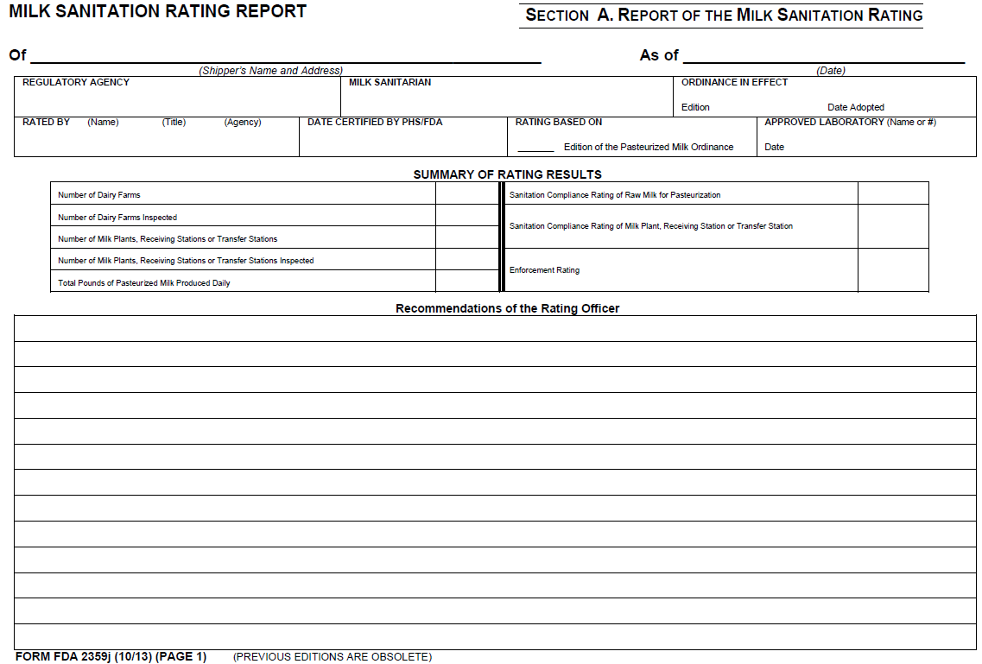
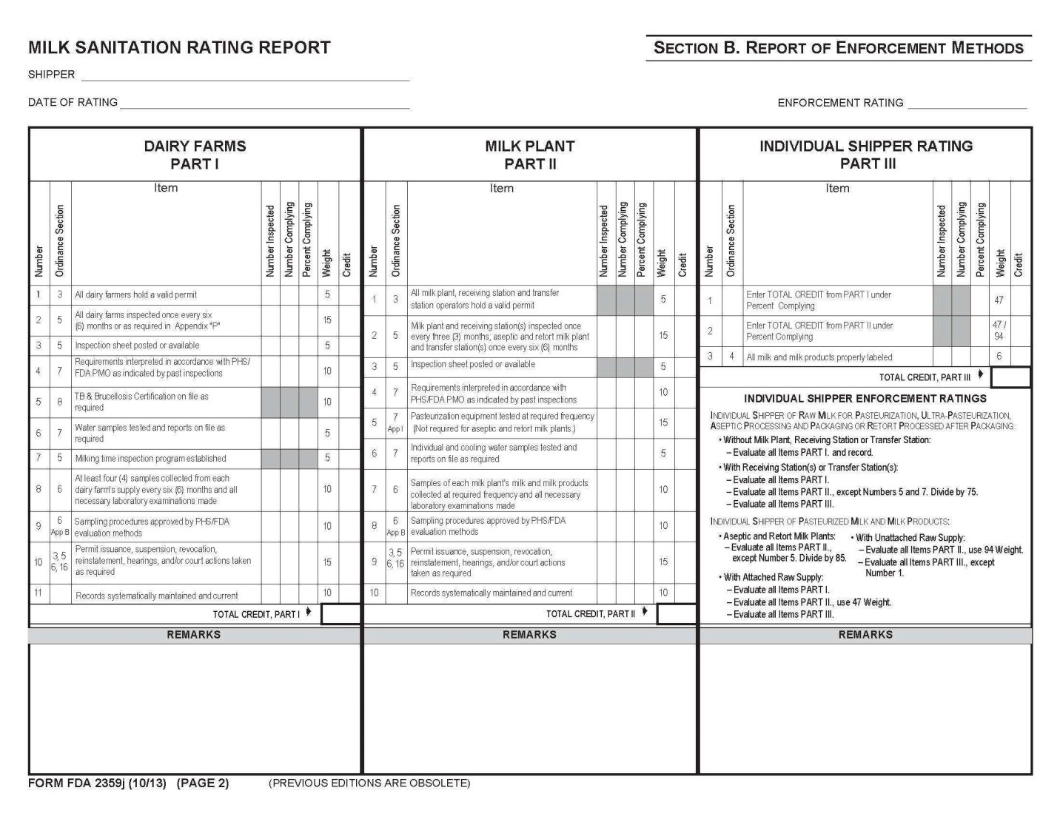
  - FORM FDA 2359j-MILK SANITATION RATING REPORT-SECTION B. REPORT OF ENFORCEMENT METHODS (PAGE 2)
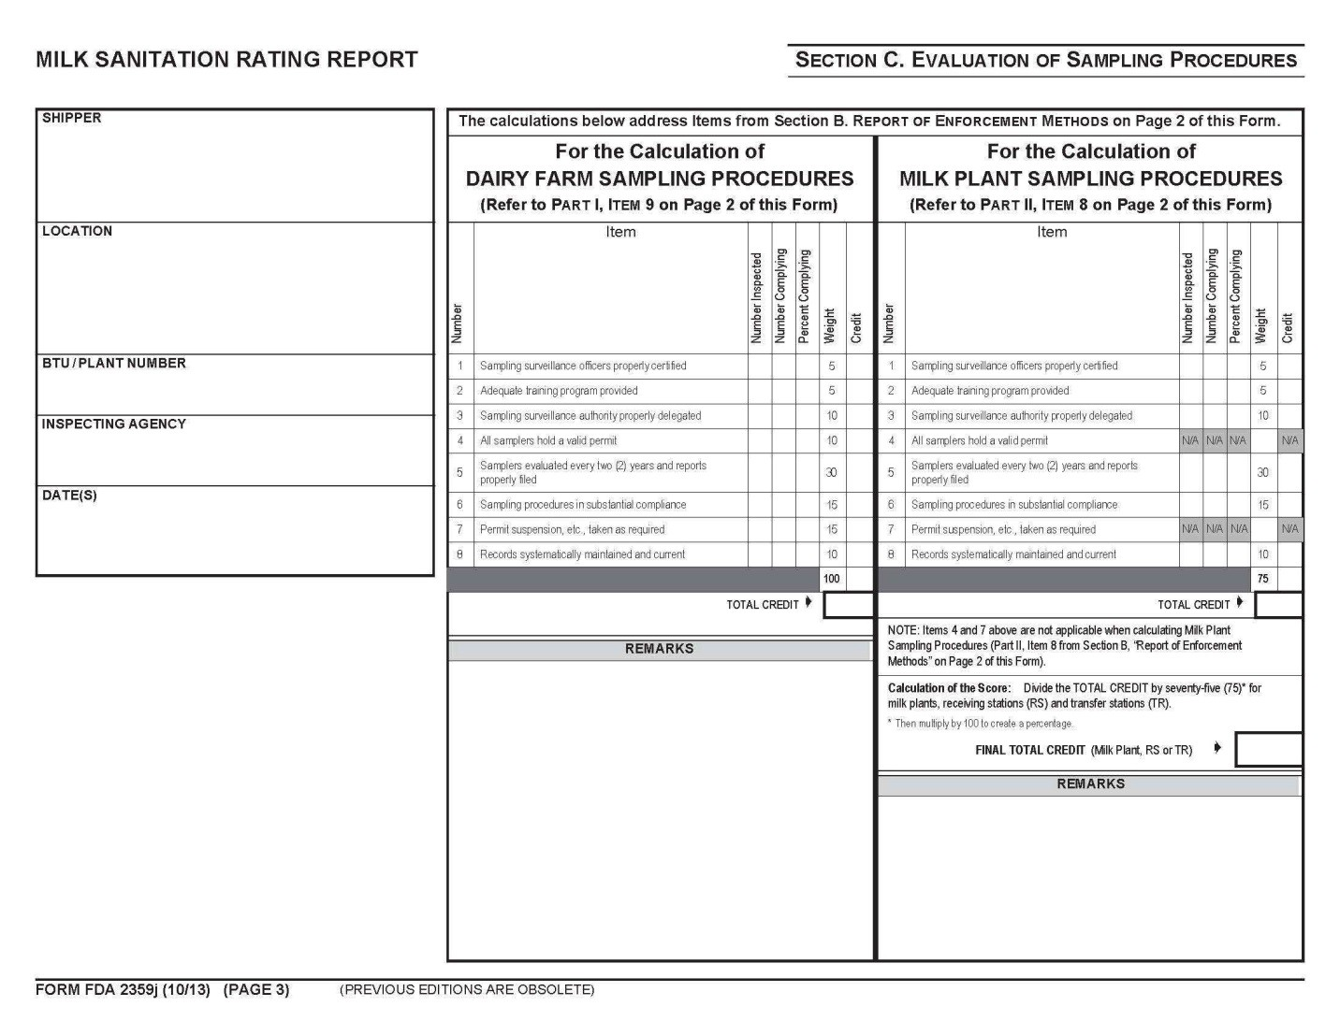
  - FORM FDA 2359j-MILK SANITATION RATING REPORT-SECTION C. EVALUATION OF SAMPLING PROCEDURES (PAGE 3)
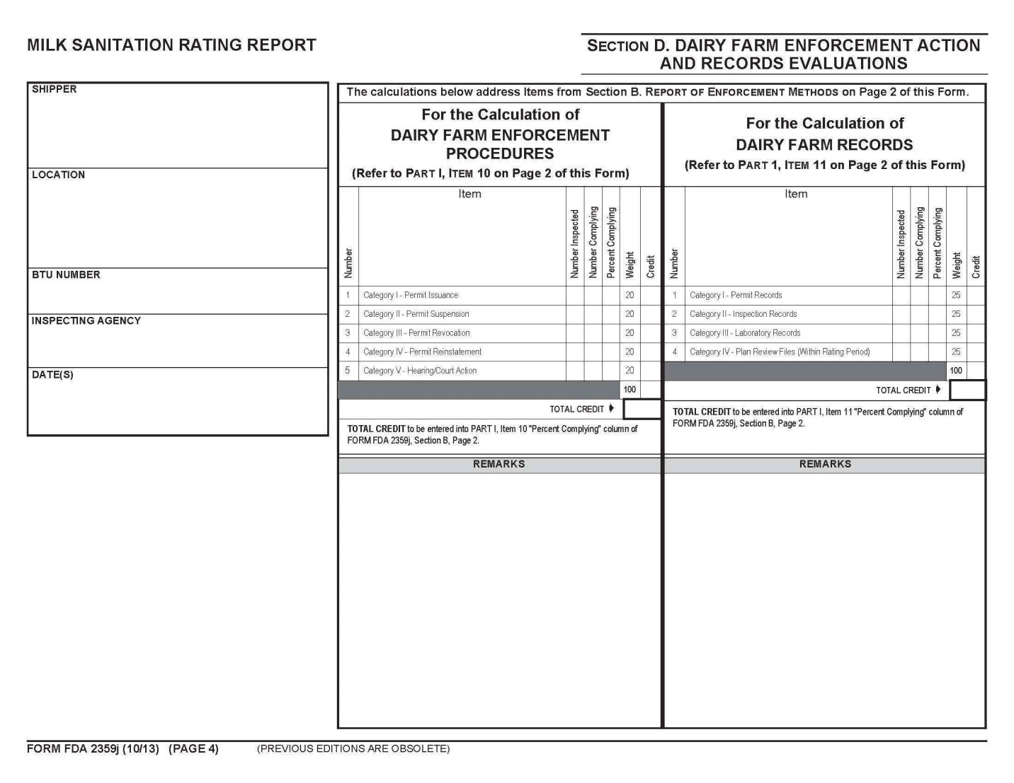
  - FORM FDA 2359j-MILK SANITATION RATING REPORT-SECTION D. DAIRY FARM ENFORCEMENT ACTION AND RECORDS EVALUATIONS (PAGE 4)
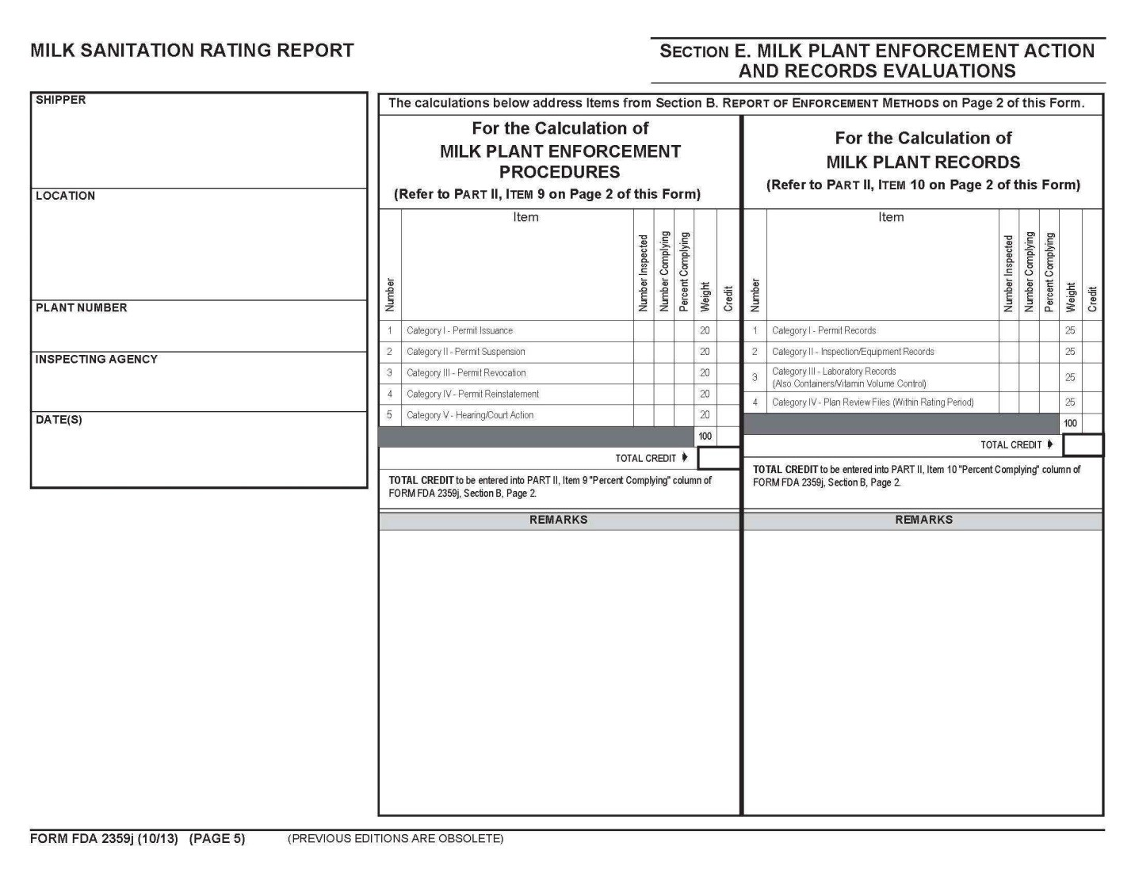
  - FORM FDA 2359j-MILK SANITATION RATING REPORT-SECTION E. MILK PLANT ENFORCEMENT ACTION AND RECORDS EVALUATIONS (PAGE 5)
  - FORM FDA 2359k-STATUS OF RAW MILK FOR PASTEURIZATION, ULTRA-PASTEURIZATION, ASEPTIC PROCESSING AND PACKAGING OR RETORT PROCESSED AFTER PACKAGING

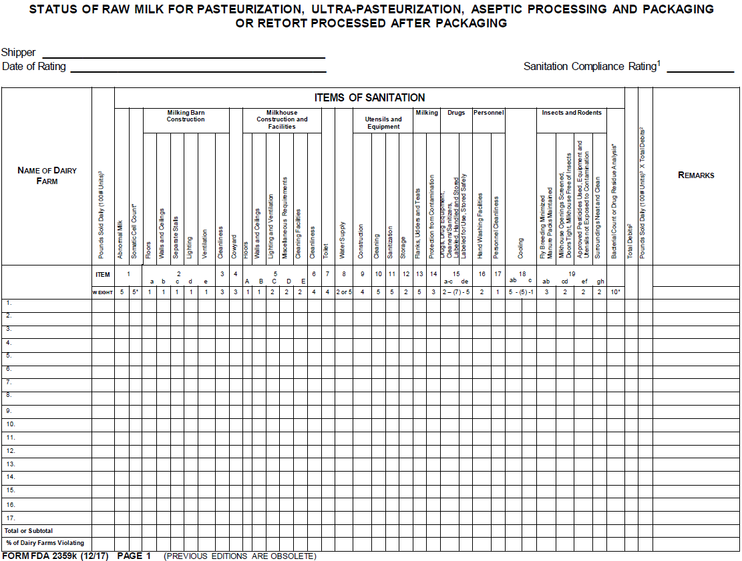

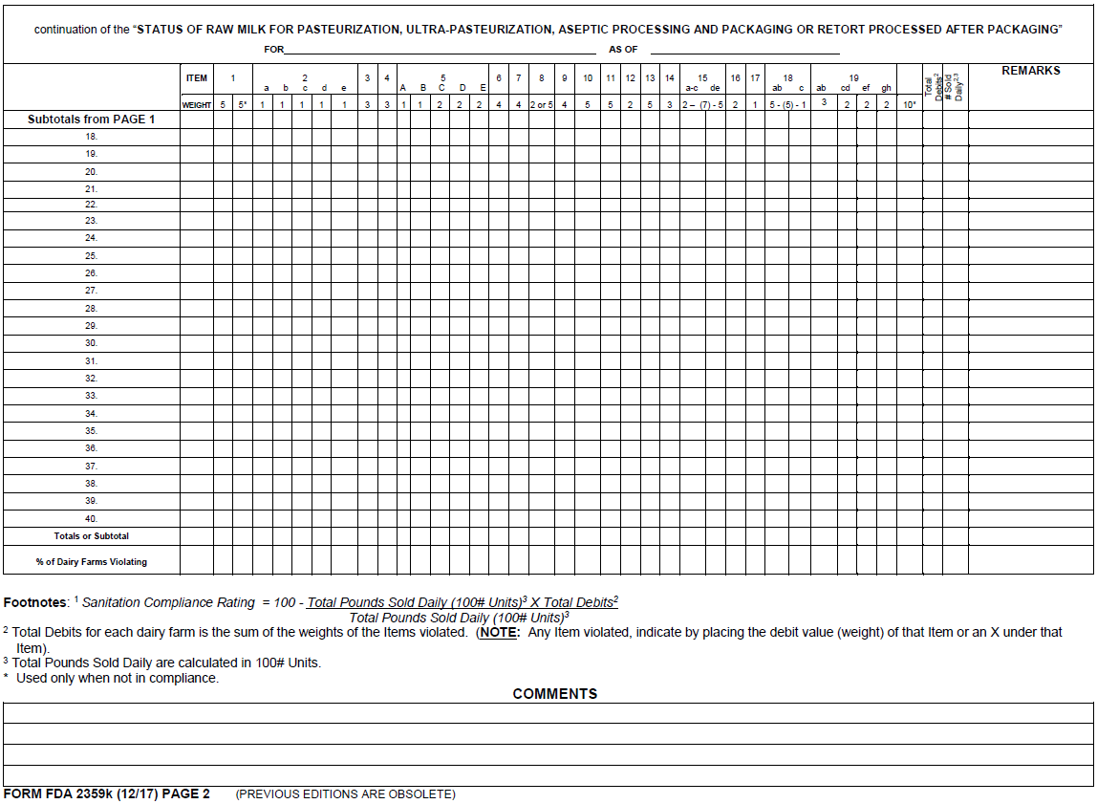
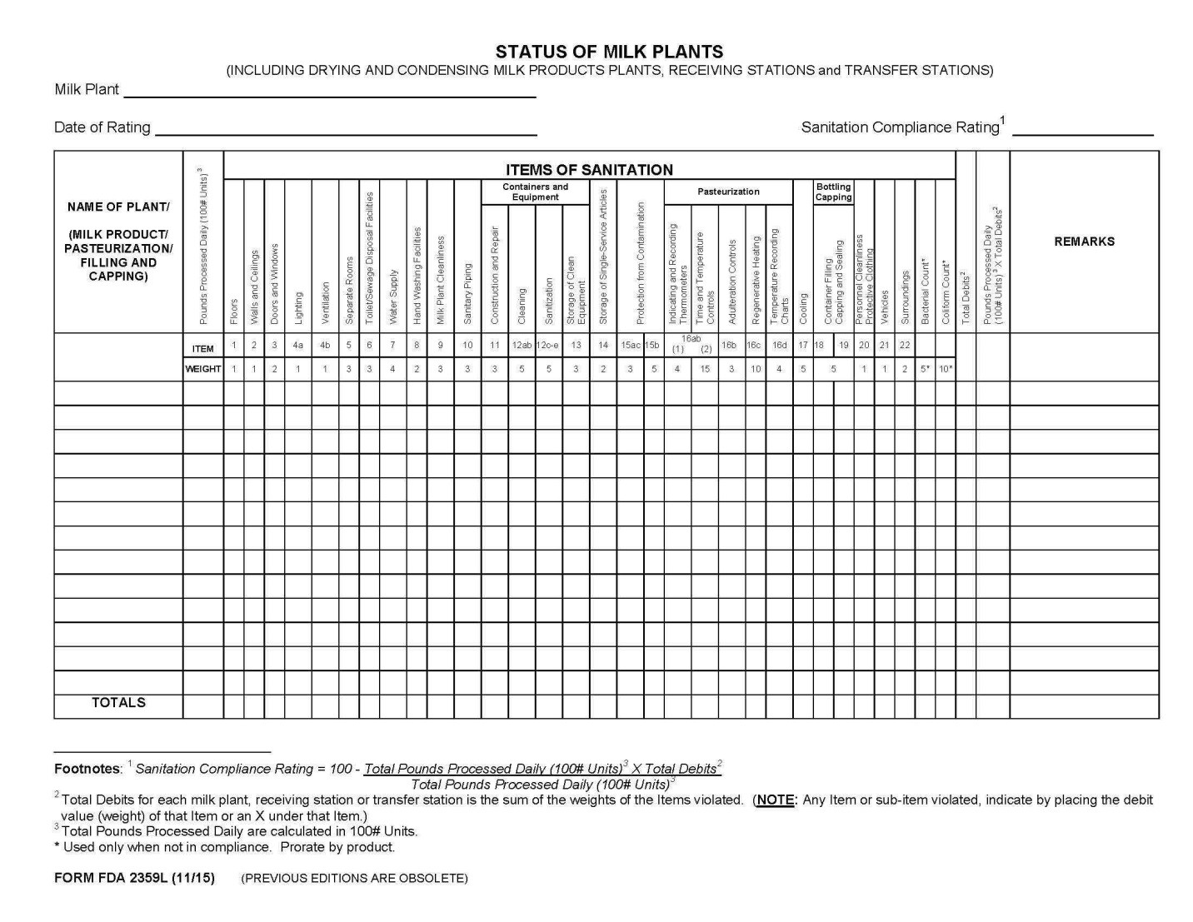
  - FORM FDA 2359L- STATUS OF MILK PLANTS (INCLUDING DRYING AND CONDENSING MILK PRODUCTS PLANTS, RECEIVING STATIONS AND TRANSFER STATIONS)
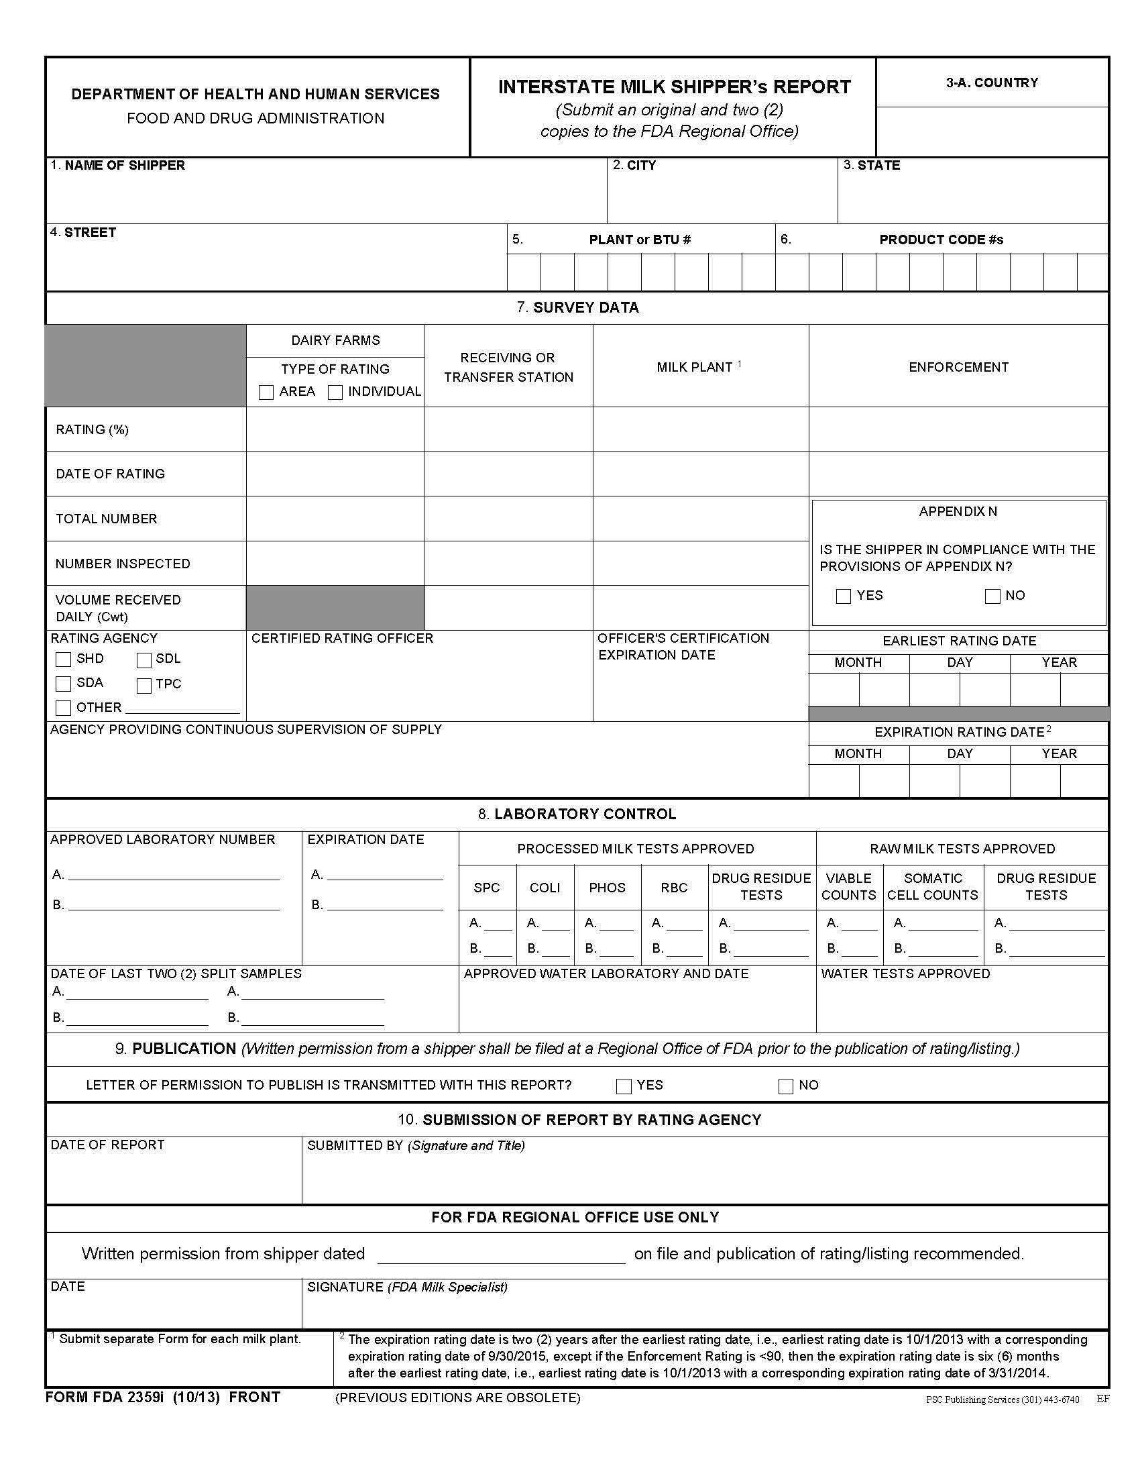
  - FORM FDA 2359i-INTERSTATE MILK SHIPPER’s REPORT
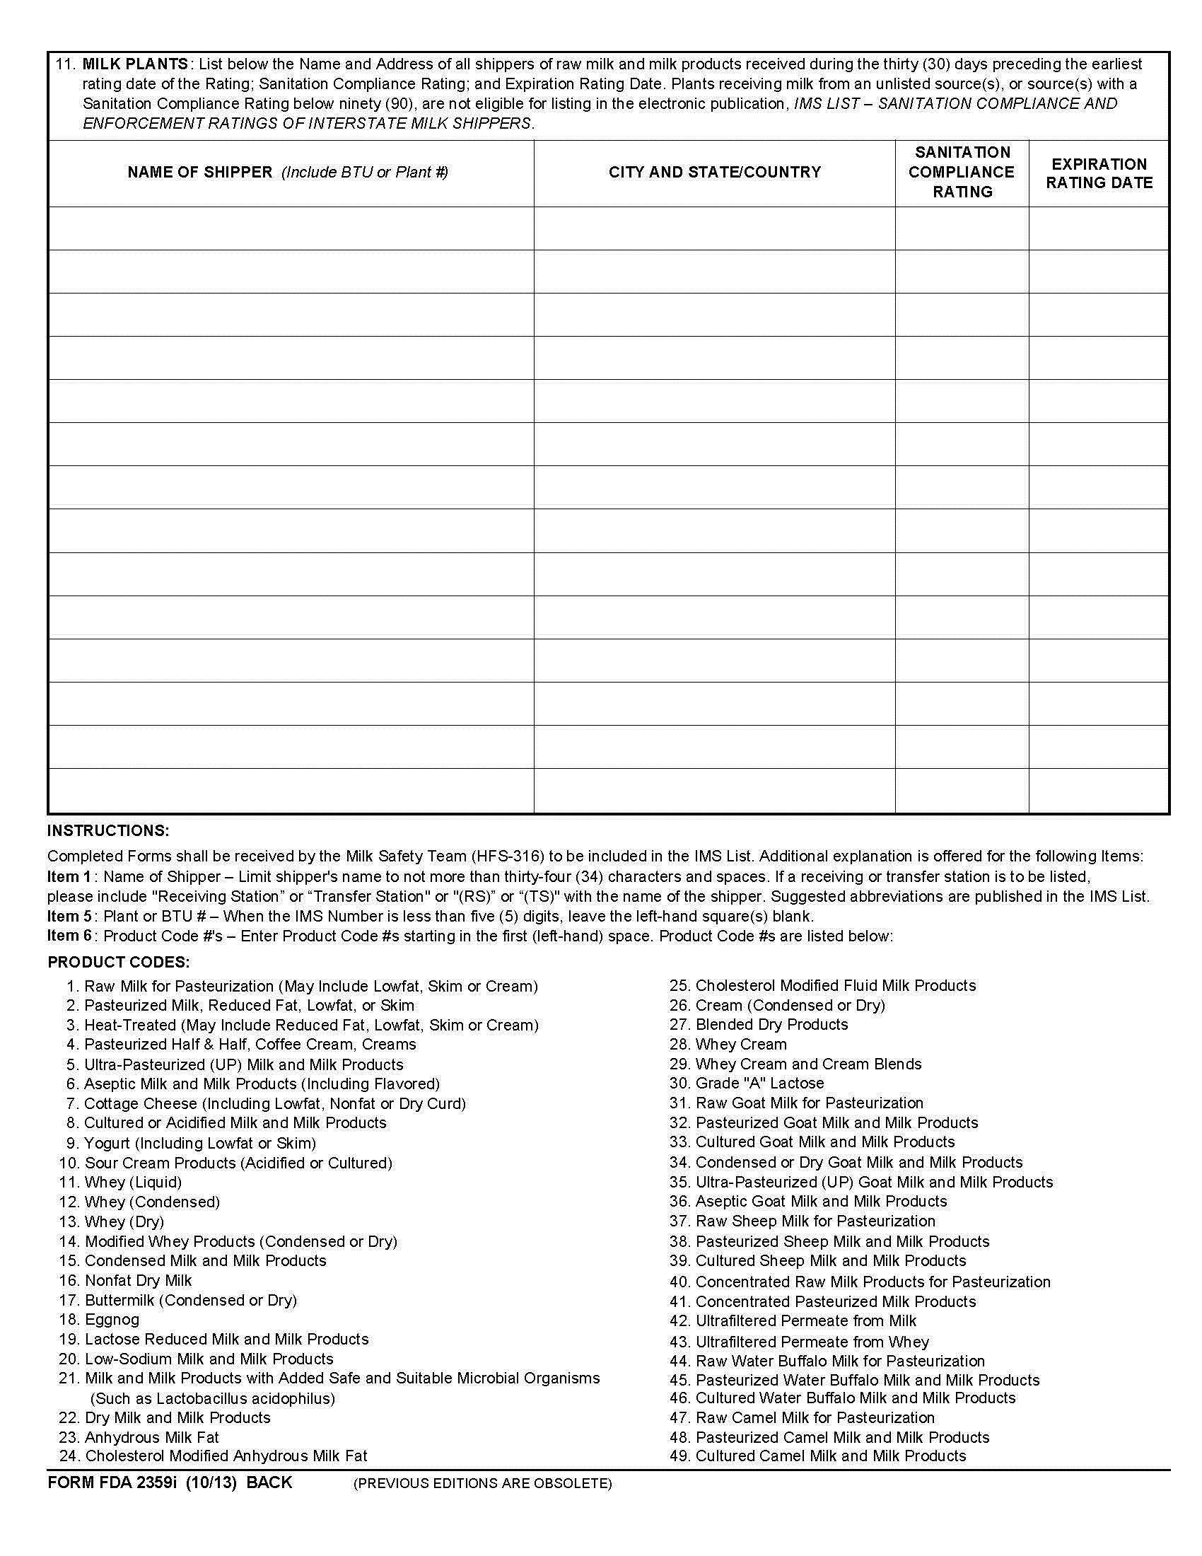
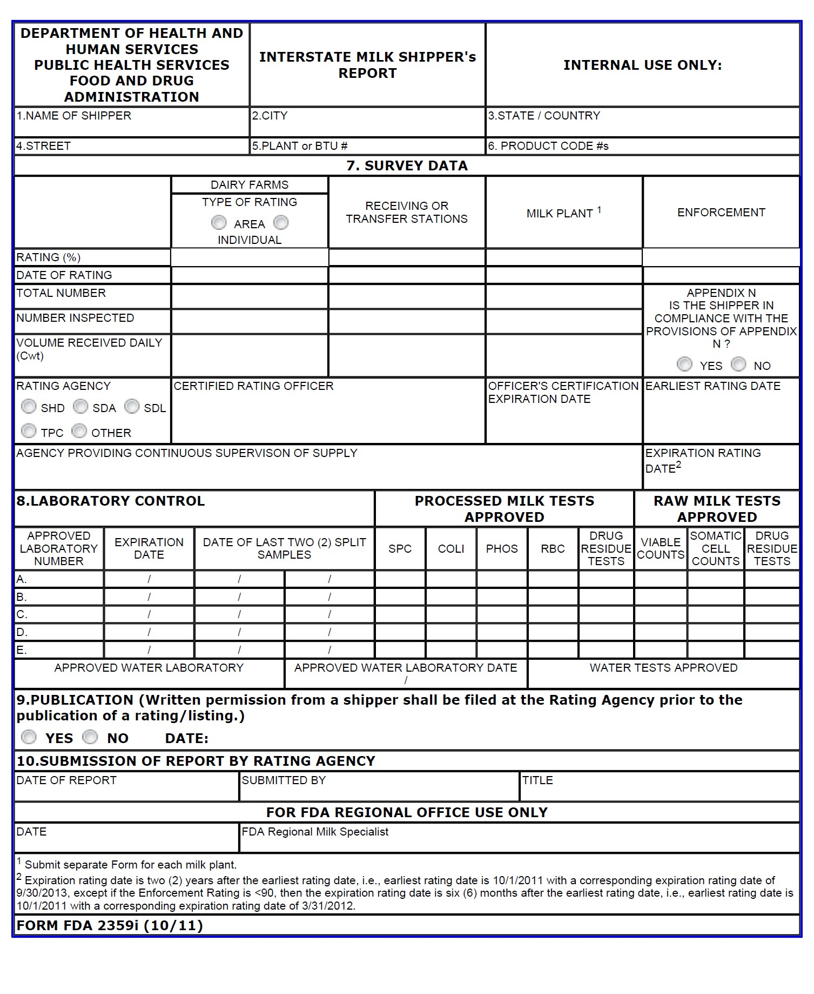
  - FORM FDA 2359i-INTERSTATE MILK SHIPPER’s REPORT (ELECTRONIC SUBMISSION)
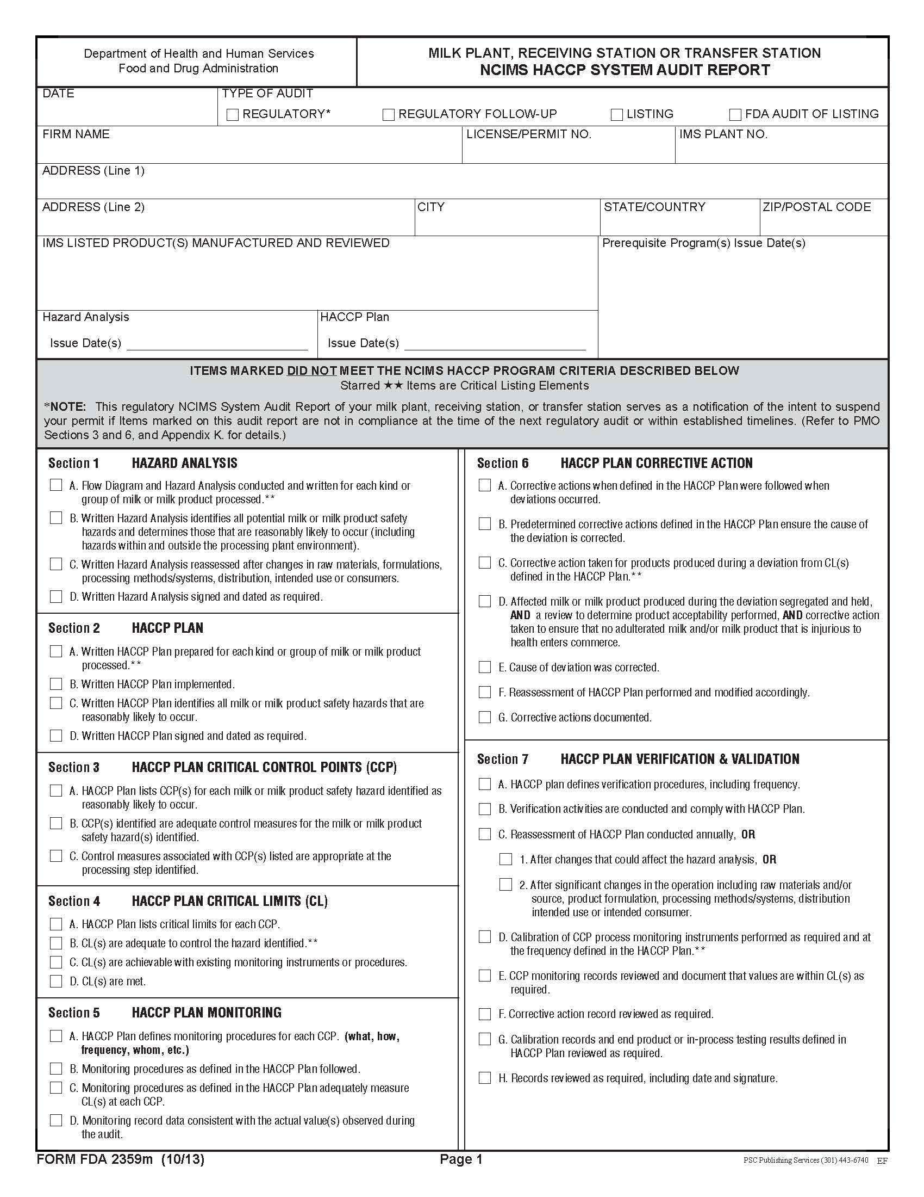
  - FORM FDA 2359m-MILK PLANT, RECEIVING STATION OR TRANSFER STATION NCIMS HACCP SYSTEM AUDIT REPORT
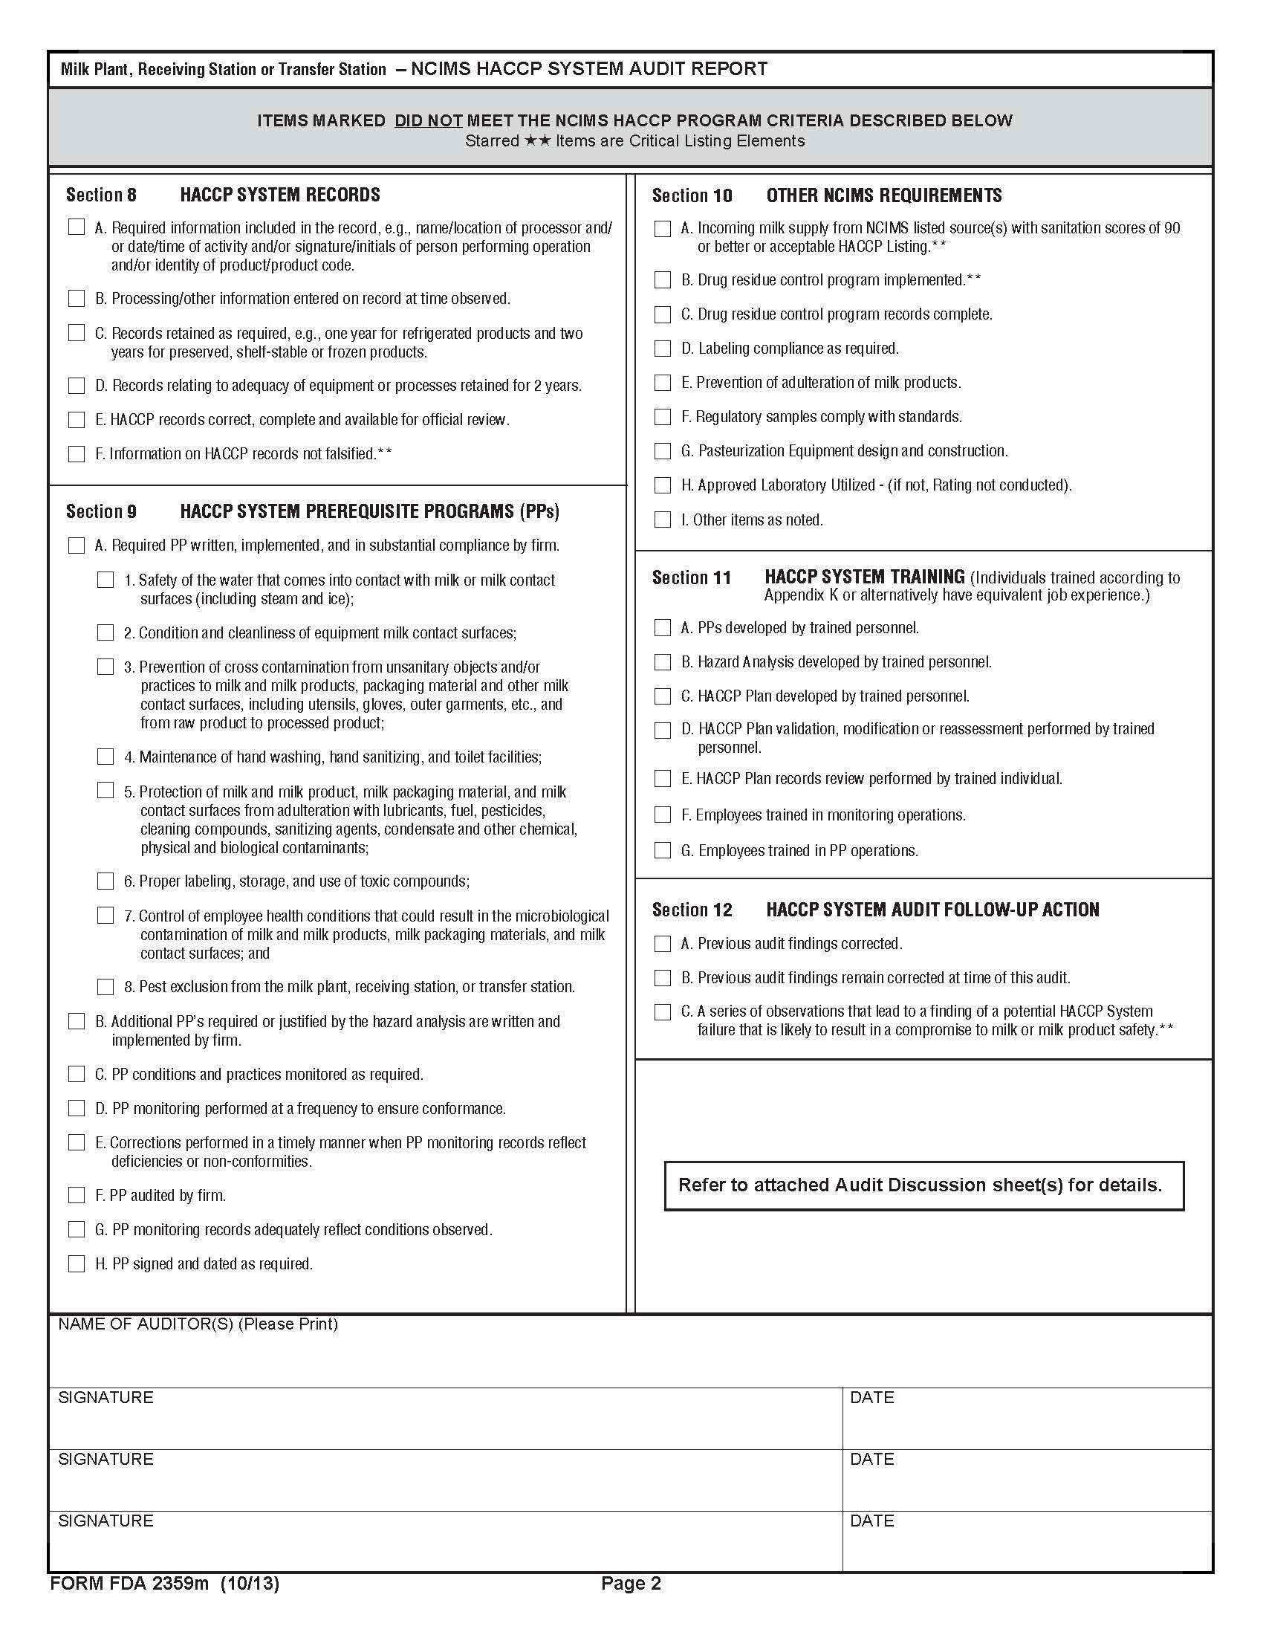
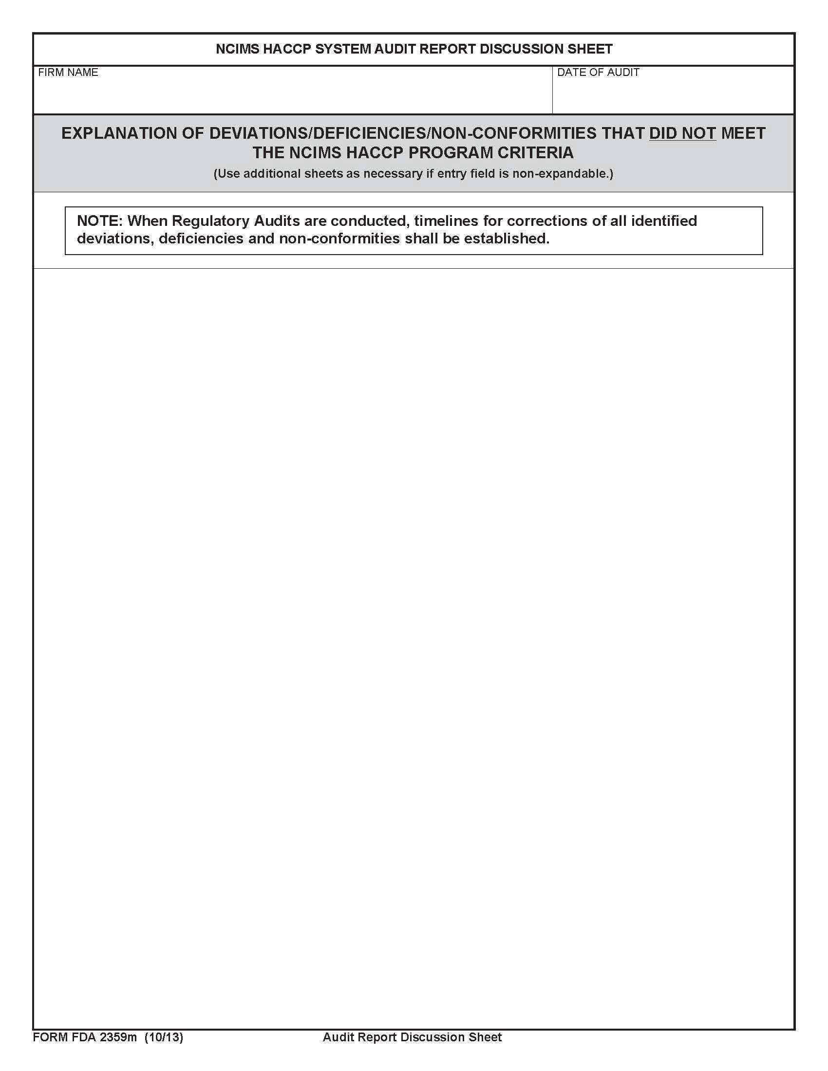
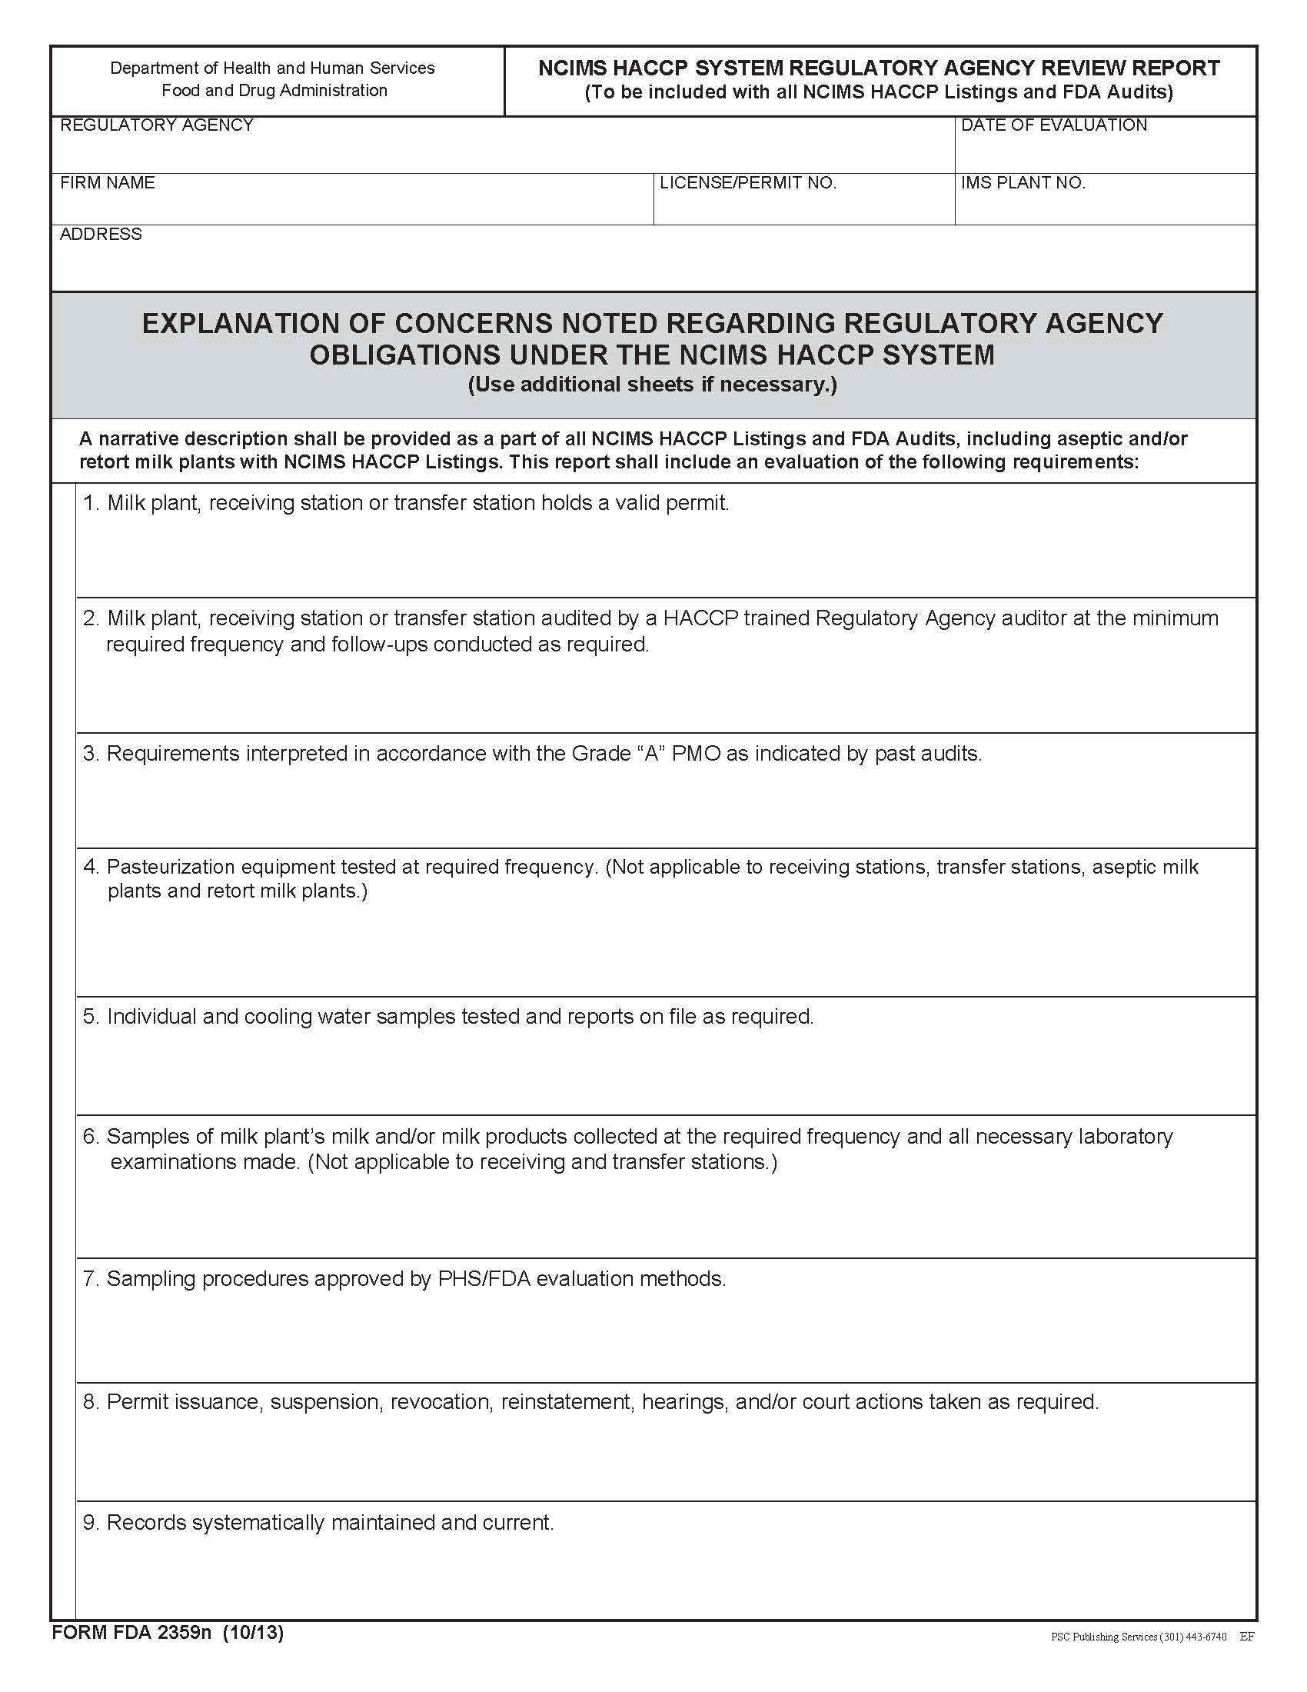
  - FORM FDA 2359n-NCIMS HACCP SYSTEM REGULATORY AGENCY REVIEW REPORT
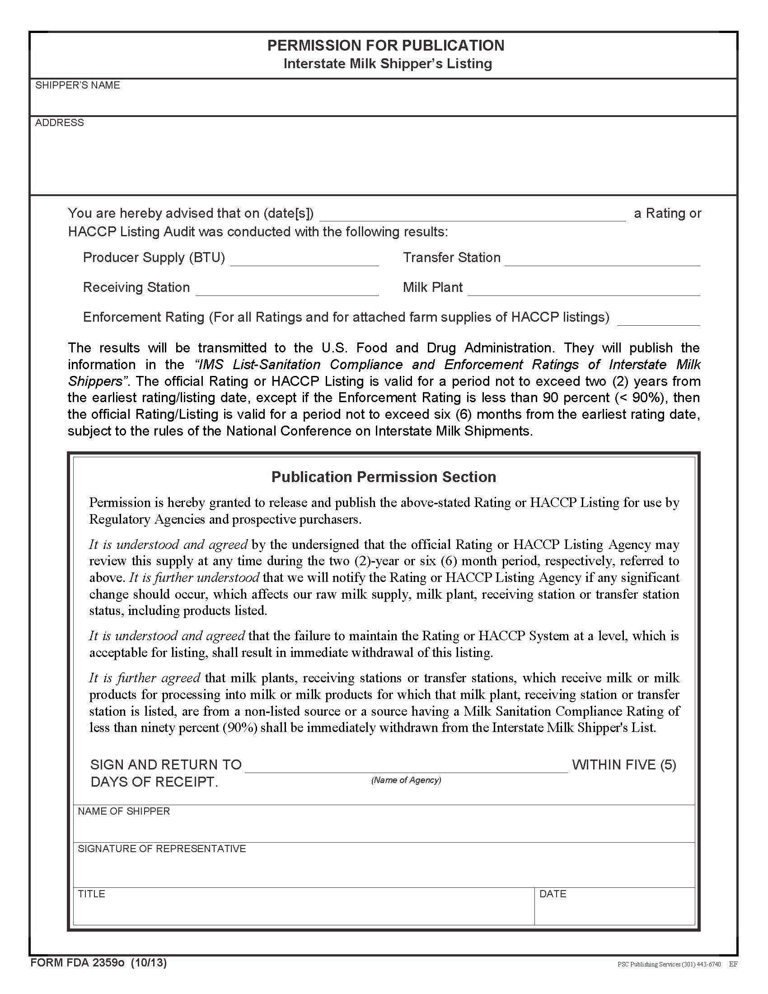
  - FORM FDA 2359o-PERMISSION FOR PUBLICATION- INTERSTATE MILK SHIPPER’s LISTING

