CHAPTER 40C-41
SURFACE WATER MANAGEMENT BASIN CRITERIA
RULE NO.: RULE TITLE:
40C-41.011 Policy and Purpose
40C-41.023 Basin Boundaries
40C-41.043 Application of Chapter
40C-41.051 Exemptions
40C-41.063 Conditions for Issuance of Permits 40C-41.011 Policy and Purpose.
The rules in this chapter establish additional surface water management standards and criteria for the Upper St. Johns River Hydrologic Basin, the Oklawaha River Hydrologic Basin, the Wekiva River Hydrologic Basin, the Wekiva Recharge Protection Basin, the Econlockhatchee River Hydrologic Basin, the Tomoka River Hydrologic Basin, the Spruce Creek Hydrologic Basin, the Sensitive Karst Areas Basin, and the Lake Apopka Hydrologic Basin, which ensure that development within the basins incorporates the appropriate water quantity and water quality control and other environmental measures necessary to protect the integrity of the public investments in the basins and which minimize adverse impacts to the water resources of the District. Standards and criteria delineated in this chapter are in addition to those criteria specified in Chapters 62-330 and 40C-44, F.A.C., in accordance with Rule 40C-41.043, F.A.C. The standards, criteria, exemptions, and additional requirements specified in this chapter are not intended to supersede or rescind the terms and conditions of any valid surface water management permit issued by the District prior to the effective date of this chapter.
Rulemaking Authority 369.318, 373.044, 373.113, 373.171, 373.4131, 373.415 FS. Law Implemented 369.318, 373.413, 373.4131, 373.415, 373.416, 373.418, 373.426, 3473.461 FS. History– New 12-7-83, Amended 5-17-87, 8-30-88, 4-3-91, 9-25-91, 11-25-98, 3-7-03, 12-3-06,_________.

40C-41.023 Basin Boundaries.
(1) The Upper St. Johns River Hydrologic Basin is that area generally depicted in Figure 41-1 and defined in “Environmental Resource Permit Applicant’s Handbook Volume II: For Use Within the Geographic Limits of the St. Johns River Water Management District”, (effective date), Appendix B which is hereby incorporated by reference, available at [http://www.flrules.org/Gateway/reference.asp?No=Ref-02999].
(2) The Oklawaha River Hydrologic Basin is that area generally depicted in Figure 41-1 and defined in “Environmental Resource Permit Applicant’s Handbook Volume II: For Use Within the Geographic Limits of the St. Johns River Water Management District”, Appendix B. (3) The Wekiva River Hydrologic Basin is that area generally depicted in Figures 41-1 and 41-6 and defined in “Environmental Resource Permit Applicant’s Handbook Volume II: For Use Within the Geographic Limits of the St. Johns River Water Management District”, Appendix B.
(4) The Wekiva Recharge Protection Basin is that area generally depicted in Figure 41-6 and defined in “Environmental Resource Permit Applicant’s Handbook Volume II: For Use Within the Geographic Limits of the St. Johns River Water Management District”, Appendix B.
(5) The Econlockhatchee River Hydrologic Basin is that area generally depicted in Figure 41-1 and defined in “Environmental Resource Permit Applicant’s Handbook Volume II: For Use Within the Geographic Limits of the St. Johns River Water Management District”, Appendix B.
Figure 41-1
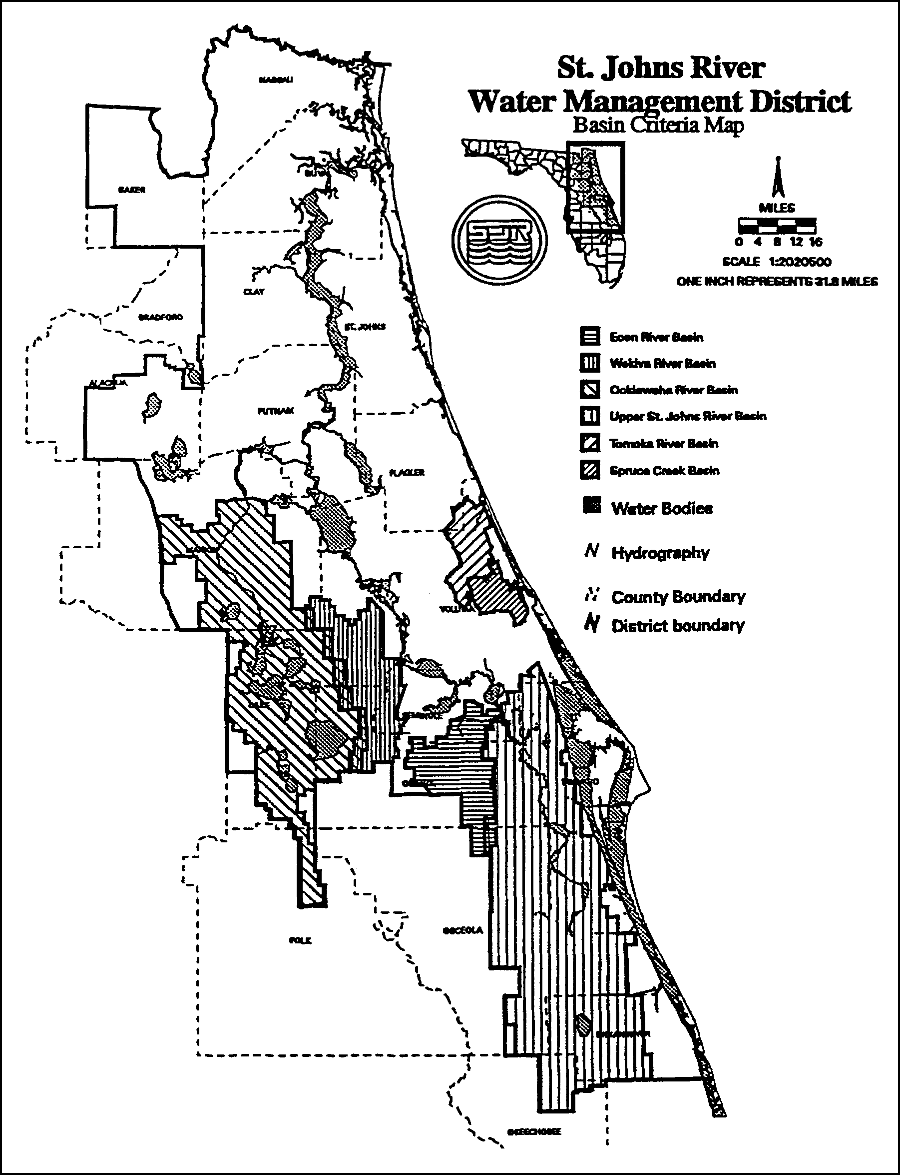
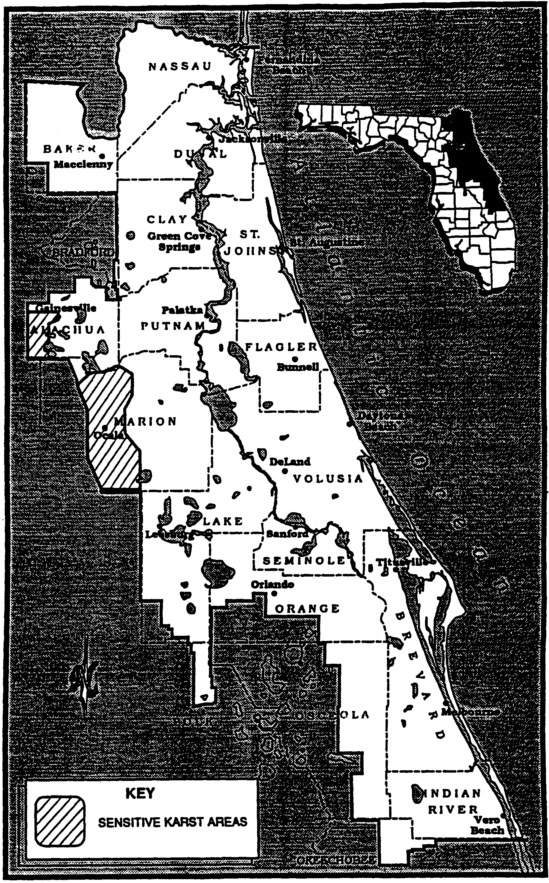
Figure 41-2 Sensitive Karst Areas in the St. Johns River Water Management District
Figure 41-3
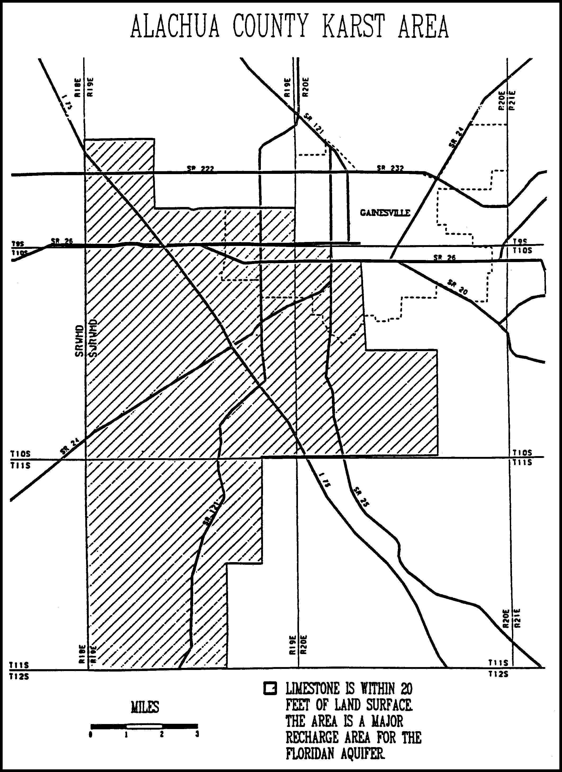

Figure 41-4
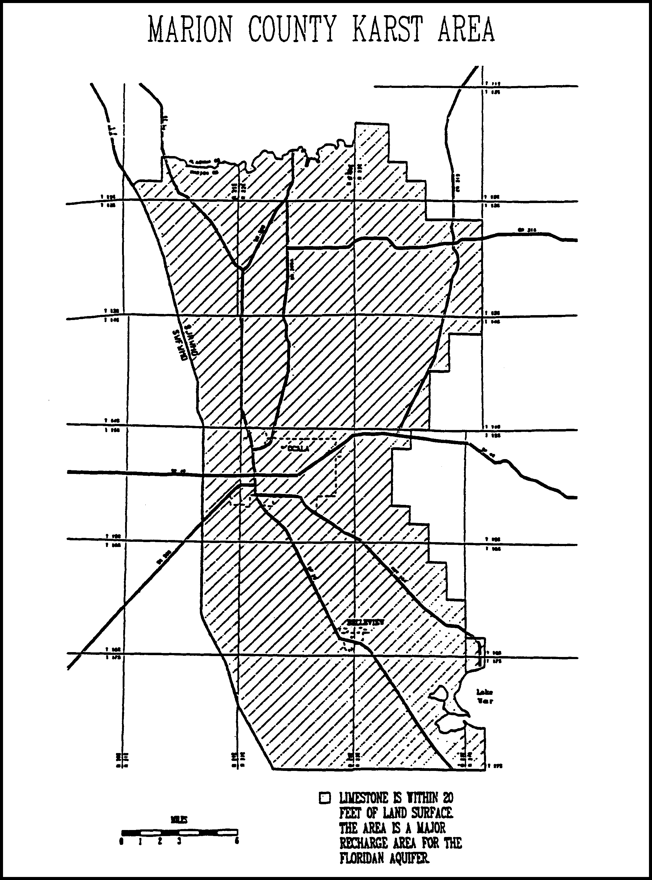

Figure 41-5 Lake Apopka Drainage Basin

Figure 41-6 Wekiva River Hydrologic Basin and Wekiva Recharge Protection Basin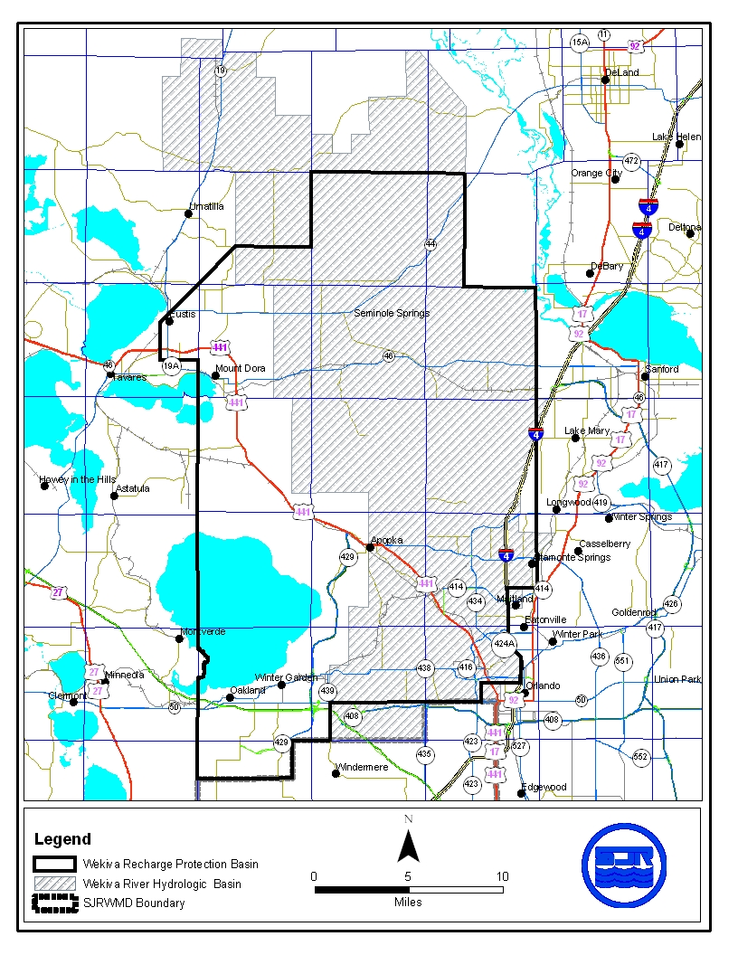

(6) The Tomoka River and Spruce Creek Hydrologic Basins are the areas generally depicted in Figure 41-1 and defined in “Environmental Resource Permit Applicant’s Handbook Volume II: For Use Within the Geographic Limits of the St. Johns River Water Management District”, Appendix B.
(7) The Sensitive Karst Areas Basin is that area generally depicted in Figures 41-2, 41-3, and 41-4 and defined in “Environmental Resource Permit Applicant’s Handbook Volume II: For Use Within the Geographic Limits of the St. Johns River Water Management District”, Appendix B.
(8) The Lake Apopka Hydrologic Basin is that area generally depicted in Figure 41-5 and defined in “Environmental Resource Permit Applicant’s Handbook Volume II: For Use Within the Geographic Limits of the St. Johns River Water Management District”, Appendix B.
This rule will become effective on July 1, 2013, or upon the date that amendments to Chapter 62-330, F.A.C., proposed by the Department of Environmental Protection to implement the statutory mandate in section 373.4131, F.S. (2012), take effect, whichever is later.
Rulemaking Authority 369.318, 373.044, 373.113, 373.171 FS. Law Implemented 369.316, 369.318, 373.413, 373.416, 373.426, 373.461 FS. History–New 12-7-83, Amended 5-17-87, 4-3-91, 9-25-91, 11-25-98, 3-7-03, 12-3-06, .

40C-41.033 Implementation.
The effective date of this chapter is December 7, 1983, for the criteria of subsections 40C-41.063(1) and (2), F.A.C.; December 3, 2006 for the standards and criteria in paragraph 40C-41.063(3)(a), F.A.C.; May 17, 1987, for the standards of paragraphs 40C-41.063(3)(b), F.A.C.; August 30, 1988, for the standards and criteria of paragraphs 40C-41.063(3)(c), (d) and (e), F.A.C.; April 3, 1991, for the standards and criteria in subsection 40C-41.063(5), F.A.C.; September 25, 1991, for the criteria of subsection 40C-41.063(7), F.A.C.; November 25, 1998, for the criteria of subsection 40C-41.063(6), F.A.C.; and March 7, 2003, for the standards and criteria in subsection 40C-41.063(8), F.A.C.
Specific Authority 369.318, 373.044, 373.113, 373.171, 373.415 FS. Law Implemented 369.318, 373.413, 373.415, 373.416, 373.426, 373.461 FS. History–New 12-7-83, Amended 5-17-87, 8-30-88, 4-3-91, 9-25-91, 11-25-98, 3-7-03, 11-11-03, 12-3-06.

40C-41.043 Application of Chapter.
(1) All projects located within the Upper St. Johns River Hydrologic Basin, the Oklawaha River Hydrologic Basin, the Wekiva River Hydrologic Basin, the Wekiva Recharge Protection Basin, the Econlockhatchee River Hydrologic Basin, the Tomoka River Hydrologic Basin, the Spruce Creek Hydrologic Basin, the Sensitive Karst Areas Basin, or the Lake Apopka Hydrologic Basin, requiring permits pursuant to Rule 62-330.020(2)(a), (b), (c), (d), (e), (f), (g), (h), or (j) or section 1.2.2, “Environmental Resource Permit Applicant’s Handbook Volume II: For Use Within the Geographic Limits of the St. Johns River Water Management District” as incorporated by reference in 40C-4.091(1)(a), F.A.C., shall be constructed, operated, maintained, altered, abandoned and removed in accordance with the standards and criteria specified in Rule 40C-41.063, and Rules 62-330.301 and 62-330.302, F.A.C., unless specifically exempted in Rule 40C-41.051, F.A.C., or otherwise provided in subsection 40C-41.043(3) or 40C-41.043(4), F.A.C. The most restrictive criteria will be applicable unless the applicant provides reasonable assurance that the purposes and intent of this chapter and Chapter 62-330, F.A.C., will be fulfilled using alternate criteria.
(2) Stormwater management systems requiring permits pursuant to Rule 62-330.020, F.A.C., that will be located within the Lake Apopka Hydrologic Basin or will discharge water to Lake Apopka or its tributaries, shall be constructed, operated, maintained, altered, abandoned and removed in accordance with the standards and criteria specified in Rules 62-330.301 and 62-330.302, F.A.C., and subsection 40C-41.063(8), F.A.C.
(3) Agricultural surface water management systems requiring permits pursuant to Rule 40C-44.041, F.A.C., that will be located within the Lake Apopka Hydrologic Basin or will discharge water to Lake Apopka or its tributaries, shall be constructed, operated, maintained, altered, abandoned and removed in accordance with the standards and criteria specified in Rule 40C-44.301, F.A.C., and subsection 40C-41.063(8), F.A.C.
(4) Agricultural surface water management systems requiring permits pursuant to Rule 40C-44.041, F.A.C., that will be located within the Wekiva Recharge Protection Basin, shall be constructed, operated, maintained, altered, abandoned and removed in accordance with the standards and criteria specified in Rule 40C-44.301, F.A.C., and paragraph 40C-41.063(3)(a), F.A.C.
(5) The Governing Board hereby incorporates by reference Part VI (sections 13.0-13.8.3), “Basin Criteria” of the document entitled “Environmental Resource Permit Applicant’s Handbook, Volume II: For Use Within the Geographic Limits of the St. Johns River Water Management District”, (effective date), available at [http://www.flrules.org/Gateway/reference.asp?No=Ref-03001], and upon request from the St. Johns River Water Management District, 4049 Reid Street, Palatka Florida 32177-2529.
Rulemaking Authority 369.318, 373.044, 373.113, 373.4131, 373.171, 373.415 FS. Law Implemented 369.318, 373.413, 373.4131, 373.415, 373.416, 373.418, 373.426, 373.461 FS. History– New 12-7-83, Amended 5-17-87, 8-30-88, 4-3-91, 9-25-91, 10-3-95, 11-25-98, 3-7-03, 12-3-06, .

40C-41.051 Exemptions.
(1) The following systems located wholly or partially in the Econlockhatchee River Hydrologic Basin are exempted from the standards and criteria in subsection 40C-41.063(5), F.A.C., and section 13.4, “Environmental Resource Permit Applicant’s Handbook, Volume II: For Use Within the Geographic Limits of the St. Johns River Water Management District”, as incorporated by reference in 40C-41.043(5), F.A.C.:
(a) Each system for which the District has issued a general or individual permit, pursuant to Chapter 40C-4 or 40C-40, F.A.C., prior to April 3, 1991. The benefit conferred by this subsection shall apply only to the project area and the plan, as approved in the referenced permit.
(b) Each system for which the District has issued a permit pursuant to Chapter 40C-42, F.A.C., prior to September 1, 1990, and for which construction has begun prior to March 1, 1991, pursuant to the referenced permit. The benefit conferred by this subsection shall apply only to a system which did not require a permit pursuant to Chapter 40C-4 or 40C-40, F.A.C., prior to April 3, 1991 and only to the project area and the plan, as approved in the referenced permit.
(c) Each system for which the District has issued a permit pursuant to Chapter 40C-4 or 40C-40, F.A.C., prior to September 1, 1989, authorizing construction of a master system for drainage and flood control. The benefit conferred by this subsection shall apply only to the project area served by the master system and to the plan, as approved in the referenced permit.
(d) Each system for which the District has issued, pursuant to Chapter 40C-4, F.A.C., and prior to September 1, 1989, both a conceptual approval permit and at least one permit authorizing construction consistent with the conceptual approval permit. The benefit conferred by this subsection shall apply only to the project area and plan approved in the referenced conceptual approval permit.
(e) Each system which consists of an improvement to an existing public road which will be constructed by a governmental entity provided the governmental entity:
1. Has monetary funds fully allocated or appropriated for that system; and
2. Has filed an eminent domain action in an appropriate court, as of June 1, 1991, seeking to condemn land wholly or partially located within the Econlockhatchee River Hydrologic Basin to be used for the construction of the system; and
3. Has a construction design for such system which is 90% complete as of April 3, 1991; and
4. Files a conceptual approval, general or individual permit application with the District for such system on or before June 1, 1991, which application is not subsequently withdrawn and which contains the factual information necessary to establish that the system meets the conditions contained in this subsection.
(f) A permitholder for a system which meets the conditions described in paragraphs (a)-(d), who has complied with all permit conditions regarding the system, and who asserts that the system can qualify for an exemption under this section shall notify the District in writing prior to June 1, 1991. The notification shall contain the name of the project, the District permit number(s) for the project, all factual information necessary to establish that the system meets the referenced conditions and permit conditions, and a clear statement that an exemption pursuant to this section is sought. The failure to timely and fully notify the District serves as a waiver of the benefits conferred by this section. When the District receives the permitholder’s notification, the District staff will review the submitted information for consistency with the provisions of this section and will inspect the permitted project for compliance with permit conditions. If the notification meets the requirements of this section and the permitholder has complied with all of the permit conditions, the staff will respond in writing to the permitholder confirming that they have qualified for the benefits conferred by this section. If the staff finds that the notification fails to meet the requirements of this section or that any of the permit conditions have not been complied with, the staff will respond in writing to the permitholder, notifying them that they have not qualified for the benefits conferred by this section.
(2) A single family dwelling unit located wholly or partially within the Tomoka River Hydrologic Basin or the Spruce Creek Hydrologic Basin, provided the unit is not part of a larger common plan of development or sale, is exempted from the standards and criteria in subsection 40C-41.063(6), F.A.C., and section 13.5, “Environmental Resource Permit Applicant’s Handbook, Volume II: For Use Within the Geographic Limits of the St. Johns River Water Management District”, as incorporated by reference in 40C-41.043(5), F.A.C.
(3) Stormwater management systems exempted in Rule 62-330.051, F.A.C., which are either located wholly or partially within the Lake Apopka Hydrologic Basin or which discharge water to Lake Apopka or its tributaries, are exempted from the standards and criteria in subsection 40C-41.063(8), F.A.C.
(4) Systems that qualify for a general permit under Part IV of Chapter 62-330, F.A.C., are exempted from the standards and criteria in Rule 40C-41.063, F.A.C., and Sections 13.0 – 13.7, “Environmental Resource Permit Applicant’s Handbook, Volume II: For Use Within the Geographic Limits of the St. Johns River Water Management District”, as incorporated by reference in 40C-41.043(5), F.A.C.
Rulemaking Authority 373.044, 373.113, 373.171, 373.4131 FS. Law Implemented 373.413,373.4131, 373.416, 373.426, 373.461 FS. History–New 4-3-91, Amended 11-25-98, 3-7-03, .

40C-41.063 Conditions for Issuance of Permits.
(1) Within the Upper St. Johns River Hydrologic Basin the following criteria are established:
(a) Storm Frequency – For purposes of design and evaluation of system performance, both the 10 year and the 25 year design storm frequencies must be met.
(b) Runoff Volume – For design purposes, those systems utilizing pumped discharge, the total post-development discharge runoff volumes shall not exceed pre-development discharge runoff volumes for the four-day period beginning the third day of the four-day design storm event.
(c) Interbasin Diversion –
1. A system may not result in an increase in the amount of water being diverted from the Upper St. Johns River Hydrologic Basin into coastal receiving waters.
2. It is an objective of the District to, where practical, curtail diversions of water from the Upper St. Johns River Hydrologic Basin into coastal receiving waters.
(2) Within the Oklawaha River Hydrologic Basin the following criteria are established:
(a) Storm Frequency – For purposes of design and evaluation of system performance, both the 10 year and the 25 year design storm frequencies must be met.
(b) Runoff Volume – For design purposes, those systems utilizing pumped discharges, the total post-development discharge runoff volumes shall not exceed pre-development discharge runoff volumes for the four-day period beginning the third day of the four-day design storm event.
(3) Within the Wekiva River Hydrologic Basin or the Wekiva Recharge Protection Basin, the following standards and criteria are established:
(a) Recharge Standard – Applicants required to obtain a permit pursuant to Chapter 62-330 or 40C-44, F.A.C., for a surface water management system located within the Wekiva Recharge Protection Basin shall demonstrate that the system provides for retention storage of three inches of runoff from all impervious areas proposed to be constructed on soils defined as Type “A” Soils as defined by the Natural Resources Conservation Service (NRCS) Soil Survey in the following NRCS publications: Soil Survey of Lake County Area, Florida (1975); Soil Survey of Orange County Area, Florida (1989) and Soil Survey of Seminole County Area, Florida (1990), which are incorporated by reference in paragraph 40C-4.091(3)(a), F.A.C. For purposes of this rule, areas with Type “A” Soils shall be considered “Most Effective Recharge Areas.” Section 13.8.1 “Environmental Resource Permit Applicant’s Handbook, Volume II: For Use Within the Geographic Limits of the St. Johns River Water Management District”, as incorporated by reference in 40C-41.043(5), F.A.C., contains a list of Type “A” soils. The system shall be capable of infiltrating this storage volume through natural percolation into the surrounding soils within 72 hours. Off-site areas or regional systems may be utilized to satisfy this requirement. As an alternative, applicants may demonstrate that the post-development recharge capacity is equal to or greater than the pre-development recharge capacity. Pre-development recharge shall be based upon the land uses in place as of 12-3-06. Applicants may utilize existing permitted municipal master stormwater systems, in lieu of onsite retention, to demonstrate that post-development recharge is equal to or greater than pre-development recharge. Also, applicants may submit additional geotechnical information to establish whether or not a site contains Type “A” soils.
(b) Storage Standard – Within the Wekiva River Hydrologic Basin, a system may not cause a net reduction in flood storage within the 100 year floodplain of a stream or other water course which has a drainage area of more than one square mile and which has a direct hydrologic connection to Little Wekiva River, Wekiva River, or Black Water Creek.
(c) Standards for Erosion and Sediment Control and Water Quality – Within the Wekiva River Hydrologic Basin, a Water Quality Protection Zone shall extend one half mile from the Wekiva River, Little Wekiva River north of State Road 436, Black Water Creek, Rock Springs Run, Seminole Creek, and Sulphur Run, and shall also extend one quarter mile from any wetland abutting an Outstanding Florida Water.
1. An erosion and sediment control plan must be submitted as part of the surface water management permit application for a surface water management system which:
a. Serves a project which is located wholly or partially within this zone; or
b. Serves a project with a total land area equal to or exceeding 120 acres.
2. The applicant proposing such a system must give reasonable assurance in the erosion and sediment control plan that during construction or alteration of the system (including revegetation and stabilization), erosion will be minimized and sediment will be retained on-site. The plan must be in conformance with the erosion and sediment control principles set forth in Section 13.8.2, “Environmental Resource Permit Applicant’s Handbook, Volume II: For Use Within the Geographic Limits of the St. Johns River Water Management District”, as incorporated by reference in 40C-41.043(5), F.A.C., and must contain the information set forth in Section 13.8.3, “Environmental Resource Permit Applicant’s Handbook, Volume II: For Use Within the Geographic Limits of the St. Johns River Water Management District”, as incorporated by reference in 40C-41.043(5), F.A.C..
3. For a project which will be located wholly or partially within 100 feet of an Outstanding Florida Water or within 100 feet of any wetland abutting such a water, an applicant must provide reasonable assurance that the construction or alteration of the system will not cause sedimentation within these wetlands or waters and that filtration of runoff will occur prior to discharge into these wetlands and waters. It is presumed that this standard will be met if, in addition to implementation of the plan required in subparagraph 1., any one of the following criteria is met:
a. A minimum 100 foot width of undisturbed vegetation must be retained landward of the Outstanding Florida Water or the abutting wetland, whichever is more landward. During construction or alteration, runoff (including turbid discharges from dewatering activities) must be allowed to sheetflow across this undisturbed vegetation as the natural topography allows. Concentrated or channelized runoff from construction or alteration areas must be dispersed before flowing across this undisturbed vegetation. Construction or alteration of limited scope necessary for outfall structures may occur within this area of undisturbed vegetation.
b. Construction of the following perimeter controls at all outfall points to the Outstanding Florida Water or its abutting wetlands must be completed prior to the start of any construction or alteration of the remainder of the system:
i. Stormwater discharge facility meeting the requirements of “Environmental Resource Permit Applicant’s Handbook, Volume II: For Use Within the Geographic Limits of the St. Johns River Water Management District” as incorporated by reference in rules 40C-4.091(1)(a), and 40C-42.091(1), F.A.C.
ii. Sedimentation trap or basic located immediately upstream of the stormwater discharge facility referred to above; and
iii. Spreader swale to reduce the velocity of discharge from the stormwater facility to non-erosive rates before discharge to wetlands abutting the Outstanding Florida Water.
These perimeter controls must be maintained routinely and operated throughout construction or alteration of the entire system. A minimum 25 foot width of undisturbed vegetation must be retained landward of the Outstanding Florida Water or the abutting wetland, whichever is more landward. Construction or alteration of limited scope necessary for outfall structures may occur within this area of undisturbed vegetation.
c. During construction or alteration, no direct discharge to the Outstanding Florida Water or its abutting wetland may occur during the 10 year 24 hour storm event or due to discharge from dewatering activities. Any on-site storage required to satisfy this criteria must be available (recovered) within 14 days following the rainfall event. A minimum 25 foot width of undisturbed vegetation must be retained landward of the Outstanding Florida Water or the abutting wetland, whichever is more landward. Construction or alteration of limited scope necessary for outfall structures may occur within this area of undisturbed vegetation.
In determining whether construction or alteration is of “limited scope necessary”, pursuant to any of the three presumptive criteria above, the District shall require that the area of disturbance be minimized and that the length of time between initial disturbance and stabilization of the area also be minimized.
(d) Standard for Limiting Drawdown – Within the Wekiva River Hydrologic Basin, a Water Quantity Protection Zone shall extend 300 feet landward of the landward extent of Black Water Swamp and the wetlands abutting the Wekiva River, Little Wekiva River, Rock Springs Run, Black Water Creek, Sulphur Run, Seminole Creek, Lake Norris, and Lake Dorr. As part of providing reasonable assurance that the standard set forth in paragraph 62-330.301(1)(d), F.A.C., is met, where any part of a system located within this zone will cause a drawdown, the applicant must provide reasonable assurance that construction, alteration, operation, or maintenance of the system will not cause ground water table drawdowns which would adversely affect the functions provided by the referenced wetlands.
The applicant shall provide an analysis which includes a determination of the magnitude and areal extent of any drawdowns, based on site specific hydrogeologic data collected by the applicant, as well as a description of the referenced wetlands, the functions provided by these wetlands, and the predicted impacts to these functions.
It is presumed that the part of this standard regarding drawdown effects will be met if the following criteria is met:
A ground water table drawdown must not occur within the Water Quantity Protection Zone.
(e) Standard for Riparian Wildlife Habitat Within the Wekiva River Hydrologic Basin.
1. The applicant must provide reasonable assurance that the construction or alteration of a system will not adversely affect the abundance, food sources, or habitat (including its use to satisfy nesting, breeding and resting needs) of aquatic or wetland dependent species provided by the following designated Riparian Habitat Protection Zone:
a. The wetlands abutting the Wekiva River, Little Wekiva River downstream of Maitland Boulevard, Rock Springs Run, Black Water Creek, Sulphur Run, or Seminole Creek;
b. The uplands which are within 50 feet landward of the landward extent of the wetlands above.
c. The uplands which are within 550 feet landward of the stream’s edge as defined, for the purpose of this subsection, as the waterward extent of the forested wetlands abutting the Wekiva River, Little Wekiva River downstream of the northernmost crossing of the Little Wekiva River with S.R. 434, Rock Springs Run, Black Water Creek, Sulphur Run or Seminole Creek. In the absence of forested wetlands abutting these streams, the stream’s edge shall be defined, for the purpose of this subsection, as the mean annual surface water elevation of the stream; however, if hydrologic records are unavailable, the landward extent of the herbaceous emergent wetland vegetation growing in these streams shall be considered to be the stream’s edge.
2. Any of the following activities within the Riparian Habitat Protection Zone is presumed to adversely affect the abundance, food sources, or habitat of aquatic or wetland dependent species provided by the zone: construction of buildings, golf courses, impoundments, roads, canals, ditches, swales, and any land clearing which results in the creation of any system. (Activities not listed above do not receive a presumption of no adverse effect.)
3. The presumption in subparagraph 2. shall not apply to any activity which promotes a more endemic state, where the land in the zone has been changed by man. An example of such an activity would be construction undertaken to return lands managed for agriculture or silviculture to a vegetative community that is more compatible with the endemic land cover.
(4) Local Government Notification for Wekiva River Protection Area – The District shall not issue a conceptual approval, individual, standard, or general permit for a proposed surface water management system located wholly or partially within the Wekiva River Protection Area, as defined in Section 369.303(9), F.S., until the appropriate local government has provided written notification that the proposed activity is consistent with the local comprehensive plan and is in compliance with any land development regulation in effect in the area where the development will take place. The applicant proposing such a system must submit to the District form no. 40C-41.063(4), entitled “Local Government Notification” (insert effective date), after it has been completed and executed by the local government. This form is hereby incorporated by reference and is available at [http://www.flrules.org/Gateway/reference.asp?No=Ref-02657] and upon request from the St. Johns River Water Management District, 4049 Reid Street, Palatka, Florida 32177-2529. Permit applications for systems within the Wekiva River Protection Area shall be processed by the District staff pursuant to the time frames established in Section 120.60, F.S., and any District rule regarding permit processing, except that any agency action to approve or approve with conditions shall not occur until the Local Government Notification has been received by the District.
(5) Within the Econlockhatchee River Hydrologic Basin the following standards and criteria are established:
(a) Design Storm Criteria. A system must meet the peak discharge requirement for the following 24 hour duration design storm events:
1. Mean annual storm (2.3 year return period).
2. 25-year return period. System outlet control structures can be designed to meet the control peak discharge rates for both design storms by use of a two-stage weir, v-notch weir, multiple orifices, or other similar structures.
(b) Floodplain Storage Criteria. A system may not cause a net reduction in flood storage within the 100 year floodplain of the Econlockhatchee River or any of its tributaries, at a location with an upstream drainage area of 1 square mile or greater, except for structures elevated on pilings or traversing works that comply with conveyance requirements in subsection 3.3.2, “Environmental Resource Permit Applicant’s Handbook, Volume II: For Use Within the Geographic Limits of the St. Johns River Water Management District”, as incorporated by reference in 40C-4.091(1)(a), F.A.C.
(c) Riparian Wildlife Habitat Standard.
1. The applicant must provide reasonable assurance that the construction, alteration, operation, maintenance, removal or abandonment of a system within the following designated Riparian Habitat Protection Zone will not adversely affect the abundance, diversity, food sources or habitat (including its use to satisfy nesting, breeding and resting needs) of aquatic or wetland dependent species:
a. The wetlands contiguous with the Econlockhatchee River and the following tributaries: Little Econlockhatchee River north of University Boulevard, Mills Creek, Silcox Branch (branch of Mills Creek), Mills Branch (branch of Mills Creek), Long Branch, Hart Branch, Cowpen Branch, Green Branch, Turkey Creek, Little Creek, and Fourmile Creek;
b. The uplands which are within 50 feet landward of the landward extent of the wetlands above; and
c. The uplands which are within 550 feet landward of the stream’s edge as defined, for the purpose of this subsection, as the waterward extent of the forested wetlands abutting the Econlockhatchee River and the above named tributaries. In the absence of forested wetlands abutting these streams, the stream’s edge shall be defined, for the purpose of this subsection, as the mean annual surface water elevation of the stream; however, if hydrologic records are unavailable, the landward extent of the herbaceous emergent wetland vegetation growing in these streams shall be considered to be the stream’s edge.
d. The following portions of streams typically lack a defined water’s edge, and subparagraph c. shall not apply:
i. Mills Creek upstream of the intersection of the creek with the Fort Christmas Road in Section 2, Township 22 South, Range 32 East;
ii. Long Branch upstream of the intersections of the creek with SR 520;
iii. Hart Branch upstream of the intersection of the creek and the Old Railroad Grade in Section 18, Township 23 South, Range 32 East;
iv. Cowpen Branch upstream of the southernmost bifurcation of the creek in Section 20, Township 23 South, Range 32 East;
v. Green Branch upstream of the intersection of the creek with the north-south section line between Section 29 and 30, Township 23 South, Range 32 East;
vi. Turkey Creek including Turkey Creek Bay upstream of the intersection of the creek with the Weewahootee Road in Section 5, Township 24 South, Range 32 East;
vii. Little Creek upstream of the intersection of the creek with the north-south section line between Sections 22 and 23, Township 24 South, Range 32 East;
viii. Fourmile Creek including Bee Tree Swamp upstream of a point along the creek exactly halfway between section lines at the south end of Section 21 and the north end of Section 33 within Section 28, Township 24 South, Range 32 East; and
ix. all of the Econlockhatchee River Swamp (a portion of the Econlockhatchee River).
2. Any of the following activities within the Riparian Habitat Protection Zone are presumed to adversely affect the abundance, food sources, or habitat of aquatic or wetland dependent species provided by the zone: construction of buildings, golf courses, impoundments, roads, canals, ditches, swales, and any land clearing which results in the creation of any system. (activities not listed above do not receive a presumption of no adverse effect.)
3. The presumption in subparagraph 2. shall not apply to any activity which promotes a more endemic state, where the land in the zone has been changed by man. An example of such an activity would be construction undertaken to return lands managed for agriculture or silviculture to a vegetative community that is more compatible with the endemic land cover.
4. Applicants seeking to develop within the Riparian Habitat Protection Zone shall be given the opportunity to demonstrate that the particular development for which permitting is being sought will not have an adverse effect on the functions provided by the zone to aquatic or wetland dependent species. The functions provided by the zone are dependent on many factors. When assessing the value of the zone to aquatic and wetland dependent species, factors which the District will consider include: vegetative land cover, hydrologic regime, topography, soils, and land uses, existing within and adjacent to the zone; and range, habitat, and food source needs of aquatic and wetland dependent species, as well as sightings, tracks, or other such empirical evidence of use.
5. The standard of subparagraph 40C-41.063(5)(c)1., F.A.C., may be met by demonstrating that the overall merits of the proposed plan of development, including the preservation, creation or enhancement of viable wildlife habitat, provide a degree of resource protection to these types of fish and wildlife which offsets adverse effects that the system may have on the abundance, diversity, food sources, or habitat of aquatic or wetland dependent species provided by the zone. Mitigation plans will be considered on a case-by-case basis upon detailed site specific analyses. The goal of this analysis shall be the determination of the value of the proposed mitigation plan to aquatic and wetland dependent species with particular attention to threatened or endangered species. Mitigation plans should include: the information set forth in subsection 10.3.3, “Environmental Resource Permit Applicant’s Handbook, Volume I (General and Environmental)”, implemented pursuant to paragraph 373.4131(2)(a), F.S. (2012), for the uplands and wetlands within the zone and within other areas to be preserved, created or enhanced as mitigation for impacts within the zone; as well as other pertinent information, including land use, and the proximity of the site to publicly owned land dedicated to conservation. Implementation of this paragraph contemplates that the proximity of development to the river and tributaries named herein and activities permitted in the zone may vary from place to place in support of a functional resource protection plan. Furthermore, some reasonable use of the land within the protection zone can be allowed under paragraph 40C-41.063(5)(c), F.A.C.
6. Roads or other traversing works which cross the zone have the potential to fragment the zone and adversely affect the habitat value of the zone to aquatic and wetland dependent species. To minimize adverse effects to the zone, applicants for permits to construct traversing works in the zone must first demonstrate the need for the traversing works to provide for regional transportation, regional utility services, or reasonable property access, in addition to meeting the requirement of subparagraph 40C-41.063(5)(c)1., F.A.C., above. Traversing works must also be designed to meet all requirements of the district rules related to water quality and quantity. Permittees responsible for traversing works shall be required to be responsible for maintaining the traversing works clean and free from trash and debris to the greatest extent practical.
(6) Within the Tomoka River Hydrologic Basin or the Spruce Creek Hydrologic Basin the following standards and criteria are established:
(a) Recharge Standard. For projects or portions of projects within the Most Effective Recharge Area, three inches of runoff from the directly connected impervious areas in the Most Effective Recharge Areas, as defined in subsection 13.5.1, “Environmental Resource Permit Applicant’s Handbook, Volume II: For Use Within the Geographic Limits of the St. Johns River Water Management District”, as incorporated by reference in 40C-41.043(5), F.A.C., must be retained within the Most Effective Recharge Area. As an alternative, applicants may demonstrate that the post-development recharge capacity is equal to or greater than the pre-development recharge capacity.
(b) Floodplain Storage Criteria. A system may not cause a net reduction in flood storage within the 100 year floodplain of the Tomoka River, Spruce Creek, or any of their tributaries except for structures elevated on pilings or traversing works that comply with conveyance requirements in subsection 3.3.2, “Environmental Resource Permit Applicant’s Handbook, Volume II: For Use Within the Geographic Limits of the St. Johns River Water Management District” as incorporated by reference in 40C-4.091(1)(a), F.A.C.
(c) Stormwater Management Standard. Construction of new stormwater management systems must be in accordance with the design and performance standards of “Environmental Resource Permit Applicant’s Handbook, Volume II: For Use Within the Geographic Limits of the St. Johns River Water Management District” as incorporated by reference in 40C-4.091(1)(a), and 40C-42.091(1), F.A.C. However, systems which serve drainage areas in excess of 10 acres cannot use detention with filtration treatment as the sole stormwater treatment methodology. Additionally, when retention systems are not feasible due to limited percolation capacity, wet detention treatment or other treatment demonstrated to be equivalent to retention or wet detention, in accordance with “Environmental Resource Applicant’s Handbook, Volume II: For Use Within the Geographic Limits of the St. Johns River Water Management District” as incorporated by reference in 40C-4.091(1)(a), and 40C-42.091(1), F.A.C., must be used.
(d) Riparian Wildlife Habitat Standard.
1. The applicant must provide reasonable assurance that the construction, alteration, operation, maintenance, removal or abandonment of a system within the following designated Riparian Habitat Protection Zone will not adversely affect the abundance, diversity, food sources or habitat (including its use to satisfy nesting, breeding and resting needs) of aquatic or wetland dependent species:
a. The wetlands and uplands which are within 50 feet landward of the landward extent of the wetlands which abut Spruce Creek north of Pioneer Trail to the FEC railroad, and the Tomoka River north of I-4 to US 1 and the following tributaries:
i. Spruce Creek east of the western section line of Section 35, Township 16 South, Range 32 East, Volusia County, Florida;
ii. Spruce Creek east of the power line easement in Section 27, Township 16 South, Range 32 East, Volusia County, Florida;
iii. Spruce Creek west of SR 415 and south of the northern section line of Section 23, Township 16 South, Range 32 East, Volusia County, Florida;
iv. The Little Tomoka River north of SR 40 and south of the western section line of Section 22, Range 31 East, Township 14 South, Flagler County;
v. Priest Branch east of the power line easement in Section 6, Township 15 South, Range 32 East, Volusia County, Florida; and
b. The uplands which are within 550 feet landward of the stream’s edge of the following portions of the streams. The stream’s edge is defined, for the purpose of this subsection, as the waterward extent of the wetlands abutting the stream:
i. Spruce Creek north of the southern section line of Section 25, Range 32 East, Township 16 South, Volusia County, Florida;
ii. Tomoka River north of the confluence of the Tomoka River and Priest Branch; and
c. The uplands which are within 320 feet landward of the stream’s edge of the following portions of the streams. The stream’s edge is defined, for the purpose of this subsection, as the waterward extent of the wetlands abutting the stream:
Spruce Creek east of I-95 and west of the FEC railroad; and
d. The uplands that are within 275 feet landward of the edge of the following streams:
i. Spruce Creek south of the southern section line of Section 25, Range 32 East, Township 16 South, Volusia County, Florida
ii. Spruce Creek east of the western section line of Section 35, Township 16 South, Range 32 East, Volusia County, Florida;
iii. Spruce Creek east of the power line easement in Section 27, Township 16 South, Range 32 East, Volusia County, Florida;
iv. Spruce Creek west of SR 415 and south of the northern section line of Section 23, Township 16 South, Range 32 East, Volusia County, Florida;
v. The Tomoka River south of the confluence of the Tomoka River and Priest Branch in Section 36, Range 31 East, Township 14 South, Volusia County, Florida;
vi. The Little Tomoka River north of SR 40 and south of the western section line of Section 22, Range 31 East, Township 14 South, Flagler County, Florida; and
vii. Priest Branch east of the power line easement in Section 6, Township 15 South, Range 32 East, Volusia County, Florida.
2. Any of the following activities within the Riparian Habitat Protection Zone are presumed to adversely affect the abundance, food sources, or habitat of aquatic or wetland dependent species provided by the Zone: construction of buildings, golf courses, impoundments, roads, canals, ditches, swales, and any land clearing which results in the creation of any system. (Activities not listed above do not receive a presumption of no adverse effect.)
3. The presumption in subparagraph 2. shall not apply to any activity which promotes a more endemic state, where the land in the Zone has been changed by man. An example of such an activity would be construction undertaken to return lands managed for agriculture or silviculture to a vegetative community that is more compatible with the endemic land cover.
4. The standard of subparagraph 1. may be met by demonstrating that the overall merits of the proposed plan of development, including mitigation as described in section 10.0, “Environmental Resource Permit Applicant’s Handbook, Volume I (General and Environmental)”, implemented pursuant to paragraph 373.4131(2)(a), F.S. (2012), provide a degree of resource protection to these types of fish and wildlife which offsets adverse effects of the proposed system on the uplands and wetlands within the Zone. Some reasonable use of the land within the Protection Zone can be allowed under this section.
5. Roads or other traversing works which cross the Zone have the potential to fragment the Zone and adversely affect the habitat value of the Zone to aquatic and wetland dependent species. To minimize adverse effects to the Zone, applicants for permits to construct traversing works in the Zone must first demonstrate the need for the traversing works to provide for regional transportation, regional utility services, or reasonable property access, in addition to meeting the requirement of subparagraph 1., above. Traversing works must also be designed to meet all requirements of the district rules related to water quality and quantity.
(7) Within the Sensitive Karst Areas Basin, stormwater management systems shall be designed to assure adequate treatment (pursuant to Sections 13.6 through 13.6.3, “Environmental Resource Permit Applicant’s Handbook, Volume II: For Use Within the Geographic Limits of the St. Johns River Water Management District” as incorporated by reference in 40C-41.043(5), F.A.C.) of the stormwater before it enters the Floridan Aquifer, and to preclude the formation of solution pipe sinkholes in the stormwater system. Many different stormwater management system designs will achieve these goals, therefore the District does not require any specific system design. However, to assure protection of the Floridan Aquifer, the District does require certain design features. The individual site characteristics may affect what design features will be required. However, for all projects in sensitive karst areas, the following minimum design features are required:
(a) A minimum of three feet of unconsolidated soil material between the surface of the limestone bedrock and the bottom and sides of the stormwater basin. Excavation and backfill of suitable material may be made to meet this criteria;
(b) Stormwater basin depth should be as shallow as possible with a horizontal bottom (no deep spots);
(c) Maximum stormwater basin depth of 10 feet; and
(d) Fully vegetated basin side slopes and bottoms. The District recommends that Saint Augustine or Bermuda grass be used for this purpose.
(e) The above requirements represent the minimum requirements for stormwater management system design in sensitive karst areas. However, depending on the potential for contamination to the Floridan Aquifer, more stringent requirements may apply for certain projects (e.g., industrial and some commercial sites). Examples for more stringent design features include:
1. More than three feet of material between the limestone bedrock surface and the bottom and sides of the stormwater basin,
2. Basin liners – clay or geotextile,
3. Sediment sumps at stormwater inlets,
4. Off-line treatment,
5. Special stormwater system design,
6. Ground water monitoring, and
7. Paint/solvent and water separators.
(8) Any surface water management system that requires a permit pursuant to Chapter 62-330, or 40C-44, F.A.C., and that will be located within the Lake Apopka Hydrologic Basin or will discharge water to Lake Apopka or its tributaries, must comply with the requirements of Section 13.7, “Environmental Resource Permit Applicant’s Handbook, Volume II: For Use Within the Geographic Limits of the St. Johns River Water Management District” as incorporated by reference in 40C-41.043(5), F.A.C.
Rulemaking Authority 369.318, 373.044, 373.113, 373.4131, 373.414, 373.415, 373.418 FS. Law Implemented 369.318, 373.413, 373.4131, 373.414, 373.415, 373.416, 373.418, 373.426, 373.461 FS. History–New 12-7-83, Amended 5-17-87, 8-30-88, 4-3-91, 9-25-91, 7-14-92, 10-3-95, 11-25-98, 10-11-01, 3-7-03, 2-10-05, 12-3-06, .

