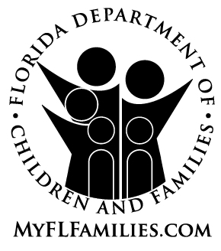 | Waiver of Administrative Disqualification Hearing  With a Program Loss

It is believed that ________________________________________________ improperly used or received the following food assistance and/or cash assistance benefits to which he or she was not entitled:
$____________ in food assistance benefits during ______________________ through ______________________

$____________ in cash assistance benefits during ______________________ through ______________________
It is believed that you received these benefits by intentional violation of a program law or rule. Therefore, a request for an Administrative Disqualification Hearing for the purpose of proving the following allegation(s) will be made.

You have a right to an Administrative Disqualification Hearing prior to any Department of Children and Families action to disqualify you from receiving benefits. Signing this agreement will waive your right to an Administrative Disqualification Hearing and will result in an automatic ______ month Cash Assistance Program and/or ______ month Food Assistance Program disqualification. Reduction of benefits to the other members of your household/assistance group will occur at the rate of twenty percent for food assistance and/or five percent for cash assistance until $____________ in food assistance and/or $____________ in cash assistance benefits have been repaid. The penalty remains the same whether you choose to have a hearing and are determined guilty, or whether you waive the hearing.

If you sign this waiver, you must also choose one of the following statements to indicate whether or not you admit to the facts as presented above. You do not have to admit to any of the charges. You have the right to remain silent concerning the charges as anything said or signed by you could be used against you in a court of law.
I admit to the facts as presented and understand that if I sign this waiver a disqualification penalty will be imposed in the above program(s) and a reduction in my benefits will occur until the amount(s) listed above is repaid.

I do not admit that the facts as presented are correct. However, I have chosen to sign this waiver and I understand that a disqualification penalty will be imposed in the above program(s), and a reduction in my benefits will occur until the amount(s) listed above is repaid.

I have read this notice and wish to exercise my right to have an administrative hearing.
I have read or had read to me this form and the Notification of Intent to Disqualify form (CF-ES 3056). I sign this form voluntarily without any threat or coercion. The head of the household must also sign this agreement if the accused individual is not the head of the household. The individual accused of this intentional program violation, as well as any household members when the violation occurred and any person connected to the household who caused an overpayment will be held responsible for repayment of the resulting claim.

___________________________________________________________ ______________
Signature of the person accused of the violation Date

___________________________________________________________ ______________
Signature of Head of Household (if not the accused) Date

FOR OFFICE USE ONLY
___________________________________________________________ ______________
Signature of Supervisor Date

