Southwest Florida Water Management District
7601 U.S. HIGHWAY 301 NORTH  TAMPA FL 33637-6759  Voice: (813) 985-7481, extension 2298  or 1-800-836-0797 (FL only)  TDD only: 1-800-231-6103 (FL only)  Fax: (813) 367-3054  Water.Variances@WaterMatters.org |  |  |  |  |  |  |  |  |  |  |  | DISTRICT USE ONLY  Received: ___/___/______  Petition #: ___-_________  Related Petition(s): _______  County: __________________  City/Town (if any): _________
PETITION FOR VARIANCE OR WAIVER
from Chapter 40D-22, F.A.C.; Chapter 40D-21, F.A.C.;
and/or an Order issued pursuant to Chapter 40D-21, F.A.C.
PART I – IMPORTANT MESSAGE
This form may be used to request relief from one or more of these regulations from the Southwest Florida Water Management District: Chapter 40D-22, Florida Administrative Code (F.A.C.), Year-Round Water Conservation Measures; Chapter 40D-21, F.A.C., Water Shortage Plan; or an Order issued pursuant to Chapter 40D-21, F.A.C.

This form is to be completed by the Petitioner and all sections must be fully completed. Persons requesting a variance pursuant to Section 373.62(7), Florida Statutes (F.S.), are not required to complete this form. The Petitioner is the property owner, local government, property association or other affected entity requesting the relief. An attorney or other authorized agent of the Petitioner may complete the form on behalf of the Petitioner.

If more space is needed for any field or combination of fields, attach additional material that refers to the applicable page, application part and field name(s). Also, provide samples, references, and other documentation as prompted.

The District does not discriminate based on disability. Anyone requiring reasonable accommodation as provided for in the Americans with Disabilities Action should contact the Demand Management Program at (813) 985-7481 or (800) 836-0797 (Florida only).

Print name: ____________________ Sign name: _______________________ Date: __/__/______

PART II – PETITONER AND LOCATION INFORMATION
Petitioner’s Name (property owner, HOA, business, etc.):
Project Name (such as “__ Residence” or "common areas”):
Physical Address (if more than parcel, attach a list):
City: |  |  |  |  |  |  |  | State: |  |  | Zip Code:
Water Source  check applicable box(es)  and supply details, as appropriate |  |  |  |  |  |  |  | Ground water (aquifer name, if known):
 |  |  |  |  |  |  |  | Potable water (water utility’s name):
 |  |  |  |  |  |  |  | Surface water (river or pond name):
 |  |  |  |  |  |  |  | Other (describe):
Water Use Permit # (if applicable): |  |  |  |  |  |  |  |  | Number of acres being irrigated:
Rules 40D-1.1002 and 40D-22.303, F.A.C. Page 1 of 7 LEG-R 42.00-058 (6/14)
PART III – ADDITIONAL PETITIONER INFORMATION

Mailing Address (if different than physical address above):
City: |  |  |  |  |  |  |  | State: |  |  | Zip Code:
E-mail Address (if any):
Telephone Number: |  |  |  |  |  |  |  |  | Fax number (if any):
PART IV – PETITIONER’S REPRESENTATIVE (IF ANY)

Attorney or Other Qualified Representative:
Mailing Address:
City: |  |  |  |  |  |  |  | State: |  | Zip Code:
E-mail Address (if any):
Telephone Number: |  |  |  |  |  |  |  |  | Fax number (if any):
PART V – APPLICABLE RULE OR PORTION OF RULE/ORDER

Specific provision(s) of the Rule or Order from which you are requesting relief : ____________________
_____________________________________________________________________________________

PART VI – INFORMATION TO DETERMINE APPLICABLE RULE OR PORTION OF RULE/ORDER

Water Use Activity  check the appropriate use classification(s) |  |  |  |  | Athletic play area irrigation, including ballfields and golf courses
 |  |  |  |  | Lawn and landscape irrigation - commercial or institutional property
 |  |  |  |  | Lawn and landscape irrigation – condo or other multi-family residential
 |  |  |  |  | Lawn and landscape irrigation – single family residential property
 |  |  |  |  | Water utility or local government service area (multiple water users involved)
 |  |  |  |  | Other (please describe):____________________________________________
Reason  for  Relief  check the reason(s)  why you are requesting a variance or waiver |  |  |  |  | Irrigation system limitation (i.e., cannot be split into morning/evening zones)
 |  |  |  |  | Large property (More total time is needed to cover all irrigation zones)
 |  |  |  |  | Mix of addresses (cannot irrigate each address on its normally assigned day)
 |  |  |  |  | Shared source (well or other supply cannot serve all addresses at same time)
 |  |  |  |  | Smart irrigation technology in use (see p. 3 of application for details)
 |  |  |  |  | Staffing not available (property is manually irrigated, needs special schedule)
 |  |  |  |  | Supply management (water utility service area needs a special schedule)
 |  |  |  |  | Water pressure (specific property experiences low potable water pressure)
 |  |  |  |  | Other (describe or attach details): _____________________________________
DISTRICT USE ONLY: Rule 40D-22._______; Rule 40D-21._______; Order _______, Paragraph ____
PART VII – STATUTE BEING IMPLEMENTED

Citation to the Statute that the Rule or Order is implementing : __________________________________
_____________________________________________________________________________________

Rules 40D-1.1002 and 40D-22.303, F.A.C. Page 2 of 7 LEG-R 42.00-058 (6/14)
PART VIII – DESCRIPTION OF RELIEF DESIRED (TYPE OF ACTION REQUESTED)

Attach a description of the relief desired (type of action requested) in lieu of following the provisions described in Part V or Part VI of this form. In lieu of attaching a description, you may instead select at least one of three common categories of relief/action shown below. Indicate which option(s) you are proposing and supply any applicable details.
I propose to follow this alternative restriction  (check box/boxes) |  |  |  |  | Change the allowable irrigation times to:  __:____ to __:____ a.m. or __:____ to __:____ p.m.
 |  |  |  |  | In lieu of separate morning and evening zones, allow irrigation from __:____ p.m. on each assigned day to __:___ a.m. the following day
 |  |  |  |  | Change the allowable irrigation day(s) to: _________________________
 |  |  |  |  | Separate property into two or more pieces and allow each piece to be irrigated in accordance with a special watering schedule (attach a map or sketch which indicates the boundary and watering schedule for each piece – see examples on p. 6-7)
 |  |  |  |  | Other (summarize):
I instead  agree to be bound to …  (check box) |  |  |  |  | … this alternative irrigation plan, if approved by the District (summarize, attaching pertinent details):
I will achieve similar/greater conservation by …  (check box) |  |  |  |  | …properly installing and using evapotranspiration-based “smart” irrigation technology (summarize, attaching pertinent details):
PART IX – DEMONSTRATION THAT THE REQUEST QUALIFIES FOR A VARIANCE OR WAIVER

Substantial hardship or violation of fairness justifying request
(describe)
Reason why request would serve the underlying statute
(describe)
Rules 40D-1.1002 and 40D-22.303, F.A.C. Page 3 of 7 LEG-R 42.00-058 (6/14)
PART X – OTHER PERTINENT FACTS

Period variance or waiver is requested  (check box/boxes)  (fill in any blanks) |  |  |  |  | The request for a variance or waiver is for permanent relief from provisions of the rule
 |  |  |  |  | The request for a variance or waiver is for temporary relief, only for the duration of the current water shortage order
 |  |  |  |  | The request for a variance or waiver is for temporary relief, only for this range of dates: ___/___/______ to ___/___/______
Damage or harm if a variance or waiver is not granted
Provisions Petitioner
can meet
(describe, indicate
compliance date)
Steps taken to comply with provisions (describe, indicate compliance date)
Any other information Petitioner believes is material
PART XI – PETITION CERTIFICATION

Petition  Certification  (sign and date) |  |  | I hereby certify or affirm, to the best of my knowledge, that the information provided above or attached as a supplement is true and correct in every material matter, and that I am the owner or authorized agent of the owner of the property involved or authorized to represent and sign on behalf of the local government or other entity seeking relief.
 |  |  | Signature: |  |  |  |  |  |  |  |  |  |  | Date: |  |  | __/__/_____
Rules 40D-1.1002 and 40D-22.303, F.A.C. Page 4 of 7 LEG-R 42.00-058 (6/14)
PART XII – HELPFUL TIPS AND SAMPLES

WHERE TO SEND YOUR PETITION

This Petition and any supporting material must be submitted via hand delivery, U.S. Mail or other mail delivery service, or facsimile to the location shown on the first page of this Petition. The District does not accept legal filings via e-mail.

SAMPLE MAP

Two examples of how a Petitioner might choose to split a property into two or more pieces for irrigation purposes are shown on the following pages.

LIMITING CONDITIONS

Pursuant to Section 120.542, F.S., the District is authorized to place an expiration date and other limiting conditions on a variance or waiver based on the particular variance sought and the basis for the requested relief in order to ensure that the relief being provided is the minimum necessary to alleviate the circumstances for which the variance or waiver was requested.

ANY QUESTIONS?

For personal assistance, call the District’s Demand Management staff at 1-800-848-0499, 1-800-837-0797, or (813) 985-7481, extension 2298, during normal business hours. Contact the Demand Management Program at any time via e-mail at Water.Variances@WaterMatters.org.

[This space is intentionally left blank.]

Rules 40D-1.1002 and 40D-22.303, F.A.C. Page 5 of 7 LEG-R 42.00-058 (6/14)
Rules 40D-1.1002 and 40D-22.303 Page 6 of 7 LEG-R42.00-058 (6/14)
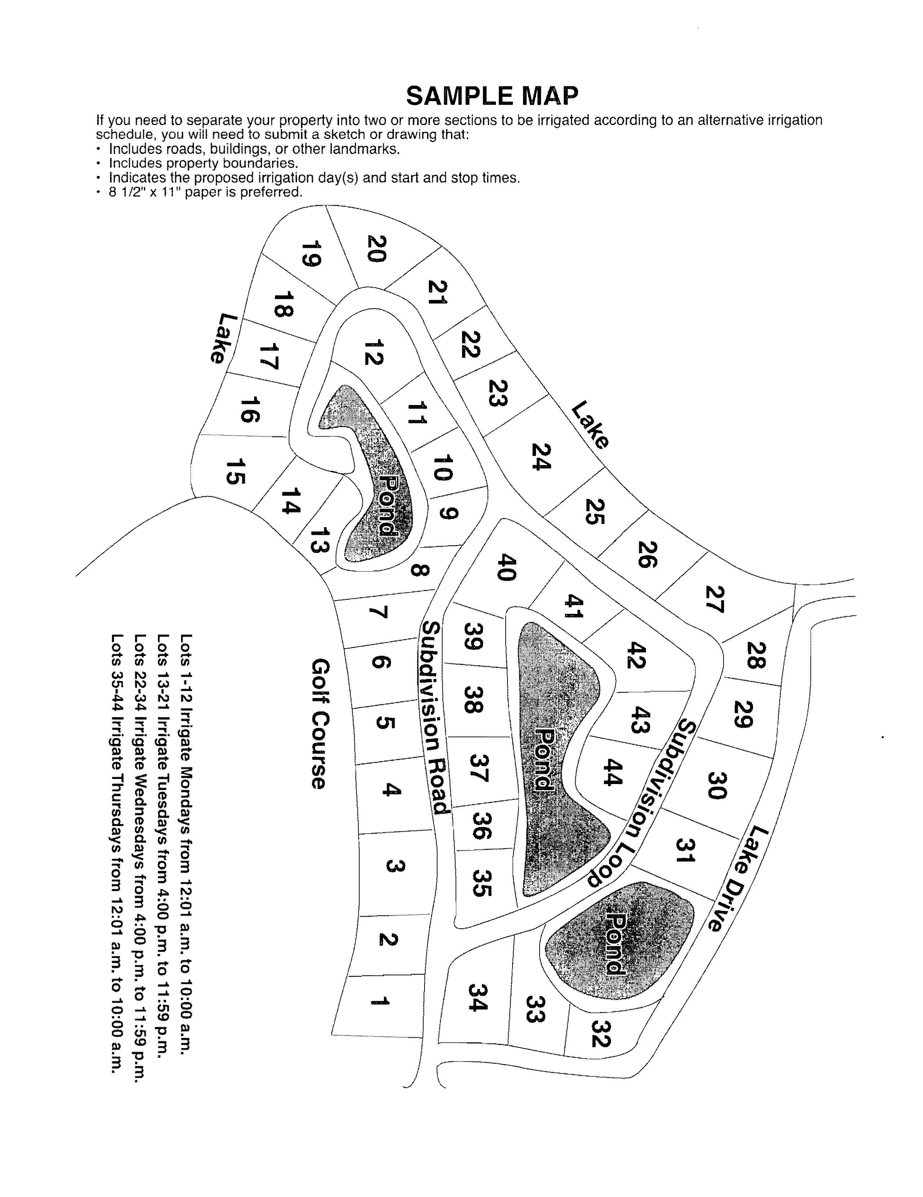

Rules 40D-1.1002 and 40D-22.303 Page 7 of 7 LEG-R42.00-058 (6/14)

