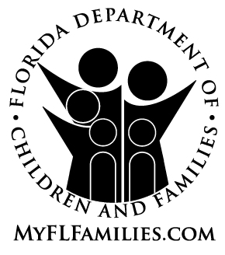 | MEMORANDUM OF AGREEMENT

(ONE COPY ADOPTIVE PARENTS – ONE COPY ADOPTION PLACEMENT RECORD)

We, the undersigned, after careful consideration, agree to receive into our family on __________________________________________________________________ a child to be named ______________________________________________________ and agree to assume the full responsibility for the care, including ordinary medical care, the support and education of this child.

We understand that this placement is made with the expectation of legal adoption after a period of agency supervision, if at that time we and the agency mutually agree that this placement is in the best interests of the child and family. It is further understood that the placement of this child may be terminated by either party prior to the legal adoption.

We understand and accept the department’s commitment to maintaining siblings together in the same home, and agree that it is in the best interest of siblings to remain together. We understand that if we accept siblings for placement and it becomes necessary to terminate the placement of one of the children, it will be the intent of the department to terminate the placements of all children in the sibling group, so that the children can remain together in subsequent placements.

We further agree not to file a petition for adoption or attempt to instigate any legal proceedings to adopt this child until the consent of the Department of Children and Families has been given.

__________________________________________
(Prospective Parent 1)

__________________________________________
(Prospective Parent 2)

____________________ __________________________________________
Date (Agency Representative)

INSTRUCTIONS: Complete in Duplicate at
the time child is placed.

CF-FSP 5072, PDF 10/2010 [65C-16.002, F.A.C.]

