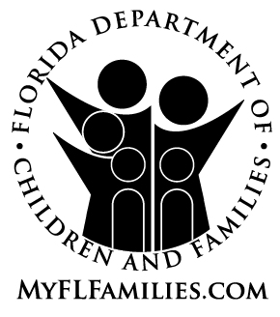 | MASTER LICENSE APPLICATION  For  ACCREDITED CHILD-PLACING AGENCIES
Pursuant to Section 409.175, Florida Statutes, application is hereby made to operate a Child Placing Agency which (check all that apply):
(a) Provides adoption services
(b) Provides foster home licensing services
(c) Provides foster care case management services
(d) Operates as a Lead Agency

Agency Name:
Main Office Address:
Applicant’s Name:
Position/Title:
Date of Application: Date of COA renewal:

Please list the location of all branch or satellite offices and the service(s) provided by each (add additional page if needed):
Street Address | City | State | Zip Code | County | Services Provided  (a,b,c,d)
1. |  | FL
2. |  | FL
3. |  | FL
4. |  | FL
5. |  | FL
6. |  | FL
7. |  | FL
8. |  | FL
If space is required for additional locations, please provide information on a page 2 of this application.
Please list all additional branch or satellite locations below:
Street Address | City | State | Zip Code | County | Services Provided  (a,b,c,d)
9. |  | FL
10. |  | FL
11. |  | FL
12. |  | FL
13. |  | FL
14. |  | FL
15. |  | FL
16. |  | FL
17. |  | FL
18. |  | FL
19. |  | FL
20. |  | FL

I understand the following responsibilities as the applicant for a Statewide Master license include the following:

- Ensure compliance with Section 409.175, Florida Statutes, and 65C-15, F.A.C., applicable to the Child Placing Agency functions identified for the primary and each satellite office listed on this application.

- Ensure response and action to resolve all identified licensing deficiencies or corrective actions involving the primary or satellite offices listed on this application.

I further understand that failure to oversee and comply with these responsibilities may impact the status of this statewide Child Placing Agency license.

________________________________________________ ______________
Executive Director Signature Date

