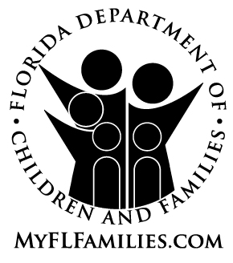 | EMERGENCY INTAKE  Date and Time: County:
Child’s Name: Date of Birth:
Child’s Physician Contact Information:
Physician’s Name | Physician’s Phone Number
Physician’s Address

Are siblings also in foster care? Yes No
If yes, siblings’ names and ages:

Parents’/Caregivers’ Names:

Reasons for Removal:
Suspected Physical Abuse Suspected Neglect Father Incarcerated Mother Incarcerated
Suspected Sexual Abuse Other (specify):

Any known allergies: Yes No
If yes, list allergies:

Any known physical or emotional problems: Yes No If yes, list problems:

Any special dietary needs/formulas: Yes No If yes, list needs:

I (print name of parent or legal guardian), , certify that my child (print child’s full name), , is currently prescribed and taking the listed medications and by my signature I am giving authorization to the Department of Children and Families to continue to provide the listed medications and continue any listed behavioral health services.

Signature of Parent:__________________________________________________ Date:_____________
Medications | Reason for taking medication | Dosage | Length of Time  on Medication | Giving to Shelter/  Foster Parent
 |  |  |  | Yes No
 |  |  |  | Yes No
 |  |  |  | Yes No
 |  |  |  | Yes No
Medical Equipment/Information Accompanying Child: Eyeglasses Medication Medical Equipment
Immunization Records Newborn Discharge Summary

Where is the child being taken: Temporary shelter Relative of family Temporary foster home
Friend of family Other (specify):

Contact Name: Phone Number:
Address:
Notes:

Name/Title of
person completing form: Phone #:

