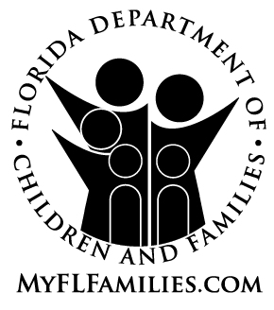 | ACKNOWLEDGEMENT OF  FIREARMS SAFETY REQUIREMENTS

Florida Statute 790.174 (Safe storage of firearms required) states:

(1) A person who stores or leaves, on a premise under his or her control, a loaded firearm, as defined in s. 790.001, F.S., and who knows or reasonably should know that a minor is likely to gain access to the firearm without the lawful permission of the minor’s parent or the person having charge of the minor, or without the supervision required by law, shall keep the firearm in a securely locked box or container or in a location which a reasonable person would believe to be secure or shall secure it with a trigger lock, except when the person is carrying the firearm on his or her body or within such close proximity thereto that he or she can retrieve and use it as easily and quickly as if he or she carried it on his or her body.

(2) It is a misdemeanor of the second degree, punishable as provided in s. 775.082 or s. 775.083, F.S., if a person violates subsection (1) by failing to store or leave a firearm in the required manner and as a result thereof a minor gains access to the firearm, without the lawful permission of the minor’s parent or the person having charge of the minor, and possesses or exhibits it, without the supervision required by law:
(a) In a public place; or
(b) In a rude, careless, angry, or threatening manner in violation of s. 790.10, F.S.
This subsection does not apply if the minor obtains the firearm as a result of an unlawful entry by any person.

(3) As used in this act, the term “minor” means any person under the age of 16.

I/We, __________________________________________________________________,
acknowledge that I/we have read and understand this document.

_________________ ___________________________________________
Date Caregiver/Adoptive Parent Signature

___________________________________________
Caregiver/Adoptive Parent Signature

NOTE: This acknowledgement must be executed by all foster and adoptive parents during the home study process.

