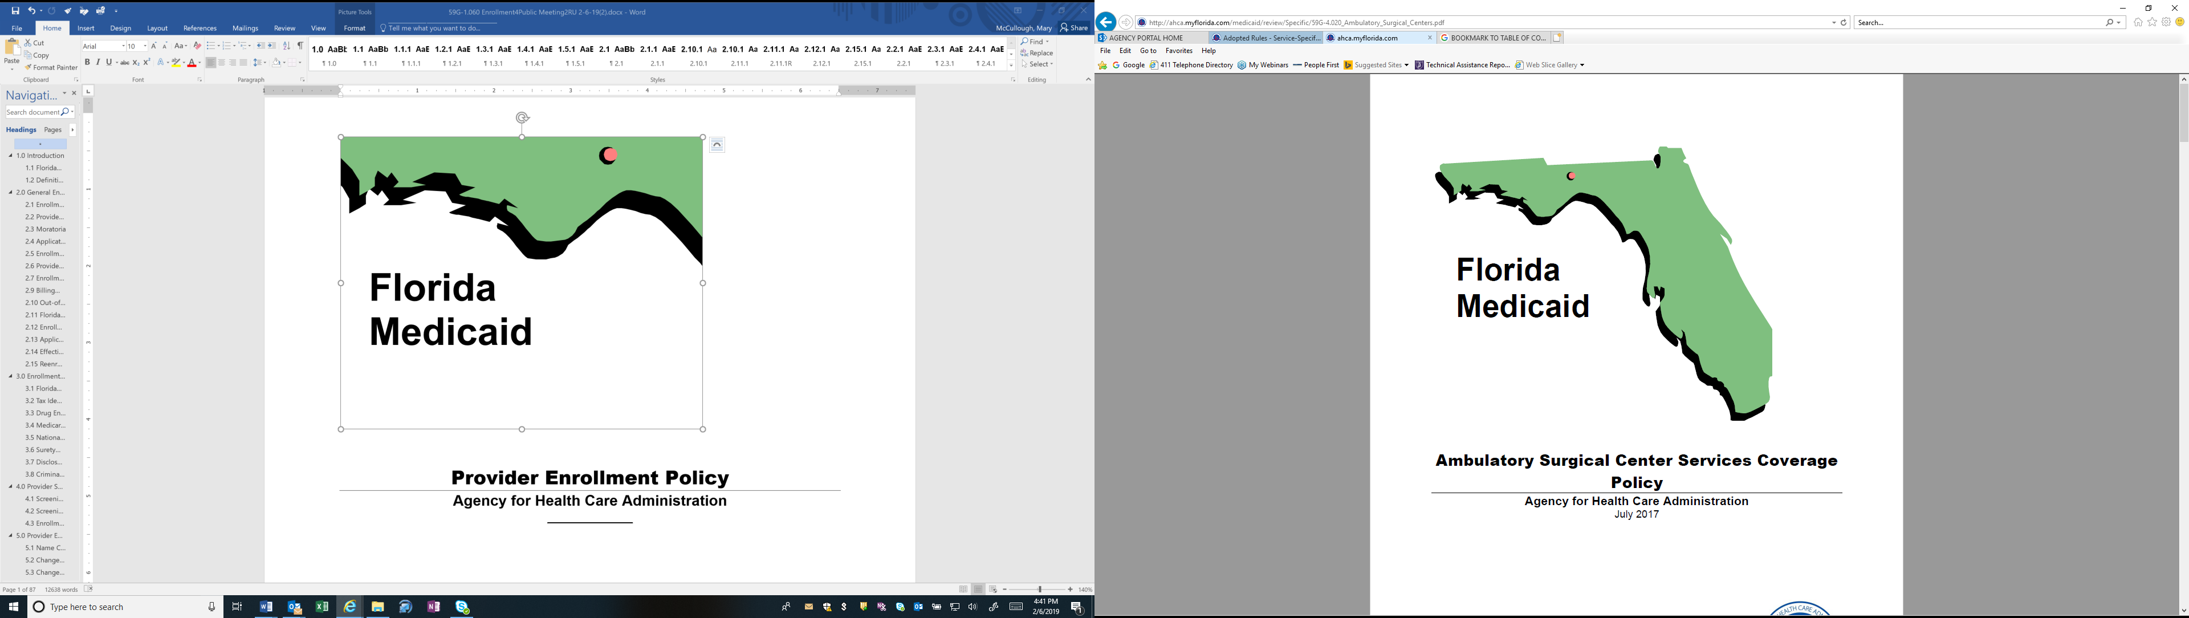

Provider Enrollment Policy
Agency for Health Care Administration
December 2019



Table of Contents
1.0 Introduction
1.1 Florida Medicaid Policies
1.2 Definitions
2.0 General Enrollment Policy
2.1 Enrollment Application Process
2.2 Provider Eligibility
2.3 Moratoria
2.4 Application Types
2.5 Enrollment Types
2.6 Provider and Specialty Type
2.7 Enrollment for Medicare Crossover-Only Payment
2.9 Billing Agents
2.10 Out-of-State Provider Enrollment Requirements
2.11 Florida Medicaid Provider Agreement
2.12 Enrollment Exclusions
2.13 Application Deficiencies
2.14 Effective Date of Enrollment
2.15 Reenrollment Process After Termination
3.0 Enrollment Application – Specific Requirements
3.1 Florida Medicaid Provider Identification (ID) Number(s)
3.2 Tax Identification Numbers
3.3 Drug Enforcement Administration (DEA)
3.4 Medicare Provider Identifiers
3.5 National Provider Identifier
3.6 Surety Bonds
3.7 Disclosure of Ownership Interest and Managing Control
3.8 Criminal History Check
4.0 Provider Screening
4.1 Screening Risk Categories
4.2 Screening Categories
4.3 Enrollment Application Interview
5.0 Provider Enrollment Changes and Failure to Report Change(s)
5.1 Name Change
5.2 Change to Provider Identifiers
5.3 Change of Ownership
5.4 Specialty Code Changes
5.5 Change in Reassignment of Payment
5.6 Change in Trading Partner
5.7 No Longer Accepts Medicaid
5.8 Provider Death
5.9 Change in Enrollment Status/Exclusion Occurrence
5.10 Change in Address or Telephone Number
6.0 Provider Enrollment Renewal
6.1 Renewal Application Submission
6.2 Failure to Renew
7.0 Post Enrollment Form
7.1 Electronic Data Interchange Agreement, AHCA Form 5000-1062 Renew
8.0 Provider Termination, Exclusion, and Suspension
8.1 Continued Requirement To Maintain Enrollment Qualifications
8.2 Termination
8.3 Suspension, Exclusion, or Termination from Medicare or Medicaid in Another State
9.0 Appendices
9.1 Appendix A: Medicaid Provider Enrollment Wizard
9.2 Appendix B: Medicaid Provider Types and Specialties
9.3 Appendix C: General Document Requirements
9.4 Appendix D: Provider Specific Documents
9.5 Appendix E: Provider Specific Documents

- Introduction
This policy provides the requirements to enroll, and maintain enrollment, as a Florida Medicaid provider.
- Florida Medicaid Policies
This policy is intended for use by all providers that render services to eligible Florida Medicaid recipients. It must be used in conjunction with Florida Medicaid’s General Policies (as defined in section 1.2) and any applicable service-specific and claim reimbursement policies with which providers must comply.
Note: All Florida Medicaid policies are promulgated in Rule Division 59G, Florida Administrative Code (F.A.C.). Policies are available on the Agency for Health Care Administration’s (Agency) Web site at http://ahca.myflorida.com/Medicaid/review/index.shtml.
- Definitions
The following definitions are applicable to this policy. For additional definitions that are applicable to all sections of Rule Division 59G, F.A.C., please refer to the Florida Medicaid Definitions Policy.
- Agent
Any person who has been delegated the authority to obligate or act on behalf of a provider.
- Board Certified
Certified by a medical specialty board; approved by the American Association of Physician Specialists, American Board of Optometry, American Osteopathic Board of Neurology and Psychiatry, American Board of Psychiatry and Neurology, American Board of Medical Specialties, or American Osteopathic Association; or certified by a dental specialty board of the American Dental Association.
- Claim Reimbursement Policy
A policy document found in Rule Division 59G, F.A.C. that provides instructions on how to bill for services.
- Covered Health Care Provider
Health care provider that electronically transmits any of the Health Insurance Portability and Accountability Act (HIPAA) standard transactions, such as claims or eligibility verification.
- Crossover-Only Provider
Eligible Medicare provider enrolled in Florida Medicaid solely for the purposes of billing the coinsurance and deductible portion of a Medicare claim in accordance with section 409.907, Florida Statutes (F.S.).
- Director
A member of the board of directors of a corporation (for use regarding requirements of Title 42, Code of Federal Regulations (CFR), Part 455, Subpart B). A medical director who is not a member of the board of directors is not considered a director.
- Direct Ownership
Individual or entity with ownership interest in the disclosing entity (e.g., owns stock in the business, etc.).
- Exclusion
A penalty imposed on a provider by Medicare or Medicaid in this or any other state.
- Facility or Other Business Entity
An entity that is formed and administered in accordance with commercial laws in order to engage in business activities.
- Fully Enrolled Provider
Providers that meet the full credentialing requirements for participation in Florida Medicaid and are eligible to provide services to recipients enrolled in either fee-for-service or managed care delivery systems.
- General Policies
Collective term for Florida Medicaid policy documents found in Rule Chapter 59G-1, F.A.C., containing information that applies to all providers (unless otherwise specified) rendering services to recipients.
- Indirect Ownership
As defined in Rule 59G-1.010, F.A.C.
- Limited Enrolled Provider
Providers only participating in the network of a Florida Medicaid managed care plan.
- Managing Employee
A general manager, business manager, administrator, director, or other individual who exercises operational or managerial control over, or who directly or indirectly conducts, the day-to-day operation of an institution, organization, or agency. This includes medical directors who are not members of the board of directors.
- Non-Covered Health Care Providers
Individuals or organizations that furnish nontraditional services that are only indirectly health care related, or that only bill for, or receive payment for, but do not furnish health care services or supplies.
- Ordering or Referring Providers (ORPs)
Providers who perform the following:
- Certify a recipient’s need for a service
- Prescribe (either drugs or other covered items)
- Refer a recipient to another provider or facility for covered services
- Send a recipient’s specimen(s) to a laboratory for testing
- Practitioner functioning as an attending provider at an inpatient or outpatient facility with primary responsibility for the recipient’s care and treatment
- Person with an Ownership or Control Interest
A person or organization as defined in 42 CFR 455.101-102.
- Registered Agent
An individual authorized to transact business on behalf of the provider, identified in the provider’s Articles of Incorporation filed with the Florida Department of State.
- Sole Proprietor
A natural person who is not an incorporated entity.
- Sole Proprietor Enrolling as a Member of a Group
A natural person who is not an incorporated entity who must reassign his or her billing rights to a group employer.
- Trading Partner
Individual or entity that contracts with a Medicaid enrolled provider to supply eligibility verification, billing, or switch vendor services.
- General Enrollment Policy
For the purposes of this policy, the term provider(s) refers to individuals or entities that are applying to become a Florida Medicaid provider or that are enrolled. All providers must comply with the following general requirements in conjunction with the provider-specific requirements set forth in the appendices.
Providers deemed ineligible during the application process will be denied, or terminated from, enrollment with Florida Medicaid, including providers who:
- Fail to furnish documentation or records validating information submitted with the provider’s application
- Do not comply with Florida Medicaid provider agreement criteria specified in section 409.907, F.S.
- Act in “violation” as defined in Rule 59G-9.070, F.A.C.
- Enrollment Application Process
Providers must submit an enrollment application using the Online Provider Enrollment Wizard (Wizard), incorporated by reference in Rule 59G-1.060, F.A.C., and available on the Florida Medicaid Web portal at http://portal.flmmis.com/flpublic.
The Wizard notifies providers of any supporting documents required for enrollment in accordance with Florida Medicaid policy once the application is created. The application submission process is complete when all required supporting documents are received and matched with the online submission.
Providers must submit true and accurate statements and documents to the Agency. Filing materially incomplete or false information is a felony and is sufficient cause to deny an enrollment application or terminate a provider’s enrollment in Florida Medicaid pursuant to section 409.920, F.S.
- Provider Eligibility
Providers must meet all of the following requirements before enrolling in the Florida Medicaid program:
- Be fully operational
- Be located in Florida or no more than 50 miles from the Florida border, unless otherwise specified in this policy
- Meet all applicable provider qualifications described in this policy, the applicable service-specific coverage policy, federal regulations, and state laws
- Moratoria
The Agency may impose temporary moratoria on enrolling new providers or provider types in accordance with 42 CFR 455.470.
- Application Types
Providers must enroll as one of the following:
- Sole proprietor
- Sole proprietor enrolling as a member of a group
- Group (greater than one member)
- Facility or other business entity
- Group Membership
Group membership authorization is required when forming, joining, or separating from, a group.
- Enrollment Types
Providers must enroll as one of the following:
- Fully enrolled
- Limited enrolled
- Ordering or referring
- Provider and Specialty Type
Providers must choose a provider type, and at least one specialty type with a corresponding taxonomy, applicable to the Florida Medicaid service the provider intends to provide.
By entering a specialty type in the enrollment application:
- Licensed practitioners attest to the successful completion of post-graduate training in the chosen specialty field.
- Non-licensed practitioners attest to the successful completion of all required education, training, work history, and certifications in the chosen specialty field.
- Enrollment for Medicare Crossover-Only Payment
Medicare providers must fully enroll in Florida Medicaid and must submit all of the following documentation with the application:
- Medicare approval letter
- Letter on company letterhead that includes all of the following:
- Attestation that the provider meets all Florida Medicaid provider enrollment requirements, including those specific to the applicant’s provider type, if applicable
- Acknowledgement that the Agency may conduct on-site reviews prior to approving the crossover provider ID number
- Handwritten authorized signature
- Enrollment of Ordering or Referring Physicians or Other Professionals
Ordering or referring providers, or other professionals, must enroll in Florida Medicaid in accordance with 42 CFR 455.410, except when an ORP orders for, or refers, a recipient prior to the recipient’s eligibility to participate in Florida Medicaid, and the ORP’s National Provider Identifier (NPI) is included on the claim.
Providers whose only relationship with Florida Medicaid is as a referring, ordering, prescribing, and attending practitioner may enroll as a ROPA provider.
Florida Medicaid billing providers must obtain a full or limited enrollment, as applicable.
- Billing Agents
Billing agents and clearinghouses must enroll in Florida Medicaid to process transactions on behalf of a provider. Compensation for billing agent or clearinghouse services must comply with all of the following:
- Be related to the cost of processing the transactions
- Not be dependent upon the collection of any Florida Medicaid payment
- Not be related to a percentage, or other basis, of the amount that is billed or collected
Providers must submit a written request with an original authorizing signature to the Agency to designate a billing agent to receive payments from Florida Medicaid in the provider’s name.
The Agency will terminate the provider agreement of any billing agent attempting to receive Florida Medicaid reimbursement in its own name or enroll as a pay-to-provider.
- Out-of-State Provider Enrollment Requirements
Out-of-state providers who furnish services in accordance with Rule 59G-1.050, F.A.C., Florida Medicaid General Medicaid Policy, must enroll in Florida Medicaid for reimbursement, including the following:
- Durable medical equipment and supplies entities enrolling as Medicare Crossover-Only providers with proof of accreditation from a Florida Medicaid-approved accrediting organization
- Fully licensed physicians in Florida that interpret diagnostic testing results from an out-of-state location through telecommunications and information technology
- Independent laboratories certified under the Clinical Laboratory Improvement Amendments
- Medical supply and durable medical equipment (DME) providers and pharmacies that supply items that are not otherwise available from other enrolled providers located within Florida
- Providers that have furnished covered services to an eligible Florida Medicaid recipient in accordance with the applicable Florida Medicaid policy
- Florida Medicaid Provider Agreement
Providers must complete, sign, date, and submit the applicable Florida Medicaid Provider Agreement, available at http://portal.flmmis.com, as follows:
- Florida Medicaid Institutional Provider Agreement
- Florida Medicaid Institutional Provider Agreement & Election to Make Presumptive Eligibility Determinations as a Qualified Hospital
- Florida Medicaid Institutional Provider Agreement as an Intermediate Care Facility for Individuals with Intellectual Disabilities
- Florida Medicaid Non-Institutional Provider Agreement
- Florida Medicaid Provider Agreement for Durable Medical Equipment and Medical Supplies
- Medicare Crossover-Only Provider Agreement
Florida Medicaid Provider Enrollment Agreements and Forms are located at http://portal.flmmis.com under Provider Services.

- Provider Agreement Signature
Sole proprietors and sole proprietors enrolling as a member of a group must personally sign the agreement; an agent may not sign in lieu of the sole proprietor.
All persons with five percent or greater ownership or controlling interest must sign the provider agreement. A senior official or designated agent of an organization may sign the agreement in lieu of all required persons; the signature is binding to all persons disclosed on the application.
An organization’s Articles of Incorporation or other official written documentation must designate any agent. The provider must submit a copy of the document with the application.
- Enrollment Exclusions
The Agency excludes individuals or entities that meet any of the following, and have not been reinstated by the Department of Health and Human Services Office of Inspector General, from enrolling as a provider:
- Currently sanctioned by Medicare or Medicaid in any state
- Involuntarily terminated by Medicare or Medicaid in any state, except for reason of inactivity
- Voluntarily terminated from Medicare or Medicaid in any state without paying monies owed to the program or submitting an acceptable repayment agreement, as applicable
- Unqualified Applicants
The Agency may prohibit applicants from submitting a new enrollment application for one year from the application date when the applicant is denied enrollment in Florida Medicaid because the provider does not meet all applicable provider qualifications described in this policy, the applicable service specific coverage policy(ies), federal regulations, or state laws.
- Application Deficiencies
Florida Medicaid will notify applicants of any technical application deficiencies in writing in accordance with section 409.907, F.S. Applicants must correct deficiencies within 21 days from the date of notification, or the application will be denied. Applicants must submit a new application to begin the enrollment process again if the applicant’s application was denied for deficiencies.
- Effective Date of Enrollment
The Agency establishes the effective date of provider enrollment in accordance with section 409.907(a), F.S.
An approved Florida Medicaid application must:
- Be accurately and fully completed
- Meet all the enrollment requirements, as specified and approved by the Agency, including:
- Background screening(s)
- Interview(s)
- Inspections
- Reenrollment Process After Termination
Providers that have voluntarily terminated from the Florida Medicaid program may apply for reenrollment with Florida Medicaid after termination for any reason.
2.15.1 Reenrollment after Involuntary Termination
Providers that have been involuntarily terminated through a contractual or final order action, except for reason of inactivity, may not apply to reenroll with Florida Medicaid for a minimum of three years after the contractual action, or after the revocation period has expired, whichever is later.
2.15.2 Reenrollment after Medicare or Medicaid Termination
Providers must supply proof of reinstatement from Medicare or any state Medicaid program with the enrollment application if the provider was terminated by Medicare or Medicaid in any other state.
Approval for reenrollment in Medicare or Medicaid in any other state does not guarantee that the provider is eligible to be reenrolled in Florida Medicaid.
2.15.3 Reenrollment with a Different Name or Tax Identification Number
Providers must furnish the prior name, tax identification number (TIN), and the previous Florida Medicaid ID number with the application if the provider applies for reenrollment under a different name or TIN.
- Enrollment Application – Specific Requirements
- Florida Medicaid Provider Identification (ID) Number(s)
Florida Medicaid assigns one provider ID number per TIN and type of service unless the provider is uniquely licensed or certified by location. Each unique license or certification requires a separate provider application and is assigned a Florida Medicaid provider ID for each license or certification.
Provider ID numbers are non-transferable and may not be shared or used by any other individual or entity that is not the provider to whom the ID is assigned.

Hospital provider IDs are transferable in cases of a change in ownership. The purchaser must disclose their ownership and controlling interest and submit to screening as part of the transfer of the ID.
- Tax Identification Numbers
Providers must report the provider’s Internal Revenue Service assigned TIN on the Florida Medicaid provider enrollment application.
Sole proprietors and sole proprietors enrolling as a member of a group must enroll with the provider’s Social Security Number. Florida Medicaid is authorized to collect this information in accordance with Section 1902(a)(78) of the Social Security Act.
Incorporated persons or entities must enroll with the provider’s Federal Employer Identification Number.
Providers may not enroll using a TIN belonging to another person or entity.
- Drug Enforcement Administration (DEA)
Providers who prescribe, order, or administer medications and are required to register with the DEA must provide their DEA registration certificate.
- Medicare Provider Identifiers
Medicare-enrolled providers must provide the provider’s Medicare number on the Florida Medicaid provider enrollment application.
- National Provider Identifier
Providers must enter the provider’s NPI if the provider is required to obtain an NPI in accordance with 45 CFR Part 162.
- Surety Bonds
Providers in a moderate or high risk category as identified in Section 4.0 of this policy may be required to post a surety bond, in accordance with sections 409.912 and 409.907, F.S., including those with:
- An approved appeal for an exception to an existing moratorium
- Applications submitted within six months of a moratorium lifting
Providers may be required to replace an expired bond within 30 days of the expiration date.
Providers required to post a surety bond must complete and submit a State of Florida Agency for Health Care Administration Florida Medicaid Provider Surety Bond, AHCA Form 5000-1064, June 2019, incorporated by reference in Rule 59G-1.060, F.A.C., and available at http://portal.flmmis.com.
- Disclosure of Ownership Interest and Managing Control
Providers must disclose all required ownership information as specified in 42 CFR Part 455, Subpart B and must also disclose all officers and directors, including individuals who serve in a voluntary (e.g., unpaid) capacity or designated as “trustee(s),” and all managing employees.
Providers must disclose all general and limited partnership interests regardless of the percentage of ownership interest or managing control.
There are no exceptions to the disclosure requirements for publicly traded, non-profit, or government-owned entities.
- Criminal History Check
All persons disclosed on the provider application must submit a complete set of fingerprints for background screening in accordance with 42 CFR Part 455, Subpart E, and section 409.907, F.S.
Florida Medicaid providers must utilize the Care Provider Background Screening Clearinghouse to request, schedule, and track fingerprint results in accordance with section 435.12, F.S.
- Florida Medicaid Electronic Funds Transfer Authorization
Providers must submit a bank letter or voided check/deposit slip to receive direct reimbursement from Florida Medicaid.
- Provider Screening
- Screening Risk Categories
The Agency conducts provider screenings based upon categorical risk levels of “limited,” “moderate,” or “high,” in accordance with 42 CFR Part 455, Subpart E. The Agency also screens provider applications for new practice location(s) and any provider applications received for reenrollment or revalidation of enrollment requests. The Agency changes a provider’s risk category dependent upon potential for fraud, waste, or abuse.
Providers seeking enrollment or enrolled providers must permit the Agency to conduct unannounced on-site inspections of any and all provider locations.
- Screening Categories
The Agency designates provider categorical risks in accordance with 42 CFR 455.450, as follows:
- Providers and suppliers designated as “limited” categorical risk:
- Individual practitioners and groups owned by the practitioners including:
- Advanced practice registered nurses
- Audiologists and hearing aid specialists
- Chiropractors
- Dentists
- Intermediate Care Facilities for Individuals with Intellectual Disabilities
- Licensed midwives
- Licensed practical nurses
- Medical assistants
- Opticians
- Optometrists
- Physicians
- Physician assistants
- Podiatrists
- Registered dental hygienists
- Registered nurses and registered nurse first assistants
- Ambulatory surgical centers
- Birth centers
- County health departments
- Community behavioral health services
- Department of Health Children’s Medical Services including early intervention services
- Freestanding dialysis centers
- Federally qualified health centers
- Hospitals
- Medical foster care
- Occupational, respiratory, or speech therapists, enrolling as individuals or as group practices
- Pharmacies
- Prescribed pediatric extended care centers
- Rural health clinics
- Skilled nursing facilities
- Trading partners
- Transportation providers – government owned ambulance and non-emergency

- Providers and suppliers designated as “moderate” categorical risk:
- Assistive care services
- Case management agencies, case managers, or social workers, unless otherwise specified
- Community mental health centers
- Home and community-based services providers
- Hospice organizations
- Independent clinical laboratories
- Portable x-ray suppliers
- Public, private, and charter schools
- Residential and freestanding psychiatric facilities
- Revalidating home health agencies
- Revalidating durable medical equipment, prosthetics, orthotics and supplies suppliers
- Specialized therapeutic services
- Transportation providers – privately owned

- Providers and suppliers designated as “high” categorical risk:
- Behavior analysis practitioners
- Mental health targeted case management providers
- Physical therapists
- Physician groups owned by non-physicians
- Prospective (newly enrolling) home health agencies and other home health service providers
- Prospective (newly enrolling) durable medical equipment, prosthetics, orthotics, and supplies suppliers
- Enrollment Application Interview
The Agency performs pre-enrollment and post-enrollment face-to-face interviews with providers designated as “moderate” or “high” categorical risks at a location determined by the Agency. The provider applicant must be present for the face-to-face interview.
Providers participating in a face-to-face interview must maintain and present documentation that meets the following, upon request:
- Validates records reported on the provider’s Florida Medicaid application and information received by the Agency
- Establishes the applicant’s identity or eligibility, including provider-specific enrollment requirements contained in this policy
- Provider Enrollment Changes and Failure to Report Change(s)
Providers must report any changes to the information submitted in the provider’s enrollment application in writing to the Agency within 30 days of the change.
The Agency will take action up to, and including, termination from participation in the Florida Medicaid program against providers that fail to report changes to their provider enrollment file.
- Name Change
Providers must report the following in writing in the event of a name change:
- Copy of an Internal Revenue Service (IRS) form, marriage license, divorce decree, or other official document authenticating the provider’s new name
- Effective date of the change
- National Provider Identifier, if required, in accordance with 45 CFR Part 162
- New name
- Prior name
- Provider’s Medicaid ID number
- Change to Provider Identifiers
Providers must report changes in the provider’s identifiers in writing including:
- Medicare ID
- NPI
- Professional or facility license, registration, or permit
- TIN
Providers reporting a change to an identifier must include the previous identifier, the new identifier, and proof from the governmental or professional agency designating the new identifier.
- Change of Ownership
Providers must report a change of ownership in writing as specified in section 409.907, F.S., except for the following:
- An entity that is publicly traded on a recognized stock exchange
- A change solely in the management company or board of directors
- Specialty Code Changes
Providers must submit a written request to add or delete specialties on the provider’s record. The request must include the following:
- An original authorized signature
- Documents verifying the provider’s eligibility for the requested specialty, as applicable
- Specialty and corresponding taxonomy to be added or removed
- Change in Reassignment of Payment
Providers may reassign their payments to a Florida Medicaid enrolled provider group by submitting a Group Membership Authorization, AHCA Form 5000-1061, June 2019, incorporated by reference in Rule 59G-1.060, F.A.C., and available at http://portal.flmmis.com.
Providers must submit a written request to the Agency to end reassignment of payment to a group; or, a group may end reassignment on the provider’s behalf. The request must contain the following:
- Effective date of change
- Group’s Medicaid ID
- Provider’s Medicaid ID
- Change in Trading Partner
Providers must report a change in third-party vendors in writing to the Agency and must include all of the following:
- Completed Electronic Data Interchange Agreement, AHCA Form 5000-1062, June 2019, incorporated by reference in Rule 59G-1.060, F.A.C., for the new vendor, available at http://portal.flmmis.com
- Effective date of the change in vendor
- Previous vendor’s name and Medicaid ID
- Provider’s name and Medicaid ID
- No Longer Accepts Medicaid
Providers must report that they are ceasing operations or no longer accepting Florida Medicaid recipients in writing to the Agency. The submission must include the following:
- Effective date of the cessation of operations, or date that the provider no longer accepts Florida Medicaid recipients
- Florida Medicaid ID number
- Provider Death
Florida Medicaid providers enrolled as a group or other business entity must report the death of a group member, or the death of any person with ownership or controlling interest in the provider in writing to the Agency. The submission must contain the following:
- Copy of an obituary, death certificate, or other written statement documenting the date of death
- Date of death
- Florida Medicaid ID number
- Name of the decedent
- NPI, if required, in accordance with 45 CFR 162
- Change in Enrollment Status/Exclusion Occurrence
Providers must report the occurrence of any of the following in writing to the Agency:
- Denial, suspension, or exclusion from Medicare or Medicaid in any state
- Money owed to Medicare or Medicaid in any state
- Restriction, suspension, or revocation of a facility or professional license
- Suspended payments from Medicare or Medicaid in any state
- Change in Address or Telephone Number
Providers must report the occurrence of changes to any of the following in writing to the Agency:
- Mailing address
- Payment address
- Physical address
- Telephone number
- Provider Enrollment Renewal
- Renewal Application Submission
Providers must renew enrollment in the Florida Medicaid program as follows:
- Institutional, DME, Medicare Crossover-Only, ORPs, and out-of-state providers must renew every three years
- Non-institutional providers must renew every five years
- Failure to Renew
Providers must complete the renewal process by the expiration date on the provider’s Florida Medicaid provider agreement. Providers are ineligible for payment from Florida Medicaid under the fee-for-service delivery system and from a Medicaid managed care plan for failure to renew the provider’s application before the renewal date.
- Post Enrollment Form
- Electronic Data Interchange Agreement, AHCA Form 5000-1062 Renew
Fee-for-service providers must submit the Electronic Data Interchange Agreement, AHCA Form 5000-1062, June 2019, incorporated by reference in Rule 59G-1.060, F.A.C., for electronic claiming or authorizing a Trading Partner to submit on behalf of the provider.
- Provider Termination, Exclusion, and Suspension
- Continued Requirement To Maintain Enrollment Qualifications
Providers must continue to meet all of the applicable provider qualifications to remain enrolled in Florida Medicaid.
The Agency may take the following actions against unqualified providers:
- Recoup Florida Medicaid reimbursement(s) for services rendered while the provider was ineligible to provide services
- Refer the provider to the Attorney General’s Medicaid Fraud Control Unit (MFCU)
- Restrict payment of claims
- Termination
- Termination
The Agency or the provider may terminate the provider agreement without cause upon 30-day written notice in accordance with section 409.907, F.S.
- Exceptions to the 30-Day Notice
Terminations may be effective in less than 30 days under any of the following circumstances:
- The provider is required to be licensed, certified, accredited, insured, or hold a surety bond and no longer meets the requirement. The effective date of termination will be the date that the requirement was end-dated or no longer met.
- The provider’s business is closed, abandoned, or non-operational. The effective date of termination will be the date that the business was closed, abandoned, or became non-operational, or that the Agency became aware of the change, whichever is earlier.
- Disqualifying information is found during a criminal history background check. The effective date of termination will be the date of conviction, or that the Agency became aware of the conviction, whichever is earlier.
- The provider is deceased. The effective date of termination will be the date of death.
- The provider is suspended, revoked, or terminated from Medicare or Medicaid in this, or any other state. The effective date of termination will be the date of suspension, revocation, or termination.
- The provider participated or acquiesced in any action for which any person with direct or indirect controlling interest in the provider, or a subcontractor to the provider, was suspended, revoked, or terminated from participating in Medicare or Medicaid in this, or any other state. The effective date of termination will be the date of the suspension, revocation, or termination.
- At any time the Agency discovers the provider purposely submitted factually or materially false or erroneous information or documentation.
- Suspension, Exclusion, or Termination from Medicare or Medicaid in Another State
The Agency will terminate a provider for a period no less than that imposed by the federal government or any other state Medicaid program, including Florida Medicaid, and will not enroll the provider in Florida Medicaid while the suspension or termination timeframe remains in effect in accordance with section 409.913, F.S, and Rule 59G-9.070, F.A.C.

- Appendices
- Appendix A: Medicaid Provider Enrollment Wizard

Enrollment Application Process
FULL ENROLLMENT
From the Florida Medicaid Web Portal Home Page, the user navigates to the Provider Enrollment Application and selects ‘new application’: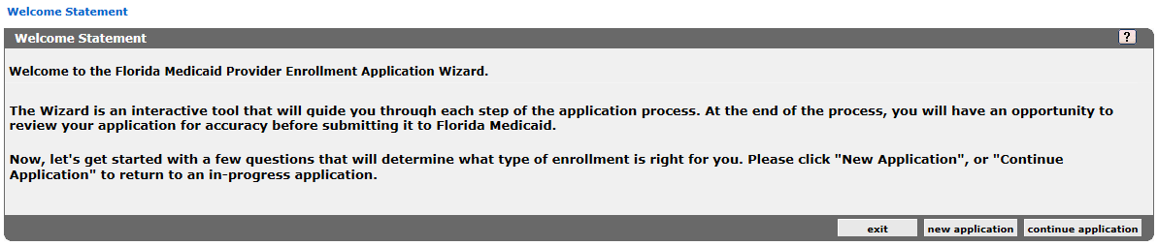
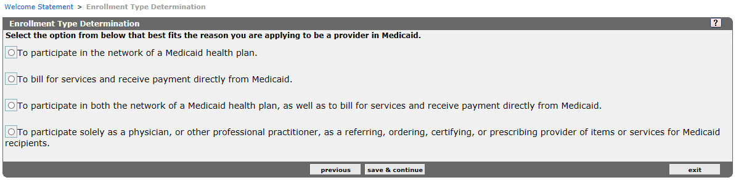
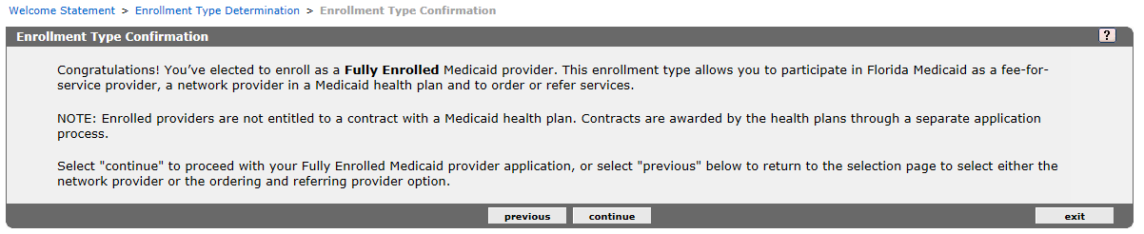
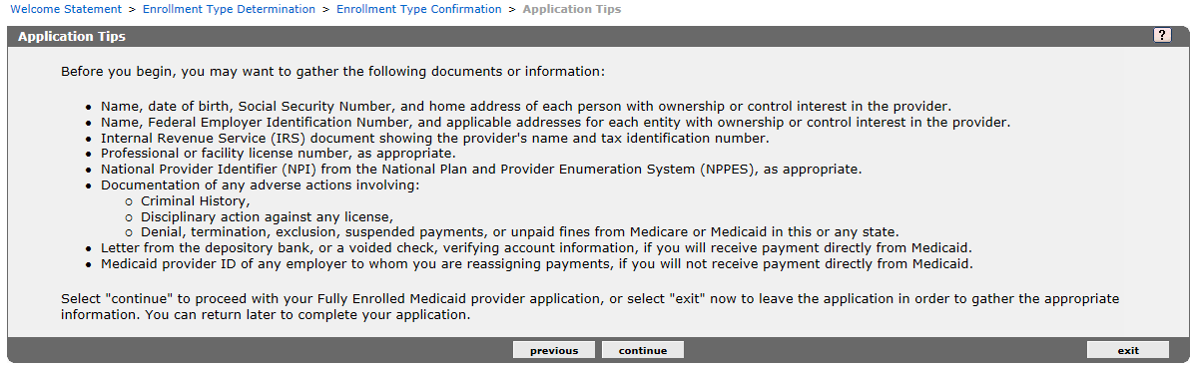
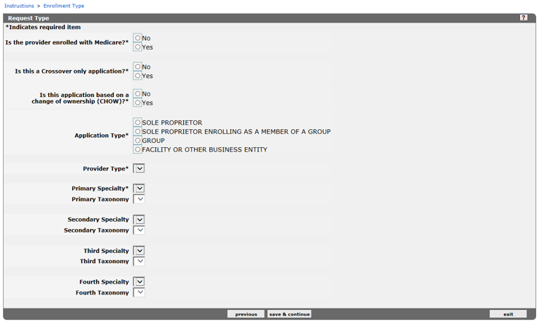
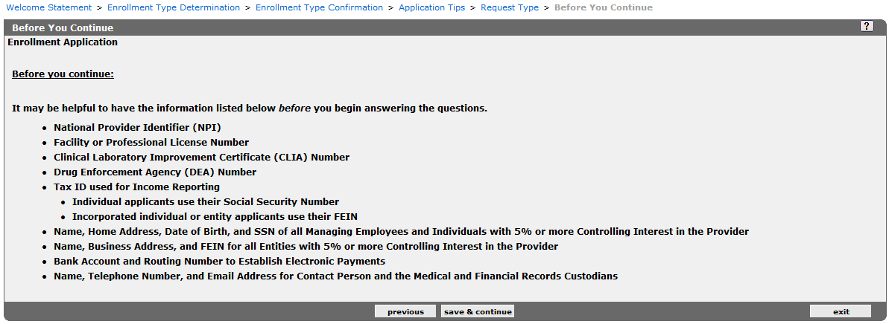

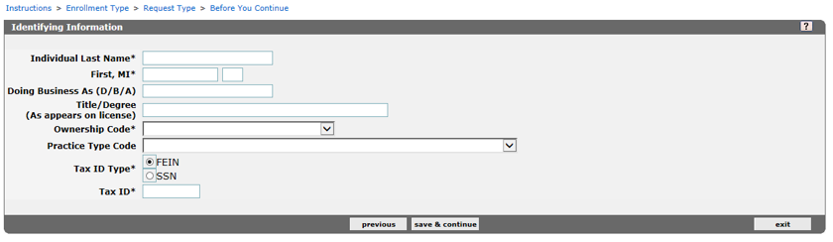
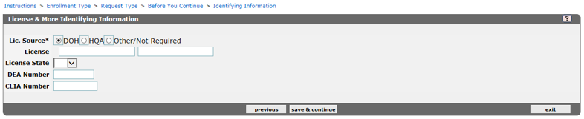
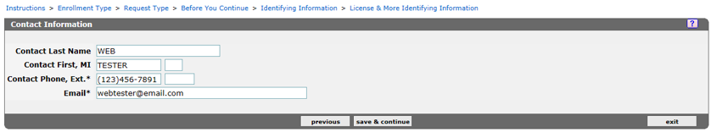
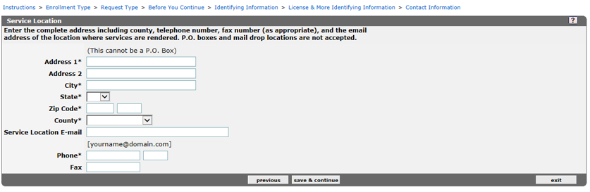

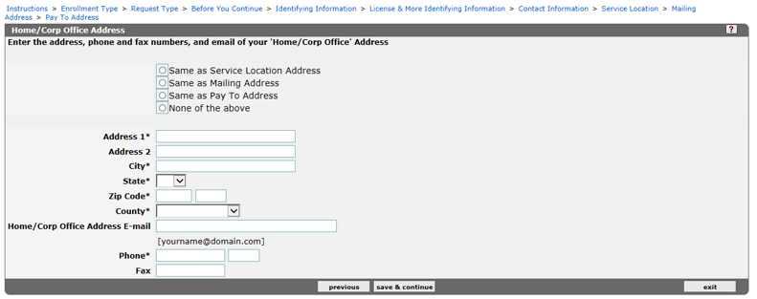
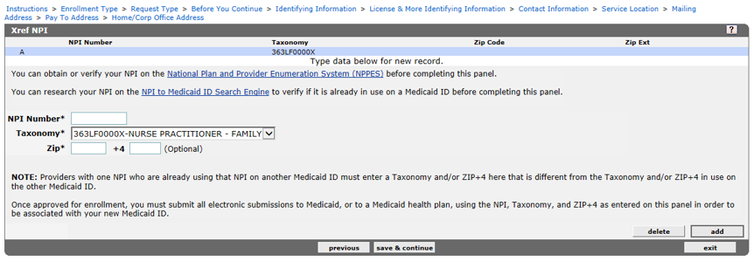
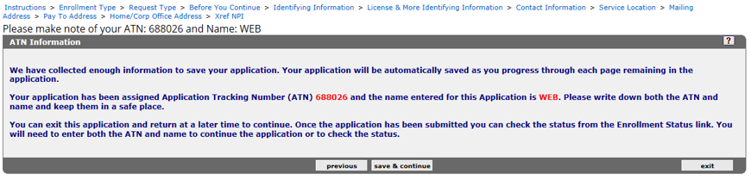

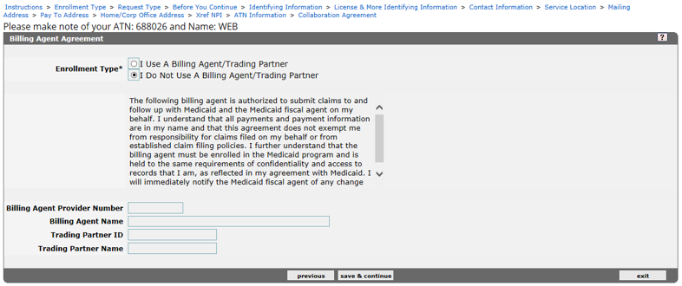
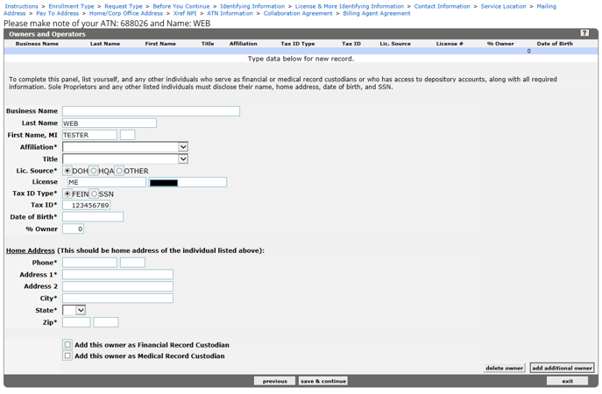

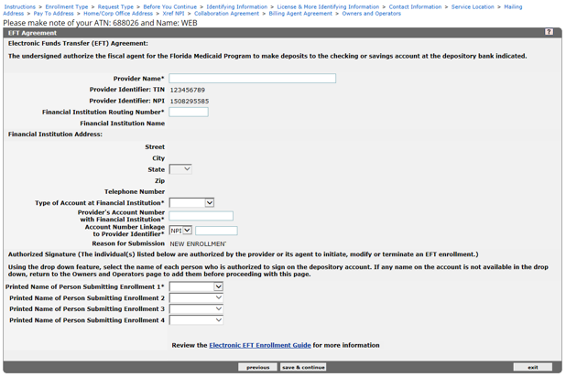
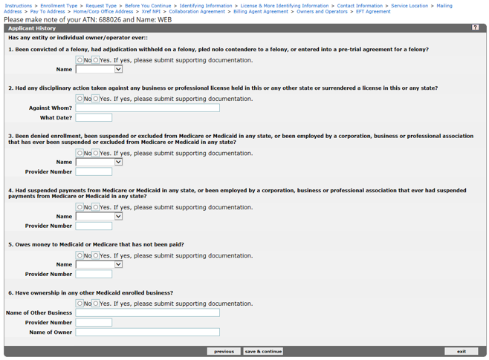

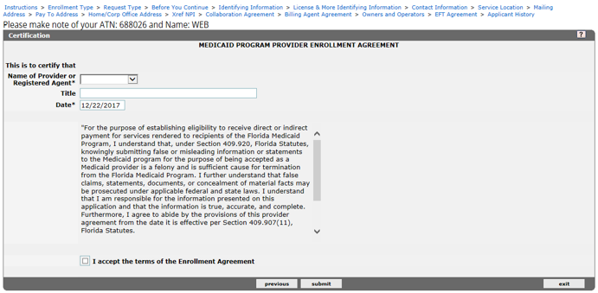

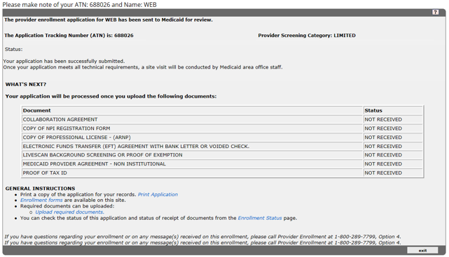

LIMITED ENROLLMENT
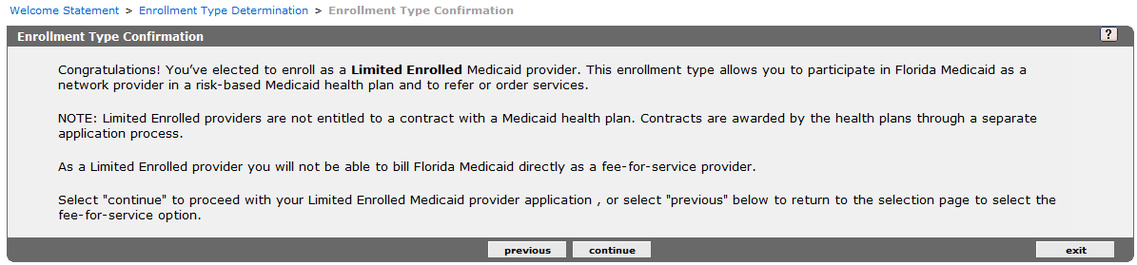
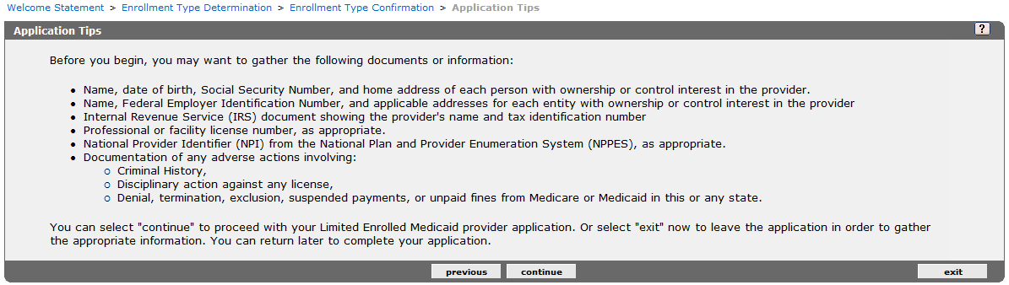

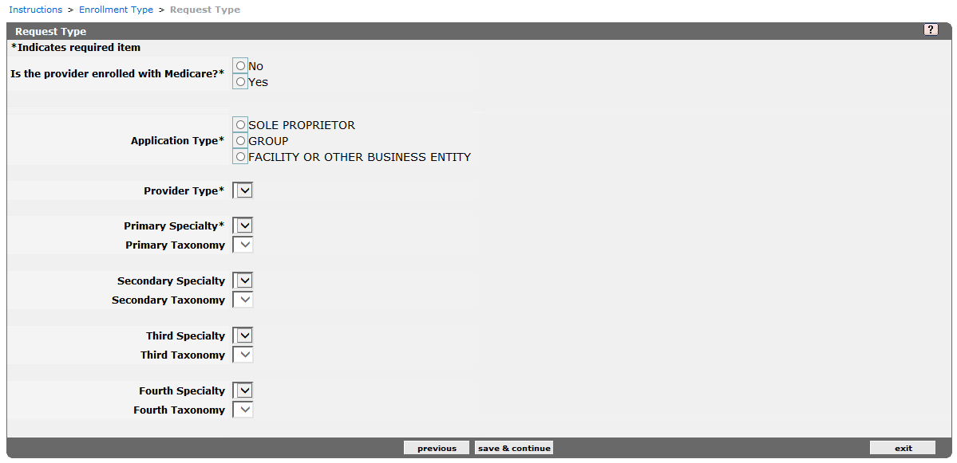
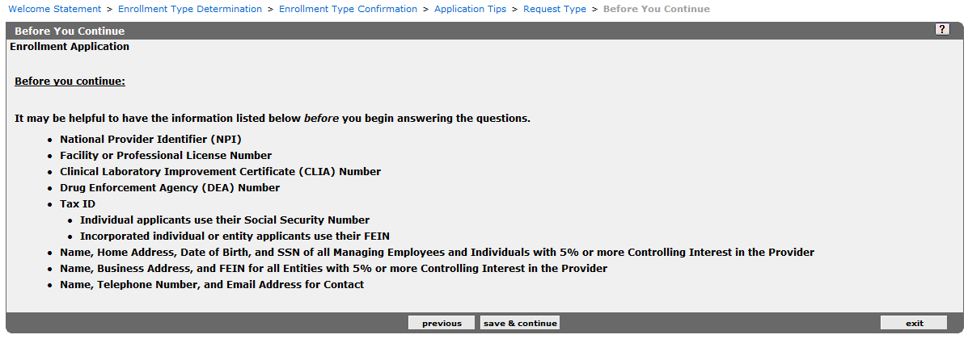
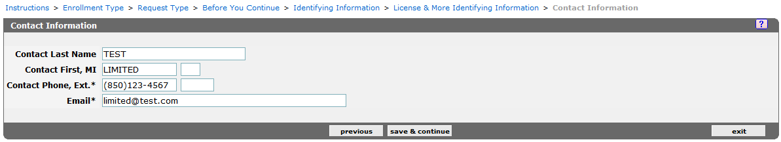
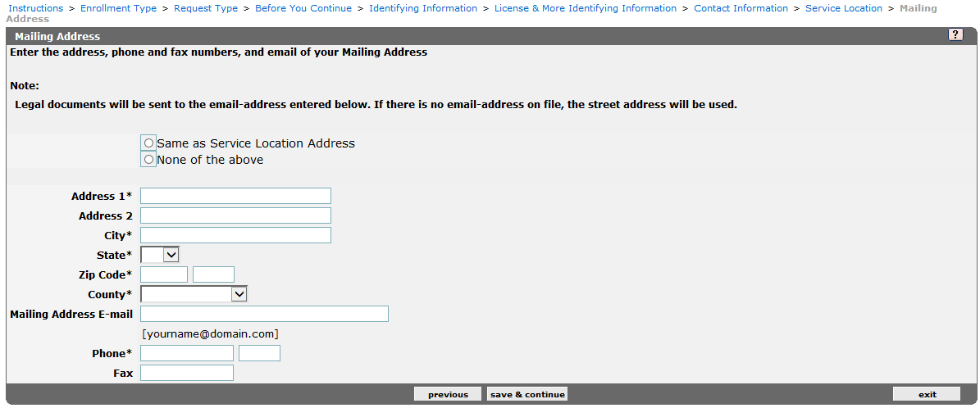
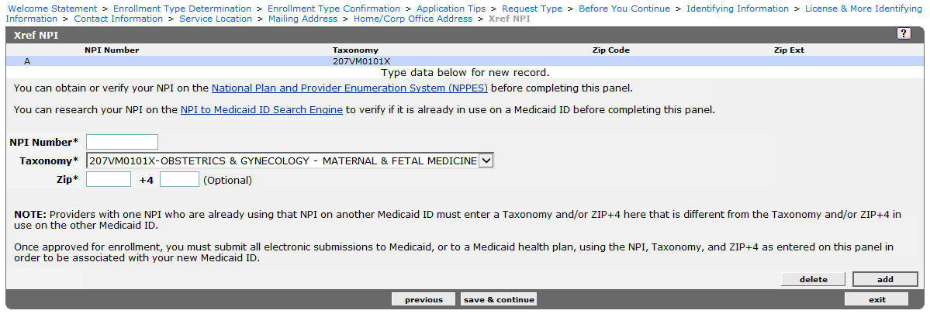
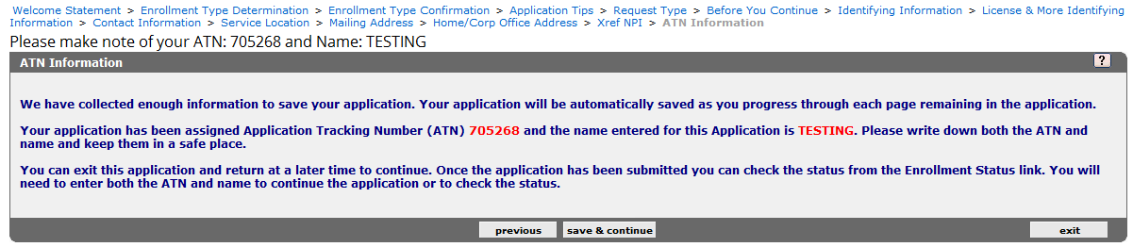
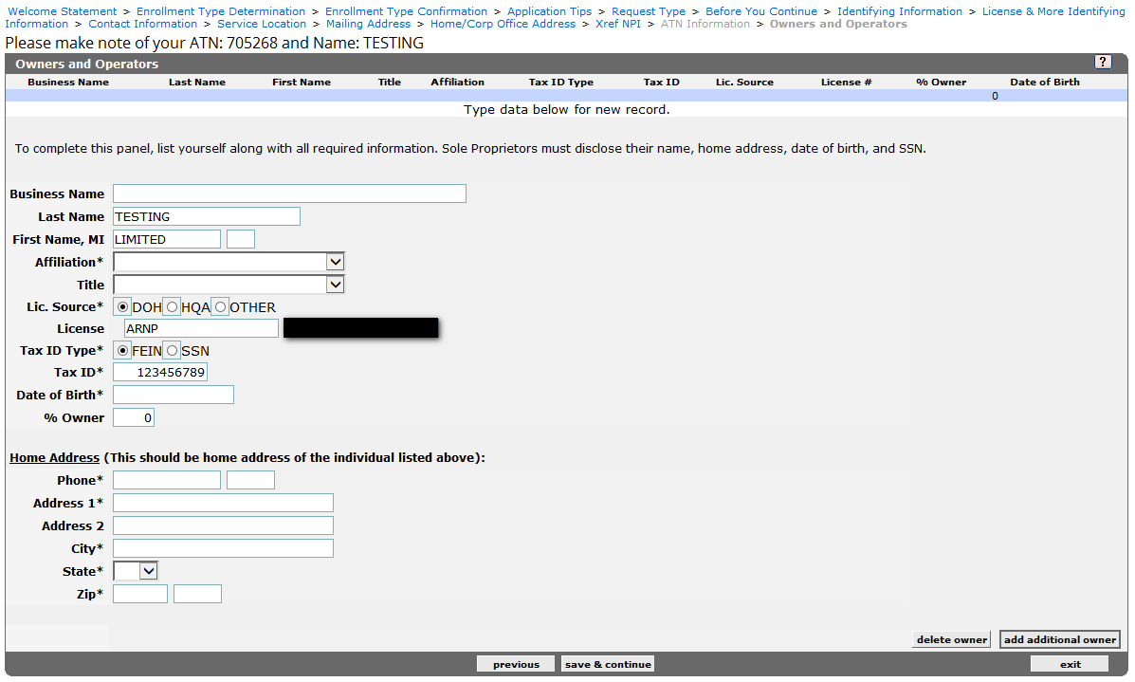

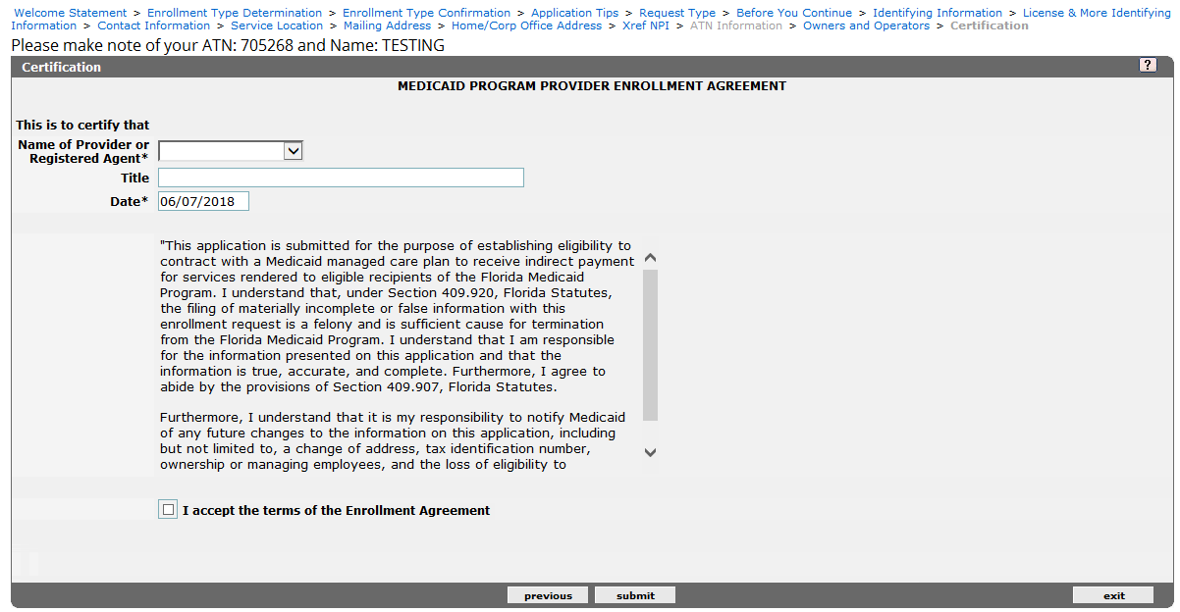
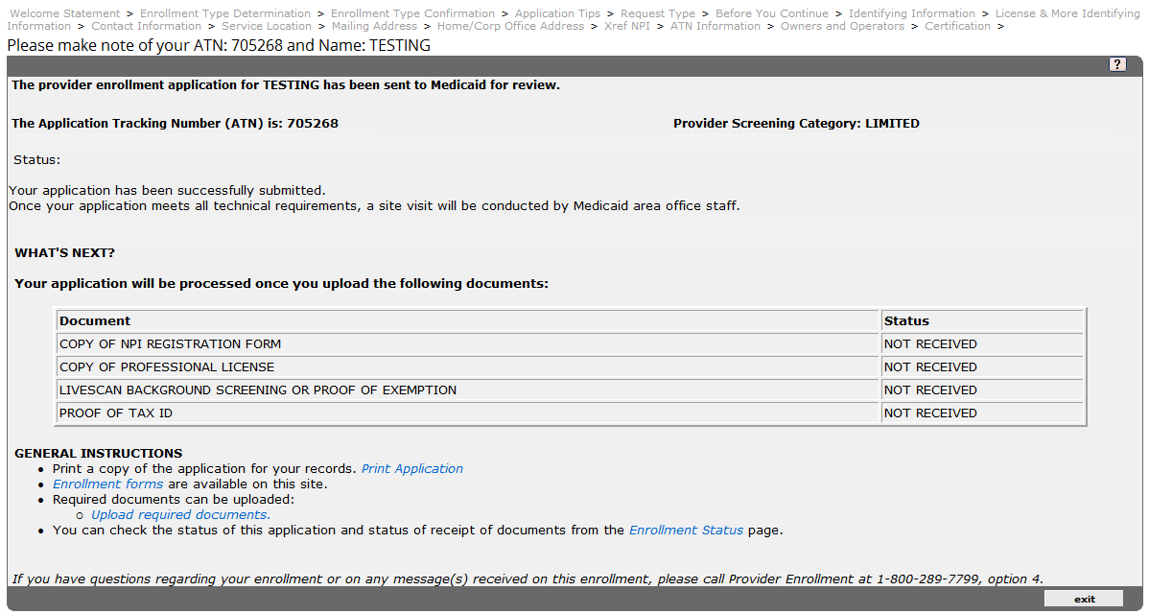
ROPA ENROLLMENT
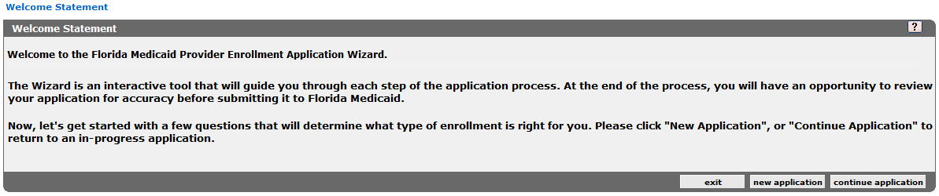
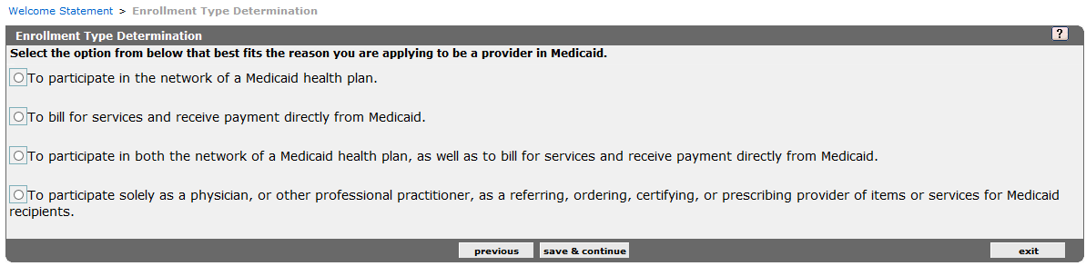
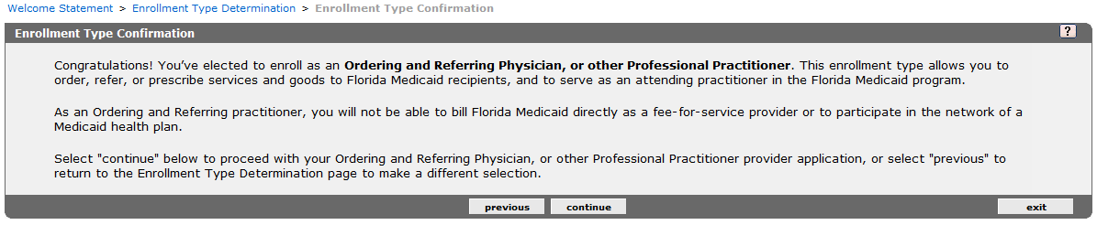
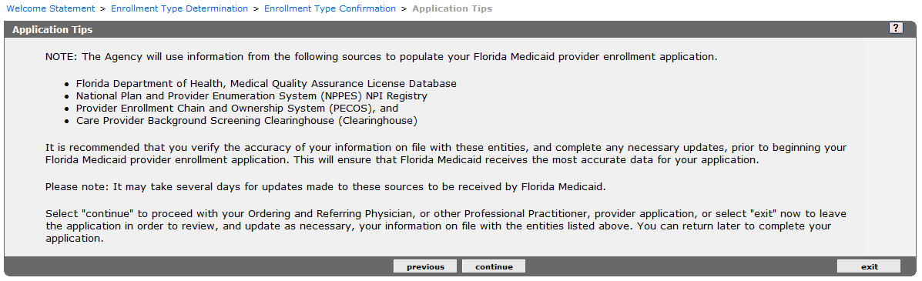
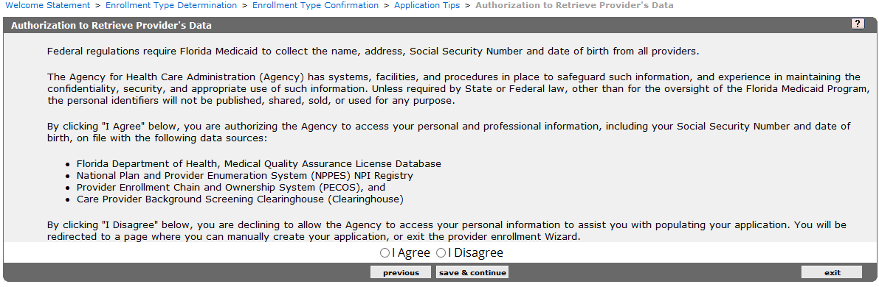
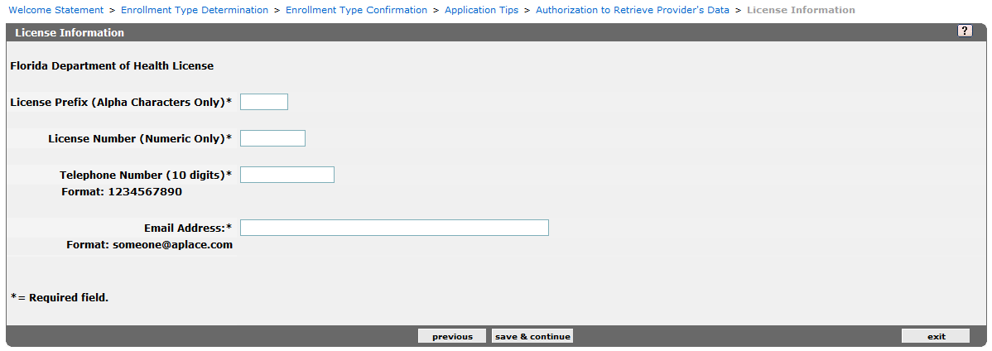

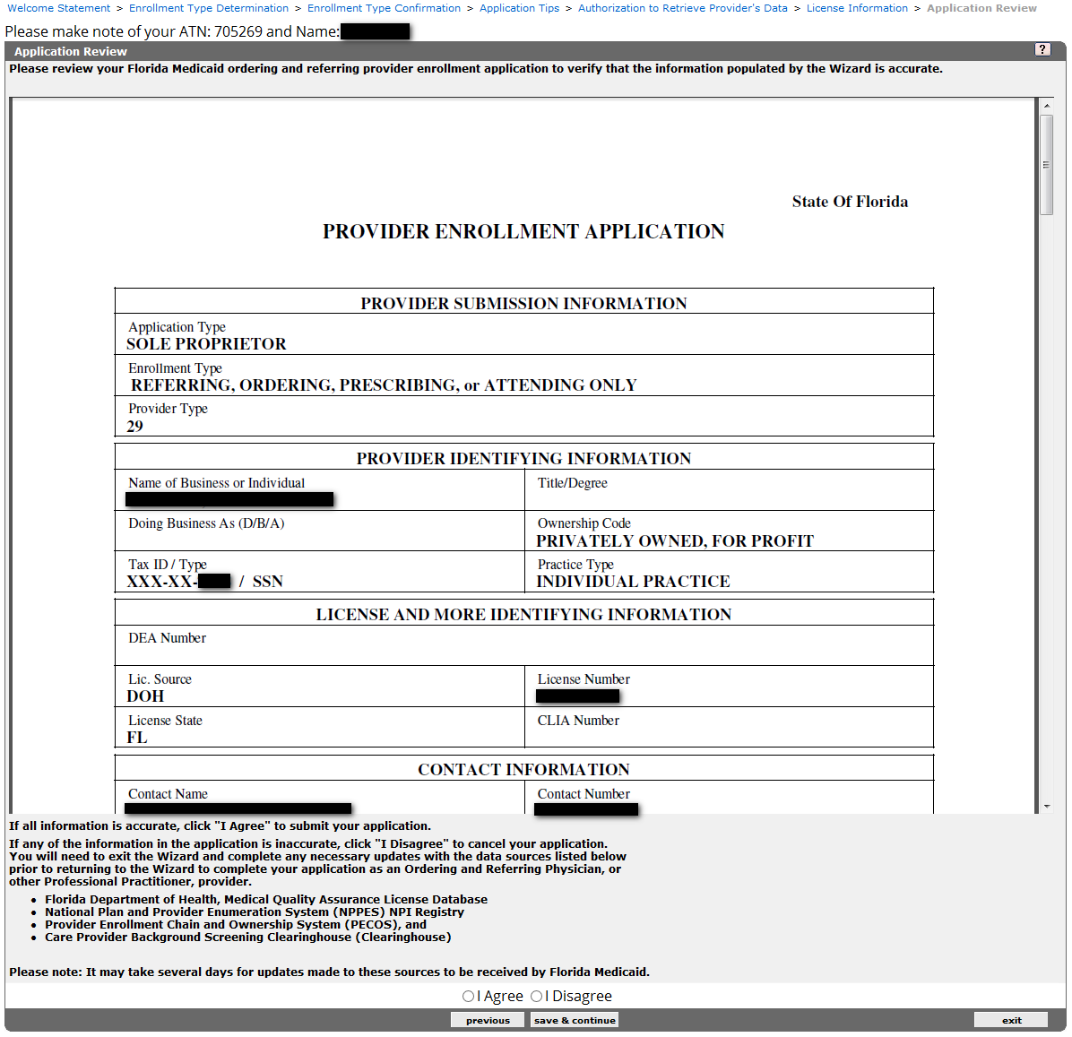

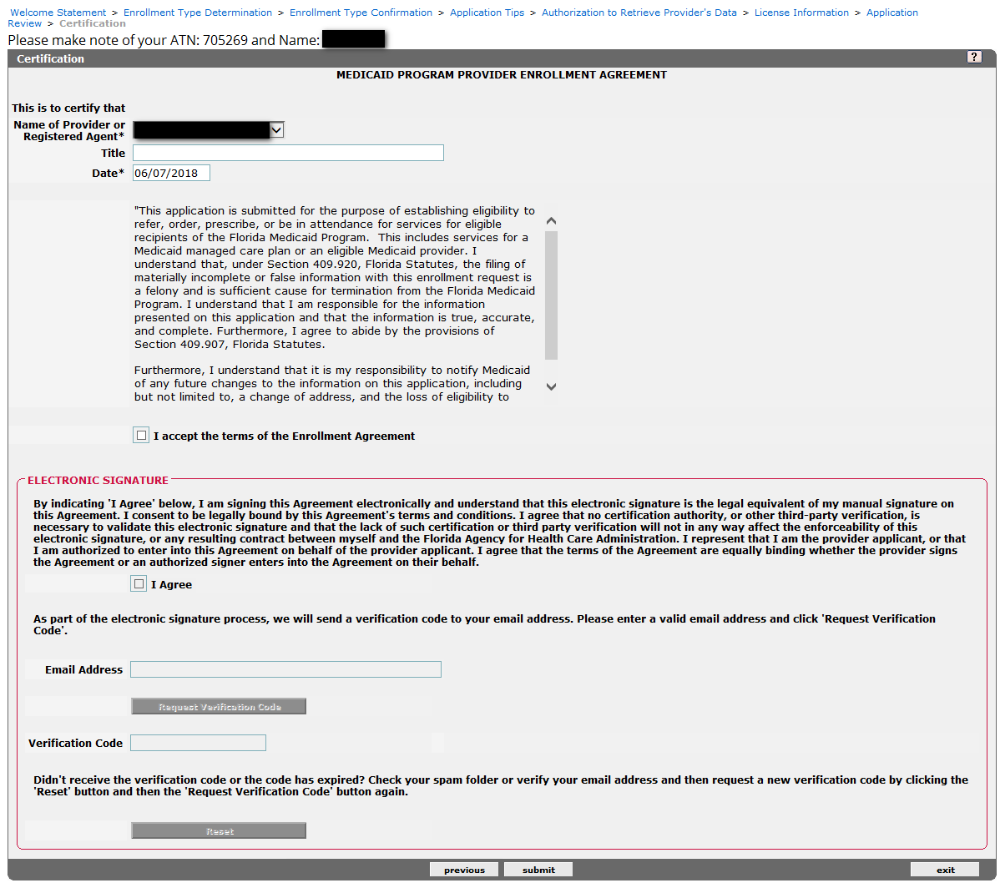
- Appendix B: Medicaid Provider Types and Specialties

Provider Type Code | Provider Type Description | Specialty Code | Specialty Description
40 | Ambulance | 940 | Ambulance
42 | Ambulance, Air | 942 | Air Ambulance
06 | Ambulatory Health Care Facility | 906 | Ambulatory Surgery Center
14 | Assistive Care Services | 121 | Assisted Living Facility
14 | Assistive Care Services | 122 | Extended Congregate Care
14 | Assistive Care Services | 123 | Limited Nursing
14 | Assistive Care Services | 124 | Limited Mental Health
14 | Assistive Care Services | 125 | Adult Family Care Home
14 | Assistive Care Services | 126 | Residential Treatment Facility
14 | Assistive Care Services | 914 | Assistive Care Services
60 | Audiologist | 960 | Audiologist
39 | Behavior Analysis | 390 | Registered Behavior Technician (RBT)
39 | Behavior Analysis | 391 | Assistant Behavior Analyst
39 | Behavior Analysis | 392 | Lead Analyst
39 | Behavior Analysis | 393 | Behavior Analysis Group
69 | Birth Center | 969 | Birth Center
91 | Case Management Agency | 174 | Mental Health Targeted Case Management (TCM)
91 | Case Management Agency | 175 | Children at Risk of Abuse and Neglect
91 | Case Management Agency | 176 | Department of Health (DOH) Children’s Medical Services (CMS) TCM
91 | Case Management Agency | 177 | DOH CMS Medical Foster Care (MFC) TCM
91 | Case Management Agency | 178 | Provider Service Network
91 | Case Management Agency | 991 | Case Management Agency
78 | Children's Medical Services | 978 | Children's Medical Services
28 | Chiropractor | 928 | Chiropractor
05 | Community Behavioral Health Services | 905 | Community Mental Health Services
77 | County Health Department (CHD) | 977 | County Health Department
35 | Dentist | 070 | Adult Dentures Only
35 | Dentist | 071 | General Dentistry
35 | Dentist | 072 | Oral Surgery (Dentist)
35 | Dentist | 073 | Periodontist
35 | Dentist | 074 | Other Dentist
35 | Dentist | 088 | Orthodontist
89 | Dialysis Center | 989 | Dialysis Center
90 | Durable Med Equip/ Medical Supplies | 069 | Medical Oxygen Retailer
90 | Durable Med Equip/ Medical Supplies | 990 | Durable Med Equip/ Medical Supplies
81 | Early Intervention Services (EIS) | 981 | Early Intervention Services
68 | Federally Qualified Health Center (FQHC) | 968 | Federally Qualified Health Center
61 | Hearing Aid Specialist | 961 | Hearing Aid Specialist
67 | Home & Community-Based Services | 068 | Consumer Directed Care
67 | Home & Community-Based Services | 094 | Model
67 | Home & Community-Based Services | 096 | Developmental Disability - iBudget
67 | Home & Community-Based Services | 110 | Familial Dysautonomia
67 | Home & Community-Based Services | 119 | Statewide Medicaid Managed Care Waiver Services
65 | Home Health Services | 114 | Personal Care
65 | Home Health Services | 117 | Independent Home Health Nurse – LPN
65 | Home Health Services | 118 | Independent Home Health Nurse – RN
65 | Home Health Services | 965 | Home Health Agency
65 | Home Health Services | 090 | Occupational Therapist
65 | Home Health Services | 091 | Physical Therapist
65 | Home Health Services | 092 | Speech Therapist
15 | Hospice | 915 | Hospice
01 | Hospital, General | 200 | Hospital with Birth Delivery Services
01 | Hospital, General | 201 | Emergency Services
01 | Hospital, General | 901 | General Hospital
09 | Hospital-Based Skilled Nursing Facility | 909 | Hospital-Based Skilled Nursing Facility
50 | Independent Laboratory | 950 | Independent Laboratory
12 | Intermediate Care Facility for Individuals with Intellectual Disabilities (ICF/IID) – Private | 912 | Private ICF/IID Facility
11 | ICF/IID Facility – State | 911 | State ICF/IID Facility
34 | Licensed Midwife | 934 | Licensed Midwife
97 | Managed Care Treating Provider | 800 | Acupuncturist
97 | Managed Care Treating Provider | 801 | Nutritionist
97 | Managed Care Treating Provider | 802 | Independent Diagnostic Testing Facility
97 | Managed Care Treating Provider | 803 | Other
36 | Medical Assistant | 130 | Anesthesiology Assistant
23 | Medical Foster Care/ Personal Care | 923 | Medical Foster Care/ Personal Care
30 | Nurse Practitioner (Advanced Practice Registered Nurse – APRN) | 075 | Adult Primary Care
30 | Nurse Practitioner (APRN) | 076 | Clinical Nurse Specialist Psych. Mental Health
30 | Nurse Practitioner (APRN) | 077 | College Health Nurse
30 | Nurse Practitioner (APRN) | 078 | Diabetic Nurse Practitioner
30 | Nurse Practitioner (APRN) | 080 | Family Nurse
30 | Nurse Practitioner (APRN) | 081 | Family Planning
30 | Nurse Practitioner (APRN) | 082 | Geriatric
30 | Nurse Practitioner (APRN) | 083 | Maternal/Child Health Family Planning
30 | Nurse Practitioner (APRN) | 084 | Certified Registered Nurse Anesthetist
30 | Nurse Practitioner (APRN) | 085 | Certified Registered Nurse Midwife
30 | Nurse Practitioner (APRN) | 086 | OB/GYN Nurse
30 | Nurse Practitioner (APRN) | 087 | Pediatric Nurse
30 | Nurse Practitioner (APRN) | 160 | Retail Clinic
30 | Nurse Practitioner (APRN) | 177 | DOH CMS MFC TCM
30 | Nurse Practitioner (APRN) | 930 | Nurse Practitioner (APRN)
63 | Optician | 963 | Optician
62 | Optometrist | 962 | Optometrist
25 | Physician (Doctor of Medicine - M.D.) | 100 | Genetics
26 | Physician (Doctor of Osteopathic Medicine D.O.) | 100 | Genetics
25, 26 | Physician (M.D.)(D.O.) | 101 | Pediatrics, Critical Care
25, 26 | Physician (M.D.) (D.O.) | 102 | Pediatrics, Emergency Care
25, 26 | Physician (M.D.) (D.O.) | 103 | Pediatrics, Surgery Non-Board Certified
25, 26 | Physician (M.D.) (D.O.) | 104 | Surgery, Urologic Non-Board Certified
25, 26 | Physician (M.D.) (D.O.) | 140 | Hospitalist
25, 26 | Physician (M.D.) (D.O.) | 205 | Endocrinology (Pediatrics)
25, 26 | Physician (M.D.) (D.O.) | 209 | Urology
25, 26 | Physician (M.D.) (D.O.) | 220 | Medical School Mobile Units
25, 26 | Physician (M.D.) (D.O.) | 001 | Adolescent Medicine
25, 26 | Physician (M.D.) (D.O.) | 002 | Allergy
25, 26 | Physician (M.D.) (D.O.) | 003 | Anesthesiology
25, 26 | Physician (M.D.) (D.O.) | 004 | Cardiovascular Medicine
25, 26 | Physician (M.D.) (D.O.) | 005 | Dermatology
25, 26 | Physician (M.D.) (D.O.) | 006 | Diabetes
25, 26 | Physician (M.D.) (D.O.) | 007 | Emergency Medicine
25, 26 | Physician (M.D.) (D.O.) | 008 | Endocrinology
25, 26 | Physician (M.D.) (D.O.) | 009 | Family Practice
25, 26 | Physician (M.D.) (D.O.) | 010 | Gastroenterology
25, 26 | Physician (M.D.) (D.O.) | 011 | General Practice
25, 26 | Physician (M.D.) (D.O.) | 012 | Preventive Medicine
25, 26 | Physician (M.D.) (D.O.) | 013 | Geriatrics
25, 26 | Physician (M.D.) (D.O.) | 014 | Gynecology
25, 26 | Physician (M.D.) (D.O.) | 015 | Hematology
25, 26 | Physician (M.D) (D.O.) | 016 | Immunology
25, 26 | Physician (M.D.) (D.O.) | 017 | Infectious Diseases
25, 26 | Physician (M.D.) (D.O.) | 018 | Internal Medicine
25, 26 | Physician (M.D.) (D.O.) | 019 | Neonatal/Perinatal
25, 26 | Physician (M.D.) (D.O.) | 021 | Nephrology
25, 26 | Physician (M.D.) (D.O.) | 022 | Neurology
25, 26 | Physician (M.D.) (D.O.) | 023 | Neurology/Children
25, 26 | Physician (M.D.) (D.O.) | 024 | Neuropathology
25, 26 | Physician (M.D.) (D.O.) | 026 | Obstetrics
25, 26 | Physician (M.D.) (D.O.) | 027 | OB-GYN
25, 26 | Physician (M.D.) (D.O.) | 028 | Occupational Medicine
25, 26 | Physician (M.D.) (D.O.) | 029 | Oncology
25, 26 | Physician (M.D.) (D.O.) | 030 | Ophthalmology
25, 26 | Physician (M.D.) (D.O.) | 031 | Otolaryngology
25, 26 | Physician (M.D.) (D.O.) | 032 | Pathology
25, 26 | Physician (M.D.) (D.O.) | 033 | Pathology, Clinical
25, 26 | Physician (M.D.) (D.O.) | 034 | Pathology, Forensic
25, 26 | Physician (M.D.) (D.O.) | 035 | Pediatrics
25, 26 | Physician (M.D.) (D.O.) | 036 | Pediatrics, Allergy
25, 26 | Physician (M.D.) (D.O.) | 037 | Pediatrics, Cardiology
25, 26 | Physician (M.D.) (D.O.) | 038 | Pediatrics, Oncology/Hematology
25, 26 | Physician (M.D.) (D.O.) | 039 | Pediatrics, Nephrology
25, 26 | Physician (M.D.) (D.O.) | 041 | Physical Medicine & Rehab
25, 26 | Physician (M.D.) (D.O.) | 042 | Psychiatry
25, 26 | Physician (M.D.) (D.O.) | 043 | Psychiatry, Child
25, 26 | Physician (M.D.) (D.O.) | 044 | Psychoanalysis
25, 26 | Physician (M.D.) (D.O.) | 045 | Public Health
25, 26 | Physician (M.D.) (D.O.) | 046 | Pulmonary Diseases
25, 26 | Physician (M.D.) (D.O.) | 047 | Radiology
25, 26 | Physician (M.D.) (D.O.) | 048 | Radiology, Diagnostic
25, 26 | Physician (M.D.) (D.O.) | 049 | Radiology, Pediatric
25, 26 | Physician (M.D.) (D.O.) | 050 | Radiology, Therapeutic
25, 26 | Physician (M.D.) (D.O.) | 051 | Rheumatology
25, 26 | Physician (M.D.) (D.O.) | 052 | Surgery, Abdominal
25, 26 | Physician (M.D.) (D.O.) | 053 | Surgery, Cardiovascular
25, 26 | Physician (M.D.) (D.O.) | 054 | Surgery, Colon/Rectal
25, 26 | Physician (M.D.) (D.O.) | 055 | Surgery, General
25, 26 | Physician (M.D.) (D.O.) | 056 | Surgery, Hand
25, 26 | Physician (M.D.) (D.O.) | 057 | Surgery, Neurological
25, 26 | Physician (M.D.) (D.O.) | 058 | Surgery, Orthopedic
25, 26 | Physician (M.D.) (D.O.) | 059 | Surgery, Pediatric Board Certified
25, 26 | Physician (M.D.) (D.O.) | 060 | Surgery, Plastic
25, 26 | Physician (M.D.) (D.O.) | 061 | Surgery, Thoracic
25, 26 | Physician (M.D.) (D.O.) | 062 | Surgery, Traumatic
25, 26 | Physician (M.D.) (D.O.) | 063 | Surgery, Urologic Board Certified
25, 26 | Physician (M.D.) (D.O.) | 065 | Maternal/Fetal
25, 26 | Physician (M.D.) (D.O.) | 066 | Comp Behavioral Health Assessment
25, 26 | Physician (M.D.) (D.O.) | 067 | Specialized Therapeutic Foster Care
25, 26 | Physician (M.D.) (D.O.) | 105 | Pediatric Palliative Care
29 | Physician Assistant | 929 | Physician Assistant
27 | Podiatrist | 927 | Podiatrist
51 | Portable X-ray Company | 951 | Portable X-ray Company
20 | Prescribed Drug Services | 150 | Community Pharmacy
20 | Prescribed Drug Services | 151 | Infusion Pharmacy
20 | Prescribed Drug Services | 152 | Long-Term Care (LTC) –  Non-Community
20 | Prescribed Drug Services | 153 | Institutional Class 1 Pharmacy (Hospital/Nursing Home)
20 | Prescribed Drug Services | 154 | Tax Supported
20 | Prescribed Drug Services | 155 | 340B Pharmacy
20 | Prescribed Drug Services | 156 | Dispensing Practitioner
20 | Prescribed Drug Services | 157 | Nuclear Pharmacy
20 | Prescribed Drug Services | 158 | Special Pharmacy (Parenteral, ALF, Closed System, End Stage Renal Disease
24 | Prescribed Pediatric Extended Care | 924 | Prescribed Pediatric Extended Care
16 | Psychiatric Resident Treatment Facility | 306 | Psychiatric Resident Treatment Facility
37 | Registered Dental Hygienist | 937 | Registered Dental Hygienist
31 | Registered Nurse/Registered Nurse First Assistant (RNFA) | 172 | Registered Nurse First Assistant
31 | Registered Nurse/RNFA | 173 | County Health Department Certified Match RN/LPN
31 | Registered Nurse/RNFA | 176 | DOH CMS TCM
31 | Registered Nurse/RNFA | 177 | DOH CMS MFC TCM
31 | Registered Nurse/Registered Nurse First Assistant | 931 | Registered Nurse First Assistant
16 | Residential and Freestanding Psych | 916 | Statewide Inpatient Psychiatric Program
16 | Residential and Freestanding Psych | 300 | Freestanding Psychiatric Hospital For Children
16 | Residential and Freestanding Psych | 301 | Freestanding Psychiatric Hospital For Adults
16 | Residential and Freestanding Psych | 302 | Addictions Receiving Facility
16 | Residential and Freestanding Psych | 303 | Residential Treatment Centers for Child/Adolescent
16 | Residential and Freestanding Psych | 304 | Crisis Stabilization Unit
16 | Residential and Freestanding Psych | 305 | Short-term Residential Treatment
66 | Rural Health Clinic (RHC) | 966 | Rural Health Clinic
13 | Rural Hospital Swing Bed Facility | 913 | Rural Hospital Swing Bed Facility
08 | Schools | 811 | Charter Schools
08 | Schools | 812 | Private Schools
08 | Schools | 908 | Public Schools
10 | Skilled Nursing Facility | 910 | Skilled Nursing Facility
32 | Social Worker/Case Manager | 174 | Mental Health TCM
32 | Social Worker/Case Manager | 175 | Children at Risk of Abuse and Neglect
32 | Social Worker/Case Manager | 932 | Social Worker/Case Manager
32 | Social Worker/Case Manager | 176 | DOH CMS TCM
32 | Social Worker/Case Manager | 177 | DOH CMS MFC TCM
07 | Specialized Therapeutic Services | 907 | Specialized Therapeutic Services
07 | Specialized Therapeutic Services | 066 | Comp Behavioral Health Assessment
07 | Specialized Therapeutic Services | 067 | Specialized Therapeutic Foster Care
04 | State Mental Hospital | 904 | State Mental Hospital
83 | Therapist Physical Therapy (PT), Occupational Therapy (OT), Speech Therapy (ST), and Respiratory Therapy (RT) | 983 | Therapy Group (PT, OT, ST, RT)
83 | Therapist (PT, OT, ST, RT) | 090 | Occupational Therapist
83 | Therapist (PT, OT, ST, RT) | 091 | Physical Therapist
83 | Therapist (PT, OT, ST, RT) | 092 | Speech Therapist
83 | Therapist (PT, OT, ST, RT) | 093 | Respiratory Therapist
99 | Trading Partner | 999 | Trading Partner
47 | Transport, Multi-Load Private | 947 | Multi-Load Private Transport
44 | Transportation, Government/Municipal | 944 | Government/Municipal Transport
41 | Transportation, Non-emergency | 941 | Non-Emergency Transport
46 | Transportation, Non-profit | 946 | Non-Profit Transportation
45 | Transportation, Private | 945 | Private Transportation
43 | Transportation, Taxi | 943 | Taxicab Company

- Appendix C: General Document Requirements

The table listed in this section includes all general documents required to be submitted with a Florida Medicaid provider application. Florida Medicaid Provider Enrollment Agreements and Forms are located at http://portal.flmmis.com under Provider Services.

The following table includes minimum documentation requirements for all providers.

Provider Type
All Provider Types
Enrollment Type
Fully Enrolled
Limited
Ordering or Referring (ORP)
Fully Enrolled Required Documents
Florida Medicaid Provider Enrollment Application
Proof of Tax ID (such as an IRS Letter 147c, IRS Form SS-4 or IRS Form W-9)
Florida Medicaid National Provider Identifier (NPI) Registration, AHCA Form 5000-1060, June 2019, incorporated by reference in Rule 59G-1.060, F.A.C. (if required in accordance with 45 CFR Part 162)
Proof of Medicaid Eligible Fingerprint-based Criminal Background Check (required in accordance with s. 409.907(5), F.S.)
Bill of Sale or Stock Purchase Agreement (required for change in ownership applications)
License or certificate of exemption from licensure, Health Care Clinic*
Limited Enrolled and Ordering or Referring Providers (ORPs) Required Documents
Limited enrolled providers must provide the documents listed above.

*Providers listed in Appendix E must show proof of health care clinic licensure in accordance with s. 400.9905 and 400.991, F.S., or proof of exemption from licensure as a health care clinic in accordance with s. 400.9905 and 400.9935, F.S. Providers that are already enrolled must satisfy this requirement by the date listed in Appendix E. Providers must submit an application for health care clinic licensure or an application for exemption from licensure as a health care clinic 60-120 days prior to the date specified in the table below, in accordance with section 408.806(2)(c), F.S.
- Appendix D: Provider Specific Documents

Providers must submit all required documents in Appendix C in addition to the provider specific documents required in this section.

The following tables provide submission requirements specific to each provider type. Providers may not be required to submit information that is readily available to the Agency, such as Florida licensure.

Florida Medicaid Provider Agreements are not required in paper format for limited enrollment or ORP, unless requested by the Agency.

Provider Type
Advanced Practice Registered Nurse
Enrollment Types
Fully Enrolled
Limited
Application Types
Sole Proprietor
Sole Proprietor Enrolling as a Member of a Group
Group
Specialties
Adult Primary Care | Family Nurse
Certified Registered Nurse Anesthetist | Family Planning
Certified Registered Nurse Midwife | Geriatric
Clinical Nurse, Specialist Psychiatric Mental Health | Maternal / Child Health Family Planning
Medical Foster Care Targeted Case Management | Obstetrics/Gynecology Nurse
College Health Nurse | Pediatric Nurse
Diabetic Nurse Practitioner | Retail Health Clinic
Practice Types
Individual
Group
Required Documents
Required documents for all provider types listed in Appendix C
Non-institutional Medicaid Provider Agreement
Practitioner Collaborative Agreement, AHCA Form 5000-1067, June 2019, incorporated by reference in Rule 59G-1.060, F.A.C. (required for Sole Proprietors and Sole Proprietors Enrolling as a Member of a Group)
License, Professional
Drug Enforcement Administration Registration Certificate (Required to prescribe controlled substances)
Additional Required Documents for Sole Proprietor Enrolling as a Member of a Group or a Group
Occupational License or Business Tax Certificate (or proof from local authority that no license or certificate is required) (Sole Proprietors and Groups only)

Additional Information
- Medical Foster Care Targeted Case Management providers must
  - Be fully enrolled in Medicaid.
- Link as members of one of the following Children’s Medical Services provider group IDs – 001560000, 911162000, 056105302, 752161800, or 914319000

Provider Type
Ambulatory Health Care Facility
Enrollment Types
Fully Enrolled
Limited
Application Types
Facility or Other Business Entity
Specialty
Ambulatory Surgery Center
Practice Type
Individual
Required Documents
Required documents for all provider types listed in Appendix C
Institutional Medicaid Provider Agreement
License, Facility

Provider Type
Assistive Care Services
Enrollment Types
Fully Enrolled
Limited
Application Types
Facility or Other Business Entity
Specialties
Assisted Living
Assisted Living with Extended Congregate Care
Assisted Living with Limited Nursing
Assisted Living with Limited Mental Health
Adult Family Care Home
Residential Treatment Facility
Practice Type
Individual Practice
Required Documents
Required documents for all provider types listed in Appendix C
Institutional Medicaid Provider Agreement
License, Facility

Provider Type
Audiologist or Hearing Aid Specialist
Enrollment Types
Fully Enrolled
Limited
Application Types
Sole Proprietor
Sole Proprietor Enrolling as a Member of a Group
Group
Specialty
Audiologist
Hearing Aid Specialist
Practice Types
Individual
Group
Required Documents
Required documents for all provider types listed in Appendix C
Non-institutional Medicaid Provider Agreement
License, Professional
Occupational License or Business Tax Certificate (or proof from local authority that no license or certificate is required) (required for Sole Proprietors and Groups)

Provider Type

Behavior Analysis – Lead Analyst (Sole Proprietor)
Enrollment Type
Fully Enrolled
Application Type
Sole Proprietor
Specialties
Lead Analyst
Practice Type
Individual
Required Documents
Required documents for all provider types listed in Appendix C
Non-institutional Medicaid Provider Agreement
Proof of one or more of the following:
- Behavior Analyst Certification Board designation as a
  - Board Certified Behavior Analyst (BCBA) or
  - Board Certified Behavior Analyst Doctoral (BCBA-D)
- Florida Certified Behavior Analyst (FL-CBA)
- Florida Licensed Clinical Social Worker
- Florida Licensed Mental Health Counselor
- Florida Licensed Marriage and Family Therapist
- Florida Licensed Psychologist
- Florida Licensed School Psychologist

Behavior Analysis – Lead Analyst (Sole Proprietor Enrolling as a Member of a Group)
Enrollment Type
Fully Enrolled
Application Type
Sole Proprietor Enrolling as a Member of a Group
Specialties
Lead Analyst
Practice Type
Individual
Required Documents
Required documents for all provider types listed in Appendix C
Non-institutional Medicaid Provider Agreement
Copy of one or more of the following:
- Behavior Analyst Certification Board designation as a
  - Board Certified Behavior Analyst (BCBA), or
  - Board Certified Behavior Analyst Doctoral (BCBA-D)
- Florida Certified Behavior Analyst (FL-CBA)
- Florida Licensed Clinical Social Worker
- Florida Licensed Mental Health Counselor
- Florida Licensed Marriage and Family Therapist
- Florida Licensed Psychologist
- Florida Licensed School Psychologist

Behavior Analysis – Assistant Behavior Analyst
Enrollment Type
Fully Enrolled
Application Type
Sole Proprietor Enrolling as a Member of a Group
Specialties
Assistant Behavior Analyst
Practice Type
Individual
Required Documents
Required documents for all provider types listed in Appendix C
Non-institutional Medicaid Provider Agreement
Copy of Behavior Analyst Certification Board designation as an Assistant Behavior Analyst (BCaBA)

Behavior Analysis – Registered Behavior Technician
Enrollment Type
Fully Enrolled
Application Type
Sole Proprietor Enrolling as a Member of a Group
Specialties
Registered Behavior Technician
Practice Type
Individual
Required Documents
Required documents for all provider types listed in Appendix C
Non-institutional Medicaid Provider Agreement
Copy of Behavior Analyst Certification Board designation as a Registered Behavior Technician (RBT) certification

Provider Type

Behavior Analysis – Group
Enrollment Type
Fully Enrolled
Application Type
Group
Specialties
Behavior Analysis Group
Practice Type
Group
Required Documents
Required documents for all provider types listed in Appendix C
Non-institutional Medicaid Provider Agreement
Surety Bond

Additional Information
Behavior Analysis groups must employ, or contract with, at least one Florida Medicaid enrolled lead analyst. The lead analyst must be added as a member of the group using the Group Membership Authorization, AHCA Form 5000-1061, June 2019, incorporated by reference in Rule 59G-1.060, F.A.C.

Provider Type
Birth Center
Enrollment Types
Fully Enrolled
Limited
Application Types
Facility or other Business Entity
Specialty
Birth Center
Practice Types
Group
Required Documents
Required documents for all provider types listed in Appendix C
Institutional Medicaid Provider Agreement
License, Facility
Occupational License or Business Tax Certificate (or proof from local authority that no license or certificate is required)

Additional Information
- Group members must be enrolled in Florida Medicaid as licensed midwives.

Provider Type
Case Management Agency - Child Health Services Targeted Case Management
Enrollment Types
Fully Enrolled
Application Types
Group
Specialties
Child Health Services Targeted Case Management
Practice Types
Group
Required Documents
Required documents for all provider types listed in Appendix C
Institutional Medicaid Provider Agreement
Occupational License or Business Tax Certificate (or proof from local authority that no license or certificate is required)

Provider Type
Case Management Agency – Mental Health Targeted Case Management (MHTCM)
Enrollment Types
Fully Enrolled
Limited
Application Types
Group
Specialties
Mental Health Targeted Case Management
Practice Types
Group
Required Documents
Required documents for all provider types listed in Appendix C
Institutional Medicaid Provider Agreement
Occupational License or Business Tax Certificate (or proof from local authority that no license or certificate is required)
One or more of the following certifications in the Mental Health Targeted Case Management Handbook (Rule 59G-4.199, F.A.C.):
- Children’s Mental Health Targeted Case Management, Appendix B
- Adult Mental Health Targeted Case Management, Appendix C
- Intensive Case Management Team Services – Adult Mental Health Targeted Case Management, Appendix D

Additional Information

Mental Health Targeted Case Management
- A mental health TCM agency must enroll as a Medicaid group provider. The group must consist of at least one case management supervisor and requires all case managers to be certified prior to rendering services.
- All supervisors and case managers providing Mental Health TCM must have Florida Certification Board certification.

Provider Type
Case Management Agency – Targeted Case Management for Children at Risk of Abuse and Neglect
Enrollment Types
Fully Enrolled
Limited
Application Types
Group
Specialties
Targeted Case Management – Children at Risk of Abuse and Neglect
Practice Types
Group
Required Documents
Required documents for all provider types listed in Appendix C
Institutional Medicaid Provider Agreement
Occupational License or Business Tax Certificate (or proof from local authority that no license or certificate is required)
Proof of Provider Agency Certification for Children’s Services Council, Appendix F
Additional Information

- Providers enrolling in Targeted Case Management Children at Risk of Abuse and Neglect must be located in one of the following counties – Broward, Duval, Hillsborough, Martin, Miami-Dade, Palm Beach, or Pinellas
Provider Type
Chiropractor
Enrollment Types
Fully Enrolled
Limited
Application Types
Sole Proprietor
Sole Proprietor Enrolling as a Member of a Group
Group
Specialty
Chiropractor
Practice Types
Individual
Group
Additional Required Documents
Required documents for all provider types listed in Appendix C
Non-institutional Medicaid Provider Agreement
Occupational License or Business Tax Certificate (or proof from local authority that no license or certificate is required) (required for Sole Proprietors and Groups)
License, Professional

Provider Type
Clinic Services - Rural Health Clinic, Federally Qualified Health Center, or County Health Department
Enrollment Types
Fully Enrolled
Application Type
Group
Specialties
Rural Health Clinic
Federally Qualified Health Center
County Health Department
Practice Type
Group
Required Documents
Required documents for all provider types listed in Appendix C
Non-institutional Medicaid Provider Agreement
Occupational License or Business Tax Certificate (required only for non-government owned clinics)
Additional Required Documents for FQHCs
Copy of one of the following:
- 329, 330 or 340 Public Health Services Grant
- Waiver of the Public Health Services Grant requirement issued by the Secretary of Health & Human Services
- Health Resources & Services Administration notice of Federally Qualified Health Center look-a-like designation
Additional Required Documents for RHCs
Medicare Part A Certification Letter

Additional Information
- Florida Medicaid will automatically assign a physician group Medicaid ID to be used for billing physician services that are not included in the encounter rate.
- Clinics may submit a request in writing to Florida Medicaid for a dental group Medicaid ID to be used for billing dental services that are not included in the encounter rate.
- Group members must be any of the following Medicaid enrolled practitioner types: APRN, Chiropractor, Dentist, Optometrist, Physician (M.D or D.O.), Physician Assistant, or Podiatrist.
- Commissioned medical officers of the Public Health Service (PHS) or Armed Forces of the United States on active duty, acting within the scope of their PHS or military responsibilities may enroll as group members linked to an FQHC.
- A County Health Department can enroll for Clinic Services or the Certified Match Program.
  - Clinic Services
    - The following providers who are employed, under contract or volunteer at a CHD, are not required to be enrolled in Medicaid:
      - APRNs
      - Dental Assistants
      - Dental Hygienists
  - Certified Match
    - The following providers who are employed by a Certified Match CHD must be enrolled in Medicaid and a member of the CHD group:
      - RNs
      - APRNs
      - LPNs
    - Nurses with temporary licenses are not eligible to enroll.
    - Nurse’s aides or assistants who are not licensed to provide nursing services are not eligible to enroll.
    - CHDs employing, contracting, or accepting volunteer services from Licensed Social Workers must submit the County Health Department Agreement Provider Credentialing of Behavioral Health Providers and Social Workers, AHCA Form 5000-1066, June 2019, incorporated by reference in Rule 59G-1.060, F.A.C.

- FQHC treating practitioners, including volunteers, must enroll as Florida Medicaid treating providers and be enrolled as members of the FQHC with the following exceptions:
  - Dental hygienists, licensed clinical social workers, LPNs, and RNs are not required to enroll as members of a FQHC group.
  - Dental assistants and licensed psychologists may not enroll as members of a FQHC group.

Provider Type
Community Behavioral Health Services
Enrollment Types
Fully Enrolled
Limited
Application Type
Group
Specialty
Community Behavioral Health Services
Practice Type
Group
Required Documents
Required documents for all provider types listed in Appendix C
Non-institutional Medicaid Provider Agreement
Occupational License or Business Tax Certificate (or proof from local authority that no license or certificate is required)
Copy of Florida Department of Children and Families, Substance Abuse License (required only if providing substance abuse services-not required for limited enrollment)
Additional Information
- Group members must be Florida Medicaid enrolled specialized therapeutic services or physician (M.D. or D.O.) providers. At least one group member must be a Florida Medicaid enrolled physician.
- Providers must have a separate Medicaid ID number for all service locations.

Provider Type
Dentist
Enrollment Types
Fully Enrolled
Limited
Application Types
Sole Proprietor
Sole Proprietor Enrolling as a Member of a Group
Group
Specialties
Adult Dentures
General Dentistry
Oral Surgery
Periodontist
Orthodontist
Other Dentist
Practice Types
Individual
Group
Required Documents
Required documents for all provider types listed in Appendix C
Non-institutional Medicaid Provider Agreement
License, Professional
Drug Enforcement Administration Registration Certificate (Required to prescribe controlled substances)
Additional Required Documents for Sole Proprietor Enrolling as a Member of a Group or a Group
Occupational License or Business Tax Certificate (or proof from local authority that no license or certificate is required) (Sole Proprietors and Groups only)

Additional Information
- Dental groups must be owned by a dentist(s) in accordance with s. 466.0285, F.S.
- Dentists with a Dental Health Access License must be linked as a member of a school, FQHC, or CHD in accordance with sections 466.067 and 466.003, F.S.

Provider Type
Department of Health Children’s Medical Services
Enrollment Types
Fully Enrolled
Application Types
Group
Specialties
Children’s Medical Services
Practice Types
Group
Required Documents
Required documents for all provider types listed in Appendix C
Non-institutional Medicaid Provider Agreement

Additional Information

- Members enrolling in a CMS group must:
  - Be an APRN, registered nurse, or case manager supervisor with one of the following specialties:
    - Medical Foster Care Targeted Case Management
    - Early Steps – Infant and Toddler Developmental Services certification

Provider Type
Durable Medical Equipment and Medical Supply Services
Enrollment Types
Fully Enrolled
Limited
Application Types
Facility or Other Business Entity
Specialties
Durable Medical Equipment and Medical Supply Services
Medical Oxygen Retailer (must also apply for the Durable Medical Equipment and Medical Supplies specialty)
Practice Type
County Health Department
Diabetic Monitors and Disposable Supplies
Durable Medical Equipment and Medical Supply Services
Durable Medical Equipment and Medical Supply Services Chain (more than 5 locations)
Facility-owned (Assisted Living Facility (ALF), Ambulatory Surgical Center, Intermediate Care Facility, Home Health Agency, Nursing Home, Hospice, or Hospital)
Government Entity
Medicaid Enrolled Pharmacy
Orthotics & Prosthetics (O&P) Practice (only supplies Orthotics & Prosthetics goods)
Physician-owned Orthopedic Group (only supplies Orthotics & Prosthetics goods)
Required Documents
Required documents for all provider types listed in Appendix C
Non-institutional Medicaid Provider Agreement
Proof of Accreditation (see limited exceptions below)
License, Home Medical Equipment (HME) or Home Medical Equipment Exemption (see limited exceptions below)
Occupational License or Business Tax Certificate (or proof from local authority that no license or certificate is required) (Sole Proprietors and Groups only)
State of Florida Agency for Health Care Administration Florida Medicaid Provider Surety Bond, AHCA Form 5000-1064, June 2019, incorporated by reference in Rule 59G-1.060, F.A.C. (see limited surety bond exceptions below)

Additional Information
- Medical oxygen retailers must:
  - Provide a copy of Medical Oxygen Retailer permit
  - Employ or contract with a licensed registered respiratory therapist, certified respiratory therapist, or a registered nurse
  - Provide a copy of the most recent IRS Form W-4 or 1099 for the employee or the contractor

- The following providers are exempt from holding an HME license or HME license exemption, as required in section 400.93, F.S.:
  - Diabetic monitors & disposable supplies providers
  - Florida Medicaid enrolled physician-owned orthopedic groups (orthotics and prosthetics only)
  - Government-owned DMEs
  - Florida Medicaid enrolled pharmacies
  - Facility-owned DMEs (must submit a valid facility license)
  - Orthotics & prosthetics practices (must submit a copy of the orthotics and prosthetics practitioner’s professional license)

- Durable medical equipment providers that are exempt from HME license requirements must supply a notarized affidavit confirming that:
  - The owner has a minimum of 1 year of experience as a DME owner, or
  - The owner or manager has a minimum of 1 year of management or billing experience as an employee of a DME

The affidavit must include the name, address, and tax ID of the DME.

- The following providers are exempt from the surety bond requirement:
  - Florida Medicaid enrolled physician-owned orthopedic groups enrolling for DME services solely to provide orthotics and prosthetics
  - Government-owned DMEs
  - Florida Medicaid enrolled pharmacies
  - Orthotics & prosthetics practices (must submit the practitioner’s orthotics or prosthetics professional license)

- The following providers are exempt from the accreditation requirement in accordance with section 409.912, F.S.:
  - Government-owned DMEs
  - Florida Medicaid pharmacies
  - Physician-owned orthopedic groups

Provider Type
Early Intervention Services
Enrollment Types
Fully Enrolled
Limited
Application Types
Sole Proprietor
Sole Proprietor Enrolling as a Member of a Group
Group
Specialty
Professional Early Intervention Services
Practice Types
Individual
Group
Required Documents
Required documents for all provider types listed in Appendix C
Non-institutional Medicaid Provider Agreement
Proof of one of the following (not required for groups):
- Professional Healing Arts License
- Children’s Medical Services, Early Steps Infant and Toddler Services Certificate
Occupational License or Business Tax Certificate (or proof from local authority that no license or certificate is required) (sole proprietors and groups only)
Proof of Local Early Steps Program Contract or Letter of Intent to Contract (not required for groups)
Early Steps Provider Attestation Checklist from the local Early Steps office (not required for groups)

Additional Information

The following provider types must be licensed:
- APRN, audiologist, clinical social worker, clinical psychologist, marriage & family counselor, mental health counselor, nutrition counselor, occupational therapist, physician, physician assistant, physical therapist, registered dietitian, registered nurse, school psychologist, speech-language pathologist

Provider Type
Freestanding Dialysis Center
Enrollment Types
Fully Enrolled
Limited
Application Types
Facility or Other Business Entity
Specialty
Dialysis Center
Practice Type
Individual
Required Documents
Required documents for all provider types listed in Appendix C
Institutional Medicaid Provider Agreement
License, Facility
Medicare Certification Letter

Additional Information
- The effective date for freestanding dialysis centers is the date specified in the Medicare certification letter in accordance with s. 409.907 (9)(a), F.S.

Provider Type
Home and Community-Based Services
Enrollment Types
Fully Enrolled
Limited
Application Types
Sole Proprietor
Sole Proprietor Enrolling as a Member of a Group
Group
Facility or Other Business Entity (not available for long-term care waiver providers)
Specialties (with available Enrollment Types by Specialty)
Consumer Directed Care (iBudget) (requires approval from the Agency for Persons with Disabilities)*
Developmental Disability (iBudget) (requires approval from the Agency for Persons with Disabilities)*
Familial Dysautonomia (requires approval from the Agency for Health Care Administration)**
Model (requires approval from the Agency for Health Care Administration)**
Statewide Medicaid Managed Care Waiver Services
Practice Type
Individual
Group
Required Documents
Required documents for all provider types listed in Appendix C
Non-institutional Medicaid Provider Agreement
Medicaid Waiver Specialist approval for Specialty Type
Occupational License or Business Tax Certificate (or proof from local authority that no license or certificate is required) (Sole Proprietors Enrolling as a Member of a Group)

Additional Information

*iBudget Waiver Consumer Directed Care and Developmental Disability applicants must contact the Florida Agency for Persons with Disabilities for approval information.

**Familial Dysautonomia and Model Waiver applicants must contact the Florida Agency for Health Care Administration for approval information.

Provider Type
Home Health Services
Enrollment Types
Fully Enrolled
Limited
Application Types
Sole Proprietor
Sole Proprietor Enrolling as a Member of a Group
Group
Facility or Other Business Entity
Specialties
Personal Care, Unlicensed
Independent Nurse, Licensed Practical Nurse (LPN)
Independent Nurse, RN
Home Health Agency
Practice Type
Individual
Group
Required Documents
Required documents for all provider types listed in Appendix C
Non-institutional Medicaid Provider Agreement
License, Facility
Occupational License or Business Tax Certificate (or proof from local authority that no license or certificate is required) (Sole Proprietors and Groups only-not required for independent practitioners)
Additional Required Documents for Independent Nurse, LPN and Independent Nurse, RN
License, Professional
Additional Required Documents for Sole Proprietor Personal Care Providers Exempt from Home Health Agency Licensure under 400.464(5), F.S.
- Unlicensed personal care providers, must provide:
  - A certificate of exemption from home health agency licensure, issued per 400.464 (6), F. S.
- Copy of training for all the following:
  - Cardiopulmonary resuscitation
  - Infection control
  - HIV/AIDS

  - A copy of one of the following:
    - Resume or history of employment showing at least 1 year of experience working in medical, psychiatric, nursing or a child care setting; or working with individuals who have a disability
    - Transcript showing college, vocational or technical training in medical, psychiatric, nursing, child care, or developmental disabilities equal to 30 semester hours, 45 quarter hours, or 720 classroom hours
Additional Required Documents for Home Health Agencies
State of Florida Agency for Health Care Administration Florida Medicaid Provider Surety Bond, AHCA Form 5000-1064, June 2019, incorporated by reference in Rule 59G-1.060, F.A.C. (see additional information below for details)
- Home Health Agencies must complete a pre-certification survey by the Health Quality Assurance licensing unit
- A surety bond is required for the first three years of enrollment if the agency has experienced sanctions or terminations (voluntarily or involuntarily) within the previous 5 years, or is currently sanctioned or terminated.
Medicare Certification Letter

Additional Information
Home health agency applicants must submit their home health agency provider rosters before the provider agreement will be effective.

Provider Type
Hospice
Enrollment Types
Fully Enrolled
Limited
Application Types
Facility or Other Business Entity
Specialty
Hospice
Practice Type
Individual
Required Documents
Required documents for all provider types listed in Appendix C
Institutional Medicaid Provider Agreement
License, Facility
Medicare Certification Letter

Additional Information
- Full Enrollment requires a State of Florida facility license. Out-of-state hospice facilities must apply for Limited Enrollment.

Provider Type
Hospital
Enrollment Types
Fully Enrolled
Limited
Application Types
Facility or Other Business Entity
Specialty
General Hospital
Practice Types
General Hospital (Acute)
General Hospital (except OB)
Pediatric Hospital
Rehabilitation
Required Documents
Required documents for all provider types listed in Appendix C
Institutional Medicaid Provider Agreement
License, Facility

Additional Information
- A clinic operated by a hospital must enroll as a Physician group provider.
- An off-site emergency facility that operates under the hospital license is not required to enroll.

Provider Type
Independent Laboratory
Enrollment Types
Fully Enrolled
Limited
Application Types
Facility or Other Business Entity
Specialty
Independent Laboratory
Practice Type
Individual
Required Documents
Required documents for all provider types listed in Appendix C
Institutional Medicaid Provider Agreement
State of Florida Agency for Health Care Administration Florida Medicaid Provider Surety Bond, AHCA Form 5000-1064, June 2019, incorporated by reference in Rule 59G-1.060, F.A.C. (required for first year of enrollment)
Clinical Laboratory Improvement Amendments (CLIA) Certificate

Additional Information
- Independent laboratories located outside of Florida may enroll in Florida Medicaid with a valid CLIA certificate.

Provider Type
Licensed Midwife
Enrollment Types
Fully Enrolled
Limited
Application Types
Sole Proprietor
Sole Proprietor Enrolling as a Member of a Group
Group
Specialty
Licensed Midwife
Practice Types
Individual
Group
Required Documents
Required documents for all provider types listed in Appendix C
Non-institutional Medicaid Provider Agreement
License, Professional
Additional Required Documents for Sole Proprietor Enrolling as a Member of a Group or a Group
Occupational License or Business Tax Certificate (or proof from local authority that no license or certificate is required) (Sole Proprietors and Groups only)

Provider Type
Medical Assistant
Enrollment Types
Fully Enrolled
Limited
Application Types
Sole Proprietor
Sole Proprietor Enrolling as a Member of a Group
Group
Specialty
Anesthesiology Assistant
Practice Types
Individual
Group
Required Documents
Required documents for all provider types listed in Appendix C
Non-institutional Medicaid Provider Agreement
License, Professional
Additional Required Documents for Sole Proprietor Enrolling as a Member of a Group or a Group
Occupational License or Business Tax Certificate (or proof from local authority that no license or certificate is required) (Sole Proprietors and Groups only)

Provider Type
Medical Foster Care - Personal Care Provider
Enrollment Types
Fully Enrolled
Application Type
Sole Proprietor
Specialty
Medical Foster Care – Personal Care Provider
Practice Type
Individual
Required Documents
Required documents for all provider types listed in Appendix C
Non-institutional Medicaid Provider Agreement
License, Department of Children and Families Foster Care
Certifications required:
- Medical Foster Care Medical Director Review of MFC Parent and Home Requirements
- Medical Foster Parenting Course Student Assessment Record

Provider Type
Optometrist or Optician
Enrollment Types
Fully Enrolled
Limited
Application Types
Sole Proprietor
Sole Proprietor Enrolling as a Member of a Group
Group
Specialties
Optometrist
Optician
Practice Types
Individual
Group
Required Documents
Required documents for all provider types listed in Appendix C
Non-institutional Medicaid Provider Agreement
License, Professional
Drug Enforcement Administration Registration Certificate (optometrists-required to prescribe controlled substances)
Additional Required Documents for Sole Proprietor Enrolling as a Member of a Group or a Group
Occupational License or Business Tax Certificate (or proof from local authority that no license or certificate is required) (Sole Proprietors and Groups only)

Provider Type
Physician
Enrollment Types
Fully Enrolled
Limited
Application Types
Sole Proprietor
Sole Proprietor Enrolling as a Member of a Group
Group
Specialties
See Appendix B for a complete listing of available specialties
Practice Types
Individual
Group
Required Documents
Required documents for all provider types listed in Appendix C
Non-institutional Medicaid Provider Agreement
License, Professional (required for out-of-state physicians)
Drug Enforcement Administration Registration Certificate (Required to prescribe controlled substances)
Additional Required Documents for Sole Proprietor Enrolling as a Member of a Group or a Group
Physician Group Certificate of Ownership, AHCA Form 5000-1068, June 2019, incorporated by reference in Rule 59G-1.060, F.A.C. (Groups only)
License, Facility (Health Care Clinic License) (required for Groups, unless exempt under section 400.9905, F.S.)
Occupational License or Business Tax Certificate (or proof from local authority that no license or certificate is required) (Groups only)
State of Florida Agency for Health Care Administration Florida Medicaid Provider Surety Bond, AHCA Form 5000-1064, June 2019, incorporated by reference in Rule 59G-1.060, F.A.C. (required for groups with majority ownership by non-physicians)
Mobile Clinics Affiliated With Academic Medical Institutions
Liaison Committee on Medical Education or the Commission on Osteopathic College Accreditation documentation

Provider Type
Physician Assistant
Enrollment Types
Fully Enrolled
Limited
Application Types
Sole Proprietor
Sole Proprietor Enrolling as a Member of a Group
Group
Specialty
Chiropractor
Practice Types
Individual
Group
Required Documents
Required documents for all provider types listed in Appendix C
Non-institutional Medicaid Provider Agreement
Practitioner Collaborative Agreement, AHCA Form 5000-1067, June 2019, incorporated by reference in Rule 59G-1.060, F.A.C. (Required for Sole Proprietors and Sole Proprietors Enrolling as a Member of a Group)
License, Professional
Drug Enforcement Administration Registration Certificate (Required to prescribe controlled substances)
Additional Required Documents for a Group
Occupational License or Business Tax Certificate (or proof from local authority that no license or certificate is required) (Sole Proprietors and Groups only)
Additional Required Documents for Certified Chiropractic Physician Assistants
Licensure certification approved by the Florida Board of Chiropractic Medicine

Provider Type
Podiatrist
Enrollment Types
Fully Enrolled
Limited
Application Types
Sole Proprietor
Sole Proprietor Enrolling as a Member of a Group
Group
Specialty
Podiatrist
Practice Types
Individual or Group
Required Documents
Required documents for all provider types listed in Appendix C
Non-institutional Medicaid Provider Agreement
License, Professional
Drug Enforcement Administration Registration Certificate (Required to prescribe controlled substances)
Additional Required Documents for a Group
Occupational License or Business Tax Certificate (or proof from local authority that no license or certificate is required) (sole proprietors and groups only)

Provider Type
Portable X-ray
Enrollment Types
Fully Enrolled
Limited
Application Types
Facility or Other Business Entity
Specialty
Portable X-ray
Practice Type
Individual
Required Documents
Required documents for all provider types listed in Appendix C
Institutional Medicaid Provider Agreement
Medicare Certification Letter

Provider Type
Prescribed Drug Services
Enrollment Types
Fully Enrolled
Limited
Application Type
Group Facility of Other Business Entity
Specialties
Community Pharmacy
Infusion Pharmacy
Long Term Care, Non-community
Institutional Class I Pharmacy, Hospital or Nursing Home
Tax Supported
340B Pharmacy
Dispensing Practitioner (requires a valid dispensing practitioner license)
Nuclear Pharmacy
Special Pharmacy, Parenteral, Assisted Living Facility, Closed System, End State Renal Disease
Practice Type
Pharmacy
Required Documents
Required documents for all provider types listed in Appendix C
Non-institutional Medicaid Provider Agreement
Pharmacy Permit or Dispensing Practitioner License
Pharmacist License (except for Dispensing Practitioner)
Current Inventory Report
Occupational License or Business Tax Certificate (or proof from local authority that no license or certificate is required)
Drug Enforcement Administration Registration Certificate (Required to prescribe controlled substances)

Additional Information
- Dispensing practitioners must enroll as both a physician and a pharmacy.
- Pharmacies who supply DME or medical supplies out of the pharmacy location can submit a New Service Type or Additional Address Request to obtain a Medicaid ID for purposes of billing those products.

Provider Type
Prescribed Pediatric Extended Care Center
Enrollment Types
Fully Enrolled
Limited
Application Type
Sole Proprietor
Specialty
Prescribed Pediatric Extended Care
Practice Type
Individual
Required Documents
Required documents for all provider types listed in Appendix C
Non-institutional Medicaid Provider Agreement
License, Facility
Occupational License or Business Tax Certificate (or proof from local authority that no license or certificate is required)

Provider Type
Registered Dental Hygienist
Enrollment Types
Fully Enrolled
Application Types
Sole Proprietor Enrolling as a Member of a Group
Specialties
Registered Dental Hygienist
Practice Types
Individual
Required Documents
Required documents for all provider types listed in Appendix C
Non-institutional Medicaid Provider Agreement
License, Professional

Additional Information
- Registered dental hygienists must enroll as a member of a school, an FQHC, or a CHD, in accordance with sections 409.906 and 466.003, F.S.

Provider Type
Registered Nurse/Licensed Practical Nurse
Enrollment Types
Fully Enrolled
Limited
Application Types
Sole Proprietor Enrolling as a Member of a Group
Specialties
Medical Foster Care Targeted Case Management
County Health Department – Certified Match RN/LPN
Registered Nurse First Assistant
Practice Types
Individual
Required Documents
Required documents for all provider types listed in Appendix C
Non-institutional Medicaid Provider Agreement
License, Professional
Occupational License or Business Tax Certificate (or proof from local authority that no license or certificate is required) (sole proprietors and groups only)
Medical Foster Care Children’s Medical Services Local Medical Foster Care (MFC) Program Care Coordinator Attestation Checklist, AHCA Form 5000-1069, June 2019, incorporated by reference in Rule 59G-1.060, F.A.C. (MFC – TCMs only)
Additional Required Documents for RNFAs
Certificate in Perioperative Nursing

Additional Information
- County Health Department – Certified Match RN/LPN providers must enroll as members of a CHD.
- Medical Foster Care Targeted Case Management providers must meet both of the following:
  - Be licensed as RNs
  - Enroll as members of one of the established Children’s Medical Services provider groups

Provider Type
Residential and Freestanding Psychiatric Facility
Enrollment Types
Fully Enrolled
Limited
Application Types
Facility or Other Business Entity
Specialties (with available Enrollment Types by Specialty)
Freestanding Psychiatric Hospital for Children
Freestanding Psychiatric Hospital for Adults
Addictions Receiving Facilities (limited enrolled only)
Residential Treatment Centers for Child/Adolescent (fully enrolled only)
Crisis Stabilization Unit
Short-Term Residential Treatment (limited enrolled only)
Psychiatric Resident Treatment Facility (fully enrolled only)
Statewide Inpatient Psychiatric Program
Practice Type
Individual
Required Documents
Required documents for all provider types listed in Appendix C
Institutional Medicaid Provider Agreement
License, Facility
Medicare Certification Letter

Additional Information
Statewide Inpatient Psychiatric Programs must be approved by the Agency prior to Florida Medicaid enrollment.

Out-of-state facilities require all of the following:
- Proof of Medicaid enrollment and a successful survey completed by the provider’s State Medicaid Agency.
- An attestation of compliance with the federal seclusion and restraint standards in 42 CFR 483.350-4832.376.

Provider Type
Schools – Public, Private, and Charter
Enrollment Type
Fully Enrolled
Application Type
Group
Specialties
Public
Private
Charter
Practice Type
Group
Required Documents
Required documents for all provider types listed in Appendix C
Non-institutional Medicaid Provider Agreement
Medicaid Services Approval

Additional Information
Schools must submit the following forms, incorporated by reference, for the services provided, as applicable:
- School District Assurance Agreement Provider Credentialing of Behavioral Sciences Staff, AHCA Form 5000-1160, June 2019, incorporated by reference in Rule 59G-1.060, F.A.C.
- School District Assurance Agreement Provider Credentialing of Mental Health Counselors and Family Therapists, AHCA Form 5000-1161, June 2019, incorporated by reference in Rule 59G-1.060, F.A.C.
- School District Assurance Agreement Provider Credentialing of Behavior Analysts, AHCA Form 5000-1162, June 2019, incorporated by reference in Rule 59G-1.060, F.A.C.
- School District Assurance Agreement Provider Credentialing of Psychologists, Behavior Analysts, and Social Workers, AHCA Form 5000-1163, June 2019, incorporated by reference in Rule 59G-1.060, F.A.C.
- School District Assurance Agreement Provider Credentialing of Registered Nurses and Licensed Practical Nurses, AHCA Form 5000-1164, June 2019, incorporated by reference in Rule 59G-1.060, F.A.C.
- School District Assurance Agreement Provider Credentialing of School Health Aides, AHCA Form 5000-1165, June 2019, incorporated by reference in Rule 59G-1.060, F.A.C.
- School District Assurance Agreement Provider Credentialing of Therapists and Therapy Assistants, AHCA Form 5000-1166, June 2019, incorporated by reference in Rule 59G-1.060, F.A.C.

Provider Type
Skilled Nursing Facility,
Hospital-based Skilled Nursing Facility, or
Rural Hospital Swing Bed Facility
Enrollment Types
Fully Enrolled
Limited
Application Types
Facility or Other Business Entity
Specialties
Skilled Nursing Facility
Hospital-based Skilled Nursing Facility
Intermediate Care Facility for Individuals with Intellectual Disabilities
Rural Hospital Swing Bed Facility
Practice Types
Nursing Home, Dual Certified
Required Documents
Required documents for all provider types listed in Appendix C
Institutional Medicaid Provider Agreement
License, Facility
Additional Information
- Full Enrollment requires a State of Florida facility license. Out-of-state nursing facilities must apply for Limited Enrollment.

Provider Type
Social Worker Case Managers
Enrollment Types
Fully Enrolled
Limited
Application Types
Sole Proprietor Enrolling as a Member of a Group
Specialties
Medical Foster Care Targeted Case Management
Children’s Medical Services – Targeted Case Management
Mental Health Targeted Case Management
Targeted Case Management – Children at Risk of Abuse and Neglect
Practice Types
Individual
Group
Required Documents
Required documents for all provider types listed in Appendix C
Non-institutional Medicaid Provider Agreement
License, Professional
Social worker case managers must submit a copy of one or more of the following:
- Medical Foster Care Children’s Medical Services Local Medical Foster Care (MFC) Program Care Coordinator Attestation Checklist, AHCA Form 5000-1069, June 2019, incorporated by reference in Rule 59G-1.060, F.A.C. (MFC – TCMs only)
- Case Management Supervisor Certification, Children’s MHTCM, Appendix E (MHTCM only)
- Case Management Supervisor Certification, Adult MHTCM, Appendix F (MHTCM only)

Provider Type
Specialized Therapeutic Services
Enrollment Types
Fully Enrolled
Limited
Application Types
Sole Proprietor Enrolling as a Member of a Group
Group
Specialties
Specialized Therapeutic Services
Specialized Therapeutic Foster Care
Comprehensive Behavioral Health Assessment
Practice Types
Individual
Group
Required Documents
Required documents for all provider types listed in Appendix C
Non-institutional Medicaid Provider Agreement
License, Professional (Required for Specialized Therapeutic Services specialty when applicant is a Psychiatric Nurse, Registered Nurse, APRN, Physician Assistant, Clinical Social Worker, Mental Health Counselor, Marriage & Family Therapist, or Psychologist) (not required for groups)
Occupational License or Business Tax Certificate (or proof from local authority that no license or certificate is required) (groups only)
Certification (one of the following if unlicensed) (not required for groups)
- Comprehensive Behavioral Health Assessment Agency and Practitioner Self-certification, AHCA Form 5000-3512, March 2014, incorporated by reference in Rule 59G-1.060, F.A.C. (Required for Comprehensive Behavioral Health Assessment specialty)
- Therapeutic Foster Care Provider Agency Self-Certification - AHCA Form 5000-3513, March 2014, incorporated by reference in Rule 59G-1.060, F.A.C. (Required for Specialized Therapeutic Foster Care specialty)

Additional Information
- Specialized therapeutic services providers must link to a community behavioral health services group provider.
- Specialized therapeutic foster care providers must link to a community behavioral health center or a specialized therapeutic services group provider.
- Comprehensive behavioral health assessment providers must link to a specialized therapeutic services group provider.
- Specialized therapeutic foster care groups must have at least one Medicaid enrolled physician with the specialized therapeutic foster care specialty as a group member.

Provider Type
Therapy Services
Application Type
Fully Enrolled
Limited
Application Types
Sole Proprietor
Sole Proprietor Enrolling as a Member of a Group
Group
Specialties
Occupational Therapist
Physical Therapist
Speech Language Pathologist
Respiratory Therapist
Practice Types
Individual Practitioner
Group
Required Documents
Required documents for all provider types listed in Appendix C
Non-institutional Medicaid Provider Agreement
License, Professional
Occupational License or Business Tax Certificate (or proof from local authority that no license or certificate is required) (groups only)

Additional Information
- Speech-language pathologists who are provisionally licensed must be:
  - In the process of qualifying for a Certificate of Clinical Competence (CCC) from the American Speech and Hearing Association.
  - Supervised by a Medicaid enrolled licensed speech language pathologist linked to the therapy group.
- Physical Therapy Assistants, Occupational Therapy Assistants, Respiratory Assistants, and Speech-language Pathology Assistants may not enroll.
- Physical Therapists and Speech-Language Pathologists with temporary licenses may enroll as Medicaid providers.
- Occupational Therapists who hold temporary licenses may not enroll.

Provider Type
Trading Partner
Enrollment Types
Fully Enrolled
Application Types
Facility or other Business Entity
Specialty
Trading Partner
Practice Types
Individual
Required Documents
Required documents for all provider types listed in Appendix C
Non-institutional Medicaid Provider Agreement

Provider Type
Transportation
Enrollment Type
Fully Enrolled
Limited
Application Type
Facility or other Business Entity
Specialties (with available Enrollment Types by Specialty)
Ambulance
Air Ambulance
Government or Municipal
Multi-load Private
Non-emergency
Non-profit
Private
Taxicab
Practice Type
Individual
Required Documents
Required documents for all provider types listed in Appendix C
Non-institutional Medicaid Provider Agreement
State License (Ambulance and Air Ambulance only)
Local License and Occupational License or Business Tax Certificate (or proof from local authority that no license or certificate is required)
Operator’s License (Private transportation and Taxicab only)
Medicare Certification Letter (ambulance only)
State of Florida Agency for Health Care Administration Medicaid Provider Surety Bond, AHCA Form 5000-1064, June 2019, incorporated by reference in Rule 59G-1.060, F.A.C. (Non-emergency, Multi-load, and Taxicabs only) (not required if contracted through the transportation coordinator)
Proof of liability insurance ($100,000 per person & $200,000 per incident)

- Appendix E: Provider Specific Documents

Providers enrolling in Florida Medicaid with the provider types listed in the table below must show proof of health care clinic licensure in accordance with s. 400.9905 and 400.991, F.S., or proof of exemption from licensure as a health care clinic in accordance with s. 400.9905 and 400.9935, F.S. Providers that are already enrolled must satisfy this requirement by the date listed.

Providers must submit an application for health care clinic licensure or an application for exemption from licensure as a health care clinic 60-120 days prior to the requirement date, in accordance with section 408.806(2)(c), F.S.

Provider Type Code | Provider Type Description | Health Care Clinic License or Proof of Exemption Requirement Date
30 | Advanced Practice Registered Nurse (Groups only) | March 1, 2021
60 | Audiologist (Groups only) | September 1, 2020
39 | Behavior Analysis (Groups only) | December 1, 2020
28 | Chiropractor (Groups only) | September 1, 2020
05 | Community Behavioral Health Services | December 1, 2020
35 | Dentist (Groups only) | September 1, 2020
61 | Hearing Aid Specialist (Groups only) | September 1, 2020
50 | Independent Laboratory | September 1, 2020
34 | Licensed Midwife (Groups only) | September 1, 2020
63 | Optician (Groups only) | July 1, 2020
62 | Optometrist (Groups only) | July 1, 2020
25 | Physician (Doctor of Medicine - M.D.) (Groups only) | June 1, 2021
26 | Physician (Doctor of Osteopathic Medicine D.O.) (Groups only) | June 1, 2021
29 | Physician Assistant (Groups only) | July 1, 2020
27 | Podiatrist (Groups only) | July 1, 2020
51 | Portable X-ray Company | September 1, 2020
31 | Registered Nurse/Registered Nurse First Assistant (RNFA) (Groups only) | September 1, 2020
66 | Rural Health Clinic (RHC) | September 1, 2020
07 | Specialized Therapeutic Services (Groups only) | July 1, 2020
83 | Therapist Physical Therapy, Occupational Therapy, Speech Therapy, and Respiratory Therapy (Groups only) | March 1, 2021

