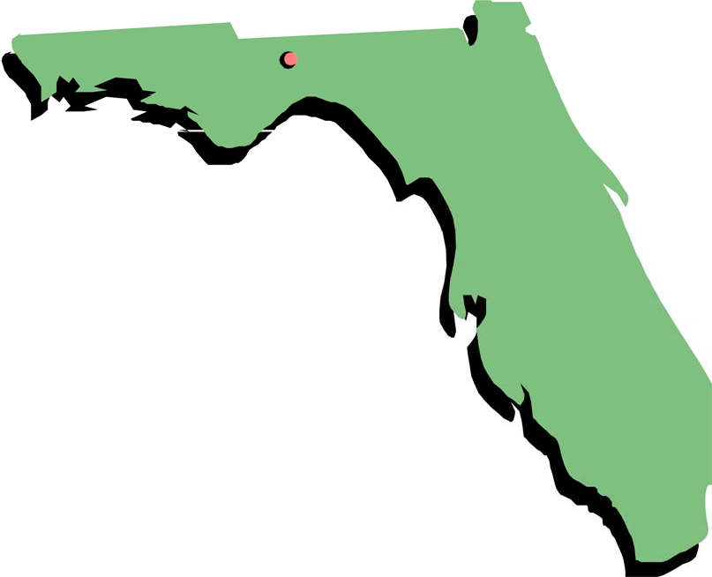

Florida Medicaid

Respiratory Therapy Services Coverage Policy

Agency for Health Care Administration
August 2018



Table of Contents
  - Introduction 1
  - Florida Medicaid Policies 1
  - Statewide Medicaid Managed Care Plans 1
  - Legal Authority 1
  - Definitions 1
  - Eligible Recipient 2
  - General Criteria 2
  - Who Can Receive 2
  - Coinsurance and Copayments 2
  - Eligible Provider 2
  - General Criteria 2
  - Who Can Provide 2
  - Coverage Information 2
  - General Criteria 2
  - Specific Criteria 2
  - Early and Periodic Screening, Diagnosis, and Treatment 3
  - Exclusion 3
  - General Non-Covered Criteria 3
  - Specific Non-Covered Criteria 3
  - Documentation 3
  - General Criteria 3
  - Specific Criteria 3
  - Authorization 4
  - General Criteria 4
  - Specific Criteria 4
  - Reimbursement 4
  - General Criteria 4
  - Claim Type 4
  - Billing Code, Modifier, and Billing Unit 4
  - Diagnosis Code 4
  - Rate 4

Introduction
Respiratory therapy services treat conditions that interfere with respiratory functions or other deficiencies of the cardiopulmonary system.

Florida Medicaid Policies
This policy is intended for use by providers that render respiratory therapy services to eligible Florida Medicaid recipients. It must be used in conjunction with Florida Medicaid’s General Policies (as defined in section 1.3) and any applicable service-specific and claim reimbursement policies with which providers must comply.
Note: All Florida Medicaid policies are promulgated in Rule Division 59G, Florida Administrative Code (F.A.C.). Coverage policies are available on the Agency for Health Care Administration’s (AHCA) Web site at http://ahca.myflorida.com/Medicaid/review/index.shtml.

Statewide Medicaid Managed Care Plans
Florida Medicaid managed care plans must comply with the service coverage requirements outlined in this policy, unless otherwise specified in the AHCA contract with the Florida Medicaid managed care plan. The provision of services to recipients enrolled in a Florida Medicaid managed care plan must not be subject to more stringent service coverage limits than specified in Florida Medicaid policies.

Legal Authority
Respiratory therapy services are authorized by the following:
    - Title XIX of the Social Security Act (SSA)
    - Title 42, Code of Federal Regulations (CFR), section440.110
    - Sections 409.905 and 409.973, FloridaStatutes (F.S.)
• Rule 59G-4.322, F.A.C.

Definitions
The following definitions are applicable to this policy. For additional definitions that are applicable to all sections of Rule Division 59G, F.A.C., please refer to the Florida Medicaid Definitions Policy.
    - Claim Reimbursement Policy
A policy document found in Rule Division 59G, F.A.C. that provides instructions on how to bill for services.
    - Coverage and Limitations Handbook or Coverage Policy
A policy document found in Rule Division 59G, F.A.C. that contains coverage information about a Florida Medicaid service.
    - General Policies
A collective term for Florida Medicaid policy documents found in Rule Chapter 59G-1,
F.A.C. containing information that applies to all providers (unless otherwise specified) rendering services to recipients.
    - Medically Necessary/Medical Necessity
As defined in Rule 59G-1.010, F.A.C.
    - Provider
The term used to describe any entity, facility, person, or group enrolled with AHCA to furnish services under the Florida Medicaid program in accordance with the provider agreement.

    - Recipient
For the purpose of this coverage policy, the term used to describe an individual enrolled in Florida Medicaid (including managed care plan enrollees).
    - Therapy Treatment Visits
Active treatment sessions with a recipient for the purpose of providing therapy services.
    - Unit of Service
A minimum of 15 minutes of therapy treatment between the therapist or therapy assistant and the recipient.

Eligible Recipient

General Criteria
An eligible recipient must be enrolled in the Florida Medicaid program on the date of service and meet the criteria provided in this policy.
Provider(s) must verify each recipient’s eligibility each time a service is rendered.

Who Can Receive
Florida Medicaid recipients under the age of 21 years requiring medically necessary respiratory therapy services. Some services may be subject to additional coverage criteria as specified in section 4.0.

Coinsurance and Copayments
There is no coinsurance or copayment for this service in accordance with section 409.9081,
F.S. For more information on copayment and coinsurance requirements and exemptions, please refer to Florida Medicaid’s Copayments and Coinsurance Policy.

Eligible Provider

General Criteria
Providers must meet the qualifications specified in this policy in order to be reimbursed for Florida Medicaid respiratory therapy services.

Who Can Provide
Services must be rendered by respiratory therapists licensed in accordance with Chapter 468, Part V, F.S. and working within the scope of their practice.

Coverage Information
General Criteria
Florida Medicaid covers services that meet all of the following:
    - Are determined medically necessary
    - Do not duplicate another service
    - Meet the criteria as specified in this policy
Specific Criteria
Florida Medicaid covers the following in accordance with the applicable fee schedule(s), or as specified in this policy:
    - One initial therapy evaluation per year, per recipient
    - One therapy re-evaluation every six months, per recipient
    - Up to 14 therapy treatment units per week (Sunday-Saturday), per recipient (maximum of four units per day)

Early and Periodic Screening, Diagnosis, and Treatment
As required by federal law, Florida Medicaid provides services to eligible recipients under the age of 21 years, if such services are medically necessary to correct or ameliorate a defect, a condition, or a physical or mental illness. Included are diagnostic services, treatment, equipment, supplies, and other measures described in section 1905(a) of the SSA, codified in Title 42 of the United States Code 1396d(a). As such, services for recipients under the age of 21 years exceeding the coverage described within this policy or the associated fee schedule may be approved, if medically necessary. For more information, please refer to Florida Medicaid’s Authorization Requirements Policy.

Exclusion

General Non-Covered Criteria
Services related to this policy are not covered when any of the following apply:
    - The service does not meet the medical necessity criteria listed in section 1.0
    - The recipient does not meet the eligibility requirements listed in section 2.0
    - The service unnecessarily duplicates another provider’s service

Specific Non-Covered Criteria
Florida Medicaid does not cover the following as part of this service benefit:
    - Developing and updating the plan of care (POC)
    - Mileage and travel expenses
    - Respiratory therapy services provided in a prescribed pediatric extended care center when billed separately
    - Securing, installing, or maintaining therapy equipment
    - Telephone communications with recipients, their representatives, caregivers, and other providers, except for services rendered in accordance with Rule 59G-1.057, F.A.C.
    - Time spent supervising assistants and students
    - Treatment visits provided on the same day as an evaluation service

Documentation

General Criteria
For information on general documentation requirements, please refer to Florida Medicaid’s Recordkeeping and Documentation Policy.

Specific Criteria
Providers must develop and update a recipient’s POC based on the results of the respiratory therapy evaluation(s). The POC must include at least the following:
    - Medical condition, including diagnostic codes
    - Functional limitations
    - Specific therapy to be provided
    - Short and long-term therapeutic goals and objectives
    - Medications, treatments, and equipment
    - Treatment frequency, length, and duration
    - Therapeutic methods and monitoring criteria
    - Diet as indicated, if applicable
    - Means of demonstrating and teaching the recipient, family, and other relevant caregiver
    - Coordination with other prescribed services

Authorization

General Criteria
The authorization information described below is applicable to the fee-for-service delivery system. For more information on general authorization requirements, please refer to Florida Medicaid’s Authorization Requirements Policy.

Specific Criteria
There are no specific authorization criteria for this service.

Reimbursement

General Criteria
The reimbursement information below is applicable to the fee-for-service delivery system.

Claim Type
Professional (837P/CMS-1500)

Billing Code, Modifier, and Billing Unit
Providers must report the most current and appropriate billing code(s), modifier(s), and billing unit(s) for the service rendered, incorporated by reference in Rule 59G-4.002, F.A.C.

Diagnosis Code
Providers must report the most current and appropriate diagnosis code to the highest level of specificity that supports medical necessity, as appropriate for this service.

Rate
For a schedule of rates, incorporated by reference in Rule 59G-4.002, F.A.C., visit the AHCA Web site at http://ahca.myflorida.com/Medicaid/review/index.shtml

