SHELLFISH
HARVESTING

AREA
HARVESTING
MAPS

Revised February 9, 2011

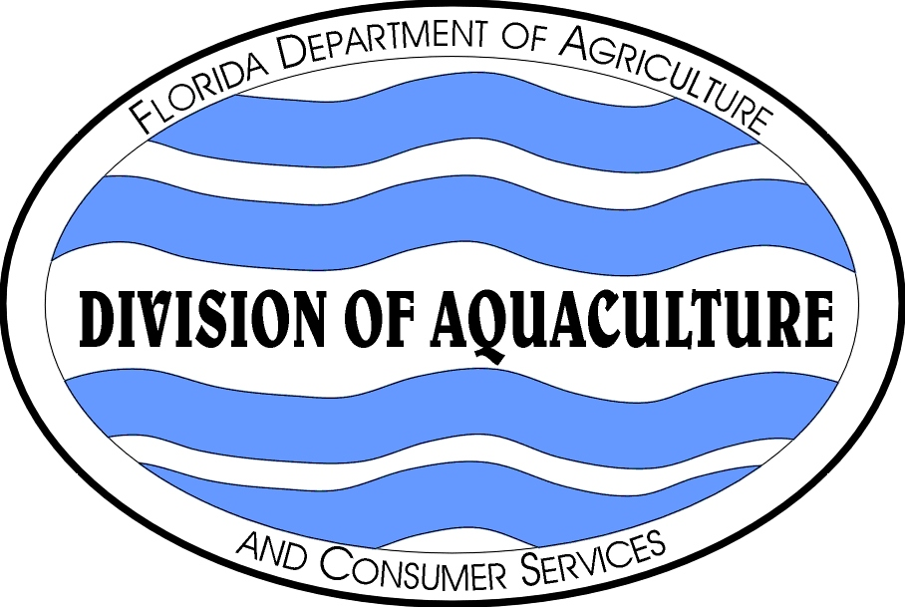 | Florida Department of Agriculture & Consumer Services
 | Division of Aquaculture
 | Shellfish Environmental Assessment Section
 | 1203 Governors Square Boulevard, 5th Floor
 | Tallahassee, Florida 32301
 | 850/488-5471, Suncom 278-5471

PREFACE
(Revised: July 6, 2007)

This document, SHELLFISH HARVESTING AREA CLASSIFICATION MAPS, illustrates classification boundaries of shellfish harvesting areas in Florida. Each shellfish harvesting area and shellfish harvesting area map has a unique name and area number. Shellfish areas are classified by the Florida Department of Agriculture and Consumer Services (DACS) to protect shellfish consumers from shellfish borne illnesses and to maximize the harvest of shellfish resources. Shellfish are defined in this context as oysters, clams and mussels. The Department is authorized by Chapter 597.020, Florida Statutes to establish regulations, specifications, and codes relating to sanitary practices for catching, handling, processing, preserving, canning, smoking, and storing of shellfish. Criteria for classification are contained in Chapter 5L-1, Florida Administrative Code (FAC), which incorporates by reference the National Shellfish Sanitation Program (NSSP) Model Ordinance. The NSSP is a voluntary and cooperative program that is designed to prevent human illness associated with the consumption of fresh and fresh-frozen shellfish through the sanitary control over all phases of growing, harvesting, shucking, packing and transportation. Participants in the NSSP include the U.S. Food and Drug Administration (FDA), U.S. Environmental Protection Agency, National Marine Fisheries Service, coastal producing and receiving states, and the shellfish industry. Only shellfish products harvested from areas that are classified and managed by a state in accordance with the NSSP are approved for harvest.
Classifications are based on pollution source, hydrographic, meteorologic and bacteriological surveys to identify where sanitary conditions are suitable for the harvest of wholesome shellfish. Pollution source, hydrographic, and meteorologic surveys characterize the introduction and distribution of contaminants that may be present in amounts that present a health hazard; hence, should not be open to harvest. The bacteriological survey identifies waters meeting NSSP fecal coliform standards. Fecal coliform is an indicator group of bacteria used by DACS. Fecal coliform live in the intestinal tract of warm-blooded animals, and each person excretes approximately two billion of these bacteria per day. Few fecal coliform are pathogenic; however, the presence of fecal coliform bacteria in coastal waters indicates feces from warm-blooded animals is present and human pathogens are likely to also be present.
The NSSP has established bacteriological standards for shellfish harvesting area classification. For areas to be classified Approved or Conditionally Approved, the level of fecal coliform in surface water samples must meet the NSSP 14/43 standard. For areas to be classified Restricted or Conditionally Restricted, the level of fecal coliform in surface water samples must meet the NSSP 88/260 standard.

NSSP 14/43 standard: The fecal coliform median or geometric mean must not exceed 14 MPN/100 ml, and not more than 10 percent may exceed 43 MPN/100 ml.

NSSP 88/260 standard: The fecal coliform median or geometric mean must not exceed 88 MPN/100 ml, and not more than 10 percent may exceed 260 MPN/100 ml.

A comprehensive shellfish harvesting area survey is written for each shellfish harvesting area to document the methods and findings of these surveys, as well as proposed changes in classification and management. NSSP guidelines require that these reports, at a minimum, be maintained annually, reevaluated every three years and resurveyed every 12 years. Areas that do not comply with sanitary requirements are immediately reclassified or closed.
Shellfish harvesting areas are classified as Approved, Conditionally Approved, Restricted, Conditionally Restricted, Prohibited and Unclassified (= Unapproved). These classifications are defined in Chapter 5L-1.003. The following provides generalized descriptions for these classifications:

Approved Area Normally open to shellfish harvesting; may be temporarily closed under extraordinary circumstances such as red tides, hurricanes and sewage spills. The 14/43 standard must be met for all combinations of defined adverse pollution conditions (tide, rainfall, river, tide/rainfall, tide/river and tide/rainfall/river).

Conditionally Approved Area Periodically closed to shellfish harvesting based on pollution events, such as rainfall or increased river flow. The 14/43 standard must be met when rainfall, river stage, and/or river discharge is less than the management plan level for temporary closure and during all other adverse pollution conditions.

Restricted Area Normally open to relaying or controlled purification, allowed only by special permit and supervision; may be temporarily closed under extraordinary circumstances such as red tides, hurricanes and sewage spills. The 88/260 standard must be met for all combinations of defined adverse pollution conditions (tide, rainfall, river, tide/rainfall, tide/river and tide/rainfall/river).

Conditionally Restricted Area Periodically, relay and controlled purification activity is temporarily suspended based on pollution events, such as rainfall or increased river flow. The 88/260 standard must be met when rainfall, river stage, and/or river discharge is less than the management plan level for temporary closure and during all other adverse pollution conditions.

Prohibited Shellfish harvesting is not permitted due to actual or potential pollution. This classification is least desirable, and is used only when standards are exceeded for Approved, Conditionally Approved, Restricted and Conditionally Restricted classification management schemes.

Unclassified Shellfish harvesting is not permitted pending bacteriological and sanitary surveys.

The verbal descriptions of shellfish harvesting areas are presented in this document from the northwesternmost shellfish harvesting area located in Escambia and Santa Rosa Counties counterclockwise along the coastline of Florida to the northeasternmost shellfish harvesting area located in Duval County.
Surface waters that lack a map in this document for shellfish harvesting area boundaries are Unclassified. Harvest of shellfish from these Unclassified waters is not lawful (Chapter 5L-1.003(7)), because the current sanitary conditions of the area have not been characterized for the protection of the health of shellfish consumers. Counties where all coastal waters classified as Unclassified are: Jefferson, Taylor, Hernando, Pasco, Monroe, Dade, Broward, Palm Beach, Martin, Flagler, and Nassau.
Shellfish harvesting areas may be in the open or closed status. Harvesting of shellfish from an area in the closed status is not permitted [Chapter 5L-1.003(2)(b), .003(3), .003(4), and .003(5), FAC]. Closed areas include prohibited and unclassified areas as well as temporarily closed approved, conditionally approved, restricted, and conditionally restricted areas. The open/closed status of shellfish harvesting areas is available from the field and headquarter offices of the DACS Shellfish Environmental Assessment Section.
Verbal descriptions of classification boundaries and management of shellfish harvesting areas are available from the Department. The locations and phone numbers of offices of the DACS Shellfish Environmental Assessment Section are presented below.

Headquarters 1203 Governors Square Boulevard, 5th Floor, Tallahassee 32301
850/488-4033, 488-5473, FAX 850/410-0893

Western Gulf Coast 4408 Delwood Lane, Panama City Beach, FL 32408
850/236-2200, FAX 850/236-2202

North Central Gulf Coast 260 7th Street, Apalachicola, FL 32320
850/653-8317/9440, FAX 850/653-4735

Big Bend Gulf Coast Cedar Key Field Station, 11350 SW 153rd Court, Cedar Key, FL 32625
352/543-5181, FAX 352/543-6958

Southern Gulf Coast Riverside Commercial Park, 25418 East Marion Ave, Unit #1, Space A, Punta Gorda, FL 33950, 941-833-2552, FAX 941-833-2553

Atlantic Coast 1378 Malabar Road, Suite 1, Palm Bay, FL 32909
321/984-4890, FAX 321/984-4892

INDEX OF SHELLFISH HARVESTING AREA
CLASSIFICATION MAPS, BOUNDARIES AND MANAGEMENT PLANS
Revised February 9, 2011

Shellfish Harvesting Area
Name | Area Number | Map Number(s) | Effective Date
Apalachicola Bay System | 16 | 16A, 16B | February 9, 2011
Alligator Harbor | 18 | 18 | May 5, 2009
Boca Ciega Bay | 42 | 42 | May 5, 2009
Body A | 80 | 80 | May 5, 2009
Body B | 78 | 78 | May 5, 2009
Body C | 77 | 77A, 77B | May 5, 2009
Body D | 76 | 76 | May 5, 2009
Body E | 75 | 75 | May 5, 2009
Body F | 74 | 74 | May 5, 2009
Cedar Key | 30 | 30 | May 5, 2009
Choctawhatchee Bay | 06 | 06 | May 5, 2009
Citrus County | 37 | 37A, 37B | May 5, 2009
Duval County | 96 | 96 | May 5, 2009
East Bay | 12 | 12 | May 5, 2009
Gasparilla Sound | 58 | 58 | May 5, 2009
Horseshoe Beach | 25 | 25A, 25B | May 5, 2009
Indian Lagoon | 15 | 15A, 15B | May 5, 2009
Indian River/St. Lucie Counties | 70 | 70 | May 5, 2009
Lemon Bay | 56 | 56 | May 5, 2009
Lower Tampa Bay | 48 | 48 | May 5, 2009
Myakka River | 60 | 60 | May 5, 2009
North Bay | 10 | 10 | May 5, 2009
North Indian River | 72 | 72 | May 5, 2009
North St. Johns | 92 | 92 | May 5, 2009
Ochlockonee Bay | 20 | 20 | May 5, 2009
Pensacola Bay System | 02 | 02 | May 5, 2009
Pine Island Sound | 62 | 62 | May 5, 2009
Sarasota Bay | 54 | 54 | May 5, 2009
South Banana River | 79 | 79 | December 28, 2009
South St. Johns | 88 | 88 | December 28, 2009
South Volusia | 82 | 82A, 82B | May 5, 2009
St. Joseph Bay | 14 | 14 | November 1986
St. Marks | 23 | 23 | June 18, 2009
Suwannee Sound | 28 | 28 A, 28 B | May 5, 2009
Ten Thousand Islands | 66 | 66 | May 5, 2009
Waccasassa Bay | 32 | 32 | May 5, 2009
Wakulla County | 22 | 22A, 22B | May 5, 2009
West Bay | 08 | 08A, 08B | May 5, 2009
Withlacoochee Bay | 34 | 34 | May 5, 2009

