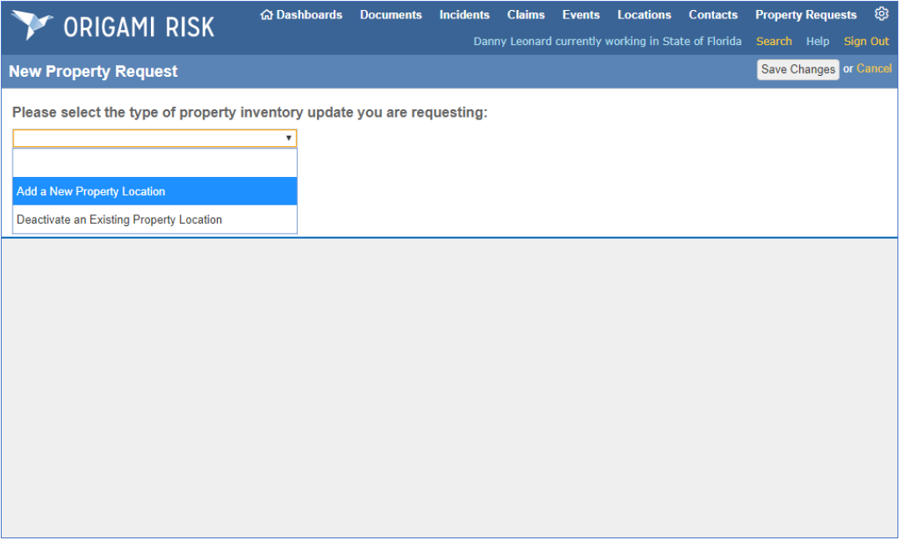

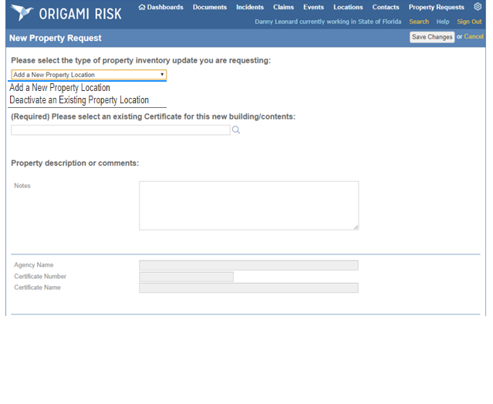

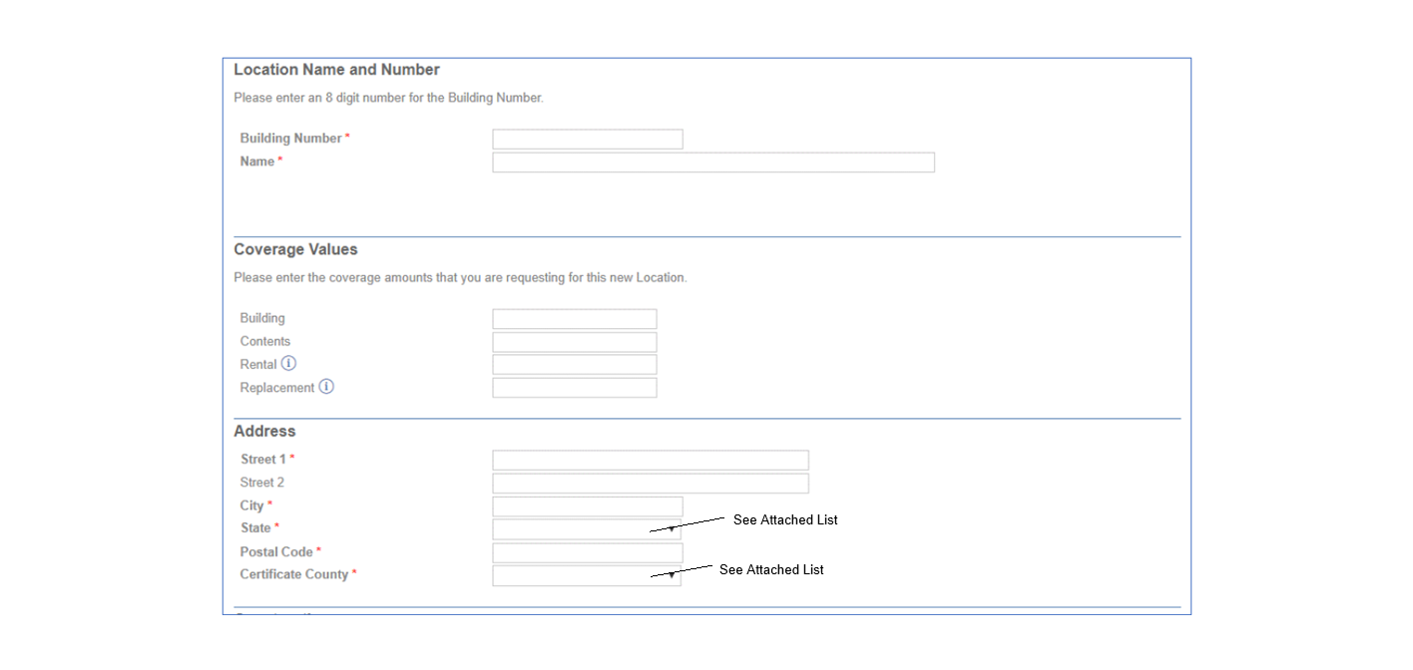

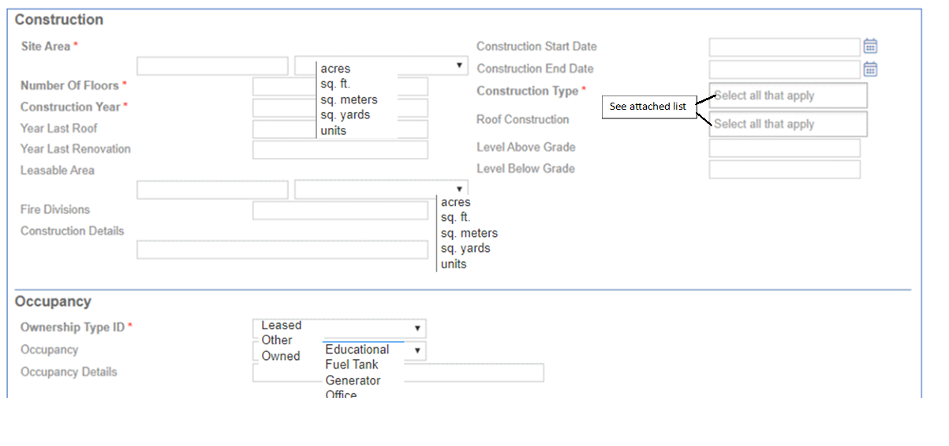

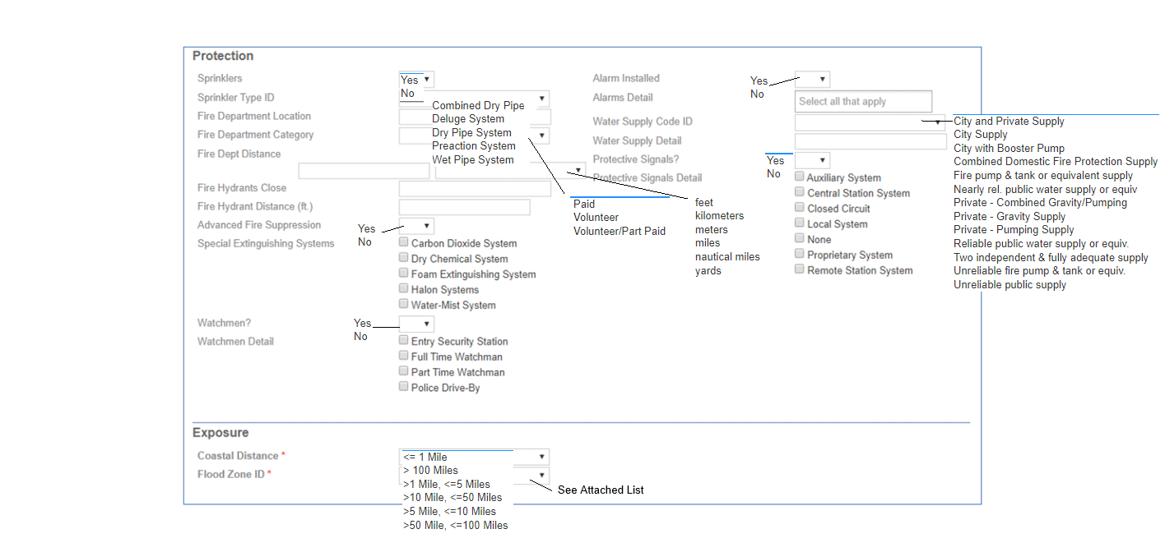

County List
Code | Description |  | Code | Description
11 | Alachua |  | 35 | Madison
52 | Baker |  | 15 | Manatee
23 | Bay |  | 14 | Marion
45 | Bradford |  | 42 | Martin
19 | Brevard |  | 38 | Monroe
10 | Broward |  | 41 | Nassau
58 | Calhoun |  | 43 | Okaloosa
53 | Charlotte |  | 57 | Okeechobee
47 | Citrus |  | 07 | Orange
48 | Clay |  | 26 | Osceola
64 | Collier |  | 99 | Out Of State
29 | Columbia |  | 06 | Palm Beach
01 | Dade |  | 28 | Pasco
34 | Desoto |  | 04 | Pinellas
54 | Dixie |  | 05 | Polk
02 | Duval |  | 22 | Putnam
09 | Escambia |  | 33 | Santa Rosa
61 | Flagler |  | 16 | Sarasota
59 | Franklin |  | 17 | Seminole
21 | Gadsden |  | 20 | St. Johns
55 | Gilchrist |  | 24 | St. Lucie
60 | Glades |  | 98 | Statewide
66 | Gulf |  | 44 | Sumter
56 | Hamilton |  | 31 | Suwannee
30 | Hardee |  | 37 | Taylor
49 | Hendry |  | 63 | Union
40 | Hernando |  | 08 | Volusia
27 | Highlands |  | 65 | Wakulla
03 | Hillsborough |  | 36 | Walton
51 | Holmes |  | 50 | Washington
32 | Indian River
25 | Jackson
46 | Jefferson
62 | Lafayette
12 | Lake
18 | Lee
13 | Leon
39 | Levy
67 | Liberty

State Codes

Code | Description |  | Code | Description |  | Code | Description
AE | Armed Forces Europe, Middle East, & Canada |  | MN | Minnesota |  | WV | West Virginia
AK | Alaska |  | MO | Missouri |  | WI | Wisconsin
AL | Alabama |  | MP | Northern Mariana Islands |  | WY | Wyoming
AP | Armed Forces Pacific |  | MS | Mississippi |  | AB | Canada - Alberta
AR | Arkansas |  | MT | Montana |  | BC | Canada - British Columbia
AS | American Samoa |  | NC | North Carolina |  | MB | Canada - Manitoba
AZ | Arizona |  | ND | North Dakota |  | NB | Canada - New Brunswick
CA | California |  | NE | Nebraska |  | NL | Canada - Newfoundland
CO | Colorado |  | NH | New Hampshire |  | NS | Canada - Nova Scotia
CT | Connecticut |  | NJ | New Jersey |  | NU | Canada - Nunavut
DC | District of Columbia |  | NM | New Mexico |  | ON | Canada - Ontario
DE | Delaware |  | NV | Nevada |  | PE | Canada - Prince Edward Island
FL | Florida |  | NY | New York |  | QC | Canada - Quebec
FM | Federated States of Micronesia |  | OH | Ohio |  | SK | Canada - Saskatchewan
GA | Georgia |  | OK | Oklahoma |  | NT | Canada - Northwest Territories
GU | Guam |  | OR | Oregon |  | YT | Canada - Yukon Territory
HI | Hawaii |  | PA | Pennsylvania |  | ZZ | Unknown or Unspecified
IA | Iowa |  | PR | Puerto Rico |  | NA | Federal Jurisdiction
ID | Idaho |  | PW | Palau |  | CD | Canada
IL | Illinois |  | RI | Rhode Island |  | CZ | Canal Zone
IN | Indiana |  | SC | South Carolina |  | FC | Foreign Country
KS | Kansas |  | SD | South Dakota |  | OTH | Other
KY | Kentucky |  | TN | Tennessee |  | CR | Costa Rica
LA | Louisiana |  | TX | Texas
MA | Massachusetts |  | UT | Utah
MD | Maryland |  | VA | Virginia
ME | Maine |  | VI | Virgin Islands
MH | Marshall Islands |  | VT | Vermont
MI | Michigan |  | WA | Washington

Flood Zones

Code | Description |  | Code | Description |  | Code | Description
N | Not Mapped |  | AE | Zone AE |  | V26 | Zone V26
A | Zone A |  | AH | Zone AH |  | V27 | Zone V27
A1 | Zone A1 |  | AO | Zone AO |  | V28 | Zone V28
A2 | Zone A2 |  | AR | Zone AR |  | V29 | Zone V29
A3 | Zone A3 |  | A99 | Zone A99 |  | V30 | Zone V30
A4 | Zone A4 |  | D | Zone D |  | VE | Zone VE
A5 | Zone A5 |  | V | Zone V |  | B | Zone B
A6 | Zone A6 |  | V1 | Zone V1 |  | C | Zone C
A7 | Zone A7 |  | V2 | Zone V2 |  | X | Zone X
A8 | Zone A8 |  | V3 | Zone V3 |  | X5 | Zone X500
A9 | Zone A9 |  | V4 | Zone V4 |  | U | Unknown
A10 | Zone A10 |  | V5 | Zone V5 |  | VO | Zone VO
A11 | Zone A11 |  | V6 | Zone V6
A12 | Zone A12 |  | V7 | Zone V7
A13 | Zone A13 |  | V8 | Zone V8
A14 | Zone A14 |  | V9 | Zone V9
A15 | Zone A15 |  | V10 | Zone V10
A16 | Zone A16 |  | V11 | Zone V11
A17 | Zone A17 |  | V12 | Zone V12
A18 | Zone A18 |  | V13 | Zone V13
A19 | Zone A19 |  | V14 | Zone V14
A20 | Zone A20 |  | V15 | Zone V15
A21 | Zone A21 |  | V16 | Zone V16
A22 | Zone A22 |  | V17 | Zone V17
A23 | Zone A23 |  | V18 | Zone V18
A24 | Zone A24 |  | V19 | Zone V19
A25 | Zone A25 |  | V20 | Zone V20
A26 | Zone A26 |  | V21 | Zone V21
A27 | Zone A27 |  | V22 | Zone V22
A28 | Zone A28 |  | V23 | Zone V23
A29 | Zone A29 |  | V24 | Zone V24
A30 | Zone A30 |  | V25 | Zone V25

Construction Type
Code | Construction Type Description
140 | Air Supported
134 | Aluminum
009 | Boards on Joist
124 | Brick
125 | Concrete Block
001 | Fire Resistive/Heavy NC
005 | Frame
137 | Frame w/Masonry
138 | Frame w/Metal Covering
139 | Frame w/Metal Covering-Trailers or Sheds
003 | Heavy Timber
135 | Lam/Wood Frame
126 | Mansonry Hollow
127 | Mansonry Hollow/Brick Veneer
004 | Masonry Joist
014 | Masonry Non-Combustible
132 | Metal
006 | Other
120 | Plank on Exposed Steel
008 | Plank on Timber
136 | Plywood on Glue
121 | Plywood on Glue Lam/Wood Frame
112 | Plywood on Lam. Beams
123 | Plywood on Lam. Beams/Tilt-Up Concr.
129 | Poured Concrete
128 | Pre-Engineered Metal
130 | Precast Concrete
115 | Protected Steel
002 | Steel Deck & Other Light NC
100 | Steel Deck (combustible)
110 | Stucco
131 | Tilt-Up Concrete
999 | Towers- Communication/Water
133 | Veneer
122 | Wood Joist
102 | Wood Truss on Steel

Roof Construction Description
Code | Roof Construction Type
RC017 | AIR SUPPORTED
RC001 | BOARDS ON JOIST
RC013 | FIRE RESISTIVE / HEAVY NC
RC002 | FRAME
RC003 | FRAME W/ METAL COVERING- TRAILERS OR SHEDS
RC004 | HEAVY TIMBER
RC011 | MASONRY JOIST
RC012 | MASONRY NC
RC005 | PLANK ON EXPOSED STEEL
RC006 | PLANK ON TIMBER
RC007 | PLYWOOD ON GLUE LAM/WOOD FRAME
RC008 | PLYWOOD ON LAM BEAM
RC018 | POURED CONCRETE
RC019 | PRE-CAST CONCRETE
RC020 | PRE-ENGINEERED METAL
RC014 | PROTECTED STEEL
RC015 | STEEL DECK & OTHER LIGHT NC
RC016 | STEEL DECK / COMBUSTIBLE
RC009 | WOOD JOIST
RC010 | WOOD TRUSS ON STEEL

