


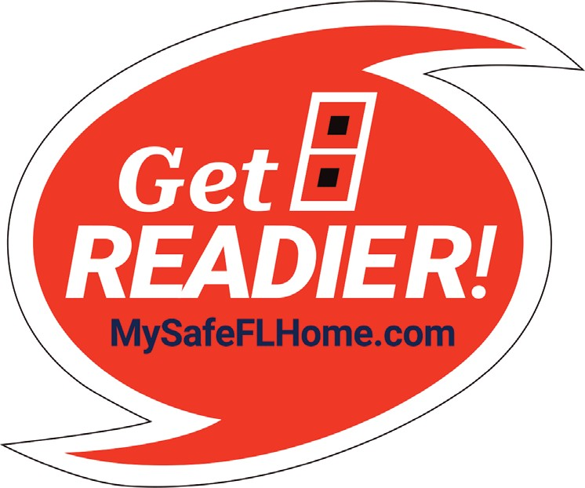
Homeowner’s Guide
My Safe Florida Home Program

A Program Administered by the Florida Department of Financial Services
MySafeFLHome.com



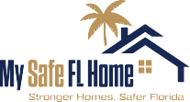

Welcome
page 2
Dear Florida Homeowner,
Welcome to the Homeowner’s Guide for the My Safe Florida Home Program (Program). The Program was recently re-enacted during a Special Session of the Florida State Legislature and has two primary components to be administered by the Department of Financial Services (DFS):
- Provide eligible Florida homeowners, free of charge and with no obligation, a home inspection that identiﬁes the current hurricane resistant features of their home and recommended improvements to further strengthen their homes against hurricane winds.
- Provide qualifying Florida homeowners with a grant to perform speciﬁc wind mitigation improvements recommended by their free Program inspection to strengthen their home against hurricanes and to save money on their Wind Insurance Premiums.
We would also like to take this opportunity to share another component of the Program available to ALL Florida homeowners, regardless of whether they participate in the free inspection or grant components, which is:
NO state sales tax (6%) will be charged on retail purchases of impact-resistant doors, anti-impact resistant garage doors, and impact-resistant windows from July 1, 2022, through June 30, 2024.
We encourage you to review this guide before reading your free inspection report and we thank you for your interest in the My Safe Florida Home Program.
As of July 1, 2023, changes have occurred to the program. Please review the Homeowners’ Guide in full to see these changes.
Sincerely,
The My Safe Florida Home Program Team
A Program Administered by the Florida Department of Financial Services
MySafeFLHome.com
Index
page 3
A Program Administered by the Florida Department of Financial Services
MySafeFLHome.com
2
20
18
17
20
15
Authorized Improvements Guide
12
Grant Program
11
Inspection Report
5
Free Home Inspections
4
Glossary of Terms
Grant Reimbursements/Disbursement
Free Home Inspections
page 4
The Florida State Legislature has allocated $25 million through the My Safe Florida Home Program to provide homeowners with a complete Home Hurricane Inspection at NO COST and NO OBLIGATION.

Who is Eligible to Apply for a Free Inspection?
ANY Floridian that has been granted a homestead exemption on their primary home is eligible to apply for a free inspection. The primary home must be a site-built, single-family home
(a home constructed at its permanent location) OR a townhouse (a single-family unit constructed in a series or group of attached units separated by property lines. Each townhouse shall be considered a separate building and shall not exceed three stories in height (§ 481.203, F.S.)).

Properties NOT eligible for free home inspections through the Program are:
- Mobile Homes or Manufactured Homes
- Condominiums or Apartments
- Cooperative Residences
- Multi-Family Dwellings
(duplex/triplex/quadplex)

Application Information
- Second/Vacation Homes
- Rental Properties
- Uninsured Properties
- Businesses
- Villas
Homeowners may apply by visiting MySafeFLHome.com and clicking the Apply Now button, or going straight to the Applicant Portal by clicking here.
To apply, homeowners are required to provide the following information:
- Valid Email Address
- First and Last Name
- Home Street Address, City, and Zip Code
- Phone Number

After Approval
Upon approval of your inspection application, the Program will notify you via email (or an alternative, if necessary) and provide you with the name and contact information of the inspection ﬁrm assigned to inspect your home. An inspector will contact you within one week to schedule a free inspection.
Inspections typically take one hour to perform, and you should receive an email notiﬁcation within two weeks from the inspection date that your report is ready for download through the Applicant Portal. To find your inspection report, open your case in the Applicant Portal and select the “documents” tab.
The inspection report will provide the homeowner with:
- A summary of the current hurricane resistant features of the home and recommendations for improvements the homeowner may take to mitigate their home against wind damage. (Please note that the only upgrade recommendation available to townhouses is opening protection.)
- Potential insurance discounts available from initial inspection and after recommended mitigation improvements have been made.
- A range of cost estimates regarding the recommended mitigation improvements.
Continued on Next Page
A Program Administered by the Florida Department of Financial Services
MySafeFLHome.com
Inspection Report
page 5
The Next Several Pages of This Guide Provide Some Additional Inspection Report Content Details.
Continued on Next Page
A Program Administered by the Florida Department of Financial Services
MySafeFLHome.com
The purpose of your home inspection report provided through MSFH is to identify speciﬁc actions you can take to strengthen your home against hurricane winds and to use the report as a resource to guide you in making your home as hurricane resistant as possible.

Report Contents
Each inspection report features the following content:
Cover Page – including an exterior photo of the inspected home, street address, the Wind Certiﬁcation Entity (WCE) who prepared the report, WCE contact information, Case Number, and Inspection Date.
Table of Contents & Introduction Pages Summary of Inspection Pages
- Summary of Uniform Mitigation Veriﬁcation Inspection Form
- Current Hurricane Resistant Features of Your Home
- Current Potential Savings to Your Wind Insurance Premium
- Missing Hurricane Resistant Features of Your Home

Home Hardening Upgrades & Insurance Discount Estimates Pages Upgrade Cost Estimates Page
Uniform Mitigation Veriﬁcation Inspection Form (4) Pages – This is Form OIR-B1-1802 and is often referred to as an “1802.”
Permits – Previous permits connected to the home, which may be provided as either an image or listing.
Inspection Photos – Various interior and exterior images taken during inspection of the home.
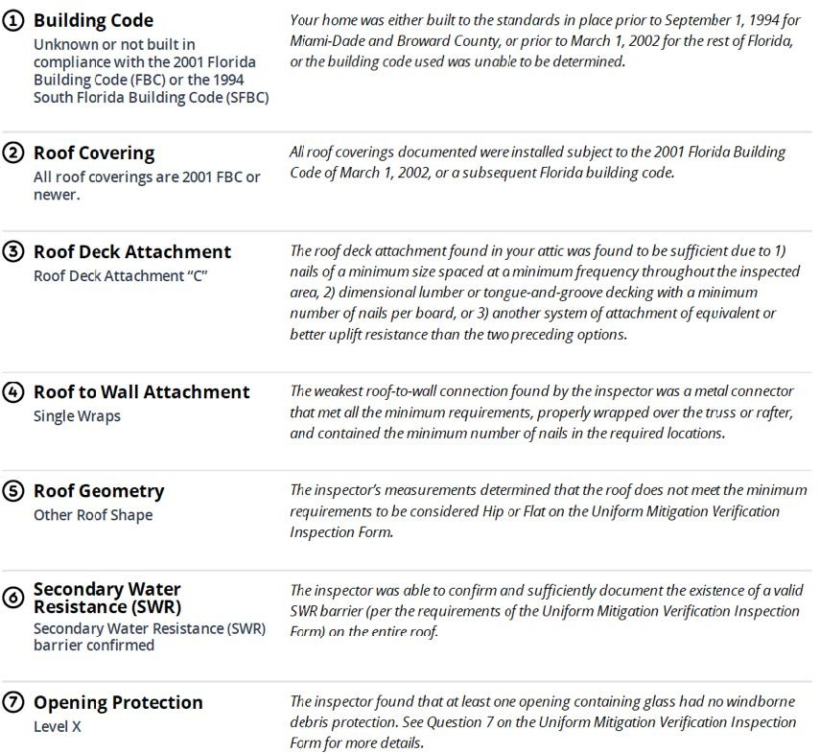
Inspection Report — Summary of Inspection
page 6
Summary of Uniform Mitigation Veriﬁcation Inspection Form
This section of the report summarizes the wind mitigation features of your home observed by your inspector and can also be found in the Uniform Mitigation Veriﬁcation Inspection Form.
Your inspector will review the following:
- Building Code
- Roof Covering
- Roof Deck Attachment
- Roof-to-Wall Attachment
- Roof Geometry
- Secondary Water Resistance Barrier (SWR)
- Opening Protection
This page within your report is intended to provide you an at-a-glance summary of the ﬁndings from your wind mitigation inspection. The inspector may make recommendations based on their findings after reviewing these features.
The following sample image demonstrates what this summary may look like within your report.
Continued on Next Page
A Program Administered by the Florida Department of Financial Services
MySafeFLHome.com

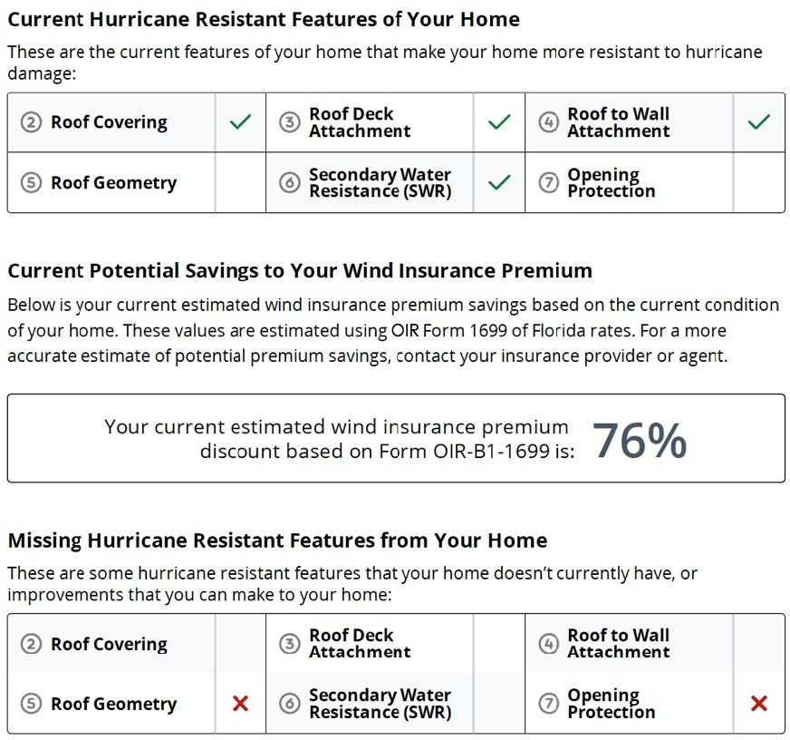
Inspection Report — Summary of Inspection
page 7
Current Hurricane Resistant Features of Your Home Current Potential Savings to Your Wind Insurance Premium Missing Hurricane Resistant Features of Your Home
This section of the report is contained within a single page to conveniently summarize the following:
- Current hurricane resistant features that make your home more resistant to hurricane damage.
- Current potential savings to your wind insurance premium based on the current hurricane resistant features of your home.
- Wind mitigation features that could be implemented to harden your home against hurricanes. These improvements may result in wind insurance premium discounts from your insurer.
The following sample image demonstrates what this summary may look like within your report.
PLEASE NOTE: Although “Roof Geometry" is considered a hurricane resistant feature for Florida homes and speciﬁc shapes can provide savings for wind insurance premiums, making any improvements to the geometry of your roof are NOT covered through the My Safe Florida Home Grant Program.
Continued on Next Page
A Program Administered by the Florida Department of Financial Services
MySafeFLHome.com

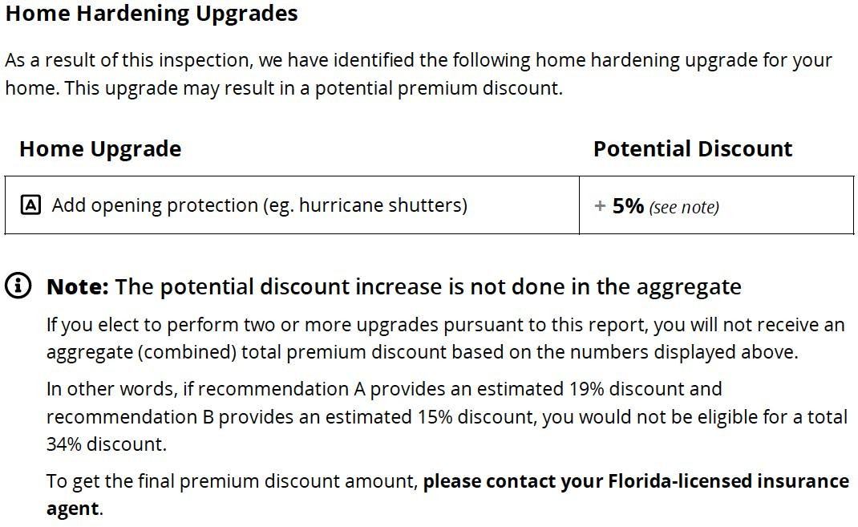
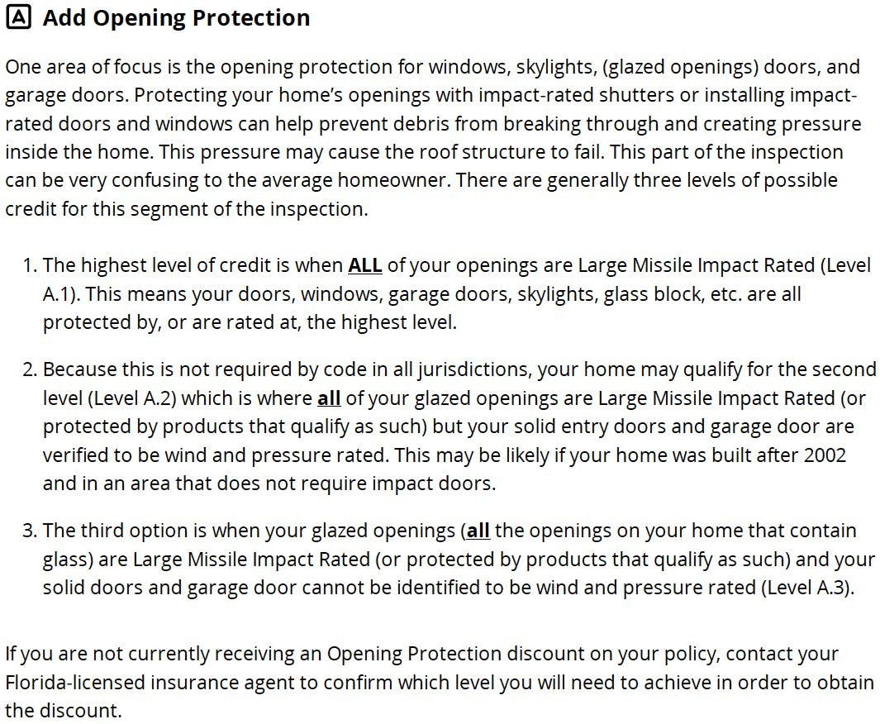
Inspection Report — Summary of Inspection
page 8
Home Hardening Upgrades & Insurance Discount Estimates Pages
One of the key components of this report is to identify potential upgrades to mitigate wind damage to your home. These types of improvements may result in wind insurance premium discounts from your insurer. Townhouses, as defined in § 481.203, F.S., may only receive recommendations for opening protection.
The following sample images demonstrate what this summary may look like within your report.
Continued on Next Page
A Program Administered by the Florida Department of Financial Services
MySafeFLHome.com

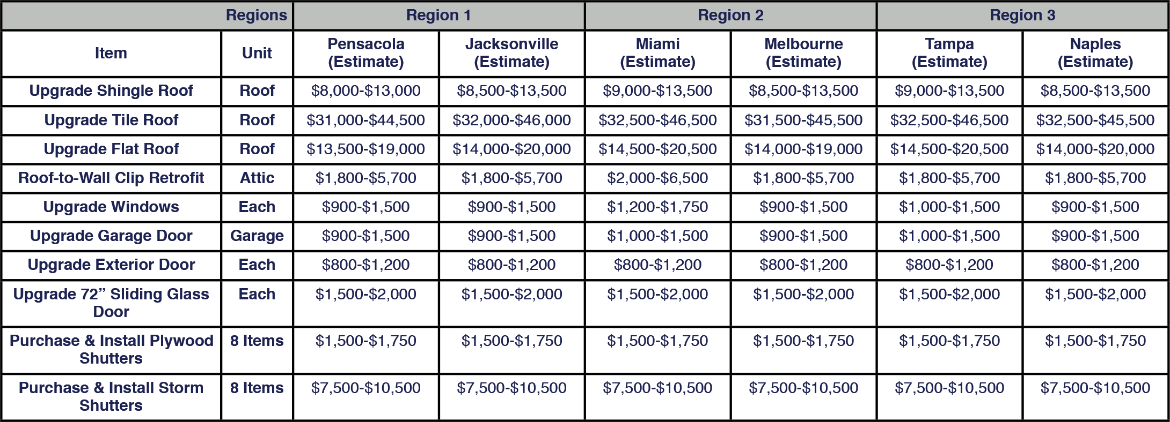
Inspection Report — Upgrade Cost Estimates
page 9
Each home inspection report contains a price range reference guide for typical wind mitigation upgrades in multiple wind-borne regions based on a 3 Bedroom, 2 Bath, 1,750 square foot home with a 400 square foot garage that is approximately 30 years old. It is important to keep in mind that individual prices can vary substantially from these ranges provided in your report due to various factors such as home location, availability of materials, labor costs, and inﬂation. We recommend that several bids be obtained from Program Contractors for any wind mitigation upgrades you are considering for your home.
PLEASE NOTE: Items listed above may not be applicable to your report. This chart is being provided for illustration purposes only.
Please review your report to see which items are applicable.
Sources
Rounded pricing estimates were made possible through the use of Homewyse.com on 11/15/2022. Please use their website to review more speciﬁc zip code pricing. Roof-to-Wall Clip Retroﬁt cost estimate range is provided by Florida Retroﬁts.

Rooﬁng Material
https://www.homewyse.com/services/cost_to_install_asphalt_shingle_roof.html https://www.homewyse.com/services/cost_to_install_tile_roof.html
https://www.homewyse.com/services/cost_to_install_membrane_roofing_system.html
Windows/Doors
https://www.homewyse.com/services/cost_to_install_storm_windows.html https://www.homewyse.com/services/cost_to_install_replacement_windows.html https://www.homewyse.com/services/cost_to_replace_garage_door.html https://www.homewyse.com/services/cost_to_install_exterior_door.html https://www.homewyse.com/costs/cost_of_replacement_sliding_doors.html https://www.homewyse.com/services/cost_to_install_hurricane_shutters.html https://www.homewyse.com/maintenance_costs/cost_to_boardup_window.html
Continued on Next Page
A Program Administered by the Florida Department of Financial Services
MySafeFLHome.com
Inspection Report — Checklist
page 10
Continued on Next Page
A Program Administered by the Florida Department of Financial Services
MySafeFLHome.com
We have created the following checklist to help you get the most out of your inspection report.
- 1. Review the information on the Summary of Inspection page and familiarize yourself with the current and missing hurricane resistant features of your home, along with the potential savings you may receive on your wind insurance premium for your current features.

- 2. Review the information on the Home Upgrades pages and familiarize yourself with the improvements that are being recommended for your home and potential discounts you may receive on your wind insurance premium from your insurance provider.

- 3. Contact your insurance provider to verify the potential premium discount savings you may receive for the current hurricane resistant features of your home and for making the recommended hurricane resistant improvements to your home.

- 4. Review the information on the Upgrade Cost Estimates page and consider the estimated cost ranges for the recommended improvements in your inspection report while keeping in mind that actual costs will vary based on location, labor, and material costs.

- 5. Decide which of the recommended improvement(s) to move forward with on your home.

- 6. If you believe you meet the eligibility requirements, login to the Applicant Portal and apply for the grant component of the Program. Please note that if you are approved for a grant, you MUST select from a list of authorized Program Contractors within the Applicant Portal to complete the work on your home. If you are NOT approved for a grant, you may still access this list by clicking here to locate a contractor or, alternatively, you may go with a contractor of your own choosing. Regardless of your approval for a grant, we recommend the remaining checklist items be followed. Approval for a grant does not guarantee funding. You must still provide additional information after improvements have been made. After you provide the draw documentation, the Program will determine your eligibility for funding.

- 7. It is recommended, but not required, that you request up to three bids from contractors on the authorized MSFH contractor list for the improvement work.

- 8. Review the bids carefully and select an authorized Program contractor. You may select more than one contractor from the authorized Program contractor list.

- 9. Before signing any contracts, conﬁrm that the selected contractor is on the authorized list, will obtain all necessary permits, and is aware of all program requirements. Prior to beginning work, you must ensure the contractor receives all applicable building permits from the local building inspector’s office. At the end of construction, you must also ensure the permits are closed out and the local building inspector’s office has completed all required inspections. Afterwards, you should request the Final Inspection from the Program to continue the grant application process.
- 10. After work is completed, you must make your home available for a final inspection before payment will be disbursed.
Grant Program
page 11
The Florida State Legislature has allocated grant money to qualifying Florida homeowners who have received their free home inspection through the Program and have decided to make eligible wind mitigation improvements that were recommended in their inspection report.
According to section 215.5586(2)(b), F.S., “All grants must be matched on the basis of $1 provided by the applicant for $2 provided by the state, up to a maximum state contribution of $10,000 toward the actual cost of the mitigation project.” In other words, the homeowner must contribute funds equal to one-third (1/3) of the cost of the project toward the project to be reimbursed for the remaining two-thirds (2/3), up to a maximum state contribution of $10,000.
Grants are only dispersed AFTER the work has been completed by an approved Program Contractor, the work has been re-inspected by the Program, and payment has been made in full for the work by the homeowner.
Low-Income (LI) homeowners, as deﬁned under section 420.0004(11), F.S., and who meet all other grant application requirements are eligible for a grant of up to $10,000 and are not required to provide a matching amount.
PLEASE NOTE: Not all applicants who have received an inspection through the Program will be eligible for a grant. When recommended by a hurricane mitigation inspection, grants for townhouses, as defined under
section 481.203, F.S., may only be used for opening protection.
Who Is Eligible To Apply For The Grant Program?
The following criteria will be used to review grant applications:
- You must have applied for, been approved for, and have received a free home hurricane inspection through the Program.
- You must provide proof of homestead exemption. If you need assistance obtaining a copy of your homestead exemption information, please confer with your local Property Appraiser or Tax Collector Oﬃce.
- You must provide insurance documentation that your home has an insured value of $700,000 or less and a copy of your current property insurance declarations page. If you do not have a copy, contact your home insurance company. Applicants participating in the Low-Income grant do not need to provide proof of the home’s insured value.
- The initial building construction permit for the home must have been issued prior to January 1, 2008. If you are unsure of when your home was built, please contact your local oﬃcials. This information is frequently available through the website or oﬃce of your Property Appraiser.
- Homeowners must make their home available for a final inspection after construction work has been completed. This final inspection is provided at no cost to the homeowner.
How To Apply & Approval Information
You must apply through the Applicant Portal by clicking here and logging into your account. Applications are reviewed in the order they are received and notiﬁcation regarding the approval status of your application will be sent to you via email within two (2) weeks.
Homeowners who have not received any recommendations for upgrades will not be able to utilize a grant and, therefore, will not be approved. The authorized Program contractor list will be available in a grant approval email.
Continued on Next Page
A Program Administered by the Florida Department of Financial Services
MySafeFLHome.com
Authorized Improvements Guide
page 12
Please read this guide carefully. Only the improvements recommended in your inspection report will be authorized for reimbursement. No other improvements are authorized under the program. To provide a better understanding of the five (5) authorized improvements covered by the My Safe Florida Home Program, we have listed them below with detailed descriptions. Please note that when recommended by a hurricane mitigation inspection, grants for townhouses, as defined under section 481.203, F.S., may only be used for opening protection.
Improvement 1– Improving the strength of your roof deck attachment.
If your roof consists of shingles nailed to plywood sheets, the inspection may reveal that the plywood sheets are not adequately nailed to your roof trusses, and additional nails or longer nails need to be added to reduce the possibility of the plywood being blown off in a hurricane.

Improvement 2 – Reinforcing roof-to-wall connections.
Completed by installing metal tie-down clips that attach roof rafters to walls to reduce the possibility that all or a portion of your roof will lift off your home during a hurricane.
Improvement 3 – Creating a secondary water barrier to prevent water intrusion.
When adding a Secondary Water-Resistant Barrier (SWR), you may use Program funds to replace your roof if the final product result includes the SWR. Please remember that the Program will only provide up to $10,000.

There are three (3) ways to accomplish a SWR:
- At the time of reroofing your home, use a full-coverage self-adhered underlayment, commonly referred to as “peel-and-stick,” directly to the roof deck material;
- At time of reroofing your home, use a self-adhere product, commonly referred to as “seam tape,” on all joints and seams of the roof decking material. This still requires a nailed down underlayment such as felt paper; or
- If you are not replacing the roof, install a foam adhesive on all the seams and joints from the attic side of your roof.

Costs relating to re-covering your roof after adding the SWR are covered by the grant. Improving the survivability of your roof covering might include upgrading to stronger hurricane-resistant roof shingles, attached with properly sized and properly applied rooﬁng nails, to reduce the susceptibility of your roof shingles blowing off in a hurricane. You may replace your roof with a different covering of your choice such as tile, metal, or shingle. DO NOT upgrade your roof covering without also adding SWR. You must replace all portions of a contiguous roof with SWR. Program funds shall not be used for roof patching or other partial repairs of the roof.

Improvement 4 – Opening Protection (Windows)
Completed by installing impact windows or hurricane shutters. When recommended by a hurricane mitigation inspection, grants for townhouses, as defined under section 481.203, F.S., may only be used for opening protection.

Continued on Next Page
A Program Administered by the Florida Department of Financial Services
MySafeFLHome.com
page 13
Continued on Next Page
A Program Administered by the Florida Department of Financial Services
MySafeFLHome.com

Authorized Improvements Guide

PLEASE NOTE: If a homeowner currently has compliant hurricane shutters, but requests grant funds for impact windows instead, the request will be denied. A home with compliant shutters has already been mitigated against wind damage. The grant cannot be used to exchange one type of protection for another.
Improvement 5 – Opening Protection Exterior Doors (Including Garage Doors)
Completed by installing hurricane-rated doors or replacing a standard garage door with a hurricane-rated garage door. When recommended by a hurricane mitigation inspection, grants for townhouses, as defined under section 481.203, F.S., may only be used for opening protection.

  - If a homeowner currently has unprotected pedestrian or garage doors that include glass, the grant may be approved to replace the door with an impact door (or shutter the door with an impact-tested product).
  - If a homeowner currently has unprotected pedestrian or garage doors that are solid (no glass),
the request to replace or shutter the door with an impact-tested product will be denied unless a recommendation is included in the inspection report. *

*Exception: An exception to the prohibition on replacing a solid door may be made IF the homeowner can provide documentation from their insurance agent indicating that replacing all solid doors and/or garage doors with upgraded impact-tested products will result in a discount on their insurance premium.
Documentation required for the above exception can be one (1) of the following: an email, letter, or quote from the insurance agent. This documentation must be uploaded to the grant portal when requesting reimbursement. The documentation must specifically mention that a rating of A.1 on the windstorm mitigation Form OIR-B1-1802 is required to obtain the discount on the insurance policy currently in force, and the amount of any potential savings if A.1 is achieved. Once this documentation is received, the replacement of a solid door can be approved.

Improvements 4 and 5 are often combined, as it is recommended that they be undertaken together.

NOTE: There are three (3) levels of opening protection under Improvement 5. They are:
- Improvement Standard – The lowest-cost option for protecting window openings. On a one-story home, this improvement would provide temporary structural panels for each window that would need to be installed each time a serious storm threatened the home. On a two-story home, this improvement would be a combination of standard shutters (ﬁrst ﬂoor) and permanently attached shutters (second ﬂoor).
- Improvement Permanently Attached – Protective devices that are permanently attached to the home and are deployed when a hurricane is approaching.
- Improvement Permanently Deployed – These are protective devices such as impact-rated glass windows and doors or hurricane screens that require no installation when a hurricane is approaching.

page 14
Continued on Next Page
A Program Administered by the Florida Department of Financial Services
MySafeFLHome.com
Authorized Improvements Guide

PLEASE NOTE: Approval of your grant application does not guarantee a disbursement of funds. Grantees must follow all the guidelines required for reimbursement or payment to the contractor. Those guidelines include the following:
- Homeowners MUST use an authorized contractor from the authorized list.
- Homeowners MUST comply with all Program requirements.
- Approval of a Draw Request will be contingent upon receipt of uploaded required documentation. If a draw request does not contain all necessary documents or information, it will be returned to the applicant so they can correct the missing information.
- Final Inspection MUST BE COMPLETED to verify that all the improvements were made.

After your final inspection is complete and entered in the system, you can return to the grant portal to submit all information required for the funding that would be covered in your approved grant. Please recall that for Matching Grants, the homeowner must contribute funds equal to one-third (1/3) of the cost of the project to be reimbursed for the remaining two-thirds (2/3), up to a maximum state contribution of $10,000.

Documents Required for Draw Reimbursement Request

Reimbursement Documentation | Homeowner – Regular | Contractor – Low Income
Invoice Cover Sheet | Yes | Yes
Original Contractor Invoice(s) | Yes | Yes
Proof of Payment (cancelled check; receipts; paid invoice) | Yes | N/A
Proof of insurance premium discounts (email; letter; new quote from insurance agent that outlines what, if any, discount is available) | Yes | Yes – homeowner will be responsible for uploading this information.

**Initial and final inspection reports are also required; however, these reports are already stored in the grant portal and are not the applicant’s responsibility to provide.

***If the applicant chooses to replace a solid door without a recommendation in an inspection report, this document must be provided for Reimbursement. An email, letter, or quote from an insurance agent requesting upgrade to change rating to A.1 as required in Form 1802 to obtain discount. This requirement is applicable to all counties, except Broward and Miami-Dade Counties which will be exempt due to the Citizens Rate Guidelines Schedule for Wind Mitigation Discounts. Contractors must request this information from Low Income applicants for payment disbursement.

page 15
A Program Administered by the Florida Department of Financial Services
MySafeFLHome.com
Grant Reimbursements or Disbursements
Contractor Confirmation and Requesting a Final Inspection

After receiving an Initial Inspection Report from a Program assigned inspector, a grant application will open in the Applicant portal. The applicant portal can be accessed at any time via mysafeflhome.com. After the grant application is submitted, reviewed, and approved, you will receive an approval email with instructions on how to move forward.

After receiving an approval email for a Matching or Low-Income grant, you are free to request quotes from up to three (3) authorized contractors. The authorized Program contractor list will be available in a grant approval email.

When you receive a grant approval, grant funds are set aside for you. Please keep in mind that the final inspection (the necessary step to initiate the Reimbursement process) must be completed within one (1) year of your approval date OR before July 1, 2024 (whichever is sooner). After one (1) year, you may apply for an extension of time; however, funding is limited, and the Program cannot guarantee future approvals. Each homeowner may receive only one (1) grant.

Please review your initial inspection report carefully. The only work that is authorized to be performed is that which is listed in the Authorized Improvements Guide and must be supported by a recommendation in your initial inspection report. If you have any questions about the recommendations that are included in your report, please contact your WCE (inspection company) using the contact information provided in your Inspection Approval email.

IMPORTANT NOTICE: Work performed that is NOT recommended on your initial inspection report WILL NOT be reimbursed.

Once you have selected a contractor, you will need to assign that contractor to your case through the Applicant Portal. All applicants, both Low-Income (LI) and Matching Grant applicants must do this prior to beginning work. If this step was not available to you at the time of approval and you have already begun work, please assign your contractor as soon as possible.

You will need to enter all requested information in the Contractor Confirmation step. Please ensure that you enter your contractor’s information as it appears in the authorized Program contractor list. The contractor’s ID number is the three-to-four-digit code next to the contractor’s name.

IMPORTANT NOTICE: While both types of Applicants will need to complete the above-mentioned step, only Low-Income applicants’ cases will appear in their contractor’s portal.

After you have clicked “Complete and Submit,” your status will change to “Contractor Confirmation Submitted.” You will not need to perform any other actions in the Applicant Portal until after the work on your home is complete. If you selected a contractor that was not on the Program list, you will receive an email notification stating that you will need to select a different contractor.

IMPORTANT NOTICE: The Program will not make any grant payments if you fail to use an authorized contractor to perform authorized work, or if you otherwise do not follow Program requirements.

Prior to beginning work, you must ensure that the contractor receives all applicable building permits from the local building inspector’s office. Once construction is completed, you must also ensure the permits are closed out and that the local building inspector’s office has completed all required inspections. Afterwards, you should request the Final Inspection from the Program.

Continued on Next Page

page 16
Continued on Next Page
A Program Administered by the Florida Department of Financial Services
MySafeFLHome.com
Grant Reimbursements or Disbursements
IMPORTANT NOTICE: Do not request a Final Inspection until all work on your home has been completed. You have only one (1) opportunity to request a Final Inspection.

When work on your home is complete, you must initiate the Reimbursement or Disbursement process for BOTH types of grants by having your home inspected again. By participating in the Program, you agreed to make your home available for a final inspection.

IMPORTANT NOTICE: There is no other way to initiate the Reimbursement or Disbursement process without requesting a Final Inspection from the Program via the Applicant Portal.

After you have requested your Final Inspection, a case manager will alert your WCE (inspection company) and will send a notification similar to the Initial Inspection Approval email. Although WCEs will prioritize Final Inspection requests over initial and Quality Control (QC) inspection requests, inspections will be scheduled based on a queue.

Once your Final Inspection has been completed, the WCE will submit the Final Inspection Report to the Program portal. After your status has changed to “Pending Reimbursement Request,” if you are a Matching Grant recipient, you are now ready to provide additional information through the Applicant Portal for Reimbursement.

If you are a Low-Income Grant recipient, you will need to return to the Program portal to upload an email, letter, or new quote from your insurance agent that outlines what, if any, discount is available. Please note that it is the contractor’s responsibility to request payment from the Program portal and to provide all relevant documents.

Below is a list of the documents required for a Reimbursement Draw Request. Contractors should refer to the Contractor Manual for information on completing a draw request for Low-Income cases. To receive the proof of insurance premium discount documentation, you will need to send your Final Inspection Report to your insurance agent.

Documents Required for Draw Reimbursement Request

Reimbursement Documentation | Homeowner – Matching $10,000 | Contractor – Low Income $10,000
Invoice Cover Sheet | Yes | Yes
Original Contractor Invoice(s) | Yes | Yes
Proof of Payment (cancelled check; receipts; paid invoice) | Yes | N/A
Proof of insurance premium discounts (email; letter; new quote from insurance agent that outlines what, if any, discount is available) | Yes | Yes – the homeowner will be responsible for uploading this information.
**Initial and final inspection reports are already stored in the grant portal and are not the applicant’s responsibility to provide.
***If the applicant chooses to replace a solid door without a recommendation in an inspection report, this document must be provided for Reimbursement. An email, letter, or quote from an insurance agent requesting upgrade to change the rating to A.1 as required in Form 1802 to obtain an insurance discount. This requirement is applicable to all counties, except Broward and Miami-Dade Counties which will be exempt. Contractors must request this information from Low-Income applicants for payment disbursement.

page 17
Continued on Next Page
A Program Administered by the Florida Department of Financial Services
MySafeFLHome.com
Grant Reimbursements

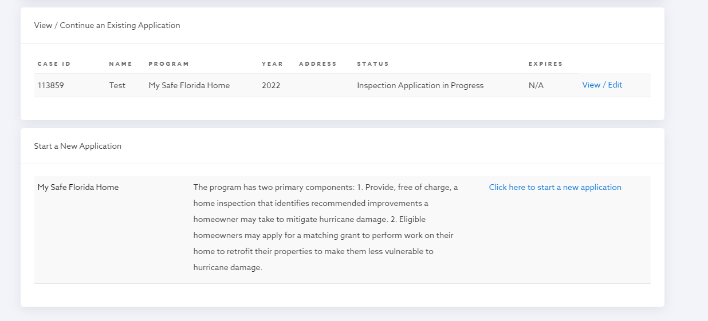
Draw Request Quick Tips
If there is an issue with your Reimbursement Draw Request, the request will be returned to you. Please check for emails from no-reply@mysafeflhome.com.
The following items may speed up the processing of your Draw Request:
- Submitting all required documents (including proof of insurance premium discounts).
- Labelling the documents.
- Ensuring that the Grant Cover Sheet and Original Contractor Invoices provide corresponding costs.
- Submitting .pdf, .jpg, or .png files.

The following items may slow down the processing of your Draw Request:
- Submitting more documents than are required.
- Submitting duplicate documents.
- Submitting files that cannot be opened.

Requesting Reimbursement

Once an application is moved to the “Final Inspection Complete – Pending Reimbursement Request” status, the application will move into the “Grants” section of your portal’s home screen.
Caption: View within the Applicant Portal prior to “Final Inspection Complete – Pending Reimbursement Request” status. Note that the main heading says “View/Continue an Existing Application.”

Grant Reimbursements
page 18
Continued on Next Page
A Program Administered by the Florida Department of Financial Services
MySafeFLHome.com


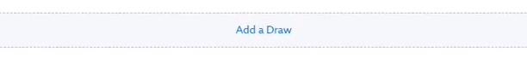
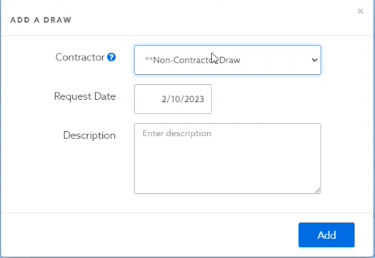
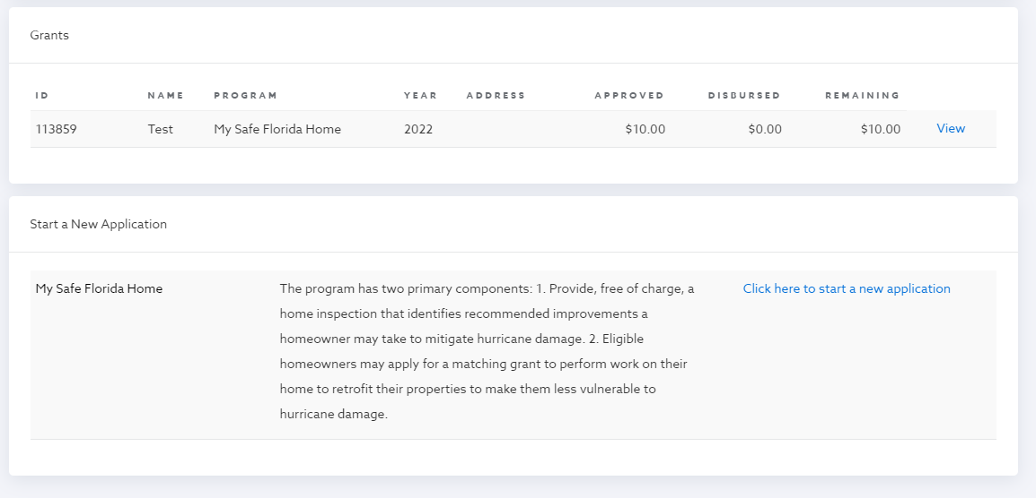
Caption: View within the Applicant Portal after the case is moved to the “Final Inspection Complete – Pending Reimbursement Request” status. Note that the main heading says “Grants.”
All documents listed within the above-mentioned Documents Required for Draw Reimbursement Request table will be provided in a Draw Request in the system. Click the “Draw Requests” tab within your case, then select “Add a Draw.”

IMPORTANT NOTICE: Low-Income applicants will not need to take this step, as it is the contractor’s responsibility.

Caption: The Draw Requests tab

Caption: The “Add a Draw” button

You will first be required to enter a name, date, and description of your request. Ensure you select “Non-Contractor Draw.” You will be required to enter a description. Please add “Reimbursement Request” to this field. Select “Add.”
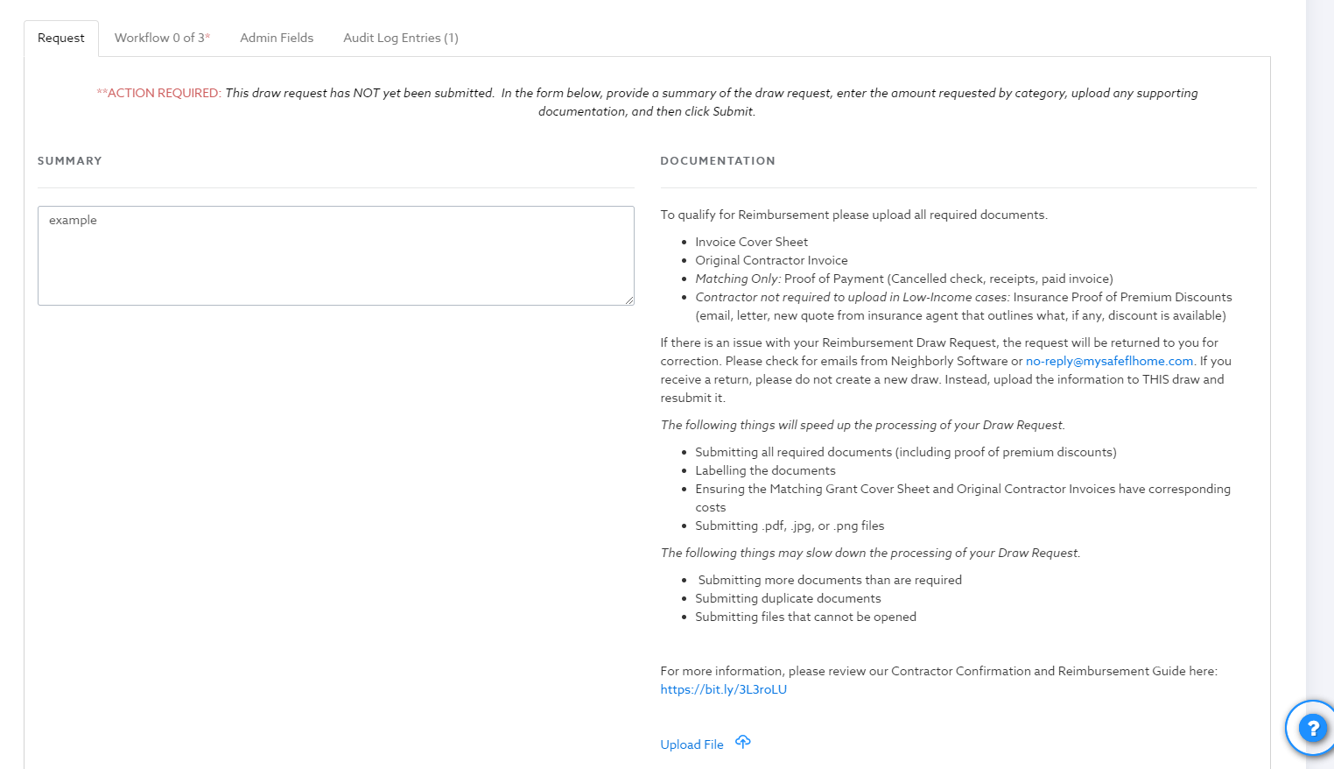
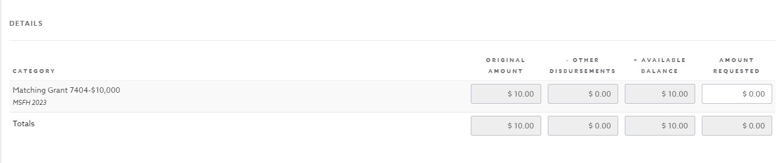
Grant Reimbursements
page 19
Continued on Next Page
A Program Administered by the Florida Department of Financial Services
MySafeFLHome.com
In this part of the screen, you may upload your required documents using the blue “Upload File” button pictured under the “Documentation” header and list. You will also need to add the amount you are requesting to the box with the white background in the bottom right-hand corner.

Please remember that for a Matching Grant, pursuant to section 215.5586(2)(b), F.S., “All grants must be matched on the basis of $1 provided by the applicant for $2 provided by the state up to a maximum state contribution of $10,000 toward the actual cost of the mitigation project.” In other words, Matching Grant recipients must contribute funds equal to one-third (1/3) of the cost of the project to be Reimbursed for the remaining two-thirds (2/3) up to a maximum state contribution of $10,000.

For example, if an applicant were to pay $15,000 for new impact-rated windows, their required contribution would be $5,000, and the state’s contribution would be equal to the maximum grant amount of $10,000. If the windows cost $9,000, the applicant would pay $3,000 and would receive a state matched Reimbursement of $6,000. If the windows cost more than $15,000, the applicant would still only receive $10,000, as that is the maximum Reimbursement amount.

After you have entered all the required information, you will be able to submit your request. If approved, you will receive an email notification from Neighborly Software, and a check will arrive in the mail in the following weeks. If there is an issue with your Reimbursement request, you will receive an email notification providing details as to why, and you will have opportunities to correct the information and resubmit. Please look for emails from
no-reply@mysafeflhome.com and check your spam folder regularly.

Caption: The Reimbursement Request screen. Note the blue “Upload File” button and the box with the white background in the lower right-hand corner.

Glossary of Terms
page 20
Hurricane Resistant – A rating or description of a building or material that will increase a building’s ability to withstand high windstorms. Most structural building products built and used after March 1, 2002, are designed to be hurricane wind resistant. These items such as windows and doors, including garage doors, are speciﬁcally designed to withstand positive and negative wind pressures caused by hurricanes, tornadoes, or straight-line winds.
Impact-Resistant – A rating or description of a building or material that is designed to withstand ﬂying debris caused by high windstorms. These items are tested, by shooting a piece of lumber or metal balls via an air-cannon at them to see if they hold together, to meet a speciﬁc standard. These can be windows, doors, garage doors, storm shutters, or storm panels.
Roof Geometry – The mathematical component of determining the roof shape according to the Uniﬁed Wind Mitigation Inspection Form (OIR-B1-1802). It is a comparison of the hip roof features to non-hip roof features.
- Hip Roof – A roof on which all the roof edges are angled towards and connected to the exterior walls, or where the non-hip features length does not exceed 10% of the total roof perimeter.
- Flat Roof (low slope) – A roof on which the roof structure has a slope of 2:12 or less and, per the OIR-B1-1802, contains five (5) living units or more (multi-family or attached residences).
- Other (non-hip) Roof – A roof where any structurally attached non-hip feature exceeds 10% of the total roof perimeter.
  - Gable or Gambrel Ends
  - Flat Roof Edges
  - Mansard Roof Edges
Roof-to-Wall Connections – The connection between the roof structure and the bearing point or exterior wall of a building.
- Toe-nailed Connection – Nails holding the roof rafters or trusses directly to the wall top plate.
- Clip Connection – A metal connector typically used in wood framed structures and attached to both the roof rafters or trusses and to the wall top plate with a minimum of three nails.
- Single-wrap – A metal connector typically used in concrete masonry construction where one end is embedded into the masonry bond beam and the other end wraps over the truss or rafter and is attached with a minimum of two nails from the embedment side and one nail on the wrapped side.
- Double-wrap – Similar to the single-wrap, except it consists of two (2) metal connectors on either side of the truss member and wrapping over the truss or rafter. The same nail conﬁguration is required in each strap.

Continued on Next Page
A Program Administered by the Florida Department of Financial Services
MySafeFLHome.com
Glossary of Terms
page 21
Secondary Water Barrier – An underlayment material used between the roof deck and the rooﬁng material. Often the material used is a mechanically attached (nailed in-place) underlayment, referred to as “tarpaper” or “rooﬁng felt,” which can also be a self-adhered product (see Secondary Water Resistance Barrier).
Secondary Water Resistance Barrier – An underlayment material that is self-adhered (peel-n-stick) directly to the roof decking. This material can be full roof coverage or seam-tape, a 6” wide rooﬁng tape covering all the seams of the roof deck material. It can also be a closed-cell spray foam adhesive used in the attic space which seals every seam of the roof deck and on either side of the trusses or rafters.
Structurally Attached Roof – A rooﬁng section that is tied into the main rooﬁng system of a home, or an area originally designed to be open to the air that has been enclosed to be part of the building envelope.
Uniform Mitigation Veriﬁcation Inspection Form – Also known as the OIR-B1-1802 or “1802,” is used by WCEs in the State of Florida for wind mitigation inspections.
Wind Mitigation – The process of adding features to your home that help withstand or increase resistance to high winds caused by major storms or hurricanes.
Wind Certiﬁcation Entity (WCE) – A state contractor that performs wind mitigation home inspections pursuant to the My Safe Florida Home Program.

A Program Administered by the Florida Department of Financial Services
MySafeFLHome.com

