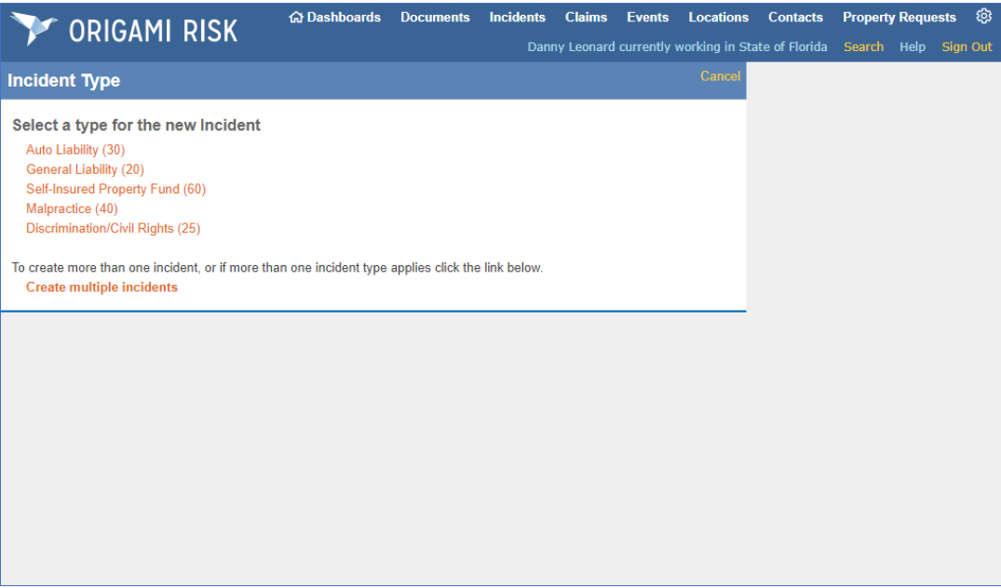

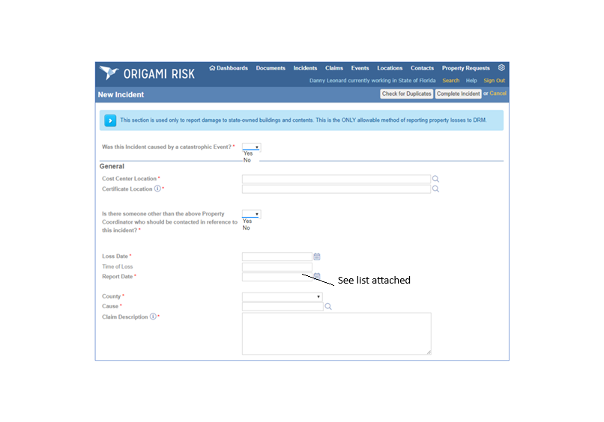

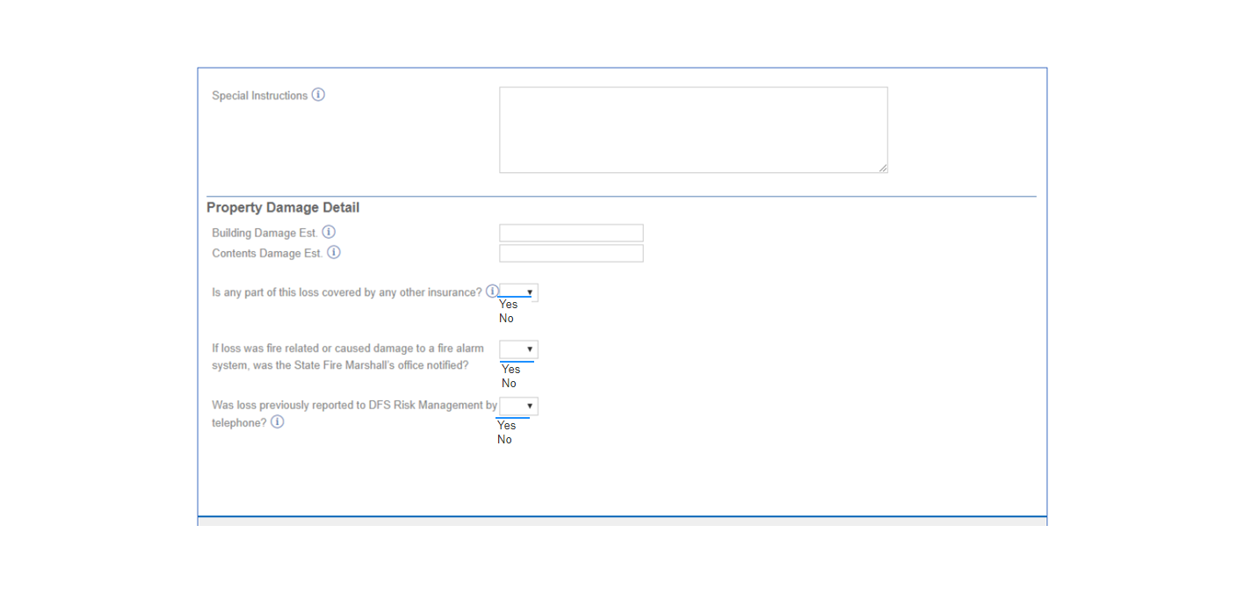

County List
Code | Description |  | Code | Description
11 | Alachua |  | 35 | Madison
52 | Baker |  | 15 | Manatee
23 | Bay |  | 14 | Marion
45 | Bradford |  | 42 | Martin
19 | Brevard |  | 38 | Monroe
10 | Broward |  | 41 | Nassau
58 | Calhoun |  | 43 | Okaloosa
53 | Charlotte |  | 57 | Okeechobee
47 | Citrus |  | 07 | Orange
48 | Clay |  | 26 | Osceola
64 | Collier |  | 99 | Out Of State
29 | Columbia |  | 06 | Palm Beach
01 | Dade |  | 28 | Pasco
34 | Desoto |  | 04 | Pinellas
54 | Dixie |  | 05 | Polk
02 | Duval |  | 22 | Putnam
09 | Escambia |  | 33 | Santa Rosa
61 | Flagler |  | 16 | Sarasota
59 | Franklin |  | 17 | Seminole
21 | Gadsden |  | 20 | St. Johns
55 | Gilchrist |  | 24 | St. Lucie
60 | Glades |  | 98 | Statewide
66 | Gulf |  | 44 | Sumter
56 | Hamilton |  | 31 | Suwannee
30 | Hardee |  | 37 | Taylor
49 | Hendry |  | 63 | Union
40 | Hernando |  | 08 | Volusia
27 | Highlands |  | 65 | Wakulla
03 | Hillsborough |  | 36 | Walton
51 | Holmes |  | 50 | Washington
32 | Indian River
25 | Jackson
46 | Jefferson
62 | Lafayette
12 | Lake
18 | Lee
13 | Leon
39 | Levy
67 | Liberty

