Contractor Manual
My Safe Florida Home Program

July 1, 2023

Specific Procedure

Registration
Registration is a two-step process. First, the contractor must apply to the Department of Financial Services (DFS) for verification and vetting, through the following link: Contractor Registration Form - My Safe Florida Home (msflh.com). DFS will verify that all the information is in order, that the contractor has a valid contractor license, and that insurance is up to date with the State of Florida. Once DFS has finalized vetting the contractor, DFS will send out an email with instructions for the second step of the process. For the second step, the contractor must register in the Contractor Portal in Neighborly, through the following link: My Safe Florida Home (neighborlysoftware.com).

[This space intentionally left blank]

Step 1

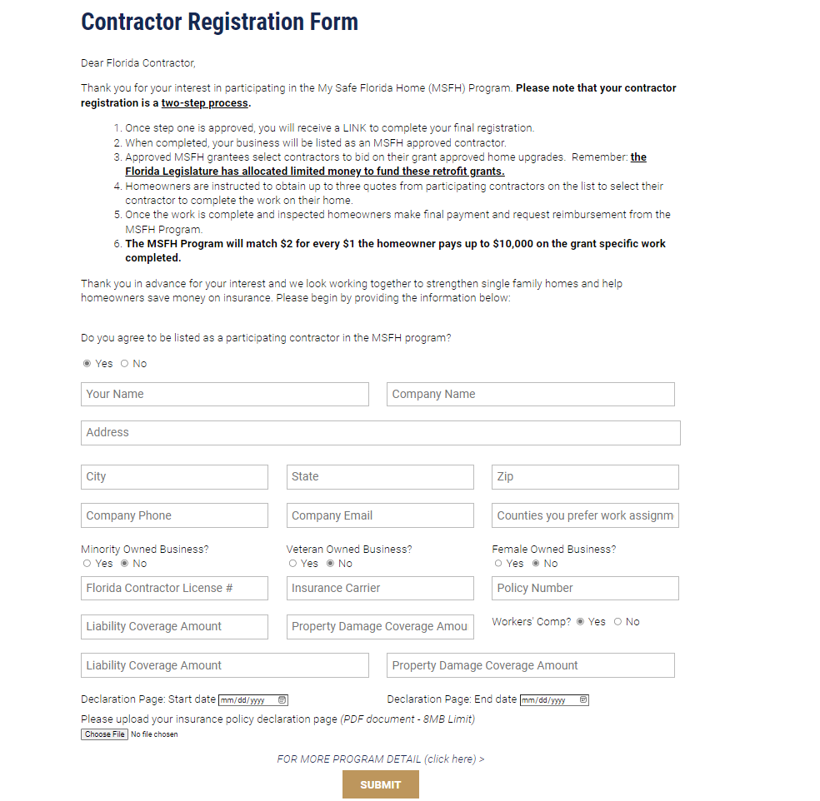

After the Contractor Registration Form is submitted, and verified by DFS, you will receive an email with a link to register in the Neighborly Contractor Portal.

[This space intentionally left blank]

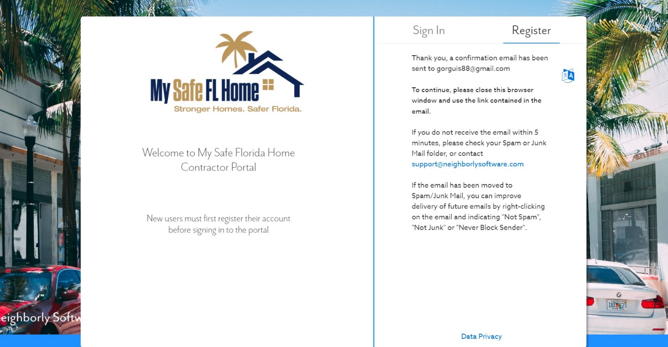
Step 2

Step 3
After registering the user in the Neighborly Contractor Portal, an account confirmation email will be sent to the email address that was used for registration.
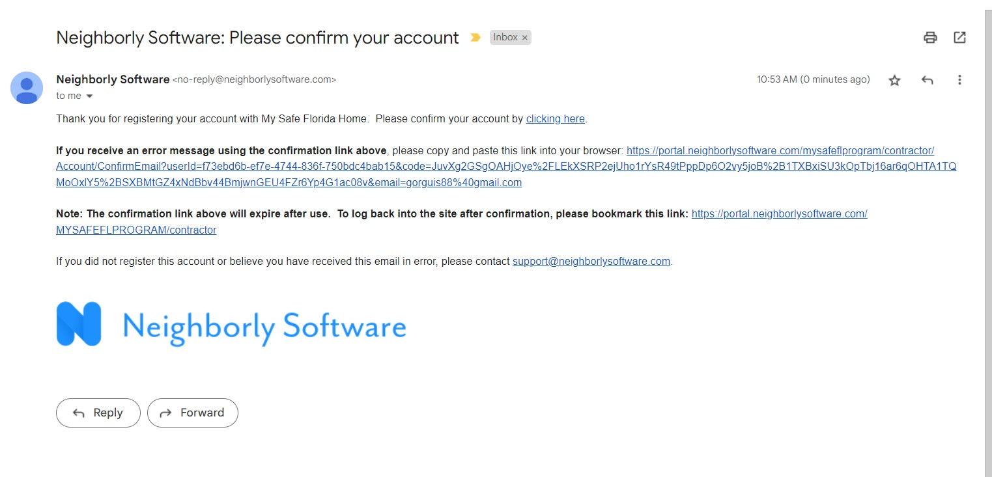

Step 4
After confirming the user and signing into the Contractor Portal, please fill out the entire form, unless certain information does not apply (e.g., fax or a secondary phone number).
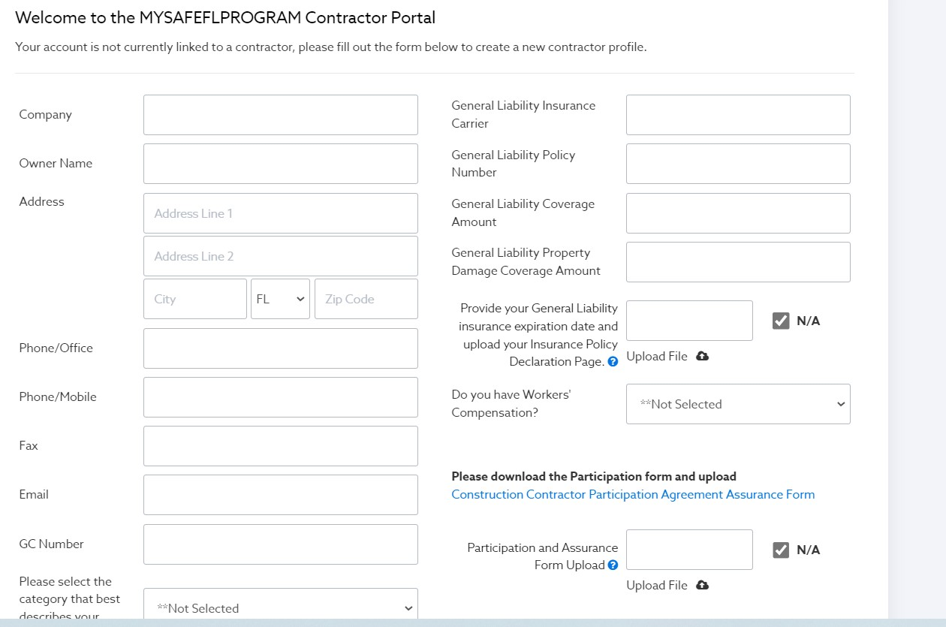

[This space intentionally left blank]

Step 5
Once you have completed Step 4 and clicked “Save,” go to the top tab and select “Contractor Information” to receive access to upload the Insurance Policy Declarations Page and the Contractor Participation Agreement Form. CONTRACTORS WILL NOT BE ACTIVATED IF THESE FORMS ARE NOT ATTACHED ON THE REGISTRATION.
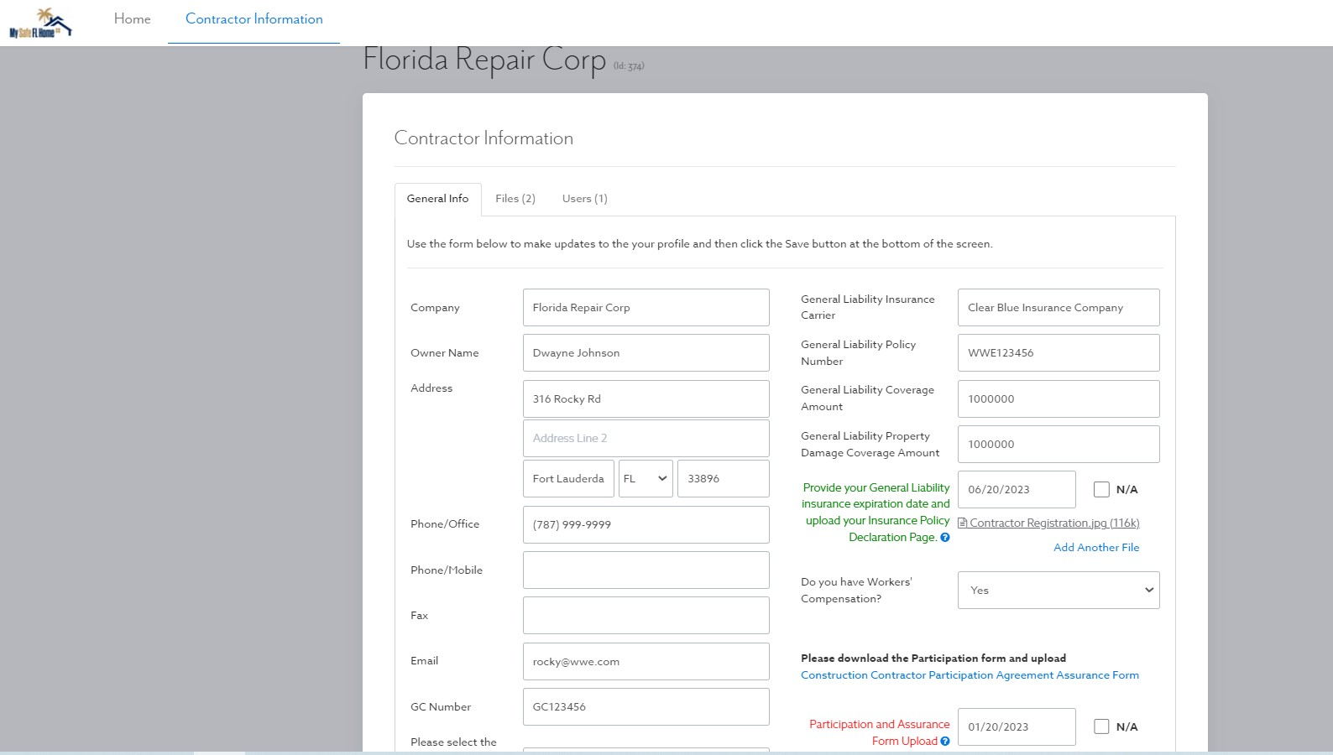
After saving the Contractor Information, this should be the view of the Contractor Portal.

[This space intentionally left blank]

Activation

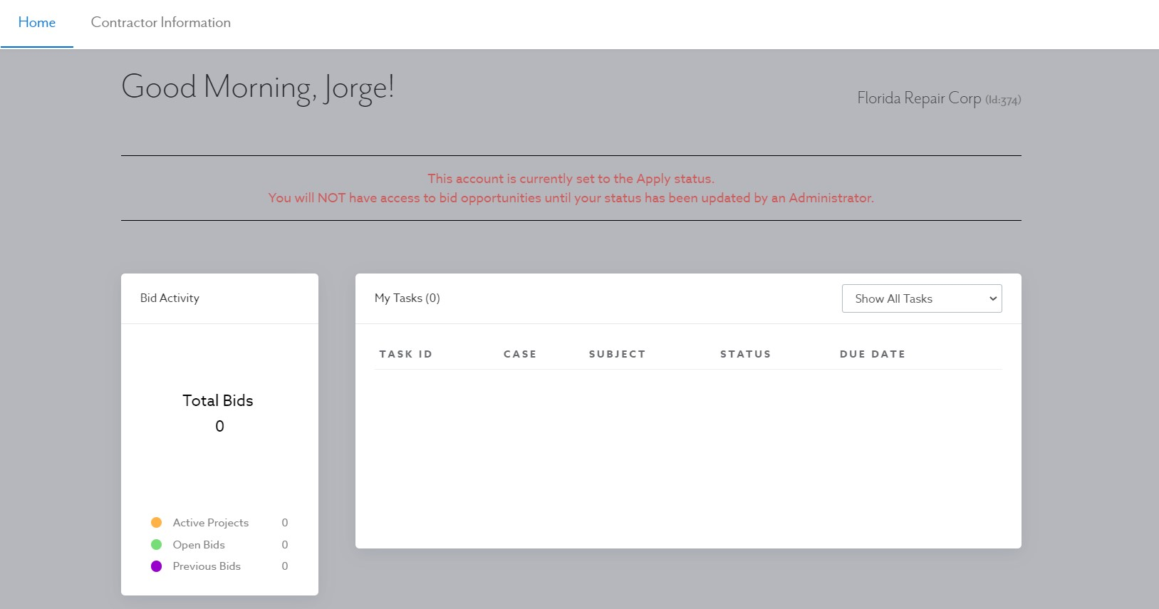
Once the MSFH Program verifies that all information is correct, contractors will be activated and visible to homeowners for them to choose up to three (3) contractors for quotes. IMPORTANT: Although there is a Bid section on the portal, this module will not be required and will not be used for the MSFH Program; therefore, bids do not need to be submitted via the Neighborly portal.

*NOTICE THAT THE RED APPLY BANNER IS GONE. THIS MEANS THAT THE CONTRACTOR HAS BEEN ACTIVATED.
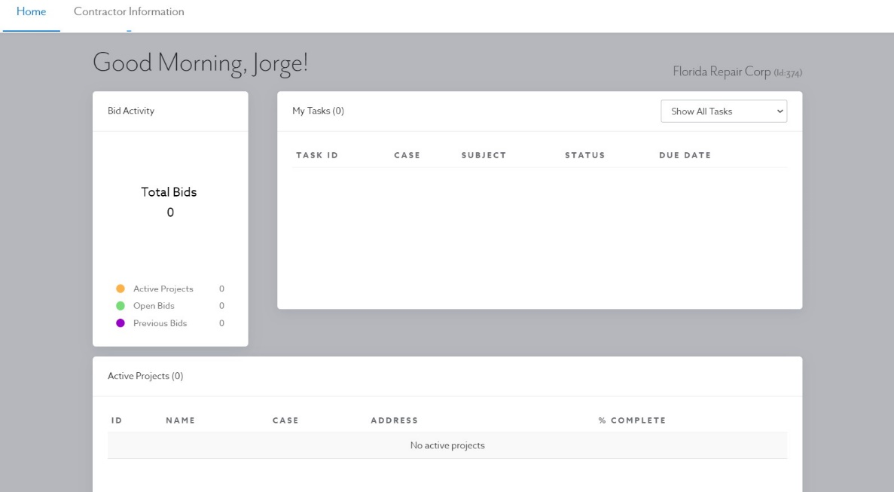

Procedure After Activation
After registration and activation, the contractor’s contact information will be visible in the Authorized Contractors List for homeowners whose Grant Applications have been approved by the MSFH Program.
Matching Grants
For Matching Grants, the homeowner will pay the entire cost of the construction project to the contractor and then request a reimbursement from MSFH Program through the portal. The homeowner will only be reimbursed for work that was recommended in the inspection report. Contractors will have to fill out a form (Grant Invoice Cover Sheet) specifying the work that they performed. Contractors are encouraged to use their normal procedure for homeowner billing (e.g., materials, down payment, balance of completion).
Low-Income Grants
For low-income homeowners, the maximum amount of the grant is $10,000 which will be assigned and paid by the MSFH Program to the contractor with all the required documentation. All authorized improvement work performed by the contractor must be included in the invoice even if it exceeds $10,000 (the MSFH Program will only pay up to $10,000). If authorized improvement work performed by the contractor exceeds $10,000, the homeowner will be responsible for any cost exceeding the $10,000 limit. The MSFH Program is not responsible for the difference. Any additional work performed by the contractor to the homeowner that is not covered by the MSFH Program should be billed separately.
Since Low-Income projects are paid for directly by the MSFH Program, the homeowner should not be billed for any costs unless they exceed the $10,000 provided by the grant. This includes deposits for the work to be completed.
Additional Considerations for Low-Income Cases
Most homeowners will not receive a recommendation in their inspection report to replace solid doors and, therefore, payment will not be disbursed for these projects. An exception to the prohibition on replacing a solid door can be made IF the homeowner can provide documentation from their insurance agent indicating that replacing all solid doors or garage doors with upgraded impact-tested products will result in a discount on their insurance premium. You will need to request this documentation (described below) from the homeowner to upload with your payment request.

Documentation required for the above-mentioned exception can be one of the following: an email, letter, or quote from an insurance agent. The documentation must specifically mention that a rating of A.1 on the windstorm mitigation form OIR-B1-1802 is required to obtain the discount on the insurance policy currently in force, as well as the amount of any potential savings if A.1 is achieved. Once this documentation is received, the replacement of a solid door can be approved. For a list of all authorized improvements, please refer to the Authorized Improvements Guide.

As of July 1, 2023, the 7th improvement for LI homeowners is no longer an Authorized Improvement. Work begun prior to July 1, 2023, can be paid for by the MSFH Program; however, all grants approved after July 1, 2023, do not have this improvement available to them. Please avoid performing this improvement, if possible.

Townhouses
As of July 1, 2023, townhouses will be allowed to participate in the MSFH Program. A “townhouse” is a single-family unit constructed in a series or group of attached units separated by property lines. Each townhouse shall be considered a separate building and shall not exceed three (3) stories in height. Townhouses are only eligible for Improvement 4.0 (Improvement 4 and Improvement 5 on the Authorized Improvements Guide) – Opening Protection. Only opening protection will be eligible for grant payments under the MSFH Program.

Contractor Confirmation in Low-Income Cases

In Low-Income cases, contractors MUST inform homeowners that before they begin authorized improvements on their property, the homeowner must go to the portal, click on the Contractor Confirmation tab, and fill out the required contractor information so that the case can be assigned to the correct contractor in the portal.

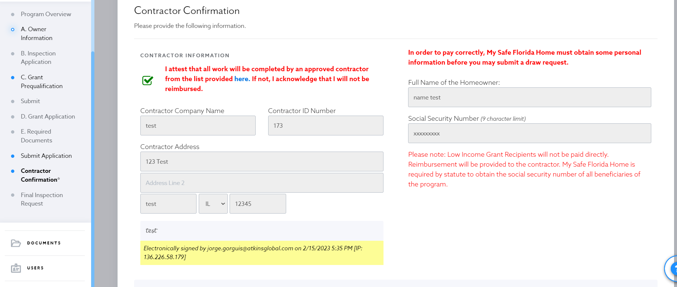
Once the information is received, the MSFH Program will verify the information and once it is approved, you will be able to see the case assigned in the Contractor Portal under Active Projects. Once you see the case in the Contractor Portal, this is your confirmation that the homeowner is indeed a Low-Income participant, and you will be paid by the MSFH Program—not the homeowner—for these repairs.
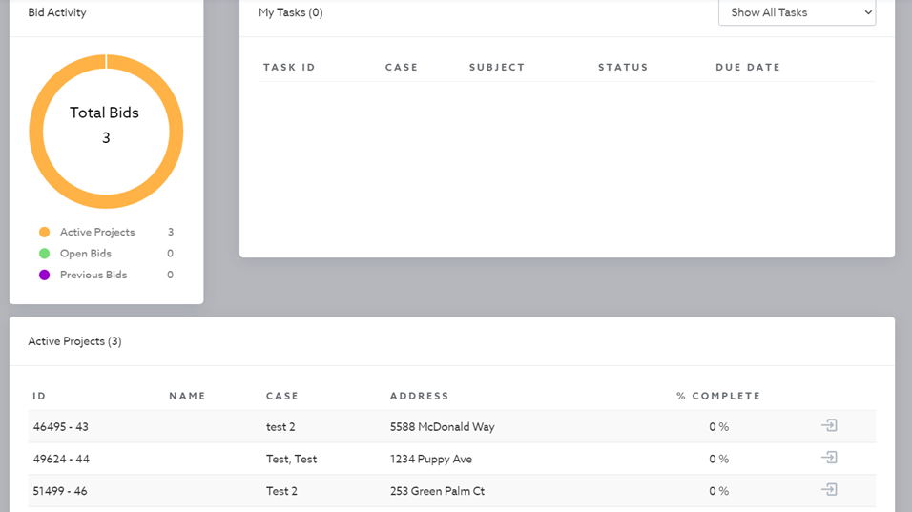

While Matching Grant recipients will also complete this step, these recipients will not appear in your portal. Matching Grant recipients are required to pay you in full and then seek reimbursement, so you do not need to access their case in your portal. Please invoice these recipients as normal and provide them with proof of payment in full.

Grant Invoice Cover Sheets

Homeowners are required to provide the MSFH Program with the Grant Invoice Cover Sheet, completed and signed by their contractor, for the work completed by the contractor on their home. Work on the Grant Invoice Cover Sheet must have been recommended by a MSFH Program Initial Inspection report. Work paid for prior to the MSFH Program’s start in November of 2022 is never eligible, and a Cover Sheet should not be filled out for that work.

While a homeowner is not required to show you their inspection report, we will show you where to find the recommended improvements for a home. Below is an example of page 5 of the Initial Inspection Report. The green checkmarks show features already present on the home, and the red X’s show what features are missing.
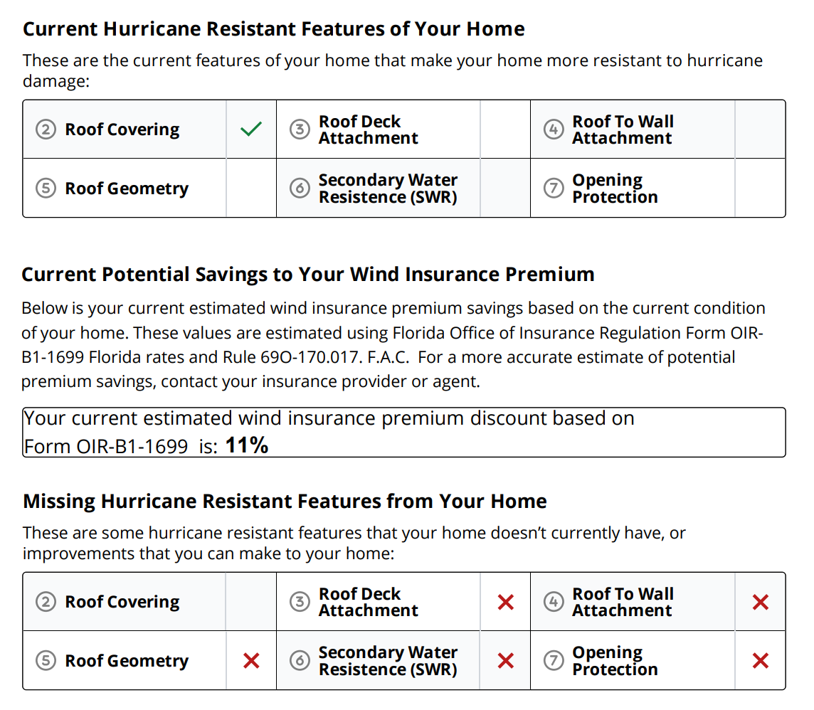
Page 6 of the inspection report lists the recommended upgrades for the home. Below is an example of what that may look like. Please note that roof covering, roof deck attachment, and secondary water resistance are all covered in the recommendation to “replace roof and add a secondary water-resistant (SWR) barrier”.
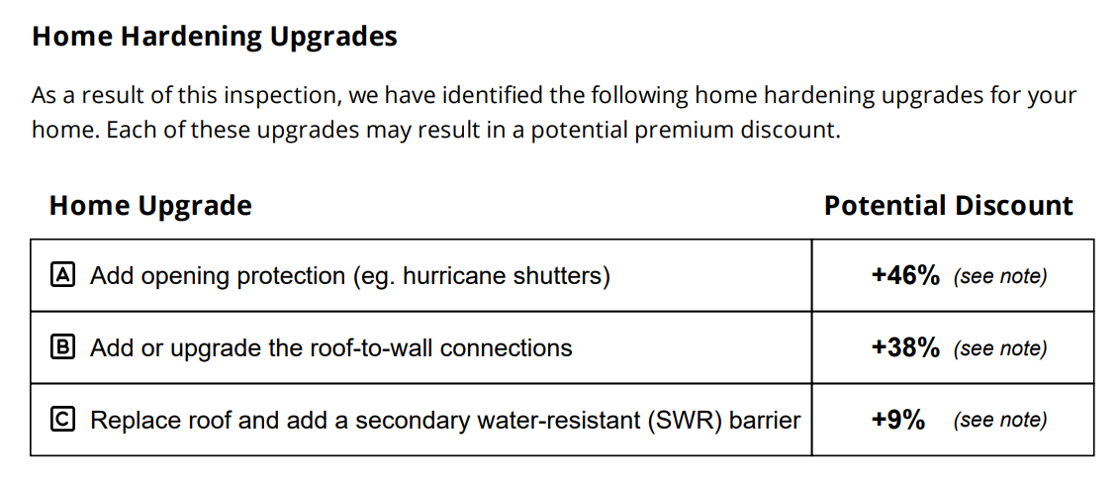

Contractors should always use the Grant Invoice Cover Sheet template. Check off the items that were completed on the home and itemize the costs relating to each improvement performed to the best of your ability. Below is an image of the checkboxes and the Notes section on the Grant Invoice Cover Sheet.
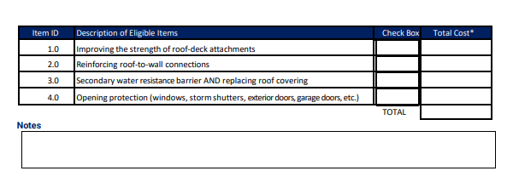

Please note that there are only four (4) possible improvements. Opening Protection covers protection for doors and windows. To install a SWR, improve their roof-deck attachments, or roof-to-wall connections, the roof covering needs to be replaced. Any costs associated with the roof covering should be incorporated into the line item for the SWR. A homeowner cannot receive reimbursement or payment for only replacing their roof covering; the homeowner must add the SWR or improve their roof-deck attachments.

If a homeowner has been recommended to replace their roof and add a SWR, but a SWR cannot be added due to the construction of the roof, please see if the homeowner has acceptable roof-deck attachments or roof-to-wall connections. If the homeowner cannot replace the SWR, the cost to replace a roof covering will be covered if an improvement is made in roof-deck attachments or roof-to-wall connections. Please ensure to note the reason that a SWR could not be installed in the Notes section.

If a homeowner was invoiced for more than the work that was included on the cover sheet, please note any costs left off the Grant Invoice Cover Sheet in the Notes section. If the draw reviewer cannot clearly see what items were left off the Grant Invoice Cover Sheet, they may not be able to approve the draw.

Payment Process for Low-Income Grant Projects

- Contractor verifies that the homeowner is an approved homeowner through the contractor’s portal, prior to performing work.
- Contractor finalizes work on the construction project.
- The homeowner must request a Final Inspection through the grant portal. If the homeowner has not requested a final inspection through the system after five (5) business days, the contractor may reach out to contractors@mysafeflhome.com. Low-Income final inspections will be prioritized in the Final Inspection queue and are intended to verify work completion. The MSFH Program will assign an inspection company to perform the follow up Final inspection; contractors will receive a notification when the Wind Certification Entity is assigned and when the inspection is completed.
- Once the Final Inspection Report is complete and uploaded to the portal, the contractor will be able to submit a draw request for payment. The contractor must upload the following required documentation for reimbursement:
- MSFH Program Grant Invoice Cover Sheet (completed and signed by the contractor).
- Original contractor invoice.
- If the homeowner chose to replace a solid door without a recommendation in an inspection report, an email, letter, or quote from an insurance agent requesting upgrade to change rating to A.1 as required in Form 1802 to obtain a discount. Contractors must request this information from low-income homeowners for payment disbursement.

If more information is required for payment, the MSFH Program will contact the contractor for more information. Please look for notifications from Neighborly Software or no-reply@mysafeflhome.com.

Completing a Draw Request to Receive Payment
Follow these instructions in the portal to receive payment.
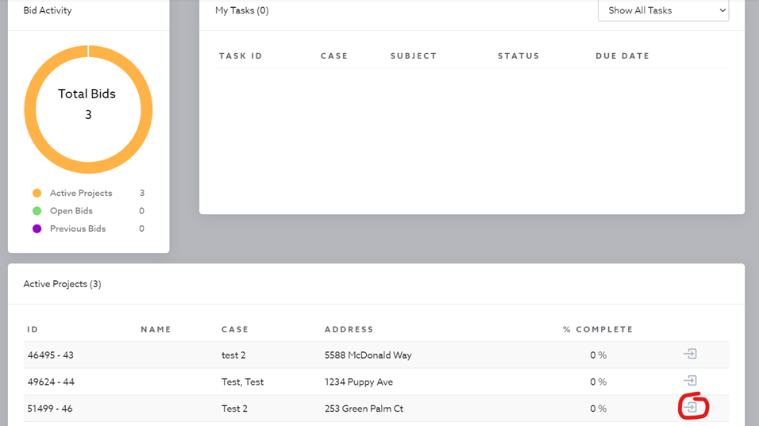
- After final inspection is complete, click on your active projects (circled in red).

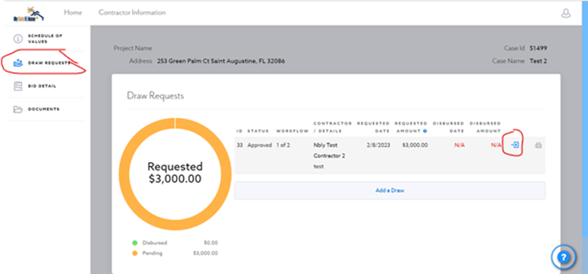
Select draw request, and then select the icon circled in red to the right-hand side.

- This step is where the Final Inspection and required documentation is uploaded. All information must be completed.

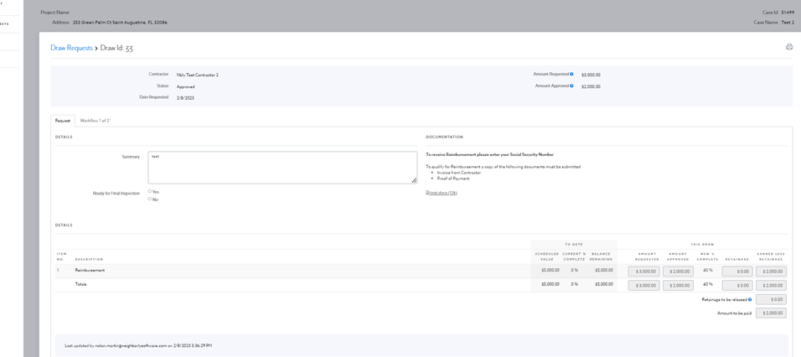

- Upon completion of the Final Inspection and after a draw request has been submitted, the MSFH Program will perform a final review of the reimbursement request. If more information is required for reimbursement, the MSFH Program will contact the contractor for more information.
- Upon review and approval, the contractor will receive a payment approval notification via email. After approval, payment will be processed through the DFS payment center, and a check will be mailed to the contractor.

Reimbursement Process for Matching Grant

- Contractor finalizes work on the construction project.
- Contractor must complete and sign the MSFH Program Grant Invoice Cover Sheet and provide the Grant Invoice Cover Sheet to the homeowner.
- Homeowners must pay the contractor’s invoice in full. The contractor must provide the homeowner with proof of payment in full.
- After work is complete, a Matching Grant homeowner must request the Final Inspection through the Neighborly Contractor Portal to verify work completion and initiate the reimbursement process. The contractor’s role is completed after this step.

Removal of Contractors

The Department of Financial Services shall remove an authorized contractor from the MSFH Program Authorized Contractor List if any of the following grounds exist:

- Failing to maintain compliance with this Contractor Manual, Request for Qualifications 2223-01, and section 215.5586, F.S.
- Misrepresenting the contractor’s licensing status with the Department of Business and Professional Regulation to the MSFH Program or the homeowner.
- Guaranteeing the homeowner will receive grant funds under the MSFH Program.
- Roofing contractors that advise a homeowner to perform patchwork on roofs.
- Failing to provide documentation to the homeowner upon the homeowner’s demand.

