Contractor Confirmation and Reimbursement Guide
  - My Safe Florida Home Program

July 1, 2023

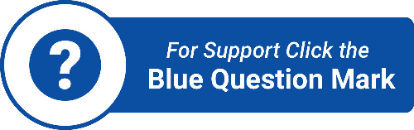

Specific Procedure
Contractor Confirmation and Requesting a Final Inspection

After receiving an Initial Inspection Report from a MSFH Program assigned inspector, a grant application will open in the Applicant portal. You may access the applicant portal at any time, via https://mysafeflhome.com/. After the grant application is submitted, reviewed, and approved, you will receive an approval email with instructions on how to move forward.

After receiving an approval email for a Matching or Low-Income Grant, you are free to request quotes from up to three (3) authorized contractors. The authorized MSFH Program contractor list will be available in the grant approval email.

When you receive grant approval, grant funds are set aside for you. Please keep in mind that the Final Inspection (the step to initiate the Reimbursement process) must be completed within one (1) year of your approval date OR before July 1, 2024 (whichever is sooner). After one (1) year, you may apply for an extension of time; however, funding is limited and the MSFH Program cannot guarantee future approvals. Each homeowner may receive only one (1) grant.

Please review your Initial Inspection Report carefully. The only work that is authorized is that which is listed in the Authorized Improvements Guide and must be supported by a recommendation in your Initial Inspection Report. If you have any questions about what is recommended in your report, please contact your Wind Certification Entity (inspection company) using the contact information provided in your Inspection Approval email.

IMPORTANT NOTICE: Work performed that is NOT recommended on your Initial Inspection Report WILL NOT be reimbursed.

Once you have selected a contractor, you will need to assign that contractor to your case through the Applicant Portal. All applicants, both Low-Income (LI) and Matching Grant applicants, must do this prior to beginning work. If this step was not available to you at the time of approval and you have already begun work, please assign your contractor as soon as possible.

You will need to enter all requested information in the Contractor Confirmation step. Please ensure that you enter your contractor’s information as it appears in the authorized MSFH Program contractor list. The contractor’s ID number is the three-to-four-digit code next to the contractor’s name.

IMPORTANT NOTICE: While both types of Applicants will need to complete the above-mentioned step, only Low-Income applicants’ cases will appear in their contractor’s portal.

After you have clicked “Complete and Submit,” your status will change to “Contractor Confirmation Submitted.” You will not need to perform any other actions in the Applicant Portal until after the work on your home is complete. If you selected a contractor that was not on the MSFH Program list, you will receive an email notification stating that you will need to select a different contractor.

IMPORTANT NOTICE: The MSFH Program will not make any grant payments if you fail to use an authorized contractor to perform authorized work.

Prior to beginning work, you must ensure that the contractor receives all applicable building permits from the local building inspector’s office. Once construction is completed, you must ensure the permits are closed out and that the local building inspector’s office has completed all required inspections. Afterwards, you must request the Final Inspection from the MSFH Program.

IMPORTANT NOTICE: Do not request a Final Inspection until all work on your home has been completed. You have only one (1) opportunity to request a Final Inspection.

When work on your home is complete, you must initiate the Reimbursement or Disbursement process for either type of grant by having your home inspected again. By participating in the MSFH Program, you agreed to make your home available for a final inspection.

IMPORTANT NOTICE: There is no other way to initiate the Reimbursement or Disbursement process without requesting a Final Inspection from the MSFH Program via the Applicant Portal.

After you have requested your Final Inspection, a case manager will alert your Wind Certification Entity (inspection company) and will send a notification similar to the Initial Inspection Approval email. Although Wind Certification Entities will prioritize Final Inspection requests over initial and Quality Control (QC) inspection requests, inspections will be scheduled by Wind Certification Entities based on a queue.

Once your Final Inspection has been completed, the Wind Certification Entity will submit the Final Inspection Report to the MSFH Program portal. After your status has changed to “Pending Reimbursement Request,” if you are a Matching Grant recipient, you are now ready to provide additional information through the Applicant Portal for Reimbursement.

If you are a Low-Income Grant recipient, you will need to return to the MSFH Program portal to upload an email, letter, or new quote from your insurance agent that outlines what, if any, discount is available. Please note that it is the contractor’s responsibility to request payment from the MSFH Program portal and to provide all relevant documents.

Below is a list of the documents required for a Reimbursement Draw Request. Contractors should refer to the Contractor Manual for information on completing a draw request for Low-Income cases. To receive the proof of insurance premium discount documentation, you will need to send your Final Inspection Report to your insurance agent.

Documents Required for Draw Reimbursement Request

Reimbursement Documentation | Homeowner – Matching $10,000 | Contractor – Low Income $10,000.00
Invoice Cover Sheet | Yes | Yes
Original Contractor Invoice(s) | Yes | Yes
Proof of Payment (Cancelled check, receipts, paid invoice) | Yes | N/A
Proof of insurance premium discounts (email; letter; new quote from insurance agent that outlines what, if any, discount is available) | Yes | Yes – the homeowner will be responsible for uploading this information.
**Initial and final inspection reports are already stored in the grants portal and are not the applicant’s responsibility to provide.
***If the applicant chooses to replace a solid door without a recommendation in an inspection report, this document must be provided for Reimbursement. An email, letter, or quote from an insurance agent requesting upgrade to change the rating to A.1 as required in Form 1802 to obtain an insurance discount. This requirement is applicable to all counties, except Broward and Miami-Dade Counties which will be exempt. Contractors must request this information from Low-Income applicants for payment disbursement.
Draw Request Quick Tips
If there is an issue with your Reimbursement Draw Request, the request will be returned to you. Please look for emails from no-reply@mysafeflhome.com and check your spam folder.
The following items may speed up the processing of your Draw Request:
- Submitting all required documents (including proof of insurance premium discounts).
- Labelling the documents.
- Ensuring the Matching Grant Cover Sheet and Original Contractor Invoices provide corresponding costs.
- Submitting .pdf, .jpg, or .png files.

The following items may slow down the processing of your Draw Request:
- Submitting more documents than are required.
- Submitting duplicate documents.
- Submitting files that cannot be opened.
Requesting Reimbursement

Once an application is moved to the “Final Inspection Complete – Pending Reimbursement Request” status, the application will move into the “Grants” section of your portal’s home screen.

Caption: View within the Applicant Portal prior to “Final Inspection Complete – Pending Reimbursement Request” status. Note that the main heading says “View/Continue an Existing Application.”
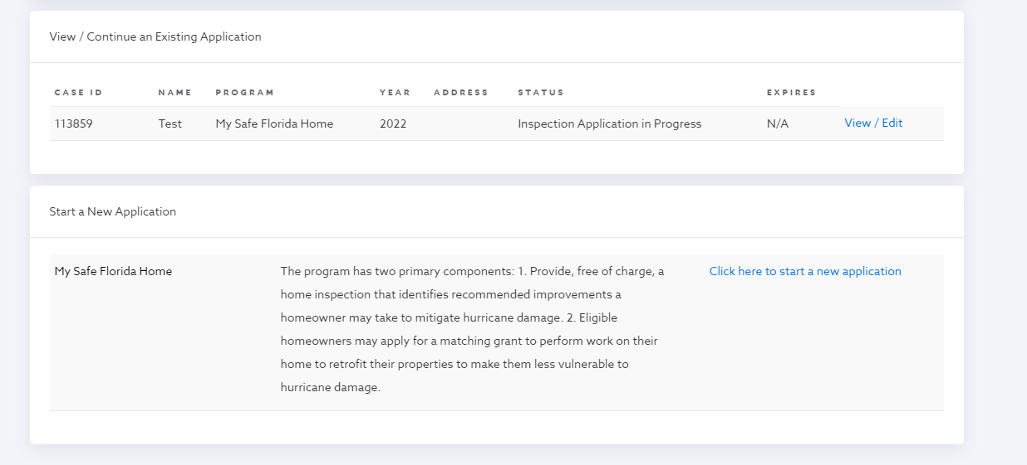

Caption: View within the Applicant Portal after the case is moved to the “Final Inspection Complete – Pending Reimbursement Request” status. Note that the main heading says “Grants.”
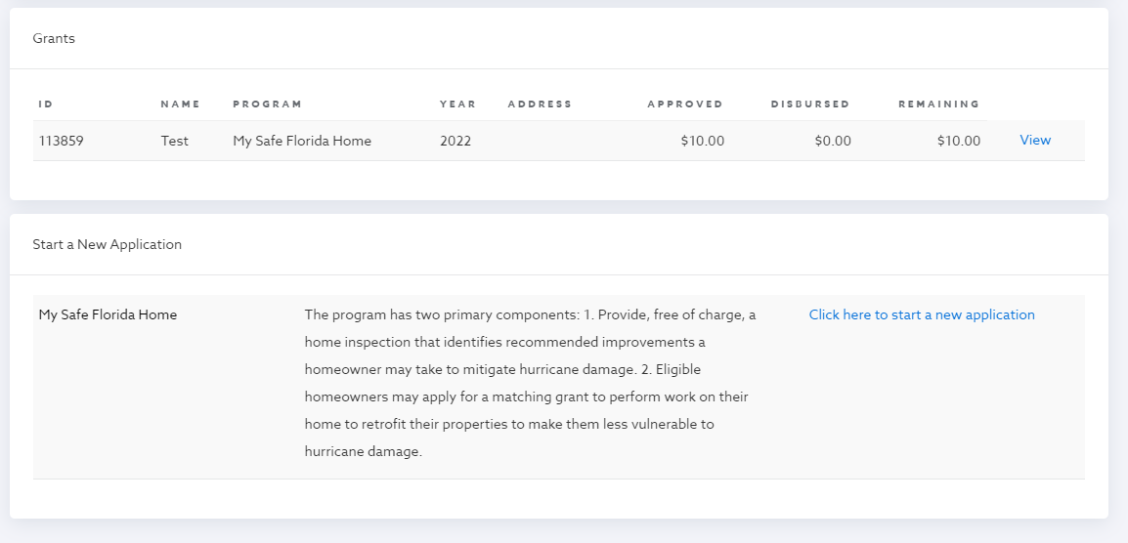

All the documents listed within the above-mentioned Documents Required for Draw Reimbursement Request table will be provided in a Draw Request in the system. Click the “Draw Requests” tab within your case, then select “Add a Draw.”

IMPORTANT NOTICE: Low-Income applicants will not need to take this step, as it is the contractor’s responsibility.

Caption: The Draw Requests tab
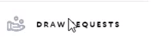

Caption: The “Add a Draw” button
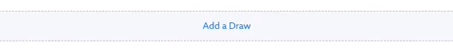

You will first be required to enter a name, date, and description of your request. You will be required to enter a description. Please add “Reimbursement Request” to this field. Select “Add.”

Caption: The “Add a Draw” initial screen

.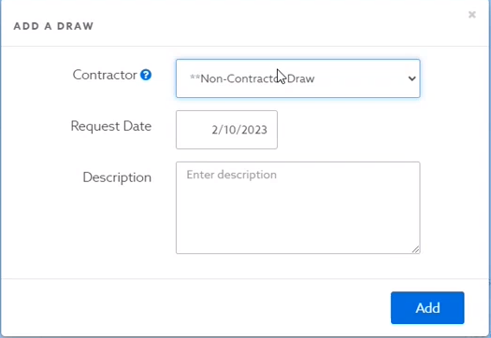

In this part of the screen, you may upload your required documents using the blue “Upload File” button pictured under the “Documentation” header and list.

You will also need to add the amount you are requesting to the box with the white background in the bottom right-hand corner.

Caption: The Reimbursement Request screen. Note the blue “Upload File” button and the box with the white background in the lower right-hand corner.

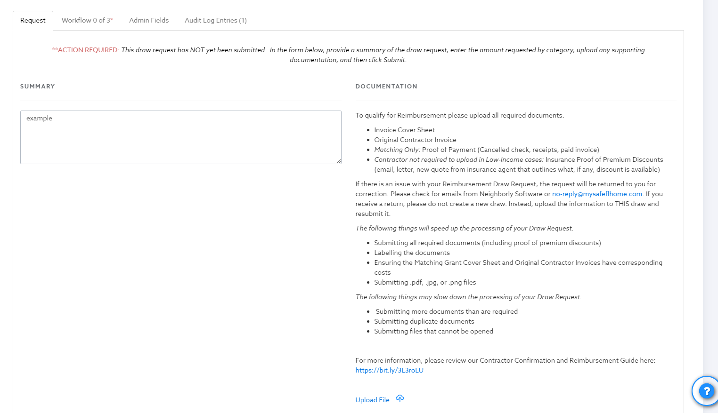

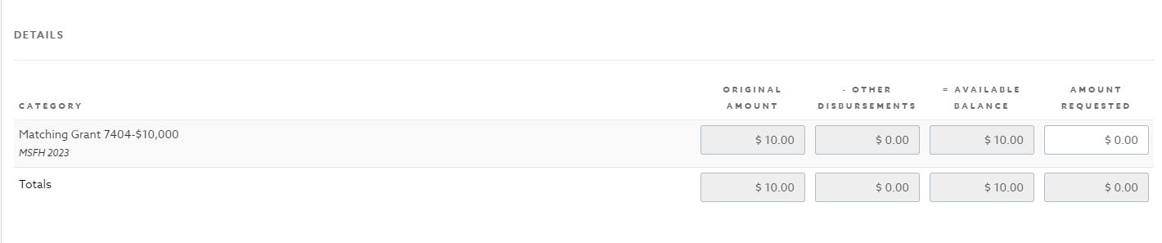

Please remember that for a Matching Grant, pursuant to section 215.5586(2)(b), F.S., “All grants must be matched on the basis of $1 provided by the applicant for $2 provided by the state up to a maximum state contribution of $10,000 toward the actual cost of the mitigation project.” In other words, Matching Grant recipients must contribute funds equal to one-third (1/3) of the cost of the project to be Reimbursed for the remaining two-thirds (2/3) up to a maximum state contribution of $10,000.

For example, if an applicant were to pay $15,000 for new impact-rated windows, their required contribution would be $5,000, and the state’s contribution would be equal to the maximum grant amount of $10,000. If the windows cost $9,000, the applicant would pay $3,000 and would receive a state matched Reimbursement of $6,000. If the windows cost more than $15,000, the applicant would still only receive $10,000, as that is the maximum Reimbursement amount.

After you have entered all the required information, you will be able to submit your request. If approved, you will receive an email notification from Neighborly Software, and a check will arrive in the mail in the following weeks. If there is an issue with your Reimbursement request, you will receive an email notification providing details as to why, and you will have opportunities to correct the information and resubmit. Please look for emails from no-reply@mysafeflhome.com and check your spam folder regularly.

