Application for
Individual and Conceptual Approval
Environmental Resource Permit,
State 404 Program Permit,

and Authorization to Use State-Owned
Submerged Lands

Florida Department of Environmental Protection/
Water Management Districts

Effective October 2026
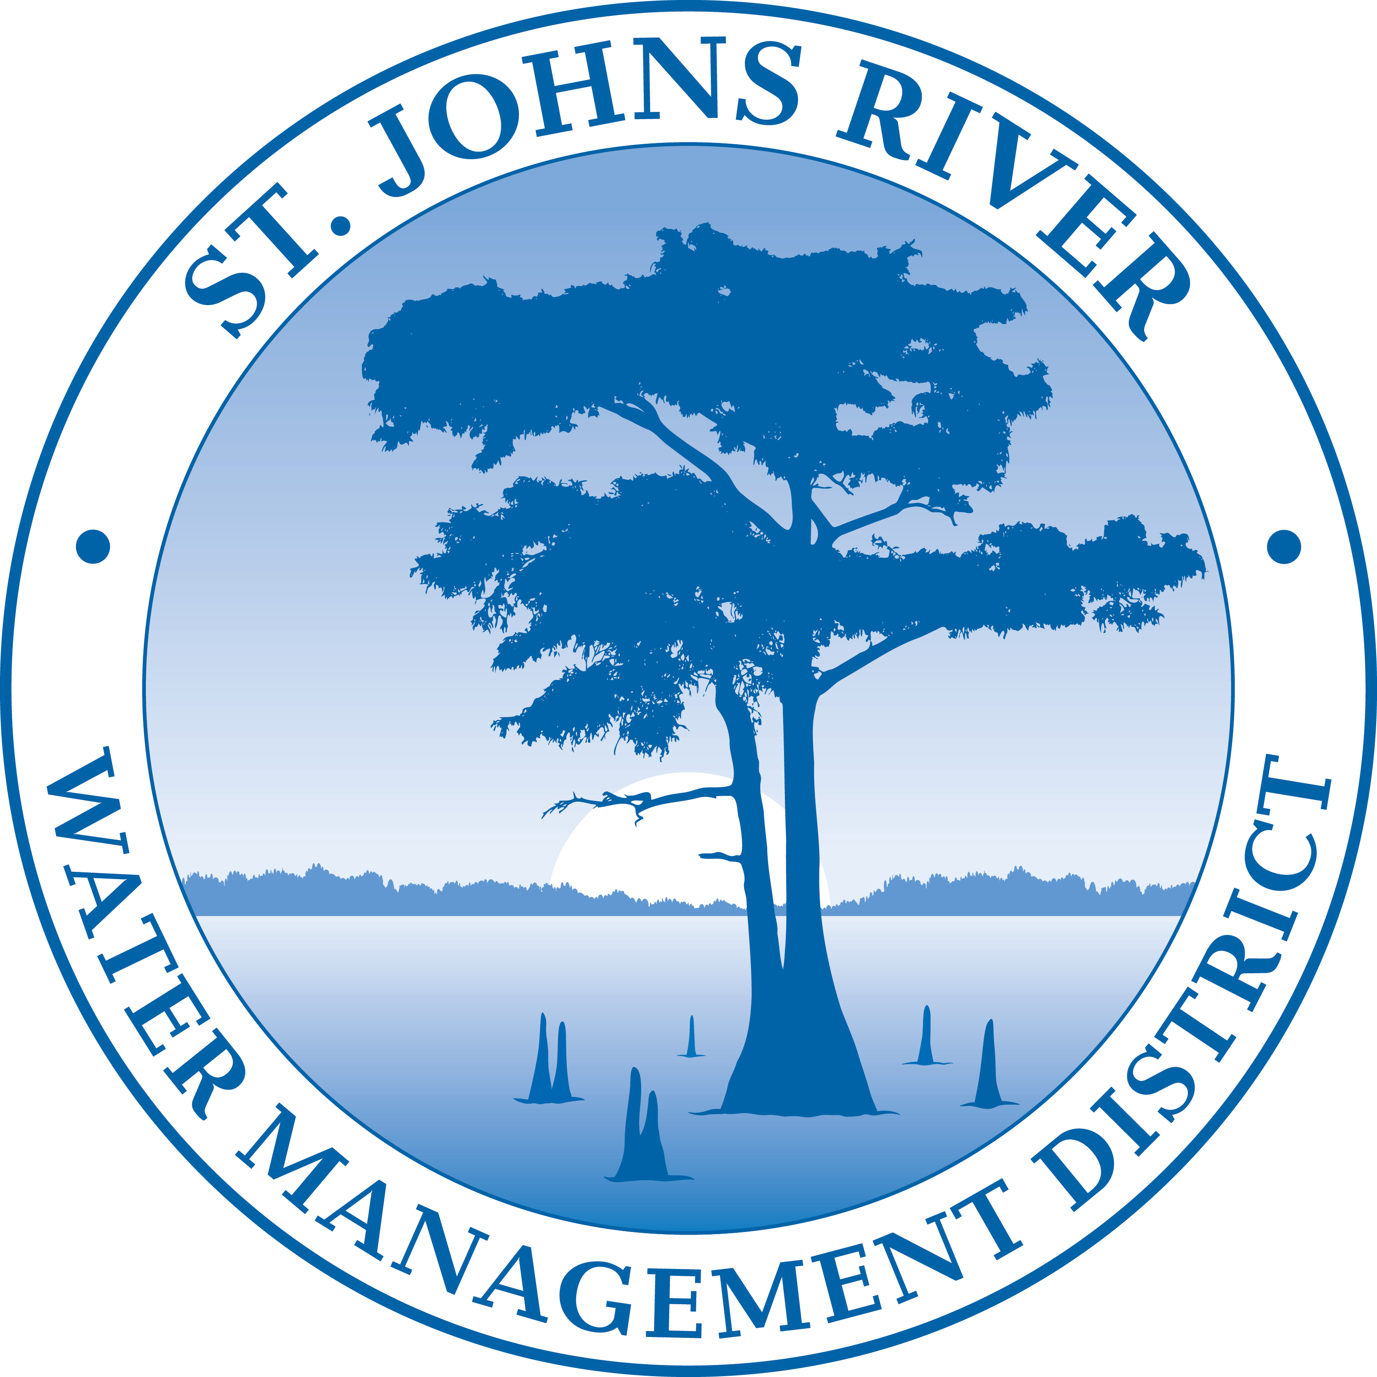
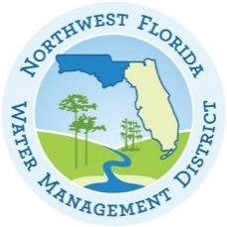

Instructions for Use of This Form:

This form is designed to assist you in submitting a complete application. All applications must include Section A- General Information for All Activities. Sections B through H list typical information that is needed based on the proposed activities and are only required as applicable. Part 1-C of Section A will guide you to the correct sections needed based on your proposed activities. Applicants are advised to consult Chapter 62-330, F.A.C., and the Environmental Resource Permit Applicant’s Handbook Volumes I and II for information regarding the ERP permitting process and requirements while preparing their application. Internet addresses for Chapter 62-330, F.A.C., and the Applicant’s Handbook, Agency contact information, and additional instructions for this form can be found in Attachment 1.

What Sections of the Application Must I Fill Out?
Type of Activity | Section A | Section B | Section C | Section D | Section E | Section F | Section G | Section H | Section  I | Section  J
Fill in wetlands or waters for a single family residence? | Y | Y | N | N | N | N | N | N | Y, if in assumed waters | N
Docks, shoreline stabilization, seawalls associated with a single family residence? | Y | Y | N | N | N | Y, as needed | N | N | Y, if in assumed waters | N
Wetland impacts (other than association with an individual residence)? | Y | N | Y | N | N | N | N | N | Y, if in assumed waters | N
Boating facilities, a marina, jetty, reef, or dredging? | Y | N | Y | Y | N | Y, as needed | N | N | Y, if in assumed waters | N
Any work on state owned submerged land? | Y | N | Y | N | N | Y | N | N | Y, if in assumed waters | N
Construction of a stormwater management system? | Y | N | Y, as needed | N | Y | N | N | N | N | N
Constructing a mitigation bank? | Y | N | Y | N | Y, as needed | N | Y | N | Y, if in assumed waters | N
Creating a mine? | Y | N | Y, as needed | N | N | N | N | Y | Y, if in assumed waters | N
Creating a WQEA? | Y | N | Y, as needed | Y, as needed | N | N | N | N | Y, if in assumed waters | Y
If you have any questions, or would like assistance completing this form, please contact the staff of the nearest office of either the Florida Department of Environmental Protection (DEP) or a Water Management District (WMD) (see Attachment 2).
Section A:
General Information for All Activities

Part 1: Name, Application Type, Location, and Description of Activity
- Name of project, including phase if applicable:

- This is for (check all that apply):

Construction and operation of new works, activities, and/ or a stormwater management system
Conceptual Approval of proposed works, activities and/ or a stormwater management system
Modification or alteration of existing works, activities, and/or a stormwater management system. Provide the existing DEP or WMD permit #, if known: Note: Minor modifications do not require completion of this form, and may instead be requested by letter in accordance with section 6.2 of Applicant’s Handbook Volume I.
Maintenance or repair of works, activities, and/ or a stormwater management system previously permitted by the DEP or WMD. Provide existing permit #, if known:
Abandonment or removal of works, activities, and/ or a stormwater management system.
Provide existing DEP or WMD permit #, if known:
Operation of an existing unpermitted work, activity, and/or stormwater management system.
Construction of additional phases of a permitted work, activity, or system.
Provide the existing DEP or WMD permit #, if known:

A State 404 Program authorization:
Exemption General Permit Individual Permit
If requesting an Exemption or General Permit provide Rule #, if known:
By checking this box, I hereby voluntarily waive, in accordance with Rule 62-330.090(8), F.A.C., the agency action deadlines in section 5.5.4 of Volume I in the event my project also requires a State 404 Program authorization (other than an exemption) under Chapter 62-331, F.A.C., and request that the agency actions for the ERP and State 404 Program authorizations be issued at the same time. (This is strongly recommended to ensure consistency, and to reduce the potential need for project modifications to resolve inconsistencies that may occur when the agency actions are issued at different times.) If this box is checked and the Agency(ies) determines that no State 404 Program authorization is required, the Agency will continue to abide by section 5.5.4 of Volume I.

- List the type of activities proposed. Check all that apply, and provide the supplemental information requested in each of the referenced application sections. Please also reference Applicant’s Handbook Volumes I and II for the type of information that may be needed.

Activities associated with one single-family residence, duplex, triplex, or quadruplex that do not qualify for an exemption or a General Permit: Provide the information requested in Section B. Do not complete Section C.

Activities within wetlands or surface waters, or within 25 feet of a wetland or surface water, (not including the activities associated with an individual single-family residence). Examples include dredging, filling, outfall structures, docks, piers, over-water structures, shoreline stabilization, mitigation, reclamation, and restoration/enhancement. Provide the information requested in Section C.

Activities within navigable or flowing surface waters such as a multi-slip dock or marina, dry storage facility, dredging, bridge, breakwaters, reefs, or other offshore structures: In addition to Section C, also provide the information requested in Section D.

Activities that are (or may be) located within, on, or over state-owned submerged lands (See Chapter 18-21, F.A.C. https://www.flrules.org/gateway/ChapterHome.asp?Chapter=18-21): In addition to Section B or C, also provide the information requested in Section F.

Construction or alteration of a stormwater management system serving residential, commercial, transportation, industrial, agricultural, or other land uses, or a solid waste facility (excluding mines that are regulated by DEP). Provide the information requested in Section E.

Creation or modification of a Mitigation Bank (refer to Chapter 62-342, F.A.C. https://www.flrules.org/gateway/ChapterHome.asp?Chapter=62-342): Provide the information requested in Section G.

Mines (as defined in Section 2.0 of Applicant’s Handbook Volume I) that are regulated by the DEP: Provide the information requested in Section H.

Creation or modification of a Water Quality Enhancement Area (refer to Chapter 62-332, F.A.C.) (insert link): Provide the information requested in Section J.

Other, describe: Please contact the Agency to determine which additional sections of the application are needed. See Attachment 2 for Agency contacts.

- Describe in general terms the proposed project, system, works, or other activities. For permit modifications, please briefly describe the changes requested to the permit:

- Project/Activity Street/Road Address or other location (if applicable):
City: County(ies): Zip:

Note: For utility, road, or ditch/canal activities, provide a starting and ending point using street names and nearest house numbers or provide length of project in miles along named streets or highways.
- Project location map and Section, Township, and Range information (use additional sheets if needed):
Please attach a location map showing the location and boundaries of the proposed activity in relation to major intersections or other landmarks. The map should also contain a north arrow and a graphic scale; show Section(s), Township(s), and Range(s); and must be of sufficient detail to allow a person unfamiliar with the site to find it.
Section(s): Township: Range: Land Grant name, if applicable:
Section(s): Township: Range:
- Section(s): Township: Range:

- Latitude (DMS) º ’ ” Longitude (DMS) º ’ ” (Taken from central location of the activity). Explain source for obtaining latitude and longitude (i.e. U.S.G.S. Quadrangle Map, GPS, online resource):

- Tax Parcel Identification Number(s):
[Number may be obtained from property tax bill or from the county property appraiser’s office; if on multiple parcels, provide multiple Tax Parcel Identification Numbers]
- Directions to Site (from major roads; include distances and landmarks as applicable): .

- Project area or phase area: acres

- Name of waterbody(ies) (if known) in which activities will occur or into which the system will discharge:
The following questions (M-O) are not applicable to activities related to an individual single-family residence, including a dock, pier, and/or seawall associated with that residence.

- Is it part of a larger plan of development or sale? yes no

- Impervious or semi-impervious area excluding wetlands and other surface waters (if applicable):
acres or square feet
- Volume of water the system is capable of impounding (if applicable):
Normal Pool: acre-feet. Depth ft.
Maximum Pool: acre-feet. Depth ft.

Part 2: Supplemental Information, and Permit History
- Is this an application to modify an existing Environmental Resource Permit or to construct or implement part of a multi-phase project, such as a project with a Conceptual Approval permit? Yes No (If you answered “yes”, please provide permit numbers below):

Agency | Date | Permit/Application No. | Project Name

- Indicate if there have been any pre-application meeting(s) with the DEP, WMD, or delegated local government, or other discussions, meetings, or coordination with other stakeholders or agencies about the proposed project, system or activity. If so, please provide the date(s), location(s) of the meeting, and the name(s) of Agency staff that attended the meeting(s):

Agency | Date | Location | Meeting Attendees

- Attach a depiction (plan and section views), which clearly shows the works or other activities proposed to be constructed. Use multiple sheets, if necessary, a scale sufficient to show the location and type of works, and include a north arrow and a key to any symbols used. Specific information to be included in the plans is based on the activities proposed and is further described in Sections B-H. However, supplemental information may be required based on the specific circumstances or location of the proposed works or other activies.

- Processing Fee: Please submit the application processing fee along with this application form and supplemental information. Processing fees vary based on the size of the activity, the type of permit applied for, and the reviewing Agency. Please reference Appendix D of Applicant’s Handbook Volume I to determine the appropriate fee.

Part 3: Applicant and Associated Parties Information
Instructions: Please complete the following sections. For corporations, list a person who is a registered agent or officer of the corporation who has the legal authority to bind the corporation.

A. Applicant (Entity Must Have Sufficient Real Property Interest)
This is a Contact Person for Additional Information

Last Name: First Name: Middle Initial:
Title: Company:
Address:
City: State: Zip:
Home Telephone: Work Telephone:
Cell Phone: E-mail Address:

Correspondence will be sent via email, unless you check here to receive it via US Mail:

Land Owner(S) (If Different or in Addition to Applicant)
Check here if land owner is also a co-applicant

Last Name: First Name: Middle Initial:
Title: Company:
Address:
City: State: Zip:
Home Telephone: Work Telephone:
Cell Phone: E-mail Address:

Correspondence will be sent via email, unless you check here to receive it via US Mail:

Operation and Maintenance Entity (see Applicant’s Handbook I, Section 12.3)

Last Name: First Name: Middle Initial:
Title: Company:
Address:
City: State: Zip:
Home Telephone: Work Telephone:
Cell Phone: E-mail Address:
Correspondence will be sent via email, unless you check here to receive it via US Mail:

Co-Applicant (If Different or In Addition to Applicant and Owner)
Last Name: First Name: Middle Initial:
Title: Company:
Address:
City: State: Zip:
Home Telephone: Work Telephone:
Cell Phone:
E-mail Address:
Correspondence will be sent via email, unless you check here to receive it via US Mail:

Registered Professional Consultant
This is a contact person for additional information
Last Name: First Name: Middle Initial:
Title: Company:
Address:
City: State: Zip:
Home Telephone: Work Telephone:
Cell Phone:
E-mail Address:
Correspondence will be sent via email, unless you check here to receive it via US Mail:

Environmental Consultant
This is a contact person for additional information
Last Name: First Name: Middle Initial:
Title: Company:
Address:
City: State: Zip:
Home Telephone: Work Telephone:
Cell Phone:
E-mail Address:
Correspondence will be sent via email, unless you check here to receive it via US Mail:

Agent Authorized to Secure Permit (If Different from Consultant)

Last Name: First Name: Middle Initial:
Title: Company:
Address:
City: State: Zip:
Home Telephone: Work Telephone:
Cell Phone:
E-mail Address:

Correspondence will be sent via email, unless you check here to receive it via US Mail:

If necessary, please add additional pages for other contacts and property owners related to this project.

Real Property Interest

- Permits are only issued to entities having sufficient real property interest as described in Section 4.2.3(d) of Applicant’s Handbook Volume I. Please attach evidence of the applicant’s real property interest over the land upon which the activities subject to the application will be conducted, including mitigation areas (if applicable). Refer to Sections 4.2.3(d)-(e) for sufficient real property interest documentation.

- For activities that require a recorded notice in accordance with rule 62-330.090(7), F.A.C., please provide either the complete legal description of the property or a copy of the pages of the document recorded in the public records that contains the complete legal description. If the land upon which the proposed activities are to occur is not owned by the applicant, the applicant must also provide copies of any right-of-way, leases, easements, or other legal agreement which authorizes the applicant to perform the activities on those lands.

Part 4: Signatures and Authorization to Access Property

Instructions: For multiple applicants please provide a separate Part 4 for each applicant. For corporations, the application must be signed by a person authorized to bind the corporation. A person who has sufficient real property interest (see Section 4.2.3(d) of Applicant’s Handbook Volume I) is required in (B) to authorize access to the property, except when the applicant has the power of eminent domain.

  - By signing this application form, I am applying for the permit and any proprietary authorizations identified above, according to the supporting data and other incidental information filed with this application. I am familiar with the information contained in this application and represent that such information is true, complete and accurate. I understand this is an application and not a permit, and that work prior to approval is a violation. I understand that this application and any permit issued or proprietary authorization issued pursuant thereto does not relieve me of any obligation for obtaining any other required federal, state, water management district, or local permit prior to commencement of construction. I agree to operate and maintain the permitted system unless the permitting agency authorizes transfer of the permit to a different responsible operation and maintenance entity. I understand that knowingly making any false statement or representation in this application is a violation of Section 373.430, F.S. and 18 U.S.C. Section 1001.

________________________________
Typed/Printed Name of Applicant or Signature of Applicant or Applicant’s Date
Applicant’s Authorized Agent Authorized Agent

(Corporate Title if applicable)

  - Certification of Sufficient Real Property Interest And Authorization For Staff To Access The Property:

I certify that:

I possess sufficient real property interest in or control, as defined in Section 4.2.3 (d) of Applicant’s Handbook Volume I, over the land upon which the activities described in this application are proposed and I have legal authority to grant permission to access those lands. I hereby grant permission, evidenced by my signature below, for staff of the Agency to access, inspect, and sample the lands and waters of the property as necessary for the review of the proposed works and other activities specified in this application, upon advance notice. I authorize these agents or personnel to enter the property as many times as may be necessary to make such review, inspection, and/ or sampling. Further, if a permit is granted, upon advance notice, I agree to provide entry to the project site for such agents or personnel with proper identification to determine compliance with permit conditions and permitted plans and specifications.

OR

I represent an entity having the power of eminent domain and condemnation authority, and I/we shall make appropriate arrangements to enable staff of the Agency to legally access, inspect, and sample the property as described above.

_______________________________
Typed/Printed Name Signature Date

(Corporate Title if applicable)

  - Designation of Authorized Agent (If Applicable):
I hereby designate and authorize to act on my behalf, or on behalf of my corporation, as the agent in the processing of this application for the permit and/or proprietary authorization indicated above and to furnish, on request, supplemental information in support of the application. In addition, I authorize the above-listed agent to bind me, or my corporation, to perform any requirements which may be necessary to procure the permit or authorization indicated above. I understand that knowingly making any false statement or representation in this application is a violation of Section 373.430, F.S., and 18 U.S.C. Section 1001.

________________________________
Typed/Printed Name of Applicant Signature of Applicant Date

(Corporate Title if applicable)

