Environmental Resource Permit
Applicant’s Handbook
Volume II
(Design and Performance Standards
Including Basin Design and Criteria)

FLORIDA Department of
Environmental Protection and northwest florida water management district

All Appendices are Incorporated by Reference
in subsection 62-330.010(4), F.A.C.

Effective (June 1, 2018)

For use within the geographic limits of the northwest florida water management district

FLORIDA DEPARTMENT OF ENVIRONMENTAL PROTECTION 
NORTHWEST FLORIDA WATER MANAGEMENT DISTRICT 

TABLE OF CONTENTS
PART I — INTRODUCTION, ORGANIZATION, APPLICABILITY 1
1.0 Introduction 1
1.1 Applicability 1
1.2 District-Specific Thresholds 2
1.3 District-Specific Exemptions 2
PART II — GENERAL CRITERIA 1
2.0 General Criteria for all Stormwater Management Systems 1
2.0.1 General Criteria 1
2.0.2 Criteria for Evaluation – Reasonable Assurance 1
2.0.3 Agriculture and Silviculture 2
2.1 Definitions 3
2.2 Existing Ambient Water Quality 4
2.3 Professional Certification 4
2.4 Maintenance Access 4
2.5 Legal Authorization 5
2.6 Public Safety 5
2.7 Tailwater Considerations 6
2.8 Retrofits of Existing Stormwater Management Systems 8
2.9 Compensating Stormwater Treatment 10
2.10 Flexibility for State Transportation Projects and Facilities 11
2.11 Dam Safety 11
2.12 Inspections to Ensure Proper Operation and Maintenance 11
PART III — STORMWATER QUANTITY/FLOOD CONTROL 1
3.0 General Flood Control Requirements 1
3.1 Stormwater Management Systems That Must Meet Water Quantity Criteria 1
3.2 Standards that Apply and Relationship to Part IV 1
3.3 Stormwater Quantity: Rate and Volume Controls 2
3.4 Storage and Conveyance 7
3.5 Low Flow and Base Flow Maintenance 8
3.6 Flood Damage 9
Part IV — Stormwater Quality 1
4.0 Purpose 1
4.1 Criterion 1
4.2 Integration with the Water Resource Implementation Rule 1
4.3 State Water Quality Standards 1
4.4 Reasonable Assurance 2
4.5 Criteria to Protect Streambanks 2
4.6 Erosion and Sediment Control Criteria for Stormwater Management Systems 5
4.7 Oil and Grease Control 6
4.8 On-Line and Off-line Stormwater Systems 7
4.9 Hazardous or toxic substances 10
4.10 Runoff Coefficient and Curve Number for Stormwater Management Ponds 10
4.11 Rural Subdivisions 10
4.12 Runoff from One-inch of Rainfall 11
4.13 Alternative Designs 12
Part V — Best Management Practices 1
5.0 Design Criteria and Guidelines for Retention Systems 1
5.1 Description 1
5.2 Treatment Volume 1
5.3 Recovery Time 3
5.4 Basin Stabilization 3
5.5 Retention Basin Construction 3
6.0 Underdrain Design and Performance Criteria 1
6.1 Description 1
6.2 Treatment Volume 1
6.3 Recovery Time 4
6.4 Safety Factor 4
6.5 Underdrain Media 4
6.6 Filter Fabric 4
6.7 Inspection and Cleanout Ports 4
6.8 Basin Stabilization 5
6.9 Base Flow 5
7.0 Exfiltration Trench Design and Performance Criteria 1
7.1 Description 1
7.2 Treatment Volume 3
7.3 Recovery Time 3
7.4 Safety Factor 3
7.5 Minimum Dimensions 4
7.6 Filter Fabric 4
7.7 Inspection and Cleanout Structures 4
7.8 Ground Water Table 4
7.9 Construction 4
8.0 Wet Detention Design and Performance Criteria 1
8.1 Description 1
8.2 Treatment Volume 1
8.3 Recovery Time 1
8.4 Outlet Structure 3
8.5 Permanent Pool 3
8.6 Littoral Zone 3
8.7 Pond Depth 8
8.8 Pond Configuration 8
8.9 Ground Water Table 8
8.10 Pre-treatment 10
8.11 Pond Side Slopes 10
8.12 Direct Discharges to Outstanding Florida Waters 10
9.0 Design Criteria for Swale Systems 1
9.1 Description 1
9.2 Treatment Volume 3
9.3 Soils Requirements 3
9.4 Dimensional Requirements 3
9.5 Construction and Stabilization 3
10.0 Design Criteria for Wetlands Stormwater Management Systems 1
10.1 Description 1
10.2 Types of Wetlands that may be Utilized for Stormwater Treatment 1
10.3 Treatment Volume 1
10.4 Recovery Time 1
10.5 Inlet Structures 1
10.6 Wetland Function 2
10.7 Residence Time 2
11.0 Design Criteria for Vegetated Natural Buffers 1
11.1 Description 1
11.2 Contributing Area 1
11.3 Buffer Area Vegetation 3
11.4 Buffer Width 3
11.5 Maximum Buffer Slope 3
11.6 Minimum Buffer Length 3
11.7 Runoff Flow Characteristics 3
11.8 Preservation and Maintenance Access 3
11.9 Maintenance and Inspections 4
12.0 Design Criteria for Stormwater Harvesting 1
12.1 Description 1
12.2 Harvesting Volume 3
12.3 Permanent Pool 3
12.4 Littoral Zone 3
12.5 Pond Depth 4
12.6 Pond Configuration 4
12.7 Ground Water Table 4
13.0 Special Basin Criteria: Sensitive Karst Areas 1
13.1 Background of the Sensitive Karst Area Design Criteria 1
13.2 Hydrogeology of the Sensitive Karst Areas 1
13.3 Additional Design Criteria for Sensitive Karst Areas 5
13.4 Considerations for Mining and Certain Other Excavation Activities 7
APPENDIX A 1
LOCATION DESCRIPTION OF SENSITIVE KARST AREAS 1
APPENDIX B 1
DETENTION WITH FILTRATION GUIDANCE 1
APPENDIX B-1 1
CAUTIONS CONCERNING THE USE OF DETENTION WITH FILTRATION SYSTEMS 1
APPENDIX B-2 2
DETENTION WITH FILTRATION CRITERIA CHECK-LIST 2
APPENDIX C 1
GUIDANCE FOR EVALUATING MINES AND BORROW PIT ACTIVITIES 1
APPENDIX D 1
PROCEDURES FOR EVALUATING PROPOSED ACTIVITIES FOR SITES PREVIOUSLY PERMITTED UNDER CHAPTERS 62-25 AND 62-346, F.A.C. 1
APPENDIX E 1
Chapter 5 of the Florida Development Manual: A Guide to Sound Land and Water Management (June 1988) 1
APPENDIX F 1
Section 3.10 of Chapter 6 of the Florida Development Manual: A Guide to Sound Land and Water Management (June 1988) 1

PART I — INTRODUCTION, ORGANIZATION, APPLICABILITY

1.0 Introduction
This is Volume II of a two-volume “Environmental Resource Permit Applicant’s Handbook. It accompanies Applicant’s Handbook—Volume I (General and Environmental). The Handbook Volumes have been developed to assist persons in understanding and applying the rules, procedures, standards, and criteria implementing the environmental resource permit (ERP) program under Part IV of Chapter 373 of the Florida Statutes (F.S.). The ERP program regulates all types of projects, including stormwater management systems, dams, impoundments, reservoirs, appurtenant work, or works, and dredging or filling, as those terms are defined in Sections 373.403(13) and (14), F.S., or any combination thereof. These terms are defined in Sections 373.019 and 373.403, F.S., and in Section 2.0 of Handbook Volume I.

1.1 Applicability
Volume I (General and Environmental), applies statewide to the Department of Environmental Protection (“Department” or “DEP”) and all the water management districts (“WMDs” or “Districts”).

This Volume II is applicable only within the geographic boundaries of the Northwest Florida Water Management District (NWFWD). It is incorporated by reference in paragraph 62-330.010(4)(b)1., F.A.C., and therefore operates as a rule of DEP and NWFWMD in accordance with Section 373.4131, F.S. Separate Volume IIs have been adopted by each of the other WMDs for use within the geographical boundaries of each District. Each of those other Volume IIs also are incorporated by reference in paragraph 62-330.010(4)(b)2. through 5., F.A.C., and therefore operate as rules of DEP and each applicable District within the geographical area of that District for activities regulated under Chapter 62-330, F.A.C.

Volume II is applicable only to those ERP activities that involve the design of a stormwater management system that requires a permit under Chapter 62-330, F.A.C. More specifically, it provides specific, detailed design and performance methodologies designed to meet the water quality and quantity requirements of stormwater management systems. It also will assist persons who are designing activities to comply with the general permit in Section 403.814(12), F.S.

This Volume also contains District-specific appendices for regionally-specific criteria applicable to such things as Sensitive Karst areas. There is a separate document titled “[References and Design Aids]” that contains example calculations and design aids for stormwater systems within the Florida Panhandle. The Design Aids Document is for reference and to provide examples, but it is not adopted by rule.

A stormwater management system is defined in Sections 373.403(10) and 403.031(16), F.S., and in Section 2.0 of Handbook Volume I, as a system that is designed and constructed or implemented to control discharges which are necessitated by rainfall events, incorporating methods to collect, convey, store, absorb, inhibit, treat, use, or reuse water to prevent or reduce flooding, overdrainage, environmental degradation, and water pollution or otherwise affect the quantity and quality of discharges from the system.

Volume II generally is not applicable to projects that generate no more than an incidental amount of stormwater runoff, such as:

- Dredging and filling to construct such things as most “stand-alone” seawalls, docks and “in water” types of activities, such as channel dredging. This would not include dredging and filling in wetlands or other surface waters to construct such things as bridges or culverted road crossings, parking areas, building sites, or land fill which may or may not contain structures;
- Pervious (e.g., slatted decking) piers that do not convey vehicular traffic.
- An overwater pier, dock, or a similar structure located in a deepwater port subject to subsection 373.406(12), F.S. This would not include activities landside of a wharf bulkhead at a port facility;
- Construction of an individual, single family residence, duplex, triplex, or quadruplex dwelling unit that is not part of a larger plan of development;
- “Stand-alone” dredging, including maintenance dredging; or
- Activities that do not add new impervious surfaces, such as the installation of overland and buried electric and communication transmission and distribution lines.

Only Volume I would apply to most of the above projects because, unless specifically exempt, the above projects are still subject to regulation under Chapter 62-330, F.A.C.

In cases where conflicting or ambiguous interpretations of the information in this Volume result in uncertainty, the final determination of appropriate procedures to be followed will be made using Chapters 120 and 373, F.S., applicable rule chapters, and best professional judgment of Agency staff. The term “Agency”, where used in this Volume, shall apply to DEP, the District, or a delegated local government, as applicable, in accordance with division of responsibilities specified in the Operating Agreements incorporated by reference in Chapter 62-113, F.A.C., except where a specific Agency is otherwise identified.

1.2 District-Specific Thresholds

There are no permitting thresholds under Chapter 62-330, F.A.C., that are specific to the NWFWMD.

1.3 District-Specific Exemptions

A permit under Chapter 62-330, F.A.C., is not required for those agricultural and silvicultural activities within the Northwest Florida Water Management District that are regulated under Chapter 40A-44, F.A.C.

There are no other exemptions specific to the NWFWMD geographical area, except those established under Section 373.4145(6), F.S. All applicable exemptions are in Rules 62-330.051 and .0511, F.A.C.

PART II — GENERAL CRITERIA

2.0 General Criteria for all Stormwater Management Systems

2.0.1 General Criteria

All stormwater management systems must be designed, constructed, operated, and maintained in accordance with the stormwater quality criteria of Part IV of this Volume. In addition, systems that exceed any of the following thresholds, whether a stand-alone system or a system that is part of a larger common plan of development or ownership, must also be designed, constructed or altered, operated and maintained to comply with the stormwater quantity/flood control criteria of Part III of this Volume:

(a) Systems that serve projects of 40 or more acres of total land area;

(b) Systems that provide for the placement of 12 or more acres of impervious surface, which also constitutes more than 40 percent of the total project area; or

(c) Systems that are capable of impounding a volume of water exceeding 40 acre-feet, as measured at the top of the berm.

Activities that require a stormwater management system under this Volume shall additionally meet all the general design and performance criteria requirements of Part II of this Volume.

2.0.2 Criteria for Evaluation – Reasonable Assurance

An applicant for an individual permit must provide reasonable assurance that a stormwater management system, dam, impoundment, reservoir, works, or appurtenant work will meet the criteria in Rules 62-330.301 and .302, F.A.C. This includes a determination that the activity:

(a) Will not cause adverse water quantity impacts to receiving waters and adjacent lands;

(b) Will not cause adverse flooding to on-site or off-site property;

(c) Will not cause adverse impacts to existing surface water storage and conveyance capabilities;

(d) Will not cause or contribute to a violation of the water quality standards set forth in Chapters 62-4, 62-302, 62-520, 62-522, and 62-550, F.A.C., including the provisions of Rules 62-4.243, 62-4.244, and 62-4.246, F.A.C., the antidegradation provisions of paragraphs 62-4.242(1)(a) and (b), F.A.C., subsections 62-4.242(2) and (3), F.A.C., and Rule 62-302.300, F.A.C., and any special standards for Outstanding Florida Waters (OFWs) and Outstanding National Resource Waters (ONRWs) set forth in subsections 62-4.242(2) and (3), F.A.C.;

(e) Will not cause adverse secondary impacts to the water resources, and will not otherwise adversely impact the maintenance of surface or ground water levels or surface water flows established pursuant to Section 373.042, F.S.;

(f) Will be capable, based on generally accepted engineering and scientific principles, of being performed and of functioning as proposed;

(g) Will be conducted by an entity with the financial, legal, and administrative capability of ensuring that the activity will be undertaken in accordance with the terms and conditions of the permit, if issued; and

(h) Will comply with any applicable special basin or geographic area criteria rules incorporated by reference in subparagraph 62-330.301(1)(k)1., F.A.C., including meeting any applicable Sensitive Karst Area Basin requirements in section 13.0 of this Volume.

(i) Will not adversely impact the value of functions provided to fish and wildlife and listed species by wetlands and other surface waters.

Specific to a stormwater management system that is either “stand alone” and does not involve any activities in wetlands or other surface waters, or a component of a larger surface water management system that involves work in wetlands and other surface waters, a showing by the applicant that the stormwater management system has been designed in accordance with the following provisions of the Applicant’s Handbook creates a presumption that reasonable assurance has been provided that the stormwater management system component of the activity meets the following specific conditions for issuance as listed above:

Compliance with: Creates a presumption of compliance with:
Part III, Volume II Sections 2.0.2(a), (b), (c), and (e)
Part IV, Volume II Section 2.0.2(d)
Part V, Volume I Section 2.0.2(f)
Part V, Volume I Section 2.0.2(g)

A stormwater management system that complies with the above identified design and performance criteria does not necessarily provide that other components of a project associated with the stormwater management system, including any work in, on, over, or adjacent to wetlands and other surface waters, will meet the Conditions for Issuance or the Additional Conditions for Issuance in Rules 62-330.301 and .302, F.A.C. This is why compliance with those design and performance criteria does not create a presumption of compliance with sections 2.2(h) and (i), above; the entire project as a whole must be evaluated for compliance with Rules 62-330.301 and .302, F.A.C.

2.0.3 Agriculture and Silviculture

Agricultural and silvicultural activities that are not exempt from permit requirements under Section 373.406(2) or (3), F.S. or Rule 62-330.0511, F.A.C., are regulated under Chapter 40A-44, F.A.C.

2.1 Definitions

(a) The definitions and terms below are used for purposes of Chapter 62-330, F.A.C., and this Volume. Section 2.0 of Volume I contains most of the definitions that apply to the ERP program.

1. "100-year flood/One Percent Annual Chance of Flood," means that flood which has a one percent probability of recurrence in any one year. The 100-year flood elevation is the highest elevation of flood waters during the 100-year flood and is calculated or estimated from the best available information. The 100-year flood elevation shall not include coastal storm surge elevations unless such elevations have been developed in an approved Federal Emergency Management Agency Flood Insurance Study and such approved storm surge elevations have been accepted for implementation by the appropriate unit of local or state government.

2. “Aquitard” means a layer of low permeability material, such as clay or rock, adjacent to an aquifer that functions to prevent the transmission of significant quantities of groundwater flow under normal hydraulic gradients.

3. “Control elevation” means the lowest elevation at which water can be released through a control device.

4. “Floodway” means the permanent channel of a stream or other watercourse, plus any adjacent floodplain areas that must be kept free of any encroachment in order to discharge the 100 year flood without cumulatively increasing the water surface elevation more than a designated amount (not to exceed one foot except as otherwise established by the Department or District or established by a Flood Insurance Rate Study conducted by the Federal Emergency Management Agency [FEMA]). For purposes of this Handbook, this term does not have the same meaning as the term “floodway” or “regulatory floodway” as defined and implemented by FEMA in 44 C.F.R. Chapter I, Part 9.4 (October 1, 2002), 44 C.F.R. Section 59.1 available at https://www.fema.gov/library/viewRecord.do?id=3064, or 44 C.F.R. Part 60 available at: http://www.gpo.gov/fdsys/pkg/CFR-2002-title44-vol1/pdf/CFR-2002-title44-vol1-part9.pdf (October 26, 1976).

5. “Littoral zone” means that portion of a stormwater management system that is designed to contain rooted emergent plants.

6. “Off-line” means the storage of a specified portion of the stormwater such that runoff in excess of the specified volume of stormwater does not flow into the area storing the treatment volume.

7. “On-line” means the storage of a specified portion of the stormwater such that runoff in excess of the specified volume of stormwater flows into or through the area storing the treatment volume.

8. “Permanent pool” means that portion of a wet detention pond that normally holds water (e.g., between the normal water level and the pond bottom), excluding any water volume claimed as wet detention treatment volume as shown in Figure 8.1-1 of this Volume.

9. “Tailwater” means the receiving water elevation (or pressure) at the final discharge point of a stormwater management system.

10. “Wetlands stormwater management system” means a stormwater management system that incorporates those wetlands described in section 10.2 of this Volume into the stormwater management system to provide stormwater treatment.

(b) Definitions and terms that are not defined above shall be given their ordinary and customary meaning or usage of the trade or will be defined using published, generally accepted dictionaries, together with any rules and statutes of the Agencies that have additional authority over the regulated activities.

2.2 Existing Ambient Water Quality

In instances where an applicant is unable to meet water quality standards because existing ambient water quality does not meet standards and the system will contribute to this existing condition, mitigation for water quality impacts can consist of water quality enhancement. In these cases, the applicant must implement mitigation measures that are proposed by or acceptable to the applicant that will cause net improvement of the water quality in the receiving waters for those parameters which do not meet standards.

2.3 Professional Certification

All construction plans and supporting calculations submitted to the Agency for projects that require the services of the registered professional must be signed, sealed, and dated by a registered professional.

2.4 Maintenance Access

Regular maintenance is crucial to the long-term effectiveness of stormwater management systems. Such systems must be designed to allow personnel and equipment access and to accommodate regular maintenance activities. For example, high maintenance features such as inlets, outlets, and pumps should be easily accessible to maintenance equipment and personnel.

Legal authorization, such as an easement, deed restrictions, or other instrument must be provided establishing a right-of-way or access for maintenance of the stormwater management system unless the operation and maintenance entity wholly owns or retains ownership of the property. The following are requirements for specific types of maintenance access easements:

(a) Easements must cover at least the primary and high maintenance components of the system (i.e., inlets, outlets, littoral zones, filters, pumps, etc.), including provisions for equipment to enter and perform the necessary maintenance on the system. Applicants may propose site-specific easements that meet this requirement, or easements that meet the criteria in sections 2.4(b), (c), (d), or (e), below, are allowed.

(b) Easements for waterbodies, open conveyance systems, stormwater basins, and storage areas that:

1. Include the area of the water surface, measured at the control elevation;

2. Extend a minimum of 20 feet from the top of bank and include side slopes or an allowance for side slopes calculated at no steeper than 4H:1V (horizontal to vertical), whichever is greater, and

3. Are traversable by maintenance equipment.

(c) Easements adjacent to water control structures must be a minimum of 20 feet wide.

(d) Easements for piped stormwater conveyance must be a minimum of the width of the pipe plus 4 times the depth of the pipe invert below finished grade.

(e) Access easements that are 20 feet wide from a public road or public right-of-way to the stormwater management system.

2.5 Legal Authorization

Applicants who propose to utilize offsite areas that are not under their ownership or control must obtain sufficient legal authorization prior to permit issuance to use the area in order to satisfy the requirements for issuance listed in Rules 62-330.301 and 302, F.A.C., and section 2.0.2 of this Volume. For example, an applicant who proposes to locate the outfall pipe from the stormwater basin on an adjacent property owner's land must obtain a recorded drainage easement or other appropriate legal authorization from the adjacent owner. Other appropriate legal authorization must include a binding reservation on the land, that is recorded such that the provisions “run with the land” and are not subject to change if the property is sold. Further, any alteration to stormwater discharges to adjacent private properties resulting from permitted activities such as increase of flow, concentration of flow, or change of discharge location also requires appropriate legal authorization from adjacent owners receiving the discharge. A copy of the legal authorization must be submitted with the permit application.

Legal authorization generally is not required for systems that discharge to public rights-of-way; waters of the state such as a natural lake, creek, or wetland, except if located on state-owned submerged lands; or large multiple-owned systems; provided there is capacity to accept flows without causing harm to the water resources, or adverse impacts to property owners. However, any such discharge must also have appropriate down-gradient energy dissipaters and erosion protection. Such discharges may also require the written permission of the receiving system owner in the case of a department of transportation, county, or city conveyance system.

2.6 Public Safety
2.6.1 Side Slopes
Detention, retention, and normally dry basins that are capable of impounding more than two feet of water, must contain side slopes that are no steeper than 4H:1V (horizontal to vertical) extending to a depth of 2 feet below the control elevation. As an alternative, the basins can be fenced or otherwise restricted from public access if the slopes must be deeper due to space limitations or other constraints.

2.6.2 Basin Side Slope Stabilization

All stormwater basin side slopes shall be stabilized by either vegetation or other means or materials to minimize erosion of the basin due to flow velocity and runoff from the banks. Good engineering practices shall be employed, taking into consideration soil, flow, and drainage characteristics. The retardation of overland runoff and soil stabilization using naturally occurring vegetation coverage shall be considered before paving, riprap, lining, energy dissipation and other structural measures are employed. Guidance on erosion and sedimentation best management practices during the construction phase is contained in Part IV of Applicant’s Handbook Volume I.

2.6.3 Control Structures

Control structures that are designed to contain more than two feet of water within the structure under the design storm and have openings of greater than one-foot minimum dimension must be restricted from public access.

2.7 Tailwater Considerations

“Tailwater” refers to the receiving water elevation (or pressure) at the final discharge point of the stormwater management system. Tailwater is an important component of the design and operation of nearly all stormwater management systems and can affect any of the following management objectives of the system:

(a) Peak discharge from the stormwater management system;

(b) Peak stage in the stormwater management system;

(c) Level of flood protection in the project;

(d) Recovery of peak attenuation and stormwater treatment volumes; and

(e) Control elevations, normal water elevation regulation schedules, and ground water management.

2.7.1 Tailwater for Water Quality Design

Stormwater management systems designed in accordance with Part IV of this Volume, must provide a gravity or pumped discharge that effectively operates (i.e., meets applicable rule criteria) under tailwater conditions. Acceptable criteria for demonstrating effective tailwater conditions include criteria such as:

(a) Maximum stage in the receiving water resulting from the two-year, 24-hour storm. This rainfall depth is shown on the isopluvial map in Figure 2.7-1. Generally, applicants utilizing this option would model the receiving waters utilizing standard hydrologic and hydraulic methods for the two-year, 24-hour storm to determine peak stages at various points of interest. Lower stages may be utilized if the applicant demonstrates that flow from the project will reach the receiving water prior to the time of maximum stage in the receiving water.

(b) Mean annual high tide for tidal areas. This elevation is the average of all the high tides for each year. This elevation may be determined from tide charts or other similar information.

(c) Mean annual wet-season high water elevation. This elevation may be determined by water lines on vegetation or structures, historical data, adventitious roots or other hydrological or biological indicators, design of man-made systems, or estimated by a registered professional using standard hydrological methods based on the site and receiving water characteristics.
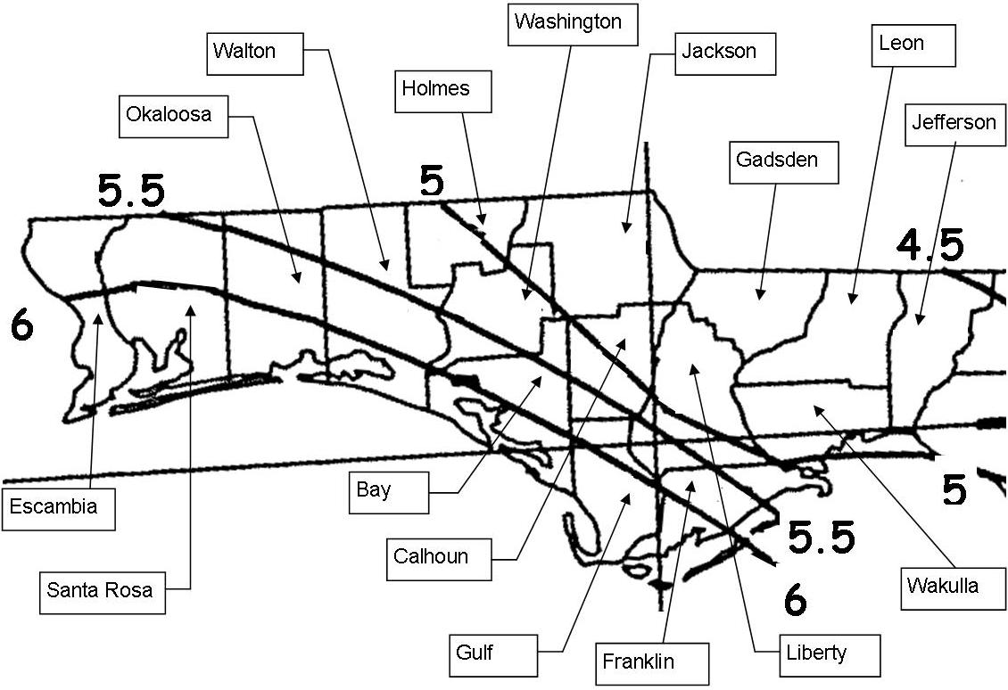

Figure 2.7-1 2-year, 24-hour Maximum Rainfall depth.

_________________________________________________________________________

(d) The applicant may propose applicable criteria established by a local government, state agency, or stormwater utility with jurisdiction over the project. The Agency will approve the use of such alternative criteria if the Agency determines that the alternative criteria will provide equivalent or greater reasonable assurance as the applicable criteria of this Volume.

In this case, the applicant is encouraged to consult with Agency staff prior to submitting an application.

2.7.2 Tailwater for Water Quantity Design

Stormwater management systems designed in accordance with Part III of this Volume must consider tailwater conditions. Receiving water stage can affect the amount of flow that will discharge from the project to the receiving water. This stage may be such that tailwater exists in portions of the project system, reducing the effective flow or storage area. Typical examples of this are illustrated in Figures 2.7-2 (gravity) and 2.7-3 (pumped).

The stage in the receiving water shall be considered to be the maximum stage which would exist in the receiving water from a storm equal to the project design storm. Lower stages may be used if the applicant can show that the flow from his project will reach the receiving water prior to the time of maximum stage in the receiving water.

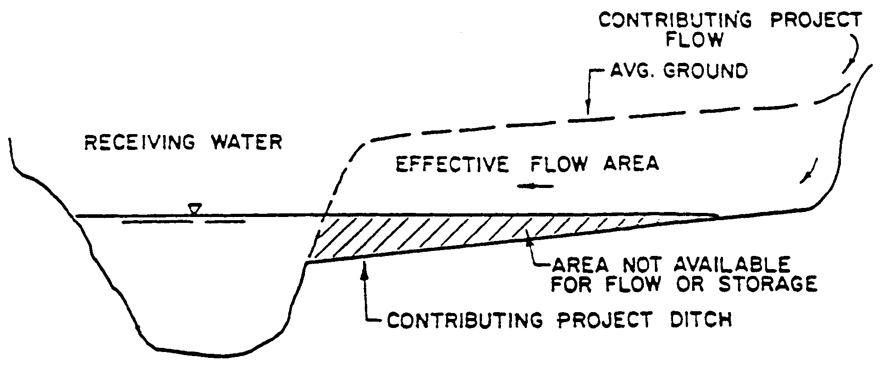

Figure 2.7-2 Gravity tailwater example.

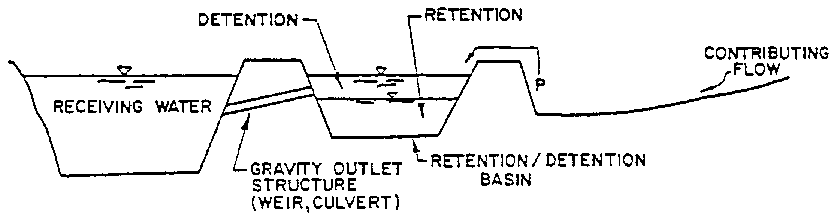

Figure 2.7-3 Pumped flow tailwater example.

2.8 Retrofits of Existing Stormwater Management Systems

(a) A stormwater retrofit project is typically proposed by a county, municipality, state agency, or water management district to provide new or additional treatment or attenuation capacity, or improved flood control to an existing stormwater management system or systems. Stormwater retrofit projects shall not be proposed or implemented for the purpose of providing the water quality treatment or flood control needed to serve new development or redevelopment.

Example components of stormwater retrofit projects are:

1. Construction or alteration that will add additional treatment or attenuation capacity and capability to an existing stormwater management system;

2. Modification, reconstruction, or relocation of an existing stormwater management system or stormwater discharge facility;

3. Stabilization of eroding banks through measures such as adding attenuation capacity to reduce flow velocities, planting of sod or other vegetation, and installation of rip rap boulders;

4. Excavation or dredging of sediments or other pollutants that have accumulated as a result of stormwater runoff and stormwater discharges.

(b) Stormwater Quality Retrofits

1. The applicant for a stormwater quality retrofit project must provide reasonable assurance that the retrofit project itself will, at a minimum provide additional water quality treatment such that there is a net reduction of the stormwater pollutant loading into receiving waters. Examples are:

a. Addition of treatment capacity to an existing stormwater management system such that it reduces loadings of stormwater pollutants of concern to receiving waters;

b. Adding treatment or attenuation capability to an existing developed area when either the existing stormwater management system or the developed area has substandard stormwater treatment and attenuation capabilities, compared to what would be required for a new system requiring a permit under Part IV of Chapter 373, F.S.; or

c. Removing pollutants generated by, or resulting from, previous stormwater discharges.

2. If the applicant has conducted, and the Agency has approved, an analysis that provides reasonable assurance that the proposed stormwater quality retrofit will provide the intended pollutant load reduction from the existing system or systems, the project will be presumed to comply with the requirements in sections 4.0 through 4.4 of this Volume.

3. The pollutants of concern will be determined on a case-by-case basis during the permit application review based upon factors such as the type and intensity of land use, existing water quality data within the area subject to the retrofit, and the degree of impairment or water quality violations in the receiving waters.

(c) Stormwater Quantity (Flood Control) Retrofits

The applicant for a stormwater quantity retrofit project must provide reasonable assurance that the retrofit project will reduce existing flooding problems in such a way that it does not cause any of the following:

1. A net reduction in water quality treatment provided by the existing stormwater management system or systems;

2. Increased discharges of untreated stormwater entering adjacent or receiving waters;

If the applicant has conducted, and the Agency has approved, an analysis that provides reasonable assurance that the stormwater quantity retrofit project will comply with the above, the project will be presumed to comply with the requirements in sections 3.1 through 3.3 of this Volume.

(d) The applicant for any stormwater retrofit project must design, construct, operate, and maintain the project so that it:

1. Will not cause or contribute to a water quality violation;

2. Does not reduce stormwater treatment capacity or increase discharges of untreated stormwater. Where existing ambient water quality does not meet water quality standards the applicant must demonstrate that the proposed activities will not cause or contribute to a water quality violation. If the proposed activities will contribute to the existing violation, measures shall be proposed that will provide a net improvement of the water quality in the receiving waters for those parameters that do not meet standards.

3. Does not cause any adverse water quality impacts in receiving waters; or

4. Will not cause or contribute to increased flooding of adjacent lands or cause new adverse water quantity impacts to receiving waters;

2.9 Compensating Stormwater Treatment

Occasionally, applicants find that it is impractical to construct a stormwater management system to capture the runoff from a portion of the project site due to on-site conditions such as extreme physical limitations, availability of right-of-way, or maintenance access. Two methods have been developed to compensate for the lack of treatment for a portion of a project. The first method is to treat the runoff that is captured to a greater extent than required by rule (i.e., "overtreatment"). The second method is to provide treatment for an off-site area which currently is not being treated (i.e., "off-site compensation"). Each method is designed to furnish the same level of treatment as if the runoff from the entire project site was captured and treated in accordance with the provisions of this Volume.

Either of these methods will only be allowed as a last resort and the applicant is strongly encouraged to schedule a pre-application conference with Agency staff to discuss the project if these alternatives are being considered. Other rule criteria, such as peak discharge attenuation, will still have to be met if the applicant utilizes these methods. Each alternative is described in more detail in the following sections.

2.9.1 Overtreatment

Overtreatment means to treat the runoff from the project area that flows to a treatment system to a higher level than the rule requires to make up for the lack of treatment for a portion of the project area. The average treatment efficiency of the areas treated and the areas not treated must meet the pollutant removal goals of Chapter 62-40, F.A.C., (i.e., 80% removal for discharges to Class III waters and 95% removal for systems which discharge to OFWs.) To meet these goals, the area not being treated generally must be small (less than 10%) in relation to the area which is captured and treated. Staff can aid in determining the proper level of overtreatment for a particular situation.

2.9.2 Off-site Compensation

Off-site compensation means to provide treatment to compensate for the lack of treatment for portions of the proposed project. The following conditions must be met when utilizing off-site compensation:

(a) The off-site area must be in the same watershed as the proposed project, and in the closest vicinity practical to the location of those untreated stormwater discharge(s) requiring compensating treatment; and

(b) The applicant shall use modeling or other data analysis techniques that provide reasonable assurance that the compensating treatment system removes at least the same amount of stormwater pollution loading as was estimated from the untreated project area.

2.10 Flexibility for State Transportation Projects and Facilities

With regard to state linear transportation projects and facilities the Agencies shall be governed by Section 373.413(6), F.S.

2.11 Dam Safety

As part of the determination as to whether a dam meets the criteria in Rule 62-330.301, F.A.C., a dam over five feet in height (as measured from the crest of the dam to the lowest elevation on the downstream toe) with the potential to store 50 acre feet or more of water, and any dam that is 10 feet or more in height must be designed, constructed, operated, and maintained consistent with generally accepted engineering practices as applied to local conditions, considering such factors as: the type of materials used to construct the dam, the type of soils and degree of compaction, hydrologic capacity, construction techniques, and hazard rating. A document that provides useful information for this purpose is Design of Small Dams, U.S. Department of Interior, Bureau of Reclamation, Third Edition, 2006.

Dams shall be designed with spillway capacities adequate to safely conduct the runoff through the impoundment based on the appropriate SCS rainfall distribution, in accordance with the following minimum storm routing requirements:

Minimum Storm Routing Requirements for Dams
Hazard Rating Principal spillway Combination of spillways
Low 2 year, 24 hour 25 year, 24 hour
Moderate 25 year, 24 hour 100 year, 24 hour
High 100 year, 24 hour PMF

2.12 Inspections to Ensure Proper Operation and Maintenance

(a) In accordance with subsection 62-330.311(1), F.A.C., stormwater management systems, dams, impoundments, reservoirs, appurtenant work, and works designed by a registered professional shall be inspected and documented by the registered professional as follows, unless otherwise specified in the permit:

TYPE OF SYSTEM INITIAL INSPECTION AFTER THE FIRST YEAR
AFTER BEGINNING OF SUCCESSFUL
OPERATION OPERATION
Dry Retention basins 1 Year Once every 5 years
Exfiltration trenches 1 Year Once every 2 Years
Underground retention 1 Year Once every 2 Years
Sand Filters 1 Year Once every 2 Years
Underdrain filtration 1 Year Once every 2 Years
Underground vault/chambers 1 Year Once every 2 Years
Swales (treatment) 1 Year Once every 5 years
Wet Detention systems 1 Year Once every 5 years
Vegetated Natural Buffers 1 Year Once every 5 years
Above-ground Impoundments 1 Year Annually

(b) Activities designed by a registered professional shall be inspected by that same registered professional, or by a similarly-registered professional in accordance with the inspection frequency and terms required in the permit.

(c) Additional information on operation and maintenance requirements is contained in section 12.4 of Volume I and in Rule 62-330.311, F.A.C.

PART III — STORMWATER QUANTITY/FLOOD CONTROL

3.0 General Flood Control Requirements

3.1 Stormwater Management Systems That Must Meet Water Quantity Criteria

Stormwater management systems that meet any of the following thresholds must be designed, constructed, operated, and maintained in accordance with this Part:

(a) Systems that serve projects of 40 or more acres of total land area;

(b) Systems that provide for the placement of 12 or more acres of impervious surface, which also constitutes more than 40 percent of the total project area; or

(c) Systems that are at any time capable of impounding a volume of water exceeding 40 acre-feet, as measured at the top of the berm.

Stormwater management systems that do not exceed the above thresholds are not required to meet the stormwater quantity and flood control criteria of this Part, provided they are not part of a larger common plan of development or ownership that exceeds any of the above thresholds.

3.2 Standards that Apply and Relationship to Part IV

In addition to the criteria in this Part, all activities that require a stormwater management system (in accordance with section 2.1 of this Volume) must also comply with the water quality criteria in Part IV of this Volume.

As an example, a system that has 14 acres of impervious surface that comprises 54 percent of the total project area of 26 acres would have to meet the stormwater quantity/flood control criteria of this Part, because such a system exceeds the 12-acre/40 percent threshold. Because the project exceeds thresholds for stormwater management systems, the criteria in Part IV also apply. Additionally, because the project involves greater than 50% impervious area, the project must also be designed according to the streambank protection discharge criteria as required in section 4.5.1 of this Volume. However, a system that consists of 13 acres of impervious surface within a 39 acre project area would not have to meet the stormwater quantity/flood control criteria of this Part (assuming the system does not impound more than 40 acre-feet of stormwater), because even though such a system exceeds the 12-acre threshold in 3.1(b), above, it constitutes an impervious surface of only 33 percent, and therefore does not exceed the second part of 3.1(b), above, or the criteria in 3.1(a). Such a system also would not have to be designed to meet the streambank protection discharge criteria. As another example, a system that consists of 2 acres of impervious surface within a 3 acre project area also would not have to meet the stormwater/flood control criteria of this Part because it does not exceed the 12-acre threshold. However, such a system exceeds the 50% impervious threshold (67% impervious) and therefore is required to comply with the streambank protection provisions.

3.3 Stormwater Quantity: Rate and Volume Controls

Criterion: Except as provided in section 3.3(c), below, the post-development stormwater discharge rate and volume must be controlled as follows.

(a) Rate Control

Any project involving construction that exceeds 50 percent impervious surface must provide rate control in accordance with section 4.5.1 of this Volume.

If the project is located totally within a stream or open-lake watershed, detention systems must be installed such that the peak rate of post-development runoff will not exceed the pre-development peak-rate of runoff for the 25-year, 24-hour design storm event, utilizing a Natural Resources Conservation Service (NRCS) type III rainfall distribution, with an antecedent moisture condition II. Rainfall associated with the 25-year, 24-hour event is provided in Figure 3.3-1. Outlet controls shall be designed such that required detention volumes are available within 14 days following the design storm event.

(b) Volume Control

A closed basin or closed-lake watershed is defined as that which does not have a surface outfall for conditions up to and including the 100-year, 24-hour flood stage. Rainfall depths associated with this event are provided as Figure 3.3-2. Flood elevation shall be determined using the most accurate information available, such as:

1. Actual data, including water level, stream flow and rainfall records;

2. Hydrologic/hydraulic modeling;

3. Federal Flood Insurance Rate Maps and supporting flood study data; or

4. Floodplain analysis studies approved by the Agency.

Flood elevations shall be evaluated for accuracy considering the extent to which flood elevations are validated by site-specific data.

For systems discharging within a closed basin or closed-lake watershed, the post-development volume of runoff discharged offsite must not exceed the pre-development volume of runoff discharged offsite resulting from a 25-year, 96-hour design storm. Retention of the post-development increase in volume can be recovered by percolation, or, if soil conditions are not sufficient for percolation, then detention must be provided for a duration sufficient to prevent adverse impacts on flood stages. Rainfall depths associated with the 25-year, 96-hour design storm are provided in Figure 3.3-3. The applicant may provide a time-dependent model utilizing a 25-year, 96-hour hyetograph in conjunction with a rating curve (or equivalent) to estimate the rate of percolation from the system during the storm.

For systems discharging to closed basins or closed-lake watersheds that are wholly-owned, the applicant is not required to demonstrate compliance with section 3.3(a) or (b) of this Volume. However, the flood damage requirements of section 3.6 of this Volume

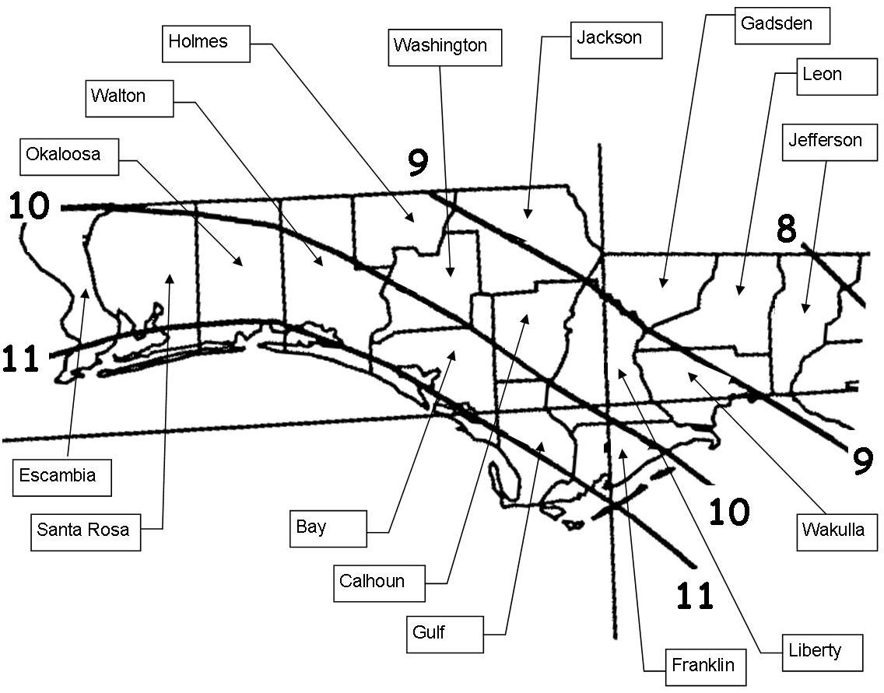

Figure 3.3-1 Rainfall Depths Associated with the 25-year, 24-hour Storm Event

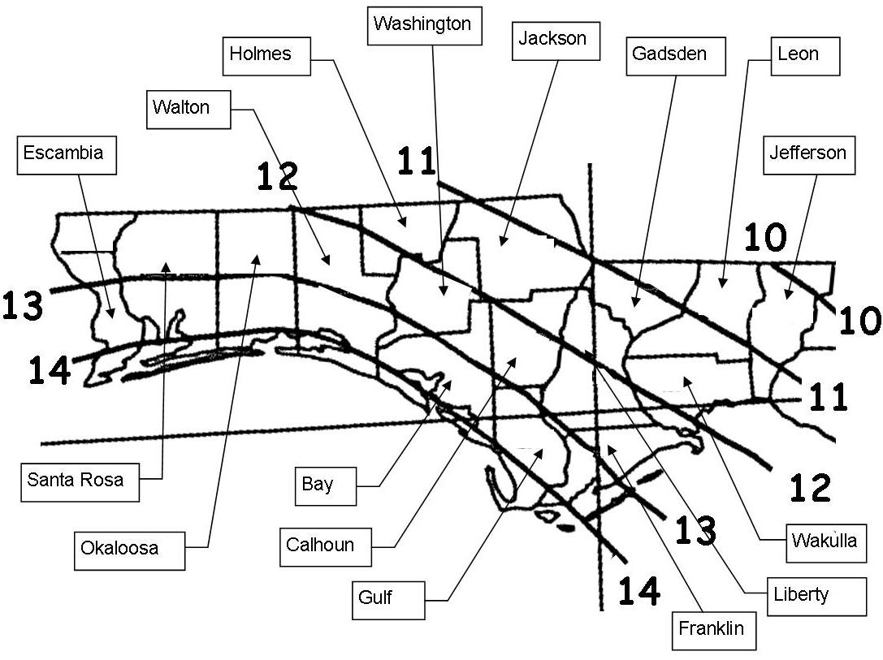

Figure 3.3-2 Rainfall Depths Associated with the 100-year, 24-hour Storm Event

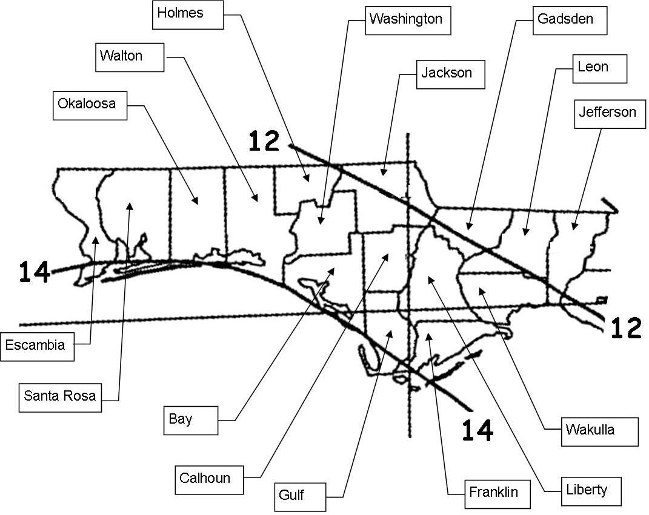

Figure 3.3-3 Rainfall Depths Associated with the 25-year, 96-hour Storm Event
____________________________________________________________________

must still be met. Additionally, for the purposes of this paragraph, minimum finished floor elevations must be located above the post-development design storm elevation associated with the 25-year, 96-hour storm event.

Post-development volume controls must be provided in accordance with this section, unless the applicant can demonstrate that cumulative increases in runoff volume from potential development will not cause an adverse impact on the frequency, duration or extent of off-site flood stages resulting from the 25-year, 96-hour design storm.

(c) Discharges to Tidally-influenced waters

The peak discharge requirements of this section are not required for systems that discharge directly into the Gulf Intracoastal Waterway, including manmade portions of the Gulf Intracoastal Waterway, or to the Gulf of Mexico, or to other tidally-influenced waterways. For the purposes of this section, “tidally-influenced waterways” includes surface waters that are characterized by a repeatable monthly average tide range of more than 0.1 feet.

3.3.1 Alternative Peak Rate Discharge Criteria

As an alternative to the peak discharge attenuation criteria in section 3.3 above, applicants may propose to utilize applicable storm event, duration, or criteria specified by a local government, state agency (including FDOT), or stormwater utility with jurisdiction over the project. The Agency will approve the use of the alternative criteria if the Agency determines that the alternative criteria will provide equivalent or greater reasonable assurance as the criteria of section 3.3 above. Applicants proposing to use alternative criteria are encouraged to have a pre-application conference with Agency staff.

3.3.2 Methodologies

A peak discharge analysis typically consists of generating pre-development and post-development runoff hydrographs, routing the post-development hydrograph through a detention basin, and sizing an overflow structure to control post-development discharges at or below pre-development rates. Acceptable design techniques also include the use of grassed waterways, and any other storage capability that the particular system may have.

Peak discharge computations shall consider the duration, frequency, and intensity of rainfall, the antecedent moisture conditions, upper soil zone and surface storage, time of concentration, tailwater conditions, changes in land use or land cover, and any other changes in topographic and hydrologic characteristics. Large systems should be divided into sub-basins according to artificial or natural drainage divides to allow for more accurate hydrologic simulations. Examples of accepted methodologies for computing runoff are:

(a) Soil Conservation Service Method [see U.S. Department of Agriculture, Soil Conservation Service “National Engineering Handbook, Section 4, Hydrology,” TR-55 ("Urban Hydrology for Small Watershed") or TR-20 User’s Manuals].

(b) Santa Barbara Urban Hydrograph Method.

(c) U.S. Army Corps of Engineers HEC-HMS Computer Programs.

(d) Storm Water Management Model (SWMM) 5 or higher

(e) Interconnected Channel and Pond Routing Model (ICPR)

(f) PONDS

(g) Other hydrograph and routing methods may be proposed and will be approved by the Agency if the applicant provides reasonable assurance that the alternative method has comparable accuracy and reliability as the above methods.

Peak discharge calculations must make proper use of the SCS Peak Rate Factor or K’. The Peak Rate Factor reflects the effect of watershed storage on the hydrograph shape and directly and significantly impacts the peak discharge value. As such, K’ must be based on the true watershed storage of runoff, and not on the slope of the landscape which is more accurately accounted for in the time of concentration. However, the average slope of natural watersheds is highly interrelated with the surface storage potential. Land development will generally result in a reduction of natural storage. As a result, the K’ value should either increase or remain constant, but never decrease. In most cases, post-development conditions will include detention storage areas; this storage should be accounted for by routing the hydrograph based on a defined stage-storage-discharge relationship and should therefore not be considered in determining K’. The most conservative approach is to use a K’ = 484 for post-development. However, in some cases where surface storage is maintained, K’ may be reduced to same value used in the pre-development condition.

Recommended K’ values for various site conditions are provided below:

K’=484:
Standard peak rate factor developed for watersheds with little or no storage. Represents watersheds with moderate to steep slopes and/or significant drainage works. Typical ecological communities include long leaf pine, and turkey oak hills.

K’=323-384:
Intermediate peak rate factor representing watersheds with moderate surface storage in some locations due to depressional areas, mild slopes and/or lack of existing drainage features. Typical ecological communities include oak hammock, upland hardwood hammock, mixed hardwoods and pine.

K’=256-284:
Represents watersheds with very mild slopes, recommended for watersheds with average slopes of 0.5% or less. Significant surface storage throughout the watershed. Limited on-site drainage ditches. Typical ecological communities include North Florida flatwoods, freshwater marsh and ponds, swamp hardwoods, cabbage palm flatlands, and cypress swamp.

3.3.3 Aggregate Discharge

Where multiple off-site discharges are designed to occur, if the combined discharges meet all other requirements of Chapter 62-330, F.A.C., and discharge to the same receiving water body, the Agency will allow the total post-development peak discharge for the combined discharges to be used rather than each individual discharge.

3.3.4 Rainfall Intensity and Volume

In determining peak discharge rates, intensity of rainfall values shall be obtained through a statistical analysis of historical long-term rainfall data or from sources or methods generally accepted as good engineering practice.

(a) Examples of acceptable sources include:

1. USDA Soil Conservation Service, “Rainfall Frequency Atlas of Alabama, Florida, Georgia, and South Carolina for Durations from 30 Minutes to 24 Hours and Return Periods from 1 to 100 Years” January 1978; Gainesville, Florida.

2. U.S. Weather Bureau Technical Paper No. 49.

3. U.S. Weather Bureau Technical Paper No. 40.

4. U.S. Department of Interior, Bureau of Reclamation, “Design of Small Dams.” 2nd Edition.

(b) For a drainage basin greater than 10 square miles, the areal rainfall can be calculated from point rainfall data using a method that has been well documented. The converting factor as described in U.S. Weather Bureau Technical Paper No. 49 can be used.

3.3.5 Upper Soil Zone Storage and Surface Storage

In most instances, the upper soil zone storage and surface storage capacities will have an effect on the pre-development and post-development peak discharges and should be considered in these computations. Any generally accepted and well-documented method may be used to develop the upper soil zone storage and surface storage values.

(a) The soil zone storage at the beginning of a storm shall be estimated by using reasonable and appropriate parameters consistent with generally accepted engineering and scientific principles to reflect drainage practices, average wet season water table elevation, the antecedent moisture condition (generally AMC II) and any underlying soil characteristics that would limit or prevent percolation of storm water into the entire soil column. The soil storage used in the computation shall not exceed the difference between the maximum soil water capacity and the field capacity (for example, gravitational water) for the soil columns above any impervious layer or seasonal ground water table.

(b) Surface storage, including that available in wetlands and low-lying areas, shall be considered as depression storage. Depression storage shall be analyzed for its effect on peak discharge and the time of concentration. Depression storage can also be considered in post-development storage routing which would require development of stage-storage relationships; if depression storage is considered, then both pre-development and post-development storage routing must be considered.

3.4 Storage and Conveyance

Floodways and floodplains, and levels of flood flows or velocities of adjacent streams, impoundments or other water courses must not be altered so as to adversely impact the off-site storage and conveyance capabilities of the water resource. Projects that alter existing conveyance systems (such as by rerouting an existing ditch) must not adversely affect existing conveyance capabilities. Also, the applicant shall provide reasonable assurance that proposed velocities are non-erosive or that erosion control measures (such as riprap and concrete lined channels) are sufficient to safely convey the flow.

(a) A system shall not cause a net reduction in flood storage within a 10-year floodplain except for structures elevated on pilings or traversing works.

(b) A system shall not cause a reduction in the flood conveyance capabilities provided by a floodway except for structures elevated on pilings or traversing works. Such works or other structures shall cause no more than a one foot increase in the 100-year flood elevation immediately upstream and no more than one tenth of a foot increase in the 100-year flood elevation 500 feet upstream.

(c) An applicant will not have to meet the requirements of (a) or (b) above if reasonable assurance is provided that the singular and cumulative impacts of not meeting those criteria will not contravene subsections 62-330.301(1) and (2), F.A.C., considering all other persons who could impact the surface water of any impoundment, stream, or other watercourse by floodplain encroachment to the same degree as proposed by the applicant.

(d) As an alternative, the applicant may propose to utilize applicable criteria established by a local government, another state agency, or a stormwater utility with jurisdiction over the project. DEP will approve the use of such alternative criteria if the alternative criteria provide reasonable assurance that the proposed project will not adversely affect existing conveyance capabilities.

3.5 Low Flow and Base Flow Maintenance

3.5.1 Low Flow

(a) Systems with both of the following conditions must meet the low flow performance criteria in sections 3.5.1(b) and (c), below.

1. Systems that impound water for purposes in addition to temporary detention storage. Water impounded longer than a 14-day bleed down period is considered conservation storage for benefits other than detention storage (for example, recreation and irrigation).

2. Systems that impound a stream or other watercourse which, under pre-development conditions, discharged surface water off-site to receiving water during 5-year, 30-day drought frequency conditions.

(b) Any system meeting the conditions of section 3.5.1(a), above, shall be designed with an outlet structure to maintain a low flow discharge of available conservation storage. When the conservation storage is at the average dry season design stage, the low flow discharge shall equal the average pre-development surface water discharge which occurred from the project site to receiving waters during the 5-year, 30-day drought.

(c) The system shall be operated to provide a low flow discharge whenever water is impounded. The actual discharge will vary according to the water stage in the impoundment. When conservation storage is at the average dry season design stage, the discharge will be the 5-year, 30-day average low flow. When storage is below the average dry season design stage, the discharge may be less than the 5-year, 30- day average low flow.

3.5.2 Base Flow

Design and performance criteria for maintaining acceptable base flow conditions include:

(a) Storage volumes in detention or retention systems shall be calculated so as not to include volumes below the seasonal high-water table for the project area;

(b) Underdrain systems shall be allowed provided that lowering of the groundwater table is restricted to the immediate vicinity of the treatment system; and

(c) Water tables shall not be lowered to a level that would decrease the flows or levels of surface water bodies below any minimum level or flow established by a water management district Governing Board pursuant to Section 373.042, F.S.

3.6 Flood Damage

The following criteria will be used to evaluate the potential for flood damages to residences and public buildings.

(a) Residential buildings shall have the lowest floor elevated above the post-development 100-year flood elevation for that site. For the purposes of this section, the design storm for determining the 100-year flood elevations shall be the 100-year, 24-hour event.

(b) Industrial, commercial, and other non-residential buildings susceptible to flood damage must have the lowest floor elevated above the 100-year flood elevation, or be designed and constructed so that below the 100-year flood elevation, the structure and attendant utility facilities are watertight and capable of resisting the effects of the regulatory flood. The design should take into account flood velocities, duration, rate of rise, hydrostatic and hydrodynamic forces, the effect of buoyancy and impacts from debris. Flood proofing measures must be operable without human intervention and without an outside source of electricity.

(c) Accessory buildings may be constructed below the 100-year flood elevation provided there is minimal potential for significant damage by flooding. An accessory building is a structure on the same parcel of property as a principal structure and the use of which is incidental to the use of the principal structure and not for human habitation. For example a residential structure may have a detached garage, a carport, or storage shed for garden tools as accessory structures. Other examples of accessory structures include gazebos, picnic pavilions, boathouses, pole barns, storage sheds, and similar buildings.

Part IV — Stormwater Quality

4.0 Purpose

All stormwater management systems that require an individual permit under Chapter 62-330, F.A.C., must be designed, constructed, operated, and maintained in conformance with the criteria in this Part. In addition, those systems that exceed the thresholds in section 3.1 of this Volume must also be designed, constructed, operated, and maintained in accordance with Part III of this Volume.

4.1 Criterion

Florida’s stormwater quality regulations are “technology-based” not “water quality effluent-based.” Collectively, the design criteria in Part II, Part IV, and Part V of this Volume are presumed to meet the minimum levels of stormwater treatment established in Chapter 62-40, F.A.C., the Water Resource Implementation Rule.

4.2 Integration with the Water Resource Implementation Rule

Subsection 62-40.432(2), F.A.C. (Water Resource Implementation Rule), provides minimum stormwater treatment performance standards. These standards, in part, provide that when a stormwater management system complies with rules establishing the design and performance criteria for such systems, there shall be a rebuttable presumption that the discharge from such systems will comply with state water quality standards.

Systems meeting the design and performance criteria of this Volume are presumed to meet the Water Resource Implementation Rule performance standards stated above. However, as new research on the design and effectiveness of stormwater treatment systems becomes available, the design and performance criteria of this Volume will be revised as appropriate through future rulemaking.

4.3 State Water Quality Standards

4.3.1 Surface Water Quality Standards

State surface water quality standards are set forth in Chapters 62-4 and 62-302, F.A.C., including the antidegradation provisions of paragraphs 62-4.242(1)(a) and (b), and subsections 62-4.242(2) and (3), F.A.C., Rule 62-302.300, F.A.C., and the special standards for OFWs set forth in subsections 62-4.242(2) and (3), F.A.C. Furthermore, the Agency cannot authorize permits that modify the quantity of water discharged offsite if such discharge will cause adverse environmental or water quality impacts.

4.3.2 Ground Water Quality Standards

State water quality standards for ground water are set forth in Chapter 62-520, F.A.C. In addition to the minimum criteria, Class G-I and G-II ground water must meet primary and secondary drinking water quality standards for public water systems established pursuant to the Florida Safe Drinking Water Act, which are listed in Rules 62-550.310 and 62-550.320, F.A.C.

Only the minimum criteria apply within a zone of discharge. A zone of discharge is defined as a volume underlying or surrounding the site and extending to the base of a specifically designated aquifer or aquifers, within which an opportunity for the treatment, mixture or dispersion of wastes into receiving ground water is afforded. Generally, stormwater systems have a zone of discharge 100 feet from the system boundary or to the project's property boundary, whichever is less.

Stormwater retention and detention systems are classified as moderate sanitary hazards with respect to public and private drinking water wells. Stormwater treatment facilities shall not be constructed within 100 feet of an existing public drinking water well, and shall not be constructed within 75 feet of an existing private drinking water well.

4.3.3 How Standards are Applied

The quality of stormwater discharged to receiving waters is presumed to meet the surface water standards in Chapters 62-4, and 62-302, F.A.C., and the ground water standards in Chapters 62-520 and 62-550, F.A.C., if the system is permitted, constructed, operated and maintained in accordance with Chapter 62-330, F.A.C., and Parts II, IV, and V of this Volume. However, this determination is rebuttable. The volume of runoff to be treated from a site shall be determined by the type of treatment system, i.e., retention, wet detention, etc. If off-site runoff is not prevented from combining with on-site runoff prior to treatment, then treatment must be provided for the combined off-site/project runoff.

4.4 Reasonable Assurance

As part of providing reasonable assurance that a system meets the general criteria for issuance described in section 2.0.2 of this Volume, a stormwater management system must meet the design and performance standards described in the applicable Parts III, IV, and V of this Volume.

4.5 Criteria to Protect Streambanks

Urbanization increases total runoff volume, peak discharge rates, and the magnitude and frequency of flood events. With an increase in the number of flood events a stream is subjected to, the potential for accelerated erosion of both the stream banks and channel bottom is enhanced, resulting in degradation of surface waters. Proper design of detention systems to limit post development peak discharge rates to predevelopment rates can minimize some of the stormwater effects of urbanization.

Proper selection of the design storm for peak discharge control is crucial to determining the effectiveness of the detention basin. Historically, stormwater programs only regulated the peak discharge from large storm events (for example, a 25-year, 24-hour storm). Unfortunately, that approach suffers from the following drawbacks:

(a) If a detention pond is only designed to reduce the peak of the 25-year storm, the discharge rates from lesser events such as the 2, 5, and 10-year flood events may not be controlled. The ineffectiveness of controlling small flood events may appear to be unimportant with respect to flood damages. However, these more frequent events do cause localized flood damage and are of prime importance as a cause of channel and streambank erosion.

(b) Cumulative water quantity impacts may occur from several projects that are below the thresholds for quantity control located within the same watershed.

To address these concerns, peak discharge rate must be controlled for the 2-year, 24-hour storm event and potentially for a larger storm event. The 2-year, 24-hour storm was selected as the design event for this rule because the shape and form of natural channels is controlled by approximately the 2-year return frequency storm. The rainfall depth for the 2-year, 24-hour storm for the Florida panhandle is shown in Figure 2.7-1. The rainfall depth at a particular location may be established by interpolating between the nearest isopluvial lines.

The 2-year event may be accommodated along with the larger flood control storm event (when required) by designing a multi-staged outlet structure to attenuate both the flood control and 2-year, 24-hour storm events, such as through the use of two-staged weirs, risers with multiple orifice controls, and combinations of weir and orifice controls. See Figure 4.5-1 for a conceptual design of a multi-staged outlet structure.

4.5.1 Peak Discharge Attenuation Criteria to Protect Streambanks

For systems serving new construction that is greater than 50 percent impervious (excluding water bodies and the area providing stormwater treatment) over the project area, the post-development peak discharge rate must not exceed the pre-development peak discharge rate for the 2-year, 24-hour design storm event, utilizing a Natural Resources Conservation Service (NRCS) type III rainfall distribution with an antecedent moisture condition II. Outlet controls shall be designed so that required detention volumes are fully bled-down at sufficient rates that result in non-erosive velocities. Projects that modify existing systems, including adding new impervious surfaces, are exempt from this criterion when the modification will not cause significant adverse impacts to water resources using the criteria in Rule 62-330.301, F.A.C. Also, projects that discharge to tidally-influenced waters in accordance with section 3.3(c) of this Volume are exempt from this criterion.

Pervious concrete and turf blocks are not considered impervious surface for this purpose. However, pervious asphalt, compacted soils, limerock, or gravel surfaces, are considered impervious for the purpose of determining the percentage of impervious surface.

The streambank protection criteria must be met concurrent with applicable flood control requirements under Part III of this Volume, including any project that also requires peak discharge attenuation of the 25-year, 24-hour storm event.

4.5.2 Modified Rational Hydrograph Method for Streambank Protection Calculations

The rational method is a popular method for estimating peak runoff rates for small urban areas. Specifically, the rational method generates peak discharge rates rather than a runoff hydrograph. However, the rational method can be modified to generate a runoff hydrograph by utilizing the rainfall intensity for various increments of a design storm.

The rate of discharge at any point in time during a storm can be calculated by combining the rainfall intensity for that time increment with the traditional rational formula. The modified rational hydrograph equation is as follows:

Figure 4.5-1 Conceptual design of a multi-stage outlet structure.

Q = C (I/P_{Total}) (P_{Total}) A

where: Q = Discharge for a given time increment (cfs)
C = Runoff coefficient
I/P_{Total} = Intensity for a given time increment (in/hr-in)
P_{Total} = Total rainfall depth (in)
A = Drainage area (acres)

Calculating the peak discharge in 15-minute increments over a 24-hour period generates a synthetic hydrograph. Intensities are typically derived from intensity-duration-frequency (IDF) curves such as those published by the FDOT. The maximum allowable drainage area (A) is 600 acres.

Similar to the rational method for peak discharge, the modified rational method must be limited to small drainage basins with short times of concentration. The use of the modified rational method for generating a runoff hydrograph is limited to systems meeting the following conditions:

(a) The drainage area is less than 40 acres,

(b) The pre-development time of concentration for the system is less than 60 minutes, and

(c) The post-development time of concentration for the system is less than 30 minutes.

The Agency does not accept the modified rational hydrograph method for use in generating hydrographs for the 25-year, 24-hour storm event for use in complying with peak discharge requirements in section 3.3 of this Volume. For projects requiring peak discharge evaluation in accordance with section 3.3 of this Volume, the modified rational hydrograph method is acceptable only for evaluation of the 2-year, 24-hour storm, and not for other events (e.g., the 25-year, 24-hour storm).

Guidance on the use of the Modified Rational Hydrograph Method is contained in Chapter 5 of the Florida Development Manual: A Guide to Sound Land and Water Management (June 1988) (Appendix E).

4.6 Erosion and Sediment Control Criteria for Stormwater Management Systems

Land clearing activities, including the construction of stormwater management systems, shall be designed, constructed, and maintained at all times so that erosion and sedimentation from the system, including the areas served by the system, do not cause violations of applicable state water quality standards in receiving waters. Further, because sedimentation of off-site lands can lead to public safety concerns, erosion and sediment controls shall be designed and implemented to retain sediment on-site as required by subsection 62-40.432(2), F.A.C. In particular, the erosion and sediment control requirements described in Part IV of Applicant’s Handbook Volume I shall be followed during construction of the system.

4.7 Oil and Grease Control

Systems that receive stormwater from contributing areas that are greater than 50 percent impervious (excluding water bodies) or which are a potential source of oil and grease (e.g., parking lots and gasoline stations) must include a baffle, skimmer, grease trap or other effective mechanism suitable for preventing oil and grease from leaving the stormwater system in concentrations that would cause a violation of water quality standards. Designs must assure sufficient clearance between the skimmer and structure or pond bottom to ensure that the hydraulic capacity of the structure is not affected. A typical illustration of a skimmer on an outlet structure is shown is Figure 4.7-1.

Figure 4.7-1 Oil skimmer detail for a typical outfall structure (N.T.S.).

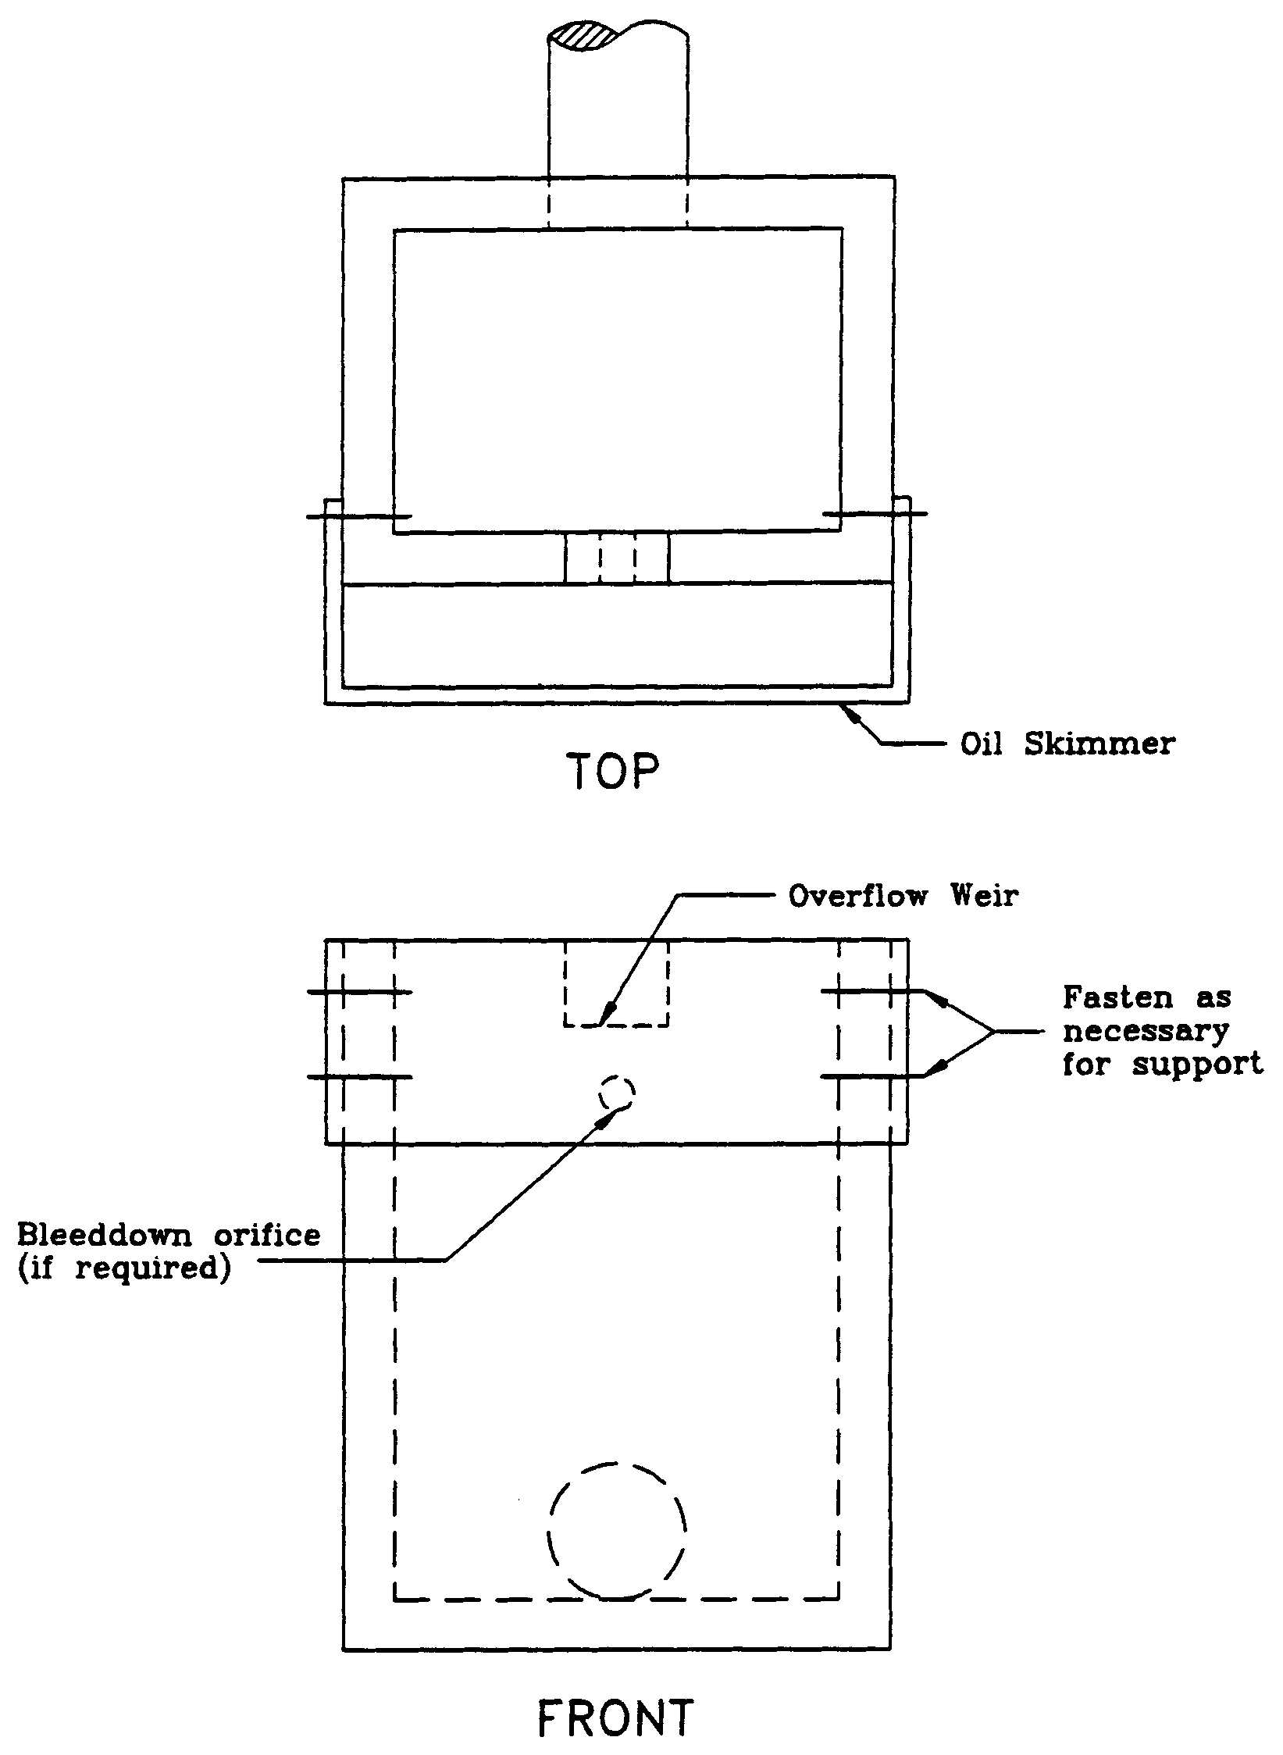

_______________________________________________________________________________

4.8 On-Line and Off-line Stormwater Systems

Each stormwater treatment Best Management Practice (BMP) specifies a required volume of stormwater runoff to be captured and treated (i.e., treatment volume) prior to release to surface or ground water. There are two basic types of configurations for capturing the treatment volume: on-line and off-line systems. On-line systems (Figure 4.8-1) consist of a storage area which provides storage of the required treatment volume for smaller storm events and, if required, temporary detention storage for peak discharge control during larger storm events. Runoff volumes in excess of the treatment volume mix with the treatment volume in the basin and potentially transport a portion of the pollutant mass load through the basin control structure.
Figure 4.8-1 On-line treatment system.

Off-line treatment systems (Figure 4.8-2) divert the treatment volume into an offline basin that is designed for storage and treatment of the applicable treatment volume. Runoff volumes in excess of the treatment volume by-pass the off-line BMP and are discharged to the receiving water or routed to a detention basin if peak discharge attenuation is required. A diversion box (Figure 4.8-3) typically is used to divert the treatment volume to the off-line BMP and route subsequent flows away from it.

Figure 4.8-2 Off-line treatment system.

Figure 4.8-3 Diversion box (N.T.S.).

Off-line systems are generally more effective at removing pollutants than on-line systems because accumulated pollutants cannot be "flushed out" during storm events that produce runoff volumes exceeding the treatment storage volume. Consequently, on-line systems must treat a greater volume of runoff than off-line systems to reduce the likelihood of flushing accumulated pollutants out of the system and achieve the minimum stormwater treatment levels required by the Water Resource Implementation Rule (Chapter 62-40, F.A.C.). Treatment volumes for each of the stormwater treatment practices are discussed in sections 5 through 12 of Part V of this Volume.

The treatment storage provided in an off-line system can be considered in the stage/storage calculations for peak discharge attenuation. Off-line systems shall be designed to bypass essentially all additional stormwater runoff volumes greater than the treatment volume to a discharge point or other detention storage area. Of course, there will be some incremental additional storage in the off-line system associated with the hydraulic grade line at the weir structure in the typical diversion structure. This will depend on the size of the weir, but the weir shall be sized to pass the design flow with minimal headwater.

Proposed off-line systems that will also serve to provide significant detention storage above the required off-line treatment storage volume will be considered to function as on-line systems. These systems shall either be designed to meet on-line treatment volume requirements, or the designer must discuss the merits of the particular system (in terms of potential of flushing accumulated pollutants) with Agency staff in a pre-application conference. In such cases, an applicant must provide reasonable assurance that the on-line treatment volume is not necessary to meet the other applicable criteria for issuance.

4.9 Hazardous or toxic substances

Systems serving a use that produces or stores hazardous or toxic substances shall be designed to have no stormwater discharge that contains such substances.

4.10 Runoff Coefficient and Curve Number for Stormwater Management Ponds

Stormwater management ponds, including dry retention ponds, detention ponds with filtration, dry detention ponds with underdrains, and wet detention ponds, shall be considered as impervious area for calculating composite runoff coefficients (C), and composite curve numbers.

4.11 Rural Subdivisions

Systems serving subdivisions with no more than five percent impervious area are considered a rural subdivision provided that:

(a) No drainage system shall act in a manner that would divert and channelize large areas of overland sheet flow, thereby creating point source discharges that will adversely affect wetlands, or areas beyond the applicant’s perpetual control; and

(b) The applicant’s demonstration of compliance with this subsection shall include provision of a typical lot layout showing proposed driveways, buildings, and other impervious areas and the anticipated percentage of impervious surfaces resulting from projected construction on individual residential lots.

Drainage areas from individual lots in rural subdivision are not required to provide treatment or attenuation of stormwater provided they are designed, constructed, and maintained in accordance with this Section. However, portions of individual lots that drain to a system that serves other activities such as roads, clubhouses, etc., must be included in the treatment and attenuation calculations for that system.

4.12 Runoff from One-inch of Rainfall

Retention, exfiltration and under-drain treatment systems, etc., that are designed as on-line systems, require treatment of the runoff from the first one-inch of rainfall over the contributing basin with a minimum of one half-inch of runoff retained. In determining the runoff from one-inch of rainfall, the applicant must calculate runoff using the runoff coefficient (C) as detailed in the example below.

(a) Example of a 15.5-acre site with: 38 quarter acre lots, rolling hills, sandy soil
1 acre retention pond
5 acres of roads and ditches

The proposed roof and driveway areas which will contribute
runoff directly to road drainage is 3,975 SF per lot.
Impervious area = (38)(3,975 SF) = 151,050 SF

The proposed road and drainage ditch area is five acres.
Impervious area = (5 acres)(43,560 SF/acre) = 217,800 SF

The total impervious area is calculated to be: 217,800 SF + 151,050 SF = 368,850 SF

The total pervious area is calculated to be:
(38 lots)(0.25 acre/lot)(43,560 SF/acre) – 151,050 SF = 262,770 SF

Calculate the composite runoff coefficient (C) using recommended values from Table 2-1 in section 2.0 of the Design Aids:

C_{impervious} = Rational Coefficient for impervious areas = 0.95
C_{pond} = Rational Coefficient for pond = 1.0
C_{pervious} = Rational Coefficient for pervious areas = 0.25

C = [(Impervious Area x C_{impervious}) + (Retention Area x C_{pond}) + (Pervious Area x C_{pervious})]
Total Project Area

C = [(368,850 SF x 0.95) + (43,560 SF x 1.0) + (262,770 SF x 0.25)]
(15.5 acres x 43,560 SF/acre)

Therefore, the composite runoff coefficient, C is calculated to be = 0.68

Total Treatment Volume from 1 inch of Rainfall:
Treatment volume = (C) (1 inch) (Project Contributing Area)
Treatment volume = (0.68) (1 inch) (15.5 acres) (1 ft / 12 inches) = 0.88 acre-ft

Also, calculate one half inch of runoff over the project for comparison:
(15.5 acres)(0.5 inch)(1 ft / 12 inches) = 0.65 acre-ft

Therefore, the required treatment volume for the project is the larger value, or 0.88 acre-ft.

4.13 Alternative Designs

An applicant may provide alternative designs to those provided in this Volume, such as when filter systems are proposed. These alternative designs will be considered by the Agency in determining whether, based on plans, test results, or other information that the alternative design is appropriate for the specific site conditions to provide for a design that can provide equivalent treatment, attenuation, and protection to water resources as the best management practices adopted in this Volume. In otherwise determining whether reasonable assurance has been provided for compliance with this paragraph, the Agency shall, where appropriate, consider:

(a) The public interest served by the system;

(b) Whether the proposed system will be as effective as the comparable system design in this Volume;

(c) The costs of the alternative controls; and

(d) Whether reasonable provisions have been made for the operation and maintenance of the proposed system.

Guidance for the use of filters is contained in Appendix B of this Volume.

Part V — Best Management Practices

5.0 Design Criteria and Guidelines for Retention Systems

5.1 Description

The term “retention system” is defined as a storage area designed to store a defined quantity of runoff, allowing it to percolate through permeable soils into the shallow ground water aquifer. Stormwater retention works best using a variety of retention systems throughout the project site. Examples of retention systems include:

- Man-made or natural depressional areas where the basin bottom is graded as flat as possible and turf is established to promote infiltration and stabilize the basin slopes (see Figure 5.1-1);
- Shallow landscaped areas designed to store stormwater;
- Vegetated swales with swale blocks or raised inlets; and
- Pervious concrete with continuous curb.

Soil permeability and water table conditions must be such that the retention system can percolate the desired runoff volume within a specified time following a storm event. After drawdown has been completed, the basin does not hold any water, thus the system is normally “dry.” Unlike detention basins, the treatment volume for retention systems is not discharged to surface waters.

Retention systems provide excellent removal of stormwater pollutants. Substantial amounts of suspended solids, oxygen demanding materials, heavy metals, bacteria, some varieties of pesticides and nutrients such as phosphorus are removed as runoff percolates through the vegetation and soil profile.

Besides pollution control, retention systems can be utilized to promote the recharge of ground water to prevent saltwater intrusion in coastal areas or to maintain groundwater levels in aquifer recharge areas. Retention systems can also be used to help meet the runoff volume criteria for systems that discharge to closed basins or land-locked lakes (see section 3.3(b) of this Volume).

There are several design and performance criteria specific to retention systems that are described below.

5.2 Treatment Volume

The first flush of runoff shall be routed to the retention basin and percolated into the ground. For systems that discharge to Class III receiving water bodies, the applicant shall provide retention for one of the following:

(a) Off-line retention of the first one-half inch of runoff from the contributing area; or

Figure 5.1-1 Typical retention system (N.T.S.).
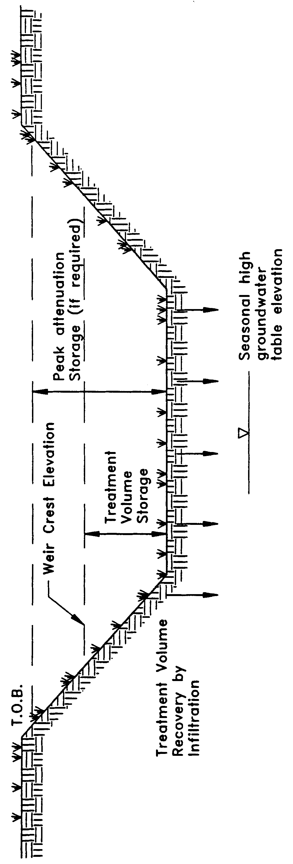

(b) On-line retention of the runoff from one inch of rainfall over the contributing area. A minimum volume of one-half inch of runoff from the contributing area is required.

For direct discharges to OFWs, the applicant shall provide retention for an additional fifty percent of the applicable treatment volume specified in (a) and (b), above.

5.3 Recovery Time

The retention system must provide the capacity for the appropriate treatment volume of stormwater specified in section 5.2 of this Volume within 72 hours following a storm event assuming average antecedent moisture conditions. In retention systems, the stormwater is drawn down by natural soil infiltration and dissipation into the ground water table, evaporation, or evapotranspiration, as opposed to underdrain systems which rely on artificial methods like drainage pipes.

Antecedent moisture condition (AMC) refers to the amount of moisture and storage in the soil profile prior to a storm event. Antecedent soil moisture is an indicator of wetness and availability of soil to infiltrate water. The AMC can vary from dry to saturated depending on the amount of rainfall received prior to a given point in time. Therefore, "average AMC" means the soil is neither dry nor saturated, but at an average moisture condition at the beginning of a storm event when calculating recovery time for retention systems.

The antecedent condition has a significant effect on runoff rate, runoff volume, infiltration rate, and infiltration volume. The infiltration volume is also known as the upper soil zone storage. Both the infiltration rate and upper soil zone storage are used to calculate the recovery time of retention systems and shall be estimated using any generally accepted and well documented method with appropriate parameters consistent with such generally accepted and well documented method to reflect drainage practices, seasonal high water table elevation, consideration of groundwater mounding, the AMC, and any underlying soil characteristics which would limit or prevent percolation of storm water into the soil column. Section 1.3 of the Design Aids for Volume II provides an accepted methodology for calculating basin recovery time.

5.4 Basin Stabilization

The retention basin shall be stabilized with pervious material or permanent vegetative cover. To provide proper treatment of the runoff in very permeable soils, permanent vegetative cover must be utilized when U.S. Department of Agriculture Natural Resources Conservation Service (NRCS, SCS) hydrologic group "A" soils underlie the retention basin, except for pervious pavement systems.

5.5 Retention Basin Construction

Retention basin construction procedures and the overall sequence of site construction are two key factors that can contribute to the effectiveness of retention basins. Sub-standard construction methods or improper construction sequence can render the basin inoperable prior to completion of site development.

Since stormwater management systems typically are required to be constructed during the initial phases of site development, retention basins are often exposed to poor quality surface runoff. Stormwater runoff during construction contains considerable amounts of suspended solids, organics, clays, silts, trash and other undesirable materials. For example, the subgrade stabilization material utilized during construction of roadways and pavement areas typically consist of clayey sand or soil cement. If a storm occurs when these materials are exposed (prior to placement of the roadway wearing surface), considerable amounts of these materials end up in the retention basin. Another source of fine material generated during construction is disturbed surface soil that can release large quantities of organics and other fine particles. Fine particles of clay, silt, and organics at the bottom of a retention basin create a poor infiltrating surface.

The following construction procedures are recommended to avoid degradation of retention basin infiltration capacity due to construction practices:

(a) Initially construct the retention basin to rough grade by under-excavating the basin bottom and sides by approximately 12 inches.

(b) After the drainage area contributing to the basin has been fully stabilized, the interior side slopes and basin bottom shall be excavated to final design specifications. The excess soil and undesirable material must be carefully excavated and removed from the pond so that all accumulated silts, clays, organics, and other fine sediment material has been removed from the pond area. The excavated material shall be disposed of in a manner so as to not cause or contribute to violations of water quality standards.

(c) Once the basin has been excavated to final grade, the entire basin bottom must be deep raked and loosened for optimal infiltration.

(d) Finally, the basin must be stabilized according the section 5.4 of this Volume.

6.0 Underdrain Design and Performance Criteria

6.1 Description

Stormwater underdrain systems consist of a dry basin underlain with perforated drainage pipe which collects and conveys stormwater following percolation from the basin through suitable soil. Underdrain systems are an option for the applicant where high water table conditions dictate that recovery of the stormwater treatment volume cannot be achieved by natural percolation (i.e., retention systems) and suitable outfall conditions exist to convey flows from the underdrain system to receiving waters. Schematics of a typical underdrain system are shown in Figures 6.1-1 and 6.1-2.

Underdrain systems are intended to control the water table elevation in the immediate vicinity of the treatment system in order to provide for the drawdown of the treatment volume. Underdrains are utilized where the soil permeability is adequate to recover the treatment volume since the on-site soils overlay the perforated drainage pipes. The design criteria for underdrain systems excludes “filter” systems as described in Structural Stormwater Controls SW BMP 3.10 of Chapter 6 of the Florida Development Manual: A Guide to Sound Land and Water Management (June 1988) (Appendix F). A copy of this material also may be obtained as described in subsection 62-330.010(5), F.A.C.

Underdrain systems provide excellent removal of stormwater pollutants. Substantial amounts of suspended solids, oxygen demanding materials, heavy metals, bacteria, some varieties of pesticides and nutrients such as phosphorus are removed as runoff percolates through the vegetation and soil profile.

There are several design and performance criteria which must be met in order for an underdrain system to meet the rule requirements. The underdrain rule criteria are described below.

6.2 Treatment Volume

The first flush of runoff shall be detained in a dry retention basin and percolated through the soil. For discharges to Class III receiving water bodies, the applicant shall provide retention for one of the following:

(a) Off-line retention of the first one-half inch of runoff from the contributing area; or

(b) On-line retention of the runoff from one inch of rainfall over the contributing area. A minimum volume of one-half inch of runoff from the contributing area is required.

For direct discharges to OFWs, the applicant shall provide retention for at least an additional fifty percent of the applicable treatment volume specified for retention in (a) and (b), above.

Figure 6.1-1 Typical cross-section of underdrain system (N.T.S.).
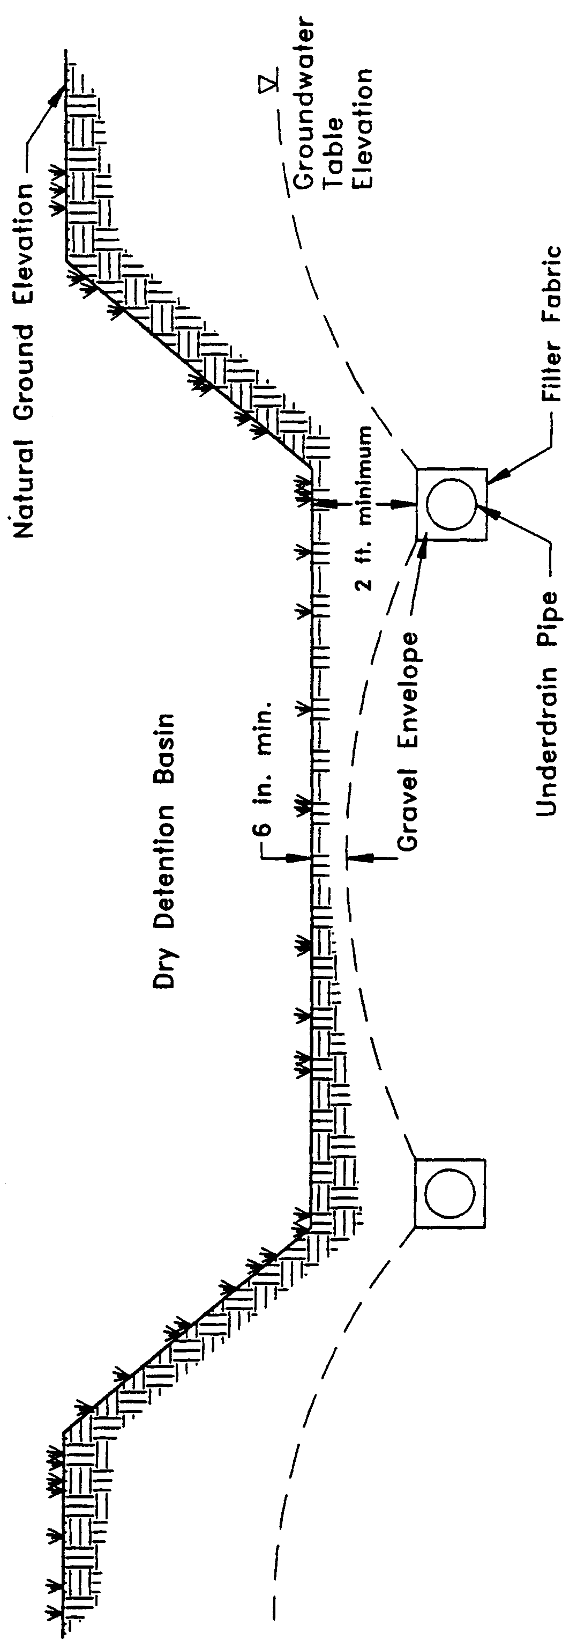

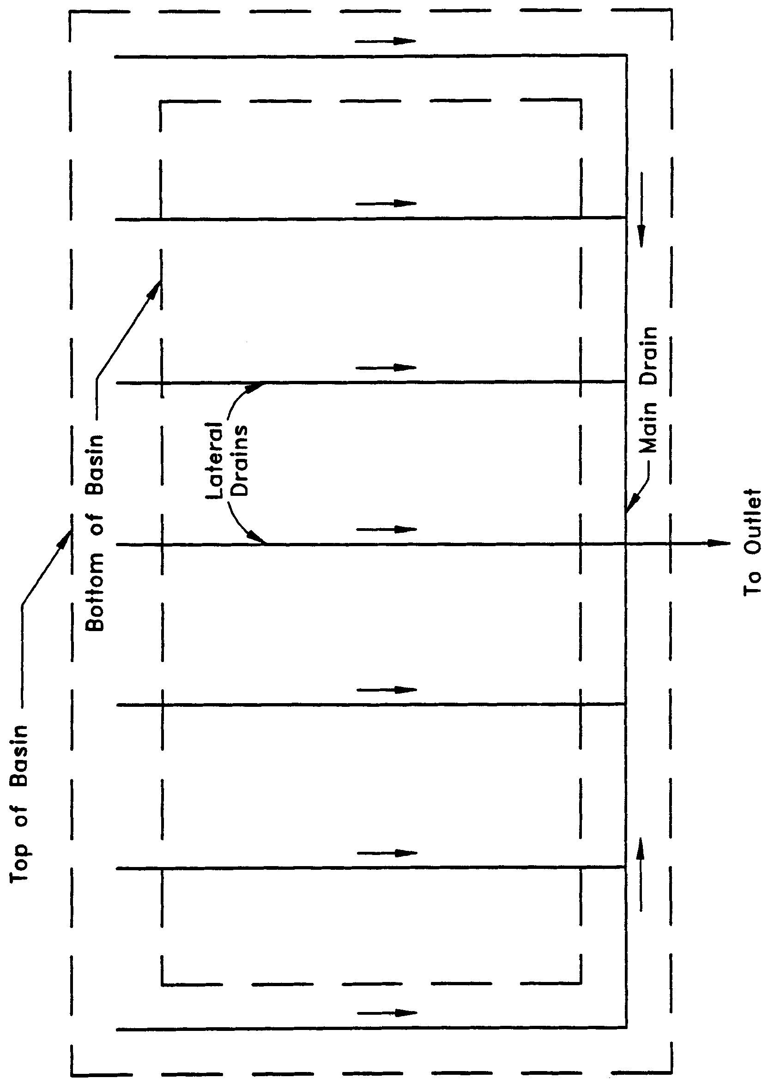

Figure 6.1-2 Plan view of typical underdrain system (N.T.S.).

6.3 Recovery Time

The system shall be designed to provide for the drawdown of the appropriate treatment volume specified in section 6.2 of this Volume within 72 hours following a storm event. The treatment volume is recovered by percolation through the soil with subsequent transport through the underdrain pipes. The system shall only contain standing water within 72 hours of a storm event.

The pipe system configuration (e.g., pipe size, depth, pipe spacing, and pipe inflow capacity) of the underdrain system must be designed to achieve the recovery time requirement. Underdesign of the system will result in reduced hydraulic capacity. This, in turn, will result in a reduction in storage between subsequent rainfall events and an associated decrease in the annual average volume of stormwater treated resulting in a reduction of pollutant removal. Such circumstances also reduce the aesthetic value of the system and may promote mosquito production.

6.4 Safety Factor

The underdrain system must be designed with a safety factor of at least two unless the applicant affirmatively demonstrates based on plans, test results, calculations or other information that a lower safety factor is appropriate for the specific site conditions. Examples of how to apply this factor include design factors such as the following:

(a) Reducing the design percolation rate by half; and

(b) Designing for the required drawdown within 36 hours instead of 72 hours.

6.5 Underdrain Media

Underdrain systems assist in volume recovery where the native soil has a good capacity for percolation, but where high water table conditions generally prevent the infiltration of the treatment volume through the soil profile. To provide proper treatment of the runoff, at least two feet of indigenous soil is required between the bottom of the basin storing the treatment volume and the outside of the gravel envelope.

6.6 Filter Fabric

Underdrain systems shall utilize filter fabric or other means to prevent the soil from moving into the gravel envelope and clogging perforated pipe.

6.7 Inspection and Cleanout Ports

To facilitate maintenance of the underdrain system, capped and sealed inspection and cleanout ports which extend to the surface of the ground using non-perforated piping shall be provided, at a minimum, at the following locations for each drainage pipe:

(a) The terminus; and

(b) At every 400 feet or every bend of 45 or more degrees, whichever is shorter.

6.8 Basin Stabilization

The underdrain basin shall be stabilized with permanent vegetative cover and should contain standing water only within 72 hours following a rainfall event.

6.9 Base Flow

(a) Underdrain systems shall be allowed provided that lowering of the groundwater table is restricted to the immediate vicinity of the treatment system; and

(b) Water tables shall not be lowered to a level that would decrease the flows or levels of surface water bodies below any minimum level or flow established by a water management district Governing Board pursuant to Section 373.042, F.S. or cause negative impacts to the functions provided by water resources on site and adjacent to the project.

7.0 Exfiltration Trench Design and Performance Criteria

7.1 Description

An exfiltration trench is a subsurface system consisting of a conduit such as perforated pipe surrounded by natural or artificial aggregate which temporarily stores and infiltrates stormwater runoff (Figure 7.1-1). Stormwater passes through the perforated pipe and infiltrates through the trench walls and bottom into the shallow groundwater aquifer. The perforated pipe increases the storage available in the trench and helps promote infiltration by making delivery of the runoff more effective and evenly distributed over the length of the system. Generally, exfiltration trench systems are utilized where space is limited and/or land costs are high (i.e., downtown urban areas).

Soil permeability and water table conditions must be such that the trench system can percolate the required stormwater runoff treatment volume within a specified time following a storm event. The trench system is returned to a normally “dry” condition when drawdown of the treatment volume is completed. Like retention basins, the treatment volume in exfiltration trench systems is not discharged to surface waters. Thus, exfiltration is considered a type of retention system.

Like other types of retention systems, exfiltration trench systems provide excellent removal of stormwater pollutants. Substantial amounts of suspended solids, oxygen demanding materials, heavy metals, bacteria, some varieties of pesticides and nutrients such as phosphorus are removed as runoff percolates through the soil profile. Exfiltration trench systems should not be located in close proximity to drinking water supply wells (see section 4.3.2 of this volume).

Besides pollution control, exfiltration trench systems can be utilized to promote the recharge of ground water and to prevent saltwater intrusion in coastal areas, or to maintain groundwater levels in aquifer recharge areas. Exfiltration trench systems can also be used to help meet the runoff volume criteria for projects which discharge to land-locked lakes (see section 3.3(b) of this Volume).

The operational life of an exfiltration trench is short (possibly 5 to 10 years) for most exfiltration systems. Sediment accumulation and clogging by fines can reduce the life of an exfiltration trench. Total replacement of the trench may be the only possible means of restoring the treatment capacity and recovery of the system. Periodic replacement of the trench should be considered routine operational maintenance when selecting this management practice.
Figure 13-1. Cross-section of Typical Underground Exfiltration Trench (N.T.S.)
There are several design and performance criteria which must be met in order for an exfiltration trench system to meet the rule requirements. A description of each criterion is presented below.

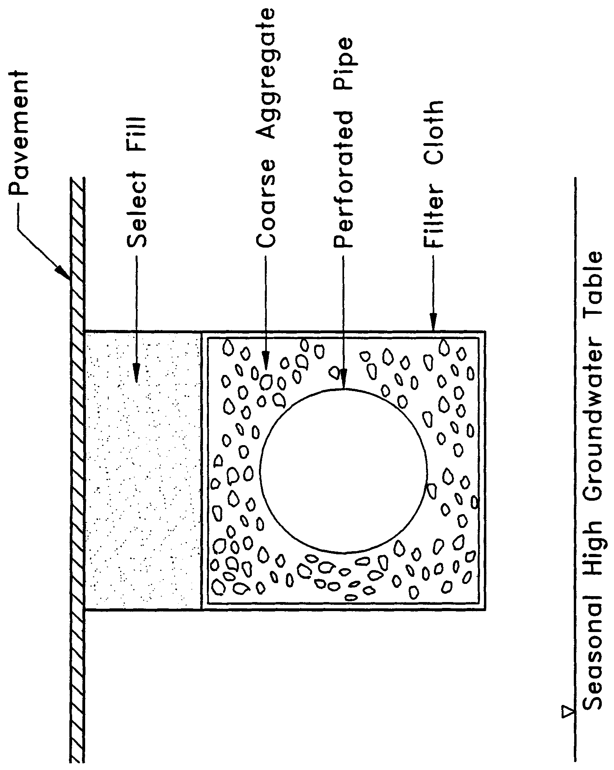
Figure 7.1-1 Cross-section of typical underground exfiltration trench (N.T.S.).

7.2 Treatment Volume

The first flush of runoff shall be collected in the exfiltration trench and infiltrated into the surrounding soil. For systems which discharge to Class III receiving water bodies, the applicant shall provide one of the following:

- Off-line storage of the first one-half inch of runoff from the contributing area; or

- On-line storage of the runoff from one inch of rainfall over the contributing area. A minimum volume of one-half inch of runoff from the contributing area is required.

For direct discharges to OFWs, the applicant shall provide storage for at least an additional fifty percent of the applicable treatment volume specified for off-line storage in (a) and (b), above.

Exfiltration trench systems must be designed to have the capacity to retain the required treatment volume without considering discharges to ground or surface waters.

7.3 Recovery Time

The system shall be designed to provide for the appropriate treatment volume of stormwater runoff specified in section 7.2 of this Volume within 72 hours following a storm event assuming average antecedent moisture conditions. The stormwater is drawn down by infiltration into the soil.

Antecedent moisture condition (AMC) refers to the amount of moisture and storage in the soil profile prior to a storm event. Antecedent soil moisture is an indicator of wetness and availability of soil to infiltrate water. The AMC can vary from dry to saturated depending on the amount of rainfall received prior to a given point in time. Therefore, “average AMC” means the soil is neither dry nor saturated, but at an average moisture condition at the beginning of a storm event when calculating recovery time for exfiltration systems.

The antecedent condition has a significant effect on runoff rate, runoff volume, infiltration rate, and infiltration volume. The infiltration volume is also known as the upper soil zone storage. Both the infiltration rate and upper soil zone storage are used to calculate the recovery time of retention systems and must be estimated using any generally accepted and well documented method with appropriate parameters consistent with such generally accepted and well documented method to reflect drainage practices, seasonal high water table elevation, the AMC, and any underlying soil characteristics which would limit or prevent percolation of storm water into the soil column.

7.4 Safety Factor

The exfiltration trench system must be designed with a safety factor of at least two unless the applicant affirmatively demonstrates based on plans, test results, calculations or other information that a lower safety factor is appropriate for the specific site conditions. For example, two possible ways to apply this factor are:

(a) Reducing the design percolation rate by half; and

(b) Designing for the required drawdown within 36 hours instead of 72 hours.

7.5 Minimum Dimensions

The perforated pipe shall be designed with a 12 inch minimum inside pipe diameter and a 3 foot minimum trench width. The perforated pipe shall be located within the trench section to minimize the accumulation of sediment in the aggregate void storage and maximize the preservation of this storage for stormwater treatment. To meet this goal, it is recommended that the perforated pipe be located at or within 6 inches of the trench bottom.

7.6 Filter Fabric

Exfiltration trench systems shall be designed so that aggregate in the trench is enclosed in filter fabric. This serves to prevent migration of fine materials from the surrounding soil that could result in clogging of the trench.

Alternatively, filter fabric may also be utilized directly surrounding the perforated pipe. In this instance, sedimentation of particulates will occur in the perforated pipe. Consequently, the pipe is more prone to clogging and reductions in capacity may occur more often than usual. However, the pipe may be cleaned relatively easy using high pressure hoses, vacuum systems, etc. On the other hand, designs without the fabric directly surrounding the perforated pipe requires complete replacement when clogging occurs.

7.7 Inspection and Cleanout Structures

Inspection and cleanout structures that extend exfiltration pipe to the surface of the ground shall be provided, at a minimum, at the inlet and terminus of each exfiltration pipe. Inlet structures shall include sediment sumps. These inspection and cleanout structures provide four primary functions:

(a) Observation of how quickly the trench recovers following a storm;

(b) Observation of how quickly the trench fills with sediment;

(c) Maintenance access to the perforated pipe; and

(d) Sediment control (sumps).

Standard precast concrete inlets and manholes are widely used to furnish the inspection and cleanout access.

7.8 Ground Water Table

The exfiltration trench system shall be designed so that the invert elevation of the trench is at least two feet above the seasonal high ground water table elevation unless the applicant affirmatively demonstrates based on plans, test results, calculations or other information that an alternative design is appropriate for the specific site conditions.

7.9 Construction

During construction, every effort should be made to limit the parent soil and debris from entering the trench. Any method used to reduce the amount of fines entering the exfiltration trench during construction will extend the life of the system. The use of an aggregate with minimal fines is also recommended.

8.0 Wet Detention Design and Performance Criteria

8.1 Description

Wet detention systems are permanently wet ponds which are designed to slowly release collected stormwater runoff through an outlet structure. A schematic of a typical wet detention system is shown in Figure 8.1-1.

Wet detention systems are the recommended BMP for sites with moderate to high water table conditions. The Agency strongly encourages the use of wet detention treatment systems for the following two reasons. First, wet detention systems provide significant removal of both dissolved and suspended pollutants by taking advantage of physical, chemical, and biological processes within the pond. Second, the complexity of BMPs, such as underdrains, is not encountered in a wet detention pond control structure. Wet detention systems offer an effective alternative for the long term control of water levels in the pond, provide a predictable recovery of storage volumes within the pond, and are easily maintained by the maintenance entity.

In addition to providing good removal of pollutants from runoff, wet detention systems also provide other benefits such as flood detention, passive recreation activities adjacent to ponds, storage of runoff for irrigation, and pleasing aesthetics. As stormwater treatment systems, these ponds should not be designed to promote in-water recreation (i.e., swimming, fishing, and boating). To exclude such uses, measures such as fencing, signage, and other methods designed to prevent unauthorized pedestrian, vehicle, and boat access to the system shall be used.

There are several components in a wet detention system which must be properly designed to achieve the level of stormwater treatment required by Chapter 62-330, F.A.C. A description of each design feature and its importance to the treatment process is presented below. The design and performance criteria for wet detention systems are discussed below. A methodology for the design of wet detention systems is provided in section 2 of the References and Design Aids.

8.2 Treatment Volume

For wet detention systems, the design treatment volume is one inch of runoff from the contributing area.

Additional treatment volume criteria apply to systems that discharge directly to OFWs (see section 8.12 of this Volume).

8.3 Recovery Time

The outfall structure shall be designed to drawdown one-half the required treatment volume between 48 and 60 hours.

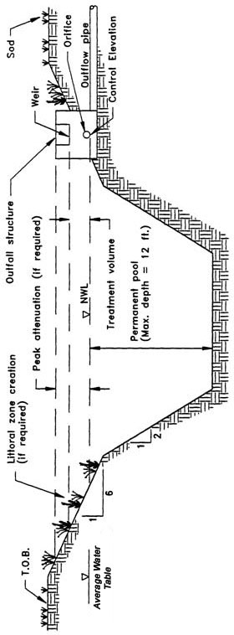

Figure 8.1-1 Typical wet detention system (N.T.S.).

8.4 Outlet Structure

The outlet structure generally includes a drawdown device (such as an orifice or "V" or square notch weir) set to establish a normal water control elevation and slowly release the treatment volume (see Figures 8.4-1 and 8.4-2). The design of the outfall structure must also accommodate the passage of flows from upstream stormwater management systems (see Figure 8.4-3).

The control elevation shall be set at or above the design tailwater elevation so the pond can effectively recover the treatment storage. Also, drawdown devices smaller than 3 inches minimum width or less than 20 degrees for "V" notches shall include a device to eliminate clogging. Examples of such devices include baffles, grates, screens, and pipe elbows.

8.5 Permanent Pool

A significant component and design criterion for the wet detention system is the storage capacity of the permanent pool (i.e., the section of the pond that holds water at all times). The permanent pool shall be sized to provide at least a 14-day residence time based upon average wet season rainfall (rainfall occurring over the wettest four months of an average year; for Northwest Florida, these are June through September).

Important pollutant removal processes that occur within the permanent pool include: uptake of nutrients by algae, adsorption of nutrients and heavy metals onto bottom sediments, biological oxidation of organic materials, and sedimentation. Uptake by algae is probably the most important process for the removal of nutrients. Sedimentation and adsorption onto bottom sediments is likely the primary means of removing heavy metals.

The storage capacity of the permanent pool must be large enough to detain the untreated runoff long enough for the treatment processes described above to take place. Since one of the major biological mechanisms for pollutant removal in a wet detention basin is phytoplankton growth, the average hydraulic residence time of the pond must be long enough to ensure adequate algal growth. A residence time of 2 weeks is considered to be the minimum duration that ensures adequate opportunity for algal growth.

Additional permanent pool volume is required for wet detention systems which directly discharge to OFWs (see section 8.12 of this Volume).
Figure 14-2. Typical Wet Detention Outfall Structure (N.T.S.)
Figure 14-3. Typical Wet Detention Outfall Structure with "V"-Notch Weir (N.T.S.)
Figure 14-4. Typical Wet Detention Outfall Structure with and without Baseflow Conditions (N.T.S.)

8.6 Littoral Zone

The littoral zone is that portion of a wet detention pond which is designed to contain rooted aquatic plants. The littoral area is usually provided by extending and gently sloping the sides of the pond down to a depth of 2 to 3 feet below the normal water level or control elevation. Also, the littoral zone can be provided in other areas of the pond that have suitable depths (i.e., a shallow shelf in the middle of the lake).

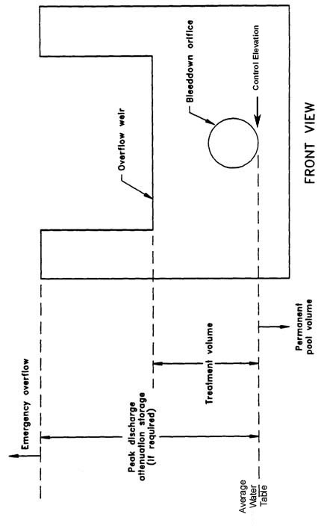

Figure 8.4-1 Typical wet detention outfall structure (N.T.S.).

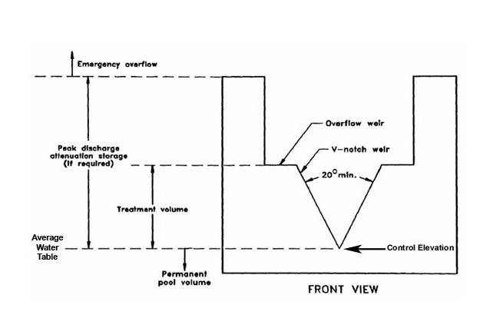

Figure 8.4-2 Typical wet detention outfall structure with "V"-notch weir (N.T.S.).

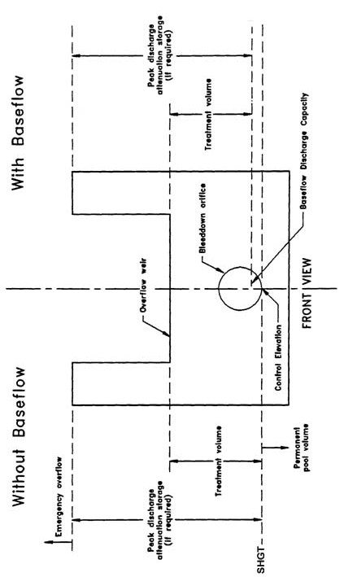

Figure 8.4-3 Typical wet detention outfall structure with and without baseflow conditions (N.T.S.).

The littoral zone is established with native aquatic plants by planting and/or the placement of wetland soils containing seeds of native aquatic plants. A specific vegetation establishment plan must be prepared for the littoral zone. The plan must consider the hydroperiod of the pond and the type of plants to be established. The Florida Development Manual provides a list of recommended native plant species suitable for littoral zone planting. Additional information is included in the References and Design Aids for Volume II. In addition, a layer of muck can be incorporated into the littoral area to promote the establishment of the wetland vegetation. When placing muck, special precautions must be taken to prevent erosion and turbidity problems in the pond and at its discharge point while vegetation is becoming established in the littoral zone.

The following is a list of the design criteria for wet detention littoral zones:

(a) The littoral zone shall be gently sloped (6:1 Horizontal:Vertical or flatter), and 30 to 40 percent of the wet detention pond surface area shall consist of a littoral zone. The percentage of littoral zone is based on the ratio of vegetated littoral zone to surface area of the pond at the control elevation.

(b) The treatment volume shall not cause the pond level to rise more than 18 inches above the control elevation unless the applicant affirmatively demonstrates that the littoral zone vegetation can survive at greater depths.

(c) Within 24 months of completion of the system, 80 percent coverage of the littoral zone by suitable aquatic plants is required.

(d) Planting of the littoral zone is recommended to meet the 80% coverage requirement. As an alternative to planting, portions of the littoral zone may be established by placement of wetland top soils (at least a four inch depth) containing a seed source of desirable native plants. When utilizing this alternative, the littoral zone must be stabilized by mulching or other means and at least the portion of the littoral zone within 25 feet of the inlet and outlet structures must be planted.

As an alternative option to establishing and maintaining vegetative littoral zones as described in this section, the applicant can provide either:

(e) An additional 50% of the appropriate permanent pool volume as required in section 8.5, above, or

(f) Pre-treatment of the stormwater prior to the stormwater entering the wet detention pond. The level of pre-treatment must be at least that required for retention, underdrain, exfiltration, or swale systems. See section 8.10, below, for additional information on pre-treatment.

Routine custodial maintenance must be performed to remove nuisance or exotic plant species such as cattails (Typha spp.).

8.7 Pond Depth

A maximum pond depth of 12 feet and a mean depth (pond volume divided by the pond area at the control elevation) between 2 and 8 feet is required. Deeper ponds are allowable, provided the registered professional affirmatively demonstrates that any design for deeper pond depths will not cause stratification within the water column and will prevent resultant anoxic bottom waters and sediments. Many of the nutrients and metals removed from the water column accumulate in the top few inches of the pond bottom sediments. If a pond is deep enough, it will have a tendency to stratify, creating the potential for anoxic conditions developing at the bottom of the pond. An aerobic environment should be maintained throughout the water column in wet detention ponds in order to minimize the release of nutrients and metals from the bottom sediments. The maximum depth criteria minimizes the potential for significant thermal stratification which will help maintain aerobic conditions in the water column that should maximize sediment uptake and minimize sediment release of pollutants.

On the other hand, the minimum mean depth criteria minimizes aquatic plant growth which may be excessive if the pond is too shallow.

8.8 Pond Configuration

The average length to width ratio of the pond must be at least 2:1. It is important to maximize the flow path of water from the inlets to the outlet of the pond to promote good mixing (i.e., no dead spots). Under these design conditions, short circuiting is minimized and pollutant removal efficiency and mixing is maximized.

If short flow paths are unavoidable, the effective flow path can be increased by adding diversion barriers such as islands, peninsulas, or baffles to the pond. Inlet structures shall be designed to dissipate the energy of water entering the pond. Examples of good and poor pond configurations are given in Figure 8.9-1.
Figure 14-5. Examples of Good and Poor Wet Detention Pond Configurations (N.T.S.)

8.9 Ground Water Table

To minimize ground water contributions which may lower treatment efficiencies, the control elevation shall be set at or above the normal on-site ground water table elevation. This elevation may be determined by calculating the average of the seasonal high and seasonal low ground water table elevations. In areas where the seasonal low water table is not determinable, the applicant may propose using the seasonal high water table elevation minus one foot. The decision to use this alternative should be made by a professional with significant experience with and knowledge of the historic weather patterns and groundwater conditions of the local area. Regardless of which method is used, the system cannot cause adverse secondary impacts to adjacent wetlands or other surface waters, such as dewatering.

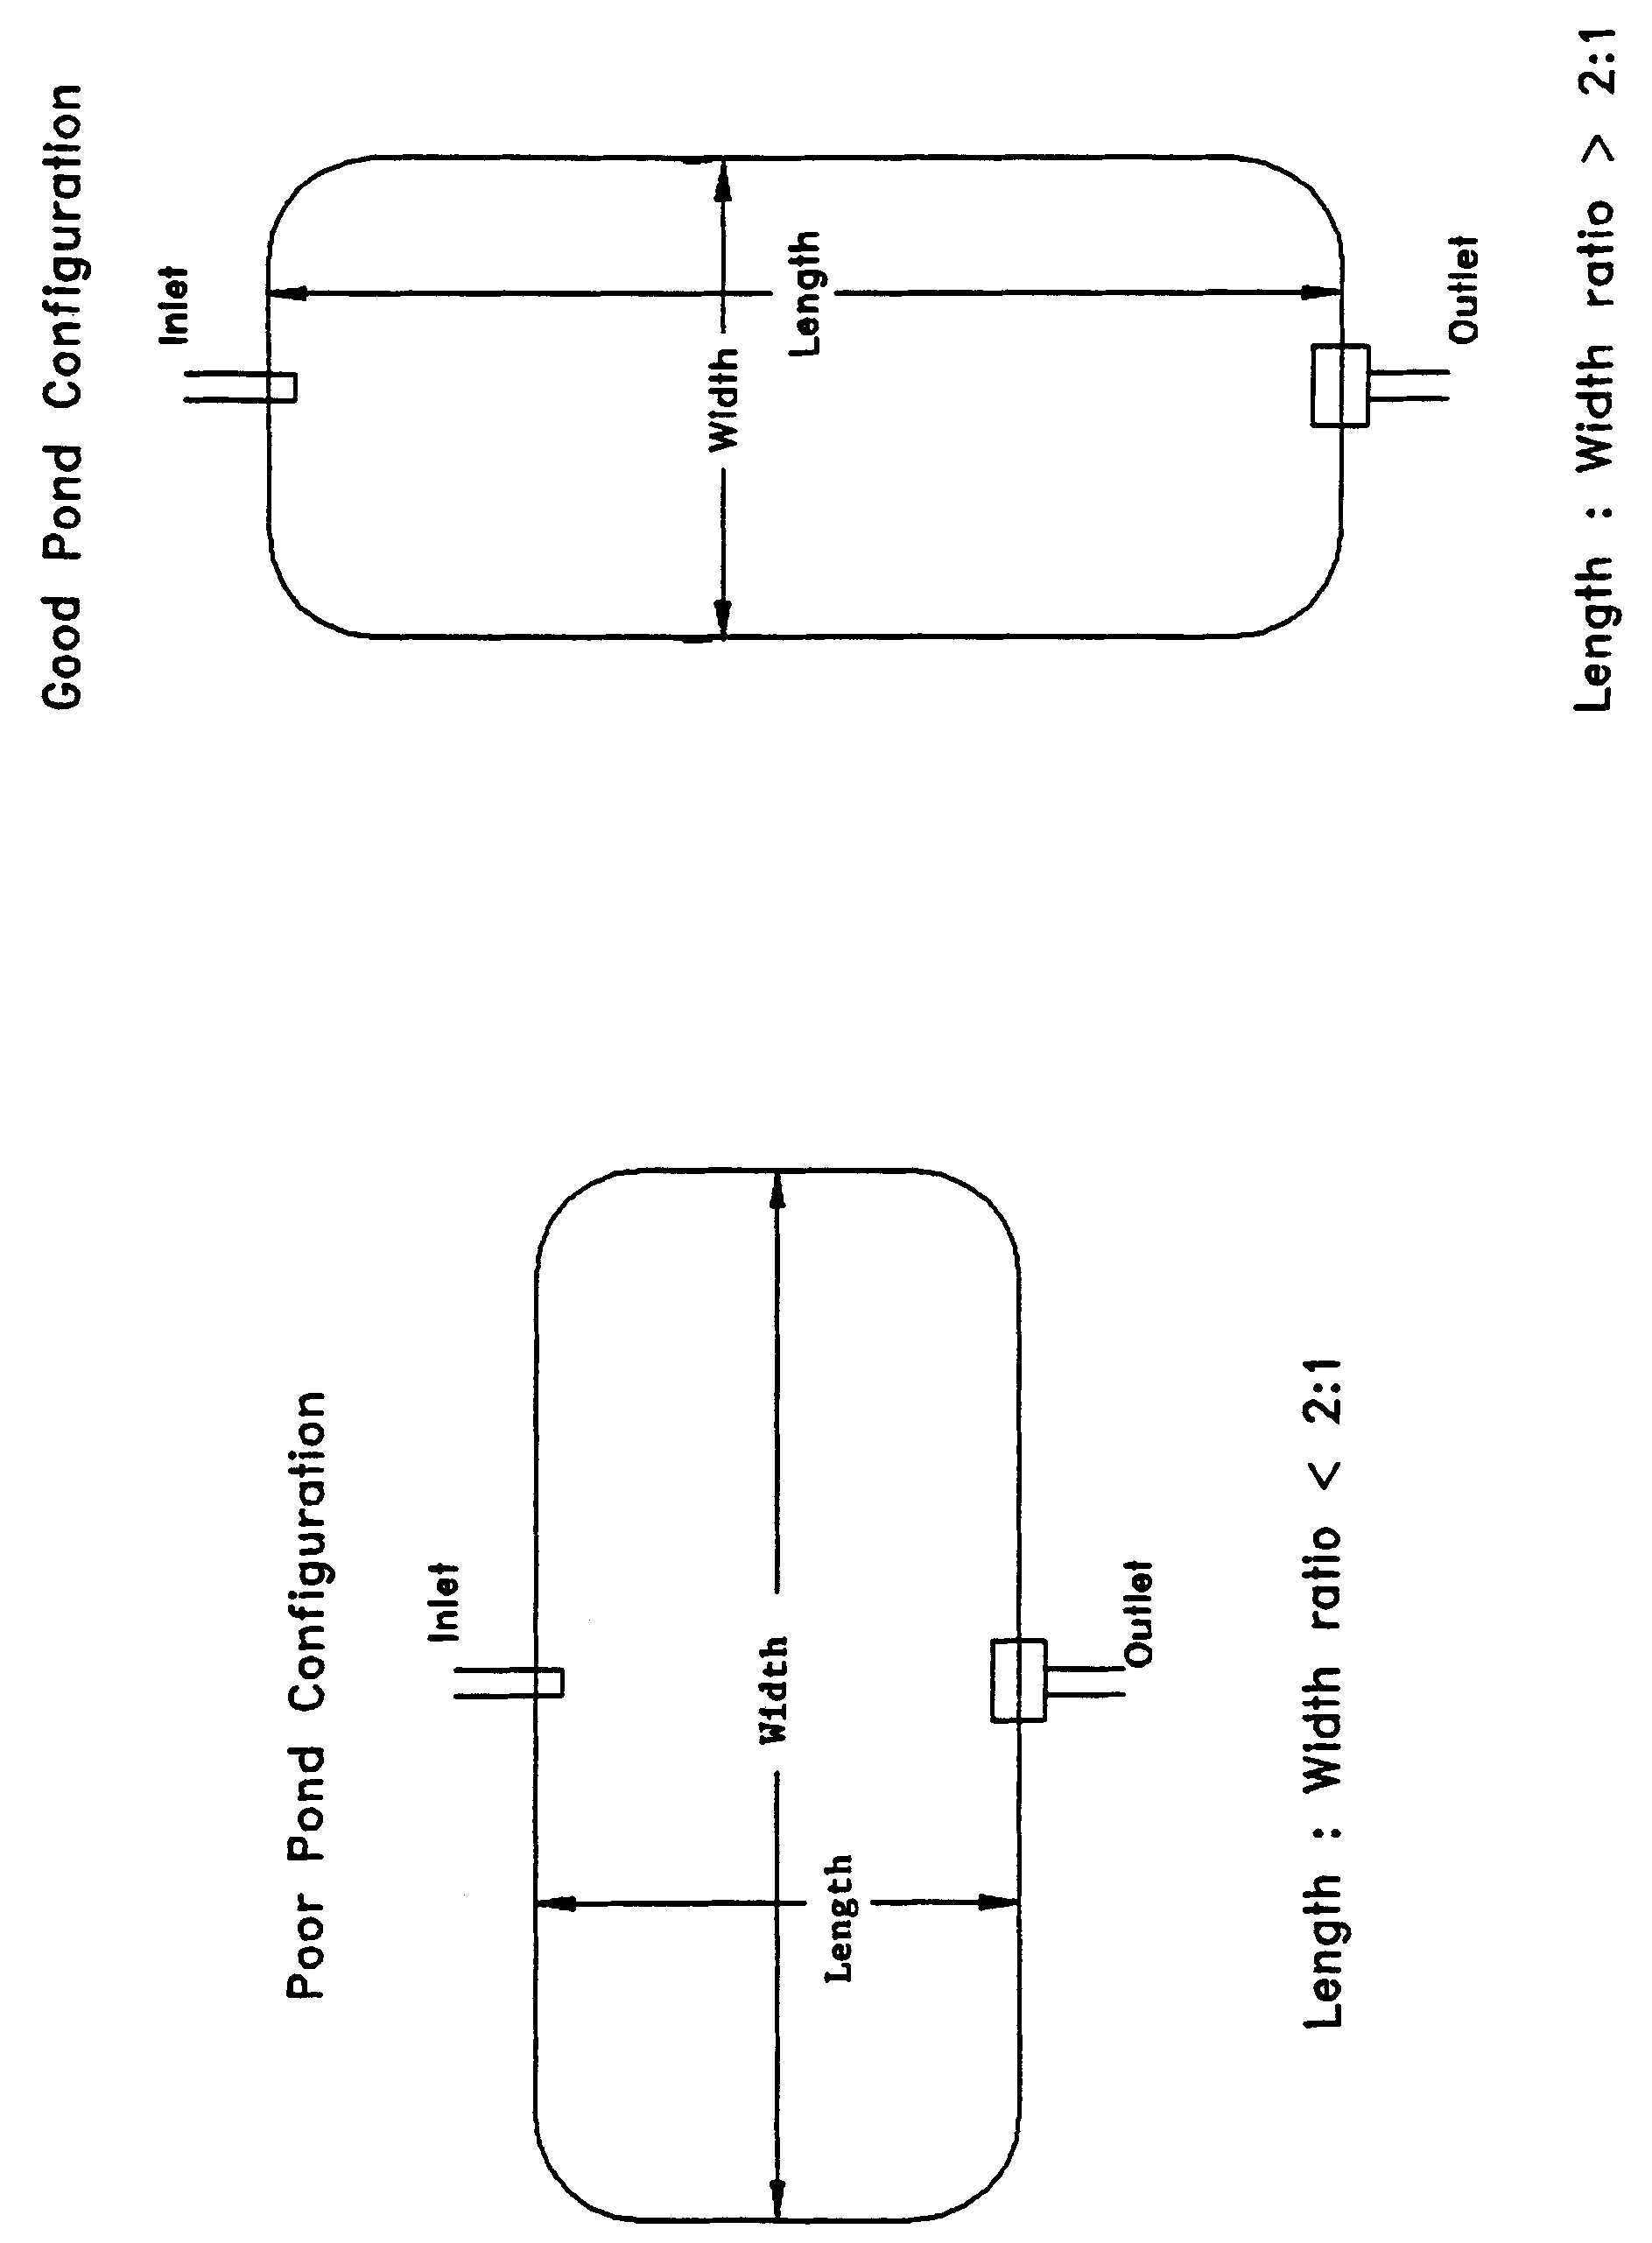

Figure 8.8-1 Examples of good and poor wet detention pond configurations (N.T.S.).

8.10 Pre-treatment

“Pre-treatment” is defined as the treatment of a portion of the runoff prior to its entering the wet detention pond. Pre-treatment increases the pollutant removal efficiency of the overall stormwater system by reducing the pollutant loading to the wet detention pond. Pre-treatment may be used to enhance the appearance of the wet detention pond or meet the additional treatment criteria for discharges to receiving water which are classified as OFWs.

For developments where the appearance of the lake is important, pre-treatment can reduce the chances of algal blooms and slow the eutrophication process. Some types of pre-treatment practices include utilizing vegetative swales for conveyance instead of curb and gutter, perimeter swales or berms around the lake, oil and grease skimmers on inlet structures, retention storage in swales with raised inlets, or shallow landscaped retention areas (when soils and water table conditions will allow for adequate percolation).

For systems in which pre-treatment is utilized to meet the additional design criteria requirements for systems with a direct discharge to an OFW, pre-treatment practices must meet the appropriate design and performance criteria for that BMP. Acceptable types of pre-treatment include the following:

(a) Retention systems which meet the design and performance criteria in section 5 of this Volume;

(b) Underdrain systems which meet the design and performance criteria in section 6 of this Volume; or

(c) Swales systems which meet the design and performance criteria in section 9 of this Volume.

Alternative pre-treatment methods will be evaluated on a case-by-case basis by the Agency. Applicants or system designers are encouraged to meet with Agency staff in a pre-application conference if alternative methods are proposed.

8.11 Pond Side Slopes

The pond must be designed so that the pond side slope measured between the control elevation and two feet below the control elevation is no steeper than 4H:1V (horizontal:vertical). Because the pond sediments are an important component in the wet detention treatment processes, this criterion will ensure sufficient pond bottom/side slope area for the appropriate processes to occur. Littoral zone areas must be 6H:1V or flatter as described in section 8.6 of this Volume.

8.12 Direct Discharges to Outstanding Florida Waters

Wet detention systems which have a direct discharge to an OFW, must provide either:

(a) An additional fifty percent of both the required treatment and permanent pool volumes; or

(b) Pre-treatment of the stormwater prior to entering the wet detention pond. The level of pre-treatment must be at least that required for retention, underdrain, or swale systems (see section 8.10 of this Volume).

9.0 Design Criteria for Swale Systems

When a stormwater management system relies in part on a swale to meet the conditions for issuance of Rule 62-330.301, F.A.C., and of this Volume, the following design criteria for swale systems apply.

9.1 Description

Swales are a man-made or natural system shaped or graded to required dimensions and designed for the conveyance and rapid infiltration of stormwater runoff. Swales are designed to infiltrate a defined quantity of runoff through the permeable soils of the swale floor and side slopes into the shallow ground water aquifer (Figure 9.1-1). Suitable vegetation is established to promote infiltration and stabilize the side slopes. Soil permeability and water table conditions must be such that the swale can percolate the desired runoff volume from the 3-year, 1-hour storm event. The swale holds water only during and immediately after a storm event, thus the system is normally “dry.” Unlike retention basins, swales are “open” conveyance systems. This means there are no physical barriers such as berms or check-dams to impound the runoff in the swale prior to discharge to the receiving water.

Swales provide excellent removal of stormwater pollutants. Substantial amounts of suspended solids, oxygen demanding materials, heavy metals, bacteria, some varieties of pesticides and nutrients such as phosphorus are removed as runoff percolates through the vegetation and soil profile.

Besides pollution control, swale systems can be utilized to promote the recharge of groundwater to prevent saltwater intrusion in coastal areas, and to maintain ground water levels in aquifer recharge areas. Swales can be incorporated into the design of a stormwater management system to help meet the runoff volume criteria for projects requiring permits under Chapter 62-330, F.A.C., which discharge to land-locked lakes (see section 3.3(b) of this Volume).

Swales can also be utilized to provide pre-treatment of runoff prior to its release to another treatment BMP such as wet detention (see section 8.10 of this Volume), or wetlands stormwater management systems (see section 10.3 of this Volume). Pre-treatment reduces the pollutant loading to the downstream treatment system, increases the pollutant efficiency of the overall stormwater management system, and reduces maintenance. In the case of wet detention systems, pre-treatment may be used to meet the additional treatment criteria for discharges to sensitive receiving waters (OFWs). For developments where the appearance of the downstream system (i.e., wet detention lake) is important, pre-treatment can reduce the probability of algal blooms occurring and slows the eutrophication process.

The design and performance criteria specific to swale systems are described below.

Figure 9.1-1 Cross-section of typical swale system (N.T.S.)
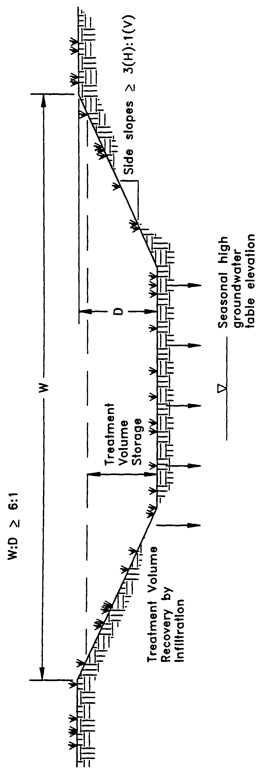

9.2 Treatment Volume

The runoff from the site shall be routed to the swale system for conveyance and percolation into the ground. For systems which discharge to Class III receiving water bodies, the swales should be designed to percolate 80% of the runoff from the 3-year, 1-hour design storm during the storm event as influenced by the time of concentration, assuming average antecedent conditions. The remaining 20% of the runoff from the 3-year, 1-hour storm event can be discharged offsite by the swale system.

Swale systems which directly discharge to OFWs, shall be designed to percolate all of the runoff from the 3-year, 1-hour storm.

9.3 Soils Requirements

Swale systems must be constructed on Hydrologic Soils Group (HSG) A or B soils and swale system design shall consider antecedent moisture conditions.

Antecedent moisture condition (AMC) refers to the amount of moisture and storage in the soil profile prior to a storm event. Antecedent soil moisture is an indicator of wetness and availability of soil to infiltrate water. The AMC can vary from dry to saturated depending on the amount of rainfall received prior to a given point in time. Therefore, “average AMC” means the soil is neither dry nor saturated, but at an average moisture condition at the beginning of a storm event when calculating recovery time for swale systems.

The antecedent condition has a significant effect on runoff rate, runoff volume, infiltration rate, and infiltration volume. The infiltration volume is also known as the upper soil zone storage. Both the infiltration rate and upper soil zone storage are used to calculate the recovery time of retention systems and should be estimated using any generally accepted and well documented method with appropriate parameters to reflect drainage practices, seasonal high water table elevation, consideration of ground water mounding, the AMC, and any underlying soil characteristics which would limit or prevent percolation of storm water into the soil column.

9.4 Dimensional Requirements

Swales must have a top width to depth ratio of the cross-section equal to or greater than 6:1 or side slopes equal to 3:1 (horizontal to vertical) or flatter.

9.5 Construction and Stabilization

Construction of swale systems must be in conformance with procedures that avoid degradation of swale infiltration capacity due to compaction and construction sedimentation. Construction of swale systems must conform to the construction practices in section 5.5 of this Volume.

Swales shall be stabilized with vegetative cover suitable for soil stabilization, stormwater treatment, and nutrient uptake. Also, the swale shall be designed to take into account the soil erodibility, soil percolation, slope, slope length, and drainage area so as to prevent erosion and reduce pollutant concentrations.

10.0 Design Criteria for Wetlands Stormwater Management Systems

10.1 Description

Wetlands are an essential part of nature's stormwater management system. Important wetland functions include the conveyance and storage of stormwater. These function to dampen flooding impacts; reduce flood flows and velocity of stormwater which in turn reduces erosion, increases sedimentation, and helps the assimilation of pollutants typically carried in stormwater. Accordingly, there is interest in the incorporation of natural wetlands into stormwater management systems, especially wetlands which have been previously drained. This concept provides an opportunity to use wetlands to help meet the requirements of this subsection. In addition, by using wetlands for stormwater management, drained wetlands can be revitalized and landowners and developers have greater incentive to preserve or restore wetlands.

For wetlands stormwater management systems the Agency must ensure that a proposed wetlands stormwater management system is compatible with the existing ecological characteristics of the wetlands proposed to be utilized for stormwater treatment. The Agency must also ensure that water quality standards will not be violated by discharges from wetlands stormwater management system. To achieve these goals, specific performance criteria are set forth herein and are described below for systems which incorporate wetlands for stormwater treatment.

10.2 Types of Wetlands that may be Utilized for Stormwater Treatment

The only wetlands which may be considered for use to provide stormwater treatment are those which:

- Are isolated and wholly-owned by one individual; or

- Are connected to other waters solely by artificial watercourses.

10.3 Treatment Volume

For systems discharging to Class III waters, the design treatment volume is one inch of runoff from the contributing area. Those systems which directly discharge to OFWs shall provide an additional fifty percent of the treatment volume.

If the wetland alone cannot provide the treatment volume, then other best management practices must be incorporated upstream and outside of the wetland to store the proper level of runoff. Utilization of other BMPs must not adversely affect the ability of the wetlands stormwater management system from meeting the requirements of this section.

10.4 Recovery Time

The system shall be designed to bleed down one-half the treatment volume specified above between 60 and 72 hours following a storm event, with the remainder bled down within 120 hours.

10.5 Inlet Structures

Inlet structures shall be designed to dissipate the energy of runoff entering the wetland and minimize the channelized flow of stormwater. Methods include design features such as sprinklers, pipe energy dissipators, overland flow, or spreader swales. Alternative designs may be proposed if they provide comparable reasonable assurance.

10.6 Wetland Function

Provisions must be made to remove sediment, oils and greases from runoff entering the wetland. This can be accomplished through incorporation of adjacent sediment sumps, forebays, baffles and dry vegetated swales or a combination thereof. Normally, a dry vegetated swale system designed for detention of the first one-fourth inch of runoff with an overall depth of no more than 4 inches will satisfy the requirement for removal of sediment, oils and greases. In addition, pre-treatment can be utilized to attenuate stormwater volumes and peak discharge rates so that the wetland's hydroperiod is not adversely altered.

10.7 Residence Time

The design features of the system shall maximize residence time of the stormwater within the wetland to enhance the opportunity for the stormwater to come into contact with the wetland sediment, vegetation, and micro-organisms. This can be accomplished by several means. The inlets and outlets should be located to maximize the flow path through the wetland. Energy dissipators and spreader swales can promote overland flow and reduce the possibility of channelized flow occurring. In some instances, berms in wetlands can act as baffles to increase the flow path of surface flow through the wetland.

11.0 Design Criteria for Vegetated Natural Buffers

11.1 Description

Vegetated natural buffers (VNB) are defined as naturally vegetated areas that are set aside between developed areas and a receiving water or wetland for stormwater treatment purposes. Under certain conditions, VNBs are an effective best management practice for the control of nonpoint source pollutants in overland flow by providing opportunities for filtration, deposition, infiltration, absorption, adsorption, decomposition, and volatilization.

VNBs are most commonly used as an alternative to swales or berms installed between back-lots and the receiving water. Buffers are intended for use to avoid the difficulties associated with the construction and maintenance of backyard swales controlled by individual homeowners. Potential impacts to adjacent wetlands and upland natural areas are reduced because fill is not required to establish grades that direct stormwater flow from the back of the lot towards the front for collection in the primary stormwater management system. In addition, impacts are potentially reduced since buffer strips can serve as wildlife corridors, reduce noise, and reduce the potential for siltation into receiving waters.

Vegetative natural buffers are not intended to be the primary stormwater management system for residential developments. They are most commonly used only to treat those rear-lot portions of the development that cannot be feasibly routed to the system serving the roads and fronts of lots. A schematic of a typical VNB and its contributing area is presented in Figure 11-1.

The design and maintenance criteria for VNBs and their contributing areas are described in sections 11.2 through 11.9 of this Volume.

11.2 Contributing Area

The contributing area is defined as the area that drains to the VNB.

Rear-lots of residential areas are allowed to contribute runoff to a VNB only if routing the runoff from such areas to the primary stormwater management system serving the development is not practical. The use of a VNB for other types of development shall only be allowed if the applicant demonstrates that there are no practical alternatives for those portions of the project, and only if the VNB and contributing areas meet all of the criteria of sections 11.2 through 11.9 of this Volume.

To promote overland flow, the maximum width (dimension parallel to the flow direction) of the contributing area is 300 feet. The contributing area must be stabilized with permanent vegetative cover that is consistent with the Florida Yards and Neighborhood program. No fertilizer shall be applied to the contributing area.

Erosion control measures such as those described in Part IV of Applicant’s Handbook Volume I must be utilized during development of the contributing area so as to prevent siltation of the buffer area.

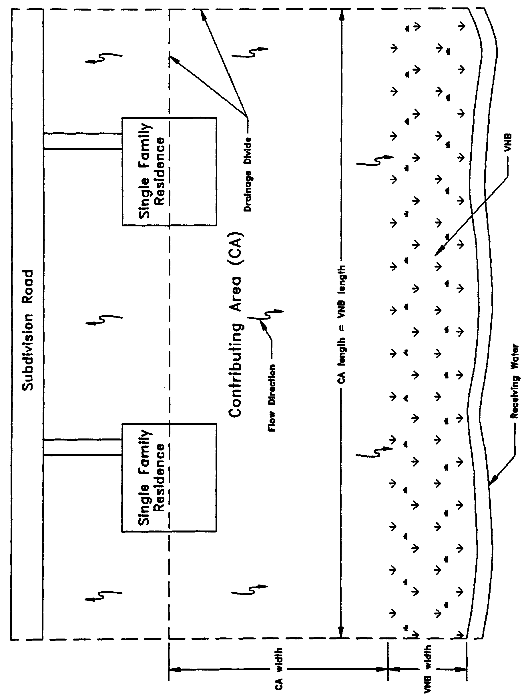

Figure 11-1 Plan View Schematic of Typical Vegetative Natural Buffer

11.3 Buffer Area Vegetation

The VNB area is an existing undeveloped area which contains naturally occurring native vegetation. The existing vegetation must not be disturbed during the development of the project.

11.4 Buffer Width

In all cases, a minimum buffer width of 25 feet is required to ensure the integrity of the treatment system. Factors affecting the minimum width (measured parallel to the direction of runoff flow) of VNBs include ground slope, rainfall, cover and soil characteristics, depth to water table and overland flow length. Infiltration is the primary means of treatment when soil characteristics and depth of ground water table promote infiltration. For sites with poor infiltration potential (i.e. hydrologic soil group C or D soils), pollutant removal occurs due to travel time across the buffer and is primarily a result of filtration and assimilation rather than infiltration. For design purposes, buffer widths shall be based upon the more conservative approach that utilizes a minimum travel time for overland flow.

Vegetated Natural Buffers must be designed to provide a specified travel time through the buffer as described herein. For systems that discharge to receiving water bodies other than OFWs, the VNB must be designed to provide at least 200 seconds of travel time by overland flow through the buffer for the 2-year, 24-hour storm event. Systems which directly discharge to OFWs must be designed to provide at least 300 seconds of travel time by overland flow through the buffer for the 2-year, 24-hour storm event.

A sample calculation for designing a buffer to meet the above requirements is provided in Section 4 of the Volume II Design Aids.

11.5 Maximum Buffer Slope

The maximum slope of VNB must not be greater than 15%.

11.6 Minimum Buffer Length

The length of the buffer (measured perpendicular to the runoff flow direction) must be at least as long as the length of the contributing runoff area (see Figure 11-1).

11.7 Runoff Flow Characteristics

Runoff from the adjacent contributing area must be evenly distributed across the buffer strip to promote overland flow. If channeling of the flow occurs, the buffer is effectively “short-circuited” and will not perform as designed.

11.8 Preservation and Maintenance Access

A legal reservation, in the form of an easement or other limitation of use, must be recorded which provides preservation of the existing undeveloped area in its natural state. The reservation must also include access for maintenance of the VNB unless the operation and maintenance entity wholly owns or retains ownership of the property. The legal reservation must include at least the entire area of the VNB. See section 2.4 of this Volume for additional maintenance access requirements.

11.9 Maintenance and Inspections

VNBs must be inspected annually by the operation and maintenance entity to determine if there has been any encroachment or violation of the terms and condition of the VNB as described below.

Buffers must be examined for damage by foot or vehicular traffic, encroachment, gully erosion, density of vegetation, and evidence of concentrated flow through or around the buffer. Repairs to the buffer must be made as soon as practical in order to prevent additional damage to the buffer. Repaired areas must be re-established with native vegetation. Invasive plant species such as cattail and primrose willow must be prevented from becoming the dominant species.

12.0 Design Criteria for Stormwater Harvesting

12.1 Description

On the average, and in most of the State of Florida, approximately 50% of the potable water delivered to residential units is used for irrigating lawns. The potable water used for irrigation may be supplemented with non-potable water from stormwater detention facilities. The use of detention stormwater in new developments is very probable, because the cost of irrigating the detained stormwater is significantly less than the cost of potable water and in most cases about 5-25% the cost of potable water. In specific new development locations in the State of Florida, the cost of irrigation water from detention ponds is certainly competitive.

Stormwater harvesting systems are designed to prevent the discharge of a given volume of stormwater into surface waters of the state by deliberate application of stormwater runoff for irrigation or other acceptable supplemental water uses. Examples of areas that can be irrigated include golf courses, cemeteries, highway medians, parks, retail nurseries, agricultural lands, and residential and commercial properties. Supplemental uses include hydration of wetlands, low flow augmentation, cooling water, process water, and wash water.

A stormwater harvesting pond is similar to a wet detention system described in section 8 of this Volume except for the drawdown of the treatment volume storage. For typical wet detention ponds, the treatment volume is released at a controlled rate by a drawdown orifice or weir. However, in a stormwater harvesting system the drawdown structure is replaced by a mechanical harvesting system which recovers the treatment volume storage by withdrawing water from the pond. In a harvesting pond the treatment volume is termed " harvesting volume" and the "control elevation" is the lowest elevation at which water can be withdrawn from the pond by the harvesting system. Like wet detention, stormwater harvesting systems are a recommended BMP for sites with moderate to high ground water table conditions. A schematic a typical harvesting pond is shown in Figure 12-1.

The Agency encourages the use of stormwater harvesting systems because of the following benefits they provide:

(a) Reduction of runoff volume discharged to the receiving waters;

(b) Reduction of pollutants discharged to the receiving waters;

(c) Substitution of stormwater use instead of potable ground water withdrawals; and

(d) Potential economic savings from not having to pay user fees for potable water.

Stormwater harvesting systems provide significant removal of both dissolved and suspended pollutants by taking advantage of physical, chemical, and biological processes associated with wet detention systems and the harvesting and recycling of constituents back to the landscape by irrigation with stormwater. Harvesting systems can be utilized to help meet the runoff volume criteria for stormwater management systems and management and storage of surface water (MSSW) projects which discharge to land-locked lakes.

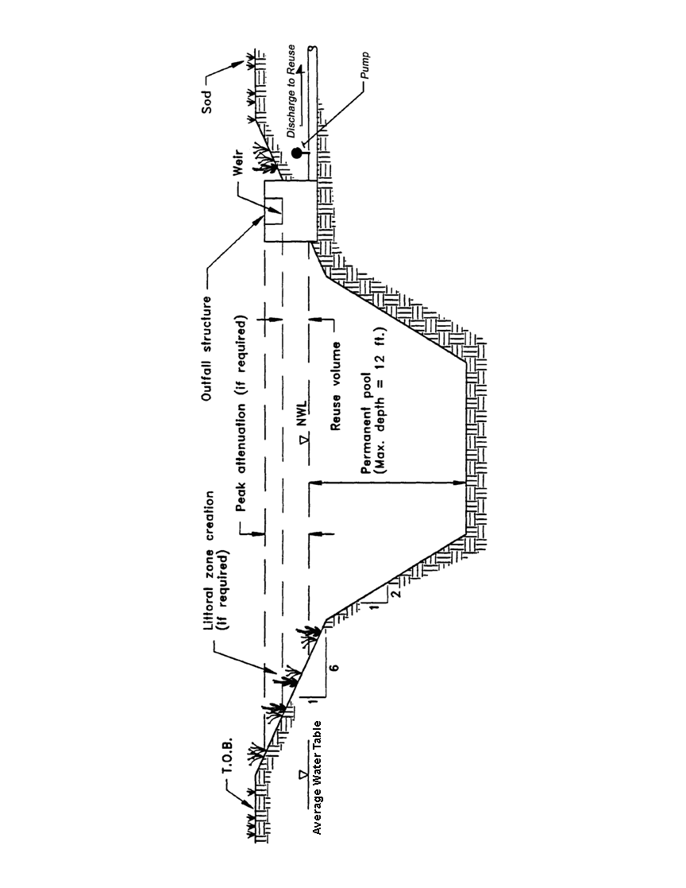
Figure 12-1 Typical stormwater harvesting system (N.T.S.).
In addition, stormwater harvesting ponds also provide other benefits such as flood detention, recreation activities adjacent to ponds, and pleasing aesthetics. As stormwater treatment systems, these ponds must not be designed to promote in-water recreation (i.e., swimming, fishing, and boating).

There are several components in a stormwater harvesting system which must be properly designed to achieve the level of stormwater treatment required by Chapter 62-330, F.A.C. A description of each design feature and its importance to the treatment process is presented below. These criteria are not intended to preclude the harvesting of stormwater from other types of stormwater management systems such as wet detention. Several of these criteria are the same as those for wet detention systems as described in section 8 of this Volume.

12.2 Harvesting Volume

A portion of the runoff from the site must be stored in the pond and subsequently withdrawn through the harvesting system. For systems which discharge to Class III receiving water bodies, the system must reuse at least 50 percent of the average annual runoff discharging to the harvesting pond.

Stormwater harvesting systems which directly discharge to OFWs, must reuse at least 90 percent of the average annual runoff discharging to the pond. A methodology for designing harvesting systems to meet the above criteria is presented in section 3 of the Volume II Design Aids.

12.3 Permanent Pool

The permanent pool is that portion of a pond which is designed to hold water at all times (i.e., below the control elevation). The permanent pool shall be sized to provide at least a 14-day residence time during the wet season (June through September). A description of the pollutant removal processes which occur in the permanent pool is given in section 8 of this Volume and a methodology for calculating the residence time is given in section 2 of the Volume II Design Aids.

12.4 Littoral Zone

The littoral zone is that portion of a stormwater harvesting pond which is designed to contain rooted aquatic plants. The littoral area is usually provided by extending and gently sloping the sides of the pond down to a depth of 2 to 3 feet below the normal water level or control elevation. Also, the littoral zone can be provided in other areas of the pond that have suitable depths (i.e., a shallow shelf in the middle of the lake).

The littoral zone is established with native aquatic plants by planting and/or the placement of wetland soils containing seeds of native aquatic plants. A specific vegetation establishment plan must be prepared for the littoral zone. The plan must consider the hydroperiod of the pond and the type of plants to be established. The Florida Development Manual provides a list of recommended native plant species suitable for littoral zone planting. In addition, a layer of muck can be incorporated into the littoral area to promote the establishment of the wetland vegetation. When placing muck, precautions must be taken to prevent erosion and turbidity problems in the pond and at its discharge point while vegetation is becoming established in the littoral zone.

The following is a list of the design criteria for stormwater harvesting littoral zones:

(a) The littoral zone shall be gently sloped (6H:1V or flatter). Thirty to forty percent of the stormwater harvesting pond surface area shall consist of a littoral zone. The percentage of littoral zone is based on the ratio of vegetated littoral zone to surface area of the pond at the control elevation.

(b) The treatment volume shall not cause the pond level to rise more than 18 inches above the control elevation unless the applicant provides reasonable assurance that the littoral zone vegetation can survive at greater depths.

(c) Within 24 months of completion of the system, 80 percent coverage of the littoral zone by suitable aquatic plants is required.

(d) Planting of the littoral zone is recommended to meet the 80% coverage requirement. As an alternative to planting, portions of the littoral zone may be established by placement of wetland top soils (at least a four inch depth) containing a seed source of desirable native plants. When utilizing this alternative, the littoral zone must be stabilized by mulching or other means and at least the portion of the littoral zone within 25 feet of the inlet and outlet structures must be planted.

12.5 Pond Depth

A maximum pond depth of 12 feet and a mean depth (pond volume divided by the pond area at the control elevation) between 2 and 8 feet is required. This criterion is needed because many of the nutrients and metals removed from the water column accumulate in the top few inches of the pond bottom sediments. If a pond is deep enough, it will have a tendency to stratify, creating the potential for anoxic conditions developing at the bottom of the pond. An aerobic environment should be maintained throughout the water column in wet ponds in order to minimize the release of nutrients and metals from the bottom sediments. The maximum depth criteria minimize the potential for significant thermal stratification which will help maintain aerobic conditions in the water column that should maximize sediment uptake and minimize sediment release of pollutants. On the other hand, the minimum mean depth criteria are required because aquatic plant growth may become excessive if the pond is too shallow.

12.6 Pond Configuration

The average length to width ratio of the pond should be at least 2:1. If short flow paths are unavoidable, the effective flow path can be increased by adding diversion barriers such as islands, peninsulas, or baffles to the pond. Inlet structures shall be designed to dissipate the energy of water entering the pond.

12.7 Ground Water Table

To minimize ground water contributions which may lower treatment efficiencies, the control elevation should be set at or above the normal on-site ground water table elevation. This elevation may be determined by calculating the average of the seasonal high and seasonal low ground water table elevations. In areas where the seasonal low water table is not determinable, the applicant may propose using the seasonal high water table elevation minus one foot. The decision to use this alternative should be made by a professional with significant history and knowledge of the local areas historic weather patterns and groundwater conditions. Regardless of which method is used, the system cannot cause adverse secondary impacts to adjacent wetlands or other surface waters such as dewatering.

13.0 Special Basin Criteria: Sensitive Karst Areas

Subparagraph 62-330.301(1)(k)1., F.A.C., provides that a condition for issuance of a permit includes compliance with any applicable special basin or geographic area criteria rules. The only area within the geographical extent of the Northwest Florida Water Management District (NWFWMD) for which additional geographic criteria have been developed are two Sensitive Karst Areas (SKAs). These areas cover portions of the central and eastern regions of the geographical extent of the NWFWMD (see Figure 13.0-1). A location description of these areas is contained in Appendix A of this Volume. In addition to the design criteria for projects outside of the SKAs, projects located within the SKAs also must meet the additional design criteria of Sections 13.3 through 13.3.2 of this Volume.

13.1 Background of the Sensitive Karst Area Design Criteria

The Floridan Aquifer System is the drinking water source for most of the population in the geographical extent of the NWFWMD. In parts of the NWFWMD, limestone (or dolostone) that makes up or comprise this aquifer system occurs at or near the land surface. Sediments overlying the limestone can be highly permeable. The limestone, due to its chemical composition, is susceptible to dissolution when it interacts with slightly acidic water. “Karst” is a geologic term used to describe areas where landscapes have been affected by the dissolution of limestone or dolostone, including areas where the formation of sinkholes is relatively common. Sensitive Karst Areas reflect areas with hydrogeologic and geologic characteristics relatively more conducive to potential contamination of the Floridan Aquifer System from surface pollutant sources. The formation of karst-related features, such as sinkholes is also more likely to occur in SKAs.

13.2 Hydrogeology of the Sensitive Karst Areas

Throughout the majority of the geographical extent of the NWFWMD the highly porous limestone that comprises the Floridan Aquifer System is generally overlain by tens to hundreds of feet of sands, clays, and other material. Where present, this material may act to protect, to varying degrees, the Floridan Aquifer System from surface pollutants. Surface water seeps through this material slowly, which allows for some degree of filtration, adsorption, and biological transformation or degradation of contaminants.

In SKAs, however, the limestone that comprises the Floridan Aquifer System may occur at or near the land surface (Figure 13.2-1), and sand overburden, confining clays, or other confining cover material is absent or discontinuous. As a result, there can be rapid movement of surface water and possibly entrained contaminants into the aquifer. The SKAs are areas of relatively high recharge to the Floridan Aquifer System. Floridan Aquifer System ground water levels vary from land surface to approximately 290 feet below land surface in the SKAs.

One factor that makes the SKAs particularly prone to stormwater contamination is the formation of solution pipe sinkholes within retention basins. Solution pipe sinkholes are common in these areas and form due to the collapse of surficial material into vertical cavities that have been dissolved in the upper part of the limestone (Figure 13.2-2). They are also formed by the movement of surface material into the underlying porous limestone. In most cases, the solution pipes are capped by a natural plug of sands and clays (Figures 13.2-1 and 13.2-2). If the cap is washed out (as may happen if a large volume of water is stored over the solution pipes), the resulting solution pipe
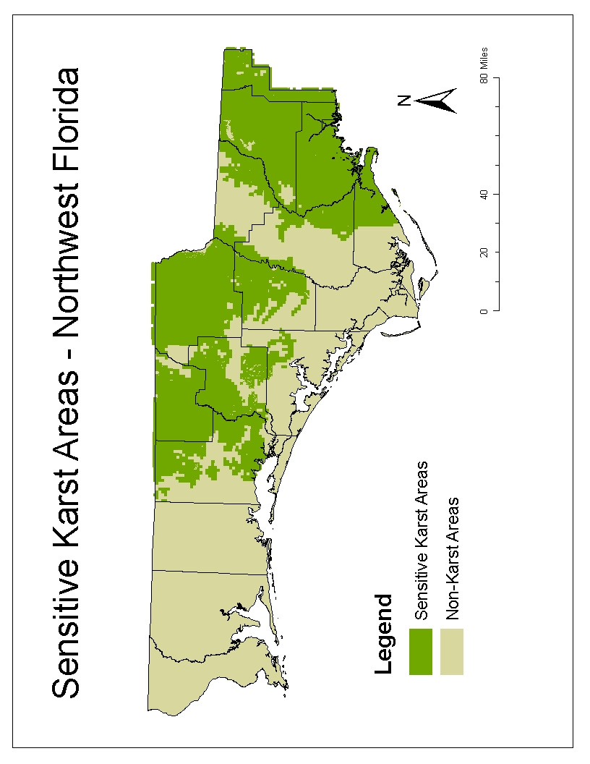
Figure 13.0-1 Sensitive Karst Areas within the NWFWMD

Figure 13.2-1 Generalized geologic section in Sensitive Karst Area
with limestone at and near land surface.
Figure 13.2-2 Retention basin added to Figure 13.2-1.
sinkhole (Figure 13.2-3) can act as a direct pathway for the movement of surface water into the Floridan Aquifer System.

Solution pipe sinkholes and other types of sinkholes may open in the bottom of stormwater retention basins. The capping plug or sediment fill may be reduced by excavation of the basin. Stormwater in the basin may increase the hydraulic head on the remaining material in the pipe throat. Both of these factors can wash material down the solution pipe. Solution pipes act as natural drainage wells and can drain stormwater basins.

The irregular weathering of the limestone surface in the SKAs contributes to uncertainty and errors in predicting the depth from land surface to limestone. For example, in Figure 13.2-1, boring A would show limestone much deeper than it would actually be encountered during excavation, shown at boring B. This potential for error must be considered for site investigations when evaluating site borings, and load-specific geological analyses must be included to base site designs.

13.3 Additional Design Criteria for Sensitive Karst Areas

13.3.1 Stormwater management systems shall be designed and constructed to prevent direct discharge of untreated stormwater into the Floridan Aquifer System. Such stormwater management systems also shall be designed and constructed in a manner that avoids breaching an aquitard and such that construction excavation will not allow direct mixing of untreated water between surface waters and the Floridan Aquifer System. The system shall also be designed to prevent the formation of solution pipes or other types of karst features in the SKAs. Test borings located within the footprint of a proposed stormwater management pond must be plugged in a manner to prevent mixing of surface and ground waters.

13.3.2 Except as provided in section 13.3.5 of this Volume, systems that are designed as follows are presumed to comply with sections 13.3.1 of this Volume:

- A minimum of three feet of unconsolidated sediment or soil material between the surface of the limestone bedrock and the complete extent of the bottom and sides of the stormwater basin at final completion of the project. Excavation and backfill of unconsolidated sediment or soil material shall be conducted, if necessary to meet these criteria. As an alternative, an impermeable liner can be used to ensure that stormwater is isolated from communication with groundwater (e.g., for wet detention). This provision is presumed to provide reasonable assurance of adequate treatment of stormwater before it enters the Floridan Aquifer System;

- To reduce the potential for solution pipe sinkhole formation caused by newly created additional hydraulic head conditions, stormwater storage areas are limited to a maximum of 10 feet of vertical staging (shallower depths are encouraged), as measured for dry ponds from the bottom of the pond to the design high water level; and for wet ponds 10 feet of vertical staging as measured from the seasonal high ground water table to the design high water level, and shall have a horizontal bottom (no deep spots); and

- Basin side slopes and bottom (if not a wet pond) must be fully vegetated or otherwise stabilized.

Figure 13.2-3. Potential sinkhole resulting from change in physical conditions due to constructed retention basin depicted in Figure 13.2-2.

13.3.3 Applicants who believe that their proposed system is not within the influence of a karst feature, notwithstanding that it is within the SKAs designated by Figure 13.0-1 and Appendix A of this Volume, and therefore wish to design their system other than as provided in Section 13.3.2 of this Volume, shall furnish the Agency with reasonable assurance that the proposed system complies with section 13.3.1 of this Volume. Such reasonable assurance shall consist of:

(a) A geotechnical analysis consisting of existing soil, geologic, and lithologic data of the project area that demonstrates the presence of an aquitard consisting of at least 20 feet of unconsolidated low permeability material [clay (particle size less than 0.002mm, or material passing No. 200 sieve) content >10%] below the pond bottom that will not be breached by the proposed design and construction;

(b) The presence of a minimum of 100 ft. of unconsolidated sediment or soil material from the bottom of the pond and the top of the limestone as demonstrated by core borings within the proposed pond area; or

(c) Other site specific geologic information demonstrating the presence of a confining layer below the pond bottom that provides protection equivalent to that set forth in (a) or (b), above.

A registered professional shall be required to certify that the submitted information, the site characteristics, and the project design provide reasonable assurance of compliance with section 13.3.1 of this Volume.

13.3.4 In addition to sites identified on Figure 13.0-1, and Appendix A of this Volume, the Agency shall require compliance with the criteria in section 13.3.2 of this Volume when available data and information indicate that a substantial likelihood exists that a proposed stormwater management system on a site has the potential to be located within the influence of a karst feature based on methodologies generally accepted by registered professionals, and has the potential to adversely affect the Floridan Aquifer System.

13.3.5 If during construction or operation of the stormwater management system, a structural failure is observed that has the potential to cause the direct discharge of surface water into the Floridan Aquifer System, corrective actions designed or approved by a registered professional shall be taken as soon as practical to correct the failure. A report prepared by a registered professional must be provided as soon as practical to the Agency for review and approval that provides reasonable assurance that the breach will be permanently corrected.

13.4 Considerations for Mining and Certain Other Excavation Activities

Reasonable assurance must be provided demonstrating that groundwater quality standards will not be violated by excavation activities, including mining, that have the potential to penetrate confining layers or, that by their nature, must be in direct communication with limestone. Applicants for such activities must demonstrate that runoff entering the excavated area is sufficiently treated prior to discharge to any surface or ground waters. For example, site grading or other water management practices must direct runoff from areas that are potential sources of pollutants into stormwater treatment areas that are designed, constructed, operated and maintained in compliance with Parts IV and V of this Volume prior to discharge to the excavated area or off-site. Entrance roads, parking areas, vehicle maintenance and wash areas, and storage areas for petroleum and hazardous substances are examples of areas that have the potential for generating and discharging such pollutants and, as such, require such treatment. However, areas associated with material processing, such as washing associated with grading and sorting of sand or limestone extracted from the site, are not considered potential sources of pollutants, provided that no chemicals, except water conditioners or pH adjusters which, are added to the process water used for transporting, washing, or processing of the sand or limestone.

Applicants are advised that such excavated areas shall not be presumed to be suitable for treating stormwater associated with any future change in land use or development of the site. For example, stormwater from future development may require treatment separate from any impoundment or other surface water created by the excavation. However, such created waters may be suitable for hydrograph attenuation provided that the 10 ft. criteria of section 13.3.2(b) above, is not exceeded.

Impoundments created by mining will not be required to have a horizontal bottom, as provided in section 13.3.2(b), above.

APPENDIX A

LOCATION DESCRIPTION OF SENSITIVE KARST AREAS

The following provides a location description of all lands included in the Sensitive Karst Areas, based on the Federal Section, Township, and Range system. Parcels are described to the “Section” level, with Section lines forming the boundary for Sensitive Karst Areas. All lands within the boundaries of a listed Section are included.

In some cases, all of the Sections within the boundary of a Township and Range are included. In those cases, only the Township and Range are specified; these listings appear at the end of the table for the county. The lack of a specified Section means that all Sections within such a Township and Range are included.

Additionally, if included parcels are located only within one county, they are listed under the title: “Part 1: Parcels Wholly Contained Within One County Boundary.” If included parcels cover areas located over two or more counties, they are listed under the title: “Part 2: Parcels Contained Within Multiple County Boundaries.” Please be sure to check both Parts when searching for included parcels.

Part 1: Parcels Wholly Contained Within One County Boundary
BAY COUNTY

TOWNSHIP | RANGE | SECTION
1N | 12W | 6
1S | 12W | 5
1S | 12W | 6
1S | 12W | 8
1S | 12W | 9
1S | 12W | 16
1S | 12W | 17
1S | 12W | 21
1S | 12W | 25
1S | 12W | 25
1S | 12W | 27
1S | 12W | 28
1S | 12W | 32
1S | 12W | 33
1S | 12W | 35
1S | 12W | 36
1S | 13W | 3
1S | 13W | 4
1S | 13W | 5
1S | 13W | 6
1S | 13W | 7
1S | 13W | 8
1S | 13W | 9
1S | 13W | 10
1S | 13W | 11
1S | 13W | 14
1S | 13W | 15
1S | 13W | 16
1S | 13W | 17
1S | 13W | 18
1S | 13W | 20
1S | 13W | 21
1S | 13W | 22
1S | 13W | 23
1S | 13W | 28
1S | 13W | 29
1S | 13W | 32
1S | 13W | 33
1S | 13W | 36
1S | 14W | 1
1S | 14W | 1
1S | 14W | 2
1S | 14W | 3
1S | 14W | 4
1S | 14W | 5
1S | 14W | 5
1S | 14W | 9
1S | 14W | 10
1S | 14W | 10
1S | 14W | 11
1S | 14W | 12
1S | 14W | 36
1S | 16W | 4
1S | 16W | 4
2N | 12W | 31
2S | 12W | 2
2S | 12W | 3
2S | 12W | 4
2S | 12W | 5
2S | 12W | 7
2S | 12W | 8
2S | 12W | 9
2S | 12W | 10
2S | 12W | 11
2S | 12W | 16
2S | 12W | 17
2S | 12W | 18
2S | 12W | 21
2S | 13W | 1
2S | 13W | 3
2S | 13W | 4
2S | 13W | 5
2S | 13W | 9
2S | 13W | 10
2S | 13W | 11
2S | 13W | 12
2S | 13W | 13
2S | 13W | 14
2S | 13W | 15
2S | 14W | 1

Bay County
CALHOUN COUNTY
TOWNSHIP | RANGE | SECTION
1N | 7W | 30
1N | 7W | 31
1N | 10W | 1
1N | 10W | 2
1N | 10W | 3
1N | 10W | 4
1N | 10W | 5
1N | 10W | 6
1N | 10W | 9
1N | 10W | 10
1N | 10W | 11
1N | 10W | 12
1N | 10W | 13
1N | 10W | 14
1N | 10W | 15
1N | 10W | 18
1N | 10W | 19
1N | 10W | 20
1N | 10W | 21
1N | 10W | 22
1N | 10W | 23
1N | 10W | 24
1N | 10W | 25
1N | 10W | 26
1N | 10W | 27
1N | 10W | 28
1N | 10W | 29
1N | 10W | 30
1N | 10W | 33
1N | 10W | 34
1N | 10W | 35
1N | 10W | 36
1N | 11W | 1
1N | 11W | 10
1N | 11W | 13
1N | 11W | 14
1N | 11W | 15
1N | 11W | 24
1N | 11W | 27
1N | 11W | 28
1N | 11W | 34
1N | 11W | 35
1S | 9W | 1
1S | 9W | 3
1S | 9W | 4
1S | 9W | 5
1S | 9W | 6
1S | 9W | 7
1S | 9W | 8
1S | 9W | 9
1S | 9W | 11
1S | 9W | 12
1S | 9W | 13
1S | 9W | 14
1S | 9W | 16
1S | 9W | 17
1S | 9W | 18
1S | 9W | 19
1S | 9W | 20
1S | 9W | 23
1S | 9W | 24
1S | 9W | 25
1S | 9W | 27
1S | 9W | 28
1S | 9W | 29
1S | 9W | 30
1S | 9W | 31
1S | 9W | 32
1S | 9W | 33
1S | 9W | 35
1S | 9W | 36
1S | 10W | 1
1S | 10W | 6
1S | 10W | 7
1S | 10W | 8
1S | 10W | 11
1S | 10W | 12
1S | 10W | 13
1S | 10W | 14
1S | 10W | 17
1S | 10W | 18
1S | 10W | 20
1S | 10W | 21
1S | 10W | 22
1S | 10W | 23
1S | 10W | 24
1S | 10W | 25
1S | 10W | 26
1S | 10W | 27
1S | 10W | 28
1S | 10W | 34
1S | 10W | 35
1S | 10W | 36
1S | 11W | 1
1S | 11W | 2
1S | 11W | 12
1S | 11W | 30
2N | 7W | 4
2N | 7W | 4
2N | 7W | 5
2N | 7W | 5
2N | 7W | 6
2N | 7W | 7
2N | 7W | 8
2N | 7W | 8
2N | 7W | 18
2N | 7W | 19
2N | 7W | 19
2N | 7W | 30
2N | 9W | 1
2N | 9W | 3
2N | 9W | 4
2N | 9W | 4
2N | 9W | 5
2N | 9W | 5
2N | 9W | 8
2N | 9W | 9
2N | 9W | 11
2N | 9W | 12
2N | 9W | 13
2N | 9W | 14
2N | 9W | 15
2N | 9W | 16
2N | 9W | 17
2N | 9W | 19
2N | 9W | 19
2N | 9W | 20
2N | 9W | 21
2N | 9W | 22
2N | 9W | 23
2N | 9W | 24
2N | 9W | 25
2N | 9W | 26
2N | 9W | 27
2N | 9W | 28
2N | 9W | 29
2N | 9W | 30
2N | 9W | 31
2N | 9W | 32
2N | 9W | 33
2N | 9W | 34
2N | 9W | 35
2N | 9W | 36
2N | 11W | 21
2N | 11W | 22
2N | 11W | 23
2N | 11W | 24
2N | 11W | 24
2N | 11W | 25
2N | 11W | 26
2N | 11W | 27
2N | 11W | 36
2S | 8W | 4
2S | 8W | 4
2S | 8W | 5
2S | 8W | 6
2S | 8W | 7
2S | 8W | 8
2S | 8W | 9
2S | 8W | 9
2S | 8W | 16
2S | 8W | 16
2S | 8W | 17
2S | 8W | 17
2S | 8W | 18
2S | 8W | 19
2S | 8W | 20
2S | 8W | 20
2S | 8W | 29
2S | 8W | 29
2S | 8W | 30
2S | 8W | 31
2S | 8W | 32
2S | 8W | 32
2S | 9W | 1
2S | 9W | 2
2S | 9W | 3
2S | 9W | 4
2S | 9W | 5
2S | 9W | 6
2S | 9W | 8
2S | 9W | 9
2S | 9W | 10
2S | 9W | 11
2S | 9W | 12
2S | 9W | 13
2S | 9W | 14
2S | 9W | 15
2S | 9W | 16
2S | 9W | 17
2S | 9W | 20
2S | 9W | 21
2S | 9W | 22
2S | 9W | 23
2S | 9W | 24
2S | 9W | 25
2S | 9W | 26
2S | 9W | 27
2S | 9W | 28
2S | 9W | 29
2S | 9W | 30
2S | 9W | 31
2S | 9W | 32
2S | 9W | 33
2S | 9W | 34
2S | 9W | 35
2S | 9W | 36
2S | 10W | 18
2S | 10W | 19
2S | 10W | 20
2S | 10W | 28
2S | 10W | 29
2S | 10W | 34
2S | 10W | 35
2S | 11W | 13
3S | 8W | 6
3S | 9W | 1
3S | 9W | 2
3S | 9W | 3
3S | 9W | 4
3S | 9W | 5
3S | 9W | 6
3S | 9W | 7
3S | 9W | 7
3S | 9W | 8
3S | 10W | 1
3S | 10W | 2
3S | 10W | 3
3S | 10W | 12
1N | 9W
Calhoun County

FRANKLIN COUNTY
TOWNSHIP | RANGE | SECTION
5S | 6W | 36
6S | 4W | 36
8S | 3W | 72
8S | 4W | 73
8S | 5W | 3
8S | 5W | 4
8S | 5W | 5
8S | 5W | 8
8S | 5W | 9
8S | 5W | 24
8S | 5W | 25
8S | 5W | 26
8S | 5W | 34
8S | 5W | 35
9S | 5W | 3
4S | 5W
6S | 1W
6S | 1W
6S | 1W
6S | 2W
6S | 2W
6S | 3W
6S | 3W
6S | 3W
6S | 4W
6S | 5W
7S | 1W
7S | 3W
7S | 4W
7S | 4W
7S | 4W
7S | 5W

FRANKLIN COUNTY
Remainder of Dog Island not already listed

GADSDEN COUNTY
TOWNSHIP | RANGE | SECTION
1N | 3W | 1
1N | 3W | 2
1N | 3W | 3
1N | 3W | 4
1N | 3W | 10
1N | 3W | 11
1N | 3W | 12
1N | 3W | 13
1N | 3W | 14
1N | 3W | 15
1N | 3W | 16
1N | 3W | 21
1N | 3W | 22
1N | 3W | 23
1N | 3W | 24
1N | 3W | 25
1N | 3W | 25
1N | 3W | 26
1N | 3W | 26
1N | 3W | 26
1N | 3W | 27
1N | 3W | 27
1N | 3W | 28
1N | 3W | 32
1N | 3W | 32
1N | 3W | 32
1N | 3W | 32
1N | 3W | 32
1N | 3W | 32
1N | 3W | 32
1N | 3W | 33
1N | 3W | 33
1N | 3W | 33
1N | 3W | 33
1N | 3W | 34
1N | 3W | 34
1N | 3W | 34
1N | 4W | 25
1N | 4W | 26
1N | 4W | 27
1N | 4W | 28
1N | 4W | 29
1N | 4W | 33
1N | 4W | 34
1N | 4W | 35
1N | 4W | 36
1S | 4W | 1
1S | 4W | 1
1S | 4W | 2
1S | 4W | 3
1S | 4W | 4
1S | 4W | 5
1S | 4W | 6
1S | 4W | 7
1S | 4W | 8
1S | 4W | 9
1S | 4W | 9
1S | 4W | 10
1S | 4W | 10
1S | 4W | 10
1S | 4W | 11
1S | 4W | 11
1S | 4W | 12
1S | 4W | 12
1S | 4W | 16
1S | 4W | 16
1S | 4W | 16
1S | 4W | 17
1S | 4W | 17
1S | 4W | 17
1S | 4W | 17
1S | 4W | 17
1S | 4W | 18
1S | 4W | 18
2N | 2W | 1
2N | 2W | 2
2N | 2W | 3
2N | 2W | 4
2N | 2W | 5
2N | 2W | 6
2N | 2W | 6
2N | 2W | 7
2N | 2W | 7
2N | 2W | 8
2N | 2W | 10
2N | 2W | 11
2N | 2W | 12
2N | 2W | 13
2N | 2W | 13
2N | 2W | 14
2N | 2W | 15
2N | 2W | 16
2N | 2W | 17
2N | 2W | 18
2N | 2W | 19
2N | 2W | 20
2N | 2W | 21
2N | 2W | 22
2N | 2W | 23
2N | 2W | 24
2N | 2W | 24
2N | 2W | 24
2N | 2W | 24
2N | 2W | 24
2N | 2W | 25
2N | 2W | 25
2N | 2W | 26
2N | 2W | 27
2N | 2W | 28
2N | 2W | 29
2N | 2W | 30
2N | 2W | 31
2N | 2W | 32
2N | 2W | 33
2N | 2W | 34
2N | 2W | 35
2N | 2W | 36
2N | 2W | 36
2N | 3W | 1
2N | 3W | 2
2N | 3W | 3
2N | 3W | 4
2N | 3W | 5
2N | 3W | 8
2N | 3W | 9
2N | 3W | 10
2N | 3W | 11
2N | 3W | 12
2N | 3W | 13
2N | 3W | 14
2N | 3W | 15
2N | 3W | 21
2N | 3W | 22
2N | 3W | 23
2N | 3W | 24
2N | 3W | 25
2N | 3W | 26
2N | 3W | 27
2N | 3W | 28
2N | 3W | 32
2N | 3W | 33
2N | 3W | 34
2N | 3W | 35
2N | 3W | 36
2N | 4W | 35
2N | 6W | 3
2N | 6W | 5
2N | 6W | 6
2N | 6W | 7
2N | 6W | 8
2N | 6W | 17
2N | 6W | 18
2N | 6W | 18
2N | 6W | 19
2N | 6W | 20
3N | 1E | 93
3N | 1E | 95
3N | 1E | 97
3N | 1E | 98
3N | 1E | 99
3N | 1E | 100
3N | 1E | 258
3N | 1E | 258
3N | 1E | 258
3N | 1E | 259
3N | 1E | 259
3N | 1E | 260
3N | 1E | 260
3N | 1E | 260
3N | 1W | 8
3N | 1W | 9
3N | 1W | 10
3N | 1W | 11
3N | 1W | 11
3N | 1W | 11
3N | 1W | 11
3N | 1W | 14
3N | 1W | 14
3N | 1W | 15
3N | 1W | 16
3N | 1W | 17
3N | 1W | 19
3N | 1W | 20
3N | 1W | 21
3N | 1W | 22
3N | 1W | 26
3N | 1W | 26
3N | 1W | 26
3N | 1W | 27
3N | 1W | 27
3N | 1W | 28
3N | 1W | 29
3N | 1W | 30
3N | 1W | 31
3N | 1W | 32
3N | 1W | 33
3N | 1W | 34
3N | 1W | 34
3N | 2W | 7
3N | 2W | 8
3N | 2W | 17
3N | 2W | 18
3N | 2W | 19
3N | 2W | 20
3N | 2W | 24
3N | 2W | 25
3N | 2W | 28
3N | 2W | 29
3N | 2W | 30
3N | 2W | 31
3N | 2W | 32
3N | 2W | 34
3N | 2W | 35
3N | 2W | 36
3N | 2W | 15
3N | 2W | 22
3N | 2W | 23
3N | 2W | 25
3N | 2W | 26
3N | 2W | 35
3N | 2W | 36
3N | 2W | 7
3N | 2W | 1
3N | 2W | 2
3N | 2W | 3
3N | 2W | 4
3N | 6W | 5
3N | 6W | 8
3N | 6W | 9
3N | 6W | 10
3N | 6W | 11
3N | 6W | 12
3N | 6W | 13
3N | 6W | 15
3N | 6W | 16
3N | 6W | 17
3N | 6W | 18
3N | 6W | 19
3N | 6W | 20
3N | 6W | 21
3N | 6W | 22
3N | 6W | 23
3N | 6W | 25
3N | 6W | 26
3N | 6W | 27
3N | 6W | 28
3N | 6W | 29
3N | 6W | 30
3N | 6W | 31
3N | 6W | 32
3N | 6W | 33
3N | 6W | 34
3N | 6W | 35
3N | 6W | 36
61N | 61E | 1
61N | 61E | 2
61N | 61E | 3
61N | 61E | 5
61N | 61E | 6
61N | 61E | 7
61N | 61E | 8
61N | 61E | 9
61N | 61E | 10
61N | 61E | 11
61N | 61E | 12
61N | 61E | 13
61N | 61E | 14
61N | 61E | 18
61N | 61E | 19
61N | 61E | 20
61N | 61E | 21
61N | 61E | 22
61N | 61E | 23
61N | 61E | 28
61N | 61E | 29
61N | 61E | 30
61N | 61E | 31
61N | 61E | 32
61N | 61E | 33
61N | 61E | 37
61N | 61E | 39
61N | 61E | 40
61N | 61E | 44
61N | 61E | 76
61N | 61E | 77
61N | 61E | 78
61N | 61E | 78
61N | 61E | 78
61N | 61E | 78
61N | 61E | 78
61N | 61E | 78
61N | 61E | 79
61N | 61E | 80
61N | 61E | 80
61N | 61E | 80
61N | 61E | 80
61N | 61E | 80
61N | 61E | 81
61N | 61E | 81
61N | 61E | 81
61N | 61E | 81
61N | 61E | 81
Gadsden County

HOLMES COUNTY
TOWNSHIP | RANGE | SECTION
3N | 17W | 33
3N | 18W | 1
3N | 18W | 2
3N | 18W | 3
3N | 18W | 10
3N | 18W | 11
3N | 18W | 12
3N | 18W | 13
3N | 18W | 14
3N | 18W | 15
3N | 18W | 15
3N | 18W | 15
3N | 18W | 22
3N | 18W | 22
3N | 18W | 23
3N | 18W | 24
3N | 18W | 25
3N | 18W | 26
3N | 18W | 27
3N | 18W | 36
5N | 14W | 5
5N | 14W | 6
5N | 14W | 7
5N | 14W | 8
5N | 14W | 11
5N | 14W | 12
5N | 14W | 12
5N | 14W | 14
5N | 14W | 14
5N | 14W | 14
5N | 14W | 18
5N | 14W | 19
5N | 14W | 23
5N | 14W | 23
5N | 14W | 23
5N | 14W | 23
5N | 14W | 26
5N | 14W | 26
5N | 14W | 27
5N | 14W | 28
5N | 14W | 29
5N | 14W | 30
5N | 14W | 31
5N | 14W | 32
5N | 14W | 33
5N | 14W | 34
5N | 14W | 35
5N | 14W | 35
5N | 14W | 35
6N | 13W | 4
6N | 13W | 4
6N | 13W | 4
6N | 13W | 8
6N | 14W | 2
6N | 14W | 3
6N | 14W | 4
6N | 14W | 5
6N | 14W | 6
6N | 14W | 7
6N | 14W | 8
6N | 14W | 9
6N | 14W | 10
6N | 14W | 11
6N | 14W | 15
6N | 14W | 16
6N | 14W | 17
6N | 14W | 18
6N | 14W | 19
6N | 14W | 20
6N | 14W | 22
6N | 14W | 27
6N | 14W | 28
6N | 14W | 29
6N | 14W | 30
6N | 14W | 31
6N | 14W | 32
6N | 14W | 33
6N | 14W | 34
7N | 13W | 19
7N | 13W | 22
7N | 13W | 23
7N | 13W | 23
7N | 13W | 26
7N | 13W | 26
7N | 13W | 27
7N | 13W | 27
7N | 13W | 28
7N | 13W | 30
7N | 13W | 33
7N | 13W | 33
7N | 13W | 33
7N | 13W | 34
7N | 13W | 34
7N | 14W | 19
7N | 14W | 20
7N | 14W | 22
7N | 14W | 23
7N | 14W | 24
7N | 14W | 25
7N | 14W | 26
7N | 14W | 27
7N | 14W | 29
7N | 14W | 30
7N | 14W | 31
7N | 14W | 32
7N | 14W | 33
7N | 14W | 34
7N | 14W | 35
7N | 14W | 36
7N | 15W | 22
7N | 15W | 23
7N | 15W | 24
7N | 15W | 25
7N | 15W | 26
7N | 15W | 27
7N | 15W | 28
7N | 15W | 29
7N | 15W | 31
7N | 15W | 32
7N | 15W | 33
7N | 15W | 34
7N | 15W | 35
7N | 15W | 36
4N | 17W
5N | 15W
5N | 16W
5N | 17W
6N | 15W
6N | 16W
6N | 17W
7N | 16W
7N | 17W

JACKSON COUNTY
TOWNSHIP | RANGE | SECTION
2N | 9W | 6
2N | 9W | 6
2N | 9W | 6
2N | 9W | 7
2N | 9W | 7
2N | 9W | 18
2N | 9W | 18
2N | 11W | 1
2N | 11W | 11
2N | 11W | 12
2N | 11W | 13
2N | 11W | 14
2N | 11W | 14
2N | 11W | 14
3N | 6W | 6
3N | 6W | 6
3N | 6W | 7
3N | 6W | 7
3N | 9W | 1
3N | 9W | 2
3N | 9W | 3
3N | 9W | 4
3N | 9W | 5
3N | 9W | 6
3N | 9W | 7
3N | 9W | 8
3N | 9W | 9
3N | 9W | 10
3N | 9W | 11
3N | 9W | 12
3N | 9W | 13
3N | 9W | 14
3N | 9W | 15
3N | 9W | 16
3N | 9W | 17
3N | 9W | 18
3N | 9W | 19
3N | 9W | 20
3N | 9W | 21
3N | 9W | 22
3N | 9W | 23
3N | 9W | 24
3N | 9W | 25
3N | 9W | 26
3N | 9W | 27
3N | 9W | 28
3N | 9W | 29
3N | 9W | 30
3N | 9W | 31
3N | 9W | 31
3N | 9W | 32
3N | 9W | 32
3N | 9W | 33
3N | 9W | 34
3N | 9W | 36
3N | 9W | 36
3N | 10W | 1
3N | 10W | 2
3N | 10W | 3
3N | 10W | 4
3N | 10W | 5
3N | 10W | 6
3N | 10W | 7
3N | 10W | 8
3N | 10W | 9
3N | 10W | 10
3N | 10W | 11
3N | 10W | 12
3N | 10W | 13
3N | 10W | 14
3N | 10W | 15
3N | 10W | 16
3N | 10W | 17
3N | 10W | 18
3N | 10W | 19
3N | 10W | 20
3N | 10W | 21
3N | 10W | 22
3N | 10W | 23
3N | 10W | 24
3N | 10W | 25
3N | 10W | 26
3N | 10W | 27
3N | 10W | 30
3N | 10W | 31
3N | 10W | 34
3N | 10W | 35
3N | 10W | 36
3N | 11W | 1
3N | 11W | 2
3N | 11W | 3
3N | 11W | 4
3N | 11W | 5
3N | 11W | 6
3N | 11W | 7
3N | 11W | 8
3N | 11W | 9
3N | 11W | 10
3N | 11W | 11
3N | 11W | 12
3N | 11W | 13
3N | 11W | 14
3N | 11W | 15
3N | 11W | 16
3N | 11W | 17
3N | 11W | 18
3N | 11W | 19
3N | 11W | 20
3N | 11W | 22
3N | 11W | 23
3N | 11W | 24
3N | 11W | 25
3N | 11W | 26
3N | 11W | 27
3N | 11W | 28
3N | 11W | 29
3N | 11W | 30
3N | 11W | 34
3N | 11W | 35
3N | 11W | 36
3N | 12W | 1
3N | 12W | 2
3N | 12W | 3
3N | 12W | 10
3N | 12W | 10
3N | 12W | 11
3N | 12W | 12
3N | 12W | 13
3N | 12W | 14
3N | 12W | 15
3N | 12W | 15
3N | 12W | 15
3N | 12W | 22
4N | 7W | 4
4N | 7W | 4
4N | 7W | 5
4N | 7W | 6
4N | 7W | 7
4N | 7W | 8
4N | 7W | 8
4N | 7W | 8
4N | 7W | 9
4N | 7W | 15
4N | 7W | 16
4N | 7W | 17
4N | 7W | 17
4N | 7W | 18
4N | 7W | 19
4N | 7W | 20
4N | 7W | 21
4N | 7W | 22
4N | 7W | 23
4N | 7W | 25
4N | 7W | 26
4N | 7W | 27
4N | 7W | 28
4N | 7W | 29
4N | 7W | 30
4N | 7W | 31
4N | 7W | 32
4N | 7W | 33
4N | 7W | 34
4N | 7W | 35
4N | 7W | 36
4N | 12W | 1
4N | 12W | 2
4N | 12W | 3
4N | 12W | 10
4N | 12W | 10
4N | 12W | 11
4N | 12W | 12
4N | 12W | 13
4N | 12W | 14
4N | 12W | 15
4N | 12W | 15
4N | 12W | 22
4N | 12W | 22
4N | 12W | 23
4N | 12W | 24
4N | 12W | 25
4N | 12W | 26
4N | 12W | 27
4N | 12W | 34
4N | 12W | 35
4N | 12W | 36
5N | 7W | 4
5N | 7W | 5
5N | 7W | 6
5N | 7W | 7
5N | 7W | 8
5N | 7W | 9
5N | 7W | 9
5N | 7W | 9
5N | 7W | 9
5N | 7W | 9
5N | 7W | 9
5N | 7W | 16
5N | 7W | 16
5N | 7W | 16
5N | 7W | 16
5N | 7W | 17
5N | 7W | 18
5N | 7W | 19
5N | 7W | 20
5N | 7W | 21
5N | 7W | 28
5N | 7W | 28
5N | 7W | 29
5N | 7W | 29
5N | 7W | 30
5N | 7W | 31
5N | 7W | 32
5N | 7W | 33
5N | 7W | 33
5N | 14W | 13
5N | 14W | 13
6N | 13W | 1
6N | 13W | 2
6N | 13W | 3
6N | 13W | 3
6N | 13W | 9
6N | 13W | 9
6N | 13W | 9
6N | 13W | 9
6N | 13W | 9
6N | 13W | 10
6N | 13W | 12
7N | 13W | 24
7N | 13W | 25
7N | 13W | 35
7N | 13W | 36
3N | 8W
4N | 10W
4N | 11W
4N | 8W
4N | 9W
5N | 10W
5N | 11W
5N | 8W
5N | 9W
6N | 10W
6N | 11W
6N | 12W
6N | 7W
6N | 8W
6N | 9W
7N | 10W
7N | 11W
7N | 12W
7N | 8W
7N | 9W

Jackson County
JEFFERSON COUNTY
TOWNSHIP | RANGE | SECTION
1N | 4E | 1
1N | 4E | 2
1N | 4E | 3
1N | 4E | 4
1N | 4E | 5
1N | 4E | 6
1N | 4E | 7
1N | 4E | 8
1N | 4E | 9
1N | 4E | 11
1N | 4E | 12
1N | 4E | 13
1N | 4E | 14
1N | 4E | 15
1N | 4E | 16
1N | 4E | 17
1N | 4E | 18
1N | 4E | 19
1N | 4E | 20
1N | 4E | 21
1N | 4E | 24
1N | 4E | 25
1N | 4E | 27
1N | 4E | 28
1N | 4E | 29
1N | 4E | 30
1N | 4E | 31
1N | 4E | 32
1N | 4E | 33
1N | 4E | 34
1N | 4E | 35
1N | 4E | 36
1N | 5E | 2
1N | 5E | 4
1N | 5E | 5
1N | 5E | 6
1N | 5E | 7
1N | 5E | 18
1N | 5E | 19
1N | 5E | 30
1N | 5E | 31
1S | 3E | 1
1S | 3E | 2
1S | 3E | 3
1S | 3E | 4
1S | 3E | 5
1S | 3E | 6
1S | 3E | 7
1S | 3E | 8
1S | 3E | 9
1S | 3E | 10
1S | 3E | 11
1S | 3E | 14
1S | 3E | 15
1S | 3E | 16
1S | 3E | 17
1S | 3E | 18
1S | 3E | 19
1S | 3E | 20
1S | 3E | 21
1S | 3E | 22
1S | 3E | 23
1S | 3E | 26
1S | 3E | 27
1S | 3E | 28
1S | 3E | 29
1S | 3E | 30
1S | 3E | 31
1S | 3E | 32
1S | 3E | 33
1S | 3E | 34
1S | 3E | 35
1S | 4E | 1
1S | 4E | 2
1S | 4E | 3
1S | 4E | 4
1S | 4E | 5
1S | 4E | 6
2N | 5E | 1
2N | 5E | 2
2N | 5E | 3
2N | 5E | 4
2N | 5E | 5
2N | 5E | 6
2N | 5E | 7
2N | 5E | 8
2N | 5E | 9
2N | 5E | 10
2N | 5E | 11
2N | 5E | 12
2N | 5E | 13
2N | 5E | 14
2N | 5E | 15
2N | 5E | 16
2N | 5E | 17
2N | 5E | 18
2N | 5E | 19
2N | 5E | 20
2N | 5E | 21
2N | 5E | 22
2N | 5E | 23
2N | 5E | 24
2N | 5E | 25
2N | 5E | 26
2N | 5E | 27
2N | 5E | 28
2N | 5E | 29
2N | 5E | 31
2N | 5E | 32
2N | 5E | 33
2N | 5E | 34
2N | 5E | 35
2N | 5E | 36
2N | 6E | 6
2N | 6E | 18
2N | 6E | 19
2S | 3E | 2
2S | 3E | 3
2S | 3E | 4
2S | 3E | 5
2S | 3E | 6
2S | 3E | 7
2S | 3E | 8
2S | 3E | 9
2S | 3E | 10
2S | 3E | 14
2S | 3E | 15
2S | 3E | 16
2S | 3E | 17
2S | 3E | 18
2S | 3E | 19
2S | 3E | 20
2S | 3E | 21
2S | 3E | 22
2S | 3E | 27
2S | 3E | 28
2S | 3E | 29
2S | 3E | 30
2S | 3E | 30
2S | 3E | 31
2S | 3E | 32
2S | 3E | 33
2S | 3E | 34
2S | 3E | 35
3N | 3E | 136
3N | 3E | 137
3N | 3E | 140
3N | 3E | 141
3N | 4E | 134
3N | 4E | 135
3N | 4E | 142
3N | 4E | 143
3N | 4E | 144
3N | 4E | 145
3N | 4E | 146
3N | 4E | 147
3N | 4E | 148
3N | 4E | 176
3N | 5E | 149
3N | 5E | 150
3N | 5E | 151
3N | 5E | 152
3N | 5E | 153
3N | 5E | 154
3N | 5E | 169
3N | 5E | 170
3N | 5E | 171
3N | 5E | 172
3N | 5E | 173
3N | 5E | 174
3N | 5E | 175
3N | 6E | 19
3N | 6E | 30
3N | 6E | 31
3N | 6E | 168
3S | 3E | 2
3S | 3E | 3
3S | 3E | 4
3S | 3E | 5
3S | 3E | 6
3S | 3E | 7
3S | 3E | 8
3S | 3E | 9
3S | 3E | 10
3S | 3E | 11
3S | 3E | 14
3S | 3E | 15
3S | 3E | 16
3S | 3E | 17
3S | 3E | 18
3S | 3E | 19
3S | 3E | 20
3S | 3E | 21
3S | 3E | 22
3S | 3E | 23
3S | 3E | 26
3S | 3E | 27
3S | 3E | 28
3S | 3E | 29
3S | 3E | 30
3S | 3E | 30
3S | 3E | 31
3S | 3E | 32
3S | 3E | 33
3S | 3E | 34
4S | 3E | 2
4S | 3E | 3
4S | 3E | 4
4S | 3E | 5
4S | 3E | 6
4S | 3E | 6
4S | 3E | 7
4S | 3E | 7
4S | 3E | 8
4S | 3E | 9
4S | 3E | 10
4S | 3E | 11
4S | 3E | 14
4S | 3E | 15
4S | 3E | 16
4S | 3E | 17
4S | 3E | 18
4S | 3E | 18
4S | 3E | 19
4S | 3E | 20
4S | 3E | 21
4S | 3E | 22
4S | 3E | 23
4S | 3E | 26
4S | 3E | 26
4S | 3E | 27
4S | 3E | 27
4S | 3E | 28
4S | 3E | 29
4S | 3E | 30
2N | 4E
3N | 4E
3N | 5E
Jefferson County

LEON COUNTY
TOWNSHIP | RANGE | SECTION
1N | 3W | 31
1N | 3W | 31
1N | 3W | 31
1N | 3W | 31
1N | 3W | 31
1N | 3W | 35
1N | 3W | 36
1S | 3W | 1
1S | 3W | 2
1S | 3W | 3
1S | 3W | 4
1S | 3W | 5
1S | 3W | 6
1S | 3W | 6
1S | 3W | 6
1S | 3W | 6
1S | 3W | 6
1S | 3W | 7
1S | 3W | 8
1S | 3W | 9
1S | 3W | 10
1S | 3W | 11
1S | 3W | 12
1S | 3W | 13
1S | 3W | 14
1S | 3W | 15
1S | 3W | 16
1S | 3W | 17
1S | 3W | 18
1S | 3W | 19
1S | 3W | 20
1S | 3W | 22
1S | 3W | 23
1S | 3W | 24
1S | 3W | 25
1S | 3W | 26
1S | 3W | 27
1S | 3W | 28
1S | 3W | 32
1S | 3W | 33
1S | 3W | 34
1S | 3W | 35
1S | 3W | 36
1S | 4W | 13
1S | 4W | 14
1S | 4W | 15
1S | 4W | 21
1S | 4W | 22
1S | 4W | 24
1S | 4W | 28
1S | 4W | 29
1S | 4W | 29
1S | 4W | 29
1S | 4W | 30
1S | 4W | 30
1S | 4W | 30
1S | 4W | 30
1S | 4W | 31
1S | 5W | 25
1S | 5W | 25
1S | 5W | 35
1S | 5W | 35
1S | 5W | 36
1S | 5W | 36
2S | 3W | 1
2S | 3W | 2
2S | 3W | 3
2S | 3W | 4
2S | 3W | 8
2S | 3W | 9
2S | 3W | 10
2S | 3W | 11
2S | 3W | 12
2S | 3W | 13
2S | 3W | 13
2S | 3W | 14
2S | 3W | 14
2S | 3W | 15
2S | 3W | 16
2S | 3W | 17
2S | 3W | 18
2S | 3W | 18
2S | 4W | 6
2S | 4W | 7
2S | 4W | 8
2S | 4W | 13
2S | 4W | 14
2S | 4W | 17
2S | 4W | 17
2S | 4W | 18
2S | 4W | 18
2S | 5W | 2
2S | 5W | 2
3N | 1E | 261
3N | 1W | 12
3N | 1W | 13
3N | 1W | 23
3N | 1W | 23
3N | 1W | 24
3N | 1W | 25
3N | 1W | 35
3N | 1W | 36
3N | 1W | 36
3N | 3E | 138
3N | 3E | 138
1N | 1E
1N | 1W
1N | 2E
1S | 1E
1S | 1W
1S | 2E
1S | 2W
2N | 1E
2N | 2E
3N | 1E
3N | 2E
Leon County

LIBERTY COUNTY
TOWNSHIP | RANGE | SECTION
1N | 7W | 2
1N | 7W | 3
1N | 7W | 4
1N | 7W | 5
1N | 7W | 6
1N | 7W | 7
1N | 7W | 8
1N | 7W | 9
1N | 7W | 17
1N | 7W | 18
1N | 7W | 19
1S | 4W | 19
1S | 4W | 19
1S | 4W | 19
1S | 4W | 20
1S | 4W | 20
1S | 4W | 20
1S | 5W | 13
1S | 5W | 21
1S | 5W | 22
1S | 5W | 24
1S | 5W | 26
1S | 5W | 27
1S | 5W | 28
1S | 5W | 30
1S | 5W | 31
1S | 5W | 32
1S | 5W | 33
1S | 5W | 34
1S | 6W | 13
1S | 6W | 20
1S | 6W | 21
1S | 6W | 22
1S | 6W | 23
1S | 6W | 24
1S | 6W | 25
1S | 6W | 26
1S | 6W | 27
1S | 6W | 28
1S | 6W | 29
1S | 6W | 30
1S | 6W | 35
1S | 6W | 36
2N | 7W | 1
2N | 7W | 2
2N | 7W | 3
2N | 7W | 3
2N | 7W | 9
2N | 7W | 10
2N | 7W | 11
2N | 7W | 12
2N | 7W | 12
2N | 7W | 13
2N | 7W | 14
2N | 7W | 15
2N | 7W | 16
2N | 7W | 17
2N | 7W | 20
2N | 7W | 21
2N | 7W | 22
2N | 7W | 23
2N | 7W | 26
2N | 7W | 27
2N | 7W | 28
2N | 7W | 29
2N | 7W | 31
2N | 7W | 32
2N | 7W | 33
2N | 7W | 34
2N | 7W | 35
2S | 6W | 1
2S | 6W | 24
2S | 6W | 25
2S | 7W | 6
2S | 7W | 7
2S | 8W | 1
2S | 8W | 2
2S | 8W | 3
2S | 8W | 10
2S | 8W | 11
2S | 8W | 12
2S | 8W | 15
2S | 8W | 21
2S | 8W | 28
2S | 8W | 33
3S | 4W | 19
3S | 5W | 2
3S | 5W | 2
3S | 5W | 2
3S | 5W | 3
3S | 5W | 3
3S | 5W | 4
3S | 5W | 8
3S | 5W | 9
3S | 5W | 10
3S | 5W | 11
3S | 5W | 11
3S | 5W | 11
3S | 5W | 12
3S | 5W | 12
3S | 5W | 13
3S | 5W | 13
3S | 5W | 14
3S | 5W | 15
3S | 5W | 16
3S | 5W | 17
3S | 5W | 18
3S | 5W | 19
3S | 5W | 20
3S | 5W | 21
3S | 5W | 22
3S | 5W | 23
3S | 5W | 24
3S | 5W | 24
3S | 5W | 25
3S | 5W | 26
3S | 5W | 27
3S | 5W | 28
3S | 5W | 29
3S | 5W | 30
3S | 5W | 31
3S | 5W | 32
3S | 5W | 33
3S | 5W | 34
3S | 5W | 35
3S | 5W | 36
3S | 6W | 24
3S | 6W | 25
3S | 6W | 36
4S | 6W | 1
4S | 6W | 12
4S | 6W | 13
4S | 6W | 22
4S | 6W | 23
4S | 6W | 24
4S | 6W | 25
4S | 6W | 26
4S | 6W | 27
4S | 6W | 33
4S | 6W | 34
4S | 6W | 35
4S | 6W | 36
5S | 6W | 1
5S | 6W | 2
5S | 6W | 4
5S | 6W | 5
5S | 6W | 8
5S | 6W | 9
5S | 6W | 11
5S | 6W | 12
5S | 6W | 13
5S | 6W | 14
5S | 6W | 15
5S | 6W | 16
5S | 6W | 22
5S | 6W | 23
5S | 6W | 24
5S | 6W | 25
5S | 6W | 25
5S | 6 | 26
Liberty County

WAKULLA COUNTY
TOWNSHIP | RANGE | SECTION
2S | 3W | 19
2S | 3W | 20
2S | 3W | 20
2S | 3W | 21
2S | 3W | 21
2S | 3W | 22
2S | 3W | 22
2S | 3W | 23
2S | 3W | 23
2S | 3W | 24
2S | 3W | 24
2S | 3W | 25
2S | 3W | 26
2S | 3W | 27
2S | 3W | 28
2S | 3W | 29
2S | 3W | 30
2S | 3W | 31
2S | 3W | 32
2S | 3W | 33
2S | 3W | 34
2S | 3W | 35
2S | 3W | 36
2S | 4W | 19
2S | 4W | 20
2S | 4W | 20
2S | 4W | 21
2S | 4W | 22
2S | 4W | 23
2S | 4W | 24
2S | 4W | 24
2S | 4W | 25
2S | 4W | 26
2S | 4W | 27
2S | 4W | 28
2S | 4W | 29
2S | 4W | 31
2S | 4W | 32
2S | 4W | 33
2S | 4W | 34
2S | 4W | 35
2S | 4W | 36
3S | 2E | 25
3S | 2E | 36
3S | 5W | 1
4S | 1E | 10
4S | 2E | 12
4S | 2E | 34
4S | 2E | 35
4S | 2E | 36
5S | 1W | 31
5S | 1W | 32
5S | 2W | 31
5S | 2W | 32
5S | 3W | 33
5S | 3W | 34
6S | 2W | 5
3S | 1W
3S | 2E
3S | 2W
3S | 3W
4S | 1E
4S | 2E
4S | 2W
4S | 3W
5S | 1E
5S | 1W
5S | 2E
5S | 2W
6S | 2W
6S | 2W
6S | 3W
Wakulla County

WAKULLA COUNTY – SPANISH LAND GRANT
TOWNSHIP | RANGE | SECTION
60N | 60E | 1
60N | 60E | 2
60N | 60E | 3
60N | 60E | 4
60N | 60E | 5
60N | 60E | 5
60N | 60E | 6
60N | 60E | 7
60N | 60E | 8
60N | 60E | 9
60N | 60E | 10
60N | 60E | 11
60N | 60E | 11
60N | 60E | 12
60N | 60E | 13
60N | 60E | 14
60N | 60E | 15
60N | 60E | 16
60N | 60E | 17
60N | 60E | 18
60N | 60E | 19
60N | 60E | 20
60N | 60E | 21
60N | 60E | 22
60N | 60E | 23
60N | 60E | 24
60N | 60E | 25
60N | 60E | 26
60N | 60E | 27
60N | 60E | 28
60N | 60E | 29
60N | 60E | 30
60N | 60E | 31
60N | 60E | 32
60N | 60E | 33
60N | 60E | 34
60N | 60E | 35
60N | 60E | 36
60N | 60E | 37
60N | 60E | 38
60N | 60E | 39
60N | 60E | 40
60N | 60E | 41
60N | 60E | 42
60N | 60E | 43
60N | 60E | 44
60N | 60E | 45
60N | 60E | 46
60N | 60E | 47
60N | 60E | 48
60N | 60E | 49
60N | 60E | 50
60N | 60E | 51
60N | 60E | 52
60N | 60E | 53
60N | 60E | 54
60N | 60E | 55
60N | 60E | 56
60N | 60E | 57
60N | 60E | 58
60N | 60E | 59
60N | 60E | 60
60N | 60E | 61
60N | 60E | 62
60N | 60E | 63
60N | 60E | 64
60N | 60E | 65
60N | 60E | 66
60N | 60E | 67
60N | 60E | 68
60N | 60E | 69
60N | 60E | 70
60N | 60E | 71
60N | 60E | 72
60N | 60E | 73
60N | 60E | 74
60N | 60E | 75
60N | 60E | 76
60N | 60E | 77
60N | 60E | 78
60N | 60E | 79
60N | 60E | 80
60N | 60E | 81
60N | 60E | 82
60N | 60E | 83
60N | 60E | 84
60N | 60E | 85
60N | 60E | 86
60N | 60E | 87
60N | 60E | 88
60N | 60E | 89
60N | 60E | 90
60N | 60E | 91
60N | 60E | 92
60N | 60E | 93
60N | 60E | 94
60N | 60E | 95
60N | 60E | 96
60N | 60E | 97
60N | 60E | 98
60N | 60E | 99
60N | 60E | 100
60N | 60E | 101
60N | 60E | 102
60N | 60E | 103
60N | 60E | 104
60N | 60E | 105
60N | 60E | 106
60N | 60E | 107
60N | 60E | 108
60N | 60E | 109
60N | 60E | 110
60N | 60E | 111
60N | 60E | 112
60N | 60E | 113
60N | 60E | 114
60N | 60E | 115
60N | 60E | 116
60N | 60E | 117
60N | 60E | 118
60N | 60E | 119
60N | 60E | 120
60N | 60E | 121
60N | 60E | 121
60N | 60E | 121
60N | 60E | 125
60N | 60E | 126
60N | 60E | 127
60N | 60E | 128
60N | 60E | 501
60N | 60E | 502
60N | 60E | 503
60N | 60E | 504
60N | 60E | 505
60N | 60E | 700
60N | 60E | 701
60N | 60E | 701
60N | 60E | 801
60N | 60E | 802
60N | 60E | 803
60N | 60E | 901
60N | 60E | 902
60N | 60E | 903
60N | 60E | 904
60N | 60E | 906
60N | 60E | 907
60N | 60E | 908
60N | 60E | 909
60N | 60E | 910
60N | 60E | 911

WAKULLA COUNTY
ALL OF PINEY ISLAND

WALTON COUNTY
TOWNSHIP | RANGE | SECTION
1N | 16W | 6
1N | 16W | 6
1N | 16W | 7
1N | 16W | 7
1N | 16W | 8
1N | 16W | 8
1N | 16W | 8
1N | 16W | 17
1N | 16W | 17
1N | 16W | 17
1N | 16W | 17
1N | 16W | 18
1N | 16W | 19
1N | 16W | 19
1N | 16W | 19
1N | 16W | 19
1N | 16W | 20
1N | 16W | 20
1N | 16W | 30
1N | 16W | 30
1N | 16W | 30
1N | 16W | 30
1N | 17W | 1
1N | 17W | 2
1N | 17W | 3
1N | 17W | 7
1N | 17W | 8
1N | 17W | 9
1N | 17W | 10
1N | 17W | 11
1N | 17W | 12
1N | 17W | 13
1N | 17W | 14
1N | 17W | 15
1N | 17W | 16
1N | 17W | 17
1N | 17W | 18
1N | 17W | 19
1N | 17W | 20
1N | 17W | 21
1N | 17W | 22
1N | 17W | 23
1N | 17W | 24
1N | 17W | 25
1N | 17W | 25
1N | 17W | 25
1N | 17W | 26
1N | 17W | 27
1N | 17W | 28
1N | 17W | 35
1N | 17W | 36
1N | 17W | 36
1N | 17W | 36
1N | 18W | 1
1N | 18W | 2
1N | 18W | 3
1N | 18W | 4
1N | 18W | 5
1N | 18W | 6
1N | 18W | 9
1N | 18W | 10
1N | 18W | 11
1N | 18W | 12
1N | 18W | 13
1N | 18W | 14
1N | 18W | 15
1N | 18W | 17
1N | 18W | 18
1N | 18W | 19
1N | 18W | 22
1N | 18W | 23
1N | 18W | 24
1N | 18W | 25
1N | 18W | 28
1N | 18W | 29
1N | 18W | 30
1N | 18W | 31
1N | 18W | 32
1N | 18W | 33
1N | 18W | 34
1N | 19W | 5
1N | 19W | 6
1N | 19W | 8
1N | 19W | 9
1N | 19W | 10
1N | 19W | 16
1N | 19W | 17
1N | 19W | 18
1N | 19W | 19
1N | 19W | 20
1N | 19W | 24
1N | 19W | 25
1N | 19W | 26
1N | 19W | 27
1N | 19W | 28
1N | 19W | 29
1N | 19W | 30
1N | 19W | 31
1N | 19W | 32
1N | 19W | 33
1N | 19W | 34
1N | 19W | 35
1N | 19W | 36
1N | 20W | 11
1N | 20W | 12
1N | 20W | 13
1N | 20W | 14
1N | 20W | 24
1N | 20W | 27
1N | 20W | 33
1N | 20W | 34
1N | 20W | 35
1N | 20W | 36
1S | 18W | 3
1S | 18W | 4
1S | 18W | 5
1S | 18W | 6
1S | 18W | 7
1S | 18W | 8
1S | 18W | 9
1S | 18W | 10
1S | 18W | 11
1S | 18W | 12
1S | 18W | 13
1S | 18W | 14
1S | 18W | 15
1S | 18W | 16
1S | 18W | 17
1S | 18W | 18
1S | 18W | 19
1S | 18W | 20
1S | 18W | 21
1S | 18W | 22
1S | 18W | 23
1S | 18W | 24
1S | 18W | 25
1S | 18W | 26
1S | 18W | 27
1S | 18W | 28
1S | 18W | 29
1S | 18W | 30
1S | 18W | 31
1S | 18W | 32
1S | 18W | 33
1S | 18W | 34
1S | 18W | 35
1S | 20W | 1
1S | 20W | 3
1S | 20W | 4
1S | 20W | 9
1S | 20W | 10
1S | 20W | 11
1S | 20W | 12
1S | 20W | 13
1S | 20W | 14
1S | 20W | 15
1S | 20W | 16
1S | 20W | 23
1S | 20W | 24
1S | 20W | 25
2N | 16W | 19
2N | 16W | 19
2N | 16W | 19
2N | 16W | 30
2N | 16W | 30
2N | 16W | 31
2N | 16W | 31
2N | 17W | 2
2N | 17W | 2
2N | 17W | 3
2N | 17W | 4
2N | 17W | 5
2N | 17W | 6
2N | 17W | 7
2N | 17W | 8
2N | 17W | 9
2N | 17W | 10
2N | 17W | 11
2N | 17W | 11
2N | 17W | 13
2N | 17W | 13
2N | 17W | 14
2N | 17W | 14
2N | 17W | 15
2N | 17W | 16
2N | 17W | 17
2N | 17W | 18
2N | 17W | 19
2N | 17W | 20
2N | 17W | 21
2N | 17W | 22
2N | 17W | 23
2N | 17W | 24
2N | 17W | 24
2N | 17W | 25
2N | 17W | 26
2N | 17W | 27
2N | 17W | 28
2N | 17W | 29
2N | 17W | 30
2N | 17W | 32
2N | 17W | 34
2N | 17W | 35
2N | 17W | 36
2N | 18W | 13
2N | 18W | 14
2N | 18W | 15
2N | 18W | 22
2N | 18W | 23
2N | 18W | 24
2N | 18W | 25
2N | 18W | 26
2N | 18W | 27
2N | 18W | 29
2N | 18W | 30
2N | 18W | 31
2N | 18W | 32
2N | 18W | 33
2N | 18W | 34
2N | 18W | 35
2N | 18W | 36
2N | 19W | 4
2N | 19W | 5
2N | 19W | 6
2N | 19W | 7
2N | 19W | 27
2N | 19W | 28
2N | 19W | 29
2N | 19W | 32
2N | 19W | 33
2N | 20W | 1
2N | 20W | 2
2N | 20W | 3
2N | 20W | 4
2N | 20W | 9
2N | 20W | 10
2N | 20W | 11
2N | 20W | 12
2N | 20W | 13
2N | 19W | 1
2N | 19W | 2
3N | 17W | 1
3N | 17W | 2
3N | 17W | 3
3N | 17W | 4
3N | 17W | 5
3N | 17W | 6
3N | 17W | 8
3N | 17W | 9
3N | 17W | 10
3N | 17W | 11
3N | 17W | 12
3N | 17W | 13
3N | 17W | 14
3N | 17W | 15
3N | 17W | 16
3N | 17W | 17
3N | 17W | 18
3N | 17W | 19
3N | 17W | 20
3N | 17W | 21
3N | 17W | 22
3N | 17W | 23
3N | 17W | 23
3N | 17W | 24
3N | 17W | 24
3N | 17W | 24
3N | 17W | 25
3N | 17W | 25
3N | 17W | 25
3N | 17W | 26
3N | 17W | 26
3N | 17W | 26
3N | 17W | 26
3N | 17W | 27
3N | 17W | 28
3N | 17W | 29
3N | 17W | 30
3N | 17W | 31
3N | 17W | 32
3N | 17W | 34
3N | 17W | 35
3N | 17W | 35
3N | 18W | 4
3N | 18W | 5
3N | 18W | 6
3N | 18W | 7
3N | 18W | 8
3N | 18W | 9
3N | 18W | 16
3N | 18W | 17
3N | 18W | 18
3N | 18W | 19
3N | 18W | 20
3N | 18W | 21
3N | 19W | 1
3N | 19W | 5
3N | 19W | 6
3N | 19W | 6
3N | 19W | 7
3N | 19W | 7
3N | 19W | 8
3N | 19W | 8
3N | 19W | 11
3N | 19W | 12
3N | 19W | 13
3N | 19W | 14
3N | 19W | 15
3N | 19W | 18
3N | 19W | 23
3N | 19W | 24
3N | 19W | 31
3N | 20W | 1
3N | 20W | 1
3N | 20W | 2
3N | 20W | 3
3N | 20W | 4
3N | 20W | 5
3N | 20W | 6
3N | 20W | 9
3N | 20W | 10
3N | 20W | 11
3N | 20W | 12
3N | 20W | 14
3N | 20W | 25
3N | 20W | 26
3N | 20W | 34
3N | 20W | 35
3N | 20W | 36
4N | 19W | 2
4N | 19W | 4
4N | 19W | 5
4N | 19W | 6
4N | 19W | 7
4N | 19W | 8
4N | 19W | 9
4N | 19W | 10
4N | 19W | 11
4N | 19W | 13
4N | 19W | 15
4N | 19W | 16
4N | 19W | 18
4N | 19W | 19
4N | 19W | 20
4N | 19W | 21
4N | 19W | 22
4N | 19W | 23
4N | 19W | 24
4N | 19W | 25
4N | 19W | 26
4N | 19W | 28
4N | 19W | 29
4N | 19W | 30
4N | 19W | 31
4N | 19W | 32
4N | 19W | 33
4N | 19W | 35
4N | 19W | 36
4N | 20W | 1
4N | 20W | 4
4N | 20W | 8
4N | 20W | 9
4N | 20W | 11
4N | 20W | 12
4N | 20W | 13
4N | 20W | 14
4N | 20W | 16
4N | 20W | 17
4N | 20W | 20
4N | 20W | 21
4N | 20W | 22
4N | 20W | 23
4N | 20W | 24
4N | 20W | 25
4N | 20W | 26
4N | 20W | 27
4N | 20W | 28
4N | 20W | 29
4N | 20W | 31
4N | 20W | 32
4N | 20W | 33
4N | 20W | 34
4N | 20W | 35
4N | 20W | 36
4N | 21W | 36
5N | 19W | 1
5N | 19W | 2
5N | 19W | 3
5N | 19W | 4
5N | 19W | 5
5N | 19W | 6
5N | 19W | 7
5N | 19W | 8
5N | 19W | 9
5N | 19W | 10
5N | 19W | 11
5N | 19W | 12
5N | 19W | 13
5N | 19W | 14
5N | 19W | 15
5N | 19W | 16
5N | 19W | 17
5N | 19W | 18
5N | 19W | 19
5N | 19W | 20
5N | 19W | 21
5N | 19W | 22
5N | 19W | 23
5N | 19W | 24
5N | 19W | 25
5N | 19W | 26
5N | 19W | 27
5N | 19W | 28
5N | 19W | 29
5N | 19W | 30
5N | 19W | 31
5N | 19W | 32
5N | 19W | 33
5N | 19W | 34
5N | 19W | 35
5N | 20W | 1
5N | 20W | 2
5N | 20W | 3
5N | 20W | 4
5N | 20W | 5
5N | 20W | 8
5N | 20W | 10
5N | 20W | 11
5N | 20W | 12
5N | 20W | 13
5N | 20W | 14
5N | 20W | 15
5N | 20W | 22
5N | 20W | 23
5N | 20W | 24
5N | 20W | 25
5N | 20W | 26
5N | 20W | 27
5N | 20W | 35
5N | 20W | 36
5N | 21W | 2
5N | 21W | 7
5N | 21W | 10
5N | 21W | 11
5N | 21W | 14
5N | 21W | 15
5N | 21W | 16
5N | 21W | 18
5N | 21W | 23
6N | 20W | 25
6N | 20W | 26
6N | 20W | 27
6N | 20W | 28
6N | 20W | 31
6N | 20W | 32
6N | 20W | 33
6N | 20W | 34
6N | 20W | 35
6N | 20W | 36
6N | 21W | 28
6N | 21W | 32
6N | 21W | 33
6N | 21W | 34
6N | 30W | 29
1S | 19W
6N | 19W

Walton County
WASHINGTON COUNTY
TOWNSHIP | RANGE | SECTION
1N | 14W | 1
1N | 14W | 2
1N | 14W | 3
1N | 14W | 4
1N | 14W | 5
1N | 14W | 6
1N | 14W | 7
1N | 14W | 8
1N | 14W | 9
1N | 14W | 10
1N | 14W | 10
1N | 14W | 10
1N | 14W | 11
1N | 14W | 12
1N | 14W | 13
1N | 14W | 13
1N | 14W | 13
1N | 14W | 13
1N | 14W | 14
1N | 14W | 15
1N | 14W | 16
1N | 14W | 17
1N | 14W | 19
1N | 14W | 20
1N | 14W | 21
1N | 14W | 22
1N | 14W | 23
1N | 14W | 24
1N | 14W | 24
1N | 14W | 25
1N | 14W | 26
1N | 14W | 27
1N | 14W | 28
1N | 14W | 29
1N | 14W | 30
1N | 14W | 32
1N | 14W | 33
1N | 14W | 33
1N | 14W | 34
1N | 14W | 34
1N | 14W | 35
1N | 14W | 36
1N | 14W | 36
1N | 15W | 1
1N | 15W | 2
1N | 15W | 5
1N | 15W | 6
1N | 15W | 7
1N | 15W | 8
1N | 15W | 9
1N | 15W | 11
1N | 15W | 12
1N | 15W | 17
1N | 15W | 18
1N | 15W | 24
1N | 16W | 1
1N | 16W | 2
1N | 16W | 3
1N | 16W | 3
1N | 16W | 4
1N | 16W | 5
1N | 16W | 9
1N | 16W | 10
1N | 16W | 10
1N | 16W | 11
1N | 16W | 12
1N | 16W | 13
1N | 16W | 14
1N | 16W | 15
1N | 16W | 16
1N | 16W | 16
1N | 16W | 22
1N | 16W | 23
1N | 16W | 26
1N | 16W | 27
1N | 16W | 29
1N | 16W | 31
1N | 16W | 32
1N | 16W | 33
1N | 16W | 34
1N | 16W | 35
1S | 16W | 5
1S | 16W | 5
1S | 17W | 1
2N | 13W | 19
2N | 13W | 20
2N | 13W | 21
2N | 13W | 27
2N | 13W | 28
2N | 13W | 29
2N | 13W | 30
2N | 13W | 30
2N | 13W | 31
2N | 13W | 32
2N | 13W | 33
2N | 13W | 34
2N | 14W | 20
2N | 14W | 21
2N | 14W | 23
2N | 14W | 24
2N | 14W | 25
2N | 14W | 26
2N | 14W | 27
2N | 14W | 28
2N | 14W | 29
2N | 14W | 30
2N | 14W | 31
2N | 14W | 32
2N | 14W | 33
2N | 14W | 34
2N | 14W | 35
2N | 14W | 36
2N | 15W | 1
2N | 15W | 2
2N | 15W | 3
2N | 15W | 4
2N | 15W | 5
2N | 15W | 6
2N | 15W | 7
2N | 15W | 8
2N | 15W | 9
2N | 15W | 10
2N | 15W | 11
2N | 15W | 16
2N | 15W | 17
2N | 15W | 18
2N | 15W | 19
2N | 15W | 24
2N | 15W | 36
2N | 16W | 1
2N | 16W | 2
2N | 16W | 3
2N | 16W | 4
2N | 16W | 5
2N | 16W | 6
2N | 16W | 6
2N | 16W | 7
2N | 16W | 8
2N | 16W | 9
2N | 16W | 10
2N | 16W | 11
2N | 16W | 12
2N | 16W | 13
2N | 16W | 14
2N | 16W | 15
2N | 16W | 16
2N | 16W | 17
2N | 16W | 18
2N | 16W | 18
2N | 16W | 18
2N | 16W | 20
2N | 16W | 21
2N | 16W | 22
2N | 16W | 23
2N | 16W | 24
2N | 16W | 24
2N | 16W | 25
2N | 16W | 27
2N | 16W | 28
2N | 16W | 29
2N | 16W | 32
2N | 16W | 33
2N | 16W | 34
2N | 16W | 37
2N | 17W | 1
2N | 17W | 12
3N | 12W | 4
3N | 12W | 4
3N | 12W | 6
3N | 12W | 7
3N | 12W | 8
3N | 12W | 9
3N | 12W | 9
3N | 12W | 16
3N | 12W | 17
3N | 12W | 18
3N | 12W | 19
3N | 12W | 20
3N | 12W | 21
3N | 12W | 29
3N | 12W | 30
3N | 13W | 1
3N | 13W | 2
3N | 13W | 3
3N | 13W | 4
3N | 13W | 5
3N | 13W | 6
3N | 13W | 7
3N | 13W | 8
3N | 13W | 9
3N | 13W | 12
3N | 13W | 13
3N | 13W | 14
3N | 13W | 17
3N | 13W | 18
3N | 13W | 19
3N | 13W | 19
3N | 13W | 20
3N | 13W | 21
3N | 13W | 23
3N | 13W | 24
3N | 13W | 25
3N | 13W | 26
3N | 13W | 27
3N | 13W | 28
3N | 13W | 29
3N | 13W | 30
3N | 13W | 33
3N | 13W | 34
3N | 13W | 35
3N | 14W | 1
3N | 14W | 2
3N | 14W | 3
3N | 14W | 4
3N | 14W | 5
3N | 14W | 6
3N | 14W | 7
3N | 14W | 8
3N | 14W | 9
3N | 14W | 10
3N | 14W | 11
3N | 14W | 12
3N | 14W | 13
3N | 14W | 14
3N | 14W | 15
3N | 14W | 16
3N | 14W | 17
3N | 14W | 18
3N | 14W | 19
3N | 14W | 20
3N | 14W | 21
3N | 14W | 22
3N | 14W | 23
3N | 14W | 24
3N | 14W | 30
3N | 14W | 31
3N | 17W | 36
4N | 12W | 4
4N | 12W | 4
4N | 12W | 4
4N | 12W | 4
4N | 12W | 5
4N | 12W | 5
4N | 12W | 6
4N | 12W | 6
4N | 12W | 7
4N | 12W | 8
4N | 12W | 9
4N | 12W | 9
4N | 12W | 9
4N | 12W | 9
4N | 12W | 16
4N | 12W | 16
4N | 12W | 17
4N | 12W | 19
4N | 12W | 20
4N | 12W | 21
4N | 12W | 21
4N | 12W | 28
4N | 12W | 28
4N | 12W | 29
4N | 12W | 30
4N | 12W | 31
4N | 12W | 32
4N | 12W | 33
4N | 12W | 33
4N | 13W | 1
4N | 13W | 2
4N | 13W | 3
4N | 13W | 4
4N | 13W | 5
4N | 13W | 6
4N | 13W | 7
4N | 13W | 8
4N | 13W | 9
4N | 13W | 10
4N | 13W | 14
4N | 13W | 16
4N | 13W | 17
4N | 13W | 18
4N | 13W | 19
4N | 13W | 20
4N | 13W | 21
4N | 13W | 22
4N | 13W | 23
4N | 13W | 25
4N | 13W | 26
4N | 13W | 27
4N | 13W | 28
4N | 13W | 29
4N | 13W | 30
4N | 13W | 31
4N | 13W | 32
4N | 13W | 33
4N | 13W | 34
4N | 13W | 35
4N | 13W | 36
5N | 13W | 19
5N | 13W | 29
5N | 13W | 30
5N | 13W | 31
5N | 13W | 32
5N | 13W | 33
5N | 13W | 34
5N | 14W | 24
5N | 14W | 24
5N | 14W | 24
5N | 14W | 24
5N | 14W | 24
5N | 14W | 24
5N | 14W | 24
5N | 14W | 24
5N | 14W | 25
5N | 14W | 36
1N | 13W
3N | 15W

Washington Count
Part 2: Parcels Contained Within Multiple County Boundaries

CALHOUN / LIBERTY COUNTIES
TOWNSHIP RANGE SECTION
1N 8W
1S 8W
2N 8W

HOLMES / WASHINGTON COUNTIES
TOWNSHIP RANGE SECTION
4N 14W
4N 15W
4N 16W

JACKSON / CALHOUN COUNTIES
TOWNSHIP RANGE SECTION
2N 10W

JACKSON / GADSDEN COUNTIES
TOWNSHIP RANGE SECTION
3N 7W
4N 6W

JACKSON / WASHINGTON COUNTIES
TOWNSHIP RANGE SECTION
5N 12W

LEON / GADSDEN COUNTIES
TOWNSHIP RANGE SECTION
1N 2W
2N 1W

LEON / JEFFERSON COUNTIES
TOWNSHIP RANGE SECTION
1N 3E
2N 3E
3N 3E

LEON / WAKULLA COUNTIES
TOWNSHIP RANGE SECTION
2S 1E
2S 1W
2S 2E
2S 2W

LEON / WAKULLA/LIBERTY COUNTIES
TOWNSHIP RANGE SECTION
2S 5W

LIBERTY / WAKULLA COUNTIES
TOWNSHIP RANGE SECTION
5S 5W
5S 4W
3S 4W
4S 4W
5S 3W

WAKULLA / JEFFERSON COUNTIES
TOWNSHIP RANGE SECTION
3S 1E

WALTON / HOLMES COUNTIES
TOWNSHIP RANGE SECTION
4N 18W
5N 18W
6N 18W

WALTON / WASHINGTON COUNTIES
TOWNSHIP RANGE SECTION
3N 16W

APPENDIX B

DETENTION WITH FILTRATION GUIDANCE

APPENDIX B-1, CAUTIONS CONCERNING THE USE OF DETENTION WITH FILTRATION SYSTEMS

APPENDIX B-2, DETENTION WITH FILTRATION CRITERIA CHECK-LIST

APPENDIX B-1

CAUTIONS CONCERNING THE USE OF DETENTION WITH FILTRATION SYSTEMS
(Note: Detention with Filtration Systems Are Not Underdrain Systems)

Detention with filtration systems used for stormwater treatment are prone to failure and high operation and maintenance (O & M) cost. Such filters should only be considered where no other Best Management Practice (BMP) is feasible. Sand-filters are only allowed as a treatment BMP in the geographic area of the Northwest Florida Water Management District under the Alternative Design Section of Applicant’s Handbook Volume I (Section 8.4.3), Chapter 62-330, Florida Administrative Code (F.A.C.). Applicants who propose the use of filtration systems must provide reasonable assurance that the stormwater management system will satisfy the conditions for issuance listed in Rule 62-330.301, F.A.C., and the general and special limiting conditions listed in Rule 62-330.350, F.A.C. Below, for informational purposes, are several of the issues related to the construction and operation of filtration systems of which applicants should be aware.

Specifically, applicant should be mindful that detention with filtration systems necessitate:

- Periodic in-situ testing for the life of the system.
- Routine inspection and cleaning by pressure back-washing to ensure full functionality as designed. Frequently, filters cannot be effectively cleaned or repaired and must be replaced. Annual reports prepared by a registered professional are necessary to ensure continued functionally.
- Sufficient budgeting for O & M costs, that accounts for inspection and maintenance activities as well as periodic replacement of the filter (e.g., one filter replacement within the first 10 years of operation).
- Heightened design considerations when proposed for construction in poorly drained soils due to frequent clogging and excessive O & M costs for the owner/operator.
- Placement of filter systems above the wet season water table; or be designed to eliminate groundwater infiltration.
- Use being limited to small drainage areas (less than five acres) such as highly imperious commercial/industrial sites that are well stabilized with little potential for erodible soils, organic matter, or other materials to negatively impact the filter function. Filters are not recommended for subdivisions where homeowners’ associations are responsible for maintenance.
- Special protection of the filter bed from the time of construction until the project area has been stabilized to prohibit covering or blinding with silty material, excessive compaction, or damage to the sub-surface drainage system.

APPENDIX B-2

DETENTION WITH FILTRATION CRITERIA CHECK-LIST

Source: Chapter 5 and Section 3.10 of Chapter 6 of the Florida Development Manual (June 1988).

Filter Construction

1. Geotextile fabrics:
- A permeable fabric shall be wrapped around the gravel pack
- If the SHGWT is above the filter pipe invert, then designed controls shall be used to the greatest extent practical to prevent or minimize inflow into the filter. Typically, this will involve the placement of an impermeable liner (minimum 30 mil thickness) between the filter media and native soils, up to an elevation at or above the seasonal high groundwater.

2. The minimum separation between the ‘top’ of filter and the gravel pack shall be two feet.

3. For a mounded or side-bank filter
a. Filter side slope no steeper than 3:1
b. Filter stabilization achieved by at least 3" of gravel (FDOT#57stone), or other suitable material (not sod or seed)

Filter-Drains

4. Filter-drain pipes shall slope towards the discharge pipe (day-lighted pipe) unless site-specific conditions dictate otherwise. In this case, the registered professional must demonstrate that the system will function under these conditions.

5. A gravel-pack shall be required around the filter-drain pipe that meets the following:
a. The gravel-pack is approximately parallel to the pond floor or side-bank (FDOT)
b. Use #57 stone or equivalent
c. An average thickness of at least six inches from the underdrain-pipes (FDOT) shall be used.

Clean-outs

6. Clean-outs shall be provided every 400 feet, at every bend, and at the terminus.

7. A detail of the clean-outs shall be provided on the construction plans that meets the following:
a. Vertical portions shall be non-perforated
b. Clean-out cap shall be water-tight.
c. Clean-outs shall incorporate fittings (wye fittings or bends) that have an angle no less than 45 degrees as measured from the upstream end of the filter pipes.

Erosion control and scour prevention

- A Registered Professional shall provide an erosion control plan specifically for preventing migration of native soils into the surface of the filter. This may include:
  - Providing controls around perimeter of filters until drainage basin is stabilized, with subsequent removal;
  - Providing an overburden of clean filter sand (six inches minimum) above the filter until all upstream areas are stabilized; and with subsequent removal;
  - Stabilizing the pond floor with suitable vegetation, except for the filter bed, immediately after construction; and
  - Improving the energy dissipation at any mitered end sections or similar inflow pipes.

Construction Drawings

- Provide a scaled drawing or detail of the filter's cross-section.
  - Sufficient detail shall be provided in order to evaluate flow-path lengths.
  - Dimensions should represent the midpoint or average between the high and low end of the filter-drain.

- For the filter-drain pipes, drawings shall show invert elevations at the beginning and termination points as well as the bends.

- If an overflow structure is present, a detail shall indicate the invert elevation(s) at which the filter-pipe(s) connect into the structure.

- Recommended filter sand specifications on cross-section detail:
  - Effective Grain Size: 0.20 to 0.55 mm
  - Uniformity coefficient 1.5 to 4.0
  - K value (Recommended design permeability not to exceed 2.5 ft/hr)
  - Contractor should provide grain-size analysis to the Registered Professional

- A depth gauge should be provided for each filter system. See comment No. 23, below.

Maintenance Plan

- The Registered Professional shall develop a site-specific maintenance plan that will include, as a minimum, (a) yearly checklist or equivalent, for use by the maintenance entity, and (b) any other pertinent instructions in order to perform adequate maintenance.

Calculations

- As a minimum, provide same treatment volume that is required with retention systems.

- Recovery calculations are provided confirming recovery of the required water quality volume in 72 hours with at least a safety factor of 2 in the design.

- Filter-drain-pipe capacity analysis is required.
  - Pipes, flowing full, will carry the maximum developed flow rate.
  - Use the design hydraulic conductivity without the safety factor.
  - The minimum pipe diameter shall be six inches.
  - Manning’s solution analysis (or similar analysis with a basis of open channel flow formulas) can only be used when there is essentially no tailwater (other than that produced by the hydraulic grade-line). When a tailwater exists, Bernoulli or equivalent is required. It must take into account:
    - Head loss from flow through orifices in the filter pipe
    - Minor and major losses in the pipe.

- Provide table specifying (a) the individual flow-path lengths and (b) average path lengths for each stage. The individual path lengths should be indicated on the scaled drawing.

- Provide a table of the ‘Darcy’ areas for each stage.

- Incremental draw-down analysis can use either FDM or FDOT methodology or equivalent methodology. Proper use of Modified MODRET or PONDS is also allowable. In such cases, the Darcy area table, etc., described in 17 and 18, above, may not be required.

- Hydraulic head must be taken from the stage to the middle of the filter-drain pipe, not the invert of that pipe. However, if a tailwater is present, the hydraulic head must be taken from the stage to the tailwater elevation.

- A geotechnical analysis must be provided to demonstrate that a retention pond will not function due to impermeable native soil conditions.

Other

- In order to facilitate the required drawdown test, a depth gauge, staff gauge or equivalent shall be installed and maintained inside each filter pond. The gauge shall meet the following guidelines:
  - The gauge shall be installed in the pond bottom or any permanent vertical surface extending from the pond bottom, and rise vertically to a height equal to the treatment volume stage elevation, plus one foot;
  - The gauge shall be marked in one tenth foot increments with vertical elevations indicated at one foot intervals, or be marked with a similar style approved by the District. The elevation representing the treatment volume stage shall be clearly indicated, and shall be verified by survey; and
  - The gauge shall be mounted and stabilized to prevent movement due to reasonably anticipated conditions.

APPENDIX C

GUIDANCE FOR EVALUATING MINES AND BORROW PIT ACTIVITIES

Background
Borrow pits are considered mining activities by the Department of Environmental Protection (DEP) when the extracted shell, sand, or clay are taken offsite for commercial, industrial or construction use. According to the Operating Agreement, DEP performs environmental resource permit (ERP) review and agency action for all mines, including sand, shell, and clay mines that have some form of onsite material processing associated with the extraction activity. Therefore, the Northwest Florida Water Management District (NWFWMD) should only be permitting sand, shell, and clay mines that do not involve onsite processing of material, other than very basic screening or scalping for removal of large rocks or debris. These facilities are commonly known as “borrow pits.”

General
Borrow pits as well as other types of mines are somewhat unique in that the entire project activity consists of a short-term or long-term excavation of a pit (or pits). Typically, much of the runoff from the activity is directed to the mine pit itself.

Prior to the start of mining, a “Notice of Intent to Mine or Mining Other Resources” must be provided to DEP if the mining will exceed 20 acres. Upon completion of the mining, there is a DEP requirement that lands disturbed by mining operations be reclaimed. The reclamation requirement applies to mines of any size. This is in addition to, and separate from any ERP permitting requirements. The finished project is typically a borrow “lake” that may be planted with littoral zone vegetation. Some pits may be excavated in-the-dry, and may ultimately be stabilized with upland vegetation per Department reclamation rules. Additional information about the Mining and Mitigation Program is available at: Department of Environmental Protection, Bob Martinez Center, 2600 Blair Stone Road, MS 715, Tallahassee, Florida 32399-2400, (850)488-8217, Fax: (850)488-1254, and web site https://floridadep.gov/water/mining-mitigation.

There is the potential for confusion on what criteria apply to mines and borrow pits, particularly with respect to activities in Karst areas, and also for use as stormwater treatment facilities for future development. There are also issues related to mines and borrow pits that may be exempt from ERP permitting (grandfathering).

Permits Required and Grandfathering
Section 373.4145(6)(a), F.S. provides that the operation and maintenance of any activity legally in existence prior to October 1, 2007, may continue without the need for an ERP permit. For the purposes of evaluating mines and borrow pits, this means that a mine or borrow pit operator may continue to extract material from a pit that was existing prior to October 1, 2007, provided they do not encroach beyond the limits of land that has been prepared for excavation prior to October 1, 2007. Land prepared for excavation includes those lands intended for immediate excavation and may involve preparation such as land clearing, root raking, removal of top soil, etc. A pit existing prior to October 1, 2007 that has no additional land prepared for excavation, may also continue to extract material in the vertical direction within the footprint of the existing disturbed area.

Any new mines or borrow pit, or expansion of existing mines or borrow pits that necessitates additional preparation of land for excavation that occurs after October 1, 2007, must obtain an ERP permit prior to initiating construction or land clearing activities. Compliance and enforcement activities related to such facilities that were legally in existence prior to October 1, 2007, and that have not expanded the operation such that an ERP is required, remain the responsibility of DEP. Similarly, compliance and enforcement activities for borrow pits that require an ERP permit will typically be the responsibility of the NWFWMD, subject to the terms of the Operating Agreement.

Mines and Borrow Pits NOT Within Sensitive Karst Area
Generally for mines and borrow pits, much or all of the stormwater runoff is directed to the pit. Often, the pit operator will construct a perimeter berm in order to keep all runoff on-site during all phases of construction. Many times there will be no discharge of surface water from the site, even for extreme storms, and freeboard measuring several feet may be provided. In most cases, a no-discharge condition may be asserted if an applicant can demonstrate that available storage at any time during excavation exceeds the cumulative volume from back-to-back 25-year, 24-hour storm events.

Where there is a reasonable assertion that the site will operate under a no-discharge condition, the pit acts as retention for water quality purposes. This is generally the case whether the activity is a wet pit, or excavated in-the-dry. The conditions for issuance for water quality are met without further demonstration. However, the applicant must demonstrate that this excessive storage is available throughout the life of the project by showing various construction phases and stages. Alternatively, the applicant may demonstrate that the pit has sufficient capacity to meet retention requirements in Part IV of Volume II, including the volume recovery components. Further, any activities such as access roads or office and parking areas that discharge off-site, must meet stormwater treatment requirements prior to discharge, similar to other types of development. Locations where petroleum products or other hazardous materials are stored, and equipment maintenance areas may need separate containment system to prevent direct stormwater flow to the pit.

For those pits that trip the thresholds in Part III of Volume II, the applicant must demonstrate that post development peak discharges do not exceed pre development discharges. For no-discharge pits, this is a fairly simple demonstration as the site will easily contain the entire storm volume in the post condition.

Any proposed mine or borrow pit application that cannot demonstrate a no-discharge condition, must be reviewed under the criteria similar to any other type of development.

If a pit is owned entirely by one person, surface water quality standards will not apply in the mine or borrow pit, except with respect to potential discharges to groundwater and to off-site waters. As such, they may be appropriate for use within a future system for stormwater treatment and attenuation that serves development adjacent to the pit.

Mines or Borrow Pits WITHIN the Sensitive Karst Area
Generally, the same criteria as described above for pits not within Karst areas apply for pits within Karst areas with a few important exceptions. Reasonable assurance must be provided demonstrating that groundwater quality standards will not be violated by excavation activities that have the potential to penetrate confining layers, or are working directly in the limestone. Breaching of confining layers or working directly in the limestone presents a high potential for direct discharge of untreated stormwater pollutants in the aquifer. In such cases, site grading must direct runoff from areas that are potential sources of pollutants into stormwater treatment areas that are designed in compliance with Part IV of Volume II prior to discharge to the pit. Entrance roads, parking areas, vehicle maintenance and wash areas, and any storage of petroleum, etc., are examples of areas that are potential sources of pollutants. Normal activities associated with excavating, stockpiling and loading of material are not considered potential sources for pollutants. Section 13.4 of Volume II contains additional information on measures required to protect Karst areas.

Storage within mines or borrow pits in karst areas that breach confining layers or directly contact limestone may be used in future development to attenuate peak discharge only, and then only if stormwater treatment is provided prior to discharge to the pit. Finished pits may only be used for stormwater treatment if the pit meets the criteria in Section 13.3.2. of Volume II, or if the applicant can demonstrate that groundwater standards will not be violated. The applicant must also demonstrate that confining layers have not been breached.

Additionally, the potential for inducing sinkholes or solution pipes within a mine or borrow pit must be evaluated for all proposed pits within the Karst area. For dry pits, vertical staging of stormwater is limited to a maximum of 10 feet of water depth under design storm conditions. For wet pits, vertical staging of stormwater is similarly limited to a maximum of 10 feet of water depth above the seasonal high groundwater table elevation under design storm conditions. At minimum, the 25-year, 24-hour storm event peak stage should be used for this measurement.

Other Hydrological Considerations
Mines or borrow pits that are excavated in wet conditions have the potential to affect adjacent wetlands, particularly those pits employing multiple work areas, and where pumping is involved. Particular attention should be paid to significant changes in water table elevations when adjacent wetlands may be considered within the zone of influence. Depending on soil permeability, this zone of influence may range from 100 to 500 feet, or more. The applicant must demonstrate that any significant decrease in on-site water table elevations will not negatively affect adjacent wetland systems. Similarly, the influence of on-site depressed water tables must be evaluated for any negative impacts on any shallow well systems located nearby.

APPENDIX D

PROCEDURES FOR EVALUATING PROPOSED ACTIVITIES FOR SITES PREVIOUSLY PERMITTED UNDER CHAPTERS 62-25 AND 62-346, F.A.C.

Background
Authorizations for activities regulated under Chapter 62-25, Florida Administrative Code (F.A.C.), have been issued in the geographic area of the NWFWMD since the early 1980’s by DEP. Activities legally in existence prior to the implementation of Chapter 62-25, F.A.C., were considered “grandfathered.”
In 1996, delegation to issue authorization for stormwater general permits under Chapter 62-25, F.A.C., was granted by DEP to the City of Tallahassee. The City has not written any 62-25 permits since October 1, 2007, when the delegation ended in conjunction with the implementation of the Environmental Resource Permit program rule for Northwest Florida, Chapter 62-346, F.A.C., on October 1, 2007.

Along with specific exemptions for systems serving single family residences, Chapter 62-25, F.A.C. provided two authorizations — construction permits (Rule 62-25.040, F.A.C.) and general permits (Rule 62-25.035, F.A.C.). Construction permits were required for projects that did not meet the conditions for issuance for a general permit. Authorizations to use the general permit were verified for those projects that met specific criteria in Rule 62-25.035, F.A.C. These authorizations were not modifiable and also do not expire. As of October 1, 2007, authorizations under Chapter 62-25, F.A.C., will no longer be issued, except for activities that meet the grandfathering provisions of Section 373.4131(4), F.S. Activities already constructed in conformance with Chapter 62-25, F.A.C., and Section 373.4131(4), F.S., may continue to be operated and maintained without a new permit under Chapter 62-330, F.A.C. In addition, as of October 1, 2013, permits for projects will no longer be issued under Chapter 62-346, F.A.C., except those that qualify for grandfathering under Section 373.4131(4), F.A.C.

New Permit Required
Modifications that are proposed to a system authorized by a Chapter 62-25, F.A.C., general or construction permit, or under Chapter 62-346, F.A.C., will require a new permit under Chapter 62-330, F.A.C., under the following circumstances:
- Project Area – Whenever any increase is proposed in the treatment area from that originally authorized under the Chapter 62-25, F.A.C., permit.
- Project Design — When the permitted project design is altered, such as by adding new impervious area within the land area served by the treatment BMP, in an amount that requires a modification to the treatment BMP design (such as may be required by a local government to address increased water volume), or that can be expected to result in more than minimal or insignificant individual and cumulative adverse impact on the water resources of the district.
- Treatment BMP – When the treatment BMP is altered in a manner that:
- Changes the treatment type;
- Modifies the treatment train by adding or removing other BMPs;
- Changes the capacity of the treatment facility; or
- Changes the discharge in a manner that may result in un-permitted impacts, or relocates the treatment system.
- Alteration in the Activity – A change in the system on site that may increase the pollutant load. This should be reviewed on a case-by-case basis.
- Alterations to an Activity Previously Permitted
Where activities for a proposed project require a permit under Chapter 62-330, F.A.C., for the conditions described above, and the project area is contained wholly in or extends into an existing project that was permitted under Chapter 62-25 or 62-346, F.A.C., the new project area shall be considered a separate project requiring authorization under Chapter 62-330, F.A.C. The remaining project area for the activity permitted under Chapter 62-25 or 62-346, F.A.C., may continue to be operated and maintained under the existing authorization.

The permit required under Chapter 62-330, F.A.C., will be limited only to the modified project area, provided:
- Runoff from the modified project area is served by its own system, and does not co-mingle with or discharge to treatment systems authorized by the Chapter 62-25 or 62-346, F.A.C., permit; and
- The final plans in the Chapter 62-25 or 62-346, F.A.C., permit provide a description of the changes to the permitted activity and also include a reference to the Chapter 62-330, F.A.C., permit number.

Activities that do not increase the authorized treatment area, do not alter the treatment BMP, and result in no change in activity type, remain authorized under the previous Chapter 62-25 or 62-346, F.A.C., permit and do not require a new Chapter 62-330, F.A.C., permit.

Guidance
When trying to determine if a proposed activity is authorized under Chapter 62-25, F.A.C., identify the following:
- Construction date of the facility
- Pre-1982, the site may have been grandfathered.
- Between 1982 and 2007, the site may have a Chapter 62-25, F.A.C., permit.
- Post 2007, the site may have a Chapter 62-346, F.A.C., permit.
- Location of the facility
- Facility is located in Tallahassee:
  - Permitted between 1996 and 2007; permit may have been issued by the City of Tallahassee.
  - Permitted prior to 1996, or for State or City projects; permit may have been issued by DEP.
  - Originally constructed between 1996-2007 and does not have a City issued Chapter 62-25, F.A.C., permit — a permit may have been issued by DEP due to annexation into the City after the time of permitting. This is because the limits of the City Tallahassee are subject to change.
- Facility is located outside the City of Tallahassee, regardless of the construction date — a permit may have been issued by DEP (i.e., the activity required a construction permit, and did not qualify for a general permit under Chapter 62-25, F.A.C.).

- Permitting Agency
- The original permitting Agency should conduct the initial review of the proposed activities to determine if they are covered under the previous authorization. When such a determination is made, the original Agency shall notify the permittee as to the entity that needs to review and authorize the proposed modification.
- If it is determined that the proposed activities are not authorized by the original permit, then the permittee/applicant shall be directed to the Agency currently responsible for regulating that activity under Chapter 62-330, F.A.C.
- Agency responsibilities are defined in the operating agreement between DEP and the NWFWMD, which can be found in Appendix A, of Volume I.

Where No Previous Chapter 62-25, F.A.C., Permit Exists
- If a previous permit cannot be located, and proof of one having been issued cannot be provided by the applicant, the proposed activities will be reviewed under Chapter 62-330, F.A.C., as new construction. Treatment is only required under Chapter 62-330, F.A.C., for the system serving the new activity. Where the new activity cannot be isolated from larger drainage basins, including run-off from off-site sources, treatment must be provided for the entire drainage basin that includes the new activity.
- Activities resulting in reduced impervious surface or reduced pollutant loading may, on a case-by-case basis, be exempted under Section 373.406(6), F.S. However, redevelopment activities that include demolition of an existing site resulting in a “bare earth” condition in preparation for new development must meet the requirements of Chapter 62-330 F.A.C. In such cases, the “pre-development” condition for purposes of the stream-bank protection criteria in section 4.5 of this Volume shall be the “developed condition” prior to demolition.
- Review permit information and documents used to issue the original permit against the activity described.

NOTE: Generally, new activities that exceed permit thresholds for a site that was in existence prior to the implementation of Chapter 62-25, F.A.C., (February 1, 1982) that was considered grandfathered under Chapter 62-25, F.A.C., will result in the need for a new ERP permit.

APPENDIX E

Chapter 5 of the Florida Development Manual: A Guide to Sound Land and Water Management (June 1988)
(Guidance on the use of the Modified Rational Hydrograph Method;
referenced in section 4.5.2 of Volume II)

APPENDIX F

Section 3.10 of Chapter 6 of the Florida Development Manual: A Guide to Sound Land and Water Management (June 1988)
(Structural Stormwater Controls SW BMP; referenced in section 6.1 of Volume II)

