APPENDIX A
SJRWMD Drainage Basins for Cumulative Impacts Evaluation and
Regional Watersheds for Mitigation Banking
SJRWMD Drainage Basins and Regional Watersheds
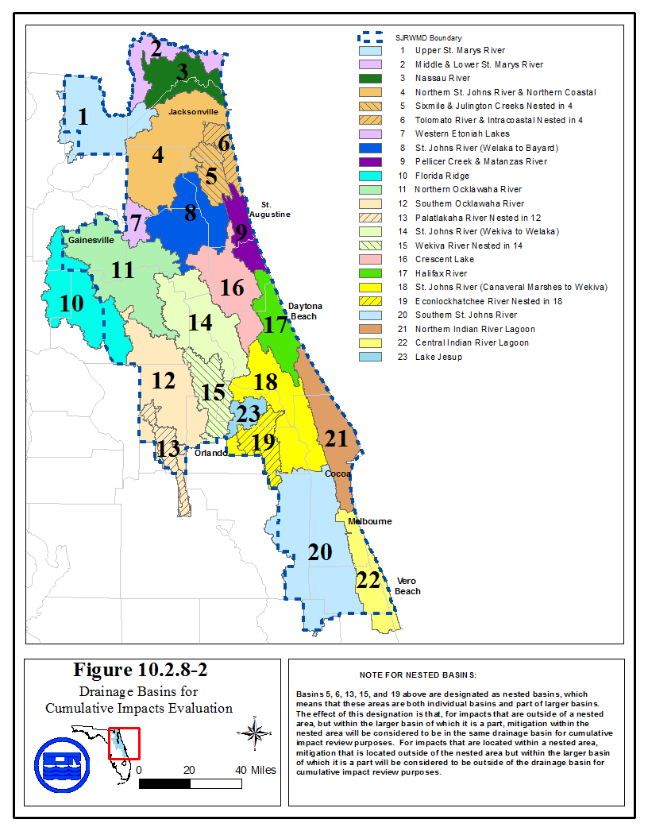
This figure constitutes Figure 10.2.8-2 in Applicant’s Handbook, Volume I (General and Environmental) effective 10-1-13

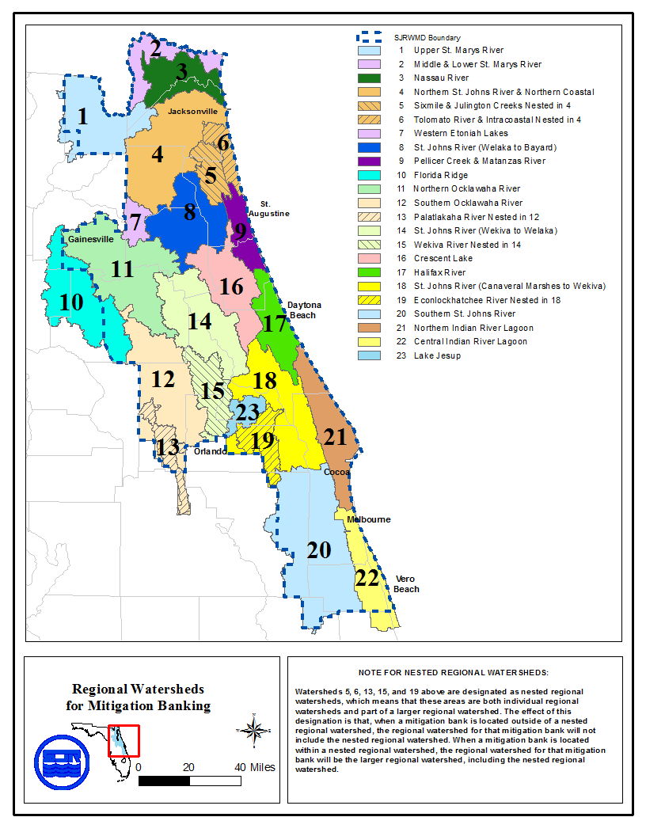
Revised 10/1/13

