Zero Tolerance Classroom Participant’s Manual
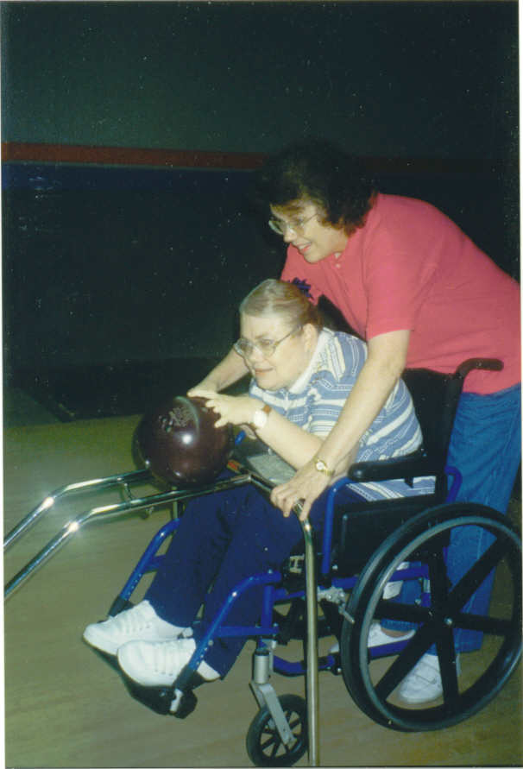

Effective Date: June 1, 2014; Incorporated by reference Rule: 65G-2.008.
Copyright:
© 2006 Agency For Persons With Disabilities. All rights reserved.
This document has been developed and produced by Davenport Design & Development, LLC for the Agency For Persons With Disabilities and all rights to the contents of this Manual are reserved. No part of this publication may be reproduced, transmitted, stored in a retrieval system, modified, or translated into any language or computer, in any form or by any means, electronic, mechanical, magnetic, optical, chemical, manual or otherwise, without express written permission of the Agency For Persons With Disabilities.

Contents
Module 1 – Training Overview 1
Purpose of Training 2
Course Learning Objectives 2
Audience and Length of Training 3
Participant’s Guide Organization 4
Instructional Icons 6
Module 2— Defining Abuse, Neglect, and Exploitation of Persons with Developmental Disabilities 7
Module Overview 7
Module Learning Objectives 7
Who is a Caregiver? 8
Caregiver Tasks 10
Caregiver Abuse – Differences in Definition for Children and Adults 11
Types of Caregiver Abuse, Neglect, or Exploitation 13
Activity: Identifying Types of Abuse, Neglect, or Exploitation 14
Laws Regarding Types of Abuse 15
New Law Regarding Sexual Misconduct
Excerpt of Florida Sexual Misconduct Statute 20
Activity 22
Module 3—Exploring the Issues 24
Module Overview 24
Module Learning Objectives 24
Desire for Power and Control 25
Common Case Characteristics 28
(Steinberg & Hylton, 1998) 28
Characteristics of Abuse 29
Incidence Studies 30
Frequency and Location of Sexual Abuse 31
Activity 33
Module 3 Summary 34
Module 4—Recognizing the Signs and Symptoms of Abuse, Neglect, and Exploitation 35
Module Overview 35
Module Learning Objectives 33
Physical Indicators of Abuse 37
Physical Indicators of Neglect 38
Behavioral Indicators 39
Behavioral Indicators of Caregiver Abuse 38
Characteristics Commonly Found in Abusive Caregivers Error! Bookmark not defined.
Profiles of Abusive Caregivers 42
Types of Emotional Abuse and Neglect 42
Physical Abuse as a Perversion of Caregiving 44
Frightening Physical Actions 45
Physical Signs of Abuse: Questionable Bruises 46
Other Physical Indicators of Abuse 47
Distinguishing Abuse from Accidental Injury 51
Behavioral Signs of Abuse 52
Signs and Symptoms of Exploitation 55
Activity 56
Factors That Make it Hard to Recognize Abuse, Neglect, and Exploitation 57
Conditions of People with Developmental Disabilities That Can Mimic Abuse 59
Activity 60
What might you suspect? 61
Summary 62
Module 5—Reporting Requirements 63
Module Overview 63
Module Learning Objectives 61
How to Report Abuse, Neglect, or Exploitation 64
Mandatory Abuse Reporting Requirements 64
Client on Client Abuse 67
Other Entities to be Notified 67
Information That May be Requested by the Florida Abuse Hotline 68
Investigating Possible Abuse 67
Barriers to Reporting 70
More Barriers to Reporting 71
Activity 72
Summary 73
Module 6—Prevention and Safety Planning 74
Module Overview 74
Module Learning Objectives 75
Prevention Methods 76
Prevention Efforts Agency Providers Can Implement with Their Employees 79
Tips For Staying Safe From Sexual Abuse 81
Additional Tips for Caregivers in Preventing Sexual Abuse 83
Here are some tips to make the discussion easier. 83
Recognize the person’s need to know 83
Set boundaries 83
Identify appropriate behavior in public and private 84
Teach children protective behaviors 84
Use appropriate names for genitals 84
Seek help when you need it 84
Appendix A: References and Resources 85

Appendix B: Final Assessment 84

Module 1 – Training Overview
A Day in the Life…


I am Kristen and I have a cognitive disability. I am nonverbal and live in a group home. Since I am the resident who has lived there the longest, I do not have a roommate. One of the house rules is lights out by 10:00 p.m. Most of the other residents are asleep by 10:30 p.m. On occasion, one of the staff members comes into my room around 11:30 p.m. and forces me to touch him sexually and he touches me sexually. He tells me he chose me because I am the prettiest and nicest resident, and that I am special and it is an honor to have him come into my room. He tells me that he is helping me experience sexual pleasure that I would not experience without him. However, to not hurt the other residents’ feelings, he tells me not to tell anyone. If I do, he says he will deny it all and come in the night and hurt me. What he says makes sense and I guess I should thank him, but I cannot figure out why I do not feel good about the situation. I wait in fear every night in the dark.
Courtesy of Disability Services ASAP (A Safety Awareness Program) of SafePlace, Austin, TX 2003

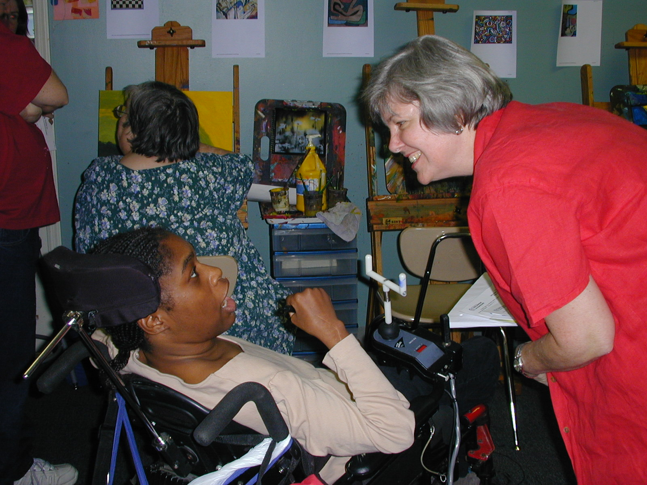
I am Shelia and I have cerebral palsy. I have some movement in my arms and cannot speak. My mother helps me get dressed every day. However, when she helps me out of bed in the morning, she pulls me by my arms with extreme force. She bathes me in HOT water and washes my hair with her nails to the point that it brings tears to my eyes every day. She also lets shampoo run into my eyes. At mealtime, she helps me eat, but she feeds me the same cold apricot baby food for every meal. She never really pays attention and stuffs too much in my mouth before I have a chance to swallow the last few bites, sometimes causing me to cough and choke. My mom scares me and I do not know what to say or whom to tell because she is my mom.
Courtesy of Disability Services ASAP (A Safety Awareness Program) of SafePlace, Austin, TX 2003

Purpose of Training
The purpose of the Zero Tolerance course is to teach direct care providers, support coordinators, and any person providing care or support to an APD client (on behalf of the Agency or its providers) about abuse, neglect and exploitation of persons with developmental disabilities. It will provide information about how often these types of crimes happen and also describe how and why these crimes usually occur. This training will provide you with the tools to identify potentially dangerous situations and tell you how to report that information. Finally, this course will provide you with information about things you can do to help prevent abuse, neglect, and exploitation from happening in the first place. | 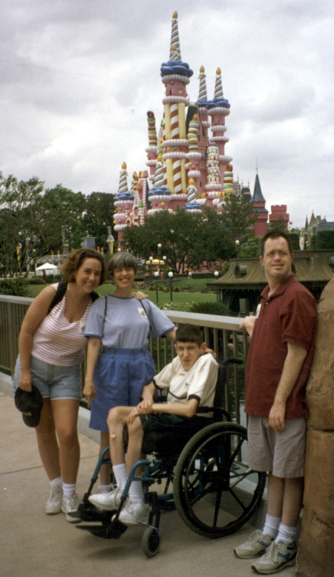

Course Learning Objectives
At the end of training, participants will be able to:
- Define caregiver.
- Define the five general types of caregiver abuse.
- Describe the reasons why people with developmental disabilities are more likely to be abused, neglected, or exploited.
- Explain how power and control contribute to caregiver abuse.
- List statistics related to the abuse, neglect, and exploitation of people with developmental disabilities.
- List who should report abuse, neglect, and exploitation.
- Describe strategies to apply when assessing a person for abuse, neglect, and exploitation.
- Explain issues to consider when assessing a person for abuse, neglect, and exploitation.
- List indicators of abuse, neglect, and exploitation.
- Explain how to report abuse, neglect, or exploitation.
- Explain procedures for investigating reported abuse.
- Describe methods which can be used to prevent, abuse, neglect, and exploitation.
- Describe how to create and maintain a safe living environment of people with developmental disabilities.

Audience and Length of Training
The Zero Tolerance course is intended for direct care providers and support coordinators.
The estimated completion time for this course is 4 hours. It consists of 6 lessons, including an introduction and a course summary.

Participant’s Guide Organization
The Zero Tolerance Participant’s Guide is organized into the following modules:

Module 1 | Training Overview  Timeframe: Approximately 15 minutes  Module Description: This module introduces the course (objectives, materials, and agenda), and discusses the main purposes for this class. It also introduces the course components and several key terms used throughout the course.
Module 2 | Defining Abuse, Neglect, and Exploitation of Persons with Developmental Disabilities  Timeframe: Approximately 1.5 hours  Module Description: In this section you’ll learn what actions can be defined as abuse, neglect and exploitation. You’ll also learn about some reasons why caregivers mistreat those in their care. Finally, you’ll learn about how the desire for power and control can contribute to such mistreatment.
Module 3 | Exploring the Issues  Timeframe: Approximately 45 minutes  Module Description: In this section you will learn about the trends and statistics associated with abuse, neglect, and exploitation of people with developmental disabilities.
Module 4 | Recognizing the Signs and Symptoms of Abuse, Neglect, and Exploitation  Timeframe: Approximately 2 hours  Module Description: In this section you will learn about various indicators of abuse, neglect, and exploitation, both in the caregiver and the person receiving care.

Module 5 | Reporting Requirements  Timeframe: Approximately 45 minutes  Module Description: The purpose of this section is to learn about how you should report abuse, neglect, and exploitation and what may happen next.

Module 6 | Prevention and Safety Planning  Timeframe: Approximately 45 minutes  Module Description: This section will identify a number of ways in which you can assist persons with developmental disabilities decrease the likelihood that they will ever have to experience abuse, neglect, and exploitation.

Instructional Icons
Throughout the Participant’s Guide, you will see instructional icons that complement the material presented as follows:

 | This icon represents an additional Note for information presented, such as an exception or something to keep in mind.
 | This icon represents something Important for you to remember or be aware of related to your job.
 | This icon is used to present the Order or a Step-by-Step process related to your job. It is also used to number components in a graphic image.

Module 2— Defining Abuse, Neglect, and Exploitation of Persons with Developmental Disabilities

Module Overview
In this section you’ll learn what actions are considered abuse, neglect, and exploitation. You’ll also learn about some reasons why caregivers may commit such acts against people with developmental disabilities. Finally, you’ll learn about how the need for power and control can lead to those situations.

Module Learning Objectives
At the compltion of this section, you will be able to:
- Define caregiver.
- Define the five general types of caregiver abuse.
- Explain how power and control contribute to caregiver abuse.

Who is a Caregiver?
Take a few minutes and write down types of people who might provide care to persons with developmental disabilities.

What are some of the personal care tasks that caregivers might provide?

Caregivers might be paid personal assistants, or they might be people who provide care for no pay. Unpaid caregivers might be:
- Family members such as a parent, spouse, sibling, or child
- Close friends
- Volunteers
- Neighbors

Still others who might be paid and are involved in an individual’s care include:
- Support coordinators
- Homemakers
- Drivers
- Doctors
- Nurses
- Teachers/ teacher’s aides
- Social workers
- Psychiatrists
- Therapists
- Counselors
- Job coaches
- Sign language interpreters
- Workers in hospitals and other institutions
- Companion Services Providers

Caregiver Tasks
Caregivers are people who provide assistance with personal care tasks that include:
- Bathing
- Dressing
- Toileting
- Transferring (moving from one place to another, such as a couch to a chair)
- Eating
- Taking prescribed or over-the-counter medications or vitamins
- Cooking
- Cleaning
- Running errands
- Paying bills
- Providing transportation

Caregiver Abuse – Differences in Definition for Children and Adults
Florida law defines a “caregiver” in two different ways. One definition applies to caregivers of adults with developmental disabilities (who are referred to as “vulnerable adults” in Florida law). The other definition of “caregiver” applies to those individuals who are responsible for caring for children.

Children | Florida Statute Section 39.01(10) and 39.01(47) state:  10) "CAREGIVER" means the parent, legal custodian, permanent guardian, adult household member, or other person responsible for a child's welfare as defined in subsection (47).  47) “Other person responsible for a child’s welfare” includes the child’s legal guardian or foster parent; an employee of any school, public or private child day care center, residential home, institution, facility, or agency; a law enforcement officer employed in any facility, service, or program for children that is operated or contracted by the Department of Juvenile Justice; or any other person legally responsible for the child’s welfare in a residential setting; and also includes an adult sitter or relative entrusted with a child’s care. For the purpose of departmental investigative jurisdiction, this definition does not include the following persons when they are acting in an official capacity: law enforcement officers, except as otherwise provided in this subsection; employees of municipal or county detention facilities; or employees of the Department of Corrections.
Adults | For adults with developmental disabilities, Florida Statute Section 415.102(4) states:  (4) "CAREGIVER" means a person who has been entrusted with or has assumed the responsibility for frequent and regular care of or services to a vulnerable adult on a temporary or permanent basis and who has a commitment, agreement, or understanding with that person or that person's guardian that a caregiver role exists. "CAREGIVER" includes, but is not limited to, relatives, household members, guardians, neighbors, and employees and volunteers of facilities as defined in subsection (9). For the purpose of departmental investigative jurisdiction, the term "CAREGIVER" does not include law enforcement officers or employees of municipal or county detention facilities or the Department of Corrections while acting in an official capacity.

Types of Caregiver Abuse, Neglect, or Exploitation

Caregiver abuse is the exertion of the caregiver’s will over the person with a disability. Caregiver abuse usually falls into one of five categories. When abuse is present, these categories of abuse frequently overlap.

 | Physical – hitting, pushing, hair pulling, kicking, biting, assault, inappropriate handling, overuse of restraints, over-medicating, inappropriate behavior modification, keeping the person awake, forcing the person to eat or take medications or beverages, attempted murder.
 | Sexual – verbal harassment; unwanted sexual touching of private parts; forced abortion, sterilization or pregnancy; unwanted display of sexual parts (pornography, exhibitionism); tricking or manipulating into sexual activity; sexual assault; rape.
 | Emotional and/or Verbal – verbal abuse focused on impairment; denial of right to make decisions; threats to harm individual, pet(s) or service animal(s), family or children; humiliation; isolating the person from friends and family; emotional neglect; name calling.
 | Financial/Exploitation – denial of access to or control of funds; misusing financial resources; stealing money and personal belongings.
 | Neglect – denial of food, clothing, shelter or transportation; not working assigned hours or not performing duties; mistreating or refusing to feed pet(s) or service animal(s); withholding medications, food, medically necessary treatment, assistive equipment or personal/medical care; leaving individuals alone without a way to call for help; leaving individuals in bed all day or not getting them dressed; leaving individuals in a car by themselves while the caregiver shops; leaving individuals on the toilet or in soiled undergarments for long periods of time.  Self-Neglect: Chapter 415 of Florida Statutes was recently changed to include a category under Neglect called “self-neglect.” Besides possibly being neglected by a caregiver, the potential exists for people to neglect themselves because of either their age or disability. The Florida Abuse Hotline receives thousands of calls each year that deal with issues involving self-neglect. Anyone who knows or suspects that an adult with a developmental disability is the victim of self-neglect must report such information (as described within Section 5). Reporting cases of self-neglect allows the Department of Children and Families to provide voluntary services or petition a court for involuntary non-emergency services and protective supervision when an investigation determines that an adult with a developmental disability is neglecting himself or herself. Any type of behavior (such as having sex with multiple partners or not taking prescription medications) that could result in that person being abused, neglected, or exploited by others or reasonably be expected to result in serious physical or psychological injury or a substantial risk of death can and should be reported to the Abuse Hotline. DCF will investigate the circumstances of each case in order to determine if self-neglect is present and subsequent services are necessary.

Activity: Identifying Types of Abuse, Neglect, or Exploitation

Choose from:
A. Physical
B. Sexual
C. Emotional and/or verbal
D. Financial/Exploitation
E. Neglect/self-neglect

1.

2.

3.

4.

5.

Laws Regarding Types of Abuse
Not only is Florida law separated into types of abuse, but it is further categorized to distinguish between issues such as abandonment, abuse, and neglect of children, and exploitation, abuse, and neglect of adults with developmental disabilities.

Child Abandonment
From Chapter 39.01(1):
“Abandoned” or “abandonment” means a situation in which the parent or legal custodian of a child or, in the absence of a parent or legal custodian, the caregiver, while being able, has made no significant contribution to the child’s care and maintenance or has failed to establish or maintain a substantial and positive relationship with the child, or both. For purposes of this subsection, “establish or maintain a substantial and positive relationship” includes, but is not limited to, frequent and regular contact with the child through frequent and regular visitation or frequent and regular communication to or with the child, and the exercise of parental rights and responsibilities. Marginal efforts and incidental or token visits or communications are not sufficient to establish or maintain a substantial and positive relationship with a child. The term does not include a surrendered newborn infant as described in s. 383.50, a “child in need of services” as defined in chapter 984, or a “family in need of services” as defined in chapter 984. The incarceration, repeated incarceration, or extended incarceration of a parent, legal custodian, or caregiver responsible for a child’s welfare may support a finding of abandonment.

Child Abuse
From 39.01(2):
“Abuse” means any willful act or threatened act that results in any physical, mental, or sexual abuse, injury, or harm that causes or is likely to cause the child’s physical, mental, or emotional health to be significantly impaired. Abuse of a child includes acts or omissions. Corporal discipline of a child by a parent or legal custodian for disciplinary purposes does not in itself constitute abuse when it does not result in harm to the child.

Child Neglect
From 39.01(44):
"Neglect" occurs when a child is deprived of, or is allowed to be deprived of, necessary food, clothing, shelter, or medical treatment or a child is permitted to live in an environment when such deprivation or environment causes the child's physical, mental, or emotional health to be significantly impaired or to be in danger of being significantly impaired. The foregoing circumstances shall not be considered neglect if caused primarily by financial inability unless actual services for relief have been offered to and rejected by such person. A parent or legal custodian legitimately practicing religious beliefs in accordance with a recognized church or religious organization who thereby does not provide specific medical treatment for a child may not, for that reason alone, be considered a negligent parent or legal custodian; however, such an exception does not preclude a court from ordering the following services to be provided, when the health of the child so requires:
    - Medical services from a licensed physician, dentist, optometrist, podiatric physician, or other qualified health care provider; or
    - Treatment by a duly accredited practitioner who relies solely on spiritual means for healing in accordance with the tenets and practices of a well-recognized church or religious organization.
Neglect of a child includes acts or omissions.

Exploitation of an Adult with a Developmental Disability
From F.S. 415.102 (8):
"Exploitation" means a person who:
1. Stands in a position of trust and confidence with a vulnerable adult and knowingly, by deception or intimidation, obtains or uses, or endeavors to obtain or use, a vulnerable adult's funds, assets, or property with the intent to temporarily or permanently deprive a vulnerable adult of the use, benefit, or possession of the funds, assets, or property for the benefit of someone other than the vulnerable adult; or
2. Knows or should know that the vulnerable adult lacks the capacity to consent, and obtains or uses, or endeavors to obtain or use, the vulnerable adult's funds, assets, or property with the intent to temporarily or permanently deprive the vulnerable adult of the use, benefit, or possession of the funds, assets, or property for the benefit of someone other than the vulnerable adult.
(b) "Exploitation" may include, but is not limited to:
- Breaches of fiduciary relationships, such as the misuse of a power of attorney or the abuse of guardianship duties, resulting in the unauthorized appropriation, sale, or transfer of property;
  - Unauthorized taking of personal assets;
  - Misappropriation, misuse, or transfer of moneys belonging to a vulnerable adult from a personal or joint account; or
  - Intentional or negligent failure to effectively use a vulnerable adult's income and assets for the necessities required for that person's support and maintenance.

Abuse of an Adult with a Developmental Disability
From 415.102(1)
"Abuse" means any willful act or threatened act by a relative, caregiver, or household member which causes or is likely to cause significant impairment to a vulnerable adult's physical, mental, or emotional health. Abuse includes acts and omissions.

 | Neglect of an Adult with a Developmental Disability  From 415.102(16)  "Neglect" means the failure or omission on the part of the caregiver or vulnerable adult to provide the care, supervision, and services necessary to maintain the physical and mental health of the vulnerable adult, including, but not limited to, food, clothing, medicine, shelter, supervision, and medical services, which a prudent person would consider essential for the well-being of a vulnerable adult. The term "neglect" also means the failure of a caregiver or vulnerable adult to make a reasonable effort to protect a vulnerable adult from abuse, neglect, or exploitation by others. "Neglect" is repeated conduct or a single incident of carelessness which produces or could reasonably be expected to result in serious physical or psychological injury or a substantial risk of death.
Aggravated Abuse and Neglect of an Elderly Person or Disabled Adult

From 825.102
(1) “Abuse of an elderly person or disabled adult” means:
(a) Intentional infliction of physical or psychological injury upon an elderly person or disabled adult;
(b) An intentional act that could reasonably be expected to result in physical or psychological injury to an elderly person or disabled adult; or
(c) Active encouragement of any person to commit an act that results or could reasonably be expected to result in physical or psychological injury to an elderly person or disabled adult.
A person who knowingly or willfully abuses an elderly person or disabled adult without causing great bodily harm, permanent disability, or permanent disfigurement to the elderly person or disabled adult commits a felony of the third degree, punishable as provided in s. 775.082, s. 775.083, or s. 775.084.

(2) “Aggravated abuse of an elderly person or disabled adult” occurs when a person:
(a) Commits aggravated battery on an elderly person or disabled adult;
(b) Willfully tortures, maliciously punishes, or willfully and unlawfully cages, an elderly person or disabled adult; or
(c) Knowingly or willfully abuses an elderly person or disabled adult and in so doing causes great bodily harm, permanent disability, or permanent disfigurement to the elderly person or disabled adult.
A person who commits aggravated abuse of an elderly person or disabled adult commits a felony of the first degree, punishable as provided in s. 775.082, s. 775.083, or s. 775.084.

(3)(a) “Neglect of an elderly person or disabled adult” means:
1. A caregiver’s failure or omission to provide an elderly person or disabled adult with the care, supervision, and services necessary to maintain the elderly person’s or disabled adult’s physical and mental health, including, but not limited to, food, nutrition, clothing, shelter, supervision, medicine, and medical services that a prudent person would consider essential for the well-being of the elderly person or disabled adult; or
2. A caregiver’s failure to make a reasonable effort to protect an elderly person or disabled adult from abuse, neglect, or exploitation by another person.
Neglect of an elderly person or disabled adult may be based on repeated conduct or on a single incident or omission that results in, or could reasonably be expected to result in, serious physical or psychological injury, or a substantial risk of death, to an elderly person or disabled adult.

(b) A person who willfully or by culpable negligence neglects an elderly person or disabled adult and in so doing causes great bodily harm, permanent disability, or permanent disfigurement to the elderly person or disabled adult commits a felony of the second degree, punishable as provided in s. 775.082, s. 775.083, or s. 775.084.
(c) A person who willfully or by culpable negligence neglects an elderly person or disabled adult without causing great bodily harm, permanent disability, or permanent disfigurement to the elderly person or disabled adult commits a felony of the third degree, punishable as provided in s. 775.082, s. 775.083, or s. 775.084.
A New Law Regarding Sexual Misconduct by Service Providers

Sexual activity between a direct service provider and a person with a developmental disability (to whom he or she is rendering services) was made a crime in 2004 and is referred to in state law as “sexual misconduct”. Keep in mind that sexual misconduct is still considered a crime even if consent was first obtained from the victim.

The Sexual Misconduct Law does the following things:
- Creates a new crime called “sexual misconduct” which is defined as any sexual activity between a service provider and certain individuals with a developmental disabilities
- Makes the crime of sexual misconduct punishable as a second degree felony
- Makes failure to report known or suspected cases of sexual misconduct a first degree misdemeanor
- Eliminates consent by the consumer as a valid defense against prosecution for this crime
- Expands Level 1 and 2 background screening requirements to include the newly-created crime of sexual misconduct as a disqualifying offense for employment



Excerpt of the Florida Sexual Misconduct Law
Following is the text taken from F. S. 393.135:
Sexual misconduct prohibited; reporting required; penalties.
(1) As used in this section, the term:
(a) "Covered person" includes any employee, paid staff member, volunteer, or intern of the agency; any person under contract with the agency; and any person providing care or support to a client on behalf of the agency or its providers.
(b) "Sexual activity" means: 1. Fondling the genital area, groin, inner thighs, buttocks, or breasts of a person. 2. The oral, anal, or vaginal penetration by or union with the sexual organ of another or the anal or vaginal penetration of another by any other object. 3. Intentionally touching in a lewd or lascivious manner the breasts, genitals, the genital area, or buttocks, or the clothing covering them, of a person, or forcing or enticing a person to touch the perpetrator. 4. Intentionally masturbating in the presence of another person. 5. Intentionally exposing the genitals in a lewd or lascivious manner in the presence of another person. 6. Intentionally committing any other sexual act that does not involve actual physical or sexual contact with the victim, including, but not limited to, sadomasochistic abuse, sexual bestiality, or the simulation of any act involving sexual activity in the presence of a victim.
(c) "Sexual misconduct" means any sexual activity between a covered person and a client to whom a covered person renders services, care, or support on behalf of the agency or its providers, or between a covered person and another client who lives in the same home as the client to whom a covered person is rendering the services, care, or support, regardless of the consent of the client. The term does not include an act done for a bona fide medical purpose or an internal search conducted in the lawful performance of duty by a covered person.
(2) A covered person who engages in sexual misconduct with an individual with a developmental disability who: (a) Resides in a residential facility, including any comprehensive transitional education program, developmental disabilities institution, foster care facility, group home facility, intermediate care facility for the developmentally disabled, or residential habilitation center; or (b) Is eligible to receive services from the agency under this chapter, commits a felony of the second degree, punishable as provided in s. 775.082, s. 775.083, or s. 775.084. A covered person may be found guilty of violating this subsection without having committed the crime of sexual battery.
(3) The consent of the client to sexual activity is not a defense to prosecution under this section.
(4) This section does not apply to a covered person who is legally married to the client.
(5) A covered person who witnesses sexual misconduct, or who otherwise knows or has reasonable cause to suspect that a person has engaged in sexual misconduct, shall immediately report the incident to the central abuse hotline of the Department of Children and Family Services and to the appropriate local law enforcement agency. The covered person shall also prepare, date, and sign an independent report that specifically describes the nature of the sexual misconduct, the location and time of the incident, and the persons involved. The covered person shall deliver the report to the supervisor or program director, who is responsible for providing copies to the agency's local office and the agency's inspector general.

Activity
Work with your group to make up three situations that show a person with a developmental disability where one or more of the laws we’ve just studied will need to be reviewed to see if the caregiver has broken them. Your presentation should include four different scenarios where a person with a developmental disability is being neglected, abused, exploited, and/or is the victim of sexual misconduct.

Potential Example of Abuse (of a Child or Adult with a Developmental Disability):

Potential Example of Neglect: (of a Child or Adult with a Developmental Disability):

Potential Example of Sexual Misconduct:

Potential Example of Financial Exploitation:

Before moving on, you may want to review the module contents since the following module will build on what you’ve learned so far.

Module 3—Exploring the Issues

Module Overview
In this section you will learn about how and why people with developmental disabilities typically experience abuse, neglect, and exploitation. | 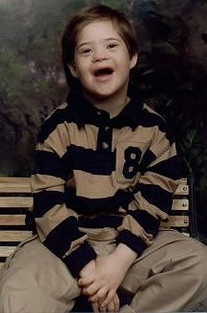

Module Learning Objectives
At the end of this secttion, you will be able to:
- Explain how the need for power and control can lead some caregivers to commit these crimes against people with developmental disabilities
- List statistics related to the abuse, neglect, and exploitation of people with developmental disabilities.

Desire for Power and Control

What happens inside a person to make them abuse someone with a developmental disability? Whatever the reasons, there is no excuse for abuse and those caregivers who abuse others must be held accountable for their actions. Understanding caregiver abuse is the first step toward preventing it from happening in the future.

On the next page is the Power and Control Wheel. It is intended to help people who are living with violence understand the dynamics of an abusive relationship.

Activity: Power and Control
Use this space as needed to develop your scenarios.
Common Case Characteristics

A number of common things have been identified among people with developmental disabilities who have been abused neglected, or exploited. For example, people with developmental disabilities are more likely to experience:
- Multiple forms of abuse, neglect, and exploitation
- Multiple perpetrators
- Abuse, neglect, and exploitation which lasts for long periods of time
- Inadequate or inappropriate healthcare
- Multiple contacts with health care providers and other professionals who:
- Fail to recognize or respond to abuse, neglect, or exploitation
- Ignore, misunderstand, or misinterpret signs and symptoms of abuse, neglect, and exploitation
- Inappropriate use or misuse of prescribed treatments and medications
- Misleading caregiver behaviors and statements
- Use of the disability to explain away or minimize the person’s condition
- Being blamed for injuries or conditions
- A lack of concern from professionals and others because of empathy for caregivers’ responsibilities
- Rejection of their reports of abuse, neglect, and exploitation by authority figures

(Steinberg & Hylton, 1998)

Characteristics of Abuse

People with developmental disabilities are:
- Abused more frequently than others
- Abused more severely and for longer periods of time than people without disabilities
- Less able to escape the abuse, find justice or services
- More likely to remain in situations that increase their vulnerability and risk of repeated abuse
- Caught up in a cycle of abuse that repeats itself



Incidence Studies
Only between 3% and 20%...of sexual abuse cases involving people with developmental disabilities are actually reported.

However, one study estimated that 90% of people with developmental disabilities will experience sexual abuse at some point in their lives.

A study of over 50,000 school children in Nebraska (Sullivan and Knutson Study, 2000) found that children who were identified by their schools as requiring special education services were 3.4 times as likely to be maltreated as children who did not need special services.

15,000 to 90,000 people… with developmental disabilities are raped each year in the U.S. Women with developmental disabilities are raped and sexually abused at a rate at least twice that of the general population of women.

Here are more statistics:

- 15.2% of children who were found to be sexually abused had disabilities (Crosse, Kaye, & Ratnofsky, 1993)
- 61% of girls and 25% of boys with disabilities have been found to be sexually abused before the age of 18 (McArthy and Thompson, 1997)
- Among deaf children, 54% of boys and 50% of girls have been sexually abused. Studies of deaf children in residential schools found that between 50-75% of these children had experienced sexual abuse (Sullivan, Vernon, & Scanlan, 1987)
- 40% of women with physical disabilities reported being sexually assaulted (Roeher Institute, 1995)
- 38% of women with developmental disabilities who have been married experienced sexual violence by their partners (Roeher Institute, 1995)
- Males with developmental disabilities are twice as likely as males without developmental disabilities to be sexually abused in their lifetimes (Roeher Institute, 1995)
- People with mental retardation have been found to be especially vulnerable to sexual abuse. Between 25-85% of people with mental retardation have been victims of sexual abuse. (Morano, 2001)

Frequency and Location of Sexual Abuse

Below are the statistics related to the frequency and location of sexual abuse occurrences among persons with developmental disabilities.

Frequency of Sexual Abuse
19%
17%
64%
1
2
3
1 time
2-10 times
10+ times

Where sexual abuse occurs

Activity
Directions: Enter the correct answer beside each statement.

___ 1. As many as ___ of people with developmental disabilities will experience sexual abuse at some point in their lives.  ___ 2. Women with developmental disabilities are raped and sexually abused at a rate at least _____ that of the general population of women.  ___ 3. _________ children experience a high rate of abuse: 54% for boys and 50% for girls.  ___ 4. Thirty-eight percent of women with developmental disabilities who have been married experienced sexual violence by their __________.  ___ 5. Between 25-85% of people with ________ have been victims of sexual abuse.  ___ 6. The great majority of people with developmental disabilities (64%) have been abused ____ or more times.  ___ 7. Only 19% of people with developmental disabilities have been abused _____ time.  ___ 8. Sixty-one percent of people with developmental disabilities report being sexually abused in a _______. | A. Deaf  B. One  C. Mental retardation  D. Partners  E. Private home  F. Twice  G. 90%  H. Ten

Module 3 Summary
In this section you’ve learned how and why people with developmental disabilities are at a higher risk for experiencing abuse, neglect, and exploitation.

In the next section you’ll find out how to identify indicators of possible abuse, neglect, or exploitation.

Module 4—Recognizing the Signs and Symptoms of Abuse, Neglect, and Exploitation

Module Overview and Learning Objectives
In this section you will learn how to recognize the warning signs that a person with a developmental disability may be the victim of abuse, neglect, or exploitation.  At the end of this section, you will be able to:  - Describe how to tell if someone has been abused, neglected, or exploited.  - Talk about issues to think about when considering whether or not somone has been abused, neglected, or exploited.  - List the common signs and symptoms of abuse, neglect, and exploitation. | 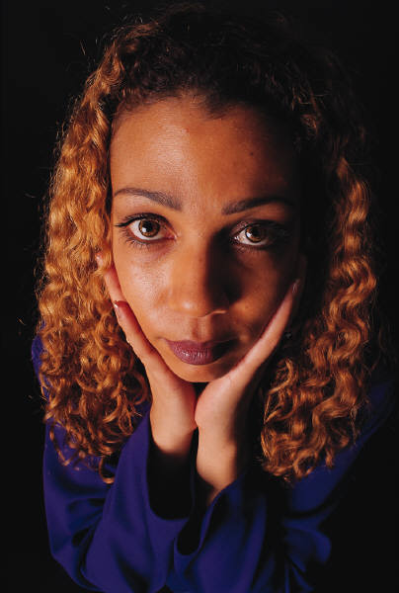
Signs of Abuse and Neglect
As you work with someone with a developmental disability, you should pay close attention to any changes in how that person looks or acts. Sudden or gradual changes in appearance or behavior may be signs that abuse or neglect has occurred ( or may still be happening).A Sudden or gradual change in appearance or behavior can be an indicator that abuse or neglect has occurred (or may still be happening).

Physical Signs of Abuse
- Bruises
- Burns
- Cuts
- Lacerations
- Broken bones
- Sprains
- Abrasions or scrapes
- Vaginal or rectal pain
- Bleeding from the ears, nose or mouth
- Frequent urinary tract infections or yeast infections
- Painful urination
- Abrasions, bleeding, or bruising in the genital area
- Incontinence in someone who was previously toilet-trained
- Frequent sore throats
- Sudden onset of psychosomatic complaints (males most frequently complain of stomach aches while females most frequently report headaches)
- Sudden difficulty walking or sitting

Physical Signs of Neglect
- Bedsores
- Dehydration
- Poor or improper hygiene
- Malnourishment/weight loss
- Lack of necessary adaptive aids such as glasses, hearing aids, leg braces walkers etc. or improper medication management

Behavioral Signs

- CHANGES in the way affection is shown, especially if unusual or inappropriate
- Suddenly fears being touched
- Sudden onset of nightmares
- CHANGES in sleep patterns; difficulty sleeping
- Sudden regression to childlike behaviors (i.e., bed-wetting, thumb-sucking)
- Sudden unusual interest in or knowledge of sexual matters (including excessive masturbation)
- Cruelty to animals
- Sudden fear of bathing or toileting
- Sudden fear of a person or place
- Depression, withdrawal, or mood swings
- ANY UNEXPLAINED CHANGE IN BEHAVIOR

Behaviors of Caregivers who may be Abusers

If you work with other caregivers, you should always be on the lookout for certain behaviors that may be indicators that this person is an abuser. Caregiver behaviors to look for include:
- Refusal to follow directions or complete necessary personal tasks
- Displaying controlling attitudes and behaviors
- Showing up late or not at all
- Working under the influence of alcohol or illegal drugs
- Abusing or harming pets or service animals
- Using threats or menacing looks/body language as a form of intimidation
- Impulsive
- Using vehicle, money or other resources without consent
- Socially isolating person with a disability (including limiting educational and/or employment opportunities)
- Devalues the person with developmental disabilities
- Frequently switches health care providers
- Speaks for the person with developmental disabilities
- Competes with the person with developmental disabilities
- Displays unwelcoming or uncooperative attitude during home visits
- Frequently makes attempts to be alone with a particular individual for no apparent legitimate purpose

Profiles of Abusive Caregivers
Caregivers who abuse, neglect, or exploit people with developmental disabilities are either UNABLE or UNWILLING to provide care to these individuals in an appropriate way. It is very important to understand what is going on with these types of caregivers because that will help us develop and implement prevention strategies (which we will talk about later on in this training).
Caregivers who UNABLE to provide care appropriately may include individuals who are not properly trained or have the necessary experience to perform their caregiving duties. They may have mental retardation or mental illness themselves. Perhaps they are physically unable to provide care to a person with the developmental disability due to their own medical or health condition. Caregivers who are UNABLE to provide appropriate care may also be overly stressed or overly tired. They may also be working under the influence of drugs or alcohol which limits their abilities.
Caregivers who are UNWILLING to provide care appropriately are more likely to know what they are doing is wrong yet continue to act in that way. Research shows that these individuals will abuse, neglect, or exploit individuals with developmental disabilities over and over again as long as they are given the opportunity to do so. Some of these caregivers may not view their victims as actual people (with feelings and emotions). In other cases, caregivers who are UNWILLING to provide appropriate care see people with developmental disabilities as the perfect victims who, as we will talk about later, may not be able to defend themselves or tell anyone what has happened.

Abusive caregivers may also have:
- Low self-esteem
- Need to control others
- Frustration with authority, which can lead to displaced aggression toward weaker persons
- History of being abused or neglected as a child
- Lack of attachment to the person with the developmental disability ( which can lead to thoughts by the abuser that the person with the developmental disability is not fully human and therefore doesn’t feel or hurt in response to their abusive actions)Types of Emotional Abuse and Neglect

Emotional abuse is the most difficult form of abuse to identify. Even though emotional abuse often happens along with other forms of abuse, it can also occur by itself.

Caregivers who have power and influence over others’ lives can use that power to harm or exploit, rather than to support and nurture. This can be especially devastating for children in their developmental years, but it can be harmful for anyone.

Verbal and emotional abuse can take the form of threats, insults harassment, and less noticeable forms that are difficult to detect. These can be perpetrated by individuals or by representatives of caregiving systems. Here are some of the most common types of emotional abuse and neglect:
- Exposure to domestic violence
- Insults and harassment
- Denial of conditions necessary for physical and emotional well-being
- Denial of communication
- Denial of right to family life
- Denial of social interaction and inclusion
- Denial of economic stability
- Denial of rights, necessities, privileges, and opportunities
- Denial of ordinary freedoms

Physical Abuse in Caregiving
Sometimes abuse of persons with developmental disabilities takes the form of acts that could be thought of as well-intentioned but unsuccessful attempts by the caregiver to ensure the person’s well-being.

In other cases, the abuse is deliberate, and is disguised as caregiving. Here are a few examples of that type of abuse:
- Rough physical handling
- Sudden movements of bedding
- Pushing and pulling
- Over-medication
- Unnecessary or excessive use of restraints
- Ignoring dietary restrictions
- Toileting abuse (leaving someone on the toilet too long or not taking them to the bathroom when they need to use it)
- Bathing in water that is too hot or too cold



Frightening Physical Actions
Using frightening physical actions that stop short of causing serious physical harm is another form of physical abuse that is too often used by abusive caregivers of people with developmental disabilities. Consider how these actions might affect a person with developmental disabilities:
- Grabbing persons with visual impairments from behind
- Jumping in front of persons with visual impairments, or trying to trip them
- Abruptly moving persons with mobility impairments
- Forcing persons with physical disabilities to move from one position to another when they are exhausted or in pain

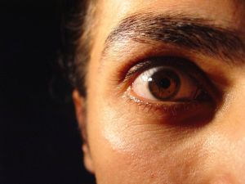

Physical Signs of Abuse: Questionable Bruises
Bruises are among the most common injuries found in children and adults with developmental disabilities who have been abused.

It is important to remember that occasional bruising is also common in people who are not abused, and that people with some disabilities may be prone to bruising for other reasons. Here are some of the more common bruises that may indicate signs of abuse:
- Facial
- Frequent, unexplained, or inadequately explained
- In unlikely places
- In various stages of healing
- On several different surface areas
- Patterned, reflecting shapes
- Bilateral: means bruises on same places on both sides of the body. Bruises would appear on both upper arms, for example, may indicate where the abuser applied pressure while forcefully shaking the person. Bruises on both sides of the body rarely result from accidental causes.
- Regularly evident after an absence, home visit, or vacation

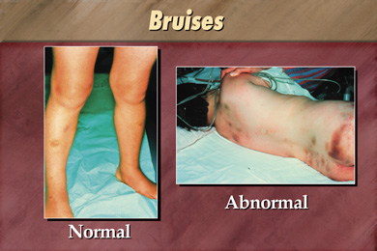

Other Physical Indicators
The following are some other physical indicators of abuse or neglect of persons with developmental disabilities. In each case, other indicators such as behavior and circumstances must be considered.

Questionable cuts and scrapes
Consider:
- Frequent, repetitive, unexplained, or inadequately explained scrapes
- Atypical locations such as mouth, lips, gums, eyes, external genitalia (e.g., places other than palms, knees, or other areas usually covered by clothing)
- Patterned scarring that may be due to inflicted injuries such as whipping

Burns or scalds
Consider:
- Patterned burns(e.g., shaped like a cigarette butt or electrical appliance)
- Burns in specific locations such as several burns on different parts of the body or on particularly sensitive locations, such as soles, palms, back, or buttocks
- Immersion burns, which appear sock-like, glove-like, or doughnut-shaped on buttocks, genitalia, or limbs
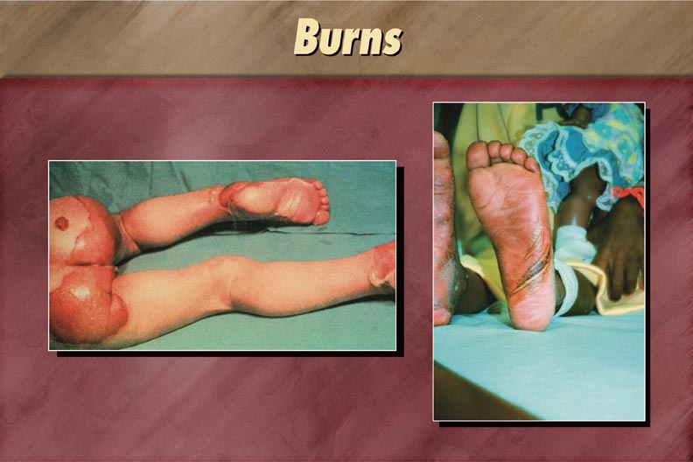

Bites
Consider:
- Human bite marks are easily distinguished from those of animals by their size and shape, and whether flesh is torn.
- If bites are explained as self-inflicted, the location and position of the bite must be consistent with the person’s functional abilities.
Ligature marks and welts (which could have come from being tied up or gagged)
- Could be the result of whipping
- Welts often follow clearly defined stroke patterns, especially if the person was immobile during the whipping
- Chafing and bruising, sometimes accompanied by swelling, on the wrists, ankles, throat, or penis can be the result of being tied up or choked
- Even when choking is severe or fatal, bruising may be faint or entirely absent
Eye and ear injuries
- Sudden or unexplained hearing loss
- Cauliflower ears (i.e., thickened external ear structures)
- Bruising to the outer ears
- Blood behind the eardrum
- Retina hemorrhage or other intraocular bleeding
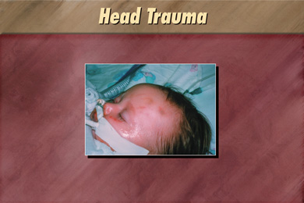

Dental and mouth injuries
- Lost or broken teeth, particularly if unrelated to dental disease, normal loss of children’s teeth, or accidental causes
- Repeated, unexplained, or inadequately explained dental injuries
- Facial bone or jaw fractures
- Bruising of cheeks and gums at corners of mouth (from gags)
- Cuts or bruises on the tongue
- Discoloration of the teeth as a result of previous abuse
Dislocations of joints
- Repeated dislocations of joints in the absence of a known disease process may indicate shaking, twisting, or pulling
- Frequent or multiple dislocations in the absence of a clear explanation may indicate physical abuse
Fractures:
- Repeated or multiple fractures in the absence of a known disease process or clear explanation may indicate abuse
- Old, untreated fractures can indicate chronic abuse
- Spiral fractures that result from twisting limbs may be related to abuse in non-ambulatory children and adults with developmental disabilities

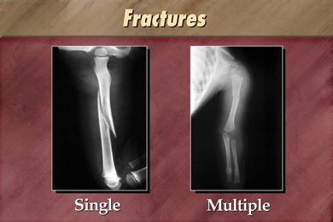

Coma:
Shaking and other forms of abuse can result in coma of undetermined origin without external injuries. Comas not associated with known accidental causes or clearly identified disease processes should also be suspected.
- Distinguishing Abuse from Accidental Injury

Accidents happen with everyone, including people with developmental disabilities. The following is a guide to help you tell the difference between accidental and non-accidental injuries. When observing an injury that might be the result of abuse, consider these factors:
Location of the injury:
Certain locations on the body are more likely to sustain accidental injury. These include the knees, elbows, shins, and forehead.
Protected body parts and soft tissue areas, such as the back, thighs, genital area, buttocks, back of legs, or face, are less likely to accidentally come into contact with objects that could cause injury.

Number and frequency of injuries:
The greater the number of injuries, the greater the cause for concern. Unless the person is involved in a serious automobile accident, he/she is not likely to sustain a number of different injuries accidentally. Multiple injuries in different stages of healing are also a strong indicator of chronic abuse.

Size and shape of the injury:
Many non-accidental injuries are inflicted with familiar objects: a stick, a board, a belt, a hair brush. The marks which result bear a strong resemblance to the objects used. Accidental marks resulting from bumps and falls usually have no defined shape.

Description of how the injury occurred:
If an injury is accidental, there should be a reasonable explanation of how it happened that is consistent with the appearance of the injury. When the description of how the injury occurred and the appearance of the injury are inconsistent, there is cause for concern. For example, it is not likely that a person’s fall from a wheelchair onto a rug would produce bruises all over the body.

Consistency of injury with the person’s developmental capability:
As children grow and gain new skills, their ability to engage in activities that can cause injury increases. A toddler trying to run is likely to suffer bruised knees and a bump on the head. Toddlers are less likely to suffer a broken arm than an eight-year-old who has discovered the joy of climbing trees.

Behavioral Signs of Abuse
Behavioral signs can be extremely important in detecting abuse and neglect, especially in people who have communication challenges and are unable to tell anyone about what happened to them. In many cases, physical signs of abuse may not yet be present or noticed so behavioral signs are often the first indicators. Usually it is a combination of physical and behavioral changes that are seen in people that have been abused. Here are some of the behavioral signs of possible abuse:

Aggressive behavior
- Is widespread among victims of abuse
- May imitate the aggression committed against the abused person (e.g., the child who is whipped may whip smaller children)
- May generalize to other forms of aggression, such as yelling or hitting others
- May be exhibited through excessively violent drawings, stories, or play

Atypical attachment
Consider:
- Children who have been abused often appear insecure with strangers, and compulsively seek the presence and attention of their primary caregivers, yet may express little affection towards them
- A preschooler may cling to his mother and cry excessively both when she leaves him and when she returns
- The person who has been abused may be uncomfortable with physical contact with anyone

Disclosure
- Direct disclosures of abuse, neglect, or exploitation are powerful evidence, even when some details are incorrect.
- Complaining of soreness or pain when unrelated to disability or illness.
- All disclosures should be given attention and referred to the appropriate authorities for full evaluation.
Fearfulness
Victims of abuse often appear fearful of others:
- Fear can be specific to the abuser, but may generalize to other people
- Fear may be age or gender-specific (e.g., the child who turns away and raises his or her arms as if to ward off a blow whenever an adult nearby makes a sudden move)
- The person may be afraid to go home, or afraid to leave home
- The child may be afraid to change clothes for gym activities (may be attempting to hide injuries, bruises), or may be afraid to take off a long-sleeved shirt even in the heat

Learning Disabilities
Difficulty learning can be a result of abuse for complex reasons. Much of the child’s energy is directed toward surviving the abuse and coping with stress. This leaves little energy for learning or other typical childhood activities.
Psychotherapy, or other appropriate treatments, can lead to improvement for those whose learning disabilities resulted from their psychological response to abuse.

Noncompliance
People who are abused often become noncompliant. Noncompliance:
- May be a generalized response to frustration, or an effort to gain personal control
- May be aimed at avoidance of the abuser or the abusive situation
- Can take the form of chronically running away (adolescents)

Regression
Often children who are abused behave like younger children. This form of regression:
- May reflect their inability to move through normal stages of development in the face of intense anxiety
- Could reflect a mechanism of escape
- Can be limited to affective and interpersonal behavior
- Can extend to developmental skills such as toileting (e.g., a child who was previously toilet trained may begin to have accidents after experiencing abuse)

Sleep disturbance
- Having nightmares or trouble getting to sleep are characteristic of abused persons
- This can lead to further abuse due to caregiver frustration and loss of sleep

Withdrawal
- People who are abused often withdraw from others and spend much of their time alone
- Sometimes the withdrawal is related to depression
- Sometimes the person will alternate between withdrawal and aggression
- Aggression may be the person’s way of discouraging interaction with others. For example, an abused child may keep to himself and avoid other children, but become aggressive when unable to avoid interaction

Signs and Symptoms of Exploitation
Taking advantage of individuals with a developmental disability can rob them of their independence and the ability to afford the basic necessities of life, such as food, rent payments and medicine. It's also a crime and should be reported promptly to the Florida Abuse Hotline as well as the police.

In particular, financial exploitation often goes unreported or is reported long after the damage is done. When that happens, the suspect is far more likely to get away with the crime and move on to other victims. Here are a few signs to watch for:

- Sudden decrease in bank account balances

- Sudden change in banking practices (such as making several large withdrawals from a bank account or ATM over a period of several days instead of one small withdrawal each week)

- Sudden problems paying bills or buying food or other necessities

- Sudden changes in wills or other financial documents

- The person begins to act very secretively. (Telephone con artists often try to isolate their victims to avoid detection by telling the victim not to let anybody know about their calls.)

- Unexplained disappearance of money or valuable possessions

- Substandard care being provided or bills which are late or unpaid despite the availability of adequate financial resources

- Concerns expressed by a person with a developmental disability that he or she is being exploited

If you notice any of these signs or suspect that a person with a developmental disability might be a victim of exploitation, please contact the Florida Abuse Hotline and the police immediately.

Activity
Directions: Working in small groups, match the description provided to the type of possible abuse, neglect, or exploitation. In other words, the person in each example might not be abused, neglected, or exploited, but this information should be reported and investigated to see if there is further cause for concern. Refer to Module 2 as needed for descriptions of the laws.

1. Dr. Paschal has become concerned for Sharla’s well-being because during her last three examinations he has noted that she has bedsores and is slightly dehydrated.
Potential Sign of: __________________________________________________

2. Jordan has mental retardation. He recently told his mom that his checking account balance did not have enough money to cover his bills. His mom began exploring the issue and discovered that a large withdrawal was made from his account during a time that one of his caregivers was running errands with Jordan. Jordan says he knows nothing about the withdrawal of funds.
Potential Sign of:____________________________________________________

3. Kasey is a 32-year old woman with cerebral palsy and mental retardation. Last month, she began awakening every morning around 3:00 am with nightmares and also began experiencing toileting accidents for the first time in many years.
Potential Sign of:____________________________________________________

Factors That Make it Hard to Recognize Abuse, Neglect, and Exploitation

A number of factors can make it difficult to identify abuse, neglect, and exploitation of persons with developmental disabilities.

Person does not recognize abuse, neglect, or exploitation
In order to let someone know they are being maltreated, victims of abuse must:
- Recognize the behavior as abusive
- Consider it significant enough to report
- Be able to communicate to someone about the abuse
- Be believed
Many people with developmental disabilities have grown accustomed to being treated without respect, and are used to routine treatment that most other people would not tolerate. People with developmental disabilities may view only the most severe acts against them to be worthy of attention and possible reporting. The victim may consider an incident “unimportant” unless it involves serious physical harm.

Greater personal assistance needs
Some people with physical disabilities require help with personal care routines such as dressing and bathing throughout their lives. Personal care routines require physical contact, and may result in occasional touching of sexual parts of the body, with the result that the person can’t tell whether these touches are accidental, required, or exploitive.

Fear of not having needs met
People with developmental disabilities who are dependent on others for their day-to-day care may be fearful that if they let anyone know they are being maltreated, they will no longer receive the care they need. They may also fear reprisals from their caregivers if they tell anyone about the abuse.

Communication challenges
Some people with developmental disabilities are limited in their ability to communicate verbally about an abusive incident. Adaptations may be required to insure adequate communications. Behavioral and circumstantial indicators become more important in identifying abuse, neglect, and exploitation in these cases.

Self-abusive behaviors
Some people with developmental disabilities resulting in behavioral or cognitive impairments engage in self-abusive behaviors, or are prone to accidental injury. This makes it more difficult to identify abuse, neglect, or exploitation when it occurs for these persons.

Signs of abuse may be interpreted as behavioral problems
The best rule of thumb for discerning behavioral signs of abuse, neglect, or exploitation is to know what is normal behavior for the particular person. When assessing the person’s behavior, it is important to take the following steps:
- Examine the history of the behavior
- Obtain a behavioral baseline
- Determine whether there has been a clear behavior change that has taken place during the time frame in question
- Consider any changes in the intensity and duration of the behavioral episodes

Conditions of People with Developmental Disabilities That Can Sometimes Look Like Abuse or Neglect
There are a number of conditions that may lead you to incorrectly think that someone with a developmental disability has been abused or neglected. Here are some of the most common:
- Injuries due to falls
- Sensory impairments
- Skin breakdown from appliances or orthopedic equipment
- Self-injurious behavior (SIB)
- Poor growth and failure to thrive
- Fractures
- Sensory integration problems: Some people with different kinds of disabilities may be overly sensitive to touch, textures, taste, or temperature. These persons may resist hugs, face washing or other harmless/innocent types of touch. This can also look like failure to thrive or significant behavioral problems.
- Mongolian spots: Mongolian spots which are bluish or bruised-appearing areas that are usually seen on the lower back or buttocks. These spots are harmless and occur more commonly in persons of color. They may remain for months or years.

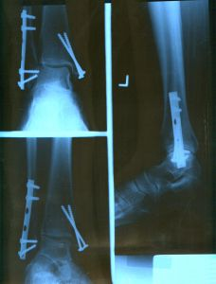

Activity
Directions: For each scenario below, choose the best answer from the selections below.
    - Physical Abuse
    - Sexual Abuse
    - Sexual Misconduct
    - Neglect
    - Exploitation
    - None of the above

- You are a waiver support coordinator who has a 27-year-old client named Lila, who lives in her own apartment. Lila has cerebral palsy and has a personal care assistant (PCA) come into her apartment every morning to help her get out of bed, bathe, and get dressed. She is able to transfer from her wheelchair to the toilet but requires some assistance from the PCA to ensure she doesn’t fall. She recently hired a new PCA who she really likes. On a recent home visit, you noticed a large bruise on Lila’s arm. When you asked Lila about it, she said that she was falling during a transfer and her PCA grabbed her arm to catch and steady her. When you asked the PCA about the bruise, she reported the same thing.
What might you suspect?

  - Carey is a 25-year-old man who lives in a group home. He has autism and mild mental retardation. He is extremely sensitive to touch, and he occasionally scratches and hits himself when he gets frustrated with the way certain clothes or seats feel as they touch his skin. During a recent visit home, his father noticed bruises on both of his upper arms. He asked Carey about them and Carey said that it was a secret. Carey’s dad asked him who else knew the secret, and Carey answered “Drew”, one of the staff members at his Adult Day Training (ADT) program.
What might you suspect?

  - You work at a group home where Maria has been a resident for several years. Maria is an engaging young woman who is always smiling and enjoys social interaction with both the other residents of the home as well as the group home staff. Maria is non-verbal and will often indicate her needs and choices by pointing or shaking her head (in response to simple yes/no questions). Recently you have been noticing a sudden change in Maria’s behavior when you try to help her with her shower. She appears terrified to go into the bathroom and cries and shakes her head whenever staff try to lead her in that direction. You also notice that she has been coming home from school with wet clothes in her backpack (when she previously had no problems using the bathroom).
What might you suspect?

  - You are a provider of Companion Services for Jacob, who is a 29-year-old man with moderate mental retardation who lives in an apartment with one roommate. Jacob also receives In Home Support Services from a provider who comes in once a week to help him pay his bills and balance his checkbook. As Jacob’s companion provider, you usually take him to the library and then stop for a soda on the way home. One afternoon, Jacob says he can’t buy a soda because he doesn’t have the money. Upon further questioning, you learn that he doesn’t have the money because his in-home support services provider has been taking money from him (which the provider says he needs to pay for his bus fare to Jacob’s apartment).
What might you suspect?

  - You are the support coordinator for Jennifer, a 27-year-old legally competent woman who lives in a group home. Jennifer tells you that one of the newly-hired group home staff members is her boyfriend and that they sometimes kiss each other on the mouth. She is very happy and says that the two of them are in love.
What might you suspect?

  - You work at an Adult Day Training (ADT) program and notice that Joseph, a 39-year-old man who uses a wheelchair, usually arrives at the ADT in dirty clothes and is wearing a diaper that looks like it hasn’t been changed since the night before. Over the past several weeks, it looks like Joseph appears to be losing weight. When you took him into the bathroom to change his diaper, you notice that he has a number of large pressure sores on his buttocks.

What might you suspect?

Summary
In this section you’ve learned how to identify possible indicators of abuse, neglect, and exploitation.

In the next section you’ll find out how to report those situations.

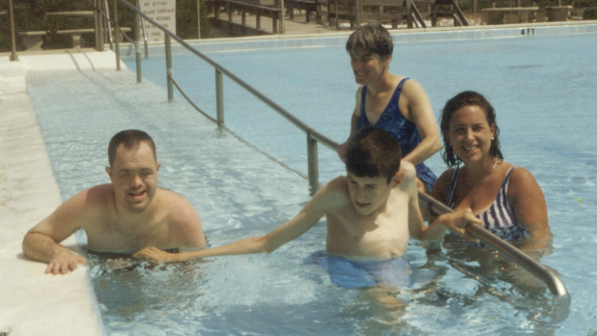

Module 5—Reporting Requirements

Module Overview and Learning Objectives
This section will teach you how to report abuse, neglect, or exploitation when you know or suspect that it may have taken place. By the end of this section, you will be able to:  After completing this module, you will be able to:  - Explain how to report abuse, neglect, or exploitation.  - Describe what may happen after the report is made.  - Identify things that may prevent persons with developmental disabilities from reporting these types of crimes. | 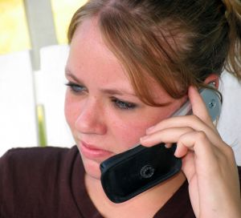

Mandatory Reporting Requirements

Any person who knows, or has reasonable cause to suspect, that a person with a developmental disability is being abused, neglected, or exploited, is required to report that information to the Florida Abuse Hotline at 1-800-96-ABUSE or 1-800-962-2873.

Failure to report known or suspected cases of abuse, neglect, or exploitation is a crime. Not reporting child abuse, neglect, or abandonment (or preventing someone else from reporting) is classified as a third degree felony in Florida. Someone convicted of a third degree felony can be required to serve up to five years in prison. Not reporting cases of abuse, neglect, or exploitation of adults with developmental disabilities (or preventing someone else from reporting) is classified as a second degree misdemeanor (which can result in you serving up to 60 days in jail).

Keep in mind that, as a service provider, failure to report known or suspected abuse can also cause you to lose your job and/or face possible legal action. When in doubt, report it; it is always better to make a mistake on the side of caution.



Client on Client Abuse

Sexual assault or any other type of injury-causing physical altercation (such as punching, stabbing, choking, or hitting another person with a heavy object) which takes place between two individuals with developmental disabilities must also be reported immediately to the Florida Abuse Hotline as well as the police so that an investigation may occur in order to determine whether or not the alleged abuse was the result of inadequate supervision or neglect on the part of a service provider or caregiver. In addition, service providers must also report the incident immediately to their supervisor as well as the local APD office to ensure the continued health and safety of the individuals involved.



How to Report Abuse, Neglect, or Exploitation

If you know or suspect that a person with a developmental disability is being abused, neglected, or exploited by a relative, caregiver, or household member then you should do all of the following immediately:
- Call the Florida Abuse Hotline, which is a nationwide, toll-free telephone number, at 1-800-96-ABUSE (1-800-962-2873), or send a faxed statement to the Abuse Hotline’s statewide toll-free fax number, 24 hours a day, 7 days a week, at 1-800-914-0004), and
- Call the police, and
- Notify your supervisor, and
- You or your supervisor should notify the area Agency for Persons with Disabilities (APD) office in accordance with established APD incident reporting procedures.
Note: If you know about a situation in which the life of a person with a developmental disability is in immediate danger due to abuse, neglect, or exploitation, you should call 911 before calling anyone else.

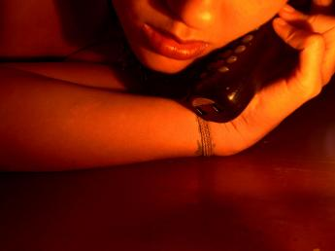

Other People to Call

Direct service providers should report knowledge or suspicion of abuse, neglect, or exploitation to their supervisors who may be required to report this information to the local APD office (in accordance with established APD reporting procedures). However, provider agencies may not require their employees to first report such information to them before permitting their employees to call the Florida Abuse Hotline or police.

In fact, any person who knowingly and willfully prevents another person from reporting known or suspected abuse is guilty of a misdemeanor of the first degree, punishable as provided in s. 775.082 or s. 775.083.

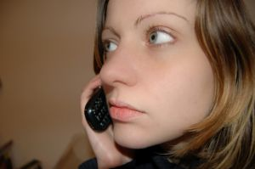

Information That May be Requested by the Florida Abuse Hotline

Hotline operators may request the following information:
- Name, age, sex, physical description, and location of each victim alleged to have been abused, neglected, or exploited
- Names, addresses, and telephone numbers of each alleged perpetrator
- Name, address, and telephone number of the person reporting the alleged abuse, neglect, or exploitation
- Description of the physical or psychological injuries sustained
- Actions taken by the reporter, if any, such as notification of the police

NOTE: It is important that you do not delay calling the Hotline until you have all of the above information. Instead, call the Hotline with whatever information you may have in order to protect persons with developmental disabilities from continued abuse, neglect, or exploitation.

What Happens After a Hotline Call is Made?

When a call is received by the Florida Abuse Hotline, hotline staff must first determine if the situation described is something that state law allows them to investigate (such as allegations involving the abuse, neglect, or exploitation of a child or vulnerable adult by a relative, caregiver, or household member).

Sometimes, a report cannot be taken by the Florida Abuse Hotline because it does not involve an allegation of abuse, neglect, or exploitation of a child or a vulnerable adult by their caregiver. In those situations, Hotline staff can still assist callers by providing them with information and making referrals to other agencies (such as law enforcement) as necessary.
When a report is made to the Florida Abuse Hotline, that information is used to assess the risk to the victim and determine findings. All information obtained during an investigation is confidential but can also be used as evidence in any court proceedings that may take place.

The Department of Children & Families (DCF) is required to conduct an investigation of all abuse reports received and accepted in order to determine if there is evidence that someone has been abused, neglected or exploited, and to see if assistance is necessary to protect the individual’s health and safety.

Within 24 hours of receiving a report, a protective investigator makes face-to-face contact with the alleged victim. If access to the alleged victim is refused to the protective investigator, law enforcement may be called to assist.

Once access is gained, the investigator will interview those involved, evaluate the information obtained, and make a decision as to whether the reported allegations did or did not occur.

If a victim is determined to be at risk and will not be safe remaining in his/her present environment, the investigator may place the victim in a more suitable living arrangement such as that of the home of a relative or friend or another licensed residential placement.

As long as victims are capable of making their own decisions, they must request or consent to placement before it can occur. If victims are not capable of making this decision, they may be removed by the investigator and placed in a safer environment, but the investigator must petition the court for a hearing within 24 hours of removal so the court may decide if continued placement is necessary. The people who have a right to be present at any hearing include the victim of a report, the victim’s spouse, guardian, legal counsel, adult children and next of kin.

Barriers to Reporting
Persons with developmental disabilities may fail to report abuse, neglect, or exploitation for the following reasons:

- Victims refuse to acknowledge that there is a problem
- Persons with disabilities are often taught to be compliant and passive and are sometimes unable to distinguish between appropriate and inappropriate physical contact
- Persons with disabilities may feel their report of abuse would not be believed
- Physical/cognitive impairments make it difficult for the victim to seek help
- Most augmentative communication systems (such as communication or picture boards used by people who cannot speak) are not programmed to report abuse, neglect or exploitation.
- Victims do not know where to turn for help, and they are often isolated
- Victims are, or perceive themselves to be, financially or otherwise dependent on the abuser for their needs; abuser tells victim they will lose everything if anyone is told
- Victims fear loss of a caregiver, even an abusing caregiver; they are fearful that the solution to the problem is more negative or frightening than the problem itself; they are fearful they will be forced to leave their current families or homes. Persons with disabilities may be more easily coerced with or threatened by the withholding of needed care or equipment.

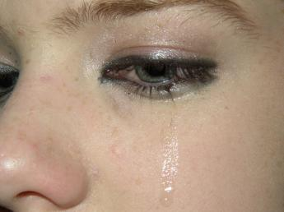
More Barriers to Reporting
People sometimes fail to report abuse, neglect, and exploitation of people with developmental disabilities because:
- There is a general lack of understanding or awareness of the high rate of these types of crimes
- People, including professionals and law enforcement, often do not recognize abuse of persons with disabilities when they see it; they are often quick to dismiss the visible signs of abuse by saying it was probably caused by the person’s disability
- Most people assume that no person would be capable of committing certain crimes against persons with disabilities
- Because they haven’t’ seen actual physical abuse, they may not believe a problem exists.
- People fear financial or legal liability and retaliation if they report suspected abuse
- Many people have the mistaken idea that their actions will not make a difference in cases of abuse, neglect, or exploitation

Activity

Directions: Discuss the following questions in your small group and be prepared to present your findings to the other participants.

- Who should you tell/notify in situations where you know or suspect someone with a developmental disability is being abused, neglected, or exploited?
- What information should you have available before you call the Florida Abuse Hotline?
- What are some reasons why someone might hesitate to report caregiver abuse, neglect, or exploitation?

Summary

It’s up to YOU to report suspected abuse, neglect, or exploitation of a person with a developmental disability. Now you know what to look for and who to contact!

If you only remember one thing from this course, we hope it is this; If you know or suspect that someone with a developmental disability is being abused, neglected, or exploited, call the Florida Abuse Hotline and the police. Your report could save that person’s life or protect him/her from further harm.

When you’re ready, move on to the final section of this course. In this section you will learn about ways you can help prevent the abuse, neglect, and exploitation of persons with developmental disabilities.

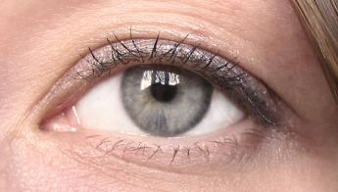

Module 6—Prevention and Safety Planning

Module Overview
While it is important to understand all of the issues surrounding abuse, neglect, and exploitation committed against persons with developmental disabilities, the ultimate goal of the Agency's Zero Tolerance Initiative is to prevent such abuse, neglect, and exploitation before it has the chance to even occur.  This section will identify a number of ways in which you can help persons with developmental disabilities decrease the chances that they will ever have to experience abuse, neglect, and exploitation. | 

Module Learning Objectives
After completing this section, you will be able to:
- Describe methods which can be used to prevent abuse, neglect, and exploitation.
- Describe how to create and maintain a safe living environment for people with developmental disabilities.

Prevention Methods

Methods for preventing abuse, neglect, and exploitation can be put into two separate groups: primary prevention and secondary prevention.

Primary prevention includes those activities, services and supports designed to prevent abuse, neglect, and exploitation of persons with developmental disabilities before those instances can occur.
Research indicates that the single most important and effective way to prevent abuse, neglect, or exploitation is through education and self-protection training for individuals with developmental disabilities.
When developing a training or education plan, the first thing you need to do is determine what you need to include. You will need to assess each person individually to figure out in what area they need help. This is called assessing risk. Is this person exhibiting any behaviors issues that put them at risk? For example, if they are overly friendly and/or physically affectionate with strangers or his/her caregivers, you will definitely want to address the issue of boundaries with that person. As part of this risk assessment, you will also need to figure out where the person relies upon another person to help them do something. For example, they may need someone to help with their medications, go to the bathroom, or pay their bills. As we discussed earlier in this training, when a person with a developmental disability relies upon someone else to perform personal, intimate, sensitive, and confidential tasks for them, that person is a potential target for someone to take advantage of them (or abuse or neglect them). These activities need to be addressed within every training program that is developed. Keep in mind that many resources are available (and are included at the end of the Participant’s Guide) that are specifically designed to be used for people with many different types of abilities and learning styles….never assume that someone will not be able to benefit from education and training to keep them safe.
Assessment of individual learning styles is also critical. Some people with developmental disabilities can certainly benefit from very basic verbal instructions (such as “just say no” or “walk away” if someone makes you feel uncomfortable) but others may understand safety concepts more if pictures, videos, or role-playing is used. When it comes to preventing physical abuse or sexual abuse, some individuals may benefit from taking basic self-defense classes. Keep in mind that many people with disabilities may need to receive this type of training more than once or on a regular basis for them to fully understand and implement what you share with them.
When teaching self-protection skills, you need to remember what you learned about the person during your assessment of their risk and learning styles. This will help you determine what skills you need to work on with the person. Basic concepts (such as locking one’s door, avoiding dangerous neighborhoods, assertiveness with caregivers and others, etc.) must certainly be addressed. Also, one of the most important things you can do in this area is to help individuals gain as much independence as possible as it relates to their activities of daily living. If they are able to do more things for themselves, they will not have to rely upon others to do those things for them (and thereby lessen their risk of being victimized).
Be as specific as possible with the person as far as what things are ok for their caregivers and others to do to them and what would not be considered ok. In the same way, they must also be taught what things they do to themselves or others are ok and which things are not ok (in specific places or with specific people). For example, it may be ok to give mom or dad a kiss on the cheek but not the pizza delivery guy.
Finally, all safety training programs must provide the individual with information about who or what to do if and when they encounter a situation that makes them uncomfortable. Some individuals can benefit from instruction on calling 911 or the Florida Abuse Hotline (with specific instruction on the proper time to call such numbers) while others may be taught to let a specific person know if they don’t feel right about a particular person or situation. Ongoing communication is very important so that caregivers can know as soon as possible if something is happening in a person’s life that requires their intervention and support to keep the person safe.
Some more primary prevention tips include:

- Education of direct care staff members on what actions are considered to be abuse, neglect, and exploitation.
- Background screening/reference checks of prospective caregivers (before they begin working with consumers).
- Unannounced visits at different times of day for the purposes of monitoring caregiver behaviors and activities to ensure they are able to complete their job duties properly.
- Growing of social circles so that the person with the developmental disability is not alone on a frequent and regular basis.
- Caregiver training is important for everyone but especially for those caregivers who work with individuals with behavioral or medical issues. For example, caregivers must be completely familiar with a consumer’s behavior plan so that they know the right way of responding to behavioral issues. Likewise, staff who are responsible for giving people medications or transferring them in and out of bed must be knowledgeable about the proper and safe ways to perform such tasks.
- Caregiver respite is important for both paid and unpaid caregivers. It is essential that staff are not too tired or stressed to carry out their responsibilities. For example, someone who works a double shift in a group home may be more likely to make a mistake by giving someone the wrong type of medication or falling asleep while they are supposed to be supervising residents.
- Video monitoring can be an important tool in helping to prevent (and detect) cases of abuse, neglect, and exploitation. However, keep in mind that video monitoring should only be done with the consent of the individual (or their guardian), should not take place in the bathroom or bedroom, and must not violate privacy and confidentially laws. To be safe, you should check with your local APD office if you wish to utilize video monitoring.

Secondary prevention includes those activities, services and supports for those individuals who have already been abused, neglected and exploited. These efforts are designed to identify and end ongoing abuse, neglect, and exploitation.

Examples of secondary prevention include:
- Education of direct care staff in recognizing and reporting the signs and symptoms of abuse, neglect, and exploitation.
- Full cooperation with police, DCF or APD investigators, and others to help ensure the arrest, prosecution and successful conviction of perpetrators.
- Modification of augmentative communication devices (used by persons with developmental disabilities who are unable to speak) so that abuse, neglect, and exploitation can be easily and quickly reported.
- Expansion of social circles so that more individuals would be involved in the person’s life and would therefore be able to identify and report suspected cases of abuse, neglect, and exploitation.
- As previously stated, video monitoring may also help to identify acts of abuse or neglect committed by caregivers.
Prevention Efforts Agency Providers Can Implement with Their Employees

To prevent abuse of people with developmental disabilities in licensed residential facilities, adult day training programs, and other service delivery settings, administrators must strive to enhance job satisfaction and create positive work environments for staff. Good communication and teamwork are essential to cultivate employees’ positive attitudes toward their jobs. Recognition that clients are consumers of their services also helps keep people with developmental disabilities safe. Employee counseling and staff support programs need to be in place when problems do occur.

Supervisory leadership
- Models and rewards good caregiving
- Models good communication and teamwork within the facility
- Models and cultivates positive attitudes about people with developmental disabilities
- Promotes a work culture of zero tolerance for abuse, neglect, and exploitation
- Encourages a team approach to dealing with behavior management

Management practices/attitudes
- Supervisors provide good role models
- Adequate and well-prepared staff; this includes ensuring that there are enough staff available to care for consumers and that those staff members are properly trained and equipped to meet the needs of the individuals they will be serving
- Realistic expectations of staff responsibilities
- Recognition that clients are service consumers
- Administrative efforts to enhance job satisfaction for staff members who provide direct services, such as incentives and rewards for good caregiving
- Employee counseling and staff support programs available

Policies and procedures
- Emphasis on inclusion versus segregation and isolation of clients
- Required criminal records and background checks for all staff, as part of a thorough pre-employment screening
- Clear abuse/neglect policies and procedures, including: required reporting of all incidents of suspected abuse, neglect, or exploitation; consistent enforcement of reporting policies,; protection for staff and clients who report;, sanctions for those who do not report; commitment to non-aversive behavior management strategies.
- Take each and every complaint or allegation of abuse, neglect, or exploitation seriously (even if the person involved has made false claims in the past).

Ongoing staff training
- Inservice training and written information available to all staff about the particular developmental disabilities of the clients they serve and the behaviors that are typical for persons with these disabilities
- Positive Behavior Support training for dealing with challenging behaviors
- Training in non-violent strategies for managing crisis situations
- Support services for dealing with work-related stress
- Client-specific trainings for all staff members (so that staff are properly prepared to meet the needs of the individuals they serve).

Tips For Staying Safe From Sexual Abuse
The following suggestions for sexual abuse prevention should be shared with all persons with developmental disabilities:

Recognize that you have rights
One of the most important things you can do to protect yourself is to know that you have rights.
- You have the right to decide who will touch your body, and how and when you will be touched.
- You have the right to sex education and information that will help you to understand healthy sexual activities and relationships.
- You have a right to be respected and to make decisions about your own sexual activities.
- You have a right to have safe relationships and to not be abused.

Discriminate between good touch, bad touch, and uncomfortable touch
Know the difference between good touch (hugs, comfortable pats), and bad touch (hitting, slapping, hurting), and uncomfortable touch (touch in private parts that make you feel uncomfortable).

Know the difference between good secrets and bad secrets
There is a difference between good secrets (memories of fun times between friends), and bad secrets (when someone doesn’t want you to tell anyone what he or she did to you).

Trust your instincts
If something feels dangerous or intrusive to you, you have a right to say “No,” and to protect yourself from harm.

Just say “No!”
Even someone you know can try to sexually abuse you. Remember that you have the right to say “no” to any unwanted touch, even from a boyfriend or girlfriend, caregiver, attendant, family member, healthcare professional or other trusted person in your life.

Tell Them to Stop, and Tell Someone
If someone touches you in a sexual way, and you do not want them to, tell that person to stop. Then be sure that you tell someone what happened. You can tell a counselor, staff person, your parents, your doctor, or someone else you trust.

Talk to Someone You Trust
If you think someone has sexually abused you, talk to someone you trust. It can help to get a second opinion of the situation and how to handle it. There may be a local sexual assault hotline in your community that you can call for support, counseling, or other referral.

Call 911
Remember to call the police (911) if you think that someone is trying to get into your home. Even if you are not sure what is happening, it is best to call the police. Also, notify police immediately if you have been physically harmed or sexually abused.

(Disability Services ASAP, 2002; Graham, 2000)

Additional Tips for Caregivers in Preventing Sexual Abuse

Research indicates that the single most important way to prevent sexual abuse is through education and self-protection training for consumers.

Unfortunately, society has traditionally viewed individuals with developmental disabilities as asexual, "eternal children" and there has not been a great effort to provide any type of sexuality information to these individuals.

By not acknowledging or understanding these individuals' need for knowledge and appropriate sexual expression, society is responsible for creating a culture of ideal victims. By ignoring this issue, we may also be contributing to creating even more perpetrators of these crimes as many people with developmental disabilities (who have not been taught otherwise) may seek to express themselves sexually in inappropriate and, sometimes, illegal ways.
Some caregivers feel uncomfortable talking to persons with developmental disabilities about sexual activities. Keep in mind that many people may feel uncomfortable talking about this subject. This is understandable and expected. You most likely will feel more comfortable once you get started. Use of printed materials appropriate to the person’s age and level of understanding will help.

Here are some tips to make the discussion easier.

Recognize the person’s need to know
Don’t assume that the person does not need to know about sexuality just because of her or his disability. We all need accurate information about our bodies to feel good about ourselves, to protect ourselves, and to take care of our bodies appropriately.

Set boundaries
Don’t permit a person with a developmental disability to engage in inappropriate sexual behavior. This kind of behavior won’t be tolerated by others and may even get the person arrested. The same rules should apply to a person with a disability as to people without disabilities. For example, a person should not get away with inappropriately touching your body just because he has mental retardation. It is appropriate to set boundaries for a person’s sexual behavior, as long as you do so in a way that is clear, open, and does not make her or him feel guilty for being sexual.

Identify appropriate behavior in public and private
Be very clear about what can be done in private (such as masturbation), and what can be done in public (such as hugging). This concept often presents problems for people with cognitive disabilities, and can put them at risk for socially unacceptable behavior.

Teach protective behaviors
For example, teach men to use a urinal properly. Do not teach men to drop their pants at the urinal. While this may be easier to teach and more convenient for them and their caregivers to manage when they are small, this behavior marks these men as easy targets for sexual predators. (O’Neill, 2003)

Use appropriate names for genitals
Use appropriate names for genitalia to “demystify” these body parts. (Graham, 2000) This helps to clarify perceptions of the body and its functions, and thereby opens the lines of communication. Let persons with developmental disabilities talk about their “private areas” and tell them about the issues and boundaries of privacy.

Seek help when you need it
There are a number of books, videos, and other sources of information which can help in the development of a safety plan against abuse, neglect, and exploitation. Many of these resources are included at the end of the Participant’s Guide. If you feel you need assistance or information, contact your local APD office for additional resources or ideas.
Last but not least, if someone with a developmental disability lets you know that they may have been abused, neglected, or exploited, it is very important that you respond to that person in a sensitive and caring way. Your response to any potential victim should always be:

I believe you.
It is not your fault.
You are not alone.
I want to help you.

Summary

Congratulations! You have completed Module 6, Prevention and Safety Planning.

Your facilitator will now pass out the final Assessment for this course. If you have any questions or need to review the information from any of the modules, now is the time to do so!

Appendix A: References and Resources
If you would like more information about abuse, neglect and exploitation of people with developmental disabilities, and the Agency for Persons with Disabilities’ Zero Tolerance Initiative, as well as other resources and materials, go to: http://apd.myflorida.com/clients/zero_tolerance.htm.
References

American Academy of Pediatrics (2001). Assessment of abuse, neglect, and exploitation of children with disabilities (Policy Statement). Pediatrics, 108(2), 508-512.

Garmezy, N. (1991). Resilience in children’s adaptation to negative life events and stressed environments. Pediatric Annals, 20(9), 456-459.

O’Neill, P. (2003). Abuse and neglect of children with disabilities: A collaborative response (Trainer’s Guide). Richmond, VA: Partnership for People with Disabilities, Virginia Commonwealth University.

Ryan, R. (2001). Handbook of mental health care for persons with developmental disabilities. Canada: Diverse City Press, http://www.diverse-city.com

Sobsey, D. (1994). Violence and abuse in the lives of people with disabilities: The end of silent acceptance? Baltimore, MD: Paul H. Brookes Publishing Company

Sullivan, P.M. Knutson, J.F., Scanlan, J.M., & Cork, P.M. (1997). Abuse, neglect, and exploitation of children with disabilities: Family risk factors and prevention implications. Journal of Child Centred Practice 4 (1), 33-46.

Disability Services ASAP (A Safety Awareness Program). (2000). SafePlace, P.O. Box 19454, Austin, TX 78760 http://www.austin-safeplace.org/

Fact Sheets

- Safety of Your Child with a Disability
- Screening Practices for Hiring People to Work with Individuals in Need of Support
- Tips for Parents: Talking to Your Child with a Disability About Sexuality

Tobin, P., Rifkin, P.L., & Carpenter, C. (1996). I’m Somebody – A child sexual abuse prevention manual. San Francisco, CA: PMT Consultants, PO Box 12101, San Francisco, CA 94712.

Educational Materials for Consumers

Research has demonstrated that consumer education and empowerment is the single most effective means by which to prevent abuse, neglect, and exploitation. Below is a list of teaching materials specifically intended for people with developmental disabilities and their caregivers:

Name of Product | Medium | Description
Sexuality: Your Sons and Daughters with Intellectual Disabilities  Karin Melberg Schwier, David Hingsburger | Book | The book's chapters include "Hold Me Tight", "Put Me Down", "Leave Me Alone", and "Let Me Go"; the authors interweave first person vignettes from parents and from persons with disabilities with the text and their own stories. The final section of the book consists of 17 pages of recommended resources.
Child Sexual Abuse Curriculum for the Developmentally Disabled  Sol R. Rappaport, Ph.D., Sandra A. Burkhardt, Ph.D., and Anthony F. Rotatori, Ph.D. | Printed Curriculum | This curriculum is divided into five parts: "Understanding Child Sexual Abuse of the Developmentally Disabled," "The Treatment of Sexually Abused Children," "Sexual Abuse: The Emotional and Behavioral Sequelae," "Factors That Mediate the Sequelae of Child Sexual Abuse," and "The Rappaport Curriculum for the Prevention of Child Sexual Abuse in Children with Developmental Disabilities." The last chapter includes 10 lessons on sexuality and sexual abuse prevention for children who are in the mild range of mental retardation. An appendix is included, which parents and caregivers can review with children.
My Body… My Choice  by Shirley Paceley, illustrated by Annette Russo Penhallegon | Book | My Body… My Choice is a fully illustrated, mini-book written for adolescents and adults with developmental disabilities. This book covers the basics of body safety and is empowering people with disabilities across the nation to resist and report sexual abuse. The book can be used in group settings as well as on an individual basis. It has been incorporated into "reading nights" in group homes: used in recovery groups and prevention education classes. It is a simple, straightforward way for parents to teach their children about safety form abuse. It can also be used in peer education and "acted out" by individuals with disabilities.
Genesis: In the Beginning... Breaking the Cycle of Sexual Abuse  by Orieda Horn Anderson and Shirley Paceley | Book | This sexual abuse prevention book targets parents and providers of preschool children with disabilities. This groundbreaking book is an insightful and practical guide which empowers parents, teachers and service providers to give the gift of information to their children about sexuality and safety. The book includes: specific skills to teach young children which may decrease the likelihood of sexual abuse in day care settings: signs of abuse in children with disabilities: and what to do if a child is abused.
Safe Beginnings: Protecting Our Children From Sexual Abuse  by Orieda Horn Anderson and Shirley Paceley | Book | Safe Beginnings is a healthy, affirming, "how to" book which can reduce the risk of sexual abuse of all children, with and without disabilities. This practical and powerful book includes strategies for teaching preschool children self-respect, self-esteem, sexuality and safety: skills to teach children which can empower them to resist and report sexual abuse: techniques for teaching the skills to children with disabilities: how to create safe environments in nurseries, preschools, day care centers and schools: tips for raising boys and girls: what to do if abuse occurs: resources and ideas for social change. This "must read" book is written with wisdom and compassion, as well as real life examples.
LifeFacts Sexual Abuse Prevention: Essential Information About Life...For Persons With Special Needs  Published by James Stanfield Company, Inc | The program comes with 55 11" by 14" laminated illustrations, 55 35mm slides and a curriculum guide. | Sexual Abuse Prevention contains all the essential materials and information necessary to teach sexual abuse recognition, prevention and protection strategies for adolescents and adults. The program provides concepts that are presented in simple terms and materials that are logically sequenced and paced for ease of presentation. Pretest and post-test for each of the instructional areas assess entry-level needs and allow evaluation of student understanding of this critical material.
SmartTrust Anti-Gullibility Training: Developing Trust & Exercising Caution in Interpersonal Relationships  Published by James Stanfield Company, Inc. | The program comes with 60 11" by 14" laminated illustrations and a curriculum guide. | SmartTrust helps students avoid being gullible and prey to financial, social, physical and emotional exploitation by teaching them SmartTrust strategies to identify when to offer trust and when not to. Included are types of exploitation to which students with special needs are particularly vulnerable.
Sexuality and Sexual Assault Awareness for Empowerment (S.A.F.E.) | Printed curriculum | This new curriculum is designed to assist facilitators in discussing the issues of sexuality, boundaries, sexual assault, and empowerment with individuals with disabilities. "S.A.F.E." is a valuable weapon in the war against sexual violence in the physically disabled community.
Introduction to Sexuality Education for Individuals who are Deaf-Blind and Significantly Developmentally Delayed  By Kate Moss and Robbie Blaha (Texas Deaf-Blind Outreach) | Book | This 126-page document is much like a curriculum, and provides good background and some specific content. While it is written about children and teens who are Deaf-Blind, it is also an excellent general disabilities resource. The chapters include an introduction, guidelines for developing a process for intervention and instruction, and topics such as modesty, appropriate touch and personal boundaries, menstruation, sexual health care, sexual abuse, and a resources section.  This document is available at no cost on the Internet at: http://www.nationaldb.org/documents/products/sex-ed.pdf
Reducing the Risk of Sexual Abuse for People who use Augmentative Communication: A Community Response | Report | This report discusses issues related to the prevention and reporting of sexual abuse committed against persons who use augmentative communication devices. The detailed appendix contains a number of related websites and resources.
Educational Materials from the National Consortium on Deaf-Blindness | Resource List | http://nationaldb.org/ISSelectedTopics.php?topicCatID=20  This link to the website of the National Consortium on Deaf-Blindness offers a list of resources pertaining to social and sexuality education for individuals with visual, hearing, and/or cognitive impairments.
Reducing the Risk: Safety Strategies for People who use Augmentative Communication Devices (ACDs) | Article | Suggestions by persons who use augmentative communication  devices include:  - Tips for Communicating About Your Boundaries  - Phrases to Communicate About Your Boundaries  - Suggested Phrases for use with ACDs  This document is available at no cost on the Internet at:  http://www.accpc.ca/rtr-resources-sayingno.htm
Your Safety… Your Rights: Empowering Adults with Disabilities II | Printed curriculum | This personal safety and abuse prevention curriculum was developed as a tool for educating and empowering adults with physical and mental disabilities. In-depth materials are presented to the trainer in a straightforward and understandable manner. Different learning techniques of participants are addressed through a wide array of tools including handouts and role-playing activities, to name a few.
Combating Violence and Abuse of People with Disabilities: A Call to Action  By Nancy M. Fitzsimons, M.S.W., Ph.D. | Book | In clear and straightforward language, abuse prevention educator Nancy Fitzsimons calls readers to action and gives them the no-nonsense guidance they need to stop violence and abuse before they start. Readers will discover how to  - help people with a wide range of disabilities learn concrete ways to arm themselves against violence and abuse  - identify situations that might make a person vulnerable to violence or abuse  - skillfully recognize the indicators of physical abuse, sexual abuse, neglect, psychological abuse, and financial exploitation  - take appropriate action if they suspect or know someone is being abused  - tear down the personal, societal, and organizational barriers that perpetuate violence and abuse  - make the most of supportive services and systems, including victim assistance programs, the criminal justice system, and advocacy services  - conduct effective training sessions that empower and educate people with disabilities about prevention of violence and abuse (includes lessons learned from a model program, the Advocacy and Empowerment Project)  Throughout this practical guide, thought-provoking anecdotes, exercises, and "Ask Yourself" questions help readers relate key concepts to their own lives, examine their beliefs and assumptions about disability and abuse, and expand their knowledge of how to take action. An eye-opening sourcebook for professionals and a must-share with anyone who has a disability, this book is the key to helping people with disabilities fight violence and abuse�and take charge of their bodies and lives
Managing Personal Assistants:� A Consumer Guide | PDF File | This free consumer guide features information on recruiting, hiring, training, keeping, and firing personal assistants, as well as on funding sources and taxes. This guide also contains forms that guide the consumer through the process of managing personal assistants.� This document is available for free on the Internet via the following link: http://www.pva.org/
Safety Planning: A Guide for Individuals with Physical Disabilities | PDF File | This safety plan is designed to help adults with physical disabilities who have been or may be abused by an intimate partner, spouse, adult child, other family member, personal assistant, or caregiver. This safety plan can also be useful for people with mental, cognitive, developmental disabilities, and those who have hidden disabilities. The brochure includes sections on: planning for an explosive incident; safety during an explosive incident; safety in your home; safety when preparing to leave; safety in public settings; and safety with a restraining order. This document is available for free on the Internet via the following link:� http://www.ncall.us/
A Step-by-Step Guide to Training and Managing Personal Assistants: A Consumer Guide | PDF File | This guide includes sample documents that you can use for hiring and managing personal assistants. This document is available for free on the Internet via the following link: http://www.rtcil.org/
Safety Planning: How You Can Help | PDF File | A safety planning guide for individuals with a cognitive disability. This document is available for free on the Internet via the following link: http://www.ncall.us/
The Circles Programs
Nearly all resources for sexual abuse prevention information for persons with developmental disabilities refer to the Circles programs by Marilyn P. Champagne and Leslie W. Walker-Hirsch. This curriculum is designed for use with persons with mild to moderate developmental disabilities.
The program guides learners in identifying the physical conduct appropriate for persons in a series of concentric circles, working outward from the center which is the most intimate level of physical contact. A few persons may be in the "close hug" circle while others are in the "wave" circle and still others in the "stranger" circle. This curriculum may be more costly than families can afford but, once purchased by an agency or organization, would be very useful for many years to come.
There are four programs in this series (Level 1, Level 2, Stop Abuse, AIDS: Safer Ways).
Circles: Intimacy and Relationships  Level 1 | The program comes with 12 video tapes, a 5' by 10' wall teaching graph, 50 large laminated graph icons, student "personal" graphs with 300 Peel n' Stick Icons and one teacher's guide. | The classic video program, used in over 10,000 facilities across the U.S., helps your students to recognize exploitative relationships as well as develop mutually respectful ones. Part I: Social Distance is comprised of 11 video programs designed to help your students "see" social and sexual distance, and explains the relationship between the level of intimacy between people and the way the TOUCH, TALK to and TRUST each other. Students will learn "relationship boundaries" and relationship specific behaviors, i.e., it's okay to hug your mother, it's not okay to hug the mailman.  In Part 2: Relationship Building, six video programs demonstrate how intimacy levels change as relationships change. The role of mutual choice among individuals is emphasized, a critical concept for protecting students from exploitation. The real strength of Circles Level I: Intimacy & Relationships is that it presents to special students some extremely abstract concepts in a very simple and concrete manner. The connection between the kind of relationship and the corresponding level of intimacy is demonstrated visually, making learning this important content area easy for students.
Circles: Intimacy and Relationships  Level 2 | Includes: 12 Video Tapes, Teacher Guide, Giant Wall Graph | Circles, Level 2, because it uses a "reality-show" format is ideal for illustrating more subtle applications of the Circles Rules of Social Distance, presented in Circles Level 1. Level 2 is an ideal "second step" program for students with moderate to mild cognitive and can be used as a stand- alone introduction for higher functioning and regular students. New Content  - Alternative Intimacy Level signs  - Circle Jumping, when it's OK and when it's NOT  - Reversal of Intimacy Level  - Rejecting Intimacy and Having Intimacy Rejected  - Relationship Dissolution  And Much, Much More
Circles: Stop Abuse | The program comes with three video tapes, a 5' by 10' wall graph and one teacher's guide. | Your students are prime targets for abuse. Teach them how to recognize and avoid sexually threatening or abusive situations with CIRCLES: Stop Abuse. The video program illustrates step-by-step lessons and strategies to recognize abusive behavior. Real-life demonstrations of how to take positive action if feeling exploited are included. This quality program uses the famous CIRCLES paradigm and was created by education and health care professionals sensitive to the needs of persons with developmental disabilities.  Part 1: Recognizing and Reacting to Sexual Exploitation Encourages your students to be assertive. Illustrates how to recognize and react to sexual exploitation occurring in close relationships with dates, close friends and relatives. Teaches students that they don't have to participate in physical contact that does not feel good to them.  Part 2: Learning Appropriate Protective Behaviors Illustrates the potential for sexual abuse from acquaintances and strangers. Students will learn to identify inappropriate behavior and initiate protective measures against unwanted advances.
Circles: Safer Ways | Also included are six video tapes, supplemental materials and one comprehensive teacher's guide. | CIRCLES video program will bring your students current information on avoiding and treating communicable diseases and in the process teach them ways to protect themselves against sexually transmitted diseases.  Part 1: Communicable Disease and Casual Contact Illustrates steps that can be taken to lessen the chances of catching a communicable disease. Four dramatized sequences model good health habits and provide the necessary readiness for the sensitive information in Part 2.  Part 2: STDs, AIDS and Intimate Contact Explains the difference between "casual" and "intimate" contact. Promotes positive decision-making, including abstinence, to best avoid STDs and AIDS. Real-life dramatic sequences present young people making decisions that help them stay healthy. Dispels myths regarding transmission of diseases and clearly illustrates risk factors. You'll also receive a general and explicit version of How AIDS and STDs Are Contracted. You decide which level is most appropriate for your students/community!  Each program comes with both a general and explicit version of "How AIDS and STD's are Contracted" so that you can decide which level is most appropriate for your students and community.

Websites for Consumers, Parents, Service Providers, and Advocates
Below are some links to Internet sites which offer information and resources pertaining to abuse, neglect, and exploitation of persons with developmental disabilities.

http://www.austin-safeplace.org/site/PageServer?pagename=program_disability
Disability Services ASAP provides education to people with disabilities in order to increase awareness about sexual abuse/assault, domestic violence and abuse by personal care providers, personal safety planning, healthy relationships and sexuality. Presentations and training are also available to professionals and family members on a range of issues including disability awareness/sensitivity, the dynamics of abuse in relationships involving an individual with a disability, developing accessible and relevant services, safety planning, providing personal safety education to persons with disabilities, etc.

http://www.advocatesforyouth.org/storage/advfy/documents/challengedyouth.pdf
This document provides information and tips for providing sexuality education information to youth with disabilities as a means by which to prevent sexual abuse.

http://www.wind.uwyo.edu/resourceguide/default.asp
Crime and abuse are critical issues in the lives of people with disabilities. Research shows that individuals with disabilities are at a greater risk for being a victim of a crime than other individuals. To find solutions to these complex issues it is critical to have accurate and comprehensive information available to a variety of professionals and stakeholders. The Victims of Crime with Disabilities Resource Guide project is designed to provide a variety of tools and services which help disseminate and share information on ending violence against people with disabilities.

http://www.fcasv.org/
The Florida Council Against Sexual violence is a statewide nonprofit organization committed to victims and survivors of sexual violence and the rape crisis programs who serve them.

http://www.fcadv.org/
The Florida Coalition Against Domestic Violence (FCADV) works towards ending violence through public awareness, policy development, and support for Florida's domestic violence centers. Serving Florida's 41 domestic violence centers, FCADV runs Florida's toll-free domestic violence hotline, maintains a resource library, and develops posters, brochures, safety plans, and other resources.

http://ici.umn.edu/products/impact/133/133.pdf
This feature issue of Impact Magazine (published by the Institute on Community Integration at the University of Minnesota) provides articles and resources pertaining to violence committed against women with developmental disabilities.

http://myfloridalegal.com/victims
The Florida Attorney General's Division of Victim Services not only serves as an advocate for crime victims and victims' rights, it also administers a compensation program to ensure financial assistance for innocent victims of crime. As part of its responsibility, the division also notifies victims of the status of any appellate decisions regarding their cases. Injured crime victims may be eligible for financial assistance for medical care, lost income, mental health services, funeral expenses and other out-of-pocket expenses directly related to the injury. If needed, they can also be referred to support organizations within their home area (which may be accessed via their website as well).

http://www.stopitnow.com/
Stop It Now! was founded in 1992 by Fran Henry, a survivor of childhood sexual abuse, who recognized that standard ideas about preventing sexual abuse of children weren't working. Stop It Now! believes that all adults must accept the responsibility to recognize, acknowledge and confront the behaviors that lead to the sexual abuse of children. This website offer adults tools they can use to prevent sexual abuse - before there's a victim to heal or an offender to punish. In collaboration with their network of community-based Stop It Now! programs, they reach out to adults who are concerned about their own or others' sexualized behavior toward children.

http://www.fddc.org/ACTIVITIES/Featured%20Project.asp
For a child or adolescent with developmental disabilities, the more family and the school communicate with each other the better support there will be for them to experience as fully as possible their sexuality in a healthy and safe way. It is critical that parents, caregivers and educators have a resource and the knowledge to help individuals with developmental disabilities discover their sexuality. Hence, the Florida Developmental Disabilities Council sponsored the development of the following publications:
• Life Span Holistic Sexuality Education for Children and Adolescents with Developmental Disabilities
• An Annotated Resource List
• Sexuality Policy and Procedures for schools and parents/caregivers
• An Instructional Manual for Educators of Individuals with Developmental Disabilities
• An Instructional Manual for Parents of and Individuals with Developmental Disabilities

http://www.albany.edu/aging/IDD/docs.htm
The resources provided on this website were developed by DiAnn Baxley, Project Director, Anna Zendell, and Jeanne Matich-Maroney as part of a grant from the Florida Developmental Disabilities Planning Council, in collaboration with the University at Albany, Center on Intellectual Disabilities. The materials are designed to open dialogue between school and home on the topic of providing sexuality education to children and adolescents with intellectual or developmental disabilities.
http://www.aacsafeguarding.ca/SUPSummaryReport.pdf
This report discusses issues related to the prevention and reporting of sexual abuse committed against persons who use augmentative communication devices. The detailed appendix contains a number of related websites and resources.
http://www.accpc.ca/rtr-resources-sayingno.htm
Suggestions by persons who use augmentative communication devices include:
• Tips for Communicating About Your Boundaries
• Phrases to Communicate About Your Boundaries
• Suggested Phrases for use with ACDs

http://www.tr.wou.edu/DBLINK/pdf/sex-ed.pdf
"Introduction to Sexuality Education for Individuals who are Deaf-Blind and Significantly Developmentally Delayed" is a 126-page document which is written much like a curriculum and provides good background and some specific content. While it is written about children and teens who are Deaf-Blind, it is also an excellent general disabilities resource. The chapters include an introduction, guidelines for developing a process for intervention and instruction, and topics such as modesty, appropriate touch and personal boundaries, menstruation, sexual health care, sexual abuse, and a resources section.

http://www.ihd.umkc.edu/Resources/Safety%20FirstPDF.pdf
"Sexual Abuse and Domestic Violence Prevention: A Consumer Information Pamphlet for Women with Developmental Disabilities" provides an easy-to-read pamphlet specifically geared to women with mild mental retardation.

http://www.thearc.org/AAdvocacyGuide.pdf
This link to the Arc's Justice Advocacy Guide was produced by The Arc of the United States and is subtitled "An Advocate's Guide on Assisting Victims and Suspects/Defendants with Intellectual Disabilities." It offers a comprehensive description of the challenges faced by those persons with intellectual disabilities who have either been victimized or accused of committing crimes as well as practical information for advocates working with these individuals.

http://icad.wordpress.com/ The International Coalition on Abuse and Disability (ICAD) was established at the JP Das Developmental Disabilities Centre in 1993 as means of sharing information about violence and abuse in the lives of people with disabilities and providing a platform for discussion on what can be done to control these problems. ICAD is a joint venture of the JP Das Developmental Disabilities Centre and the John Dossetor Health Ethics Centre at the University of Alberta in Edmonton, Canada.

Please note: The State of Florida and the Agency for Persons with Disabilities (APD) do not control or guarantee the accuracy, relevance, timeliness or completeness of information contained on a linked website. APD does not necessarily endorse the organizations sponsoring linked websites and does not necessarily endorse the views they express or the products/services they offer. APD cannot authorize the use of copyrighted materials contained in linked websites. Users must request such authorization from the sponsor of the linked website. APD is not responsible for transmissions users receive from linked websites.

Appendix B: Final Assessment

Instructions: Fill in the bubble that matches the correct answer in the Zero Tolerance Final Assessment.

Name: ________________________ Date: _____________________

A
B
C
D
E
1.

A
B
C
D
E
2.

A
B
D
E
C
3.

A
B
C
D
E
4.

A
B
C
D
E
5.

A
B
C
D
E
6.

A
B
C
D
E
7.

A
B
C
D
E
8.

A
B
C
D
E
9.

10. .
A
B
C
D
E

