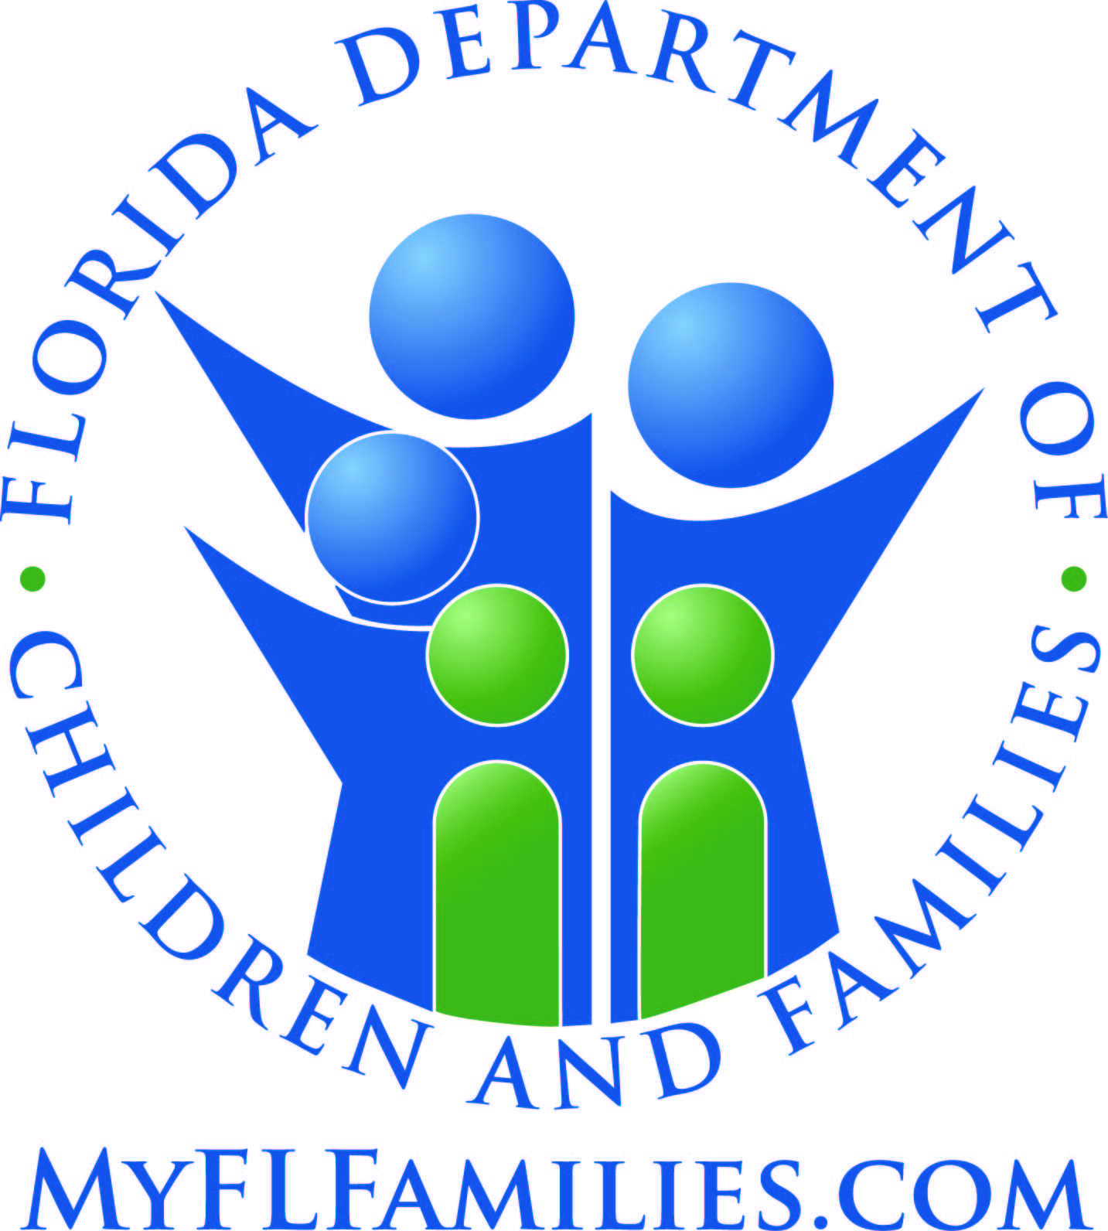

DOMESTIC VIOLENCE CENTER

APPLICATION FOR CERTIFICATION
Form CF 613, January 2015

Authority: s. 39.903, FS, Chap 65H-1.012, FAC

Department of Children & Families
Office of Domestic Violence Program
1317 Winewood Boulevard
Building 3, Room 330
Tallahassee, Florida 32399-0700
850/921-2168

TABLE OF CONTENTS

I. APPLICATION PROCESS INFORMATION

A. Background 3

B. Who May Apply 3

C. How to Apply 3

D. Technical Assistance 3

E. Application Review Process 4

II. WHAT AN APPLICATION MUST INCLUDE

A. Application for Domestic Violence Center Certification 4
Form CF 613, January 2015 6

B. Business Plan 4

1. Executive Summary 4

2. Community Support 4

3. Financial Plan 4

4. Management Plan 5

5. Personnel Plan 5

6. Operations Plan 5

7. Service Plan 5

C. Operating Policies and Procedures Manual 5

I. APPLICATION PROCESS INFORMATION

A. Background
The Department of Children and Families operates the statewide Domestic Violence Program (Department) that is responsible for developing minimum standards and approving or rejecting certification of domestic violence centers (section 39.903, Florida Statutes). In accordance with these responsibilities, each eligible organization seeking state certification is required to submit an application (Form CF 613) to the Department with details about the organization and the provision of services.

B. Who May Apply
A not-for-profit domestic violence provider, having met all certification standards is eligible for certification by the Department. Minimum standards are provided in Chapter 65H-1, Florida Administrative Code, and section 39.905, Florida Statute, that may be found on the Department’s webpage at: http://www.myflfamilies.com/service-programs/domestic-violence.

C. How to Apply
Instructions for submitting an application are included in this application packet or are available from the Office of Domestic Violence Program’s website at: http://www.myflfamilies.com/service-programs/domestic-violence.

Please provide the Department with one hard copy and one electronic copy of the application, including all appropriate documentation outlined in these instructions. The hard copy of the application packet may be mailed or hand-delivered. Faxes will not be accepted. The hard copy of the application must include an original signature of the authorized official. The electronic version of the entire application must be sent via e-mail and include a statement verifying the date the hard copy of the application package was sent.

Applications must be mailed or hand-delivered and emailed to:
Office of Domestic Violence Program
Florida Department of Children and Families
1317 Winewood Boulevard, Building 3, Room 330
Tallahassee, Florida 32399-0700

Email: domestic.violence@myflfamilies.com

D. Technical Assistance
A certification pamphlet with guidelines is posted on the Department’s website at: http://www.myflfamilies.com/service-programs/domestic-violence. Applicants are encouraged to refer to the pamphlet to assist with the completion of their application.

In addition, applicants may contact the Domestic Violence Program Office at (850) 921-2168 regarding assistance with the completion of their application. Applicants may also email questions to domestic.violence@myflfamilies.com. Program staff will assist the applicant with any questions or additional information.

E. Application Review Process
The Department’s Domestic Violence Program staff members will conduct a review of the application and an on-site review of the applicant’s facilities. Please allow a minimum of 90 days for the review process to be completed. Upon completion of the review, the applicant will be notified in writing on the status of their certification request.

II. WHAT AN APPLICATION PACKET MUST INCLUDE
The application packet must be submitted in the order of the information listed below, include a table of contents, dividers for each section, and in the page format provided below:

- Double spaced
- 8½ x 11 inch paper
- One inch margins
- Type no smaller than 11 point, Arial font
- Pages numbers

A. Form CF 613, Domestic Violence Center Application for Certification
Application for initial certificaton shall be made on Form CF 613, Domestic Violence Center Certification Application, January 2015. The full-time administrator, board president, or the designated representative of the domestic violence provider shall complete and sign the application.

B. Business Plan
The business plan shall provide a comprehensive description of all administrative and programmatic activities for current and future operations in a narrative format. The plan must include the following as provided in Chapter 65H-1, F.A.C.:
1. Executive Summary. Include, at a minimum, the mission, goals, objectives, and history of organization.
2. Community Support. Written endorsement(s) of local law enforcement agencies and three letters of support from community partners.
3. Financial Plan. Description of the organization’s spending and saving plan. Include the organization’s financial statement, which identifies revenues by source and expenditures by category; an independent financial audit covering the previous 18 months operation as a domestic violence program, conducted by an independent certified public accountant; and a plan for sustainability with projected revenues and expenditures for the 24 months of operation following date of certification. The financial documentation must demonstrate a 25 percent local match in the form of cash, in–kind services, or a combination thereof.
4. Management Plan. Description of the organization’s legal and organizational structure, including names, affiliations, mailing address, phone numbers, email addresses , and titles and positions held for the management team, board of directors, and any advisory boards. Resumes of board officers and management team must also be included. The plan must include documentation of the selection process, code of conduct, duties and responsibilities, training requirements for the board of directors, and any advisory boards. Minutes from the past six board and any advisory meetings must be included. Copies of by-laws, IRS tax exemption determination letter, Federal Employment Identification (FEID) number, city business license and/or county business license, and certificate of status or acknowledgement letter of registration from the Florida Department of State must also be included.
5. Market Analysis and Plan. Description of the local needs for domestic violence services and how those needs are being met or if they are currently unmet. Demonstrate how services provided by the organization address a need identified in the most current statewide needs assessment approved by the Department. The current needs assessment may be obtained from the Domestic Violence Program Office or on the Department’s website at http://www.dcf.state.fl.us/programs/domesticviolence/publications/docs/NeedsAssessment0607.pdf. Include descriptions of the service area and demographics, as well as strategies for public awareness and fundraising.
6. Operating Plan. Description of the facilities, cities where located (no confidential addresses), equipment, and assets. Include approval of the shelter facilities signed by local authorized zoning, building, and other applicable permitting agencies, based upon inspections not more than 60 days prior to the date of filing the certification application. Those buildings that have pre-established schedules with local regulatory agencies for annual re-inspection may submit written documentation of the results of such inspection held within the past calendar year.
7. Services. Description of each core service required by s. 39.905, F.S., and any additional services and programs. Illustrate the manner in which services are integrated with existing resources for domestic violence victims, for example, inter-agency agreements. For each of the core services, address the needs of underserved populations, including populations that are underserved because of disabilities, ethnicity, race, language, or geographic isolation. Identify the populations in the service area and address efforts to reach each of these populations. Include the number of persons served for each required service, and the gender, age, and ethnicity of the people served during the previous 18 months’ operation as a domestic violence program.

C. Operating Policies and Procedures Manual.
The operating policies and procedures manual must meet the requirements provided in Rule 65H-1.013, F.A.C.

Application for Certification

Domestic Violence Center

Date: ________________________________

Name of Organization: _________________________________________________________________________
(as registered with Secretary of State)
Fictitious Name/DBA: __________________________________________________________________________
(if applicable and as registered with Secretary of State)

Other Names (if applicable): ____________________________________________________________________

Physical Address: _____________________________________________________________________________
(administrative office only, do not provide confidential address of emergency shelter)

City: ___________________________________________ ZipCode: ____________________________________

Mailing Address: _______________________________________________________________________________
(if different from physical address):
_____________________________________________________________________________________________

City: ___________________________________________ ZipCode: _____________________________________

Administrative Telephone #:_______________________________ Fax #:________________________________

Hotline Telephone #:__________________________ E-Mail Address: ___________________________________

Website: _____________________________________________________________________________________

Federal Employer ID #: __________ City Business License#: __________ County Business License#:________

Form of Organization: Corporation _______ LLC _______ Partnership _______ Sole Proprietorship ________

City Government _______ County Government _______

Date Incorporated or Legally Established:_________________

Date Services Began._______________________ Months of operation as a domestic violence center ________.

Date Shelter Opened (24 hours a day, 7 days a week): _____________________. How many months? ______. Number of Adult Shelter Beds: ______________

Types and numbers of service centers: ___________________________________________________________
(i.e. shelters, outreach, childcare, etc.)

Has the organization been granted tax-exempt status by the IRS? _______ Yes _______ No _______ Pending
If yes, under what section of the federal code? 501(c) ________ (insert number)

Is the organization a member of the Florida Coalition Against Domestic Violence? ___Yes ___No ___Pending

Service Area (list by county): _______________________________________________________________________

Mission Statement as included in the Articles of Incorporation: ________________________________________

_____________________________________________________________________________________________

_____________________________________________________________________________________________
Applicant Information
The applicant is the designated representative for the organization and must attach resume. All contact from the Department will be through the designated representative.

Name: _______________________________________________________________________________________

Position/Title: _________________________________________________________________________________

How long have you held this position/title? ________________

Mailing Address: _______________________________________________________________________________

_____________________________________________________________________________________________

City: ___________________________________________ ZipCode: _____________________________________

Telephone Number:_______________________________ Fax Number:_________________________________

E-Mail Address: _______________________________

Parent Organization Information
Complete if the domestic violence provider is a subsidiary of another company or agency.

Name of Parent Organization: ___________________________________________________________________

Contact:________________________________________________ Position/Title: _________________________

Physical Address: _____________________________________________________________________________

_____________________________________________________________________________________________

City: ___________________________________________ ZipCode: ____________________________________

Mailing Address: _______________________________________________________________________________
(if different from physical address):
City: ___________________________________________ ZipCode: _____________________________________

Telephone Number:_______________________________ Fax Number:_________________________________

E-Mail Address: ________________________________________________________________________________

Website: _____________________________________________________________________________________

Federal Employer ID Number: ________ City Business License: ________County Business License: _________

Form of Organization: _______ City Government _______ County Government _______ Corporation

_______ LLC _______ Partnership _______ Sole Proprietorship ________ Non for Profit ________ For Profit

Date Incorporated or Legally Established: ___________________________

Company/Agency Head:___________________________________ Title/Position:_________________________

Telephone Number:_______________________________ Fax Number:_________________________________
We declare that __________________________________________________________________________ meets all standards for state certification as required by Chapter 65H-1, Florida Administrative Code, and section 39.905, Florida Statutes. By submission of this application and upon approval by the Department of Children and Families, we agree to abide by all rules and statutes that apply to the operation of a certified domestic violence center. We understand that any omissions, misstatements, or misrepresentations are grounds for rejection of certification. We understand that certification is for one year and is non-transferable. We understand that knowingly making a false statement on this application constitutes a second-degree misdemeanor as provided in section 837.06, Florida Statutes. By signing this application, we are declaring that all the information given within this application is true and correct.

____________________________________________________
Print Applicant’s Name

____________________________________________________ ____________________________________
Signature of Applicant Date

____________________________________________________
Applicant’s Position/Title

____________________________________________________
Print President’s Name, Board of Directors

_____________________________________________________ __________________________________
Signature of President, Board of Directors Date

