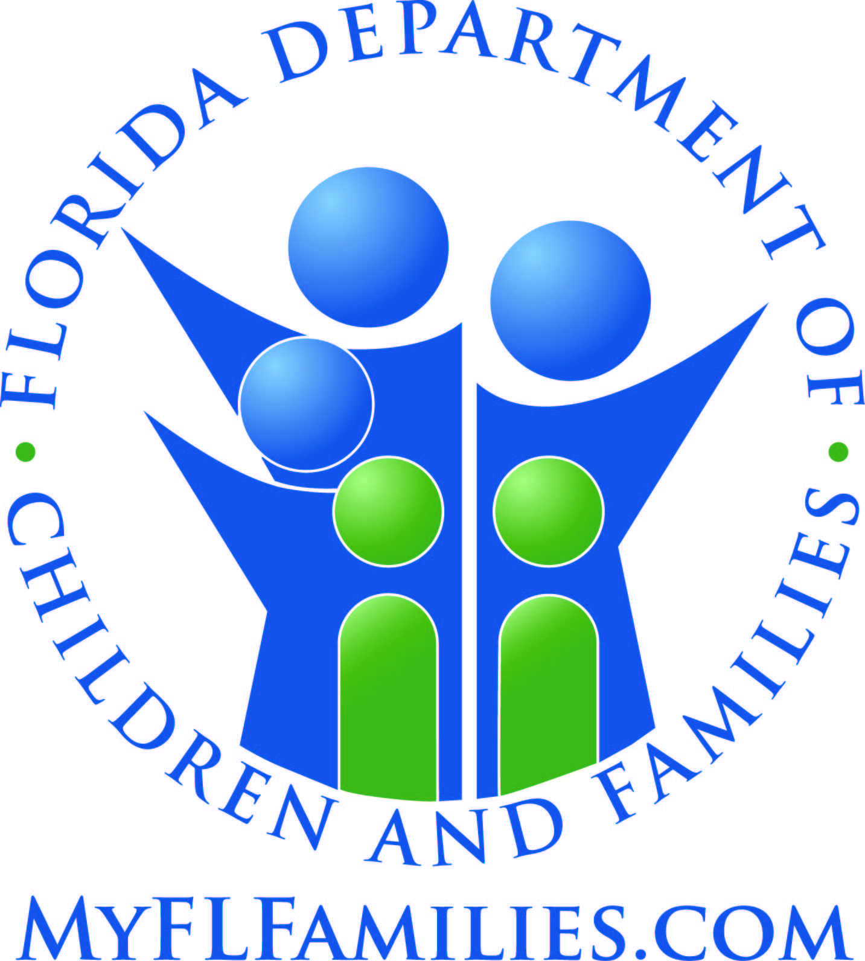 | Food Assistance Work Registration Notice

Date: _________________________________________________
DCF Office Address/FAX #

Case Name: ____________________________________________

Case Number: ___________________________________________

You or the members of your household listed below are mandatory participants in the Food Stamp Employment and Training (FSET) Program. If you or members of your household must participate, the Regional Workforce Board's (RWB) One Stop Career Center staff will contact you.

Last Name | First Name

Work Participation Requirements
The Department of Children and Families (DCF) staff must register, at the time of application and every 12 months thereafter, household members who do not meet an exemption from work requirements. These household members also must:
- Participate in an FSET program if assigned; | - Participate in a workfare program, if assigned;
- Give the Regional Workforce Board information regarding employment status or availability for work; | - Not voluntarily and without good cause, quit a job of 30 or more hours a week or reduce work hours to less than 30 hours a week;
- Report to an employer, if referred; | - Accept a valid offer of suitable employment;
- Report good cause reasons for not participating, immediately; | - Apply for and seek employment;
- Inform the RWB of changes in participation, employment, family circumstances including change of address, telephone number, childcare needs, transportation problems, health problems, etc.
- The food assistance group (AG) must choose and agree on a member as head of the AG who is an adult parent or an adult with parental control of children under age 18. If the AG does not name a head member that meets these requirements, the eligibility specialist will name the adult member with the highest earned income as head of the AG.

Consequences For Failure To Participate
If you or the mandatory household members do not complete the work requirements, we will take action using the following penalties. Before we begin a penalty, we will send you a notice of adverse case action. If you complete the work requirements within the 10-day time period in the notice of adverse action, we will remove the penalty.

Food Assistance Penalties
1st Penalty: Loss of food assistance benefits for one month or until compliance, whichever is longer.
2nd Penalty: Loss of food assistance benefits for three months or until compliance, whichever is longer.
3rd Penalty: Loss of food assistance benefits for six months or until compliance, whichever is longer.
NOTE: If the person who does not complete the work requirement is the head of household, we must close the food assistance benefits for the entire food assistance household, unless that person meets a food assistance work exemption.
Work Participation Information
- You may have your case reviewed by a supervisor at the RWB. If you disagree with a decision about your work activity or support service(s), you may ask for a fair hearing.
- You may be excused from work activities, if you have good cause. Good cause reasons may include circumstances beyond your control such as illness, household emergency,or transportation failure, or lack of child care for a child under age 12. Let the RWB or DCF know if you think you have good cause.

Time Limited Able-Bodied Adults Without Dependents (ABAWDs)
Able Bodied Adults Without Dependents (ABAWDs) are healthy adults who are able to work or participate in a work program and whose food assistance benefits may be time-limited.

Time limited ABAWDs are people who:

- Are 18 through 49 years of age; | - Do not meet an exception to the ABAWD time limits; or
- Do not have children under the age of 18; | - Do not live in Labor Surplus Areas (federally approved areas of the state with high unemployment).

When FSET services are available for time limited ABAWDs, they may get food assistance in only three full months out of 36-months unless they are meeting work rules. Meeting work rules means:
- Working 20 hours per week; | - Attending a work program 20 hours a week and performing all activities;
- Working and attending a work program for a total of 20 hours per week; or | - Attending and meeting all the rules of a workfare program.

Becoming Eligible Again
An ABAWD who has already gotten food assistance benefits for three time-limited months may get them again by doing one of the following in the month before applying:

- Work 80 or more hours; | - Meet an exception to the ABAWD time limits;
- Take part in and meet all rules of a work program for 80 or more hours; or | - Work and attend a work program for a total of 80 hours; or take part in and meet all the rules of a workfare program.
This institution is prohibited from discriminating on the basis of race, color, national origin, disability, age, sex, and in some cases religion and political beliefs. The U.S. Department of Agriculture also prohibits discrimination against its customers, employees, and applicants for employment on the basis of race, color, national origin, age, disability, sex, gender identity, religion, reprisal, and where applicable, political beliefs, marital status, familial or parental status, sexual orientation, or all or part of an individual’s income is derived from any public assistance programs, or protected genetic information in employment or in any program or activity conducted or funded by the Department. (Not all prohibited bases will apply to all programs and/or activities.)

If you wish to file a Civil Rights program complaint of discrimination with USDA, complete the USDA Program Discrimination Complaint Form, found online at http://www.ascr.usda.gov/complaint_filing_cust.html, or at any USDA office, or call (866) 632-9992 to request the form. You may also write a letter containing all of the information requested in the form. Send your completed complaint form or letter to us by mail at U.S. Department of Agriculture, Director, Office of Adjudication, 1400 Independence Avenue, S.W., Washington, D.C. 20250-9410, by fax (202) 690-7442 or email at program.intake@usda.gov. Individuals who are deaf, hard of hearing or have speech disabilities may contact USDA through the Federal Relay Service at (800) 877-8339; or (800) 845-6136 (Spanish).

For any other information dealing with Supplemental Nutrition Assistance Program (SNAP) issues, persons should either contact the USDA SNAP Hotline Number at (800) 221-5689, which is also in Spanish or call the State Information/Hotline Numbers (click the link for a listing of hotline numbers by State); found online at http://www.fns.usda.gov/snap/contact_info/hotlines.htm. To file a complaint of discrimination regarding a program receiving Federal financial assistance through the U.S. Department of Health and Human Services (HHS), write: HHS Director, Office for Civil Rights, Room 515-F, 200 Independence Avenue, S.W., Washington, D.C. 20201 or call (202) 619-0403 (voice) or (800) 537-7697 (TTY). USDA and HHS are equal opportunity providers and employers.

