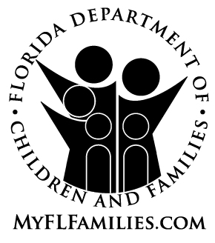 | Notice of Determination of Asset (or Income) Transfer

Name: |  |  | Date Mailed:
Address: |  |  | Case Name:
 |  |  | Case Number:

We have determined that you gave away, reduced the value of, or sold the following asset(s), or income, for less than fair market value:
Asset(s)/Income | Date of Transfer | Fair Market Value | Compensation Received | Uncompensated Value
 |  | $ | $ | $
 |  | $ | $ | $
 |  | $ | $ | $
The uncompensated value is the difference between what the asset or income was worth (fair market value) and the value of what you received for the asset or income.
When you give an asset or income away, reduce the value of it, or sell it for less than it is worth, we must presume that you did this to receive Medicaid benefits. This action may result in your being ineligible for Medicaid Institutional Care Program (ICP), Home and Community Based Services (HCBS), Institutional Hospice or Program of All-inclusive Care for the Elderly (PACE) unless you present to us clear and convincing evidence that:
● You gave away, reduced the value of, or sold the asset (or income) solely for a reason other than to receive Medicaid; or
● You would have an undue hardship situation because you cannot pay for food, clothing, a place to live, or medical care and your life or health would be endangered if a penalty period is imposed causing you to not qualify for ICP, HCBS, Institutional Hospice, or PACE Medicaid assistance. In order for the undue hardship waiver provision to apply, you must make all efforts to recover the transferred assets (or income), or to receive fair compensation.
You or your designated representative must contact the eligibility specialist whose name and telephone number appear below within 15 calendar days of the mailing date on this notice to discuss this matter.
With your consent, or the consent of your designated representative, your facility may request a hardship exception on your behalf.
If we do not hear from you within 15 calendar days of the mailing date on this notice, we must presume that you made the transfer for the purpose of receiving Medicaid. We will send you a formal notice of your Medicaid eligibility status, including your rights to a fair hearing, when the final determination is complete.
Eligibility Specialist/Phone Number: | Office Address:

