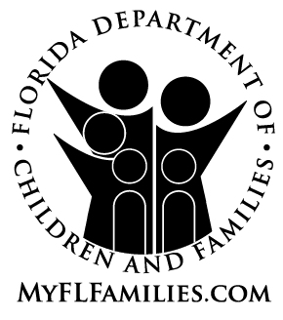 | MEDICAID TRANSFER DISPOSITION NOTICE

Name:  Address: | Date Mailed: _______________  Case Name: __________________  Case Number: _______________
– – – – – – – – – – – – – – – (Fold here for window envelope) – – – – – – – – – – – – – – –

Dear |  | :

We determined that your application dated _______________ for _________________________ (program) is approved for general Medicaid services only. This means that Medicaid may pay for a wide variety of services for you, such as physician’s services, hospital services, medical supplies and equipment, laboratory and others.

Your application was not approved for Medicaid to pay for the long-term care services you received from _________________________ to _________________________ as you transferred assets (or income) without receiving fair compensation and you did not present clear and convincing evidence that you:
● Gave away, reduced the value of, or sold the asset (or income) solely for a reason other than
to receive Medicaid; or
● Have an undue hardship situation and your life or health is endangered because you are
unable to pay for food, clothing, a place to live, or medical care.
We will review your case in the last month indicated above to redetermine your eligibility for Medicaid for long-term care services.

This action is in accordance with Rule 65A-1.712, Florida Administrative Code.
Eligibility Specialist/Phone Number: | Office Address:

If you have questions about this notice, contact the eligibility specialist at the telephone number or address listed above.
You have the right to ask for a hearing before a state hearings officer. You can bring with you or be represented at the hearing by a lawyer, relative, friend or anyone you choose. If you want a hearing, you must ask for the hearing by writing, calling the call center, or coming into the office within 90 days from the mailing date at the top of this notice. If you ask for a hearing by the end of the last day of the month prior to the effective date of the adverse action, your benefits may continue at the prior level until the hearing decision. You will be responsible to repay any benefits continued if the hearing decision is not in your favor. If you need information about how to receive free legal advice, you can call the ACCESS Florida Customer Call Center toll free at 1-866-762-2237 for a listing of free legal agencies in your area or you can get it at www.myflorida.com/accessflorida/.
In accordance with Federal laws and State policy, the Department of Children and Families is prohibited from discriminating on the basis of race, color, national origin, sex, age, disability, religion, political belief or marital status.

