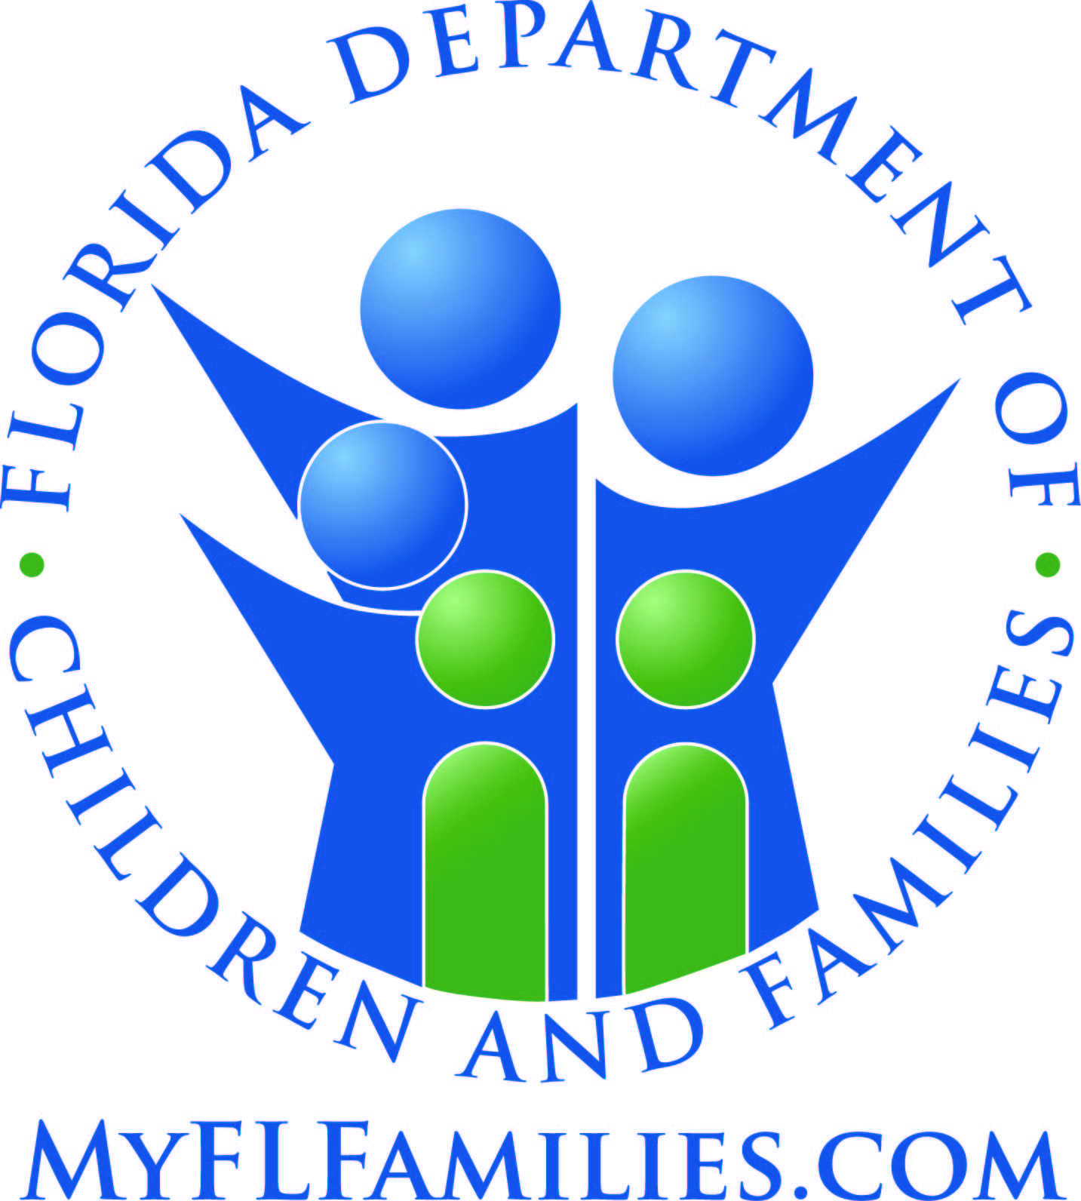 | CHANGE REPORT FORM |  | OFFICE USE ONLY – DATE STAMP
Name: |  | Case No:
Address: |  | Phone numbers where you can be reached
City/State/Zip: |  | Home: Other:
Food assistance households only have to report a change when the total monthly gross income exceeds 130% of the Federal Poverty Level for the household size and when work hours of able bodied adults fall below 20 hours per week when averaged monthly. The household must report these changes within 10 days after the end of the month of the change.
Is this a new address? Yes No Date moved:________________
New rent / mortgage payment: $___________ per Month Week Other:__________________
Do you pay separately for utilities? Yes No Do you have a heating or cooling expense? Yes No
Please tell us about the change(s) by filling in the spaces below. Continue your reply on the back of this form if you need to. You can mail this form to us or bring it to the office. If you do not understand this form, call your local office at _________________ and someone will help you. You can also report change(s) through My Account.
1. PERSONS: Moved In Moved Out Date moved in / out:________________
NAME | RELATIONSHIP TO YOU | INCOME / ASSETS | DATE OF  BIRTH / DEATH | SOCIAL SECURITY NUMBER | DISABLED  Yes No
2. INCOME CHANGES: New income source Rate of pay/number of hours increase/decrease:____________
Income loss Date & amount of first/last payment:____________________ First/last day of work:__________
Reason employment/income stopped:______________________________________________________________
WHOSE INCOME | WHAT INCOME SOURCE CHANGED | PAID/RECEIVED  (weekly, every 2 wks, biwkly, monthly, other) | DAY OF WEEK PAY / INCOME RECEIVED | GROSS INCOME AMOUNT
3. ASSET CHANGES: You must report if the money you have in cash, checking, savings, stocks, bonds, etc., reaches $2,000 or if you buy/sell a vehicle, house, property, etc.: New Bought Sold Traded Transferred
Depleted Other:__________________________________________________________________________
WHOSE ASSET | WHAT ASSET / YEAR | HOW USED | AMOUNT
4. FUTURE CHANGES: Do you think the changes you reported will stay the same next month? Yes No. If no, please explain:______________________________________________________________________________________
IF YOUR BENEFITS CHANGE, we will send you a notice. If you do not agree with the change in benefits, you may ask for a Fair Hearing. A Hearings Officer will decide if the decision we made was right or wrong.
PLEASE READ AND SIGN: I understand and agree to the following: DCF, Public Assistance Fraud (PAF), and authorized Federal Agencies may verify the information I give on this form and at my interview. Information may be obtained from my past or present employers. I will report any change in my situation according to program requirements. If any information is incorrect, benefits may be reduced or denied and I may be subject to criminal prosecution or disqualified from the program for knowingly providing incorrect information. I can be prosecuted if I provide false information or hide information. I understand that: I may be entitled to more food assistance if I report that my household’s income has decreased or stopped; if I do not report that my household’s income has decreased or stopped, then I will not get an increase in my food assistance benefit amount; and if I do not report increases in income or that income has started, then there may be penalties.
__________________________________________________________________ ____________________
Your Signature Today’s Date

