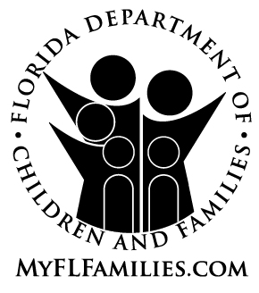 | Public Assistance Fraud Reward Program  REPORT OF SUSPECTED OR KNOWN  PUBLIC ASSISTANCE FRAUD

You may be eligible to receive a reward. If you remain anonymous or opt out of the reward program you will not be eligible for a reward but your report will still be processed.
I wish to remain anonymous: ☐
I understand that by checking this box I am withholding my personal information and I will not be eligible for a reward through the Public Assistance Fraud Reward Program. In addition, I will not have the ability to track the status of my report.
I wish to opt out of the reward process: ☐
I understand that by checking this box I will not be eligible for a reward through the Public Assistance Fraud Reward Program, however I will have the ability to track the status of my report.

Who Do You Think Is Committing Fraud
To ensure that your report can be processed and/or investigated thoroughly, please provide as much information about the person you think is committing Public Assistance Fraud (Food Assistance, Food Stamps, SNAP, TANF, Cash Assistance or Medicaid). All fields marked with an asterisk (*) must be completed for the report to be processed.
First Name:* |  | Last Name:*
Street Address: |  | City:*
State: | Zip Code: | Phone (include area code):
Date of Birth or estimated Age:* |  | DCF Case Number (if known):

Allegation Details
Please tell us below why you think they are committing fraud. You may attach additional sheets, if necessary.

CONFIDENTIALITY NOTICE: The information and any attachments provided are intended for the sole use of the Department, but are subject to public disclosure pursuant to Chapter 119, F.S.
Your Information
If you wish to remain anonymous, please do not enter any personal information. To be eligible for a reward and to have the ability to track the status of your report, all fields marked with an asterisk (*) must be completed.
First Name:* |  | Last Name:*
Mailing Address:* |  |  | City:*
State:* | Zip Code:* |  | Phone (include area code):

Mail reports of suspected or known fraud to:
ACCESS Central Mail Center
Fraud Report
PO Box 1770
Ocala, FL 34478-1771
Reports of suspected or known fraud can also be faxed to:
(850) 487-0800

