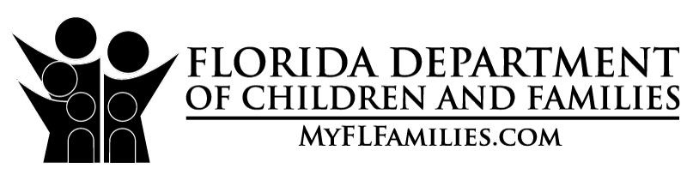 |  | 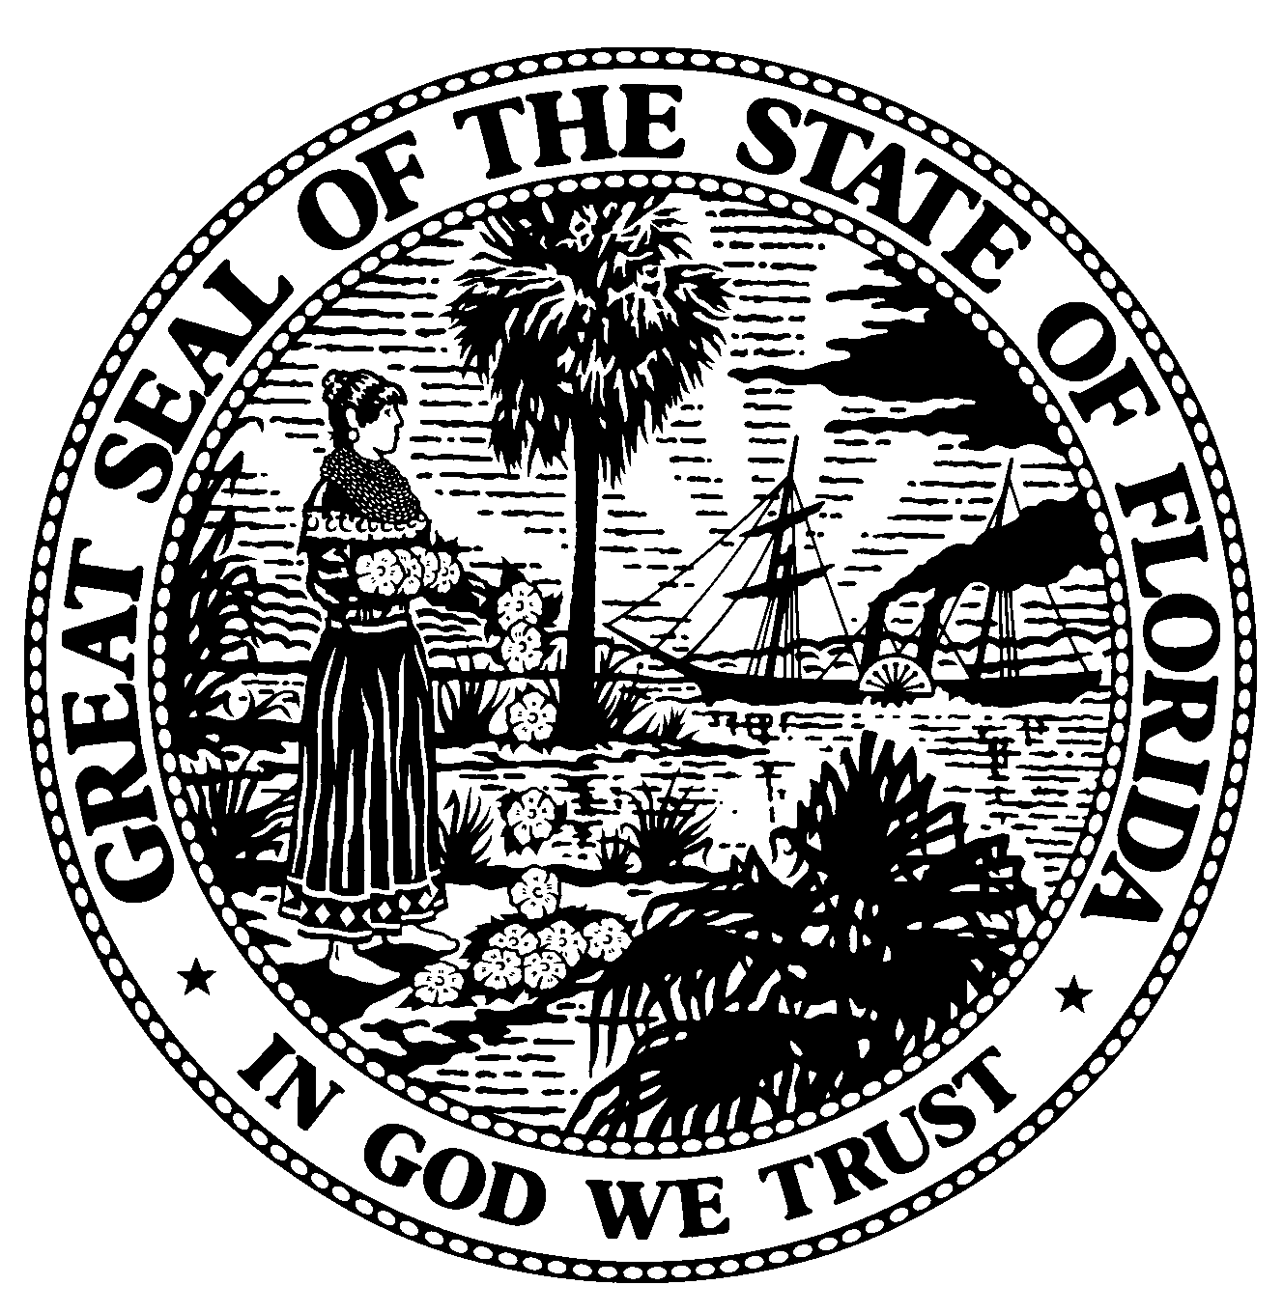 |  | RESULTS  SATISFACTORY to meet level II requirements  UNSATISFACTORY  to meet level II requirements  CORRECT VIOLATIONS
PURPOSE
INITIAL
FOLLOW-UP  RE-LICENSING | State of Florida  Department of Children and Families  FOSTER HOME INSPECTION CHECKLIST |  |  | BY FOLLOW-UP ON:  __________ (date)  __________ (time)

Name of Foster Parent(s):
(Last Name) (First Name)
Location Address:

City: |  | State: | FL | Zip Code:

E-Mail: |  | Home Phone: |  | Work Phone:

Licensed Capacity
for Foster Home: k

Current Capacity
for All Children
in the Home: k
 | BEGIN TIME | END TIME | DATE

WATER SUPPLY & WASTE WATER  C NC NO NA  1. Private well – routine testing  2. Private well – results absent  SEWAGE  C NC No NA  3. Onsite septic system operational per 64E-6  PLUMBING  C NC NO NA  4. Bath clean and working  5. Toilet clean and working | VEXTOR CONTROL  C NC NO NA  6. Effective control measures  7. Creation of conditions  8. Rodent/Rat proof  9. Inside opening screened  GARBAGE & RUBBISH DISPOSAL  C NC NO NA  10. Collection frequency  11. Garbage placed in receptacle  12. All garbage cans have covered lids  13. Garbage areas clean | FIRE SAFETY/OTHER  C NC NO NA  14. Smoke detectors  15. Burglar bars  16. Fire extinguisher  17. Safety net for trampoline
Marking Key: C = the act or item was observed to meet standards; NC = the act or item was observed not to meet standards; NO = the act or item was not observed to be occurring at the time of inspection; NA = the act or item is not performed by the facility or not part of the operation
Comments:

Licensing Counselor: |  | Foster Parent  Signature:

Licensing Supervisor: |  | Date:

DCF Check Sheet for Licensed Foster Homes

WATER SUPPLY & WASTE WATER
1. Private well-routine testing: Licensed out-of-home caregivers not served by a municipal water supply shall test the water and submit bacteriological water test results to the local county health department. Testing may also be conducted by the licensing specialist using an at home water testing kit. Routine Testing shall occur (I) Before license approval; (II) At least every 12 months; (III) Upon relocation; (IV) Before having the well placed in service after construction, repair, or modification; or (V) After an emergency situation, such as a flood, that may introduce contaminants to the system.
2. Private well-results absent: Test results must be negative for bacteriological contamination. Positive test results require the facility to use potable water from a source approved by law for the purpose of drinking, cooking, and oral contact, until test results are negative. In addition, wells that test positive shall be disinfected, flushed, and tested for bacterial contamination.

SEWAGE
3. Onsite septic system: The Department of Health requires any home not on a municipal sewage system and having an onsite sewage treatment and disposal system or septic tank to meet applicable standards in Chapter 64E-6, Florida Administrative Code.

PlumbINg
4. Bath clean & working: Bath facilities shall be clean and in good working order.
5. Toilet clean & working: Toilet facilities shall be clean and in good working order.

Vector Control
6. Effective control measures: Effective control measures shall be utilized to minimize the presence of rodents, flies, cockroaches, and other vectors and vermin on the premises.
7. Creation of conditions: The creation, maintenance, or causing of any condition capable of causing vectors and vermin will not be permitted.
8. Rodent/Rat Proof: The home shall be effectively maintained rodent-proof and rodent free.
9. Inside openings screened: All inside openings shall be effectively sealed or screened with 16 mesh screening or equivalent, to prevent entry of insects, rodents, or other vectors and vermin.

GARBAGE & RUBBISH DISPOSAL
10. Collection frequency: All garbage, trash, and rubbish from the kitchen area shall be collected daily. Garbage or trash containing diapers, or any odor-causing agent shall also be collected daily and placed in garbage receptacles. Garbage or trash consisting only of paper items must be collected weekly. Garbage shall be removed from garbage receptacles frequently enough to prevent a sanitary nuisance, as defined in Chapter 386, F.S.
11. Garbage placed in receptacle: All garbage, trash, and rubbish from the kitchen area, paper items, and diapers or odor-causing agents shall be placed in garbage receptacles.
12. Wet garbage in fly tight container: Wet garbage shall be collected and stored in impermeable, leak proof, fly tight containers pending disposal.
13. Garbage areas clean: All containers, storage areas and, surrounding premises shall be kept clean and free of vectors and vermin. And, all garbage and trash shall be covered and removed regularly.

FIRE SAFETY/OTHER
14. Smoke Detectors: A description of how the home complies with safety requirements, including smoke detectors.
15. Burglar Bars: If the home is equipped with burglar bars, the caregiver shall demonstrate that the burglar bars can be released to allow exit. A key placed near a window does not qualify as an approved emergency release method. Age appropriate training on opening of the burglar bars shall be provided to each child upon placement.
16. Operating fire extinguishers: Each floor in the home shall have a fully charged 2A10BC fire extinguisher.
17. Trampoline: A description of how the home complies with safety requirements, including a safety net for trampolines.

