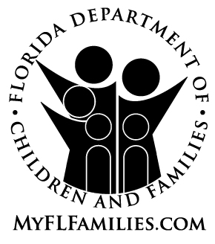 | EXTENDED FOSTER CARE AGREEMENT

Name: |  | Date of Birth:

The day that I will enter Extended Foster Care (EFC):

My option to remain in EFC according to section 39.6251, Florida Statutes, and chapter 65C-41, Florida Administrative Code, has been explained to me and I believe this decision is in my best interest. I agree
that I will:

- Live in an approved supervised living arrangement;
- Meet face to face in my home with designated staff every month;
- Participate in ongoing transition and case planning; AND
- Participate in a qualifying activity.

The qualifying activity that I have chosen while remaining in EFC is (must select at least one):
Completing secondary education or a program leading to an equivalent credential;
Enrollment in an institution that provides postsecondary or vocational education;
Participating in a program or activity designed to promote or eliminate barriers to employment;
Employment at least 80 hours per month;
Unable to participate full time in any of the programs or activities listed above due to a physical, intellectual, emotional, or psychiatric condition that, limits my participation.*

*I understand that if my case file, medical or educational records do not already contain documentation that establishes a qualifying condition, staff will help me in obtaining documentation from a licensed health care provider – a list of licensed providers is in 65C-41.003, F.A.C.

Signed:

______________________________________________ ______________
Youth Date (mm/dd/yyyy)

______________________________________________ ______________
Designated Staff Date (mm/dd/yyyy)

Designated staff shall provide a copy to the young adult and attach a copy to the Transition Plan that is filed with court at the last review hearing before the child’s 18 birthday.

