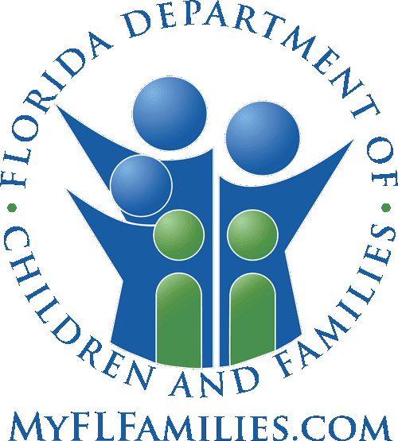 | State of Florida  Department of Children and Families  APPLICATION FOR  GUARDIANSHIP ASSISTANCE PROGRAM

Date: ____________________

I / We ____________________________________________________________________________________________
Applicant One: First Name Middle Name Last Name
also known as _____________________________________________________________________________________

____________________________________________________________________________________________
Applicant Two: First Name Middle Name Last Name
also known as _____________________________________________________________________________________

Residing at _______________________________________________________________________________________

County _____________________ Phone _________________ E-mail ______________________________________

Hereby apply for the Guardianship Assistance Program in accordance with the provisions of Section 39.6225, Florida Statutes, and agree to cooperate with the requirements of the Department for participation in the Guardianship Assistance Program.

_______________________________________________________________
Applicant One Signature Last 4 of SSN

_______________________________________________________________
Applicant Two Signature Last 4 of SSN

(All applicants must sign the application.)

This application may be withdrawn at any by time the applicant(s).

IMPORTANT NOTE: Pursuant to the Multi-Ethnic Placement Act of 1994 and the Small Business Job Protection Act of 1996, Section 1808, Removal of Barriers to Interethnic Adoption, “race, culture or ethnicity may not be used as a basis for any denial of placement, nor may such factors be used as a reason to delay any foster or adoptive placement. Discrimination is not to be tolerated, whether it is directed toward adults who wish to serve as foster or adoptive parents, toward children who need safe and appropriate homes, or toward communities or populations which may have previously been under-utilized as a resource for placing children.”

