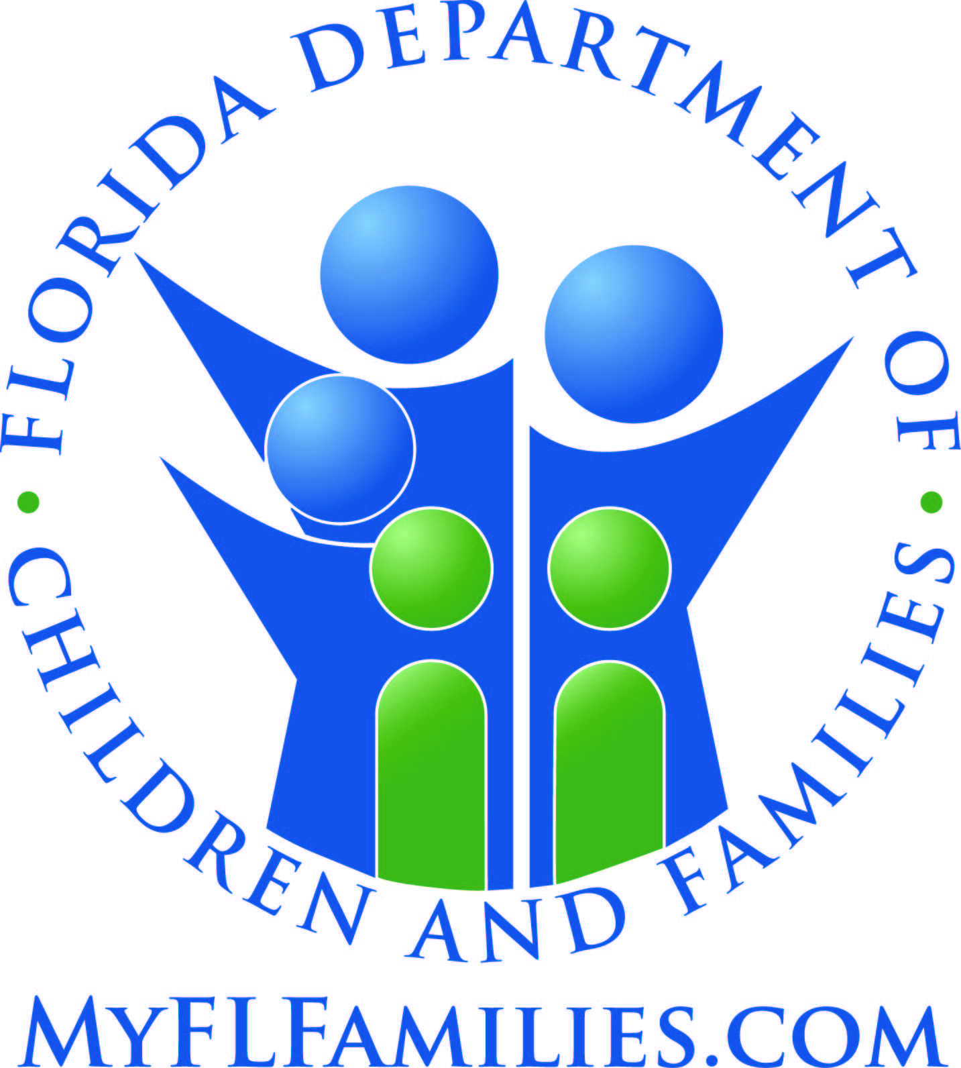

Methodology of Determination of Need
Methadone Medication-Assisted Treatment

Department of Children and Families
Office of Substance Abuse and Mental Health

Introduction
The Office of Substance Abuse and Mental Health within the Department of Children and Families (Department) is the single state agency responsible for a statewide system of prevention, treatment, and recovery support services for individuals with or at risk of developing substance use disorders. This includes regulating substance abuse treatment services. In accordance with s. 397.427, F.S., the Department shall not license any new medication-assisted treatment programs for opioid addiction until it conducts a needs assessment to determine whether additional providers are needed in each Florida sub-state entity. The determination of need only applies to methadone medication-assisted treatment programs.
In determining need for additional methadone medication-assisted treatment programs, the following data will be examined:
- Population estimates for those ages 18 and older by county;
- Estimated number of individuals with Pain Reliever misuse or disorder in the past year;
- Estimated number of individuals with Heroin Use in the past year;
- Estimated number of individuals needing but not receiving treatment for Drug Use; and
- Data on treatment accessibility of existing and approved providers, specifically:
  - Clinic Capacity,
  - Average Daily Census, and
  - Service provision for indigent individuals eligible for publicly-funded services, pregnant women, and Medicaid recipients

The data examined will be used to determine whether and where there is a need for new methadone medication-assisted treatment programs.

Needs assessment methodology
This methodology is based on data from the National Survey on Drug Use and Health (NSDUH), an annual survey sponsored by the Substance Abuse and Mental Health Services Administration (SAMHSA). The NSDUH collects data from a representative sample of the non-institutionalized household population through face-to-face interviews. The formula to determine unmet treatment need considers the estimated number of people who misuse/abuse/dependent on heroin or pain relievers who felt a need to get treatment but did not receive treatment, as well as provider reported treatment accessibility and program data.

Data
Described below is the information that will be used in determining need.
- Population Estimates: Population estimates will be exported (Population: 18 and older by County) from the Florida Health Charts website at (http://www.flhealthcharts.com/FLQUERY/Population/PopulationRpt.aspx). These population estimates are provided by the Department of Health, Office of Health Statistics and Assessment in consultation with the Florida Legislature's Office of Economic and Demographic Research.

- Estimated number of individuals with Pain Reliever Misuse or Disorder in the past year: The estimated number of individuals with Pain Reliever Use Misuse or Disorder is derived from the NSDUH. Pain Reliever Use Disorder is defined as meeting criteria for pain reliever dependence or abuse. Misuse of prescription psychotherapeutics (including pain relievers) is defined as use in any way not directed by a doctor, including use without a prescription of one's own; use in greater amounts, more often, or longer than told; or use in any other way not directed by a doctor. Prescription psychotherapeutics do not include over-the-counter drugs. The estimated number of individuals with Pain Reliever Use Misuse or Disorder is based on a multiple year pooling of data that produce state and sub-state level percentage estimate. This percentage is applied to the county population estimates to give an estimated number of individuals with Pain Reliever Use Misuse or Disorder.
Source: https://www.samhsa.gov/data/data-we-collect/nsduh-national-survey-drug-use-and-health

- Estimated number of individuals with Heroin Use in the past year: The estimated number of individuals with Heroin Use is derived from the NSDUH. The assumption is made that all individuals with past year Heroin Use need treatment. The estimated number of individuals with heroin use is based on a multiple year pooling of data that produce state and sub-state level percentage estimate. This percentage is then applied to the county population estimates to give an estimated number of individuals with heroin use.
Source: https://www.samhsa.gov/data/data-we-collect/nsduh-national-survey-drug-use-and-health

- Past year estimated number of individuals needing but not receiving treatment for Drug Use: The estimated number of individuals who had need for treatment but did not receive treatment in the past year for Drug Use is derived from the NSDUH. The estimated number is based on a multiple year pooling of data that produce a national, state, or sub-state percentage estimate. Individuals are classified as needing treatment for a drug problem if they met the criteria for illicit drug use, dependence, or abuse. Illicit Drug Use includes the misuse of prescription psychotherapeutics or the use of marijuana, cocaine (including crack), heroin, hallucinogens, inhalants, or methamphetamine. Needing But Not Receiving Treatment refers to individuals classified as needing treatment for drugs, but have not received treatment for a drug problem at a specialty facility.
Source: https://rdas.samhsa.gov/#/

- Treatment Accessibility Data:
The following data will be gathered from the Department-approved Central Registry and Licensure Database where approved providers self-report.
  - Clinic capacity is defined as the maximum number of active individuals that can be in treatment per provider. Standardized reporting of clinic capacity is recorded in Licensure Database for all providers. Data will reflect clinic capacity as it was reported by the provider. The Central Registry does not anticipate projected year clinic capacity. Clinic capacity is self-reported by the provider.
  - Average daily census is defined as the average total number of individuals in treatment. Standardized reporting of average census is recorded in the Central Registry for all providers. Data will reflect clinic census as it stands for the previous 12 months from collection date.

Formulas and Determination of Need
The formula used in this needs assessment uses the above variables as follows:
- Population estimates for those 18 and older by county were obtained (POP).
- Estimated Number with Past Year Pain Relieve Misuse or Disorder (NPRMD):
  - Estimated percentage of individuals with Pain Reliever Misuse or Disorder (PPRMD) is applied to the county population estimates to give an estimated number of individuals with Pain Reliever Misuse or Disorder.
(PPRMD*POP) = NPRMD
- Estimated Number with Past Year Heroin Use (NHU):
  - Estimated percentage of individuals with Heroin Use (PHU) is applied to the county population estimates to give an estimated number of individuals with Heroin Use.
(PHU*POP) = NHU
- Total Individuals with Use/Disorders (TIUD):
  - Combine the Estimated Numbers of Pain Reliever Use Disorder and Heroin Use.
(NPRMD + NHU) = Total Individuals with Use/Disorders (TIUD)
- Unmet Treatment need (UNMET):

  - Estimated percentage of individuals needing but not receiving treatment for Drug Use/Disorder (NOTREAT) is applied to the total number of individuals with a use/disorder (TIUD).
(TIUD*NOTREAT) =UNMET
- Remaining County Treatment Capacity (RTC):
  - Combine providers clinic capacity to have a county capacity (TCC) and subtract the combined average daily census (ADC)
(TCC – ADC) = RTC
The Department will determine need for each county by entering values for each data point as described.
- If UNMET minus RTC is < 60, then additional clinics are not needed.

- If UNMET is not greater than RTC, then additional clinics are not needed, unless the existing clinic(s) do not serve individuals who are indigent and eligible for publicly-funded services, pregnant women, and Medicaid recipients and then an additional clinic which serves these populations is needed.

- If UNMET minus RTC is > 60, then additional clinics are needed, at least one of which must serve individuals who are indigent and eligible for publicly-funded services, pregnant women, and Medicaid recipients.

- Determination of number of additional clinics needed:
  - If UNMET is not greater than RTC, but the existing clinic(s) do not serve individuals who are indigent and eligible for publicly-funded services, pregnant women, and Medicaid recipients and then one additional clinic which serves these populations is needed.

  - If UNMET minus RTC is > 60, then determine average clinic capacity (ACC) by adding the provider capacity of all full clinics and divide by the number of full clinics.

    - Divide UNMET by average clinic capacity (ACC)

    - (UNMET/ACC) = Number of additional clinics needed per county

