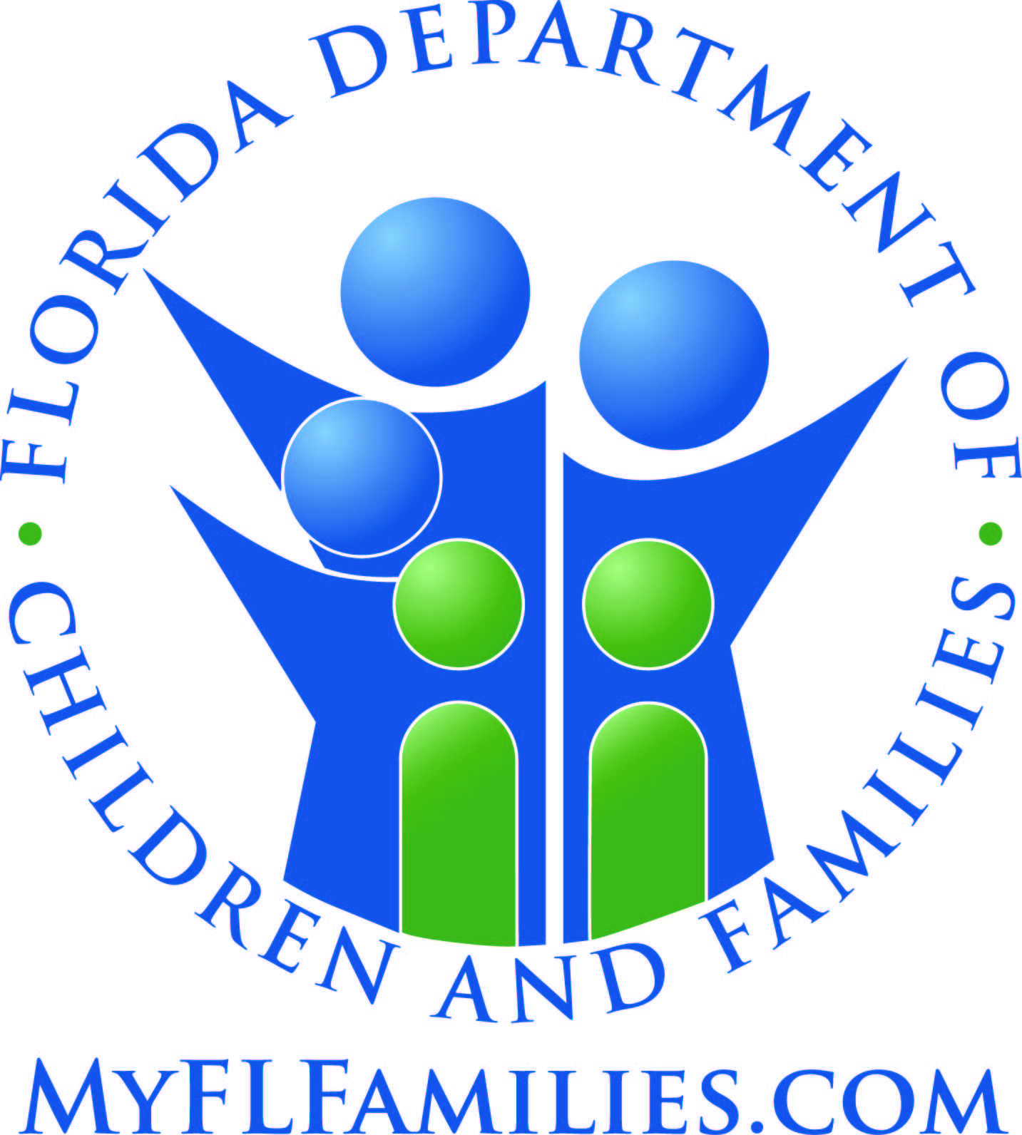 | Adult Protective Services  DUE PROCESS RIGHTS

If the Department has denied your application for services under the Home Care for Disabled Adults (HCDA) or Community Care for Disabled Adults (CCDA) programs, or if your services have been stopped or reduced, and you believe the Department’s decision is incorrect, you may request an administrative hearing to challenge the decision.

If the Department denies your application for HCDA or CCDA services, or terminates or reduces services you were already receiving, the Department will send you a letter explaining its decision. If you wish to challenge the decision, you must file a request for a hearing in writing within 21 calendar days from the day you receive the Department’s letter. The Department’s letter will tell you where to mail or fax your written request for a hearing. A request for a hearing is “filed” when it is received by the Department. If the Department does not receive your request within the 21-day period, your right to a hearing will be lost.

The administrative hearing may be “formal” or “informal”. A formal hearing is held if you dispute the facts on which the Department made its decision. Your request for a hearing must identify the specific facts which you dispute. An administrative law judge assigned by the Division of Administrative Hearings will conduct a formal hearing. You and the Department will have the opportunity to present witnesses and documents as evidence. You will have the opportunity to tell the judge why you believe the Department’s action is incorrect. The judge will make findings of fact to resolve the factual dispute and will provide a recommendation as to how the case should be decided based on the facts the judge has found. The judge will then return the case to the Department Secretary for a decision. The Department’s decision is called a “final order”.

An informal hearing is held when you do not dispute the basic facts relating to your case, but you disagree with the Department’s decision concerning your application for or receipt of services. A hearing officer assigned by the Department will conduct an informal hearing. You will have the opportunity to explain why the Department’s decision was incorrect, based on the facts of your case and the applicable law. The hearing officer will identify the agreed facts and will provide a recommendation as to the how the case should be decided based on those facts. The hearing officer will then send the case to the Department Secretary for a final order.

You have the right to appeal an unfavorable final order to the District Court of Appeal. The final order will explain how to start the appeal process. Generally, if your case involves a termination or reduction of services, the termination or reduction will take effect once the final order is issued. If you appeal to the District Court of Appeal, you may request the Court to enter an order directing the Department to continue your services while the appeal is pending. If, however, you eventually lose the appeal, you may be required to repay the cost of the services to the Department.

ADDITIONAL INFORMATION CONCERNING ADMINISTRATIVE PROCEEDINGS MAY BE FOUND IN CHAPTER 120, FLORIDA STATUTES, AND CHAPTER 28-106, FLORIDA ADMINISTRATIVE CODE.

