

Agricultural Marketing Service, USDA Pt. 56

and Budget pursuant to the Paperwork Reduction Act of 1995 (44 U.S.C. Chap- ter 35).

7 CFR section where requirements are described | Current OMB control No.
54.1008(a) ......................................................... | 0581–0126
54.1017 .............................................................. | 0581–0126
54.1018(e) ......................................................... | 0581–0126
54.1019 .............................................................. | 0581–0126
54.1020 .............................................................. | 0581–0126
54.1021 .............................................................. | 0581–0126

PART 56—VOLUNTARY GRADING OF SHELL EGGS

Subpart A—Grading of Shell Eggs
DEFINITIONS
Sec.
  - Meaning of words and terms defined.
  - Designation of official certificates, memoranda, marks, other identifica- tions, and devices for purposes of the Ag- ricultural Marketing Act.
GENERAL
  - Administration.
  - Basis of grading service.
  - Accessibility of product.
  - Supervision.
  - Nondiscrimination.
  - Other applicable regulations.
  - OMB control number.
LICENSED AND AUTHORIZED GRADERS
  - Who may be licensed and authorized.
  - Financial interest of graders.
  - Suspension of license; revocation.
  - Cancellation of license.
  - Surrender of license.
  - Political activity.
  - Identification.
  - Equipment and facilities for graders.
  - Schedule of operation of official plants.
  - Prerequisites to grading.
APPLICATION FOR GRADING SERVICE
  - Who may obtain grading service.
  - How application for service may be made; conditions of service.
  - Filing of application.
  - Form of application.
  - Rejection of application.
  - Withdrawal of application.
  - Authority of applicant.
  - Order of service.
  - Types of service.
  - Suspension or withdrawal of plant ap- proval for correctable cause.
  - Application for grading service in offi- cial plants; approval.

REPORTS
  - Report of grading work.
  - Information to be furnished to grad- ers.
  - Report of violations
IDENTIFYING AND MARKING PRODUCTS
  - Authority to use, and approval of offi- cial identification.
  - Form of grademark and information required.
  - Lot marking of officially identified shell eggs.
  - Retention authorities.
PREREQUISITES TO PACKAGING SHELL EGGS IDENTIFIED WITH GRADEMARKS
  - Quality assurance inspector required.
  - Grading requirements of shell eggs identified with grademarks.
  - Check grading officially identified product.
  - –56.43 [Reserved]
FEES AND CHARGES
  - Payment of fees and charges.
  - On a fee basis.
  - Fees for appeal grading or review of a grader’s decision.
56.49 Travel expenses and other charges.
  - Charges for continuous grading per- formed on a resident basis.
  - Fees or charges for grading service performed under cooperative agreement.
  - Charges for continuous grading per- formed on a nonresident basis.
GRADING CERTIFICATES
  - Forms.
  - Issuance.
  - Disposition.
  - Advance information.
APPEAL OF A GRADING OR DECISION
  - Who may request an appeal grading or review of a grader’s decision.
  - Where to file an appeal.
  - How to file an appeal.
  - When an application for an appeal grading may be refused.
  - Who shall perform the appeal.
  - Procedures for appeal gradings.
  - Appeal grading certificates.
DENIAL OF SERVICE
  - Debarment.
  - Misrepresentation, deceptive, or fraud- ulent act or practice.
  - Use of facsimile forms.
  - Willful violation of the regulations.
  - Interfering with a grader or employee of the AMS.
  - Misleading labeling.
  - Miscellaneous.

§ 56.1

FACILITY REQUIREMENTS
  - Applicability of facility and operating requirements.
  - Minimum facility and operating re- quirements for shell egg grading and packing plants.
  - Health and hygiene of personnel. AUTHORITY: 7 U.S.C. 1621–1627.

Subpart A—Grading of Shell Eggs
DEFINITIONS

§ 56.1 Meaning of words and terms de- fined.
For the purpose of the regulations in this part, words in the singular shall be deemed to import the plural and vice versa, as the case may demand. Unless the context otherwise requires, the terms shall have the following mean- ing:
Acceptable means suitable for the pur- pose intended by the AMS.
Act means the applicable provisions of the Agricultural Marketing Act of 1946 (60 Stat. 1087, as amended; 7 U.S.C. 1621 et seq.), or any other act of Con- gress conferring like authority.
Administrator means the Adminis- trator of the AMS or any other officer or employee of the Department to whom there has heretofore been dele- gated, or to whom there may hereafter be delegated the authority to act in the Administrator’s stead.
Agricultural Marketing Service or AMS means the Agricultural Marketing Service of the Department.
Ambient temperature means the air temperature maintained in an egg stor- age facility or transport vehicle.
Applicant means any interested per- son who requests any grading service.
Auditing services means the act of pro- viding independent verification of writ- ten quality assurance and value added standards for production, processing and distribution of shell eggs. Auditing services are performed by graders au- thorized by the Secretary to perform such audits and the service provided will be in accordance with the provi- sions of this part for grading services, as appropriate.
Cage mark means any stain-type mark caused by an egg coming in con- tact with a material that imparts a

7 CFR Ch. I (1–1–16 Edition)

rusty or blackish appearance to the shell.
Case means, when referring to con- tainers, an egg case, as used in com- mercial practice in the United States, holding 30 dozens of shell eggs.
Chief of the Grading Branch means the Chief of the Grading Branch, Poultry Programs, AMS.
Class means any subdivision of a product based on essential physical characteristics that differentiate be- tween major groups of the same kind, species, or method of processing.
Condition means any condition (in- cluding, but not being limited to, the state of preservation, cleanliness, soundness, wholesomeness, or fitness for human food) of any product which affects its merchantability.
Consumer grades means U.S. Grade AA, A, and B.
Department means the United States Department of Agriculture (USDA).
Eggs of current production means shell eggs that are no more than 21 days old. Grademark means the official identi- fication symbol (shield) used to iden- tify eggs officially graded according to
U.S. consumer grade standards.
Grader means any Federal or State employee or the employee of a local ju- risdiction or cooperating agency to whom a license has been issued by the Secretary to investigate and certify in accordance with the regulations in this part, the class, quality, quantity, or condition of products.
Grading or grading service means: (1) The act whereby a grader determines, according to the regulations in this part, the class, quality, quantity, or condition of any product by examining each unit thereof or each unit of the representative sample thereof drawn by a grader and issues a grading certifi- cate with respect thereto, except that with respect to grading service per- formed on a resident basis the issuance of a grading certificate shall be pursu- ant to a request therefor by the appli- cant or the AMS; (2) the act whereby the grader identifies, according to the regulations in this part, the graded product; (3) continuous supervision, in an official plant, of the handling or packaging of any product; and (4) any regrading or any appeal grading of a previously graded product.

Agricultural Marketing Service, USDA § 56.1

Grading certificate means a statement, either written or printed, issued by a grader pursuant to the Act and the reg- ulations in this part, relative to the class, quantity, quality, or condition of products.
Holiday or legal holiday means the legal public holidays specified by the Congress in paragraph (a) of section 6103, title 5, of the United States Code. Identify means to apply official iden- tification to products or the containers
thereof.
Interested party means any person fi- nancially interested in a transaction involving any grading, appeal grading, or regrading of any product.
National supervisor means (a) the offi- cer in charge of the shell egg grading service of the AMS, and (b) other em- ployees of the Department designated by the national supervisor.
Nest run eggs means eggs which are packed as they come from the produc- tion facilities without having been washed, sized and/or candled for qual- ity, with the exception that some Checks, Dirties, or other obvious undergrades may have been removed.
Office of grading means the office of any grader.
Official plant or official establishment means one or more buildings or parts thereof comprising a single plant in which the facilities and methods of op- eration therein have been approved by the Administrator as suitable and ade- quate for grading service and in which grading is carried on in accordance with the regulations in this part.
Official standards means the official
U.S. standards grades, and weight classes for shell eggs maintained by and available from Poultry Programs, AMS.
Officially identified means eggs that have official marks applied to the prod- uct under the authority of the AMS in accordance with the act and its regula- tions.
Origin grading means a grading made on a lot of eggs at a plant where the eggs are graded and packed.
Packaging means the primary or im- mediate container in which eggs are packaged and which serves to protect, preserve, and maintain the condition of the eggs.

Packing means the secondary con- tainer in which the primary or imme- diate container is placed to protect, preserve, and maintain the condition of the eggs during transit or storage.
Person means any individual, part- nership, association, business trust, corporation, or any organized group of persons, whether incorporated or not.
Potable water means water that has been approved by the State health au- thority or agency or laboratory accept- able to the Administrator as safe for drinking and suitable for food proc- essing.
Product or products means shell eggs of the domesticated chicken.
Quality means the inherent prop- erties of any product which determine its relative degree of excellence.
Quality assurance inspector means any designated company employee other than the plant owner, manager, fore- man, or supervisor, authorized by the Secretary to examine product and to supervise the labeling, dating, and lotting of officially graded shell eggs and to assure that such product is packaged under sanitary conditions, graded by authorized personnel, and maintained under proper inventory control until released by an employee of the Department.
Regional director means any employee of the Department in charge of the shell egg grading service in a des- ignated geographical area.
Regulations means the provisions in this entire part and such United States standards, grades, and weight classes as may be in effect at the time grading is performed.
Sampling means the act of taking samples of any product for grading or certification.
Secretary means the Secretary of the Department or any other officer or em- ployee of the Department to whom there has heretofore been delegated, or to whom there may hereafter be dele- gated, the authority to act in the Sec- retary’s stead.
Shell egg grading service means the personnel who are actively engaged in the administration, application, and direction of shell egg grading programs and services pursuant to the regula- tions in this part.

§ 56.2

Shell eggs means shell eggs of domes- ticated chickens.
Shell protected means eggs which have had a protective covering such as oil applied to the shell surface. The prod- uct used shall be acceptable to the Food and Drug Administration.
Shipped for retail sale means shell eggs that are forwarded from the proc- essing facility for distribution to the ultimate consumer.
State supervisor or Federal-State super- visor means any authorized and des- ignated individual who is in charge of the shell egg grading service in a State. United States Standards for Quality of Individual Shell Eggs means the official
U.S. Standards, Grades, and Weight Classes for Shell Eggs (AMS 56) that are maintained by and available from Poultry Programs, AMS.
United States Standards, Grades, and Weight Classes for Shell Eggs (AMS 56) means the official U.S. standards, grades, and weight classes for shell eggs that are maintained by and avail- able from Poultry Programs, AMS.
Washed ungraded eggs means eggs which have been washed and that are either sized or unsized, but not seg- regated for quality.
[20 FR 669, Feb. 1, 1955]
EDITORIAL NOTE: For FEDERAL REGISTER ci-
tations affecting § 56.1, see the List of CFR Sections Affected, which appears in the Finding Aids section of the printed volume.

§ 56.2 Designation of official certifi- cates, memoranda, marks, other identifications, and devices for pur- poses of the Agricultural Marketing Act.
Subsection 203(h) of the Agricultural Marketing Act of 1946, as amended by Pub. L. 272, 84th Congress, provides criminal penalties for various specified offenses relating to official certifi- cates, memoranda, marks or other identifications, and devices for making such marks or identifications, issued or authorized under section 203 of said act, and certain misrepresentations concerning the grading of agricultural products under said section. For the purposes of said subsection and the provisions in this part, the terms listed in this section shall have the respec- tive meanings specified:

7 CFR Ch. I (1–1–16 Edition)

- Official certificate means any form of certification, either written or print- ed, used under this part to certify with respect to the sampling, class, grade, quality, size, quantity, or condition of products (including the compliance of products with applicable specifica- tions).
- Official memorandum means any initial record of findings made by an authorized person in the process of grading or sampling pursuant to this part, any processing or plant-operation report made by an authorized person in connection with grading or sampling under this part, and any report made by an authorized person of services per- formed pursuant to this part.
- Official mark means the grademark and any other mark, or any variations in such marks approved by the Administrator and authorized to be affixed to any product, or affixed to or printed on the packaging material of any product, stating that the product was graded, or indicating the appro- priate U.S. grade or condition of the product, or for the purpose of main- taining the identity of products graded under this part, including but not lim- ited to, those set forth in § 56.36.
- Official identification means any United States (U.S.) standard designa- tion of class, grade, quality, size, quan- tity, or condition specified in this part or any symbol, stamp, label or seal in- dicating that the product has been offi- cially graded and/or indicating the class, grade, quality, size, quantity, or condition of the product approved by the Administrator and authorized to be affixed to any product, or affixed to or printed on the packaging material of any product.
- Official device means a stamping appliance, branding device, stencil, printed label, or any other mechani- cally or manually operated tool that is approved by the Administrator for the purpose of applying any official mark or other identification to any product or the packaging material thereof.
[28 FR 6341, June 20, 1963. Redesignated at 42
FR 32514, June 27, 1977, and further redesig-
nated at 46 FR 63203, Dec. 31, 1981]

Agricultural Marketing Service, USDA § 56.6

GENERAL

§ 56.3 Administration.
The Administrator shall perform, for and under the supervision of the Sec- retary, such duties as the Secretary may require in the enforcement or ad- ministration of the provisions of the Act and the regulations in this part. The Administrator is authorized to waive for limited periods any par- ticular provisions of the regulations in this part to permit experimentation so that new procedures, equipment, and processing techniques may be tested to facilitate definite improvements and at the same time to determine full com- pliance with the spirit and intent of the regulations in this part. The AMS and its officers and employees shall not be liable in damages through acts of commission or omission in the admin- istration of this part.
[20 FR 670, Feb. 1, 1955, as amended at 38 FR
26798, Sept. 26, 1973; 42 FR 2970, Jan. 14, 1977.
Redesignated at 42 FR 32514, June 27, 1977,
further redesignated at 46 FR 63203, Dec. 31,
1981, as amended at 60 FR 12402, Mar. 7, 1995;
71 FR 42007, July 24, 2006]

§ 56.4 Basis of grading service.
  - Any grading service in accordance with the regulations in this part shall be for class, quality, quantity, or con- dition or any combination thereof. Grading service with respect to the de- termination of the quality of products shall be on the basis of the ‘‘United States Standards, Grades, and Weight Classes for Egg Shells.’’ However, grad- ing service may be rendered with re- spect to products which are bought and sold on the basis of institutional con- tract specifications or specifications of the applicant and such service, when approved by the Administrator, shall be rendered on the basis of such speci- fications. The supervision of packaging shall be in accordance with such in- structions as may be approved or issued by the Administrator.
  - Whenever grading service is per- formed on a representative sample basis, such sample shall be drawn and consist of not less than the minimum number of cases as indicated in the fol- lowing table. A minimum of one hun- dred eggs shall be examined per sample case. For lots which consist of less

than 1 case, a minimum of 50 eggs shall be examined. If the lot consists of less than 50 eggs, all eggs will be examined.

MINIMUM NUMBER OF CASES COMPRISING A
REPRESENTATIVE SAMPLE

Cases in lot | Cases in sample
1 case .................................................................... | 1
2 to 10, inclusive ................................................... | 2
11 to 25, inclusive ................................................. | 3
26 to 50, inclusive ................................................. | 4
51 to 100, inclusive ............................................... | 5
101 to 200, inclusive ............................................. | 8
201 to 300, inclusive ............................................. | 11
301 to 400, inclusive ............................................. | 13
401 to 500, inclusive ............................................. | 14
501 to 600, inclusive ............................................. | 16

For each additional 50 cases, or frac- tion thereof, in excess of 600 cases, one additional case shall be included in the sample.
[20 FR 670, Feb. 1, 1955, as amended at 22 FR
8167, Oct. 16, 1957; 28 FR 6342, June 20, 1963; 42
FR 2970, Jan. 14, 1977. Redesignated at 42 FR
32514, June 27, 1977, and further redesignated
at 46 FR 63203, Dec. 31, 1981, as amended at 71
FR 42007, July 24, 2006]

§ 56.5 Accessibility of product.
Each product for which grading serv- ice is requested shall be so conditioned and placed as to permit a proper deter- mination of the class, quality, quan- tity, or condition of such product.
[20 FR 670, Feb. 1, 1955, as amended at 27 FR
10317, Oct. 23, 1962. Redesignated at 42 FR
32514, June 27, 1977, and further redesignated
at 46 FR 63203, Dec. 31, 1981]

§ 56.6 Supervision.
All grading service shall be subject to supervision at all times by the respon- sible State supervisor, regional direc- tor and national supervisor. Such serv- ice shall be rendered in accordance with instructions issued by the Admin- istrator where the facilities and condi- tions are satisfactory for the conduct of the service and the requisite graders are available. Whenever the supervisor of a grader has evidence that such grader incorrectly graded a product, such supervisor shall take such action as is necessary to correct the grading and to cause any improper grademarks which appear on the product or the containers thereof to be corrected prior

§ 56.7

to shipment of the product from the place of initial grading.
[40 FR 20055, May 8, 1975. Redesignated at 42
FR 32514, June 27, 1977, as amended at 43 FR
60138, Dec. 26, 1978. Redesignated at 46 FR
63203, Dec. 31, 1981, as amended at 71 FR
42008, July 24, 2006]

§ 56.7 Nondiscrimination.
The conduct of all services and the li- censing of graders under these regula- tions shall be accomplished without discrimination as to race, color, na- tional origin, sex, religion, age, dis- ability, political beliefs, sexual ori- entation, or marital or family status.
[71 FR 42008, July 24, 2006]

§ 56.8 Other applicable regulations.
Compliance with the regulations in this part shall not excuse failure to comply with any other Federal, or any State, or municipal applicable laws or regulations.
[20 FR 670, Feb. 1, 1955. Redesignated at 42
FR 32514, June 27, 1977, and further redesig-
nated at 46 FR 63203, Dec. 31, 1981]

§ 56.9 OMB control number.
- Purpose. The collecting of infor- mation requirements in this part has been approved by the Office of Manage- ment and Budget (OMB) and assigned OMB control number 0581–0128.
- Display.

SECTIONS WHERE INFORMATION COLLECTION REQUIREMENTS ARE IDENTIFIED AND DESCRIBED

56.3(a) | 56.24 | 56.52(b)(3)(ii)
56.4(a) | 56.25 | 56.54(b)(1)
56.10(a) | 56.26 | 56.54(b)(3)(ii)
56.11 | 56.30 | 56.56(a)
56.12 | 56.31(a) | 56.57
56.17(b) | 56.35(b) | 56.58
56.18 | 56.35(c) | 56.60
56.21(a) | 56.37 | 56.62
56.21(b) | 56.52(a)(1) | 56.76(f)(7)
56.21(c) | 56.52(a)(4) | 56.76(h)
56.23 | 56.52(b)(1) | 56.76(h)

[71 FR 42008, July 24, 2006; 71 FR 47564, Aug.
17, 2006]

7 CFR Ch. I (1–1–16 Edition)

LICENSED AND AUTHORIZED GRADERS

§ 56.10 Who may be licensed and au- thorized.
- Any person who is a Federal or State employee, the employee of a local jurisdiction, or the employee of a cooperating agency possessing proper qualifications as determined by an ex- amination for competency and who is to perform grading service under this part, may be licensed by the Secretary as a grader.
- All licenses issued by the Sec- retary shall be countersigned by the of- ficer in charge of the shell egg grading service of the AMS or any other des- ignated officer.
- Any person, who is employed at any official plant and possesses proper qualifications, as determined by the Administrator, may be authorized to candle and grade eggs on the basis of the ‘‘U.S. Standards for Quality of In- dividual Shell Eggs,’’ with respect to eggs purchased from producers or eggs to be packaged with official identifica- tion. In addition, such authorization may be granted to any qualified person to act as a ‘‘quality assurance inspec- tor’’ in the packaging and grade label- ing of products. No person to whom such authorization is granted shall have authority to issue any grading certificates, grading memoranda, or other official documents; and all eggs which are graded by any such person shall thereafter be check graded by a grader.
[71 FR 42008, July 24, 2006]

§ 56.11 Financial interest of graders.
Graders shall not render service on any product in which they are finan- cially interested.
[71 FR 42008, July 24, 2006]

§ 56.12 Suspension of license; revoca- tion.
Pending final action by the Sec- retary, any person authorized to coun- tersign a license to perform grading service may, whenever such action is deemed necessary to assure that any grading service is properly performed, suspend any license to perform grading service issued pursuant to this part, by

Agricultural Marketing Service, USDA § 56.17

giving notice of such suspension or rev- ocation to the respective licensee, ac- companied by a statement of the rea- sons therefor. Within 7 days after the receipt of the aforesaid notice and statement of reasons, the licensee may file an appeal in writing with the Sec- retary, supported by any argument or evidence that the licensee may wish to offer as to why their license should not be further suspended or revoked. After the expiration of the aforesaid 7-day period and consideration of such argu- ment and evidence, the Secretary will take such action as deemed appropriate with respect to such suspension or rev- ocation. When no appeal is filed within the prescribed 7 days, the license to perform grading service is revoked.
[71 FR 42008, July 24, 2006]

§ 56.13 Cancellation of license.
Upon termination of the services of a licensed grader, the grader’s license shall be immediately surrendered for cancellation.
[71 FR 42008, July 24, 2006]

§ 56.14 Surrender of license.
Each license which is canceled, sus- pended, or has expired shall imme- diately be surrendered by the licensee to the office of grading serving the area in which the licensee is located.
[31 FR 2773, Feb. 16, 1966. Redesignated at 42
FR 32514, June 27, 1977, and further redesig-
nated at 46 FR 63203, Dec. 31, 1981, as amend-
ed at 71 FR 42008, July 24, 2006]

§ 56.15 Political activity.
Federal graders may participate in certain political activities, including management of and participation in political campaigns, in accordance with AMS policy. Graders are subject to these rules while they are on leave with or without pay, including fur- lough; however the rules do not apply to cooperative employees not under Federal supervision and intermittent employees on the days they perform no service. Willful violations of the polit- ical activity rules will constitute grounds for removal from the AMS.
[71 FR 42008, July 24, 2006]

§ 56.16 Identification.
Graders shall have in their possession at all times, and present upon request while on duty, the means of identifica- tion furnished to them by the Depart- ment.
[71 FR 42008, July 24, 2006]

§ 56.17 Equipment and facilities for graders.
Equipment and facilities to be fur- nished by the applicant for use of grad- ers in performing service on a resident basis shall include, but not be limited to, the following:
(a)(1) An accurate metal stem ther- mometer;
- Electronic digital-display scales graduated in increments of 1⁄10-ounce or less for weighing individual eggs and test weights for calibrating such scales. Plants packing product based on metric weight must provide scales graduated in increments of 1-gram or less;
- Electronic digital-display scales graduated in increments of 1⁄4-ounce or less for weighing the lightest and heaviest consumer packages packed in the plant and test weights for cali- brating such scales;
- Scales graduated in increments of 1⁄4-pound or less for weighing shipping containers and test weights for cali- brating such scales;
- Two candling lights that provide a sufficient combined illumination through both the aperture and down- ward through the bottom to facilitate accurate interior and exterior quality determinations.
- A candling booth adequately dark- ened and located in close proximity to the work area that is reasonably free of excessive noise. The booth must be suf- ficient in size to accommodate two graders, two candling lights, and other necessary grading equipment.
(b) Furnished office space, a desk, and file or storage cabinets (equipped with a satisfactory locking device) suitable for the security and storage of official supplies, and other facilities and equipment as may otherwise be re- quired. Such space and equipment must

§ 56.18

meet the approval of the national su- pervisor.
[32 FR 8230, June 8, 1967. Redesignated at 42
FR 32514, June 27, 1977, as amended at 46 FR
39570, Aug. 4, 1981. Redesignated at 46 FR
63203, Dec. 31, 1981, as amended at 60 FR
12402, Mar. 7, 1995; 63 FR 13330, Mar. 19, 1998;
69 FR 76375, Dec. 21, 2004; 71 FR 42008, July 24,
2006]

§ 56.18 Schedule of operation of offi- cial plants.
Grading operating schedules for serv- ices performed pursuant to §§ 56.52 and
56.54 shall be requested in writing and be approved by the Administrator. Nor- mal operating schedules for a full week consist of a continuous 8-hour period per day (excluding not to exceed 1 hour for lunch), 5 consecutive days per week, within the administrative workweek, Sunday through Saturday, for each shift required. Less than 8-hour sched- ules may be requested and will be ap- proved if a grader is available. Clock hours of daily operations need not be specified in the request, although as a condition of continued approval, the hours of operation shall be reasonably uniform from day to day. Graders are to be notified by management 1 day in advance of any change in the hours grading service is requested.
[48 FR 20683, May 9, 1983]

§ 56.19 Prerequisites to grading.
Grading of products shall be rendered pursuant to the regulations in this part and under such conditions and in ac- cordance with such methods as may be prescribed or approved by the Adminis- trator.
[71 FR 42008, July 24, 2006]

APPLICATION FOR GRADING SERVICE

§ 56.20 Who may obtain grading serv- ice.
An application for grading service may be made by any interested person, including, but not being limited to any authorized agent of the United States, any State, county, municipality, or common carrier.
[71 FR 42009, July 24, 2006]

7 CFR Ch. I (1–1–16 Edition)

§ 56.21 How application for service may be made; conditions of service.
- Noncontinuous grading service on a fee basis. An application for any non- continuous grading service on a fee basis shall be made in any office of grading, or with any grader at or near- est the place where the service is de- sired. Such application may be made orally (in person or by telephone), in writing, or by other electronic means.
- Continuous grading service on a resident basis or continuous grading serv- ice on a nonresident basis. An applica- tion for continuous grading service on a resident basis or for continuous grad- ing service on a nonresident basis must be made in writing on forms approved by the Administrator and filed with the Administrator. Such forms may be obtained at the national, regional, or State grading office, or at the AMS Web site. In making application, the applicant agrees to comply with the terms and conditions of the regulations (including, but not being limited to, such instructions governing grading of products as may be issued from time to time by the Administrator). No mem- ber of or Delegate to Congress or Resi- dent Commissioner shall be admitted to any benefit that may arise from such service unless derived through service rendered a corporation for its general benefit.
- Temporary grading service on a fee basis. An application for grading serv- ice on a temporary basis must be made in writing on forms approved by the Administrator and filed with the Ad- ministrator. Such forms may be ob- tained at the national, regional, or State grading office. In making appli- cation, the applicant agrees to comply with the terms and conditions of the regulations (including, but not limited to, such instructions governing grading of products as may be issued from time to time by the Administrator). No member of or Delegate to Congress or Resident Commissioner shall be admit- ted to any benefit that may arise from such service unless derived through

Agricultural Marketing Service, USDA § 56.27

service rendered a corporation for its general benefit.
[42 FR 2970, Jan. 14, 1977. Redesignated at 42
FR 32514, June 27, 1977, and further redesig-
nated at 46 FR 63203, Dec. 31, 1981, as amend-
ed at 69 FR 76375, Dec. 21, 2004; 71 FR 42009,
July 24, 2006]

§ 56.22 Filing of application.
An application for grading service shall be regarded as filed only when made pursuant to the regulations in this part.
[71 FR 42009, July 24, 2006]

§ 56.23 Form of application.
Each application for grading or sam- pling a specified lot of any product shall include such information as may be required by the Administrator in re- gard to the product and the premises where such product is to be graded or sampled.
[28 FR 6342, June 20, 1963. Redesignated at 42
FR 32514, June 27, 1977, and further redesig-
nated at 46 FR 63203, Dec. 31, 1981]

§ 56.24 Rejection of application.
  - An application for grading service may be rejected by the Administrator:
    - Whenever the applicant fails to meet the requirements of the regula- tions prescribing the conditions under which the service is made available;
    - Whenever the product is owned by or located on the premises of a person currently denied the benefits of the Act;
    - Where any individual holding of- fice or a responsible position with or having a substantial financial interest or share in the applicant is currently denied the benefits of the Act or was responsible in whole or in part for the current denial of the benefits of the Act to any person;
    - Where the Administrator deter- mines that the application is an at- tempt on the part of a person currently denied the benefits of the Act to obtain grading services;
    - Whenever the applicant, after an initial survey has been made in accord- ance with the regulations, fails to bring the grading facilities and equip- ment into compliance with the regula- tions within a reasonable period of time;

    - Notwithstanding any prior ap- proval whenever, before inauguration of service, the applicant fails to fulfill commitments concerning the inau- guration of the service;
    - When it appears that to perform the services specified in this part would not be to the best interests of the pub- lic welfare or of the Government; or
    - When it appears to the Adminis- trator that prior commitments of the Department necessitate rejection of the application.
  - Each such applicant shall be promptly notified by registered mail of the reasons for the rejection. A written petition for reconsideration of such re- jection may be filed by the applicant with the Administrator if postmarked or delivered within 10 days after the re- ceipt of notice of the rejection. Such petition shall state specifically the er- rors alleged to have been made by the Administrator in rejecting the applica- tion. Within 20 days following the re- ceipt of such a petition for reconsider- ation, the Administrator shall approve the application or notify the applicant by registered mail of the reasons for the rejection thereof.
[71 FR 42009, July 24, 2006]

§ 56.25 Withdrawal of Application.
An application for grading service may be withdrawn by the applicant at any time before the service is per- formed upon payment by the applicant, of all expenses incurred by the AMS in connection with such application.
[71 FR 42009, July 24, 2006]

§ 56.26 Authority of applicant.
Proof of the authority of any person applying for any grading service may be required at the discretion of the Ad- ministrator.
[20 FR 671, Feb. 1, 1955. Redesignated at 42
FR 32514, June 27, 1977, and further redesig-
nated at 46 FR 63203, Dec. 31, 1981]

§ 56.27 Order of service.
Grading service shall be performed, insofar as practicable and subject to the availability of qualified graders, in the order in which applications there- fore are made except that precedence

§ 56.28

may be given to any application for an appeal grading.
[20 FR 671, Feb. 1, 1955; 20 FR 757, Feb. 4, 1955,
as amended at 42 FR 2970, Jan. 14, 1977. Re-
designated at 42 FR 32514, June 27, 1977, and
further redesignated at 46 FR 63203, Dec. 31,
1981, as amended at 71 FR 42009, July 24, 2006]

§ 56.28 Types of service.
- Noncontinuous grading service. This type of service is performed when an applicant requests grading of a par- ticular lot of shell eggs. Requests are made not on a regular basis. Charges or fees are based on the time, travel, and expenses needed to perform the work. This service also may be called the fee grading service. Shell eggs graded under fee grading service are not eligi- ble to be identified with the official grademarks shown in § 56.36.
- Continuous grading service on a
resident basis and continuous grading service on a nonresident basis. Service on a resident basis has a scheduled tour of duty, while service on a nonresident basis has a nonscheduled tour of duty. Both of these services are performed when an applicant requests that a USDA licensed grader be stationed in the applicant’s processing plant and grade shell eggs in accordance with
U.S. Standards. The applicant agrees to comply with the facility, operating, and sanitary requirements of resident service. The charges for resident grad- ing services are based on the hours of the regular tour of duty and the vol- ume of shell eggs received into the plant, while nonscheduled service is based on the cumulative time required to perform the work and an adminis- trative service charge. Shell eggs grad- ed under resident grading service are only eligible to be identified with the official grademarks shown in § 56.36 when processed and graded under the supervision of a grader or quality as- surance inspector as provided in § 56.39.
- Temporary grading service. This type of service is performed when an applicant requests resident grading on a fee basis. The applicant must meet all of the facility, operating, and sani- tary requirements of resident service. Charges or fees are based on the time and expenses needed to perform the work. Shell eggs graded under tem- porary grading service are only eligible

7 CFR Ch. I (1–1–16 Edition)

to be identified with the official grademarks when they are processed and graded under the supervision of a grader or quality assurance inspector as provided in § 56.39.
- Auditing service. This type of serv- ice is performed when an applicant re- quests independent verification of writ- ten quality assurance and value added standards for production, processing, and distribution of shell eggs. Charges or fees are based on time, travel, and expenses needed to perform the work.
[69 FR 76375, Dec. 21, 2004, as amended at 72
FR 11775, Mar. 14, 2007]

§ 56.29 Suspension or withdrawal of plant approval for correctable cause.
- Any plant approval given pursu- ant to the regulations in this part may be suspended by the Administrator for:
  - Failure to maintain grading fa- cilities and equipment in a satisfactory state of repair, sanitation, or cleanli- ness;
  - The use of operating procedures which are not in accordance with the regulations in this part; or
  - Alterations of grading facilities or equipment which have not been ap- proved in accordance with the regula- tions in this part.
- Whenever it is feasible to do so, written notice in advance of a suspen- sion shall be given to the person con- cerned and shall specify a reasonable period of time in which corrective ac- tion must be taken. If advance written notice is not given, the suspension ac- tion shall be promptly confirmed in writing and the reasons therefor shall be stated, except in instances where the person has already corrected the deficiency. Such service, after appro- priate corrective action is taken, will be restored immediately, or as soon thereafter as a grader can be made available. During such period of sus- pension, grading service shall not be rendered. However, the other provi- sions of the regulations pertaining to providing grading service on a resident basis will remain in effect unless such service is terminated in accordance with the provisions of this part.
- If the grading facilities or meth- ods of operation are not brought into compliance within a reasonable period

Agricultural Marketing Service, USDA § 56.35

of time as specified by the Adminis- trator, the Administrator shall initiate withdrawal action pursuant to the Rules of Practice Governing Formal Adjudicatory Proceedings (7 CFR part 1, subpart H), and the operator shall be afforded an opportunity for an oral hearing upon written request in ac- cordance with such Rules of Practice, with respect to the merits or validity of the withdrawal action, but any sus- pension shall continue in effect pend- ing the outcome of such hearing unless otherwise ordered by the Adminis- trator. Upon withdrawal of grading service in an official plant, the plant approval shall also become terminated and all labels, seals, tags, or packaging material bearing official identification shall, under the supervision of a person designated by the AMS, either be de- stroyed or the official identification completely obliterated or sealed in a manner acceptable to the AMS.
- In any case where grading service is withdrawn under this section, the person concerned may thereafter apply for grading service as provided in
§§ 56.20 through 56.29 of these regula- tions.
[71 FR 42009, July 24, 2006]

§ 56.30 Application for grading service in official plants; approval.
Any person desiring to process and pack products in a plant under grading service must receive approval of such plant and facilities as an official plant prior to the rendition of such service. An application for grading service to be rendered in an official plant shall be approved according to the following procedure: When application has been filed for grading service, as aforesaid, the State supervisor or the supervisor’s assistant shall examine the grading of- fice, facilities, and equipment and specify any facility or equipment modi- fications needed for the service. When the plant survey has been completed and approved in accordance with the regulations in this part, service may be installed.
[71 FR 42009, July 24, 2006]

REPORTS

§ 56.31 Report of grading work.
Reports of grading work performed within official plants shall be for- warded to the Administrator by the grader in a manner as may be specified by the Administrator.
[71 FR 42010, July 24, 2006]

§ 56.32 Information to be furnished to graders.
The applicant for grading service shall furnish to the grader rendering such service such information as may be required for the purposes of this part.
[71 FR 42010, July 24, 2006]

§ 56.33 Report of violations.
Each grader shall report, in the man- ner prescribed by the Administrator, all violations of and noncompliance with the Act and the regulations in this part of which such grader has knowledge.
[71 FR 42010, July 24, 2006]

IDENTIFYING AND MARKING PRODUCTS

§ 56.35 Authority to use, and approval of official identification.
- Authority to use official identifica- tion. Authority to officially identify product graded pursuant to this part is granted only to applicants who make the services of a grader or quality as- surance inspector available for use in accordance with this part. Packaging materials bearing official identifica- tion marks shall be approved pursuant to §§ 56.35 to 56.37, inclusive, and shall be used only for the purpose for which approved and prescribed by the Admin- istrator. Any unauthorized use or dis- position of approved labels or pack- aging materials which bear any official identification may result in cancella- tion of the approval and denial of the use of labels or packaging materials bearing official identification or denial of the benefits of the Act pursuant to the provisions of § 56.31.
- Approval of official identification. No label, container, or packaging ma- terial which bears official identifica- tion may contain any statement that

§ 56.36

is false or misleading. No label, con- tainer, or packaging material bearing official identification may be printed or prepared for use until the printers’ or other final proof has been approved by the Administrator in accordance with the regulations in this part, the Federal Food, Drug, and Cosmetic Act, the Fair Packaging and Labeling Act, and the regulations promulgated under these acts. The use of finished labels must be approved as prescribed by the Administrator. A grader may apply of- ficial identification stamps to shipping containers if they do not bear any statement that is false or misleading. If the label is printed or otherwise ap- plied directly to the container, the principal display panels of such con- tainer shall for this purpose be consid- ered as the label. The label shall con- tain the name, address, and ZIP Code of the packer or distributor of the product, the name of the product, a statement of the net contents of the container, and the U.S. grademark.
- Nutritional labeling. Nutrition in- formation must be included on the la- beling of each unit container of con- sumer packaged shell eggs in accord- ance with the provisions of title 21, chapter I, part 101, Regulations for the Enforcement of the Federal Food, Drug, and Cosmetic Act and the Fair Packaging and Labeling Act. The nu- trition information included on labels is subject to review by the Food and Drug Administration prior to approval by the Department.
- Refrigeration labeling. All con- tainers bearing official U.S. Grade AA, A, or B identification shall be labeled to indicate that refrigeration is re- quired, e.g., ‘‘Keep Refrigerated,’’ or words of similar meaning.
[40 FR 20055, May 8, 1975, as amended at 42
FR 2970, Jan. 14, 1977. Redesignated at 42 FR
32514, June 27, 1977, and further redesignated
at 46 FR 63203, Dec. 31, 1981, as amended at 60
FR 12402, Mar. 7, 1995; 64 FR 56947, Oct. 22,
1999; 71 FR 42010, July 24, 2006]

§ 56.36 Form of grademark and infor- mation required.
- Form of official identification sym- bol and grademark. (1) The shield set forth in Figure 1 of this section shall be the official identification symbol for purposes of this part and when used,

7 CFR Ch. I (1–1–16 Edition)

imitated, or simulated in any manner in connection with shell eggs, shall be deemed prima facia to constitute a rep- resentation that the product has been officially graded for the purposes of
§ 56.2.
- Except as otherwise authorized, the grademark permitted to be used to officially identify USDA consumer- graded shell eggs shall be of the form and design indicated in Figures 2 through 4 of this section. The shield shall be of sufficient size so that the printing and other information con- tained therein is legible and in approxi- mately the same proportion as shown in these figures.
- The ‘‘Produced From’’ grademark in Figure 5 of this section may be used to identify products for which there are no official U.S. grade standards (e.g., pasteurized shell eggs), provided that these products are approved by the Agency and are prepared from U.S. Consumer Grade AA or A shell eggs.
- Information required on grademark.
- Except as otherwise authorized by the Administrator, each grademark used shall include the letters ‘‘USDA’’ and the U.S. grade of the product it identifies, such as ‘‘A Grade,’’ as shown in Figure 2 of this section. Such infor- mation shall be printed with the shield and the wording within the shield in contrasting colors in a manner such that the design is legible and con- spicuous on the material upon which it is printed.
- The size or weight class of the product, such as ‘‘Large,’’ may appear within the grademark as shown in Fig- ure 3 of this section. If the size or weight class is omitted from the grademark, it must appear promi- nently on the main panel of the carton.
- Except as otherwise authorized, the bands of the shield in Figure 4 of this section shall be displayed in three colors, with the color of the top, mid- dle, and bottom bands being blue, white, and red, respectively.
- The ‘‘Produced From’’ grademark in Figure 5 of this section may be any one of the designs shown in Figures 2 through 4 of this section. The text out- side the shield shall be conspicuous, legible, and in approximately the same proportion and close proximity to the

Agricultural Marketing Service, USDA § 56.38

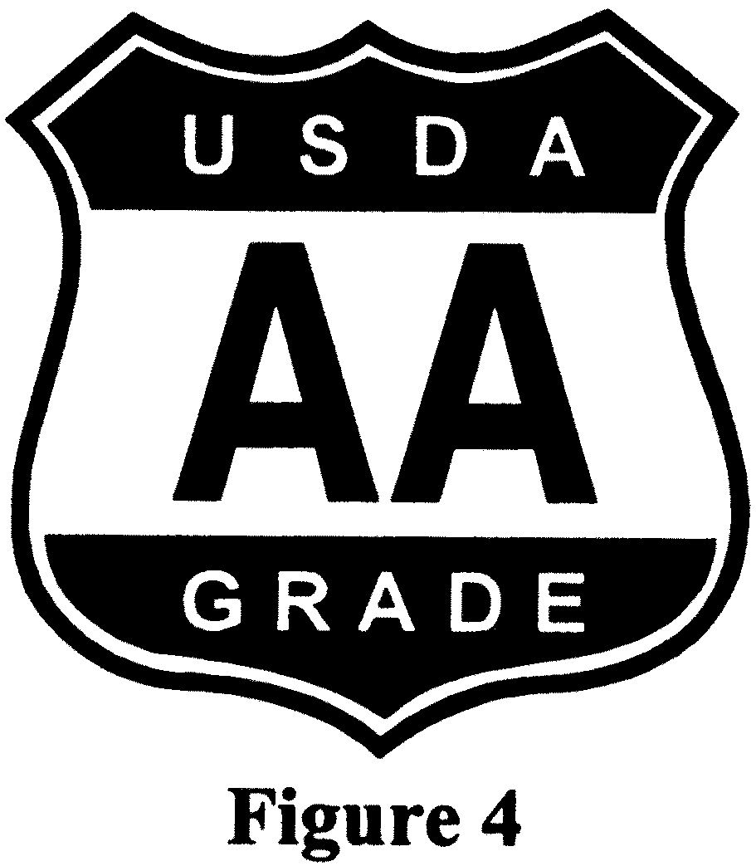shield as shown in Figure 5 of this sec- tion.
- The plant number of the official plant preceded by the letter ‘‘P’’ must be shown on each carton or packaging material.

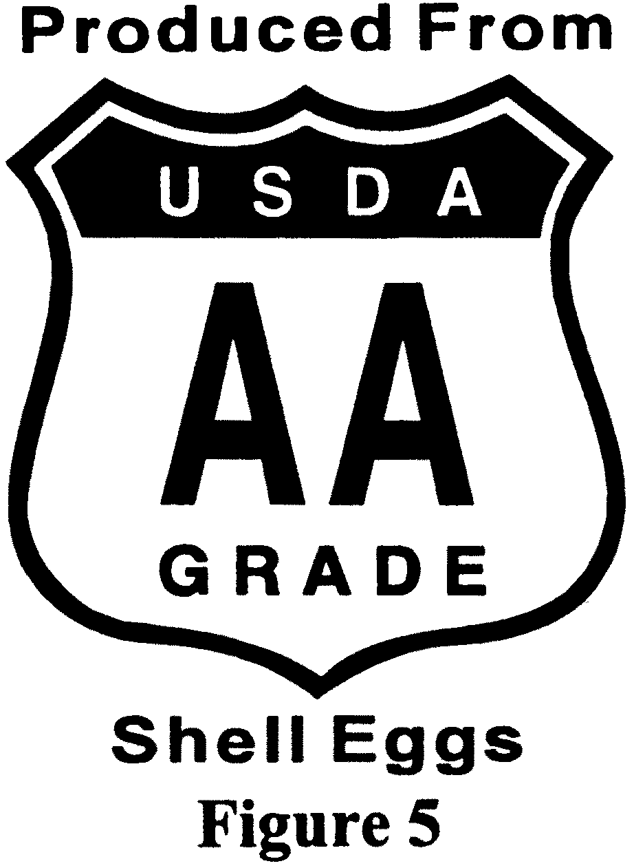
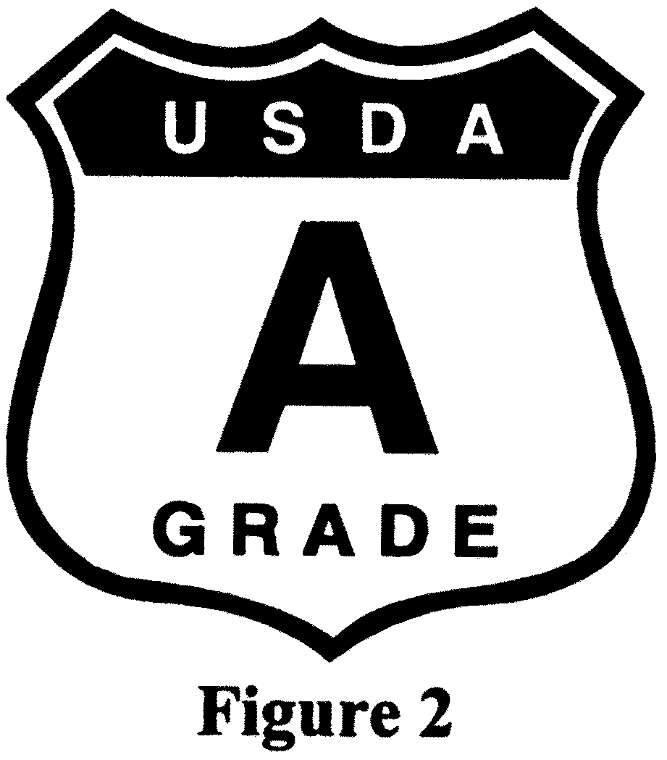[63 FR 13330, Mar. 19, 1998, as amended at 68
FR 25485, May 13, 2003]

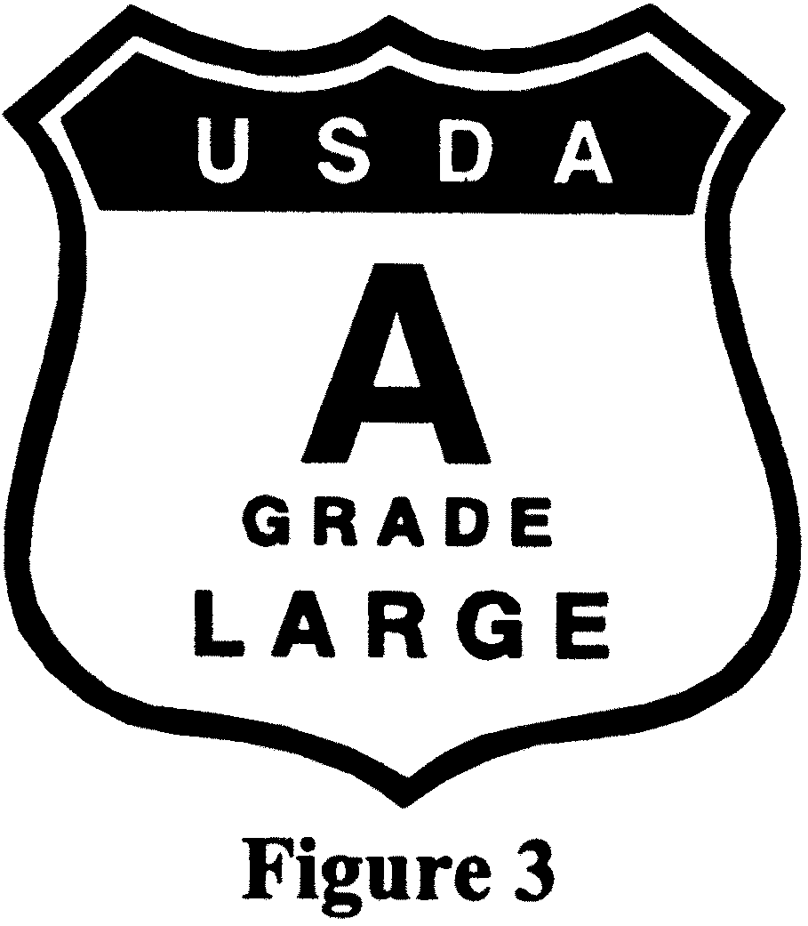§ 56.37 Lot marking of officially identi- fied shell eggs.
Shell eggs identified with the grademarks shown in § 56.36 shall be legibly lot numbered on either the in- dividual egg, the carton, or the con- sumer package. The lot number shall be the consecutive day of the year on which the eggs were packed (e.g., 132), except other lot numbering systems may be used when submitted in writing and approved by the Administrator.
[35 FR 5664, Apr. 8, 1970. Redesignated at 42
FR 32514, June 27, 1977, as amended at 46 FR
39570, Aug. 4, 1981. Redesignated at 46 FR
63203, Dec. 31, 1981, as amended at 60 FR
12402, Mar. 7, 1995; 63 FR 13331, Mar. 19, 1998;
69 FR 76376, Dec. 21, 2004]

§ 56.38 Retention authorities.
A grader may use retention tags or other devices and methods as approved

§ 56.39

by the Administrator for the identi- fication and control of shell eggs which are not in compliance with the regula- tions or are held for further examina- tion and for any equipment, utensils, rooms or compartments which are found unclean or otherwise in violation of the regulations. Any such item shall not be released until in compliance with the regulations and retention identification shall not be removed by anyone other than a grader.
[35 FR 5664, Apr. 8, 1970. Redesignated at 42
FR 32514, June 27, 1977, and further redesig-
nated at 46 FR 63203, Dec. 31, 1981. Redesig-
nated at 71 FR 42010, July 24, 2006]

PREREQUISITES TO PACKAGING SHELL EGGS IDENTIFIED WITH GRADEMARKS

§ 56.39 Quality assurance inspector re- quired.
The official identification with the grademark of any product as provided in §§ 56.35 to 56.41, inclusive, shall be done only under the supervision of a grader or quality assurance inspector. The grader or quality assurance inspec- tor shall have supervision over the use and handling of all material bearing any official identification.
[42 FR 2971, Jan. 14, 1977. Redesignated at 42
FR 32514, June 27, 1977, as amended at 46 FR
39570, Aug. 4, 1981. Redesignated at 46 FR
63203, Dec. 31, 1981; 69 FR 76376, Dec. 21, 2004]

§ 56.40 Grading requirements of shell eggs identified with grademarks.
  - Shell eggs to be identified with the grademarks illustrated in § 56.36 must be individually graded by a grad- er or by authorized personnel pursuant to § 56.11 and thereafter check graded by a grader.
  - Shell eggs not graded in accord- ance with paragraph (a) of this section may be officially graded on a sample basis and the shipping containers may be identified with grademarks which contain the words ‘‘Sample Graded’’ and which are approved by the Admin- istrator.
  - In order to be officially identified with a USDA consumer grademark, shell eggs shall:
    - Be eggs of current production;
    - Not possess any undesirable odors or flavors; and

7 CFR Ch. I (1–1–16 Edition)

    - Not have previously been shipped for retail sale.
[32 FR 8231, June 8, 1967. Redesignated at 42
FR 32514, June 27, 1977, as amended at 46 FR
39571, Aug. 4, 1981. Redesignated at 46 FR
63203, Dec. 31, 1981, as amended at 63 FR
13331, Mar. 19, 1998; 69 FR 76376, Dec. 21, 2004;
71 FR 20292, Apr. 19, 2006]

§ 56.41 Check grading officially identi- fied product.
Officially identified shell eggs packed or received in an official plant may be subject to final check grading prior to their shipment. Such product found not to be in compliance with the assigned official grade shall be placed under a retention tag until it is regraded to comply with the grade assigned or until the official identification is re- moved.
[35 FR 5664, Apr. 8, 1970. Redesignated at 42
FR 32514, June 27, 1977, and further redesig-
nated at 46 FR 63203, Dec. 31, 1981]

§§ 56.42–56.43 [Reserved]
FEES AND CHARGES

§ 56.45 Payment of fees and charges.
      - Fees and charges for any grading service shall be paid by the interested party making the application for such grading service, in accordance with the applicable provisions of this section and §§ 56.46 to 56.54, both inclusive; and, if so required by the grader, such fees and charges shall be paid in advance.
      - Fees and charges for any grading service shall, unless otherwise required pursuant to paragraph (c) of this sec- tion, be paid by check, draft, or money order payable to the Agricultural Mar- keting Service and remitted promptly to the AMS.
      - Fees and charges for any grading service under a cooperative agreement with any State or person shall be paid in accordance with the terms of such cooperative agreement.
[33 FR 20004, Dec. 31, 1968 and 42 FR 2971, Jan.
14, 1977. Redesignated at 42 FR 32514, June 27,
1977, and further redesignated at 46 FR 63203,
Dec. 31, 1981, as amended at 71 FR 42010, July
24, 2006]

Agricultural Marketing Service, USDA § 56.49

§ 56.46 On a fee basis.
        - Unless otherwise provided in this part, the fees to be charged and col- lected for any service performed, in ac- cordance with this part, on a fee basis shall be based on the applicable for- mulas specified in this section. For each calendar year or crop year, AMS will calculate the rate for grading or audit services, per hour per program employee using the following formulas:
          - Regular rate. The total AMS grad- ing or audit program personnel direct pay divided by direct hours, which is then multiplied by the next year’s per- centage of cost of living increase, plus the benefits rate, plus the operating rate, plus the allowance for bad debt rate. If applicable, travel expenses may also be added to the cost of providing the service.
          - Overtime rate. The total AMS grad- ing or audit program personnel direct pay divided by direct hours, which is then multiplied by the next year’s per- centage of cost of living increase and then multiplied by 1.5 plus the benefits rate, plus the operating rate, plus an allowance for bad debt. If applicable, travel expenses may also be added to the cost of providing the service.
          - Holiday rate. The total AMS grad- ing or audit program personnel direct pay divided by direct hours which is then multiplied by the next year’s per- centage of cost of living increase and then multiplied by 2, plus benefits rate, plus the operating rate, plus an allow- ance for bad debt. If applicable, travel expenses may also be added to the cost of providing the service.
(b)(1) For each calendar year, based on previous fiscal year/historical ac- tual costs, AMS will calculate the ben- efits, operating, and allowance for bad debt components of the regular, over- time and holiday rates as follows:
            - Benefits rate. The total AMS grad- ing or audit program direct benefits costs divided by the total hours (reg- ular, overtime, and holiday) worked, which is then multiplied by the next calendar year’s percentage cost of liv- ing increase. Some examples of direct benefits are health insurance, retire- ment, life insurance, and Thrift Sav- ings Plan (TSP) retirement basic and matching contributions.

            - Operating rate. The total AMS grading or audit program operating costs divided by total hours (regular, overtime, and holiday) worked, which is then multiplied by the percentage of inflation.
            - Allowance for bad debt rate. Total AMS grading or audit program allow- ance for bad debt divided by total hours (regular, overtime, and holiday) worked.
- The calendar year cost of living expenses and percentage of inflation factors used in the formulas in this sec- tion are based on the most recent Of- fice of Management and Budget’s Pres- idential Economic Assumptions.
- Fees for grading services will be based on the time required to perform the services. The hourly charges shall include the time actually required to perform the grading, waiting time, travel time, and any clerical costs in- volved in issuing a certificate.
- Fees for audit services will be based on the time and expenses re- quired to perform the audit. The hour- ly charge shall include the time actu- ally required to perform the audit, waiting time, travel time, and any clerical costs involved in issuing an audit report.
[79 FR 67322, Nov. 13, 2014]

§ 56.47 Fees for appeal grading or re- view of a grader’s decision.
The cost of an appeal grading or re- view of a grader’s decision shall be borne by the appellant on a fee basis at rates set forth in § 56.46, plus any travel and additional expenses. If the appeal grading or review of a grader’s decision discloses that a material error was made in the original determination, no fee or expenses will be charged.
[63 FR 52133, Sept. 30, 1998]

§ 56.49 Travel expenses and other charges.
Charges are to be made to cover the cost of travel and other expenses in- curred by the AMS in connection with rendering grading service. Such

§ 56.52

charges shall include the cost of trans- portation, per diem, and any other ex- penses.
[42 FR 2971, Jan. 14, 1977. Redesignated at 42
FR 32514, June 27, 1977, as amended at 46 FR
8, Jan. 2, 1981. Redesignated at 46 FR 63203,
Dec. 31, 1981, as amended at 71 FR 42010, July
24, 2006]

§ 56.52 Charges for continuous grading performed on a resident basis.
Fees to be charged and collected for any grading service, other than for an appeal grading, on a resident grading basis, shall be calculated as described in this part. The fees to be charged for any appeal grading shall be as provided in § 56.47.
  - Charges. The charges for the grad- ing of shell eggs shall be paid by the applicant for the service and shall in- clude items listed in this section as are applicable. Payment for the full cost of the grading service rendered to the ap- plicant shall be made by the applicant to AMS. Such full costs shall comprise such of the items listed in this section as are due and included in the bill or bills covering the period or periods dur- ing which the grading service was ren- dered. Bills will be rendered by the 10th day following the end of the period in which the service was rendered and are payable upon receipt.
    - When a signed application for service has been received, the State su- pervisor or the supervisor’s assistant shall complete a plant survey pursuant to § 56.30. The costs for completing the plant survey shall be borne by the ap- plicant on a fee basis as described in
§ 56.46. No charges will be assessed when the application is required be- cause of a change in name or owner- ship. If service is not installed within 6 months from the date the application is filed, or if service is inactive due to an approved request for removal of a grader(s) for a period of 6 months, the application will be considered termi- nated, but a new application may be filed at any time. In addition there will be a charge of $300 if the application is terminated at the request of the appli- cant for reasons other than for a change in location, within 12 months from the date of the inauguration of service.

7 CFR Ch. I (1–1–16 Edition)

    - Charges for the cost of each grad- er assigned to a plant will be cal- culated as described in § 56.46, except that no charge will be assessed when the assigned grader is temporarily re- assigned by AMS to perform grading service for other than the applicant. Base salary rates will be determined on a national average for all official plants operating in States under a Fed- eral Trust Fund Agreement where Fed- eral graders, State graders, or a com- bination of Federal and State graders are used, by averaging the salary rates paid to each Federal or State grader assigned to such plants. Charges to plants are as follows:
      - For all regular hours of work scheduled and approved as an estab- lished tour of duty for a plant, the reg- ular rate charge will be made. The reg- ular rate charge will be determined by adding an amount to the base salary rate to cover the costs to AMS for such items as the Employer’s Tax imposed under the U.S. Internal Revenue Code (26 U.S.C.) for Old Age and Survivor’s Benefits under the Social Security Sys- tem, retirement benefits, group life in- surance, severance pay, sick leave, an- nual leave, additional salary and travel costs for relief grading service, acci- dent payments, certain moving costs, and related servicing costs.
      - All hours worked by an assigned grader or another grader in excess of the approved tour of duty, or worked on a nonscheduled workday, or actu- ally worked on a holiday in excess of the tour of duty, will be considered as overtime. The charge for such overtime will be 150 percent of the grader’s base salary rate.
      - For work performed on a holiday which is within the established tour of duty approved for a plant, the added charge will be the same as the grader’s base rate.
      - For work performed between 6
p.m. and 6 a.m., night differential charges (for regular, overtime, or holi- day hours worked during this period) will be at the applicable rates estab- lished plus 10 percent of the base rate.
      - For work performed on Sunday, Sunday differential charges (for reg- ular, overtime, or holiday hours

Agricultural Marketing Service, USDA § 56.54

worked on Sunday) will be at the appli- cable rates established plus 25 percent of the base rate.
      - For all hours of work performed in a plant without an approved tour of duty, the charge will be one of the ap- plicable hourly rates in § 56.46.
    - A charge at the hourly rates spec- ified in § 56.46, plus actual travel ex- penses incurred by AMS for inter- mediate surveys to firms without grad- ing service in effect.
    - An administrative service charge based upon the aggregate number of 30- dozen cases of all shell eggs handled in the plant per billing period multiplied by $0.055 beginning March 30, 2008, and
$0.058 on or after January 25, 2009, ex- cept that the minimum charge per bill- ing period shall be $275 and the max- imum charge shall be $3,150 beginning March 30, 2008, and $3,225 on or after January 25, 2009. The minimum charge also applies where an approved applica- tion is in effect and no product is han- dled.
  - Other provisions. (1) The applicant shall designate in writing the employ- ees of the applicant who will be re- quired and authorized to furnish each grader with such information as may be necessary for the performance of the grading service.
  - AMS will provide, as available, an adequate number of graders to perform the grading service. The number of graders required will be determined by AMS based on the expected demand for service.
  - The grading service shall be pro- vided at the designated plant and shall be continued until the service is sus- pended, withdrawn, or terminated by:
    - Mutual consent;
    - Thirty (30) days’ written notice, by either the applicant or AMS speci- fying the date of suspension, with- drawal, or termination;
    - One (1) day’s written notice by AMS to the applicant if the applicant fails to honor any invoice within thirty
(30) days after date of invoice covering the cost of the grading service; or
    - Action taken by AMS pursuant to the provisions of § 56.31.
(4) Graders will be required to confine their activities to those duties nec- essary in the rendering of grading serv- ice and such closely related activities

as may be approved by AMS: Provided, That in no instance may the graders assume the duties of management.
[34 FR 8232, May 28, 1969]
EDITORIAL NOTE: For FEDERAL REGISTER ci-
tations affecting § 56.52, see the List of CFR Sections Affected, which appears in the Finding Aids section of the printed volume.

§ 56.53 Fees or charges for grading service performed under coopera- tive agreement.
Fees or charges to be made to an ap- plicant for grading service which differ from those listed in §§ 56.45 through
56.54 shall be provided for by a coopera- tive agreement.
[36 FR 7894, Apr. 28, 1971. Redesignated at 42
FR 32514, June 27, 1977, and further redesig-
nated at 46 FR 63203, Dec. 31, 1981]

§ 56.54 Charges for continuous grading performed on a nonresident basis.
Fees to be charged and collected for grading service on a nonresident grad- ing basis, shall be calculated as de- scribed in this part. The fees to be charged for any appeal grading shall be calculated as provided in § 56.47.
- Charges. The charges for the grad- ing of shell eggs shall be paid by the applicant for the service and shall in- clude items listed in this section as are applicable. Payment for the full cost of the grading service rendered to the ap- plicant shall be made by the applicant to the AMS. Such full costs shall com- prise such of the items listed in this section as are due and included in the bill or bills covering the period or peri- ods during which the grading service was rendered. Bills will be rendered by the 10th day following the end of the billing period in which the service was rendered and are payable upon receipt.
  - A charge for the salary and other costs, calculated as described in § 56.46, for each grader while assigned to a plant, except that no charge will be made when the assigned grader is tem- porarily reassigned by AMS to perform grading service for other than the ap- plicant. Charges to plants are as fol- lows:

§ 56.55

    - For all regular hours of work scheduled and approved as an estab- lished tour of duty for a plant, the reg- ular rate charge will be made. The reg- ular rate charge will be determined by adding an amount to the base salary rate to cover the costs to AMS for such items as the Employer’s Tax imposed under the U.S. Internal Revenue Code (26 U.S.C.) for Old Age and Survivor’s Benefits under the Social Security Sys- tem, retirement benefits, group life in- surance, severance pay, sick leave, an- nual leave, additional salary and travel costs for relief grading service, acci- dent payments, certain moving costs, and related servicing costs.
    - All hours worked by an assigned grader or another grader in excess of the approved tour of duty, or worked on a nonscheduled workday, or actu- ally worked on a holiday in excess of the tour of duty, will be considered as overtime. The charge for such overtime will be 150 percent of the grader’s base salary rate.
    - For work performed on a holiday which is within the established tour of duty approved for a plant, the added charge will be the same as the grader’s base rate.
    - For work performed between 6
p.m. and 6 a.m., night differential charges (for regular, overtime, or holi- day hours worked during this period) will be at the applicable rates estab- lished plus 10 percent of the base rate.
    - For work performed on Sunday, Sunday differential charges (for reg- ular, overtime, or holiday hours worked on Sunday) will be at the appli- cable rates established plus 25 percent of the base rate.
    - For all hours of work performed in a plant without an approved tour of duty, the charge will be one of the ap- plicable hourly rates in § 56.46.
  - An administrative service charge equal to 25 percent of the grader’s total salary costs. A minimum charge of $275 will be made each billing period. The minimum charge also applies where an approved application is in effect and no product is handled.
- Other provisions. (1) The applicant shall designate in writing the employ- ees of the applicant who will be re- quired and authorized to furnish each grader with such information as may

7 CFR Ch. I (1–1–16 Edition)

be necessary for the performance of the grading service.
- AMS will provide, as available, an adequate number of graders to perform the grading service. The number of graders required will be determined by AMS based on the expected demand for service.
- The grading service shall be pro- vided at designated locations and shall be continued until the service is sus- pended, withdrawn, or terminated by:
  - Mutual consent;
  - Thirty (30) days’ written notice, by either the applicant or AMS speci- fying the date of suspension, with- drawal, or termination;
  - One (1) day’s written notice by AMS to the applicant if the applicant fails to honor any invoice within thirty
- days after date of invoice covering the cost of the grading service; or
  - Action taken by AMS pursuant to the provisions of § 56.31.
  - Graders will be required to confine their activities to those duties nec- essary in the rendering of grading serv- ice and such closely related activities as may be approved by AMS: Provided, That in no instance may the graders assume the duties of management.
  - When similar nonresident grading services are furnished to the same ap- plicant under part 70 of this chapter, the charges listed in this section shall not be repeated.
[35 FR 19327, Dec. 22, 1970]
EDITORIAL NOTE: For FEDERAL REGISTER ci-
tations affecting § 56.54, see the List of CFR Sections Affected, which appears in the Finding Aids section of the printed volume.

GRADING CERTIFICATES

§ 56.55 Forms.
Grading certificates and sampling re- port forms (including appeal grading certificates and regrading certificates) shall be issued on forms approved by the Administrator.
[71 FR 42010, July 24, 2006]

§ 56.56 Issuance.
    - Resident grading basis. Certificates will be issued only upon request there- for by the applicant or the AMS. When requested, a grader shall issue a certifi- cate covering product graded by such

Agricultural Marketing Service, USDA § 56.62

grader. In addition, a grader may issue a grading certificate covering product graded in whole or in part by another grader when the grader has knowledge that the product is eligible for certifi- cation based on personal examination of the product or official grading records.
    - Other than resident grading. Each grader shall, in person or by the grad- er’s authorized agent, issue a grading certificate covering each product grad- ed by such grader. A grader’s name may be signed on a grading certificate by a person other than the grader, if such person has been designated as the authorized agent of such grader by the national supervisor: Provided, That the certificate is prepared from an official memorandum of grading signed by the grader: And provided further, That a no- tarized power of attorney authorizing such signature has been issued to such person by the grader and is on file in the office of grading. In such case, the authorized agent shall sign both the agent’s name and the grader’s name, e.g., ‘‘John Doe by Mary Roe.’’
[71 FR 42010, July 24, 2006]

§ 56.57 Disposition.
The original and a copy of each grad- ing certificate, issued pursuant to
§ 56.56, and not to exceed two additional copies thereof if requested by the appli- cant prior to issuance, shall, imme- diately upon issuance, be delivered or mailed to the applicant or the appli- cant’s designee. Other copies shall be filed and retained in accordance with the disposition schedule for grading program records.
[36 FR 9842, May 29, 1971. Redesignated at 42
FR 32514, June 27, 1977, and further redesig-
nated at 46 FR 63203, Dec. 31, 1981, as amend-
ed at 47 FR 46070, Oct. 15, 1982; 47 FR 54421,
Dec. 3, 1982; 71 FR 42010, July 24, 2006]

§ 56.58 Advance information.
Upon request of an applicant, all or part of the contents of any grading cer- tificate issued to such applicant may be telephoned or electronically trans- mitted to the applicant, or to the ap- plicant’s designee, at the applicant’s expense.
[69 FR 76376, Dec. 21, 2004]

APPEAL OF A GRADING OR DECISION

SOURCE: Sections 56.60 through 56.66 appear
at 35 FR 9918, June 17, 1970, unless otherwise
noted. Redesignated at 42 FR 32514, June 27,
1977, and further redesignated at 46 FR 63203,
Dec. 31, 1981.

§ 56.60 Who may request an appeal grading or review of a grader’s de- cision.
An appeal grading may be requested by any interested party who is dissatis- fied with the determination by a grader of the class, quality, quantity, or con- dition of any product as evidenced by the USDA grademark and accom- panying label, or as stated on a grading certificate and a review may be re- quested by the operator of an official plant with respect to a grader’s deci- sion or on any other matter related to grading in the official plant.

§ 56.61 Where to file an appeal.
- Appeal from resident grader’s grad- ing or decision in an official plant. Any interested party who is not satisfied with the determination of the class, quality, quantity, or condition of prod- uct which was graded by a grader in an official plant and has not left such plant, and the operator of any official plant who is not satisfied with a deci- sion by a grader on any other matter related to grading in such plant may request an appeal grading or review of the decision by the grader by filing such request with the grader’s imme- diate supervisor.
- All other appeal requests. Any in- terested party who is not satisfied with the determination of the class, quality, quantity, or condition of product which has left the official plant where it was graded or which was graded other than in an official plant may request an ap- peal grading by filing such request with the regional director in the area where the product is located or with the Chief of the Grading Branch.
[35 FR 9918, June 17, 1970. Redesignated at 42
FR 32514, June 27, 1977, and further redesig-
nated at 46 FR 63203, Dec. 31, 1981, as amend-
ed at 71 FR 42010, July 24, 2006]

§ 56.62 How to file an appeal.
Any request for an appeal grading or review of a grader’s decision may be

§ 56.63

made orally or in writing. If made oral- ly, written confirmation may be re- quired. The applicant shall clearly state the reasons for requesting the ap- peal service and a description of the product, or the decision which is ques- tioned. If such appeal request is based on the results stated on an official cer- tificate, the original and all available copies of the certificate shall be re- turned to the appeal grader assigned to make the appeal grading.

§ 56.63 When an application for an ap- peal grading may be refused.
When it appears to the official with whom an appeal request is filed that the reasons given in the request are frivolous or not substantial, or that the quality or condition of the product has undergone a material change since the original grading, or that the origi- nal lot has changed in some manner, or the Act or the regulations in this part have not been complied with, the appli- cant’s request for the appeal grading may be refused. In such case, the appli- cant shall be promptly notified of the reason(s) for such refusal.

§ 56.64 Who shall perform the appeal.
  - An appeal grading or review of a decision requested under § 56.61(a) shall be made by the grader’s immediate su- pervisor, or by one or more licensed graders assigned by the immediate su- pervisor.
  - Appeal gradings requested under
§ 56.61(b) shall be performed by a grader other than the grader who originally graded the product.
  - Whenever practical, an appeal grading shall be conducted jointly by two graders. The assignment of the grader(s) who will make the appeal grading requested under § 56.61(b) shall be made by the regional director or the Chief of the Grading Branch.
[35 FR 9918, June 17, 1970, as amended at 40
FR 20056, May 8, 1975. Redesignated at 42 FR
32514, June 27, 1977, and further redesignated
at 46 FR 63203, Dec. 31, 1981; 71 FR 42010, July
24, 2006]

§ 56.65 Procedures for appeal gradings.
- The appeal sample shall consist of product taken from the original sample

7 CFR Ch. I (1–1–16 Edition)

container plus an equal number of sam- ples selected at random.
- When the original samples are not available or have been altered, such as the removal of undergrades, the appeal sample size for the lot shall consist of double the samples required in § 56.4(b).
- Shell eggs shall not have been moved from the original place of grad- ing and must have been maintained under adequate refrigeration and hu- midity conditions.
[35 FR 9918, June 17, 1970. Redesignated at 42
FR 32514, June 27, 1977, and further redesig-
nated at 46 FR 63203, Dec. 31, 1981, as amend-
ed at 47 FR 46070, Oct. 15, 1982; 47 FR 54421,
Dec. 3, 1982; 69 FR 76376, Dec. 21, 2004; 71 FR
42010, July 24, 2006]

§ 56.66 Appeal grading certificates.
Immediately after an appeal grading is completed, an appeal certificate shall be issued to show that the origi- nal grading was sustained or was not sustained. Such certificate shall super- sede any previously issued certificate for the product involved and shall clearly identify the number and date of the superseded certificate. The issuance of the appeal certificate may be withheld until any previously issued certificate and all copies have been re- turned when such action is deemed nec- essary to protect the interest of the Government. When the appeal grader assigns a different grade to the lot, the existing grademark shall be changed or obliterated as necessary. When the ap- peal grader assigns a different class or quantity designation to the lot, the la- beling shall be corrected.
[35 FR 9918, June 17, 1970. Redesignated at 42
FR 32514, June 27, 1977, and further redesig-
nated at 46 FR 63203, Dec. 31, 1981, as amend-
ed at 71 FR 42010, July 24, 2006]

DENIAL OF SERVICE

§ 56.68 Debarment.
The acts or practices set forth in
§§ 56.69 through 56.74, or the causing thereof, may be deemed sufficient cause for the debarment by the Admin- istrator of any person, including any agents, officers, subsidiaries, or affili- ates of such person, from all benefits of the act for a specified period. The Rules of Practice Governing Formal Adjudicatory Proceedings (7 CFR part

Agricultural Marketing Service, USDA § 56.76

1, subpart H) shall be applicable to such debarment action.
[71 FR 42011, July 24, 2006]

§ 56.69 Misrepresentation, deceptive, or fraudulent act or practice.
Any willful misrepresentation or any deceptive or fraudulent act or practice found to be made or committed by any person in connection with:
  - The making or filing of an appli- cation for any grading service, appeal, or regrading service;
  - The making of the product acces- sible for sampling or grading;
  - The making, issuing, or using or attempting to issue or use any grading certificate, symbol, stamp, label, seal, or identification authorized pursuant to the regulations in this part;
  - The use of the terms ‘‘United States’’ or ‘‘U.S.’’ in conjunction with the grade of the product;
  - The use of any of the aforesaid terms or any official stamp, symbol, label, seal, or identification in the la- beling or advertising of any product.
[71 FR 42011, July 24, 2006]

§ 56.70 Use of facsimile forms.
Using or attempting to use a form which simulates in whole or in part any certificate, symbol, stamp, label, seal or identification authorized to be issued or used under the regulations in this part.
[71 FR 42011, July 24, 2006]

§ 56.71 Willful violation of the regula- tions.
Any willful violation of the regula- tions in this part or the Act.
[71 FR 42011, July 24, 2006]

§ 56.72 Interfering with a grader or employee of the AMS.
Any interference with or obstruction or any attempted interference or ob- struction of or assault upon any grad- ers, licensees, or employees of the AMS in the performance of their duties. The giving or offering, directly or indi- rectly, of any money, loan, gift, or any- thing of value to an employee of the AMS or the making or offering of any contribution to or in any way supplementing the salary, compensa-

tion or expenses of an employee of the AMS or the offering or entering into a private contract or agreement with an employee of the AMS for any services to be rendered while employed by the AMS.
[71 FR 42011, July 24, 2006]

§ 56.73 Misleading labeling.
The use of the terms ‘‘Government Graded’’, ‘‘Federal-State Graded’’, or terms of similar import in the labeling or advertising of any product without stating in the label or advertisement the U.S. grade of the product as deter- mined by an authorized grader.
[71 FR 42011, July 24, 2006]

§ 56.74 Miscellaneous.
The existence of any of the condi- tions set forth in § 56.24 constituting the basis for the rejection of an appli- cation for grading service.
[71 FR 42011, July 24, 2006]

FACILITY REQUIREMENTS

§ 56.75 Applicability of facility and op- erating requirements.
The provisions of § 56.76 shall be ap- plicable to any grading service that is provided on a resident or temporary basis.
[69 FR 76376, Dec. 21, 2004]

§ 56.76 Minimum facility and operating requirements for shell egg grading and packing plants.
- Applicants must comply with all applicable Federal, State and local government occupational safety and health regulations.
- General requirements for premises, buildings and plant facilities. (1) The outside premises shall be free from refuse, rubbish, waste, unused equip- ment, and other materials and condi- tions which constitute a source of odors or a harbor for insects, rodents, and other vermin.
- The outside premises adjacent to grading, packing, cooler, and storage rooms must be properly graded and well drained to prevent conditions that may constitute a source of odors or propagate insects or rodents.
- Buildings shall be of sound con- struction so as to prevent, insofar as

§ 56.76

practicable, the entrance or harboring of vermin.
- Grading and packing rooms shall be of sufficient size to permit installa- tion of necessary equipment and con- duct grading and packing in a sanitary manner. These rooms shall be kept rea- sonably clean during grading and pack- ing operations and shall be thoroughly cleaned at the end of each operating day.
- The floors, walls, ceilings, parti- tions, and other parts of the grading and packing rooms including benches and platforms shall be constructed of materials that are readily cleanable, maintained in a sanitary condition, and impervious to moisture in areas exposed to cleaning solutions or moist conditions. The floors shall be con- structed as to provide proper drainage.
- Adequate toilet accommodations which are conveniently located and separated from the grading and pack- ing rooms are to be provided. Handwashing facilities shall be pro- vided with hot and cold running water, an acceptable handwashing detergent, and a sanitary method for drying hands. Toilet rooms shall be ventilated to the outside of the building and be maintained in a clean and sanitary condition. Signs shall be posted in the toilet rooms instructing employees to wash their hands before returning to work. In new or remodeled construc- tion, toilet rooms shall be located in areas that do not open directly into processing rooms.
- A separate refuse room or a des- ignated area for the accumulation of trash must be provided in plants which do not have a system for the daily re- moval or destruction of such trash.
- Adequate packing and packaging storage areas are to be provided that protect packaging materials and are dry and maintained in a clean and sani- tary condition.
- Grading and packing room require- ments. (1) The egg grading or candling area shall be adequately darkened to make possible the accurate quality de- termination of the candled appearance of eggs. There shall be no other light source or reflection of light that inter- fere with, or prohibit the accurate quality determination of eggs in the grading or candling areas.

7 CFR Ch. I (1–1–16 Edition)

- The grading and candling equip- ment shall provide adequate light to facilitate quality determinations. When needed, other light sources and equipment or facilities shall be pro- vided to permit the detection and re- moval of stained and dirty eggs or other undergrade eggs.
- The grading and candling equip- ment must be sanitarily designed and constructed to facilitate cleaning. Such equipment shall be kept reason- ably clean during grading and packing operations and be thoroughly cleaned at the end of each operating day.
- Egg weighing equipment shall be constructed of materials to permit cleaning; operated in a clean, sanitary manner; and shall be capable of ready adjustment.
- Adequate ventilation, heating, and cooling shall be provided where needed.
- Cooler room requirements. (1) Cooler rooms holding shell eggs that are iden- tified with a consumer grade shall be refrigerated and capable of maintain- ing an ambient temperature no greater than 45 °F (7.2 °C) and equipped with humidifying equipment capable of maintaining a relative humidity which will minimize shrinkage.
- Accurate thermometers and hygrometers shall be provided for mon- itoring cooler room temperatures and relative humidity.
- Cooler rooms shall be free from objectionable odors and from mold, and shall be maintained in a sanitary con- dition.
- Shell egg protecting operations. (1) Shell egg protecting (oil application) operations shall be conducted in a manner to avoid contamination of the product and maximize conservation of its quality.
- Component equipment within the shell egg protecting system, including holding tanks and containers, must be sanitarily designed and maintained in a clean and sanitary manner, and the application equipment must provide an adequate amount of oil for shell cov- erage of the volume of eggs processed.
- Eggs with excess moisture on the shell shall not be shell protected.
- Oil having any off odor, or that is obviously contaminated, shall not be used in shell egg protection operations.

Agricultural Marketing Service, USDA § 56.76

Oil is to be filtered prior to applica- tion.
- The component equipment of the application system shall be washed, rinsed, and treated with a bactericidal agent each time the oil is removed.
- Adequate coverage and protection against dust and dirt shall be provided when the equipment is not in use.
- Shell egg cleaning operations. (1) Shell egg washing equipment must be sanitarily designed, maintained in a clean and sanitary manner, and thor- oughly cleaned at the end of each oper- ating day.
- Shell egg drying equipment must be sanitarily designed and maintained in a clean and sanitary manner. Air used for drying purposes must be fil- tered. These filters shall be cleaned or replaced as needed to maintain a sani- tary process.
- The temperature of the wash water shall be maintained at 90 °F (32.2
°C) or higher, and shall be at least 20 °F (6.7 °C) warmer than the internal tem- perature of the eggs to be washed. These temperatures shall be main- tained throughout the cleaning cycle. Accurate thermometers shall be pro- vided for monitoring wash water tem- peratures.
- Approved cleaning compounds shall be used in the wash water.
- Wash water shall be changed ap- proximately every 4 hours or more often if needed to maintain sanitary conditions, and at the end of each shift. Remedial measures shall be taken to prevent excess foaming during the egg washing operation.
- Replacement water shall be added continuously to the wash water of washers. Chlorine or quaternary sani- tizing rinse water may be used as part of the replacement water, provided, they are compatible with the washing compound. Iodine sanitizing rinse water may not be used as part of the replacement water.
- Only potable water may be used to wash eggs. Each official plant shall submit certification to the national of- fice stating that their water supply is potable. An analysis of the iron con- tent of the water supply, stated in parts per million, is also required. When the iron content exceeds 2 parts per million, equipment shall be pro-

vided to reduce the iron content below the maximum allowed level. Frequency of testing for potability and iron con- tent shall be determined by the Admin- istrator. When the water source is changed, new tests are required.
- Waste water from the egg washing operation shall be piped directly to drains.
- The washing, rinsing, and drying operations shall be continuous and shall be completed as rapidly as pos- sible to maximize conservation of the egg’s quality and to prevent sweating of eggs. Eggs shall not be allowed to stand or soak in water. Immersion-type washers shall not be used.
- Prewetting shell eggs prior to washing may be accomplished by spraying a continuous flow of water over the eggs in a manner which per- mits the water to drain away or other methods which may be approved by the Administrator. The temperature of the water shall be the same as prescribed in this section.
- Washed eggs shall be spray-rinsed with water having a temperature equal to, or warmer than, the temperature of the wash water. The spray-rinse water shall contain a sanitizer that has been determined acceptable for the intended use by the national supervisor and of not less than 100 p/m nor more than 200 p/m of available chlorine or its equiva- lent. Alternate procedures, in lieu of a sanitizer rinse, may be approved by the national supervisor.
- Test kits shall be provided and used to determine the strength of the sanitizing solution.
- During non-processing periods, eggs shall be removed from the wash- ing and rinsing area of the egg washer and from the scanning area whenever there is a buildup of heat that may di- minish the quality of the egg.
- Washed eggs shall be reasonably dry before packaging and packing.
- Steam, vapors, or odors origi- nating from the washing and rinsing operation shall be continuously and di- rectly exhausted to the outside of the building.
- Requirements for eggs officially identified with a grademark. (1) Shell eggs that are officially identified with a grademark shall be placed under re- frigeration at an ambient temperature

§ 56.77

no greater than 45 °F (7.2 °C) promptly after packaging.
(2) Eggs that are to be officially iden- tified with the grademark shall be packed only in new or good used pack- ing material and new packaging mate- rials that are clean, free of mold, mustiness and off odors, and must be of sufficient strength and durability to adequately protect the eggs during nor- mal distribution. When packed in other than fiber packing material, the con- tainers must be of sound construction and maintained in a reasonably clean manner.
- Use of approved chemicals and com- pounds. (1) All egg washing and equip- ment cleaning compounds, defoamers, destainers, sanitizers, inks, oils, lubri- cants, or any other compound that comes into contact with the shell eggs shall be approved by the national su- pervisor for their specified use and han- dled in accordance with the manufac- turer’s instructions.
- All pesticides, insecticides, and rodenticides shall be approved for their specified use and handled in accordance with the manufacturer’s instructions.
[69 FR 76376, Dec. 21, 2004]

§ 56.77 Health and hygiene of per- sonnel.
  - No person known to be affected by a communicable or infectious disease shall be permitted to come in contact with the product.
  - Plant personnel coming into con- tact with the product shall wear clean clothing.
[32 FR 8232, June 8, 1967. Redesignated at 42
FR 32514, June 27, 1977, and further redesig-
nated at 46 FR 63203, Dec. 31, 1981]

PART 57—INSPECTION OF EGGS (EGG PRODUCTS INSPECTION ACT)

Subpart A—Regulations Governing the Inspection of Eggs
GENERAL

7 CFR Ch. I (1–1–16 Edition)

SCOPE OF INSPECTION
57.20 Inspection in accordance with methods prescribed or approved.
57.22 Basis of service.
57.28 Inspections.
RELATION TO OTHER AUTHORITIES
57.35 Eggs in commerce.
EGGS NOT INTENDED FOR HUMAN FOOD
57.45 Prohibition on eggs not intended for use as human food.
EXEMPTIONS
57.100 Specific exemptions.
57.105 Suspension or termination of exemp- tions.
PERFORMANCE OF SERVICES
57.110 Licensed inspectors.
57.112 Suspension of license or authority; revocation.
57.114 Surrender of license.
  - Political activity.
  - Financial interest of inspectors.
57.130 Identification.
57.132 Access to plants.
57.134 Accessibility of product.
RECORDS AND RELATED REQUIREMENTS FOR
EGG HANDLERS AND RELATED INDUSTRIES
57.200 Records and related requirements.
57.220 Information and assistance to be fur- nished to inspectors.
ADMINISTRATIVE DETENTION
57.240 Detaining product.
APPEAL OF AN INSPECTION
57.300 Who may request an appeal inspec- tion.
57.310 Where to file an appeal.
57.320 How to file an appeal.
57.330 When an application for an appeal in- spection may be refused.
57.340 Who shall perform the appeal.
57.350 Procedures for selecting appeal sam- ples.
57.360 Appeal inspection certificates.
57.370 Cost of appeals.
RETENTION
57.426 Retention.
REGISTRATION OF SHELL EGG HANDLERS
57.690 Persons required to register.

Sec.
57.1 Definitions.
57.10 Administration.
57.13 Federal and State cooperation.
  - Nondiscrimination.
  - OMB control number.

INSPECTION AND DISPOSITION OF RESTRICTED EGGS
57.700 Prohibition on disposition of re- stricted eggs.
57.720 Disposition of restricted eggs.

