

§ 351.22

RECORDS AND REPORTS

§ 351.22 Certified plants to maintain records and make reports; access to records.
- Each day a certified plant pre- pares, receives, or ships certified tech- nical animal fat or receives material for use in such product, the operator of the plant shall prepare records identi- fying the kinds and quantities of such materials and technical animal fats re- ceived, the number of pounds of cer- tified technical animal fat prepared or shipped, and an up-to-date inventory of certified technical animal fats in stor- age. The operator of each certified plant shall include in the records re- quired by this section all MP Forms 85 which he receives with shipments of certified technical animal fat from any other certified plant. These records shall be maintained by the operator of each certified plant and made available to an inspector, upon request, for ex- amination and copying, for a period of 1 year after the date of the transaction involved.
- The operator of each certified plant shall provide such relevant infor- mation as any inspector may request to enable him to determine whether any technical animal fats are eligible for certification and whether the plant is eligible for certification service under the regulations in this part.
(Approved by the Office of Management and Budget under control number 0583–0036)
[40 FR 58627, Dec. 18, 1975, as amended at 47
FR 746, Jan. 7, 1982]

PART 352—EXOTIC ANIMALS AND HORSES; VOLUNTARY INSPECTION

Subpart A—Exotic Animals
Sec.
  - Definitions.
  - Type of service available.
  - Application by official exotic animal establishment for inspection service.
  - Application for ante-mortem inspec- tion service in the field.
  - Fees and charges.
  - Denial or withrawal of inspection serv- ice.
  - Marking inspected products.
  - Time of inspection in the field and in an official exotic animal establishment.
  - Report of inspection work.
  - Ante-mortem inspection.
9 CFR Ch. III (1–1–16 Edition)
  - Post-mortem inspection.
  - Disposal of diseased or otherwise adulterated carcasses and parts.
  - Handling and disposal of condemned or other inedible exotic animal products at official exotic animal establishments.
  - Entry into official establishments; re- inspection and preparation of products.
  - Records, registration and reports.
  - Exports.
  - Transportation.
  - Cooperation of States in Federal pro- grams.

Subpart B—Horses
  - Ante-mortem inspection and applica- ble requirements.
AUTHORITY: 7 U.S.C. 1622, 1624; 7 CFR 2.17
(g) and (i), 2.55.
SOURCE: 50 FR 41847, Oct. 16, 1985, unless
otherwise noted.

Subpart A—Exotic Animals

§ 352.1 Definitions.
The definitions in § 301.2, not other- wise defined in this part, are incor- porated into this part. In addition to those definitions, the following defini- tions will be applicable to the regula- tions in this part.
    - Act means the applicable provi- sions of the Agricultural Marketing Act of 1946, as amended (60 Stat. 1087, as amended; 7 U.S.C. 1621 et seq.).
    - Acceptable means suitable for the purpose intended and acceptable to the Food Safety and Inspection Service.
    - Antelope means any animal be- longing to the antelope family.
    - Applicant means any interested party who requests any inspection service.
    - Bison means any American bison or catalo or cattalo.
    - Buffalo means any animal belong- ing to the buffalo family.
    - Catalo or Cattalo means any hy- brid animal with American bison ap- pearance resulting from direct cross- breeding of American bison and cattle.
    - Condition means any condition, including, but not limited to, the state of preservation, cleanliness, or sound- ness of any product or the processing, handling, or packaging which may af- fect such product.
    - Condition and wholesomeness means the condition of any product, its

Food Safety and Inspection Service, USDA § 352.2

healthfulness and fitness for human food.
    - Deer means any member of the deer family.
    - Exotic animal means any reindeer, elk, deer, antelope, water buffalo or bison.
    - Elk means any American elk.
    - Exotic animal inspection service means the personnel who are engaged in the administration, application, and direction of exotic animal inspection programs and services pursuant to the regulations in this part.
    - Exotic animal producer means any interested party that engages in the raising and/or marketing of an exotic animal for commercial purposes.
    - Field ante-mortem inspection means the ante-mortem inspection of an ex- otic animal away from the official ex- otic animal establishment’s premises.
    - Field designated area means any designated area on the applicant’s premises, approved by the Regional Di- rector, where field ante-mortem in- spection is to be performed.
    - Identify means to apply official identification to products or con- tainers.
    - Inspection means any inspection by an inspector to determine, in ac- cordance with regulations in this part,
(1) the condition and wholesomeness of an exotic animal, or (2) the condition and wholesomeness of edible product of an exotic animal at any state of the preparation or packaging in the official plant where inspected and certified, or
(3) the condition and wholesomeness of any previously inspected and certified product of an exotic animal if such product has not lost its identity as an inspected and certified product.
    - Interested party means any person financially interested in a transaction involving any inspection.
    - Official exotic animal establishment means any slaughtering, cutting, boning, curing, smoking, salting, pack- ing, rendering, or similar establish- ment at which inspection is main- tained under the regulations in this part.
    - Official device means a stamping appliance, branding device, stencil printed label, or any other mechani- cally or manually operated tool that is approved by the Administrator for the

purpose of applying any official mark or other identification to any product or packaging material.
- Official identification means any symbol, stamp, label or seal indicating that the product has been officially in- spected and/or indicating the condition of the product approved and authorized by the Administrator to be affixed to any product, or affixed to or printed on the packaging material of any product.
- Program means the Voluntary Ex- otic Animal Inspection Program of the Food Safety and Inspection Service.
- Reindeer means any reindeer com- monly referred to as caribou.
- Transport vehicle means any vehi- cle used to transport an exotic animal.
- Veterinarian means an authorized veterinarian of the Program employed by the Department or any cooperating State who is authorized by the Sec- retary to do any work or perform any duty in connection with the Program.
(aa) Water buffalo means any Asiatic water buffalo, commonly referred to as carabao; and the water buffalo of India, commonly referred to as the Indian buffalo.
[54 FR 1330, Jan. 13, 1989]

§ 352.2 Type of service available.
Upon application, in accordance with
§§ 352.3, 352.4, and 352.5, the following type of service may be furnished under the regulations in this part:
- Voluntary Inspection Service. An inspection and certification service for wholesomeness relating to the slaugh- ter and processing of exotic animals and the processing of exotic animal products. All provisions of this part shall apply to the slaughter of exotic animals, and the preparation, labeling, and certification of the exotic animal meat and exotic animal products proc- essed under this exotic animal inspec- tion service.
- Only exotic animals which have had ante-mortem inspection as de- scribed under this part and which are processed in official exotic animal es- tablishments in accordance with this part may be marked inspected and passed.
- Exotic animals, exotic animal meat and meat food products shall be handled in an official exotic animal es- tablishment to ensure separation and

§ 352.3

identity of the exotic animal or exotic animal meat and meat food products until they are shipped from the official exotic animal establishment to prevent commingling with other species.
[54 FR 1330, Jan. 13, 1989]

§ 352.3 Application by official exotic animal establishment for inspection services.
  - Any person desiring to process an exotic animal, exotic animal carcasses, exotic animal meat and meat food products in an establishment under ex- otic animal inspection service must re- ceive approval of such establishment and facilities as an official exotic ani- mal establishment prior to the ren- dition of such service. An application for inspection service to be rendered in an official exotic animal establishment shall be approved in accordance with the provisions contained in §§ 304.1 and
304.2 of subchapter A of this chapter.
  - Initial survey. When an applica- tion has been filed for exotic animal in- spection service, the Regional Director or designee, shall examine the estab- lishment, premises, and facilities.
[54 FR 1331, Jan. 13, 1989]

§ 352.4 Application for ante-mortem in- spection service in the field.
Any exotic animal producer desiring field ante-mortem exotic animal in- spection service must receive approval of the field ante-mortem designated area from the Regional Director or des- ignee prior to the rendition of such service. An application seeking ap- proval of the designated area for ante- mortem inspection shall be obtained from the Regional Director, and com- pleted and submitted to the Regional Director.
- An initial application for field ante-mortem exotic animal inspection service shall be made by an official ex- otic animal establishment to the Re- gional Director. Subsequent requests shall be made by the official exotic ani- mal establishment on behalf of an ex- otic animal producer to the Regional Director in one of the following man- ners: (1) telephone, (2) telegraph, (3) mail, or (4) in person as determined by the Regional Director.

9 CFR Ch. III (1–1–16 Edition)

- Upon receipt of the completed ap- plication, the Regional Director or des- ignee shall examine the field ante- mortem designated area and facilities for approval of the designated area.
- All fees involved for the approval of the designated area, including but not limited to any travel, per diem costs, and time required to perform such approval services, shall be paid di- rectly by the applicant to the Regional Director.
[54 FR 1331, Jan. 13, 1989]

§ 352.5 Fees and charges.
- Fees and charges for service under the regulations in this part shall be paid by the applicant for the service in accordance with this section.
- The fees and charges provided for in this section shall be paid by check, draft, or money order payable to the ‘‘Treasurer of the United States’’ and shall be remitted promptly to the Re- gional Director upon furnishing to the applicant a statement as to the amount due.
- The fees to be charged and col- lected for service under the regulations in this part shall be at the rates speci- fied in §§ 391.2, 391.3, and 391.4 respec- tively for base time; for overtime in- cluding Saturdays, Sundays, and holi- days; and for certain laboratory serv- ices which are not covered under the base time, overtime, and/or holiday costs. Such fees shall cover the costs of the service and shall be charged for the time required to render such service, including, but not limited to, the time required for the travel of the inspector or inspectors in connection therewith during the regularly scheduled admin- istrative workweek.
- Charges may also be made to cover other expenses incurred by the Service in connection with the fur- nishing of the service.
- Fees and charges for any inspec- tion pursuant to a cooperative agree- ment with any State shall be paid in accordance with the terms of such co- operative agreement.
[50 FR 41847, Oct. 16, 1988, as amended at 53
FR 13398, Apr. 22, 1988; 54 FR 6390, Feb. 10,
1989]

Food Safety and Inspection Service, USDA § 352.6

§ 352.6 Denial or withdrawal of inspec- tion service.
  - For miscellaneous reasons. An ap- plication or a request for service may be rejected, or the benefits of the serv- ice may be otherwise denied to, or withdrawn from, any person, without a hearing by the appropriate Regional Director: (1) for administrative reasons such as the nonavailability of per- sonnel to perform the service; (2) for the failure of payment for service; (3) in case the application or request re- lates to exotic animals or exotic ani- mal products which are not eligible for service under this part; (4) for failure to maintain the designated area or the plant in a state of repair approved by the Service; (5) for the use of operating procedures which are not in accordance with the regulations of this part; (6) for alterations of buildings, facilities, or equipment which cannot be approved under the regulations in this part. No- tice of such rejection, denial, or with- drawal, and the reasons therefore, shall promptly be given to the person in- volved. The applicant or recipient shall be notified of such decision to reject an application or request for service or to deny or withdraw the benefits of the service, and the reasons therefor, in writing in the manner prescribed in
§ 1.147(b) of the rules of practice (7 CFR 1.147(b)), or orally. Such decision shall be effective upon such oral or written notification, whichever is earlier, to the applicant or recipient. If such noti- fication is oral, the person making such decision shall confirm such deci- sion, and the reasons therefor, in writ- ing, as promptly as circumstances per- mit, and such written confirmation shall be served upon the applicant or recipient in the manner prescribed in
§ 1.147(b) of the rules of practice (7 CFR 1.147(b)).
  - For disciplinary reasons—Basis for denial or withdrawal. An application or request for service may be denied, or the benefits of the service may be with- drawn from, any person or entity who, or whose officer, employee or agent in the scope of his employment or agency:
(1) Has willfully made any misrepresen- tation or has committed any other fraudulent or deceptive practice in con- nection with any application or request for service under this part; (2) has

given or attempted to give, as a loan or for any other purpose, any money, favor or other thing of value, to any employee or agent of the Department or a cooperating State authorized to perform any function under this part;
- has interfered with or obstructed, or attempted to interfere with or to ob- struct, any employee or agent of the Department or cooperating State in the performance of his or her duties under this part by intimidation, threats, assaults, abuse, or any other improper means; (4) has knowingly rep- resented that any exotic animal car- cass, or exotic animal product, has been officially inspected and passed by an authorized inspector under this part, when it had not, in fact, been so inspected; (5) has been convicted of more than one misdemeanor under any law based upon the acquiring, han- dling, or distributing of adulterated, mislabeled, or deceptively packaged good, or fraud in connection with transactions in food, or any felony; Provided, an application or a request for service made in the name of a per- son or entity otherwise eligible for service under the regulations may be denied, or the benefits of the service may be withdrawn, from such a person or entity in case the service is or would be performed at a location operated by a person or entity, from whom the ben- efits of the service are currently being denied or have been withdrawn under this part; or by a person or entity hav- ing an officer, director, partner, man- ager or substantial investor from whom the benefits of service under this part are currently being denied or have been withdrawn under this part, and who has any authority with respect to the location where service is or would be performed; or in case the service is or would be performed with respect to any exotic animal or exotic animal product in which any person or entity, from whom the benefits of service are currently being denied or have been withdrawn under this part, has con- tract or other financial interest.
  - Procedure. (1) An application or re- quest for service may be denied or ben- efits of the service may be withdrawn by the Secretary, as provided by para- graph (b) of this section, after notice and opportunity for hearing before a

§ 352.7

9 CFR Ch. III (1–1–16 Edition)

designated official of the Department. The Administrator may suspend serv- ice under this paragraph without hear- ing, pending final determination of the matter, when he determines that the public health, interest or safety so re- quires. The applicant or recipient shall be notified of the Administrator’s deci- sion to suspend service, and the rea- sons therefor, in writing or orally. The Administrator’s decision to suspend service under this part shall be effec- tive upon such an oral or written noti- fication, whichever is earlier, to the applicant or recipient. If such notifica- tion is oral, the Administrator shall confirm such decision, and the reasons therefor, in writing, as promptly as cir- cumstances permit, and such written confirmation shall be served upon the applicant or recipient in the manner prescribed in 1.147(b) of Departmental rules of practice (7 CFR 1.147(b)).
(2) The written notification specified in paragraph (c) of this section, which shall constitute the complaint in the proceeding, shall briefly set forth the reason for the denial or withdrawal of service, including allegations of fact which constitute a basis for the action. After the complaint is served upon the respondent, as provided in § 1.147(b) of Departmental rules of practice (7 CFR 1.147(b)), the proceeding shall there- after be conducted in accordance with rules of practice which shall be adopted for the proceeding.
[50 FR 41847, Oct. 16, 1985, as amended at 54
FR 1331, Jan. 13, 1989]

§ 352.7 Marking inspected products.
Wording and form of inspection mark. Except as otherwise authorized by the Administrator, the inspection mark applied to inspected and passed exotic animal carcasses, meat or meat food products under this part shall in- clude wording as follows: ‘‘Inspected and Passed by U.S. Department of Ag- riculture.’’ This wording shall be con- tained within a triangle in the form and arrangement shown in this section. The establishment number of the offi- cial establishment shall be included in the triangle unless it appears elsewhere on the packaging material. Ordering and manufacture of the triangle brand shall be in accordance with the provi- sions in 9 CFR 317.3(c) of the Federal

meat inspection regulations. The Ad- ministrator may approve the use of ab- breviations of such inspection mark, and such approved abbreviations shall have the same force and effect as the inspection mark. The inspection mark or approved abbreviation shall be ap- plied, under the supervision of the in- spector, to the inspected and passed ed- ible product, packaging material, im- mediate container or shipping con- tainer. When the inspection mark or approved abbreviation is used on pack- aging material, immediate container or shipping container, it shall be print- ed on such material or container or on a label to be affixed to the packaging material or container. The name and address of the packer or distributor of such product shall be printed on the packaging material or label. The in- spection marks may be stenciled on the container, and when the inspection mark is so stenciled, the name and ad- dress of the packer or distributor may be applied by the use of a stencil or rubber stamp. The name and address of the packer or distributor, if promi- nently shown elsewhere on the pack- aging material or container, may be omitted from insert labels which bear an official identification if the applica- ble establishment number is shown.
  - The inspection mark to be applied to inspected and passed carcasses and parts of carcasses of an exotic animal, and products as therefrom approved by the Administrator, shall be in the form and arrangement as indicated in the example below. 1 The establishment number of the official establishment shall be set forth if it does not appear on the packaging material or con- tainer.
    - For application to exotic animal carcasses, primal parts and cuts there- from, exotic animal livers, exotic ani- mal tongues, and exotic animal hearts.

1 The number ‘‘38’’ is given as an example only. The establishment number of the offi- cial exotic animal establishment where the product is prepared shall be used in lieu thereof.

Food Safety and Inspection Service, USDA § 352.7

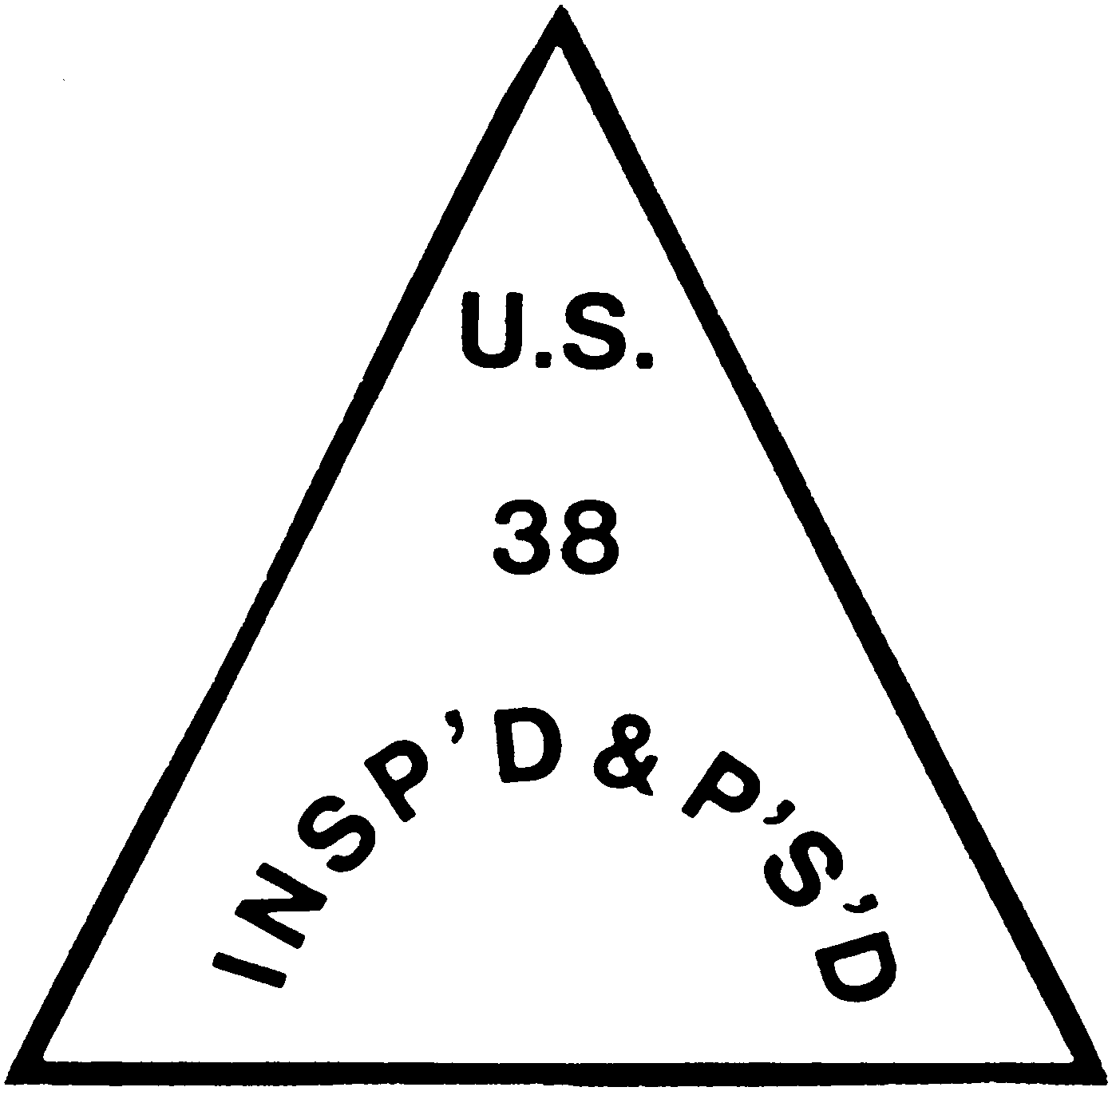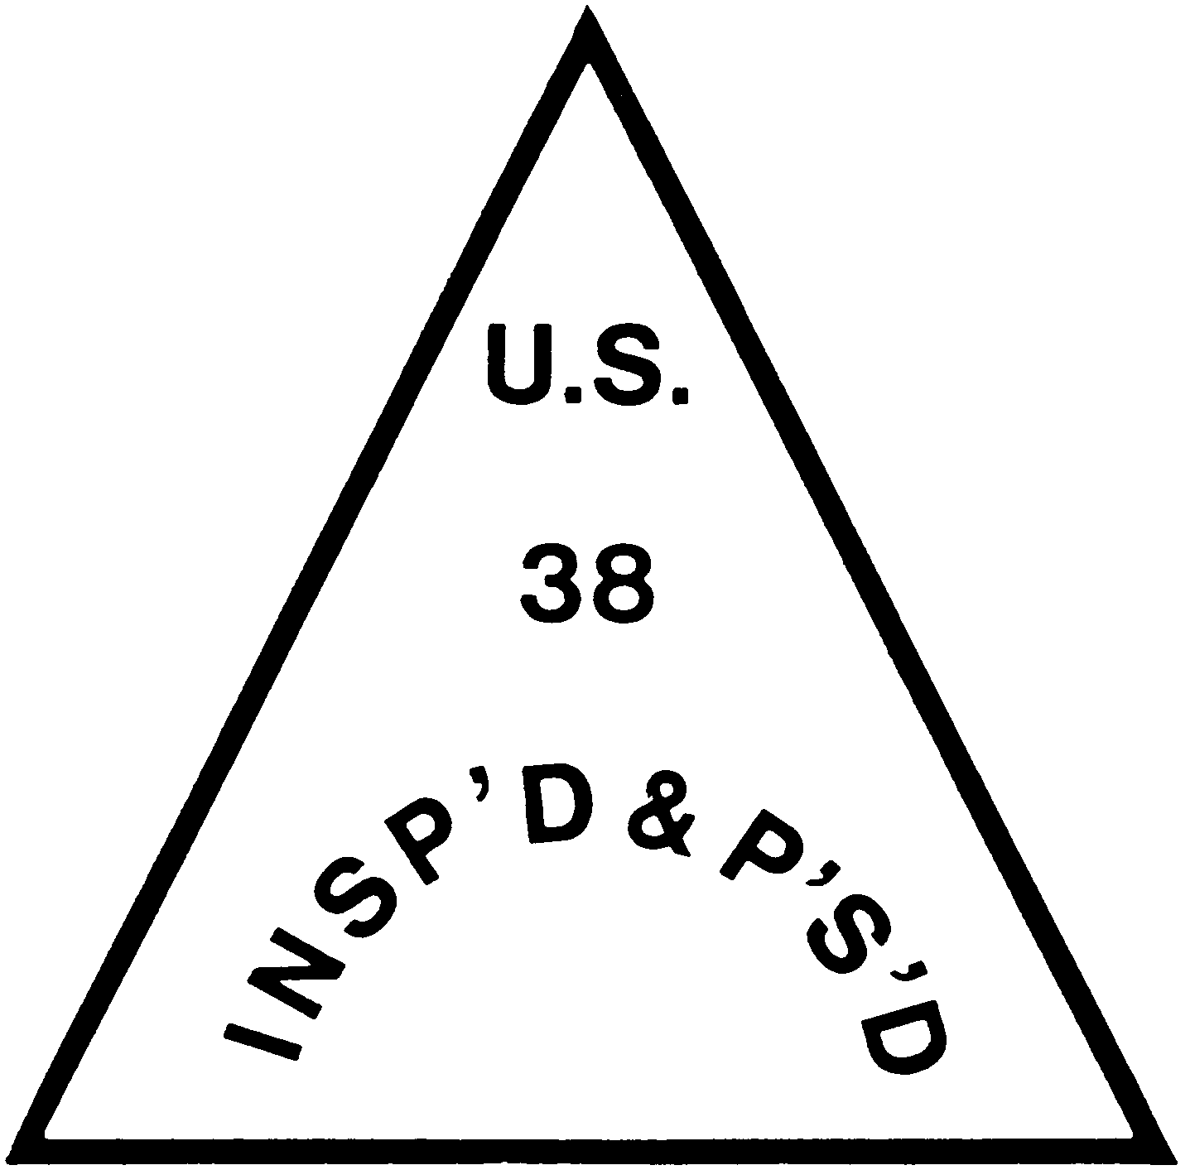

    - For application to exotic animal calf carcasses.

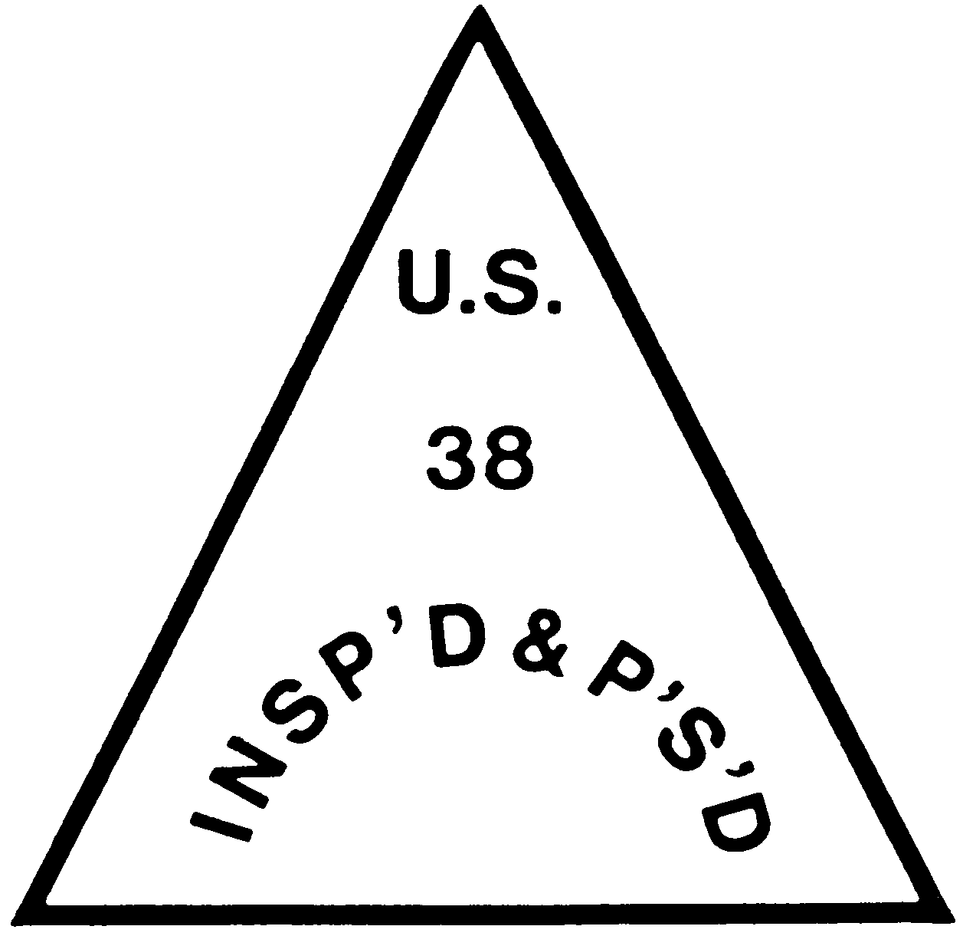
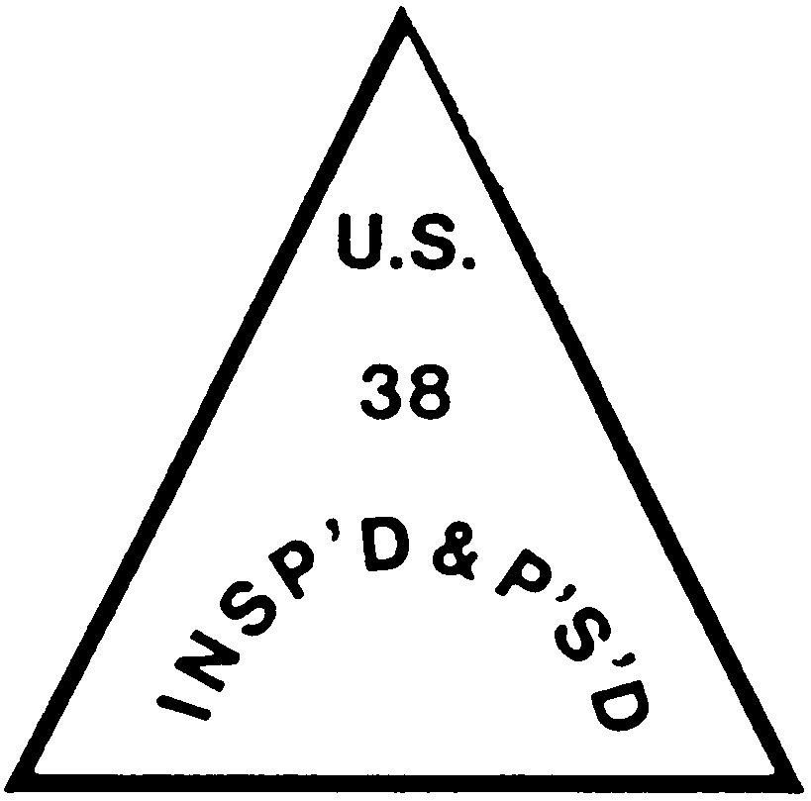
    - For application to exotic animal tails.
  - The official inspection mark to be shown on all labels. 1 (1) For inspected and passed products of an exotic ani- mal shall be in the following form, ex- cept that it need not be of the size il- lustrated, provided that it is a suffi- cient size and of such color as to be conspicuously displayed and readily legible and the same proportions of let- ter size and boldness are maintained as illustrated:

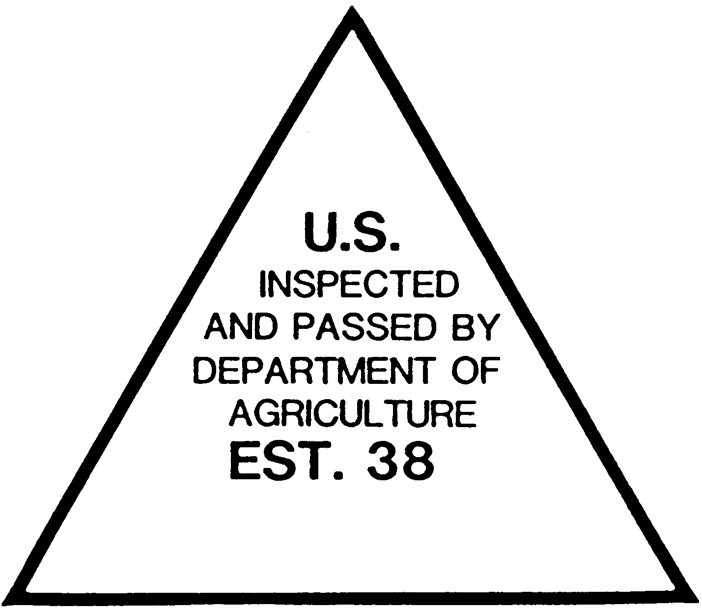

(2) This official mark shall be applied by mechanical means and shall not be applied by a hand stamp.

(4) For application to burlap, muslin,
cheesecloth, heavy paper, or other ac-

ceptable material that encloses car- casses or parts of carcasses.
1 The number ‘‘38’’ is given as an example
only. The establishment number of the offi- cial exotic animal establishment where the product is prepared shall be used in lieu thereof.

§ 352.8

(3) The official inspection legend de- scribed in paragraph (b)(1) of this sec- tion shall also be used on shipping con- tainers, bond labels, artificial casings, and other articles with the approval of the Administrator.
  - Any brand, stamp, label or other device approved by the Administrator and bearing any official mark pre- scribed in paragraph (a) or (b) of this section shall be an official device for purposes of the Act.
[50 FR 41847, Oct. 16, 1985, as amended at 54
FR 1331, Jan. 13, 1989]

§ 352.8 Time of inspection in the field and in an official exotic animal es- tablishment.
The official exotic animal establish- ment on behalf of the applicant shall notify the Regional Director or des- ignee, in advance, of the hours when such inspection is desired. Inspection personnel shall have access at all times to every part of any field ante-mortem inspection area and/or official exotic animal establishment to which they are assigned.
[54 FR 1332, Jan. 13, 1989]

§ 352.9 Report of inspection work.
Reports of the work of inspection carried on within the field ante- mortem inspection area of an exotic animal producer’s premises and/or offi- cial exotic animal establishment shall be forwarded to the Administrator by the ante-mortem inspector. The appli- cant for such inspection shall furnish to the Administrator such information as may be required on forms provided by the Administrator.
[54 FR 1333, Jan. 13, 1989]

§ 352.10 Ante-mortem inspection.
An ante-mortem inspection of an ex- otic animal shall, where and to the ex- tent considered necessary by the Ad- ministrator and under such instruc- tions as he may issue from time to time, be made on the day of slaughter of an exotic animal, in one of the fol- lowing listed ways or as determined by the Administrator. Humane handling of an exotic animal during ante- mortem inspection shall be in accord- ance with the provisions contained in 9 CFR 313.2. Immediately after the ani-

9 CFR Ch. III (1–1–16 Edition)

mal is stunned or killed, it shall be shackled, hoisted, stuck and bled.
- To be performed on an exotic ani- mal in the field in a designated area of an exotic animal producer’s premises.
- Reindeer, elk, deer, antelope, bison and water buffalo are eligible for field ante-mortem inspection. The field ante-mortem designated area must be approved by the Regional Director or designee prior to rendition of the serv- ice.
- Any person who desires to receive field ante-mortem inspection must pro- vide:
  - Notification from an official ex- otic animal establishment to the Re- gional Director or designee.
  - A field ante-mortem designated area.
  - A stunning/slaughtering area which is in a condition that minimizes the possibility of soiling the animal when stunned/slaughtered and bled as determined by the inspector.
  - A transport vehicle that is as sanitary as practicable as determined by the inspector.
- The ante-mortem inspector shall determine the acceptableness and safe- ty of performing field ante-mortem in- spection. If, in the opinion of the ante- mortem inspector, an unsafe cir- cumstance exists at the time of field ante-mortem inspection, the service shall be denied.
- An exotic animal that, in the ante-mortem inspector’s opinion, does not pass ante-mortem inspection must be withheld from slaughter.
- Stunning to render the animal un- conscious shall be in accordance with 9 CFR 313.15 or 313.16.
- All stunned/slaughtered and bled exotic animals shall be tagged with a ‘‘U.S. Suspect’’ tag in an ear by the ante-mortem inspector or designee prior to loading on the transport vehi- cle.
- The transport of intact exotic ani- mal carcasses to an official exotic ani- mal establishment for post-mortem in- spection shall be as expedient as pos- sible, and must be within the same day as field slaughter.
- Ante-mortem cards (Form MP 402–
2) shall be filled out by the ante- mortem inspector. One copy is to be re- tained by the ante-mortem inspector.

Food Safety and Inspection Service, USDA § 352.19

The other copy shall accompany the transport vehicle to the official exotic animal establishment and shall be de- livered to the post-mortem veteri- narian.
- The ante-mortem inspector shall supervise all phases of field ante- mortem inspection.
- To be performed on exotic ani- mals that are inside of the transport vehicle at an official exotic animal es- tablishment.
  - Reindeer, elk, deer, antelope, bison, and water buffalo are eligible for transport vehicle inspection.
  - The ante-mortem inspector shall remain outside the transport vehicle while performing ante-mortem inspec- tion.
  - The person requesting transport vehicle inspection must provide a transport vehicle that is as sanitary as practicable and that would safely and thoroughly permit the inspection of an exotic animal from outside of the transport vehicle as determined by the inspector.
  - The ante-mortem inspector shall determine the adequacy and safety of performing ante-mortem inspection. If, in the ante-mortem inspector’s opin- ion, the transport vehicle is not ade- quate or safe to perform ante-mortem inspection, the service shall be denied.
- To be performed in pens at official exotic animal establishments. The in- spection shall be conducted in accord- ance with the provisions contained in 9 CFR part 309.
[54 FR 1333, Jan. 13, 1989]

§ 352.11 Post-mortem inspection.
- Post-mortem inspection of rein- deer, elk, deer, antelope, bison and water buffalo shall be conducted in ac- cordance with the provisions contained in 9 CFR part 310 or as determined by the Administrator.
- The post-mortem examination of field ante-mortem-inspected exotic ani- mals must occur in the shortest length of time practicable and on the day that field ante-mortem inspection is per- formed to minimize the changes in the carcass which can affect the post- mortem examination, disposition and wholesomeness of the carcass and its parts.

- The post-mortem veterinarian shall inspect and make the disposition of all incoming ‘‘U.S. Suspect’’ tagged exotic animals.
[54 FR 1333, Jan. 13, 1989]

§ 352.12 Disposal of diseased or other- wise adulterated carcasses and parts.
This shall be conducted in accord- ance with the provisions contained in 9 CFR part 311.

§ 352.13 Handling and disposal of con- demned or other inedible exotic animal products at official exotic animal establishments.
This shall be conducted in accord- ance with the provisions contained in 9 CFR part 314.

§ 352.14 Entry into official establish- ments; reinspection and prepara- tion of products.
This shall be conducted in accord- ance with the provisions contained in 9 CFR 318.1, 318.2, and 318.3.

§ 352.15 Records, registration, and re- ports.
This shall be conducted or main- tained in accordance with the provi- sions contained in 9 CFR 320.1 through 320.7.

§ 352.16 Exports.
This shall be conducted in accord- ance with the provisions contained in 9 CFR 322.1 through 322.5.

§ 352.17 Transportation.
This shall be conducted in accord- ance with the provisions contained in
§§ 325.1 through 325.21.

§ 352.18 Cooperation of States in Fed- eral programs.
Under the ‘‘Talmadge-Aiken Act’’ of September 28, 1962 (7 U.S.C. 450), the Administrator is authorized to utilize employees and facilities of States in carrying out Federal functions.

Subpart B—Horses

§ 352.19 Ante-mortem inspection and applicable requirements.
Notwithstanding part 309 of this sub- chapter, an official establishment that

Pt. 354

wishes to slaughter horses can apply for voluntary ante-mortem inspection according to § 352.3. Such establish- ments shall pay the applicable base time, overtime, and holiday rates for ante-mortem inspection in accordance with § 352.5. Such ante-mortem inspec- tion shall be made in pens on the prem- ises of the establishment at which the horses are offered for slaughter in ac- cordance with § 309.1(b), and such estab- lishments also shall comply with all applicable provisions of §§ 352.8 and
352.9. If the establishment complies with all these requirements for ante- mortem inspection, FSIS will conduct ante-mortem inspection at that estab- lishment in accordance with § 352.10, and all other provisions in part 309 of this subchapter that pertain to horses will apply. FSIS may deny or withdraw ante-mortem inspection services at of- ficial establishments that slaughter horses for any applicable reason under
§ 352.6. Official marks and devices to identify inspected and passed horse carcasses and parts of carcasses, or horse meat food products shall be those in § 312.3 of this subchapter.
[71 FR 6341, Feb. 8, 2006]

PART 354—VOLUNTARY INSPEC- TION OF RABBITS AND EDIBLE PRODUCTS THEREOF
GENERAL
Sec.
  - Definitions.
  - Designation of official certificates, memoranda, marks, other identifica- tions, and devices for purposes of the Ag- ricultural Marketing Act.
ADMINISTRATION
  - Administration.
BASIS OF SERVICE
354.10 Inspection service.
  - Eligibility.
  - Supervision.
  - Authority to waive provisions of
§ 354.12.
PERFORMANCE OF SERVICES
  - Licensed or authorized inspectors.
  - Suspension of license; revocation.
  - Surrender of license.
  - Identification.
  - Financial interest of inspectors.
  - Political activity.

9 CFR Ch. III (1–1–16 Edition)

  - Schedule of operation of official plants.
APPLICATION FOR INSPECTION SERVICE
  - Who may obtain inspection service.
  - How application for service may be made; conditions of resident service.
  - Filing of application.
  - Authority of applicant.
  - Application for inspection service in official plants; approval.
  - Rejection of application.
  - Withdrawal of application.
354.38 Suspension of plant approval.
VIOLATIONS
  - Denial of service.
  - Misrepresentation; deceptive or fraudulent acts or practices.
  - Use of facsimile forms.
  - Willful violation of the regulations.
  - Interfering with an inspector or em- ployee of Service.
354.51 Miscellaneous.
OTHER APPLICABLE REGULATIONS
354.53 Other applicable regulations. IDENTIFYING AND MARKING PRODUCTS
354.60 Approval of official identification.
  - Inspection mark with respect to prod- uct.
  - Marking inspected products.
  - Form of official identification.
  - Form of inspection mark. SUPERVISION OF MARKING AND PACKAGING
  - Evidence of label approval.
  - Affixing of official identification.
  - Packaging.
  - Retention labels.
  - Prerequisites to inspection.
  - Accessibility of products.
  - Time of inspection in an official plant.
REPORTS
  - Report of inspection work.
  - Information to be furnished to inspec- tors.
  - Reports of violations.
FEES AND CHARGES
  - Payment of fees and charges.
  - On a fee basis.
  - Fees for additional copies of inspec- tion certificates.
  - Travel expenses and other charges.
  - Continuous inspection performed on a resident basis.
  - Fees or charges for inspection serv- ice performed under cooperative agree- ment.
  - Disposition of fees for inspection made under cooperative agreement.

