DBPR PMW-3360 – Personnel Roster

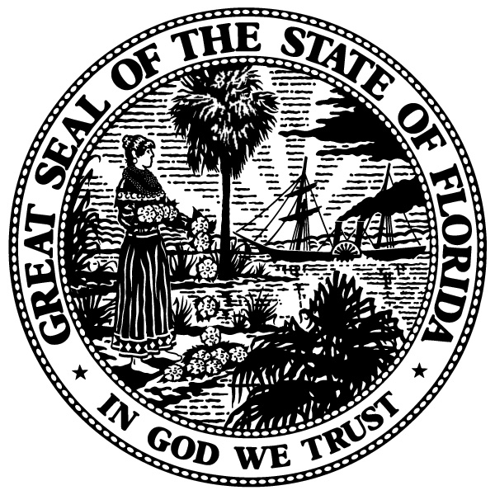 | State of Florida  Department of Business and Professional Regulation  Division of Pari-Mutuel Wagering  myfloridalicense.com

Pursuant to s. 550.105(4), Florida Statutes, it is unlawful to take part in or officiate in any way at any pari-mutuel facility without first having secured a license and paid the occupational license fee.

DATE: ____________________ FACILITY:

STABLE OR KENNEL NAME:

STABLE OR KENNEL OCCUPATIONAL LICENSE #:

ADDRESS:

STABLE OR KENNEL OWNER: _______________________________________ OWNER LICENSE #

POST COPY AT STABLE / KENNEL

EMPLOYEE NAME | POSITION | LICENSE NO.
 | TRAINER OF RECORD
 | ASSISTANT TRAINER
 | ASSISTANT TRAINER
 | ASSISTANT TRAINER
 | STABLE / KENNEL HELPER
 | STABLE / KENNEL HELPER
 | STABLE / KENNEL HELPER
 | STABLE / KENNEL HELPER
 | STABLE / KENNEL HELPER
 | STABLE / KENNEL HELPER
 | STABLE / KENNEL HELPER
 | STABLE / KENNEL HELPER
 | STABLE / KENNEL HELPER
 | STABLE / KENNEL HELPER

White Copy – Facility Racing Secretary
Pink Copy - State Office Chief Inspector
_____________________________
Trainer of Record’s Signature

DBPR PMW-3360, Effective December 2015, Rule 61D-6.002, F.A.C. Page 1 of 1 2.0

