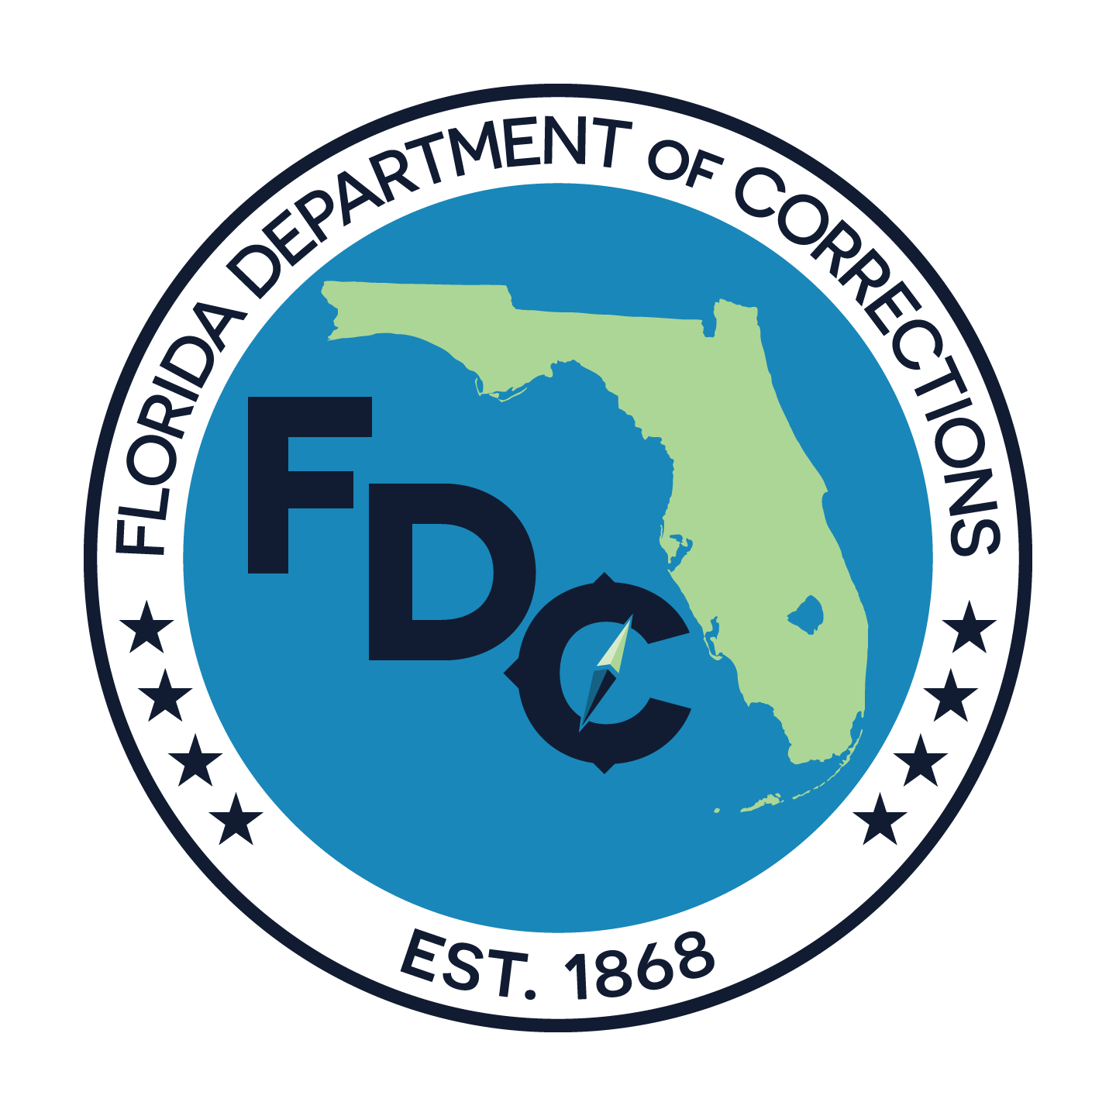

STATE INSTITUTION CLAIMS PROGRAM
Florida Department of Corrections
501 S. Calhoun Street; Tallahassee, FL 32399-2500

This form is also available at: http://www.flrules.org/Gateway/reference.asp?No=Ref-13991

INSTRUCTIONS: Pursuant to section 402.181, Florida Statutes, the purpose of this document is to ascertain restitution information for property damages and/or direct medical expenses for injuries caused by an inmate in the care and custody of the Florida Department of Corrections
For a claim to be considered, this form must:
- Be completely filled out, signed, and dated by the claimant or legal representative;
- If completed by a legal representative, include documentation to prove the relationship with the claimant;
- Fully describe the restitution amount per Section 2 and attach related documentation;
- Fully describe the property damage and/or medical expenses in Section 2 and attach related documentation; and
- Be received at the office address or e-mail address, shown above, within 90 calendar days of the incident. Failure to submit a complete form timely will result in denial of your claim.
SECTION 1: CLAIMANT/LEGAL REPRESENTATIVE INFORMATION
1. Claimant’s Name (last, first, middle):___________________________________________________________
2. Claimant’s Mailing Address:__________________________________________________________________
3. City:_______________________________ 4. State:____________ 5. Zip Code:______________________
6. Claimant’s Telephone Number:(____)____________ 7. Claimant’s E-mail (optional):_____________________
If the claimant is under the age of 18, incompetent, incapacitated, or deceased, the legal representative filing on behalf of the claimant must provide information below.
8. Legal Representative’s Name (last, first, middle):_________________________________________________
9. Relationship to Claimant (you must attach documentation to prove relationship) (check one):
Parent Foster Parent Guardian Estate Representative Power of Attorney
10. Legal Representative ’s Mailing Address:_______________________________________________________
11. City:______________________________ 12. State:______________ 13. Zip Code:___________________
14. Legal Representative’s Phone Number:(__________)_____________________________________________
15. Legal Representative’s E-mail (optional):_______________________________________________________

SECTION 2: RESTITUTION INFORMATION
- Location of Incident (including address):________________________________________________________
- Date and Approximate Time of Incident:________________________________________________________
- Type of Restitution Requested: Property Damages Medical Expenses
- List each injury/loss and specify the repair/replacement cost. You must attach itemized receipts, bills, or estimates of repair which verify the requested amount. The maximum award for losses caused by all persons supervised by the Agency shall not exceed $1,000.00 per incident.
Description of Each Loss (Property Damages or Medical Expenses) | Amount
 | $
 | $
 | $

- Provide a statement describing the facts upon which the claimant seeks restitution for property damages and/or medical expenses. Attach additional pages as necessary. You must attach documentation which supports the facts described below. Documentation may include photograph(s), police report, witness statement, etc.

- Have you requested compensation with workers’ compensation, private insurance, or any other entitlement related to this incident? Yes No
If yes, explain:_______________________________________________________________________________

By my signature, under penalty of perjury and fraud, I certify that the information contained herein is true and correct to the best of my knowledge. I understand that I may have other options for reimbursement under other entitlements, such as workers’ compensation or private insurance. I further acknowledge, any individual who submits a claim containing documentation that has been falsified or that contains misrepresentations shall be held liable under the False Claims Act pursuant to sections 68.081-68.092, Florida Statutes.
Signature: _______________________________________________ Date:_____________________________

