To access Form DFS-H2-0100, the applicant must create a MyProfile account at https://dice.fldfs.com/public/pb_index.aspx and submit the license application through the Department of Financial Services’ online portal.

Create MyProfile Account - Individual
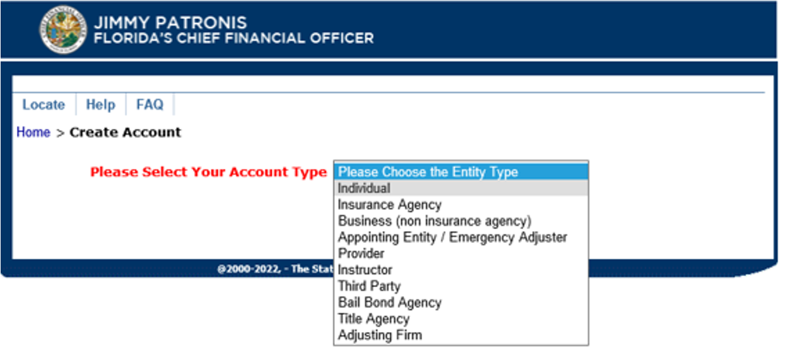

Enter Social Security Number and Date of Birth
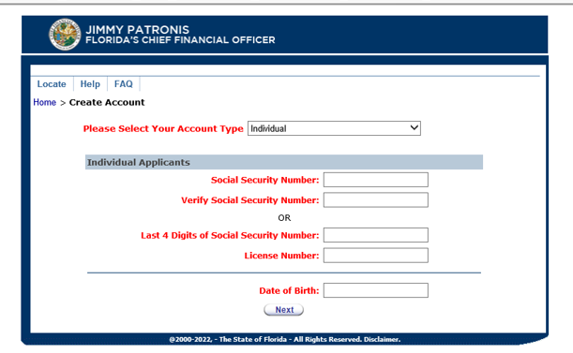
Privacy Statement
Pursuant to the Privacy Act of 1974, 5 U.S.C. § 552a, the State is responsible for informing you whether disclosure of your social security number is mandatory or voluntary, by what statutory or other authority your social security number is solicited, and what uses will be made of your social security number. Under § 119.071(5)(a)2., F.S., a state agency may collect your social security number if the collection is:
(I) specifically authorized by law; or
(II) imperative for the performance of the agency's duties and responsibilities as prescribed by law.
Disclosure of your social security number on this form is mandatory pursuant to the Welfare Reform Act, 42 U.S.C. § 666, and §§ 626.171(2)(a) and (7), 626.231(2)(a), 626.541(1), and 626.9953(3)(a) and (7), F.S.
The purposes for the requested information are to verify the identity of an applicant for licensure, to conduct criminal and disciplinary history background checks, and to determine if the applicant lacks the fitness or trustworthiness to engage in the business of insurance. Your social security number is confidential and exempt from the disclosure requirements of § 119.07(1), F.S., and § 24(a), Article I of the Florida Constitution and will not be used for any purpose other than the purposes provided herein, or as otherwise authorized under § 119.071(5)(a), F.S.
A copy of this Privacy Statement is provided to you as required by § 119.071(5)(a)3., F.S.

Enter Account Profile Information
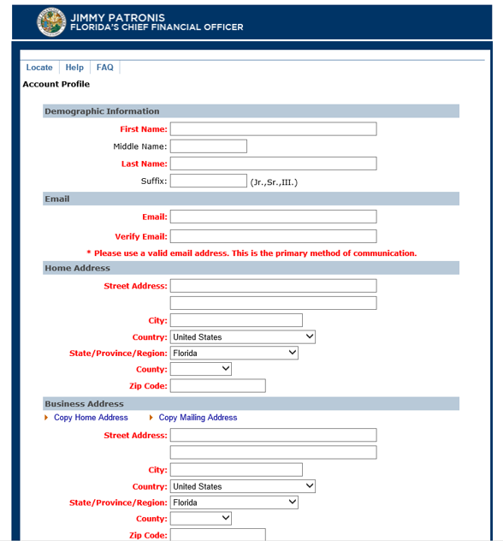
(continued on next page)
*See end of form for all Country, State, and County listings.
Enter Account Profile Information continued
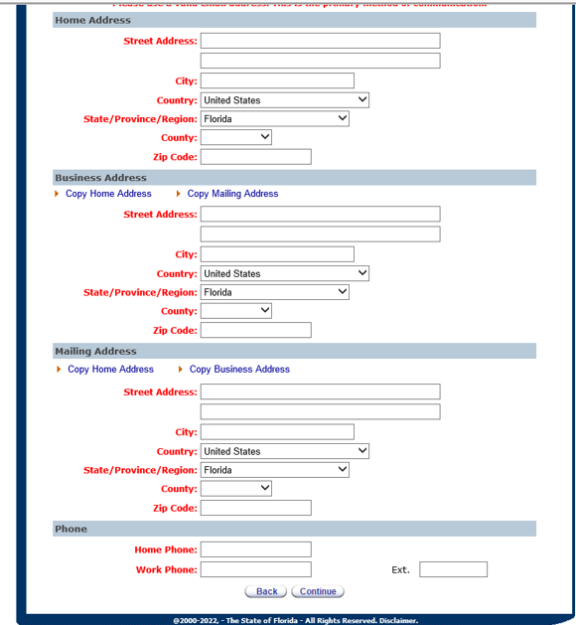

Create Account Credentials
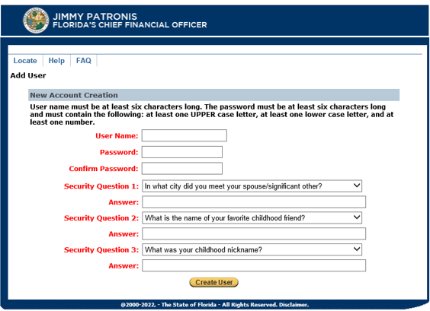

MyProfile Account In-Box, select New Application
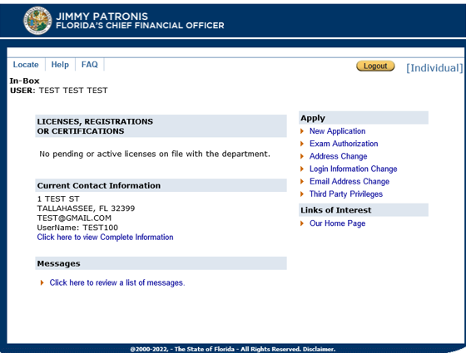

New Application, Application Advise
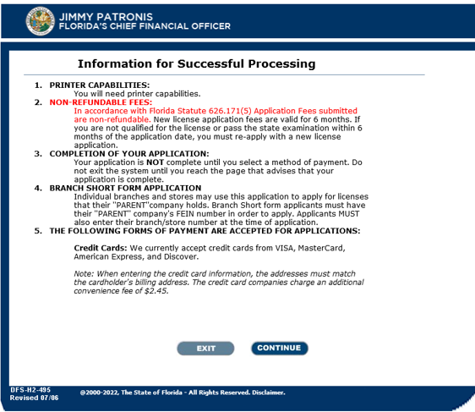

New Application, Background Questions, page one
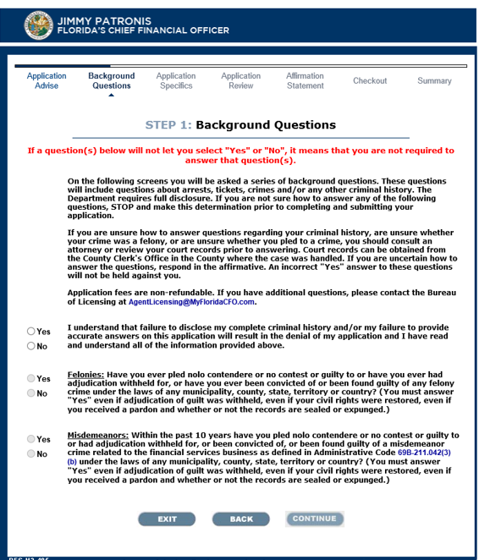

New Application, “No” Response to Background Question One
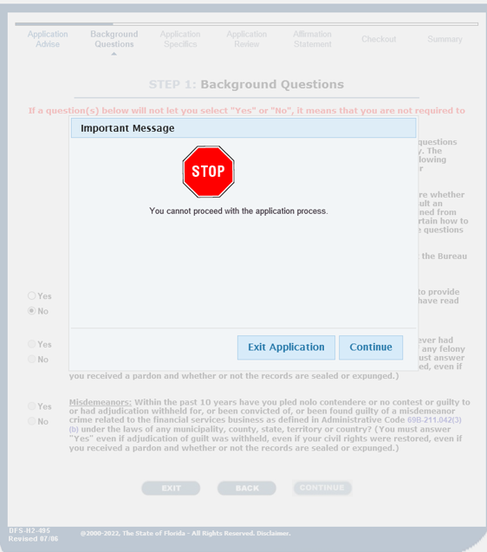

New Application, Background Questions, page two, required field in response to “Yes” on question one.
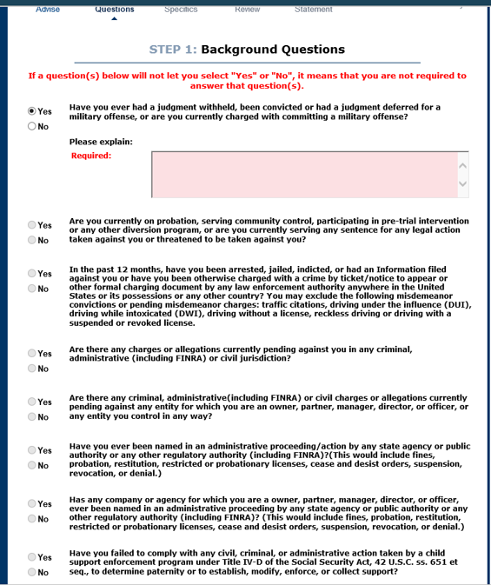

New Application, Background Questions, page two
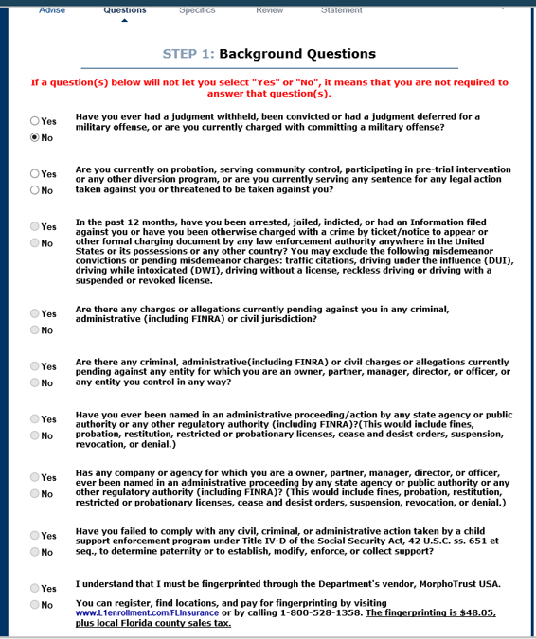

New Application, Background Questions, “Yes” response to question two of page two
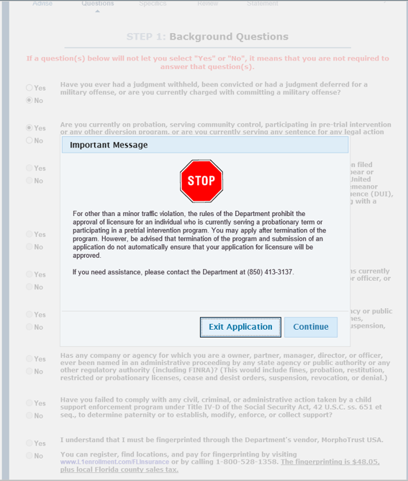

New Application, Background Questions, page two, required field in response to “Yes” on question three
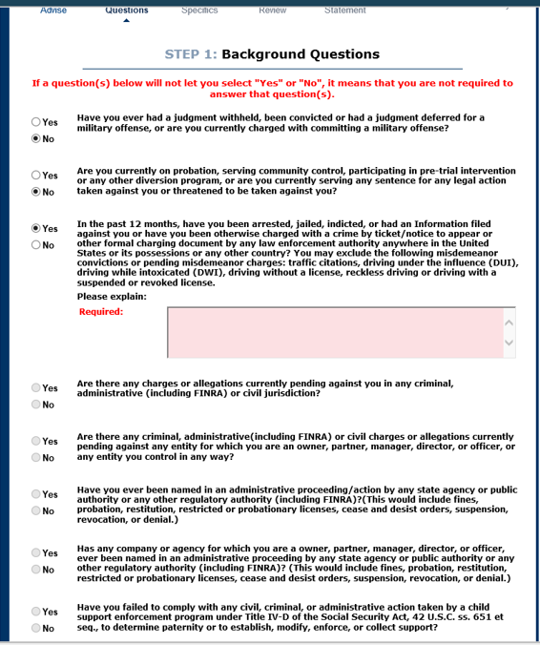

New Application, Background Questions, page two, required field in response to “Yes” on question four
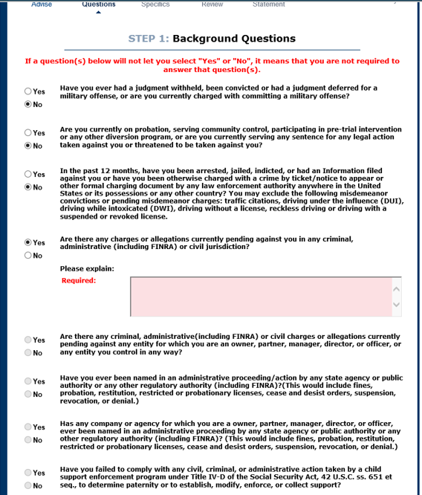

New Application, Background Questions, page two, required field in response to “Yes” on question five
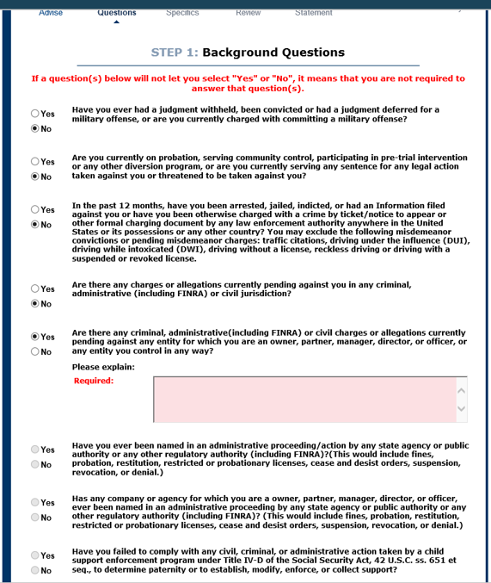

New Application, Background Questions, page two, required field in response to “Yes” on question six
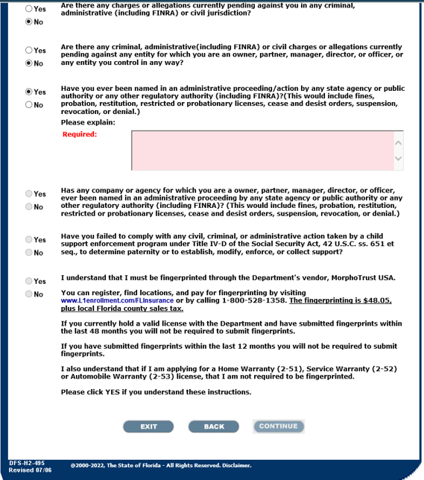

New Application, Background Questions, page two, required field in response to “Yes” on question seven
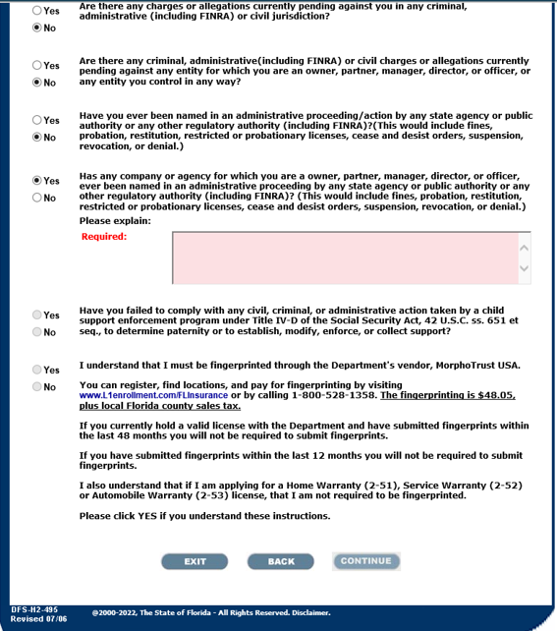

New Application, Background Questions, page two, required field in response to “Yes” on question eight
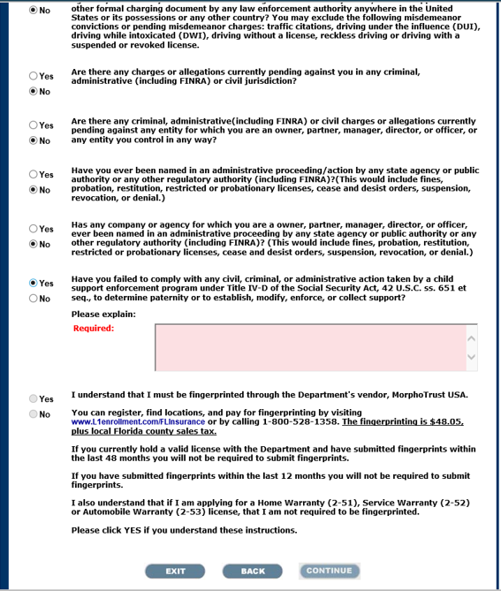

New Application, Background Questions, page two, “No” response to ninth question
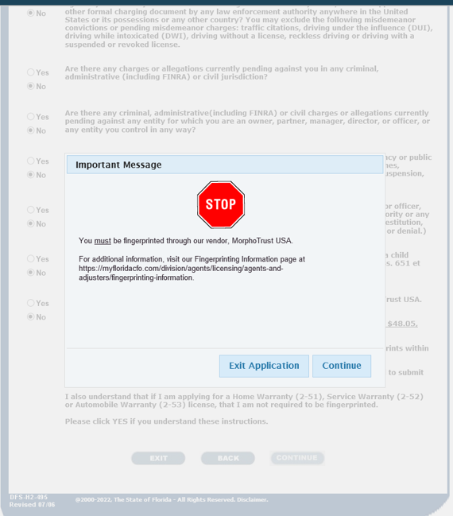

New Application, Background Question Review
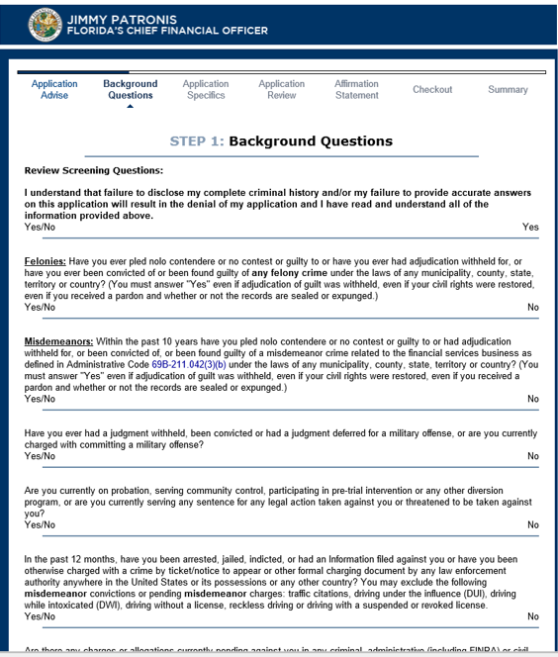
(continued on next page)

New Application, Background Question Review continued
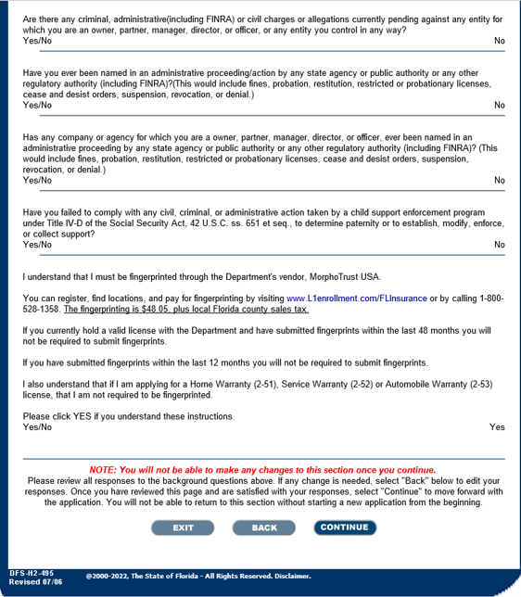

New Application, Application Specifics, select permanent or temporary license type
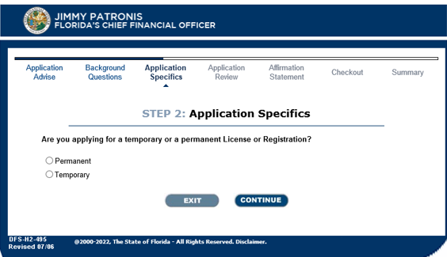

New Application, Application Specifics, select resident license type/class
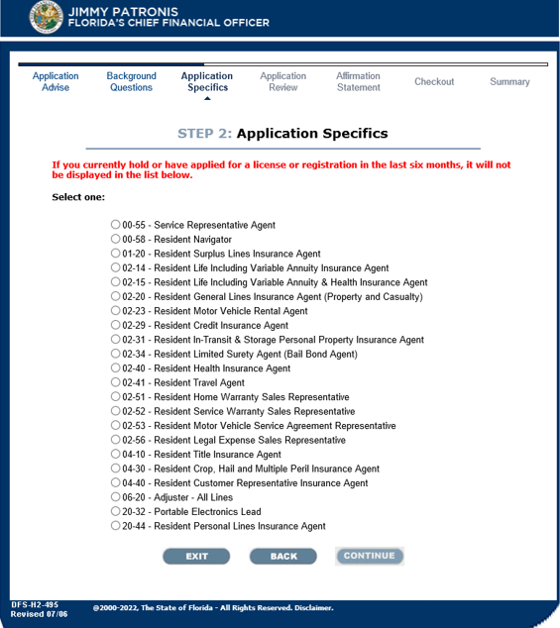

New Application, Application Specifics, select type/class 04-40 - Resident Customer Service Representative Insurance Agent
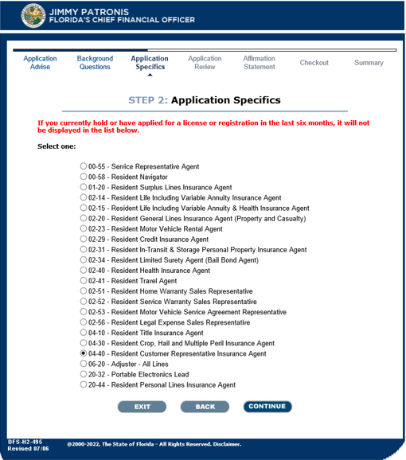

New Application, Application Specifics, type/class 04-40 - Resident Customer Service Representative Insurance Agent, popup message after selection
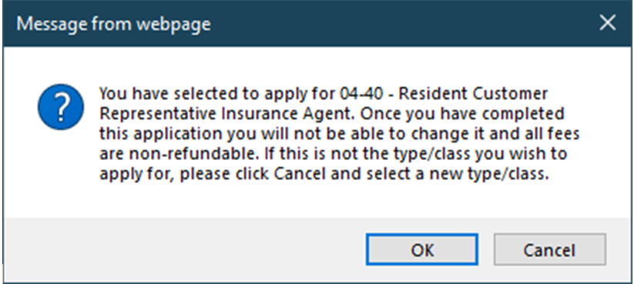

New Application, Application Specifics, type/class 04-40 - Resident Customer Service Representative Insurance Agent, type/class specific questions
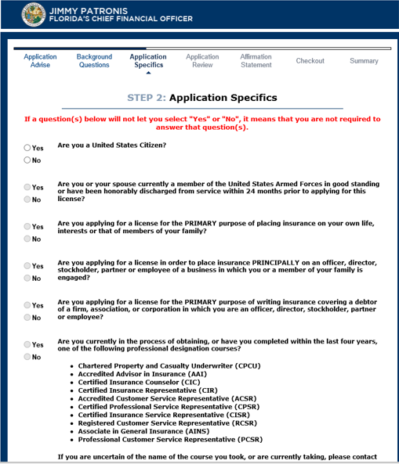
(continued on next page)
New Application, Application Specifics, type/class 04-40 - Resident Customer Service Representative Insurance Agent, type/class specific questions continued
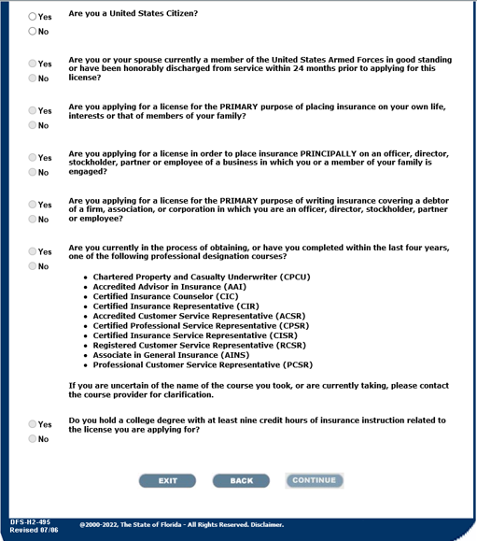

New Application, Application Specifics, type/class 04-40 - Resident Customer Service Representative Insurance Agent, “No” response to question one
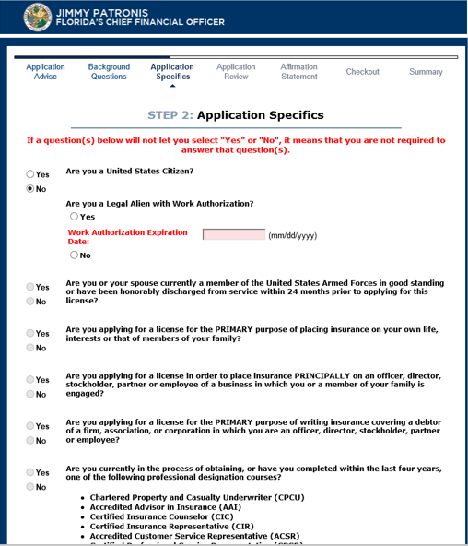

New Application, Application Specifics, type/class 04-40 - Resident Customer Service Representative Insurance Agent, “No” response to sub-question of question one
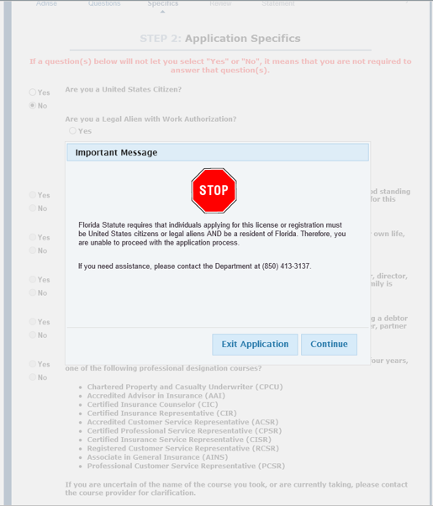

New Application, Application Specifics, type/class 04-40 - Resident Customer Service Representative Insurance Agent, “Yes” response to question two
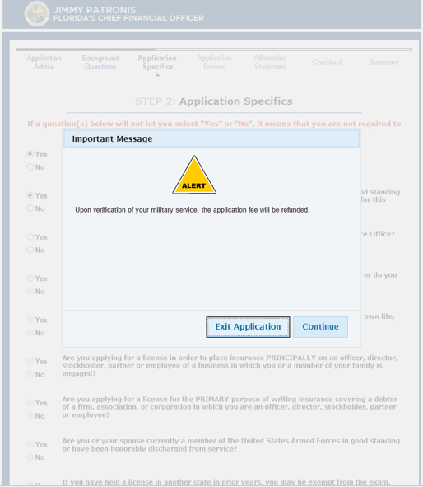

New Application, Application Specifics, type/class 04-40 - Resident Customer Service Representative Insurance Agent, “Yes” response to question three
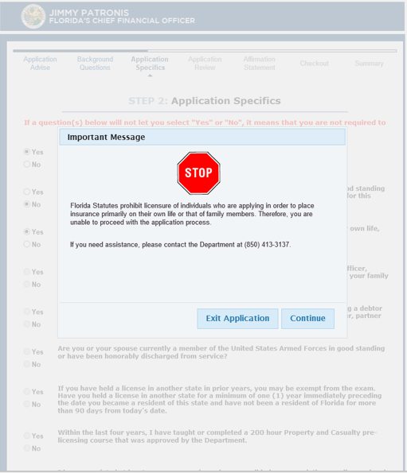

New Application, Application Specifics, type/class 04-40 - Resident Customer Service Representative Insurance Agent, “Yes” response to question four
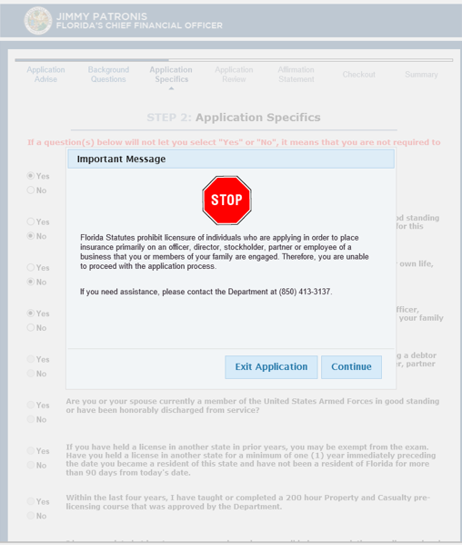

New Application, Application Specifics, type/class 04-40 - Resident Customer Service Representative Insurance Agent, “Yes” response to question five
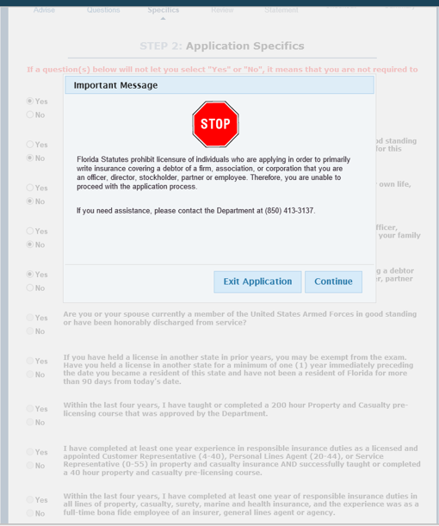

New Application, Application Specifics, type/class 04-40 - Resident Customer Service Representative Insurance Agent, “Yes” response to question six
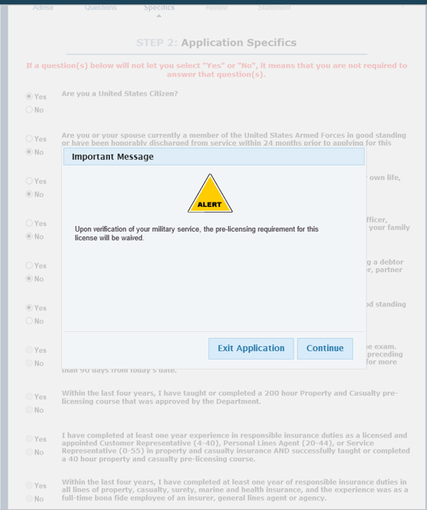

New Application, Application Specifics, type/class 04-40 - Resident Customer Service Representative Insurance Agent, “Yes” response to question seven
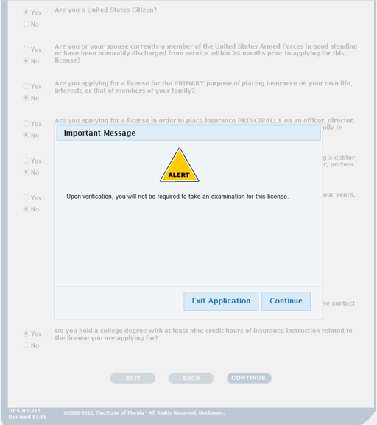

New Application, Application Specifics, type/class 04-40 - Resident Customer Service Representative Insurance Agent, question for another license type
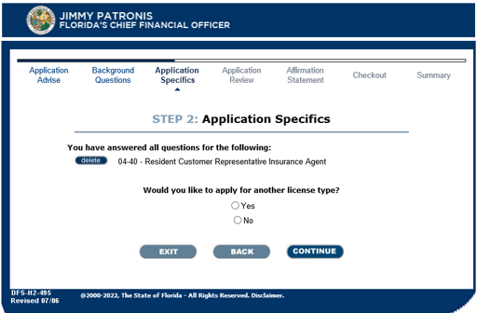

New Application, Application Review
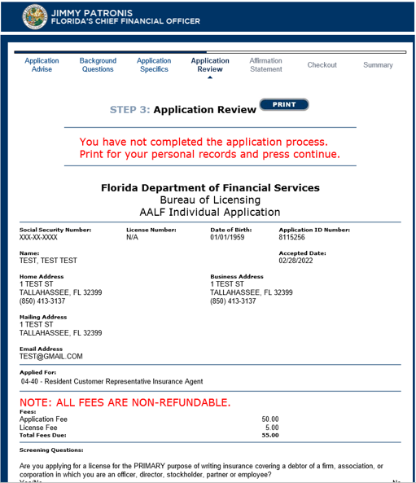
(continued on next page)

New Application, Application Review continued
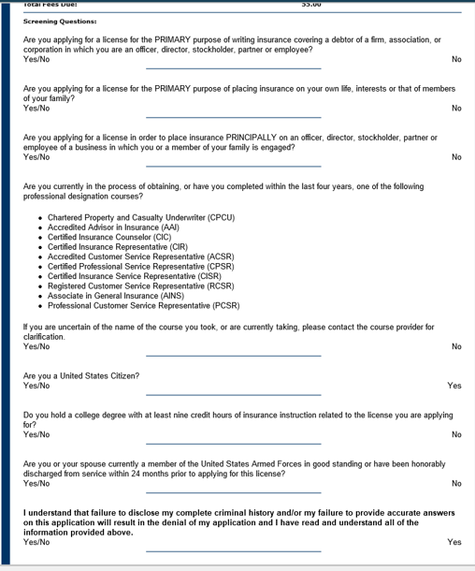
(continued on next page)

New Application, Application Review continued
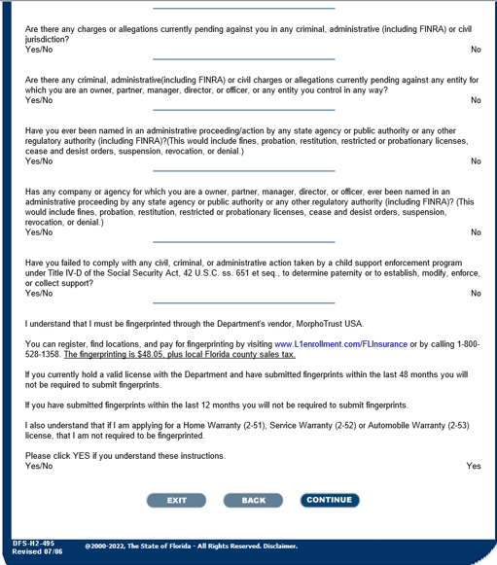
New Application, Affirmation Statement 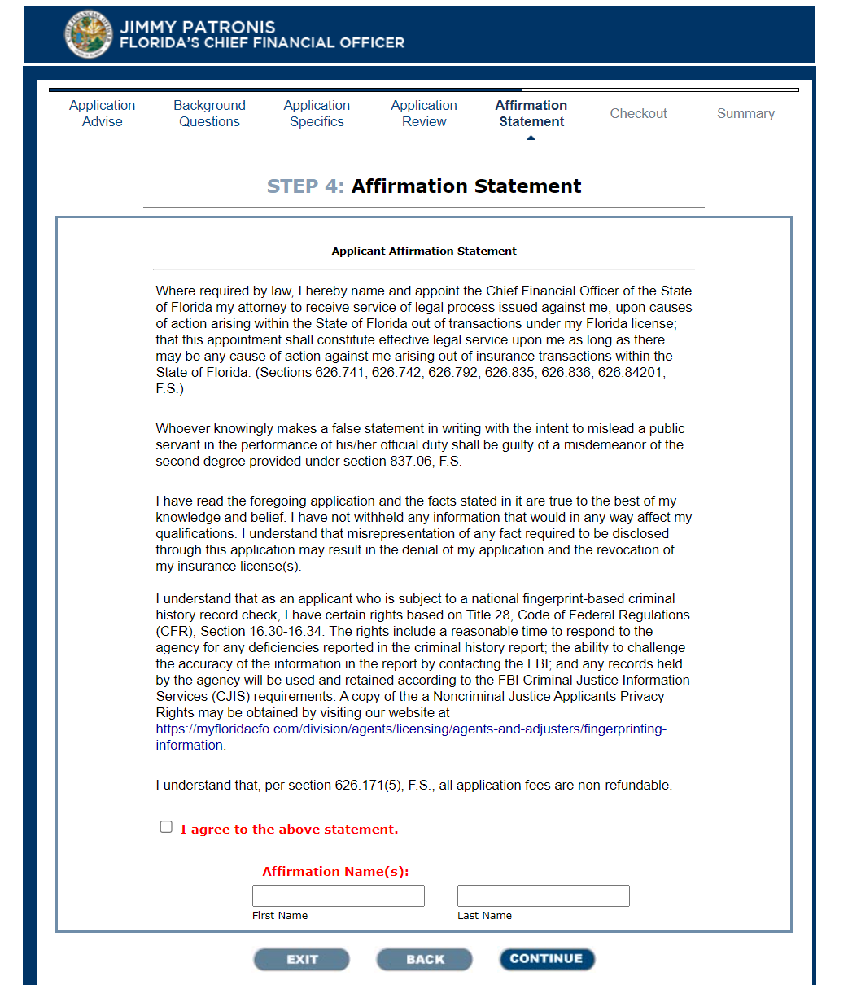
New Application, Checkout
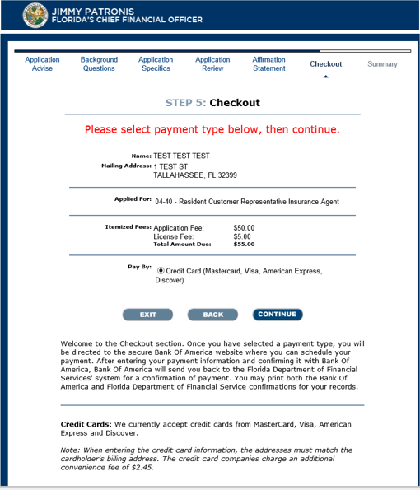

Regarding each “Country:” field on this form, the following are potential selections:
Antarctica, Antigua and Barbuda, Argentina, Armenia, Aruba, Australia, Austria, Azerbaijan, Bahamas, Bahrain, Bangladesh, Barbados, Belarus, Belgium, Belize, Benin, Bermuda, Bhutan, Bolivia, Bosnia and Herzegovina, Botswana, Bouvet Island, Brazil, British Indian Ocean Territory, Brunei Darussalam, Bulgaria, Burkina Faso, Burundi, Cambodia, Cameroon, Canada, Cape Verde, Central African Republic, Chile, China, Christmas Island, Cocos (Keeling) Island, Colombia, Comoros, Congo, Cook Islands, Costa Rica, Côte d'Ivoire, Croatia, Cuba, Cyprus, Czech Republic, Democratic Republic of the Congo, Denmark, Djibouti, Dominica, Dominican Republic, Ecuador, Egypt, Equatorial Guinea, Eritrea, Estonia, Ethiopia, Falkland Islands (Malvinas), Faroe Islands, Federated States of Micronesia, Fiji, Finland, France, France Metropolitan, French Guiana, Gabon, Gambia, Georgia, Germany, Ghana, Gibraltar, Great Britain (UK) Greece, Greenland, Grenada, Guadeloupe, Guam, Guatemala, Guinea, Guinea-Bissau, Guyana, Haiti, Heard Island and McDonald Islands, Honduras, Hong Kong, Hungary, Iceland, India, Indonesia, Iraq, Ireland, Israel, Italy, Jamaica, Japan, Jordan, Kazakhstan, Kenya, Kiribati, Korea (south), Kuwait, Kyrgyzstan ,Laos, Latvia, Lebanon, Lesotho, Liberia, Libya, Liechtenstein, Lithuania, Luxembourg, Macao, Macedonia, Madagascar, Malawi, Malaysia, Maldives, Mali, Malta, Marshall Islands, Martinique, Mauritania, Mauritius, Mexico, Moldova, Monaco, Mongolia, Montenegro, Montserrat, Morocco, Myanmar, Netherlands, Netherlands Antilles, Northern Mariana Islands, Norway, Panama, Philippines, S. Georgia and S. Sandwich Islands, Saint Kitts and Nevis, Saint Lucia, Serbia, Spain, Sri Lanka, Sweden, Switzerland, United Arab Emirates, United States, Western Sahara
Regarding each “State/Province/Region:” field on this form, the following are potential selections:
Alabama, Alaska, Arizona, Arkansas, California, Colorado, Connecticut, Delaware, Florida, Georgia, Hawaii, Idaho, Illinois, Indiana, Iowa, Kansas, Kentucky, Louisiana, Maine, Maryland, Massachusetts, Michigan, Minnesota, Mississippi, Missouri, Montana, Nebraska, Nevada, New Hampshire, New Jersey, New Mexico, New York, North Carolina, North Dakota, Ohio, Oklahoma, Oregon, Pennsylvania, Rhode Island, South Carolina, South Dakota, Tennessee, Texas, Utah, Vermont, Virginia, Washington, West Virginia, Wisconsin, and Wyoming
Regarding each “County:” field on this form, the following are potential selections:
Alachua, Baker, Bay, Bradford, Brevard, Broward, Calhoun, Charlotte, Citrus, Clay, Collier, Columbia, DeSoto, Dixie, Duval, Escambia, Flagler, Franklin, Gadsden, Gilchrist, Glades, Gulf, Hamilton, Hardee, Hendry, Hernando, Highlands, Hillsborough, Holmes, Indian River, Jackson, Jefferson, Lafayette, Lake, Lee, Leon, Levy, Liberty, Madison, Manatee, Marion, Martin, Miami-Dade, Monroe, Nassau, Okaloosa, Okeechobee, Orange, Osceola, Palm Beach, Pasco, Pinellas, Polk, Putnam, Santa Rosa, Sarasota, Seminole, St. Johns, St. Lucie, Sumter, Suwannee, Taylor, Union, Volusia, Wakulla, Walton, and Washington

