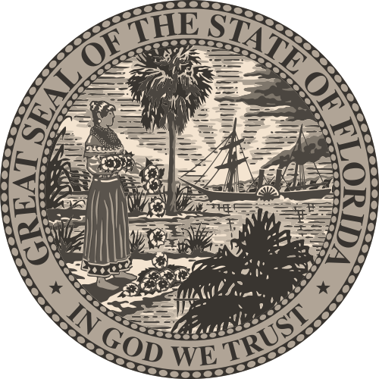
Temporary Permit to Operate a
Florida Department of Financial Services
Bail Bond Agency

Name of Bail Bond Agency
Address of Bail Bond Agency
City, State, Zip Code
Name of Individual
Issue Date

Pursuant to Section 648.285(2), Florida Statutes this temporary permit will
expire on ____________
Jeff Atwater
Chief Financial Officer
State of Florida

