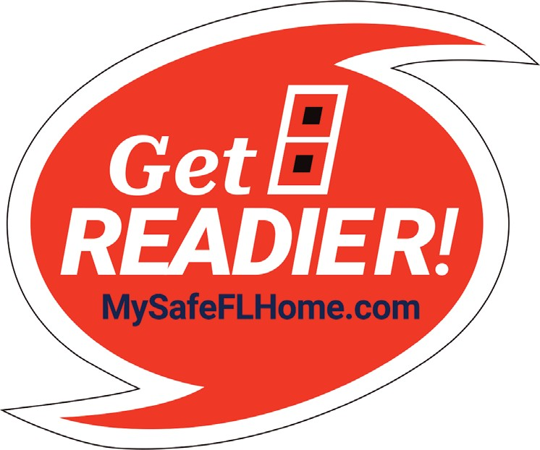
Homeowner’s
Guide
My Safe Florida Home Program

Dear Florida Homeowner,
Welcome to the Homeowner’s Guide for the My Safe Florida Home Program (Program). The My Safe Florida Home Program (“MSFH Program” or “Program”) has two primary components to be administered by the Florida Department of Financial Services (“Department” or “DFS”):
- Provide eligible Florida Homeowners, free of charge and with no obligation, a Hurricane Mitigation Inspection that identiﬁes the current Hurricane Resistant Features of their homes and recommends Improvements to further strengthen their homes against hurricanes.
- Provide eligible Florida Homeowners a Hurricane Mitigation Grant to help fund speciﬁc home Improvements recommended by the Program’s Initial Inspection, strengthening homes against hurricanes and offering potential discounts on home insurance premiums.
Please review this guide before your initial application and before moving to the next step of the process, and we thank you for your interest in the My Safe Florida Home Program.

Sincerely,
The My Safe Florida Home Program Team

TABLE OF CONTENTS
Application Steps 4
Hurricane Mitigation Inspections 5
Eligibility Requirements 5
Initial, Final, and Quality Control Inspections 6
Inspection Reports 7
Hurricane Mitigation Grants 13
Eligibility Requirements 13
Matching and Low-Income Grants 14
Hurricane Mitigation Projects 15
Improvements Guide 15
Draw Requests 18
Submitting a Draw Request 18
Approval of Draw Request 19

APPLICATION STEPS
Step 1: Apply for a Hurricane Mitigation Inspection.
- The Homeowner submits an Inspection Application via the Applicant Portal https://mysafeflhome.com/.
- Homeowners must provide all required information and documentation to receive Inspection Application approval.
Step 2: Schedule an Initial Inspection.
- Upon Inspection Application approval, the Homeowner schedules an Initial Inspection for the Inspector to determine which, if any, Improvements are recommended for the home.
Step 3: Receive an Initial Inspection Report.
- The Inspector uploads the Initial Inspection Report to the Applicant Portal.
- If the Inspector does not recommend any Improvements, please send your report to your insurance company to obtain any potential premium discounts. If you have no recommended Improvements, you will not be able to proceed with a Grant Application.
Step 4: Apply for a Hurricane Mitigation Grant.
- The Homeowner submits a Grant Application via the Applicant Portal on https://mysafeflhome.com/.
- The Grant Application is made up of two stages, the Eligibility Confirmation and Contractor Confirmation, submitted at different times.
- Homeowners must provide all required information and documentation to receive Grant Application approval.
Step 5: Complete a Hurricane Mitigation Project.
- The Homeowner works with their Contractor to complete a Mitigation Project for Improvements on the home based on the recommendations in the Initial Inspection Report.
Step 6: Schedule a Final Inspection.
- Upon completion of the Mitigation Project, the Homeowner schedules a Final Inspection for the Inspector to observe any Improvements that were successfully completed on the home.
Step 7: Receive a Final Inspection Report.
- The Inspector uploads the Final Inspection Report to the Applicant Portal.
Step 8: Submit a Draw Request.
- The Homeowner submits a Draw Request via the Applicant Portal on https://mysafeflhome.com/.
- Homeowners must provide all required information and documentation to receive Draw Request approval.
- Only Improvements that are recommended in the Initial Inspection Report and observed in the Final Inspection Report are eligible for Grant funding.
HURRICANE MITIGATION INSPECTIONS
The Florida State Legislature has allocated funds through the My Safe Florida Home Program to provide Homeowners a Hurricane Mitigation Inspection (“Inspection”) of their home at NO COST and NO OBLIGATION. A Hurricane Mitigation Inspection is a home inspection performed by a Wind Certification Entity (“Inspector”) pursuant to the MSFH Program. Hurricane Mitigation Inspections typically take one (1) hour to perform. An approval for a Hurricane Mitigation Inspection is NOT an approval for a Grant.
These Inspections are designed to describe the presence or absence of Hurricane Resistant Features that have been proven to help a home survive windstorms and are not condition-based inspections. If features of your home are showing signs of age and wear, have them examined by a proper professional who can help you assess their condition and make suggestions.
Eligibility Requirements
Florida Homeowners who meet the following requirements may qualify for a free Inspection:
- The home must be a single-family, detached residential property or a townhouse as defined in section 481.203, Florida Statutes (F.S.);
- The home must be site-built and owner-occupied; and
- The Homeowner must have been granted a homestead exemption on the home under chapter 196, F.S.
PLEASE NOTE: Single-family homes that are attached to other units will be treated as Townhouses for the purposes of the MSFH Program.
Properties that are NOT eligible for a free Inspection include:
- Multi-Family Homes (such as apartments, duplexes, and triplexes)
- Condominiums
- Cooperatives
- Retirement Homes
- Mobile Homes & Manufactured Homes
- Second Homes, Vacation Homes, & Rental Properties
PLEASE NOTE: Not all applicants who received an Inspection through the Program will be eligible for a Hurricane Mitigation Grant.
How To Apply
Homeowners may apply by visiting https://mysafeflhome.com/ and clicking the “Apply Now” button.
PLEASE NOTE: For the first sixty (60) days after the Program starts accepting Inspection Applications, Homeowner will be prioritized based on age and income criteria as outlined by the Legislature.
To apply for an Inspection, Homeowners are required to provide the following information:
- First and Last Name
- Valid Email Address
- Home Steet Address, City, and Zip Code
- Phone Number
If you would like to check your home type or homestead exemption status, please contact your county Property Appraiser or Tax Collector Office. You can find their information here; https://floridarevenue.com/property/Pages/LocalOfficials.aspx.
Initial, Final, and Quality Control Inspections
Initial Inspections
Upon approval of an Inspection Application, the Program will notify the Homeowner via email and provide the name and contact information of the Inspector assigned to inspect the home. An Inspector will contact the Homeowner within seven (7) days to schedule a free Initial Inspection.
The Homeowner should receive an email within fourteen (14) days from the date of the Initial Inspection notifying them that the Initial Inspection Report has been uploaded to the Applicant Portal. To find the Initial Inspection Report, open your case in the Applicant Portal and select the “documents” tab.
Final Inspections
Homeowners must request Final Inspections upon completion of the Mitigation Project before proceeding to the Draw Request stage. The Final Inspection is the concluding Hurricane Mitigation Inspection performed by an Inspector to observe any Improvements that were successfully completed on the home.
Each Homeowner will only have ONE (1) opportunity to request a Final Inspection.
Homeowners should follow the steps listed below closely to request a Final Inspection:
- Confirm with their Contractor that work on the home is complete.
- Ensure the permits are closed out and that the local building inspector’s office has completed all required inspections.
- Return to the Applicant Portal at https://mysafeflhome.com/ and request a Final Inspection for the home.
After a Homeowner has requested a Final Inspection, a Program case manager will alert the Inspector and send a notification email. Inspections will be scheduled based on a queue.
Once the Final Inspection is completed, the Inspector will upload the Final Inspection Report to the Applicant Portal.
Quality Control Inspections
A Quality Control Inspection may be completed to verify the accuracy of Initial or Final Inspections. Quality Control Inspections are not typically provided and are used on a case-by-case basis.
Inspection Reports
Please thoroughly read your MSFH Program Inspection Reports.
INITIAL INSPECTION REPORT
The Initial Inspection Report will indicate which, if any, recommend Improvements are available to a Homeowner to strengthen their home against hurricane damage.
Each Initial Inspection Report will contain the following:
1. Introduction
2. Recommended Improvements
3. Improvement Cost Estimates
4. Summary of Form OIR-B1-1802
5. Attachments
a. Form OIR-B1-1802 (Uniform Mitigation Verification Inspection Form)
b. Initial Inspection Photographs and Documents
PLEASE NOTE: Only Improvements recommended by an Inspector in an Initial Inspection Report and observed by an Inspector in a Final Inspection Report will be eligible for funding under the Program. No other construction is eligible for funding.
PLEASE NOTE: Townhouses are only eligible to receive funding for Improvement 1.0 – Opening Protection. Single-family homes that are attached to other units will be treated as Townhouses for the purposes of the MSFH Program.
Recommended Improvements
One of the key goals of the Initial Inspection Report is to recommend specific Improvements a Homeowner can make on their home to mitigate hurricane damage. These types of Improvements may result in wind insurance premium discounts from the Homeowner’s insurer.

The following sample image demonstrates what this summary may look like within the Initial Inspection Report. The recommendations will vary by home and depend on what the Inspector observes; a Homeowner’s Initial Inspection Report may not have all of the recommendations listed on the sample image.
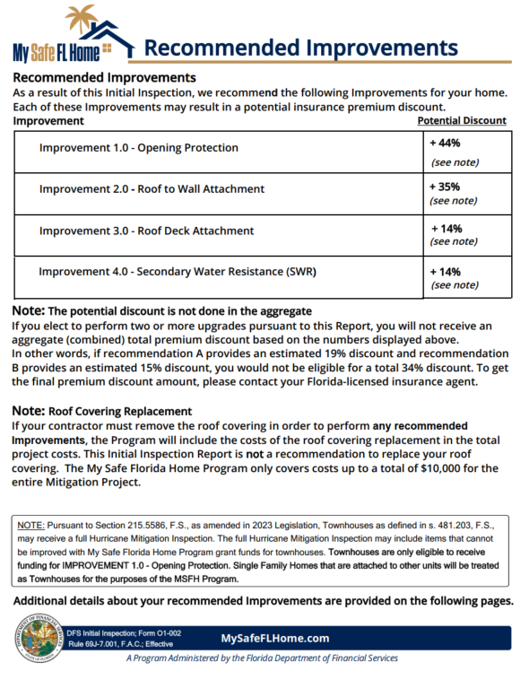
Improvement Cost Estimates
The estimated and rounded prices quoted below include a range of prices based on a typical three (3) bedroom, two (2) bathroom, 1,750 square foot home with 400 square foot garage that is approximately 30 years old. Items below may not be applicable to your Hurricane Mitigation Inspection. This is just a reference guide for typical upgrade repairs on typical houses. Individual prices from Contractors can vary substantially from these ranges due to availability and inflation. It is recommended that that several bids be obtained on any work being considered. DO NOT RELY ON THESE PRICES ONLY AND GET FURTHER ESTIMATES FROM LICENSED PROFESSIONALS.
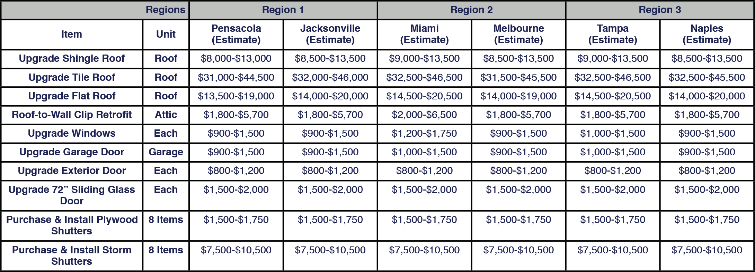
PLEASE NOTE: Items listed above may not be applicable to a Homeowner’s Initial Inspection Report. This chart is being provided for illustration purposes only.
Sources
Rounded pricing estimates were made possible using Homewyse.com on 11/15/2022. Please use their website to review more specific zip code pricing. Roof-to-Wall Clip Retrofit cost estimate range is provided by Florida Retrofits.
Roofing Material:
https://www.homewyse.com/services/cost_to_install_asphalt_shingle_roof.html https://www.homewyse.com/services/cost_to_install_tile_roof.html
https://www.homewyse.com/services/cost_to_install_membrane_roofing_system.html

Windows/Doors:
https://www.homewyse.com/services/cost_to_install_storm_windows.html https://www.homewyse.com/services/cost_to_install_replacement_windows.html https://www.homewyse.com/services/cost_to_replace_garage_door.html https://www.homewyse.com/services/cost_to_install_exterior_door.html https://www.homewyse.com/costs/cost_of_replacement_sliding_doors.html https://www.homewyse.com/services/cost_to_install_hurricane_shutters.html https://www.homewyse.com/maintenance_costs/cost_to_boardup_window.html

Summary of Form OIR-B1-1802
This section of the Initial Inspection Report summarizes the current Hurricane Resistant Features of the home. These Features can be found on the Form OIR-B1-1802.
This page is intended to provide an at-a-glance summary of the findings from the Initial Inspection. The Inspector may make recommendations based on their findings after reviewing these features.

FINAL INSPECTION REPORT
The Final Inspection is the concluding Hurricane Mitigation Inspection performed by an Inspector to observe any Improvements that were successfully completed on the home.
Each Final Inspection Report will contain the following:
- Cover Page
- Final Inspection Results
- Attachments
  - Form OIR-B1-1802 (Uniform Mitigation Verification Inspection Form)
  - Final Inspection Photographs and Documents
Final Inspection Results
The Inspector will record notes on their observations and report the Improvements that they observed during the Final Inspection. The following sample image demonstrates what this table may look like in the Final Inspection Report. The table will vary by home and depend on what the Inspector observes.
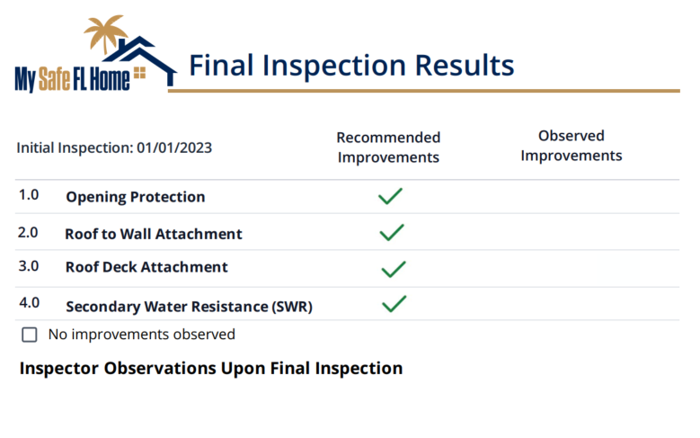
HURRICANE MITIGATION GRANTS
The Florida State Legislature has allocated funds through the My Safe Florida Home Program to provide Homeowners a Hurricane Mitigation Grant (“Grant”). Eligible Homeowners who have received their free Initial Inspection through the Program and have decided to make Improvements that were recommended in their Initial Inspection Report can apply for a Grant.
PLEASE NOTE: Not all applicants who received an Inspection through the Program will be eligible for a Hurricane Mitigation Grant.
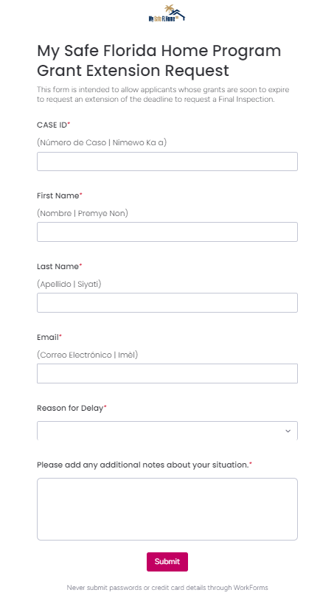
The Grant Application is divided into two stages: the Eligibility Confirmation and the Contractor Confirmation. Whenever the next stage is made available to the Homeowner, an email notification will be sent. To be eligible for disbursement, you must not perform any work, sign with a Contractor, or make any materials purchases prior to receiving an email informing you to proceed with work. Funding is set aside for applicants after a Grant Application has been approved. To receive Grant funds, the Homeowner must request a Final Inspection within one (1) year of Grant Application approval. If a Homeowner cannot complete their construction within one (1) year, they may request an extension on the MSFH website at this link https://wkf.ms/3N3P2rJ.
If an extension request is not submitted within a year, the application is deemed abandoned and the grant money reverts to the Program. Each Homeowner may receive only one (1) Grant.
Approval of a Homeowner’s Grant Application does not guarantee a disbursement of Grant funds. Homeowners must follow all Program requirements to qualify for disbursement.
Eligibility Requirements
A Homeowner is eligible for a Grant if all the following criteria are met:
- The home must be eligible for a Hurricane Mitigation Inspection and must have received an Initial Inspection through the Program.
- The home must be a dwelling with an insured value of $700,000 or less. Low-Income Homeowners, as defined under section 420.0004(11), F.S., are exempt from this requirement.
- The building permit application for initial construction of the home must have been made before January 1, 2008.
- The Homeowner must provide the name and license number of the Contractor selected to perform the Mitigation Project.
- The Homeowner must agree to make the home available for a Final Inspection once the Project is complete; and
- The Homeowner must agree to provide to the Program any and all information received from the Homeowner’s insurer identifying the discounts realized by the Homeowner because of the Improvements funded through the Program.
Proof of Insured Value
Homeowners must provide documentation that the home has an insured value of $700,000 or less; this could be a copy of their current insurance declarations page, a quote, or an application for insurance. Homeowners without a copy should contact their insurance company.
Low-Income Homeowners, as defined under section 420.0004(11), F.S., are exempt from this requirement. However, they will still need to indicate to the Program if they do not have insurance to meet requirement (6) listed previously.
Building Construction Permit
For a home to be eligible for a Hurricane Mitigation Grant, the home’s initial building construction permit must have been issued prior to January 1, 2008. A home’s building construction permit is available through the website or office of the Homeowner’s Property Appraiser.
No Recommended Improvements
If the Inspector does not recommend any Improvements, please send your report to your insurance company to obtain any potential premium discounts. If you have no recommended Improvements, you will not be able to proceed with a Grant Application.
How to Apply
Homeowners must receive an Initial Inspection Report for the home before they can apply for a Hurricane Mitigation grant. The application can be accessed at https://mysafeflhome.com/.
PLEASE NOTE: For the first sixty (60) days after the Program starts accepting Grant Applications, Homeowner will be prioritized based on age and income criteria as outlined by the Legislature.
Contractor Confirmation
The Homeowner must provide the name and license number of the Contractor(s) selected to perform the Mitigation Project in the Contractor Confirmation stage of the Grant Application.
Homeowners can verify their Contractor’s license information by visiting the following website: https://www.myfloridalicense.com/.
The Department of Business and Professional Regulation license number should begin with a “C”. Please confirm that the Contractor is authorized to perform the intended Mitigation Project within the scope of their license; for instance, a plumber is not licensed to install a roof. Homeowners must also select their intended Mitigation Project. They will have sixty (60) days from notification that the Contractor Confirmation stage has opened to complete the stage.
If you need to change your Contractor after your Grant Application has been approved, you will have an opportunity to do so at the Draw Request stage. It is the Homeowner’s responsibility to verify that the new Contractor has a certified State license (license number should begin with a “C”). Improvements must be recommended in the Initial Inspection Report and observed in the Final Inspection Report to be eligible for funding. If you do not use a properly licensed contractor or complete a recommended Improvement, YOU WILL NOT BE PAID.
Matching and Low-Income Grants
There are two types of Hurricane Mitigation Grants: Matching Grants and Low-Income Grants.
Matching Grants
The MSFH Program Matching Grant works on a reimbursement basis. Your Grant Application must be approved prior to proceeding with construction work. Payment requests are made at the end of the application process through a Draw Request. You must provide a paid-in-full invoice with your Draw Request. If your Draw Request is approved, you will be reimbursed for 2/3 of the total costs of the construction project up to a maximum state contribution of up to $10,000, subject to legislative appropriation.
Low-Income Grants
Low-Income Homeowners who meet all other Hurricane Mitigation Grant Requirements are eligible for a Low-Income Grant of up to $10,000, subject to legislative appropriation, and are not required to provide a matching amount to receive grant funds. Low-Income Homeowners do not need to provide a paid-in-full invoice and are exempt from the insured value requirement.
To determine if you are a Low-Income Homeowner, please click this link: https://www.huduser.gov/portal/datasets/il.html.
PLEASE NOTE: Only Improvements recommended by an Inspector in an Initial Inspection Report and observed by an Inspector in a Final Inspection Report will be eligible for funding under the Program. No other construction is eligible for funding.
PLEASE NOTE: Townhouses are only eligible to receive funding for Improvement 1.0 – Opening Protection. Single-family homes that are attached to other units will be treated as Townhouses for the purposes of the MSFH Program.

HURRICANE MITIGATION PROJECTS
Improvements Guide
Please read the information below carefully.
Thoroughly review the Initial Inspection Report. For questions about the Initial Inspection Report, please contact the Inspector using the contact information provided in the Inspection Application approval email.
PLEASE NOTE: Only Improvements recommended by an Inspector in an Initial Inspection Report and observed by an Inspector in a Final Inspection Report will be eligible for funding under the Program. No other construction is eligible for funding.
PLEASE NOTE: Townhouses are only eligible to receive funding for Improvement 1.0 – Opening Protection. Single-family homes that are attached to other units will be treated as Townhouses for the purposes of the MSFH Program.
PLEASE NOTE: It is the Homeowner’s responsibility to ensure that their Contractor understands the procedures and requirements of the Program. The Homeowner should review their Initial Inspection Report with their selected Contractor.
Building Permits: Homeowners must ensure Contractors receive all applicable building permits from the local building inspector’s office.
There are four (4) Improvements that are eligible for Grant funding under the Program when recommended in an Initial Inspection Report:
Improvement 1.0 – Opening Protection
Improvement 2.0 – Roof to Wall Attachment
Improvement 3.0 – Roof Deck Attachment
Improvement 4.0 – Secondary Water Resistance (SWR)

IMPROVEMENT 1.0 – OPENING PROTECTION
Opening Protection pertains to exterior doors, garage doors, windows, and skylights. Most insurance agencies only require a level of A3 for insurance discounts. Please contact your insurance company to determine if a rating of A2 or A1 is required to receive discounts and refer to your inspection report to determine which specific openings require Improvement. Homeowners may be recommended to do the following:
- Install impact-rated windows or shutters.
  - If a Homeowner currently has compliant hurricane shutters, but requests disbursement for impact windows instead, the request will be denied. A home with compliant shutters already has mitigation against hurricane damage. The Grant cannot be used to exchange one type of opening protection for another.
- Install impact-rated exterior doors or garage doors.
  - If a Homeowner currently has unprotected entry or garage doors that include glass (a “glazed” opening), the Grant may be approved to replace the door with an impact door or shutter the door with an impact-tested product. If a Homeowner currently has unprotected entry or garage doors that are solid (no glass, or “non-glazed”), the request to replace or shutter the door with an impact-tested product will be denied unless a recommendation is included in the Initial Inspection Report.
PLEASE NOTE: Only the specific openings recommended for improvement in the Initial Inspection Report are eligible for funding under the Program. An opening that is already protected cannot be improved and is therefore ineligible for funding. Refer to the following chart in your Initial Inspection Report to understand which specific openings are being recommended:
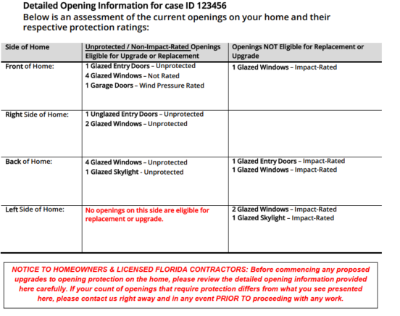

IMPROVEMENT 2.0 – ROOF TO WALL ATTACHMENT
One area of focus is the Roof to Wall Attachment, or how the trusses or rafters in your attic are attached to the walls of the home. This reduces the possibility that all or a portion of the roof will lift off the home during a hurricane.
If new connectors are installed, they must be approved for roof to wall retrofit and installed according to the manufacturer’s instructions.
PLEASE NOTE: It is absolutely essential that whatever work is done needs to be done to EVERY truss or rafter to become eligible for the windstorm mitigation credit. Please ensure you contact a Contractor who specializes in improving roof-to-wall attachment for insurance discounts as they relate to Form OIR-B1-1802.
The new connections must meet the following minimum conditions:
- Secured to truss/rafter with a minimum of three (3) nails; AND
- Attached to the wall top plate of the wall framing, or embedded in the bond beam, with less than a ½" gap from the blocking or truss/rafter and blocked no more than 1.5” of the truss/rafter, and free of visible severe corrosion.
The following are examples of Roof to Wall Attachments:
- Clip Connection
- Single-wrap
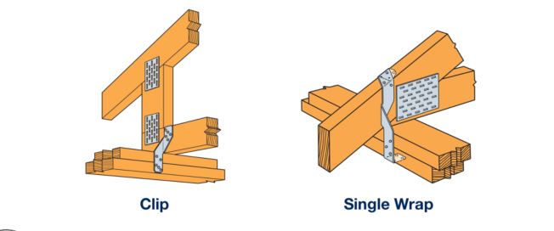
- Double-wrap
Roof to Wall Attachments can be done in a few ways:
- A convenient time to address this is during re-roofing. Remove the bottom section of the sheathing (plywood for example) and install a new clip or wrap or add additional nails as the case may require.
- Remove the exterior soffits of the home to expose the roof to wall section to install a new clip, or install additional nails as needed that will help strengthen the attachment and qualify for the insurance credit.
- If the attic space is adequate and accessible, it may be possible to add the additional nail(s) or to even retrofit a clip from inside the attic.
PLEASE NOTE: Roof to Wall Attachments can often be upgraded without replacing a roof.
IMPROVEMENT 3.0 – ROOF DECK ATTACHMENT
Roof Deck Attachment can be improved by installing additional nails or longer nails. Adding nails reduces the possibility of the sheathing being blown off in a hurricane.
When installing a roof to the current code, your licensed roofing Contractor will ensure your roof sheathing (e.g., plywood) is nailed down to the trusses or rafters with the proper nails and spacing. This helps hold your roof deck to the trusses/rafters in the event of a windstorm and should ensure it qualifies for the proper windstorm mitigation credit.
IMPROVEMENT 4.0 – SECONDARY WATER RESISTANCE (SWR)
An SWR is an underlayment material that is self-adhered (peel-and-stick) directly to the roof decking. This material can be full roof coverage or seam-tape, a 6” wide rooﬁng tape covering all the seams of the roof deck material. It can also be a closed-cell spray foam adhesive used in the attic space which seals every seam of the roof deck and on either side of the trusses or rafters.
There are three (3) ways to add a SWR to the home:
- At the time of reroofing the home, a full-coverage self-adhered underlayment (commonly referred to as peel-and-stick) is directly added to the roof sheathing.
- At the time of reroofing the home, a self-adhered product (commonly referred to as seam tape) is used on all joints and seams of the roof deck sheathing. A nailed down underlayment, such as felt paper, is still required.
- If not replacing the roof, install a closed cell foam adhesive on all the seams and joints from the attic side of the roof.
The following are NOT SWR and installing them will result in a denial of payment disbursement. Please ensure you are clear with your Contractor about Program requirements.
- Hot mop
- Tar
- Felt
- Peel-and-stick applied OVER any other kind of underlayment
- Any underlayment (synthetic or otherwise) that is not self-adhering
ROOF REPLACEMENTS
If your contractor must remove the roof covering in order to perform any recommended Improvements, the Program will include the costs of the roof covering replacement in the total project costs.
Improving the survivability of the roof covering might include upgrading to stronger hurricane-resistant roof shingles, attached with properly sized and properly applied roofing nails, to reduce the susceptibility of your roof shingles blowing off in a hurricane. The roof may be replaced with the Homeowner’s choice of covering, such as tile, metal, or shingle.
Roof Patching or Partial Repairs
Roof patching or other partial repairs of the roof will not be eligible for funding under the Program. To receive grant funding for roof covering replacement as part of a recommended Improvement, you must replace the entire, contiguous roof covering.
PLEASE NOTE: The My Safe Florida Home Program only covers costs up to a total of $10,000, subject to legislative appropriation, for the entire Mitigation Project.

DRAW REQUESTS
Approval of a Draw Request is contingent upon completion of the home’s Final Inspection AND receipt of uploaded required documentation. A Final Inspection of the home must be requested and completed BEFORE the Homeowner submits a Draw Request.
Submitting a Draw Request
- The Final Inspection of the home must be completed, and the Final Inspection Report must have been uploaded by the Inspector to the Applicant Portal.
- The Homeowner must submit the Final Inspection to their insurance provider requesting discounts.
- Once their insurance provider has responded, the Homeowner must complete or submit the following in the Applicant Portal.
  - Draw Request Summary – contains basic information about the Homeowner’s Mitigation Project.
  - Original Contractor Invoice - a detailed invoice or quote that describes the Mitigation Project that was performed.
  - Proof of Payment In Full - cancelled check, receipts, paid invoice, or financing agreement, etc. PLEASE NOTE: This is NOT required for Low-Income participants.
  - Proof of Insurance Premium Discounts - email, letter, new declarations page, new insurance quote.
  - Payment Verification – contains information about where the disbursement will be sent.
- Once the Homeowner has completed the Draw Request, the Draw Request will be reviewed by the Program. If there is a problem with the Draw Request, the Homeowner will be alerted to correct the information.
Reimbursement for Approved Draw Requests
Homeowners approved for their Draw Request will receive an approval email. A disbursement check will arrive in the mail in the following weeks. Please look for emails from the Program and check your spam folder regularly.
If there is an issue with a Homeowner’s Draw Request, the request will be returned to the Homeowner. Please check for emails from the Program.

