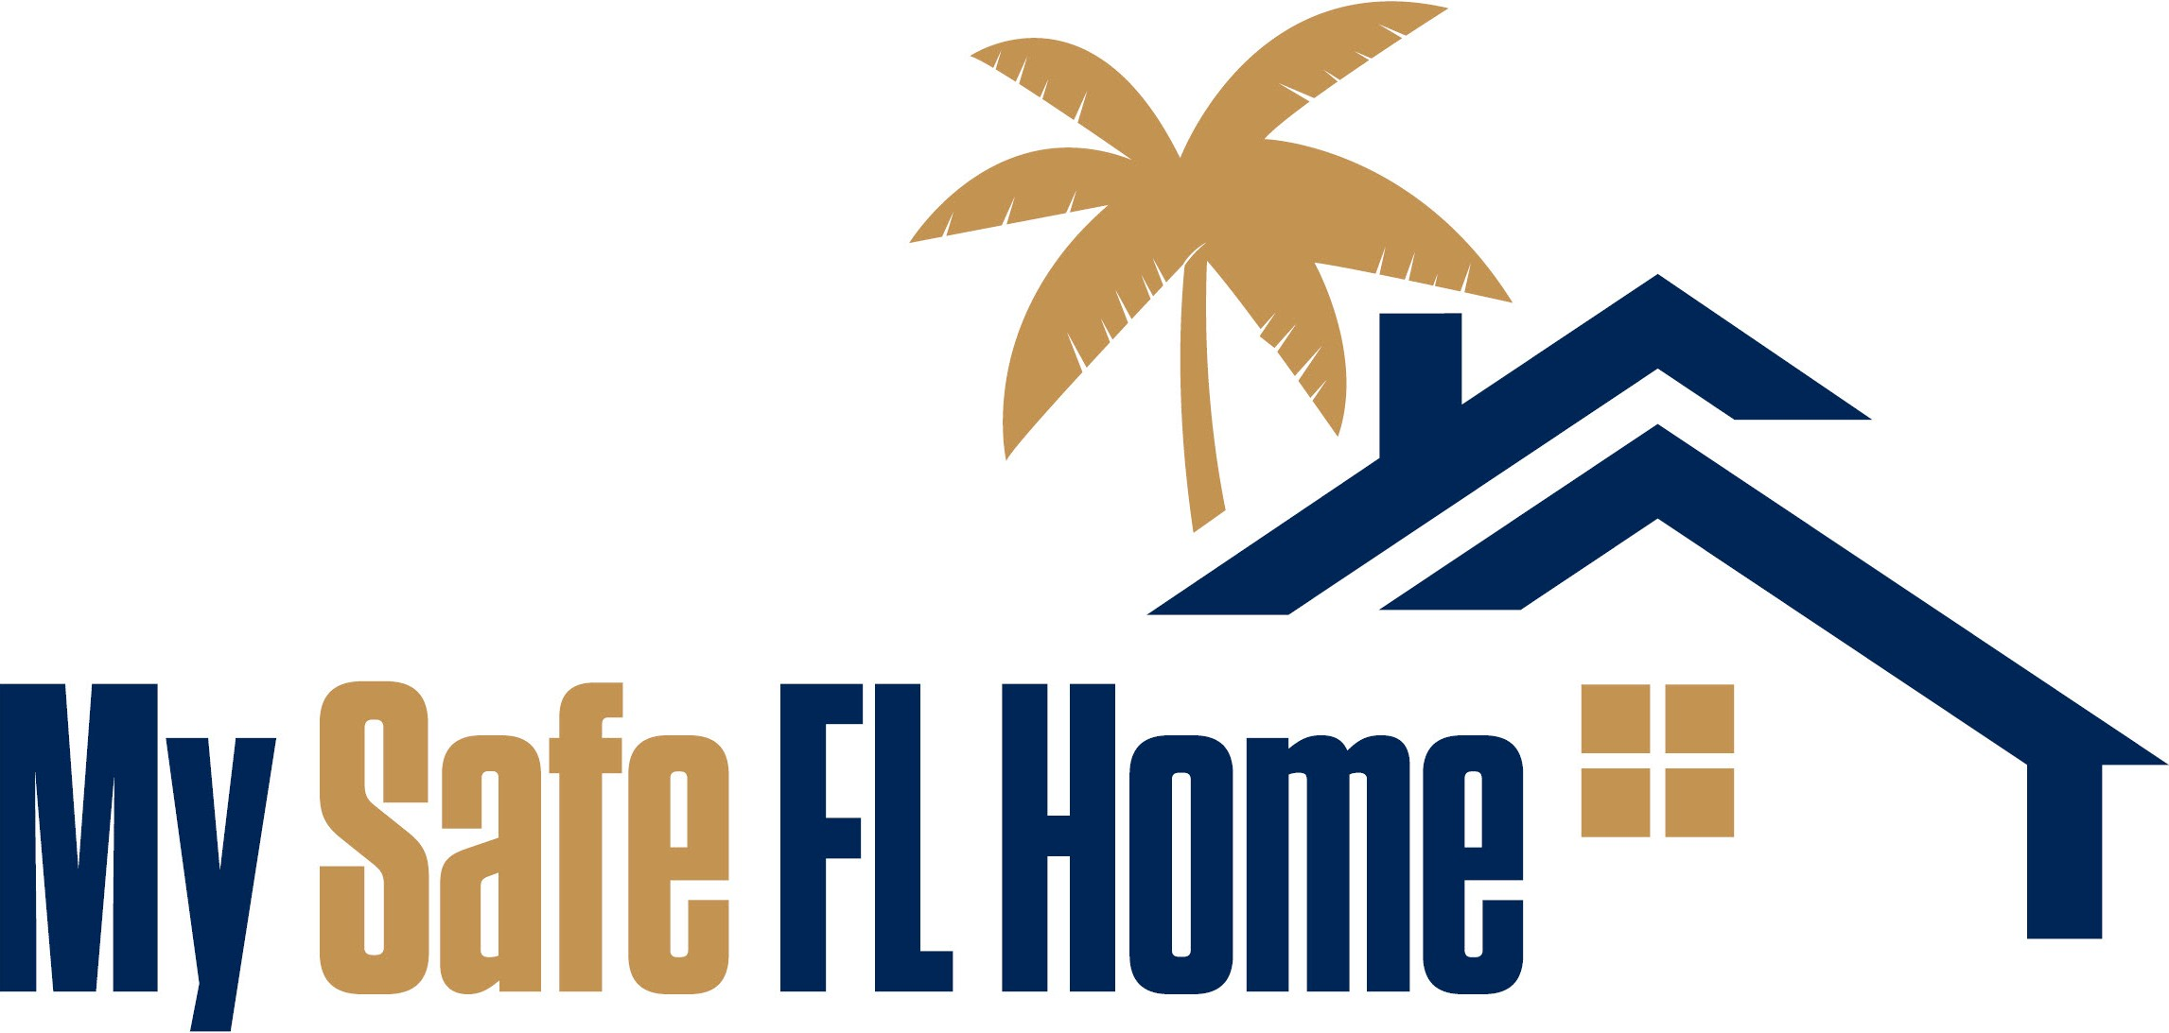

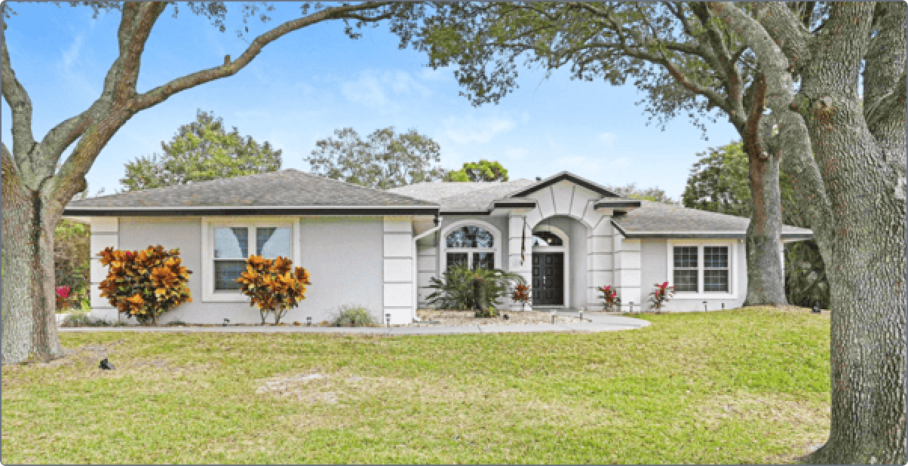


Property Image

Property Address
Home Type
(Townhome or Attached Single Family Residence or Detached Single Family Residence)
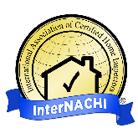


Phone Number 12345 1/10/2024
Email Address
Initial Inspection Date
Case No.
This Initial Inspection Report was prepared by WCE. For
questions or concerns, please contact:

Logo

Table of Contents

Introduction
- Recommended Improvements
- Improvement Cost Estimates
- Summary of Form OIR-B1-1802
- Attachments
  - Form OIR-B1-1802 (Uniform Mitigation Verification Inspection Form)
  - Initial Inspection Photographs and Documents

NOTE: Pursuant to Section 215.5586, F.S., as amended in 2023 Legislation, Townhouses as deﬁned in s. 481.203, F.S., may receive a full Hurricane Mitigation Inspection. The full Hurricane Mitigation Inspection may include items that cannot be improved with My Safe Florida Home Program grant funds for townhouses. Townhouses are only eligible to receive funding for IMPROVEMENT 1.0 - Opening Protection. Single Family Homes that are attached to other units will be treated as Townhouses for the purpose of the MSFH Program.

At the specific request of the Florida Department of Financial Services, this Initial Inspection was conducted on a best- eﬀorts basis and with a speciﬁc and limited scope - to document the presence or absence of speciﬁc Hurricane Resistant Features as listed on the Florida Oﬃce of Insurance Regulation’s Form OIR-B1-1802, otherwise known as the Uniform
Mitigation Veriﬁcation Inspection form, and to make recommended Improvements available for grant funding by statute under the My Safe Florida Home ("MSFH Program"). The user of this Report agrees to use this Report for this purpose and no other, and to hold harmless all those involved in its production for any such misuse.

Introduction

Dear Homeowner,
At your request, the State of Florida has paid for an inspection of your home by a Wind Certification Entity ("WCE"). The purpose of this Initial Inspection Report is to recommend any speciﬁc Improvements that you can make to strengthen your home against hurricanes.

This Initial Inspection Report Provides you with:
- A list of recommended Improvements that may make your home more resistant to hurricane damage
- A list of your home's current and missing Hurricane Resistant Features
- Your potential percentage of savings on home insurance premiums based on your current and missing Hurricane Resistant Features

Completing recommended Improvements may:
- Fortify your home against hurricane damage
- Protect yourself and other residents within your home
- Reduce Insurance Premiums

This inspection is designed to describe the presence or absence of Hurricane Resistant Features that have been proven to help a home survive windstorms and is not a condition-based inspection. If features of your home are showing signs of age and wear, have them examined by a proper professional who can help you assess their condition and make suggestions.
Please refer to the Homeowner's Guide available on our website at https://mysafeflhome.com/ for more information about your Initial Inspection Report and the MSFH Program.
Thank you for your participation in the MSFH Program.

Sincerely,

The My Safe Florida Home Program Team

m

Recommended Improvements

Recommended Improvements
As a result of this Initial Inspection, we recommend the following Improvements for your home. Each of these Improvements may result in a potential insurance premium discount.
Improvement Potential Discount

Improvement 1.0 - Opening Protection | + 44%  (see note)
Improvement 2.0 - Roof to Wall Attachment | + 35%  (see note)
Improvement 3.0 - Roof Deck Attachment | + 14%  (see note)
Improvement 4.0 - Secondary Water Resistance (SWR) | + 14%  (see note)
Note: The potential discount is not done in the aggregate
If you elect to perform two or more upgrades pursuant to this Report, you will not receive an aggregate (combined) total premium discount based on the numbers displayed above.
In other words, if recommendation A provides an estimated 19% discount and recommendation B provides an estimated 15% discount, you would not be eligible for a total 34% discount. To get the ﬁnal premium discount amount, please contact your Florida-licensed insurance agent.

Note: Roof Covering Replacement
If your contractor must remove the roof covering in order to perform any recommended Improvements, the Program will include the costs of the roof covering replacement in the total project costs. This Initial Inspection Report is not a recommendation to replace your roof covering. The My Safe Florida Home Program only covers costs up to a total of $10,000 for the entire Mitigation Project.

NOTE: Pursuant to Section 215.5586, F.S., as amended in 2023 Legislation, Townhouses as deﬁned in s. 481.203, F.S., may receive a full Hurricane Mitigation Inspection. The full Hurricane Mitigation Inspection may include items that cannot be improved with My Safe Florida Home Program grant funds for townhouses. Townhouses are only eligible to receive funding for IMPROVEMENT 1.0 - Opening Protection. Single Family Homes that are attached to other units will be treated as Townhouses for the purposes of the MSFH Program.
Additional details about your recommended Improvements are provided on the following pages.

1, F.A.C.; Effective

MySafeFLHome.com

Improvement 1.0

Opening Protection
One area of focus is the opening protection for windows, skylights, doors, and garage doors and other glazed openings (openings on your home that contain glass). Protecting your home’s openings with impact-rated shutters, doors and/or windows can help prevent debris from breaking through and creating pressure inside the home. This pressure may cause the roof structure to fail. There are generally three levels of possible credit for this segment of the inspection.
- Level A.1 is the highest level of credit, available when ALL of your openings are Large Missile Impact Rated. This means your doors, windows, garage doors, skylights, glass block, etc. are all protected by, or are rated at, the highest level.
- Level A.2 applies when all of your glazed openings are Large Missile Impact Rated (or protected by products that qualify as such) but your solid entry doors and garage door are veriﬁed to be wind and pressure rated. This may be likely if your home was built after 2002 and in an area that does not require impact doors.
- Level A.3 applies when your glazed openings are Large Missile Impact Rated (or protected by products that qualify as such) and your solid doors and garage door cannot be identiﬁed to be wind and pressure rated
If you are not currently receiving an Opening Protection discount on your policy, contact your Florida-licensed insurance agent to conﬁrm which level you will need to achieve in order to obtain the discount.

Pursuant to Section 215.5586, F.S., as amended in 2023 Legislation, Townhouses, as defined in s. 481.203, F.S., may receive a full Hurricane Mitigation Inspection. The full Hurricane Mitigation Inspection may include items that cannot be improved with My Safe Florida Home Program grant funds for townhouses. When recommended by a Hurricane Mitigation Inspection, grants for townhouses may only be used for Improvement 1.0 Opening Protection. Single Family homes that are attached to other units will be treated as Townhouses for the purposes of the MSFH Program.

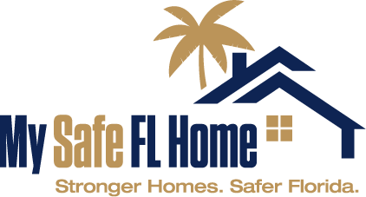
Improvement 1.0 cont.

Detailed Opening Information for case ID 123456
Below is an assessment of the current openings on your home and their respective protection ratings:

Side of Home | Unprotected / Non-Impact-Rated Openings  Eligible for Upgrade or Replacement | Openings NOT Eligible for Replacement or  Upgrade
Front of Home: | 1 Glazed Entry Doors – Unprotected 4 Glazed Windows – Not Rated  1 Garage Doors – Wind Pressure Rated | 1 Glazed Windows – Impact-Rated
Right Side of Home: | 1 Unglazed Entry Doors – Unprotected 2 Glazed Windows – Unprotected
Back of Home: | 4 Glazed Windows – Unprotected 1 Glazed Skylight - Unprotected | 1 Glazed Entry Doors – Impact-Rated 1 Glazed Windows – Impact-Rated
Left Side of Home: | No openings on this side are eligible for replacement or upgrade. | 2 Glazed Windows – Impact-Rated 1 Glazed Skylight – Impact-Rated
NOTICE TO HOMEOWNERS & LICENSED FLORIDA CONTRACTORS: Before commencing any proposed upgrades to opening protection on the home, please review the detailed opening information provided here carefully. If your count of openings that require protection differs from what you see presented here, please contact us right away and in any event PRIOR TO proceeding with any work.
How Updating Your Openings Affects Your Inspection Report
To achieve an A3 (good) rating for opening protection, ALL glazed openings (windows and glass or entry and garage doors with windows) MUST be protected with an approved impact-rated device. This includes, but is not limited to, approved impact-rated windows, accordion shutters, and panel or fabric shutters.

To achieve an A2 (better) rating for opening protection, ALL glazed openings (windows and glass) MUST be protected with an approved impact-rated device (see A3 requirement above) and ALSO, ALL UNGLAZED openings (entry doors and garage doors which do not contain windows) must be protected with an approved wind pressure or better rated device.

To achieve an A1 (best) rating for opening protection, ALL glazed openings (windows and glass) MUST be protected with an approved impact-rated device (see A3 requirement above) and ALSO, ALL UNGLAZED openings (entry doors and garage doors which do not contain windows) must be protected with an approved impact-rated device.

Improvement 2.0

Roof-To-Wall Attachment
One area of focus is the Roof to Wall Attachment, or how the trusses or rafters in your attic are attached to the walls of the home. This reduces the possibility that all or a portion of the roof will lift off the home during a hurricane.

If new connectors are installed, they must be approved for roof to wall retrofit and installed according to the manufacturer's instructions.
Note: It is absolutely essential that whatever work is done, it needs to be done to EVERY truss or rafter to become eligible for the windstorm mitigation credit. Please ensure you contact a
contractor who specializes in improving roof-to-wall attachment for insurance discounts as they relate to Form OIR-B1-1802.
The new connections must meet the following minimum conditions:
  - Secured to truss/rafter with a minimum of three (3) nails; AND
  - Attached to the wall top plate of the wall framing, or embedded in the bond beam, with less than a ½" gap from the blocking or truss/rafter and blocked no more than 1.5” of the truss/ rafter, and free of visible severe corrosion.
The following are examples of Roof to Wall Attachments:
  - Clip Connection
  - Single-wrap
  - Double wrap
Roof to Wall Attachments can be done in a few ways:
  - A convenient time to address this is during re-rooﬁng. The appropriate contractor can remove the bottom section of the sheathing (plywood for example) and install a new clip or wrap, or add additional nails as the case may require.
  - Remove the exterior soﬃts of the home to expose the roof to wall section to install a new clip, or install additional nails as needed that will help strengthen the attachment and qualify for the insurance credit.
  - If the attic space is adequate and accessible, it may be possible to add the additional nail(s) or to even retroﬁt a clip from inside the attic.
Note: Roof to Wall Attachments can often be upgraded without replacing a roof.

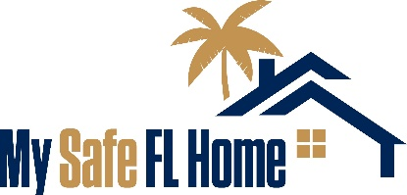
Improvement 2.0 cont.

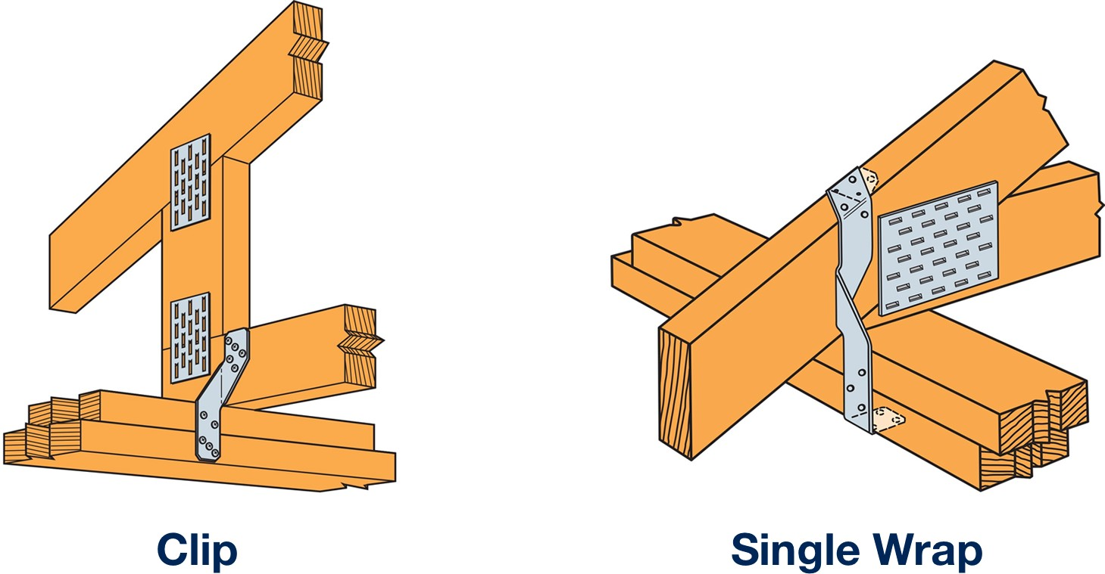

Roof Covering Replacement:
If your contractor must remove the roof covering in order to perform any recommended Improvements, the Program will include the costs of the roof covering replacement in the total project costs.

Note: This Initial Inspection Report is not a recommendation to replace your roof covering. The My Safe Florida Home Program only covers costs up to a total of $10,000 for the entire Mitigation Project.

Homeowners Guide; Form O1-001

Improvement 3.0
Roof Deck Attachment:
Roof Deck Attachment can be improved by installing additional nails or longer nails. Adding nails reduces the possibility of the sheathing being blown off in a hurricane.
When installing a roof to the current code, your licensed roofing contractor will ensure your roof sheathing (e.g., plywood) is nailed down to the trusses or rafters with the proper nails and spacing. This helps hold your roof deck to the trusses/rafters in the event of a windstorm and should ensure it qualifies for the proper windstorm mitigation credit.
Roof Covering Replacement:
If your contractor must remove the roof covering in order to perform any recommended Improvements, the Program will include the costs of the roof covering replacement in the total project costs.

Note: This Initial Inspection Report is not a recommendation to replace your roof covering. The My Safe Florida Home Program only covers costs up to a total of $10,000 for the entire Mitigation Project.

Improvement 4.0

Secondary Water Resistance (SWR)

SWR is an underlayment material that is self-adhered (peel-and-stick) directly to the roof decking. This material can be full roof coverage or seam-tape, a 6” wide roofing tape covering all the seams of the roof deck material. It can also be a closed-cell spray foam adhesive used in the attic space which seals every seam of the roof deck and on either side of the trusses or rafters.

There are three (3) ways to add an SWR to the home:

- At the time of reroofing the home, a full-coverage self-adhered underlayment (commonly referred to as peel-and-stick) is directly added to the roof sheathing.

- At the time of reroofing the home, a self-adhered product (commonly referred to as seam tape) is used on all joints and seams of the roof sheathing. A nailed down underlayment, such as felt paper, is still required.

- If not replacing the roof, install a closed cell foam adhesive on all the seams and joints from the attic side of the roof.
The following are NOT SWR and installing them will result in a denial of payment disbursement. Please ensure you are clear with your contractor about Program requirements.
- Hot mop
- Tar
- Felt
- Peel-and-stick applied OVER any other kind of underlayment
- Any underlayment (synthetic or otherwise) that is not self-adhering Roof Covering Replacement:
If your contractor must remove the roof covering in order to perform any recommended Improvements, the Program will include the costs of the roof covering replacement in the total project costs.
Note: This Initial Inspection Report is not a recommendation to replace your roof covering. The My Safe Florida Home Program only covers costs up to a total of $10,000 for the entire Mitigation Project.

Improvement Cost Estimates

The estimated and rounded prices quoted below include a range of prices based on a typical 3 Bedroom, 2 Bathroom, 1,750 square foot home with 400 square foot garage that is approximately 30 years old. Items below may not be applicable to your Wind Mitigation Inspection. This is just a reference guide for typical
upgrade repairs on typical houses. Individual prices from contractors can vary substantially from these ranges due to availability and inﬂation. It is recommended that that several bids be obtained on any work being considered. DO NOT RELY ON THESE PRICES ONLY AND GET FURTHER ESTIMATES FROM LICENSED PROFESSIONALS.

 |  | Region 1 |  | Region 2 |  | Region 3
Item | Unit | Pensacola (Estimate) | Jacksonville (Estimate) | Miami (Estimate) | Melbourne (Estimate) | Tampa (Estimate) | Naples (Estimate)
Upgrade Shingle Roof | Roof | $8,000–$13,000 | $8,500–$13,500 | $9,000–$13,500 | $8,500–$13,500 | $9,000–$13,500 | $8,500–$13,500
Upgrade Tile Roof | Roof | $31,000–$44,500 | $32,000–$46,000 | $32,500–$46,500 | $31,500–$45,500 | $32,500–$46,500 | $32,000–$45,500
Upgrade Flat Roof | Roof | $13,500–$19,000 | $14,000–$20,000 | $14,500–$20,500 | $14,000–$19,000 | $14,500–$20,500 | $14,000–$20,000
Roof to Wall Clip Retrofit | Attic | $1,800–$5,700 | $1,800–$5,700 | $2,000–$6,500 | $1,800–$5,700 | $1,800–$5,700 | $1,800–$5,700
Upgrade Windows | Each Item | $900–$1,500 | $900–$1,500 | $1,200–$1,750 | $900–$1,500 | $1,000–$1,500 | $900–$1,500
Upgrade Garage Door | Garage | $900–$1,500 | $900–$1,500 | $1,000–$1,500 | $900–$1,500 | $1,000–$1,500 | $900–$1,500
Upgrade Exterior Door | Each | $800–$1,200 | $800–$1,200 | $800–$1,200 | $800–$1,200 | $800–$1,200 | $800–$1,200
Upgrade 72” Sliding Glass Door | Each | $1,500–$2,000 | $1,500–$2,000 | $1,500–$2,000 | $1,500–$2,000 | $1,500–$2,000 | $1,500–$2,000
Purchase & Install Plywood Shutters | 8 Items | $1,500–$1,750 | $1,500–$1,750 | $1,500–$1,750 | $1,500–$1,750 | $1,500–$1,750 | $1,500–$1,750
Purchase & Install Storm Shutters | 8 Items | $7,500–$10,500 | $7,500–$10,500 | $7,500–$10,500 | $7,500–$10,500 | $7,500–$10,500 | $7,500–$10,500
Note: Items listed above may not be applicable to your Report. Please review your Report to see what items listed above may be applicable.

Sources
Rounded pricing estimates were made possible through the use of Homewyse.com on 11/15/2022. Please use their website to review more speciﬁc zip code pricing. Roof to Wall Clip Retroﬁt provided by Florida Retroﬁts.

Rooﬁng Material
https://www.homewyse.com/services/cost_to_install_asphalt_shingle_roof.html https://www.homewyse.com/services/cost_to_install_tile_roof.html
https://www.homewyse.com/services/cost_to_install_membrane_rooﬁng_system.html
Windows/Doors
https://www.homewyse.com/services/cost_to_install_storm_windows.html https://www.homewyse.com/services/cost_to_install_replacement_windows.html https://www.homewyse.com/services/cost_to_replace_garage_door.html https://www.homewyse.com/services/cost_to_install_exterior_door.html https://www.homewyse.com/costs/cost_of_replacement_sliding_doors.html https://www.homewyse.com/services/cost_to_install_hurricane_shutters.html https://www.homewyse.com/maintenance_costs/cost_to_boardup_window.html

24
MySafeFLHome.com

Summary of Form OIR-B1-1802
The remaining pages of your Initial Inspection Report are for educational purposes only. Only the Improvements recommended in the previous section of this Report are eligible for grant funding under the MSFH Program.

Below you will find a summary of some of the Hurricane Resistant Features observed by your inspector. Please refer to the attached Uniform Mitigation Verification Inspection Form (Form OIR B1-1802) for additional details.

Roof Deck Attachment
Roof Deck Attachment “A”

Roof to Wall Attachment
Toe nail connectors, or visible metal connectors that are insuﬃcient

Secondary Water Resistance (SWR)
No Secondary Water Resistance (SWR) barrier

Opening Protection
Level X
The roof deck attachment found in your attic, while it may have been appropriate at the time of installation, was found to be weaker than the current building code would require.

Either 1) the inspector did not ﬁnd visible metal connectors in at least one location, so the weakest roof-to-wall attachment is assumed to be nails driven at an angle through truss or rafter and into the top plate of the wall, or 2) the weakest roof-to- wall connection found by the inspector did not meet the minimum requirements to be considered a Clip, Single Wrap Strap, or Double Wrap Strap.

The inspector was able to conﬁrm there is not a valid SWR barrier that would meet the requirements of the Uniform Mitigation Veriﬁcation Inspection Form on at least part of the roof.

The inspector found that at least one opening containing glass had no windborne debris protection. See Question 7 on the Uniform Mitigation Veriﬁcation Inspection Form for more details.

Summary of Form OIR-B1-1802

Current Hurricane Resistant Features of Your Home
These are the current Hurricane Resistant Features of your home:

Roof Deck Attachment |  | Roof to Wall Attachment
Secondary Water Resistance (SWR) |  | Opening Protection

Current Potential Savings to Your Wind Insurance Premium
Below is your current estimated wind insurance premium savings based on the current condition of your home. These values are estimated using Form OIR-B1-1699. For a more accurate estimate of potential premium savings, contact your insurance provider or agent.
Your current estimated wind insurance premium
discount based on Form OIR-B1-1699 is:
< 1%

Missing Hurricane Resistant Features from Your Home
These are the missing Hurricane Resistant Features of of your home:

Roof Deck Attachment |  | Roof to Wall Attachment
Secondary Water Resistance (SWR) |  | Opening Protection

Inspection Notes

No additional notes for this report

