Program Overview

Program Overview

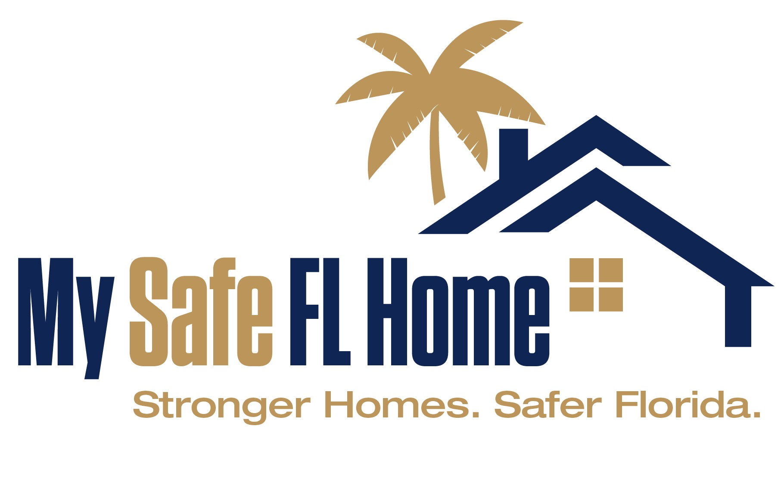
Contact Information
866-513-6734
info@mysafeflhome.com

All applicants must review our Homeowner's Guide here. If you have any questions about the My Safe Florida Home Program at any time, please re-review the relevant section of the Homeowner’s Guide.

What is the My Safe Florida Home Program?
The My Safe Florida Home Program (“MSFH Program” or “Program”) has two primary components to be administered by the Florida Department of Financial Services (“Department” or “DFS”):

- Provide eligible Florida Homeowners, free of charge and with no obligation, a Hurricane Mitigation Inspection that identiﬁes the current Hurricane Resistant Features of their homes and recommends Improvements to further strengthen their homes against hurricanes.

- Provide eligible Florida Homeowners a Hurricane Mitigation Grant to help fund speciﬁc home Improvements recommended by the Program’s Initial Inspection, strengthening homes against hurricanes and offering potential discounts on home insurance premiums.

When can I apply for the MSFH Program?
For the first sixty (60) days after the Program starts accepting Applications, Homeowner will be prioritized based on age and income criteria as outlined by the Legislature.

Who is eligible for a Hurricane Mitigation Inspection?
To be eligible for a Hurricane Mitigation Inspection under the Program:

- The home must be a single-family, detached residential property or a townhouse as defined in s. 481.203;

- The home must be site-built and owner-occupied; and

- The Homeowner must have been granted a homestead exemption on the home under chapter 196, F.S.

PLEASE NOTE: Single-family homes that are attached to other units will be treated as Townhouses for the purposes of the MSFH Program.

Who is eligible for a Hurricane Mitigation Grant?
To be eligible for a Hurricane Mitigation Grant under the Program:

The owner’s home must meet all the requirements for a Hurricane Mitigation Inspection and must have received an Initial Inspection through the Program.
The owner’s home must be a dwelling with an insured value of $700,000 or less. Low-Income Homeowners, as defined under section 420.0004(11), F.S., are exempt from this requirement.
The building permit application for initial construction of the owner’s home must have been made before January 1, 2008.
The Homeowner must provide the name and license number of the Contractor selected to perform the Mitigation Project.
The Homeowner must agree to make the home available for a Final Inspection once the Mitigation Project is completed.
The Homeowner must agree to provide to DFS any and all information received from the Homeowner’s insurer identifying the discounts realized by the Homeowner because of the Improvements funded through the Program.

What is the application process?
After registering through the MSFH Program’s web portal, the Homeowner should begin by submitting an Inspection Application. If approved, the Homeowner can schedule an Initial Inspection through the MSFH Program to determine which, if any, Improvements are recommended for their home. Then, the Homeowner may open a Grant Application.

The Grant Application is a two-stage process (Eligibility Confirmation and Contractor Confirmation). If approved, the Homeowner can begin a Mitigation Project with their selected contractor based on their recommended Improvements. Homeowners must not perform any work, sign with a contractor, or purchase any materials prior to receiving an email informing you to proceed with work.

To receive disbursement, the Homeowner must submit a Draw Request. This includes completion of a Final Inspection and submission of all required documents.

What types of Mitigation Projects will be considered for Homeowners?
Please review the Improvements Guide within the Homeowner’s Guide for additional information.
Only Improvements recommended by an Inspector in an Initial Inspection Report and observed by an Inspector in a Final Inspection Report will be eligible for funding under the Program. No other construction is eligible for funding. The following Improvements may be recommended in your Initial Inspection Report:
Improvement 1.0 – Opening Protection*
Improvement 2.0 – Roof to Wall Attachment
Improvement 3.0 – Roof Deck Attachment
Improvement 4.0 – Secondary Water Resistance (SWR)
* Townhouses are only eligible to receive funding for Improvement 1.0 – Opening Protection. Single-family homes that are attached to other units will be treated as Townhouses for the purposes of the MSFH Program.

How do Matching Grants work?
The MSFH Program Matching Grant works on a reimbursement basis. Your Grant Application must be approved prior to proceeding with construction work. Payment requests are made at the end of the application process through a Draw Request. You must provide a paid-in-full invoice with your Draw Request. If your Draw Request is approved, you will be reimbursed for 2/3 of the total costs of the construction project up to a maximum state contribution of $10,000.

How do Low-Income Grants work?
Low-Income Homeowners who meet all other Hurricane Mitigation Grant Requirements are eligible for a Low-Income Grant of up to $10,000 and are not required to provide a matching amount to receive grant funds. Low-Income Homeowners do not need to provide a paid-in-full invoice and are exempt from the insured value requirement.

To determine if you are a Low-Income Homeowner, please click this link; Income Limits | HUD USER.

How does the disbursement process work?
Approval of a Draw Request is contingent upon completion of the home’s Final Inspection AND receipt of uploaded required documentation. A Final Inspection of the home must be requested and completed BEFORE the Homeowner submits a Draw Request. If there is an issue with a Homeowner’s Draw Request, the request will be returned to the Homeowner. Please check for emails from the Program.
The Homeowner must complete or submit the following in the Applicant Portal.
  - Draw Request Summary – contains basic information about the Homeowner’s Mitigation Project.
  - Original Contractor Invoice - a detailed invoice or quote that describes the Mitigation Project that was performed.
  - Proof of Payment In Full - cancelled check, receipts, paid invoice, financing agreement. PLEASE NOTE: This is NOT required for Low-Income participants.
  - Proof of Insurance Premium Discounts - email, letter, new declarations page, new insurance quote.
  - Payment Verification – contains information about where the disbursement will be sent.

Can I use my own inspector?
No. Upon approval of an Inspection Application, the Program will notify the Homeowner via email and provide the name and contact information of the Inspector assigned to inspect the home. You may not use another inspector to qualify for a MSFH Program grant and the Program will not reimburse you for an inspection obtained from a non-participating inspector.
Can I choose my own contractor to complete the work on my house?
Yes, as long as they are properly licensed. The Homeowner must provide the name and license number of the Contractor(s) selected to perform the Mitigation Project in the Contractor Confirmation stage of the Grant Application.

Homeowners can verify their Contractor’s license information by visiting the following website: https://www.myfloridalicense.com/.

The Department of Business and Professional Regulation license number should begin with a “C”. Please confirm that the Contractor is authorized to perform the intended Mitigation Project within the scope of their license; for instance, a plumber is not licensed to install a roof. Homeowners must also select their intended Mitigation Project. They will have sixty (60) days from notification that the Contractor Confirmation stage has opened to complete the stage.
If you need to change your Contractor after your Grant Application has been approved, you will have an opportunity to do so at the Draw Request stage. It is the Homeowner’s responsibility to verify that that the new Contractor has a certified State license (license number should begin with a “C”). Improvements must be recommended in the Initial Inspection Report and observed in the Final Inspection Report to be eligible for funding. If you do not use a properly licensed contractor or complete a recommended Improvement, YOU WILL NOT BE PAID.

o I confirm that I have read the Homeowner’s Guide and Program Overview.

Homeowner Information
No data saved

Homeowner Information

Please provide the following information.

HOMEOWNER INFORMATION
A.1. Primary Applicant First Name:

A.2. Primary Applicant Last Name:
You may enter an additional applicant’s name ONLY if they are also on the homestead.
Secondary Applicant First Name (optional):

Secondary Applicant Last Name (optional):

A.3. Homesteaded Property Address:

A.4. Homeowner Mailing Address (if different than above):

A.5. Homeowner Phone Number:

A.6. Homeowner Second Phone Number:

A.7. Insurance Provider Name.:
Please click HERE to view Florida Insurance Providers.

A.8. Annual Hurricane Insurance Premium:
$0.00

A.9. Sq. Footage of Home:

A.10. Year Property Built:

A.11. County:

A.16. Name of Person Filling Out if Different than Owner:

ALTERNATE CONTACT PERSON
A.17. Alternate Contact Name:

A.18. Alternate Phone:

Household Members

Household Members

Please enter all household members.

Name:
Birthdate:

Name:
Birthdate:

Total Household Members:

Household Income Verification

Please enter your annual income.

The MSFH Program will use the information you provided above to verify that I meet the definition of low or moderate income defined in section 420.004(11) and (12), Florida Statutes in order to prioritize my application in accordance with section 215.5586(2)(i)4., Florida Statutes.

o Under penalties of perjury, I declare that I have read the foregoing and that the income and family size information provided above is true and accurate.

Confirm Prioritization Questionnaire
Is any owner of your home sixty years or older?
[ ] Yes
[ ] No

If yes, please enter their driver’s license number or Florida state ID number.

If no;
Please enter the Applicant’s driver’s license number or Florida state ID number.

For the first sixty (60) days after the Program starts accepting Applications, Homeowner will be prioritized based on age and income criteria as outlined by the Legislature. Please return to this page and check your status in the next few days after completing all the required prioritization steps to see which prioritization group you are in. Please note that being sorted into a group does not guarantee access to an Inspection or Grant Application; Inspection and Grant Application access is determined by the criteria outlined by the Legislature and the availability of funding.

o I hereby affirm that the information I have provided to the Program is true and correct to the best of my knowledge. I understand that:
- Whoever knowingly makes a false statement in writing with the intent to mislead a public servant in the performance of his or her official duty shall be guilty of a misdemeanor of the second degree, punishable as provided in s. 775.082 or s. 775.083. See § 837.06, Florida Statutes.
- Any person who shall make or cause to be made any false statement, in writing, relating to his or her financial condition, assets or liabilities, or relating to the financial condition, assets or liabilities of any firm or corporation in which such person has a financial interest, or for whom he or she is acting, with a fraudulent intent of obtaining credit, goods, money or other property, and shall by such false statement obtain credit, goods, money or other property, shall be guilty of a misdemeanor of the first degree, punishable as provided in s. 775.082 or s. 775.083. See § 817.03, Florida Statutes.
- Any person who willfully files with the Department, or who willfully signs for filing with the Department, a materially false or materially misleading financial statement or document in support of such statement required by law or rule, with intent to deceive and with knowledge that the statement or document is materially false or materially misleading, commits a felony of the third degree, punishable as provided in s. 775.082, s. 775.083, or s. 775.084. See § 817.2341(1), Florida Statutes.
- Any person who knowingly makes a material false statement or report to the Department or any agent of the Department, or knowingly and materially overvalues any property in any document or report prepared to be presented to the Department or any agent of the Department, commits a felony of the third degree, punishable as provided in s. 775.082, s. 775.083, or s. 775.084. See § 817.2341(3)(a), Florida Statutes.

Inspection Application Submit

Submit

Once an application is submitted, it can only be "re-opened" by an Administrator. Note: Please check your Spam email folder if you have not received any emails from Neighborly.

o I hereby affirm that the information I have provided to the Program is true and correct to the best of my knowledge. I understand that:
- Whoever knowingly makes a false statement in writing with the intent to mislead a public servant in the performance of his or her official duty shall be guilty of a misdemeanor of the second degree, punishable as provided in s. 775.082 or s. 775.083. See § 837.06, Florida Statutes.
- Any person who shall make or cause to be made any false statement, in writing, relating to his or her financial condition, assets or liabilities, or relating to the financial condition, assets or liabilities of any firm or corporation in which such person has a financial interest, or for whom he or she is acting, with a fraudulent intent of obtaining credit, goods, money or other property, and shall by such false statement obtain credit, goods, money or other property, shall be guilty of a misdemeanor of the first degree, punishable as provided in s. 775.082 or s. 775.083. See § 817.03, Florida Statutes.
- Any person who willfully files with the Department, or who willfully signs for filing with the Department, a materially false or materially misleading financial statement or document in support of such statement required by law or rule, with intent to deceive and with knowledge that the statement or document is materially false or materially misleading, commits a felony of the third degree, punishable as provided in s. 775.082, s. 775.083, or s. 775.084. See § 817.2341(1), Florida Statutes.
- Any person who knowingly makes a material false statement or report to the Department or any agent of the Department, or knowingly and materially overvalues any property in any document or report prepared to be presented to the Department or any agent of the Department, commits a felony of the third degree, punishable as provided in s. 775.082, s. 775.083, or s. 775.084. See § 817.2341(3)(a), Florida Statutes.

o I hereby certify, under penalty of perjury, that I have submitted only one Inspection Application or that I am allowed to submit a subsequent Inspection Application pursuant to s. 215.5586(1)(b)2., Florida Statutes.

o I authorize the MSFH Program to send an Inspector to conduct an Initial Inspection of my property for the purpose of recommending Improvements that may be made to my property to increase its resistance to hurricane damage.

o I understand that qualifying for and receiving an Initial Inspection does not automatically make me eligible or guarantee that the property will receive a grant to perform any Improvements recommended by the Initial Inspection Report, and that a subsequent separate Grant Application will be required for consideration by the Program.

By electronically signing and submitting this application, you consent to transact and communicate electronically with My Safe Florida Home Program and all of its contractors and servicers. You may withdraw your consent to doing business electronically at any time by contacting us and withdrawing your consent. However, any communications or transactions between us before your withdrawal of such consent, will be valid and binding.

CAUTION: If your application for a free inspection is approved, you will receive an email confirmation from the Program telling you to expect contact from a specific inspection company hired by the State to conduct an inspection of your home (the “Inspector”). The confirmation from the Program will provide the name of the inspection company. Please note that you may receive solicitations from other businesses, not connected to this Program, offering to perform inspection or construction services on your home. The “free inspection” offered in this Program refers only to an inspection by the inspection company named in the approval email from the Program. This is not an application for a grant. The Program will not pay for an inspection conducted by any other inspection firm or business. The Program urges you to ensure that you are dealing with the inspection firm named in the Program’s approval email addressed to you when you schedule the free inspection.

Applicant’s Signature

