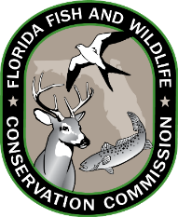
Florida Fish and Wildlife Conservation Commission
Physician Certification of Disability
For purpose of exemption to income requirement for
restricted species endorsement

Physician Certification of Total and Permanent Disability
This is to certify that ________________________________, born on ____/____/_______, in my professional opinion, has an impairment of mind or body which is sufficient to render it impossible for the average person to follow a substantially gainful occupation and that the impairment is reasonably certain to continue throughout the life of the person with a disability. The patient has been affected by this impairment since __________________.
(Patient’s First and Last Name)
(Date of Disabilty)

Patient’s Social Security Number* Print Physician’s Name
Physician’s Street Address Physician’s License Number (Must begin with ‘ME’, 'RS', 'LL', 'OS', 'PA' or 'CH')

Physician’s City, State, Zip Physician’s Telephone Number (with area code)

Physician’s Signature Date

This certification is valid for one year from the date of certifying signature.

*The Florida Fish and Wildlife Conservation Commission (FWC) collects social security number (SSN) for the issuance of recreational and professional wildlife, fishing or hunting licenses or permits to an individual in accordance with s. 379.352 F.S. and 42 USC 666 for the purposes of administration of the Title IV-D program for child support enforcement, use by the commission, and as otherwise provided by law.

